EDITORIAL AUTUMN 1996

Oh what is life if full of care
as long as I'm comfy in the typists chair

If you don't understand the meaning of the doggerel it means you didn't read last issue's editorial. Shame on you. Since my visit to the York three day fair at the end of March, I have managed to get around and have been to postcard fairs at Stafford, Orpington, Croydon, Cheltenham, Leeds, Harpendon, Bristol, Birmingham, Folkestone, Bloomsbury, Chester le Street, and Bexhill, as well as giving a display to the Canterbury Club. I have also been down to Branch 2 at Brighton, who must have the largest stock of any shop I know. While there a funny thing happened to me, I was sitting on a four legged old typists chair when suddenly the back leg went through a rotten floorboard, and I was thrown over backwards, hitting my head on the wall. If only it had happened in America I could have claimed about a million pounds compensation for injuries and loss of dignity. As it was I did get a second cup of coffee from Robert.
I am doing most of my travelling to far away fairs with a local dealer going strictly as a passenger, and to give you an idea of what happens when I set out under my own steam, in August I went down to the Canterbury Postcard Fair. I got to Canterbury all right, and to anyone who does not know the town it is made up of no-go roads, one way systems (always going in the wrong direction) pedestrian areas, and in general a place to be avoided. I spent just under an hour and a quarter looking for the fair, and was on my way home when one of the windscreen wipers stopped working, the other one banged into the stationary arm and promptly broke in half. At this point He or is it She who was obviously keeping an eye on me, took over and caused the rain to stop, and at the same time conjured up a garage, with an old attendant who knew all about windscreen wipers and in no time at all had a new one fitted and the stopped one working. This so encouraged me that I decided to head back into town and give it one more try to see if I could find the fair, driving into the first car park I came to. As I stepped out of the car in brilliant sunshine, I spotted a chap carrying a bundle of ten postcard boxes to his car, and there was the Hall right under my nose. So close I didn't even have to go out of the car park to get to it. At the first table I got two cards, one a coloured Beagles card titled 'Brocks Fireworks at the Crystal Palace' of a type I have not seen before, with a printed advert on the back for the N. V. Sunlight Oil Co., and the other a nice pull-out for the Anglo-American Exposition London which I had not got. At three pounds each I realised my luck had changed, and finished up having a good day.
As I am writing this I have not had many replies in about the Convention, but what with the postal strike and the summer Journal going out late I hope to be getting more forms back soon. Burton Benedict phoned me from America to say he will be attending and offering to give us a slide display.
Mike Perkins has now got a programme on his computer compatible with mine so we can exchange discs, and the last time he was down I gave him some hand written articles that have been sent in to me from time to time. He is going to type them into articles I can use in the Journal. We tried it out in the last Journal and he has done two more for me to use in this issue.
Stanley Hunter has now produced E S G Publication No. 3 "Footsteps at the American Worlds Fairs" and a write up on it appears else where in the Journal. E S G Publication No. 4. "Price Guide and Check List for Postcards of the British Empire Exhibition 1924-1925" by Mike and myself is now available and I shall bring a supply to the Convention. E S G Publication No. 5 "Exhibitors at the British Empire Exhibition 1924 1925" was finished, when Keith Cooper phoned me to say he had just picked up a copy of The Canadian Pavilion Catalogue for 1924 listing all the Canadian exhibitors and their stand numbers, he has let me have a photo-copy of it. The 1924 Fleetway Catalogue does not include all the stand numbers, so I shall update the book before it goes off to the printers hopefully within the next month or so.
I shall then be able to have a glorious clear up and get down to the next one which will cover the Festival of Britain. With help from members of our group and the members of the Festival of Britain Society I intend to cover the postcards, stickers and postal history of the F.O.B.
Exhibition Study Group Publication No. 3

FOOTSTEPS AT THE AMERICAN
WORLDS FAIRS

The Great International Exhibitions
of Chicago, New York & Philadelphia
Revisited in 1993

Stanley K Hunter, FSA (Scot)

The United States has staged some of the most important international exhibitions ever held. America's first World's Fair was stager in New York in 1853-54 to rival London's Great Exhibition of 1851. A much grander exhibition in Philadelphia marked the US Centennial in 1876 while Chicago's Columbian Exposition in 1893 was probably the grandest and most important American World's Fair of the 19th Century.

All three cities marked these events by staging further international exhibitions in the 20th century. The most recent were the NY World's Fairs of 1939-40 and 1964-65.

The author set out to visit the sites of all seven great events to find what - if anything - remains. He walked over the actual locations - often now landscaped parks, visited surviving buildings and monuments and scoured local museums for links with the events that attracted almost 140 million visitors. In Chicago he took part in the centenary celebrations marking the Columbian, and visited a number of the centenary exhibitions held throughout the city.

The national tribute to the Columbian was staged in the National Museum of American Art in Washington DC. The Philadelphian Centennial of 1876 is recalled in the Art & Industries Building of the Smithsonian Institute in Washington which also houses souvenirs of other great expositions in the National Museum of American History.

The author also paid a visit to Coney Island - purely for research purposes - which has a number of links with great exhibitions. A collector of international exhibition souvenirs and ephemera, the author notes the items he came across, including postcards and even postage stamps celebrating the important exhibitions.

He has already written about "footstepping" international exhibitions after visiting the sites of the five great World's Fairs of San Francisco and San Diego in California. He has done the same for the various sites in Brussels, London, Edinburgh and his home town of Glasgow. His book, Kelvingrove and the 1888 Exhibition was the first published with the imprint of The Exhibition Study Group. He has lectured on the subject of international exhibitions and their impact on social history, art and architecture and organised tours of exhibition sites.

Footsteps at the American World's Fairs 87pp 77 illustrations, A4 format © 1996
ISBN 0 9502746 4 X

May be obtained from
The Secretary, Exhibition Study Group, 23, Bramley Way, West Wickham, Kent BR4 9NT
or the author
Stanley K. Hunter. 34, Grey Street, Glasgow. G3 7TY.

£5.00 plus 65p p&p or US $10 bill post paid
Exhibition Study Group Publication No. 4

Price Guide and Check List for Postcards of the
British Empire Exhibition Wembley
1924 & 1925

Mike Perkins & Bill Tonkin.

When we produced our book "Postcards of the British Empire Exhibition Wembley 1924-1925", in 1994 we discussed the question of including prices in it. We were advised by a wholesaler and friends in the postcard world, that including prices would increase the sales of the book. Since our aim was to produce the definitive reference work on the Wembley cards, we finally decided against doing this. With that thought in mind, we planned to follow it with a small pocket sized catalogue and check list which could be produced in a paper-back format, without illustrations, and with reduced text.
This check list gives a valuation for every card listed in our first book, and is meant to complement, and be used in conjunction with, our book, and not to replace it.
Most dealers will have to know something about a wide range of subjects, and will rely on experience and the general catalogues when pricing cards. The specialist, whether a collector or dealer, knows a great deal about a particular subject. and is more likely to know whether a card that comes within his field of interest is common, comes up every now and again, or is really rare, and what it is worth.
While researching our book Mike and I have visited many Wembley collectors, and in addition visit 100-150 postcard fairs a year. We feel we are in the unique position of being able to look at a Wembley card and to give a valuation
Unfortunately, the rarity of a card is not the only factor governing its value, and a cards appeal is often the over riding consideration. There are cards where only one or two copies are known, and if it is a drab sepia card it will not warrant a high price, while a commoner but more attractive and desirable coloured card will often command a higher price.
For example the unattractive Jarvis 'Comfy' Coaches cards are very seldom seen, and when found are usually priced at £2.00 or under. On the other hand there is a nice coloured Tuck Advert card 'Defenders of the Empire' published by Macdonald, Greenlees & Williams (Distillers) Ltd., which is much commoner. At one fair recently I could have bought no less than six copies, one dealer having three in his stock. I have seen this priced as high as £16.00; there is no justification for this high price, and we have priced it lower accordingly.
It is unfortunate that while we can suggest what we feel is a reasonable price for a card, because we are not dealers with a large stock to back up these prices, we cannot enforce them, unlike Stanley Gibbons who can effectively set catalogue prices, although they cannot stop other dealers discounting prices.
In the past there have been cases where dealers have put what we feel are sometimes grossly over rated prices on cards. We ourselves have at times paid well over the odds for a card we want. We hope that our estimates of values will come to be accepted as fair guide to prices by both dealers and collectors.

May be obtained from
The Secretary, Exhibition Study Group, 23, Bramley Way, West Wickham, Kent BR4 9NT

£6.50 plus £1.00 p&p
Copies will be available at the convention

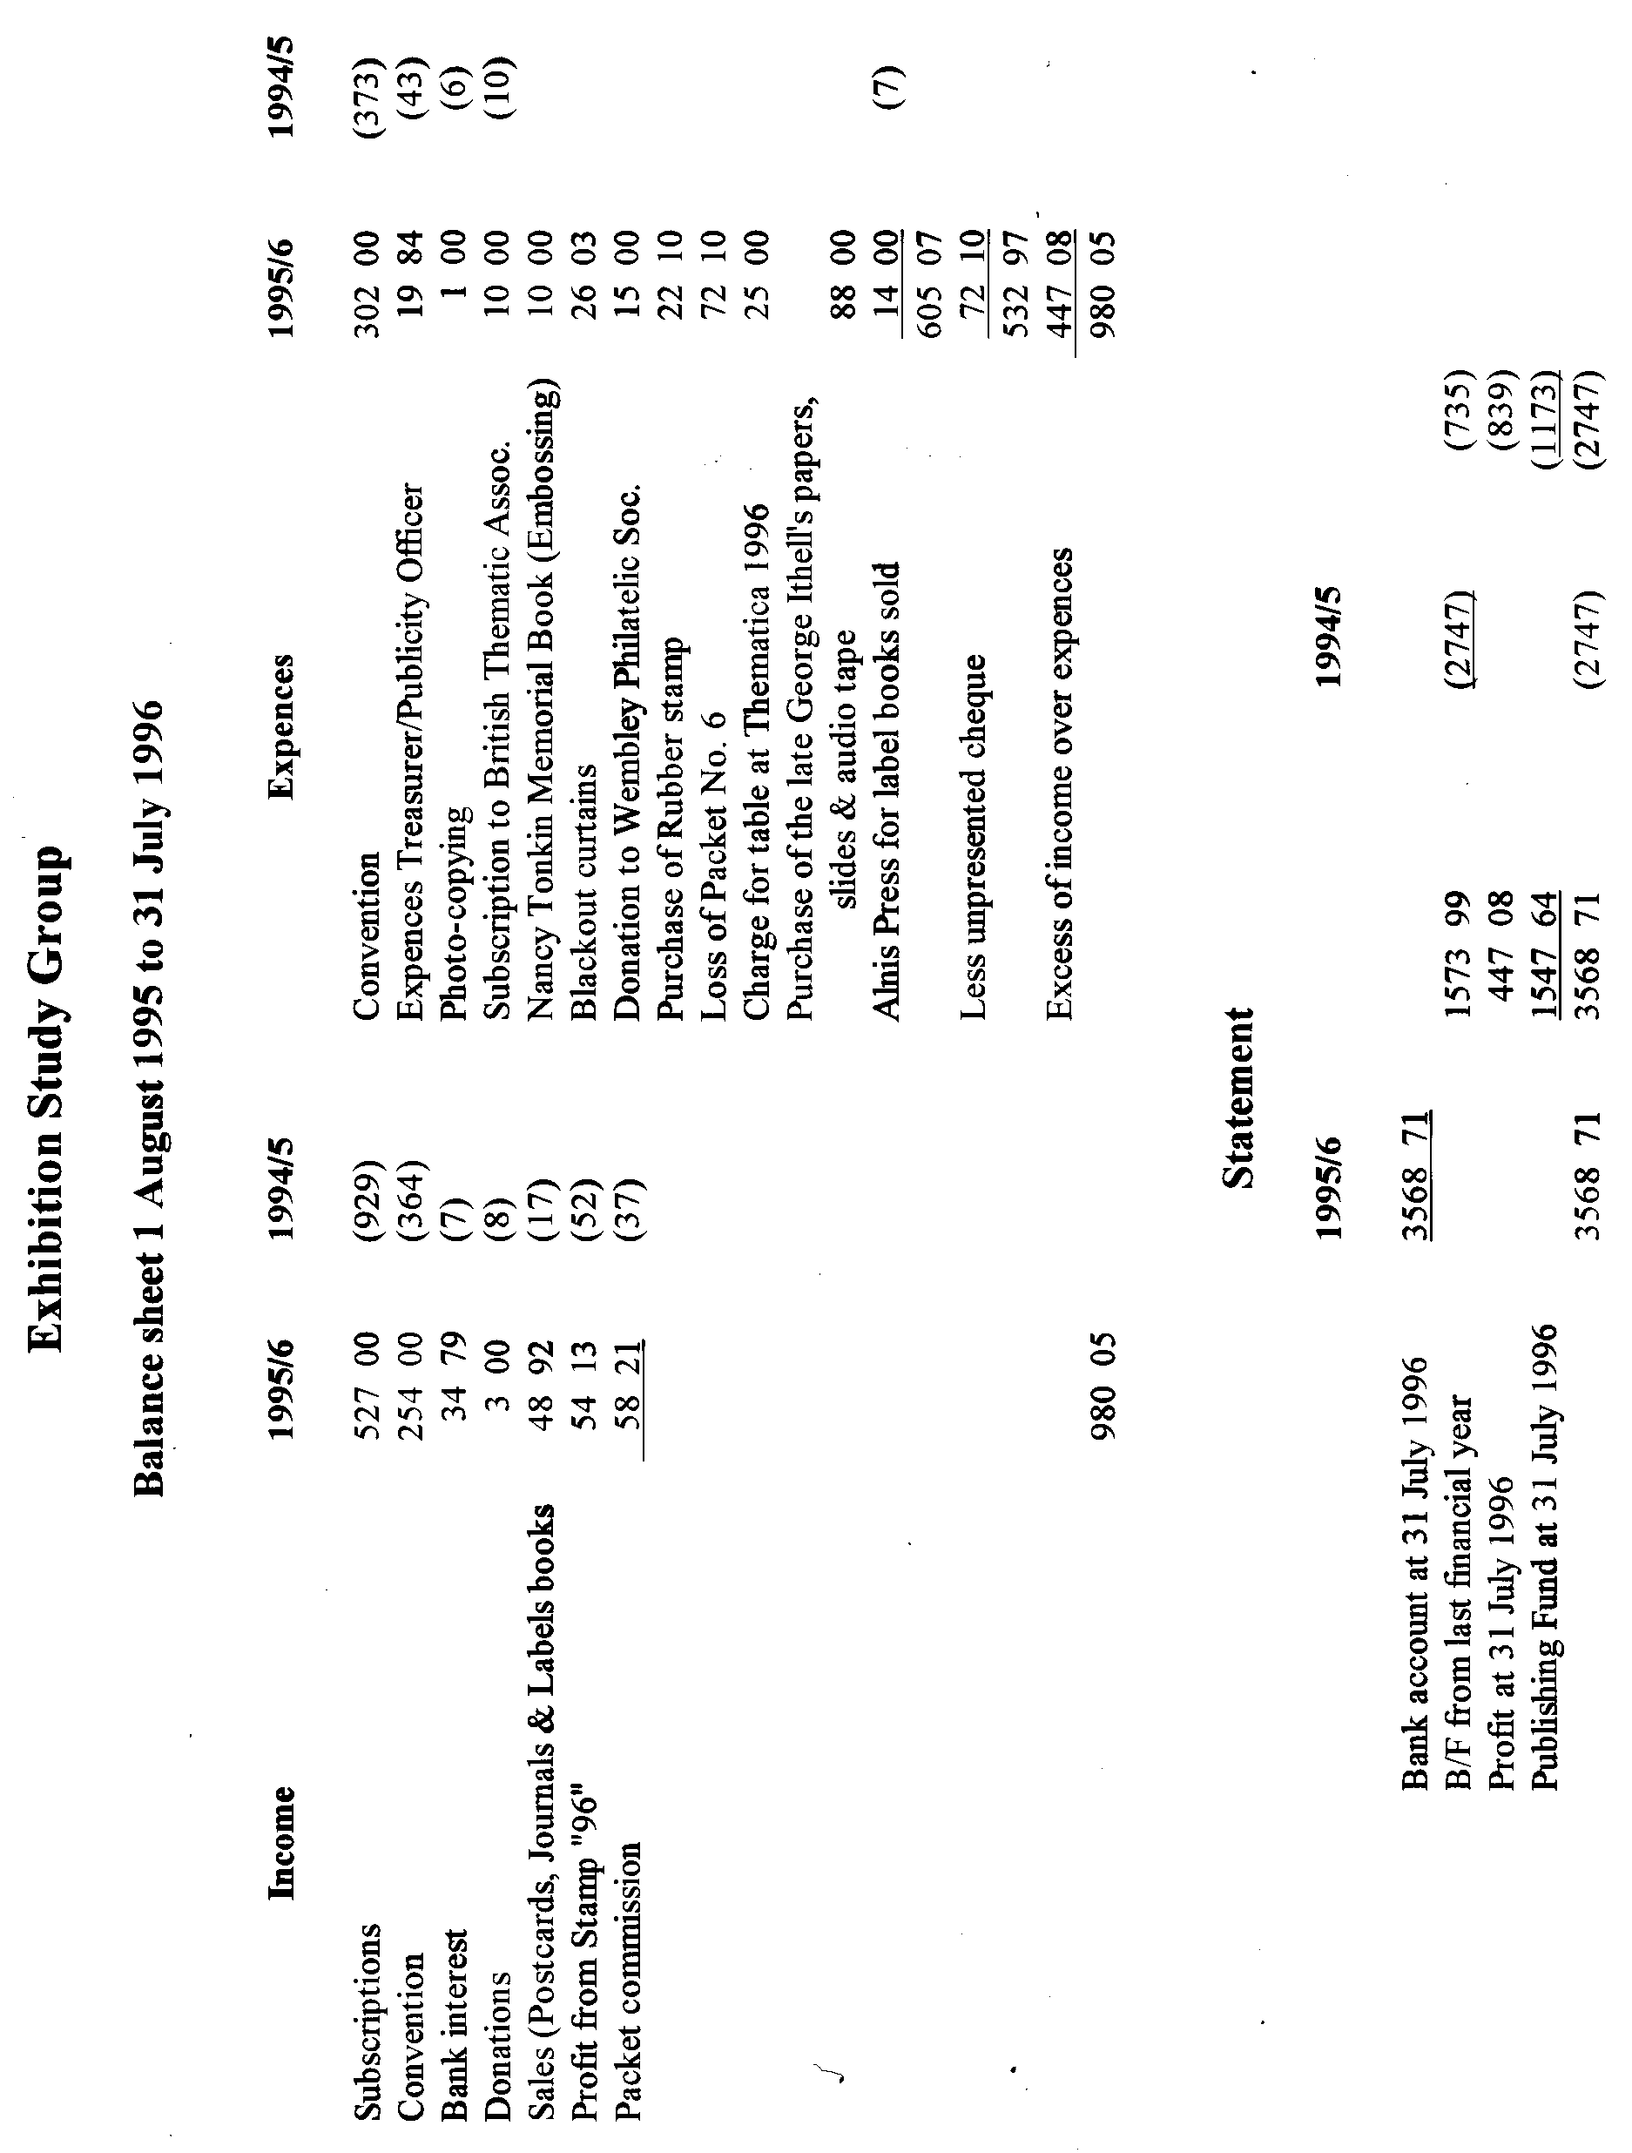

Lloyds Bank
Information Leaflet No. 4
(un-dated, but after 1984)

British Empire Exhibition Stickers.

The British Empire Exhibition opened at Wembley Park in April 1924. It was estimated to have cost £10 million to produce and an entirely new concrete city was erected to house it. Contemporary publicity hailed the exhibition as a stocktaking of the whole of the resources of the Empire.
Lloyds Bank were official bankers to the exhibition and also to various Dominion pavilions. Other exhibitors, and of course visitors, were able to use the facilities offered there. The exhibition branch was situated in the central avenue midway between the Palaces of Industry and Engineering, and was therefore one of the first buildings to catch the eye as visitors entered the main gates. The manager of the exhibition branch was Hugh Stanley Gill, MC, who lived in nearby Harrow. His staff were drawn from branches all over the country. Kenneth Jones, who came from Colonial and Foreign Department, recalled:
‘The premises were spacious, provided with a counter for about five cashiers, with a general office behind and two big rooms, one for the cash-counting machines and another for the cash van from Head Office, which drove in to collect the huge sums in cash from daily attendance. The staff worked in two shifts, one from 9am to 4.30pm and the other for the remainder of the day, leaving about 11.30pm.’
In keeping with the spirit of the event, a great deal of foreign exchange work was carried out. Other duties of the bank staff included telegraphic transfers, foreign drafts and remittances.
Lloyds Bank designed and issued special advertising stickers or labels to commemorate its involvement. These were printed by Bradbury Wilkinson & Co. at New Malden, Surrey. They were produced in sheets of 100 in a number of colours - red, green. blue and, more rarely, mauve. All issues depicted the exhibition branch and were dated 1924.
The labels were given free to visitors and a small supply was sent to every Lloyds Bank branch. They were used to seal the join on the back of envelopes containing pass-books, when these were sent to customers through the post. (Pass-books were the forerunners of statements of account and were written-up by hand).
The printing of these labels was probably stimulated by the decision of the Post Office to mark the occasion of the exhibition by its first issue of commemorative stamps. Other companies, besides Lloyds Bank had similar labels printed. Although of historical interest, the stickers have only a modest market value and are referred to by philatelists as ‘Cinderella material’. They are also commonly, but wrongly, referred to as stamps.
At the end of the exhibition in 1925, and in keeping with the banking ethic of thrift, the carpet from the exhibition branch was sent to Lloyds Bank, Tunbridge Wells, to grace the manager’s room.

George E. R. Ithell

Members will remember that George sadly passed away last December. It was known that after he published his book on Ballymaclinton, he had continued his researches on the subject. The last time Mike Perkins came to stay with me for a few days I invited Alan Sabey over and during the conversation we agreed that his unpublished notes should if possible be purchased by the Study Group, to save the knowledge being lost or destroyed. This has been done, and the archive containing all of George's notes, files, two tapes recording an interview with Miss Alice Brown, a descendant of the Brown family, the owners of 'Maclintons', (on these amongst other things she talks about the Irish Village at the White City), and a collection of about 100 slides of the pages of his collection is now
the property of the Group. His postcard and postal history collection will eventually be auctioned by Phillips, but it could well have happened that his notes would not have been saved, now they are safe.

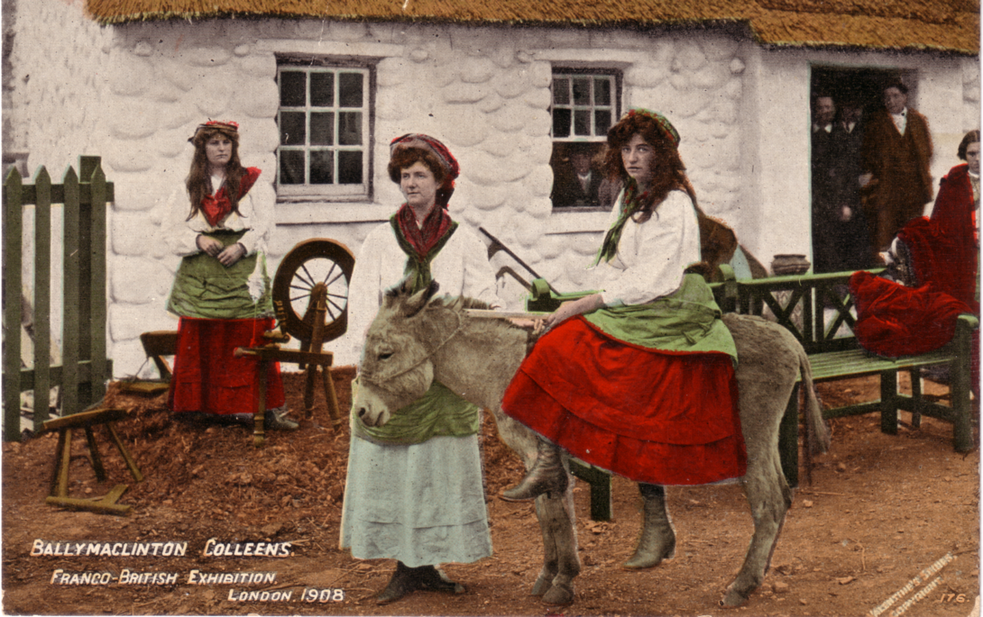

Angel Atkinson, Mrs Gee and Myrtle Atkinson

In one part of the archive there are many pictures and photographs of the Irish Colleens at the exhibition whom George has been able to identify and name. There are also photo-copies of a page from the post office records illustrating the Ballymaclinton canceller issued to the Western District Office on June 5 1908, and photo-copies of the parcel post labels produced specially for use at the Ballymaclinton Post office at the exhibition.
The acquisition of this material will raise the question of the possible need for a member to take on the position of archivist and who would be prepared to store this, and any other material acquired in the future. This and the possible availability of the material to members is something that will have to come up at our A.G.M.
Some of the slides from this archive will be shown during the evening after our Annual Dinner, and this is being organised by Alan Sabey.

POST CARDS OF THE WHITE CITY

A preamble by Bill Tonkin

My decision to start the listing of the White City postcards, has caused quite a lot of interest, and several members have written or phoned me offering their help in the project. Arthur Smith was quick off the mark to point out I had made a mistake on one title, Alexander's No 29 which I had down as 'Old London-A Dealer in Stocks' and it should be 'Old London-A Dabbler in Stocks'. Thanks for pointing it out Arthur. Don Knight rang me up and during the conversation raised a doubt as to whether many collectors were interested in black or brown backs, upright or inverted. My position on this is that of course I am not setting out to tell collectors that they must collect this or that variation of a card. But I think it important that collectors should know what varieties or types exist. The majority will just want one copy of a card in their collection, fine, but there are others who go into it deeper. Wembley, the Scottish Exhibitions, and the Festival of Britain, all have their followers who
study the backs, as well as the picture.
You have a similar situation in the stamp collecting world where a stamp can have a dozen different watermarks, and many collectors are content to just have a single example, but as their interest grows in an issue, many end up by wanting every watermark that is available.
One concern I had, has not materialised, nobody as yet has complained that a lot of space is going to be taken up in the Journal on the White City.

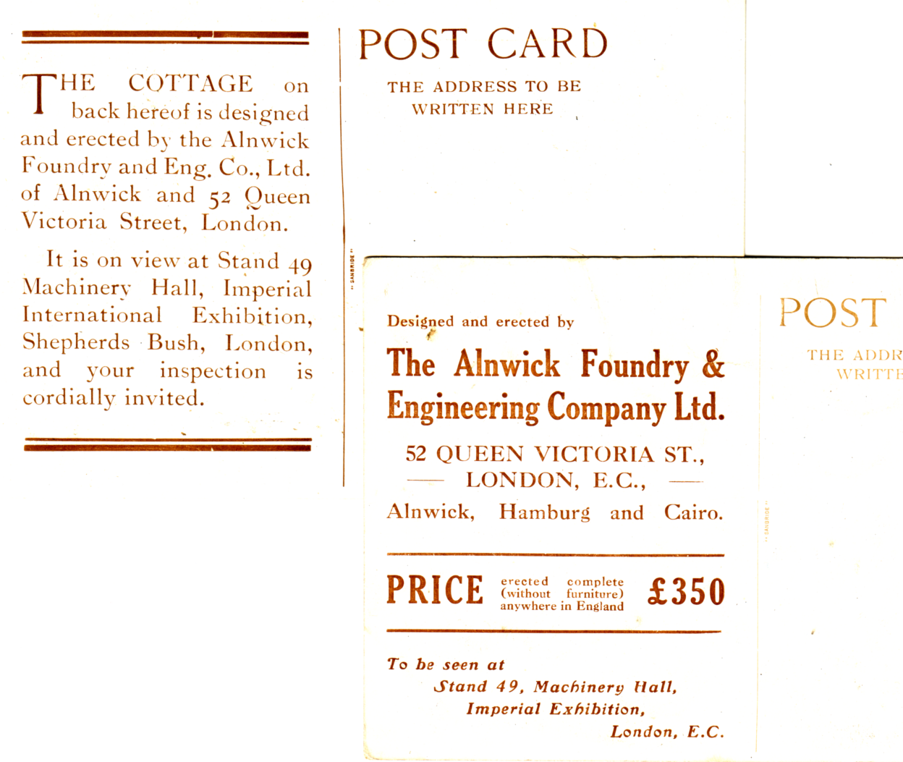

Type 1 Type 2

A second type of back has turned up for the Alnwick Foundry & Engineering Co. Ltd.,
card, listed in part 1, and I have illustrated them both.

I shall as far as possible try and start each instalment at the top of a page, and finish at the end of a page, so it will be convenient to take those pages out and keep them in a ring binder. I think most people have a paper punch, and if they do this they will finish up with a handy reference book on the White City.
POST CARDS OF THE WHITE CITY

Part 2.

by
Bill Tonkin

"Bat" Expanding Bedstead.
B/W combination line and screened photogravure trade card, black and red back with a map of the site and stand location marked.
No title, but a description of the bed invented by Mrs Keightley.

J. Beagles & Co. Ltd. London E.C.
Beagles produced quite a wide range of cards for the Franco-British Exhibition, calling the event by several names, starting with the Anglo-French Exhibition, then the Franco-British Exhibition, and finished up by masking out the title with a gold panel and renaming it White City Exhibition. Most of the cards came under the heading of Series 961 running from A to Z, it is not known if all the letters of the alphabet was used, and since letters 'I', 'N' & 'Q' have not been seen yet, if two of these were not used, this could leave a nice round figure of 24 which would fit nicely into four packets of six cards. Parts of this series was published in R/Photo, coloured and B/W. This was followed by a Series 964, which may have consisted of only two cards 964 & 964A. Beagles finished with a series of cards for the Japan-British Exhibition again using Series 964 and extending the series, but whether this was a short series, or went right through the alphabet is not known.

Series 1. Consisting of Series 961 titled 'Anglo-French Exhibition.' The same picture with slight variations was used for type 1, 2, & 3 and shows two clasped hands in the centre flanked with the two flags, and a view of the Court of Honour in an oval frame near the top. All the cards in series 1 have the same view numbered 961 C, but in series 2 & 3 this view has been renumbered 961 A.
Type 1. Coloured card, title in red. Red-brown back type A with the number on the back in small print.
961 C Souvenir Anglo-French Exhibition 1908. The Court of Honour.

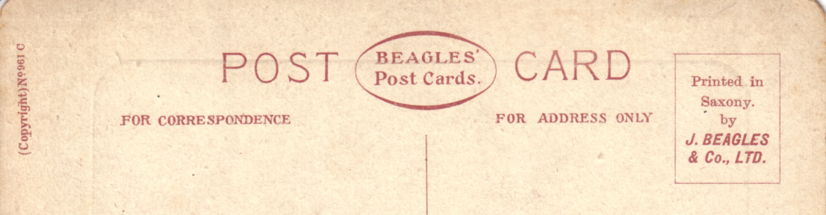

Back type A. POST CARD and logo measures 69mm.

Type 2. R/Photo with white border, the picture is almost the same as type 1, but there are slight differences and it has been enlarged from a measurement of 85mm across the flags, to 114mm. There is no title and the number is now printed on the front. Black back type B.
961 C. no title.

Type 3. B/W litho printing as type 1 but has again been enlarged to 120mm. There is no title and the number is now printed on the front and the back. Brown back type C with 'J. Beagles & Co., Ltd., London, E.C. Copyright. No. 961 C. Printed in England.' down the left side. This back is known in two varieties A has 'Ltd.,' included in the imprint and B where 'Ltd.,' is omitted.
961 C. no title.
A. With Ltd.,
B. Without Ltd.,

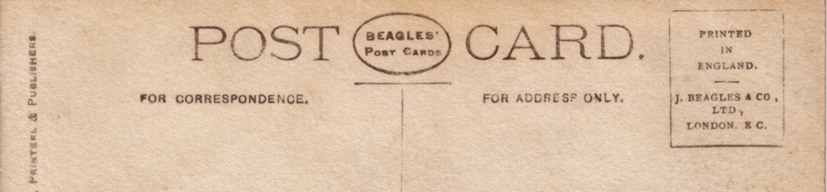

Back type B. POST CARD and logo measures 76mm.

Series 2. Consisting of Series 961 titled 'Franco-British Exhibition.' All the titles in series 2 & 3 are prefixed with 'Franco-British Exhibition' except 961 O.
Type 1. Coloured card with the title in red, red-brown back type C with the number on the back. From 961 L, the number is printed in a larger size print.
961 A General View of the Court of Honour.
961 D Palace of British Applied Arts.
961 E Palace of Womans Work.
961 H The Irish Village.
961 L Court of Honour by Night.
961 T Elite Gardens and Palace of British Applied Arts.
961 U The Lagoon and Palace of British Applied Arts.

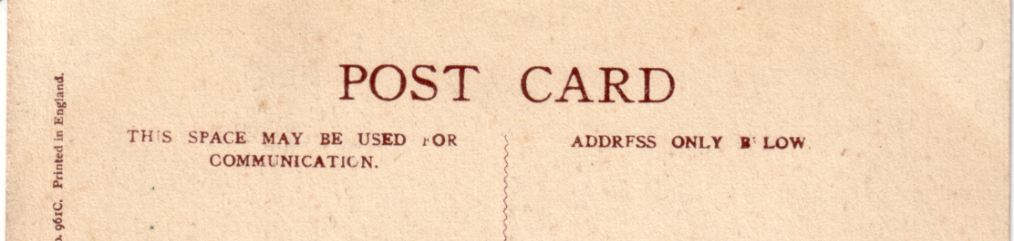

Back type C. POST CARD measures 47mm.

Type 2. R/Photo with white border, the numbers are on the front. Black back type B.
961 F. Palace of French Applied Arts.
961 G. Palace of Music.
961 L. Court of Honour by Night.
961 M. Canadian Section.

Type 3. R/Photo with white border, the numbers are on the front. Black back type D.
961 A. General View of the Court of Honour.
961 B. The Elite Gardens, showing Bandstand.

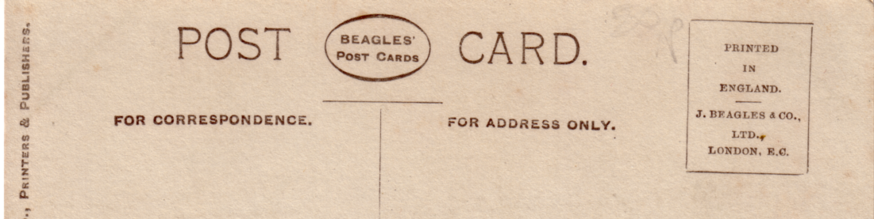

Back type D. POST CARD and logo measures 65mm.
Imprint in 1 line, 'Printed in England etc.' in stamp box.

961 G. Palace of Music.
961 H. The Irish Village.
961 L. Court of Honour by Night.
961 O. Entrance to Franco-British Exhibition, Wood Lane.
961 S. The Lake & Court of Honour.
961 T. Elite Gardens & Palace of British Applied Arts.
961 W. The Flip-Flap. Vert right.
961 X. The Flip-Flap. Vert right.
961 Z. The Bandstand & Flip-Flap.
Type 4. R/Photo with white border, the numbers are on the front. Black back type E.
961 O. Entrance to Franco-British Exhibition, Wood Lane.

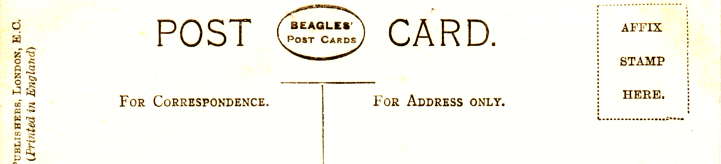

Back type E. POST CARD and logo measures 65mm.
Imprint in 2 lines, 'Affix stamp here' in stamp box.

Type 5. B/W litho printing, the title is in white unless there is a white background, then it is in black. The number is printed on the front, and also on the back where it is in a small print. Brown back type C with 'J. Beagles & Co., Ltd., London, E.C. Copyright. No. 961 .... Printed in England.' down the left side. This back is known in two varieties 'A' has 'Ltd.,' included in the imprint and 'B' where 'Ltd.,' is omitted.
961 A General View of the Court of Honour.
B. Without Ltd.,
961 B. The Elite Gardens, showing Bandstand.
A. With Ltd.,
961 D Palace of British Applied Arts.
A. With Ltd.,
961 E Palace of Womans Work.
A. With Ltd.,
B. Without Ltd.,
961 F. Palace of French Applied Arts.
A. With Ltd.,
961 G. Palace of Music.
B. Without Ltd.,
961 H The Irish Village.
A. With Ltd.,
961 J. Australian Section.
A. With Ltd.,
B. Without Ltd.,
961 K. The Stadium.
B. Without Ltd.,
961 L. Court of Honour by Night.
B. Without Ltd.,
961 M. Canadian Section.
A. With Ltd.,
B. Without Ltd.,
Type 6. B/W litho printing, with the title on the front in red-brown. The number is printed on the back in small print. Brown back type C with 'J. Beagles & Co., Ltd., London, E.C. Copyright. No. 961 .... Printed in England.' down the left side. The type 'B' where 'Ltd.,' is omitted does not seem to appear on type 6 cards, although one card has been noted where 'Ltd.,' has been misplaced and comes between 'London' and 'E.C.'
961 A General View of the Court of Honour.
961 L. Court of Honour by Night.
'Ltd.,' has been misplaced and comes between 'London' and 'E.C.'
961 R. The Elite Gardens and Palace of Womens Work.
A. Title measures 103mm
B. Title measures 106mm
961 S. The Lake and Court of Honour.
961 T Elite Gardens and Palace of British Applied Arts.
961 U The Lagoon and Palace of British Applied Arts.
961 V. The Scenic Railway.
961 W. The Flip Flap. Vert left.
961 Y. The Flip Flap.
961 Z. The Flip Flap. (This title has been altered from 'The Bandstand & Flip-Flap.')

Series 3. Consisting of Series 961 titled 'White City Exhibition.'
Type 1. R/Photo with white border, this series is series 2 type 3 reused with the Franco-British Exhibition title covered with a gold panel and a new White City Exhibition title printed on the gold panel in blue. Some titles have been altered. The numbers are on the front. Black back type D.
961 A The Lake and Court of Honour.
961 L. Court of Honour by Night.
961 P. Entrance to the Irish Village. Vert right.
961 R. The Elite Gardens.
961 S. The Lake and Court of Honour.
961 X. The Flip Flap. Vert right.

Type 2. B/W litho printing, this series is series 2 type 6 reused with the Franco-British Exhibition title on the front in red-brown, now covered with a gold panel and a new White City Exhibition title printed on the gold panel in blue, sometimes so dark that it almost looks black. Some titles have been altered. The number is printed on the back in small print, and on a few cards the number is also printed on the front. Brown back type C with 'J. Beagles & Co., Ltd., London, E.C. Copyright. No. 961 C. Printed in England.' down the left side. The type B where 'Ltd.,' is omitted does not seem to appear on these reissued cards.
961 A The Lake & Court of Honour. (Not numbered on the front.)
961 B. The Elite Gardens, and Bandstand.
961 H The Irish Village.
961 R. The Elite Gardens. (Not numbered on the front.)
961 S. The Lake & Court of Honour. (Not numbered on the front.)
961 T The Elite Gardens. (Not numbered on the front.)
961 X. The Flip Flap. Vert left. (Not numbered on the front.)
961 Y. The Flip Flap. (Not numbered on the front.)

Series 4. Consisting of Series 964. titled 'Franco-British Exhibition.'
Type 1. Coloured card with the title in red, red-brown back type A with the number on the back in large print. All the titles are prefixed with 'Franco-British Exhibition'.
964 Court of Honour and Congress Hall.
964 A. Cascade Cafe and Palace of French Applied Arts.
Type 2. R/Photo with white border, the numbers are on the front. Black back type D. The titles are prefixed with 'Franco-British Exhibition'.
964 Court of Honour & Congress Hall.
964 A. Cascade Cafe & Palace of French Applied Arts.

Type 3. B/W litho printing, with the title on the front in red-brown, are prefixed with 'Franco-British Exhibition'. The number is printed on the back in small print Brown back type C with 'J. Beagles & Co., Ltd., London, E.C. Copyright. No. 964 Printed in England.' down the left side. The type B where 'Ltd.,' is omitted does not seem to appear on this series of cards.
964 Court of Honour and Congress Hall.
964 A. Cascade Cafe and Palace of French Applied Arts.

Series 5. Consisting of Series 964. titled 'Japan-British Exhibition, 1910.'
Type 1. R/Photo with white border, the numbers are on the front. Brown back type F. The titles are prefixed with 'Japan-British Exhibition, 1910.'
964 D. The Japanese Gardens.
964 F. The Japanese Gardens.
964 G. Japanese Gardens of the Floating Islands.

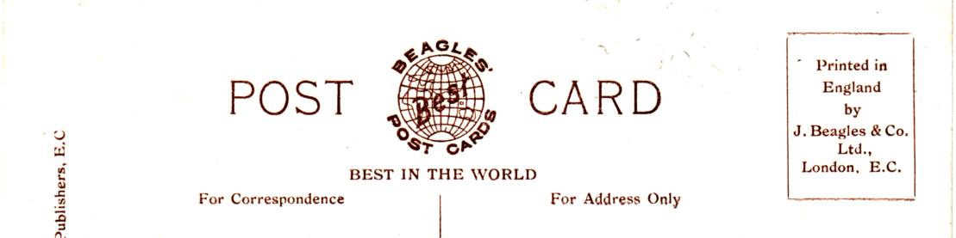

Back type F. POST CARD and new logo measures 63mm.

Bonnet & Shum (L.P.A. Ltd) Cheapside, E.C.
Bonnet & Shum published a series of 36 B/W cards, each produced in three types as follows. All the titles finish with 'Franco-British Exhibition, London, 1908.'
Type 1. This series has the firms imprint on the back down the left side, the backs can be found in a range of shades from deep brown to a golden brown.
Type 2. The views on this series are the same as on type 1, the back is also the same as type 1 but there is no firms imprint down the left side, the backs can be found in a range of shades from deep brown to a golden brown.
Type 3. In this series the title is printed sans serifs while in type 1 & 2 the title has serifs. The views are from the same negatives as types 1 & 2, but have been used in a different way, sometimes the whole picture has been increased in size, sometimes less of the negative has been used and this has been enlarged, or more of the negative has been used showing detail missing on type 1 & 2. There is also some variation in the colour of the picture from B/W to sepia, but there is no variation in colour of the brown backs. There is a different ornament at the top of the dividing bar, and there is no firms imprint down the left side. As there can be quite a difference in the size of the picture, measurements for all of them are given.
Algeria
Type 1. picture measures 88 x 65mm.
Type 2. picture measures 88 x 65mm.
Type 3. picture measures 114 x 70mm. (Less of the negative used)
Australian Court.
Type 1. picture measures 88 x 65mm.
Type 2. picture measures 88 x 65mm.
Type 3. picture measures 105 x 70mm. (More of the negative used)
British & French Decorative Arts.
Type 1. picture measures 95 x 64mm.
Type 2. picture measures 95 x 64mm.
Type 3. picture measures 105 x 70mm. (Slightly more of the negative used)
Canada Court.
Type 1. picture measures 109 x 65mm.
Type 2. picture measures 109 x 65mm.
Type 3. picture measures 115 x 64mm. (Less of the negative used)

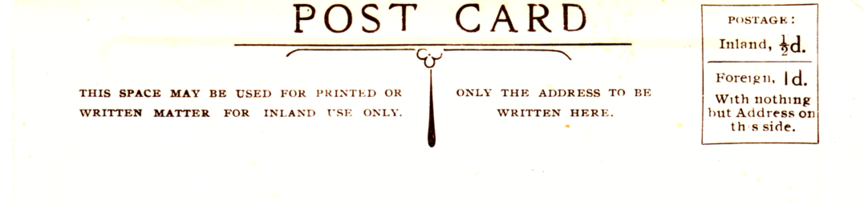
Type 1 back.

The Cascade.
Type 1. picture measures 114 x 65mm.
Type 2. picture measures 114 x 65mm.
Type 3. picture measures 116 x 65mm. (Slightly less of the negative used)

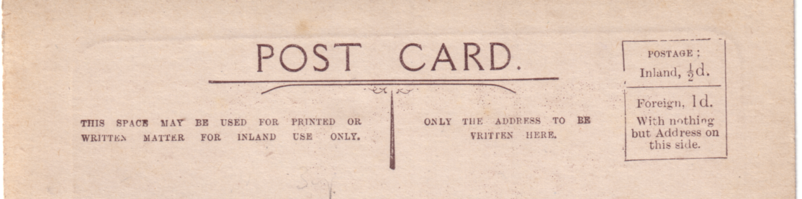

Type 3 back.

Congress Hall. (Colonnade on the left)
Type 1. picture measures 114 x 65mm.
Type 2. picture measures 114 x 65mm.
Type 3. picture measures 109 x 70mm. (More of the negative used)
Congress Hall (Colonnade on the right)
Type 1. picture measures 114 x 65mm.
Type 2. picture measures 114 x 65mm.
Type 3. picture measures 114 x 640mm. (Slightly more of the negative used)
Court of Art.
Type 1. picture measures 108 x 62mm.
Type 2. picture measures 108 x 62mm.
Type 3. picture measures 115 x 65mm. (Slightly more of the negative used)
Court of Honour. (Large boat full of passengers bottom centre)
Type 1. picture measures 115 x 65mm.
Type 2. picture measures 115 x 65mm.
Type 3. picture measures 113 x 63mm. (Slightly more of the negative used)
Court of Honour. (Large boat full of passengers bottom right)
A. Gap between 'Honour' and 'Franco' measures 33mm.
Type 3. picture measures 114 x 63mm. (Slightly more of the negative used)
B. Gap between 'Honour' and 'Franco' measures 36mm.
Type 1. picture measures 114 x 64mm.
Type 2. picture measures 114 x 64mm.
C. Gap between 'Honour' and 'Franco' measures 38mm.
Type 1. picture measures 114 x 64mm.
Court of Honour. (Small boat just going under bridge in centre)
Type 1. picture measures 102 x 65mm. (No chimneys)
Type 2. picture measures 102 x 65mm. (No chimneys)
Type 3. picture measures 114 x 63mm. (Two large factory chimneys in the background)
Court of Honour-Entrance.
Type 1. picture measures 106 x 65mm.
Type 2. picture measures 106 x 65mm.
Type 3. picture measures 114 x 64mm.
Fine Art Palace.
Type 1. picture measures 115 x 65mm.
Type 2. picture measures 115 x 66mm.
Type 3. picture measures 115 x 64mm.
Flip Flap. (With Webb's Glass Factory on left)
A. Gap between 'Honour' and 'Franco' measures 41mm.
Type 1. picture measures 107 x 65mm.
Type 2. picture measures 114 x 65mm.
B. Gap between 'Honour' and 'Franco' measures 49mm.
Type 1. picture measures 107 x 65mm.
Type 3. picture measures 114 x 63mm. (Slightly less of the negative used)
Flip Flap. (Flip Flap behind Band Stand)
Type 1. picture measures 101 x 65mm.
Type 2. picture measures 101 x 65mm.
Type 3. picture measures 114 x 64mm. (Slightly less of the negative used)
Flip Flap. Vert left.
Type 1. picture measures 64 x 108mm.
Type 2. picture measures 64 x 108mm.
Type 3. picture measures 64 x 115mm. (Slightly less of the negative used)
Fountain.
Type 1. picture measures 105 x 65mm.
Type 2. picture measures 106 x 65mm.
Type 3. picture measures 114 x 63mm.
General View.
Type 1. picture measures 114 x 65mm.
Type 2. picture measures 114 x 65mm.
Type 3. picture measures 114 x 640mm. (Slightly more of the negative used)
India. Vert left.
Type 1. picture measures 65 x 100mm.
Type 2. picture measures 65 x 100mm.
Type 3. picture measures 63 x 113mm.
Indo-Chinese Palace. (Large group of visitors in foreground)
Type 1. picture measures 102 x 65mm.
Type 2. picture measures 102 x 65mm.
Type 3. picture measures 114 x 64mm. (Slightly less of the negative used)
Indo-Chinese Palace. (Several solitary visitors in foreground)
Type 1. picture measures 102 x 65mm.
Type 2. picture measures 102 x 65mm.
Type 3. picture measures 115 x 64mm.
Irish Village. Vert left.
Type 1. picture measures 65 x 114mm.
Type 2. picture measures 65 x 114mm.
Type 3. picture measures 63 x 115mm. (More of the negative used)
Irish Village-Interior.
Type 1. picture measures 91 x 65mm.
Type 2. picture measures 91 x 65mm.
Irish Village-Interior. Vert left. (This is the same negative as the one above but is now used in a vertical format)
Type 3. picture measures 63 x 114mm.
Machinery Hall.
Type 1. picture measures 99 x 65mm.
Type 2. picture measures 99 x 65mm.
Type 3. picture measures 114 x 64mm. (Slightly less of the negative used)
Machinery Hall-Shipping & Railways.
Type 1. picture measures 114 x 65mm.
Type 2. picture measures 114 x 65mm.
Type 3. picture measures 114 x 64mm.
Main Entrance. Vert left.
Type 1. picture measures 65 x 112mm.
Type 2. picture measures 65 x 112mm.
Type 3. picture measures 63 x 115mm. (Slightly more of the negative used)
New Zealand Court.
Type 1. picture measures 114 x 65mm.
Type 2. picture measures 114 x 65mm.
Type 3. picture measures 113 x 64mm. (Slightly less of the negative used)
Palace of British Applied Arts. (Gardens in foreground)
Type 1. picture measures 113 x 65mm.
Type 2. picture measures 113 x 65mm.
Type 3. picture measures 114 x 62mm.
Palace of British Applied Arts. (Lagoon in foreground)
Type 1. picture measures 93 x 63mm.
Type 2. picture measures 93 x 63mm.
Type 3. picture measures 115 x 64mm. (Less of the negative used)
Palace of Music.
Type 1. picture measures 101 x 65mm.
Type 2. picture measures 101 x 65mm.
Type 3. picture measures 115 x 640mm. (Less of the negative used)
Palace of Woman's Work.
Type 1. picture measures 114 x 64mm.
Type 2. picture measures 114 x 64mm.
Type 3. picture measures 114 x 640mm. (More of the negative used)
Palais Des Arts-Appliqués Arts Francais.
Type 1. picture measures 114 x 65mm.
Type 2. picture measures 114 x 65mm.
Type 3. picture measures 115 x 64mm.
Scenic Railway. (Caley's pavilion on left)
A. Gap between 'Honour' and 'Franco' measures 38mm.
Type 1. picture measures 113 x 66mm.
Type 2. picture measures 113 x 66mm.
Type 3. picture measures 115 x 64mm. (More of the negative used)
B. Gap between 'Honour' and 'Franco' measures 40mm.
Type 1. picture measures 113 x 66mm.
Scenic Railway. (Wheel chairs in foreground)
Type 1. picture measures 102 x 65mm.
Type 2. picture measures 102 x 65mm.
Type 3. picture measures 115 x 64mm. (Slightly less of the negative used)
Senegalese Village.
Type 1. picture measures 91 x 62mm.
Type 2. picture measures 91 x 62mm.
Type 3. picture measures 114 x 64mm. (Slightly less of the negative used)
Wood Lane Entrance.
Type 1. picture measures 114 x 65mm.
Type 2. picture measures 114 x 66mm.
Type 3. picture measures 115 x 65mm.

Bootham School, York.
B/W with black back. Apart from the title in the centre, there is 'Bootham School, York.' on the left, and 'Exhibited at the Franco-British Exhibition, 1908' on the right.
A Study of Norman Architecture. Vert left.
A Study of Pond Life.
Making Seats for the Cricket Field.
Natural History Club. A boy lecturing on the birds of Bamburgh.

Bovril.
Coloured advert card showing the 'Bovril Castle', brown back. The views of the castle are slightly different for each year.
Type 1. Franco British-Exhibition.
Visitors to the Franco-British Exhibition should not fail to visit the "Bovril Castle", opposite the Stadium, close to Garden Club

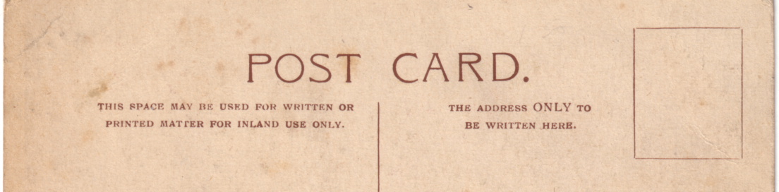

Type 1 back.

Type 2. Imperial International Exhibition.
Visitors to the Imperial International Exhibition should not fail to visit the "Bovril Castle", opposite the Stadium, close to Garden Club

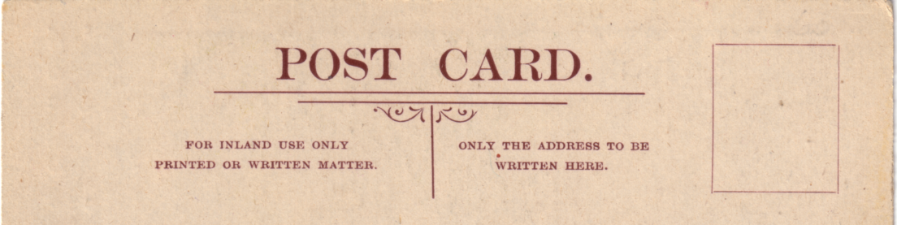

Type 2 back.

