EDITORIAL SUMMER 1996

When you have a bad slipped disc
Going to fairs is an awful risk

When chaps did not turn up for work with the excuse they had back trouble, I always thought they were malingerers, and in most cases I was probably right. I have just had my third spell of back trouble, when I was out of action for about three weeks. It still hurts but I can get about now. To anyone who has not suffered, and still has this joy to come, I can assure them the agony is out of this world. I had intended to go up to Chester le Street to a fair, and had booked accommodation, but had to cancel it. I wanted to go to the three day fair at York, and in the end a local post card dealer who was doing the York fair drove me up using my car, so I had no driving to do. We stayed up there four nights. I lasted two and a half days in the fair, and then I had to go and sit in the car for a couple of hours, as my back was killing me.
The good news is that it was a wonderful fair as far as exhibition cards were concerned, I managed to find 157, and some of them were cards I never expected to ever own. When Mike and I were gathering information for the book, one member of the Study Group had a Wembley card of a Chinese doll maker in the Hong Kong section. He let us have a photo-copy of it but it came out so dark we were unable to use it as an illustration, and when we tried to get back to him, we heard his marriage had broken up and he had moved. As far as we know it is the only known copy of this card. At one stand the dealer mentioned as I was going through his cards, that he had bought this chaps Wembley cards, and when I showed him the doll maker card which I was going to purchase, remarked "yes that's one from his collection". I of course knew this and was over the moon to get it for a fiver. Altogether I spent quite a bit at that stand and got some beautiful cards including a Mr & Mrs Brown at Wembley of which I only know of about five other copies. Fortunately the collection had not been too broken up when I saw it, so I was lucky.
I also got some fairly scarce Festival of Britain cards, including two "Cries of London" cards printed and published by Lansdowne Production Co. for "Empire Stores". Now there were very few advert cards published for the Festival, and I bought them both. When I got home I checked them with my list and found I already had a vertical card of a girl holding a basket of Outspan Oranges. However when I checked it with the card in my collection, I found that although the basket of oranges might have been the same, it was a different girl. This is one of the problems with carrying little note books around, you might have a card ticked off, not knowing there are two different cards with the same title.
There was also two extremely scarce Japanese Japan-British exhibition cards, both bearing the special post mark used in Japan on the opening day the 14th May 1910, or as 14th May 43 as the Japanese call 1910. One was the Tokyo post mark of which I already have nine examples, but the other was a post mark I have never seen before. I think it must have been used at one of the two post offices outside Tokyo. Now we have a Japanese member I hope she will be able to help me on this one, as inquiries will have to be made at the Japanese Postal Museum, if they have one?
Nearly three months has gone by since I started this editorial, and I am taking pen to hand again, or rather sitting down at the computer again to get on with the Journal. My bad back is still with me and still giving trouble, I should be grateful it's not worse. They have told me the likely cause of the problem was my sitting for hours at the computor in an unsuitable kitchen chair, 'slumped' was the expression used. So I have now bought myself a proper adjustable typists chair.

Bill Tonkin. Editor

ALAN SABEY DISPLAY AT STAMPEX

Those of you who will be going to Stampex on September 18th-22nd at the Business Design Centre, Upper Street, Islington, will have the opportunity to see three frames of his incomparable 'Wembley' collection. It will be well worth seeing.
HULL CIVIC FORTNIGHT

OPENING OF WEMBLEY EXHIBIT

Contributed by

Mike Perkins

Whilst researching background material on some Wembley cards recently, I came across the folowing item in the Lloyds List & Shipping Gazette dated Thursday July 3 1924.

During the course of the British Empire Exhibition at Wembley, the Civic Hall is being allocated in turn to the various cities and towns of the United Kingdom. For the next fortnight it will be occupied by the City of Hull, and a collection of objects which admirably illustrate the advantages of Britain's third port was formerly opened by the Lord Mayor of Hull, Councillor E. Ernest Keighly, yesterday. The chief exhibit is an excellent model of the river front, which is over seven miles long. It has been built specially for the occasion, and is, as we have already recorded, a gift from the North Eastern Railway Co. to the Hull Museums Committee. Thirty feet long, ten feet wide and eight feet high it has been entirely prepared under the direction of Mr. T. Sheppard, the museum curator, and contained 2000 model ships and barges. It is complete in every detail, and no efforts have been spared to endure that everything is correct to scale. The section of the river front which the model illustrates, starts at St. Andrews Dock extension on the west and finishes at the King George Dock on the east. The fish dock, the riverside quay, and Messrs. Earles' Shipbuilding yard, complete with models of vessels on the stocks and a 100-ton crane, are all shown.
Hull claims to be the Covent Garden of the Midlands, and it is of interest to note that the imports of fruit and vegetables into the port totalled 7,6000,000 packages in 1923. An excellent picture, the work of students at Hull Art School, illustrates this side of it's activity. Numerous other pictures from the City's collection have been brought to Wembley, and the domestic side of the town is well represented.
A well illustrated brochure has been prepared and will be available for those interested, giving the history of the city and drawing attention to the trade facilities offered by the port.

The Civic Hall at Wembley was sited just inside the South entrance, facing up Southern Run, and was used by six towns and cities during 1924 to display their history and commerce. The Hall was booked as folows:
Bristol May 29 to June 13
Derby June 14 to June 28
Hull July 2 to July 15
Cardiff July 17 to July 31
Salford August 1 to August 14
Liverpool September 12 to October 2

Hull also had an athletic carnival in the Stadium on Saturday May 3, which was the first athletic meeting ever held in the Stadium.
Bristol used the Stadium from Saturday June 7 to Tuesday June 10 to hold a Pageant which told the story of Bristol in seven episodes. Wildt & Kray card No. 4 shows a view of the Stadium which displays a poster advertising the Pageant.
The 1924 Fleetway photographic card No. 56 shows a view of the Australian Pavilion, and on the right edge of the card you can just see part of the Civic Hall about two rows behind Australia.
AN AUSPICIOUS YEAR.

As far as I can make out this is the fifteenth anniversary of the founding of the Exhibition Study Group, and the convention this year will be the tenth. We have come a long way since Newsletter No. 1 was published by Andrew Brooks and circulated to just ten members including himself. In it he says the subscription for 1981 will be 75p. Newsletters 1 and 2 were published in 1980
1981 was the first full year of the group. Don Knight wrote to me some time ago and said the group was founded in 1980, Andrew and Fred Fletcher had published two books one in 1978 and one a year later. Don Knight had also published a book in 1978 "The Exhibitions. The Great White City".
It was at Bipex in 1978 that the three authors came together, and talked about their interests in exhibitions, and about forming an Exhibition Study Group. At about the same time Andrew had made contact with Stanley Hunter, who was then editor of the 'Scottish Stamp News' who was also interested in the idea. Andrew then wrote to various magazines informing their readers of the Exhibition Study Group, and this raised a few more members.
Five of the original ten members are still with us Andrew, Fred, Don, Stanley and Graham Hall. As far as I can make out even the 75p annual subscription was open to negotiation, and in his Editorial No. 3 Andrew was asking for an article or 75p. News Letters came out very spasmodically, and only five were published in the next seven years. No. 7 came out in February 1987, and in this Andrew announced the holding of our first one day convention, to take place at York, in the October of that year.
I can still remember that convention, it was a wonderfull do. You must remember until then collectors were isolated people, who in the main never met anyone else with the same interest. To spend a whole day hearing people talk exhibitions and see selections on display from some of the great collections, was an experience never to be forgotten. It was so successful that everybody wanted a two day event next year, as it has been ever since. It was there I first met Mike Perkins, and the seeds were sown for our first book on Wembley. As I write this Mike has only been gone about half an hour having come down for a three day visit to finalise our 'Price Guide and Check List of British Empire Exhibition Cards, this will be on its way to the printers tomorrow. Now we are preparing to hold our 10th convention. The years certainly fly by.

10th CONVENTION.

The time has come to remind you about our 10th convention, the rooms have been booked, at the Century Inn and also at Mrs Mullane's. The convention will be held on Saturday 28th and Sunday 29th of September 1996, at the Century, Forty Avenue, Wembley Park. I am including in this issue a sheet for members to fill in, who are coming to the convention, stating their sleeping requirements, if they are coming to the Dinner, and if they would be prepared to give a short display or talk on either day. I have said this before, I know some members are not happy standing up and addressing a meeting, but you all have something of interest you could bring along and show us. Last year several new members brought along material to show, and it would be nice to see more joining in. Last year I produced a printed programme but to do this I must first make out a list of members who would be willing to display, and if I can get the information from you I will do this again this year.
For those who have not attended one of our conventions before, the programme is as follows, the room will be available to us from 9.00 and we shall hold our A G M at 10.00, which as usual should not take long. The first display will start at 10.30 . There will be a coffee break during the morning session. We will have a break from 1.00 to 2.00 when food will be available from the pub. There will be further displays during the afternoon, plus a tea break.
We will finish at 5.00 and meet again at the Century at 6.30 for a 7.00 dinner this will be a roast, wine will be extra.
On the Sunday we will follow the same proceedure as on the Saturday, The room will be available from 9.00 with the first display starting at 10.00, as last year there will be no formal displays during the afternoon, and it will be devoted to chatting amongst ourselves.
THE TREVESSA LIFEBOAT AT WEMBLEY.

By

Mike Perkins

Collectors of Wembley cards will be aware of the card showing the lifeboat from the SS Trevessa, which was on display in the exhibition grounds during both 1924 and 1925. The lifeboat could be found by crossing eastward over Adams Bridge towards the Amusement Park, and proceeding to the Ceylon Pavilion. The lifeboat had been purchased by the Ceylon Committee after it's epic journey in 1923, and was positioned on the right hand side of the Ceylon Pavilion, where it doubled as a collecting box for donations to the R. L. N. I..

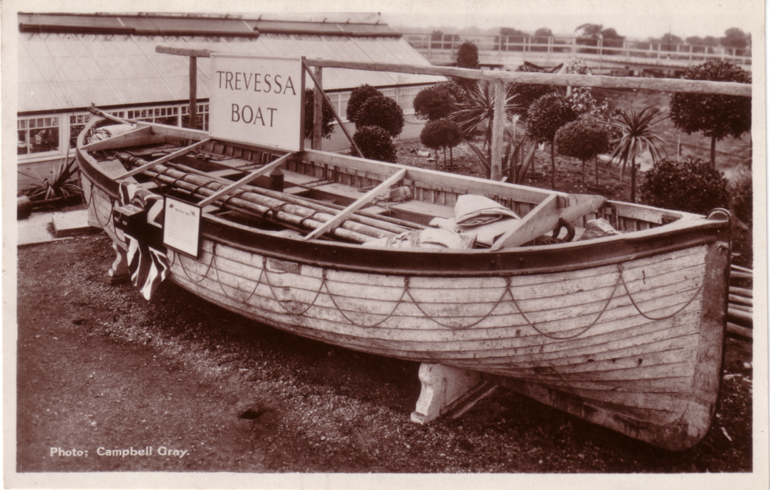

The Lifeboat outside the Ceylon Pavillion.

Here is the story of the lifeboat, it's sister boat, and the men who sailed some 1750 miles in 25 days across the Indian Ocean in them to reach the safety of Mauritius.
The story is from the book "Adrift as far from land as possible" by Len Ortzen, and is reproduced with the kind permission of the publishers Arthur Barker Ltd., of Weidenfeld and Nicolson of London.

The Trevessa, a freighter of 5,004 tons gross, had sailed through a hurricane in the North Atlantic on the voyage out from Liverpool to Sydney. Now she was at Port Pirie, at the head of Spencer's Gulf in South Australia, loading a full cargo of zinc concentrates which her master, Captain Cecil Foster, had orders to deliver at Antwerp. The Trevessa duly sailed on 15 May 1923, having been surveyed before loading and passed as satisfactory by the Lloyd's Register surveyor.
Freemantle was safely reached on 24 May, the Trevessa took on about four hundred tons of bunker coal and sailed again the following morning in fine weather. Captain Foster shaped course for Durban and the Trevessa made good progress across the southern Indian Ocean during the next few days. Then the westerly wind blew more strongly, shifted to the southward, and by the afternoon of 3 June the sea was running so high that Captain Foster decided to heave to. At about midnight, water was heard swishing around in No.1 hold and the pumps were switched on, but no water came through them.
The ship had sprung a leak, but the cargo of concentrates had the consistency of half-set cement, and due to this and the method of stowing the cargo, the water entering the hold could not reach the bilges and tanks and therefore could not be removed by the pumps. In the past years, hundreds of vessels had loaded concentrates at Port Pirie and all had been stowed in the same manner as in the Trevessa; only one ship had ever been known to meet trouble, and she had successfully put back for repairs.
The ship was already well down by the head, and heavy seas were breaking right over the hatches making it impossible to open the holds to investigate the damage. Less than an hour had passed since the alarm had been given, but the water was up to the top of No.1 hold.
Captain Foster on the bridge, turned the ship round so as to run before the wind and sea, thus easing the pressure on the bulkheads. But he realised the ship was doomed and at 1 a.m. ordered all hands to the boats and told the radio officer to send SOS. Three replies were received, but all from ships a long way off. The Tregenna was 350 miles to the east, and the Trevcan (both sister ships of the Hain Line) was 272 miles to the south.
The two starboard lifeboats were quite sufficient for the whole company, forty-four officers and crew. The two stewards began putting some provisions in them, working as fast as possible against time. The ship was settling fast by the head; the collision bulkheads had started to give way and water was rushing through the forecastle into the forepeak. One of the Indian firemen fell into the water as the boats were being launched, but he was got safely into the chief officer's boat. The ship was lying at an angle, the engines stopped and the stern high out of the water. Foster ordered 'abandon ship'.
The two lifeboats stood off, keeping their heads to the sea by using the oars; Captain Foster was in command of one, First Officer J. C. Stewart Smith the other. Half an hour after they had left her, the Trevessa floundered, standing almost on end. It was then 3 a.m. on 4 June. They were adrift in a heavy sea and about as far from land as it was possible to be: the west coast of Australia was 1,600 miles in one direction and the Mauritius group of islands 1,700 miles in the other.
The boats lay to all that day, a sharp lookout being kept for the smoke of a rescue ship. By evening they had drifted some distance from the position where the Trevessa had floundered, and Captain Foster had to come to a decision: to remain in the area or to set course for land. They were in mid-ocean, at about latitude 28 degrees 45 minutes south, longitude 85 degrees 42 minutes east. The nearest islands were St Paul and Amsterdam to the southward, but both were small and uninhabited; and to reach them would take the boats through westerly gales and bitterly cold weather. To turn back and make for Australia would mean steering for the northern most because of the prevailing winds, which might even carry them to Java; this would take them through tropical heat which few of the men were likely to survive on the available water ration. The best course was undoubtedly to make for the Mauritius group; although the distance was the greatest, the winds were likely to be favourable, rainy weather could be expected at this season of the year, and temperatures along the route should be supportable.
Captain Foster reckoned that it would take three weeks to reach one of the Mauritius group. He conferred with Smith and they calculated that the rations would be just about enough to see them through. Each boat had roughly the same amount; three cases of condensed milk (130 tins), five tins of biscuits, and about fifteen gallons of water. (They also had five thousand cigarettes, ten pounds of tobacco and three dozen boxes of matches, much to the appreciation of those who smoked.). Smith had two or three gallons more than Foster, but he also had four more men in his boat, which was carrying twenty-four as against twenty in the captain's boat.
The daily rations issued by the two boat commanders were exactly the same - starvation rations - one biscuit per man, about four teaspoonfuls of condensed milk, and about three teaspoonfuls of water.
The two boats were alike in size and each had on board the equipment required by the Board of Trade regulations, but there was one important difference: the sail on the captain's boat was larger than that of the other. Consequently, it was difficult for the two boats to keep company. After nine days (on 9 June) Foster decided that it would be better for the boats to proceed independently. They
parted at 8 a.m. and by mid-afternoon the chief officer's boat was far astern, and soon afterwards was lost to sight.
At this time two boats were searching for the crew of the Trevessa. They had reached the scene of the sinking on 6 June, when the two lifeboats were about one hundred miles away on their course westwards. One ship continued searching to the eastwards and the other, the cargo vessel Tregenna, to the westward. On 9 June she was zigzagging on a course about one hundred and fifty miles behind the lifeboats, but then she turned north-east and maintained this direction until 13 June, when she again proceeded on her westward course to Mauritius.

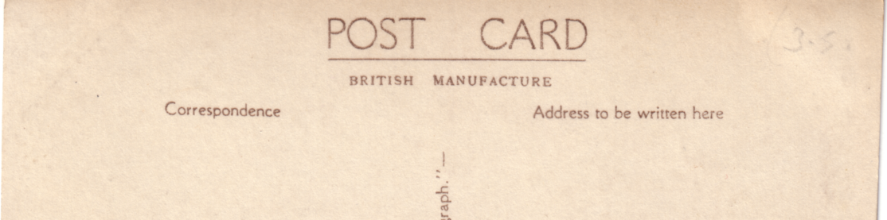

Type 1 back, 'POSTCARD' measures 37mm

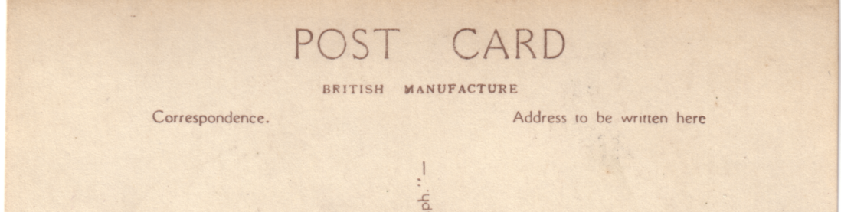

Type 2 back, 'POSTCARD' measures 45mm

There had been no time to collect chronometers before the Trevessa sank, so Foster was unable to calculate latitude accurately; but by keeping to the latitude of Rodriguez, the most easterly of the Mauritius group, he was bound to sight it - unless he passed it in the dark or was blown off course. However, he would then be within reasonable distance of Mauritius, 344 miles further to the west and almost on the same latitude. And beyond Mauritius was the French island of Reunion and then the long coastline of Madagascar.
During the First World War Foster had spent ten days in a lifeboat after his ship had been torpedoed in the Atlantic, and twelve of the thirty-one men in it had died from exposure before reaching the north coast of Spain. This experience now stood him in good stead.
By the end of a week everyone was looking haggard and was suffering from the shortage of food and drink - water was the dominant thought on everyone's mind. Late on the morning of the 14 June they sailed into a big squall, and they caught enough rainwater for everyone to have a good drink.
Smith was sailing almost as fast as Foster, but his track was some distance to the south of the other boat, and they never sighted one another again. Speeding in the same direction but about two hundred miles south of Smith's track was the Tregenna, bound for Mauritius, which she reached on 21 June.
Meanwhile both lifeboats were meeting heavy weather. This brought more rain, which was very welcome; but the crews were kept busy baling, which made great demands on their little remaining strength. Moreover, for several periods the weather was so bad that it became necessary to heave to and ride to a sea-anchor. Foster was having great difficulty in keeping on the desired latitude, and he had only a very approximate idea how far west he was. But by his reckoning they
should sight land in a week's time.
The chief officer's boat was almost keeping pace with the captain's but was well to the southward, too much so to make Rodreguez Island. The conditions of wind and sea were making it impossible to steer an exact compass course. On 22 June Smith reduced the rations by half as a precautionary measure, as there still remained enough water and biscuits for another week. No land was sighted, and Smith held on his course westward to Mauritius.
Foster reduced the rations in his boat at almost the same time as Smith, also as a precaution against missing Rodreguez.
On 25 June, in mid-afternoon, land was sighted to the south-west. By four o'clock they were close enough to land for there to be no doubt that it was indeed Rodreguez Island. Darkness fell soon after but there was a bright moon, and they ran along the coast and rounded the northern end of the island. Suddenly they heard a shout from across the water; a fisherman in a small boat was gesticulating to them that they where running onto a reef. He came aboard and piloted them into harbour. Minutes later, eighteen survivors were being carried ashore and taken to the nearest building, which was the police station.
The island's doctor had the four weakest sent to hospital; the others were taken into homes and given every attention. There was an Eastern Telegraph Company station on the island, and Foster telegraphed to England the names of the crew and details of the route of the other boat for assistance to be requested. They had survived almost twenty-three days in the open boat on the absolute minimum of food and water, and by their seamanship and courage had brought all but two of the twenty men to safety.
Two days later Foster received a telegraph that the chief officer's boat had reached Mauritius. The excitement and joy was dimmed when more detailed messages disclosed that nine of the twenty-four in the other boat had not survived the ordeal. Smith's boat had been twenty-five days at sea and had sailed 1,750 miles to reach Mauritius.
A British naval vessel sailed from Mauritius to collect Foster and the others, and a few days later all thirty-three survivors from the forty-four who had sailed in the Trevessa were reunited at Port Louis, the capital of Mauritius.
The British survivors of the Trevessa sailed for home on a Union Castle liner on 16 July, and were given a great welcome on arrival at Tilbury. A few months later, Captain Foster and Chief Officer Smith were received by the King and Queen at Buckingham Palace. Captain Foster's lifeboat was brought to England and put on show at the British Empire Exhibition. Lloyds awarded the Silver Medal for saving life at sea to the Captain and the First Officer, and the Hain Steamship Co. presented pieces of plate to the Captain, First Officer and Chief Engineer N. V. Robson
The Trevessa was built in Germany in 1909 by FlensburgerSchiffsb Gesellschaft, and was originally named the Imkenturn. She was 401 feet long, 52.2 feet wide and 28.2 feet deep, had four cylinder triple expansion engines of 2,400 horse-power, and was capable of 11.5 knots. She had electric lighting and wireless. She was taken from Germany at the end of the First World War, re-named Trevessa, and added to the fleet of the Hain Steamship Company Limited, of St. Ives, Cornwall.
I have looked at the cards in my collection and the lifeboat is visible on one of the Aerial View cards and Beagle 696G, which appear to have been taken before the Exhibition was opened as the greenhouse has not yet been built, and the lifeboat is alongside the Pavilion. Valentine's XL series card number 91132 shows a front view of Ceylon, with the greenhouse on the right. The lifeboat is positioned just to the right of this greenhouse. Also in the background to the lifeboat card, is the bridge which carried the Roadrail over the Wembley Loop railway track.
The cards have been found with two backs, and it is possible that these reflect the two years it was there.

The end.
POST CARDS OF THE WHITE CITY

A preamble by Bill Tonkin

When I joined the Exhibition Study Group many years ago, I was very interested in the White City, and still am, in fact I suppose it is my favourite collecting area, with the Japan British Exhibition taking place of honour. At that time it was my intention to do a list of the Franco British cards, and many letters passed between Andrew Brooks and myself. I remember we spent a lot of time designing layouts for an information sheet on the subject. I realised it would be an enormous job, and at the time felt it should be left until I had more experience on making out lists, as there were many problems for which I did not know the answers.
My first serious effort was to get involved in Andrew's Ideal Home list. This was at first a very basic list, and I extended it to include more information on the various types of backs. I then started on a listing of the Festival of Britain cards, which has now got to about 60 pages. This still needs a lot of work done on it as I have not touched it for about three years, having in the meantime got bogged down on the Wembley book with Mike. That is now behind us and the priced guide and check list is now finished and at the printers. The list of Wembley exhibitors is also now finished, so the time has come to give some serious thought to the White City.

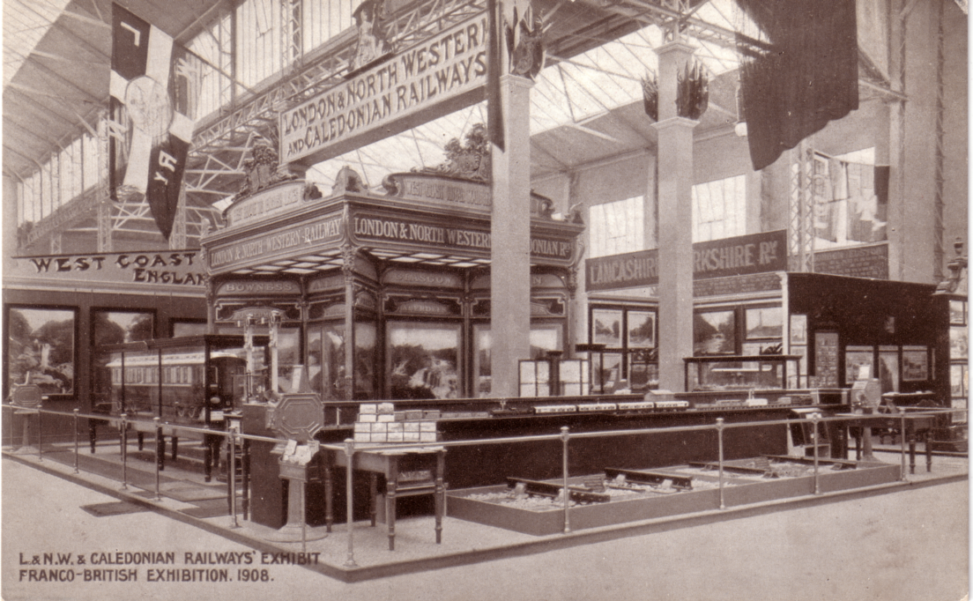

London & North Western and Caledonian Railway Stand

I get the impression that the White City is coming in for a spell of popularity, indeed several of our new members have joined because of their interest in the Franco British and the Japan British exhibitions. I may be wrong but dare I suggest that the interest in Wembley is beginning to burn itself out, there are too many people hunting too few cards. I am also conscious of the fact that Wembley has more than its fair share of space in the Journal, and it is important that we cater for all interests. I say more than its fair share and this is perhaps not correct, for there are undoubtedly more people into Wembley than any other exhibition, with the Festival of Britain running it a close second. Another reason why I think it must be tackled now is that there is three or four years work to do and time is beginning to run out.
I have decided that the listing shall include all the exhibitions held there from its opening in 1908 until it was taken over by the government at the outbreak of the first war. This will include the
1908 Franco British, 1909 Imperial International, 1910 Japan British, 1911 Coronation, 1912 Latin British, 1913 National Gas and the 1914 Anglo American exhibitions. The 1908 Olympics will also come into it, and will include that part that was held in the Stadium.
My reason for including all the exhibitions is that many firms, Valentines in particular used the same cards for more than one exhibition, just altering the title to bring it up to date each year. To take an example Valentines card No. 484 Court of Honour, was used for six different exhibitions, those held in 1908, 1909, 1910, 1911, 1912, and 1914. It was also published with an all embracing title that could be used at any time the 'Great White City' It is interesting to note that for the 1912 and the 1914 exhibitions the bridge across the lake in the Court of Honour which had by then been dismantled, was carefully painted out by Valentine's artists, although they left the reflection of the bridge on the water.
This one card No. 484 was published as a black and white, sepia, real photograph, coloured, and has at least eight different types of ornamental border. An added complication is that in my collection alone I have 19 different backs on this card. The good news is that these cards are still very cheap to acquire, but you must be able to get them on approval if you intend collecting these cards in depth.
Contrary to an oft stated comment I do not have them all, anything like, but I do have about 6,000 White City cards and this will form the basis of the listing. I shall be using our Journal to publish an instalment in each issue, and shall go through the many firms that produced cards in alphabetical order. I do not intend to follow the same procedure Mike and I used for the Wembley book, to try and visit all the important collections, looking for unknown items, because in that instant we both had a very comprehensive illustrated file to take when going on a visit. That file does not exist for the White City. My method in this instance is to first publish as complete an instalment as is possible, and then rely on those collectors who have White City cards to fill in any blank spaces. I can then update my master list, and eventually finish up with as complete a listing as possible. As all the information will be put on disk as I go along, the final publication will present no problem. I shall keep illustrations down to a minimum, and these will be almost entirely devoted to the various types of backs of cards. The completeness will depend entirely on the support I get from members of the Study Group. I am hoping that as each section will only cover a very small area, members will not find this an onerous task.
By the time I have reached Zimms Wear the Hall Mark of Stirling Quality in Ribbed Knit Underwear, and "Zog" the paint cleaner, I should be in a position to assess the demand for the finished book. I am aware that the demand will be very limited, but I think the job should be tackled.
I should be pleased to hear members thoughts on the subject, as you are going to be reading a lot about the White City for years to come.

PRICE GUIDE & CHECK LIST FOR POST CARDS
OF THE
BRITISH EMPIRE EXHIBITION
1924 & 1925

Mike Perkins & Bill Tonkin

Exhibition Study Group Publication No. 4 is now at the printers and we will have copies available at the convention. It is a pocket sized book with 160 pages, and will give a valuation for around 3,900 'Wembley' cards, with a small box for you to tick in the cards you have in your collection. The price has not been finalised yet, but it will be around £6.
POST CARDS OF THE WHITE CITY

GLOSSARY.

Advert card. A card containing advertising matter, meant to be used as a postcard, and sent through the post.
B/W. Black and White picture produced by a Screened Photogravure method of printing.
B/W litho printing. I have used this term to cover those methods of printing where no screen is visible. The mass of colour will be seen to have an irregular grained effect.
Back. The address and message side of a picture postcard.
Capital letters. These are used as in "POST CARD" or "INLAND PRINTED PAPER" to indicate the heading on the back of the postcard.
Coloured. This refers to a coloured picture produced by screened photogravure. When examined under a glass the colours will be seen to be made up of small rosettes of dots of basic colours which when seen as a whole give the effect of a range of colours.
Combination line and screened photogravure. This refers to a plate that is made by a combination of two printing processes. The toned or coloured part of the picture is made by the screened photogravure method, and the text and any solid mass of colour, is printed by the line or letter press method.
Divider. A division down the centre of the back of the card, it can be in the form of a line, or words, or a combination of both.
Front. The picture side of a postcard.
Italics. Italics are used in brackets after a title to give details of the card, and are not part of the title.
Line printing. This is a method of printing where there are no tones or shades. An example would be a pen and ink drawing, or where text is printed in solid colour without a screen.
Litho printing. I have used this term to cover the various methods of printing pictures where no dots or screen are visible. The mass of colour will be seen to have an irregular grain. There are several processes that produce a similar effect, such as Litho, Collotype, Bromotype, and Sepiatype (the last two are Valentine trade names). I shall use these names where they are
known, but are classing them all as litho, as I know of no way to distinguish between the various processes.
Matt R/Photo. Black and white real photograph with a dull surface.
Measurements. Where these are given for "POST CARD." it will include the stop if any.
Photogravure. See under screened photogravure.
R/Photo. Black and white glossy real photograph.
R/Photo hand tinted Colour photography as we know it did not come in until well after the period covered by this listing. Cards were hand tinted using a few basic colours, and there is often a variation of colours between cards. It would be impossible to list these variations of colour, but where there is a major complete change of colour, this will be listed. One way to identify hand tinting is when the areas of colour overlap the design.
Screened photogravure. The method of producing printing plates by a photographic process using a screen to break the picture up into small dots. This is sometimes referred to as half tone.
Sepia. Sepia picture produced by a screened photogravure method of printing.
'T' Divider. Any type of divider with a cross bar on the top.
Trade card. A card printed on both sides, designed to be given away and not sent through the post.
Vert left. A vertical format card which when turned over like the page of a book, the heading "POST CARD" is on the left.
Vert right. As above, but the heading "POST CARD" is to the right.
POST CARDS OF THE WHITE CITY

Part 1.

by
Bill Tonkin

A. N. Paris.
R/Photo hand tinted with white border, black back with "CARTE POSTALE". These cards are published in France, they all have the same title. They are hand tinted, and the dresses can be found in different colours. They feature the national symbolic figures Britannia and Marianne holding hands.
Entente Cordiale. Remember Franco-British-Exhibition 1908 London (Figures standing sideways Britannia in red dress) Vert right.
Entente Cordiale. Remember Franco-British-Exhibition 1908 London (Figures standing sideways as above Britannia in yellow and red dress) Vert right.
Entente Cordiale. Remember Franco-British-Exhibition 1908 London (Figures standing facing Britannia in red dress) Vert left.

E. Alexander Ltd. London W.C.
Alexander published several series for the White City and also for the Franco-British Exhibition. All cards were printed with both black and brown backs. The black backs have Alexander's logo, "E A" in a circle with "Series" underneath and "Printed in France" in the stamp box, while the brown backs only have Alexander's logo and "Series" in the stamp box, and "Printed in France" is on the left side at the top. Some of the cards were printed with inverted backs, or in the case of vertical cards, with the backs printed to the right or left. The titles are therefore listed with four possible types of back. "A" black back, "B" black back inverted, "C" brown back and "D" brown back inverted.
Type 1. Greetings Cards.
R/Photo hand tinted with white border. This series has "GREETINGS" in a panel at the top and "From the White City" below, it is a composite of three views on a background of the flags of Britain and France.
Elite Gardens Shewing Garden Club-The Court of Honour-Machinery Hall.
A. Black back.
C. Brown back.
Palace of Music-The Court of Honour-Australian Pavilion.
C. Brown back.
The Irish Village-The Court of Honour-Palace of French Applied Arts.
A. Black back.
C. Brown back.
The Stadium Shewing Swimming Tank-The Court of Honour-Palace of British Applied Arts.
A. Black back.
C. Brown back.
Wood Lane Entrance-The Court of Honour- Shepherds Bush Entrance.
A. Black back.
C. Brown back.

Type 2. First Series, not numbered.
R/Photo hand tinted with white border. The cards are hand tinted and this can vary on each card. The title is in two lines with the top line reading "Franco-British Exhibition." As some cards can be found with the title in two sizes, and it is not known to what extent this occurs, measurements are given for all cards.
Australian Pavilion.
A. Franco-British Exhibition measures 45mm.
A. Black back.
C. Brown back.
B. Franco-British Exhibition measures 50mm.
A. Black back.
C. Brown back.
D. Brown back inverted.
Court of Honour by Night, shewing Fireworks.
A. Franco-British Exhibition measures 44mm.
A. Black back.
B. Black back inverted.
C. Brown back.
Elite Gardens shewing Garden Club.
A. Franco-British Exhibition measures 43mm.
A. Black back.
B. Black back inverted.
C. Brown back.
Machinery Hall.
A. Franco-British Exhibition measures 42mm.
A. Black back.
B. Black back inverted.
C. Brown back.
Palace of British Applied Arts
A. Franco-British Exhibition measures 41mm.
A. Black back.
B. Black back inverted.
C. Brown back.
Palace of French Applied Arts.
A. Franco-British Exhibition measures 44mm.
A. Black back.
B. Black back inverted.
D. Brown back inverted.
Palace of Music.
A. Franco-British Exhibition measures 43mm.
A. Black back
B. Black back inverted.
D. Brown back inverted.
Shepherds Bush Entrance.
A. Franco-British Exhibition measures 42mm.
A. Black back Vert right
B. Black back Vert left.
D. Brown back Vert left.
The Court of Honour.
A. Franco-British Exhibition measures 44mm.
A. Black back.
B. Black back inverted.
C. Brown back.
The Irish Village.
A. Franco-British Exhibition measures 43mm.
A. Black back.
D. Brown back inverted.
B. Franco-British Exhibition measures 52mm.
A. Black back.
C. Brown back.
The Stadium shewing Swimming Tank.
A. Franco-British Exhibition measures 45mm.
A. Black back.
B. Black back inverted.
D. Brown back inverted.
Wood Lane Entrance.
A. Franco-British Exhibition measures 42mm.
A. Black back.
B. Black back inverted.
C. Brown back.

Type 3. Second Series, numbered.
R/Photo hand tinted with white border. The cards are hand tinted and this can vary on each card. This series is a continuation of the first series, but is now numbered. The title is in two lines but has been reversed with the bottom line now reading "Franco-British Exhibition." While in the first series little attention was paid as to whether a back was printed upright or inverted, in the second series inverted backs are seldom found.
13 Special Day in Court of Honour.
A. Franco-British Exhibition measures 50mm.
A. Black back.
C. Brown back.
14 Swan Boats in the Court of Honour.
A. Franco-British Exhibition measures 48mm.
A. Black back.
C. Brown back.
15 The Scenic Railway the most popular diversion at the
A. Franco-British Exhibition measures 49mm.
A. Black back.
C. Brown back.
16 The Indian Pavilion.
A. Franco-British Exhibition measures 50mm.
A. Black back.
C. Brown back.
17 The Pride of the Irish Village.
A. Franco-British Exhibition measures 48mm.
C. Brown back.
B. Franco-British Exhibition measures 52mm.
A. Black back.
18 The Palace of Women's Work.
A. Franco-British Exhibition measures 51mm.
A. Black back.
C. Brown back.
19 The Spiral Railway.
A. Franco-British Exhibition measures 50mm.
A. Black back.
C. Brown back.
20 Cascade Gardens.
A. Franco-British Exhibition measures 51mm.
A. Black back.
C. Brown back.
21 General View showing Flip Flap.
A. Franco-British Exhibition measures 50mm.
A. Black back.
C. Brown back.
22 The Canadian Pavilion.
A. Franco-British Exhibition measures 52mm.
A. Black back.
C. Brown back.
23 The Royal Pavilion.
A. Franco-British Exhibition measures 51mm.
A. Black back.
C. Brown back.
24 The Flip Flap. the great thing at the Vert left.
A. Franco-British Exhibition measures 40mm.
A. Black back.
C. Brown back.
25 The Senegalese at Home.
A. Franco-British Exhibition measures 69mm.
A. Black back.
C. Brown back.
26 Rickshaws do a big business in the Cascade Gardens.
A. Franco-British Exhibition measures 71mm.
A. Black back.
C. Brown back.
27 The Court of Honour from the Lake Steps.
A. Franco-British Exhibition measures 71mm.
A. Black back.
C. Brown back.
28 A Swan Boat in the Elite Gardens.
A. Franco-British Exhibition measures 69mm.
A. Black back.
C. Brown back.
29 Old London-A Dealer in stocks. (title in a single line without Franco-British Exhibition)
A. Black back.
C. Brown back.
30 Eastern Sports.
A. Franco-British Exhibition measures 69mm.
A. Black back.
C. Brown back.
31 The Court of Honour showing French Dress Section.
A. Franco-British Exhibition measures 67mm.
A. Black back.
C. Brown back.
D. Brown back inverted.
32 Some Very Clever Elephants.
A. Franco-British Exhibition measures 63mm.
A. Black back.
C. Brown back.
33 A Typical scene in Ballymaclinton. (The Irish Village).
A. Franco-British Exhibition measures 70mm.
A. Black back.
C. Brown back.
34 Ceylon Village. Vert right
A. Franco-British Exhibition measures 66mm.
C. Brown back.

Type 4. Odd cards.
There are several odd cards which do not fit into any of the preceding series. They are all R/Photo hand tinted with white border, and the standard back in black or brown.
The Great Event of 1908. The King Opening the Olympic Games.
C. Brown back.
Greetings from the Flip Flap.
A. Black back.
C. Brown back.
118 Illustrious Patrons of the Franco-British Exhibition. H. M. Edward VII. Mr Armand Fallières.
A. Franco-British Exhibition measures 50mm.
A. Black back Vert right
B. Black back Vert left.
Card no. 118 was also published without the title as above, but has a different manuscript title printed at the top. It is not numbered.
Come and join us at the White City.
A. Black back Vert right
Alexander's also had on sale many non exhibition cards, and these can be found with exhibition postmarks, and messages relating to the exhibition. These are not listed as they are outside the scope of this listing.

Alnwick Foundry & Engineering Co. Ltd.
Sepia advert card, with brown back. A picture and plan of the cottage built at Stand 49, Machinery Hall, Imperial International Exhibition 1909.
Designers & Makers, Alnwick Foundry & Engineering Co., Ltd. Alnwick London.

The Alphalsa Publishing Co. Ltd.
Coloured, black back with "THE "ALPHA" POSTCARD", a stylised "ALPHA" in an oblong box over "Reg Trade Mark" in the stamp box. Name and address down left side and "No. 1303"
Royal Engine. S. E. & C. Railway, No. 516. Franco-British Exhibition, 1908.

Aristophot Co. Ltd. London W.C.
Aristophot published at least four series of real photograph cards, some B/W and some hand tinted.
Type 1.
R/Photo hand tinted with white border, brown back type 1.
L' Entante Cordiale. (This shows the heads of Fallières and Edward VII in small circles against a background of the French and British flags.)
Type 2.
R/Photo with white border, a composite of two views in scrolled frames, with a heading "Franco British Exhibition Shepherds Bush, W. 1908". Brown back type 2, with "A L Series" and "Printed in Saxony" in the stamp box
Uxbridge Road Entrance. Wood Lane Entrance.

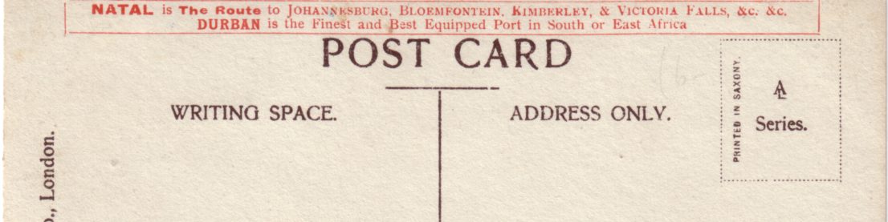

Aristophot Type 1.

Type 3.
R/Photo hand tinted with white border, brown back type 2. This is the same card as type 2 but is now coloured. The other details are the same.
Uxbridge Road Entrance. Wood Lane Entrance.

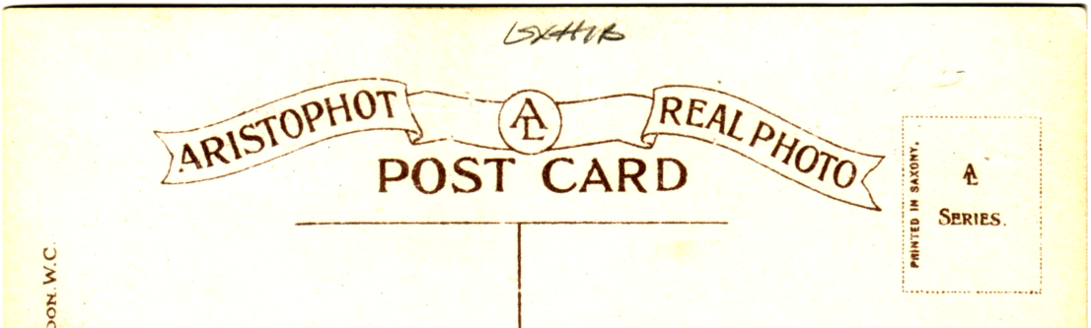

Aristophot Type 2.

Type 4.
R/Photo hand tinted with white border, the views have an ornamental border with columns on each side with ribbons bearing the names of various countries taking part, and featuring the two flags. Brown back type 2.
Indian Palace.
Machinery Halls: Iron Steel Shipping and Railways Section.
Palace of British Applied Arts.
Palace of French Applied Arts.
Palace of Music.
Palace of women's Work.
Part of Elite Garden.
The Elite Gardens.
The Indian Court. (This card is wrongly titled and is a view of the Court of Honour)
The Stadium showing Swimming Bath and Cycling Track.

"Aspidero" (Reg) The Wonderfull Plant Food. Frederick Leech.
Coloured trade card, F. Leech of the Experimental Nurseries, Old Trafford, Manchester. advertised on the backs (in black) of Valentine's "Conveyances at the Great White City, London" series of cards.
A Vincent Chair.

