EDITORIAL SPRING 1996

The spring is here shout out hooray
But why's there snow, on the ground today?

We have just had a new member join the group, a young Japanese lady Dr Yuriko Fukasawa, and for her doctorate thesis, she studied the Ainu aboriginal tribe of Japan, staying in the village where the people lived, who came over here to take part in the 'Ainu Home' at the Japan British Exhibition in 1910. We had spoken on the phone, and when I told her I had a fairly large collection of cards of this tribe we arranged for her to visit me to see them, and in fact she has been over twice. It turns out she is another George Ithell, as no sooner did she lay eyes on the cards than she started reeling off the names of some of the natives pictured on them. One Ainu maiden she was able to recognise and name by the pattern of tattooing on her face, commenting "I never expected to see a photograph of her". On one of the cards there is a young lad shown, and apparently in 1910 an English Doctor was so impressed by the lad, he wanted to adopt him, and was prepared to pay for his education to become a doctor. The parents naturally did not want to be parted from their son, and would not agree to leave him behind. Although the lad has long since died, Yuriko has met his son, who still lives in the same Ainu village, and remembered many of the stories his father told him about his trip to England. It is things like this that add another dimension to collecting. I was also able to give her some photo-copies of pages of the 1910 catalogue dealing with the Ainu tribe.
Before I leave the Japan British Exhibition, at the last Bloomsbury Fair I not only had the pleasure of seeing Ron Mead on his first appearence since his illness, but had the added pleasure of buying from his stand the last card I needed to complete my set of 48 Mortimer Memphes cards published by Tuck's for the Japan British Exhibition. It has taken a long time probably about 15 years, but isn't it a lovely feeling when you are able to complete a long set. I don't suppose there are many sets of those knocking about. I also picked up the last card I wanted to complete the set of six Wembley 'Gas Exhibit' cards, not off Ron at £25.00 which is what he's asking for these cards, but at a more realistic price of £3.00 from another dealer.
Ken Harman's list of exhibitions spread over three issues has proved popular, one member has sent me £2.00 for a copy of part 1 which being a fairly new member he missed, and several members have written to me about it. One, Burton Benedict, has sent a list of early American exhibitions to be added, and Dilwyn Chambers has also sent me some additions. It makes the job all worthwhile when I get a bit of a responce about an article, otherwise I don't know whether members find the articles interesting, or even read them.
Members will be aware that I have been working for several years on a complete listing of all the exhibitors who had or shared a stand at the British Empire Exhibition at Wembley in 1924 & 1925. and listing the stand number and location. Apart from a few corrections this is now completed. I realise the demand for a book containing this kind of information is going to be very limited, and I should like to know how many members would want a copy. Its going to run to about 180 A4 pages ie 90 sheets, I have not costed it yet, but I imagine as there will only be a very short run printed, it will come out at about £15 - £20. A sample page appears elsewhere.
Mike Perkins came and stayed with me for about five days, and we have now got the check list and priced catalogue to complement our book on Postcards of the British Empire Exhibition Wembley 1924-1925 finished. This will give a valuation for about 3,900 Wembley cards, each with a small square you can tick in if you have the card. It will be in a handy pocket size, like a penguin book. There will be no illustrations in it, and is meant to be used in conjunction with our main book, and not in place of it. This has been produced mainly by Mike, using a disc of our main book, altering the layout and deleting a lot of the descriptive matter. At the moment we are looking at about £6 - £7 and hope to have the price finalised by the time the next Journal comes out.
The Festival of Britain Society is meeting at the Waterloo Bar, Festival Hall on Saturday 27th April from 11.00am to 4.00pm. Turn up you will be welcome.
Bill Tonkin Editor.
Sample page from
Exhibitors at the British Empire Exhibition
Wembley 1924 & 1925

Marlow, John & Sons, Ltd. 1924 Pal. of Ind. Sta. N. 514.
Phoenix Shoe Works, Northampton.
Marmet Baby Carriage Syndicate, Ltd. 1924 Pal. of Ind. Sta. F. 206.
Letchworth, Herts.
Marmet Limited. 1925 Pal. of Ind. Sta. F. 205.
Letchworth, Herts.
Marrian, Wm. L., Ltd. 1925 Pal. of Ind. Jewellery Sect.
248, Barr St., Birmingham.
Marryat & Scott, Ltd. 1924 Pal. of Eng. Sta. 35, Ave. 7, Bay 5.
28, Hatton Garden, London, E.C.1.
and Hounslow.
Marshall & Snellgrove. 1925 Pal. of Ind. Sect. J.
Vere St., & Oxford St., London, W.1.
Marshall, Percival & Co. 1924 Pal. of Eng. Ave. 15, Bay 14.
66, Farringdon St., London, E.C.4.
Marshall, S. W. 1924 Australia.
Southern Tasmania.
Marshalsea Bros., Ltd. 1924 Pal. of Eng. Exhibit 246.
1, Fore St., Taunton.
Marston, John, Ltd. 1924 Pal. of Eng. Exhibit 129, 148-9, & 173-4.
Sunbeamland, Paul St. Works, Pal. of Eng. Exhibit 115.
Wolverhampton. Pal. of Ind. Section E.
Martin, W. & J. 1924 Pal. of Ind. Sta. O. 560.
Albion Leather Works, Glasgow.
Marx, J. & E. 1924 Pal. of Eng. Sta. 273, S.E.Block, Bay 24.
39, Wolfington Rd., West Norwood, 1925 Pal. of H. & T. Ave. 1, Bay 19.
London, S.E.27.
Mason, D., & Sons, Ltd. 1924 Pal. of Ind. Sta. O. 566f.
12-18, Bath Row, Birmingham, and
Chelsea Works, London, S.W.6.
Mason, George, & Co., Ltd. 1924 Pal. of Ind. Sta. P.P. 615.
Chelsea Works, London, S.W.6. 1925 Pal. of Ind. Sta. P.P. 612.
Mason, H. L. (Klinger Patents). 1924 Pal. of Eng. Sta. 249, Ave. 1, Bay 1.
120, Southwark St., London, S.W.1.
Mason, Henry. (Shipley), Ltd. 1924 Pal. of Ind. Sta. J. 306.
Victoria Works, Shipley, Yorks. 1925 Pal. of Ind. Sta. J. 306.
Mason, Page, & Co. 1925 Pal. of H. & T. S.E. Block, Bay 26-27.
Boswell Works, Thornton Heath, Surrey. Pal. of Ind. Sta. D. 143.
Mason, T., & Co., Ltd. 1925 Pal. of Ind. Jewellery Sect.
27, Hylton St., Birmingham.
Massey-Harris Co., Ltd. 1925 Canada Sta. 46-50, & 68-70.
Toronto, Ont.
Mather, Mr. H. 1924 Gold Coast.
Drury Lane Theatre, London, W.C.2. 1925 Gold Coast.
Mather & Platt, Ltd. 1924 Pal. of Eng. Ave. 8-9, Bay 11-13.
Manchester, and 14, Great Smith St., Pal. of Ind. Sta. U. 853.
London, S.W.1.
CARDS OF THE MALAYA PAVILION.
Published by the Malayan Government and
printed by Houghton Butcher (Eastern) Ltd.

by
Mike Perkins

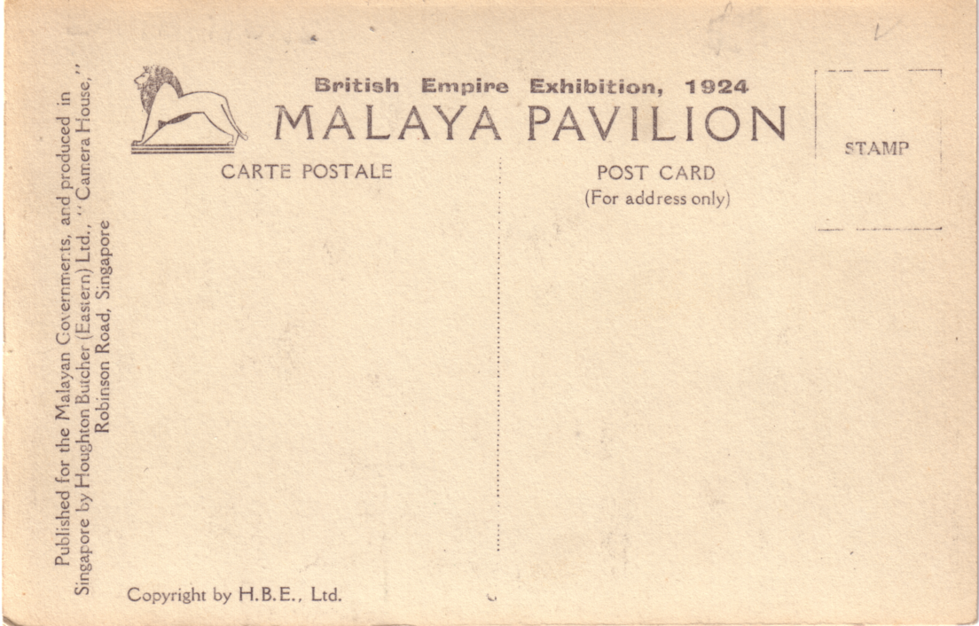

Back with varieties A, D, E, & H.

Those members who collect the cards of the British Empire Exhibition will be aware of that long, long set from the Malaya Pavilion which number over 600 cards in the set. Whilst collecting these cards is in itself a somewhat daunting task, given the number in the set, the fact that they don't turn up all that often, and the wide range of prices that can be asked for then, it can be fun looking for varieties !
Perhaps the first thing to mention is the fact that the picture on the front can be displaced left, right, up or down, so that you can get two slightly different views. We did list a couple in our book where the difference was readily apparent, but basically I think it is a difficult area to try to cover.

Close examination of the backs show that there are minor setting variations amongst these cards, which are difficult to try and quantify and hardly seem worth bothering with. However, the good news is that there are four varieties which are easy to spot and constant across a large number of cards.

The first variety lies on the right side of the card, and in my collection I have designated it as follows :
Variety A = (For address only) (Small a & o)
Variety B = (For Address Only) (Capital A & O)
The second variety is at the bottom on the left side of the card,
Variety C = Copyright by H. B. E. Ltd. (No comma after E)
Variety D = Copyright by H. B. E., Ltd. (Comma after E))
It should therefore be posible to find cards with either AC, AD, BC, or BD backs, although the majority of cards in my collection have BD backs, with about 25% having BC backs and about
15% having AD backs. I haven't yet seen a card with a AC back. Any offers ? I have cards with two back types, and Bill has three or four cards which show a third type of back. Still that makes some 4,800 cards to collect, oh well, only another 4,300 -odd to find !!!!!
The third variety lies on the left side of the card, and I have designated it as follows:
Variety E = "Camera House" (quotes after House)
Variety F = "Camera House (No quotes after House)
I have seen two cards (same number) with BD backs, one with Variety E, and the other with Variety F. I have looked through Bill's cards and found that only about 5% had variety F backs.
The fourth variety is at the bottom left of the card,
Variety G = Copyright by H.B.E. Ltd (No stop after Ltd)
Variety H = Copyright by H.B.E. Ltd. (Stop after Ltd.)
So now you have a possible 9,600 cards to collect, if all cards exist in all varieties !

Aviation and the Crystal Palace Exhibition.

By
Bob Tough

The connection between Aviation and the Great Exhibition in Hyde Park in 1851 started right from the very opening of the Exhibition by Queen Victoria on May 1st. While the Queen was performing the opening ceremony in the building designed by Paxton, the Chaiman of the Organising Committee, being her husband, Prince Albert, a balloon flew overhead. The balloon was piloted by Charles Spencer, a family who were leaders in ballooning for well over half a century. No doubt some of the exhibits referred to ballooning. The Crystal Palace was re-erected on Sydenham Hill and re-opened by Queen Victoria on 10th June 1854. Ballooning had taken place in Britain for nearly half a century, either using hot air or domestic gas. Vauxhall Gardens were a favourite ballooning site.

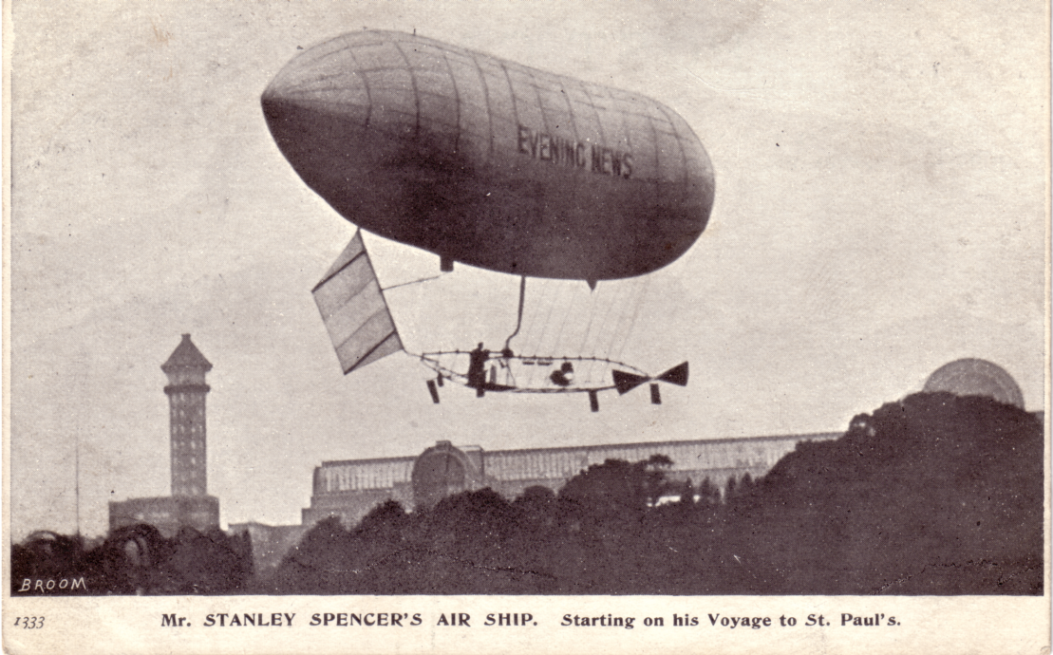

Stanley Spencer's Airship

With the Exhibition being on a hill it was not long before the idea of ballooning from the Exhibition taking passengers was commenced in 1859 by Mr Lythgoe who worked for the local gas company. By 1862 Harry Coxwell had been appointed Crystal Palace Aeronaut, and was regularly
taking passengers at £5 per flight. The Royal Aeronautical Society has a lithograph coloured by Josiah Taylor showing his mammoth balloon flying over the Crystal Palace; it was 55 ft. in diametre. This did not compare in size with the French Aeronaut and photographer Nadar's giant balloon, the basket of which contained a saloon, captain's cabin, dark room, laboratory and printing press which was exhibited at Crystal Palace in the following year.

Nadar is remembered for organising the balloon postal service out of Paris during the German siege of 1870. Many balloons were flown and a number of very small letters written on very thin paper still exist. In fact, in the same year mail was flown by balloon from the Crystal Palace; there were four flights and six cards are known which were carried on these flights.

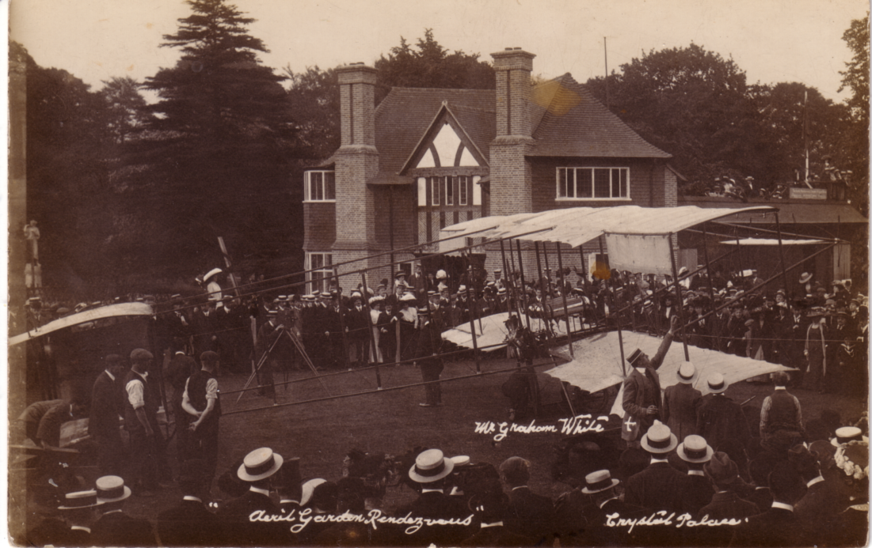

Graham-White at the Palace 1910

In 1868 the worlds first Air Show was staged at the Crystal Palace, comprising models of airships and various flying machines, one model actually works. This was made by John Stringfellow and was driven by a small motor along a wire, but was seen to lift off the wire and actually fly.

Other attempts at flying machines seem tohave concentrated at the Crystal Palace; Thomas May built an aerial 'Steamer' which was seen to lift off a track round one of the fountains at Crystal Palace. It could not however be manned.

Sir Hiram Maxim, who lived near the Palace, built what he called a 'Flying Machine' there, which was in fact a free-flying roundabout, the cars could be controlled by rudder and ailerons. The back of a card says that the writer travelled at 100 miles per hour on this contraption. There is no doubt that it must have been very fast, and precarious. The machine was moved to Earls Court, and then to Blackpool and may still be operating there. This was first introduced in 1894.

By the end of the century the Crystal Palace was having difficulty in attracting visitors; a spectacular trapeze act from a balloon by Leona Dare was one of the attractions in about 1890. despite her risky activities she lived to an age of nearly 90.

Firework displays were another attraction and the Brock's Benefit was born. These displays included hot-air balloons, made of Japanese tissue paper on wire frames, some of which carried
postcards asking for the finder to return them to the sender. Although quite a number were despatchedonly about four are now known. Meanwhile Mr. Spencer continued with his balloon ascents. He also flew the first successful airship in Britain, departing from the Palace for St. Pauls and actually landing in Highgate in 1902. The first British military airship, 'Nulli Secondus' built and flown by Captain Cody, flew from Farnborough to St. Pauls but came to grief on the return at Crystal Palace in 1907. It was taken back to Farnborough by road, rebuilt and renamed 'Alpha'.

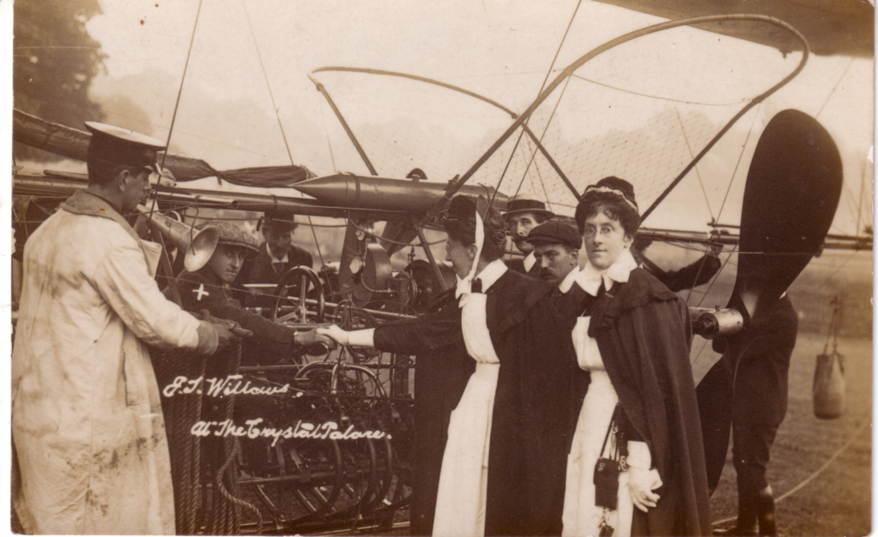

E. T. Willows at the Palace.

In 1902 balloon post was an attraction at Beckenham Flower Show; cards were dropped from a balloon and posted by passers-by back to the sender, only about seven cards are known. In 1907 the Daily Graphic mammoth balloon flew from the Palace, mail was thrown overboard at Mullerud in Sweden, and returned to the senders. A number of cards exist, some with Swedish stamps and others with 'postage due'. 1907 was a busy year at Sydenham, for the Wright Brothers made the first aeroplane flight in Britain from the cycle track at Crystal Palace. Bleriot's monoplane, which flew across the Channel was exhibited in 1909 and in the following year Claude Grahame-White made flights from there. In that year the unfortunate British airship pioneer, E. T. Willows flew No. II from its building shed at Cardiff to the Palace and subsequently flew off to Paris. Although his airships were quite successful he never achieved any real government support, and his firm foundered before the first World War.

The Festival of Empire in 1911 included at least one aeroplane exhibit. I have a postcard of Mr. Beaumont's aeroplane on show there. In the same year a Miss Alice Honeyman had a balloon flight and has written a vivid account of it. During the first World War the Crystal Palace became a Royal Naval Depot, but after the War in 1920 it was choosen for the Imperial War Museum and Victory Exhibition with a whole section on aviation including Barrage Balloons and a whole range of aeroplanes and seaplanes. During the same year the world's first regular overseas air service was set up from Hounslow to Le Bourget. The Crystal Palace on Sydenham Hill was used for navigation as the aircraft regularly flew over it.

Two of the few British airships also flew over the Palace, the R33 when she made her only visit to Croydon Airport in 1921, her sister ship the R34 being the first aircraft to fly both ways
across the Atlantic, and in each crossing had flown almost twice the distance that Alcock and Brown flew to cross the Atlantic the previous year.

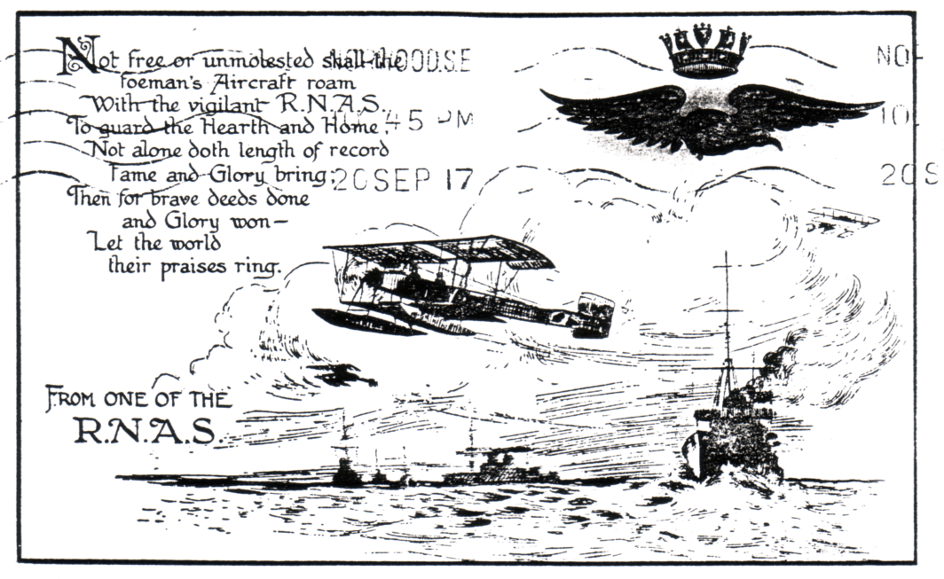

Card sent by G. Hale A.C.2. Class 32 R.N.A.S.
from the Crystal Palace 20th September 1917

I have a card of the R100 over Crystal Palace in 1930, she did a number of flights around Britain and like the R34 flew across the Atlantic this time to Canada and back.. Her sister ship, the R101, was lost with nearly all hands in a tragic accident on a hillside in Beauvais on the way to india. The Palace continued to be important from an air navigation point of view; in 1931 the Battle of Britain pilot Douglas Bader, flying a Bristol 'Bulldog' was lost in a fog. He landed in a field and asked a passerby for directions. The passerby directed him to the Palace and from there he knew the route to nearby Kenley Aerodrome.

There is no doubt had the Crystal Palace or even one of its towers survived until the second World War, they would have been an important landmark for the German bombers. It is said this is why the two towers which survived the fire in 1936, were demolished.

Exhibitions in the grounds continue and as recently as 1990 the Transport Spectacular included Model aircraft, model balloon flights etc. Eighty years after the first balloon flight, Kevin Johnson flew a hot -air balloon from the site in 1991 with Tony Stevens and Gill Ridgewell as passengers. This appears to be the end of aviation from Crystal Palace.

We would like to thank the Royal Aeronautical Society for kindly giving permission to use the illustration on our cover of Henry Coxwell's Mammoth balloon over Crystal Palace in 1862.

Another giant leap forward in the world of technology. Readers will note in the next article that the fraction 'half' is no longer represented as 1/2 but now appears as ½. The back-up people where I bought the computer from, said it could not be done.

Perfins on Wembley Stamps

By
John Nelson

Members will remember some time ago John Nelson of the Perfin Society asked for help on a listing he was making of perfins on Wembley Stamps. The Perfin Society has published the results of his research as reported in our Newsletter No. 30 in a 16 page A4 size booklet. John has kindly sent me the second update on the booklet as follows.

This second update covers additional information concerning Wembley perfins which I have received from collectors since the last list appeared in 1994. The total number of different dies is now increased to 60 and the number of stamps reported to 468. I am grateful to all those who have contributed additional information.

New Dies

CCW C1800.03 1924 1½d, Pmkd,London FS 1 Aug 1924
C. C. Wakefield & Co., Limited
Lubricant manufacturers,
30-32, Cheapside, London, E.C.2.
Exhibitors in 1924 (Pal. of Eng. Ave 14, Bay 6-7).

Additional stamps and covers

ABC A0530.05 1925 1d. (2) and 1½d
BS&S B6850.01 1924 !½d
C.B C0470.04 1924 1d on cover pmkd, London E.C. 4 Sep 1924
DM D3110.03 1924 1½d on a postcard pmkd, London E.C. 28 Apr 1924. Heading on card is Associated Newspapers Ltd but reference to a subscription to the Daily Mail confirms the identity
F.G F1590.01 1924 1d pmkd, London S.W.1. 24 Sep 1924
HGS H1680.03 1924 1d and 1½d
IOM I1928.01 1925 1d
J.S/&Co J6980.03 1924 1d and 1½d
M.N. M4130.01 1924 1½d
MW/Co M6020.02 1924 1d
O&Co O0480.01 1924 1½d
PBL P0710.02 1924 1d
S.P/L S6000.01 1924 1½d Parts of dies on either side suggests a multi-head die
TP/Ld T3600.02a 1924 1d
W/&Co W1340.03a 1924 1d and 1½d on registered cover addressed to Hamburg pmkd Fenchurch St. 28 Jul 1925, and with identity Wigglesworth & Co., Limited, (Hemp Merchants) 82, Fenchurch St., London, E.C.3.
W&S W6680.07 1924 1½d (3) two on cover pmkd London 6 Jun 1924 and
25 Jun 1924

It has been suggested to me by several people that IOM (I1928.01) might have some connection with the Isle of Man. I am informed that the "Isle of Man Official Board of Advertising of
Guides and Exhibition Pictures" had a stand at the gate of Harmony entrance to the Palace of Industry in 1924 so that such an identity is possible but in no way proven.

John Nelson finishes by acknowledging information received from, and his thanks to, Dennis Bundy, Bill Tonkin, Alan Sabey, Rosemary Smith, Mike Oxley, John Grier and Ian Hamill.

The History of the South East District Office
and its Sub Offices

by
J. W. A. Lowder

Section 7 Exhibitions

The first postmarks in connection with a notable event were put on letters posted at the Festival of Empire Imperial Exhibition at the Crystal Palace 12th May to 28th October 1911. There were six machine dies illustrated as E.1 with the die number in the lower part of the date circle, and two hand stamps E.2 numbered 7 and 8. Correspondence was handled by the Norwood office.

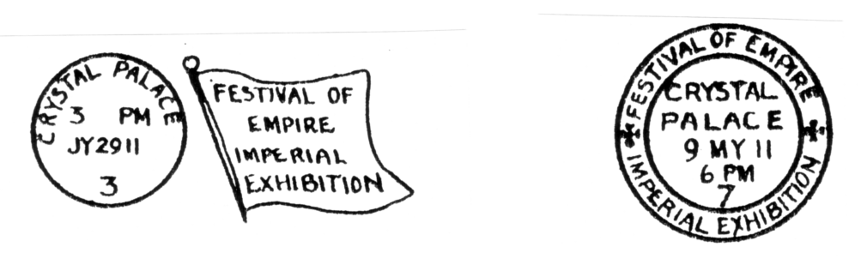
E.1 E.2

The Festival of Britain held on the South Bank site opened on the 4th May 1951 a Friday. The first collection was made at 2.30 from the eight boxes situated in the area, and continued at regular intervals daily until the exhibition closed on Sunday 30th September 1951.

The total postings were 3,459,866 letters and 10,307 registered letters. A more detailed history of the exhibition I have written in P. H. S. Bulletin 99.

I have illustrated the cancellations applied to correspondence as E.3, E.4 and E.7. Two machines were in use obliterating as E.3 and the 24 handstamps as E.4. E.5 illustrates the registration serial label S.E.97 used at the exhibition post office. E.6 was the office internal hand stamp but I have seen it on the reverse of letters which had been postmarked by machine and hand.

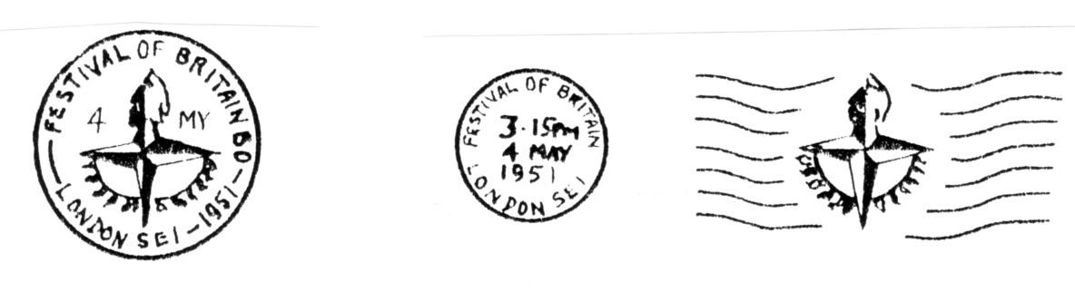
E.3 E.4

On the 12th June 1951 the E.3 date die was assembled with the year 1952 in error and the obliterator proof book was initialed by supervising officers unnoticed*.The whole days collection was thus dated 1952! The error was discovered after the noon collection the following day the 13th. A total of
16,739 items were stamped by the machine during this period. (12890-12th. 3849-13th).
* The Proof Book was found by myself and handed to the G.P.O. Record Room.

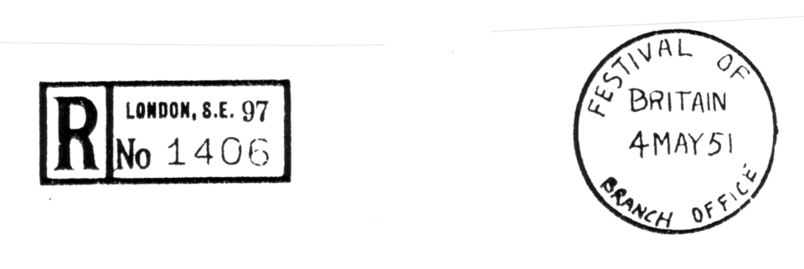
E.5 E.6

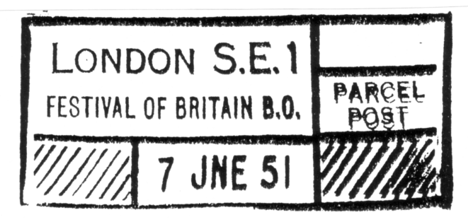
E.7

On Wednesday 6th April 1960 the Seabourne Mail Exhibition was opened in the Greenwich Maritime Museum. Mr Alan Robertson author of "The Maritime (Postal ?) History of the British Isles" had organised special posting facilities from the Greenwich sorting ofice and for a special handstamp as E.8. Although the exhibition was open until December 1960 only letters posted from the 6th April to the 13th April were specially postmarked. The daily postings were,

Ordinary Registered
Wednesday 6 April 17,297 308
7 153 198
8 445 200
9 201 200
10 369 200
11 599 200
12 910 200
13 278 305
20252 1811

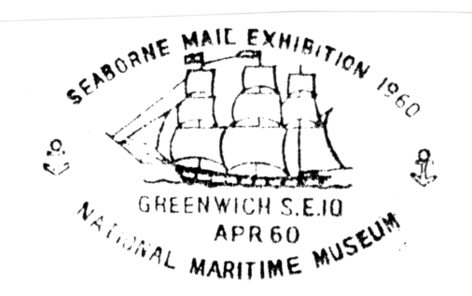
E.8
The London International Stamp Exhibition 1960 was held at the Royal Festival Hall 9th July to 16th July. Correspondence received the cancellation as E.9 for registered and express letters handed to the exhibition post office. Ordinary letters were collected to the S.E.D.O. for machine stamping as E.10. One machine was found sufficient to cope with the work although two slogan dies were available. The date die was F. There were five special handstamps as E.9, two were in use at the S.E.D.O. for packets and orkwardly placed stamps, and some registered correspondence. The remaining three were in use at the exhibition post office.

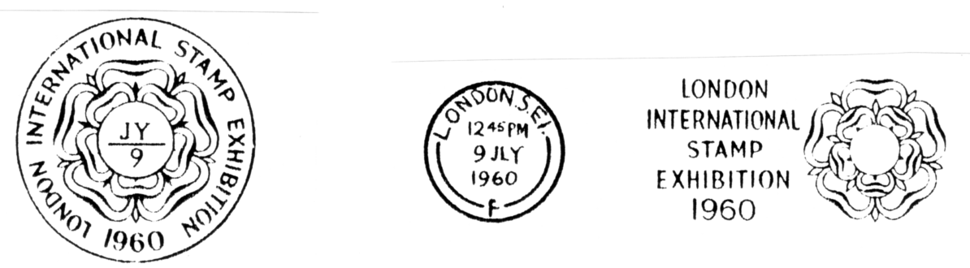

E.9 E.10

On the 13th July one of the clerks found his obliterator flooded with ink which resulted in bad impressions. He stripped the dies and after cleaning replaced the date die reversed. some 25 registered and 13 express letters were forwarded before the error was brought to notice.

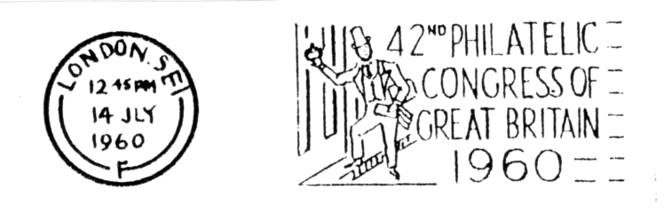
E.11

During the week the 42nd Philatelic Congress of Great Britain was held on the 14th July. The slogan die as E.11 was in use on all ordinary correspondence posted at the exhibition but the E.9 hand stamp continued in use for registered and express items. The total postings were,

Ordinary Express Registered
Saturday 21,371 257 2205
4,153 272 199
10,191 241 232
8,303 241 363
7,702 387 400
21,737 617 442
7,511 339 232
10,850 563 317
91,818 2,944 4822

The Exhibition Study Group wishes to thank Mr J. W. A. Lowder for kindly giving permission to reproduce part 7 of his work "The History of the South East District Office and its Sub Offices". Mr Leonard Johnson who made this section available to me, and also obtained permission to use it, tells me that this work has never been published. A single copy was however bound and presented to the Post Office Archives. Mr Lowder mentions he wrote a more detailed history of the Festival of Britain in the P.H.S Bulletin 99. I shall endeavour to obtain a copy of this.
A List of World Exhibitions

Part 4
Additions to Ken Harman's list

As I briefly mentioned in the Editorial this series of three articles by Ken Harman has raised a lot of interest among members, in fact there has been more response about this article, than anything else printed since I have been Editor, apart from the Pull-outs. I am going to print from time to time new information as it comes in, and it may well be that after perhaps a couple of years has elapsed we might think of producing a booklet devoted to the subject. I am starting with two contributions sent in by Professor Burton Benedict and Dilwyn Chambers. Burton comments "Although there exists many lists of World Exhibitions (all of them incomplete) Ken Harman has performed a real service in providing a list of World Exhibitions for which there are postcards." As will be seen many of these just list the locations, and it would be nice if anyone can fill in some details.

1886
Paris
1888
Cardiff
1889
Brighton
Ghent
New Zealand
Ottawa
1890
International Exhibition "Old America"
Manchester. P.C.
Sydney
1891
London (Canada)
1892
Bradford
Isle of Man
Kimberley
Kingston (Jamaica)
London (Canada)
1893
Asnieres
London (Canada)
Ottawa
1894
California Midwinter International Exposition
San Francisco, U.S.A. Att 1,315,022, 160 acres P.C.
1895
Manchester
Cotton States
Att 780,000 189 acres P.C.
India A Grand Historical Spectacle P.C.
World Tentoonskelling
Amsterdam P.C.
1896
Deutsche Colonial Austellung P.C.
1897
German East Africa Exhibition
Leipzig (Possibly the same as 1896) P.C.
Kraft-arbettsmeschinen Austellung
Leipzig (Possibly the same as 1896) P.C.
1898
Jubilee Exhibition (For Franz Joseph)
also in Budapest P.C.
Trans-Mississippi International Exhibition
Omaha, U.S.A. Att 2,614,000, 200 acres. P.C.
Centenario da India
Portugal P.C.
1899
Greater Britain Exhibition Savage South Africa Spectacle
London, England, Earls Court. P.C.
1901
Exposition 1901 of Ponta Delgada
S. Michel-Azores P.C.
1902
Exposition de Primatifs Flamands
Bruges, Belgium P.C.
Dusseldorf P.C.
Guatamala City P.C.
1903
Exposizione Regionale
Udine P.C.
1904
Kunst u. Gartenblau Austellung
Dusseldorf P.C.
1905
Brussels P.C.
Lewis and Clark Exposition
Portland Oregan, U.S.A. Att 2,554,000, 1588 acres P.C.
1906
Marseilles P.C.
Nuremberg P.C.
Exposition Coloniale de Paris P.C.
Roumanian National Exhibition P.C.
Exposition Internationale d'Ameins P.C.
1907
Foire de Bourdeaux Coloniale et Internationale (same as b) P.C.
Exposition Coloniale
Bourdeaux P.C.
1908
Prague Jubilee P.C.
Exposiçao National de 1908 Rio de Janiero P.C.
Austellung Munich P.C.
Exposition de Toulouse P.C.
1909
Bombay Exhibition P.C.
Internationalen Luftshiffahrt Austellung
Frankfurt P.C.
Exposition de Nancy
Nancy, France. P.C.
1910
Exposition National en Valencia P.C.
Austellung Munich P.C.
1911
Exposition Internationale du Nord de la France
Roubaix P.C.
Celebration de la Indepndencia Centenario de Venezuela P.C.
Exposition de Mans P.C.
1912
Fete Nationale de Switzerland P.C.
1913
Internationale Baufachause Austellung
Leipzig P.C.
1914
Exposition Internationale
Lyon P.C.
1922
Exposition des Arts Appliqués
Caen P.C.
1924
Exposzione Internationale d'Arte della citta da Venezia P.C.
1929
Polish National Exposition
Poznan P.C.
1936
Texas Centennial Exhibition
Dallas, U.S.A. P.C.
1937
Great Lakes and International Exposition
Cleveland, Ohio P.C.
1968
Hemisfair'68
San Antonio, 92 acres P.C.
1982
The 1982 World's Fair
Knoxville, Tennessee P.C.
1986
World Expo.
Vancouver P.C.
1991
Universal Czecoslovak Exhibition
Prague P.C.

Odd notes to fill the gap

Don't forget to send in any nominations for officers and committee that you may wish to make.
Also the Exhibition Study Group will have a stand at Stamp '96 manned by our own members, From the 25th to 28th April 1996. Drop in for a chat if you have nothing to do, or even better releive someone on the stand for an hour.

