Editorial No. 4

My apologies for the long delay between Newsletter No 3 and this issue. I will try to maintain a steady output in future.

In this issue we include the following items for your interest and consideration.

1 Members interests and addresses. Please inform me of any change.
2 The Orient in London. We have found it difficult to research the various Missionary
Exhibitions. If any member can give evidence that these Exhibitions travelled throughout GB we would be grateful.
3 Continuation of 'Australian Exhibitions' by Percy Oliver (New 3). This completes this
item.
4 Items from 'Pageant of Empire' programme. I have two complete programmes, if
anyone requires a Xerox please let me know.
5 Item by Terry Hougham on the Great Wheel at Earls Court.
Stanley K Hunter
Ol|1-3992775
Sylvia Cnions Plymouth 33^Eli
Percy Oliver
John Allwood
073?-8?26?u
Don White
Graham Hall
Bindley Ij5l8
John K Parnell Wanganui 5lf-h%6
Barrie Evans 03?2-2135l40
Tonie Valrr.ai Holt 030U-6122!46
6 Postcard Checklist. I am sure that Stanley Hunter will not mind the infringement of
copyright. If members Xerox this sheet they will find it useful to pass information.

Please send articles for the next newsletter as soon as possible. (A4 typed if possible).
For our own personal research we would like information on Rotary postcards issued for GB Exhibitions. If you think you can help, please send for our checklists. You might be able to fill in the gaps. We are willing to pay postage.
We also require assistance in compiling a checklist for all G.B. exhibitions commemorated by postcards. We are especially interested in Local, Art, Missionary and Daily Mail Ideal Home Exhibition cards.

Please send for our checklist if you think that you can add to our listings.

Hope that you enjoy this issue. Please write to each other.

A. D. Brooks P. A. Fletcher

June 1983

Members 1983

Andrew D. Brooks. Fairhaven, Sunderland Road, East Boldon, Tyne and
Bolden 364 219 Wear.
Andrew D. Brooks Boldor. 36I4215
Fred A Fletcher. Boldon 3625140
Don Knight Ol-l|iiO-357ij
Con Butter 09014 22UUS
All Exhibitions Postcards and Printed Ephemera
Fred A. Fletcher 35, St. Georges, East Boldon, Tyne & Wear
Bolden 362 540 All Exhibitions Postcards and Printed Ephemera.
Don Knight 2, Crescent Road, New Barnet, Herts.
01 440 3574 White City - All aspects.
Con Rutter 94, Brookfield Park Drive, Huntington Road,
0904 22445 York.
World Exhibitions. Special interest silks and advert, cards.
Stanley K. Hunter 34, Gray Street, Kelvingrove, Glasgow G3 7TY
041 3992 775 Scottish Exhibitions - all years - all aspects.
Sylvia Onions 89, Hemerdon Heights, Plympton, Plymouth
Plymouth 34484 PL7 3SZ
Special interest - Wolverhampton Exhibition.
Percy Oliver 66, Kitchener Street, Trigg 6020, Western Australia
John Allwood Hortcndene, Ingtham, Sevenoaks, Kent. TN1
0732 882 654 59HN
All Trade, National and International Exhibitions with particular emphasis on British and International Exhibitions & World Fairs - General Exhibition Information.
Don White Noble Londes Building, 32, Hanover Street, Dunedin, New Zealand.
New Zealand exhibitions - All aspects.
Graham Hall 43, Moorside, Micklethwaite Lane, Micklethwaite, Nr
Bingley, West Yorks.
Bradford Exhibition.
John K. Parnell Wanganui Stamp and Coin, 52a, Guyton Street, Wanganui 54 456 PO Box 756, Wanganui N.Z.
All New Zealand Exhibitions.
Barrie Evans Messengers, 7, Eldertree Gardens, Exeter, 0392213 540 Devon. EX4 4DE
Dealer in cut-of-print bocks, historical documents and
ephemera.
Toni & Valma Holt Oak House, Oak Hill, Woodnesborough,
0304 612248 Sandwich, Kent.
Require information on Exhibition Postcards for S.G.
Catalogue.
Melvin Harrison 9b leak Hill, Sydenham, London. SE 26
01 778 6479 Membership Secretary. The Crystal Palace Foundation.
Melvyn r
OI-778-6I
01-275-31
Terry Hougham VillEarly
David J Otterwell
Ron Griffiths
T.A. Illingworth
O6I-22/4-O6U4
K.G raham-Bonnalie
Kichael Griffin James Lowe
Brian Lund
01 275 3152
Terry Hougham 23, Hanover Place Canterbury Kent
William Early 16, Stratherden Road, West Perry, Dundee. DD5 1QF
Scottish Exhibitions-all aspects, also Wembley
David J. Otterwell 128. Newdigate Road, Watnall, Nottingham.
Main interest 1908 Franco-British. Exhibition
Ron Griffiths 47, Long Arrotts, Hemel Hempstead, Herts. HP1 3EX
Editor.
T. K. Illingworth 168, Birchfields Road, Fallowfield, Manchester MI4 6PE
061 224 0644 All World Exhibitions, Postcards, Ephemera
M. Graham-Bonnalie 21, Onslow Gardens, South London, SW17
British. Empire 1924/25, Festival of Britain plus all
non-philatelic exhibitions in G.B. All aspects.
Michael Griffin 1761, Leclair Avenue, Verdun, Montreal H4H 2M9
Quebec, Canada.
James Lowe Deltiologists of America.
10, Felton Avenue, Ridley Park PA 19078 U.S.A
General Information.
Brian Lund Reflections of a Bygone Age
27, Walton Drive, Keyworth, Nottingham
Editor & publisher of Picture Postcard Monthly

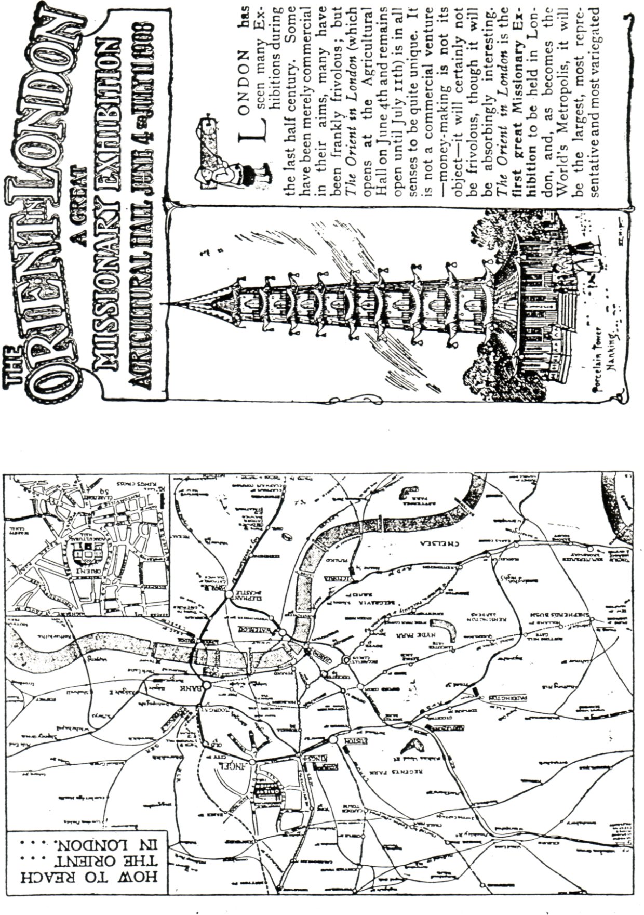

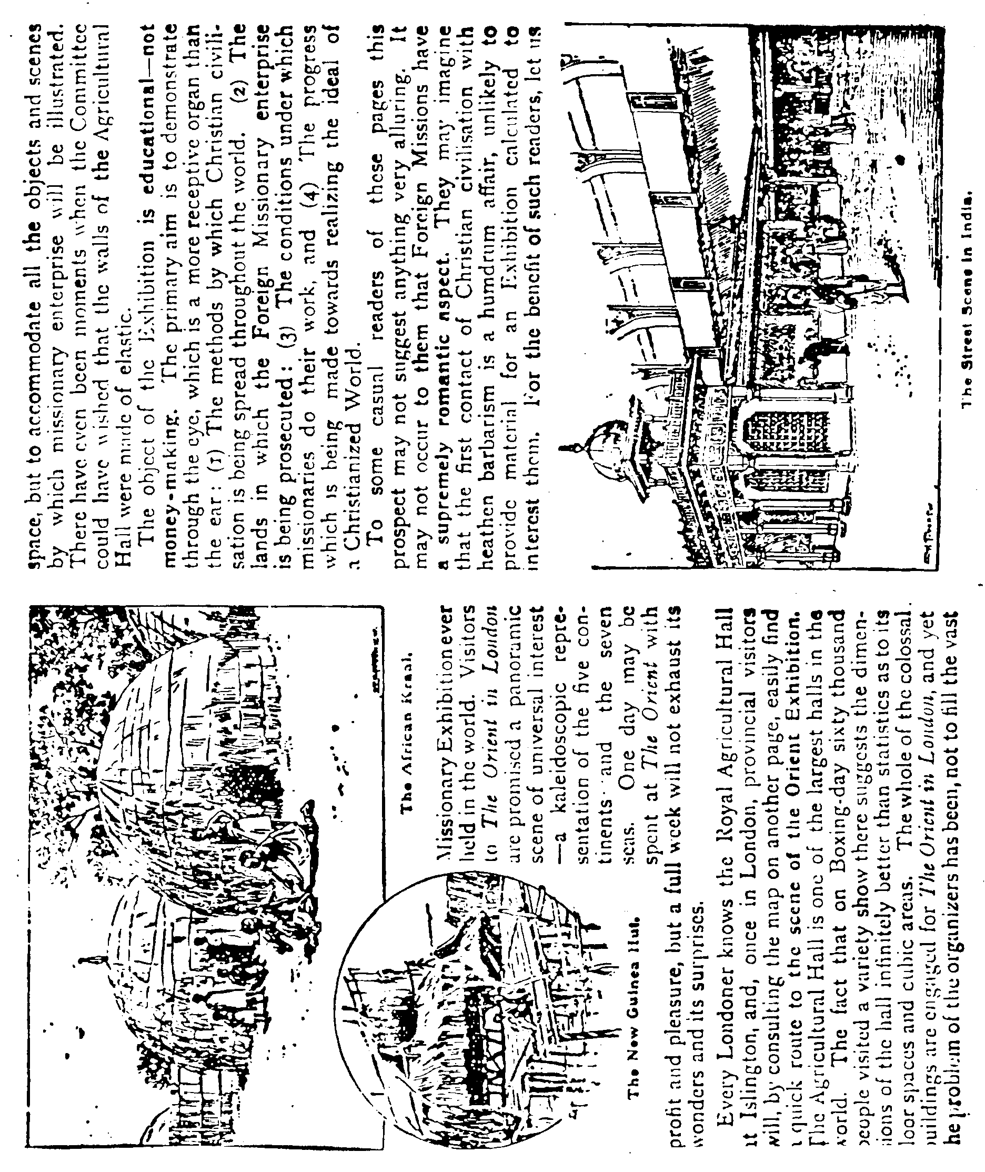

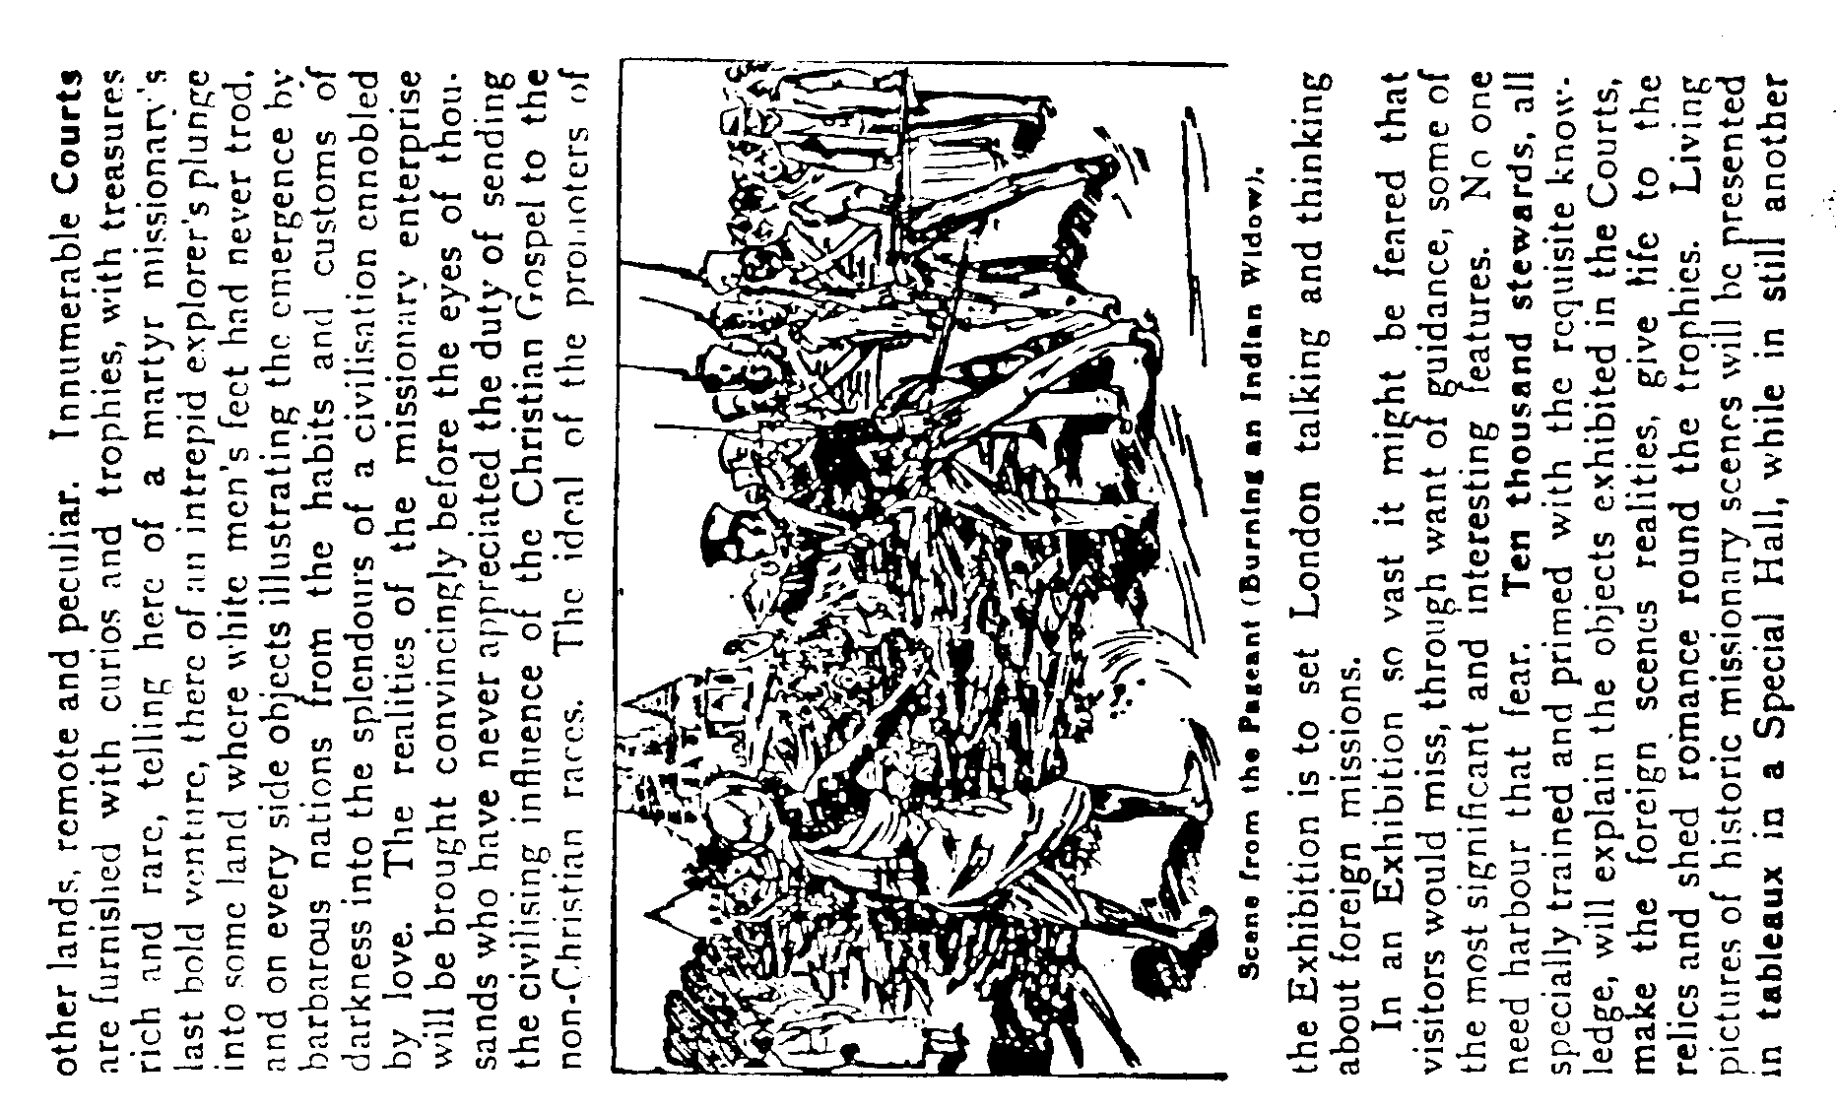

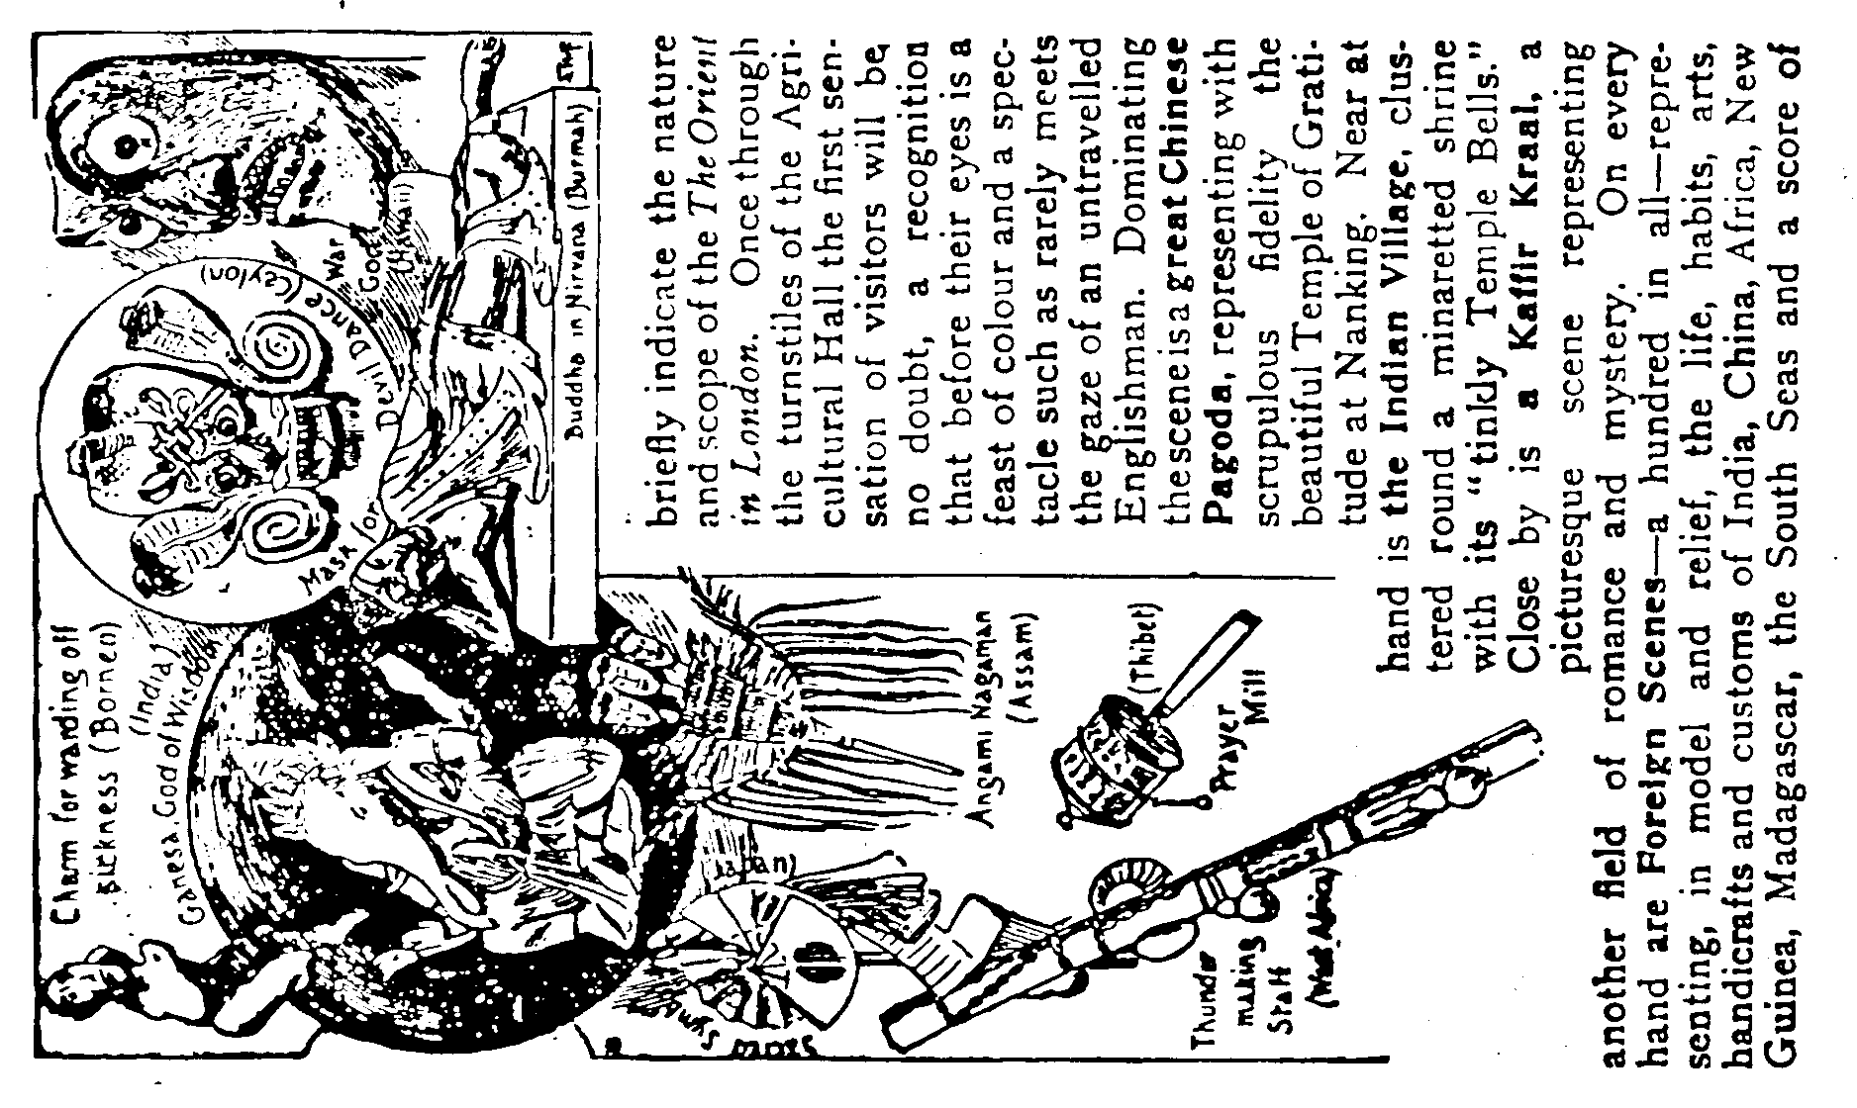

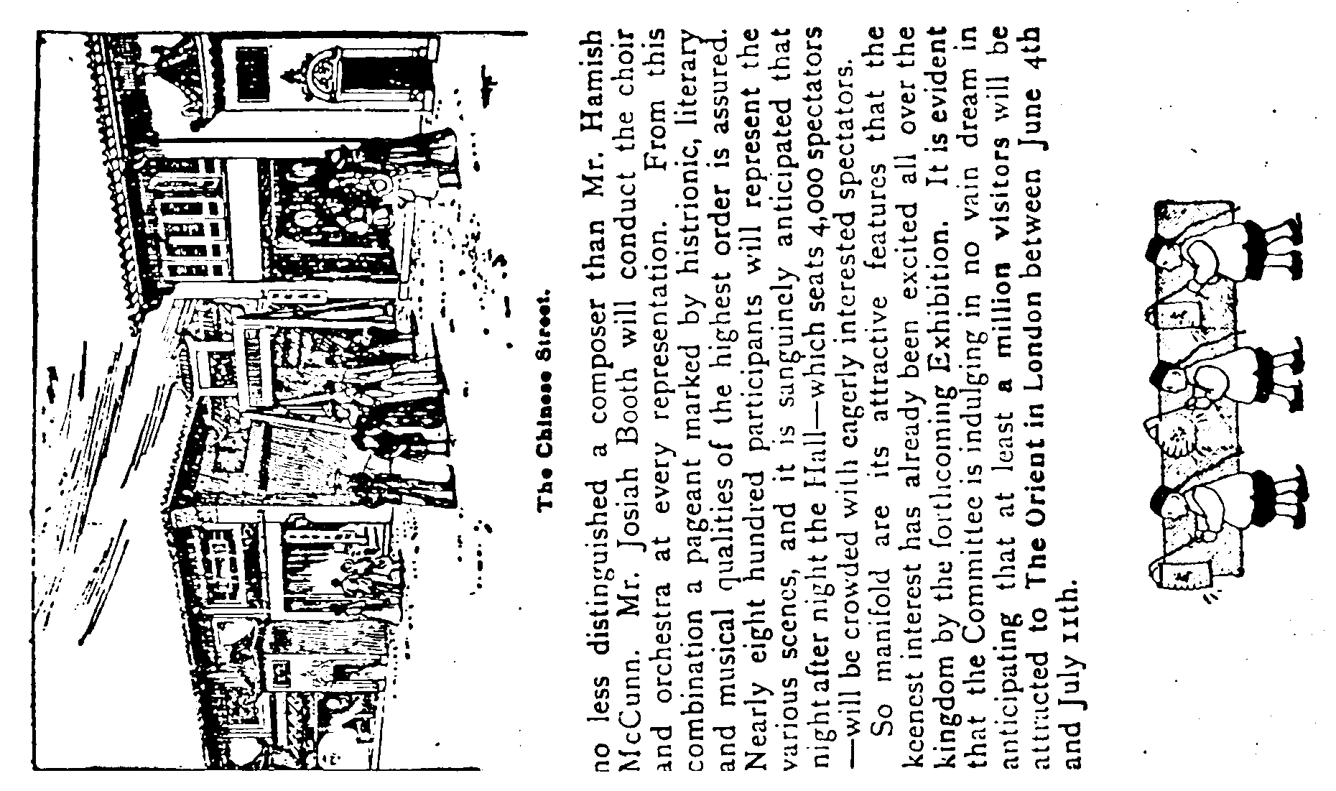

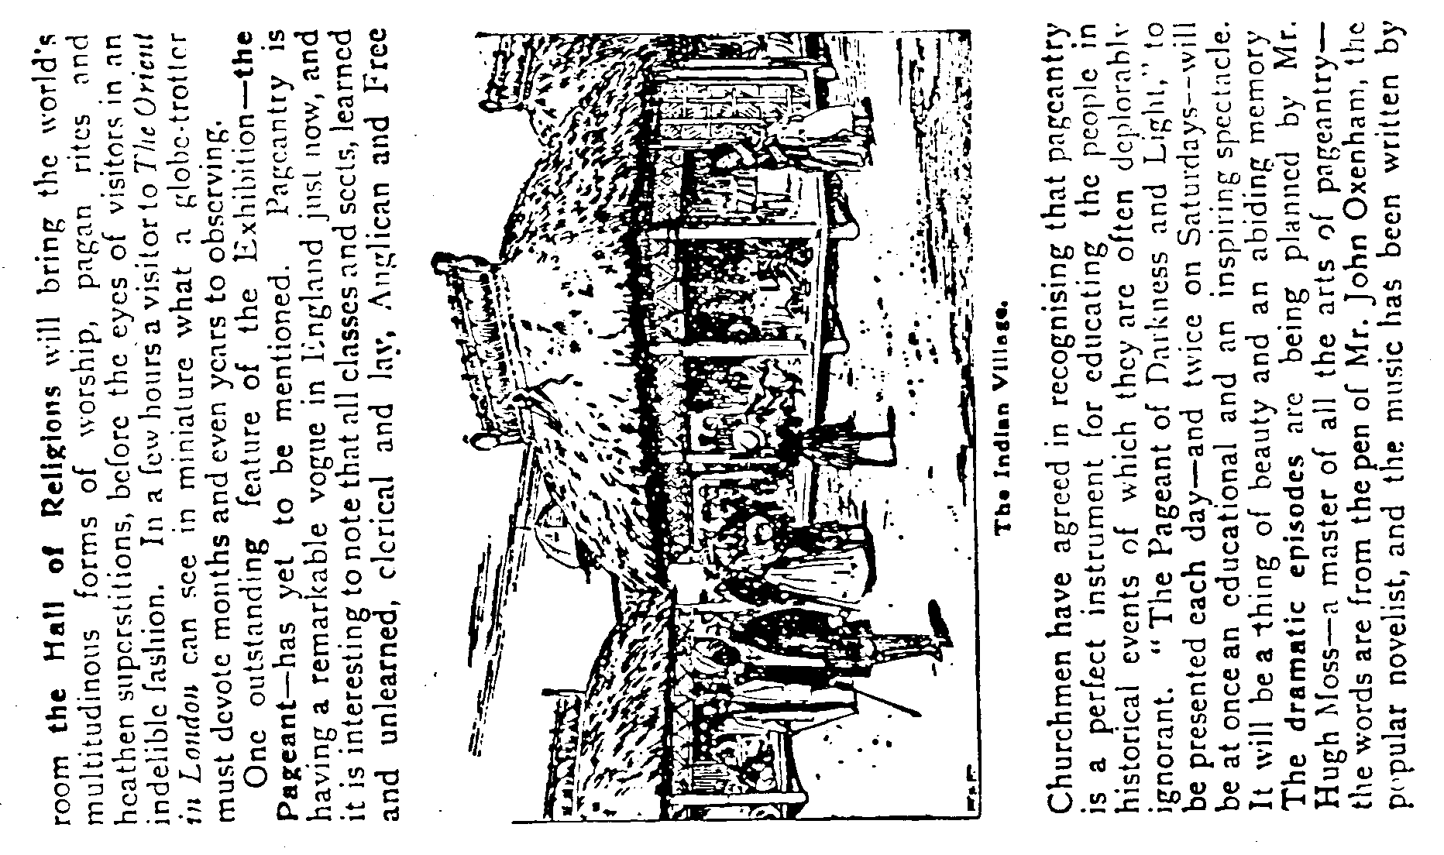

Australian Exhibitions
by
Perry Oliver

This famous exhibition building was used as the first Federal Parliament from 1901 till 1927, when the new capital city of Canberra began to function. Amid great display the Duke and Duchess of Cornwall and York cane out from England specially to open their first parliament of 1901. They travelled on the Orient line passenger ship, "Ophir", which had been specially chartered by the British Government as a royal yacht. A famous series of postcards issued by Wrench to record the affair and postcards were specially posted from the ports visited on the way to Australia, and on the voyage home via South Africa, Ascension and Canada. It was a brilliant occasion in Melbourne, with the first Governor General Lord Hopetoun, and the first Australian Prime Minister, Sir "Edmund Barton, meeting the Royal couple at St. Kilda Pier. The scene at the opening of the parliament in the Exhibition building is recorded on a famous painting and it was most colourful and impressive. The building later was used as an emergency hospital during the dreadful world-wide "Spanish infleunza" epidemic of 1919. In the building free Xmas dinners were given to 11,500 unemployed during the great depression of the thirties. The structure was used for some events of the Melbourne Olympic Games of 1956. In recent years, the building has actually been expanded in size. It has a very beautiful and impressive entrance and is now used for many purposes. I have seen a recent picture of it with a great cloth banner stretched across, reading "9 Leisure ’time Show.75" . This referred to a television show then being televised from there. In 1907 an exhibition was held there, and I have a postcard (photographic} showing the "Royal Exhibit" apparently a collection of needlework. This card, posted in Melbourne, has a special cancellation "Melbourne Exhibition", so the Australian post office considered it to be of considerable importance.
For the Hobart exhibition of 1894 special commemorative pictorial postcards were issued, and these, very early in picture postcard history, are valuable and scarce to-day. They are, of course, small in size and of about Court Card dimensions.
On the occasion of the Adelaide exhibition of 1887, the year of Queen Victoria’s Golden Jubilee, scientific progress enabled the opening to take place at exactly the hour that the Queen was proceeding in state to the Jubilee Service at Westminster Abbey.
A distinguished visitor, Maturin Ballou, was astounded by "the completeness, thorough organisation, and amazing variety of this exhibition of industry."
Appropriate to this article would be a verbatim quotation of an Australian press report of the exhibition. The "Sydney Morning Herald" of August 31.1870 said "The opening of the inter-colonial exhibition yesterday was an occasion of general rejoicing. A public holiday was proclaimed, and a numerous. and brilliant company assembled at noon to take part in the ceremony intended to celebrate the centenary of Captain Cook's landing on these shores, and afforded some indication of the wonderful progress made by Australia during the first hundred years of its existence as a
portion of the British Empire. A more appropriate place could not have been selected for such a purpose than Sydney the capital of the oldest of the Australian sisterhood, and which, if not the "fastest" and most self-asserting may yet claim to be the most highly favoured and stable of the group. Among the crowd were numbers from remote parts of New South Wales and many from distant colonies. Flags of all nations floated in the breeze; the park, which bears the name of Prince Alfred, was partially covered with machinery of the most approved construction, stock of the best breeds, produce in great variety and of choice quality, shrubs and flowers of rare beauty and manufactured articles of various kinds; while the building challenged general admiration, not only on account of its interior arrangement, but also a splendid commemorative monument, affording evidence alike of architectural taste, mechanical skill and public spirit.
After 1900, enthusiasm for large all-embracing exhibitions waned and. disappeared, arid such exhibits as were required to reach the public were shown in specialised displays throughout Australian cities. The Royal Shows or Agricultural Shows, held annually in each of the capital cities, and in most country town s of importance, have displayed to the public the new items and processes used in industry, agriculture and mining. The situation has been such that I have been unable to find any trace of any exhibition since the year 1907 when the exhibition was opened by the Governor general, Lord Northcote, who made a notable speech.

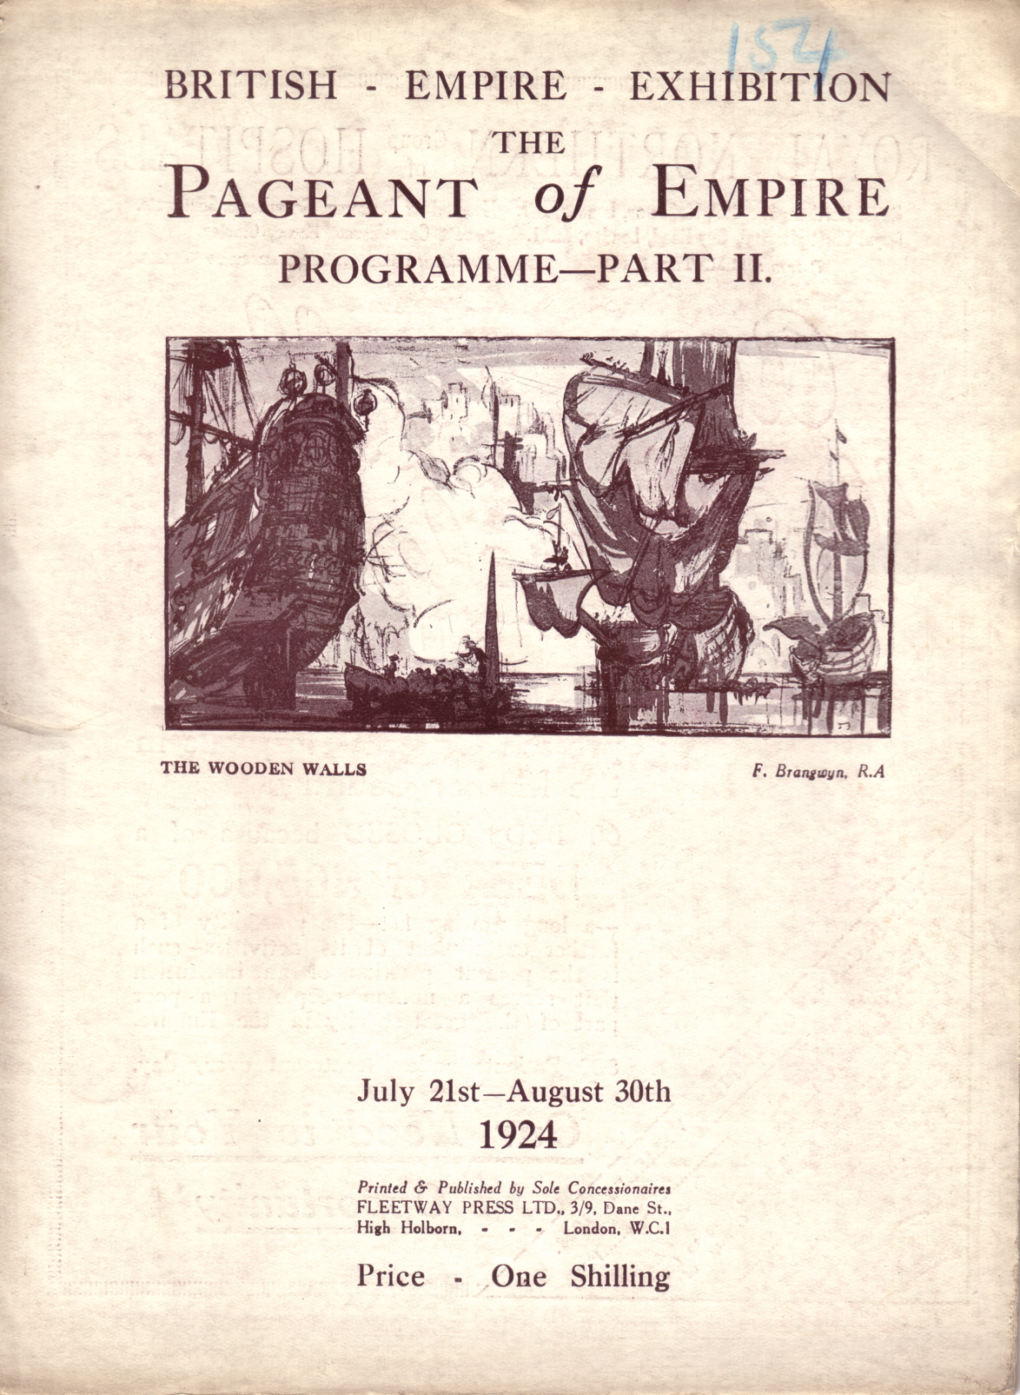

The Empire Pageant Council desire to record their special appreciation of the generous assistance given by Sir Harold Bowden, Bart., in placing at the Government’s disposal a guarantee of £33,000 towards the cost of the Pageant; of the action of the Corporation of London and of nine great Livery Companies in subscribing a sum of £1,575 towards the cost of staging the City Companies scene in the Elizabethan episode; Mr. Rudyard Kipling, for consenting to allow the “ Recessional" to be played throughout the Pageant, Mr. Alfred Noyes, for his original contribution of special verses to form "The Golden Chain” of the Pagean, Sir Edward Elgar, O.M., for his composition "The Empire March-1924” written specially for the Pageant, and for his music for Mr. Noyes’ “The Golden Chain” Mr. Frank Brangwyn, R.A., who designed the scenery; Mr. Sydney Walton, for valuable expert advice and assistance, Sir Charles Oman, K.B.E., M.P., who provided a survey of the historical period covered by the programme of the Pageant; Sir E. Denison Ross, C.I.E., and Mr. William Foster, C.I.E., who designed and arranged the Indian episode, Mr. E. V. Lucas, who selected the anthology for the Empire Pageant Souvenir, and Mr. R. H. Powis, for expert advice and assistance.
It is desired to pay a special tribute to the ladies and gentlemen in Wembley who organised the recruitment of the performers required for the Elizabethan episode.
The Council are also deeply indebted to a very large number of ladies and gentlemen who have given so much of their time voluntarily during the recent months to the very difficult and onerous work involved in the organisation of a Pageant on such a scale.

What exhibition is this. Card produced by Scott, Russell & Co., Birmingham and Sheffield. Scott series No. 950.
Card reduced to 75%

The Great Wheel. Earls Court.

My main interest in Exhibition cards are those showing illuminations and in a future issue I will show you some of these cards.
For this time I have selected two Souvenir Postcards of the Great Wheel. Now all postcard collectors will have seen some of the military set of 12 Advert. Cards issued by Prices Patent Candle Co. Well these two cards are also advert cards for the same firm. Prices Trade Mark is on the back of
each card. Also Prices & their products were very well advertised on the side of each of the 40 glass cabins.
I have also a Souvenir Coin of the Great Wheel, the same size as an old penny. On one side it shows a picture of the Gigantic Wheel Earls Court, dated 1901 and on the reverse is written, "The Gigantic Wheel at Earls Court is 28 feet in diameter and weighs about 900 Tons. There are 40 cars each to carry 30 persons. From the top of the wheel about 300 feet Windsor Castle is visible on the west. I have seen another similar coin dated 1899 so these must have been minted each year.
What I would like to know is if these cards were issued for any other years and are there any different views in the set ?

Sir Hiram Maxim’s Captive Airship, at the Exposition Liege 1905

A suggested sample sheet for recording details of post cards designed by Andrew Brooks

