EDITORIAL Spring 1995

The subs are due, so don't delay,
If you haven't paid, do it straight away.

I sometimes wish I'd not started this doggerel lark, as it seems to get more difficult to think of rhymes, still we won't be beaten, even if the quality is going downhill. In the winter edition I mentioned my long association as a fan, with George Webb's Dixielanders. Within a few days Fred Peskett phoned me up to tell me that when he started working, he was an apprentice at Woolwich Arsenal under George Webb, who was a grinder there. Fred remembers that George took him along to the Red Barn at Barnhurst to hear his band. This must have been about the same time as I was going there to hear him play.
Getting on to more unpleasant things, Alan Sabey our treasurer tells me there are still some members who have not paid their subscriptions yet. Don't forget our subs are due on October 1st, many members pay up at the Convention. Those that cannot get there not only miss a good do, but also miss the opportunity to pay their subs. Will you also note that the Convention this year will be on Saturday 23rd and Sunday 24th of September. This is the last full weekend in September, the next weekend falls half in September and half in October. While we are still on the Convention what about thinking of giving a display yourself, I am going to try and get out a programme this year, so start thinking now and let me know what you could do.
Members who attended our 1993 Convention may remember Andrew Brooks asked the meeting for information about Exhibition Pullouts, for any who do not know what a pullout is, it's a card with a flap on the front, you lift this and pull out a concertina of views, usually twelve, that are concealed under the flap. Five members have produced an amazing amount of pullouts, and I am devoting this Newsletter to the list as it stands at the moment. If anybody has pullouts in their collection not listed, please let me have the details, and I will see it gets to Andrew.
You will all be pleased, but not so pleased as I am, to hear that I have now got all the names, addresses, and stand locations, for every firm that exhibited at the British Empire Exhibition at Wembley in 1924 and 1925 onto a disc. Before I can process it I still have to get sight of the enlarged version of the 1924 Catalogue. Until I see this I don't know whether the job is finished or not. It began to get very gutty towards the end, and I hope I've seen the last of it. Try typing out 4,800 lines of information onto a spread sheet, and you'll see what I mean. The good news is that my typing speed has improved.
Mike Perkins spent four days with me last week and we priced every Wembley card in the book, he now has a computer and is working on the priced check list, which we hope to have out in time for the next Convention. I have now completed the Festival of Britain list of cards, which I had to leave when I got bogged down on 'Postcards of the B.E.E.' This runs into fifty pages so far. I have discussed this with George Simner and he has agreed to come in on this and help with the postal history side of the F.O.B. I intend to also cover the stickers and letter sheets of the F.O.B. I understand Fred Peskett is going to do a catalogue of all the known books, magazines, and ephemera relating to the F.O.B., but as he has only just started, it will be some time before he will have it completed.
Many of you will know about Stamp '95 on the 27th to the 30th of April at Wembley, Alan Sabey is putting on a 600 sheet display on the B.E.E. This should not be missed, as the opportunity to see so much of what is probably the finest collection of Wembley material in existence is unlikely to occur again.
Mike has also given me a run down on how the packet is going. As you know he is calling it in when it gets down to ten cards, and at the moment it is going very well. Number 2, 3, and 4, have now come back to him, and out of a total value of £381.65 sent out, £314.00 were sold. This proves there is a need for a packet, so turn out your spares and let Mike have them. I suppose blokes like me who sometimes get to three Postcard Fairs a week, don't appreciate the difficulties of members who perhaps can only get to a Fair every few months, or even less than that. To them the packet is a boon, and this is reflected in the sales.
PULL OUTS

This is a catalogue of all the known pullout cards relating to British Exhibitions, and was instigated by Andrew Brooks, who asked for information about these at the 1993 Exhibition Study Group Convention. It has been compiled from notes and photo-copies sent in by members of the Group.

1886 Colonial and Indian Exhibition. London.

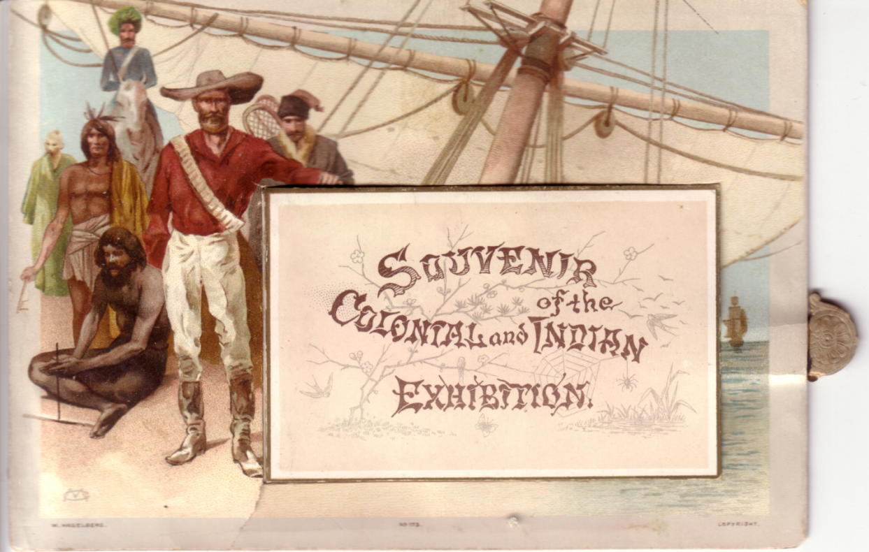

Published by W. Hagelberg, coloured, this was the forerunner of the modern Pull-out card, published in 1886, although it was not a true postcard meant to be sent through the post. Under a flap on the front were a strip of eight views, . It has a tab sticking out of the side, which when pulled out, slides the pictures out, which flip up one at a time until they are all exposed. So it’s not only the first pull-out but also the first mechanical card. The card is larger than normal measuring 165 x 115 mm. The title is printed on the outside of the flap.
Contents, horizontal strip of eight views. pasted back to back to form a booklet with titles on the opposing pages
The Indian Jungle. / Shop of Seal Engraver in the Courtyard of Indian Palace. / Shops of Miniature Painter and Old Potter, Courtyard of Indian Palace. / Sleighing in Canada. / Natives of British Guiana. / Family of Victorian Aboriginals in Native Hut. / South Australian Forest Scene. / Chinese Junks Hong Kong.

No. 173 Souvenir / of the / Colonial and Indian / Exhibition. / A Merry Christmas and a Happy New Year.

1904 Bradford Exhibition.

Published by Trotter & Co. by arrangement with Rosemont, and using copyright photographs by Rosemont, B/W, The flap is held closed by a swivelling brass tag. A very thick card was used,
and the black back was divided by double lines, horizontally, with a small space at the bottom for a message. ‘R. Ackrill’s Patent. 1d Stamp’ in the line stamp box. This was the first true Pull-out postcard.
Contents, horizontal strip of eight views
Lake, showing New Bridge. / Band Stand and Promenade. / Industrial Hall. / Cartwright Memorial Hall. / Swinton Castle, Lord Masham’s Seat. / Lake and Boat House. / Concert Hall and Promenade. / Water Chute.
No number. Bradford Exhibition 1904. Rosemont, Photo, Leeds. (Copyright)

1907 Palestine Exhibition.

Published by Photochrom Co. Ltd. Coloured, black back with ‘NOVELTY CARD’ and ‘Palestine Exhibition. L. J. S., 16, Lincolns Inn Fields, London, W.C.’ down left side.
Contents, horizontal strip of twelve views with text on the backs.
Bedouin Encampment. / River Jordan. / Ploughing. / Nazareth. / Bethany General View. / Jaffa. / Bethlehem General View. / Burden bearer. / The Site of Solomon’s Temple. / Mount Hermon. / Jerusalem from Mt. of Olives. / Garden of Gethsemane.
No number. Palestine Souvenir. The Water Seller. Vert left.

1908 Franco-British Exhibition. London.

Published by the Central London Tube Railway, printed by H.G. Ltd. B/W with red flap to pull-out, with ‘Quickest way to Exhibition by Tube’ printed in white, and underneath times of trains from the exhibition.
Contents, horizontal strip of fourteen views, laid out as an underground map, with the line
and stations named in red. The views are of the locality of each station. Wood Lane Exhibition Station shows a view of the Wood Lane Entrance taken from a Bonnett & Shum (L.P.A. Ltd.) card, while Shepherds Bush shows the Main Entrance to the Exhibition from an unknown source.
Wood Lane Exhibition Station. / Shepherds Bush. / Holland Park. / Nottinghill Gate. / Queen’s Road. / Lancaster Gate. / Marble Arch. / Bond Street. / Oxford Circus. / Tottenham Court Rd. / British Museum. / Chancery Lane. / Post Office. / Bank.
No number. Central / London / Tube / Rly.

Published by Valentine & Sons Ltd. Coloured ‘Vive L’entente Cordiale’ series with a flags border.
Contents vertical strip of six views.
Scenic Railway. / Canadian Pavilion. / Australian Pavilion. / British Applied Arts Palace. / Royal Pavilion. / Stadium.
193 Royal Pavilion, Franco-British Exhibition, London, 1908.

1908 Scottish National Exhibition. Edinburgh.

Published by William Ritchie & Sons Ltd., (W. R. & S.) Reliable Series, coloured Tartan card, brown-lake back. The first and last views are pasted in the card to form a booklet under the flap, and do not pull out.
Contents, vertical strip of six views.
General view. / Senegal Village and Baby Incubator. / Band Stand. / Figure 8 Railway. / Water Chute. / Helter Skelter and Airships.
No number. Souvenir of Exhibition. (Key on red tartan background)
1910 Japan British Exhibition London.

Published by Valentine & Sons Ltd, these cards can be divided up into four types, with the same strip of twelve views used in all the Japan-British Exhibition pull out cards.
Contents, vertical strip of twelve views.
Congress Hall by Night. / In the Japanese Gardens. / In the Japanese Gardens. / View from Flip Flap. / Court of Progress. / Cascade. / In the Japanese Gardens. / Fine Art Palace. / In the Japanese Gardens. / Elite Gardens. / Court of Arts. / Court of Honour.

Type 1. Coloured, greenish grey ‘two globes’ ‘Famous throughout the World’ back.
467 Elite Gardens, Japan British Exhibition.

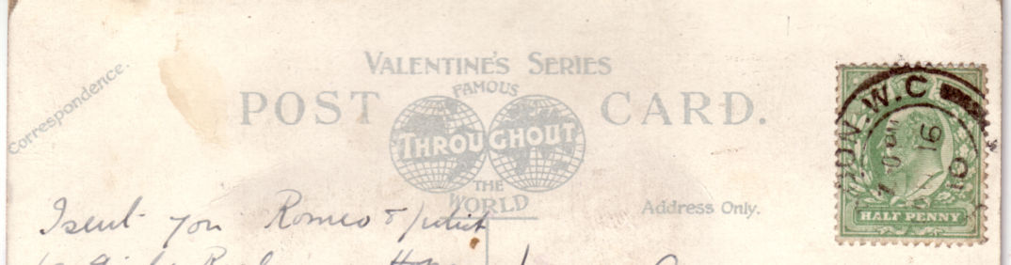
Two globes

Type 2. Valentine’s also published a series of coloured cards cut out to various shapes, printed on both sides, folded and held together by tags fitting into slits. when these were opened out, they contained a vertical strip of twelve standard views as above, pasted by the top edge. The name and address was written on a small buff luggage label tied to the cards with red string, the label included a space for the sender to sign a name, and room for a stamp box. These labels come in two types, type A printed in black on buff with ‘A Souvenir of the Japan-British Exhibition’ and ‘½d Stamp’ in the stamp box, and type B printed in red on buff with ‘Souvenir of Japan-British Exhibition’ and ‘Halfpenny Stamp’ in the stamp box.
No number. Cut out shape of Japanese house. Label type A.
No number. Cut out shape of a leaf. Regd. 535,148 Label type A.
No number. Cut out shape of wooden soled clog. Label type B.
No number. Cut out shape of a ‘Bonsai’ Tree in a pot. Label type A.

Type 3. In addition to the cut outs listed above Valentine’s also published another series of cut outs that were printed on the front only. The plain back had a small envelope pasted to it and this contained a loose strip of twelve views. The strip had a short length of red or white tape glued to it, to enable the strip to be pulled from the envelope. Although the envelope had ‘To’ and ‘From’ and space for a stamp, some of the cards also had the luggage label tied on with red string.
No number. Cut out shape of Japanese house.
This is another picture of the house in type 2 but the first card is a much closer view. Patent No. 26,399. Label type A.
No number. Cut out shape of an oval fan with a wooden handle glued to it.
The picture on the fan is ‘Three Japanese Maids in the Bamboo Avenue’, this card does not have the luggage label.

Type 4. This type of cut out has a flat base and a small strip of card at the back that could be folded back at an angle, to enable the card to be stood up as an ornament. These cards had the small envelope on the back containing the strip of twelve views with a red or white tape, and also a luggage label. This has been altered to read ‘A little Jap from the Japan-British Exhibition’, type C.
The cards are much taller than usual.

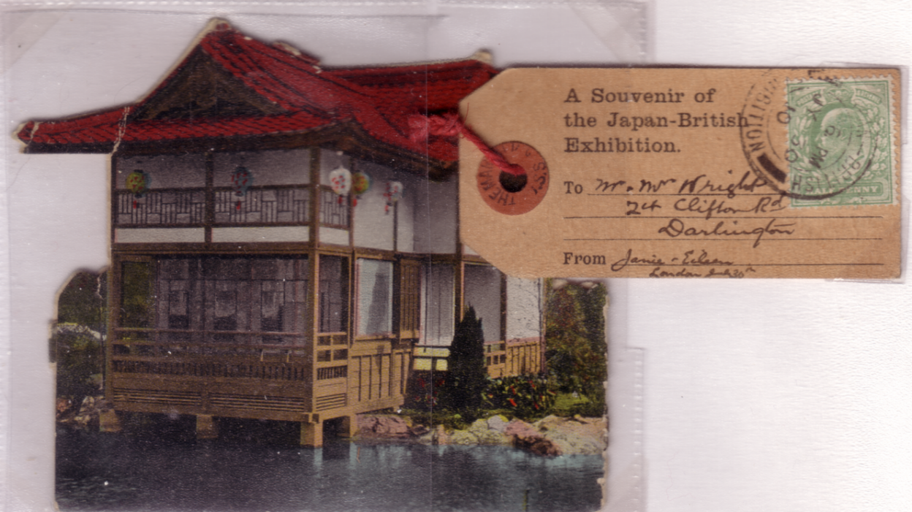

Type A

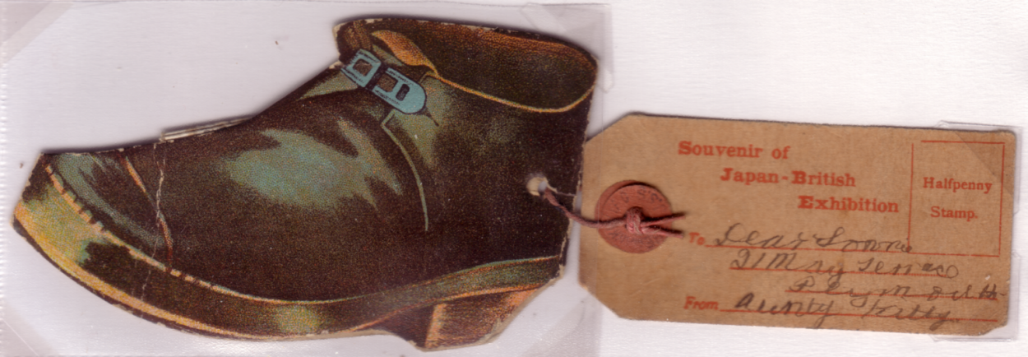

Type B
No number. Cut out shape of Japanese Lady with sunshade. Patent No. 26,399.
The card is 190 mm high.

No number. Cut out shape of Japanese doll. Patent No. 26,399, Regd. No. 559,006.
The card is 175 mm high.

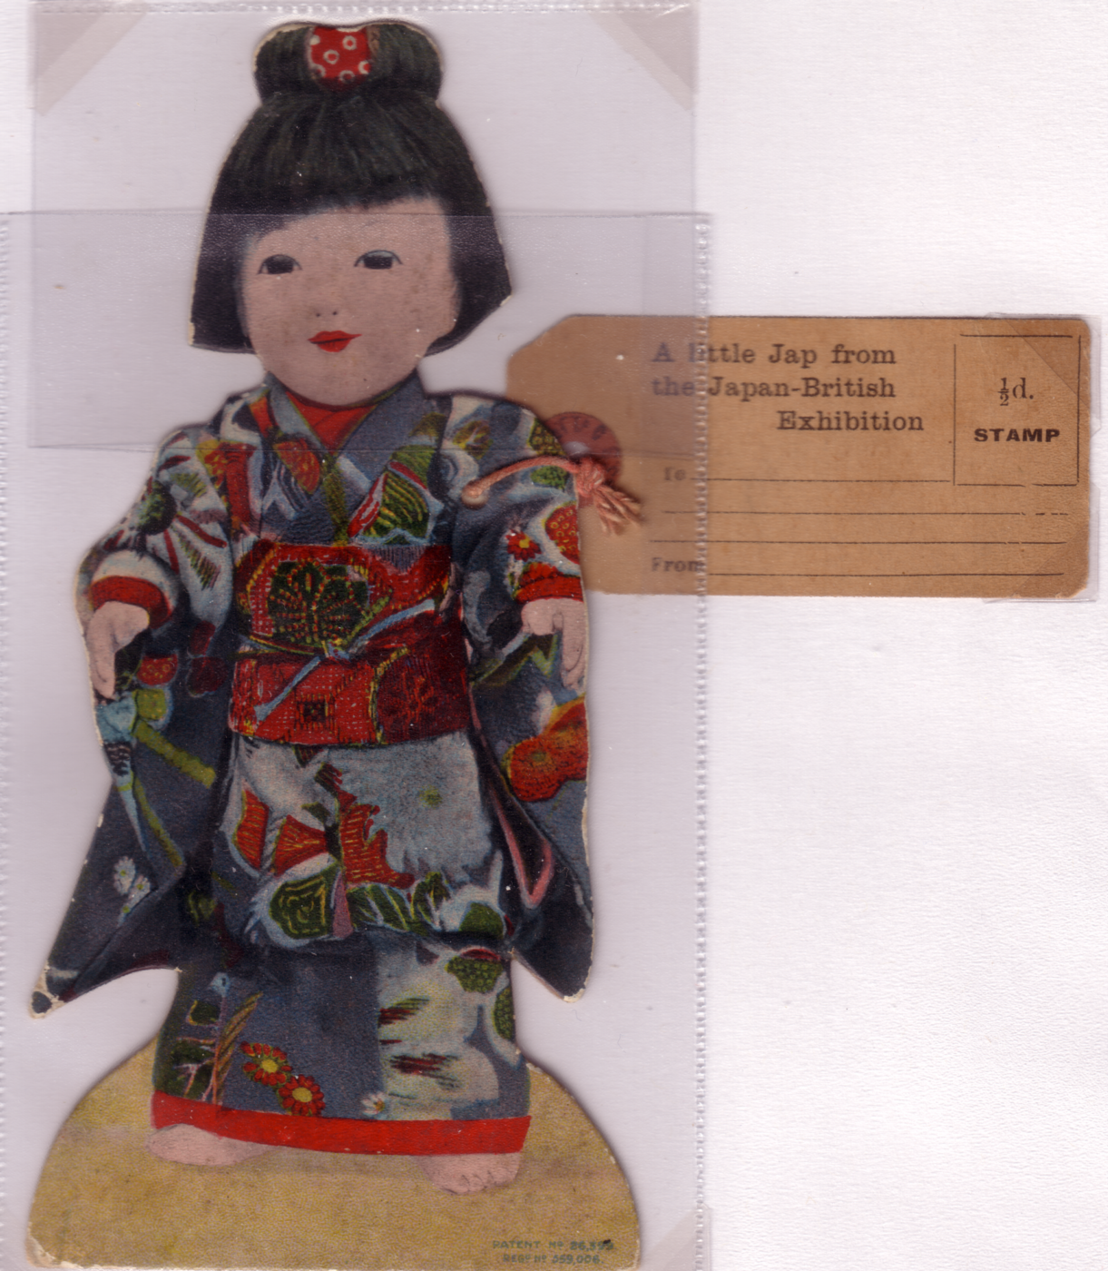
Type C

1911 Coronation Exhibition London.

Published by Valentine & Sons Ltd, the Coronation Exhibition cards have three different types of backs, and are listed separately. Type A. has ‘MAILING CARD’, type B. has ‘MAILING NOVELTY’, and type C. also has MAILING NOVELTY’ but three lines of text on the back are printed in red.
Valentine’s also published pull-out cards to commemorate the Coronation of King George V and although no mention is made of the Coronation Exhibition on the front of these cards, as some of these contain the Coronation Exhibition strip of views, they are therefore included as exhibition
cards. Some of the George V Coronation cards have additional text on the back. The vertical strip of twelve views are the same for all cards. It will also be noted that standard comic cards are now being used, with a special overprint, which could be altered to suit any event or locality, the same picture being used over and over again. For some reason the printers sometimes used several different settings, so the titles can be found as in the case of No. 786 in three lines or four lines, the spacing of the words can also vary. For this reason it was necessary to see photo-copies of many of the cards to make sure that two collectors who have sent in cards with the same title, do in fact have identical cards. In many cases they did not.

Contents vertical strip of twelve views.
The Grand Restaurant. Coronation Exhibition London 1911. / The Garden Club. Coronation Exhibition London 1911. / The Royal Pavilion. Coronation Exhibition London 1911. / Elite Gardens. Coronation Exhibition London 1911. / Court of Progress. Coronation Exhibition London 1911. / The Mountain Railway. Coronation Exhibition London 1911. / The Lagoon. Coronation Exhibition London 1911. / Court of Arts. Coronation Exhibition London 1911. / Court of Honour. Coronation Exhibition London 1911. / Native Scene Burmah Indian Section. Coronation Exhibition London 1911. / In the Garden of Floating Islands. Coronation Exhibition London 1911. / Gibraltar African Section. Coronation Exhibition London 1911.

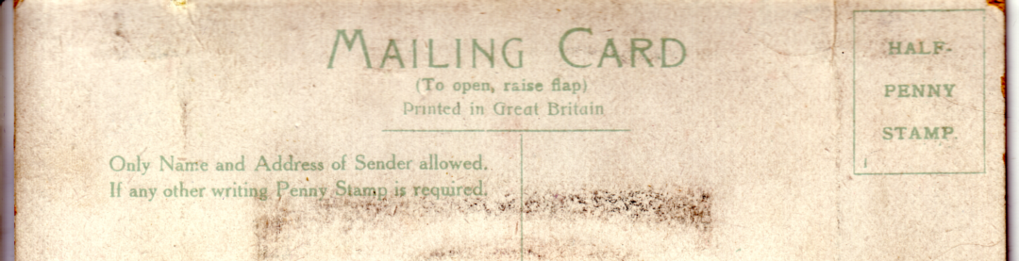
MAILING CARD

Type 1. Coloured, with greenish grey back, ‘MAILING CARD’, stamp box with ‘Half Penny Stamp’ and ‘1’ in the bottom left corner.
132 Scenic Railway, Coronation Exhibition, London, 1911.
142 Flip Flap, Coronation Exhibition, London, 1911. Vert left.
427 The Flip Flap, Coronation Exhibition, London, 1911.
(488) Court of Honour, Coronation Exhibition, London, 1911. (No number on card)
(551) Court of Arts, Coronation Exhibition, London, 1911. (No number on card)
710 View from Flip Flap, Coronation Exhibition. London, 1911.
725 A Little Fresh ‘Air From / The Coronation Exhibition. / London. Vert left.
732 British Empire / in a Nut Shell, / Coronation / Exhibition, / London, 1911. (Walnut)
Regd. No. 577,099, Copyright No. 53,452.
785 Garden of Peace, Coronation Exhibition, London, 1911.

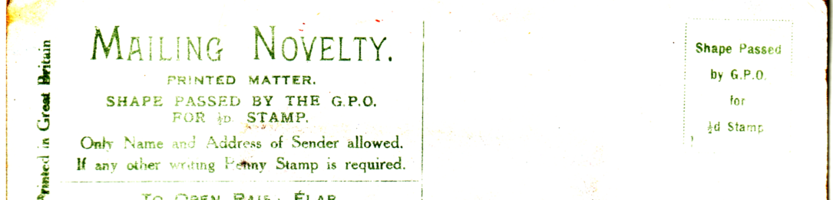
MAILING NOVELTY
Type 2. Coloured, with back in shades from greenish grey to brownish ochre, ‘MAILING NOVELTY’, stamp box with ‘Shape passed by G.P.O. for ½d Stamp’ and ‘1’ in the bottom left corner.
731 British Empire in a Nut Shell, / Coronation / Exhibition, / London, 1911. (Brazil Nut) Regd. No. 577,100, Copyright No. 53,453.
743 King George V / Coronation / Souvenir. / The Stage Coach. (With additional text on the back), Regd. No. 578,854.
746 Coronation Souvenir. / The / Coronation / Chair. Vert left. (With additional text on the back), Regd. No. 578,839.
777 Coronation Souvenir of King George V Vert left. (Composite of three views, Westminster Abbey, Houses of Parliament, and Royal Carriage passing House of Commons, with the King, Queen, and title in the centre.
786 One of the (H)Attractions at / The Coronation Exhibition. / London. (With four lines of doggerel)
A. ‘C’ of ‘Coronation’ under ‘e’ of ‘One’. Regd No. 572,832 in the centre. Vert left.
B. ‘C’ of ‘Coronation’ under ‘t’ of ‘the’. Regd No. 572,832 on the left.
Vert left.
C. ‘C’ of ‘Coronation’ under ‘e o’ of ‘One of’. 572,832 on the left.
A. Vert right.
B. Vert left.
786 One of the (H)Attractions at / Coronation Exhibition, / London, / 1911. (No second ‘the’ and 1911 added to the title).
A. ‘C’ of ‘Coronation’ under ‘t’ of ‘the’. Regd No. 572,832 on the left.
Vert left.
B. ‘C’ of ‘Coronation’ under ‘f’ of ‘of’. Regd No. 572,832 on the left.
Vert left.
788 Holding my Own at / The Coronation Exhibition. / London.

Type 3. Coloured, with greenish grey back, as Type 2, ‘MAILING NOVELTY’, stamp box with ‘Shape passed by G.P.O. for ½d Stamp’ and ‘1’ in the bottom left corner. Three lines of text under ‘MAILING NOVELTY’ printed in red. These cards have no mention of the Coronation Exhibition on the front, but have the exhibition contents.
820 North American / Indian Boy. Vert left.
(824) Indian Woman and Child. Vert left. (No number on card)

1911 Festival of Empire Exhibition. Crystal Palace.

Published by Valentine & Sons Ltd, coloured, with greenish grey back, ‘MAILING CARD’, stamp box with ‘Half Penny Stamp’ and ‘1’ in the bottom left corner.
Contents, vertical strip of twelve views.
The All Red Route. / In Tudor Village. / The Bandstand. / Bridge in Tudor Village. / The Pavilions. / Mountain Railway. / View from Crystal Palace. / The Amusements. / Pageant Performers. / Empire Avenue. / Indian Pavilion. / The Pageant Ground.
106 The Amusements, Festival of Empire Exhibition, London, 1911.
123 Mountain Railway, Festival of Empire Exhibition, London, 1911.

1911 Scottish National Exhibition, Glasgow.

Published by Alex. MacLaren & Son, coloured with brown back, CAIRT PHOSTAIL. The contents are a strip of circular views 64 mm in diameter, joined at the edges.
Contents, horizontal strip of six views.
Tigh a ‘Phosta agus Buth Icabaichean gaidhilg. (Post office and book shop.) / Croiss a’ Chlachain - (The Village Cross.) / Anns a Chlachain - (In the Clachan.) / An Tigh Osda - (The Village Inn.) / Granny a’ Chlachain - (Granny at her Spinning Wheel.) / Muinntir Duthchasach a’ Chlachain - (The Natives of the Clachan.)
No number. Ceud mile failte, / Frae The Clachan, / Scottish National Exhibition, Glasgow.
A. Sporran on red tartan background. Vert left.
B. Sporran on brown tartan background. Vert left.
C. Sporran on green tartan background. Vert left.
Note. Ceud Mile Failte = 100,000 Welcomes.

William Ritchie & Sons Ltd., (W. R. & S.) published some coloured cards under their ‘Reliable Series’ cut out to various shapes, with a picture printed on the front. These were folded and held together by tags fitting into slits. When these were opened out, they contained a vertical strip of six views, pasted by the top edge. The back of the card, printed in blue, had ‘Souvenir of Scottish Exhibition, Glasgow, 1911.’ a stamp box with ‘Postage with name of sender only ½d’, and a printed panel in the shape of a luggage label in which to write the address. The layout of the backs, varies to accommodate the shape of the card. Each card seems to have a different contents strip. There are no titles on the cards.

Type A. Contents, vertical strip of six views.
River Rides. / River Rides. / River Rides. / Aerial Railway. / Joy Wheel. / Whirlpool.
No number. Cut out shape of Mysterious River Rides, and windmill. Vert left

Type B. Contents, vertical strip of six views.
Glasgow Exhibition 1911, The Clachan Gateway. / Glasgow Exhibition 1911, In the Clachan. / Glasgow Exhibition 1911, The Clachan High St. / Glasgow Exhibition 1911, Natives of the Clachan. / No title, (Woman at Spinning Wheel.) / Glasgow Exhibition 1911, The Clachan Inn.
No number. Cut out shape of the Clachan Post Office.

Type C. Contents, vertical strip of six views.
Palace of History & Garden Club. / Kelvin Hall & Concert Hall. / Garden Club. / Duck Pond, night. / Music Court. / Old Scotch Street.
No number. Cut out shape of Industrial Court.

Type D. Contents, vertical strip of six views.
Old Scotch Street. / No title (Bell-Man with stick). / Old Scotch Street with Keep. / Old Scotch Street. / No title (Metal polish sign). / No title (Toffee Shoppe).
No number. Cut out shape of Old Scotch Keep & Bell-Man.

Type E. Contents, vertical strip of six views.
From Garden Club. / No title (Palace of History & Garden Club). / Historic Ships on the Kelvin. / No title (Model Warships). / No title (The Kelvin & Palace of Industry).No title (Model Warships).
No number. Cut out shape of "Great Michael" at sea.
Type F. Contents, vertical strip of six views.
Scenic Railway. / Scenic Railway. / Scenic Railway. / Mountain Slide. / Aerial Railway. / Joy Wheel.
No number. Cut out shape of Great Mountain Scenic Railway.

Published by Valentine & Sons Ltd, coloured, there are three different settings of the backs. all in greenish grey type A MAILING CARD type B MAIL NOVELTY and type C MAILING NOVELTY. There are also three different contents which are not related to the backs.

Type 1. consists of a vertical strip of twelve folded sections made up into four panoramic views, extending over two or four sections.
Contents, Scottish Exhibition Glasgow, 1911. (View extends over two sections). / Scottish Exhibition Glasgow, 1911. (View extends over four sections). / Palace of Industries, Scottish Exhibition Glasgow, 1911. (View extends over two sections). / Scottish Exhibition Glasgow, 1911. (View extends over four sections).

Type 1A ‘MAILING CARD’, details of stamp box not known.
No number. Extra / The latest / about the / Glasgow / National / Exhibition / "Extra Special". Vert left.

Type 2, a vertical strip of twelve views.
Contents, Fountain Square, Scottish Exhibition, Glasgow, 1911. / Palace of History, Scottish Exhibition, Glasgow, 1911. / Spinning Wheel, Highland Village, Scottish Exhibition, Glasgow, 1911. / Exhibition Administrative Offices, Scottish Exhibition, Glasgow, 1911. / West African Village, Scottish Exhibition, Glasgow, 1911. / Music Court, Palace of Industries, Scottish Exhibition, Glasgow, 1911. / Types of Scottish Vessels, River Kelvin, Scottish Exhibition, Glasgow, 1911. / An Clachan, The Highland Village, Scottish Exhibition, Glasgow, 1911. / The Tower, Palace of Industries, Scottish Exhibition, Glasgow, 1911. / Mountain Scenic Railway, Scottish Exhibition, Glasgow, 1911. / Palace of Fine Art, Scottish Exhibition, Glasgow, 1911. / Old Glasgow, Scottish Exhibition, Glasgow, 1911.

Type 2C. ‘MAILING NOVELTY’ details of stamp box not known.
711 ‘Waverley’ coming out of his / shell at The Scottish Exhibition. Vert left.
730 Something from / The Scottish Exhibition. Glasgow. / Worth looking into. Vert left.
736 The Scottish Exhibition, beneath a parasol. Vert
780 A Small Scotch from / The Scottish / Exhibition / Glasgow. Vert left (No number on card)
783 We’re Near Killt "Wi’ Kindness at / The Scottish / Exhibition" / Glasgow.
801 I’m right in a whirl at The Glasgow Exhibition. Joywheel.
812 We are having D-lightful / time at / The Scottish Exhibition, Glasgow.

Contents as type 2. Back type unknown, ‘Half-penny Stamp’ in the stamp box.
No number. Extra / The latest / about the / Scottish / Exhibition / "Extra Special". Vert.

Type 3, Contents vertical strip of twelve views.
Exhibition Administrative Offices, / West African Village, / Music Court, / Palace of Industries, / Types of Scottish Vessels, River Kelvin, / An Clachan, The Highland Village, / The Tower, / Palace of Industries, / Mountain Scenic Railway, / Palace of Fine Art, / Old Glasgow,

Type 3a. 'MAILING CARD' back, details of stamp box unknown.
Contents, vertical strip of twelve views as type 3.
753 A Souvenir from The / Scottish National / Exhibition Glasgow.
788 Holding my own at / The Scottish Exhibition, Glasgow.

Type 3b. 'MAIL NOVELTY' back, details of stamp box unknown.
No number. Scottish National Exhibition Landmarks. Vert.

Contents as type 3. Back type unknown.
No number. Extra / The Latest / about The / Scottish Exhibition / "Extra Special". Vert.

There are some cards where the details of the contents or of the back types, are not known.
730 Something from / The Scottish Exhibition, Glasgow / Worth looking into. Vert. Back type MAILING NOVELTY.
732 Scottish National Exhibition in a Nut Shell. Regd. No. 577,099, Copyright No. 53,452. (Walnut)
749 We are having our "Fling" at / The Scottish Exhibition, Glasgow. Regd 583,676 Vert. Back type MAILING NOVELTY.
786 One of the "H"Attractions at / The Scottish Exhibition, Glasgow. Vert. Regd. No. 572,832. Back type MAILING CARD.
815 The Scottish Exhibition, Glasgow / is worth "blowing" about. Vert. Back type MAILING NOVELTY.

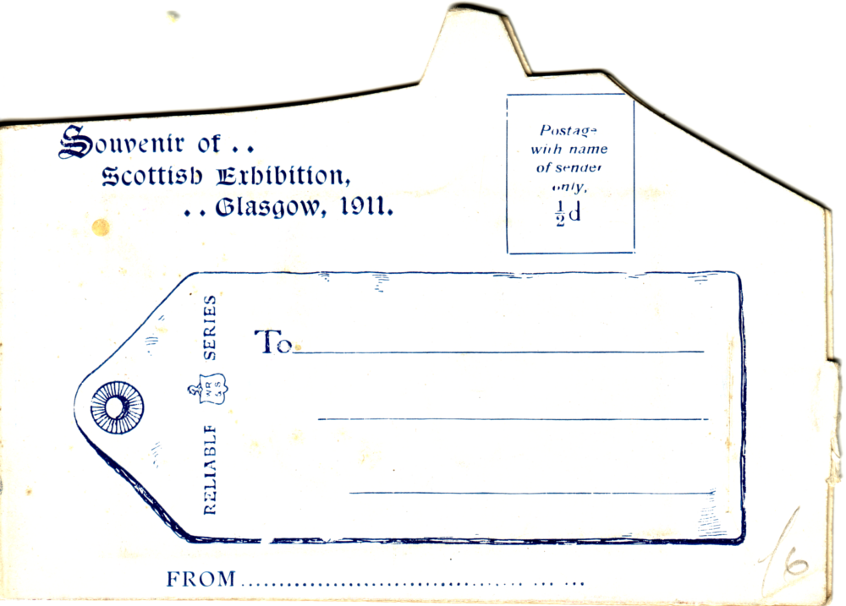
Printed panel in the shape of a luggage label

1912 Latin-British Exhibition. London.

Published by Valentine & Sons Ltd. Coloured, with greenish grey back, ‘MAILING NOVELTY’, next three lines of text in lined box. Stamp box with ‘Shape passed by G.P.O. for ½d Stamp’ and ‘2’ in the top left corner.
Contents, vertical strip of twelve views.
The Lagoon. / Flip Flap. / The Fine Art Palace. / The Grand Restaurant. / Court of Honour. / The Whirl-Pool. / Central View from Flip Flap. / Court of Honour. / Court of Arts. / Wood Lane Entrance. / Mountain Railway. / Garden of Peace.
730 Something from / Latin-British Exhibition, London. / Worth Looking Into. Vert left.
754 Charged with good things from / Latin-British Exhibition, / London.
973 Something for you from / Latin-British / Exhibition, / London. Vert left.

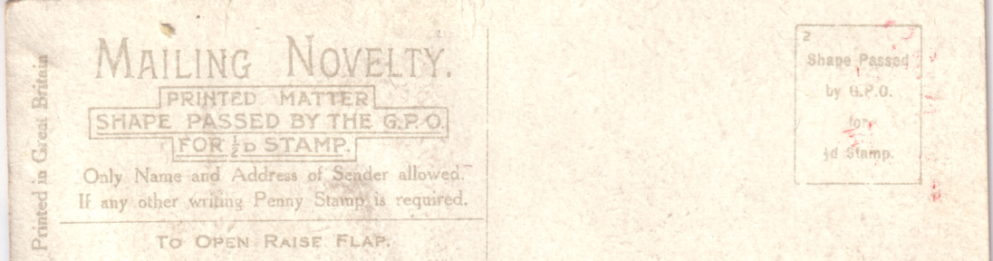
Three lines of text in lined box

1912 The Great White City Exhibition, London.

Published by Valentine & Sons Ltd., coloured, with back in shades from greenish grey to brownish ochre, ‘MAILING NOVELTY’, next three lines of text in lined box. Stamp box with ‘Shape passed by G.P.O. for ½d Stamp’ and ‘2’ in the top left corner.
Contents, vertical or horizontal strips of twelve views.
Court of Arts. / Bandstand and Imperial Tower. / Court of Honour. / Elite Gardens. / The Flip Flap. / Court of Honour. / The Cascade. / Mountain Railway. / The Whirlpool. / Scenic Railway. / Grand Restaurant. / The Entrance.
706 Good Luck From / The Great White City. Vert left.
711 I am coming out of my Shell at / The Great / White City. Vert left. (Horizontal strip)
738 Jolly Golly from / The Great / White City. Regd. No. 583,892. Vert left.
762 We are Not / Downhearted at / Great White City. Vert left.
780 A "Small Scotch" / from / The Great / White City. Regd. No. 583,677. Vert left.
947 The Great White City. / Before I started for this place Vert left. (Horizontal strip)
952 Something / Dainty from / The Great / White City.
A. ‘The Great White City’ at the side of the title. Vert left.
B. ‘The Great White City’ underneath the title. Vert left.
958 Luckbringers / from / The Great White City. (With four lines of doggerel)
A. The Great White City in one line. Vert left.
B. The Great White City in two lines. Vert left.
958 Luckbringers / from / Great White City. Vert (No ‘the’ in title.)
973 Something / for you from / The Great / White City. Vert left
1004 There are some / good views of / The Great / White City / Under the Table. vert left.
1006 A Gondola at The Great White City / London.

