EDITORIAL WINTER 1994

Old Father Time with his long sharp scythe,
'asn't caught me yet, 'cos I'm still alive.

The Newsletter is a bit late, as I have been laid up with Chronic Bronchitis for five weeks, during which time I didn't feel like doing anything, I always thought this was an old mans complaint. One of my other interests is collecting old jazz records, and three or four times a year Nancy and I go off on Jazz weekends, listening to trad bands and generally enjoying ourselves. At a recent one I met an old friend of long ago, and while we were having a chat with George Webb of George Webb's Dixielanders, which was the first English band to play Jazz in this country, and is still playing, I staggered him by saying my friend and I had been fans of his for a total of 100 years between us. It brings home that old saying 'doesn't time fly'.
By now most of you will have seen the book, even if you have not bought a copy, Mike and I are very pleased with the way it has turned out. So far only two errors seem to have crept in, one in the introduction on page X, where I have Edward Vll down as dying in 1911, Allan was the first to spot this and pointed out to me he died in 1910, (no prize was awarded) and on page 3 Aerograph type 3 reads "Right side of card" this should be "Left side of card". So far we have sold about 100 copies out of the total run of 500. In the end the printers were a week later than promised, but they did get fifty finished in time for them to be on sale at the Centenary Post Card Fair. As the book has had no publicity yet, we are very pleased with this initial response. A review will appear in the P.P.M. by Andrew Brooks, and also in the Philatelic Exporter. The latter is generally only available to members of the Stamp Trade, but I have been a subscriber to it for nearly thirty years. Liz McKernan the Brighton postcard dealer writes in it each month.
Our eighth convention is now over, and I think I can safely say it must be one of the best we have held. It was certainly the largest attendance so far, with thirty two members and wives present. Twenty five sat down to our dinner and a very enjoyable time was had by all. A report of the convention will be found elsewhere in the Newsletter. I must apologise to the two ladies who had booked single rooms, and in the event had to share a bedroom, it will not happen again. John Swanborough wrote to me suggesting that it would be nice if a programme could be got out for the weekend with the speakers given or giving a guide on how long their display should take. I can see the advantage of this, and must admit that I have followed the casual approach to this as it was originally laid down by Andrew. With our more experienced speakers they can judge say a forty five minute display, but many of our members are not in this class, they are happy to display their treasures but do not want to say a lot.
I am not a good speaker myself, and envy someone like Stanley Hunter who when asked if he would say a few words about a 1901 Glasgow Exhibition Poster brought along by Roy Allen, got up and entertained us for a good ten minutes with an off the cuff talk about an item he had never seen before. At these do's I think people like to have plenty of time to chat around, I meet collectors like Andrew Brooks, Karl Illingworth, Don Knight, and Stanley to name a few, at the most only twice a year. Mike spend three or four short breaks with me each year, and I spend a lot of time on the phone mainly to Alan Sabey. I welcomed John's comments and would like to hear from others how they feel the Convention can be improved. From what I heard after the tour round the Stadium, it's going to be a job to beat this last one. Another suggestion, from Mike Gorringe was that we should wear name stickers, this again is a good idea and I will try and get something organised for the next convention.

The Centenary Post Card Fair was a great success, it was nice to have room to move around in comfort, and even nicer to have a large restaurant area with plenty of tables and chairs. What a difference from Bloomsbury where you have to fight for one of the three seats to sit and drink a cup of tea. I have just read that the venue will be used in future for Bipex. I spent three days there and managed to find 120 cards, so I did fairly well, one or two nice cards but nothing really outstanding. I did have one bit of luck there, ever since Arthur Smith gave his display on Royal Tournament cards I have been collecting these, and while I was going through some cards I heard the chap next to me ask the dealer if he had any Tournament cards. As soon as he was finished I invited him to come and have a cup of tea and we spent a pleasant twenty minutes talking about the Tournament, during which he mentioned another Tournament collector Paul Brinklow, who advertised in the P.P.M. for Gale & Polden cards. I followed this up and a couple of weeks later Paul visited me with his collection. It was a really fine lot and I was able to prevail upon him to leave this with me for about ten days to really study it. We both had about equal collections but amazingly there was virtually no duplication in the two lots, apart from the later Fleetway cards. When I returned his visit taking his cards back, he showed me his main interest which was the military uniforms and badges on Gale & Polden cards. I got the impression that he was in fact not so interested in the Tournament cards, and the outcome of it, was that I bought the bulk of his collection from him.
I have been working away on the alphabetical listing of all the exhibitors at the 1924 and 1925 British Empire Exhibition, together with their address and location of their stand. This is an extremely gutty job, and I worked out if I did two hours a day I could get the job onto a disc in three months, I am now nearly three quarters of the way through it. Looking at my copy of all the British Empire Exhibition material in the British Library the other day I found to my horror that they have three different 1924 catalogues, with 178, 244 and 292 pages. I have been working from the 244 page one, so there could be another 50 pages to be copied out. Fortunately I have a British Library Readers Pass, so perhaps the end is not in sight after all.
The end.

CONVENTION 1994 24 -25 Sept 1994.

by Alan Sabey.

Again, the Annual Convention was held at the Century Tavern Forty Avenue, Wembley, but with an even higher number of members attending. After the business of the Annual General Meeting was concluded, a succession of displays were given. The first was by Don Knight, an author of 'The Lion Roars at Wembley' (1948) who showed various 'Wembley' Exhibition postcards including views, advertising, royalty, and silhouettes.
This was followed by Alan Sabey, the other co-author of the above book, who showed a complete range of postal slogans advertising for the exhibition from around the Empire from Australia to the Turks and Caicos Islands. He also showed a large drawing printed by Waterlows giving the impression of how Wembley Park may have looked if the Tower had been completed. It was demolished in 1906 and the Stadium is on the actual site.
A new member, George Burr, followed with a range of medallions for the 1924 and 1925 Exhibitions and he asked members to let him have details of any they have as he is thinking of compiling a listing, hopefully for publication in due course.
Roy Allen brought along a poster from the 1901 Glasgow Exhibition, and this was described to the audience by Stanley Hunter.

Mike Perkins brought along 10 postcards with the question "where were they. "Several suggestions were made, including the British Empire Exhibition and the British Industries Fair
Mike Gorringe has an advert in a magazine for ladies and he showed the results of his requests with personal photographs, a school party badge, passes, and even a sheet of paper with the Wembley Lion as a watermark. One has the impression of him being pursued by little old ladies saying "I've got this from when I went to Wembley, would you like it?"
Fred Peskett then showed some photographs taken during the construction of the Royal Festival Hall, for the 1951 Festival of Britain.
John Swanborough, another new member, and one of the authors of the 'Special Events' handbook showed covers with postmarks of some of the more obscure exhibitions in Queen Victoria's reign and continued with a range of exhibitions through to the 1938 Glasgow.
Judith Edwards, also a new member, showed Congress labels from 1909 to 1961 for the Philatelic Congresses of Great Britain, and had a number of stories to tell to accompany her display.
A tea table of British Empire Exhibition china and cutlery set up mainly by Alan Sabey, with some items loaned by Lyn Lane and Nancy Tonkin was on show for the day on the Saturday, and at afternoon tea that day members enjoyed a piece of celebration cake made by Nancy Tonkin, and bearing the legend '1924-1994 B.E.E.' and the Wembley Lion.
Twenty six members enjoyed the Annual Dinner on Saturday evening and this was followed by a slide show presented by Bob and Gwen Tough on the 1958 Brussels World Fair.
Sundays display began with Festival of Britain items from Bill Tonkin and George Simner, the latter showing a collection of sheet music for the Festival.
Moray Graham-Bonnalie showed postal and ephemeral items from the 1934 Air Post Exhibition 'Apex' including admission tickets and special cachets.
Stanley Hunter showed a range of postcards of the 1938 Empire Exhibition in Glasgow including anticipated views, actual views set against a tartan background and a series of views of Tait's Tower, the centrepiece of the exhibition. One unusual item was a letter card with a map of the exhibition grounds.
The new President, Karl Illingworth, also showed Festival of Britain items including a table cloth, a loud wide tie, embroidery, and other assorted momentoes.
After Lunch thirty four people including members of the Wembley History Society and a member of the Society of Olympic Collectors over from Norway, enjoyed an Official Tour of Wembley Stadium, with a look behind the scenes at the Crowd Control and Traffic Control Rooms, a film about the history of the Stadium and a chance to be presented with a replica F.A. Cup by Queen Nancy Ist. (Nancy Tonkin).
Everyone expressed the feeling that it was a successful Convention, concluded with an interesting tour of the Stadium. The Group is planning to hold their 1995 Convention at Wembley and it is hoped that the attendance will be even larger.

the end

The picture on the front page is an interleave from a Waterlow & Sons Ltd. Christmas card. The front has a coloured view of the Stadium and Indian Pavilion on a grey background, while the centre-fold has a border of twenty four small views of the exhibition.

A COLLECTING MANIA

by Bill Tonkin

A couple of months ago a lady phoned me, asking if she could put an article in our newsletter we discussed it and it turned out she wanted to sell some B.E.E. ephemera and thought she might do it through the newsletter. As Nancy wanted to go up to Cambridge to visit a churchyard for her family history project, we decided to combine the two, and went up to see her. She had an interesting story to tell. as follows,
Once upon a time there lived an old Aunt May Savidge, who was a bit eccentric, but clever with it. She was a qualified Craftswoman and about thirty years ago decided to move house, she was then in her late fifties. She bought a pot of paint and started taking her two storied timbered house to bits painting numbers on each plank and beam. when she had completed the demolition she hired a lorry and shifted the whole lot about a hundred miles, to the new site. She then set about rebuilding it, doing the majority of the work herself, and generally having a go. Soon the papers and later the television got to hear of it and sent reporters along to do an article and take some pictures. They probably thought she was mad and would never finish it. They kept coming back every few years to see if she was still at it. It would seem she asked the press for copies of any photos they took, so in time she accumulated a long series of pictures of the house in its various stages of rebuilding. In her later years she used to pin a note on the gate for callers requesting them to wait ten minutes as it took her that long to come down the scaffolding when she was doing the roof, as she was now in her late seventies and not too nimble.
At last the time came for her to pass on her way, and in her will she left the property to the children of her nephew and niece in law (Christine Adams, who told me the story), on condition the parents finished building the house. The have become hooked on the job and managing to get three years leave of absence are now well involved in finishing off the house.
When they went to look at the property a surprise awaited them. I did mention that the old girl was a bit eccentric, her eccentricity took the form of never throwing any paper away. she would soak the wrappers off tins, and save the wrappers off bars of chocolate and iron them out and write the date on them and every bit of paper she collected was carefully kept. Christine got Opie down (he has a museum of packaging and advertising material) and he was over the moon with it especially as so much of it was dated, and has taken a lot. The old girl also kept over 500 diaries starting at number 1 made out of old sheets of paper she sewed together, so there is a day by day progress report on the house. Christine said when they first went into the house they had to walk sideways as every room and passage was stacked ceiling high with bundles of paper wrapped in plastic to keep it dry, she said the only clear space was where the dogs basket was. The old girl had lined the inside of the building with plastic sheet, to store her paper, while she lived in a caravan on the site. This obsession went back to her childhood, and Christine found the notes she made on the outing the school went on to the 1925 British Empire Exhibition, plus all the folders leaflets and booklets she gathered on her trip round the exhibition. I have bought the lot and the niece tells me that the cash will just pay for three leaded windows for the house. The bulk of the material was concerned with immigration offers to people wishing to start a new life in Canada, South Africa, Australia etc.
I suggested she frames a coloured exhibition site map which would only fetch a few pounds and the school trip composition as a reminder of the old girls trip to Wembley, Christine thought this was a good idea and is going to do it.
Some years ago Nancy and I visited Snowshill Manor, an Elizabethan Manor House, where every room including the attics were filled with the owner, Charles Wade's collections.
Each room was jammed solid. He was described as a 'Magpie' all was grist to his mill, when he died it was left to the National Trust. Wade lived in a small cottage in the kitchen, without electric light, sleeping in an old Tudor cupboard-bed and apart from a table and chair, that was his living quarters. I remember the attics contained a magnificent collection of model horse drawn farm wagons, and apparently when he got his first one he was so impressed, he commissioned the whole output over many years, of the man who made it, H. R. Waiting, so nearly all the known examples of his work are at Snowshill. They are to one-eighth scale, one off models made with particular detail to the iron strips and fittings which are individual to different counties and manufacturers, these had all been faithfully copied.
This does beg the question when does a hobby become an obsession, and when does an obsession become a form of harmless mental illness.

The end.

LETTERS TO THE EDITOR.

Strictly speaking the next two letters from Mike Perkins are not letters, he sent down a disc with them on, so all I had to do was put the disc in the machine, display the contents on the screen and move them over to the newsletter. This is wonderful and saves all the effort of typing it out. I then remove the disc and send it back to Mike. Unfortunately the button to eject the disc is right next to the button to switch the machine off, and I pressed the wrong button, and in the blink of an eye I irretrievably lost about two hours work. The old Amstrad had the on off button round the back of the machine, they guessed there were people like me about, and designed their computers accordingly.

Dear Members,

After thoroughly enjoying the Annual Convention at Wembley, I spent an equally enjoyable few days with Bill and Nancy down in sunny Kent. Nancy's treacle tarts are the stuff dreams are made of !!! When I got home I found a letter from Brian England with a dozen cards for the Exchange Packet and the following note,
"Thanks for a splendid Conference. It's difficult to see how we can keep up such a high standard. To hear the crowd in the Stadium chanting "England, England " did wonders for my ego. " I have to echo his sentiments - the look of shear joy on Karl's face as he held up the Cup brought tears to my eyes......
Brian used one important little word in his note - 'WE'. Whilst the Committee - sorry, perhaps I should say Bill - organises the weekend, it is the people who make the effort to turn up that really make the Convention what it is. Brian made his first visit last year and gave us an excellent 10 minute talk showing some super cards. This year, several first time visitors gave us marvellous displays, and showed some fascinating ingenuity in obtaining material and information.
I think everyone there learned something - I am indebted to Judith Edwards for telling me that Campbell Gray - the official Wembley photographer - was in fact a Mr. Campbell and a Mr. Gray ! I shall definitely follow up on that one.
How can 'we' make next year's Convention better ? - easy, just turn up!

Mike Perkins.

Dear Bill,
INSURANCE - THE WHITE MAN'S BURDEN.

A few weeks ago three letters arrived together, one was a reminder for the house insurance, one was a reminder for my stamp and postcard insurance, and the other was from Direct Line Insurance advertising their services. I have my car insured with Direct Line, so I decided to see if they could save me money on the house insurance. A nice young man ( well he sounded young ) took down various details and gave me a quote that was a £100 cheaper than the renewal quote. Magic I thought. Well, I was on a roll so I decided to go for broke and asked about insuring the stamps and cards. "How much are they worth?" asked the nice young man. I gave an approximate figure and the line went quiet for several seconds then the nice young man came back on the line and said that they couldn't insure me at all because of the risk. It seems that because the cards could be a target for unsavoury characters, the risk of the house being damaged by a break-in was too great for them.
I then rang nine other insurance companies asking for house insurance quotes and then asking about insurance for the stamps. Five companies gave me quotes that were close to my renewal figure and three gave higher quotes. All the companies said the stamps would be no problem subject to a limit of 10% of the contents insurance. It would appear that the discount insurance companies only want safe bets!
I would just like to suggest to all our members that you be aware of this anomaly - your card collection could just invalidate your house insurance!

Happy Hunting.

Mike Perkins.

P.S. For stamp and card insurance try Barry Horne at 2, Bakery Meadow, Puddington, Tiverton, Devon, EX16 8LW.

Dear Bill,

As promised here is a photo-copy of the Brian Gerald 'Art Colour' card A 703. It has the usual Red Lion on the back. I've paid for The Great Exhibitions book by Allwood, so hopefully it will turn up soon, when I will be pleased to lend it to you, assuming it is of use or interest. (in due course Ken did lend me the book, which is one I have heard about but never seen, it's a very good book.)

Best wishes,

Ken Harman.

Dear Bill,

Empire Exhibition, Scotland, 1938.
Art Colour Postcards by Brian Gerald.

Re the article in Newsletter 34, I have a few notes which should be added to the article.
Type 1. I have six cards A 691-4, A 696-7. It should be noted that these Grey Lions are not as common as Red Lion cards.

Envelopes. I have noted the following 'Art Colour' packets,
22. 'Oil Facsim' 9 for 1/6 A 619-9.
23 'Clan Tartan' 6 for 1/- A 708-13.
24 8 'Art Colour' for 1/- A 691-4, A 697, A 700, A 703, & A 718.
25 ditto A 694, A 696, A 702, A 716, & A 719-21.
26 ditto A 693, A 695, A 698, A 701, A 704-5, & A 722-23.
u/n ditto A 691-4, A 696-7, & A 699.
While it is possible that Valentine's might vary the above contents, all deviations I have seen were from doubtful sources where a dealer may well have replaced cards at will. The above are from the publisher's sample books.
Packets were produced side and or top opening and usually printed brown on buff or blue on white paper. All 'Art Colour' packets I have seen were side opening and printed blue on white paper with the Tower of Empire in blue and the Exhibition Lion motif in red 30mm high. The unnumbered envelope also exists with the Red Lion motif in the 35mm size.
Type 3. Has the card with a glazed surface and a standard Valentine's (i.e. non-exhibition) back. As the 'Art Colour' were only an artist's impression, they could be issued before the Exhibition opened. This was a common practice with exhibition cards. Type 3 is most uncommon and I only have A 692-3. The only used one I have is postmarked July 1939. Could they have been retailed after the exhibition closed, rather than before? (All mine are unused Editor)
'C.B.' I have no idea what this means but it could be a printer's control. It appears at the bottom right of the stamp box and exists in small or large sans-serif capital letters. I have it on some A 692 with small capitals and A 694 & A 696 in both styles. (I have two copies of A 692 with it, but did not know the letters came in two sizes. If you can let me have a photo-copy of the two sizes I can let you know which size mine are. Editor)
While the majority of cards carry the imprint in capital sans-serif 'From an Original Water Colour by Brian Gerald' A 715 & A 717 are inscribed 'From Original Water Colours by Brian Gerald'. An unacknowledged card shows Mary Morrison, the 'Auld Grannie' spinning in the Clachan. It is inscribed 'Cleuch Dryburgh Tweed Warehouses Highland Spinning Empire Exhibition, Scotland 1938. It is unnumbered and has no reference to the exhibition on the back, but has '38-2' in the stamp box.
Brian Gerald's exhibition paintings were also employed as the source for a few of Valentine's 'Real Photo' cards. These appear usually in the A series with four digits, i.e. A 6623-31, with six major variations of printings of the back. Look out for the crazy 'PHOTOGHAPH' spelling.
The cards can appear in (the early) glossy black & White or Glossy sepia, with the usual back variations and hand tintings.

'Art Colour' LETTER CARDS
1. 6 Views in Art Colour A 691-4, & A 696-7.
2. not known
2a. 6 Views in Art Colour A 691, A 694-5, & A 697-9.
3. ditto A 691, A 694-6, & A 698-9.
4. ditto A 691-3, A 695-6, & A 698.
4a. ditto A 692-4, & A 696-8.
10. not examined
11. 6 Views in Art Colour A 691, A 693, A 695-6, & A 698-9.
13. ditto (Varnished) A 691, A 693-4, A 696-7, & A 699.
14. ditto A 691, A 694-5, & A 697-9.

15. ditto A 691-3, A 695-6, & A 699.
16. ditto A 692-4, & A 696-8.

'SOUVENIR'
12 Views A 691-2, A 694, A 700-1, A 705, & A 715-9.
A 6631 shows A panoramic map of the exhibition but only appears in black & white on a card and in colour only on this Souvenir. It is probably not by Gerald.
A 697 (South Cascade & Tower by Night) is the most prolific view of any 1938 Empire Exhibition painting. As A 6628 it takes on A host of variations, sepia hand tinting, searchlights, hand and machine lettering (left and right bottom corners in quite a few different styles), black & white, (tinted and plain, again with variations) and blue moonlight cards which remind one of Paris 1937 cards.
A 693 or R/Photo A 6627 (North Cascade and Tower) is another rich source of varieties to look out for.
A 716 appears to have been based on the photo used on the sepia R/Photo X 71. It includes the 'foam' statue (seen in the Taggart TV drama 'Root of Evil') with spray added to the fountain, now restored to the National Trust for Scotland gardens at Greenbank, Glasgow.
Some of the paintings were also used as 'Real Photos' in the glossy sepia 'X' series, but I have not detailed them here. Close examination of the view will show that the photo is actually a painting. Watch out for the Union Flag on the top of the Tower of Empire. Gerald shows it at the west edge. Later photos show it actually on the east edge, where it was finally erected.
I am preparing a detailed checklist of 1938 Empire Exhibition postcards and would welcome details of members collections of these cards, or, in fact, any other ephemera or souvenirs of this great exhibition.

Yours,

Stanley Hunter.

A B.E.E. IN MY BONNET

by Peter Griffin

Part 4

Stationery, Cards and Collectibles

No Wembley collection should be without an example or two of the Postal Stationary items. Four items were produced for each year and printed with an impression of the relevant stamps.
The 1d rate postcard was printed in red on stiff white card and the 1 1/2d envelope in brown on good quality cream laid paper. The 1.1/2d rate postcard for overseas was printed on thin buff card and a 1 1/2d letter card on greyish-cream card. The latter enjoy a few varieties relating to number of perforation holes, distribution of gum etc., so even the mundane postal stationery items provide something else to look for. Unfortunately most of the material to be had is affected by foxing to some degree. Be prepared to pay a lot extra for pristine material.
I understand there are in excess of 3,900 picture postcards relevant to the exhibition. Most likely to be found now are the general views or specific scenes of individual pavilions.

Less common are scenes from within the pavilions or from the countries concerned, (Fig. 1), and scarcest of all are the advertising cards produced by some of the commercial exhibitors. A few comic postcards were available and again are very seldom found now. Some subjects are on-going collectable themes as in the case of The Queen's Doll's House, which is now on display at Windsor, for which fresh ranges of cards have been produced since 1924. I am fortunate in possessing a letter by Queen Mary in which she thanks the many craftsmen involved in the designing, building and furnishing of the Doll's House.

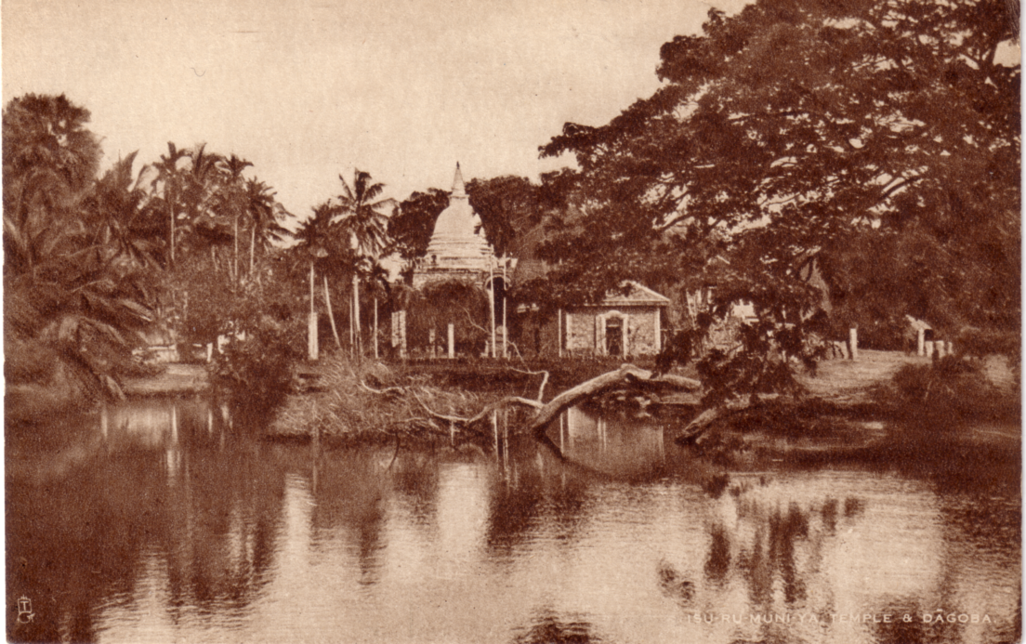

Fig. 1.
The humble and so often maligned perfin should get a mention here as the stamp not only pays the postage but provides a bit of advertising for the firm it relates to. It is assumed the majority of them were produced by businesses actually involved at the exhibition and any with the exhibition postmarks almost certainly would have been. Many of these perfins have yet to be identified so there is a study area some one might like to take up.
The Government Pavilion boasted its own 'Post Office', but it was for demonstration only. A series of six cards advertised such services as the telephone, telegrams and trans-world cables was available at the post office exhibit, and these could be processed in the new demonstration electric cancelling machine. (Fig. 2)
The slogan can be found on adhesives on cover but these undated items are purely philatelic and never went through the postal system. They are none the less very collectable and very scarce.
Also in this section one could send a telegram to oneself. The appropriate message was written onto the form which had a 1d adhesive affixed to the top right corner. This was cancelled with the special dated hand stamp and the message duly transmitted. At a delivery point elsewhere in the pavilion one would collect the printed telegram - All for the cost of a penny. The matching pairs of forms are now horribly expensive, and not the sort of thing that turns up in dealers junk boxes I'm afraid.
A nice letter I have to pair with Queen Mary's Doll's House item is one written by King George in which he refers to the somewhat unpleasant weather conditions on the opening day that seemed to set the general standard throughout the 1924 season. This
prompted the production of a strange little publicity item that more in hope than certainty predicted better things for the 1925 season.

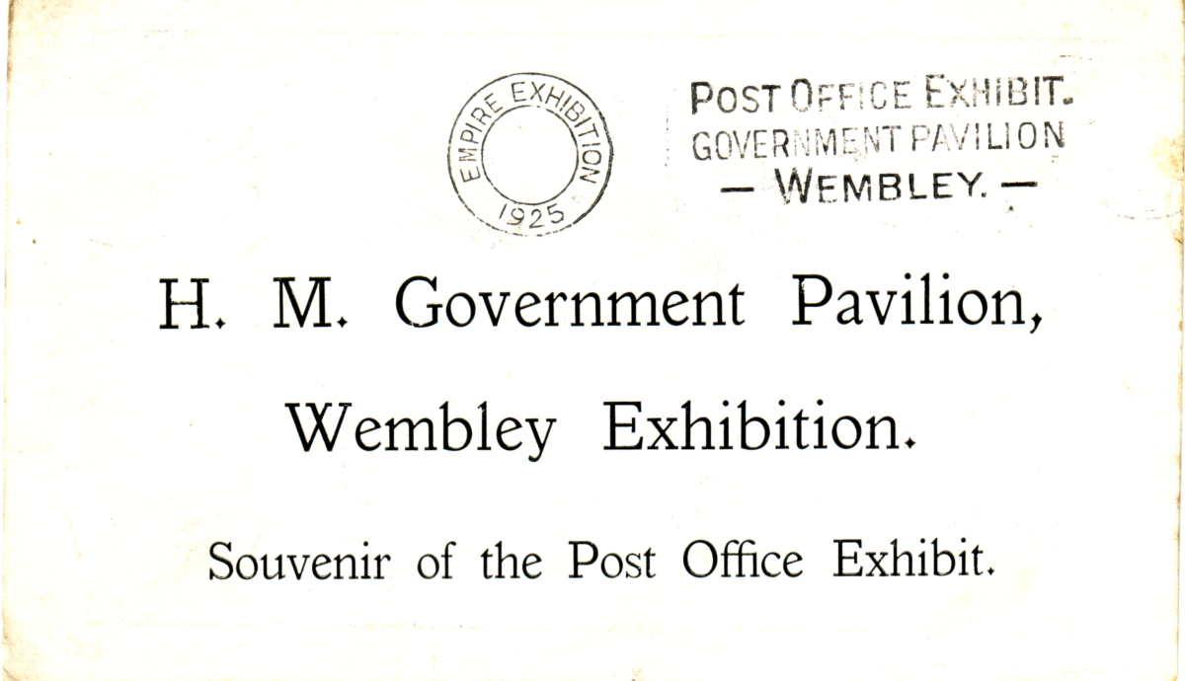
Fig. 2.
Oh for the contents of just one litter bin from that exhibition! Amongst the wasps and apple cores would be a wealth of 'Junk' bearing the magic Lion that normally sane people now do battle for in auction houses the world over. Entrance tickets, guides, programmes, commercial handouts of all descriptions that are flat enough to go on an album page are all collectable and fascinating items from this most wonderful of events. Besides the paper 'flatware' can be included brooches, medallions, mounted photographic souvenirs and then the bulkier ornaments, boxes, bottles, tins and containers of all types that have survived the ravages of time and seventy years of spring cleaning clearouts.
In the next newsletter I shall discuss the range of postmarks used on mail actually posted from within the exhibition grounds.

the end

THE EMPIRE EXHIBITION

SOUTH AFRICA

JOHANNESBURG, Sept. 1936 - Jan 1937

Extracts from a pamphlet distributed by the Government Travel Bureau,
South Africa House, Trafalgar Square, London, W.C.2.

Natural beauty, charm, grandeur and a wonderful climate are well known features of South Africa which are annually proving irresistible to an ever increasing number of visitors from overseas. To winter in the Union of South Africa ensures a holiday which is unforgettable and invariably results in a return visit.

To those who intend to visit South Africa during the winter of 1936-37 a fresh and unique attraction is offered, that of the Empire Exhibition which is to be held in Johannesberg, the Golden City of a Golden Country.
The Union of South Africa is indeed fortunate, for whilst so many other lands are deep in the slough of industrial depression she firmly treads the broad path of prosperity with undiminishing confidence.
No wonder then, that the Union has been chosen as the venue for the first great Empire Exhibition to be held since Wembley.
The City of Gold
Johannesburg celebrates its Golden Jubilee in October 1936, and it is therefore fitting that the Golden City should stage the great exhibition.
It has been well said that "where ever one goes in Johannesburg it is gold, more gold, and still more gold," and it is largely to the precious metal which comes in the main from this African Eldorado that the prosperity of the Union can be attributed.
However the Exhibition, although coinciding with Johannesburg's Jubilee Celebrations, will not be local in character, but will be staged on a comprehensive scale in order to demonstrate the progress made by the Empire during the past fifty years.
That the idea of the exhibition is well conceived may be gathered from the fact that through it, thousands of South African and Overseas visitors will, for the first time, realise what the Empire means to them and the great place which the Union holds in this vast Commonwealth of Peoples.
Strong Backing
The wide appeal which this great venture makes is borne out by the strong recommendations made in its favour to British manufacturers by the Grand Council of the Federation of British Industries. The Exhibition has likewise the approval and also the strong financial backing of the Government of the Union, whilst the City of Johannesburg has given a grant equal to that guaranteed by the Government.
Site of the Exhibition
The site of over 100 acres will be Milner Park, in the grounds of the Witwatersrand Agricultural Society and is considered to be the most suitable that has ever been available for a great Exhibition.
These grounds, although only a mile from the heart of the city, are of great scenic beauty, and provide extensive views to the Magaliesberg Hills, some 50 miles away. An artificial lake, with waterfalls, is being formed, surrounding which will be a South African rock garden, filled with rare specimens of flora.
New pavilions and halls are being erected, while in the centre of the grounds will be a tower 200 feet high, which will be illuminated and visible up and down the Reef at night.
Amongst the other displays The Port of London Authority is setting up a replica of its London headquarters. This structure will be 60 feet high and will cover 4,000 square feet, besides standing in a garden of its own.
All parts of the grounds will be rendered easily accessible by the Exhibition's own transport service of miniature buses, which are expected to carry over a million passengers during the three months.
Entertainment's
In the centre of the Exhibition grounds a vast open-air Auditorium is being constructed, designed to contain 12,000 seats in the stands, and a total 20,000 when its grassy floor is included. In this Auditorium there will be staged native war dances, many picturesque pageants of African history, and probably a Rodeo and other performances.
Ten thousand spectators will be accommodated in an open air theatre, for which the seats are to be cut into the bluff on either side of the waterfall feeding the artificial lake. Projecting into the lake there will be an open air bandstand and stage. Ballets and musical performances will be given here, and their beauty will be enhanced by the lighting effects reflected from the water.
Arrangements are well on the way towards holding an Empire Chess Tournament during the run of the Exhibition, and it is also hoped to hold a Bowling Tournament, and possibly an Ice Hockey Competition.
There will be a large Ice Skating Rink, on a perfect sheet of frozen water, a quarter of an acre in extent. It is hoped to secure the services of many famous skaters from overseas to give exhibitions on the Rink. A magnificent ballroom dancing floor is being laid down, which will provide a pleasure resort of a kind not seen before in South Africa. It will not be a palais-de-dance, but new ideas and effects are being considered by experts from London, Paris, and New York, as well as by the dancing profession of the Union itself.
The musical arrangements for the theatres, and restaurants, skating rink and ballroom are in the hands of a well known impresario, who is searching Europe for the finest personnel available.
On the artistic side visitors will find galleries of pictures, photographs, black and white drawings and sculpture, which will survey the collective achievements of the Empire and the Union. There will also be dioramas displaying various scenes in the history of the Union.
The Industrial Side
There are already over thirteen acres of buildings available for industrial and commercial exhibits, and further construction is in progress. There will be pavilions displaying the products of Great Britain, the Dominions, Rhodesia and the East African Colonies, while separate buildings will house the exhibits of such large undertakings as the Transvaal Chamber of Mines, the Iscor Steel Works of Pretoria, the South African Railways and the Port of London Authority. The commercial exhibits will be grouped under eight main categories.
Conferences
Conferences of important scientific, technical and social bodies are being convened at Johannesburg in conjunction with the Exhibition. Among the local bodies who are planning these functions are the S.A. Association for the Advancement of Science, the S.A. Institute of Electrical Engineers, the S.A. Institute of Engineers, the S.A. Chemical Institute, the Geological Society of S.A. the Institute of South African Architects and others.
In addition negotiations are in progress towards the holding of various conferences on matters of imperial and commercial interest, such as Civil Aviation, Town Planning, Road Construction, Irrigation, Infant Welfare, Electrical Engineering, Metallurgy and Locust Prevention.
How to Visit the Exhibition
The Exhibition will be held over the period September 1936, to January 1937, the best season of the South African Year and special fares will be in operation by certain Steamship Lines and over the South African Railways, which are the acme of comfort. During this time special arrangements will be made for visitors to see the World-famed Kruger Park Game Reserve, the Victoria Falls, the Zimbabwe Ruins, the Johannesburg Gold Mines, the mountain scenery of the Provinces and the varied native life of the country. Bookings, on the steamship passages and any inland tour in South Africa can be made at the office of The Director, Government Travel Bureau, South Africa House, Trafalgar Square, London. or Principal Tourist and Travel Agencies.

the end

Missionary Exhibitions and Postcards.

In the November Picture Postcard Monthly was an article by Dr Derek A. Pocock on the S.P.G Missionary cards. I have for some time been interested in Missionary cards and have about 1,400 to 1,500 of them. Missionary Exhibitions often sold Missionary cards, and these can be roughly sorted into four groups.
1. Where a standard range of Missionary cards were used, with no printing on it to tie it to any particular exhibition, but sometimes if you are lucky a message on the back reading something like "I got this at the Missionary Exhibition in Hull". The British Empire Exhibition had several stands taken by Mission groups, and cards of the London Missionary Society are known with Wembley stamp and exhibition postmark. However the majority of these cards cannot be identified with any particular exhibition.
2. Where the cards have a hand stamp on the back, a common one is the oval with "Africa and the East" June 8 - July 3, 1909 Royal Agricultural Hall. There is also a round double ring hand stamp with Palestine in London June 11 to July 2 1907. This one is slightly more interesting as it has movable date slugs in the centre and can be found dated for each day of the exhibition. In this class also falls cards bearing an exhibition sticker like the 1908 'Orient in London'.
3. Many exhibitions used cards with text printed on the back of the card referring to a specific exhibition. Photochrom Co. Ltd. cards in particular are known used for several different exhibitions.
4. The forth group is where cards were specially produced for National or Local Exhibitions, and the title is printed on the front of the card.
I have added a lot of titles to Pococks list, which now stands as follows.

S.P.G. Missionary Cards.

Type 1. Coloured, combination line and screened photogravure printing, with 'S.P.G. Coloured Postcard No. ...' at the top, and title at the bottom, with 'P.T.O.' in the bottom right corner. The picture is boxed in double black lines, inside a white border. Brown back, 'POST CARD' measures 44mm, 'Inland 1/2d. stamp Foreign 1d.' in stamp box.

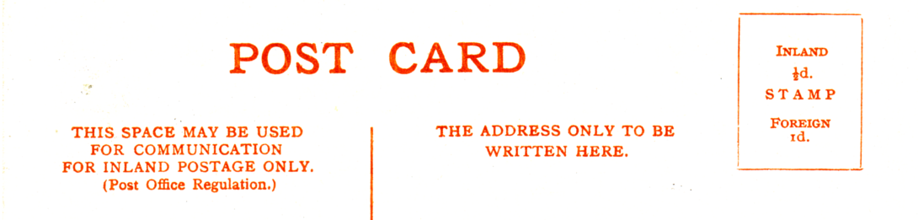

No. 1. Harvest Scene in Chhota-Nagpur.-Christian Villagers.
No. 2. On the march in West Africa. The S.P.G. is about to resume the work in W. Africa which it began in 1751. Vert left.
*No. 4. Wamira Mission School, New Guinea.
No. 3. A Buddhist Priest in N. India. Vert left.
No. 6. Chinese Mandarins.

Type 2. B/W litho printing, with 'S.P.G. Missionary Postcard No....' at the top, and title at the bottom in brown, white border. Dark green back 'POST CARD' measures 54mm, blank stamp box.

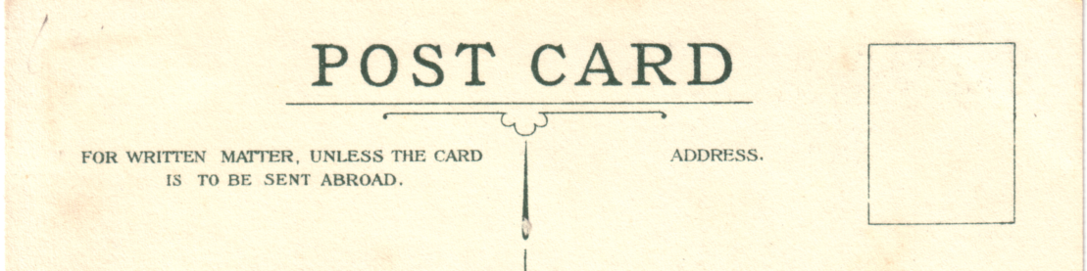

No. 26. School Girls in S. India engaged in gymnastic exercises.
No. 32. A blacksmiths shop worked by mission pupils in South India.
*No. 35. A Wood Shop in South India.
*No. 36. A Coolgardie Gold Prospector, Western Australia.
*No. 38. A Typical Scene in West Central Africa. Vert.
No. 45. A Cocoanut Palm in the South Pacific. The S.P.G. started and carried on for many years the work in the South Pacific which is now supported by the Melanesian Mission Society. Vert right.
No. 48. A Burmese Lady. The S.P.G. began missionary work in Burma in 1864. There are 3,000 children attending Mission Schools.

Type 3. B/W litho printing, with 'S.P.G. Missionary Postcard No....' and title at the bottom in brown, white border at bottom only. Dark green back 'POST CARD' measures 51mm, blank stamp box.

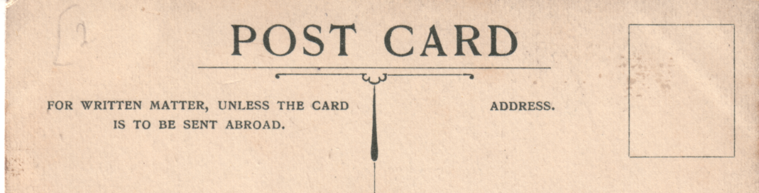

No. 58. Australian Aborigines. The S.P.G. is helping to support work both amongst the English Colonists and the aborigines in different parts of Australia.
No. 60. A native of West-Australia. Vert left.
No. 61. Pounding corn in Corea. (This card has a perforated left side indicating it has come from a book of postcards)
*No. 63. The Church at Kanghoa, Corea.
*No. 66. Chingeng, Nikko.
*No. 67. Hear No Evil, Speak No Evil, See No Evil. Japan.
*No. 68. Japanese Pilgrims with hats, gongs & rosaries.
*No. 72. Children at St. Faiths Mission Peking.
*No. 77. Fijians at work making fans and hats.
Note. There is another card which may be of this type but unfortunately it has been badly cut and it is possible that 'S.P.G. Missionary Postcard No....' is missing. The title is

Children of different nationalities at Singapore. The S.P.G. began work in the district of Singapore in 1861.

Type 4. Coloured, title in white. Brown back with 'S.P.G. Coloured Post Card No.... Series 8.' down left side, 'POST CARD.' measures 42mm, divider and top bar in double lines, 'Printed in Great Britain.' in stamp box.

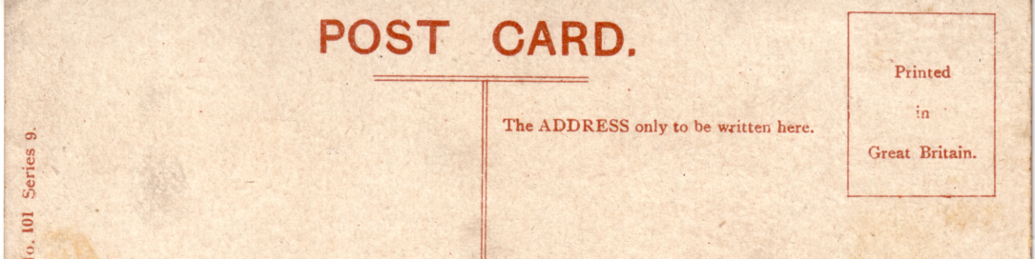

Series 8.
No. 90. Cascade Mountain, Alberta.
*No. 91. A House in Fiji. Vert.

Type unknown. Coloured, this card has not been examined and may be type 4, 5, or a new type.
Series 9.
*No. 108. A Group of Dyaks.

Type unknown. Coloured, these cards have not been examined and may be type 4, 5, or a new type.
*No. 121. S.P.G. Mission School, Boys, Merdang, Borneo.
*No. 122. Christian Dyaks, Borneo.

Type 5. Coloured, combination line and screened photogravure printing. Brown back with 'S.P.G. Coloured Post Card Series 16.' down left side, 'POST CARD.' measures 40mm, blank stamp box. The title is repeated on the back with additional text.

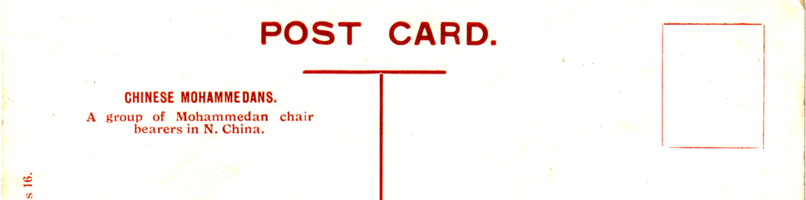

Series 16.
Chinese Mohammedans.

Type 6. B/W combination line and screened photogravure printing, the picture is boxed in a single line, on some cards the picture is quite small to allow room for a message. In addition to the title on the front there is also text, on some cards this can be as much as eight lines. Dark green back 'POST CARD' measures 55mm, 'A half-penny stamp to be placed here' in stamp box.

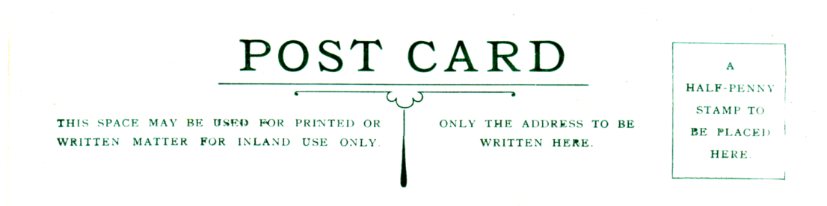

A Clergy House in Andros, West Indies.
A native home in Trinidad, West Indies.
A native of Borneo. Vert right.
Beggars at Bangkok, Siam.
Childrens bazaar in Burma.
Halt of a caravan in W. Africa. Vert left.
Karen girls carrying water.
School girls on the East Coast (Madagascar).
The first native Church in Buluwayo. Vert left.
Umbrella hat, Chhota Nagpur. S.P.G. Vert left.

Type 7. Sepia Matt R/Photo, title in white. Black back, 'POST CARD' measures 31mm with 'Greetings' underneath, 'Published by S.P.G., 15 Tufton Street, Westminster.' down left side.

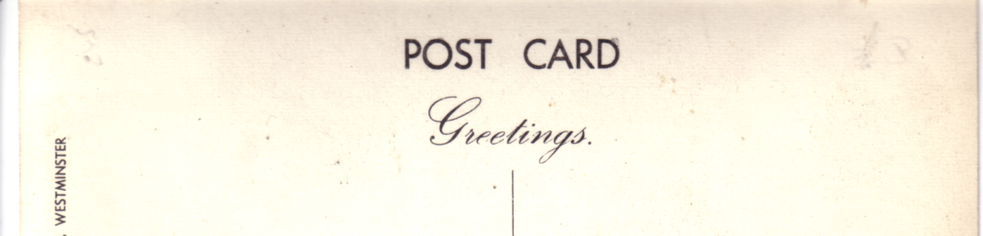

The S.P.G. Ship 'Centurion' at Swanage.

Type 8. Coloured, combination line and screened photogravure printing, 'Copyright S.P.G.' and title in blue at bottom. Blank back.
A New Epiphany

Type 9. Coloured, details unknown.
Series 21.
* Carriers in N. Borneo.
* Women & Children, N. Borneo.
* S.P.G. Mission School, Banting, Serawak. (The same view as Type unknown No. 121.)

I have written to Dr Pocock asking for details of all cards marked *. At the moment I have put them in where I think they should go. If any members have any S.P.G. Missionary cards and can add to these, I should like to hear from them.

