EDITORIAL AUTUMN 1994

It's too b..... hot to think of rhymes
They'll have to wait till cooler times

When I said in the last Newsletter the book was finished, I really thought the book was finished, I realise now it would have been more correct to say that the first phase of the book was finished. The publisher we approached just over a year ago could not produce the quality we were looking for. The next made encouraging noises, but it took him about three months to decide not to go ahead, this took us half way through April.
We then approached a third publisher who had already produced a book on the 1951 Festival of Britain, they were very encouraging, and were almost sure they would publish it. On the 20th of April, I wrote to them sending a sample chapter and illustrations, explaining that we wished to launch it at the Postcard Centenary Fair and Exhibition at the end of August. It was not until the second week in June that I was able to get from them that, yes, they were still interested in publishing it, but they had so much work on, that they could not think of getting around to it for at least a year. I asked if that was so, why didn't they tell me this two months ago, pointing out that they were aware of my delivery requirement, if they had read my letter. This met with a stony silence. After this Mike and I realised if we wanted it out this year, we would have to consider publishing it ourselves.
At a committee meeting held in April at Karl Illingworth's house in Manchester, we reported the position, and during the discussion Karl very generously said that his company would sponsor the printing costs. The committee also voted a grant of two hundred pounds towards the expences incurred by Mike and myself in the preparation of the book. An offer which was gratefully accepted.
So again we sent out samples, and here our luck changed. I had managed to find a firm that specialised in printing short runs of books, they sent me a sample book of the same style they would do for us, they also sent sample printings of illustrations from the photos I sent them, and they were first class. They could also deliver by the 22nd of August, if I could present them with the text spaced out to take the illustrations where required, within ten days.
So it was back to the computor again, re-setting out the text, to include a Fig No. for each illustration, and inserting the Fig No. in the space for each illustration. Personally I dislike having to guess which illustration is being referred to. Often it is obvious, but it can sometimes be confusing. So now everything has been delivered to the printers, and we are waiting for the 22nd.
We have not gone over the top with regard numbers, and are only having 500 printed. We feel it is better to aim for a sellout, than finish up ten years from now with a thousand unsold copies in the loft.
One of the points we had to decide was whether to include valuations in the book. We both felt that to include prices would date the book, and we were against this. We could have got round it by giving the cards a scarcity rating, but we see the book being regarded as a text book that will stay in use for many years. We have decided however to produce a small pocket supplement to the book, that will have no photos of cards or text, but will just contain the titles with a box to tick in when you have the card and a valuation for each of the 3,900 plus cards listed. This will in no way make the book obsolete, as the pocket edition is meant to be used in conjunction with the book. Unless you have it, the pocket edition will be almost meaningless, it is designed to supplement, rather than replace the book at a lower price.
Mike has now got himself a computor compatable with mine, and as he had to leave the main book for me to produce, is going to start work on the pocket one. This will entail

going through the disc deleting all matter we shall not be including in the pocket edition. This should be ready in about a year's time. For myself it will be nice to get away from Wembley for a bit, as I have many other projects that got shelved for the book.
For the future when collectors have had a chance to go through the book, I hope they will let us know of any cards they own that we have not listed, and, perish the thought, any mistakes they spot.
It is nice to be able to record that the firm dealing with the allocating of the I S B N (International Standard Book Numbering), is a very efficient firm and although there were queries, each letter from me was replied to within 24 hours, the whole matter involving three phone conversations and four letters was dealt with in six days.
Readers may remember in the spring issue I mentioned the need for replacing a few of the earlier Newsletters, as some of the Groups master copies were not too good. I am happy to report that Mike has come up with about eight of the early ones, and these have now replaced poorer quality master copies.

Editor.

8th CONVENTION
At 'The Century' on the 24th & 25th of September 1994

This is the last reminder you will get about our 8th Annual Convention, which is being held at the same place as last year, The Century, Forty Avenue, Wembley Park. The number of members who have offered to give a display at our convention is coming along nicely, and I am making a list of those requiring lodging at Mrs Mullane, also those joining us for our annual Dinner on Saturday evening, so if you have not already done so please let me know, also don't forget the guided tour of the Stadium, on the Sunday afternoon. I mentioned in the last newsletter that one of our new members John Swanborough was giving a display, and now another new member Mike Gorringe, who has not attended a convention before because of business commitments hopes to attend and has offered to give a display, as has Judith Edwards, also attending her first Convention. This week I heard from Professor Burton Benedict (at 2.00 in the morning) phoning from America to say he is coming over, and will be attending. He will be renewing old acquaintances as he has not been to one since the first, held in York in 1987. We will be starting both days at 9.30. On the Saturday as usual before the start of the displays we will be holding our A.G.M. This should not take long. There will be breaks for coffee and tea, and lunches will be available midday. On the Saturday evening we shall hold our Dinner at 7.00 for 7.30. After lunch on Sunday we will be going on an official organised tour of the Stadium, this will start about 2.30. Members with long distances to travel should be able to be on the road by about 4.00

BACK COPIES OF THE NEWS LETTER

Some time ago, I had a request for a back number of the News Letter No. 22 from Mike Mobbs, who was interested in the list of Belgian Exhibitions it contained. When I photo-copied it, I noticed the list was missing. from it. After phoning around, I found that because it was a loose supplement, in Dutch or Flemmish, nobody had kept a copy. Eventually Stanley Hunter found one page of it.
Then just as I was giving up hope, out of the blue John H. D. Smith who does the I.P.M. Catalogue handed me an updated copy of the two sheets recently sent to him by the author, R. Van Peteghem, which I was able to forward to Mike.

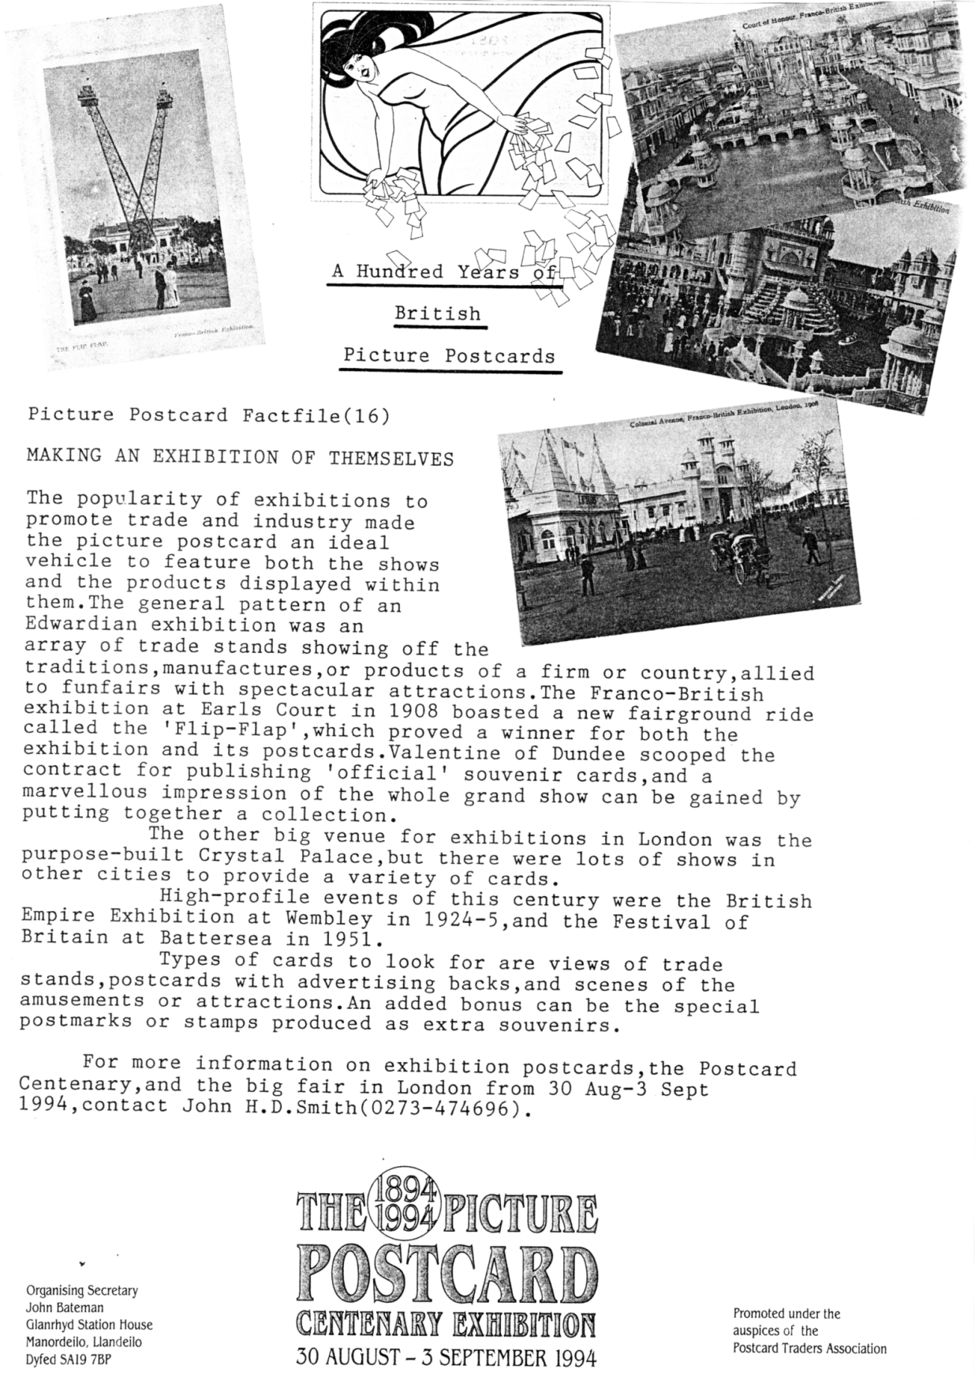
A HUNDRED YEARS OF BRITISH PICTURE POSTCARDS

Mike Perkins was given the Picture Postcard Factfile (16) by Brian Lund who kindly gave permission for us to print it in the News Letter. Any publicity on exhibitions must be good, even if the author John H. D. Smith reckons the 1908 Franco-British Exhibition was held in Earls Court.

CIRCULATION PACKET

The idea of a circulation packet for postcards arose in 1993 but, due to internal problems, it did not get off the ground until the beginning of this year. To date, two packets have been sent out, with the third ready to go and a fourth awaiting compiling. The packets are primarily aimed at postcards, but anything of interest to our members can be included provide it is postcard sized (and not too thick). If you have anything that is bulkier such as books, china, etc., please send me details and I will include them in the packet for members to contact you direct.
Packet number one went out in January and contained 64 cards, mainly Wembley, which were seen by 22 members, and took about 18 weeks to circulate. The total value of the packet was £122.00, and 49 cards were sold yielding sales of £94.00.
Packet number two was despatched in March, has 64 cards plus a book of exhibition labels, etc.. To date this packet has been seen by 13 out of 24 members, who have purchased 35 cards plus labels.
There are now 29 members who have asked to see the packets, and what I am trying to do is tailor the packets and lists so that members see the cards they collect. At the moment it looks as if it will be split between Wembley packets and other exhibitions. It all depends, of course, on what material I have to make the packet up with! So come on everyone, dig out all those surplus cards (and ephemera) and let me have it - remember there aren't many shopping days left 'till Christmas so the cash will come in handy!!!
How does the packet work? Well, material for inclusion is sent to me, held until I have sufficient material, sorted and logged, and sent out. When the packet returns, sales are totalled up, commission deducted (at 10%), and any unsold cards plus cash (less postage) returned to sender. Members who receive the packet are allocated a number on joining, and numbers are drawn out of a hat to determine the circulation list order. This ensures that members appear on the list in a random order, and do not always follow someone who collects exactly the same cards that they do. I do cheat slightly where two members live close to each other, and I pair them up so that they appear together on the list. This saves them postage and speeds the packet. I do reverse their order for each packet!
On receiving the packet, the member checks the contents against the contents list, selects any items for purchase, signs for them on the list, fills in the advice slip (whether purchases have been made or not),and parcels up the packet securely. If posting the packet on, a certificate of posting MUST be obtained! The cert of posting, the advice slip, and payment if needed (make cheques payable to M PERKINS please), are then posted to the Packet Secretary.
If a member leaves the packet with 10 or less cards, they should please return the packet to the Packet Secretary.
If you would like to receive the packet, or have material for the packet, please contact the Packet Secretary - see front cover for address.

Mike Perkins.

POSTCARDS OF THE

BRITISH EMPIRE EXHIBITION

WEMBLEY

1924 & 1925

by
MIKE PERKINS & BILL TONKIN
Exhibition Study Group publication No. 2
Copyright M. Perkins & W. E. Tonkin
Published by the Exhibition Study Group
23, Bramley Way, West Wickham, Kent. BR4 9NT.

Probably the first thing which the reader will notice on looking through this book is the amount of detail that has been recorded about the cards. We believe this is the first time that an attempt has been made to produce a detailed and specialised study of the postcards on any subject. In the past compilers have been content to produce basic lists with little attention paid to details of printing methods used, whether there has been more than one printing, which may be different and can be identified, or if for instance the back of the card has been produced in different styles or even different colours. We have for the first time recognised that vertical format cards can have the backs printed facing right or left, ie. if a vertical card is turned over as you would the page of a book, the word POST CARD and the stamp box (if there is one) is either on the right or left. Some cards can be found in both types, printed Vert right and Vert left. There is also an instance in the Malaya Pavilion series where the same negative has been used to produce both a vertical and a horizontal format card, both with the same number. To us these are different cards and we have listed them as such. Postcard collectors sometimes start out as stamp collectors, as we did, and from there go on to collecting postcards for various reasons. The collector moves from a world where the catalogues are a specialised source of knowledge, telling the collector everything he wishes to know, not only about the value placed on a stamp, but recording in the greatest detail all the particulars of that stamp.
How different is the picture when we look at the postcard catalogues. Their information is so limited by lack of knowledge and lack of space that one must question the use of the word catalogue.
While working on this book we did at one point count up how many different 1924-25 British Empire Exhibition cards we had recorded, and it came to over 3,900. The 1994 Post card catalogue is able to cover this in just ten words and four prices ranging from 75p to £25. To be fair to the catalogue editors, until detailed lists are compiled and made available by collectors or specialised societies, the job of comprehensive pricing of the cards cannot begin. We are now working on a pocket sized price and check list. to supplement the book.
It is not suggested that collectors will wish to collect their cards to the degree of specialisation which we have laid out, but we think it is important that collectors should know what is available so that they can form their own opinion on how far they wish to go in their particular field. Although both authors have a background firmly based on stamp collecting, we have not got involved in colour shifts, or different shades, so dear to the heart of the philatelist, although often what starts out as a slight colour variation, leads on closer examination to have other differences. Some of these might be slight, but may indicate a
different printing or setting, so that one is led in the end to a decision that it is a new type, that should be listed.
After working on this for nearly seven years, we felt that the seventieth anniversary of the exhibition was a good time to publish a book just on the Post Cards of the British Empire Exhibition 1924 & 25. An enormous amount of new material has come to light, since the last publication on these cards, and an example of this, is the fact that the Houghton Butcher Malay Pavilion listing by Brooks and Fletcher contained 10 titles, this was increased by Knight and Sabey to 50, and we have brought this total up to 566. With so many cards listed it is important that the reader should be able to find a card easily. The layout of the book is in alphabetical order, so that under Canada for instance, will be found all the cards published by the Canadian Government, Canadian Businesses, and publishers producing one or a series of cards solely featuring Canada. Other cards are listed under the publishers name, and some of these may have several Canadian scenes included in their series. All the Trade or Advertising cards are listed under the name of the Advertiser, who is generally also the publisher, and not under the name of the printer or subject. Where we have thought it would help we have cross referenced certain items, anyone for instance looking for Tibettan Dancers will be referred to F. J. Bhumgara, or Grafton China to A. B. Jones & Sons.
One of the early questions we had to ask ourselves was "what is a British Empire Exhibition card"? Obviously any card showing an exhibition scene or saying in big black letters "See our stand in the Palace of Engineering" is O K, but what about the dozens, possibly hundreds, of cards often showing a colonial scene with no mention of the exhibition. Many collectors pass these by because they have not seen the packet in which the set of cards was sold and this may state "Specially produced for the British Empire Exhibition 1924", or words to that effect. Sometimes one of these cards can be found with a Wembley stamp, and exhibition cancellation showing it was posted at the Exhibition, and perhaps if you are lucky a message on the back reading "We have bought this card from the Indian Pavilion". So yes, these are all Exhibition cards. We have in all doubtful instances given our reasons for including cards or sets in the book, where these we feel are proven. There are a few cards included where we have a gut feeling that we are right, and in these instances we have stated that we are unable to prove that this is an exhibition card".
It could be argued that a visitor may have taken a card to the exhibition to post, and that a Wembley stamp and exhibition cancellation by itself is no proof that the card was bought at the exhibition, and this is so. To take an example it is possible that a visitor living at Hampton Court might take a card he has bought locally to the exhibition, but the chances of this happening twice is very unlikely, and yet two Hampton Court cards of the same Gale and Polden series are known with a Wembley stamp and exhibition cancellation. It is up to the collector to decide whether he wishes to include Hampton Court cards in his British Empire Exhibition collection. This is a personal opinion only and one of the joys of collecting, is that you do it as you want to do it. We certainly are not setting out to tell you what you should or should not collect. But having said that we have gone to great lengths to describe what we feel can be termed exhibition cards.
It is necessary, particularly with Tuck's cards to pay careful attention to the backs of the cards. The fact that a card may have 'By Appointment' under the Coat of Arms of King Edward VII (who died in 1911) does not mean that it is not a B. E. E. card, as there is no doubt that Tuck took the opportunity to sell off old stock at the exhibition. Also many of their past favourites were to take on a new lease of life, when sold in a packet with for example 'Reproduced by Raphael Tuck & Sons, Ltd. for the Palestine Pavilion. British Empire Exhibition. 1924.' as happened with the cards of The Holy Land and Jerusalem. There are so many different backs, which indicate different printings spread over perhaps twenty years,
that one must be careful to get the right back which was available at the exhibition. We have also been careful to only include cards that we have personally verified the existence of. It would have been so easy to fall into the trap of assuming that types exist, like the 45mm and 48mm measurements of POST CARD in the Valentines X.L. series. Probably all the titles exist with both measurements, but we cannot be sure until we have seen them all. In the same way we cannot be sure that all titles in the Tuck Ceylon Committee series exist with both 62mm and 65mm. inscriptions.
We plan to launch the book at the Post Card Centenary Fair and Exhibition to be held at the end of August. It will become the standard work of reference for many years to come. The book will be a hard back with dust jacket in A4 size. In all we have listed over 3,900 cards, there are 270 illustrations, and 228 pages of text.
The book will be in a limited edition with a 500 print run, retailing at £17.95. We are making a special offer to members of the Group, who may order one copy only at a reduced price of £15.95 post free, in the U.K. Please make cheques out to W. E. Tonkin.

THE FESTIVAL OF BRITAIN

A List of Information Sources
by
John Kirby

This is an attempt to list the known printed ephemeria published on the Festival of Britain, compiled by John Kirby, Librarian, of the School of Cultural Studies, Sheffield Hallam University.
In his introduction he states "It is by no means a complete record, new material surfaces at regular intervals, and almost every second-hand bookseller's list on design history or similar topics can reveal previously unrecorded items on the Festivals ramifications in towns and villages up and down the country." How right he is, and this is a sensible approach.
The title is I think a bit misleading, as by using the term 'sources' it implies information on where the listed items can be found, this is not so, it is a plain straight forward list of books pamphlets, cards, advertising stickers, and all the associated souvenirs that were available. At the end of 1989 a decision was taken to collate as much information as possible, to add to the collection already owned by the Sheffield Hallam University, and John circulated all the public libraries in the U. K. asking for details of Festival material in their collections. "The response was mixed and a number of libraries felt unable to reply".
The book is divided into two parts, first the 'Title Sequence' a numerical list running from 1 to 1412, mainly in alphabetical order, and in the second part the items have been grouped into a 'Subject Index'.
I spoke and wrote to John back in September 1992, mentioning our group and the Festival of Britain Society, inviting him to our Convention, and offered a bed if he wished to stay. I told him that one of the friends staying with me that weekend, was Fred Pesket, Chairmen of the Festival of Britain Society, who had a large collection of F.O.B. material, and that I would use our newsletter to try and get information for him. I wrote that I had a 37 page list of F.O.B. postcards. To date John has not contacted either The Study Group or the F.O.B. Society, and it would seem he prefers the academic approach to compiling a list rather than accept help from the collectors, who let's face it own the bulk of the available material and the knowledge that goes with it.
This narrow view is reflected in the fact that he has only been able to list just 31 post cards in the subject index, 8 Jarrold, 2 Salmon, 7 Tuck, and 16 Valentine, making a total of
33, (the other two you have to hunt for in the Title Sequence list). He lists one set of stickers, out of the six sets that I know of, not counting the different colours, and in the printed ephemeria and souvenir fields, has barely scratched the surface.
Those who buy the book will notice that the numbers on the right hand pages jump from odd numbers to even numbers at page 188, this is caused by duplication of page 187.
Despite its shortcomings this is the only book on Festival collectables and all Festival bods will want to own a copy. It can be obtained from,
Peter Inch. Inch's Books. 82, The Mount, York. YO2 2AR. for £16.50 post free. Peter also produces lists of books relating to exhibitions, and if any of you do not get his lists which are free, drop him a line and ask for his list No. 75, this contains about a hundred International Exhibition Items.

THE ROYAL TOURNAMENT

Members who attended the 1992 Convention held at the Crystal Palace will remember the display given by Arthur Smith on the Royal Tournaments. The highlight of this was the fact that he had been able to identify the year of publication of the cards connected with these events, covering the years 1906 to 1949. It has always been a problem in that not all of the cards have the year printed on them.
At the time I felt that Arthur's research should not be lost, and he has now given me copious notes so that his work can be recorded. His solving of this major problem has meant it should now be possible to produce. a listing of all the Royal Tournament cards. I doubt if this task could have been tackled without his breakthrough.

Editor

THE ROYAL TOURNAMENTS at OLYMPIA

1906 to 1949 inclusive
Less the war years 1915-18 and 1940-46

Copyright Arthur P Smith 1-7-1993

TITLES

1906-14 Royal Naval and Military Tournament
1919 only Royal Naval Military and Air Force Tournament
From 1920 The Royal Tournament
DISPLAYS

Year inc. Main Display Other Displays
opening &
closing dates
1906 Tilting in Olden Times R.N. crossing the line
17/5-2/6 R.N. Field Gun Crews from H.M.S. Victory & H.M.S. Excellent
1907 Ye Tournament in ye Olden Days R.N. Physical Training
16/5-1/6 R.N. Field Gun Crews
1908 West African Regiment R.N. Field Gun Display
21/5-6/6 Boys R.N. School Greenwich
1909 Transportation of Troops to a Riding & Jumping Display
13/5-29/5 Theatre of War Musical Ride R.H.A. & Dragoon Guards
R.N. Field Gun Crews
1910 Britannia's Muster Army & Navy Gymnastics
20/6-6/7 (400 men & 175 horses) Musical Ride 21st Lancers
Arab Tent Pegging
R.N. Inter Port Field Gun Crews
1911 Heroes of British History Peninsular Period Costume
18/5-3/6 (320 men & 100 horses) Army & Navy Gymnastics
Musical Ride (R. Scot Greys)
1912 The Call to Arms 1588 Historical Ride 1685 - 1912
23/5-8/6 (500.men & 100 horses) Old Time Firing Excercise by Green
Howards
R.N. Field Gun Display
Musical Ride
1913 The Restoration 1660 Musical Ride 2nd Life Guards
22/5-7/6 Cavalry Display 20th Hussars
R.N. Field Battery Display
1914 The Romans in Britain Army & Navy Gymnastics
14/5-30/5 Highland Dancing by Boys
(Q. V. School Dunblane)
R.H.A. Musical Drive
5th Dragoons Musical Ride
1915-18 No Tournaments held
1919 The Attack Boys from H.M.S. Excellent
26/6-12/7 (Items from the Great War Displays by W.R.N.S.
tanks etc)
1920 "I Remember" Pageant Royal Marine Light Infantry
20/5-5/6 R.F.A. Vaulting Display
1921 Neptune's Soldiers Pageant R.H.A. Musical Drive
19/5-4/6 2nd Life Guards Musical Ride
R. E. Display
1922 The Royal Navy Past and Present Rope Climbing
18/5-3/6 Q Boat and Submarine
Guard Mounting
1923 Scotland in Arms Massed Pipes and Drums
24/5-9/6 12th R Lancers Musical Ride
1924 Hearts of Oak Naval Pageant Musical Drive R.H.A.
22/5-7/6
1925 "Ubique" Royal Artillery R.N. Gun Crews
28/5-13/6
1926 A Frontier Fight Brigade of Guards
8/7-24/7 (Combined Display) R.A. Service Corps
Musical Ride R.H.A.
1927 Scotland Massed Pipe Bands
19/5-4/6 1. Battle of Killiecrankie R.A.F. Display
2. Scottish Dancing R.N. Field Gun Competition
3. Unity (100 years after) Kings Squad R.M.
1928 The Battle of Inkerman R.S.F. Mounted Display (Weedon School)
24/5-9/6 R.A.S.C. Display
The Royal Scots Greys
1929 1st Batt. Middlesex Regt. Musical Ride 17th / 21st Lancers
23/5-8/6 (Die Hard the 57th) Mounted School Weedon
(Steady the Drums & Fifes) 3rd Batt. R. Tank Regt.
1930 Royal Fusiliers Historical Display 17th / 21st Lancers Display
29/5-14/6 Musical Ride (3rd Carabiniers)
Pipers of the Scots Guards
Army School of P. T.
1931 2nd Batt. Gloucester Regt R.N. Gun Crews
28/5-13/6 Historical Display Musical Ride R.H.A.
R.A.F. P. E. Display
1932 1st Batt. Prince of Wales Regt. Activity Ride Life Guards
25/5-11/6 Musical Ride
Royal Signals Motor Cycle Ride
Jumping Competition
1933 1st Batt. The Royal Scots Musical Double Ride
25/5-10/6 (The Royal Regt.) R.M. & R.N. Field Gun
Surrender of Ft. St. John's R.H.A. Musical Drive
Newfoundland
1934 2nd Batt. The Black Watch Musical Ride R.H.G.
17/5-2/6 (Royal Highlanders) Window Climbing & Rope Climbing
by Boys of R.N.
P. T. by the R.A.F.
1935 Arrival of Katherine of Braganza R.N. Field Gun Competition
9/5-25/5 at Portsmouth
1936 2nd Batt. Norfolk Regt. Armada Territorial Army Air Defence Display
7/5-23/5 Display Musical Drive R.H.A.
1937 Hon Artillery Company Historical Royal Marines
27/5-12/6 Display Boys of the Duke of York School
Toy Soldiers
1938 Scottish Regiments Musical Jumping Display 5th Royal
19/5-4/6 Inniskilling Dragoon Guards
K. Battery R.H.A.
P. T. R.A.F.

1939 Mimic Battle Toy Soldiers Royal Marines
18/5-3/6 (Boys of the Duke of York Grenadier Guards
R.M.S.) Motor Cycles Royal Signals
Musical Ride Life Guards
1940-46 No Tournaments held
1947 Massed Pipes and Drums Fleet Air Arm join R.N. Gun Crew
12/6-28/6 Competition
Royal Signals Despatch Riders
1948 Sunset Ceremony by Massed Bands Ceremony of the Keys
10/6-26/6 of the R.N. school of Music R.N. Inter Port Field Gun Competition
Royal Signals Despatch Riders
1949 Massed Drums and Pipes of the R.N. Field Gun Competition
16/6-2/7 Brigade of Guards Royal Engineers Bridge Building
Competition
Royal Signals Despatch Riders

POST CARD PRINTERS

1906 Gale & Polden Photographic
1907 Unknown printer Photographic
1908 Gale & Polden Photographic
1909 Gale & Polden Photographic
1910 Gale & Polden Photographic
1911 Gale & Polden Photographic
Unknown printer 1. Coloured poster card
1912 Gale & Polden Photographic
Unknown printer 2. Coloured poster cards
1913 Gale & Polden Photographic
Unknown printer 1. Coloured poster card
Mrs Albert Broom Photographic (dated)
1914 Gale & Polden Photographic
Set of six prepared before the Tournament
(dated)
Unknown printer 1. Coloured poster card
1919 Gale & Polden Photographic
Unknown printer Photographic

1920 Gale & Polden 3. Coloured cards
Unknown printer Photographic
1921 Gale & Polden 5. Coloured cards
Unknown printer Photographic
1922 Fleetway Press Photographic (dated)
Coloured (dated)
1923 Fleetway Press Photographic (dated)
1924 Fleetway Press Photographic (dated)
John Waddington Coloured (dated)
1925 Fleetway Press Coloured poster card (dated)

1926 Fleetway Press Set of six photographic (dated)
Black & red poster card
1927 Fleetway Press Photographic (dated)
1928 Fleetway Press Set of six Photographic (dated)
1929 Fleetway Press Photographic (dated)
1930 Fleetway Press Photographic
L.P.M. 1. Coloured Modern poster card (dated)
1931 Fleetway Press Photographic
1932 Fleetway Press Set of six photographic
From 1933 Fleetway's old address 3-9, Dane St, Holborn, W.C.1. was altered to their new address 11-15, Emerald St, London, W.C.1.
1933 Fleetway Press Set of six photographic
1934 Fleetway Press Photographic
Unknown printer Photographic (dated)
1935 No cards seen
1936 Fleetway Press Photographic
1937 Betts Son & Malyon Photographic
1938 Betts Son & Malyon Photographic
1939 Betts Son & Malyon Photographic
1947 Gale & Polden Photographic
1948 Gale & Polden Photographic
1949 Gale & Polden Photographic
I have only two cards of different types, of subjects common to all three years 1947, 1948 and 1949. Further information is required to date these cards. I have used the word photographic as a general term to include both Real Photograph and Photogravure.

A B.E.E. IN MY BONNET

By Peter Griffin

Part 3

The Wembley Stamps 1924 - 25

We are all familiar with the stamps from the Exhibition. Just the two values were issued, 1d and 1 1/2d, with a change of date for the 1925 issue. They were originally intended for issue and use at the exhibition offices only, but such was the demand from the general public that some main offices were issued a stock. Many dealers had stamps and stationery items mailed to them from the exhibition to satisfy collector demand. The price of these issues has fallen substantially in recent years as the early investors and collectors of that period are departing to that great stamping ground in the sky leaving behind sheets and smaller multiples that are now flooding the market. It is still worth the extra effort and expense in finding the freshest and best centered copies you can find.
The paper was watermarked Block Cypher and no inverted watermarks are thought to exist. The paper is generally of a uniform standard but occasionally a denser, harder paper turns up and is associated with more intense shades as less of the ink is absorbed into the surface.
The stamps can be found with both Specimen and Cancelled overprints, at a price. As with coil-joins (see below) these can be, and have been, faked - so beware.
It seems two plates were used for the 1924 1d and just one for each of the other three values. There were no control or plate numbers in the margins but some North East corner blocks are to be found with what are generally considered to be batch numbers (fig. 1) as not all corner blocks have them.
The sheets of 120 were separated into the Post Office issued panes of 10 x 6 at the guide crosses. Similar crosses appear in the corners as well. (fig. 1)

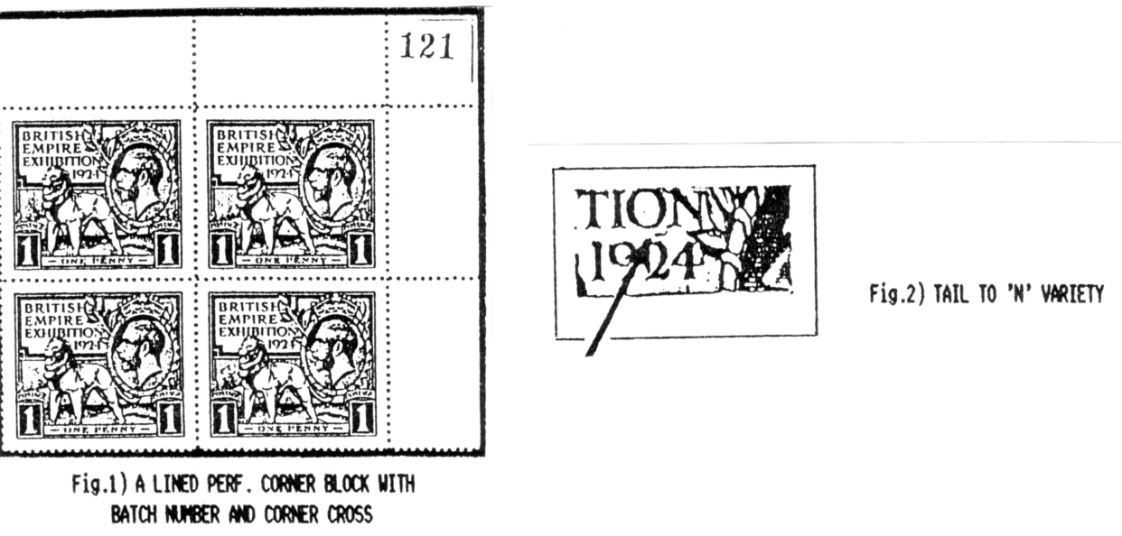
As with all recess-printed issues there are plenty of minor varieties to be discovered but there seems to be only one on the Wembleys that seems to rouse any sort of excitement. It is to be found on plate one of the 1924 1d in position 1/5 of the left pane. Known as the 'Tail to N' variety it commands a hefty premium but you could get lucky as I did and find it on a postcard. (fig. 2)
The first issues of the 1924 pair were line perforated. That is to say they were perforated vertically and horizontally in two separate operations that resulted in a tangle of holes at the corners of each stamp. These are readily recognised by the very tiny perf. holes and the blunted corners of the stamp. Later a comb perforator was used which produced larger holes and neater corners (fig. 3). Broken perf. pin varieties exist, I have found only one and believe they must be very scarce. Mine is on one of the line perf. 1d stamps. I also have a line perf. stamp which is one perf. taller than any others I have seen. Where there are tall stamps there may well be short stamps too, so keep an eye open.
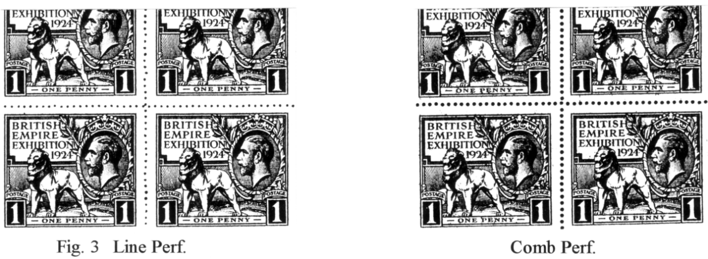
The coil stamps were distributed by the grand sounding 'British Stamp and Ticket Automatic Delivery Co. Ltd.' who had seven machines installed at various points around the grounds. They made up the coils by separating standard panes into vertical strips with the lower selvedge being used to effect the coil join every tenth stamp. In most, but not all the examples I have seen the vertical separation seems to have been carried out with a guillotine. Evidence of this in the squared-off or blunted perfs. would do much to persuade me I had a genuine coil stamp and not something someone had faked. The only coil join I've seen that I'm totally convinced is genuine is a 1925 1d and 1 1/2d pair in vertical strips of four where each stamp is pierced by two holes caused by the missaligned feed mechanism that is supposed to co-incide with the perforation holes. Obviously the stamps must be considered damaged but it is a super variety and well worth keeping if discovered. I have a single 1 1/2d and a pair of 1d values but not a coil join I regret to say (fig. 4).
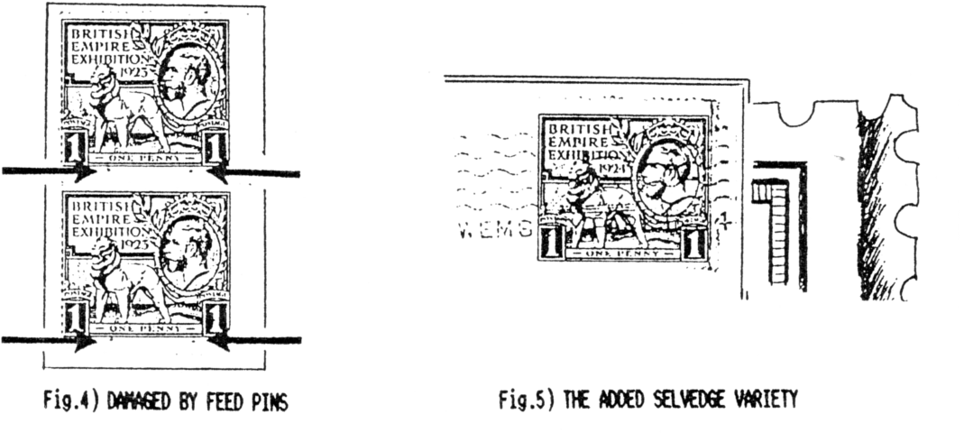

I always look at Wembleys on cover for coil joins. They are almost certainly going to be single stamps but one in every ten from the machines will have a narrow strip of selvedge under the top edge of the stamp. The only one I've yet seen was found by a dealer first and he wanted too much for it so I'm still without one. However I have found something that is perhaps more interesting.
I bought a collection of postcards several years ago as it included a number of early cards from my area. On checking the reverse I found two Wembley adhesives on cards tied by the official Wembley slogan. One stamp appeared to be faulty down the right hand margin and on closer inspection I could see the original perfs. had been somewhat raggedly trimmed and an extra piece of selvedge had been added to restore its fully perforated appearance (fig 5). It suggested that besides the recorded vertical delivery machines there must have been a sideways delivery type installed somewhere in the Exhibition Grounds, and I was looking at a coil join. Although it seemed most unlikely, the only other conclusion was that the sender of the card had produced this oddity for reasons best known to him/her alone.
It made an interesting write up but with just an isolated example no firm conclusions could be made. Then a couple of years later another one turned up. This one, completely trimmed to a straight edge on the right, again had a piece of selvedge added to restore the original width. One is a freak, two is a phenomenon! So I publicised my findings, and sideways machine theory, in the G. B. Journal. This prompted a responce from Alan Sabey (of "The Lion Roars" fame) who apparently has one as well and he put forward the most likely theory, that when the stamps were being guillotined into vertical strips the occasional miscut resulted in narrower stamps. Presumably this could have affected the smooth running of the coil machines, maybe some sideways fluctuation, thus causing a malfunction which could be corrected by the restoration of the stamp's original dimensions. This may explain the fact that later examples of coil stamps seem to have been separated by folding and tearing in the normal way thus avoiding the extra work involved after a mishap with the guillotine. As with single Coil-join stamps this variety has to be tied to a cover or card to be sure it is genuine. As few people are yet aware of it any piece of Wembley mail is worth an extra squint - just in case.

End of part three.

1938 SCOTTISH EMPIRE EXHIBITION.

I have had a request for a list of the coloured Brian Gerald cards issued for this exhibition, and thought it may be of interest to other members. Type 1 is an odd series and I have only found two of them, they could be early cards issued, before Valentines decided to tart them up with a splash of red. Further information on these would be welcome. As far as I
know I am only four cards short of Type 2 which is the main series, Nos. 703, 706, 707, and 714 unless there are any more nombers after 722. The list for Type 3 is complete.
You will notice I have described the vertical format cards as Vert left, if you hold a vertical card looking at the picture and turn it over like the page of a book, the heading ie POST CARD will be on the left or the right side. I do this as some cards are known with the backs printed to the right and the left, and where this occurs I collect them both.

Valentine & Sons Ltd.

Art Colour Series.
Type 1. Coloured, from original water colours by Brian Gerald. Grey back with the Empire Exhibition Lion logo at bottom of the single line divider also in grey. All the titles end in 'Empire Exhibition, Scotland 1938.'
A 691 The Clachan,
A 693 North Cascade and Tower,

Type 2. As Type 1 with grey back, but the Empire Exhibition Lion logo is now in red, this was printed in a second operation as the red can be misplaced sideways by as much as 17mm, minor misplacements are common. The logo is also misplaced verticaly, on some cards the divider line touches the lions head while in others there can be a 3mm gap. There are shade variations in both the grey and the red, but like the misplacements these are not listed individually. Numbers 708 to 713 were sold in a packet (Set No. 23) as 'Clan Tartan' at six for 1/-, and were earlier views repeated, the other cards were sold at eight for 1/-.
A 691 The Clachan,
A 692 Dominions and Colonial Avenues,
A. The letters C.B. are printed in the stamp box, at bottom right.
A 693 North Cascade and Tower, Vert left.
A 694 South Cascade and Tower,
A 695 Cascade and Lake, Dominions Avenue,
A 696 Dominions and Colonial Avenues,
A 697 South Cascade & Tower by night, Vert left.
A 698 Atlantic Restaurant and Tower,
A 699 The Tower Vert left.
A 700 Scottish Avenue
A 701 Kingsway,
A 702 The Lake Illuminations
A 704 The Lake Illuminations
A 705 The Tower of Empire, by night, Vert left.
A 708 The Tower, (as No. 699 but with a Cameron Tartan border including their Coat of Arms and sprig of heather) Vert left.
A 709 Dominions & Colonial Avenues, (as No. 696 but with a Fraser Tartan border including their Coat of Arms and sprig of heather)
A 710 Dominions & Colonial Avenues, (as No. 692 but with a Gordon Tartan border including their Coat of Arms and sprig of heather)
A 711 The Clachan, (as No. 691 but with a Royal Stewart Tartan border including their Coat of Arms and sprig of heather)
A 712 North Cascade & Tower, (as No. 693 but with a MacKenzie Tartan border including their Coat of Arms and sprig of heather) Vert left.
A 713 South Cascade & Tower, (as No. 694 but with a MacDonald Tartan border including their Coat of Arms and sprig of heather)
A 715 The Globe, United Kingdom Pavilion, Vert left.
A 716 Scottish Avenue showing Tower and Atlantic
A 717 Victoria Falls Rhodesia Pavilion,
A 718 United Kingdom Pavilion
A 719 North Cascade and Tower
A 720 An Clachan
A 721 The Post Office, an Clachan
A 722 An Clachan
A 733 An Clachan
Note. It is possible that No. 733 was printed in error and should be 723, or it could have been an odd card produced for some reason. The cards were sold in two packets of 8 and one of 6 which adds up to 22 ie 691 to 722

Type 3. As Type 2, coloured but with a simulated 'brush stroke' effect on the front like the Tuck Oilfacsims, on the packet (Set No. 22) these are listed as 'Art Colour Postcards with oil paint finish', and were sold at nine for 1/6. Grey back, with the Empire Exhibition Lion logo in red, this like Type 2 was printed in a second operation as the red can be misplaced verticaly, on some cards the divider line touches the lions head while in others there can be a 3mm gap. Very little sideways misplacement has been noted, there are shade variations in both the grey and the red, but like the misplacements these are not listed individually.
A 691 The Clachan,
A 692 Dominions and Colonial Avenues,
A 693 North Cascade and Tower, Vert left.
A 694 South Cascade and Tower,
A 695 Cascade and Lake, Dominions Avenue,
A 696 Dominions and Colonial Avenues,
A 697 South Cascade & Tower by night, Vert left.
A 698 Atlantic Restaurant and Tower,
A 699 The Tower Vert left.

