EDITORIAL SUMMER 1994

The summer has come and it's pouring with rain
Time for the groups news letter again

The book is finished, Mike Perkins came down and stayed for four days last week and we crossed the last t and dotted the last i and that's it. We have decided that this is not going to be the last of the British Empire Exhibition, but rather a pause. We shall still continue to collect information about the cards ready for the first update.We also have other intentions, but of those later. The text and illustrations will run to about 200 pages. At the moment we have not got a publisher, and if we cannot find one shall have to publish it ourselves.
Our Treasurer Alan Sabey tells me there are still a few members who have not yet paid their subscriptions, which were due on October 1st , so come on, send a cheque to Alan for £8.00, now.
I've been hauled over the coals about my article on Bicycles and Exhibitions, by somebody who while not a member of the Study Group, knows all about bikes. It turns out he lives in Shirley, about a mile down the road, we have spoken on the phone and talked about a meeting. Apparently Andrew Hall of Glass Slipper gave Douglas Marchant a copy of the Newsletter to read. Just shows how it gets around. I have mentioned Douglas's letter under letters to the editor.
The prices some dealers are asking for cards never cease to amaze me, a couple of weeks back I saw a Sharp's Toffee card at £35.00 and a Railways (of Ireland) Tourist Office card at a staggering £50.00. Now neither of these are scarce cards, the Irish Railway card is the least seen of the two, but there has been about half a dozen come onto the market in the last couple of years, and no way is it worth the figure being asked. Readers may be interested to know that John H. D. Smith has asked me to price the British Empire Exhibition section in his next catalogue which I have done. I showed Mike my list of suggested prices and he agreed they were about right. I suppose looking back over the last few years there are very few cards that I have turned down because of the price, but then I am fortunate in having most of todays high flyers. I am a firm believer that anyone who pays these ridiculous prices is making a rod for his own back. It will be a sad day for all collectors if dealers manage to find mugs to pay these prices. It is a certainty that there will never be a comprehensive priced catalogue for every postcard, and it follows that dealers will make up prices as they go along.
At our last Annual General Meeting it was agreed that the Minutes should be published in the Newsletter, this has been done and will be found elsewhere. Members will see that we are in a very happy financial position, thanks to Karl Illingworth who generously meets all the costs of printing and distributing the Newsletter. The Study Group held a Committee Meeting in Manchester at Karl's house on the third weekend of April, with half a dozen of us staying with him for one or two nights. The meeting confirmed Mike as the Packet Secretary, and this will come up at the next A. G. M. According to our constitution the notice of the A. G. M. should have been announced in the Spring Newsletter, together with a call for nominations for officers and committee which should be in by the end of July. This unfortunately was overlooked and I am putting it in now. The A. G. M. will be held at the start of our Convention which will be on the weekend of the 24th and 25th of September.

Bill Tonkin.

Minutes of the A.G.M. held at the Century Wembley
on Saturday 25 September 1993

Apologies for absence were read from Celia Bailey, Chris Butler, Moray Graham-Bonnalie, Fred Peskett, and Debora Sugg.

1. Presidents Report Stanley Hunter welcomed all present at the meeting and went on to thank the Officers and Committee for their efforts during the past year. In talking about the future of the Group he said he would like to see the Group publishing specialised pamphlets on research being done by members, where the likely demand did not warrant publishing a book.

2. Secretary's Report Bill Tonkin gave his report, and gave details of the Groups involvement with the exhibition on the Ideal Homes Exhibition held at the Design Museum. Several members had loaned material, and a small group had made it for the Official Opening. He said that Debora Sugg who had organised the exhibition had agreed to give a talk at the Convention, but at the last minute a serious opperation had meant she had to cancel it. He went on to say he was not happy with the way things had gone during the past year, and instanced the way the newsletter was being delayed and not being passed on to Karl, the Spring copy being held on to for three months, the Summer copy two months, and the Autumn number which he posted on the 2nd of August so that members would get a final reminder about the convention had still not been passed on to Karl after eight weeks. He suggested the Newsletter team be reduced from three to two. He reported that since last November he had repeatedly asked the Membership Secretary for names and addresses of members which he still had not received, and made the point that although he understood about twenty members had notified the Membership Secretary that they wished to receive a club packet, despite repeated requests for the names and addresses since May, he had not been able to obtain them, he suggested the position of Membership Secretary be merged with that of Secretary.

3. Treasurers Report....Damon Murrin gave his report, and said he had not produced a Balance Sheet but the finances were in a healthy state with a balance of £516.25. He went on to say the membership had increased from 25 paid up members in 1990 to 49 with a possible 5 more to pay in 1993. We now had about fifty members, and this after about thirty names had been taken off the membership list who had not replied to two letters. He had also written to all members asking if they wished to receive a packet. Don Knight proposed a vote of thanks to Karl Illingworth for his generosity in producing and distributing the Newsletter at no cost to the Group, this was agreed. He also inquired if the £8.00 subscription was enough to cover the Newsletter should we ever have to produce it ourselves, and Damon assured him that it would.
It was suggested that to attract new members, cards giving details of the Group could be introduced into the exhibition sections of dealers stock. Mike Perkins agreed to take care of this and thought he could get the cards into at least forty dealers boxes.

4. Election of Officers. The following officers were elected.
President Stanley Hunter
Vice President Karl Illingworth
Secretary Bill Tonkin
Treasurer Alan Sabey

Newsletter Team
Editor Bill Tonkin
Distribution Karl Illingworth
Membership Secretary Bill Tonkin
Public Relations Alan Sabey
Committee Andrew Brooks
Don Knight
Mike Perkins
Fred Peskett
Auditor Nancy Tonkin
Don Knight proposed a vote of thanks to Damon for his work over the past years, this was seconded by Mike Perkins.

5. Constitution The Secretary had been asked to prepare a Constitution for the Group, and had distributed copies of a proposed Constitution to the meeting. This was adopted after several alterations had been agreed, namely,
Objects C. (A) was deleted.
E. add 'to be held normally'.
Officers & Committee Delete D. and E. leave in the alternative D.
Change F. to E.
Management C. Don Knight proposed that five members form a quoram and this was seconded by Damon Murrin. Brian England proposed an amendment making it four members and this was seconded by Andrew Brooks. On a vote being taken the amendment was lost.
Committee Meetings It was proposed that 'by the Secretary' be added, and this was agreed.

Don Knight proposed that the Constitution be agreed and also proposed a hearty vote of thanks to the Secretary for the work he had done in drawing it up. This was seconded by George Simner and agreed.

6. 1994 Convention It was agreed that it should be held at the same venue. Several suggestions were made for next year's Convention.
A. Alan Sabey said he intended to put on a 'Wembley' tea table at the Convention.
B. Brian England suggested a guided tour of the Stadium.
C. Andrew Brooks suggested a possible display for the public.
D. Dilwyn Chambers suggested advanced details of the meeting might attract more visitors, he also said it might be possible to borrow and display some items from the Grange Museum.
E. Bill Tonkin suggested making it a B.E.E. weekend, but it was pointed out that some members had other interests.

7. A.O.B.
A. Mike Perkins and Bill Tonkin reported on progress with their book on Wembley Post Cards, Bill was to contact Phillimore to see if they would publish it. They hoped to finish it by January so that it could be published in 1994.
B. It was suggested that the Walk-about Guide that Alan Sabey and Bill Tonkin had produced, might be offered as a booklet. If this were to be done it would need considerably more text to be added.

C. Alan Sabey reported that the Cinderella Club had agreed to publish a listing of Firms Advertising Labels for the B.E.E. 1924-25.
D. Bill Tonkin suggested publishing an updated Members Interests List. It was agreed that members should have the opportunity to be excluded if they so wished.
E. Dilwyn Chambers suggested that the minutes of the A.G.M. and possibly the accounts also should be published in the Newsletter. This was agreed.
F. Don Knight proposed a vote of thanks to the Chair, and the A.G.M. was concluded at 11.43 am.

After the A.G.M. six Seville Beakers donated by Bob and Anne Tough were auctioned by Don Knight and these raised £30.50 for the Group. Bob and Anne were thanked for their generous gesture.

End

EXPO '92 SEVILLE

By Ron Trevelyan

Like Stanley Hunter my plans to visit Seville with the Study Group were dashed at the last minute. However, I was fortunate to receive an 11th hour opportunity to go for a brief (3 day) visit at the end of September. By this time most people at Expo 92 were counting the days to the end of the event (12 October) and local Spaniards were flooding in for a final taste of what was on offer. For example, on Saturday 3 October the attendance was 600,000. Despite the brevity of my visit, my appetite to learn more about the event was sharpened.

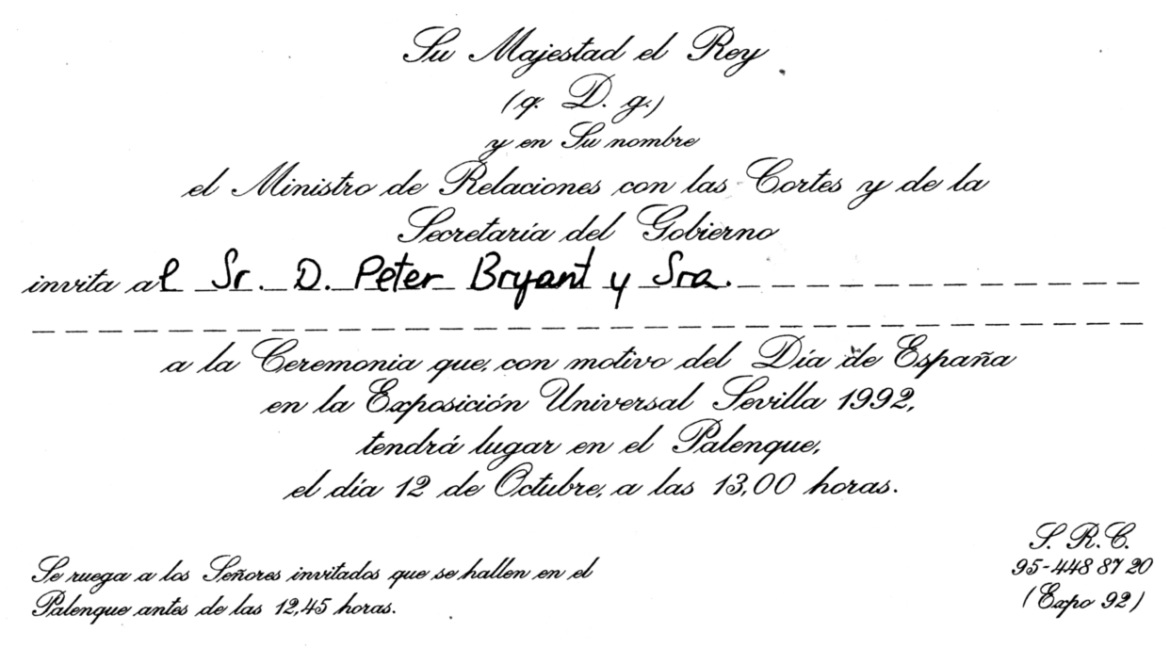

Invitation to a formal ceremony for Spanish National Day
at the Spanish Pavilion on 12 October 1992. Speeches included those
by the Spanish Prime Minister, The Director General of Expo '92
and the King of Spain

The Seville Expo story really begins in Paris in 1983 when the Bureau International des Expositions (B.I.E.) decided at their 93rd Session on 15 June to award the event to Seville rather than to the other contender, Chicago. Both had chosen the same theme 'The Age of Discovery'. The decision meant that this was the first 'Universal' event to be staged in Europe since Brussels in 1958. Seville fitted the bill well because 1992 was the 500th Anniversary of the discovery of the New World by Christopher Columbus and the latter began his epic voyage from Seville. The closing date of Expo '92 actually coincided with the day when Columbus discovered the Americas.
Having received the go ahead, the Spanish authorities earmarked a 538 acre site on the island of Cartuja separated from Seville by the Guadalquivir River. The island was named after the 15th Century Carthusian monastery which still exists and, totally refurbished, became the Royal Pavilion during Expo '92. Columbus frequently stayed at the monastery and his remains were buried there for some time. Planning for Expo '92 involved changing the course of the river, raising the level of the island by some 13 feet and the building of seven new bridges and nineteen miles of new roads. Added to this was a new airport terminal and railway station for Seville (with a new fast train service to Madrid), as well as a huge car park 3 miles long to provide parking spaces for up to 40,000 cars and 1,000 buses. A garden city project was commenced in 1985 which transformed a former wasteland on Cartuja by the planting of 25,000 trees and 300,000 shrubs from 5 Continents. All this involved a massive transport and infrastructure investment of 7 billion US dollars and in the process created about 18,000 jobs.
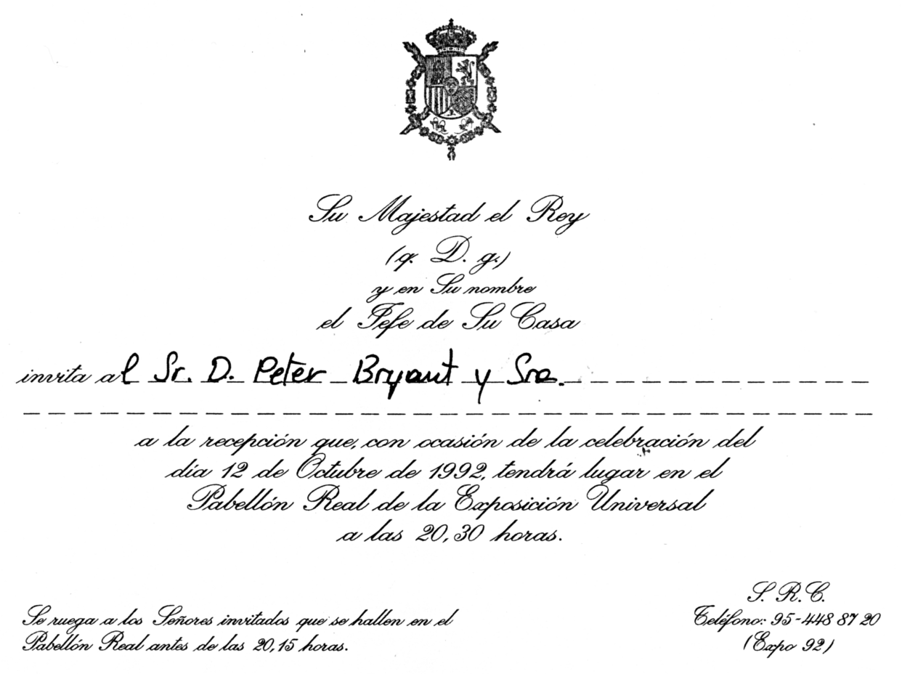

Invitation to a reception at the Royal Pavilion on 12 October 1992

Expo '92 was opened by King Juan Carlos on 20 April 1992 with a 21 gun salute and the release of 5,000 doves and 110 balloons, one for each participating nation. The Expo '92 planners had to bear in mind the extreme heat of high summer in Seville and to combat this

created a microclimate by the use of 'outdoor air conditioning' in trees and a bioclimatic sphere. Thus there were some shady walks with additional cooling from fine sprays of moisture droplets, and numerous fountains had an important psychological effect.
Before the opening there was a good deal of criticism in the press about the last minute nature of much of the construction work, especially on individual pavilions. The media also made much of two fires when the Pavilion of Discovery was irretrievably damaged by fire in February 1992 and the Pacific Islands Pavilion was burnt down by the spark from a welder's torch in April 1992. However, as one of Stanley Hunter's illustrations shows (Newsletter No. 30, page 32) expo fires have occurred before, eg the Brussels 1910 Exposition. The eventual line-up to greet the king was one of 110 nations and up to 23 multinational companies which were housed in 95 separate pavilions.

3rd Series 12 April 1988
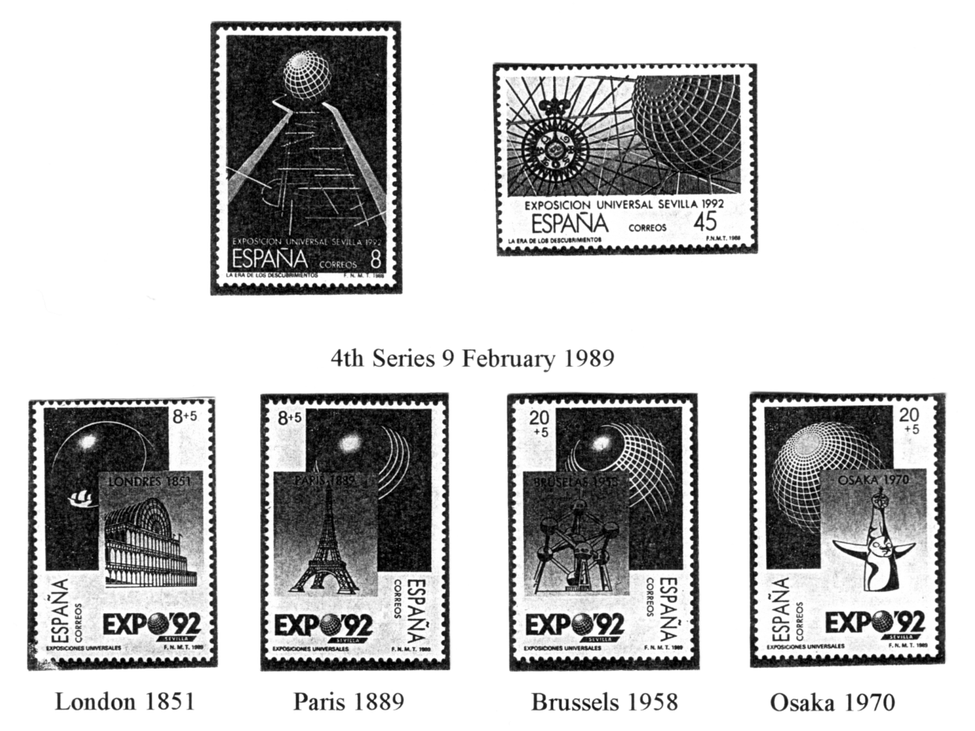

I am afraid that a combination of limited time and long queues at many of the major pavilions meant that, with one or two exceptions, the medium and smaller sized pavilions were my happiest hunting grounds. Nevertheless, an ideal view of the pavilion exteriors could be obtained from a trip on the monorail which circled the whole site. The following interesting features of some of the individual pavilions may be worth recording.
British Pavilion
A steel, glass and canvas structure as large as Westminster Abbey with the front curtained by a moving sheet of water, mainly powered by solar panels. The pavilion won an architectural award in the U.K. and the multi-media show won an industry award. Some disappointment was expressed over the quality of the inside static displays.
French Pavilion
Models of Paris through the ages - on three levels - could be viewed through the floor.

Japenese Pavilion
Built entirely of wood, it is said to be the world's largest wooden building.
New Zealand Pavilion
The exterior featured cliffs complete with gannets.
Chilean Pavilion
Constructed of wood and copper, it housed a 60 tonne iceberg shipped from Antartica.
Swiss Pavilion
This featured an 82 feet high tower made entirely of papier-mache.
Indian Pavilion
Formed in the shape and coloured plumage of a spread peacock's tail.
Hungarian Pavilion
Constructed from 20 truck loads of oak and pine brought from Hungary. It resembles a rustic church with bell towers representing various religions. Portrayed in a surrealistic way, the internal theme was Hungary as the crossroads between east and west.
Danish Pavilion
With white sails on wood and surrounded by water, it resembled a boat.
Norwegian Pavilion
A gateway of ice and an enormous pipeline led to the pavilion.
Russian Pavilion
The sloping face of the pavilion was composed of swivelling cubes so that different colour schemes could be achieved. It was noteworthy that the cubes often showed the red, white and blue of the Russian flag, bearing in mind that the pavilion was originally conceived as the Soviet Union Pavilion.
Australian, Canadian and Spanish Pavilions
All had breathtaking cinema shows. Canada and Spain had Imax shows with the Spanish Pavilion having tilting seats to provide appropiate effects. The Australian cinema showed stunning scenery on large screens which ran right round the walls. It transpired that the screens were static whilst the auditorium and audience moved around.
Theme Pavilions
Despite the disaster with the Pavilion of Discovery, a number remained. These included the Pavilions of the Universe, Energy, Telecommunications and the Environment (all in the Plaza of the Future), as well as the Pavilions of Arts, Nature, Navigation and the 15th Century.
Each participating nation had a national day which provided occasions for big displays, parades art and folklore. The British one was held on the 21st May when the Prince and Princess of Wales attended. The Spanish National Day did not take place until the closing day and was marked by a number of ceremonies, receptions etc. it was attended by the Spanish Royal Family, the Spanish Prime Minister etc.
So, after all this was it a success? I have no information on the financial outcome, but despite rival attractions in Spain like the Barcelona Olympics and Madrid being the European Cultural Capital of the year, there were about 41 million visits to Expo '92 (which probably meant 18 to 20 million visitors). As expected a large proportion of the visitors were Andulasian, the event being very popular with them. Soon after the opening about 200,000 six monthly season tickets costing the local equivalent of £170 each had been sold to Spaniards. Those who bought daily tickets for the evening only were able to watch the nightly firework/ laser display which took place at 10 pm.
The impression I formed during my visit, in what was probably just about the busiest period, was of a well laid out exposition with much of interest both outside and inside the pavilions. The use of foliage and the creation of the microclimate was very imaginative and

made life much more comfortable walking around. As mentioned above the British Pavilion had some criticism but it remained a popular pavilion throughout, attracting more than 2.1 million visits. My particular interest in Expo '92 stems from the special issue stamps and according to my reckoning around 35 nations commemorated the event in this way.
It is reasonable to ask what future the Seville expo site has after such an enormous financial outlay. It seems that the Spaniards intend to retain at least some of the buildings and to create a theme park there. However, the British Pavilion did not remain. It was the subject of earlier rumours linking it with the London Zoo, but in the event it was purchased by an Asian company in the U.K. who intend to rebuild it in the Park Royal area of Brent. There it will become part of a leisure centre with a number of facilities and serve as the Asian Sky T.V. I was pleased to receive a cutting from the Willesden and Brent Chronicle from a sharp eyed Study Group member at the Annual Convention in September. After seeing my small display on Seville he had noticed an article in his local paper about the future of the pavilion. A photo showed the pavilion which had been shipped from Seville in 107 steel containers, waiting to be constructed. Maybe a parallel can be drawn with the Crystal Palace which also had a new lease of life, our latest pavilion is said to be a modern interpretation of it.
Finally, to end this Seville story, Expo '92 did provide some inspiration for a couple in Derbyshire who bought a former village post office in 1992. They were at a loss to know what to call it, but then had a brilliant idea. By now you have probably guessed what their final choice was . It was "EX PO '92"!

End

STANLEY GIBBONS
POST CARD DEALER 1899

A friend recently came across a small publication by Stanley Gibbons. It was their 'New Announcements' for the year 1899, and it seems they were into the post card business offering a range of 'Government Post Cards'. These are some of the packets they are listing.
No. 27 The Sixpenny Packet, contains 6 varieties, including obsolete Japan, Perak, Cashmere, obsolete Cyprus, obsolete German Empire, and Roumanian Post Cards. Post free 7d.
No. 28 The Shilling Packet, containing 10 varieties, including provisional Ceylon, Straits Settlements, Mauritius, Holland, Surinam, Bulgaria, Danish, Servia, Wurtemburg and Bavaria 3pf. Post free 1/1.
At the end Packet No. 39 offered 100 Post Cards "including many rare" for 20/- post free. Stanley Gibbons also did a range of Albums for post cards from 5/- to 12/6.
All of the cards offered in these packets were unused, I have wondered why there are so many unused Victorian postal stationery cards about and this looks like the answer. Used cards are very seldom seen, especially from some of the out of the way colonies.
In their 10/- 'Jubilee Exhibition Packet' as an added inducement Gibbons give away one of the Prince of Wales Hospital Fund Diamond Jubilee Stamps.

1994 CONVENTION
AND TOUR OF WEMBLEY STADIUM

Alan Sabey has contacted the Tours Manager of Wembley Stadium and has paid a deposit for a guided tour on the Sunday of our Convention, that is the 25th of September

starting at 2.30, and finishing at approx 3.50. Normally the prices are £4.95 for adults, and £3 95 for Senior Citizens. If we can make up a party of 25 people then the charges are reduced to £4.50 and £3.50 respectively. We are again extending a welcome to members of the Wembley History Society as we did last year, so we should reach this figure. Alan would like to hear from members who wish to go on the tour.
I have also provisionally booked between 15 and 20 beds at Mrs Mullane's Boarding House and have told her I shall be able to give a firm booking nearer the date. It is important that I know if you will be coming, and if you are staying on the Friday and Saturday nights or only wish to stay on the Saturday. Also I shall want to know how many will be coming to our Annual Dinner on the Saturday night. Since writing this, Alan informs me that he has nearly got 25 names, so it looks as if the under 25 party prices will not apply.
So far I have had one new member John Swanborough, offer to give a display, and he asks how many sheets should he bring. We borrow frames from a local stamp club, they have nine frames which take twelve sheets each. John's name may be familiar to some of you as he helped compile the forth edition of 'Special Event Postmarks of the United Kingdom', a must for anyone collecting exhibition postmarks. He tells me that with a few exceptions he has a near complete collection of these. This is a display that I for one am looking forward to seeing. I hope some of our other members who have not displayed at our convention can be persuaded to have a go.
We are very fortunate in the group, in having members with outstanding collections, whom I can call on to give a display. The convention is your convention, and I should like to see more of our members taking part. If you have only a few sheets on a subject, don't think they will not be of interest. Time and time again a member with only a very modest collection turns out to have an item no one has ever seen before. So let me know that you are prepared to put on a small show. If you are not happy speaking to an audience, don't worry, there is no need for you to give a long talk, let your display speak for you.
Two thirds of our members have not attended a convention yet, and may not know what it is all about. Our first convention was organised by Andrew Brooks, who announced in Newsletter No. 7, in 1987 that if ten members would indicate they would come, then he would organise a a one day meeting to be held at York. He got his ten names and Professor Burton Benedict, Graham Hall, Stanley Hunter and Don Knight, agreed to give displays. Don's included a movie film he had made, one part of which showed a working model of the Flip Flap. The meeting wound up with us all walking round to Inche's Books for a glass of wine , and a browse through their stock of exhibition books. It was enjoyed so much by those attending, that the only complaint Andrew received was that it all went too quickly. After that it was decided to make the convention a two day affair, and on the Saturday evening we hold our annual dinner. The last four have been held at Crystal Palace or Wembley, and members regularly come from as far away as Avon, Hampshire, Glasgow, Manchester, Norfolk, Tyne & Wear and West Midlands. I think this says more than I can, how good the conventions are.

MOUNT EVEREST

by Brian England

It was many years after Everest was first recognised to be the highest mountain in the world, before political conditions in Nepal and Tibet allowed an attempt to be made to climb it. The first expedition eventually took place in 1921 organised by the Royal Geographical Society. This was mainly a reconnaisance and mapping expedition. So the 1924 Expedition

led by General Hon. G. C. Bruce C.B. was early indeed and, apart from very bad weather, was plagued by the effects of high altitude on the human body, about which, little was then known.

It was on the 1924 Expedition that G. L. Mallory and Andrew Irvine were seen going well at 8589 metres. They never returned, and, whatever disaster befell them is still unknown. What is even more intriguing is whether they died on the way to the summit or on the way back. Could the first conquest of Everest have taken place in 1924 rather than 1953, we shall probably never know. Knowing how crudely the team was equiped in 1924, this would have been a remarkable feat.

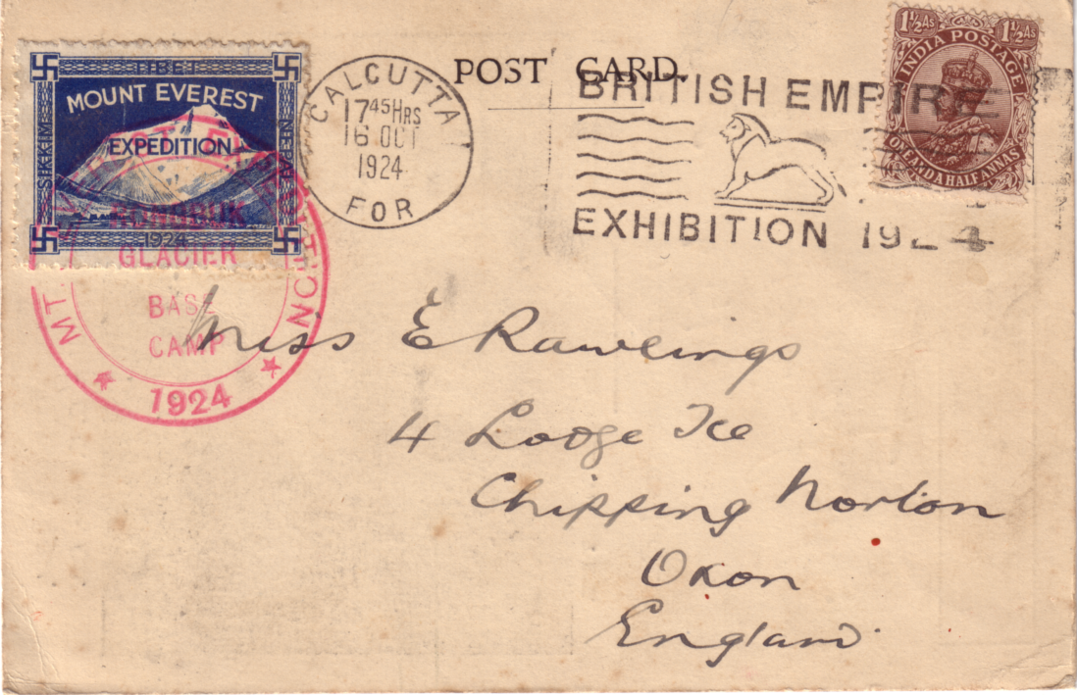

Among other features of the card illustrated, which are particularly interesting are the special 'Mount Everest Expedition' stamp and the base camp cancellation applied to it. Captain J. B. L. Nash, whose handwriting appears on the face of the card, paid from his own resources, £10,000 to be appointed official photographer to the expedition. These cards and their special stamps were devised by him. Together with the films and photographs he was able to show on his return, he hoped to make a financial success of the adventure. Captain Nash seems to have been something of an 'ideas man' as, at his suggestion, snow tractors, made by Citreon, were used in the early stages on the lower slopes.

As is so often the case when you start to research your latest postcard find, it's surprising how much interest there can be in one unusual item. Part of the Indian Pavilion at the British Empire Exhibition Wembley was given over to Nepal, and as a centrepiece in their 'court' was a model of Mount Everest. Throughout the exhibition small flags were fixed day by day to mark the progress of the expedition based on messages which were specially radioed back. Just when it seemed a celebration was in order, news of the loss of Mallory and Irvine was received. For the rest of the time the exhibition was open to the public, a wreath of bay leaves was placed over the model as a mark of respect to two very courageous men who had typified the best traditions of exploration and Empire.

PERFINS ON WEMBLEY STAMPS

By John Nelson

Members will remember some time ago John Nelson of the Perfin Society asked for help on a listing he was making of perfins on Wembley Stamps. The Perfin Society has published the results of his research as reported in our Newsletter No. 30 in a 16 page A4 size booklet. John has sent me an update on the booklet as follows.

Members (of the Perfin Society) may wish to note the following additions to the Catalogue of these perfins published by the Society in 1993. The total number of different dies is now increased to 59 and the number of stamps reported to 444. I am grateful to all those who have contributed additional information.

New Dies

B&M/LTD B4930.01 1924 1 1/2d
*BELLISS & MORCOM LIMITED,
Engineers,
Ledsam Street Works, Birmingham 16.
Exhibitors in 1924 (P/E Ave 11-12, Bay 17-18).

IOM I1928.01 1924 1d
User not identified.

NB N0210.2 1924 1d (pair)
User not identified but pmk London, 7 Aug 1924.

Additional stamps and covers

ABC A0530.05 1925 1d.
1925 1 1/2d on cover pmkd London NW1 7 Aug 1925.
BS&S B6850.01 1924 1 1/2d.
DM D3110.03 1924 1 1/2d.
D.S D4370.01 1924 1d (two).
ETC E4700.05 1924 1 1/2d.
F.G F1590.01 1924 1 1/2d.
HW/LD H7770.01 1924 1d (two) one on cover pmkd London 15 Jun 1924 with Williamson identity.
1924 1 1/2d.
J/TS J7900.01 1924 1d and 1 1/2d on cover pmkd London F S 10 Oct 1924 addressed to Basle.
M&P/P M4560.01 1924 1 1/2d.
PBL P0710.02 1924 1 1/2d (two).
R R0010.43 1925 1d and 1 1/2d.
RL/S R3340.01 1924 1d with complete pair of dies pmkd London 6 Jun 1924.
SM/L S5090.04 1924 and 1925 1 1/2d.
S.P/L S6000.01 1924 1 1/2d.

TWW T5220.02 1924 1 1/2.
W&S W6680.07 1924 1 1/2d (three) including two covers with Waterlow identity pmkd London EC and dated 11 and 26 Jul 1924.
W&S W6680.14 1925 1d and 1 1/2d.

end.

TROWELL - THE 1951 FESTIVAL VILLAGE

By Bill Tonkin

At the beginning of February Nancy and I decided to do the Nottingham Postcard Fair and not knowing the area at all we got in touch with Brian Lund who kindly sent down a list of lodgings in the area. We picked one that looked suitable and booked up for a couple of nights. We got there on the Friday afternoon and as I got out of the car I noticed the guest house we had booked in to was next door to a fairly large pub. I couldn't believe my eyes, there up on a post was the Inn sign, a huge Festival of Britain logo complete with the string of bunting underneath and the date 1951. After we had unpacked we went over to have a drink, and I saw that the pub was called the Festival Inn. There were a couple of large round plaques on the wall outside again with the Festival logo. We went in and I asked to see the manager, to find out what it was all about, but disappointment, he didn't know anything about the Festival, neither could I see any sign of lots of festival pots and jugs etc. on show. Had they got any souvenirs of the festival I asked having a vision of a cellar filled with unwanted festival junk. No he said, the only thing they had in the pub was a leaded glass door on a cupboard, which he pointed out behind the bar. It was a really beautiful thing about two ft in diameter let into the centre of the glass panel and was a festival logo in coloured glass. We went back the next evening for a meal, and I saw that the wine list and menu all had a rather modernised festival logo on them. We found out a bit more about the village later from the owner of the guest house, apparently Trowell Village had been selected as a typical English Village at the time of the Festival in 1951 and the village had been awarded a bronze plaque by the Festival Committee to commemorate this. The village decided that as they had no public hall, the placque should be kept in the church. On the Sunday morning before we left we went over to the church to see the plaque. It was about 18" by 12" and at the bottom in the centre was a coloured enamel festival logo about 2" in diameter. The village pub 'The Barley Mow' had lost its licence over a 100 years before the festival, so it was strange that the judges should pick a village without a pub. After going for so long without a drink, the brewers decided enough was enough and in 1956 a new pub was built. As at that time the festival was still fresh in everybody's thoughts, they named the new pub the Festival Inn.

the end

BRITISH THEMATIC ASSOCIATION

The Study Group has become a Society Member of the B. T. A. and will recieve two copies of their magazine 'Themescene' each quarter. Should any member wish to see a copy, this can be arranged on receipt of a large stamped (29p) and addressed envelope. Themescene will also available for members to read at our annual convention.

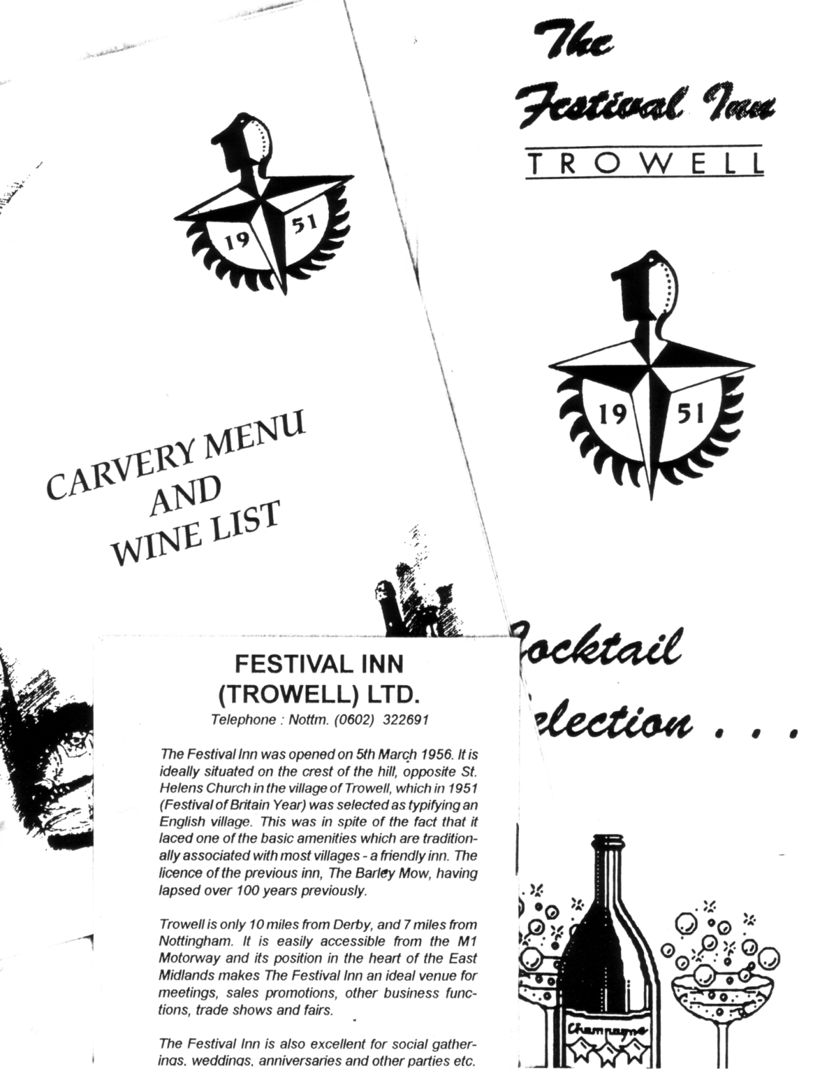
LETTERS TO THE EDITOR

I have had a long letter (two pages) from Douglas Marchant who is Editor of 'Cycle Clips' (this deals with matters and ephemeria to do with cycling). He comments that I have consulted various books and repeated the errors that have been repeated and repeated over the decades. This does happen and unfortunately it is not always possible to spot these errors, and once a fact has been recorded several times it tends to be taken as gospel. A case in point is my mention of the early 'two wheels in a line machine, that could not be steered', which Doug doubts ever existed, Bartleet however states quite categorically "could not be steered, the front wheel being rigidly attached to the main frame", he goes on to say that this was later improved "by passing the fork through a socket, so making it possible to direct the front wheel by a handle and so steer the machine". Bartleet formed possibly the largest collection of old bicycles ever assembled, which on his death was left to the City of Coventry, to found a cycle museum, and the above facts are taken from Bartleet's Bicycle Book published in 1931. Doug may be right, and it would then follow that nobody could "improve the design of a non - existent machine". There are other points, mostly minor, Griffin (1890) mentions Dennis Johnson taking out a patent in December 1818, Douglas claims Denis (one n) Johnson took out the patent in June 1818. He noticed that I missed out the year when I mentioned Macmillan knocking over a boy in Glasgow on the 6th of June, it was in 1842. Thanks for putting me right Doug, we'll have a get together some time.

Dear Bill,

Having sorted through the second circulating packet of postcards, I thought I should let you know how pleased I am to receive them. As a relative newcomer not only have I been able to buy cards (some of which I have not even seen before), but have also been able to learn at first hand about such abstruse things as Isle of Man cloud formations.
Of course, I realise only too well that it becomes more difficult to find 'new' cards as time goes by and your collection improves, but I have noticed that even 'old timers' appear to have found some cards of interest.

With best wishes
Ken Harman.

A B.E.E. IN MY BONNET

By Peter Griffin

Note. Unfortunately on page 14 an illustration of the Krag cancellation was left out, I have put it in at the start of part 2, and apologise for this omission. Editor

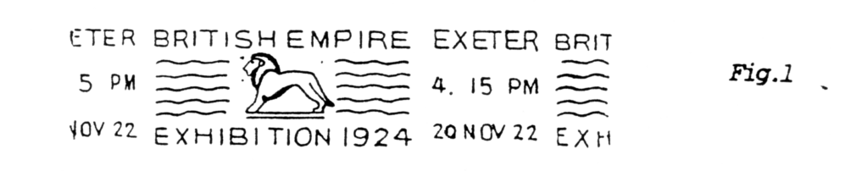
Part 2

Special Wembley publicity slogans of Great Britain 1924 - 25

During the period the Wembley Empire Exhibition was open a range of publicity slogans appeared promoting events to be held at the stadium. The first to appear, and the only one for 1924 was the Pageant of Empire slogan.
The Pageant of Empire was a three part production on the grand scale that depicted famous happenings in British History. Although the slogan was used on 34 machines throughout the country it does not turn up very often (fig 1).
Beside the double circle Hey Dolphin cancels a triangle containing the telegraphic codes appeared for London Eastern District Office and Newcastle-on-Tyne. These codes, E.D.O. and N.T. are particularly scarce but just the sort of thing that might turn up unexpectedly, as so few people would realise their significance. The slogans were in use from 10th July to 1st September 1924.
The only special slogan to appear that did not actually promote an event was the Fellowship slogan. During 1924 the Exhibition Fellowship was founded by the Prince of Wales as a patriotic fund -raising organisation to help finance the 1925 Exhibition. (1924 had not been the financial success hoped for so there were no profits to be re-invested.)
For the then considerable sum of two guineas one could become a member of the Fellowship. For this princely amount one received a special badge and a certificate signed by the Prince of Wales himself. Members were allowed certain concessions on entrance fees and tickets for events taking place at the Stadium. The slogans appeared from mid-march to August 1925 (fig 2). They appeared on Hey Dolphin machines only and at just two London Offices, Birmingham, Liverpool and Edinburgh.

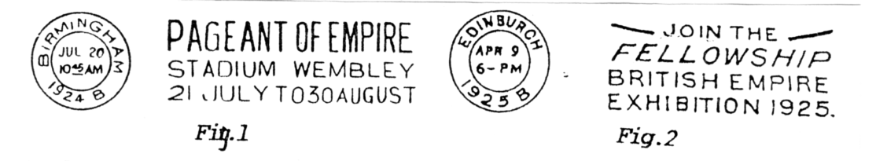
The first special attraction of the 1925 season was to be the military display 'London Defended'. Originally planned to run from 6th to 27th May at the Stadium the slogans were issued to that effect and were already in use, when the starting date had to be put back due to last minute problems. The Exhibition, and 'London Defended' eventually opened on 9th May 1925, but the performances continued until 1st June to make up for lost time.
Single circle Universal machines were used at three offices in London, and at four Provincial Offices. Southampton had two, one of which was the very rare Paquebot cancel, apparently the only such date die issued.
Seven London offices used a total of 16 double circle Hey Dolphin machines and a further eight from Provincial Offices (fig 3). Triangles appeared from London S. E. 1 and Glasgow G. W. both scarce. PAID dies appeared from Paddington and Southampton, again rare and I'm still looking.

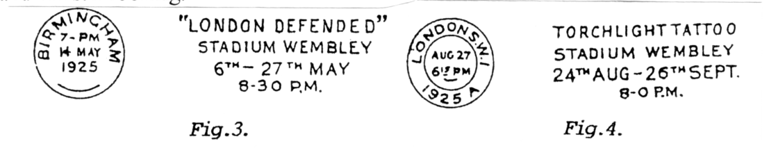
Probably the most interesting series to concentrate on collecting are the Torchlight Tattoo slogans.

The Tattoo was an evening performance, actually lit by searchlights and was planned to start on 24th August, which somewhat surprisingly it did,and to run until 26th September. Warm dry evenings and favourable publicity caused the final date to be extended four times. The original slogan (fig 4) was used on 42 machines at 24 different offices, nine of which were in London. This included Universal and Hey Dolphin machines, again with the odd scarce triangle and Paid dies being used. Three London offices changed their slogans to read 24th Aug - 10th Oct (fig 5) and as the dates moved ahead again some offices removed the date altogether. Both of these types are understandably difficult to find but are just the sort of rather boring looking item that collector after collector would shuffle through in a dealer's junk box without realising their significance.
When it was finally decided to let the performances run to the end of the Exhibition (31st October) many offices filled the date areas with various arrangements of blobs and bars. (figs 6, 7 & 8). Sheffield rather outshone the others by coming up with two very scarce types, totally different from anything else (figs 9 & 10)These are highly sought after and fetch good prices in any condition. (Hint, Hint!)
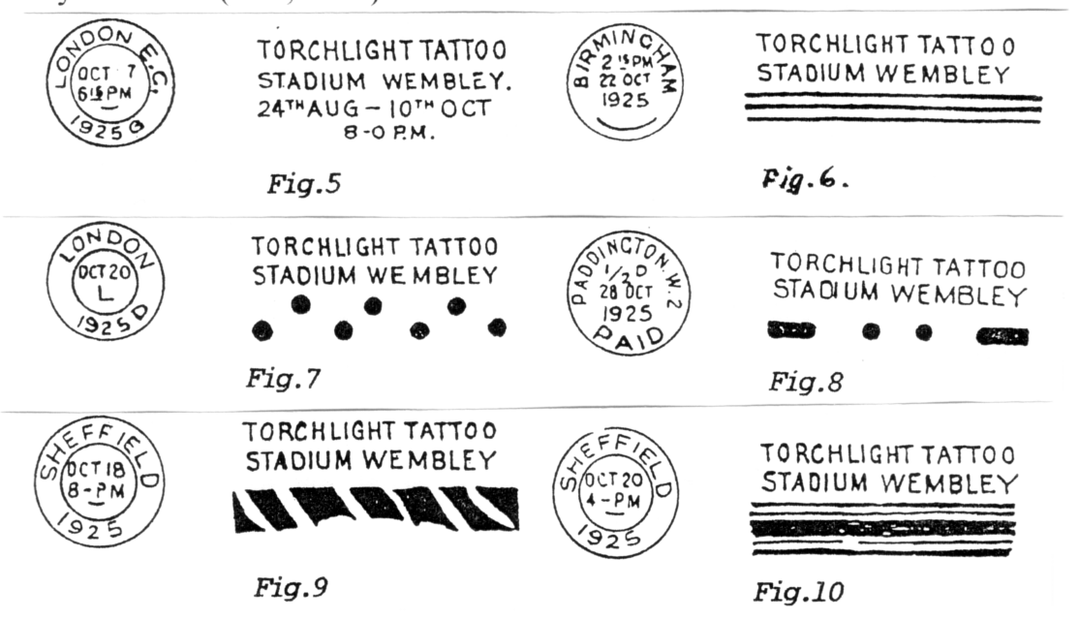
Some of these slogans exist in as many as three states so it is a real challenge to try and find matching pairs and trios bearing the same machine code from a particular office.
Another pair of cancellations that perhaps should fall into this range of publicity slogans are the very attractive machine cancels from Ulster. I have already listed them amongst the Empire cancellations, but as they were used within the British Isles and encourage a visit to the Ulster Pavilion they deserve a mention here. A number of philatelic items are around, usually on postal stationery, but genuine used examples are surprisingly scarce and very desirable in good condition (fig 11 & 12).

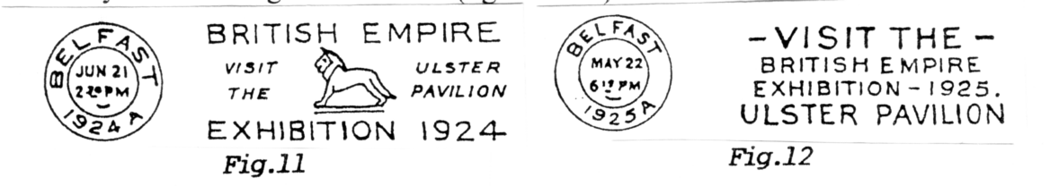
Though some of these special slogans are quite easy to find, to make a complete collection of each source and type would be a monumental task and I'm not sure anyone has yet attempted it let alone achieved it. They can be found for as little as 50p in good condition and as much as £50 for a scarce type even in poor condition.

