EDITORIAL SPRING No 32

I've got a new computor and I should be glad
But oh! it's not so easy as the old Amstrad

Yes you can say that again, but we are begining to master the brute, although not without a lot of trials and tribulations. I can now do nearly all the things I could do on the Amstrad, but much faster, and the laser printer produces really first class printing as you can see. I have also treated myself to a scanner, although as yet I am not using it. Fortunately I have been able to call on the services of the son of a local post card dealer, and he has been able to get me started. Our next session is going to be on scanners and how to use them.

My reasons for getting a new outfit was that the Amstrad was getting so slow, coupled with the fact that the printer was beging to play me up. One of the problems is that when you change from Locoscript which the Amstrad uses, on to the now almost universal IBM system not only are the discs a different size, but all the commands that you build into your work, like spacing, centering, typing in columns, etc, have to be deleted before you can transfer your text on to the new sized disc. In the case of the Wembley Book this has meant an estimated 8,400 manipulations, to get all the new commands typed in, thank goodness it's all done now. We have lost a good month, Mike and I hoped to have it ready to go to the printers early in the new year, but this has set us back a bit. Nothing has yet been finalised regarding getting it printed.

The Ideal Home Exhibition, and Festival of Britain lists which both run to about forty pages as well as the work I have done on listing the names and addresses of the 1924 & 25 Wembley exhibitors will also have to be done, but at least there is no urgency about those.

I have also been spending some of my spare time photo-copying two runs of back numbers of the News Letters. This is another time consuming job, one set has been ordered by a new member, and the other is wanted by The British Library, this being a legal requirement. Two things have impressed me during this operation, firstly the vast field that has been covered since No 1 was circulated to just ten members way back in 1980, There is a lot of interesting reading, and I had time to glance at each page, as the printer was doing two copies of the previous page. In the first Editorial was a note that the years subscription for 1981 would be 75p. Ah well. The second point that struck me was that the quality of some of the earlier numbers leaves a lot to be desired. Pictures especially photographs will not stand constant reproducing, and by the time you have got to a third or fourth generation photo-copy, you have lost a lot of the picture, even the text deteriorates, though not so badly as the pictures. Andrew Brooks has let me have his set of master copies, but unfortunately some of the early masters are themselves photo-copies of photo-copies, and by the time I copy them the result is not too good. What is needed is a member who has some of the first News Letters who would let me have them, in exchange I will do a copy of them for his own use and keep the originals as masters to be used as required. If this could be done then new members would get better quality back numbers. Unfortunately there are not a lot of the original ten founder members left now.

Back again to my hobby horse, the prices some dealers put on their cards, as I am sure they never sell them. One dealer I noticed at Bipex had about ten of the Franco-British Tasmanian Government cards at the staggering price of £40.00 each. I do not have too many
of these cards myself, but on checking mine I find that averaging them out I have paid £3.50 each. Another hopeful had one of the Coleman & Co 'Wincarnis the tonic restorative' cards priced at £26.00. I have four out of a possible set of six, and none of them has cost more than £6.00. I see also that the dealer with the £22.00 St. Augustine's Church card that I mentioned in the Summer Newsletter still has it in his stock. This card is known with several types of back and I have just picked up one with the short divider, which is one of the scarcer backs for 50p

BICYCLES AND EXHIBITIONS

By Bill Tonkin

Bicycles and exhibitions go together like oranges and lemons, they both started about the same time, and as exhibitions were all about displaying manufacturers goods, it was inevitable that bicycles would be on show. In its earliest forms the bicycle predates exhibitions by many years. The first record of what is held by some to be a representation of a bicycle, is on a glass window in the Cloisters at Stoke Poges Church, near Windsor dated 1642, and features an angel blowing a trumpet astride what could be a hobby horse.

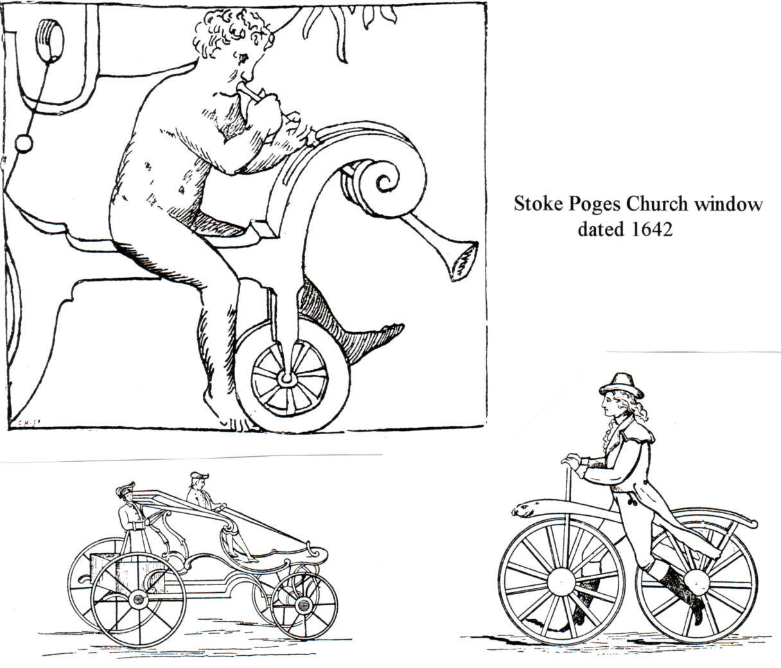

A Manumotive Carriage 1766 French Celeripere 1816

Later in 1766 the first horseless carriages were called Manumotives, and consisted of four wheels the back wheels being driven by levers and two treadles, operated by a footman
standing at the back, the passenger steering by reins attached to the front wheels. One of the machines is reported in 1824 of being capable of eight miles per hour, down a steep hill I imagine. Later a much larger machine was dreamed up, built like a coach to take six people the driver seated on the box in front, four passengers inside, and a footman in full uniform at the back on the treadles. I have found no record that this machine ever moved.

It is not known who first invented a 'two wheels in line' machine, credit is generally given to a Frenchman, about 1816 it was known as a Celeripere, and consisted of two cart wheels connected by a wooden beam. The rider sat astride the machine and propelled it forward with his feet, the front wheel was fixed and could not be steered. In 1818 this was improved upon by a Baron Drais de Saverbrun, and it became known as the Draisienne, it had a padded rest for the arms, and the forks went through a socket, so that the front wheel could be turned and the machine steered. In December of 1818 a London coachmaker Dennis Johnson, applied for a patent for the machine calling it a 'Pedestrian Curricle'. It soon became known as the 'Hobby Horse' and then the 'Dandy Horse' It suddenly lost its popularity in the 1830's when the penny dropped and the Dandies realised why they all had hernias. It was reported as being used in country areas as late as 1850.

The next major step forward, was by a Scotsman Kirkpatrick Macmillan, who in 1839 fitted cranks to the back wheel activated by swinging arms. The story goes that he watched children playing with a hoop, and thought if he had two hoops connected together they would stay upright as long as they were moving.

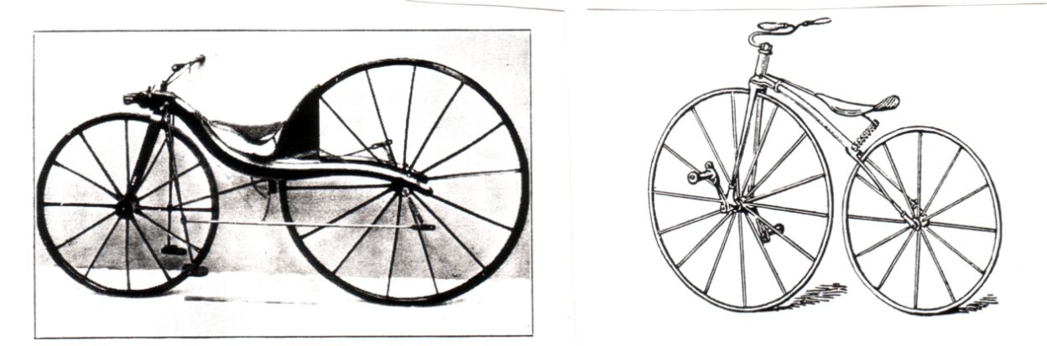

Macmillan 1839 Boneshaker 1868

To us today this seems so simple, but at that time it was a brilliant conception, that made possible many forms of transport we take for granted today. On the 6th of June he set off on his first long journey from Courthill near Dumfries to Glasgow to visit his brother, on arriving he unfortunately knocked down a child and the next day was fined five shillings. The idea did not catch on and he took no steps to patent it. There were several other machines built involving complicated systems of levers, but none of them lasted. It is interesting to note that in the early days of the bicycle no names had been invented for the various parts, anything to do with steering, was called reins and pedals were called stirrups. Possibly one of the early deeds by a cyclist Gavin Dalzell that gave a hint of the future in store for the bicycle, was his ten mile race against a Kings Mail Coach, which by statute had to maintain a speed of ten miles per hour. He not only comfortably beat it, but played with it en route, by riding round it three times, to the chagrin of the driver and guard who had backed their cattle to win. It seems that Dalzell must have been capable of about twelve miles per hour.
The Great Exhibition of 1851, had on show a cart wheel shod with rubber, and a contempory report states "it was allowed to roll over the hands and feet of the bystanders without causing the slightest sensation of pain", adding optimistically "running over a living being would cause no injury to life or limb". It was to be seventeen years before J. Hastings in November 1868 rode thirty miles on a boneshaker with rubber strips nailed and cemented to the wheels.

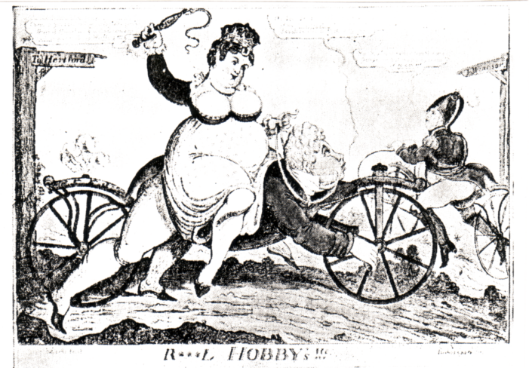

The mind boggles trying to imagine what Royal scandal was behind this caricature.
Those higher minds amongst us will appreciate that the Hobby Horse appears to have cranks and pedals, something that was not invented until half a century later.

The next step forward in the mid 1800's was probably again by a Frenchman, Pierre Michaux who fitted cranks and pedals to the front wheel of an old Draisienne or Hobby Horse. I say probably because the date is not certain, and there was a German in 1862 Karl Kech of Munich who did the same to an old Hobby Horse. Michaux was the better business man and while Kech took it no further, Michaux started to produce them and later exhibited in the Paris Exhibition of 1867. Here they were seen by another exhibitor Rowley B. Turner the French agent for the Coventry Sewing Machine Co. Ltd. of which more later. Up till then all two, three and four wheeled velocipedes or manumotives had been driven by lever systems. Four wheeled Velocipedes were on hire at the Crystal Palace up to 1883. In 1862 cranks were also fitted to a tricycle, this was by an English firm Messrs Mehew of Chelsea, who exhibited it in the 1862 International Exhibition. This was the forerunner of the childrens tricycle which is still made today. So the 1860's saw both bicycles and tricycles fitted with cranks on the front wheel, time would prove the two wheeler to be the most popular means of transport.

To get back to Rowley B. Turner, who in 1868 brought back to England a Michaux Boneshaker. This was first demonstrated and ridden by Turner at Spencers Gymnasium in Old St. London. He then took it up to the Coventry Sewing Machine Co. Ltd. where his uncle Josiah was Manager, together with an order for 400 Boneshakers to be sold France. It was discovered that the Articles of Association of the company were not equal to the demand, and as the sewing machine trade was slack, it was resolved to reconstruct the company, and it became The Coventry Machinists Co. Ltd. When the order was only partly completed the Franco-German War broke out, and Turner was to make his escape from Paris riding one of these machines. At home The Coventry Machinists Co.were able to create a demand in this country and the 1870's was to see Coventry become the Cycle Manufacturing Centre of the world. A position it enjoyed until well into this century. The Coventry Machinists Co were later to change their name again to the 'Swift Cycle Co.' and then to 'Swift of Coventry'.
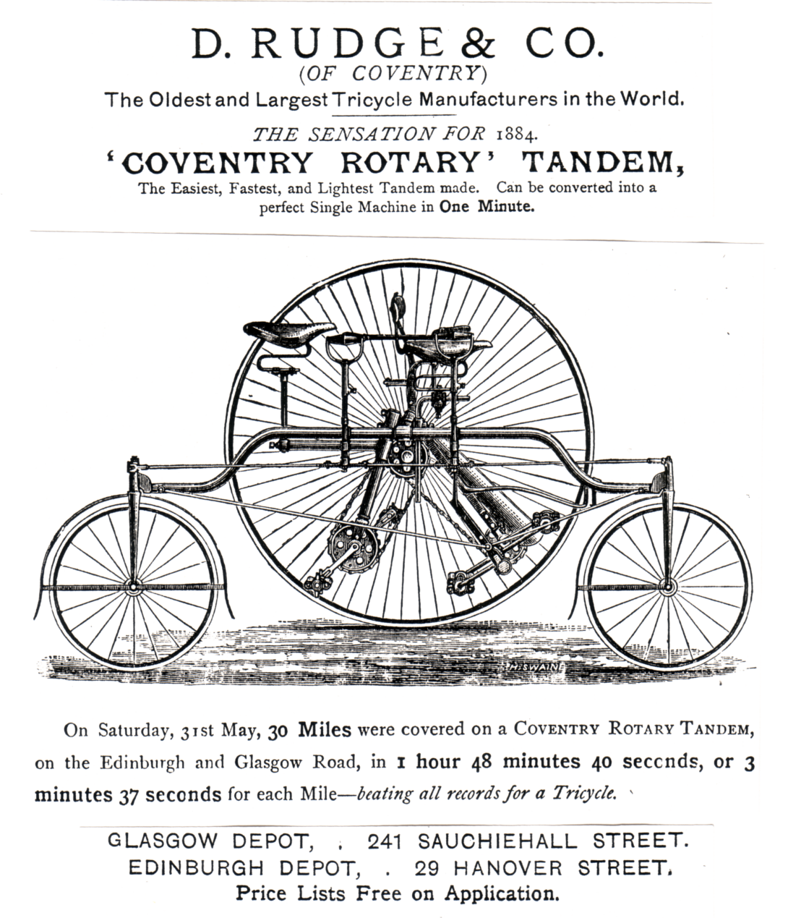
Page from the 1884 International Forestry Exhibition Official Programme

In 1869 there was a race held on the top paved terrace at the Crystal Palace and a Velocipede Show (Cycle Exhibitions to this day are always called shows) at which many wonderful Manumotives were shown. one was in the shape of a boat, mounted on wheels and propelled by levers arranged to represent oars. The coxswain sitting at the stern, and steering by straps passing to the bows. On 26th of June 1869 a Grand Exhibition of Velocipedes and a race was held at Studley Royal Park. This was claimed to be the finest display ever brought together. A prize of four pounds was offered for the finest bicycle with a runner up prize of one pound ten shillings. Also in June that year a bicycle was on display at the Horse Show. 1869 also saw the term Bicycle become generally accepted.This period saw the birth and death of many quite impractable inventions, like the one with a single 12ft diameter wheel the unhappy man balanced on top, and held there by two 15ft balloons. On a par with this ten years later was the suggestion that to increase his speed the rider should have wings fitted to his arms and steer by his chin. Against these weird ideas, in a fortnightly magazine the
'English Mechanic' for April 20 1866 the first suggestion for using an endless chain for giving motion to the driving wheel appeared, again an idea of outstanding importance.

1871 saw the start of the Stanley Cycle shows, and these started off the season, and continued for many years. Apart from exhibitions, races or endurance runs became another way of advertising bicycles and 1873 saw the first London to John o' Groats ride, and six years later a fifty mile race was won in under five hours. There had been an enormous increase in the number of firms making cycles, in 1871 there were about a dozen and by 1881 this number had risen to 1,072, and the trade was well able to support its own Shows. At the Stanley Show of 1883 Tricycles outnumbered the two wheeled cycles, but this was not to last. Some early venues were the Holborn Town Hall and the Albert Hall. An indication of how uncomfortable these early bicycles were to ride, is that at the 1890 Stanley Show there were no less than 56 machines fitted with springs or rubber pads to make the rider more comfortable. Without doubt the aim that gave greatest scope for inventors, was how to make cycling easier, by means of speed gears, between 1877 and 1906 over 800 devices of various kinds were registered, although not all were manufactured. Amongst all this clutter of 'it might work' designs one must stand out as possibly the most important invention of all time after the wheel. This was the invention by James Starley in 1877 of the differential gear built into the axle, of tricycles. This simple gearing system allowed a driving force to be unequally distributed to two shafts at 90 degrees to the main drive. This was necessary because when a tricycle went round a corner, the outside wheel had to turn faster than the inside wheel. A fixed drive machine was impracticable as it could only go in a straight line, while if one wheel was free running, although it could turn corners, it was very inefficient by having a drive on one side only. Starley's invention made possible the motor car because until this was invented, the motor car industry would have been hamstrung.

The programme for the 1884 International Forestry Exhibition has a full page advert for the Rudge 'Coventry Rotary, Tandem. and on another page it lists nine cycling events taking place on Saturday 30 August, ranging from rides of 18 miles up to rides of 44 miles. A year later the first 'touring on a cycle'. book was published 'A Canterbury Pilgrimage' written, ridden and illustrated by Joseph and Elizabeth Robins-Pennell. This was done on a Coventry Rotary Tandem. They took it easy spending three days on the journey from London to Canterbury. 1885 also saw the introduction of the first bicycle, the design of which would not look out of place today, built by the Rover company, it marked a turning point for the cycle trade. Its advantages were so obvious. Two small wheels, chain driven, no more falling off from a great height, efficient brakes, it soon saw off the ponderous heavy tricycles. It is interesting to note that Rover Cycles were still in business in 1924 and had a stand at the British Empire Exhibition at Wembley.

In 1896 the 20th Stanley Show took place, it had carried on although they had had a competitor for the last five years, 'The National Cycle Show' was held under the auspices of the Cycle Manufacturers Trade Protection Association. Their sixth was held at the Crystal Palace in 1897 and had about 400 firms exhibiting, one showed a wide range of cycles constructed with bamboo instead of steel for the main tubes. Eventually the Stanley Show fell by the wayside and the National Cycle Show took over. The connection between Bicycles and Exhibitions is still with us today, and only a few years ago Nancy and I went to a Cycle Show held in the Birminghan Exhibition Centre.
As far as I was concerned this turned out to be a bit of a farce. This was at the time when oval tubes were all the rage, and a bright young spark on the Raleigh stand tried to convince me that if you squash a round tube into an oval tube it becomes lighter. On another stand they were showing another oval or it might have been a tear-shape tubed bike at about £2,000, I asked the occupier of the stand what made it so expensive, and he explained to me that it took a skilled man about a week just to mitre the tubes, it was at this point that I mentioned to him that I had been a cycle frame builder for about 20 years. He rushed off into his office and would not come out again. (The point of this story is that given a hacksaw and a 10" half round bastard file it takes about ten minutes to mitre the tubes on a frame, and we both knew it.)

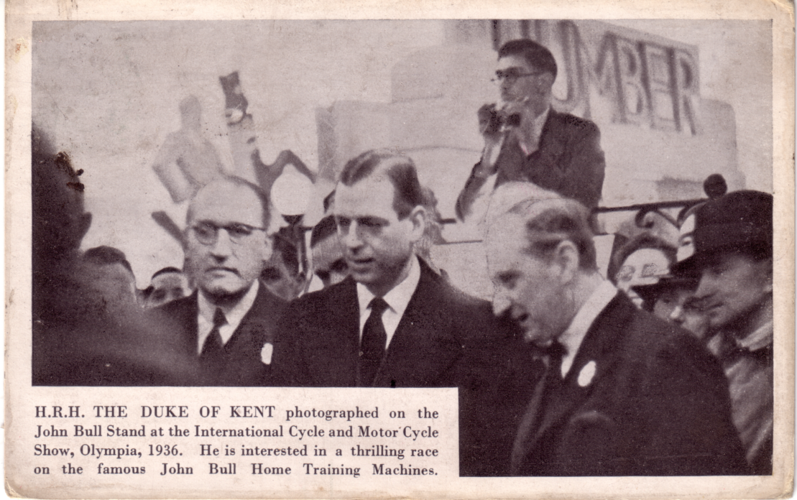

936 International Cycle and Motor Cycle Show at Olympia

The finale was at the Peugeot stand, where they had on show 'The Bike of the Future'. This was a prototype of what designers thought the bike of the future would look like, and I'll admit they had made a nice job of it. I was studying it in some detail, when up came another bright young spark, and asked me what I thought of it. I said what a pity it was that they had gone to so much trouble to make something that was unrideable. He seemed to get very excited about denying this, and when I was able to assure him that he had never actually seen the bike ridden, he realised he was a bit out of his depth and went for the manager. By now for some reason quite a crowd seemed to have gathered. The Manager when he arrived went to great lengths to explain that all the fittings were real fittings, and when he had finished I told him why the bike was unrideable He conceded that the bike was un-steerable, something he was not too happy about having to admit but tried to convince me that theoretically it could be ridden in a straight line. On being challenged he too admitted that he had never seen it ridden and was not prepared to try it himself, even though I suggested a small wager on the outcome. I never heard of Peugeot putting the bike on show again.

And so the bike designers had gone round in a complete circle, back to the Celeripere the unsteerable bike, but now made of alloy.
Bibliography

Official Programme of the International Forestry Exhibition 1884
A Canterbury Pilgrimage by Joseph and Elizabeth Robins-Pennell 1885
The All England Series Cycling by H. H. Griffin 1890
The Badminton Library Cycling by Earl of Albermarle & G. Lacy Hillier 1895
The Romance of the Cyclist Touring Club by James T. Lightwood 1928
Bartleet's Bicycle Book by H. W. Bartleet 1931
The First Fifty Years of the Catford Cycling Club by E. J. Southcott 1939
LETTERS TO THE EDITOR.

I am happy to say that I am getting some response to the appeal for information on Wembley cards. Prof. Burton Benedict who some of you will remember, when he came over from the States and attended one of our York Conventions, has sent me photo-copies of his complete Wembley collection. He has got several cards Mike and I have never seen before, including an H. B. comic card. In a second letter he sends details of the back of one of the cards I had asked for. He is hoping to come to our 1994 Convention.

Peter Griffin also sent me some photo-copies of items from his collection, which includes a nice 'Knowling's Newfoundland Series' card, with a message "Dear Mother Just a line from Wembley Alfred" Posted at the exhibition and with a Wembley stamp. A Tuck's card showing the R. M. S. Orsova of the Orient Line, again bearing a Wembley stamp and posted at the exhibition. and a White Star Line shipping card, Quadruple-Screw R. M. S. Majestic, used at the exhibition. These three cards have no printing on them to indicate they are exhibition cards and if they had been unused would have been passed over, by many collectors. Peter also has two comic cards Mike and I have not seen before, another H. B. and an International Art Co.

Bob Tough writes to me enclosing a list compiled by Gwen of Queen's Dolls House cards, and the details of an album she has.

A new member Graham Watling has sent me a print out of his Wembley cards, which I am going through.

And a short note from Dilwyn Chambers, commenting on a reference which first appeared in the North Wales Observer for October 20th 1893, and comes from 'The University Movement in Wales' by J. Gwynn Williams. "It is recorded that 5,000 Welshmen attended an International Eisteddfod at the Fair (The Colombian Exposition) in September 1893, and enthusiastically resolved after the chairing ceremony, and fortified by trumpets, to express their gratitude to Gladstone and his government for acceding to the demand of the Welsh people for a National University.". Were there no Welshwomen there? asks Dilwyn. Well I don't know about that, but I have noticed that there have been very few Welsh exhibitions held, compared with the hundreds or even thousands held in England and Scotland. I can call to mind the National Pageant of Wales, at Cardiff in 1909, and the Welsh Empire Exhibition also at Cardiff in 1930, but that's the lot. I admit that I base my comment on the fact that I've got no postcards of anything apart from those two. Why is this I wonder? In the years before the First War, in the heyday of exhibitions and postcards, Wales had virtually nothing. Perhaps the country was so thinly populated that it was not considered a
viable proposition, or could it be that the Welsh language which I imagine was more widely used then, was a bar?

I have also heard from another member John Swanborough who helped to compile 'Special Event Postmarks of the United Kingdom'. If any of you have not seen this book, it is a jolly good buy at £6.00 from the British Postmark Society. John has offered to give a display at this years Convention, he also wanted to know what printer I am using, so if any other members are interested it's a Hewlett Packard Laser Jet 4L Printer. The monster is a 486 DX 33, 214 MB, with an extra 4 RAMS and 64K Cache. The scanner is a Hewlett Packard Scan Jet IIp. Had I been prepared to spend a little bit more, well actually a great deal more, I could have produced the Newsletter in up to 18 million different colours, there, isn't modern technology a wonderful thing, but I'm afraid you'll have to stick with black and white.

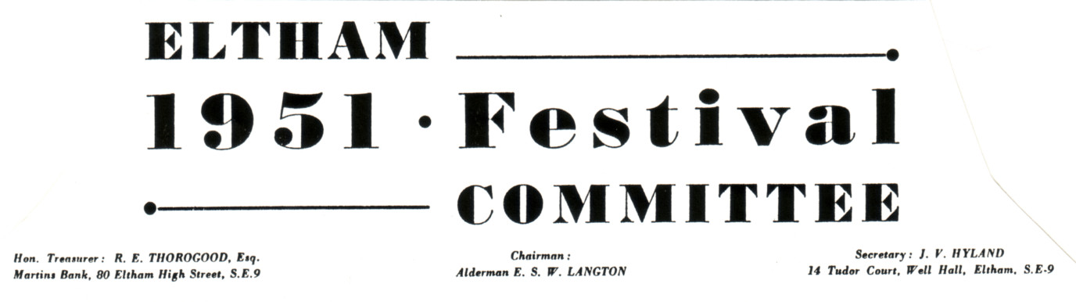
ELTHAM 1951 FESTIVAL of BRITAIN PAGEANT

Recently a copy of the script for the Pageant held at Eltham as part of the 1951 Festival of Britain celebrations has come into my hands, and having seen so many pageant cards, I feel this gives an added insight into what went on at the pageants held up and down the country.

Episode 1. 1075 The Manor Fields of Eltham

Odo Bishop of Bayeux Invests Haimo Shire-Reeve of Kent with the Manor of Eltham

Stalls are set up and people pass to and fro, some with items for sale, others engaged in purchasing.
1st Man (To man at stall with pots arranged)
"Come man, there are five goodly skins well cleaned and dressed, 'tis a bargain for yonder pot, the size is smaller than I require, but twill do."
Stallholder "Nay make it a bundle of six skins and the pot is yours. I could get more I warrant if I waited till noon and more were afoot."
1st man "I cannot put six for I only have five with me, so it's five for the pot or I go elsewhere."
Stallholder "Take it then, but 'tis a sorry exchange for me the pot is worth more."
A withered man in rags and ringing a tin bell passes by calling "Unclean! Unclean!" Women draw their children to them, a woman places a load of bread in his path and hurriedly withdraws. He takes the loaf and passes on calling "Unclean! Unclean!"
The children play.
The above conversation goes on during the general bustle of the market, and is not intended as important dialogue.
Enter Peter hurriedly
Edgar "Hey Peter, what’s afoot? It must indeed be urgent news for you to hurry so."
Peter "Friend Edgar, it is indeed, methinks the goodly folk hereabouts will find it not to their liking either, and I fear it means much distress amongst us all."
Edgar "Come now, to the news, what is it."
Peter "Well within the hour there is to be much business here."
Edgar "Stay I'll call the others, then you can tell us all (He calls) Hey Bewam! Uffa! Ella! all of you, our Peter here has news of great portent, and you Owulf go keep watch."
The peasants gather round murmuring, and one goes off to the side to keep watch.
Peter "Pray listen all of you, within the hour there is to be a great ceremony, Norman William having given all of Kent to his nearest relation Bishop Odo."
1st peasant "Aye he be the kings half-brother they do say."
Peter "Yes the very same, he comes here this very morning together with others and one named Haimo the Shire-reeve whom 'tis said bears relation to the King."
2nd peasant "Yea so 'tis said."
Peter "The Haimo, friends, will be our Overlord, and to him will we have to pay our tribute."
1st peasant "How comes all this, you speak in riddles."
Peter "This very day they all come here, Bishop Odo to give unto Haimo the manor of this place."
2nd peasant "So we are to be ruled here by men who speak a strange sounding tongue."
Owulf runs on and points off
Owulf "Look to yourselves and your behaviour, the lords approach ere now."
(The peasants fall back into line muttering. Mothers snatch their children to their sides.)
Enter the Procession of Haimo
First go men at arms to clear the way, then Haimo attended by three or four lords and their ladies and attendants. They take their places standing in a semi-circle around Haimo.
Enter the Procession of Odo
Odo although a Bishop is also a soldier. He is attended by his chaplin, two monks, two scribes and attendants.
Odo "Our kinsman Haimo you are here upon the hour, to receive from us that which we have in mind to give."
(They clasp fore-arms, Haimo kneels)
Odo "So as from this day, the manor of this place, Altehame you hold in fief for us, and see its people conform unto our rule as sober subjects."
Haimo "All this to do, I this day swear."
Odo (To the scribes who have been busily writing)
"Bring you here the writ."
The scribes offer their boards. Odo signs one and Haimo the other.Odo seals them both, and hands one to Haimo, the other to one of the monks. Odo places his hand on Haimo's head whilst the Chaplain forms the sign of the cross.
Odo "So look you well to the business and see that the Hundred Courts be held hereabouts in accordance to the rule of our brother William."
Haimo (Raising his right hand)
"All this I swear to do."
Haimo rises and goes off with Odo in procession.
Edgar "Aye so the business is well done in their own fashion and tongue, and may it portend nothing dire for us. Come Peter."
The peasants and villagers go off in groups chattering about what they have seen.

Episode 2. 1347.

The Establishment of the Most Noble Order of the Garter at Eltham
Music.
Knights and Ladies enter from various points, stop and converse or curtsey and bow and pass on their way to various appointed positions.
Fanfare of Trumpets.
Enter in procession,
The King and Queen
The Prince of Wales (The Black Prince)
Attendants
Followed by A Company of Knights
All take their places, the Royal party in one place, the Knights at a little distance away.
Fanfare of Trumpets
Herald (reading proclamation)
"My Lords, My Ladies, Sirs, Esquires and all company here assembled, be it known that our Sovereign, Edward, by the Grace of God, King of England, does this day proclaim that he has caused to be established a most goodly company of valiant Knights and from this day forth to be known throughout Christendom as the Most Noble Order of the Garter and that the company thereof to show this signal mark of the King's favour to wear about their left leg a garter of blue enscribed thereon in letters of gold "Honi Soit qui Mal y Pence" the motto so approved by our sovereign King, and to bear it valiantly throughout the Realm and beyond the seas to the glory of God, the honour of the King, and the championship of all in distress."
"LONG LIVE THE KING!"
King "Bring to us the twelve garters of blue which we have caused to be made and delivered to this our wardrobe at Eltham that we may name and bestow to those whom we are pleased to appoint firstley to this noble order."
The Keeper of the Wardrobe advances with a cushion on which are laid in a row twelve Garters. He stands by the King.
Fanfare of Trumpets
Herald "Stand forth in this order that ye may receive from our sovereign King, that badge of the goodly company to which you are appointed.
His Royal Highness Edward Prince of Wales
His Grace the Earl of Lancaster and Derby
Sir Thomas Beauchamp
Sir John L'Isle
Sir John Grey
Sir Hugh Courtenay
Sir Miles Stapleton
Sir John Beauchamp
Sir John Chandos
Sir William Montacute
Sir John de Grey
Sir Hugh Wrottesley
These most valiant Knights we have been pleased to appoint to the Most Noble Order of the Garter, having fought courageously and victoriously with us on the fields of Calais and Cressy."
LONG LIVE THE KING
The Knights stand in line before the King.
Twelve pages bring footstalls and place one before each Knight. The Knights simultaneously place their left feet upon the stools and kneel on their right knees.
King "To the honour of God Omnipotent and in memory of the blessed Martyr Saint George, tie about thy leg for thy renown this Most Noble Garter, wear it as the symbol of the most illustrious order, never to be forgotten or laid aside, that thereby thou mayest be admonished to be courageous and having undertaken a just war, stand firm, valiantly fight, courageously and successfully conquor."
(The king then passes from one to the other fastening with the aid of an esquire a Garter about the left knee of each Knight) "And we do decree that thy ladies, you as having such, may place about their left arma like garter of blue to proclaim to all your valour and courage."
Prince "Sire, we are grateful for the favour conferred and having no pretensions to so distinguished a mark of favour, knowing that we owe it solely to your grace and goodness." (He kisses the King's hand).
The King's standard bearer, Sir John Beauchamp stands forward
Sir John "For England and Saint George."
The whole company repeat the phrase.
King "We do now repair to our tilt yard here adjacent with a goodly company till set of sun."
Fanfare of Trumpets
Music.
King's procession departs. The Knights follow then the assembled company.
Notes on Episode 2.
In 1347 the ages of the principal characters were as follows
King Edward III 35 years of age
Queen Philippa 35
Prince of Wales 17
Sir Thomas Beauchamp 30
Sir John L'Isle 29
Sir John Grey 50
Sir Hugh Courtnay 21
Sir Miles Stapleton 30
Sir John Beauchamp 32
Sir John Chandos 25
Sir William Montacute 19
Sir John de Grey 50
Sir Hugh Wrottesley 35

Other instalments to be published in future Newsletters.
Episode 3. 1515 The Investiture of Cardinal Wolsey as Lord Chancellor of England in the Chapel of Eltham Palace.
Episode 4. 1535 The Lady of Well Hall.
Episode 5. Elizabeth of England.
Episode 6. 1785 Highwaymen on Shooters Hill, the Old Dover Road, an incidence based on facts.
Episode 7. 1833 Golden Jubilee of the Rev J. K. Shaw-Brooke.

CLUB PACKET

I saw Mike Perkins at Bloomsbury last week and he tells me our first Club Packet has now gone out. It has taken a long time to get it going (no fault of Mike's), and it will be interesting to see how it goes. I would remind everyone to pass it on as soon as you can. Any members with spare postcards, labels or stickers, let Mike have them at
4, Churchill Drive, Amblecote, Stourbridge, West Midds. DY8 4JS.

FESTIVAL OF BRITAIN SOCIETY

The Festival of Britain Society held their second Annual one day convention on the last Saturday of January and about twenty five members and visitors turned up for what was a very enjoyable day seeing other peoples treasures, and renewing old acquaintances. Many of our members are also members of the F.O.B. Society, so there were some familiar faces there Fred Peskett, George and Flo Simner, Ron Trevelyan, and Graham Watling enjoying his first convention. Nancy and I along with our un-official official photographer, or is she our official un-official photographer Winnie. Winnie has been to several of our conventions snapping away, thoroughly enjoying herself, although she is not a collector of exhibition material herself. Fred, George, and myself gave displays, Fred showing the similarity between the 1851 Exhibition and the 1951 Festival, which entailed displaying related items from both do's. George showed Postal History items of the Festival with some very scarce commercial and official covers and postal markings. I gave a short display of Harvey Barton cards and some views of the Festival site taken before they started building the Festival. There was a Colegate factory or warehouse there previously and this can be seen in aerial views of London, also the mountain of rubble when it was knocked down, and one showing the Dome of Discovery when it was just girders without a roof.

A B.E.E. IN MY BONNET

by Peter Griffin

Part 1

"That's not a collection - that's an addiction!" a collecting colleague stated, after an hour spent looking through my 1924 / 25 British Empire Exhibition Collection.
I do collect other G.B. up to 1952 and have other special studies but my Wembley collection, like Topsy, has 'just growed and growed' over 15 years, from a poor 1924 1d to a range of material that few normal collectors would ever suspect existed.
My first Wembley 1d was a mucky mint off-centre and poorly perfed but a prized
possession from my schoolboy collection. I stopped collecting when in 1948 my mother refused indignantly to buy me a Silver Wedding £1 (Dad was earning a fiver a week at that
time!). Thirty years later the old album reappeared, the old enthusiasm was rekindled, my family had passed the 'grossly expensive to maintain' stage so limited funds were available to prime the old hobby once more.
Almost the first thing I did was to replace that tatty old 1d with a used set and for a while was content I had 'em all. Then in a small George V collection I bought from a friend I came across the 1d postal stationery cards for both years. This was something new! I soon discovered there were sets of four postal stationery items for each year to track down, both mint and used, and then a slogan came my way. A few picture postcards, a set of mint stamps and I had an embryonic specialist collection!
It took about three years to spread it out to nine sheets for a themetic entry in a club competition, and to my surprise it won. Automatically it went off to represent our Society at Federation level. I remember it being well packed out with photos, postcards and diagrams with a sufficiency of stamps to satisfy the rules. There was much muttering about it 'really belonging to the Postal History Section' from some of the other competitors... but it won!
That was enough to fire me up and gradually from the basic sets of stamps and stationery a whole world of Wenbley has opened up.
It may seem logical to start my discourse by discussing the adhesives but the whole concept starts long before 1924. In fact the idea of a Brirish Empire Exhibition was first suggested in 1913 and it was suggested it could be held in the existing pavilions at White City that had been built for the Franco-British Exhibition of 1908. Before the many ideas and inspirations had a chance to gel the 1914-18 war intervened and it was not until 1919 the project resurfaced with the backing of Lloyd George's government, King, and country.
Anything relevant to this early period of planning is now almost impossible to obtain and it is not until October 1922 that anything even vaguely suitable for inclusion appears in any quantity. During October and November a number of publicity slogans appeared and are often to be found on postcards of that period. There is a wide range of these to collect and though the slogan itself remains virtually unchanged to the end of the 1924 period some local varieties have been discovered including re-cut dies showing second states. The main variations of course concern where they were used and the type of machine they were used on.
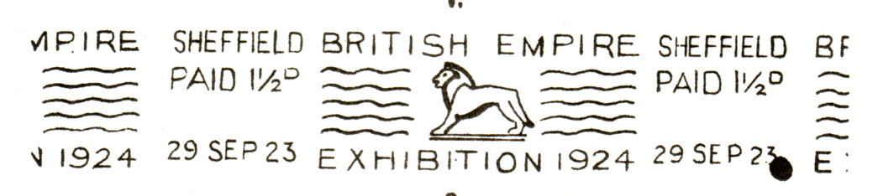
Fig 1
The first to appear was the continuous Krag (Fig 1). These were used at twelve provincial offices only but are still around if you have the patience to hunt about for them. I found three in a dealers junk box, one of which turned out to be the earliest known day of usage at Cardiff, 13th October 1922. That cost me 30p but Murphy's Law being what it is the more desirable marks turn up on expensive items priced for their pictorial value.
Far less common are the Krag Machine triangles with telegraphic codes, and the 'Paid' dies used on pre-paid bulk mail (Fig 2). In fact these are decidedly scarce and I have yet to get one for my collection.
The commoner types include the Hey Dolphin single impression, single circle and double circle machines. Wherever more than one machine was in use there are different codes collect as well (Figs 3 & 4). The Universal machines of London, Manchester and Glasgow had year dates in the centre of the datestamp, not at the base. Notably there were two London offices that had Hey Dolphin machines fitted with the telegraph numbered triangles, again scarce and well worth looking for.
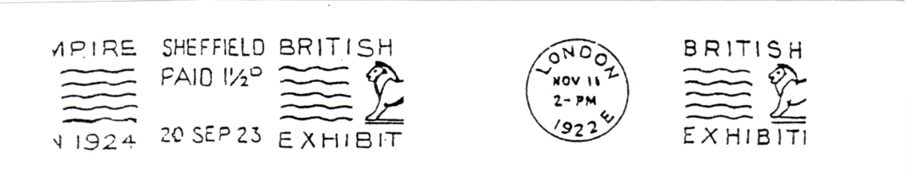
Fig 2 Fig 3
In all there are about one hundred to track down and that does not include for each of the three years they were in use. The 1925 slogan (Fig 5) was different and for some reason the Wembley Lion was left out. There was a wide gauge slogan and a narrower one which appears to have been used only at Newcastle-on-Tyne and on the London Code G machine. No continious slogans appeared but single circles, doubles and triangles appeared once more. A total of twenty offices used these slogans and to date 33 machines have been identified, 16 of which are from outside London. Finding the 1925 slogan is more of a challenge but they are still to be had if you ask around.

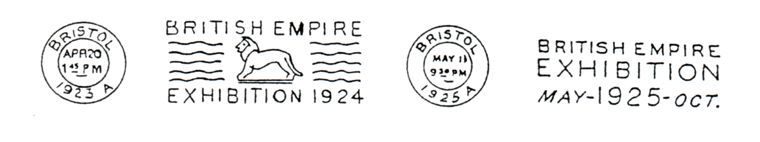
Fig 4 Fig 5
While out slogan hunting one day a dealer showed me a Calcutta slogan on a card commemorating the 1924 Everest Expedition. I just had to have that and probably paid too much for it. After a little further research I discovered that if I hoped to have a really comprehensive collection I was going to have to go international!
I discovered continuous machine cancellations were used in Australia, Bermuda, Ceylon, Gold Coast, Kenya, Singapore, New Zealand and South Africa. Single machine cancellations were used in India, Jamaica, Malaya (Kelantan), Newfoundland, Trinidad & Tobago and Ulster. Undated circular handstamps (Fig 6) were used in British Guiana, Malaya (Johore, Kedah, Kuala Lumpur), Malta and Turks& Caicos Islands. Various types of boxed cancels (Fig 7) exist from British Guiana, British Honduras, Ceylon, Fiji, Palestine and possibly North Borneo. Like the circular handstamps these too were undated.

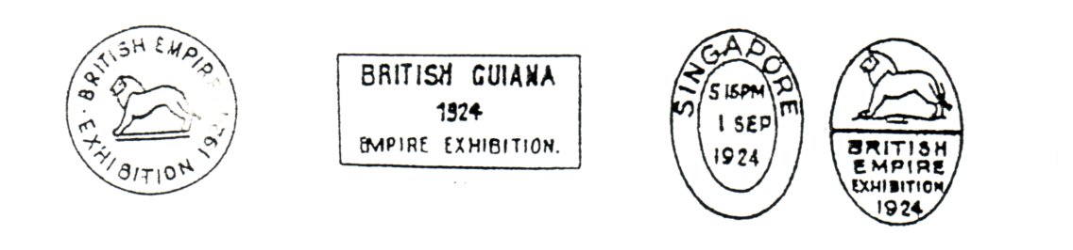
Fig 6 Fig 7 Fig 8
The most unusual of the cancellers resembled the Duplex type of Victoria's reign (Fig 8) and are from Malacca, Penang and Singapore.
The handstamps were usually used as publicity cachets in conjunction with the normal dated cancellations but some are to be found on the adhesives themselves. Dated types and machine cancels frequently appear as receiving marks. All of these Empire slogans are of double figure scarcity and for some of them you would need a very deep pocket indeed.
I think I have covered the basics of the pre-Exhibition publicity slogans and next time I propose discussing the range of publicity slogans used during the Exhibition. The most recent reference work on this subject is 'The Lion Roars at Wembley' by Donald Knight and Allan Sabey. A most readable book full of fascinating facts and amazing statistics about the B.E.E. There is a large section on the postal aspects in far greater detail than space allows here and anyone who decides to take a serious interest in this fascinating subject really ought to get a copy.

End of Part 1

Peter Griffin one of our newer members has let us have a series of articles he wrote, that were originally published in RAFLET. I would like to thank Eric Cowley of RAFLET who has agreed to us publishing them in our newsletter.If any of our members are interested in the R.A.F. and the related philately Eric's address is, Swiss Cottage, Sutton Rd, Huttoft, Alford, Lincs. LN13 9RG. I should also like to thank Alan Sabey who first heard of the articles, and for getting the act together for me. Thanks are also due to Don Knight for giving permission to use illustrations from 'The Lion Roars at Wembley'.

