Editorial Winter No 31

In the winter comes the rain
Blow me down, its at it again.

Bipex this year must have finally laid to rest that old wives tale about dealers keeping back their best items to bring out for Bipex. Taking advantage of my bus pass and cheap rail tickets I got a season ticket for Bipex and went up there each day. Mike Perkins was also there each day, and Alan Sabey went more than once, there were several other collectors including Andrew Brooks. It is certain that every dealers stock of exhibition cards was gone through many times, and as far as Wembley goes just two decent cards were found. With my usual luck I missed them both, Mike and Alan getting one each. It seems that all the once common cards with the exception of the Fleetway sepias have disappeared, one sees very few Valentine's for instance. Valentine's Franco-British are still very common, and this exhibition was certainly the most 'postcarded' of them all.

Members will be aware that the Autumn Newsletter, which should have come out in August, was delayed and not sent out until the end of September. The weak link in the chain of the newsletter production team responsible for the delays, was removed at the A.G.M., and I am sure we shall now get back to regular newsletters.

I was very happy to received my first Christmas Card a few weeks back, from Mark Bailey who I first met at a fair several years ago, he collects caves. The blue ribbon was perhaps a little bit tatty, but the coloured view on the front looking from Malaya towards the Indian Pavilion with the Stadium on the right was very nice. Inside it reads 'Christmas and the New Year 1924-5 British Empire Exhibition Wembley', and in the centre 'Best Wishes for Christmas and the New Year' in a border of twenty four views of the exhibition. The card was printed by Waterlow & Sons. This is the first Wembley Christmas card I have seen, although I do have about half a dozen Franco-British Christmas cards. This one will certainly not get thrown away with the rest after Christmas. I also have a Birthday card from the Colonial and Indian Exhibition London 1886.

I remember at one of our first Conventions held at York, Karl Illingworth showed a Franco-British Bon-bon (cracker) box, that had originally contained a dozen crackers. It had pictures of various Palaces on the sides and top. Now these flimsy boxes are invariably thrown away with the turkey bones, so how did it come to survive? Karl bought it as 'a collection of birds eggs in a cardboard box'. One can imagine a lad keeping the box for his collection of eggs, one can also imagine Karl tipping the eggs out onto the floor, and explaining to a shocked Auctioneer 'He was only here for the box'.

There is a report elsewhere about our Convention. It is nice that although we have a hard core of regulars going back to the York days, we are also getting some of our newer members attending, Bob and Gwen Tough, and Ron Trevellyan both started coming when we met at the Palace, this will be their second or third attendance, Brian England and Dilwyn Chambers made their first appearance this year. Speaking for myself, I can say that I look forward to these meetings, and have gained a lot from them. I met Mike at the first one and started a friendship which has gone from
strength to strength for seven years now, he comes to stay with us several times a year, and I am sure that this long association has benefited us both, helping to keep our interest flourishing. Without doubt we have both not only maintained but increased our interest in the cards of the British Empire Exhibition, to a point where our book is now in its final stages, and will we hope be published in 1994, for the seventieth anniversary of the exhibition. There are many members who have still to attend their first convention, and to them I say try and make the next one. It is a great boost to your collecting if you can meet another collector with the same interest, who you can then keep in touch with.

Bill Tonkin.

SEVENTH ANNUAL CONVENTION.

25-26 September 1993 at Wembley. By Alan Sabey.

The Convention started with our A.G.M. where we elected the officers and committee for the coming year. A proposed Constitution for the Study Group was handed out to all those present, and with only slight alterations was adopted. One suggestion from the floor was that the minutes of the A.G.M. and the balance sheet be included in the newsletter. This was agreed and after the minutes have been agreed this will be done. As no audited balance sheet was given to the meeting, our Auditor has produced balance sheets from the accounts for the last three years, which have been distributed to the committee. When these have been accepted they too, will be published in the newsletter.

After the A.G.M. had taken place, the President, Stanley Hunter, started off the displays with photos of the Anniversary Celebrations of the 1893 Columbus Exhibition, and included some souvenir reproduction postcards of it. The President continued on the theme of his recent visit to the U.S.A. with displays relating to the 1876 Philadelphia Exhibition and the 50th anniversary which was marked by an exhibition in F.D. Roosevelt Park in 1926. We learned that each State had its own special building and that the Ohio State Building still exists.

After lunch taken at the bar downstairs, Andrew Brooks (who was one of the founders of the Group) showed Novelty Pull-out cards for various exhibitions, starting with the earliest at which they can be found, Bradford (1904) through the range of exhibitions at the White City (1908-13), the British Empire Exhibition (1924-25) to the New Castle Exhibition of 1929. These cards are the type where a flap is lifted and a strip of views can be pulled out. He told the meeting that he was going to make a list of all the Exhibition pull-outs, and appealed for members owning any of these cards, to let him have details of them, and if possible a photo-copy. Andrew's other display was of cards for foreign exhibitions in France, Belgium, Italy, and Spain. Also shown were cards for the Bergen Exhibition (1910), a range of pre-World War I exhibitions in Switzerland, further American ones, and on to the New Zealand ones, Christchurch (1906-07), Auckland (1913) and the 1939-40 Centennial Exhibition in Wellington.
Ron Trevelyan followed with a thematic display on the Worlds Fair, Seville 1992 which was open from 20th April to 12th October, and featured stamps and postmarks issued to mark the event. He was also able to display some of the personal invitation cards sent out for some of the more exclusive functions held during the exhibition.

Alan Sabey then showed some photographs of Wembley Park as it was in September 1922 prior to the commencement of construction of the British Empire Exhibition which transformed it from a rural park and woodland. Also shown were photos of the interior of the Palaces of Engineering and Industry when completed by November 1923, along with a covering letter on exhibition headed stationery, and two framed sets of cigarette cards for the 1924 exhibition.

A display by Karl Illingworth brought the first day to a close, by showing a range of assorted ephemera including a clock with the Wembley Lion on the top of it, through to a special shield manufactured for a Victorian exhibition held in Paris by Elkington, where it gained a gold medal. The lady members were pleased to see a selection of fans.

On the Saturday evening 16 members sat down to the Annual Dinner which is a regular feature now.

The first display on Sunday morning was by George Simner on the Festival of Britain, he started with an official envelope dated 1949, then went on to covers showing the Post Office slogan advertising the Festival, next private and commercial covers dated 4-5-51 showing Festival stamps in singles and blocks of four. Exhibition covers dated 3-5-51 were sent all over the world. Some on show were to Australia, New Zealand, Canada, the Falklands, and India. There were some official covers used by the Festival Offices. There were six offices in all, and George showed examples of three, Offices 1, 2, and 6. Then came letter cards and a home made envelope, he ended his display with two covers and a minature celebrating 25 years on, held at the V. & A. Museum, the exhibition was called 'A Tonic to the Nation'.

Don Knight followed him with a display which he called "Any Old Iron" and in fact was all exhibition items such as trays, sweet tins, tea caddies, jam pot holders etc. covering the period 1908 to 1951 about which Bryant and May book-matches in boxes were shown.

Gwen Tough kindly donated six Seville Expo mugs to the group. Don acted as Auctioneer and these raised thirty pounds for the Groups funds. Thanks Gwen.

Alan Sabey then explained about the discovery and research that had gone into Copes Tobacco cards for Wembley 1924, as this had been requested by Brian England who showed a range of unusual printed matter about the same exhibition, including a leaflet about the production of cars at the exhibition by Ford of Dagenham.

Bill Tonkin showed various cards for the Ideal Home Exhibition over the years. Themes were introduced on several years eg. Royal gardens in 1923, Kitchens in 1926, Heath Robinson in 1934, Walt Disney in 1938, and gardens again in 1939. After the war, the printing of Newspapers was featured in 1948.

After lunch, Alan Sabey lead 21 members on a guided walk around the Exhibition site at Wembley for which a Guide comprising of a map and photos was produced. The walkers saw some of the remaining features including the Palace of Industry, the Fiji Pavilion, and the North Station of the Never- Stop Railway.

IDEAL HOME EXHIBITION PUBLICITY SLOGANS 1968-84.

By Arthur Smith.

Arthur sent me photo-copies of his Ideal Home Exhibition slogans, and also enclosed some spare slogans for my own collection. I found this of such interest that I have decided to include it in the newletter in the form of an article. Thanks Arthur.

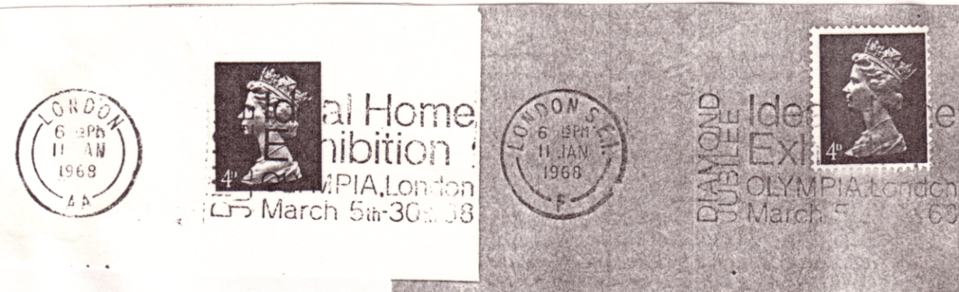
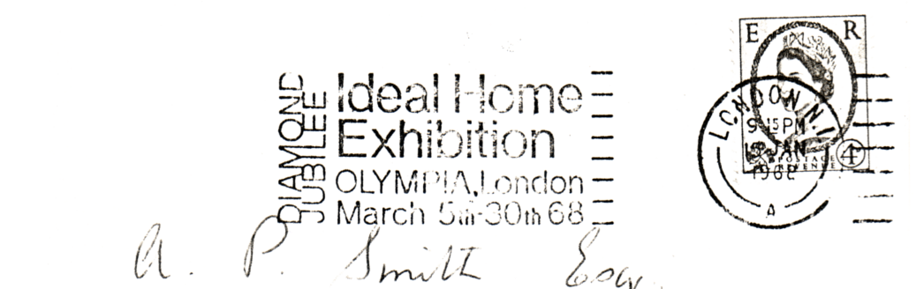

1968 The Diamond Jubilee year of the Ideal Home Exhibition, the slogan is in both the standard and the transposed position.

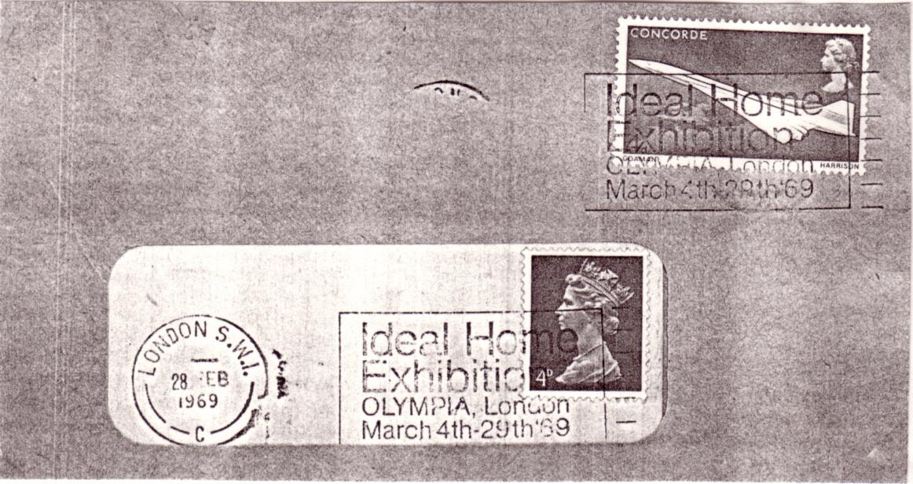

1969 Slogan in the standard position.
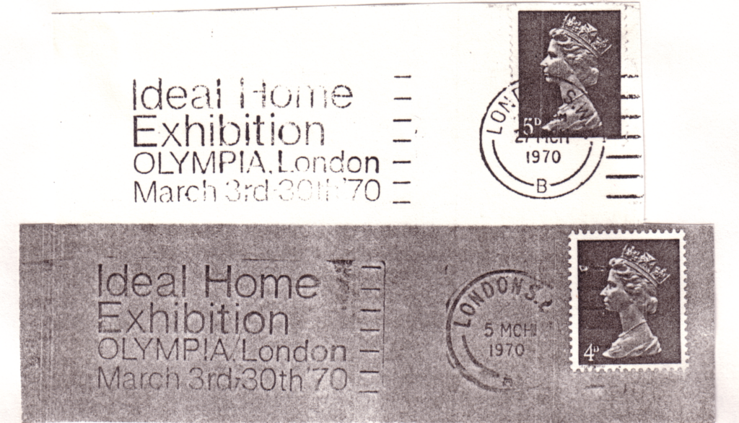

1970 Slogan in the transposed position.
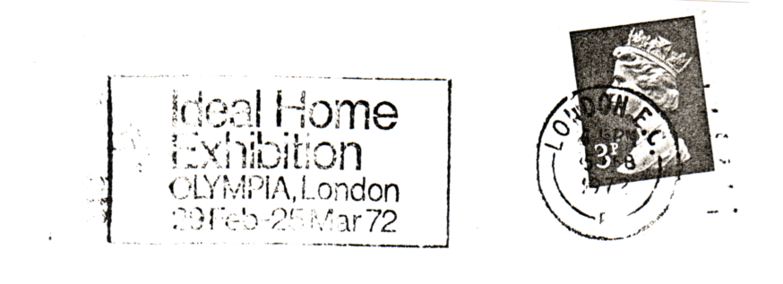
1972 Slogan in the transposed position.

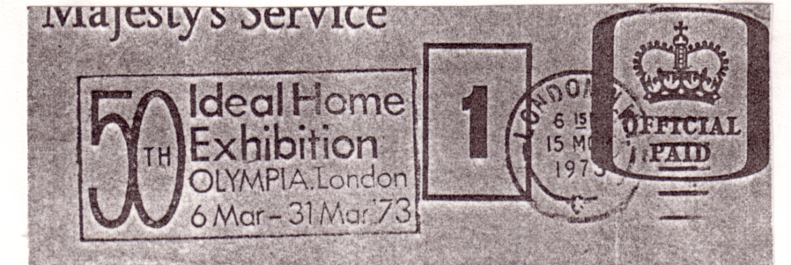

1973 50th Ideal Home Exhibition, the slogan is known in the standard and transposed position.

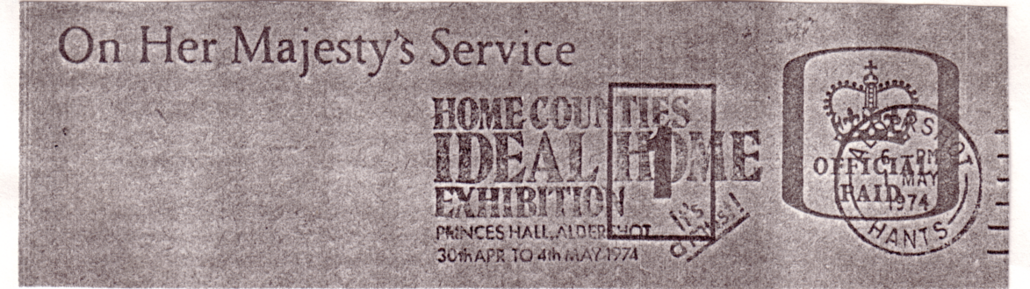

1974 Home Counties Ideal Home Exhibition, held in Princes Hall, Aldershot. Slogan in the transposed position. A very scarce slogan.

1974 Ideal Home Exhibition held at Olympia. Slogan is in the transposed position.

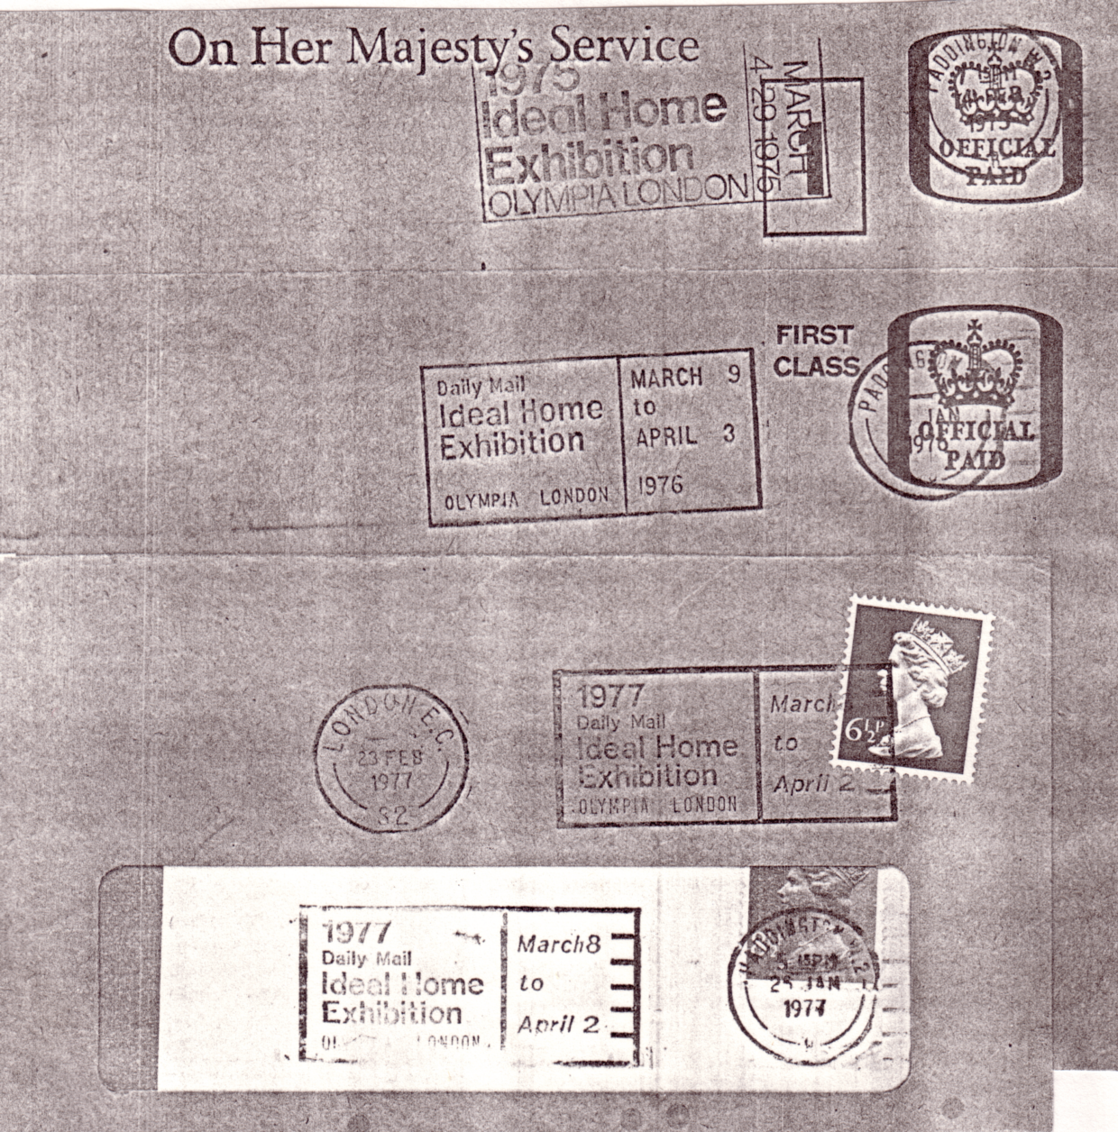

1975 to 1977 showing a mixture of standard and transposed positions.

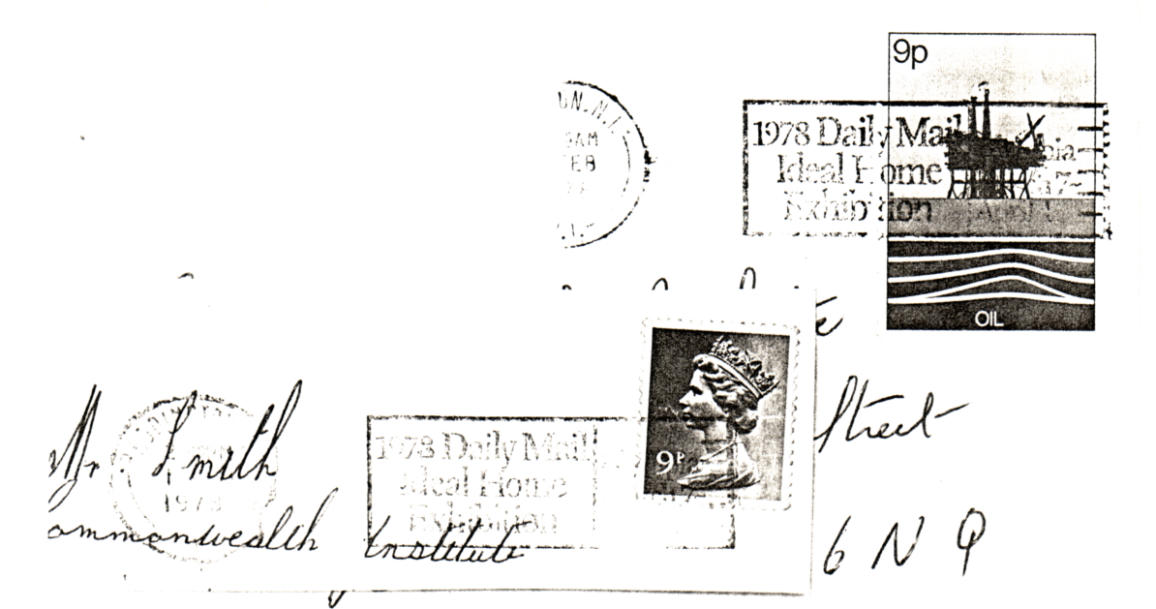

1978 slogan in the standard position.

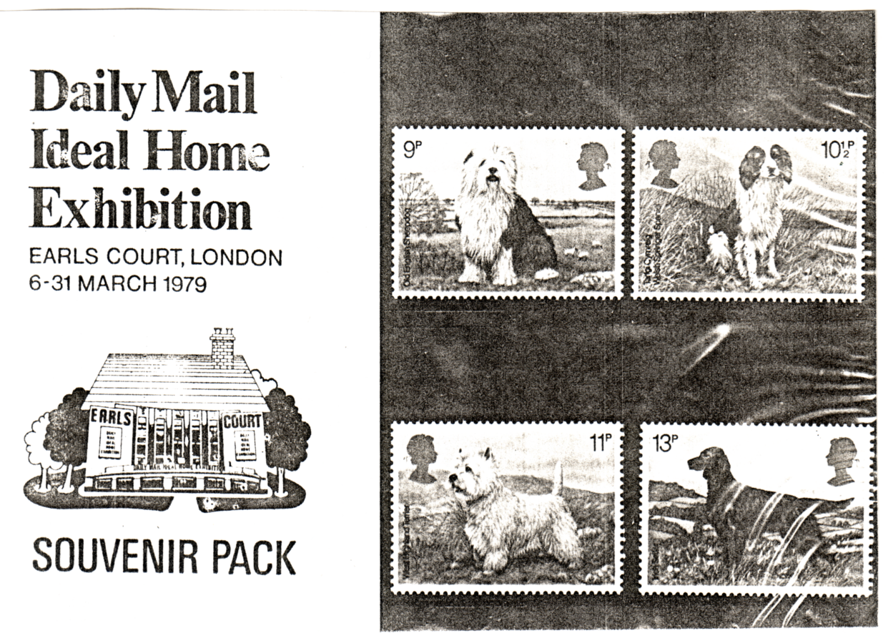

1979 Presentation pack specially printed for the Ideal Home Exhibition.

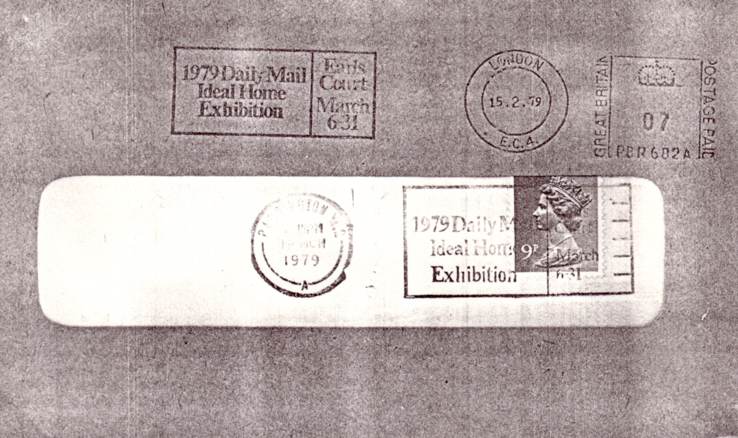

1979 slogans in the standard position and transposed position on the meter mark.

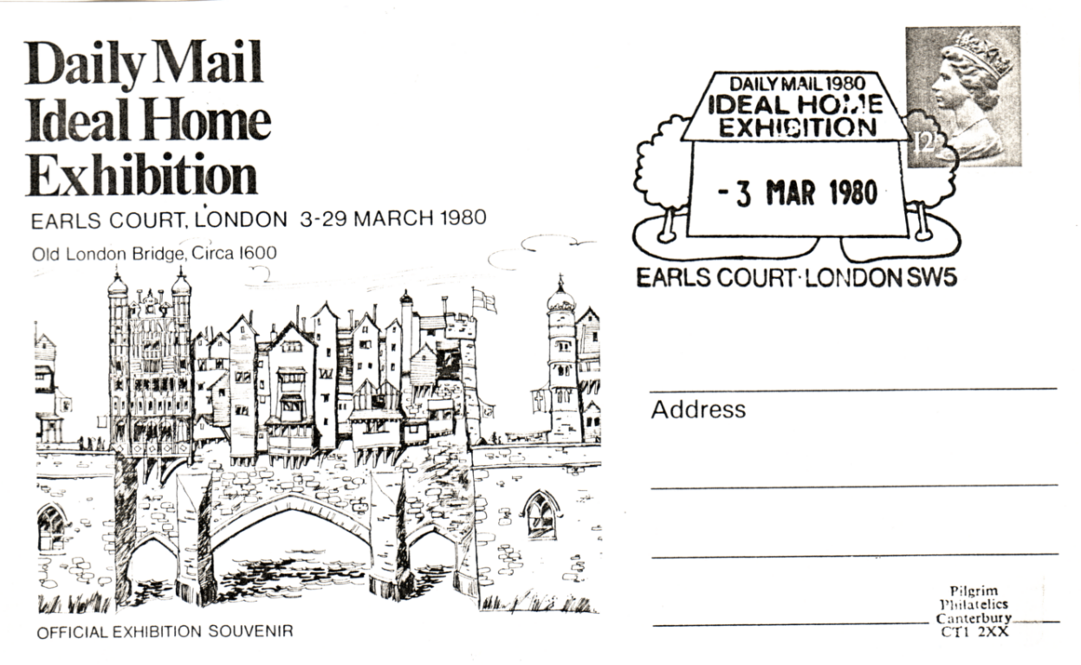

1980 Souvenir card produced by Pilgrim Philatelics for Ideal Home Exhibition with special handstamp
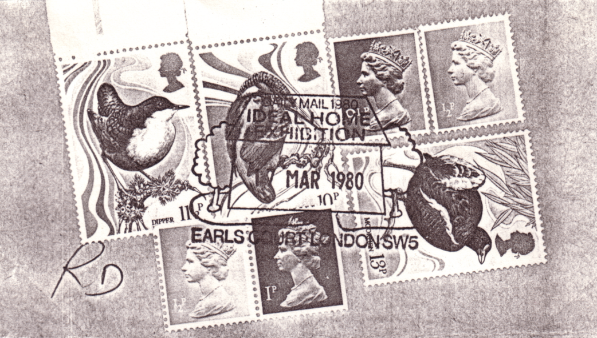

1980 Special handstamp on piece.

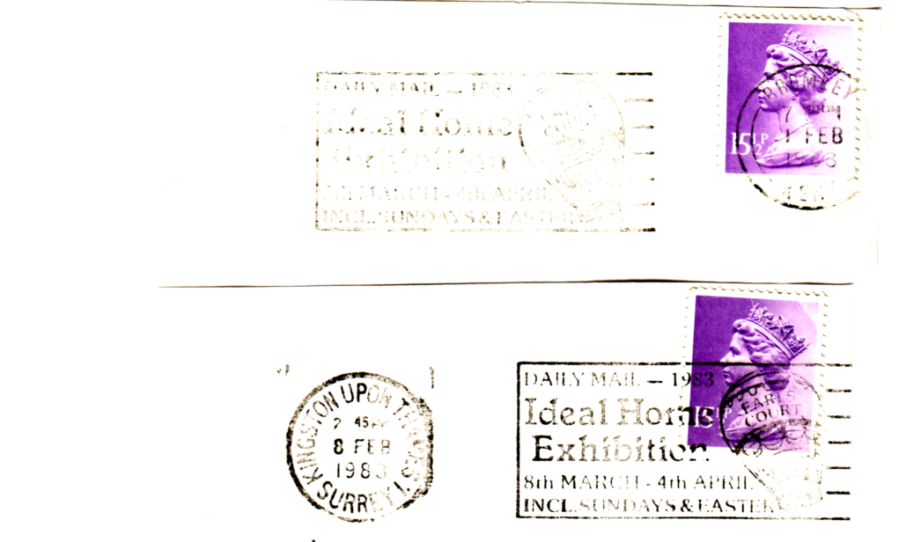
1983 Slogan in the standard and transposed position.

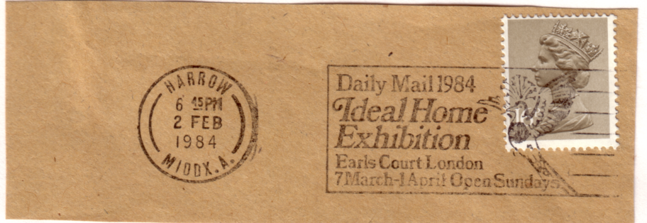

1984 Slogan in the standard position.

Arthur makes the point that clear impressions are very difficult to find sometimes, and there are gaps where he has not been able to find some years. He is still looking for the missing years.
At the 1993 Convention a proposed Constitution was placed before the meeting, which with a few slight alterations was adopted. A copy of this is being sent out in the Newsletter, and from now on all new members will be supplied with a copy when they join.

CONSTITUTION 1993.

1. Title
The title of the society shall be the 'Exhibition Study Group'. Afterwards refered to as 'The Group'.

2. Objects
A. The objectives of The Group shall be to encourage the study of Exhibitions, and related events of all types.
To gather information regarding any aspect of exhibitions, and if practical to publish or make available any research carried out.
C. To publish quarterly newsletters which will be sent free to all members, and which may be sold to non-members.
D. To assist and help in any way deemed desirable, any persons or organisations involved in any aspect connected with exhibitions.
E. To hold an Annual Convention to be held normally on the last weekend in September.

3. Membership
Membership shall be open to any person interested in Exhibitions, and the Secretary shall forward an application form to anyone wishing to join.

4. Officers and Committee
A. The officers of The Group shall consist of a President, Vice President, Past Presidents, (providing they continue their membership), Secretary, Treasurer, Editor, Public Relations Officer. These officers plus up to four members to serve on the committee. All these members to be collectively called 'The Committee'
B. The Committee may all stand for re-election each year with the exception of the President who shall not hold office for more than three consecutive years.
C. An Auditor, who need not be a qualified person, shall be elected at the Annual General Meeting.
D. The notice of the A.G.M. shall be announced in the Spring News-letter, together with a call for nominations for officers and committee. which should be in by the end of July. The Summer News-letter shall formally announce the A.G.M. and list the nominations for the committee. Votes for the committee shall be accepted by post up to three days before the A.G.M.
E. Should a vacancy occur among the officers, The Committee shall have the power to fill such vacancy, until the Annual General Meeting.

5. Management
A. The management of The Group shall be vested in The Committee, who are empowered to conduct the business affairs of the Group.
B. The Committee shall have the power to introduce any new rules which shall at once become operative, but such new rules must be submitted to the next Annual General Meeting for confirmation or otherwise.
C. Five members of the Committee to form a quorum
6. Accounts
A. The accounts shall be closed on the 31st of July each year.
B. A statement of receipts and expenditure for the year shall be prepared by the Treasurer, and after audit shall be submitted to the members at the Annual General Meeting.
C. All payments made by cheque on the Group's Bankers to be signed by the Treasurer and one other officer of the Group as the Committee may appoint.

7. Subscriptions
A. These shall be decided at the Annual General Meeting, and will become due on the 1st of October following.
B. Any Member allowing his subscription to be in arrear shall receive written notice thereof from the Treasurer, and if still unpaid shall be deemed to have resigned.

8. Annual General Meeting
This will be held at the opening of the Annual Convention.

9. Committee Meetings
These shall be called by the Secretary as necessary.

10. Rules
Each member shall be supplied with a copy of the constitution.

End

FESTIVAL OF BRITAIN SOCIETY.

The members of the Exhibition Study Group have had an invitation extended to them to attend a meeting being held in the Chelsfield Room at the Festival Hall, on Saturday January 29th, from 10.30am to 4.00pm. There will be a charge of #4.50 for each member attending, and this will include coffee and biscuits. Many of our members already go to this do, which is a very pleasant and informal get together of collectors and those interested in the 1951 Festival of Britain. There will be displays and talks, and a good time will be had by all. If you have any Festival items bring them along, and show them.

THE DEVELOPEMENT OF THE BRITISH EMPIRE EXHIBITION.

By Alan Sabey

The idea of holding an Exhibition to show the assets of the British Empire was first put forward in 1913 by Lord Strathcona and it was intended to hold it in 1915, probably at the White City site.

After the first world war, in fact in June 1919, a provisional committee was appointed to draw up definite plans. By August 1919 approval had been granted by the Board of Trade and King George V had agreed to be its Patron. On June 7th 1920 a meeting was held at the Mansion House, London at the request of the Prince of Wales. Leading figures in this country formed the Executive Council, and a resolution was taken at that meeting as follows, "That this meeting at the Mansion House, under the Presidency of the Rt. Hon. The Lord Mayor of London, cordially endorses the proposal to hold in London a Great Exhibition for the purpose of promoting trade within the Empire,
and pledges it-self to give the project its whole-hearted support"

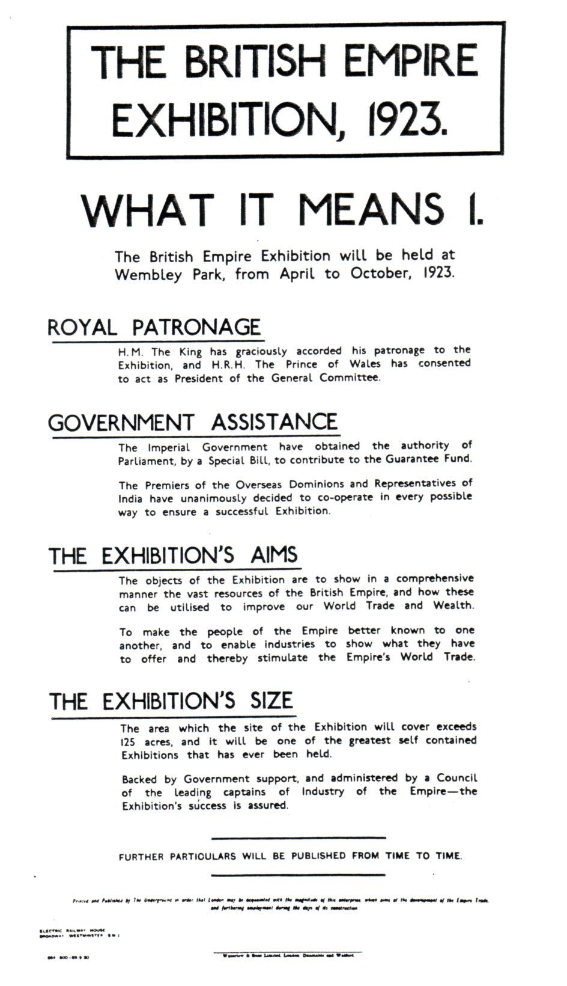

fig 1.

Poster reproduced by kind permission of the London Transport Museum

On December 23rd 1920 a special Act of Parliament was passed authorising the Government to contribute to the Guarantee Fund, and the Dominions were officially invited by the Colonial Office to participate in the Exhibition.

The site at Wembley Park was chosen because it was deemed to be accessible from all parts of the country. Wembley is six miles by road from Marble Arch, and trains from Baker Street would take no more than ten minutes to reach the Exhibition. Even from Clapham Junction it would only take just over twenty minutes. So once the visitor had arrived at London from which ever direction, his journey to the Exhibition would only be a short one.

From a London Transport poster of the time (fig 1) dated 23-9-20 it was intended to open the Exhibition in 1923 (construction work having started on January 10th 1922).

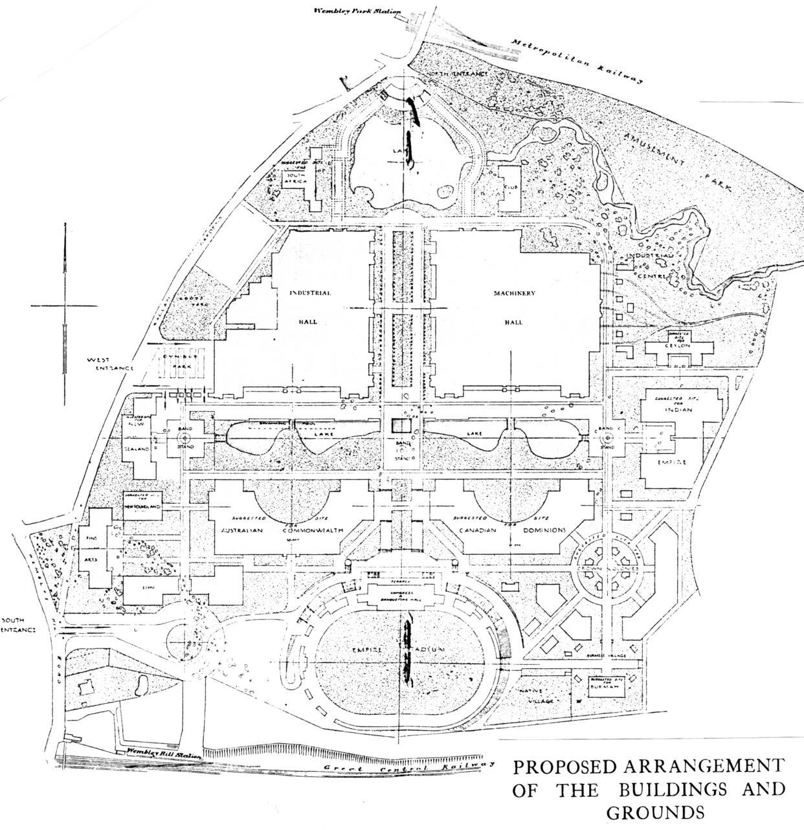

fig 2.

But by the time of the Cup Final on April 28th 1923 only the Stadium was fully usable, and some of the Colonial Pavilions were not ready, so the opening of the Exhibition it-self was delayed until 1924.

Looking now at the proposed site plans one can see in fig 2 that the Stadium was to be at the southern end of a main avenue leading from Wembley Park station and at that end the original lake from the Park was retained. This was subsequently drained, filled in and became the North Entrance Gardens. The South African Pavilion was proposed for that end, (Figs 2 & 3) but the site became the Lucillus Restaurant. What can be noticed from fig 2 is that the eastern boundary of the site was the India Pavilion, and many of the buildings were crowded together in circles or blocks. A further plan of the site (fig 3) shows the acquisition of land to the east and the original boundary behind 'India' has become a loop line with a special Exhibition station in the grounds. To the east of the railway loop it was at one stage proposed to have an experimental farm, but this land was used to spread out the Pavilions and eventually housed the Pavilions for Ceylon, Hong Kong, the West Indies, Fiji, Newfoundland, and His Majesties Government Building. The site which covers 214 acres in all, extends as far as the southern direction of the Wealdstone Brook.

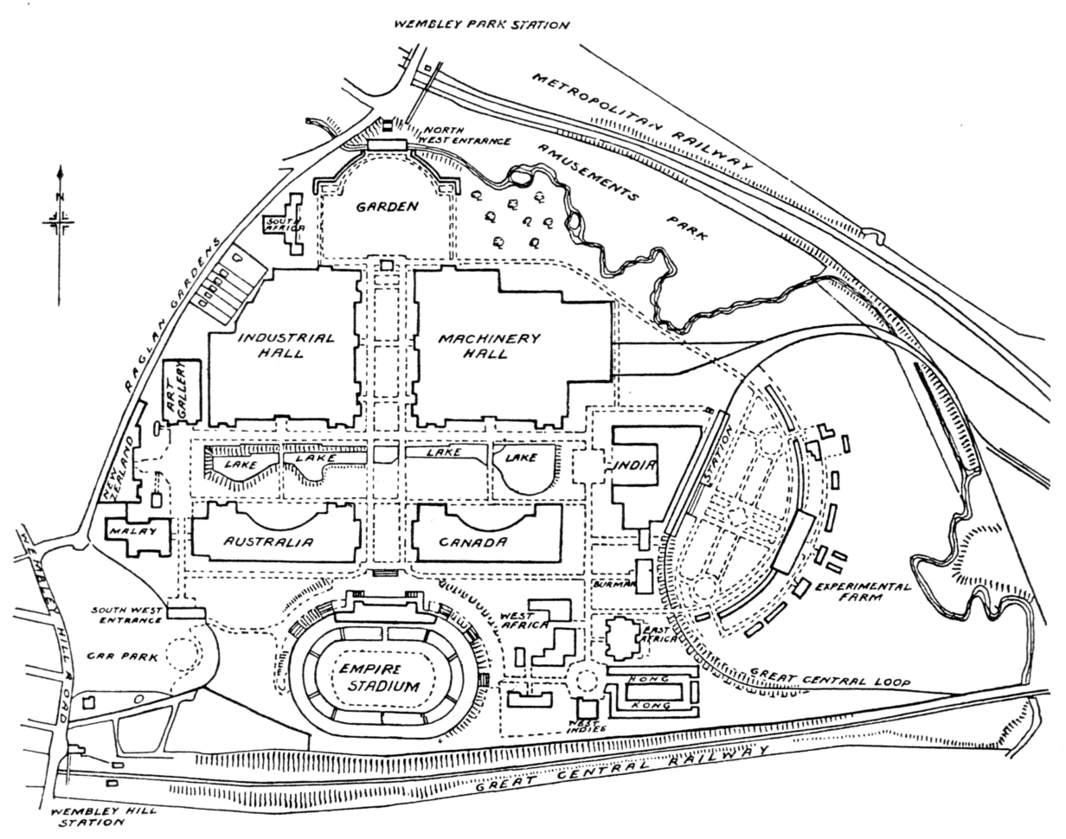

fig 3.
THE OTHER WEMBLEY EXHIBITIONS

By Alan Sabey

WEMBLEY CIVIC INDUSTRIAL AND COMMERCIAL EXHIBITION

CIVIC HALL OCTOBER 13-23 1948

This Exhibition was opened by the Mayor of Wembley, H S Sirkett J.P. at 3pm on October the 13th 1948. It came within a couple of months after Wembley Stadium had been the main venue of the Olympic Games, and was held in the Civic Hall, a building (since demolished) dating back to the 1924 British Empire Exhibition.

There were 50 stands 24 on the ground floor and 26 on the first floor, and well known names who were there, apart from the Borough of Wembley, and Wembley Stadium Ltd were.
Wembley Observer (local newspaper)
Johnson, Matthey & Co. Ltd. (Their building occupied the site of the British Guiana Pavilion)
Kodak Ltd. (Whose factory produced milling, drilling, and lathe components for use at the main factory at Harrow)
Tyre Products Ltd. (Whose works in the Palace of Engineering manufactured Fabricated Rubber Mats)
Adana (Printing Machines) Ltd. of Willesden. (It was on an Adana machine that the late Ron Philips produced 6th Wembley Scouts Christmas Post Stamps).
Hoover Ltd.
there were also a number of smaller local firms.

THE FESTIVAL OF WOMEN

JUNE 7-29 1957

The second exhibition to be held at Wembley, nine years later was 'The Festival of Women', this was described as "The family exhibition that is different. Sponsored by Women, featuring a Women's World". It was held in the Empire Pool with some kiosks outside in the gardens around the second section of the lake. (The Empire Pool having been built in 1934 on the first section at the western end). The Festival ran from June 7-29 1957 and Brittania's head appears many times on the front cover of the catalogue. The President was the Duchess of Marlborough, and the committee included the following organisations.
British Federation of Business and Professional Women
Federation of Soroptimist Clubs of Great Britain and Ireland
National Association of Women's Clubs
National Council of Women
National Federation of Business and Professional Women's Clubs of
Great Britain and Northern Ireland
National Union of Townswomen's Guilds
Scottish Woman's Rural Institute
Scottish Co-operative Women's Guild
Trade Union Congress National Woman's Advisory Committee
Women's Co-operative Guild

Apart from various Trade Union stands, there was a grand total of 93 exhibition stands ranging from women's garments, make up, cookery, china to household articles, and from general
matters of health to the National Childbirth Association of Great Britain.

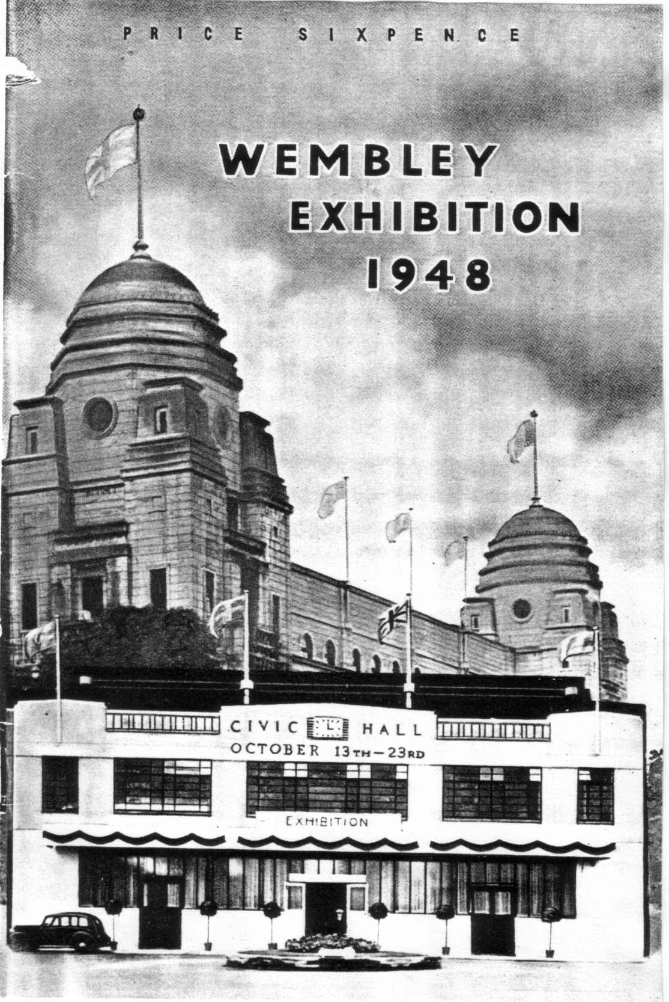

Calipso Island (the island in the middle of the lake) was one of the main attractions, with evening entertainment and dancing with music provided by Calipso bands. A Pageant 'Spirit of Co-operation' was presented by the Women's Co-operative Guild on Saturday June 29th. Also various
dramas and lectures were given in the theatre set-up in the Empire Pool and Sports Arena. The Festival of Women was open daily, except Sundays, from 10am to 10pm and a special postmark was produced to mark the event.

Now that the Exhibition Halls have been built near the Stadium there are regular trade and public exhibitions.

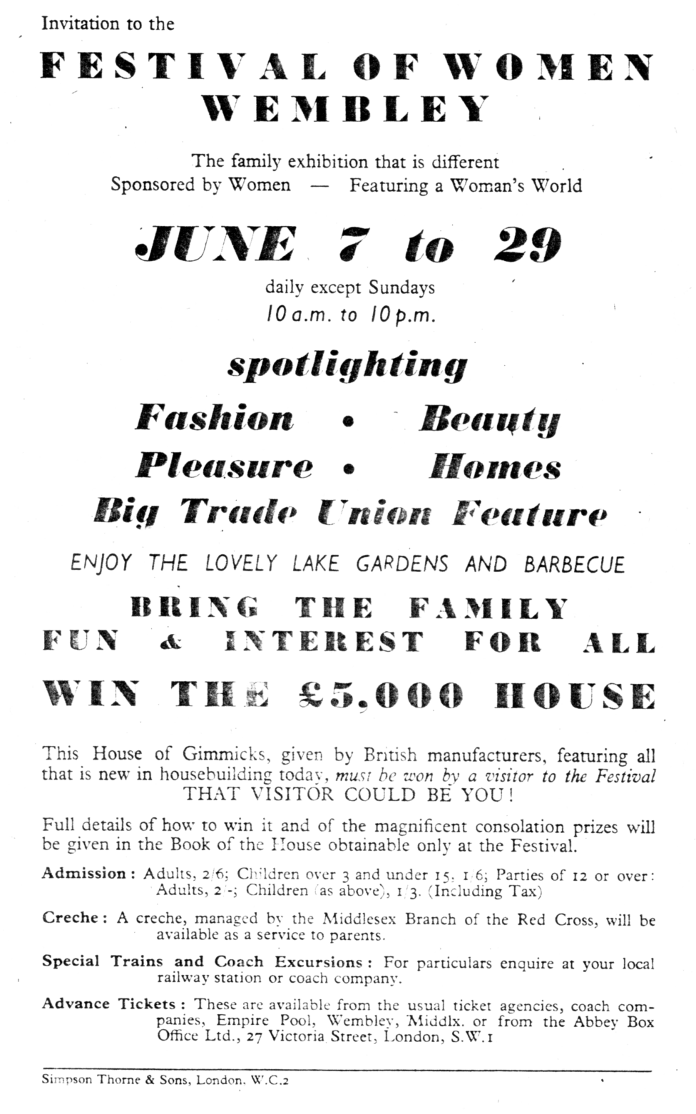
POSTCARDS OF THE QUEEN'S DOLLS HOUSE

By Bill Tonkin

Mike Perkins and myself are trying to find answers to the many queries we have on these postcards, and we hope that any members of the Group who own albums or the boxed sets of these cards, will check up on the contents, and hopefully help us to complete the picture.

Post Cards of the Queen's Dolls House were sold as singles or in six packets of eight cards. they were also sold by Fleetway and Tuck's in albums containing 48 cards. Tuck's albums initially had British Empire Exhibition 1924 printed on it. After the exhibition closed Tuck's continued to produce albums, but without reference to the exhibition on them. Fleetway also produced boxed sets of 48 cards in a blue box with British Empire Exhibition 1924 on the lid.

So far it is all straight forward, unfortunately Tuck's for some reason were not content to produce 48 cards, they went one better literally and produced 49 cards. The extra card was in series III titled 'The Queens Bed'. It would appear that when they realised that series III had nine titles, they decided to move a series III card 'Regalia in Strong Room' into series II, and this title can be found listed on the front of both series II and series III packets, packets can be found with two different make-ups listed on the front. The card itself has series II or series III on the back. This of course meant that series II now contained nine cards. So we now have a situation where series II & III both have nine cards.

It follows that the albums and boxed sets of 48 cards therefore do not contain the complete set, and further that these can be found with different make-ups. This was proved when Bob Tough and Alan Sabey both produced complete Queen's Dolls House albums (containing 48 cards) at the 1992 convention, with different contents.

To further complicate matters there were two printings, the line reading 'Published at the British Empire Exhibition by the Fleetway Press Ltd.' is printed in sloping letters, and has two 'the's (Type 1). In another printing the second 'the' is left out so that the line now reads 'Published at the British Empire Exhibition by Fleetway Press Ltd.' and this is printed in upright letters with one 'the' (Type 2). There are also other differences. Apart from the printings listed above there were other later Queen's Dolls House sets issued by Tuck's but these have no connection with the British Empire Exhibition, and so do not concern us.

Type 1. Sloping letters, two 'the's, '(For Address Only.)' in brackets.

Postcard No. 4501 Series II.
Corner of the Library. Vert left.
Drawing Room.
Drawing Room cabinet. Vert left.
Grand Piano in Drawing Room.
Regalia in Strong Room.
Some of the Drawing Room furniture.
Some of the Library furniture.
The King's Library table.
The Library.
Postcard No. 4502 Series III.
Princess Royal's Bedroom. Vert left.
Queen's Bedroom.
Regalia in Strong Room.
Some of the furniture in the Queen's Bedroom.
The King's Bathroom. Vert left.
The King's Bedroom.
The Queen's Bathroom. Vert left.
The Queen's bed. Vert left.
Wardrobe and chest of drawers in the Queen's Apartments.

In type 2 Tuck's managed to get their act together, and removed a title from series II & III thereby reducing both to series of eight cards.

Type 2. Upright letters, one 'the', 'For Address Only' without brackets.

Postcard No. 4501 Series II.
Corner of the Library. Vert left.
Drawing Room.
Drawing Room cabinet. Vert left.
Grand Piano in Drawing Room.
Some of the Drawing Room furniture.
Some of the Library furniture.
The King's Library table.
The Library.

Postcard No. 4502 Series III.
Princess Royal's Bedroom. Vert left.
Queen's Bedroom.
Regalia in Strong Room.
Some of the furniture in the Queen's Bedroom.
The King's Bathroom. Vert left.
The King's Bedroom.
The Queen's Bathroom. Vert left.
Wardrobe and chest of drawers in the Queen's Apartments.

The questions we want answered are
1. Do you have an album or boxed set of cards
2. What colour is it
3. Is it 1924 or 1925
4. Does it have 'British Empire Exhibition' on it
5. Do the cards have
'Published at the British Empire Exhibition by the Fleetway Press Ltd.' printed in sloping letters, with two 'the's (Type 1). or
'Published at the British Empire Exhibition by Fleetway Press Ltd.' printed in upright letters, with one 'the' (Type 2).
6. Can you write down the titles of series II and Series III (you should not need to take the cards out of the album to do this as the series number is right in the corner). These are the only two series where any differences occur.
7. There are only 16 titles to write down
8. Go on, turn the box off, and do it now
9. Thanks
Mike and I are hoping to publish our book on the Postcards of the British Empire Exhibition 1924-25 next year this being the 70th anniversary, and we have already had a lot of help from members of the Group. We would appeal to any members who have any Wembley Exhibition cards to please get in touch with us, so that we can arrange an opportunity to go through your cards, looking for titles that we are still missing. At the moment we have approx 3,000 cards listed on disc.

Do not think that because you only have a few cards, we probably know all about them, this is often so, but on the other hand you may have a card or cards that we have not seen. A couple of weeks before the Convention we visited a lady who had a fairly extensive collection, and at the end of our visit we had found 29 cards (which she was good enough to loan us to photograph) that were new to us. Not only this, but two of the cards were numbered 2 and 12 in a series, this indicates that there is a series of a dozen cards which have never been recorded, or were even known about.

We would also appreciate photo-copies of the front and back of any card not being an obvious Wembley card, (like for instance the Fleetway cards), which has a Wembley stamp and was posted at the Exhibition. There are many Tuck 'Wide Wide World' cards that come into this category. We would also like to have photo-copies of any Tuck packets that have reference to the British Empire Exhibition printed on them, as many of the cards from these packets have no indication that would tie them to the exhibition. We will be happy to pay any postage or photo-copying costs.

SUBSCRIPTIONS

Subscriptions became due on the 1st of October 1993 and if you did not pay at the convention would you please send a cheque for £8.00 to our new Treasurer Alan Sabey. His address is on the inside of the front cover.
I understand from Alan that there are still a few members who have not paid their last years subscription yet, they must appreciate that the Group will not send them Newsletters indefinitely in the hope that they will pay up. Last year Damon culled the herd of some long term defaulters, and we would like to think that any present members who have not paid, have done this through an oversight.

