EDITORIAL AUTUMN No 30

Now the Autumn's here at last
But it means the Summer's past.

I must start off by apologising to Fred Peskett who kindly sent me in two articles, one published in the Spring Newsletter 'The Amazing World of Exhibitions', and the other which appeared in the Summer issue 'Successful Public Speaking' which I unfortunately credited to Stanley Hunter.

Just to show you I am prepared to put my money where my mouth is Fred, I will buy you a pint at our Convention, how about that. Come to think about it I'll try and recover the cost from Stanley.

In the last two Editorials I have discussed the over valuation by some dealers of the price of post cards, and this is a subject that effects most of us. There is another side to it, while we want to get our cards at what we feel is the 'right' price, are we expecting to pay too little for items which we know are scarce. This was brought home to me the other day when I was chatting to Brian England, one of our members who phoned to book accommodation for our Convention. He let a card go several years ago because he felt at the time it was too dear, and has regretted it ever since. My own tale of woe goes back many years to the days when I was courting. We had gone on a day's coach outing to the coast, and at a stop on the way, went into a second hand book. One of my other interests is books on fishing, and they had a reproduction of the first book on fishing by Dame Juliana Berners, an Abbess who wrote it in 1496. It was printed on hand made paper in the gothic style of the day, and was priced at 12/6 (62 pence), as we were saving to get married I just could not afford it. Years later I can remember when the 1935 2d prussian blue was advertised at £35, blocks pro rata. I couldn't afford that either.

Getting back to post cards the research that Mike Perkins and I have done on Wembley cards has shown us that there are cards where only one copy is known to exist, and many where there are only three or four copies known. Collectors have been able to pick these up for less than the cost of a packet of cigarettes. Certainly Mike and I have, so we cannot really complain if those days are over. What we should all complain about loud and clear, is when very high prices are asked for common cards. When the 1993 catalogue can deal with the 3,000 odd known Wembley cards in four lines, and give a blanket valuation of from 75p to £25, then no wonder dealers prices are in a state of chaos.

Another interesting thought I have had recently, concerns the price of cards and covers with Exhibition labels stuck on. Now a card or cover can usually be picked up for coppers, and plenty of labels can still be bought for between two and three pounds, if you stick one on the other your result can go into an auction and will fetch a good price. This is obviously ridiculous, and I should be very wary about any items where the sticker is not tied by the cancellation, or as I have seen recently where the label is surrounded by the message. Remember the post office regulations stated "no labels were to be cancelled", I am sure there are unscrupulous people about who would have a go. It could be a very profitable way of getting rid of your surplus labels. After all what collectors seem to be paying for is the age of the lick.
Brian also mentioned that it would be nice if we could display at our Convention some of the Cope advert cards, as he thought many collectors himself included have not seen them. This is a good idea and we will show five of them plus a photo-copy, which is the best we can do, unless someone can bring along the one showing a box of a hundred Kenilworth Cigarettes.

Alan Sabey has suggested that any member who is giving a display to a club, should let me have details to go into a newsletter, so that any member who lives near the venue can turn up to see it. I think this is a good idea, and I am sure that club secretaries would be pleased to welcome a visitor, especially if he or she had got in touch with him requesting permission to attend. These things are usually arranged months in advance, so there is time to do it. He also suggests that a short report by the member displaying should also be sent in, and again I would welcome this, and elsewhere you will find this has been done.

Bill Tonkin.

BRUSSELS Via SEVILLE '92.

A 'Retrospective' of Brussels Exhibitions. by Stanley K Hunter.

The abandonment of our plans to visit Seville came at the very last moment. I was already in London for the Annual Convention - complete with passport and holiday cash! Pity about that engraving at the Crystal Palace Foundation Museum - temporarily on loan to the Seville Expo!

A brief word with a Time Out travel Agent at Victoria and I was considering spending the week in Brussels. I had been at Expo '58 and had not been there since. It might be interesting to see what was left - apart from the Atomiun, of course.

Thanks to Bill and Nancy Tonkin, I caught an early Monday flight to Brussels. I always like to do a little research on any Expo expeditions. This time I had a small Berlitz and a hazy memory of Fletcher & Brooks, part II. The train journey from the airport gave a glimpse of the Atomium. At least that was still there!

I had been building up an outline stamp and postcard collection on Belgium Expositions, but as yet, had done no research whatsoever. I wasn't even sure how to get to the Atomium from my hotel in the Chausee de Mons.

The first major Belgium exhibition had been staged to celebrate the 50th anniversary of the Kingdom, in 1880. A Jubilee Park was laid out in Brussels, east of the city centre. A triumphal arch was erected, linking various exhibition buildings. It can be discerned on a panoramic view of the city on a 1989 stamp.

In my first visit to Brussels in 1955 this was one of the sights we visited. We were taken to the Army Museum. It was still there (and still free). The World Wars exhibits, however, were awaiting a move into the adjoining Bordiau Hall. This steel and glass hall dates from 1880 and was designed by the architect responsible for the Liege Exposition of 1905. It had required a good deal of restoration, including financial support from the government which had studied appeals for its continued use.

Also adjoining is the huge hall devoted to the section on air and space. In the balloon section on the first floor is Piccard's historic balloon, featured on a set of Belgian stamps of 1932. The space was labelled - temporarily on loan to the Seville Expo!

The linked complex now includes, opposite, a permanent auto exhibition Autoworld (free) and the Royal Museum of Art & History (free). Some stained glass from this museum appeared on a 1969 postage stamp. I have labels for the Culinary Art Exhibition, held 8 - 16 October, 1900 and the 2nd Agricultural & Dairy Exhibition held in the Jubilee Palais, 12 - 21 March, 1910. I haven't traced a stamp for Autoworld, although there was a BT phonecard (priced now at #10).

A later check on Glasgow's Mitchell Library collection only revealed a detailed 32 page foolscap report (with a further 17 pages of line plates) prepared for the Indian Government on the Brussels International Lifesaving Exhibition of 1876. There was also a pamphlet about Uruguay for the 1910 International Exposition. Prior research in this field might not have been worth too much!

I did know, however that there had been an international in Brussels in 1888. Brief details appear in contemporary copies of The Illustrated London News. I had come across these in my research on the Glasgow International of 1888. King Leopold II was apparently put out that the Brussels Exhibition was behind schedule. According to the I.L.N., the only major pavilion ready on time in May, was the 'British Empire Section' (which the I.L.N. quaintly called 'England'). The British Commissioner- General was S. Lee Babty, who was to organise the 1890 Edinburgh International Exhibition. The President of the organising committee was the Lord Mayor of London - by chance, a native of Belgium!

The Grand Concours International des Sciences & de l'Industries, staged in 220 acres in the old Champ de Mars, opened in stages up to June. Leopold slipped over to Scotland in August and visited the Glasgow International Exhibition (where he bought a suite of furniture). His response to finding that he had arrived on a temperance day was gleefully recorded by a local amateur poet!

The Card Research Centre of the Belgian Postcard Federation (C.R.C.) records a Brussels Commercial and Industrial Exposition in 1889 but I have no records on this. The first stamps issued for a Brussels Exhibition were for the 1897 International and Colonial Exposition, attended by 6 million visitors. These show two versions of the city's patron, St. Michael, and incorporate the 'Do not deliver on Sunday' bandalette labels.

The 'Fetes diverses & Attractions' and Colonial Section was held outside Brussels in Parc de Tervueren, an eastern suburb. The exhibits were held to form a Congo Museum. In 1905-10, a new building was erected to house the present Royal Central African Museum at Tervueren. Museum postcards are not uncommon. Ern. Thill produced 12-card booklets of cards with the NELS motif. A 1966 stamp shows a Kasai head from the collection while the museum itself is seen on a 1979 stamp. Statues from 1897 apparently still appear in the park.

The 1897 Exhibition resulted in a good number of labels. One series showed a character surveying a skyline of Brussels. This design was adapted for use as the official label for the 1901 Glasgow International
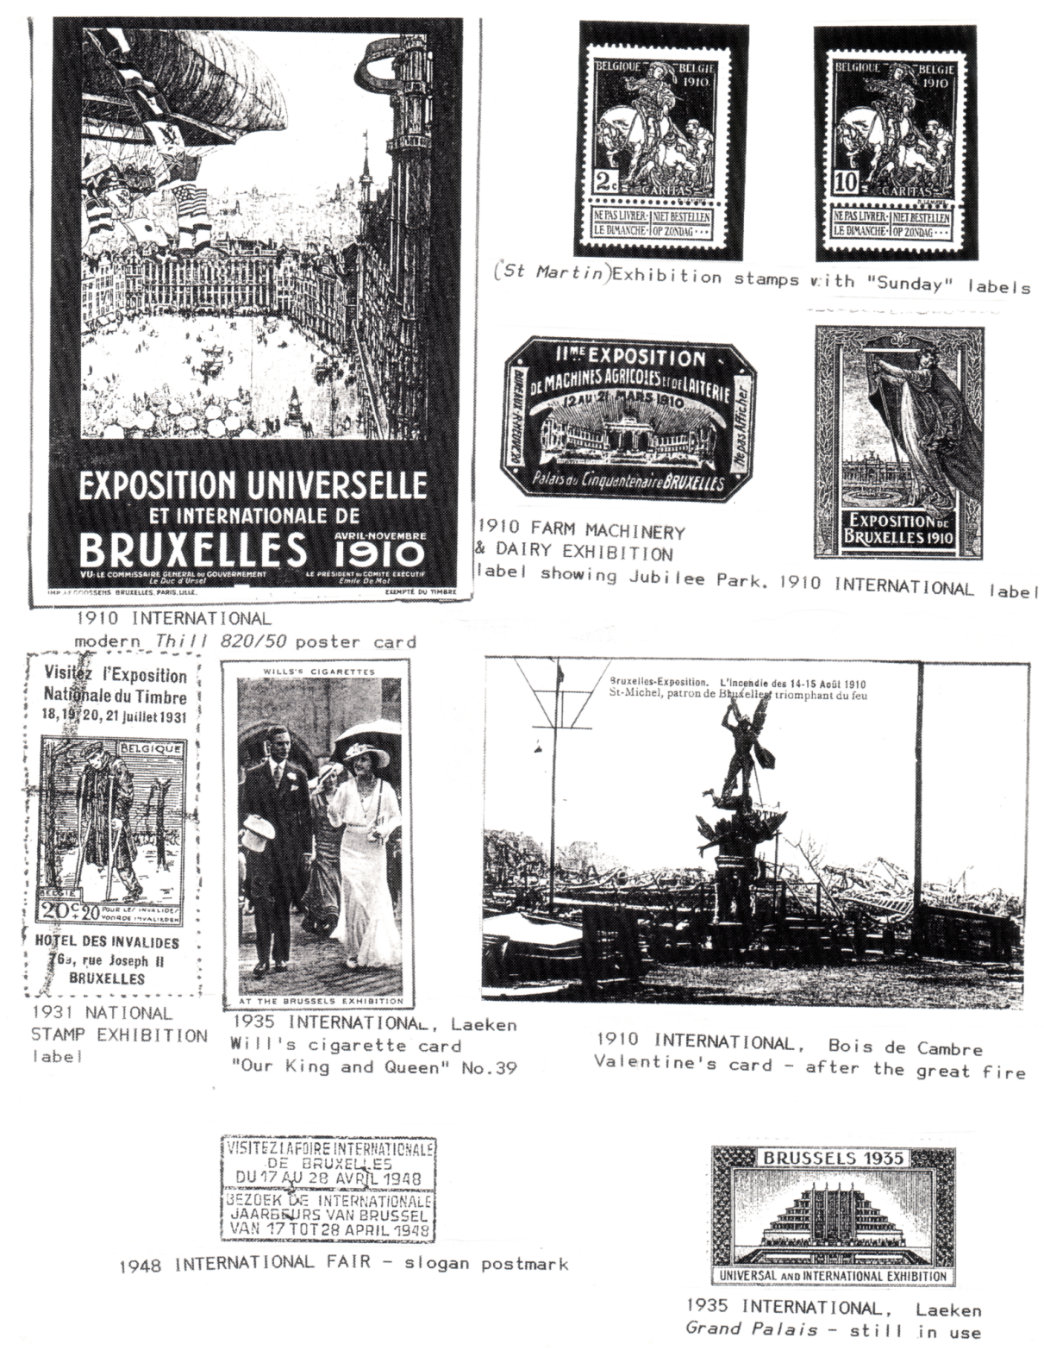

Exhibition, but lithographed locally by Carter & Pratt. The official Glasgow postcards were designed by Henri Cassiers and published by Dietrich of Brussels. The Glasgow archive minutes on these cards are still extant.

In 1910 Brussels staged several exhibitions. The major one was the Universelle & Internationale, attended by 13 million. This was held in an awkward shaped area of 220 acres adjoining the eastern edge of the north pocket of the Bois de la Cambre, which itself extends south to the field of Waterloo.

The exposition site was already being built over. Much of the site is now occupied by housing and the (French-language) Free University of Belgium (ULB). The 150th anniversary of the ULB was marked by a stamp in 1984. I could see few survivals of the 1910 Exhibition but there are still tram stops called Brazil, Uruguay, etc. A set of four TB charity stamps portraying St. Martin, was issued in 1910 in two styles and then overprinted '1911' the following year. In June they were additionally overprinted 'Charleroi', highlighting its exposition.

Valentine's produced official postcards. As I have already shown, a number of these cards actually portray visitors to the 1908 Franco-British Exhibition at Great White City, London in 1908, glued down to Brussels views. These cutout figures also appeared at the 1911 Imperial International Exhibition at White City, and in Glasgow the same year at the Scottish Exhibition staged at Kelvingrove.

I am not recording the various Brussels philatelic exhibitions here as I feel that there is room for a specialist account of these. Similarly, I have ignored the various congress and convention events. After 1935, these would probably be staged in the pavilions at the Heysel. I do have however a single label for the National Stamp Exhibition of 1931. This was held in the Hotel des Invalides in the rue Joseph II, 18-21 July. This was marked by a stamp issue. The 2nd International Textile Exhibition (with a stamp in 1955) and the 50th Auto Salon (marked by a stamp in 1971) were probably held in the Grand Palais at Heysel.

The Parc des Expositions at Heysel, in the north of the city, was my principal goal. I was soon below the great Atomium. In 1958, I had travelled through the Atomium by cable-car. Entry to the attraction itself had either been too expensive or too busy.

309 acres of the park had been used for the 1935 International, which attracted 20 million visitors. A permanent series of linked buildings was erected, the Centenary Hall or Grand Palais, and these survive (although a special facade was added for EXPO '58). A set of stamps was issued in 1934 showing the Grand Palais, the Brussels Palace, the Congo Palace and the 'Old Brussels' attraction. To mark the opening in April 1935, a further set of three stamps was issued showing a 'mail diligence'.

Again labels were issued while W D & H O Wills issued a cigarette card (No. 39) in its series 'Our King & Queen'. This showed 'At the Brussels Exhibition, 1935', with the Duke & Duchess of York (King George VI & Queen Elizabeth), visiting the exposition to open the British Pavilion.

On my latest visit, the complex was being used for the 33rd Salon of Computer and Office Equipment Bureau 92. On payment of a reasonable fee, I entered the complex and visited Palaces 4-6 and 8-10 and the Patio. The post office was located in Palace No. 4 (but was closed for lunch).

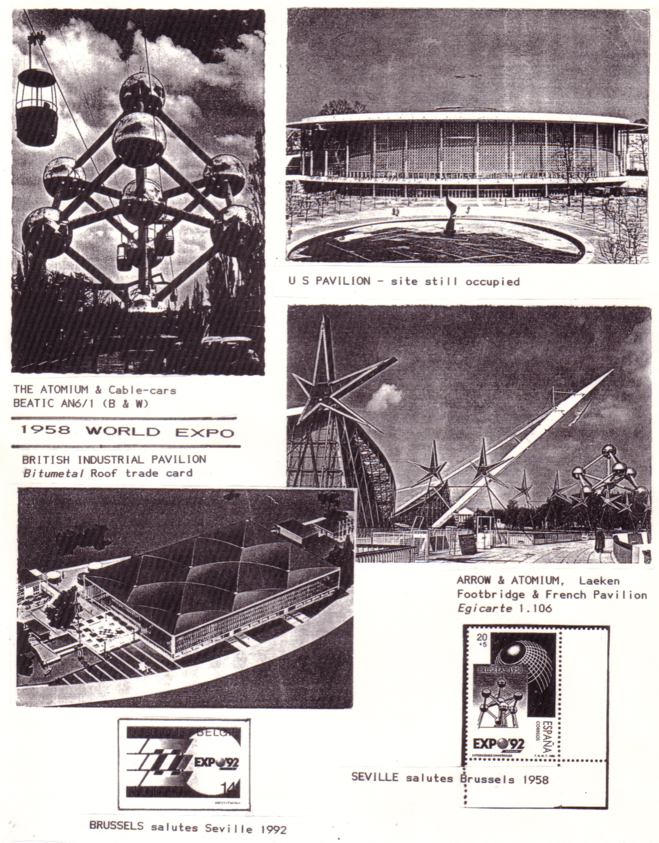

The Atomium was built (privately) for EXPO '58 and is still operated as a franchise. Postcards are by SOMINEX although the early cards (still on sale) are by BEATIC. There is a shop with a wide range of Atomium souvenirs (no access cards accepted). I acquired a 1958 board-game sheet and the VHS video but the Expo slides were sold out. On request postcards were cacheted 'as posted at the Atomium'. Does a checklist of these cachets exist?

After going up the Atomium (by stair and escalator) and examining the current exhibition, I got a good view of the park. I could see the Heysel Stadium, the 1935 permanent Grand Palais buildings and Bruparck. This includes the largest cinema complex in the world, a 'village' of restaurants and shops and 'Mini Europe'. This display (joint fee with Atomium, if desired) is an excellent collection of models and animations of sites of the European Community on a scale of 1:25.

Comparing plans, it would seem that the present bars and shops occupy the 'Merry Belgium' Folklore section of the 1958 Exhibition, which I found so enjoyable. Included now is a Metro (subway) and pre-Metro (tram) terminus. The city centre is only minutes away. The area also includes the New Planetarium which appears on a 1974 Historic Building stamp. The Heysel Stadium is a major point of interest and I managed a wee refreshment in the integral bar of the Sporting Club Heysel. The stadium first appeared on a 1950 European Athletics set of stamps.

I took a leisurely walk through the Parc which has few other visible signs of 1935 or 1958. Almost 41 million visited the 500 acre site in 1958. To ease the large influx of foreign visitors, a special team of hostesses/guides was formed in Brussels. The 20th anniversary of this service was marked by a stamp in 1978.

My visit in 1958 had been organised by the W(R)VS for British servicemen stationed in West Germany. We bussed it to Brussels and were billeted in a temporary hostel, over a long weekend, which was OK for us, although I cannot recall where it was located.

One semi-derelict concrete area at the far end of the old avenue des Nations seemed rather familiar. The empty fountain and surviving building appeared to be the survival of the vast American Pavilion. Part seemed to have been used as a cinema or something similar and as a store.

The outfitter NEXT has shown two mounted prints of pavilions of the Paris 1900 Exposition, architects 'water colours' of the China and Japan pavilions. Walking into the Royal Domain of Laeken from the site of the American pavilion leads to seeing the actual oriental buildings. In reality, however, these were reconstructed on the orders of Leopold II. On completion, the buildings were handed over to the nation.

While I was there the Chinese Pagoda was closed to the public for restoration. It was opened here in 1906 and it is not easy to discover how much of it was the original 1900 design. The two buildings are separated by a busy main road and access to the Japanese Tower is made by an underground entrance located near the Pagoda. The Tower housed an exhibition of Chinese and Japanese porcelain as well as gifts from the Mikado to King Leopold. It is difficult to believe that the building was intended to be a restaurant (on the same basis as the pagoda in the Tivoli in Copenhagen).

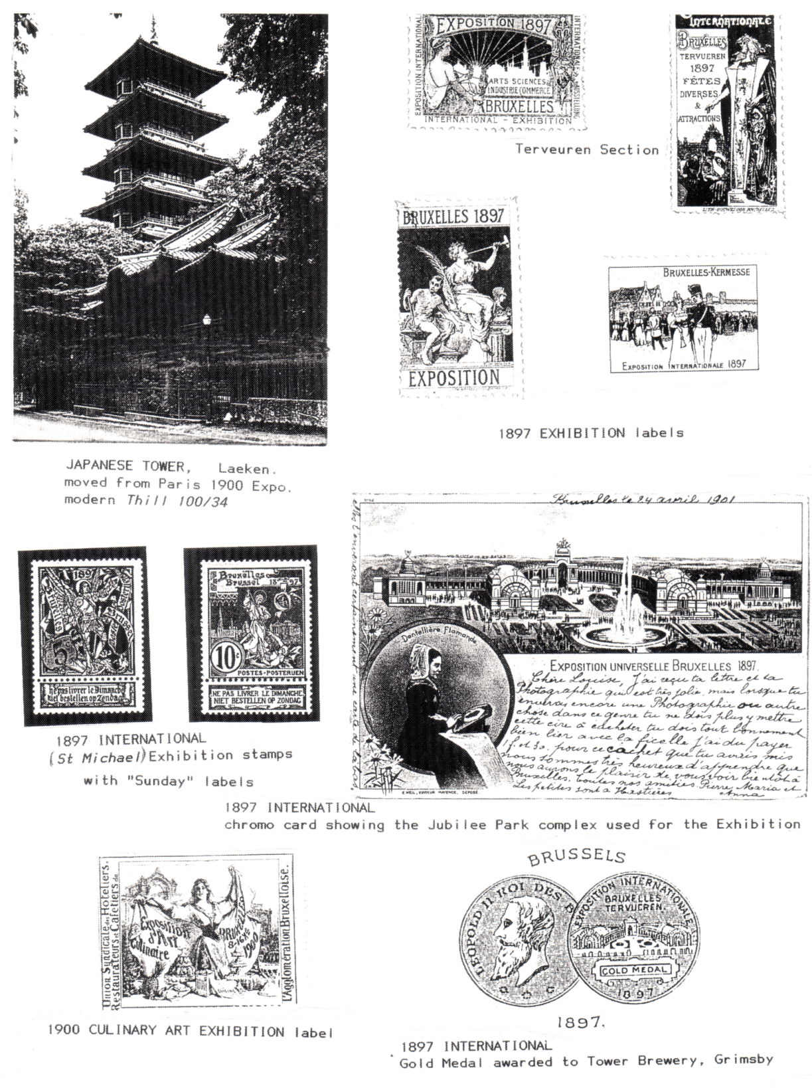

I was now in quite a whirl of exhibitions. What I needed was to marshal my various experiences . Was there some central display of Brussels exhibitions? I visited the city museum in the Grand Place (seen on several stamps) but could only see a medal certificate for 1910. In the Urban Brussels Transport Museum (open weekdays only, fee), in the Avenue de Tervueren are a number of destination boards for trams en route to EXPO '58 (there is also a popular postcard of buses, including one going to the exhibition).

While examining a Brussels bookshop, I spotted a new poster. Entirely in Flemish, I found I could read it perfectly! 'WERELD-TENTOONSTELLINGEN TE BRUSSEL'. It announced an exhibition of archives of Brussels exhibitions from 1897 to 1958. It was being held in the Archive & Museum of Flemish Life in Brussels.

This turned out to be a very discreet museum near the city centre, in Visverkoperstraat. The exhibition, however, proved to be well worth searching out. While concentrating on paper records there were also some material of general interest, beermats, matchbox covers, etc. There was a rather worn 1935 tin, alongside a 1935 chocolate tin, depicting the Cote d'or chocolates stand. The tin was in mint condition and must surely have been acquired for the archives?

The display included organising letters, telegrams, etc., along with copies of the official publications and all the major magazine supplements, maps, labels etc., plus some marvellous posters. Included were details of the Flemish protest against EXPO '58. There were plenty of postcards, particularly the 1910 and 1935. There was also a wide range of leaflets issued by various pavilions.

There was no catalogue for this exhibition (which apparently only included a small part of the exposition archives) but the poster was available at 40p, thanks to the finances provided by the National Lottery and the Culture Ministry. The exhibition filled in a lot of gaps in my knowledge of Brussels exhibitions. I had been acquiring as many modern postcards showing the Atomium, the 1935 buildings, and the Chinese Pagoda and Japanese Tower as I could. Poster cards are available and I got a nice modern Thill Paris 1900 Exposition card advertising excursions to Brussels (820/4), 5th Salon du Cycle, Brussels, 1897 (820/6), and 1910 Universelle & Internationale (820/50).

I then asked about EXPO '58 cards and was usually offered around 200 cards to choose from, at 40p each. I also acquired an exhibition plan (from a postcard dealer). Having a base to work on, I have managed to make some sense of the SOMINEX system of postcard numbering and hope to show preliminary results in the Newsletter in due course.

At the airport I thought I'd bring back some Belgian chocolate. There I saw a fine 800gr tin of Cote d'Or 1935 Exposition toffees, yes, exactly the same as in the exhibition! I too have a mint tin.

Immediately on my return home, I got a call from a dealer friend. He had acquired a rather solid Atomium, stainless steel atoms on a heavy marble 1958 mounting. Was I interested? He also had three metallic buttonhole Atomium pin back badges.

As a final souvenir of Seville, there is the 20+5 peso Spanish stamp issued in 1989 depicting the Atomium and entitled 'Bruselas 1958' as part of a series showing the 1851 Crystal Palace, the 1889 Eiffel Tower, and Osaka 1970. In return Belgium issued a stamp to mark the Spanish Expo.

In 1958, the only stamps showing the Atomium were issued (apart from Belgium) by Haiti and San Marino.

Belgium has reproduced the Atomium several times on its stamps, I have noted 1983 (24th International Periodical Press Federation World Congress) and 1989 (Direct Elections).

Do readers know of any others?

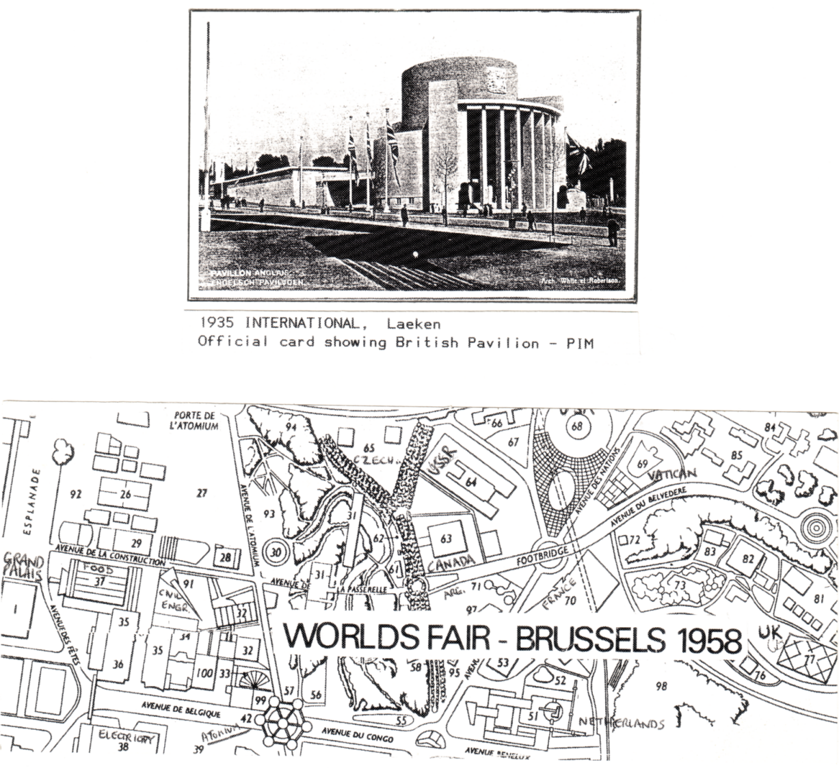

LETTERS TO THE EDITOR.

Dear Mr Tonkin.

I have been given your name by Karl Illingworth who I recently met in my search for 19th century exhibition catalogues. He suggested you may be able to help.

I enclose a brief outline of my current project. You will understand better than most people how valuable exhibition catalogues can be in tracing the development of taste, processes, and the work of individuals. I have been able to trace a number of catalogues which are mainly photographic, though not exclusively. These are providing me with first level of knowledge for my project, as I am gradually inputting them onto a relational database which allows me to analyse the information. A list of catalogues is enclosed.

Karl suggests I should use your newsletter to seek support for information or photocopies of exhibitions (catalogues ?) within my period. Would it be helpful if I were to write a short paragraph or two for inclusion or do you have enough information here ?

Is there a comprehensive listing of exhibitions 1839-1875?

I look forward to hearing from you and remain,

Yours sincerely Roger Taylor.

36, Heaton Grove, Bradford, West Yorkshire, BD9 4DZ. Tel. 0274 541504

Roger has enclosed a list of 34 catalogues he has been able to trace and apart from the 1851 London, 1855 Paris, 1862 London, 1865 Dublin, and the 1867 Paris which are all International Exhibitions, the rest are mainly Photographic or Art Catalogues up to 1868.

In my reply to Roger I can only bring to his attention a reprint of Frank Leslie's 'Historical Register of the Centennial Exposition 1876. They also have, in the Red Cross Archives at Wonersh, a copy of an International Health Exhibition, London 1884 publication. This is more of a First-aid manual (before the word first-aid was invented).

Regarding the list of exhibitions, The Exhibition Study Group published a list in our newsletter No. 5 1986, compiled by Professor P L Simmonds. This covers the years 1851-1887 and lists about 150 exhibitions. The 1851 is listed as 'The Worlds Fair at Hyde Park'. I haven't heard it called that before.

I hope any members who can help Roger will do so. Unfortunately catalogues this old are very thin on the ground, once you pass into the 20th century they become far more common. I am also sending him Graham Hall's address, as I am sure he will help Roger if he can.

I have been corresponding recently with a Canadian collector Ken Barlow, and he sent me a photo copy of a page from his collection, showing the front and back of a card and saying he was not sure if it was in fact a Wembley card. I was able to set his mind at rest and assure him it was.

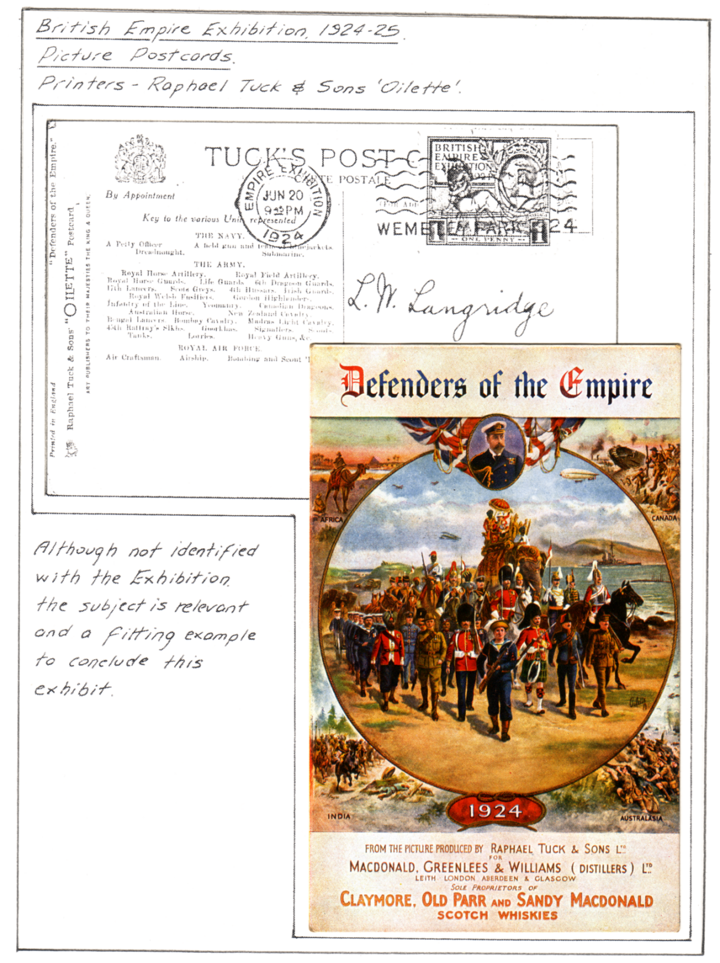

Dear Ken,

Nice to hear from you so promptly, despite your natural desire to be out and kicking the dandelions to death. Be advised, work on the postcards it gives more pleasure, and the weeds will still be there next week.
Regarding the copy of your display sheet, yes this is definitely a Wembley card. We list it as an advertising card published by Macdonald, Greenlees & Williams (Distillers) Ltd. and printed by Raphael Tuck & Sons, My copy has a message on it "Have had three hours in Wembley and have not seen 1/1000th of it yet", unfortunately it was not posted from the exhibition, but I know of other copies that have the Wembley Stamp and postmark. Macdonald Greenlees & Williams. exhibited on the Whisky Association Stand, The Whisky Assoc. was there in 1924 and 1925 in the food section of the Palace of Industry, and had stand No. 655 both years. The 1924 catalogue does not list all the firms on the Whisky stand, but the 1925 catalogue does, and lists Macdonald Greenlees & Williams as being there.
Yes I would appreciate a photo-copy of your inventory, as I could then see if you have anything I don't know about.

Ken has since that letter sent me a copy of the inventory of his collection, and I am going through it to see if I will want photocopies of any of his cards, which he has kindly offered to do for me.

1993 CONVENTION AT WEMBLEY.

This is well in hand and I should like to hear from members who would like to have a go and show us a few sheets from their collections, You need not be afraid of saying a few words about some of your favourite items. Just think of it like this, if you like them, then it's almost certain that we will too. So have a go. We are very fortunate in the Group to have some members with very fine collections, who are always willing to give a show, but the convention is for everybody, and those of you who were at our last convention will remember two members gave their first ever display, one on Flying at the Palace, and the other on Royal Tournaments, and how well they did it.

We will be starting on both days at 9.30. On the Saturday as usual before the start of the displays we will be holding our A.G.M. This should not take long. There will be breaks for coffee and tea, and lunches will be available midday. After lunch on Sunday Alan Sabey will be leading an organised tour of the exhibition site. This will start about 2.15 by the telephone kiosks at the entrance at the end of Brook Avenue. There are still some of the pavilions standing, although most of them have gone, this should take about an hour and a quarter. It will depend of course on how long you stop and natter. I know the walk-abouts were much enjoyed at Crystal Palace. Alan is producing some sheets which will be given out before the tour starts. So far I have booked in at Mrs Mullanes Guest House, seven people who will be staying Friday night, and eleven who will be staying Saturday night. Alan who lives at Wembley is also filling his house with members. I believe the washing up is going to be done on a rota system. I am certainly looking forward to the weekend.

REPORTS ON MEMBERS DISPLAYS.

On the 15th May 1993 to the Great Britain Philatelic Society.

Wembley. by Alan Sabey.

Starting with the Empire Exhibition stamps, I showed instructions for the designs as given to the chosen artists, bromides of unaccepted designs by Harold Nelson and die proofs in black and in brown of the chosen designs. The issued stamps were represented with examples in blocks of four of both perforations, stamps printed on thin papers with both perforations, and corner number copies. The exhibition stamps display concluded with perforation errors caused by paper folds, vending machine leaders, and stamps from those machines some on cards posted at Wembley, also booklets of definitive stamps where the covers or interleaving had advertisments for a hearing aid firm at the Exhibition, and on how to get to the exhibition by railway. The rest of the display comprised stamps issued for the 1948 Olympic Games, and the finals of the 1966 World Cup Football Match, both of which were 'Wembley' events.

On the 17th June 1993 to Worthing Philatelic Society

Wembley. by Alan Sabey.

I started with examples of the Empire countries postal advertising, and a few examples of the British advertising, including a birthday card posted at Brighton on 10th October 1922 which was the first town to start advertising on that date. The rest of the first half contained many of the items included in the Great Britain P. S. display. The second half of the evening was a thematic display looking at the designs of the pavilions and other buildings and covering what the exhibition was all about. It was well received at Worthing with an attendance of 37, several of whom could remember going to the exhibition. A number of visitors were fascinated by the never-stop railway.

This display was also given two evenings earlier to Hounslow Philatelic Society where Alan is a Past President.

FUTURE DISPLAYS.

On the 14th September 1993 at 7.30 to the Sussex Postcard Club
Church of the Good Shepherd Hall, Dyke Rd, Brighton.

The Japan-British Exhibition. by Bill Tonkin.

WEMBLEY PERFINS.

You will recall that last year John Nelson asked through our Newsletter for information on Wembley Perfins (Wembley stamps with perforated firms initials). Don Knight and Alan Sabey had covered this very well in their book 'The Lion Roars at Wembley'. John used this as his starting point, for a survey he was doing through the Perfin Society. He received altogether details of 412 stamps, and this covered 63 different types. The Perfin Society has now produced a 16 page A 4 size booklet on the results of his survey. 'Catalogue of Perfins 1924 - 1925 British Empire Exhibition Stamps' (not a priced catalogue). A copy of this has been sent to all the members of the Study Group who helped John in his research. One of the tables lists all the known examples for each firm, this is interesting as it shows at a glance which are the common, and which are the scarce ones. In the case of 12 firms only a single example is known, and only two copies are known of a further 12 firms. This compares with over 60 used by Waterlow & Sons Ltd. So as you can see a lot of these are very scarce items, particularly if you have them on cover.

THE WEMBLEY LION.

By Alan Sabey.

I thought members might be interested in the following article which appeared in 'The Bookseller and the Stationery Trades Journal' July 1924.

There is no emblem of the present year which is more universally seen, or which possesses deeper significance, than the Wembley Lion. It will therefore interest our readers to know that it was originated in the studios of our printers, Messrs. Saunders Phillips & Co. Ltd., at The Baynard Press, Brixton, S.W.9. who since their removal from the site of the old Baynard Castle in Upper Thames Street, four years ago, have captured with a rush a reputation for designing and printing of the very first order.

The lion himself may be treated pictorially in many ways, but the one for the British Empire Exhibition was intended to express strength, firmness, and a serene confidence. This it does, and although they may not consciously realise it, thousands are impressed and inspired by this masterly conception of what the British Empire is.

Criticism of anything entirely new is easy, and the Empire Lion has not escaped. A correspondent of a daily paper, rashly daring, suggested as an improvement what would actually have been a fall from the sublime to the ridiculous. His letter was noted by that scholarly commentator, 'The Londoner', and criticised in its turn. The comments on the design are so true and informative that the following extracts may well be placed on record here.

"Yet I am still living and learning. Yesterday I gained something which I had not known before. I took it from a letter to the editor of the Daily Mail. "Sir" said a gentleman, addressing himself to the Editor, "the lion shown on the Wembley advertisments has its tail down, like a Belgian lion. The British lion always is depicted with its tail up. Is it too late to alter it ?

The answer to that question must be, yes. That picture of the Wembley Lion must have gone all round the world and back again. No lion in all the world is now more familiar to the eye than this one, which is badge and ensign of the great Wembley Exhibition of 1924.

And I would say that it were a pity to change him for another lion whose tail should point upward to the skies. For he is a noble lion, haughty and valiant as any in the tales of the old books. I fancy that the artist who imagined him, who did not copy him out of a picture book, must have been
well pleased to see his work when, with a few strokes of the brush, he had made such a lion, so thick of mane, so mighty and terrible.

As for the British Lion, I am almost ready to say that the Wembley Lion is the first British lion. Therefore, if you would know how a British lion should carry its tail, look about you for the Exhibition posters, and see a lion with much dignity in its sweep.

Patriot artists learned that a shaggy lion was Britannia's household pet, to be pictured as sitting beside her knee, they drew the lion's tail in the fashion that was most to their taste. And now you have the British Lion set out by authority. He is indeed a noble scion, as a despairing poet said, but his tail does not point upwards like the tail of my pussycat when she comes stepping delicately into a room whose door has been opened at her command."

FRANCO-BRITISH CONNECTION

Arthur Smith has sent me a copy of a card he has, with a definite Franco-British connection. A musical comedy 'Our Miss Gibbs' was put on at the Gaiety Theatre. It ran for 636 performances from
23rd January 1909. The 2nd act takes place at the White City. Note the back cloth on the stage it's the Court of Honour. The star of the show was Gertie Millar. All the information has been supplied by Arthur Smith.

