EDITORIAL NO. 3

The two main articles for the first issue of the I98I season have been provided by Graham Hall (Bradford Exhibition) and Percy Oliver (Australian Exhibitions), Percy provided enough material to split his article and the second half will follow in issue No. 4. The illustrations are all from exhibitions held in the 1920's - please let me know if I can include in any future issue, cards that you would like to see. Even better, send a couple of unusual cards for me to publish.

Fred has made contact with the Crystal Palace Study Group and we have provided the information for any member who wishes to join. Even if you don’t live in the London area their magazine must be worth the subscription. We have also reprinted the letter from the World Exhibition Society. £12.00 per year may seem expensive for a quarterly 36 page booklet, however, the content and quality of reproduction are good. I would suggest a letter of enquiry might bring a sample copy and then you could make up your own mind.

New members
B. Evans ‘Messengers’ All exhibitions
11, Hillsborough Avenue, Printed ephemera
Exeter,
Devon.

William Early Scottish exhibitions
16, Stratheden Road,
West Perry,
Dundee,
DD5 1QF

Any member who has not contributed an article or 75p subscription for 1981 – I will be very happy to receive both!

Good Hunting for 1981.

A. D. Brooks

June 1981

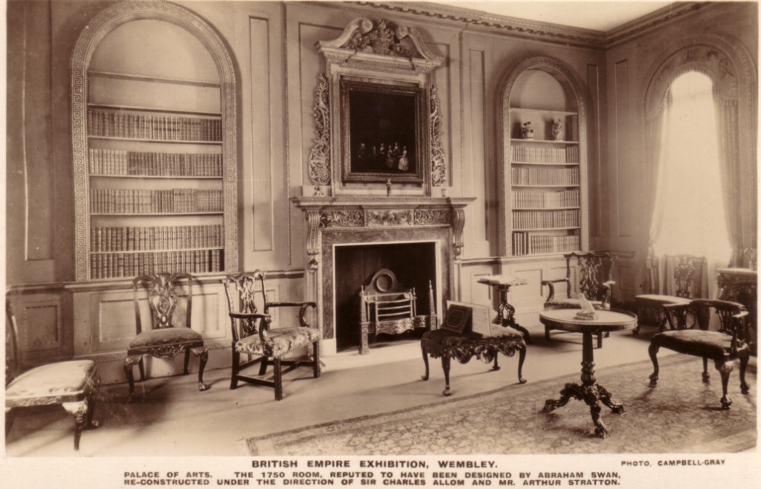

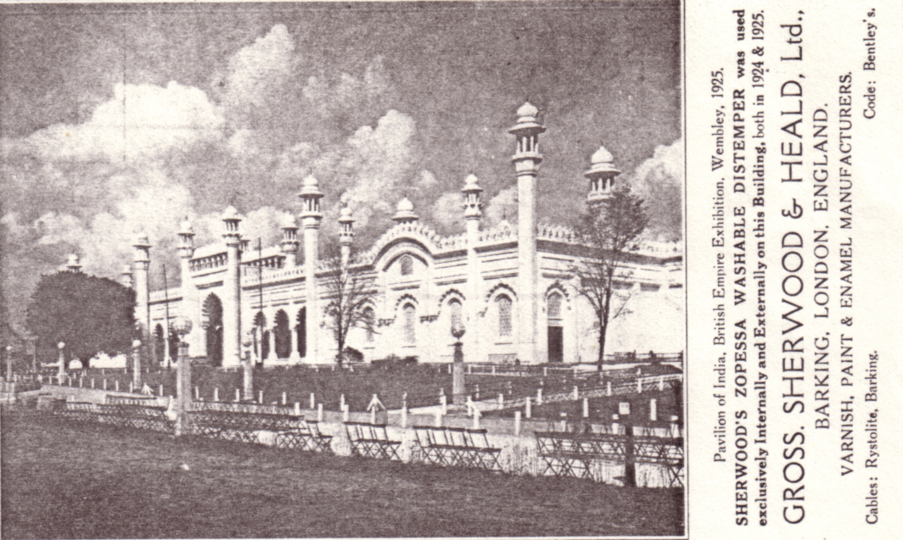

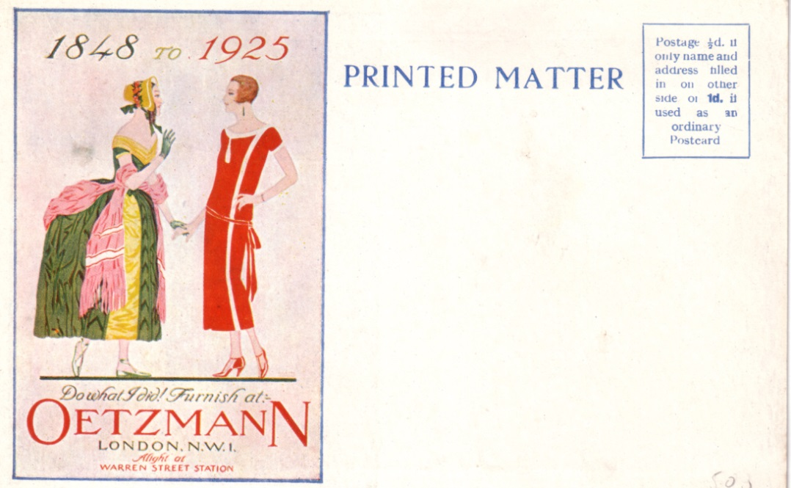

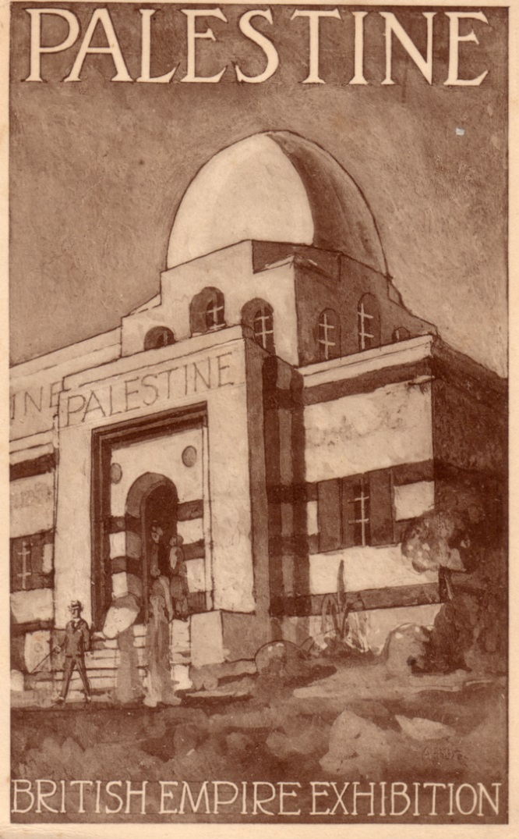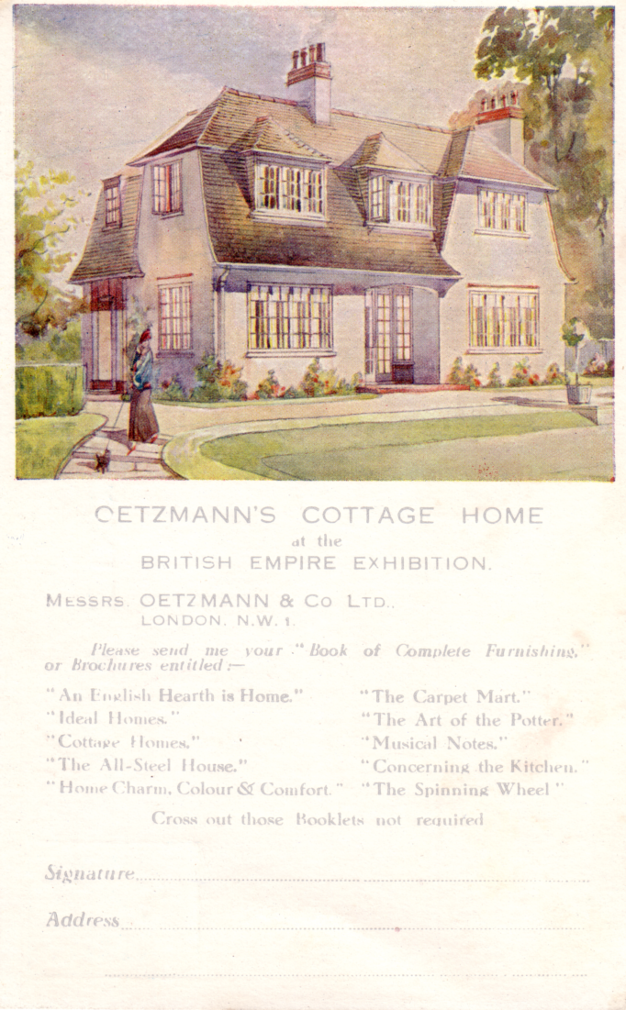

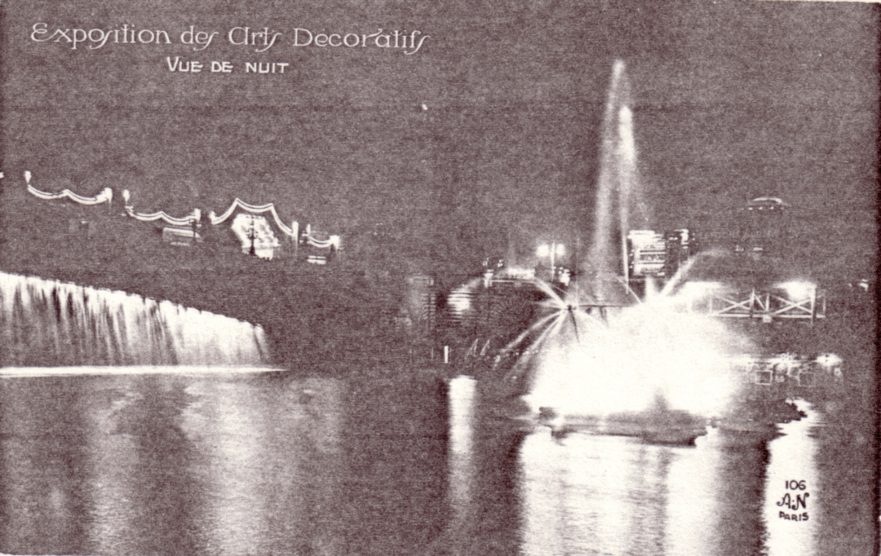

The 1904 Bradford Industrial Exhibition

Correspondence of John Masefield.
by
Graham Hall

John Masefield became Secretary to the fine art section of the Bradford Exhibition in late 1902, having served in a similar capacity at the Wolverhampton Exhibition which was held during the same year. He wrote profusely to members of the Exhibition organising committee and the Corporation from his first application for the post of Secretary in a letter dated the 3rd. of November, 1902, until the 10th. of April, 1905. In all the correspondence covers 107 letters, 4 postcards and 19 telegrams. Given below are complete quotations of the most important.

November 12th. 1902.
In his official application for the post addressed to Frederick Stevens, the Town Clerk, dated 12th. November and following an initial approach of the subject dated the 3rd. of November, he mentions both his position at the Wolverhampton exhibition and the fact that he was Correspondents Clerk & Secretary’s assistant to the Royal Commission for the 1900 Paris Exhibition.

November 5th. 1902.
Letter on headed notepaper of the Wolverhampton Art & Industrial Exhibition, 1902. Gresham Chambers, Lichfield Street, Wolverhampton.
Dear Mr. Wood,
Many thanks for your kind letter of yesterday and for your promise to lay my application before your committee in due course. Even should it prove impracticable to employ me I would be glad to render you any assistance in my power in making your exhibition a success.
Believe me
Yours very truly,
John Masefield.

In May of 1903 Butler Wood wrote to Masefield asking him what remuneration he required and in a reply dated 7th. May, 1903 he mentions a figure of three pounds or three pounds ten shillings per week as being fair plus expenses. He goes on to say that he could earn that sum by his pen in the time he proposed to demote to the matter and these were his expenses for work on the Wolverhampton Exhibition.
On a visit to Bradford John Masefield’s expenses amounted to: Railway: £1.11.9; Hotel: £0.6.6.; Cab: £0.1.2. (total £1.19.5.)

May, 14th. 1903.
Letter on headed notepaper: “The Speaker” The Liberal Review, 14, Henrietta St., Covent Garden.
Dear Mr. Wood,
Many thanks for your letter and for sending an acknowledgment to Mr. Hodson. Mr. Hodson very kindly asked the committee to dine with him at the Cafe Royal last night and a meeting took place satisfactorily, with results as follows.
The artists are willing to act upon the committee and to borrow, select, and hang the works of art included in the exhibition. They think that the exhibition should confine itself to the English school from the time of Hogarth until the present day without giving undue prominence to any school of painters such as the P.R.B., or that of Norwich or Blake.
They feel that they could bring together a splendid selection of English painting, and if this programme meets the approval of your local committee perhaps your chairman will be so kind as to pass a resolution confirming their powers as a working body. On receipt of a copy of such a resolution appointing them the borrowing and selecting committee for the exhibition they will at once begin to secure pictures etc. for the exhibition, and will also discuss in detail the arrangement of the galleries and rooms.
They were of the opinion that Sir Walter Crane should be asked to join the committee on the account of the textile and old furniture to be included among the exhibits, and I am writing to him today.
Photography, it was thought, had better be excluded from the programme. It would look out of place in the black & white rooms and could not under any circumstances be shown in contrast to oil painting. Water colours, being so perishable, ought not to be shown in any number, if at all. We should be very glad if you could furnish us with some scale drawings (however rough) of the galleries and rooms and corridors, with a list of the pictures now in the corporation gallery and a mark against those the committee will wish to include in the exhibition.
The Working committee we suggest consists of the following! Mr. l.W. Hodson; Mr. John M. Swan; Sir Walter Crane; Mr. P. W. Steel Mr. W. Rothenstein; Mr. W. Strang; Mr. C. H. Shannon. I will of course see to it that all arrangements I make on your behalf will be made in an economic manner, but the committee would like to know what sum the town wishes to be expended in the ordering of the exhibition. The insurance is a heavy item, being roughly speaking £200 on every £100,000 of pictures. And it is on the quality of the works borrowed that the amount of the insurance would of course depend.
Yours very truly,
John Masefield

The prospectuses are returned herewith with the remark of the committee that the booklet system would be advisable as much for its newness as for its excellence. The grotesque head is form the happy pencil of Mr. Rothenstein. Lawrence Hodson of Compton Hall, Wolverhampton, arranged black white dept. of art exhibition. Prints and drawings at Wolverhampton Exhibition were his and success of same due to him.

In a letter dated November 9th. 1903, the following appears, I saw Sir Lionel Curt on Saturday about the King’s pictures. He says that his majesty objects to lending, but that if Lord Masham or the Hon. Greville were to write to the King’s Chamberlain we might get a Gainsborough drawing, one of the two now at Birmingham, for one or two of the months the exhibition remains open.

On November 10th. 1903 he asks Butler Wood if he may employ a clerk at £1 per week for the dealing with correspondence (which is granted).

An un-dated letter of about 1904?
1, Diamond Terrace, Greenwich.
Dear Mr. Wood,
The committee wish me to let you know that their charges for the hanging of the gallery amount to £10.10 per man. Strang, Steel, Rothenstein were the three men engaged, for I do not know whether Hodson would care to be remunerated. I am glad the show has done so well.
Yours very truly,

Australian Exhibitions
by
Perry Oliver

It could be said that the history of Australia in connection with exhibitions began in 1851 at the Great Exhibition in the Crystal Palace in Hyde Park, London. At the time, the conception “Australia” represented the continent, because the Australian colonies were separate entities, there being six of then - Queensland New. South Wales, Victoria, Tasmania, South Australia and Western Australia. Each of these colonies had a separate and distinct group of exhibits at the. Great Exhibition.
Enthusiasm throughout the world was generated by the historic conception of Prince Albert, and exhibitions were staged in various countries in the next two decades. The Paris exhibition was held in 1855, and London provided international exhibitions in 1662 and 1873 with the US.A holding its Centennial Exhibition of 1876 in Philadelphia, to mark the passage of a hundred years since the declaration of independence. On these various occasions, the Australian continent did not fail to be represented by displays, and the colonial cities of Sydney and Melbourne provided previews of the items which were subsequently shown overseas. In these same two decades, while the colonies were sending material across the seas, inter-colonial exhibitions were held in various places, principally in capital cities but one of the earliest was in a city other than a capital. The National Library of Australia, at Canberra, has a picture, gleaned from the Melbourne Post of September 20.1866 of the arrival of the governor of Victoria at the Ballarat Exhibition.
The Governor’s carriage is shown driving along an avenue provided by a line of cavalry (or mounted policemen) on one side of the main street, and a close formation line of colonial riflemen on the other flank. From the set-out (and the names on the buildings can be seen clearly) it seems that the exhibition was probably held in n 1arge brick building called the Mechanics Institute. Ballarat is an inland city, seventy miles north of Melbourne was the scene of the famous miners rebellion, Eureka Stockade, and in 1868 the goldfield there was at the peak of its prosperity, and the town had 64,000 people. Melbourne also had an exhibition that year and Sydney held them in 1851, 1870, 1873, and 1875. For the Sydney Inter-colonial Exhibition of 1870 a special building was erected in Prince Alfred Park, and remained in use for various purposes until 1954, when its demolition occurred. Faraway Brisbane entered the scene with an inter-colonial event in 1876.
The era of inter-colonial events ended when New South Wales had the first International Exhibition ever held in the south land, in Sydney, commenced on September 17th 1879. The event…….
A line or lines is missing on the original copy owing to poor photo-copying
……..fate of the exhibition was never ascertained but there was a very general conviction that arson had taken place and the arsonists aim and achievement had been the destruction of convict records stored there. The fire destroyed three hundred pictures owned by the Art Society, and also the scientific records of the Rev. W. B. Clarke, which the government had thought sufficiently valuable and important to be purchased for £7,000 several years previously.
It is very interesting that Sydney had an exhibition contemporary with the Great Exhibition in London in 1851, in emulation of it. The Surveyor General of New South Wales, the bad-tempered explorer, Sir Thomas Mitchell, showed there his invention of a boomerang-shaped propeller for steam ships. Nothing seems to have come of it, so the assumption is that it was more Australian than practical.
The Melbourne Exhibition of 1866 saw a proposed “electro-magnetic engine”, invented by James Musgrave, and Alex Smith of Carlton came out with a “self-acting water lift” and to show Victoria’s progress in the musical field, George Finchan exhibited an organ entirely built in the Melbourne suburb of Richmond. The Victorian railways had a wide range of locally invented and built pistons, gauges, pumps and other appliances of steam. At this exhibition of 1866, some 1,500 people assembled in this first exhibition building on Queen Victoria’s birthday “strongly reminiscent of a Mayor’s ball in an English provincial town.” The crush was excessive and dancing difficult, but everyone of consequence knew that you would see all society there, so everyone attended.
The Sydney exhibition of 1870, held to mark the centenary of Captain Cook’s appearance in what would become New South Wales was disappointing, not showing much of an advance in local industry but, by 1879, the industrial picture had greatly changed, and the colony could be proud, of its progress. The attendance at this exhibition, with the aid of the steam trams, exceeded one million, and Sydney could point out that on a population basis, this was seven times that of the famous Paris Exhibition of 1876. There were exhibits of ice making machines, launch engines and oscillating paddle engines, diving gear and manual fire engines.
For the Melbourne International Exhibition of 1880, a special building was erected - a permanent one - in Carlton Gardens. The building still stands today and has had a long and celebrated history. It had, when originally erected, floor space of twenty-two acres, 32,000 exhibits were shown, the building cost £250,000, and it included the biggest dome in the world. The building had the triumph of showing an electricity generation plant which cost £60,000 to install. In 1888 the building was used for the Centennial International ………
A line or lines is missing on the original copy owing to poor photo-copying
………continued until April 20 1880, and it was housed in a structure specially built for the occasion……..
A line or lines is missing on the original copy owing to poor photo-copying
………Palace. Against the strongly expressed disapproval and agitation of many citizens the building was erected on the eastern slope of the ………grounds surrounding Government House. Opposition had been engendered by the realisation that the huge structure would permanently blot out the harbour view from that area. But the agitators had no prescience of what fate had in store. The building had a dome of fine appearance and proportion, placed centrally; and supported by four gigantic towers. The main entrance on the ground floor was opposite the spot where a statue of Governor Philip now stands, and it was possible to have a basement floor on the east side because of the downward slope there. Beneath the central dome, a fountain played at the foot of a statue of Queen Victoria: the exhibition centred around this point.
Great interest and excitement were generated throughout the colony by the fact that Sydney was then inaugurating its service of transport provided by the new American steam-powered trams. The first four Baldwin trams, imported from. the U. S. A. in 1879, puffed along tracks laid from. Hunter Street, along E1izabeth Street, across Belmore Park, to Redfern Station. With the influx of visitors to the first International Exhibition, the trams carried a sensational half a mi11ion passengers in their first three months. Fares were reallv very cheap. eight tickets for the full distance costing only six pence.
The “Sydney Punch” saw; these steam trams as a public menace, and illustrated one, breathing fire, smoke and steam, driven by a masked figure, escorted by ghosts, and carrying a grinning skull and the devil himself at the front.
Major exhibitions occurred in the eighties enacted at Melbourne in 1880 and 1866, at Brisbane in 1897, Adelaide in 1881, and 1887, Perth in 1881, Launceston in 1801 and Hobart in 1894. These big public exhibitions had the effect of making the colonials believe themselves to be one people - Australians - and must have helped greatly to conceive the idea of federation. They certainly displayed to all the progress and development of other area, and acted as a spur to greater efforts. The colonies were mainly agricultural and pastoral producers, so in the engineering field, the emphasis was on the machine which could be of use in those pursuits, and ploughs and harvesters were popular exhibits. It was the age of the horse and cart, and saddlery was always a major display.
Great drama was added to the Australian history of exhibitions by the destruction by fire on September 22 1882 of Sydney’s Garden Palace, built only three years previously. The blaze was one of the most spectacular ever seen in the city. The cause of the fire……..
A line or lines is missing on the original copy owing to poor photo-copying
……….exhibition which commemorated one hundred years of Australian settlement. The Victorian Railways lent its electrical experts and new plant to the Trustees of this exhibition.
The greatest display of lighting so far achieved in Australia was used at this event with in action one thousand arc lamps, three thousand x 16 candle-power bulbs and 40 x 400 candle power sunbeam lamps. After the exhibition closed the plant was used to illuminate the new railway administration building in Spenser Street.

To be continued in the next news letter.

Dear Fellow World's Fair Enthusiast:
As you can see, World's Fair is a journal that is hard to categorize, so we're sending you this preview edition with the hope that you'll read it and want to subscribe.
But if I had to describe the publication in a few words, I'd call it a journal of events. It uses the written word (with a few pointed Illustrations: a single word, I maintain, is often worth 10,000 pictures) to recreate the great world's fairs of the past and explore the important fairs, festivals and gatherings of the present (coining up, for example, is a report on the elaborate annual food marketing exposition in Dallas). We'll also be reporting and speculating about things to come, such as the 1982 Knoxville International Energy Exposition, the first world's fair having energy as its theme.
As a collector of world's fair books and ephemera, I hope other collectors will find WF of deep interest and value. We aim also to attract those without a specialized interest, because fairs are fun and they embody the genius, beauty, raw vitality and sometimes the dark side of our cultural heritage, and deserve the continuing attention they will receive in our new journal. And most of all, because they are great teachers. World's fairs-events of international character tell us much about ourselves as a society and as individuals. The view from the top of the Eiffel Tower, built for the Paris Exhibition of 1889, or the Seattle Space Needle, or the original Ferris Wheel, 264 feet high at the Chicago fair of 1893 all showed a world below shaped according to the dominant tastes, high and low, of their time. In like manner, WF will offer a perspective on today's human landscape and what is needed more in a time of shrill voices and lowering clouds?
The artists and writers who have gathered together to create this journal are not engaged in a conventional commercial venture. We are doing some-thing that pleases us immensely and that we think is important. If you get the same feeling, the same sense of optimism and fulfillment about this new venture, please join in by filling out the enclosed "admission" ticket.

