23, BRAMLEY WAY, WEST WICKHAM, KENT. BR4 9NT.
Phone 081 777 8861.

Editorial Summer No 29

Ring out the bells, coz summer's here
Arn't Wembley postcards getting dear.

It may be that I should not go on about the price of cards, but it seems to me that some dealers have no idea of what a card should be priced at. When you get ignorance coupled with greed, the result can be a joke.
Wembley collectors will know the St. Augustine Church card that was given out at the Wembley Exhibition, where the Rev G. S. Day was raising funds to build a church at Wembley Park. Now this is not a scarce card and I don't expect you could go to any large postcard fair without seeing two or three, usually around the £1.50 - £2.50 mark. One well known dealer and fair organiser has this priced at a staggering £22.00. Mike Perkins had a heart to heart talk with the lad about a year ago, but he would not listen to reason and at Cheltenham on May 3rd there it was still at £22.00. Even the run of the mill cards like the Photochrom coloured 'Celesque' Series, one dealer is asking £6.00 for, and the same price for the Tuck coloured cards. One must expect to pay for a scarce card, but these are still common cards.
I was not able to get up to the York Cardexpo International in April but Alan Sabey did, and while he was trotting round York called in at an Information Centre, where he collected a leaflet publicising the fair. I don't know whether Jack Stasiac or Ron Mead thought up the idea, but they should be congratulated. It must have cost quite a bit to produce a multi- coloured leaflet, and is one up on the usual tatty card tied to a lamp post. Lets hope it encourages lots of members of the public to sort out their old postcards and sell them, because come to think of it we dont realy want more people taking up collecting. There are not enough cards to go round as it is.
About a month ago I was sitting at my desk working furiously, when I became conscious that Nancy was talking to someone on the phone, it sounded as if she was saying "so you remember Dorando coming into the stadium do you", when I heard her talking about the Flip-Flap I grabbed the other phone, and found that one of the members of her Local History Society was discussing his memories of when he went to the Franco-British Exhibition in 1908. We arranged to go and see him that Sunday evening, and I took some cards of the Flip-Flap with me. He lives just round the corner, literally about twelve houses away, we had a glass of sherry, while he told us about the old days . He is now ninty six years old and mentally very alert, although he admits his memory sometimes fails him, he looks after himself, and writes a regular monthly article for the Bromley Historical Society. Needless to say he was immediately requested to write something for our Newsletter, which he has agreed to do. Apparently he was eleven years old when he went to the White City. We discussed the Flip-Flap and he said that it did not hold many people at a ride, and was probably not a great money maker which he thought explained why it was broken up, and why Flip-Flaps did not appear all over the country, like Scenic Railways and Giant wheels. Unfortunately he was not present to see Dorando but knew of the incident. We have been round to see him several times since, and do not stop too long as he soon tires.
In our last Newsletter I mentioned our 1993 Convention and this is another reminder. Don't forget if you are coming it is on September, Saturday 25th and Sunday 26th. The meetings will be at a pub called 'The Century' in Forty Avenue, Wembley Park, Middlesex. They will also be doing our Dinner on the Saturday night. For those coming from some distance there is a good lodging house 'Mullanes' 66, Wembley Hill Rd, Wembley. Phone 081 902 9211. The charges are very reasonable £14.00 for a single room bed & breakfast, and £26.00 for a double room, £30.00 en-suite. Now it is important to book as soon as possible. It only wants a conference or something and accomodation may be difficult.

P. S. Since starting this Editorial, we went to a fair at Hatfield and there amongst other things I got a very nice Wembley 'Anchor Line' card with a Wembley stamp and posted from the exhibition, for the sum of £2.50. From the same dealer who still had the £22.00 St. Augustines Church card in his stock. I give up.

Bill Tonkin.

Ideal Homes Exhibition Exhibition
Design Museum. Butlers Wharf. Shad Thames. London SE1 2YD.

A few months back I had a phone inquiry from the Bromley Council Local Studies Centre. They were trying to trace a house that had been on display at the Daily Mail Ideal Homes Exhibition in 1912, and which had afterwards been re-erected near us, could I help them. All they could give me was a photo-copy of the house taken from a contempory newspaper article about it. It did not take long to find, and apart from having had a double garage added, had not changed much. It had cost #11,000 in 1912 when it was sold at the Ideal Homes Ex. which was a lot of money and for that you got a lot of house. Bearing in mind that Oetzmann did a double story Tudor style house for #450.00 or a bungalow for only #250.00, you can imagine what a palatial dwelling it is.

The enquiry was on behalf of Deborah Sugg lecturer in History of Art & Design at the University of Wolverhampton who was doing her Ph.D. Thesis on the Daily Mail Ideal Homes Exhibition. When I spoke to Deborah to say I had traced the house, she told me that she was putting on an exhibition in ten days time at the Design Museum. This was to be a fairly important do, as 1993 marked the 70th Ideal Homes Ex. It would take up a complete floor of the museum running from March through to August, and was being sponsored by Alliance & Leicester.

Although Deborah had been working for three years on her Thesis she had not come across the fact and did not know that the Ideal Homes Ex. had published postcards, and when I told her I had cards going back to the first Exhibition in 1908, she was amazed and asked if she could come down to see them. She had not been able to find anything as early as I had.
Two days later Deborah with a colleague, and Clair Catterall Curator of Collections at the Design Museum visited us at home to see what I had. They spent a long time sorting out cards and eventually borrowed enough to fill four display frames. They showed great interest in the Exhibition Study Group and asked many questions about us. They were surprised that word of our activities had not got around in academic circles, and Deborah bemoaned the fact that she did not know earlier of the wealth of knowledge and material that could have been available to her and other researchers.
I also put her in touch with Alan Sabey who has a lot of receipts and recipe booklets that his mother got from the Ideal Homes Ex. many years ago. Alan's mother kept every receipt to do with her wedding in a wooden box, and some of these were for things she bought at the Ideal Homes Ex, like the illustrated order and receipt for three rugs.
The Design Museum felt these were so important they sent a motor bike courier to collect them, the morning before the exhibition was due to open, so they could go on display. At my request the postcards are credited to the Exhibition Study Group, as I felt we could do with the publicity.
Deborah is working on a book about the Ideal Homes Ex. and I was able to show her the Study Groups effort which impressed her. She has also agreed provisionally to be one of the speakers at our Convention.
On Tuesday evening the 9th March there was a private opening ceremony, and view of the exhibition. I was able to invite George & Flo Simner and Arthur Smith to join Nancy and myself, so the Study Group was well represented, and we spent a very enjoyable evening. They had certainly put on a very good show, and had managed to get hold of a lot of archival material, in the way of press photos etc. I should imagine that firms like Hoover were approached and had loaned early types of vacuum cleaner, and all together a lot of hard work had gone into it.
The Daily Mail Ideal Home Exhibition launched in 1908 by the paper's proprietor Lord Northcliffe, was both a philanthropic and commercial venture. Social reformers and architects exhibited their ideas alongside speculative builders. For a fee of one shilling the public was educated by full-scale show homes, spectacular displays and a wealth of labour-saving devices. With attendances of over 1.3 million by 1958, the exhibition was hugely influential on public tastes and aspirations, promoting the concept of a modern lifestyle decades before it became the media obsession we know today.
1993 sees the 70th Ideal Home Exhibition, and the Design Museum is marking this anniversary with a retrospective appraisal of the seventy shows. Drawing on the archives of the Daily Mail, the Victoria and Albert Museum, as well as the experiences of people who visited and worked on the shows, the display looks at the promotion of the idea of a modern lifestyle and seeks to evaluate the exhibitions influence on the lives of its many visitors. Furnishings and domestic appliance, architectural models, archive film footage, documentary photographs and publicity material will reveal just what factors made this exhibition so popular.

Four themetic sections explore the story of public housing, suburban development and notions of modernity, home ownership in the twentieth century, and the advent of the electric servant. Highlights include,

'Homes fit for Heroes' and other schemes developed by social reformers.

Visions of Olde England, the 'Tudorbethan' style promoted by speculative builders of the thirties.

The Housewife as Designer, The search in the fifties to find 'the House that Women Want' as identified by members of the Womens Institute and listeners to BBC Radio's 'Woman Hour'.

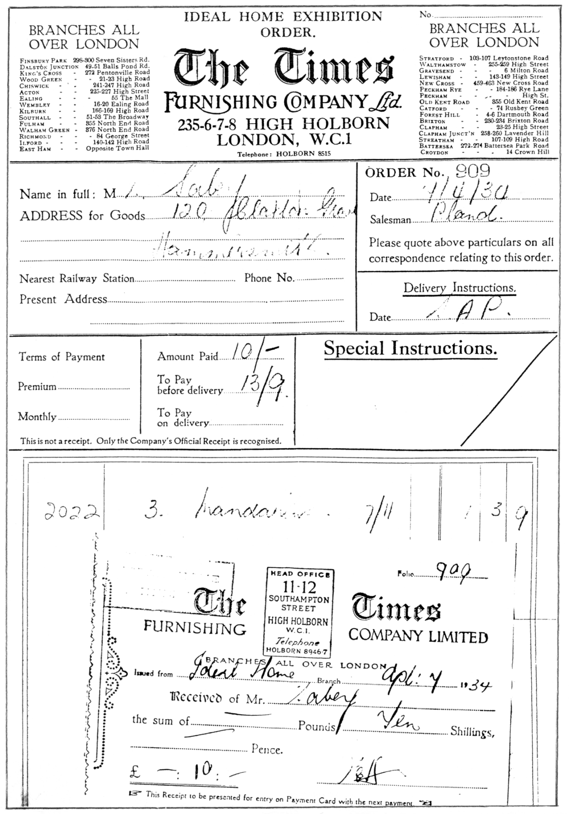

'The House of the Future' as forecast by avant-garde architects, Alison and Peter Smithson and sponsored by the plastics industry in 1956.

In a world before most homes had radios and the advent of television,
the Ideal Home Exhibition was a major form of publicity for the organisers and exhibitors alike. It stimulated newspaper advertising and brought in more revenue whilst establishing a new commercial culture of home making.

After the Great War the exhibitions emphaised the development of 'Ideal Homes' which could be run without the help of servants. Judges, including leading architects, pioneers from the Garden City Movement, and social reformers invariably chose neo-Georgian, Arts and Crafts influenced cottages as winners. House plans, examples of 'Good Design' were made available to local authorities for their council housing or 'Homes fit for Heroes', and speculative builders exhibited the latest nostalgic 'Tudorbethan' houses, which were built in the suburbs for the new middle classes, aided by cheap mortgages.

In the 1950s and 1960s, with Britain emerging from post-war austerity, the Ideal Home Exhibition gave valuable floor-space and publicity to the developing mass market for fitted kitchens which department stores did not have the window or the floor space to display. By the 1970s the DIY superstores and out-of-town shopping centres had arrived with the space and spophisticated marketing techniques to create the room sets, bathrooms and dream kitchens which had been the forte of the Ideal Home Exhibition. Commercial television too, with its advertising campaigns for public utilities such as Gas and Electricity, white goods and new food products, undermined the monopoly of the commercial trade exhibition which had hitherto been of such central importance in the promotion of these goods and services.

The end.

It is now some time since the last update of the checklist of post cards of the Ideal Home Exhibition, and a lot of new material has turned up.

Ideal Home Exhibition Additions No. 3.

1910 Garden Life Press. Copyright Illustrations Bureau. B/W, view outlined in black with white border, green back.
A group in the Tudor Village.
No title. (People sitting on a seat round a tree).
The Ducking Stool.

Garden Life Press. B/W pen & ink drawings by G B, line printing, green back.
Add to Souvenir of the Ideal Home Exhibition 1910. (shows front view
of Harris Bacon Shop.) A.
Add to The Waterfall, Souvenir of the Ideal Home Exhibition April
1910. A.
Add to Ye Village Print Shop at the Ideal Home Exhibition, London,
1910. A.

Printed by the Fine Art Publishing Co. R/Photo, with white border, black back. Ideal Home Exhibition. (Moore & Moore Pianos.) Vert right.
Ideal Home Exhibition. (Ye Ducking Stool.)

1912 F. B. den Boer. Sepia litho printing, black back. As more of these cards have turned up, it would appear that the backs are the same with the exception of the printing down the left side. So far nine types have been seen. The titles are on the back.

A. Edition F. B. den Boer, Middleburg. Depose
B. Published by F. B. den Boer, Middleburg. (Holland).
C. J. Salmon, Sevenoaks, Kent, Sole Agent for British Isles & Coloniesalso U.S.A. Published by F. B. den Boer, Middleburg. (Holland).
D. J. Salmon, Sevenoaks, Kent, Sole Agent for British Isles & Colonies also U.S.A. Published by F. B. den Boer, Middleburg. (Zeeland).
E. Utig. F. B. den Boer, Middleburg. Agent for Great Britain J. Salmon, Sevenoaks, Kent,
F. Utig. firma F. B. den Boer, Middleburg. J. Salmon, Sevenoaks, Kent, Sole Agent for British Isles & Colonies also U.S.A.
G. Utig. F. B. den Boer, Middleburg. Sole Agent for Great Britain J. Salmon, Sevenoaks, Kent.
H. Utig. firma F. B. den Boer, Middleburg. (Holland).
I. Utig. firma F. B. den Boer, Middleburg. (Holland). J. Salmon, Sevenoaks, Kent, Sole Agent for British Isles & Colonies also U.S.A.

2 Kerkuitgang Zoutelande. I.
8 Out for a walk. Zeeland (Holland). D. Vert left.
9 On the way to School. Zeeland (Holland). D. Vert left.
13 Walchersche Meisjes. Zeeland (Holland). H. Vert left.
16 Naar de stad. Vischvrouwen.
A. with Zeeland (Holland). H.
B. without Zeeland (Holland). H.
17 Molenzicht (Zeeland). Zeeland (Holland). H. Vert left.
18 Walchersche Meisjes met Molenzicht. (Zeeland). F.
Vert left.
23 Children on the Beach. Zeeland (Holland). C.
25 Children on the Beach. Zeeland (Holland). B.
Kinderen op t Strand. (Zeeland). F.
28 Dancing on the Sand-hills. Zeeland (Holland). C.
30 Cutting Sea-cabbage in Walcheren. Zeeland (Holland). C.
38 Naar de stad. (Zeeland). E.
40 Molenzicht, Walcheren.
A. (Zeeland). G. Vert left.
B. Zeeland (Holland). H. Vert left.
44 You like a sweet? Zeeland (Holland). C. Vert left.
54 Hallo! Hier ben ik! H.
55 Kasteeltje bouwen in het zand. H.
59 Dutch Ferry. Zeeland. (Holland). C.
65 Overzetveer Arnemuiden. Zeeland (Holland). I.
66 The Juliana Mill. De molen Juliana. Zeeland (Holland). I Vert left.
69 Zuid-Bevelandsche boerin. Zeeland (Holland). A. Vert left.
71 On the lookout for Father. Zeeland (Holland). C.
83 Volendam Children. (Holland). C. Vert left.
89 The boatpasses by. The Isle of Marken. (Holland). C. Vert left.
90 On the way to Marken. (Holland). C. Vert left.
93 Straatje te Volendam. A.
115 Molenzicht, Volendaam. A.
F. B. den Boer & Sons. Coloured with large white border, black back.
Series II. All the cards are Vertical.
363 De Watermolen 'Volendam'
364 Grietje en Jan van Volendam.
366 Jeugdige Marker-Eilandbewoners.
367 Jeugdig Volendam.
368 Visschende Volendammer.
369 Oud Bruggetje, Eiland Marken.
370 Een Zomerdag aan de Zuiderzee.
371 Haven, Volendam.
376 Rookende Jan van Volendam.
378 Aan de Zuiderzee.
379 Uitzeilende Visscher, Volendam.

Derry & Toms. B/W Advert card, green back.
Our exhibit at the Ideal Home Exhibition, April 12th to 30th 1912.

Virol Ltd. B/W, black back.
Lim Saye. (Chinese). Vert right.

1922
A. Luff & Sons. Sepia Advert card, brown back with title Blue Garden etc.
(View of garden with two corkscrew trees and two small statues of children in foreground.

W. H. Gaze & Sons Ltd. B/W Advert card, black back.
Model Garden of H.R.H. Princess Alice at Ideal Homes Exhibition, Olympia, 1922.

1924
Sepia R/Photo, black back, with 'Daily Mail Ideal Homes Exhibition 1924'.
Bungalow Town Ideal Homes Exhibition 1924'.

Monks Rest. Add Type A.
No. 1. Add type 1. 'POST CARD' measures 38mm, DM.
No. 3. Add type 2. 'POST CARD' measures 38mm, no DM.
No. 4. Add type 2. 'POST CARD' measures 35mm, no DM.
No. 5. Add type 2. 'POST CARD' measures 38mm, no DM.
No. 6. Add Type A.
No. 8. Add type 1. 'POST CARD' measures 38mm, DM.
No. 8. Add type 2. 'POST CARD' measures 38mm. Daily Mail on the front
has been removed, but traces can still be seen. 'George G. Whitelegg' has been added on the front, and 'G. G. Whitelegg Chislehurst' stamped on the back.
No. 8. Add type 2. 'POST CARD' measures 35mm. Daily Mail on the front
has been re-removed, and no traces can now be seen. No 'George G. Whitelegg' on the front or back.
No. 12 . Add type 1. 'POST CARD' measures 38mm, DM. R. Neal & Sons added on front.
No. 13 . Add type 1. 'POST CARD' measures 38mm, DM.
1925
No. 1. Crazy Paved Terrace Garden.

1926
Central Garden Supplies, Hardy Plant Farm, Kenton. rubber stamped on the back of the official series.

1928
No. 1. Add type B.
No. 4. Add type B.
No. 18 . Add type B.
No. 23 . Add type A.

1929
No. 15. The Garden Retreat. No DMIHE on the front.
No. 19. A Japanese Garden. No DMIHE on the front.

1930
No. 4. The Sundial Court Garden. type A.
No. 6. Add type B. & C.

1931
No. 9. A Devonshire Garden. type B.
No. 11. A Middlesex Pergola Garden (by Russell). type C.
No. 17. Add type A.
No. 18. The Mother Shipton Dripping Well by Burton Holt. type A.

1932
No. 8. Add type A.
No. 13. Add type A.

B/W Advert card, black back.
Telegrams command attention.

1933
Drake & Gorham Ltd. R/Photo Advert card, black back.
Drake & Gorham Ltd.
No. 2. The Barrier Garden by Carter's Tested Seeds Ltd. type A. B. & C.
No. 6. Add type C.
No. 9. Add type B. & C.
No. 14. Add type C.
No. 15. Add type C.
No. 17. Add type B.

1934
Crane. R/Photo Advert card, black back.
Crane Exhibit.

No. 9. An Old World Topiary Garden, by John Klinkert. type B.
No. 14. Mapledurham Mill Garden. type B.

1935
No. 1. Irish Garden by R. Wallace & Co. type A. & B.
No. 8. Add type A.

1936
No. 1. Add type A.
No. 9. Add type A.
No. 17. Add type B.

1937
No. 9. Add By G. Whitelegg. type B.
No. 15. Add type B.
No. 16. Dante and Beatrice Garden, by J. Klinkert. type A.

1938
No. 3. Add type A.
No. 5. 'Francis Brett Young' Garden by L. R. Russell Ltd. type B.
No. 8. Add type A.

1948
All the cards are Vertical left.
Printing the Daily Mail. Carmelite House. type B.
Printing the Daily Mail. The Linotype Machines. type B.
Printing the Daily Mail. The Printing Presses. type B.
Printing the Daily Mail. The Special Trains. type A. & B.

1952
Marley Tiles. B/W Trade card, black back.
No title. (View of Westminster Bank).

1979
Large sized card measuring 191mm x 117mm showing B/W pen & ink drawing of daffodils, primroses, and other wild flowers. 'Daily Mail Ideal Home Exhibition' and 'Official Exhibition Souvenir' in red. Black back.

1980
Large sized card measuring 104mm x 70mm showing B/W pen & ink drawing of Old London Bridge Circa 1600. 'Daily Mail Ideal Home Exhibition' and 'Official Exhibition Souvenir' in red. Black back.

1981
Post Office Picture Card Series P H Q. 49 (a) 2/81, overprinted at the bottom 'Daily Mail Ideal Home Exhibition 1981. It is not known if the set of four cards were all overprinted.
49 (a) Saint Valentines Day. 14th February.

1982
Large sized card measuring 190mm x 116mm showing B/W drawing of 52ft Arun Class Life-boat. 'Daily Mail Ideal Home Exhibition' and 'Maritime Heritage Year 1982' in red. Black back.

It is possible that this series of cards from 1979 were produced in collaboration with the Post Office, as they all have special cancellations.

1992
First Impressions. Advertising Text in blue, with Stand No. 414 crossed out and 652 entered in Biro. Plain back. These cards were sent out before the opening, and acted as vouchers to get discounts off purchases made at the exhibition. After the exhibition closed a small quantity of cards was made available without the Biro alteration.
Date unknown

Trojan (Suction Sweeper) B/W Advert card, black back.
Ideal Home Exhibition, Stand designed by Cyril G. Saunders.
(From the type of back I would date this from 1930 - 1933.

Comic card, coloured, green back with 'Printed in Holland' and number.
A 509. Ideal Home Exhibition. Now showing. (Lady lifting skirt to
show legs.

Garden Studies. A series of thirty post cards given away with the larger packets of De Reszke Cigarettes and other Godfrey Phillips Associated brands.
No. 28. Carter's Old Mill Garden, Ideal Home Exhibition, Olympia.
(This is a coloured reproduction of No. 4 of the 1929 Official series).

Note. Members will note that I am now listing Vertical cards as either 'Vert right' or 'Vert left' and perhaps I should explain this. For a long time it has been known that vertical cards, when turned over, (as you would the page of a book) the top, i.e. where it has POST CARD printed is either on the right hand side or the left hand side. Post card manufacturers had no hard and fast rule on this. Some cards like the Wembley A.P.O.C. cards by Tuck can be found both right and left. I personally collect both of them, and I felt it was time that this variety was recorded. I am not suggesting that everyone should do this, as collecting is a personal business, and the last thing we want is someone making rules on what you should do. But when anyone sets out to make a list or catalogue of cards I think it is important to make it as accurate as possible. Horizontal cards are nearly always printed with the backs the right way up, and off-hand I can only call to mind the E. Alexander, Franco-British cards where the 'horizontal cards' are printed both ways. When I get around to a Franco-British catalogue I shall probably call them 'inverted back'

Successful Public Speaking.

By Stanley Hunter.

In a recent Newsletter, Bill made a plea for more speakers at the A.G.M.'s noting the fact that many people do not come forward because of a lack of confidence to get up and talk about a favourite topic or collection. While a few lines cannot give you the confidence that is required, a few well tried hints are given to persuade you that you don't have to be an expert to stand up and make an interesting talk and in particular, some useful tips to avoid the pitfalls that one dreads may happen when engaged in a group or public talk.

1. PRESENTATION.
Structure your talk using the '10-85-5' rule, that is 10% Introduction and Aim, 85% Main Content, and 5% summary and Conclusion. Prepare what you have to say by using the spoken rather than the written word approach. If the subject matter is long with detail, then it is far better to produce a written handout than to try and cram masses of facts and figures in a few minutes, the chances are that your audience will have forgotten most of the detailed material by the time you start your next sentence.

Frame your talk against the type of audience, the time available, the broad purpose and aim of talk, and most important, the dialogue and questions if you wish to have a response from the audience. If there is a handout, mention this at the start of your talk.

Use Simple English. Your audience must understand what you say. Use words that both you and they know. Use simple phrases, short sentances, frequent pauses and rests, an audience likes to absorb one fact at a time. They will be grateful for having an easy time listening to you. Never use abbreviations unlesss you have fully explained them first.

Never use hackneyed phrases like, "the cuttting-edge-of-technology" "you know" and "well basically", also avoid the use of jargon and words ending in "ism" and "ization".

Complete your talk in the time limit set, this may need a little rehearsal. Speak with the aim to interest your audience not to weary and exhaust them.

Do not bluff, the audience can easily spot a 'bullshiner'.

Be enthusiastic, let yourself go, no speaker has ever been criticised for their enthusiam! Your spirit will be contagious.

Speak slowly and try to modulate your voice for greater impact.

Speak to the aaudience, never to a display, screen, or ceiling.

Finish on a high note, leave the audience thinking!

O.K.? So far we have covered the actual talking bit. Just as important is what you do while you are talking.

2. APPEARANCE.
A. Position. Your position in relation to the audience will depend on its size, the seating arrangements and the degree of formality of the occasion. Other than very informal occasions, it is normally best to stand. Whatever your position, make sure you can easily be seen.

B. Feet. Place your feet several inches apart with one foot slightly forward. Be well balanced and natural looking. Stand relaxed and preferably still. Pacing up and down or swaying back-and-forth will annoy your listeners.

C. Hands. Hands should rest easily at the sides with unclenched fists. The position of the hands this way makes it easy to give effective gestures! also to use notes or point out items on display.

D. Body position. Lean slightly forward when giving a talk. This position gives an impression of being eager to talk to the audience, it also makes sure that you will fall forward if someone draws a pistol and shoots you!

E. Eyes. Eye contact should take place over the entire audience as well as being directed to individuals from time to time.

THINGS TO AVOID.
Never put your hands in your pockets and jingle money, keys, etc.
Never cover your mouth with your hands.
Never rock backwards and forwards on your heels.
Never fix your eyes above the level of the audience or stare at your own or somebody else's shoes!

4. THE AUDIENCE.
They want you to entertain them, give them information, and share your topic. An audience does not like.

A. Sluggishness. Too long getting to the point.

B. Verbosity. Too much to say.

C. Superfluity. Too many points of emphasis, too much material, and uninteresting detail.

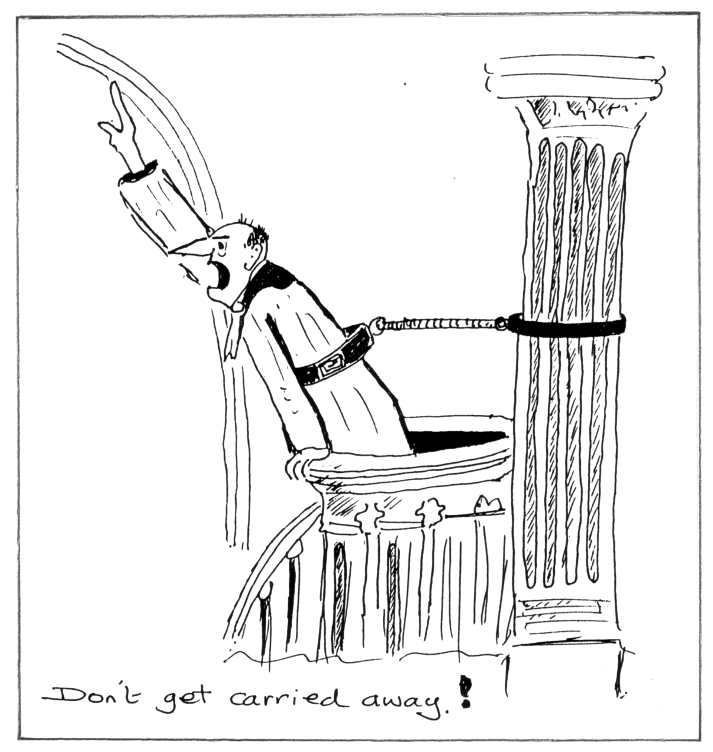

D. Boredom. Watch the reaction at all times, if they start to twitch in their chairs, constant yawning, and nodding off. CONCLUDE. If you have done the correct preparation you will never have to deal with this sort of problem.

E. Fear. Most of all, do not be afraid of your audience. They are looking forward to what you have to say, and the interesting and topical items on display.

5. Remember.
There is one golden rule to Public Speaking. Be yourself.
There are also ten DO NOT rules to remember.

1. Reduce your authority by commencing with apologies.
2. Flaunt figures (unless you have one worth flaunting1).
3. Be sentimental.
4. Be sarcastic.
5. Exaggerate.
6. Be dull.
7. Murder the English Language.
8. Wander from the subject (too far).
9. Waste time.
10. Be long winded.

6. In conclusion.
Rehearse your talk well in advance. A small sheet of paper with the main headings, important dates etc. may be used to aid the memory, but keep this short. After a couple of talks it will come easier, but you have to make a start somewhere to gain confidence. Good speaking is Good Entertaining.

King's speach at the opening of Wembley
Public broadcast at Clacton-on-Sea.

By Alan Sabey.

I recently picked up a card showing a crowd scene, and the owner had thoughtfully written on the back "Listening in to the Kings speach. Opening of Wembley Exhibition April 23rd 1924. Clacton on sea".

On examining the card closely I thought several of the people in the crowd were holding what looked like a programme. So on the off chance I wrote to the library at Clacton to see if they could throw any light on the subject. Helen Cook the Local Studies Librarian was very helpful, and although she could not trace a copy of the programme she did send me a photocopy of the report which appeared on the 26th of April 1924 in the Clacton News.

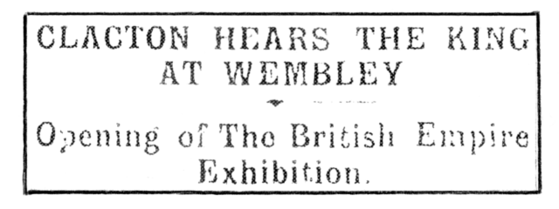

Wednesday was indeed a day of days in the British calendar, for not only was it St. George's Day, Shakespeare's Day, Zeebrugge Day, and a day of many other proud memories in our Island and Empire story, but it was marked by the opening of the British Empire Exhibition at Wembley, an exhibition which apart from the fact that it is the greatest thing of its kind which has ever been attempted in the history of the world, is one which must, from its very object and caracter, draw to itself the interest, if not a personal visit from every individual of the English speaking peoples in every Colony, Dependency, and country within the mighty British Dominions, and at noon on the great opening day the ceremony which was taking place in that London district must have been in the minds of millions of people whose number could never be gauged.

Moreover in one particular respect that opening ceremony marked a historic achievement of science, for never before in the world's history has it been possible on such an occasion for the vast multitudes of people throughout the Kingdom to hear their ruler's voice as it was ringing out to those who were gathering together in the stadium. This was accomplished by the wireless and Clacton was among those who heard their beloved Prince the President, and their King, the choir of 10,000 voices, the Bishop of London, the massed bands, the guns in royal salute and the cheers of the spectators as plainly as if they had been present, and far more distinctly than hundreds on the fringe of the crowds within the Wembley grounds.

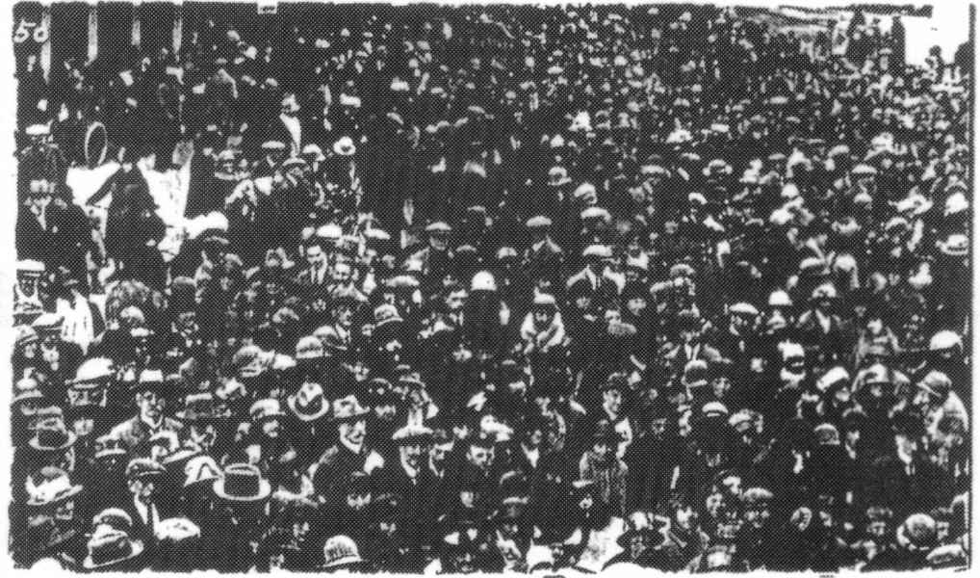

Crowds in Pier Avenue Clacton

In this Clacton participated, thanks to the arrangements made by Messrs F. W. Lewellen and Co. and it was a memorable scene in Pier Avenue when nearly a thousand people heard from two amplifiers, the audible sounds of the ceremony which was being enacted a hundred miles away. Everything was most distinctly heard, the apparatus working admirably and so clear was the reproduction that even the military commands to the soldiers as they were to come to the "Present" and the "Tion" were audible, giving that artistic touch that transported the listeners to the very scene in a mental visualisation of exactly what was taking place.

The King on that day, thanks to the marvellous medium which is summed up in that one word 'Wireless' was literally addressing millions of his people, and the thought must have been an inspiring one.

The end.

It would be appropriate to follow this with the actual speach. Editor.

The King's Speech at the Opening of the Exhibition.

It gives me the greatest pleasure and satisfaction to come here today with the Queen for the purpose of opening the British Empire Exhibition.

Our heartiest thanks are due to the Board of Management, to the Executive Council and to all who have worked with and under them for the marvellous organisation and industry which have produced this triumphant result. I am well aware of the numerous adverse circumstances, including the exceptionally unfavourable weather, which had to be faced. These were successfully overcome by arduous labours, carried out with resolution and good will. Many who, like the Queen and myself, have seen the work in the earlier stages, can appreciate to the utmost the skill and toil which have translated the magnificent conception into this splendid reality that now stands before us .

I am happy to welcome the representitives, official and unofficial, of my Dominions beyond the Seas, and to express the pleasure we all feel that they are taking part in today's opening ceremony.

You have said that your object has been to produce a picture of our commonwealth of nations. No one can doubt that this has been fully attained. The Exhibition may be said to reveal to us the whole Empire in little, containing within its 220 acres of ground a vivid model of the architecture, art and industry of all the races which come under the British Flag. It represents to the world a graphic illustration of that spirit of free and tolerant co-operation which has inspired peoples of different races, creeds, institutions and ways of thought, to unite in a single commonwealth and to contribute their varying national gifts to one great end.

This Exhibition will enable us to take stock of the resources, actual and potential, of the Empire as a whole, to consider where these exist and how they can be best developed and utilised, to take counsel together how the peoples can co-operate to supply one another's needs and to promote national well-being. It stands for a co-ordination of our scientific knowledge and a common effort to overcome disease and to better the difficult conditions which still surround life in many parts of the Empire.

Think for example, of the scientific work accomplished in recent years for the prevention and treatment of tropical diseases? And it is easy to imagine how greatly the Exhibition can contribute towards the progress of our tropical territories and the development of the yet unexplored capacities of the Empire.

Our thoughts go back to the Great Exhibition of 1851, associated for all time with the memories of Queen Victoria and of the Prince Consort, and to the brilliant hopes of the growth of international peace and friendship with which it was inaugurated. Our object here is not quite so ambitious, and for that very reason perhaps more hopeful of attainment. We believe that this Exhibition will bring the peoples of the Empire to a better knowledge of how to meet their reciprocal wants and aspirations, and that, where brotherly feeling and the habit of united action already exist, the growth of inter-imperial trade will make the bonds of sympathy yet closer and stronger. Business relation between strangers may or may not lead to friendhip, co-operation between brothers for the better development of the family estate can hardly fail to promote family affection.

And we hope further that the success of the Exhibition may bring lasting benefits, not to the Empire only but to mankind in general. No nation or group of nations can isolate itself from the main stream of modern commerce, and if this Exhibition leads to a greater development of the material resources of the Empire and to an expansion of its trade, it will at the same time be raising the economic life of the world from the disorganisation caused by the war.

I declare the British Empire Exhibition open, and I pray that by the Blessing of God it may conduce to the unity and prosperity of all my peoples and to the peace and well-being of the world.

The late arrival of the Spring Newsletter.

I must apologise to readers for the late arrival of the Spring Newsletter, this was posted to Damon a few days short of two months ago, where it has unfortunately lingered. He has assured me that he will get it off to Karl, (who very generously prints and meets the costs of the Newsletter) as soon as he can. In the meantime I have now finished the Summer Newsletter which I shall be sending to Damon this week. Which explains why you should be getting two newsletters close together.

Circulating Packets of Postcards.

As we now have enough members wishing to receive a circulating packet of Post Cards, I should be getting the first packet off in the near future. Mike Perkins has offered to take the job on, so would you make a note of his address.
Mike Perkins.
4, Churchill Drive,
Amblecote,
Stourbridge,
West Midlands.
DY8 4JS

