23, BRAMLEY WAY, WEST WICKHAM, KENT. BR4 9NT.
Phone 081 777 8861.

Editorial Spring No 28

The Spring is sprung, the grass is riz.
I wonder where the rare cards iz.

Most funny stories start off with "a funny thing happened to me" etc. this one is different, and if I had to start it in the traditional way I would say, a terrible diabolical thing happened to me at the December Bloomsbury Fair. I had only just got there when I bumped into a fellow member of the Study Group who unfortunately also collects Wembley. Hello sez I, lets have a cup of tea, and after a sit and a few minutes chat we parted after me saying to him we might as well split up you do that half and I'll do this half, that was the last I saw of him that day.

He phoned me up during the evening to tell me that after he left me he got three of the Cope Wembley advert cards at £22 each, which is under the going rate for these cards. Not only are they scarce but they are really beautiful cards as well. As he already had one in his collection he is now the proud possessor of four. As far as is known they were issued as a set of six cards, although Mike Perkins and I who have done a lot of research into Wembley cards have seen only five out of the six. All together we know of only seven which includes two duplicates. Ah well if only 'He' hadn't been there I would have got them, still you can't win em all. When I received the photo copies of the three cards they were addressed to Mr B Cope-Tonkin, that's what I call 'turning the sword in the wound'.

When I went to the January Bloomsbury I saw John Smith who told me that he had bought for £60 from another dealer a very rare Wembley Advert card. He had made inquiries round the trade including Ron Mead and apparently no one else had ever seen one, so he decided that being so rare it must be worth £100, and sold it to another dealer at this price. As he had not yet passed it over he was good enough to let me see it. Yes it was another Cope, the same card as one of the three sold the previous month for £22. During our conversation John showed me a Cigarette Card Catalogue where they listed the Cope cards as a set of four. I was told afterwards that Peter Crawford had bought the card.

Later when I was at home I had one of those 'clutching at straws' ideas and next time I saw John I asked if I could have a look at his Cigarette Card Catalogue again, and made a note of the name and address of the firm. Monday morning I phoned them and asked if they had any Copes in stock. They were sorry they could not do the set, but they had three odd ones. That afternoon I was up there and bought the three, paying well under what John had paid for his, and leaving a request that if they get any more to please let me know. So like all the best fairy stories Prince Charming found his beautiful post cards and lived happily ever after. One of mine by the way was the hither-to unseen sixth design.

There are two worrying things about this story, firstly how the price of a card can escalate passing from dealer to dealer, before the collector gets a look in, and secondly both (now joint) of our catalogue publishers seem to have a very inflated idea of what the value of
a scarce post card is, or even just how scarce a scarce card is. To take a middle of the road card like the Anchor Line cards with the blue Wembley imprint on the back, these could be picked up at around the £6 to £8 mark, and are fairly plentiful. They are listed in the 1993 catalogue produced by John and Ron at £15 which is a bit over the top, One dealer now has them in his stock book at £25 each.

Incidentally the illustration of the Anchor Line card in the Catalogue is of one of several cards that Ron has been carting round the fairs for about a year. These have the bottom 5mm cut off. This is the strip that includes the name of the ship and the company printed on it. Now these are mutilated cards, and Ron has been told this, but he still has them priced at £12 each. I have no doubt there are inexperienced Wembley collectors who may buy them, but in my opinion they should be in the 10p box or better still the waste bin. To produce a catalogue illustrating a mutilated card with the title cut off the bottom without informing its readers of the fact, is I am sure a mistake that has unfortunately crept in, and not a deliberate attempt to mislead readers in what should after all be a work of reference.

Bill Tonkin.

Modern Reprints.

A couple of months back I read of a collector who had bought a small collection of expensive real photographic cards only to find out afterwards that they were modern reprints, worth about 50p each. I thought at the time that an experienced collector would not be taken in by these.

I understand there is a firm producing adhesive replica backs which can be stuck on to post card sized photographs, there-by transforming them into what looks like genuine post cards. Last week I bought one of these from a dealer, who I hasten to add told me it was a modern reprint. It was of a Scottish 1901 Exhibition I think.

The card had a matt surface with quite a heavy graining effect, which was unusual for this period, and round the edge were traces of red. Apart from this it was a black & white photo. I cannot explain this red, it was not heavy enough to be a red border, it was almost as if the original was printed on a red surfaced card and the colour had started to come through on the edges. The corners of the original had been well worn and rounded, and the card had had the corners also rounded, not so well done. The edges had been cut probably with a photographers scalpel and under a magnifying glass, the two layers could be clearly seen, in fact it was possible to part the backing from the front with a finger nail.

The reason that stick on backs are being made available, is because the photographic manufacturers are no longer producing the post card sized blanks, so that amateur photographers can produce their own post cards. They have even stopped producing the double weight paper, which was a lot thicker than the present flimsy film, and so to stiffen it up, you stick a bit of paper on the back. Its as simple as that.

The main giveaway was in the brilliant white back, as stamp collectors will know, some years back in the early sixties, a whitener was introduced into stamp papers, and under ultra violet light these papers fluoresce quite brightly, while the papers that do not have an added whitener in them show up as grey under the lamp. Since as far as I know, all papers now have brightner added, (even this newsletter) it stands to reason that 1960's paper production technology cannot appear on a 1901 post card. The back which is undivided is illustrated so if you come across any like it, very white in colour beware.

The fact remains that with a simple piece of equipement ie a photocopier which most offices now have, and some sticky backed paper, some very good replica backs can be produced by any Tom, Dick, or Harry. All that is needed is an original to work from.

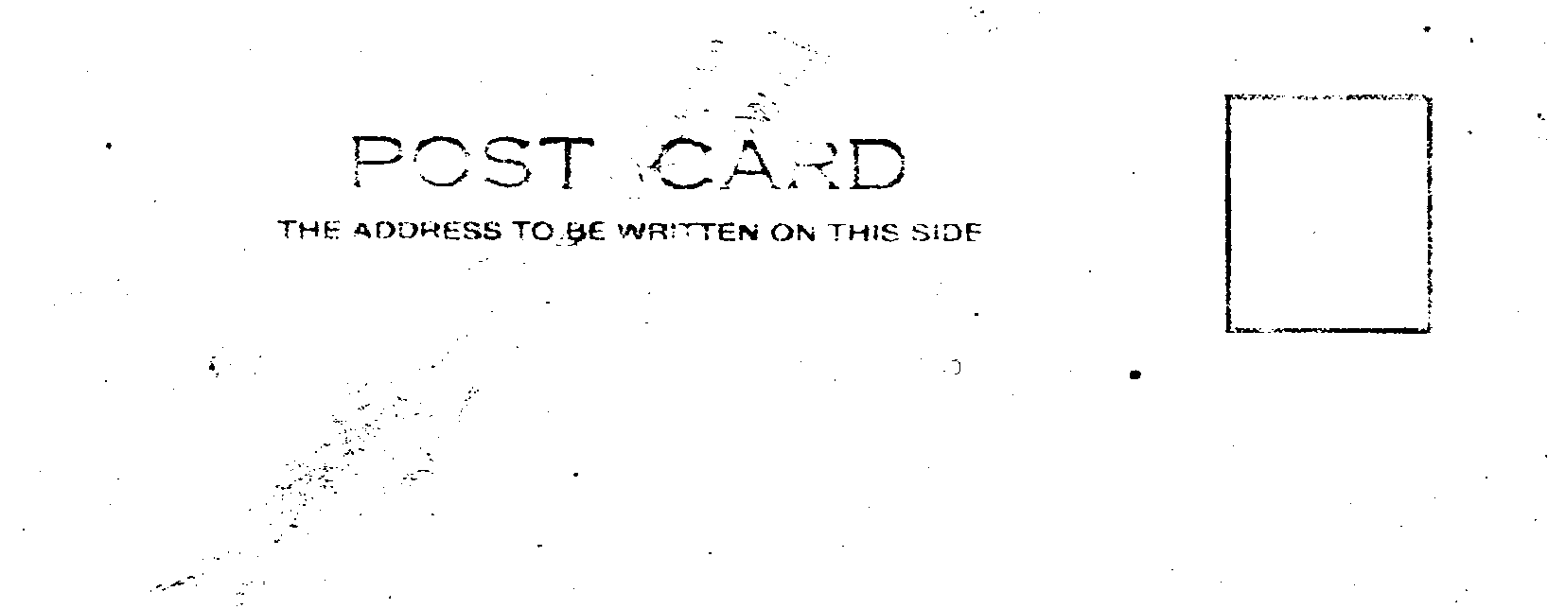

A stick on back

There are also a lot of Frith 'post cards' about which are not post cards at all, they should really be called photographs, and again these have bright white backs. I should say they have all been produced within the last twelve months. Just because a photograph has the word 'post card' printed on the back, does not automatically change its status. It is still a photograph, but of course the price rockets.

Festival of Britain Society

On the last Saturday in January the Festival of Britain Society held their first annual convention in the Chelsfield Room at the Royal Festival Hall. Those present included many familiar faces from our own membership, spent a very pleasant day, seeing some magnificent displays of Festival Memorabilia.
It started off with a slide show given by their Secretary Derek Smith covering the story of the Festival from the first thought "that it might be a good idea", through the early
planning under Herbert Morrison, to the sucessful conclusion. I found this particularly interesting as my own field is in the collecting of post cards, and the background history was all new to me.

It was in the general discussion and questions after the talk that the magic moment occurred that every organiser of a "do" like this hopes for but seldom sees realised. One of the members turned out to be Irene Langton-Dodds, who was involved in an administrative capacity both before and during the Festival. She was to keep us enthralled with her stories, like the one about how they actually unrolled a toilet roll to count how many squares there were. Nobody knew anything about the number of toilets that might be needed on the sites, so she was one of a party that set out with stop-watches to produce statistics on the time ladies, gents, and children spent in public toilets, and from these figures, the planners were able to estimate the requirements for the Festival. Asked how accurate they were Irene had to admit that at times there were queues. As the planning took shape she was to become Personel Supervisor in charge of the female staff.

Irene was able to show the meeting the original sketches by Dorville of the staff uniforms that were sent to her in May 1950 for her approval. Last but not least Irene covered a table with Press photographs taken at the time. I spoke to her afterwards and she said how pleased she was that people were still interested in the Festival. The silence as she was talking was the best indication of the interest of the gathering.

This was followed by about half a dozen displays by various members, showing post cards, the postal history of the Festival and a whole range of souvenirs, powder compacts, badges, and many other items, finishing with a display by their President Fred Peskett. Fred probably has the largest collection of Festival material in existance. He showed from cottons to silks, an amazing lot of ties, head scarves, table cloths, curtains, embroidered items like hankerchiefs, it seemed never ending. On some items Fred was able to tell amusing stories of how he came to get them. He also brought along three from a fifteen volume collection of Contractors site progress photographs.

The Amazing World of Exhibitions

By Stanley Hunter

1. Eugene Mercier and the Paris Exhibitions

The name of Mercier is synonymous with that sparkling beverage 'Champagne', but did you know that the founder of the company was one of the foremost exhibitors in the Paris Exhibitions of 1889 and 1900? Not only did Eugene Mercier exhibit his prize Champagnes to the world, but his method of gaining publicity made him a very remarkable exhibitor indeed!

For the Paris 1889 Exhibition Mercier devised the worlds largest 'Tun' to exhibit his champagne. A Giant cask was made from oak which held the equivalent of 215,000 bottles of champagne. It was over twenty feet in diameter, forty feet long and weighed over 100 tons. The journey from Epernay to Paris took over three weeks, the cask being mounted on a specially constructed waggon, and pulled by 40 oxen and horses. Many of the roadways
between Epernay and Paris had to be widened, bridges had to be strengthened, with some houses having to be purchased for demolition to enable the journay to be completed. Mercier was in fact awarded a gold medal for his champagne, but at what cost!

To entertain his customers at the 1900 Paris Exhibition, Eugene Mercier had a huge captive balloon constructed. Visitors were lifted aloft by the gas filled balloon to a height of some 500 feet for a magnificent view of Paris and the exhibition. The descent was made by the use of a large steam engine driving a windlass which wound the tethering cable around a giant winding drum. Mercier was probably one of the first industralists to use a captive balloon for advertising purposes, and thus is considered to be an aviation pioneer as well as a producer of fine champagnes.

2. The Great Exhibition of 1851.

As part of the Welsh Coal Mining Industries contribution to the great Exhibition, a huge block of coal weighing in at 15 tons was cut and fashioned at the Tredegar Pit. The block of coal proved to too heavy to move to London and has remained at the ever since. On October 17th 1992 the block of coal was declared a historic monument. It is now suitably identified and will be listed in the local tourist guides!

3. Lace and John Livesey. 1851

In 1812 the first mechanical machinery for the mass production of lace came into operation. It was invented by Samuel Clark and James Mart of Nottingham. By 1835 the Jacquard process whereby the design was accomplished by punched cards and pins, (akin to the mechanics of the Hurdy Gurdy Organs in the fairground) was combined with the lace loom, by Samuel Draper also of Nottingham.

This was able to produce lace with infinite designes to an exacting quality. By 1851, another Nottingham lace producer John Livesey took the process one stage further by combining all the known mechanical devices into one gigantic loom, which required an amazing 12,000 to 15,000 individual punched cards to produce some very complex designs. John Livesey exhibited both the machinery and the finished product at the Great Exhibition, even selling finished lace curtains five yards long and two yards wide at #1.10.00 (#1.50) per rair. Less than one thousandth of the cost of a pair made by hand!

John Livesey's loom together with some of the designs shown at the Great Exhibition can be seen in 'The Lace Hall' Museum on the High Pavement, Nottingham, plus many other interesting items from the world of lace and it's production.

Life-boat House Wembley

The Royal National Lifeboat Institute took advantage of the fortunate coincidence that the British Empire Exhibition 1924 was held in its Centenary Year, to erect its own house in the Exhibition grounds. Life-boat House Wembley, was very appropriately placed (when one remembers that the Institute was founded in the City of London), just at the corner of Old London Bridge, looking across the gardens to Government Building.
Here was got together as complete an exhibition of Life-boat work as possible, certainly more complete than has appeared in any previous exhibition. There were models, some lent by the Science Museum, at South Kensington, but the majority the Institution's own, showing the development

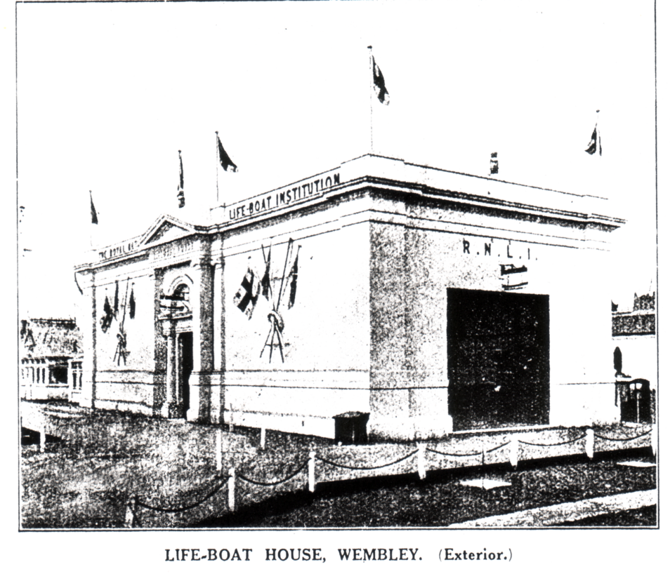

of the Life-boat, from Wouldhave and Greathead's 'Original' built in 1789, to the latest type of Cabin Motor Life-boat. There were the Institution's portraits of Sir William Hillary, Bt., and Mr. Thomas Wilson, M.P., its founder and first Chairman, its collection of paintings of Life-boat scenes, a moving picture machine with a series of coloured pictures, showing a number of Life-boat Stations, different types of Life-boats, different types of Life-boat houses, the different methods of launching, and famous Coxswains, a scenic model of the service to the Hospital Ship Rohilla at the beginning of the war, a working model showing how a Life-boat is launched down a slipway, another working model showing a Life-boat taking men off a wreck by means of a breeches buoy, and yet another showing a Life-boat launched to a steamer in distress, the sinking of the steamer, just after the Life-boat reaches her and takes off the crew, and the Life-boats return.

There were wax figures of Life-boat-men dressed in oilskins and belts, one of the Institution's D.E. engines, which for the purpose of the Exhibition, was opened out and made to work by electricity, a line throwing gun, acetylene and electric searchlights, blocks, different kinds of ropes, and a pillar of wood, which showed the exact proportions of the different kinds of wood, oak, rock-elm, Honduras mahogany, teak, Christiania fir, and Norway spars (fir), used in the construction of a Life-boat.

Finally in the centre of the house, was one of the Institution's latest types of Motor Life-boat, the Watson Cabin. This boat had been specially built for the Exhibition, and is to
be stationed at Margate. The Boat was open to visitors, who were able to walk round her deck, see the cabin and engine-room, and inspect the many details of the equipement of a modern Life-boat.

During the six months of the Exhibition something like three-quarters of a million people have been over the Boat. The majority of them, even if they had seen Life-boats, had, of course never been on board one before, nor seen one at close quarters. Many were the strange questions asked, and the strange comments made. A foreigner, who spoke good English, when he saw the Boat said, "What is it ?" He was told "a Life-boat." And what, "he said "is that ?" But most of the questions were with regard to details. None of the others showed quite so complete an ignorance. One old gentleman, seeing the name 'Grace Darling' on the bows of the Boat, asked if this really was the Boat in which Grace Darling had gone out to the Forfarshire. He had allways thought that it was quite a small boat.

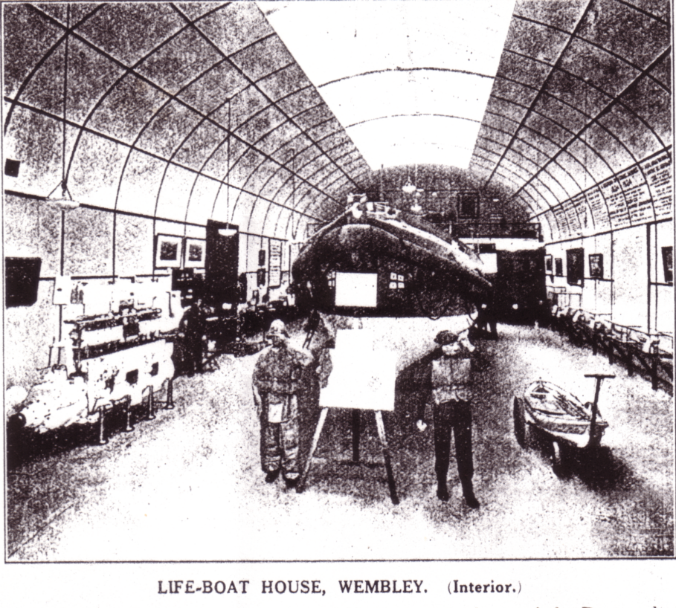

The water barricoes, perhaps, caused more confusion than anything else. They were mistaken for various things, including buoys, life-buoys, fenders and hot-water bottles! A visitors book was kept, and among the countries beyond the British Isles which were represented in it were Australia, Canada, South Africa, India, Malta, Nigeria, the Gold Coast, Bermuda, the United States, France, Italy, Sweeden, Finland, Belgium, Norway, Switzerland, Portugal, Holland, Spain, China and Japan.

Besides the distribution of literature, leaflets and a short illustrated history of the Service, a number of Life-boat Souvenirs were on sale, metal pincushions, in the form of a Life-boat, small figures of Life-boatmen, statuettes of Life-boatmen, motor mascots in the form of Life-boatmen, and ash trays with a Life-boatman in the centre. Of these souvenirs, in alll 11,758 were sold. Not only did they bring a substantial contributionto the Institution's funds, but, more important still, thousands of houses have, in these souvenirs, daily reminders of the Life-boat Service.

The article on the Royal National Lifeboat Institution at Wembley was taken from the November 1924 issue of The Lifeboat. The Study Group would like to thank Gill Mace Assistant Editor of The Lifeboat for supplying the material, and permission to use it.

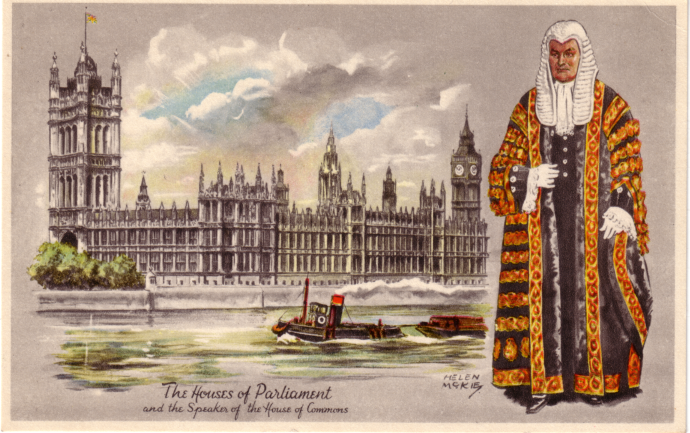
Unrecognised 1951 Festival of Britain Set.

In the September 1992 issue of Picture Postcard Monthly, the above card was illustrated, with a short write up. What they did not say was that the set of 12 cards were specially produced for the 1951 Festival of Britain by Raphael Tuck. They are titled 'London Character Series' and are signed on the front by the artist Helen McKie. They were sold as two sets of six, and only on the envelope is it mentioned that they were produced for the Festival. George Simner some time ago found an empty envelope, which of course set us both hunting. So far we both have 11 out of the set of 12, and by a coincident we are both looking for the same card 'Buckingham Palace'. So should anyone see one please get it.

Series 1.
Buckingham Palace Sentry of the Scots Guards
Westminster Abbey Two Choristers
Tower Bridge Senior Head Watchman of the Bridge
Horse Guards Trooper of the Life Guards
St. James Palace Officer of the Kings Body Guard of the.......
Trafalgar Square Lord Nelson

Series 2.
St. Pauls Cathedral Sergeant of the City of London Police
Law Courts Judge of the Kings Bench Division
Houses of Parliament Speaker of the House of Commons
Tower of London Yoeman Warder, Beefeater
Piccadilly Circus Flower Seller
Mansion House Lord Mayors Coachman
List of Wembley Exhibition Exhibitors

In the last issue I mentioned that Nancy and I were working on a listing of the Exhibitors present at the 1924 & 25 British Empire Exhibition. Since then Alan Sabey who has friends in high places at Brent Museum has been able to arrange that I could borrow their copy of the 1924 Catalogue. I in return have agreed to let them have a copy of the 1925 list when it is finished, as they do not have a 1925 catalogue.

We have finished the 1925 list showing in numerical order the exhibitors in Canada, the Palace of Housing and Transport, the Palace of Industry, and the other pavilions and areas containing exhibitors stands. We are now well into the 1925 Alphabetical list of names and addresses.

Letters to the Editor

Dear Mr Tonkin,

Many thanks for the membership application form received whilst I was away on holiday, this has now been duly completed and sent onto Damon Murrin, together with my cheque.

Unfortunately I shall be working during the A.G.M. As a freelance designer and technical manager of exhibitions, I work unsocial hours and this clashes with my attendance at the woodworking Exhibition at Sandown Park, but hopefully in the future I will be able to attend.

I feel a little information about myself may be of interest, I have been in the exhibition industry all my working life, starting with a four year design course at Twickenham College in the 60's and to date have designed many exhibition stands for well known companies, assist organise major public and trade exhibitions home and abroad, in Europe and America. Following recent redundancies, I have now decided to offer my assistance to organisers and consultants on a freelance basis and am now earning a reasonable living.

As you saw last December, my personal exhibition of the British Empire Exhibition was an ambition which was realised, thanks to the the directors of the company I was with at that time (sadly no longer). They took great personal interest in this collection of memorabilia. This may be not as large as Alan Sabey's but I think I may have some items not in his collection. I would like to display this collection at some time, and perhaps give a brief talk, (although my programmed philatelic chat did take over an hour!). I do also have an interesting number of anecdotes by people who attended the exhibition as children and are still alive today.

Reading the summer newsletter about articles for disposal, I do have the following for sale or offers.
1. Miniature copy (7" x 5") of the Newcastle Daily Chronicle for the North East Coast Exhibition. 24 pages in good condition, but with centre staple rust marks. £10.00
2. Souvenir copy (9" x 7") of the Guide for the Scottish Exhibition at Bellahouston Park 1938 in very goodd condition. 56 pages with grey/red cover. £15.00
3. Liptons Tea Caddy from the 1924 B.E.E. Wembley, brassed, complete but very ented and solder repaired. Offers
I am glad I bumped into you at Sandown and hope that I can be of some assistance to the Study Group in some way in the future.

At present, I am Chairman of the Ashford (Middlesex) Philatelic Society for this season '92/93, and on the second evening of our new seaon our guest speaker will be Don Knight on Exhibitions. My normal role within the Society is Press and Publicity Officer, a position I have held for the last 10 years (with a one year break to compile my Wembley display).

One of my future ambitions, when time allows, is to redraw the B.E.E. site plan and also the interior stand layouts of the Palace of Engineering and Industry, a winter task.

I am wondering how much the Exhibition Study Group is known about within our industry and if necessary can help promote it, perhaps within our Bible, The Exhibition Bulletin. I do have many contacts within the industry and one in particular is a keen collector of 1890 Crystal Palace prints and Memorabiblia etc. If I can be of any assistance in the meantime, please do not hesitate to contact me.

Yours sincerely

Michael J Gorringe

This was a nice letter to get and I think Michael is going to be a useful member of the group. I have suggested he gets in touch with Alan Sabey, and discuses this years convention which is going to be at Wembley. Michael also sent me a publication that I have not come across before, a copy of his Bible the Exhibition Bulletin. It lists all the exhibitions that take place here and abroad and in the November 1992 edition gives details of a staggering 800 odd exhibitions that will take place in this country alone. On top of that there are a further 2,100 exhibitions being held abroad. And that is just November.

Another welcome item was a letter from James (Jim) Negus enclosing an index and contents list, and several helpful comments. One I had already done, have a numbering system so that each page can be self identifying. Our earlier newsletters did not have page numbers, they now do, also the year of issue on the bottom line. Looking through the index I am surprised at the amount of ground covered. Jim has also been able to send me a disc so that I could print it out into the news letter. Unfortunately I have had to get his disc copied onto my size disc. I tried fourteen firms before I found one that could do this simple job. As I am typing this it still has not come back, but has been promised for tomorrow.

1924 Scout Jamboree

Now we all know that there was a Scout Jamboree held at Wembley during the British Empire Exhibition in 1924. Post cards of this event are very seldom seen, so when I heard that one was coming up in a Healey & Wise Auction I got on to them and asked for a Photo-copy of the front and back, which they were good enough to send me.
The front of the card has 'International Scout Jamboree August 1924' and part of the message on the back reads "your letter which I got just before I left for Denmark. We have had a ripping
voyage and I have been a little sick.......I had a ripping time at Wembley".

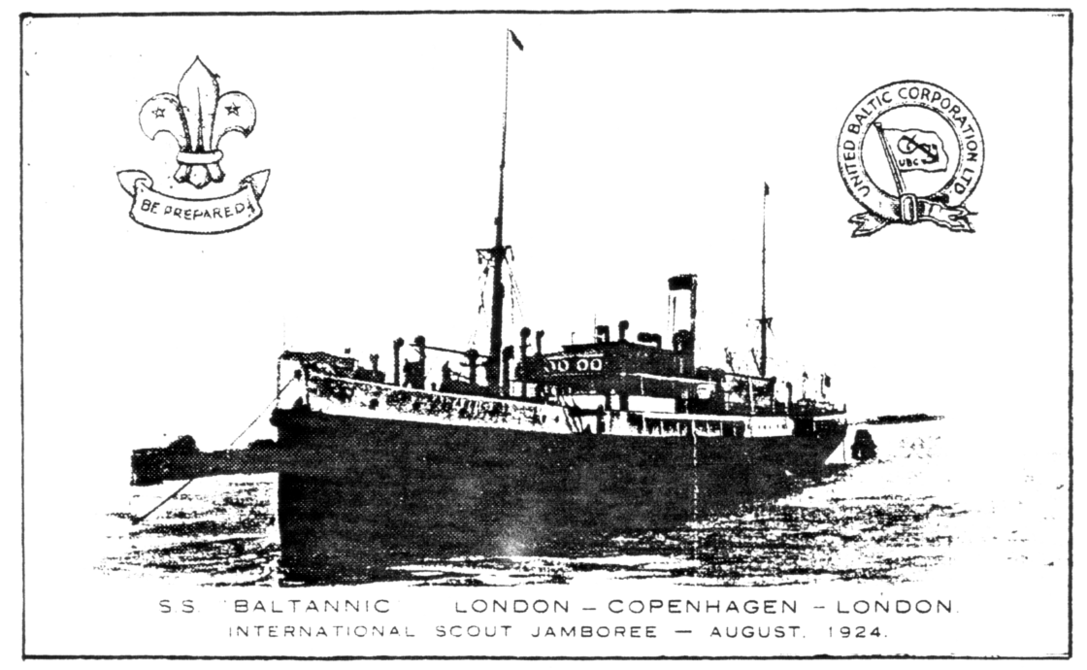

Now my first thought was that this was a card bought at Wembley at the Jamboree, and posted by a Scout on his way home. This did not tie up with the London - Copenhagen - London bit, was this a return trip starting from Wembley, but if so it would have been Wembley - Copenhagen - Wembley. I finally refered to 'The Imperial Jamboree 1924' published by The Boy Scouts Association, and the penny dropped. The Wembley Jamboree was 'The Imperial' and the card was for an 'International' held in Copenhagen later in the same year. So it was not a Wembley Exhibition card, and since there was an estimated valuation of #100 put on it thank goodness for that.

1993 Convention at Wembley

It's time to start thinking of our Seventh Annual Convention which is being held at Wembley this year. Again it will be on the last weekend of September, Saturday 25th and Sunday 26th. The meetings will be at a pub called 'The Century' in Forty Avenue, Wembley Park, Middlesex. They will also be doing our Dinner on the Saturday night. For those coming from some distance there is a good lodging house 'Mullanes' 66, Wembley Hill Rd, Wembley. Phone 081 902 9211. The charges are very reasonable 314.00 for a single room bed & breakfast, and 326.00 for a double room, 330.00 en-suite. Now it is important to book as soon as possible, either through me or direct to Mullanes. It only wants a conference or something and accomodation is going to be difficult. I have already booked two rooms for us and our official unpaid photographer Winnie. So I'm alright Jack. Alan Sabey has made arrangements for us to borrow some philatelic display frames, so it's all begining to take shape.

Another member who I have been corresponding with is Derek B Bartlett, who recently had an article printed in Post Card Monthly about Cross-words. So far we know of one series with an exhibition connection. These were published by the British Empire Gas Exhibit Committee for the 1925 Wembley Exhibition and are in the form of a post card. They organised a monthly Cross-word Competition and there were eight prizes, starting with a 'New World' gas cooker. So far card No. 3 and No. 4 have come to light.
Since the exhibition ran from May to October this could give us a set of six. News of any of the others would be welcome.

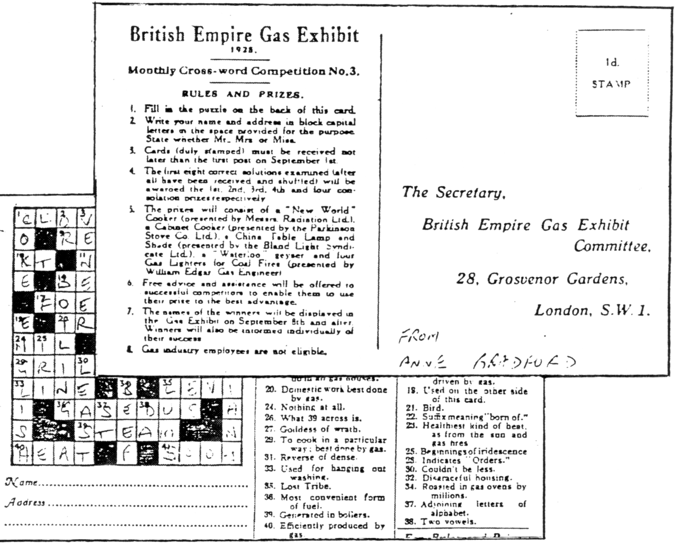

Ideal Homes Exhibition Exhibition
Design Museum. Butlers Wharf. Shad Thames. London SE1 2YD.

The Design Museum is putting on an Exhibition about the Daily Mail Ideal Homes Exhibition from 1908 to the present day. and is the result of three years work by Deborah Sugg for her Ph.D. Thesis, which she is doing at the University of Wolverhampton. She only found out about the Exhibition Study Group, about two weeks before the show was due to open. When I told her the scope of my collection, she visited me with the Design Museum's Collections Manager Claire Catterall to arrange for the loan of material. This is being displayed under the name of the Exhibition Study Group. Alan Sabey has also loaned material. The Exhibition will be open until the 22nd August, and is well worth going to. I will be giving a full report in the next newsletter.

