23, BRAMLEY WAY, WEST WICKHAM, KENT. BR4 9NT.
Phone 081 777 8861.

Editorial Winter No 27

Our annual convention took place at the end of September, and those who attended saw some lovely displays of Exhibition related material, of which a full report appears elsewhere.

When I received my last sales list from Roger Hudson's firm 'Cover Boys' I was pleased to find enclosed also a membership application form for the Exhibition Study Group, which Roger had agreed to send out, This was produced by Damon, and since it goes out to about 250 customers, we are hoping to get some new members from it. I first met Roger at Stampex some years ago, and since then have had some nice covers, mainly Philatelic Congress of Great Britain, and exhibition stickers from him, as well as general exhibition covers. If any of our members do not already get his lists, they are well worth while, so drop him a line, enclosing a stamp for postage to, Roger Hudson, Cover Boys, P. O. Box 172, Coventry, CV6 6NF.

The Philatelic Congress and The Ideal Homes Exhibition share the honours of being the two oldest, still running exhibitions held each year, although they both suspended operations during the two wars. I say share the honours because although the Ideal Homes was first held in 1908 it did not start out as an annual event and was not held in 1909, so their non-stop run really started in 1910. The Philatelic Congress started in 1909 with an exhibition in Manchester, so they are both coming up for their centenary.

This brings to mind that we have over the years seen several displays at our convention of Congress material but no display on the Ideal Home Ex. of which there is certainly no shortage of material.

One continually reads and hears of the shortage of good post cards coming on to the market, and certainly the dealers boxes bear this out, but all is not gloom and despair. We have a local antique market held every Wednesday and Nancy and I usually look in. There is only one post card dealer who we have become quite friendly with although it must be said that overall it is a bit of a dead loss, and then last week there was another dealer with a few boxes, and on going through them I found a card whose existance I knew about because Damon has one in his collection, it's a photograph showing a girl in a block of ice with the title 'Frozen Alive, Festival of Britain 1951' a card I had never expected to find, and the chap had two copies! Another nice card I have picked up, was from a dealer whom I regularly see and have looked through his album many times, but on this occasion I looked at this very common Wembley card (the Tuck Oilfacsim of the Canadian National Railways Pavilion) which I know he has had for months, and a little voice said "Bill you ought to take it out and look at the back and see if it is the scarce one with the text in french" (of which I know of only one other copy to exist). I did and it was, and at £1.25 I walked round the rest of the day in a daze. I have also passed by an advert in the Post Card Monthly of Alfie's antique market many times, and noticing it a couple of weeks ago I went there and got a beautiful trade card
printed by Tuck's of their stand at Wembley. Now the moral of this is that you have just got to keep on looking and the good cards will turn up.

Bill Tonkin.

Report from the Illustrated London News Sept 26th 1874

A Fungus Exhibition was opened in Aberdeen yesterday week. The idea of the Exhibition was first suggested by the Rev Mr Ferguson of New Pitsligo, in the 'Scottish Naturalist' for April. The suggestion was readily taken up by the fungologists and men of science, and the result was an exhibition which gentlemen entitled to speak with authority say was never equalled in this country. The specimens numbered about 7,000. Almost every county in Scotland made large contributions, while England sent a number of exhibits. In fact almost every fungologist in Britain contributed specimens. A considerable portion of the fungi belonged to the larger classes, but there were also collections of Microscopic fungi, and important additions to the British flora. Several species of fungi new to science were exhibited.

The Great Exhibition of the Works of Industry of all Nations
1851.

By Bill Tonkin

Local exhibitions were not new as the Society of Arts (the present Royal Society of Arts) had started in 1756-7 with shows held in London of displays of manufactured goods. It was the French who had started holding a series of larger National Expositions at the turn of the 19th century. Prince Albert and Henry Cole were both members of the Society of Arts, Albert being made President in 1843, and it was they who made the series of Exhibitions, starting in 1847 such a success. The first one attracted 20,000 visitors, 1848 saw 70,000 visitors and the third one in 1849 reached 100,000. This success prompted them to decide to hold an even larger Exhibition in 1851. To hold an International Exhibition was an entirely new concept and it is recorded that at a meeting at Buckingham Palace on the 29th of June 1849 when asked by Henry Cole if he wanted a National or an International exhibition Prince Albert said "it must embrace foreign productions" and be an "International". In the event it was divided, half the space being allocated for Britain and her Empire, and half for foreign countries and their exhibitors.

Henry Cole was a Victorian Mr Fixer a 'one man think tank'. While his nominal position was with the Public Records Office, he had been seconded out to promote one project after another, like launching with Rowland Hill the Penny Post, worked successfully for the introduction of the standard gauge railway track, and was later responsible for the
Royal College of Music, the Albert Hall, and was in overall control for the first twenty years from 1853 of the South Kensington Museum, which was eventually to become the present group which includes The Victoria and Albert, the Science, the Natural History, and the Geological Museums.

It was not however a one sided affair with Cole doing all the work, and Prince Albert getting all the praise, as might be supposed, Richard Cobden M.P. who was one of the 1851 commissioners, and was also on the finance committee, spoke most highly of Prince Albert's efforts over a long and difficult period. There is no doubt that these two men were the driving force, that got things moving, to such a successful outcome.
Prince Albert had originally suggested Leicester Square as a venue but this was not considered large enough, and it was finally decided to hold it in Hyde Park. The building was to cover 16 acres which was eventually increased to 19 acres. The Society of Arts had explored its feasibility and had made a list of 5,000 influential people who would support it. They then decided that for such an important undertaking a Royal Commission was more appropriate to organise an international event of such magnitude, the Society applied to the Government and on the 3rd of January this was granted.

A Building Committee was set up and they organised a competition to find the most acceptable design, 245 designs were sent in, all of them deemed unpractical, so the committee made up their own which was published in the Illustrated London News on the 22nd of June. This caused an uproar, the public reaction to it was so violent and derisory, that for a time the whole scheme for an exhibition was in jeopardy. Just previously a Col Charles de Laet Waldo Sibthorpe a 67 year old M.P. had raised objections in the Commons because it was planned to cut down some elm trees in the park to make way for the building. He was successful in this and the plans had to be designed to accommodate the trees. All sorts of reasons were given as to why the project should not be allowed to go ahead, crime would increase, disease would spread, and as 'The Times' put it the whole of Hyde Park "will be turned into a bivouac of all the vagabonds of London". They returned to the attack a couple of days later declaring that the Park was going to be transformed into something between Wolverhampton and Greenwich Fair. The Prince was to write on the 4th of July that "the whole public, led on by The Times, has all at once made a set against me and the Exhibition". Fortunately the opponents to the scheme were not able to carry the day and after a division in the House the Government gave their blessing, so one way or another the Commissioners and Prince Albert went through a very sticky time.

It was now that another man appeared on the scene, Joseph Paxton, and although the competition closing date had expired, asked for an extension and said he would produce some drawings in nine days time. The Building Committees reaction when they saw the design can be imagined, to say it was revolutionary would be an understatement, never before had a building been made of two virtually untried materials glass and iron, and such a large building too. Paxton's only previous experience of these materials was building a conservatory and lily house to preserve the Duke of Devonshire's giant water lily 'Victoria Regia'. Four days later Paxton not a man to hang about and before the committee had had time to give a decision, sent the drawings to the Illustrated London News, these were published on the 6th of July, this time to add to the committees problems the design met with universal approval, and they found themselves being swept along on a wave of enthusiasm. Not perhaps universal approval as the professional bodies were quick to point out that Paxton
had no qualifications in building or architecture, and predicted that the building would collapse with the resultant loss of life and injuries. However the famous engineer Robert Stephenson (who was on the Board of Commissioners) did appreciate it as the work of a genius. The Building Committee by now were in a cleft stick, as they had run out of time, and a week later they gave in. At the end of July the ground was given over to the contractors, and work started, The Great Exhibition was to open on May the 1st 1851 with the proviso that it must be cleared away from the site by the 1st of June 1852.

From then on it was all systems go, 39 men were employed at the begining of September, this rose to 419 in October, 1,467 in November, 2,260 in December, and an average of 2,000 from then until a month before the opening. The structure was errected by means of shear-legs i.e. two poles fixed at the top and block and tackle, a simple device that could be erected anywhere at a moments notice, and loads pulled up by man or horse power. The main structure was designed in multiples or dividends of 24ft. One problem that had to be overcome was the supply of glass. This was all made by hand, being first blown into a hollow ball, which was then rolled into a long cylinder, the end cut off, slit down the length and flattened out, it was then cut to size and trimmed into panes 49" x 10". 293,655 panes were needed and as there were not enough skilled craftsmen in this country, foreign workers were brought over to get the work done on time. 4,000 tons of iron, 600,000 cubic feet of timber, and 24 miles of special guttering, and at the end between 400 and 500 men at work painting.

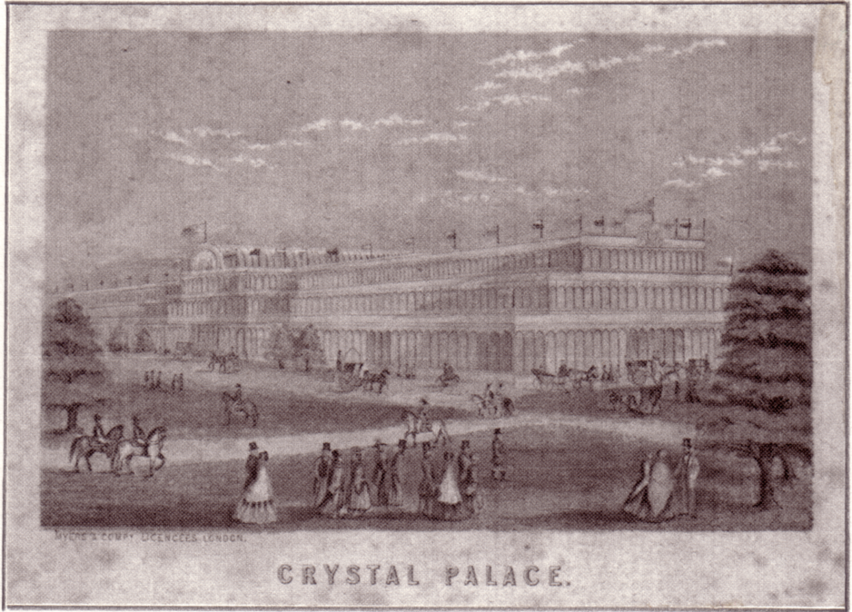

The Crystal Palace at Hyde Park
The Great Exhibition was a huge success and 6,039,195 visitors of whom the bulk paid one shilling to enter ensured a large profit. With an income of £552,179 and an expenditure of £335,742 the result was a profit of £186,437 a fortune in 1851. The final accolade was to be given by 'Punch' who christened it the 'Crystal Palace', a name which will live for ever. The largest attendance in one day was 109,915 and the largest number to be in the building at one time was 93,224. The Great Exhibition closed on the 15th of October 1851, and in accordance with their agreement the building was dismantled in the summer of 1852.

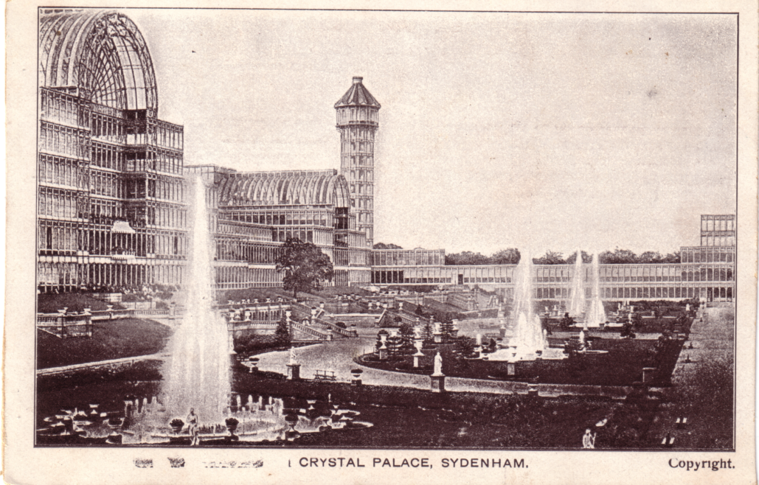

The altered shape as built at Penge Place

Before we leave Hyde Park to follow the Crystal Palace to Sydenham a few words must be said about the 1851 Commissioners, they carried on after the 1851 Great Exhibition closed, and are still in existance today. Their first step was to purchase some 87 acres of land at South Kensington. On this site it was their intention to provide a centre for the encouragement of the Sciences and Art and the measure of their success can be seen today in the group of museums at South Kensington, The Victoria and Albert Museum, The Science Museum, The Natural History Museum, and The Geological Museum, and among the teaching institutions the Imperial College of Science and Technology, the Royal School of Mines, the City and Guilds Engineering College, the Royal College of Art, and the Royal College of Music. All of these and others are housed on the original estate of the Commissioners. The land has either been given or leased to the various bodies often with financial assistance from the Commissioners funds. Around the begining of the twentieth century saw a change in the Commissioners policy from expenditure on capital projects to the financing of scholarhips for the promotion of science and art. Former scholars include seventy-six Fellows of the Royal Society, including two Presidents, and seven Nobel Prize
winners, and it was as an 1851 scholar that Lord Rutherford came from New Zealand to Cambridge to start his career. By careful use of the profits they have been able to donate to various bodies around £1.800,000 and still retain assets of #900,000 (these are figures given in 1951)

Joseph Paxton was soon able to raise £500,000 and the Crystal Palace Company was formed to purchase the building for £70,000, it was erected at Penge Place where they bought a 200 acre area of woodland. Owing to its unique method of construction in units of 24 feet, when it was rebuilt they were able to change the shape of the building considerably. In its new role at Penge the Crystal Palace became a noted exhibition and educational centre, with its series of Courts showing the arts of many ages, the Egyptian Court, the Renaissance Court, the Pompeian Court, the Roman Court, and the Alhambra Court amongst others, there was also a 4,000 seat Concert Hall. In the central transept there was room for a Great Orchestra of 4,000 musicians.

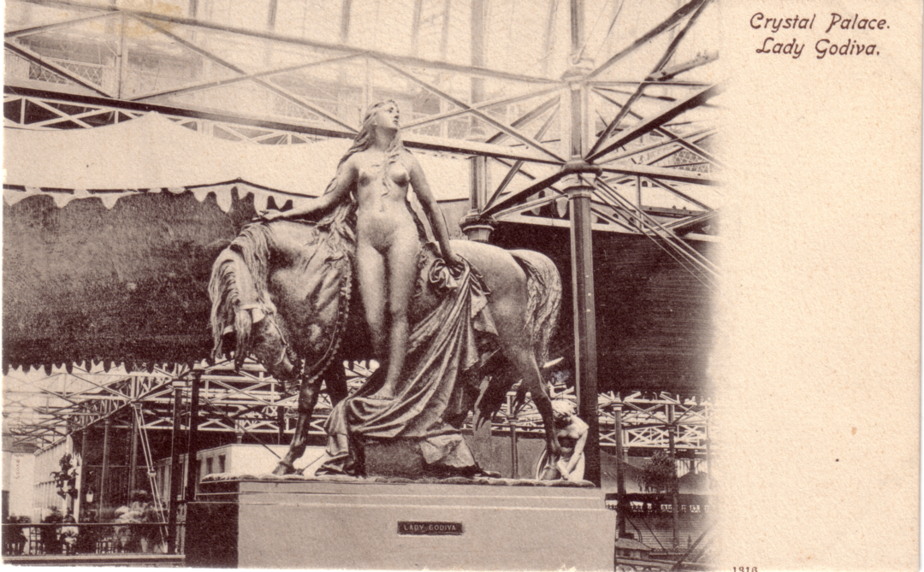

Picture of slave girl not available

There was also hundreds of statues, amongst which were many of young ladies, naked slave girls were the 'in thing' in 1851. There were slave girls with their hands chained in front of them, slave girls with their hands chained behind them, and slave girls wearing no chains at all.
Hiram Powers's Greek Slave (naked of course) had been on display in 1851 under a red velvet canopy, on a revolving pedastal so that the statue could be viewed from all angles. Paxton planned to have some classical Greek male statues on show, in a state of nature, but when this was anounced it was greeted with a howl of indignant outrage. It appeared that what was sauce for the goose would not do for the gander. The Directors received a letter signed by thirteen eminent persons, threatening dire consequences if something was not done, i.e. fig leaves. They must have been thirteen very influential people because the Directors
gave in immediately, a mason was sent round with a hammer and chisel to remove all the offending bits. The Times was to report on the 8th of May that with only a month to go before the opening, the Directors were having difficulty finding sufficient plaster fig leaves to cover the mutilated statues.

Paxton's grand schemes soon ran through the half a million, but such was the enthusiasm that he was easily able to raise further capital and the final cost came to #1,300,000. It was a wonderful dream come true, and was opened on the 10th of June 1854 by Queen Victoria and Prince Albert. For many years until the turn of the century in fact, the Crystal Palace continued to thrive, until the 1880's an average of 2,000,000 people visited it each year. Two new railway lines were built to cater for travellers.

It was an ideal centre for all kind of shows, cat, dog, canary, bee keeping, rabbits even some of the early Ideal Home Exhibitions were held there, and at one point it was the home of the Imperial War Museum. In 1886 a disasterous fire destroyed the northern end of the Palace and it took two years to repair the damage done. Owing to a shortage of money the North Transept was never rebuilt.

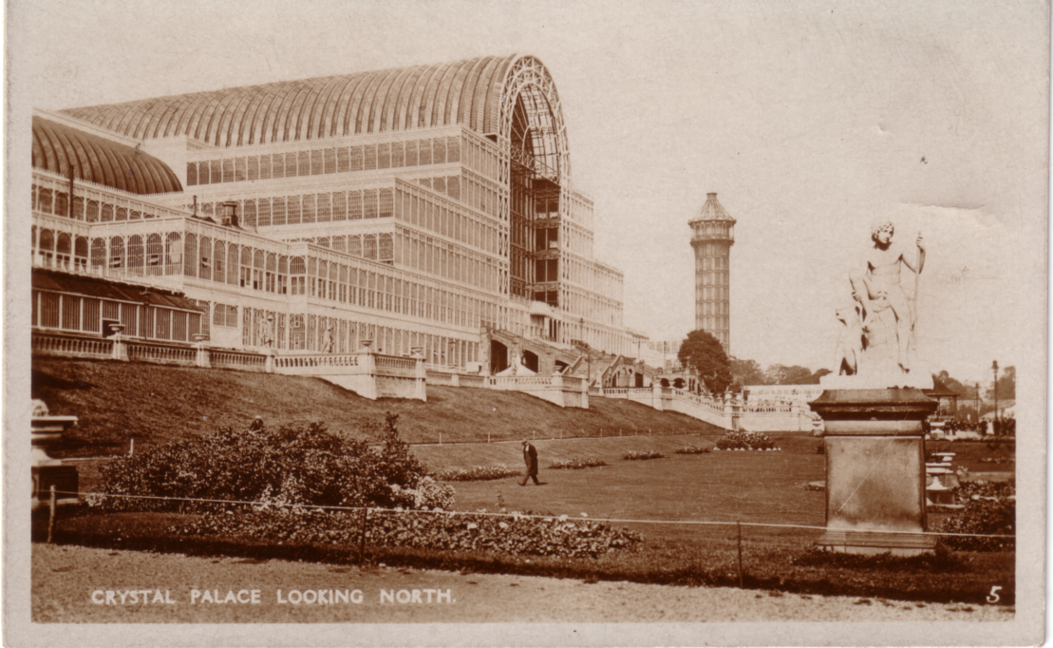

The Crystal Palace after the North Wing & Transcept
was destroyed by fire in 1886

Its earlier success unfortunately was not to be maintained, this was due in some measure to the power of the Lord's Day Observance Society who were able to ensure that the Crystal Palace was not allowed to open on a Sunday to paying visitors, although the park was not affected, but as this was free it did not help the Company who were always short of money, a problem they were never able to overcome. Also the tastes of the public changed.
Its finest hour was in 1911 when it staged the Festival of Empire and Pageant of London. At a luncheon given in the Savoy, the Lord Mayor asked the Mayors of the Metropolitan Boroughs for their support in a spectacle to be staged at the Crystal Palace in the summer. It was to consist of two parts, an Exhibition and a series of pageants. Over #250,000 had already been raised, and it was estimated that as much again would be needed. This was to have been held in 1910 but the death of King Edward VII forced its postponement. It was opened on the 11th of May by King George V and Queen Mary, and closed on 28th of October. 15,000 voluntary performers took part under the organiser Frank Lascelles. The Pageant was divided into four parts each comprised of eight scenes, with a band of 50, and a chorus of 500. The British Empire was constructed in minature in the grounds and one of the attractions was 3/4 sized replicas of the Parliament Buildings of all the Commonwealth countries. The finest of them all was the Canadian Government Building built at a cost of #70,000. The All-Red tour on a minature railway was another attraction, stopping at a South African Diamond Mine, an Indian Tea Plantation, and a Canadian Logging Camp, to name but a few wonders to be seen. The whole building and part of the grounds were devoted to an All-British Exhibition covering engineering, mining, chemistry, transport, art and the sciences, and many other industries.

The Crystal Palace Company was now in severe financial trouble, a Receiver had been appointed in 1909 and after the Festival of Empire the Court of Chancery ordered the sale of the property which was then valued at #230,000. It was purchased by Lord Plymouth who presented it to the Nation in 1913, afterwards a Lord Mayors Fund was set up to raise money to relieve him of this burden.

During the Great War of 1914-18 the Crystal Palace and grounds were used as a Naval establishment, and was not opened to the public again until 1920 when it was in a very dilapidated condition. Sir Henry Buckland was appointed as Managing Director and every effort was made to make a success of the Crystal Palace, an enormous undertaking, with huge bills to be met for refurbishing the building and grounds, gradually the crowds began to return. The firework displays started in the 1860's were still very popular, and many people alive today remember seeing them. The building was still structurally sound, a tribute to Paxton's design but by now very run down.

In 1936 well under-insured the Crystal Palace burnt down and finished as it began, a great exhibition, the glow seen from all over London and the Home Counties, and as far away as Brighton to the south.

The Exhibition Study Group would like to thank Patrick Beaver for his kind permission to use information contained in his book 'The Crystal Palace'. If any member has not read it, it can be thoroughly recomended.

Wembley Advertising Labels

Alan Sabey is wanting any information on Wembley 1924 & 1925 Advertising Labels as he is hoping to compile a record of these. Members may not be aware that the Philatelic Section of the British Library has a 36 volume collection of Advertising Labels donated in 1932 by Mrs Louis Campbell-Johnston. A large proportion of these are Exhibition Labels and Alan has made a start by getting in to see the collection and has made a list of all the Wembley items. With this, plus his own considerable collection he has got off to a good start. If anybody has this material Alan would be glad of details, and if possible photocopies of your items. Please send any information to A Sabey. 46, Thorncliffe Rd, Norwood Green, Southall, Middx. UB2 5RQ. If you wish to phone him his No. is 081 843 9920

6th Annual Convention and A.G.M.

This was held as usual on the last weekend of September at the White Swan. Apologies were received from Karl Illingworth, whose father was in hospital having suffered two heart attacks, Andrew Brooks as his son was getting married that day, Barry Norman who had to go to Devon as his Mother had suffered a stroke, Celia Bailey who had most of her business stock stolen the day before the Convention, and Mike Perkins who was unable to make it. Our President Stanley Hunter gave his report, and mentioned the books published and to be published by the Study Group, and that back numbers of the Newsletter were now available. This was followed by the report of the Secretary & Editor Bill Tonkin who said that he was now up to date with the Newsletter which had fallen sadly behind, before he took on the job in May and explained that the Newsletter was being produced by a team of three. The Treasurer Damon Murrin reported that a lot of dead wood (non paying members) was being cut out, and the Group's number now stood at 38, which included 9 new members. these reports were accepted by the meeting. Afterwards the election of Officers and Committee took place, and the following were elected.

President Stanley Hunter
Vice President Karl Illingworth
Secretary Bill Tonkin
Treasurer Damon Murrin
Committee Don Knight
Mike Perkins
Fred Peskett
Andrew Brooks
Auditor Nancy Tonkin
News Letter Team Bill Tonkin
Damon Murrin
Karl Illingworth

The following items were discussed and agreed.
1. That a constitution should be drawn up which will be presented at our
next A.G.M.
2. That there should be a Circulating Packet organised, if sufficient
members wished to receive it. This would consist of a packet
containing approximately 100 postcards, to be posted round a
circuit.
3. Next year's Convention will be held at Wembley, on the 25th & 26th of
September 1993.
As there was no other business the meeting closed at 10.45.

After the A.G.M. the first display was given by Stanley Hunter on the subject that he had just produced a book on, namely the 1888 Glasgow International Exhibition. I think everyone was impressed by the amount of material he has been able to amass on what is a relatively unknown exhibition, certainly until his book was published I don't think anyone knew much about it. After a break for coffee we saw a display by Arthur Smith, who had stepped in at the last moment to replace Barry Norman's display, which Barry was unfortunatly not able to give. To me his display on the Royal Tournament was a really first class effort. As you will all be aware, the post cards of this series of events which started in the early 1900's never have a date on them, and are very seldom postally used, so it is almost impossible to sort them out. Arthur has tackled this problem and has been able to date the whole lot, He explained how he had done this with the aid of programs which gave details of each years special feature.

After a ploughman's laid on by our host, we settled down to Don Knight's Cinderella at the Exhibition, this we found was not about a glass slipper and pumpkin, but a superb show of Cinderella material connected with exhibitions. To think at one time they gave this stuff away. I only wish I had more of it. A break for tea and biscuits and then our final display of the afternoon given by Fred Peskett on the 1939 New York Worlds Fair, a good show on a subject that we have not seen before. After the last display we went back to Bill's house for a cup of tea and a general browse through his spare post cards. 7.00 saw us back at the White Swan for our Annual Dinner, where we were pleased to welcome Celia who had managed to make it and commiserate with her on her misfortune.

The first display at 10.00 on Sunday morning was by a new member giving his first ever public display. This was Bob Tough showing Early Balloon and Air Flights from Crystal Palace, Bob knows his subject and has some very nice material, and we all enjoyed it. To finish before our coffee break we had a short display by Alan Sabey on Wembley stamps bearing Wembley Exhibition Parcel Cancellations, all carefully placed over tracings of the large parcel postmark, a lot of work went into that display. In my days as a stamp collector nobody would dare show a stamp with a parcel cancellation as it ruined the stamp, but looking at Alans display brought home to me just how scarce this sort of material is today.

Bill Tonkin finished up with some very nice Japan British Exhibition cards, including two complete sets of the very scarce Japanese Department of Communication cards, one unused and one with the special 1910 Tokio hand stamp.

After lunch we crossed the road and went into the Crystal Palace Museum. We had done this last year and members had enjoyed it so much that several had requested that we did it again, not with a guided tour this time, but a slow amble round at our own pace. There is still so much to see that has been there since 1854, the sun was out, and it was the end to a perfect weekend.
Circulating Packets of Post Cards

It has been suggested that the Group organises a packet to go to all members who notify the Secretary that they wish to receive it. This will contain Exhibition post cards sent in by members who have cards they wish to dispose of. I have listed some simple guide lines.
1. Members sending in cards will mark in pencil the price, the Packet Secretary will add a reference number to each card.
2. The box will hold 100 cards if these are circulated without being put in plastic bags. If the cards are put in plastic bags this could reduce the number to about 40 as some types of bags weigh more than a post card. As the cards will be sent round in a stout cardboard box they should not need plastic bags to protect them.
3. The Group will retain 10% of the monies collected as commission.
4. The packet will not be insured by the Group owing to the high cost of a policy. I was the Packet Secretary of a stamp club for 20 years during which as much as £40,000 worth of stamps were sent through the post in a year, to and from contributors with just a Certificate of Posting, and never one went missing.
5. If the box is placed in a Jiffy bag or wrapped up in brown paper and posted second class it should weigh between 500 to 600gms and cost #1.15, (it might go for 93p) for postage, as cards get sold the postage costs will be reduced. It is not intended that the packets should be registered, again owing to the cost, which would work out at an extra #2.25 per packet.
6. Members should not keep the packet for more than 7 days before posting it on.
7. There will be a list of the contents of the packet which must be filled in by all members receiving the packet. This list will remain with the packet until it comes back to the Packet Secretary. This list will also contain the name and address that the packet must be posted on to next.
8. There will also be slips which will have to be filled in by purchasers of cards, and returned to the Packet Secretary with their remittance and Certificate of Posting, even non-purchasers will be required to do this.
9. Members posting the packet should obtain a 'Certificate of Posting' which must be forwarded to the Packet Secretary together with the slip, and remittance for any cards purchased.
10. Members should check that the right number of cards are in the box when they receive it, as mistakes will occur that can be sorted out if it is not left for too long.
11. It is anticipated that a packet will be sent out each month, or as material comes in.
12. The make-up of the packet will consist of a mixture of exhibitions as it would not be practical to supply individual requests for a single exhibition. Exhibition stickers could also be included.
If any members can think of anything I have forgotten, or any improvement please let me know. Providing enough members wish to have the packet I will start it off, and if it is a success we can elect a Packet Secretary at our next A.G.M. Damon is sending out a flyer with this Newsletter and it is important that you fill it in if you are interested.

Wembley Perfins

John Nelson tells me he is having a good response to his appeal for information on perfins on Wembley Stamps, mainly from members of the Perfin Society but with some from our people. To date he has had details of about 300 stamps which he has sorted into 56 different firms, so even if you only have one sample please let him know about it. John Nelson. 69 Aperfield Rd, Biggin Hill, Westerham, Kent. TN16 3LX.

List of Wembley Exhibition Exhibitors

I or we, as Nancy is doing the bulk of the work, are working on producing a complete list of the Exhibitors who had Stands or who shared a Stand at the Wembley Exhibition in 1924 & 1925. Alan Sabey has been good enough to lend me a copy of the 1925 Catalogue, and Nancy has nearly finished getting it onto a disc. We intend to give in alphabetical order the name and address of each exhibitor with their Stand number and the year or years that they were present.

In a second part we are going to list numerically all the Stand numbers and the names of the Company's that occupied them, and this will be done for each year. There is a need for this information to be collated onto a disc so that it can be readily available to anyone who needs information. The 1925 alphabetical list which is nearly finished will run into about 60 pages, by the time we have finished we could be looking at a possible 180 pages.

We are now appealing for anyone who has a copy of the 1924 Wembley Catalogue who would be prepared to let us borrow it for about a month. It is the Catalogue I want, not the Guide Book which does not have all the Exhibitors listed.

Letters to the Editor

Dear Bill,

Here comes the 'sleeping partner' of the Study Ggoup! I know it's far too long since I was last in touch but of course my prime subject is Bradford as a whole and not just the exhibition, so this does tend to push specific research to one side occasionally.

Two things prompt me to put typewriter to paper. Firstly I was extremely interested in Stanley Hunter's article in the latest issue of the Newsletter concerning films which have depicted exhibitions. Perhaps I have found at least firm evidence - if not the film itself - of
probably the earliest covering such an event. Some years ago from Bradford Central Library I obtained copies of a satirical magazine published in Bradford from the 14th of August 1904 to the 14th of August 1905. Called 'The Jackdaw', most of the articles relate, if in a somewhat humerous manner to the Bradford Industrial Exhibition of 1904. Needless to say it is a mine of information and in one issue appears the following.

"What a wonderful thing the cinematograph is, and how greatly it will help future generations to understand how we carried on in 1904 and so on. At St. Georges Hall this week they are showing the opening of the Cartwright Hall just as it happened, movement for movement, detail by detail."

The article rambles on somewhat and it contains a picture of St. George's Hall which was and still is Bradford's main Concert Hall. Built in 1853 films were first shown there in 1898 with regular film sessions inaugurated by New Century Pictures in 1901.

Despite several years of searching I have never seen a copy of the Bradford Exhibition film and it's unlikely to have survived anyway. I have been in touch with British Movietone News who still hold vast amounts of film in their archives and may well have material on other exhibitions (I can furnish the address if anyone wishes to contact them). I have obtained a video copy of some early Bradford film from them but it's extremely expensive. The National Film Archive was another source but again I drew a blank and through them I obtained the address of the Yorkshire Film Archive which is part of York University but based in Ripon. These people were extremely helpful and they hold copies of many early locally produced film but sadly nothing on the Bradford Exhibition. Because this would have been on the highly inflammable nitrate film there is little chance that any copies of it survived, but should anyone know of such material existing ring me straight away! (Bradford 564518).

Now a question, has anyone come across ephemera relating to the International Printing, Stationery & Allied Trades Exhibition of 1904 which was held in London ? What connection with Bradford you may well ask. The event has a significant and highly important connection. None other than the Coe Collotype Company of Bradford exhibited at the exhibition and in my 'Bradfordiana' collection is a bronze medallion which on one side has the above wording about the event along with a superb illustration of what seems to be early printing. on the other side is the following. "Awarded to Coe Collotype Company of Bradford for Collotype Postcards".

Any information about this event and exactly where it took place in London will be gratefully received. Although I have an extensive amount of personal ephemera relating to the Coe family nothing beyond the medallion gives us a clue. My research continues Bill, if at a snails pace. Trust all is well with you and yours.

Best Wishes

Graham Hall.

Nice to hear from you Graham, those who attended our early conventions at York will wish to be remembered to you. Now the exhibition you are inquiring about was held at the Agricultural Hall, April 30th to May 14th 1904. Open from 10 a.m. to 10 p.m. Admission 1/-. The entry ticket was in the form of a postcard Printed by Raphael Tuck on card supplied by Spicer Brothers Ltd, with the message 'Hallo stranger come right in'. On the back is a warning in red that there is to be no touting by non-exhibitors

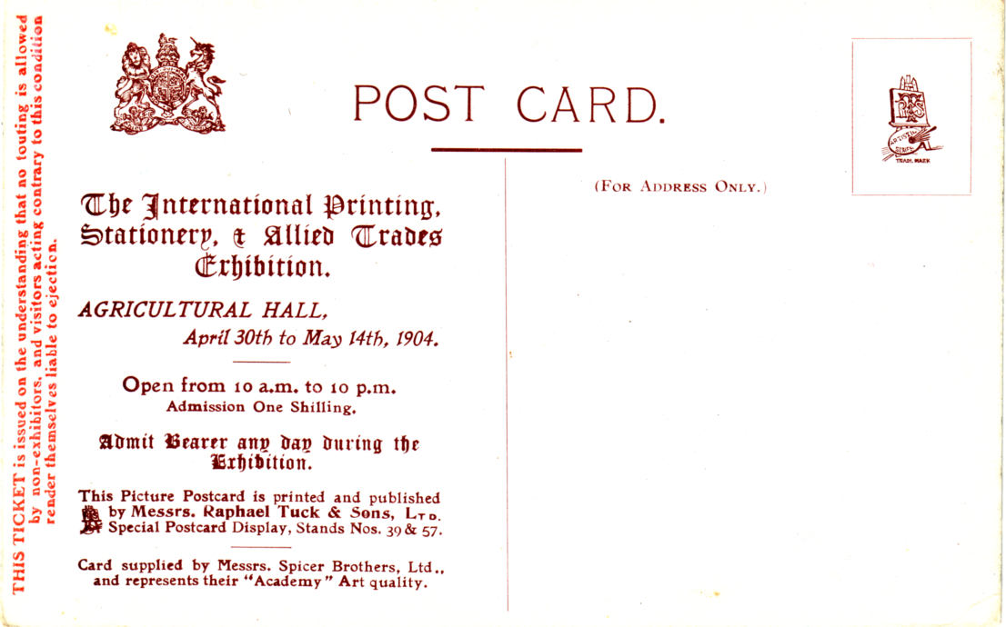

Another member Jim Negus has written to me enclosing an index which I will be sending out with the next Newsletter. It covers the years 1981 to 1991 starting with Newsletter No. 1. Jim makes some useful comments and suggestions one of which I have already done, which is to number all the pages, which will make future indexing an easier job. He is going to update his index to include this present Winter No. 27 Newsletter.

Ideal Home Exhibition Additions No 2.

1908 Trade Cards.
Major & Co Ltd Hull. Col.
The Solignum Cottage at the Ideal Home Ex. Olympia 9 to 24
October 1908. Vert.
The Association of Diamond Merchants Jewellers Silversmiths Ltd.
B/W.
(Picture of Stand). Vert.
Boulton & Paul Ltd. Col.
5. Cottage.
1910 Trade Cards.
Virol Children of All Nations. B/W.
Carolina (St Kitts, West Indies) Vert.
Lulu (Demerara) Vert.
Topsy (St. Kitts West Indies) Vert.
Pete (Jamaica) Vert.
Ummah (Cingalese Girl). Vert.
Ranee (Jamaica) add Vert.

1912 Trade Cards
Virol Children of All Nations. B/W.
Beattie (Polish). Vert.
Marguerite and Max (Breton). Vert.
A Chinese baby Vert.
Kitt (West Indies).
John Bradley. "Buntlet". Col.
"Bunty" The Childrens Model Kitchen.
Cards sold in the Dutch Village.
F B den Boer.Middelburg (Holland). Sepia
13. Walchersche Meisjes. Zeeland (Holland). Vert.
40. Molenzicht (Walcheren). Zeeland (Holland). Vert.

1913 Trade Cards.
Add to Cleaver Ltd. Series 1 to 7.
There are two types of backs, on A 'Post Card' measures 40mm, and on B 'Post Card' measures 42mm.
1. Souvenir of Russian Village. A.
2. The Village School,Russian Village. A. B.
3. The South Russian Farm, Russian Village. A.
4. The Crucifix in the Forest, Russian Village. Vert. A. B.
5. The Village Church, Russian Village. A.
Type A is known upright and inverted.
6. A Group of Russian Peasants, Russian Village. A. B.
Type B is known upright and inverted.
7. North Russian Log House, Russian Village. B.

Moore & Moore Pianos. Glossy R/P.
(No title, picture of stand).

1923 Trade Cards.
R. Neale & Sons. B/W.
Garden designed by H.R.H. The Princess Alice.

Official Cards. Glossy R/P.
A Crazy Garden.

1924 Official Cards.
This is a fairly complex issue and can be divided up into two main types. Type A has "Daily Mail Ideal Homes Exhibition 1924" on the back, and Type B does not. Both printings can be further divided into two groups, one where "Post Card" measures 35mm and has a short dividing line, and the other where "Post Card" measures 39mm and has "This is a Real Photograph" down the centre.
Some printings of the same card have "Daily Mail Ideal Homes Exhibition 1924" on the front "DM", and some omit "Daily Mail" from the title, "no DM".

Numbered Series, R/Phot, brown back
1. The Dell.
Type B.
2. Carnation Garden.
Type B. 39mm, no DM.
3. Japanese Tea House Garden.
Type A. 39mm, DM.
4. Japanese Garden.
Type A. 35mm, no DM.
Type B.
5. A Rock and Terrace Garden.
Type B.
6. A Rill Garden.
Type A. 39mm, DM.
Type B. 35mm, DM.
7. A Pentagular Garden.
Type A. 39mm, no DM.
Type B. 35mm, no DM.
8. A Fountain Garden.
Type A 39mm, DM.
Type B. 39mm, no DM.
9. Rill and Pergola Garden.
Type A. 39mm, DM.
Type B. 39mm, no DM.
11. Diana's Garden.
Type A.
Type B. 35mm, no DM.
13. A Pergola Garden.
Type B. 35mm, no DM.
14. Spring and Rose Garden
Type A. 39mm, DM.

Un-numbered Series. R/Phot, no "Daily Mail Ideal Homes Exhibition 1924" on back, black back, "Post Card" Measures 47mm.
A Rock Garden. DM.
Monks Rest.

1926 Trade Cards.
A Luff & Sons Wimbledon Park. Glossy R/P.
Limestone Weatherworn Rockwork. Olympia Mar 1926.

1928 Official Cards.
6. The Garden End. Type A.
9. add Type A.
8. add A.
11. add A.
15. add Type A.
19. A Restful Arbour. Type A.
23. add A.
1929 Official Cards.
Some cards omit "Daily Mail Ideal Homes Exhibition 1929" from the title on the front, "no DMIHE 1929".
9. A Rose Temple Garden. no DMIHE 1929.
10. A Corner Garden.
13. add no DMIHE 1929.
14. add no DMIHE 1929.
16. add no DMIHE 1929.
17. add no DMIHE 1929.

1930 Official Cards.
1. add Type C.
5. add Type C.
7. add Type C.
8. add Type C.

1931 Official Cards.
14. add A.
15. The Terrace of a Hampshire Garden (by Cheal). C.

1932 Official Cards.
5. add C.
9. The Moorland Cottage Garden, by Baker. B.
12. add B.
17. add A.
19. "Bleak House" Garden, by J Cheal & Sons Ltd. B.
20. "The Honourable Molly" Garden, by Burton Holt Ltd. A.
21. The Bleak House, by J Cheal & Sons. B.
22. add A.

1933 Official Cards.
21. "The Marrying of Ann Leeke" Garden, by J Cheal & Sons Ltd. B.

1934 Official Cards.
5. add A.
7. Westmoreland Rock Garden, by Granville Ellis.
A.
10. add A.
16. Mapledurham Mill Garden. A.
18. add A. C.
20. add A.

1935 Official Cards.
5. add A.
13. check this, my card is Welsh Garden by Gavin Jones.
15. add A.

1936 Official Cards
15. add C.
16. add A. B.
1937 Trade Cards.
B. Sunley & Co. Ltd. Col R/P.
Sunley's Garden at the Ideal Home Exhibition 1937.
Official Cards.
2. Petrarch and Laura Garden, by Granville Ellis. A.

1938 Official Cards.
12. add C.

1939
(N). Small pool in rockery, Elizabethan house top R.

1948 Trade Cards. Printing the Daily Mail.
There are two types A. where "Post Card" measures 30mm and the front background is pale salmon, and B. where "Post Card" measures 43mm and the front has a light grey background.
The Printing Presses.
Carmelite House. B.
The Linotype Machine. B.
The Special Trains. A.

1954 Official Cards.
97. Garden Landscape by Winkfield Manor Nurseries. (This seems to
have two numbers 89 & 97)?

It would be helpful if members could check their 1913, 1924, 1929, and 1948 Ideal Homes Exhibition cards and let me have an updated list of what they have.

