23, BRAMLEY WAY, WEST WICKHAM, KENT. BR4 9NT. Phone 081 777 8861

Editorial Autumn No 26

It seems all I'm doing these days is writing Editorials, three in just over a month must be a record for a quarterly newsletter. By the time you get this Autumn copy I shall be up to date. I am now wanting articles, lists, and any old thing you like to send me. While I am on about things coming to me I have just had two auction lists sent in, nothing strange about that you say, but wait, one lists a Fleetway Series N empty envelope, yes no postcards in it just an empty envelope, Est value £5.00. At the Sandown three day fair I could have bought several Fleetway envelopes complete with cards, each of them under £5.00. The other auction list offered another Fleetway Series M envelope this time complete with cards with a staggering £28.00 est. valuation. Now these cards even in envelopes must be the commonest of all exhibition cards. Valuations like this are just not on. Are they hoping for mugs to come along.

At our convention at Manchester in 1989 one of our members Jean Osborne suggested that we do a circulating club packet of postcards. I have been doing some homework and find that we can circulate a 100 cards, in a stout cardboard box enclosed in a jiffy bag for £1.15 postage. I don't think it would be worth registering them as this would push the price up to £3.05 a packet, I would suggest not using plastic sleeves on the cards as the thick sleeves weigh more than cards, in fact we would only get 40 in a box. I shall bring this up at our A.G.M. in the meantime I would like to know if the members would be interested in this. If we run it the same as the stamp clubs do, the group would get 10% commission on sales, it is something to think about.

I had hoped to have this newsletter out earlier but my Amstrad printer has had to go in twice for repair, I have now got a Bubble Jet printer but it is not working yet, the firm that supplied it has not been able to programme the Amstrad to use it.

If anyone wants a copy of Stanley's book he will bring one down to the convention if you let him know in advance, at 041 339 2775, This will be at members special price of £20.00

Our 6th annual convention will take place at the White Swan 79, Westow Hill, Crystal Palace. the displays are all organised, and we should have a very enjoyable weekend. I have listed a provisional program, but as usual there will be time for extra displays if you wish to bring anything along on the day.

Saturday 26th September.

9.30 A.G.M. and election of officers
10.00 1888 Glasgow International Exhibition by Stanley Hunter.
11.15 Coffee break.
11.45 Exhibition treasures from the Karl Illingworth Collection.
1.00 Lunch. (please let me know in advance at 081 777 8861).

2.00 Cinderella at the Exhibition by Don Knight.
3.15 Tea break.
3.45 Gravity fairground rides, scenic railways etc by Barry Norman.
5.00 Finish
6.30 for 7.00 we meet again at the White Swan for our Annual Dinner

Sunday 27th September.

10.00 1939 New York Worlds Fair by Fred Peskett.
11.15 Coffee break.
11.45 Crystal Palace Aerial Flights by Bob Tough.
1.00 Lunch. (again please let me know).
2.00 Visit to the Crystal Palace Museum and walk round the grounds.

In this news letter I have included a circular received from John Nelson secretary of the Perfin Society, which he has distributed to his members. They have already listed about three dozen new Wembley Perfins. I am sure many of our members have some of this material, and I hope you will fill in the enclosed questionnaire. If possible a photocopy of your stamps taken face upwards would be appreciated, (so that the back of the stamp is photocopied and not the design on the front, this way the holes show up better). These lads go into it very deeply counting holes, stops, and measuring sizes etc. John has agreed to let us publish his final review on the subject in our news letter.

Bill Tonkin

end

PERFINS ON THE COMMEMORATIVE STAMPS OF THE 1924 and 1925 BRITISH EMPIRE EXHIBITION

by John Nelson

I have recently had brought to my notice a short section on perfins which is to be found in 'The Lion Roars at Wembley' by Donald R. Knight and Alan Sabey. The subject of the book is the 1924 and 1925 British Empire Exhibition and in it the authors focus much attention on the special stamps which were issued to commemorate the Exhibition.

These were the 1d scarlet and 1 brown bearing the date 1924 issued on 23rd April 1924 and which were reissued on 9th May 1925 with the year date on the printing dies changed to 1925. The stamps were withdrawn from sale on 19th December 1925 by which time almost the whole printing order of 17 million stamp had been sold.

The following is an extract from the book of the section relative to perfins.
Perfins (Security initials of firms)

A number of firms decided to use the special stamps and had their initials perforated into the stamps for security purposes. The following have been identified but there are probably others.

A B C Aerated Bread Co.
A C F A. C. Fincken and Co. Ltd., Watford.
& Co
C B Coope Brothers.
F.P. Frederick Penberthy.
F.G. Frank Godden Ltd.
H W H. Williamson, London.
L
J D W J.D.Williams & Co. (Wholesalers), Manchester.
M
J S James Simpson and Co. Ltd. Grosvenor Rd,
& Co London.
M W Marconi Wireless Co.
Co
M W & Co Mappin Webb and Co.
P. B. L. Scottish Provident Institution Mutual Insurance.
S & B The Wall Papers Manufacturers Ltd.
Ld Smith Brothers, Leeds.
or
Spillers and Bakers Ltd.
W & S Waterlow and Sons.
also Wilkins and Sons Ltd., Tiptree, Essex.

Perfins seen but not identified

D M D.S. G L C K & G M & S S & W S M L "

It seems to me that although this listing has several apparent shortcomings it is a most useful foundation on which, with the assistance of members of the society (Perfin Society) a more comprehensive and updated review could be compiled. It is hardly for me to suggest this as an excercise that might be undertaken by someone else (perhaps one with more specialist knowledge than I of the perfins of the KGV period) so with the approval of the Editor I am having a go at it myself.
Accompanying this Bulletin is a survey form which you are invited to complete. What I have done is to list the twenty perfins mentioned in the book, leaving some space at the end for you to add any dies not included. If there is not enough room for all your new ones, please put these on a separate sheet using the same column format.

On your survey form please make any corrections to the first column particulary as to the addition or deletion of stops. In the second column you should insert the die number which appear in the Society's Illustrated Catalogue or a specification in the form utilised in the Tomkins Catalogue. (Exhibition Study Group members please note that you will be
unable to fill in the second column as it is unlikely that you will have their Illustrated catalogue). Tick in the appropriate centre boxes the stamps bearing each die which you possess or positively know to exit.

The last column is for further information, if any, such as postmark details and identities. Only include identities which you can personally verify and not those you have taken from the Society's lists or have copied from other sources.

Even if you only have one example of a Wembley perfin do plese send me your completed survey form. There is no need to write a covering letter. All information will be collated for future publication but returns will not be acknowledged unless you so request or either of us should wish to raise any query.

end

GOLD COAST CARDS AT WEMBLEY

It so happens that within the last month or so I have had two collectors asking for details of Gold Coast cards available at the Wembley Exhibition. One of them John Mills has now joined the Study Group. This is the list that I have sent them, and as I know we have other Wembley collectors I thought they might like to see it. Mike Perkins and myself have compiled it.

Tuck Oilette cards. Brown back. Series 1 to 6 are sets of six cards from paintings by E. Cheesman, series 7 is a set of 9 cards and are not credited to anyone. There are variations of the setting of 'series' in relation to 't' of 'Government', and this has been chosen to describe the different types, as it is easy to identify. There can even be slight differences between the six cards of a type, and t over eri means the t could be over e, r, or i, or between any two of the letters . The variation will remain constant for that card in a given series. Sufficient information is given to easily identify the different types, but there are many minor differences not listed. 'For address only' is usually in small letters without brackets and measures 14mm, but where it is in large letters with brackets measuring 19mm this has been listed. Where a series has not been seen complete in any type, they are listed individually.

Series 1

Type A. Without series number on the back, 'Tuck's Post Card' measures 66mm.
Type B. With series number, 'Tuck's Post Card' measures 64mm, 'for address only' (in large letters) with brackets, there is a 5mm gap between t and series, which is in a heavier type.
Type C. With series number, 'Tuck's Post Card' measures 64mm, t over S of
series, which is in lighter type.
A manganese mine in the Gold Coast.
A market scene, Accra, Gold Coast.
A native court in the Gold Coast.
Christiansborg Castle, Gold Coast, The Residence of the Govenor.
Loading cocoa into surf boats, Accra, Gold Coast.
The Old Boat Harbour, Seccondee, Gold Coast,

Series 2

Type A. 'Tuck's Post Card' measures 64mm, t over ser of series.
Type B. 'Tuck's Post Card' measures 66mm, t over er of series.
Type C. 'Tuck's Post Card' measures 68mm, t over ser of series.
A ward in the Hospital for Africans, Accra, Gold Coast, type A & C.
Ashanti weavers. type A & B.
Exterior of the gold mine, Abontiakoon, Gold Coast. type A & B.
Manganese mine, Insuta, Gold Coast. type A.
The Fort, Coomassie, Gold Coast. type A & B.
The Railway Workshops, Seccondee, Gold Coast. type A & B.

Series 3

Type A. 'Tuck's Post Card' measures 64mm, t over eri of series.
Type B. 'Tuck's Post Card' measures 66mm, t over eri of series.
A Fulani village, Gold Coast.
Entrance to Christiansborg Castle, Accra, Gold Coast.
Fort Nassau Mori, Gold Coast.
Government officers bungalow, Gold Coast.
Old type house for europeans, Accra, Gold Coast.
The Carpenters Shop, Kibby Trade Sshool, Gold Coast.
Note, 'Entrance to Christiansborg Castle', type A is printed with an inverted back, and type B is printed with an upright back.

Series 4

Type A. 'Tuck's Post Card' measures 64mm, t over eri of series.
Type B. 'Tuck's Post card' measures 66mm, t over eri of series.
A steam shovel at Takoradi, Gold Coast.
Ashanti drummer with talking drums, Gold Coast.
Christiansborg Castle by moonlight, Gold Coast.
Dix Cove near Seccondee, Gold Coast.
Fulani herdsman at Mampon, Gold Coast.
Government House, Accra, Gold Coast.
Note, 'Ashanti drummer with talking drums' type A & B are both printed with inverted backs.

Series 5

Type A. 'Tuck's Post Card' measures 64mm, 'for address only' (in larger letters) with brackets, t over se of series.
Type B. 'Tuck's Post Card' measures 64mm, 'for address only' (in larger letters) with brackets, there is a 4mm gap between t and series.
A corner of the courtyard, Elmina Castle, Gold Coast.
Anambo Fort, Gold Coast.
Ashanti potters, Gold Coast.
Boys on parade, Kibby Trade School, Gold Coast.
Cape Coast Castle, Gold Coast.
Kormantin Fort with fishing village, Abadsi, Gold Coast.
Note, 'A corner of the courtyard Elmina Castle', type A is printed with an inverted back, and type B is printed with an upright back.

Series 6

Type A. 'Tuck's Post Card' measures 64mm, 'for address only' (in larger letters) with brackets, t over seri of series.
Type B. 'Tuck's Post Card' measures 64mm, 'for address only' (in larger letters) with brackets, there is a 4mm gap between t and series.
A Palaver of chiefs, Accra, Gold Coast. type A & B.
Accra from Government House, Gold Coast. type A & B.
An Ashanti Priest, Gold Coast. type A & B.
Elmina Castle, Gold Coast. type B.
Koforidua Station, Gold Coast. type A & B.
Old Accra, Gold Coast. type A & B.
Note, 'An Ashanti Priest', type A is printed with an inverted back, and type B is printed with an upright back.

Series 7

All titles are prefaced with Interior, Gold Coast Building, Wembley.
Ashanti Court.
Native products.
The beach at Accra.
The Cocoa Court.
The Commercial Courts.
The Government Courts.
The Minerial Court.
The Northern Territories Court.
The Timber Court.

There are four other Gold Coast Series.

(1) Coloured, no indication of printer on the back just the word Post Card in black.
The Courtyard, Fort St. George, Elmina, Gold Coast Colony.
Fort St. George, Elmina.
Inner Court, Fort St. George, Elmina, Gold Coast Colony.
Courtyard, Cape Coast Castle, Gold Coast Colony.
Fort St. Jago from the Ramparts Fort St. George, Elmina, Gold
Coast Colony.
Note there may be others to this set.

(2) Black/White, Tucks Gold Coast Government Series, showing pictures of coloured athletes from the Government Technical School, Accra, no titles, black back.
Putting the shot.
Pose with arm and leg outstretched.
Note although only two are known there may be others to this set.

(3) Coloured, Tuck, no title, brown back, The Gold Coast, Ashanti and The Northern Territories.
Reproduction of the Thos Shepard Gold Coast poster.

(4) Sepia, Tuck, brown back, Photo-Graphic Photo Union.
Princess Baa of Ashanti and her Husband.
Prempeh son of the late King of Ashanti.
Gold Coast Africans in the Native Village at Wembley.
Note as above.

end

THE RED CROSS AT WEMBLEY

by Bill Tonkin

As early as the 20th of December 1922 an article had appeared in "The Spectator" suggesting arrangements should be made for a creche, where the smaller children of family parties could be left, while the others made the grand tour of the exhibition. This was immediately taken up by the Executive Committee of the Red Cross at their meeting on 24th Jan 1923. The Chairman Sir Arthur Stanley stated that the Central Council for Infant and Child Welfare (C.C.I.C.W.)were anxious to undertake this work, and had expressed a wish to work with the British Red Cross Society (B.R.C.S.) if they were taking part in the exhibition. The Secretary Brig-General H.B.Champain was authorised to get in touch with the C.C.I.C.W. and draw up some concrete proposals for a scheme, and setting out some approximate costs.

On 1st Mar 1923 the Secretary was able to report that he had been in touch with the C.C.I.C.W and a Major E. A. Belcher C.B.E., one of the Directors of the British Empire Exhibition (B.E.E.), and from the conversations he had had it appeared that the Directors of the Exhibition would welcome the assistance of the B.R.C.S. in furnishing first aid posts and ambulances as well as nurseries and playgrounds for children.

It was agreed that a small Sub-Committee be set up and it was decided to invite Mrs St. Loe Stracey and Dr Woodcock, the County Director for Middlesex to serve as representitives of the B.R.C.S. and to work in conjunction with representitives of the C.C.I.C.W. It was further agreed that the Finance Sub-Committee should be asked to consider favourably any application from this Sub-Committee for a grant of money to carry out the necessary work.
Undoubtedly of all duties carried out during 1924 the work at Wembley stands out above all others. The First-Aid work was undertaken by the Society and The Order of St. John in alternative months. The First-Aid work was particularly interesting, and of great value from the point of experience. For this work there was never a lack of volunteers.

The following Shifts were filled
Men 764
Women 359
1,123

The B.R.C.S. took over the whole of the First-Aid duty at the Exhibition from 5th May until 31st May, and during that period 18 women V.A.D. members and 71 men were on duty daily. The number of cases dealt with totalled 2,500. The B.R.C.S. also took over from the 7th July until the 2nd August. and during this period treated 4,012 cases. One accident occured during July to a Mr S Thomas of Woolwich while he was on one of the domes of the Stadium. Private James Armstrong V.A.D. from Dumfriesshire went to his aid climbing the iron ladder on the face of the dome.

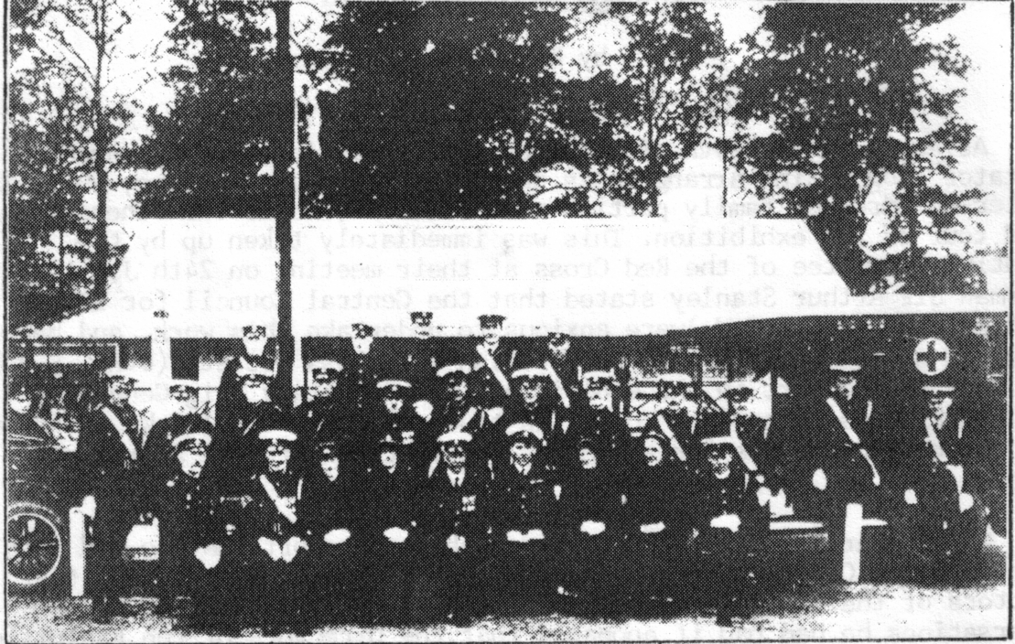

British Red Cross Personnel on duty at Wembley, the corrugated roofed
building in the background is the Fire Brigade Rest House.

The numbers were supplemented on various occasions at the request of the Exhibition authorities when special events in the Stadium brought unusually large crowds to the Exhibition. The B.R.C.S. were again present from 1st Sept to the 4th of October, when 3,978 cases of accident and sickness were dealt with.
The Medical Report of the British Empire Exhibition 1924. by Major-General S. Guise Moores, C.B.,C.M.G., Director of Medical Services to the B.E.E. makes interesting reading but is a bit too long to give in its entirety.
I have picked out those parts that reflect the degree of planning that went into the organising of such a large event by people who gave their services unstintingly, over a long period, and who in the main had no previous experience of such an event to fall back on.

Extracts from the Medical Report

Exhibition crowds are made up of all classes and all ages, from infancy to decrepitude. It was therefore necessary to provide for the special requirements incidental to these extremes, quite apart from the ordinary medical and surgical happenings ordinarily associated with a communal life.
To meet all requirements provision was made for.
(1) Immediate assistance at "First-Aid" cabinets placed in
different parts of the Exhibition grounds and buildings
(2) Early transportation of patients by motor ambulance from the
cabinets direct to the Main Ambulance Station.
(3) The attendance day and night of a medical officer and complete
staff at the Main Ambulance Station.
(4) The dispatch of selected cases by motor ambulance from the Main
Ambulance Station to hospitals, nursing homes, railway
stations, or patients residences.
(5) The treatment, care and feeding of paralysed ex-soldiers and
others suffering from disabilities incidental to age.
(6) The care of persons visiting the Exhibition from epileptic
colonies.
(7) Adequate "rest house" and drying arrangements for people
falling into the lake. Some 150 cases have been attened to.
(8) Special outdoor facilitiesto accommodate numbers over-come by
the "heat and burden of the day".
(9) The admission of infectious cases to special hospitals.
(10) The admission of colonial natives to special hospitals.
(11) The occurrence of "crises", such as the Whit-Monday food-
poisoning epidemic.

NUMBER OF CASES TREATED

April 329
May 2,500
June 4,804
July 5,006
August 4,570
September 3,978
October 2,201
23,388

Of this total of 23,388, some 400 may be classed as serious. These include caes of hemiplegia, fractures of skull, thigh, leg, arm, forearm, etc., dislocations of shoulders etc., appendicitis, gastric and duodenal ulcer, etc. 124 cases were sent to the Willesden General
Hospital, the remainder were dispatched to their homes or elsewhere by motor ambulances. the combined distance covered by these was 10,625 miles.
At the Stadium Ambulance Station a medical offier and First-Aid attendants were on duty during all ceremonies and performances.
(1) The Opening Ceremony.
(2) The Empire Thanksgiving Service.
(3) The Rodeo Displays.

Mention was made in the report of the Whit-Monday food poisoning epidemic, the incriminated article of food was the veal and ham pie issued that day to the restaurants in the Exhibition. There were some 4,700 pies sold, and it is probable that as many as 7,000 persons partook of these. 87 cases were admitted to the Main Ambulance Station, but it is certain that there were other caes, probably less affected that went direct to their homes from the Exhibition. The total number attacked was approximately 75% of the partakers. This fact points to the probability of only a small consignment which found its way into the Exhibition to meet a Bank Holiday demand.

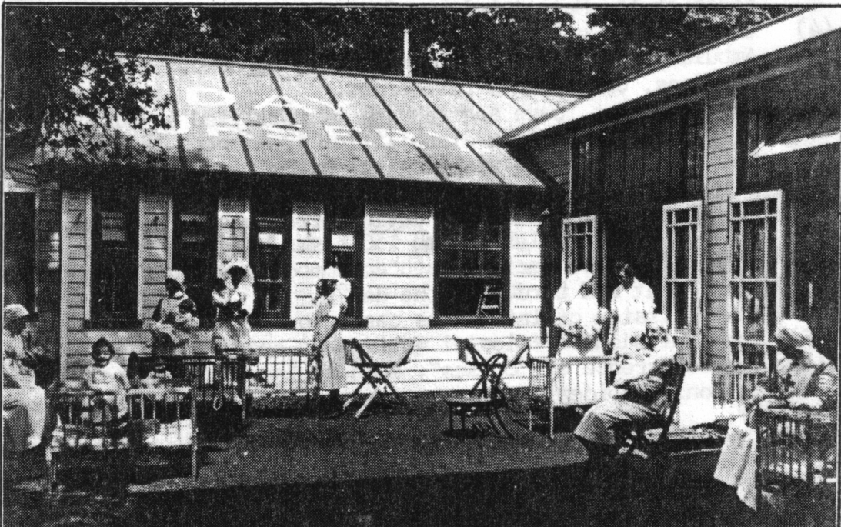

The Day Nursery

A Day Nursery for chilren had been built close to the north entrance of the B.E.E. in which mothers could leave their children, either for the whole time that they were at the Exhibition, or for a rest during a part of the day's excursion. The C.C.I.C.W. had the responsibility of its administration, and the staff was partly professional and partly composed of V.A.D.s. There were three trained nurses with V.A.D.s to help them, and besides this the older childrenwere looked after by trained kindergarten teachers and helped to play organised games, and to make full use of the toys provided for their amusement. There were also cots in which the babies could take a rest. The fee to mothers was 6d per child for a 4 hour period.
In the June issue of "The Red Cross" (the Official Journal of the British Red Cross) it was able to state that since the opening of the Day Nursery at the end of April, 1,153 children had been cared for.

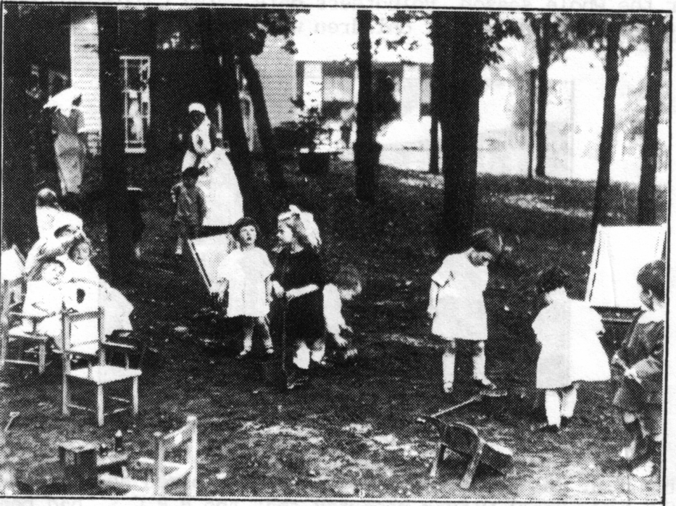

The playground

Her Majesty the Queen accompanied by His Royal Highness Prince George, and attended by Lady Cynthia Colville and Mr Verney, visited the Day Nursery on Friday 30th May. A letter sent by the committee, expressing their grateful appreciation of the fact that Her Majesty had been able to honour the Day Nursery by her presence, brought the reply.

Buckingham Palace
2nd June 1924

I am commanded by the Queen to thank you very much for your letter on behalf of the Chairman and Committee of the Day Nursery at the British Empire Exhibition, and to inform you that Her Majesty greatly enjoyed her visit to the Nursery last Friday.
The Queen was much struck by the charm and quietness of the surroundings in the heart of such a busy section of the Exhibition, no less than by the cheerful pleasant rooms in the Nursery itself. The generally happy aspect of the chilren as also of the efficient and capable looking staff made a most favourable impression on the Queen, who considered the Day Nursery an ideal institution for its purpose.

By the time the Nursery closed on 1st November 11,091 children had been cared for. The children who came to the Nursery often arrived tired out by a long journey, they were immediately fed, and put to bed, and slept happily until it was time to go home. Some of the children were daily visitors their mothers being employees in the Exhibition.
In 1925 the Nursery was again opened at the request of the Exhibition Authorities. The C.C.I.C.W. did not co-operate with the B.R.C.S. as they had in 1924 and the Order of St. John took their place. It was decided to staff the Nursery on rather different lines, and a permanent staff were engaged for the whole season, volunteers only being called for on occasions when a very large attendance of children was expected.

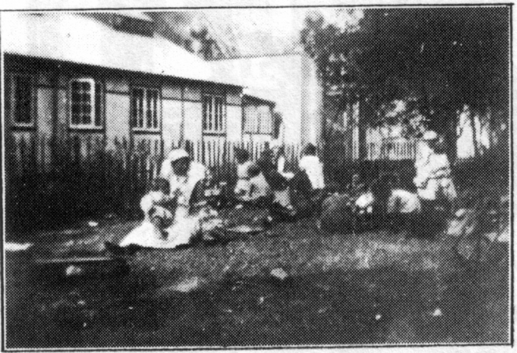

The Toddlers Garden

The B.R.C.S. was to become even further involved and at a meeting on 3rd July 1924 Lady Beryl Oliver reported that the B.R.C.S. had been asked by The Boy Scouts Association to set up a hospital for the Boy Scouts Camp (The Imperial Jamboree) which was to be held from the 15th July to the 15th of Aug. Lady Oliver said she had discussed the matter with the Secretary and had provisionaly undertaken to organise the hospital. She had been successful in obtaining the services of Surgeon Vice-Admiral Sir Robert Hill, who had consented to take charge of the medical arrangements. It was estimated that the cost to be borne by the B.R.C.S. would not exceed #200, and it was hoped that this sum could be found from the grant of #2,000 which had already been approved. Major Abrahams said he was extremely interested in the Boy Scouts movement and regarded this connection between the B.R.C.S. and the Boy Scouts as such an excellent one that he asked to be allowed to make a donation of #200 to cover the expences, this offer was gratefully accepted.

The following is the report sent to the Imperial Headquarters of the Boy Scouts Association by Sir Robert Hill after the Imperial Jamboree had finished.

I beg to forward the following report on the medical arrangements for the Boy Scouts Camp at Wembley (Imperial Jamboree), and a medical report on the health of the scouts while in camp.
On 23rd June I received a request from the B.R.C.S. that I should take medical charge of the Boy Scouts Jamboree Camp to be held at Wembley Paddock from 15th July to 15th Aug. I was informed that the greatest number of scouts in camp at one time would be 12,000, and that the average number would be 10,000.
Having accepted I considered the organisation fell under the following heads,
(a) Accomodation, (b) Personnel, (c) Equipment, (d) Arrangements for serious cases and also for infectious diseases.
(a) Accomodation. Taking 10,000 as the average, I worked on a basis of 1 per cent sickness requiring treatment in bed. The hospital as planned consists of.

4 marques, each capable of taking 25 beds
1 bell tent for observation cases
1 bell tent for stores and wardmaster
1 bell tent for nurses
1 bell tent for orderlies
3 bell tents for the 3 medical officers

In addition there were three bell tents distributed through the camp as first aid posts to collect cases and render first aid in minor injuries. The management of the Willesdon General Hospital kindly consented to receive any serious cases, and the Isolation Hospital at Acton our cases of infectious disease.
(b) Personnel. A sanitary officer appeared the great desideratum, and I was fortunate in obtaining the services of Colonel Percy Evans, C.M.G., M.B., D.P.H. (retired), who worked with the Camp Commandant before the arrival of the Scouts and throughout the existence of the Camp. Surgeon-Captains Osborne and Horley accepted my request that they would help me. They were both retired naval medical officers whome I had known during their service. I thought myself particularly fortunate in getting Captain Osborne, as he had had long experience in boys training ships and at Shotley. As store officer and dispenser, I secured Mr Blackman, a retired wardmaster, R.N. Lady Oliver procured a matron and the nursing staff. Miss Reid, R.R.C., retired Matron, Queen Alexandra Imperial Military Nursing Service (Q.A.I.M.N.S.), accepted the position of Matron, and was supported by three sisters Q.A.I.M.N.S. (retired) and one sister Q.A.I.M.N.S. (reserve).
The nurses and orderlies were obtained from the members of the Red Cross Voluntary Aid Detachments (V.A.D.). Four V.A.D. nurses and four V.A.D. orderlies started at the camp until the 31st July, and were then supplemented up to the 9th August. During this period there were,

Red Cross V.A.D. nurses
2 Commandants, 13 nurses.
Red Cross V.A.D. Orderlies
1 Commandant, 4 Section Leaders, 1 Quarter-master,
3 N.C.O.s, 9 Orderlies.

Mr Stuart Lang (a Rover Scout), of Albany Street, offered his services to look after any Scouts requiring emergency dental treatment. During the quiet period Scouts were sent to his house, but from the 1st to the 9th August he came to camp and on four occasions administered gas.
(c) Equipment. We were indebted to the Admiralty and the Medical Director-General R.N. for the loan of a considerable part of our equipment, but the B.R.C.S. had to purchase drugs and a great many other things which could not be obtained on loan. An ambulance was supplied by the B.R.C.S. and driven by one of the Red Cross orderlies.
The B.R.C.S. provided a surgical pannier, many surgical dressings and some stretchers, and the League of Remembrance sent some eye bandages.

I am glad to report that the health of the Scouts while in camp was excellent. The greatest number of beds occupied on any night was 50. The total number treated as bed cases was 172. An average of 250 attended daily between the 1st and 9th of August. These were cases of minor injuries and slight ailments not requiring bed treatment. About 25 minor cases were treated daily in each of the first aid posts.

5 cases were sent to Willesden General Hospital, 3 of appendicitis and 2 of broncho-pneumonia, and 5 cases were sent to the Isolation Hospital, Acton. 3 of scarlet fever, 1 of mumphs, and 1 of rubella.

In addition to the cases treated in the main hospital, the hospital in the Scottish camp, administered by Dr Hood, treated a considerable number of patients, but as Dr Hood had arranged with me that he would send any serious or infectious cases to the main hospital, it may be assumed that those generally treated in that hospital were of a mild type.

The camp appeared to me to be administered admirably from the sanitory point of view, and enormous difficulties had to be overcome to deal with the quagmire left by the storm on the night of August 3rd. The mud in the feeding marquees, mixed with food refuse, caused a most unpleasant and nauseating smell, the plentiful use of ashes and insistance on freer ventilation had the desired effect of reducing this. I cannot say that any cases of illness resulted from these conditions.

The food was wholesome and plentiful, and no cases of illness can be attribute to any food taken in the messes. "Wembley Rock" and too many ices claimed a certain number of victims (sickness, stomach-aches, etc.), but they quickly responded to treatment.

No serious injuries were sustained. A large number of minor injuries were treated, but really few, when the percentage of Scouts in camp is taken into consieration.

When considering the formation of future camps of a large size, approximating to 10,000, I do not think it would be safe to reduce the size and personnel of the hospital accommodation.

I am of the opinion it is unwise to allow boys of under 12 to come into these large camps, chiefly owing to the distances entailed between the tents and feeding accommodation. The cases of boys of 9, 10, and 11 taken into the hospital were much more due to exhaustion than to illness, and over-strain at that age will do more harm than camp life will do good. I wish to emphasise that these remarks do not imply that small boys ought not to camp out, on the contrary, I think it most healthful, but these camps should be composed of boys from 9 to 12, and each camp limited to small numbers.

The site of the camp at Wembley, except for the clay soil, was ideal.
In conclusion I wish to record my gratitude to Lord Glenusk, General Davidson, and Mr Montgomery, for their cordial co-operation with me in any suggestion I made.

I cannot sufficiently thank my own staff for their ceaseless work and devoted care and attention to their patients throughout a very strenuous 10 days.(I think they mut have caught the Scout spirit).

Especially do I wish to emphasise my indebtedness to Miss Reid, R.R.C., our Matron, whose thorough knowledge and experience of camp life were invaluable. Her tact and kindness in dealing with the staff prevented any semblance of friction, and her skill and loving attention to the boys I am sure will linger in her young patients memories for some time to come.

After the Imperial Jamboree was over the Chief Scout Sir Robert Baden Powell sent a personal letter of appreciation both to Sir Robert Hill and to Miss Reid, expressing his thanks to them for all they had done, and each letter was accompanied by the Boy Scouts "Badge of Thanks" in gold.

The Exhibition Study Group would like to thank Mrs M Poulter and
Mrs V Marchbanks of the British Red Cross Archives Section for their help and assistance, and also for permission to make use of their material.

UNIDENTIFIED EXHIBITION CARDS



Any ideas on this one, posted in Blackpool 4th August 1914,
Published by The Cynicus Publishing Co

