23, BRAMLEY WAY, WEST WICKHAM, KENT. BR4 9NT. Phone 081 777 8861

Editorial Summer No 25

The time has come for you to make a note in your diary of the date of our next two day Convention and A.G.M. This will take place at the White Swan. 79, Westow Hill, Crystal Palace. and will follow the same pattern as for previous years, as usual it will be the last weekend, Saturday 26th and Sunday 27th of September 1992. On Saturday night at 7.30 we will hold our Annual Dinner (also at the White Swan) which those of you who have attended in the past will not want to miss, to those of you who have not attended I can assure you it is a very enjoyable evening, a roast meal, pleasant company, what more can you ask for. We will open the proceedings at 9.30 on Saturday morning by holding our A.G.M. which does not take long, and this will be followed by displays of exhibition or related material and talks by our members. Morning coffee, snacks at midday, and tea during the afternoon will be available.

I would like to see some new faces displaying some of their treasures, and would say to anybody who has not previously shown, don't be nervous about standing up and saying a few words, remember it will give us all pleasure, and more-over in the chatting that follows each display you are very likely to learn something you did not know. there is nothing nicer when you have finished, to have someone come up and say they liked a particular item, but did you know....... Thats what collecting is all about, sharing your knowledge, and learning about your collection.

We are fortunate in the Study Group to have members who can stand up and talk about their collections at great length, to be a good speaker is an ability that we do not all possess, so if you feel you only want to say a few words about an item in your collection, then do just that.

It will help if you can let me know as soon as you can, if you will be attending, showing, and eating. If you are coming from a long distance let me know if you are requiring accommodation, as I may be able to help.

Dont forget to send in any articles or anything I can use in the newsletter, owing to the snarl up of the Spring and Summer issues, I have as yet had no response to my request for wants and disposal items from members. I am always open to any suggestions from members on how the newsletter can be improved, as I am conscious of the role an interesting and informative newsletter has to play in keeping members who live so far apart, together as a group. Very often this is their only connection with other collectors, and a collector isolated, is a collector who is missing out on so much, that he or she never realises the full potential of their hobby.

Bill Tonkin.

EXPOS AT THE MOVIES

Continued from page 7. Spring issue No 24
by Stanley K Hunter

Three commercial videos for the Garden Festival were issued. The "official" video was COMING UP ROSES, released by the Scottish Development Agency which was the parent body of the Festival. FESTIVAL IN FOCUS was made up of more than 200 colour transparencies. This "electronic picture book" was compiled from the work of two local amateur photographers and lasts 30 minutes.

The Church of Scotland produced PENTACOST SUNDAY (26 minutes). While this homes in on a single day, Sunday 22nd 1988, it is perhaps the best general approach to the Festival of all three videos. Attendance was 4,345,820 - which is not bad for a "flower show"! (Should members be interested in obtaining any of these, I can supply further information).

The most widely screened shots of the Festival appeared in the Taggart adventure ROOT OF EVIL. This screenplay showed a number of features of the Festival - D.C. Jardine (James Macpherson), on speed craft on the Clyde racing past the Festival site. The villian of the piece was a performer in a barbershop quartet which performed in the National Trust for Scotland Exhibit. This included the water statue Foam, (J d'O Pilkington Jackson) and depicted on a NTS Festival postcard. It had first been exhibited in a fountain at the 1938 Empire Exhibition. It can be seen on Valentine's 1938 cards X71 and X73 and the Artcolour A716, complete with plaster dolphins (now lost). The original photographs do not show the fountain in action but a variant shows X71 with a fancy spray added by hand.

Foam has now been returned to the NTS garden at Greenbank, Glasgow, where it can be seen by visitors.

Taggart featured Kelvingrove Park in a number of programmes, Dead Ringer, for example, had a hilarious scene with the suitcase of ransom banknotes floating over the Robert Stewart Memorial Fountain. This was designed by James Sellars - the architect who designed the 1888 International Exhibition held in the park. This fountain was used as a photo opportunity for all three major exhibitions staged in the park, 1888, 1901, and 1911, and on later postcards. The fountain was turned on in 1872 and has been restored. It is overlooked by the dramatic Park Terrace complex, which featured in Death Cell. The University on the opposite drumlin appears in several Taggart episodes, like Flesh and Blood.

Not all of these episodes have yet been released on video, but they are featured in the book Taggart's Glasgow. This was compiled by Mark McManus & Glen Chandler. It is a Scottish Television book published by Lennard Publishing, Oxford. (1989) ISBN 1 85291 072 0

Tyne-Tees TV produced a video in 1990 of the National Garden Festival - Gateshead. Using the link of Alice in Wonderland ("Through the Looking Glass" was written in the neighbourhood), the film gives a good account of the 1990 National Garden Festival.

It was intended to produce a commercial video of the Glasgow 1990 European City of Culture Year, but negotiations apparently broke down. As a result many interesting events were not recorded. One such event was the remarkable GLASGOW'S GLASGOW 1990 Exhibition. Although beset with problems (mainly politically inspired) it was certainly the largest loan exhibition held in Britain that year. The earlier Glasgow exhibitions were featured in two main displays and I was invited to lend material for both. One display covered the 1888, 1901, and 1911 Exhibitions held at Kelvingrove, while the other dealt with the Empire Exhibition at Bellahouston, 1938.

Both displays had loop videos running, the early display incorporated stills of the exhibitions while the 1938 video used film. I have tried to obtain copies of both videos but have had no luck so far. In one of the cinemas there were regular showings of a colour film of all aspects of the floodlit fountains which were such a feature of the 1938 Exhibition.

I mentioned in an earlier article that there was a commercial video of films of the Golden Gate International Exposition held on Treasure Island, San Francisco 1939-40, I do not know if it is available on the PAL format suitable for Europe.

In the same article I mentioned that I wanted to visit the US Army Museum in the Presidio, the 1,400 acre military instalation in San Francisco. I had been informed there were some items on the San Francisco Exhibitions, including dioramas (and a display on the 1906 earthquake). Unfortunately, the Army Museum was closed because of the damage suffered in the 1989 earthquake. I had to be satisfied with a few snapshots of the exterior of the museum, just south of the site of the 1915 Pan-Pacific International Exposition.

A few weeks ago I spotted a video called THE PRESIDIO starring Sean Connery, Mark Harmon and Meg Ryan, I thought there may be some good shots of the Presidio, Perhaps even a glimpse of the museum. Imagine my surprise when there was a shot of the exterior, exactly like my own photograph, looking north towards the Golden Gate Bridge. Then an entire sequence took place inside the museum with Sean Connery, as provost of the Presidio walking through the rooms, with curator Jack Warden (who comes to a sticky end). Alas, only military exhibits can be glimpsed. The film (Paramount, 35 mins) was apparently shot only months before the earthquake.

At our Exhibition Study Group annual dinner, a few other suggestions were thrown at me. It was thought that a Frank Sinatra movie SUDDENLY had a sequence at a US Worlds Fair of 1940. The film (UA 1954) concerns a plot to kill the US President. As it is set in the sleepy town of Suddenly, California, I assume it was the Golden Gate Exposition of 1940. The President is on a top secret fishing trip but is on his way to destiny with the crazed Sinatra. The film (75 mins) also stars Sterling Hayden, James Gleason, and Nancy Gates. It
makes direct references to the killing of Lincoln and Garfield. McKinley was shot during the Pan-American Exposition at Buffalo, NY, in September 1901.

Although it does not appear to be on video it went through a "Colorization" process. Astonishingly, "Old Blue Eyes" appears with brown eyes in the later film copy!

It is reputed that Lee Harvey Oswald had watched "Suddenly" only days before murdering Kennedy in 1963. The film was withdrawn shortly afterwards. Can anyone confirm that this was the film remembered?

Another suggestion was a John Mills film featuring the Festival of Britain. This was presumably IT'S GREAT TO BE YOUNG (Marble Arch/AB Pathe, 1952, 94 mins). Sir John plays a popular music teacher who is sacked by the head-teacher Cecil Parker. The co-ed grammar school revolt that follows stars Jeremy Spenser, Ruby Murray, Elizabeth Kentish, and Humphrey Lyttleton. The climax comes at a national music festival. Over thirty years later the Motion Picture Guide could still describe it as "a fresh comedy with Mills at top form". It does not appear to be issued on video.

I am sure that other exhibition-related films and videos exist. A listing could be a useful database and perhaps your editor could be persuaded to use some of the newsletter space for such an ongoing catalogue. (Note the Editor is very persuadable Stanley, and will always find room for anything of interest)
END.

Letter from Alan Sabey. 46, Thorncliffe Rd, Norwood Green,
Southall, Middlesex. UB2 5RQ.

Dear Bill

Stanley Hunter's article on Exhibition sites makes interesting reading, however I do not agree with him on one point. That is concerning the Uxbridge Road entrance of the Franco-British Exhibition. I have a good card of it in 1908 showing a placard for the 1908 Olympics (another interest of mine) and I think that the building to be seen today, is not a replacement as Stanley says, but is the original entrance somewhat modified. The glass canopy over the doors has gone, but the four columns at the entrance doors, and the four vertical bars in the large window above are still there. Also to be seen today are the small doors under the columns which have lost their ornate tops. I can recall seeing it with the curved name place over the window still there, but believe that the structure has had a further "face-lift" in recent times.
Alan goes on to mention a visit we both made to Wembley to look at a possible venue for our 1993 convention that he had found. On inspecting it we both agreed it would do us very well. They will also do our Saturday Night Dinner. We also found very suitable accommodation for those who will be staying for the weekend.
Thanks Alan.

LONDON EXHIBITION SITES

Some notes by Arthur P Smith

This is some extracts from a letter sent by Arthur to Stanley Hunter, which Stanley thought may be of interest to members.

Regarding your excellent article for the Study Group, may I give you additional material regarding South Kensington Exhibition, and correct something regarding Earls Court.

As you may know, I worked in the South Kensington Exhibition area and at our last meeting (5th Convention at Crystal Palace in 1991), I displayed some material on the Imperial Institute, not as it says on page 3 (News letter No 23) Commonwealth Institute, that is a different story. I spoke because it was built to celebrate Queen Victoria's Jubilee and it followed on the previous speaker's display on the same subject.

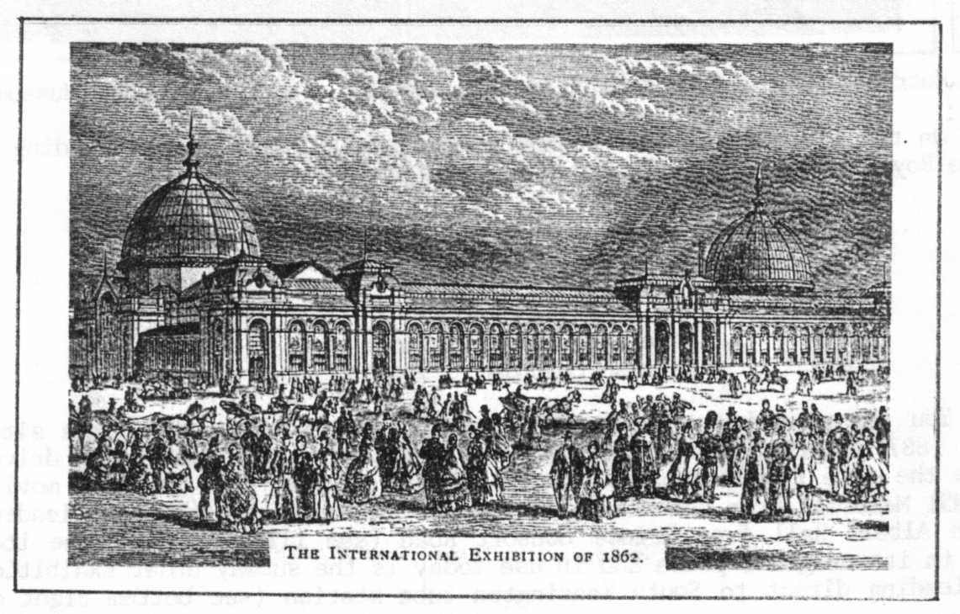
The International Exhibition of 1862

Now re South Kensington, on some of the ground purchased with the profits from the 1851 Exhibition, they built the International Exhibition of 1862. The front of the building was on Cromwell Road where the Natural History Museum stands today, see illustration. I have a number of these stereoscopic cards showing other exhibits at the Exhibition, The V & A also did a booklet on the subject. The V & A at this time was a temporary structure known
as the South Kensington Museums, see notice on right, View No 185. The Natural History Museum was built from 1873 until 1880.

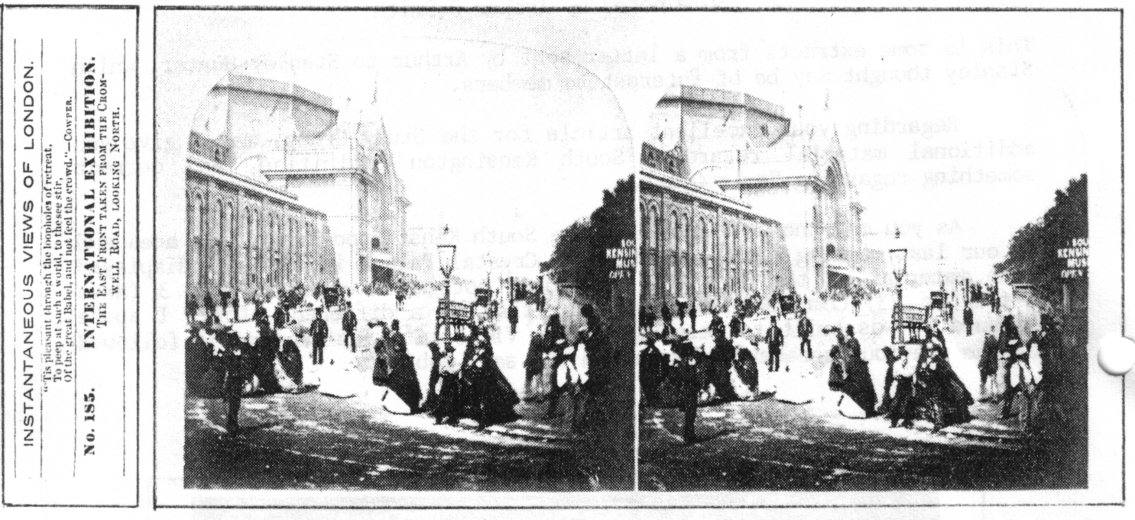

Entrance to the 1862 Exhibition and showing site of the V & A Museum

On the Gardens laid out behind the Natural History Museum leading up to the Royal Albert Hall, the following exhibitions took place.

1881 Medical & Sanitary
1881/2 Smoke abatement
1883 Fisheries
1884 Health
1885 International Inventions
1886 British Colonial & Indian

You saw my guide to the 1885 Exhibition with the plan of the site. After 1887 Imperial Institute Road and Prince Consort Road were driven across the site from Exhibition Road to Queen's Gate. This involved moving the 1851 Memorial from the middle of the garden, up on to the steps leading to the Albert Hall from Prince Consort Road (see illustration). One item still in its original place and in use today is the subway under Exhibition Road leading direct to South Kensington tube station (see bottom right of plan).

The Imperial Institute opened in 1893 and in 1896 held the first ever Motor Car Show. Only in those days the title was the International Horseless Carriage Exhibition.

Now to Earl's Court.

Just as your flat overlooks the Kelvingrove Park site, so from my top window I can see the roof of the main Earl's Court building. The reason I am living at this address is
because my Grandfather moved here in 1909, to be nearer his work as General Foreman of the Works Dept of Earl's Court Exhibitions. One of the Fulham entrances used to be at the end of this road. He had been working there then for over 20 years. My father joined him in 1900 and my uncle a few years later. Just as your main Exhibition interest is Glasgow, it follows from my address and family connections, that my main Exhibition interest is Earl's Court, and I have amassed
since my father's death in 1961, over 450 cards plus other souvenirs of his and his father. So having done a lot of research into the subject may I correct that which is originally wrong at the beginning of page 17 in Part 1 of Fletcher & Brooks work British Exhibitions and their Post Cards. The Earl's Court originator was John R Whitley, not Whittey as stated. My grandfather worked for him, and I have a photograph of his early staff.

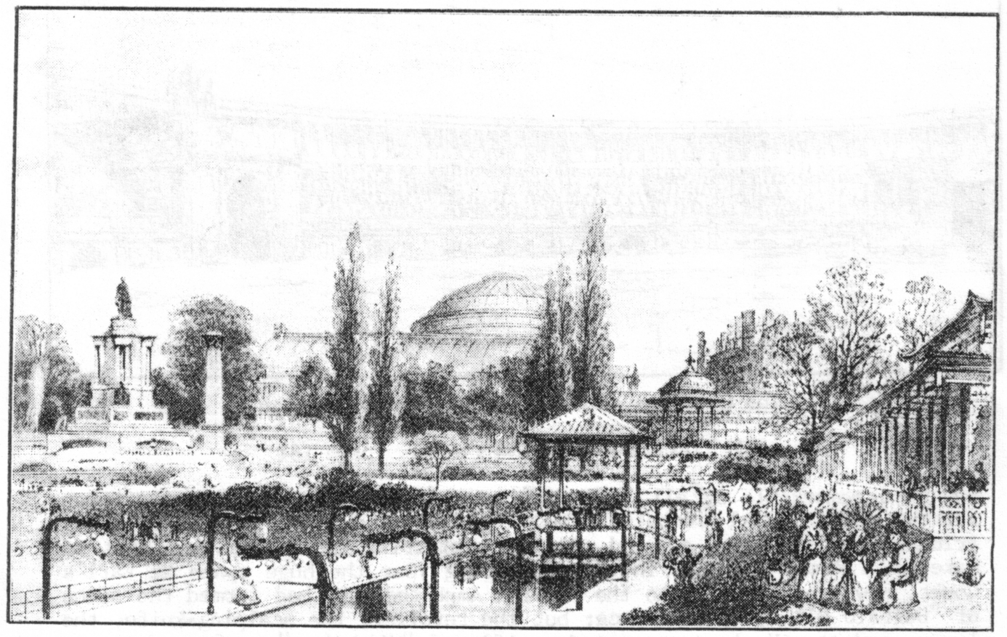

The Gardens at the 1885 Inventors Exhibition showing the 1851 Memorial and
The Albert Hall in the background

The Fletcher & Brooks book also states that the "Empress Theatre" was built for Buffalo Bill Cody in 1887, this is not so. The Empress Theatre was not built until 1895 for the Empire of India Exhibition, and was at the end of my road at Fulham. It was called the Empress Theatre because Queen Victoria was the Empress of India. My grandfather and his men helped to build it. My father was taken along to see the building site when he was nine years old. It later became the Empress Hall, an ice-skating rink, and was demolished to make way for the highest building in Fulham, called the Empress State Building. Unfortunately it is out of bounds to the public as it is a Government (MOD Admiralty) building.
Now what Buffalo Bill used was not a theatre but an amphitheatre, because his was an open-air show. This was situated near Earl's Court Station in the Borough of Kensington & Chelsea where the main Earl's Court building stands today. (The picture of Buffalo Bills Open air show of 1887 will not unfortunately photo copy, but I have been able to show his picture of the Coliseum, and a page from the guide to the 1888 Italian Exhibition which ties up the date and venue of Buffalo Bill's show. Editor).

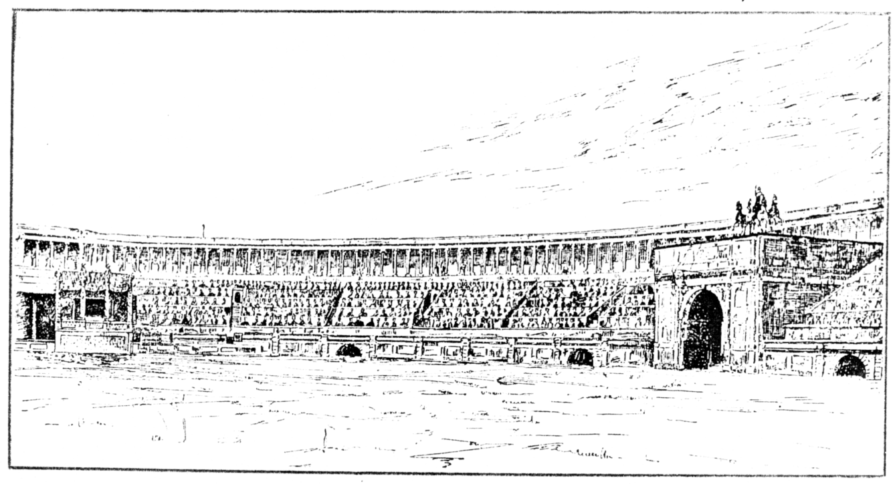

The Coliseum at the 1888 Italian Exhibition

THE ITALIAN EXHIBITION (1888) page 181

and most remarkable of all, a reproduction of the Coliseum with its Roman sports, gladiatorial combats, wrestling bouts, chariot and foot races, triumphal processions, and all the other stirring spectacles that went to make up a Roman holiday. In the proceeding year the huge space at Earl's Court, now transformed into the Flavian Amphitheatre, had formed the scene of "Buffalo Bill's" performance; but the revolver, the scalping-knife, the lasso, and the Winchester repeating-rifle of "Wild West" warfare were now exchanged for the gladiatorial short sword, the net, and the trident of the Roman arena; and it was hard to say which species of personal combats exercised the greatest spell on the spectators.
As a mere show this reproduction of "Rome under the Caesars" was admitted to be one of the finest and most interesting things of the kind that had ever been essayed in England, and a perfect triumph of scenic art. By continuing the semicircle of seats right round, the "Wild West" Arena had been converted into a wonderful resemblance of the Flavian Amphitheatre, its dimensions, for one thing, being exactly the same as those of the Coliseum.
An extract from the 1888 Italian Exhibition guide book
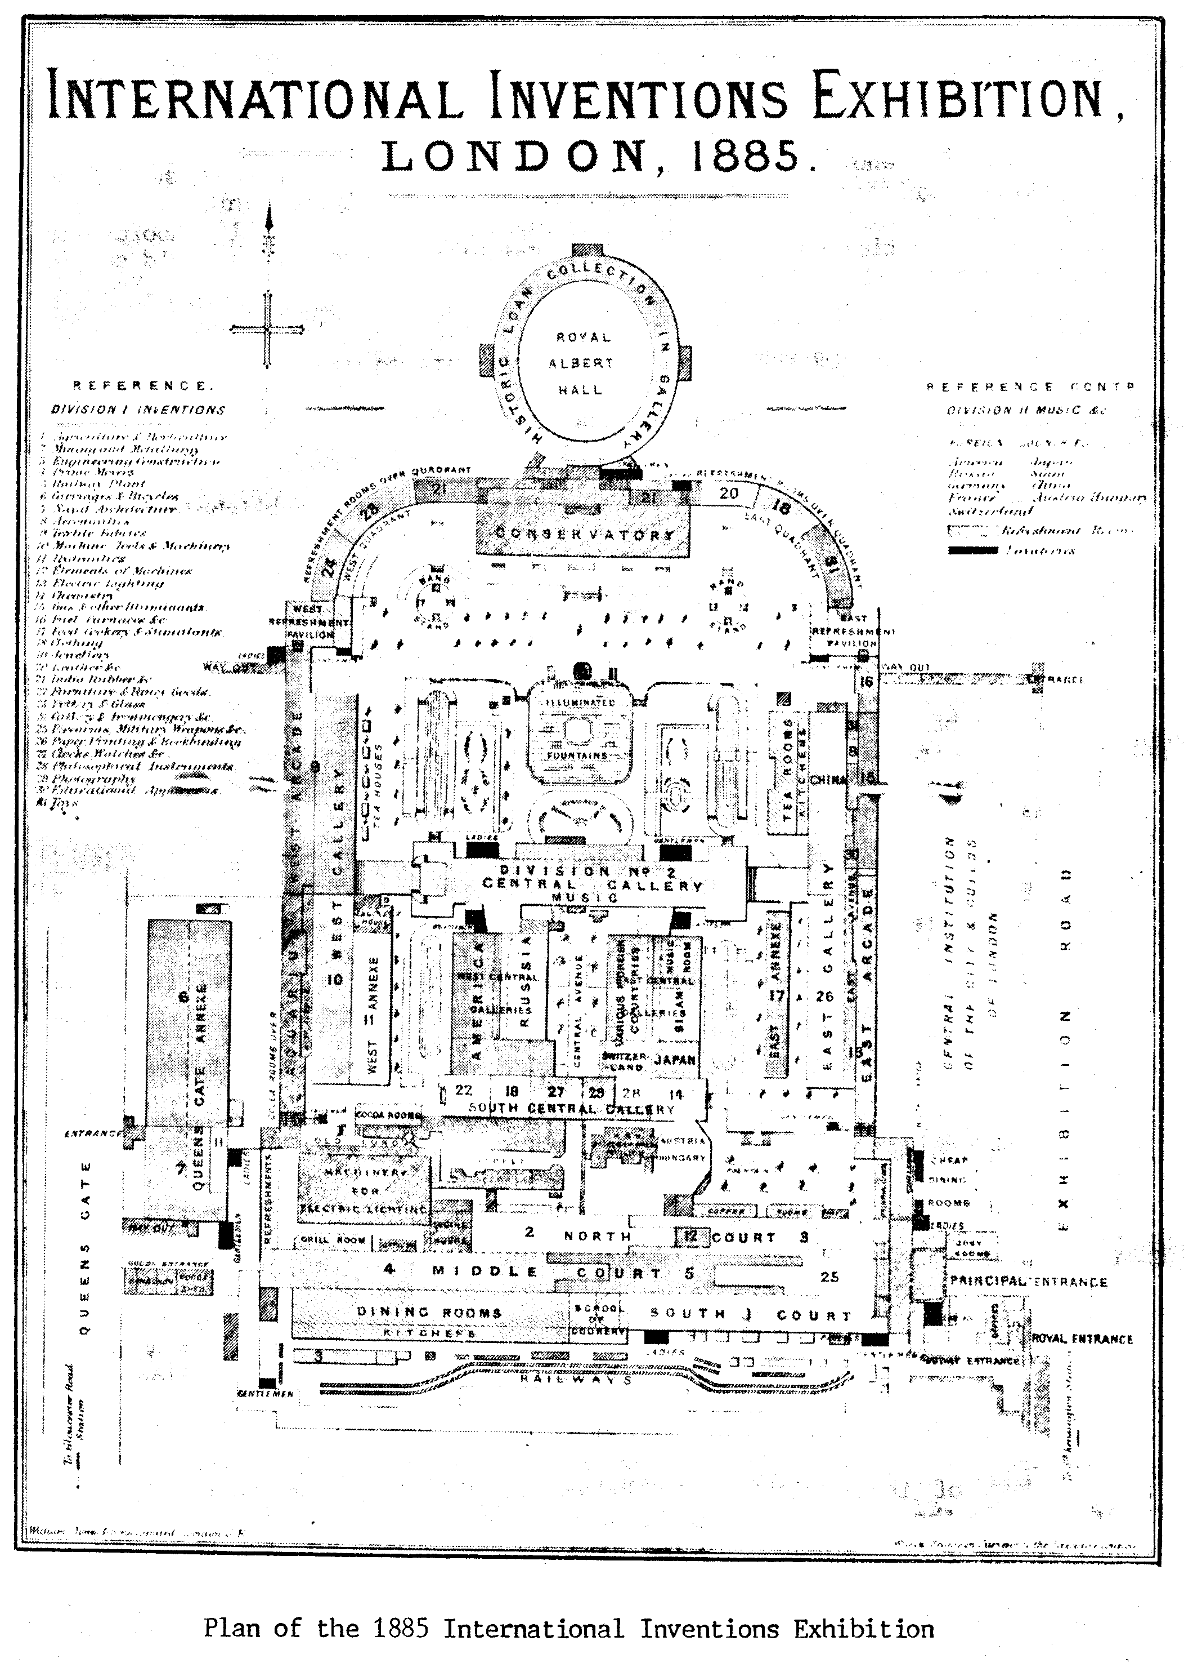
Those members who came to our last convention will remember seeing on display a magnificent blue vase that was one of the items exhibited at the 1924 Wembley Exhibition on the Moorcroft stand. Recently Moorcrofts published an article on Wembley and Don Knight was asked if he could supply them with some information, which he was happy to do.

UP FOR THE CUP or MOORCROFT'S TRIP TO WEMBLEY

by Paul Atterbury

The tradition of international exhibitions established in the Victorian period was maintained before the First World War by major displays in St Louis, Brussels, Ghent, and elsewhere, but also important was the more localised Franco-British Exhibition, held in London's White City. The success of this venture lead directly to the idea of an exhibition designed to celebrate the British Empire, a scheme apparently first developed by Lord Strathcona in 1913. The outbreak of war put things on ice, but the idea was revived in 1919, quickly gaining the support of the Prince of Wales and King George V, who saw the exhibition as a way of affirming Britains faith in the commonwealth of nations that made up the Empire. The government backed the plan, and voted the sum of £100,000 towards the guarantee fund, and soon financial support was being raised in other quarters.

In July 1921 Wembley was confirmed as the site for the exhibition and a 216 acre site was purchased, with good road and rail connections. At this early stage the plans included "a great national sports ground", designed to hold 125,000. In the event the stadium, which cost #750,000, was first used for the F A Cup Final on 28rd of April 1923, when Bolton Wanderers beat West Ham United 2-0. Today, nearly 70 years later, the stadium is virtually all that remains of the exhibition, everything else having become little more than a memory.

The opening, originally scheduled for 1923, had to be postponed until the spring of 1924 owing to complications with the various participating countries, but the building work progressed at great speed, owing to the widespread use of ferroconcrete. This was the first major building project in which concrete was used as a material in its own right, rather than for internal and generally invisible purposes, and in the event 15,000,000 cubic feet of concrete was poured into the Wembley site. On April 23rd 1924 the British Empire Exhibition was declared open by King George V in a speech that was broadcact to the nation, and then the turnstiles were opened to admit the first of the 17,403,267 visitors who paid to see the exhibition before it closed on the 1st of November.

Most of these visited the Palace of Industry, the second largest building in the exhibition, the largest being the Palace of Engineering, at the time the biggest concrete building in the world with a covered floor space over six times the size of Trafalgar Square.

The Palace of Industry was designed by Sir John Simpson and Maxwell Ayrton, while a panel of 50 approved architects ensured a harmony of design and planning throughout the displays, one of these was Edward Maufe, and it was he, later the architect of Guildford Cathedral and the Runnymede Memorial, who was selected by Liberty & Co to design the Moorcroft Stand. By August 1923 a large space of 1,000 square feet had been reserved by Moorcroft in the pottery and glass section, at a cost of #750. Only Wedgwood and Pilkington had stands of a similar size. Fronting one of the main thoroughfares in the Palace of Industry, the Moorcroft stand also had the advantage that visitors wishing to see the smaller stands behind had to pass through its gateway, and thus had to see the Moorcroft wares in passing. Among those placed behind were R.H. & S.L. Plant, Wiltshaw & Robinson, the makers of Carlton Ware, Grafton China, and Poultney of Bristol. The combination of Maufe's striking design, to be seen on several of the postcards sold at the exhibition, in style a simple 1920s classicism that anticipated Art Deco, with the fine display cabinets in Austrian oak made by the Liberty workshps ensured a memorable setting.

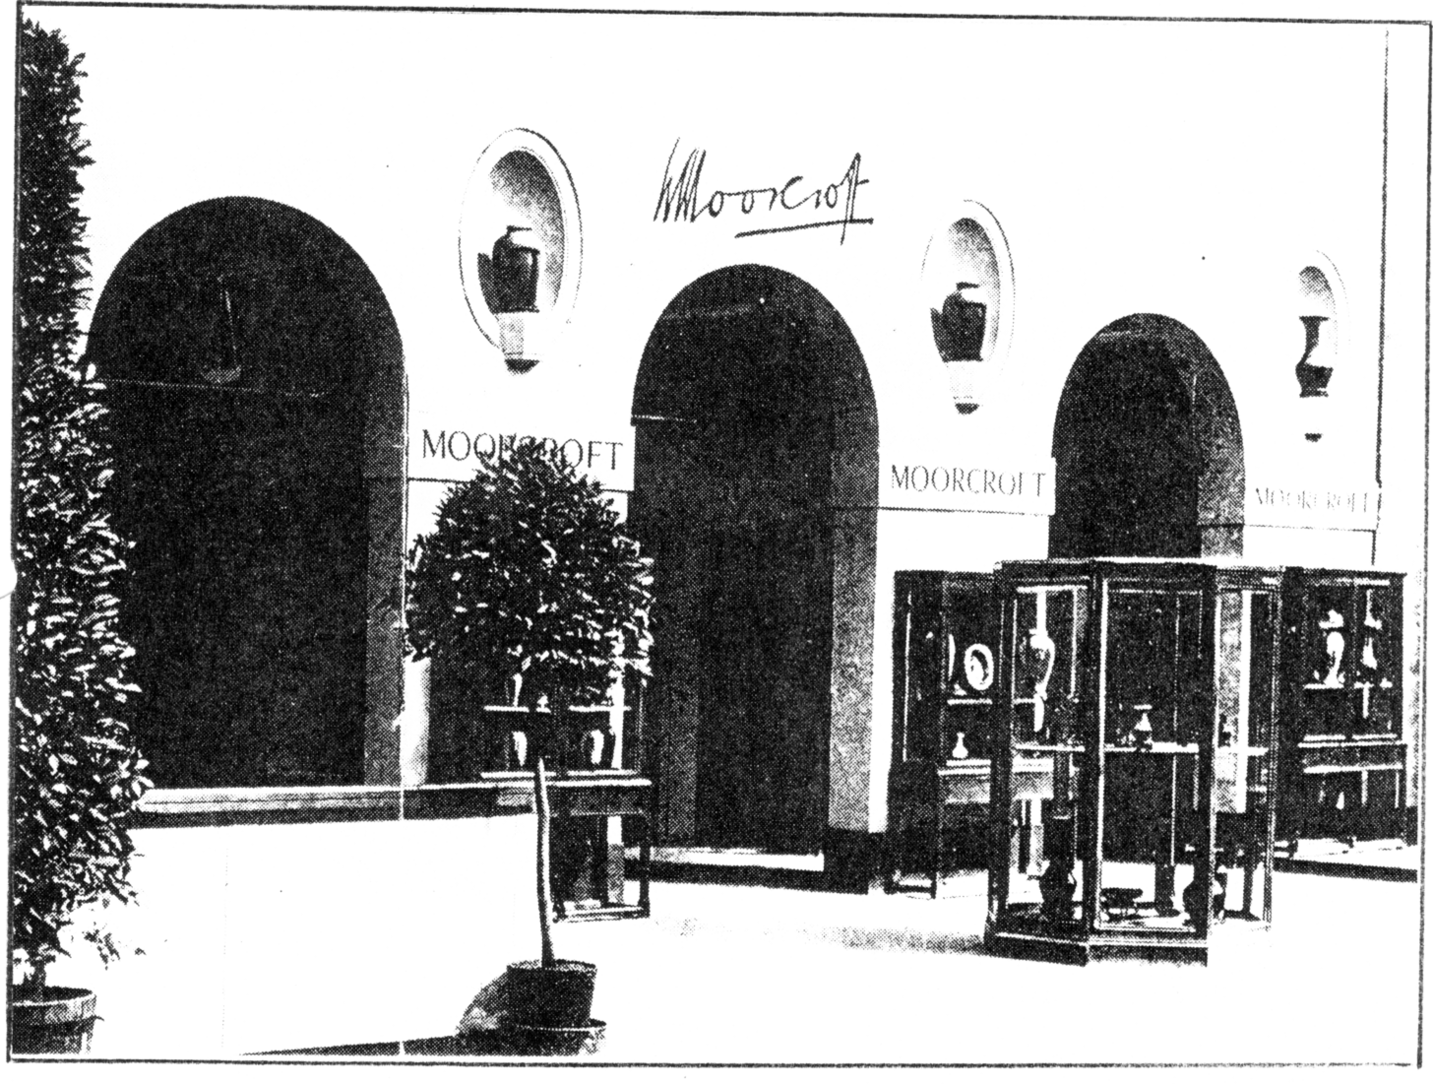

The Moorcroft Stand at Wembley designed by Edward Maufe

Much of the planning was undertaken by Alwyn Lasenby, with William Moorcrofts co-operation, and notices in the display directed buyers to Liberty's shop in London's Regent Street, Liberty's virtually acting as Moorcroft's agent for the exhibition. Unfortunately, surviving records only hint at what was on display, although some of the pieces and their designs can be identified on contemporary photographs, such as that used for the cover of the Moorcroft Collectors magazine in December 1989. However, contemporary press reports do give a fair idea. Under a heading "Moorcroft Ware A Potter of Genius", the Daily Graphic of the 28th of June published a glowing description of wares decorated with "Moonlit Blue" and"Autumn Tree" designs, and flambe effects. Equally enthusiastic was the report in The World Today, "The Wembley exhibit of Moorcroft pottery is an assembly of many colours, but not a single one is out of place. Nothing harsh or crude obtains, all are beautifully blended. Some of the contrasts are a delight to dwell upon. Lustres are conspicuous. Fruit and flowers figure in some of the decorated pieces, forming a homogeneous, indestructible part of the body of the ware...They are the product of an ideal British pottery conducted by an experienced artist-potter...one who knows his work thoroughly, and whose enthusiasm for British pottery production is remarkable".

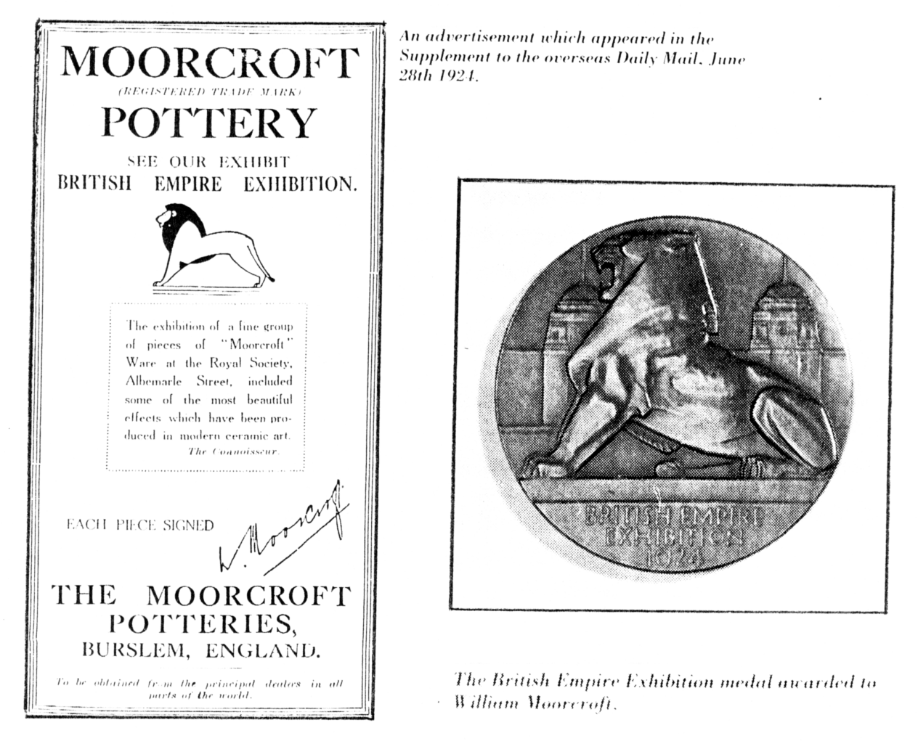

Others also noted "the fine colourings of the lustre wares", while emphasising the importance of the hand made element in Moorcroft generally.
Also important was the attention given to the royal reaction. On the 3rd of May The Times commented, "Mr Moorcroft's exhibit of pottery at Wembley was honoured by a visit from the King and Queen,, the Duke and Duchess of York, and Prince Axel of Denmark... Mr Moorcroft felt that their Majesties visit to his exhibition, and the interest they evinced, constituted an honour not only to himself but to the English Potteries generally...Our readers will join us in warmly congratulating Mr Moorcroft upon these further marks of Royal favour, for their Majesties have of course long been interested in Mr Moorcroft's beautiful pottery products, the samples of which at the Wembley Exhibition are magnificent specimens of pottery decoration, and raise Mr Moorcroft's reputation to unprecedented height..." These and other articles confirm that Queen Mary was a keen collector of Moorcroft ware, along with other types of British ceramics past and present. It is therefore a tragedy that none of the wares she so avidly assembled can now be traced in the Royal Collections.

With such widespread appreciation, and with buyers visiting the stand from all over the world, and not just from the British Empire, Wembley must be considered a great success for Moorcroft. Orders preserved in the archive came from as far afield as Buenos Aires and Copenhagen, and patterns in demand included Pomegranate, Moonlit Blue, Autumn Tree, Heartsease, lustres in green, old gold, and lemon, rouge flambe, along with plenty of blue porcelain tableware. Yet for all this, William seems to have had some reservations about Wembley. In a letter to the Board of Trade, written after the exhibition had closed, he draws a clear distinction between it and the annual British Industries Fair. "We took considerable space at the British Empire Exhibition, because we realise how much we owe to the Empire, and because we feel our Colonial friends would make, and have already made, great sacrifices for us. The British Empire Exhibition is in my humble opinion purely an exhibition, and I sent there the best objects we could produce, solely with a view to showing the best we could do. Our Exhibit cost us at Wembley, in one year, more than the whole of the money spent during ten years at the British Industries Fair, and we regarded our Wembley Exhibit as merely a bouquet, the best possible, to throw at our Colonials

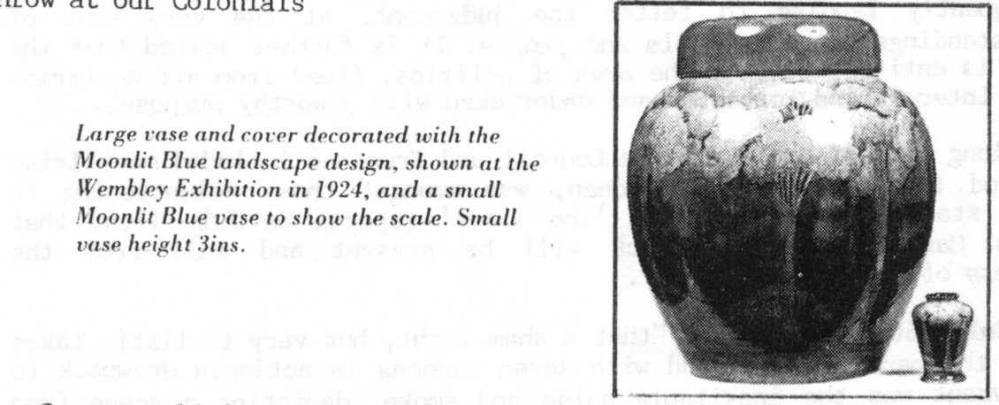

The Group would like to thank W. Moorcroft PLC for permission to use this article from the Moorcroft Collectors Club News Letter and for the illustration of their stand supplied by them.

1888 IRISH EXHIBITION OLYMPIA

by

George E. R. Ithell

Looking recently at the Daily Mail Ideal Homes Exhibition details prompted my memory of an item sent to me some time ago. This was a photo-copy of a parcel post receipt of 1888. I then pursued some facts of this little recorded event, but didn't do a 'full-blooded' effort owing to other committments at the time (five or six years ago). I came across my notes recently and it is possible that the Olympia Exhibition researchers may have some interest in my information. I'll have to apologise if its 'old hat', but I don't think it will be.

Originally Olympia was first used from 1886 and a futile attempt was made to arouse some interest for the centenary amongst some of my acquaintances in that area. The earlier use of this area would probably be under canvas and a more open-air spectacular be witnessed. The modern Olympia buildings have been extended since 1931 and have been in constance use for all such exhibitions.

This Irish Exhibition which opened on June 4th 1888, closed on October 27th 1888 and 'The Times' of February 3rd 1888 reported that..."The first list of patrons of the Irish Exhibition to be held at Olympia in May (opening, evidentally delayed) has just been issued and contains over 200 names of noblemen, prelates, M.P.'s, and of distinguished men in literature, science, art, and commerce which are representitive of the various political creeds of the United Kingdom. According to a statement just issued by the executive with the following objectives...(a) to place before the English public a clear view of the predominate industries of Ireland; (b) To awaken public interest in the efforts being made to revive her trade; (c) To exhibit to the many thousands of English persons who have never crossed the Irish Channel, somewhat of her deeply interesting and historical antiquarian treasures; (d) To illustrate the worth and significance of Irish art and, finally, to help moderate prejudices which are frequently tending to fetter the judgement, at the very foot of misunderstandings between people and people. It is further stated that the movement is entirely outside the area of politics, freed from all sectarian or class interest and initiated and undertaken with a worthy purpose".

A long list of the Executive Council and Trustees included many Irish peers, and the Countess of Aberdeen, was amongst those volunteering to manage a stall on a rota basis. 'The Times' reports on July 17th, that "Princess Mary, Duchess of Teck will be present and sell from the Marchioness of Salisbury's stall".

A July 26th report says, "that a sham fight, but very realistic takes place in the parade ground and with seven cannons in action,a drawback to the enjoyment was the inevitable noise and smoke, depicting a scene from the Indian Mutiny, of a siege of a village.

Another excerpt from the October 20th issue says, "For whatever the height to which discord runs amongst Irishmen, nobody denies that, at bottom, they are a warmhearted and kindly race and especially to children. A generous and graceful act by the Committee of the Irish Exhibition in defraying the cost of a free trip for the School of the Benevolent Society of St. Patrick. This Treat was enjoyed by the majority of the residents of this school, who qualify for this charity on being the children of the poor hard-working Irish parents living in London. A total of 450 are being cared for at this time".

'The Times' advertised on its front page of July 26th an Irish firm of Fitzgerald, Shirt Makers of 44, Patrick Street, Cork! The paper carried much news from this event and included many references to the "interesting finds of Greek remains after extensive research at the site of Olympia", amongst these dates were the 11th, 17th, and 22nd of October.

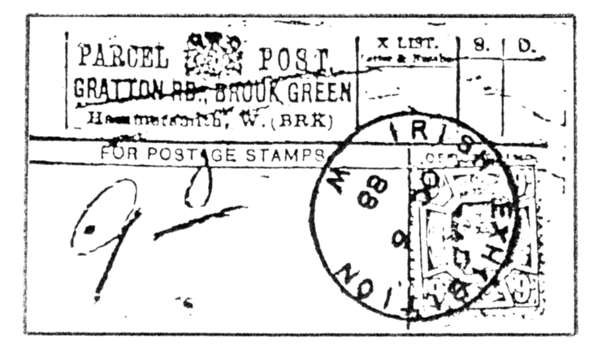

A really scarce hand stamp, I wonder
if it will ever turn up on a cover

Due to bomb damage during the war of 1939-45, the geography is altered and the Gratton Road Post Office was a casualty. At one time the road was a cul-de-sac, but access from Blythe Road is now possible. I couldn't find a resident who was familiar with the area before the War, but the site of the Post Office and general shop is still intact, but was a reasonable distance from the Olympia site.

An article was published in the issue of September 1929 of Gibbons Stamp Monthly by J. H. Daniels on "Postmarks used at Exhibitions in Great Britain, 1851-1925". No reference at all is made of this Irish Exhibition, and another he missed out, was an Irish sponsored Exhibition of three days in Croydon from March 19th 1888, to which the Government gave #1,000 as a grant. The latter show is understandable in not having any Post Office memento, but John Daniel's missing out the Olympia show is surprising.

Trusting that this information will be of some value.
Thanks George E. R. Ithell, this article was sent in, some time ago and Andrew has forwarded it on to me to use.

UNIDENTIFIED EXHIBITION CARDS

Can anyone tell me what exhibition these cards were issued for?

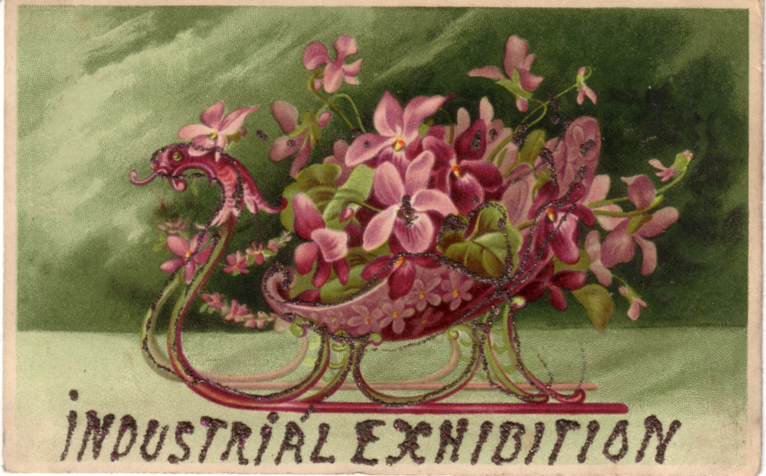

Posted in Edinburgh on October 18th 1906, it has an interesting message on the back. "came into this exhibition and heard the Great Military Band (of) H.M. Guards. So bought a few P.C.s at one of the stalls. There is some very fine work to be seen". Is the second one a Trade card or an exhibition card. Any information would be helpful. P.S. No prizes.

