23, BRAMLEY WAY, WEST WICKHAM, KENT. BR4 9NT Phone 081 777 8861

Editorial Spring No 24

I regret that Newsletter No 24 is late in coming out, but I shall be catching up and intend to produce four issues this year. Andrew Brooks has been Editor since the Newsletter started in 1981, and a few weeks ago he phoned me up asking if I would like to take over, as he felt the time had come to have a rest. As many of you are aware Andrew has other collecting interests and his increasing involvement with various societies concerned with W. W. 1. has meant that something had to give way. Andrew has not lost interest in Exhibitions but has put them on the back burner for the time being, he is not giving up so there is no need to rush to make offers for his collection.

Although Andrew and Fred Fletcher started the Exhibition Study Group together, it was Andrew who has nursed almost single-handed the Group from its original ten members paying 75p per year to its present strong position.

On Saturday 16th of May we held a six and a quarter hour committee meeting in Manchester at Karl Illingsworth's house, and covered a lot of ground, it was decided that a team would produce the Newsletter consisting of Damon Murrin, Karl and myself. The highlight of the meeting was provided by Stanley Hunter, who brought along copies of the Exhibition Study Group Publication No 1 "Kelvingrove and the 1888 Exhibition". This really first class effort by Stanley runs to 370 pages with many illustrations, and covers the International Exhibition of Industry Science and Art held in Glasgow in 1888. This is the first of a series of books that the Group is planning to produce, and Stanley mentions in the acknowledgments, that the Group helped to finance the major part of the production side of the work. I am sure that all of our members will want to own a copy, and this can be purchased direct from Stanley K Hunter. 34, Gray St, Kelvingrove, Glasgow, G3 7TY. at a special price to Group members of £20.00, post and packaging will be £3.00 extra. This is a very limited edition and if any are left Stanley will bring some to our September Convention, already nearly a quarter of the printing has been sold, and it may well be that if you leave it till September you may be unlucky.

I am looking to members to keep me supplied with articles, letters of interest that I can use, and any queries that you are stuck on, someone will know the answer, at the moment I am not short of material but please make an effort as a good newsletter will be a benefit to all of us.

In future issues I will start printing any wants or disposal items that members like to send in.

Bill Tonkin.

BUILDING WEMBLEY STADIUM

by Mike Perkins

In January this year I was pleasantly surprised to receive a letter from Alan Sabey reminding me that the 10th of January was the 70th Anniversary of the cutting of the first sod for the building of the British Empire Exhibition. I have copies of the McAlpine house journal for June and October 1973 which contain articles celebrating the 50th Anniversary of Wembley. The following is an extract from these articles describing the construction of the Exhibition (in particular the Stadium).

"At the begining of 1922 a contract was signed, huts were erected on Wembley Golf Course, and McAlpine engineers began driving pegs into the fairways which were to be the site for the first part of the scheme, the massive Sports Stadium".

"The Stadium was sited on the summit of a hill. This meant heavy excavations, for the top of the hill had to be sliced off and the embankments for seating built up with the excavated soil. To set the whole scheme going there was to be an official ceremony at the digging of the first sod. But because part of the area to be excavated was wooded, the first sod was a tree trunk and the digger a steam navvy".

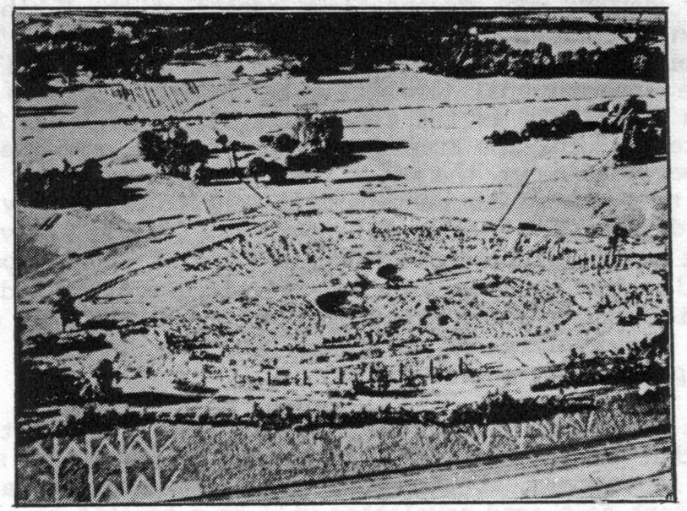

The start at Wembley Golf Course

"With due ceremony the party arrived, the speeches were made and Sir Lawrence Weaver, the Lord Mayor of London, gave the signal and the navvy driver pulled the lever to raise the bucket and tear the tree from the ground, roots and all. The assembled party looked at the great machine in admiration.......and waited. The signal had been given but the tree root
was still in the ground. A few polite jokes were passed in the party as the navvy stood motionless over the tree stump. A few remarks, urgent and much, less polite, were passed on to the navvy driver. But still the machine refused to do the thing they were all there to see it do, so they left. There is no record of an interview between the site management and the driver, who had simply failed to raise enough steam before the group arrived".

"This first small set-back was no ill-omen for the contract, for everything after that went with remarkable speed and efficiency. Within a few days the usual service rails were laid, cranes erected and the necessary plant was arriving on site. The opening of the stadium was planned for April the following year, in time for the Cup Final".

"Night shifts during the summer were running for a few joiners and steel fixers although as far as possible concreting was confined to the day-time".

"As the summer progressed, enormous quantities of material went into the stadium structure, and its vast form began to impose itself on the surrounding district. By the end of that year 7,500 tons of cement had been consumed, together with nearly 40,000 tons of ballast and 1,400 tons of steel. The concrete was poured with one of the most remarkable pieces of

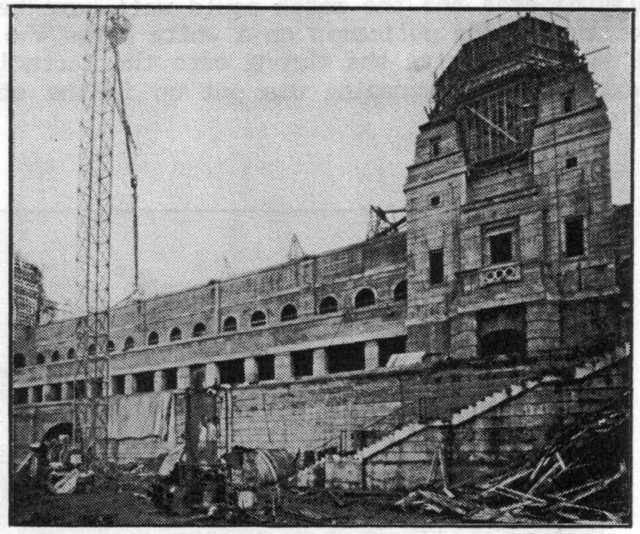

The Insley Tower

equipment then seen on a building site, the Insley Tower. The Tower, 160 feet high was supported by stays from the ground and carried a sloping chute down which concrete flowed to be distributed up to 400 feet from the base. Concrete was raised up the tower to the chute in a cubic yard skip. Another skip collected the concrete as it came sluicing off into the
shutters. As the stadium was built mainly of reinforced concrete the Tower was rarely idle".

"The date of the 1923 Cup Final approached, and when a writer for "The Engineer" magazine visited the site the work was all but finished. On the day he arrived the structure was being tested. There was a dead load of 300 tons on part of the curved terracing, but the entertainment value of the static testing was nothing to compare with that of the live load. A body of 1280 hefty men were led to the banks of seats immediately behind the Royal Box. Captain F. B. Ellison, the resident architect, then put the men through a series of movements all of which had to be done to time. Then the instructions were to shout and jump about and wave the arm frantically so as to reproduce as nearly as possible the movements of a crowd watching an exciting match. Then the men were marched along the steps until they came beside the portion which was loaded with dead weight. There, further movements were gone through".

"The testing the stadium had on Cup Final day 23rd April, 1923 was far less well ordered than Captain Ellison's parade. The terraces were intended to house a capacity crowd of 100,000. Unfortunatly there were no turnstile barriers to regulate the numbers entering the stadium, whats more, there were no arrangements for even counting them". "The results of this oversight are well known, half a million people turned up to watch the match and 300,000 were allowed in before the gates were shut, treble the number that the stands were designed to take. Crowds massed uncontrolled over the playing area and the match could well have been cancelled had it not been for the famous policeman on a white horse who managed, apparently with little help, to drive the throng onto the terracing. After that near disaster, extensive balustrading was put up in the stands and turnstiles were fitted at the gates".

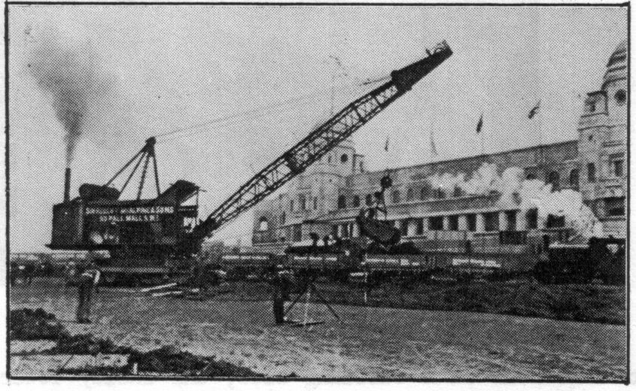

In 1922 one of the largest excavators in the world

The Group would like to thank Sir Robert McAlpine & Sons Ltd, for permission to use this article from their House Journal.

EXPOS AT THE MOVIES

by Stanley K Hunter

The showing on channel 4 of CENTENNIAL SUMMER made me think about other international exhibitions featured in feature films (some available on video). CENTENNIAL SUMMER centres on the 1876 Philadelphia Exposition and was a Lerner-Lowe musical (1946) with music by Jerome Kern, Otto Preminger directed this version of Albert Ernest Idell's novel. It stars Jeanne Crain, Linda Darnell and Cornel Wilde who plays the hard-pressed commissioner for the French Pavilion.

The film starts with the opening ceremony when the father of the central family grumbles about President U S Grant mumbling his speach and walks out in disgust. In their first visit the family travel in bathchairs pushed by the attendants and we see inside the troubled French Pavilion. The triumphal gala opening of the pavilion forms an important part of the plot.

Jeanne Crain also stars in STATE FAIR the Rodgers and Hammerstein II musical. The 20th Century Fox film (1945) also features Dana Andrews, Dick Haymes and Vivian Blaine. This time the central family from Iowa spends a week in a caravan home at the Iowa State Fair & Exposition. We see the judging for the Pickle & Mincemeat entries and also the Swine Pavilion. The parents carry off the prizes while the son and daughter meet their putative spouses. The son falls for a band singer on the Midway. The Midway is rather well handled here and there is a thrilling roller-coaster ride.

While the Fair theme song "Our State Fair is a Great State Fair", is catchy, the real hits were "It Might as Well be Spring" and "Its a Grand Night for Singing". (The Rodgers & Hammerstein Collection Video, 96 mins).

The story was from Philip D Strong's novel and first appeared as a film starring Will Rodgers (Fox Films) in 1933. The sons romance was with a trapeze artist. The film was remade by 20th Century Fox in 1962. This time it starred Pat Boone, Bobby Darin, Alice Faye and Janet Gayner. A showgirl is the object of the sons romance. This was probably the least successful, even the story was moved to urban Dallas Texas.

Vincente Minnelli's 1944 MGM musical MEET ME IN ST LOUIS stars Judy Garland, Margaret O'Brien and Tom Drake. The story comes from Mrs Sally Benson's "The Kensington Stories" which appeared in the "New Yorker". It is set around the lovely period house at 5135 Kensington Avenue. The Smith family of St Louis receive the terrible news that papa is being promoted to New York City. As a result they will all miss the Louisiana Purchase Exposition of 1904.

Martin & Blain's hits include "The Trolley Song" and "Have Yourself a Merry Little Christmas". The contemporary classic "Meet me in St Louis" (Andrew B Sterling & Kerry Mills) is probably the theme song of all exhibition enthusiasts. "The Trolly" is featured when
a party take the electric street-car "Special to Fair Grounds" to view the site, six months before the exposition opens.

The film gives a really good build-up of the excitement which must have grown during the approach of the opening. Papa realises that as a result of the exposition, St Louis will increase in importance. The Worlds Fair is only viewed at the close of the story when the family express their delight at finding that St Louis is going to be the centre of the universe for a few months. ("MGM Musicals" Video 110 mins).

The film should not be confused with MEET ME AT THE FAIR (1952) which stars Dan Dailey and "Tad" Bayliss. Also set in 1904 it is the story of a crooked medicine-show operator and an orphanage scam with a happy ending. It is based on Gene Markey's novel "Good Companions" with script by Irving Wallace.

One film which features a modern exhibition was Elvis Presley's IT HAPPENED AT THE WORLDS FAIR (MGM) in 1962. It was produced in Metrocolor and Panavision (64 mins) and again I have not come across a video. The film involves two crop spraying pilots and is dismissed as a routine vehicle for The King. The fair was Century '21 Exposition, staged in Seattle, in 1962

The Paris Exposition of 1889 is the centre of the Gainsborough thriller SO LONG AT THE FAIR (1950), written by Anthony Thorne. I think that the total disappearance of Jean Simmon's brother David Tomlinson is one of the best mysteries shown on the screen. It is all in aid of saving the exposition, but nothing is revealed until the end, with the help of Dirk Bogarde and Honor Blackman.

The building of the Eiffel Tower for the 1889 Universal Exposition was well covered in the 1989 C4-TV documentary film MR EIFFEL'S TOWER, a "Designs Classic", marking the centenary of the exposition. A home movie of the 1937 Paris International Exposition appeared in BBC-2's "Cine Memo" series.

Michael Crichton's THE (FIRST) GREAT TRAIN ROBBERY (United Artists 1978) starring Sean Connery, Donald Southerland and Lesley-Ann Down, gives a splendid recreation of the Crystal Palace in Sydenham. Connery plays a villain visiting the luckless Wayne Sleep during one of the regular firework displays at Crystal Palace, after the 2nd June Horticultural Fete in 1855. The film is noted for its accurate mid-Victorian period recreation and its Crystal Palace shots could almost be contemporary.

The YEAR TO REMEMBER series of video documentaries cover the 1938 Empire Exhibition, Scotland and the South Bank at the 1951 Festival of britain. The material is from the Pathe News Library. Bill Tonkin has made a superb private compiliation incorporating the Empire Exhibition 1938 and Pathe shots of FDR opening the New York's World Fair on 30th April 1939, the Festival of Britain and Expo '58 at Brussels. (note Group member Barry Norman did the work Bill got the credit, Editor). This brought back happy memories. There is a bonus of film of Glasgow's monorail, the Bennie Railplane (Valentines postcards retail around #35 each). Four 1938 Valentines postcards (X122-125) form a sequence cut from the
Gaumont- British newsreel of the King and Queens visit to the Clachan. Rushes from this film were shown the same day in the Exhibition Cinema.

The cinema equipment had been lent by Gaumont-British. When the building was sold, the new owner found that he had acquired the equipment as well. It opened as the New Empire Cinema in Lochgilphead, Argyll. It was later converted to the Empire Snooker Club. A friend picked up a brand new leaflet for me, now advertising it as the "EGH" the Empire Guest House. Although completely refurbished inside it still has a nice 'Thirties look. The motif of the guest house is the red chequered Lion Rampant designed for the exhibition.

The Scottish Film Library holds some archive and amateur film of the 1938 Empire Exhibition including a documentary on Glasgow, SECOND CITY, which includes newsreel footage. I have received permission to reprint the various catalogue entries and hope that our Editor will publish this consolidated list. A proportion is on 7.5 amateur stock. Apparently the cost of conversion is very high.

There is quite a good scene of the Festival of Britain in PRICK UP YOUR EARS, John Lahr's biography of Joe Orton (Civilhand Zench/Goldwyn 1986). We see night outdoor dancing on the South Bank. After the Skylon is dimmed we get a fireworks display. The film starred Gary Oldman and Vanessa Redgrave, (Virgin Video).

A more lighthearted view of an exhibition is Jacques Tati's TRAFFIC, (Corona 1971). Although packed with visual gags on the motor car, the story tells of Tati's doomed attempt to transport an extraordinary exhibit to a major motor show in Amsterdam. Tati's PR lady is Maria Kimberley. The exhibit arrives as the exhibition is being dismantled, but all is not lost, (Channel 5 Video).

Television has shown documentaries on a number of exhibitions. At one of our meetings, we saw a feature on the Queen's "Dolls House" which was displayed at the 1924 British Empire Exhibition at Wembley.

In May 1988, BBC Scotland screened THE EMPIRE EXHIBITION - FIFTY YEARS ON to coincide with the opening of the Glasgow Garden Festival and we also saw that at a group meeting. A pictorial 32 page booklet was published by BBC Mainstream (#2.95) and includes some favourite items from my own collection of souvenirs as seen in the TV film, some of which was recorded in my home. The film which featured Magnus Magnusson, was reshown on the anniversary of the closing of the Empire Exhibition with some of the comparisons with the Garden Festival removed to make it an half-hour film.

The Glasgow Garden Festival was well recorded on TV, with the BBC establishing a major pavilion to broadcast daily (as in 1938). A display of my Empire Exhibition souvenirs was featured at the Festival and featured on a BBC Radio Scotland broadcast interview.

(To be concluded in our next newsletter.)

KELVINGROVE

AND THE

1888 EXHIBITION

INTERNATIONAL EXHIBITION OF INDUSTRY, SCIENCE & ART
GLASGOW 1888

Compiled by Stanley K Hunter. Chairman, Exhibition Study Group.

The first handbook published by the Exhibition Study Group is devoted to the Glasgow International Exhibition of 1888. This was the greatest exhibition held outside London and the largest ever in Scotland during the 19th century.

Kelvingrove & the 1888 Exhibition deals not only with the exhibition but sets it in context with the City of Glasgow of the time and with many other exhibitions worldwide, right up to the Glasgow Garden Festival exactly a century later. The whole area surrounding Kelvingrove, Glasgow's West End and its rival burghs, is examined in detail.

The book (370 pages, A4) traces the course of the exhibition from its original concept right up to its direct consequencces in the 20th century. 27 pages of illustrations, including plans, have been confined to contemporary line drawings.

A special study is made on the work of the exhibition's architect, James Sellars. His work still remains throughout Scotland. Tragically, he was to die just before the close of this vastly successful International Exhibition. Rumour had it that he had stood on a rusty nail while examining some construction work at the exhibition and died of blood poisoning!

The book contains the largest-ever anthology of poems devoted to a single Scottish event, certainly the most outrageous collection of Scotttish rhymes and doggerel, with even William Topaz McGonagall having to fight for a place in the many accounts of the 1888 Exhibition! There are also over 30 versions of the ballad "Kelvingrove", but not the original one that shocked Regency Glasgow in 1820.

The Fine Art at the exhibition is well documented in the book and it is intriguing to note that many of the outstanding works on show (on loan) eventually ended up in the permanent collection at Kelvingrove Art Gallery, donated by collectors who were impressed at the interest shown by the public. The profits of the Exhibition went to the fund to build the Art Gallery, which opened in 1901 as a feature of the 2nd International Exhibition at Kelvingrove.

There is a major study of the 1888 Exhibition work of SIR JOHN LAVERY, one of the leading members of the "Glasgow Boys" school of painting. He did about 40 oils of the Exhibition and many of these are traced in the book. His "State Visit of Queen Victoria" includes 253 characters and these are all identified in full detail. A tipped-in full-colour card is included. The huge painting is on long-term loan to the Glasgow Royal Concert Hall from Kelvingrove.

There is the first detailed account of the Postal arrangements at the Exhibition with examples of the very rare postmark used, reproduced for the first time from the Regional Archives. Expert M Morton Hunter has contributed a study of Glasgow's comprehensive HORSE TRAM network as affected by the Exhibition. CATERING at the Exhibition is examined, including the rise of Joe Lyons and Kate and Stuart Cranston.

The Archives also hold a wonderful collection of 200 letters held by the POLICE OFFICE at the heart of the Exhibition. These letters have been carefully examined and the book gives a faithful summary of each epistle. Subjects range from lost brollies to a complaint of using a display Shank's toilet (unplumbed!). The Police Office also got a tip-off that "Jack the Ripper" was en route for the Glasgow Exhibition. (The last Whitechapel Murder took place on the day before the Exhibition closed).

The huge BIBLIOGRAPHY on publications of the 1888 Exhibition is the first for any major Scottish event and includes everything from contemporary press-cuttings to all major works on the Exhibition. There is also an account of later exhibitions which included material originally shown in 1888. The INDEX is very comprehensive.

KELVINGROVE & THE 1888 EXHIBITION is probably the most detailed general and entertaining account of any British exhibition since the Great Exhibition of 1851.

ISBN 0 9502746 2 3

It is now on sale, in a limited first edition of 50 copies at £25.00 per copy. (Postage and packing £3.00 extra). Trade (and Academic) terms by arrangement.

ORDERS & FURTHER INFORMATION from,

STANLEY K HUNTER
34, GRAY STREET
GLASGOW G3 7TY

Tel. 041 339 2775
WHAT TO SEE AT THE PARIS EXHIBITION

A contemporary article on the 1900 Paris Exhibition sent in by

Derek B Bartlett

The average visitor to the Paris Exhibition, anxious though he may be to look upon the stately buildings erected to glory art, science, and industry, will in his heart of hearts feel greater anxiety to find his way to the "spectacles" that partake of the startling or of the bizarre.

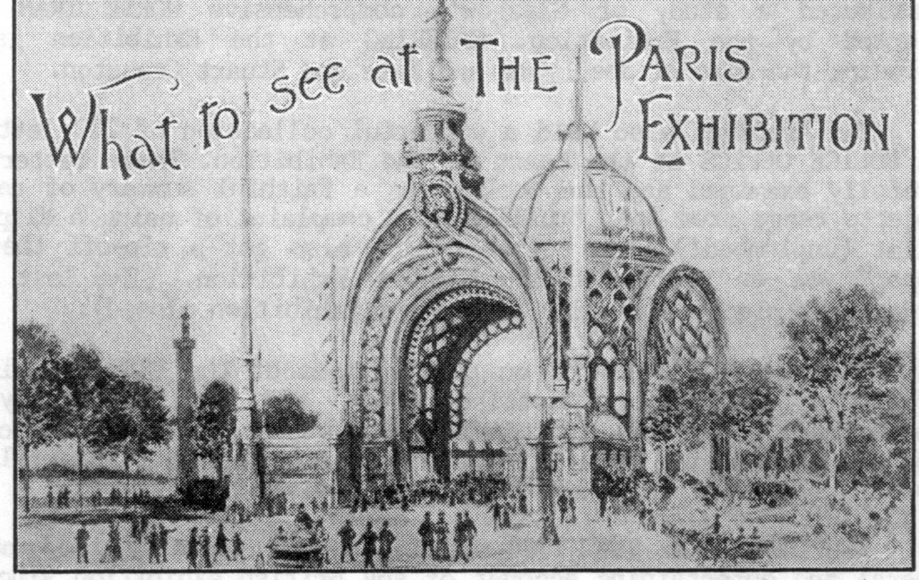

The Grand entrance to the Exhibition

Certainly he will have no cause to complain of any lack of variety, if his time be brief. the difficulty will rather be to make a satisfactory selection. After he has walked down the Street of Nations, where the great peoples of the earth, and some of the little ones as well, have built up their national pavilions, after he has visited the buildings erected by France and her colonies, and by England's colonies too, after he has inspected with curiosity the Boer farm and the Creusot Pavilion, reminiscent of "Long Toms" and mammoth projectiles, he will realise that his round of sight-seeing has only just begun.

The ingenuity and the enterprise of those who hope to attract the attention and participate in the wealth of the stranger, certainly command admiration. they will show him not only the wonders of the earth itself, but the marvels of the heavens above, and of the waters under the earth. The provincial Frenchman who is a staid, stay-at-home soul, will be conducted on a tour round the world in the briefest space of time, while the seasoned traveller will find that he too, has not been overlooked.

Whatever else may be said, it is only necessary to cast a brief glance at the list of attractions to realise that the showman's art is in no danger of decay, and to grasp the fact that
endless time, skill, and capital have been expended in order to cater for the millions who will be the guests of France during 1900.

The idea of combining amusement with instruction has in several cases been as consistently carried out as if the originators had graduated in the school of Artemus Ward.

The Grande Globe Celeste, for instance, if eminently instructive, is equally a wonderful creation, apart from the educational value claimed for it by its designers. On a huge pedastal, some fifty feet high, it stands a mighty ball, to which access is gained by broad staircases or electric lifts. The diameter of the globe is a hundred and forty feet, and on its surface of azure blue are depicted in gold mythological figures of the constellations, which at night will blaze out in wondrous lights. The globe is crowned at its summit, over sixty yards from the ground, by a platform from which the visitors may view the surrounding Exhibition. But it is the interior that presents attractions for the seeker after knowledge. Here there is a second sphere from which the spectator may watch the workings of the planets, the earth revolving on its axis, the moon passing through her phases, and even eclipses are to be arranged to add to the illusion. The Grand Globe Celeste provides other and more frivolous attractions, but its exposition of the solar system is its chief claim to distinction.

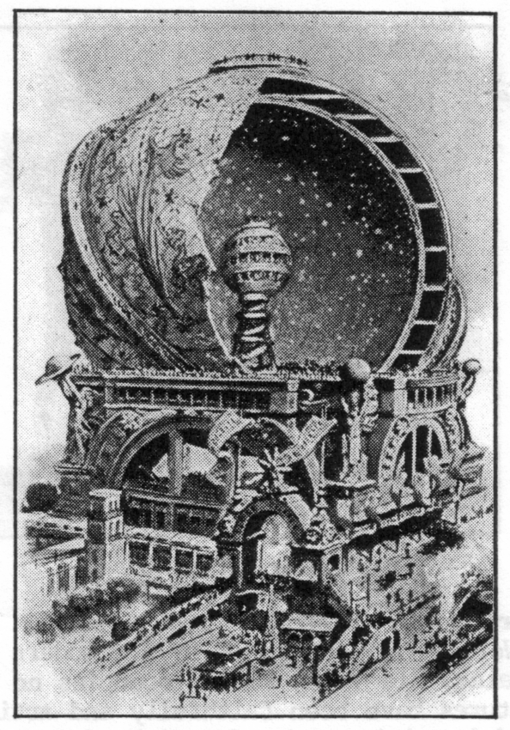

The diameter of the Grand Celestial Globe is 140 ft

In the shadow of the Eiffel tower is the Palais d'Optique, the attraction of which is what has been called by Parisians "The moon at a Metre". The moon will of course, not be brought within a yard of the amateur astronomer, but the phrase has fairly seized the popular mind. With the aid of the telescope that has been built up here, Mother Earths
satellite will be as visible as if it were only fifty or sixty miles away. This great glass is a marvellous structure. It is about two hundred feet in length, and its total cost, including the apparatus used in connection with its working, is said to have reached #56,000. The manufacture of the machinery necessary for moving a telescope weighing nineteen tons presented enormous difficulties. It was therefore decided that the great glass should be stationary, and that a gigantic side-rostat or movable mirror should be utilised, by means of which the rays of light proceeding from any heavenly body could be caught and thrown into the glass itself. The object thus reflected can be directed through the telescope on to a huge screen so that hundreds of people, comfortably seated may at the same time gaze on wonders revealed by the gigantic glass.

The manufacture of the mirror, weighing as it does some three and a half tons, was attended with many difficulties. A furnace capable of containing twenty tons of glass, was specially built to carry out the work, and in order to obtain two perfect discs it was necessary to make no less than twelve, ten being spoiled in the process of cooling. When the mirror was completed, it was brought by special train to Paris, and carted through the streets by night in order to minimise the danger of accident.

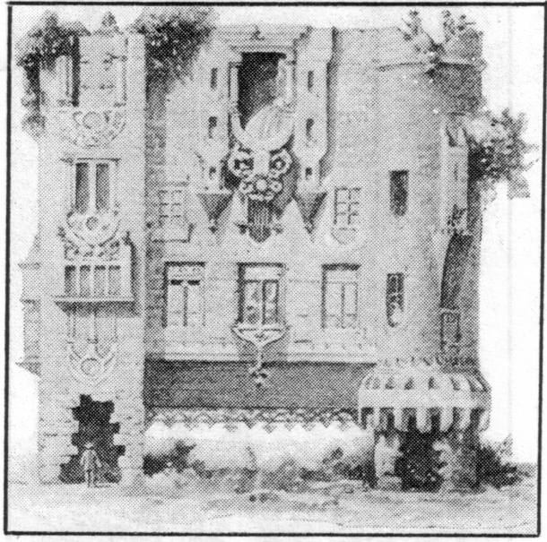

The Topsy Turvy House

Old Paris, rich in historic and sinister memories, is well represented at the Worlds Fair organised by her modern successor. along the right bank of the Seine, "le Vieux Paris" occupies no inconsiderable area, and many of her features have been faithfully and artistically reproduced. Old Paris is peopled by citizens in the garb of past centuries, and is a picturesque section of the great Exhibition.

The reproduction represents various epochs in the history of France's capital. One part is devoted entirely to the fifteenth century, another illustrates the architecture of the eighteenth, while in a third division there are edifices belonging to various epochs. These historic buildings recall to the mind many wild and turbulent episodes in the stirring history of France.

IT is somewhat startling to suddenly come upon a house in a literal state of topsy-turvydom, and to be politely invited to enter by way of the chimney. A Russian gentleman, it appears, is responsible for the weird idea which has been carried out in the Cours la Reine, near the main entrance in the Place de la Concord. When a residence is constructed with its roof in the ground, it is not surprising to learn that it can be removed from place to place at the will of the proprietor. A feudal mansion in this extraordinary position suggests a staid old gentleman standing on his head, and the designer was not far wrong when he suggested it would certainly attract attention. In the rooms of the "Manoir a l'Envers" to give its official title, there are various optical illusions, and on looking out of the window the visitor will observe that the passers-by appear, like the house itself, to be in an inverted position.

The Aquarium de Paris is devoted to the wonders of the deep. There is shown in minature the bed of tropical ocean and Polar sea. Mackerel, whiting and other familiar fish, as well as representatives of the turtle and the octopus, have found their way to the centre of Paris, to add to the gaiety of nations, and it is anticipated that by bringing water from the sea, and with the aid of an elaborate system of filtration, they, or at all events, most of them, will be kept alive until the Exhibition comes to an end. By an ingenious system of lights a submarine volcano is shown in full eruption, and to complete the picture of deep sea marvels there lies in the ocean bed the wreck of a good ship, with divers hard at work sending the cargo to the surface. In order that details may not be wanting to give reality to the scene, oysters and other shell fish, as well as anemones and sponges, have been collected by the designers of this unique aquarium, whose work of preparation extended over several years.

A building that never fails to arrest the attention of the passer-by is that in which is housed the great panorama known as the Tour du Monde. The ediface itself, though of a composite character, is mainly Indo-Chinese in its aspect, and the lofty towers and great wood carvings, excuted in the far east, which enter so largely into its construction, suggest to the mind distant lands and bluer skies. The entertainment which purports to take the visitor on a journey round the world, has been organised in a remarkable fashion. In order to ensure a faithful portrayal of life in distant lands, M. Louis Dumoulin, painter to the Ministry of Marine, visited many far-off countries, obtained photographs of the most picturesque views and monuments, and at the same time opened up negotiations for the engagement of the dancers and artisans who give life and vraisemblance to the foreground of the picture.

The Tour du Monde is not merely a pictorial representation of the worlds most interesting countries. In order to heighten the effect of the picturesque scenes represented on
canvas, groups of natives of the countries conjured up occupy the foreground, so that in passing from city to city, and from continent to continent, the spectator is able to witness certain phases of the national life. here a Syrian potter, surrounded by his family, fashions his ware, there a troupe of Siamese display the curious poses which represent their national dance, In Japan dainty geishas charm the eye, in China tiny actresses perform a curious play, in Spain dark-eyed beauties go through the steps of the witching bolero, Indian jugglers, Japanese wrestlers, and Chinese acrobats help to add life and animation to the scene.

On the outskirts of the Exhibition, near the great wheel, is to be found the Swiss village, which is really, as its designers describe it, an epitome of a entire country. To have built a simple village would have been comparatively easy, there however, we find reproduced a hostelry at Lucerne, a chalet at Brienz, and a house at Berne, in addition to the natural features of the country of mountain and lake. Beneath an overhanging rock is the chapel of William Tell, yonder the house in which the tragedienne Rachel first saw the light. But charming beyond words is the reproduction of Swiss natural scenery, valleys with verdant vegetation, stretching out apparantly into the illimitable distance, fir trees raising their heads in the shadow of lofty precipices, while the humble homes of the peasantry nestle on the mountain side.

Though the highest peaks only tower a hundred and thirty feet above ones head, the illusion is perfect, so well have the proportions been worked out in every detail, that the general effect is picturesque to the eye, and convincing to the mind. Those who have spent happy hours in Switzerland will have pleasant memories revived by a visit to this minature country.

Another picturesque attraction, "Andalusia in the time of the Moors" occupies a place in the garden of the Trocadero. Here are minarets and mosques, dancing girls from Tunis and Tangier, picturesque gitanas and dusky swordsmen renowned for their agility and their strength. The Gate of Justice under which the Moorish kings of Grenada gave judgment, are among the buildings represented, while a huge arena is devoted to the equestrian excercises of Spaniard and Moor.

The silks and chiffons of modern Paris are dear to the heart of the average woman. In the Palace of Costume she will find not only the "Creations" of today, but the dainty gowns and millinery that adorned fair beauties who have long since passed into the shadows. The idea of the Palace of Costume is an ambitious one, and well it has been carried out. Artistic tableaux illustrate the vagaries of fashion, down through the centuries, from the days of the Gaul to the year of grace 1900. In one Josephine surrounded by her maids of honour is displaying to the Emperor the beauties of a new costume. The dress and mantle, in velvet and satin, are embroidered with gold, and the cost of their production was no less than £2,000. This figure relates to the costume actually shown, and not to the original, for which £40,000 is said to have been paid, real diamonds and pearls having been used.

