Editorial No. 23.

In the final issue for 1991 I have again included an account of the Exhibition Study Group Annual Conference. This will be delivered in two parts, firstly the minutes of the A. G. M. and secondly an account of the displays and social events of the weekend.
As promised, the Daily Mail Postcard Checklist has been published as a booklet and is available from the Membership Secretary. The format is essentially the same as we used in Newsletter No. 16. Members will remember the draft list produced by Fletcher and Brooks, containing a mere 67 cards ! Thanks to many members and especially Bill Tonkin, the present booklet contains over 470 listed picture postcards. This 21 page, A4 booklet is priced at £2.50. inc. postage.
Members are now working on a Festival of Britain checklist and if you would like to contribute, please contact Bill Tonkin, 23, Bramley Way, West Whickam.Kent. 081 777 8861.
The cover for this newsletter has been provided from the collection of Arthur Smith. Perhaps if Arthur brings it to the next conference we can sing it during the dinner !
The first item in the newsletter has been contributed by our incoming Chairman, Stanley Hunter. Stanley is an editor's dream. This article is on the London Exhibition Sites and he has already sent me an extremely interesting account, entitled Expos at the Movies, for the first issue of 1992.
Our second article will be split over at least three newsletters. Fred Peskett has combed the Stamp Catalogues to provide the Study Group with a listing of all the postage stamps issued to commemorate exhibitions.
All the best for 1992 and Seville (those lucky enough to go).
Subscriptions are now due- please send your £8 (yes - eight) to Damon Murrin, 8 Anchor Quay, Norwich, NR33PR.

Andrew Brooks Nov. 1991.

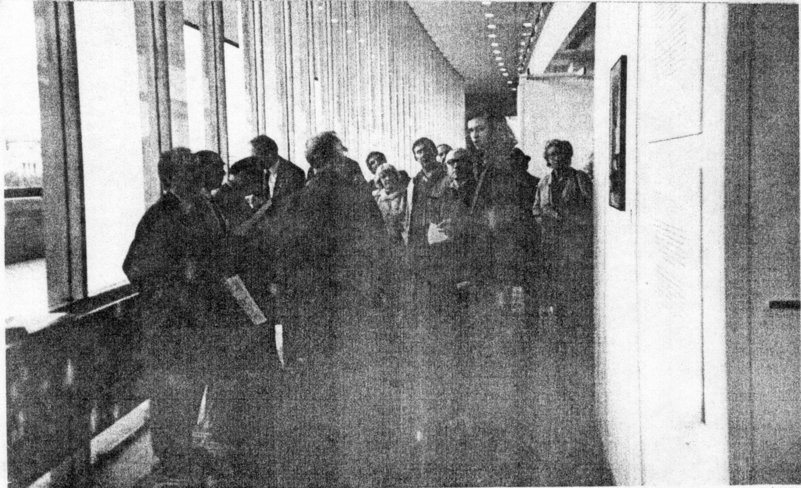

Exhibition Study Group Conference - Crvstal Palace - 1991
A. G. M. held on Saturday. 26th. September at The White Swan.

Members present Don Knight, Andrew Brooks, Stanley Hunter, Bill Tonkin, Alan Sabey, Karl
Illingworth, Mike Perkins, Arthur Smith, Damon Murrin, Celia Bailey, Fred Peskett, George Simnier, Keith Cooper, S. Henderson and Bob Tough. Invited guests included Mrs Tonkin, Mrs Simnier, Mrs Tough, Mrs Anderson, Keneth Tonkin and Chris Whitehead.
Apologies for absence were received from Con Rutter and Graham Hall.
The meeting commenced under the Chairmanship of Don Knight. The first item on the agenda was the election of Officers for 1992. The Chairman was retiring after a two year period in office and the Vice- Chairman, Stanley Hunter was elected to the Chair for the next two years.
The following members were then elected to office.
Vice-Chairman Karl Illingworth. Proposed- Stanley Hunter. Seconded- Don Knight.
Hon Secretary Bill Tonkin Proposed- Fred Peskett. Seconded- Mike PerKins.
Election of three extra Committee members.
Mike Perkins, Don Knight and Fred Peskett were elected.
Editor Andrew Brooks re-elected.
Publisher Karl Illinworth re-elected.
Memb.Sec
Treasurer Damon Murrin re-elected.
The Committee to appoint Auditors.

As members will note some of the roles and titles have been re-defined. Following the election of Officers, a few important matters were discussed.
1 If possible, it was thought that items for discussion at the A. G. M. should be presented as an
agenda in the newsletter prior to the A. G. M. This would give members who are unable to attend the meeting, the right to express their views.
2 It was proposed and seconded that the Annual subscriptions commence from October 1st.
each year. This starts at once.
3 After considerable debate it was decided to increase the Annual subs, to £8. Most of the
debate was over the proposal to increase subs to £10.
4 It was decided to hold a Committee meeting on April 4th in Manchester.
5 The 6th Annual Conference is to take place on 26 & 27th September, 1992 at The White
Swan, Crystal Palace. Bill Tonkin agreed to organise the weekend. The provisional 7th. conference at Wembley may be deferred until 1994, for obvious reasons. At the moment we shall probably hold the 7th at the Crystal Palace.
6 Mention of a proposed visit to Seville '92. (Please contact Damon Murrin if you are
interested).
7 It was decided by the Committee to support members , if possible , towards the cost of
publication of books , papers etc., relating to exhibitions. Thanks to the fantastic support of Illingworth Developments Ltd., the Study Group only need to spend a small amount of their income each year. Whilst we have a healthy bank account and intend to use it wisely , it seems pointless to accumulate money in the bank. With this in mind we decided to support members in their efforts. Each case will be dealt with on merit and in fact a sum of £100 has already been allocated to a publication by Stanley Hunter. The subject is the International Exhibition of 1881, held in Glasgow. Details will be given as soon as copies are available.
Displays and Social Events
For the second year running the Study Group weekend was arranged by Bill and Nancy Tonkin. The talks and dinner were held again at The White Swan , Crystal Palace. Bill also organised a grande finale, a guided talk and tour of the Festival of Britain Exhibition at the Festival Hall.

Displays
Saturday: 10.15 am. Don Knight, following a tradition established over five annual conferences started us on the road with two wonderful displays , mounted in the best traditions of a true philatelist/
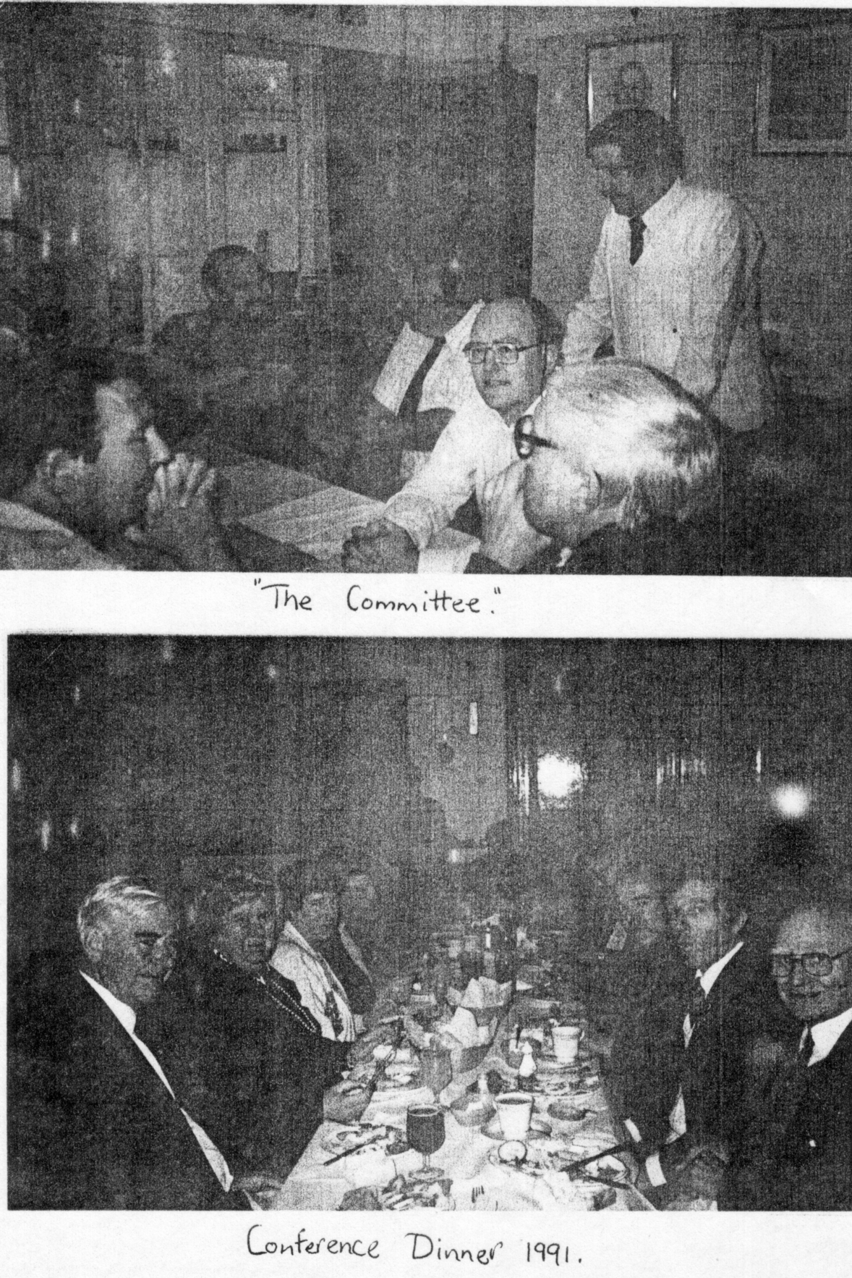

postal historian. The ideal way to present and talk about most printed ephemera always seems to rest on the established methods of stand-up display boards. To see a long stretch of boards covered with Don's material always gets the weekend off to a cracking start . We do not have the space to describe any of the displays in great detail and it would take the whole of this newsletter to describe the rare postcards , the exhibition cancellations and handstamps and all the scarce 'bits and pieces'. The highlight for me came after the coffee break in the second display when Don showed some of his White City Greyhound ephemera, including Car Park tickets.
After Don’s display our new Chairman, Stanley Hunter took centre stage and delighted us with a photographic collection based on a glass slide accumulation he had recently purchased. Needless to say they were of Scottish Exhibitions. The story of his successful attempts to transfer the frail images onto photographs, at a reasonable price , and the discovery of further glass slide collections at the Mitchell Library has certainly kept Stanley busy over the last year ! It kept us quiet until lunch.
Once one set of crockery had been swept away and we were all inwardly satisfied, another type of crockery was set before the members - in the shape of a small part of Karl Illingworth’s collection of Crested Exhibition China. It is difficult for me to describe the magnificence of glass , china and other exhibition items of such quality. We are all really pleased that Karl goes to the effort of transporting such material to the annual meetings so that we can share his enjoyment in looking at such objects. To give members an idea of the scope of this material I would like to point out that Karl showed over 70 different transfers used on the Crested China for the British Empire Ex. held in 1924/25. Another item which needs to be mentioned was the Moor vase, again for the B.E.E.
Two further displays were given before we finished at 5.00p.m. Bill Tonkin gave an interesting display on “Memories from Two Wembley Collections”. He had managed to acquire accounts of two people who took part in the Wembley Pageant. (Some of this material has been seen by members in Newsletter No. 21)
Fred Peskett followed with two short displays. The first was an award winning display at area level which had been entered in Thematica. A collection of postcards, special event covers etc. on expositions. It covered a wide period in time and also many countries. His second display was on the early development of the Picture Postcard, not exactly on exhibitions but the members showed just as much interest in this as they had in all the other displays they had seen during the day.
At the end of the formal session most members and friends departed for tea at Bill and Nancy's, just down the road in West Wickham. We were soon back at the White Swan for our Conference Dinner, another important feature of the weekend. During a very pleasant meal we listened to taped songs from the British Empire Exhibition kindly left by Alan Sabey, who unfortunately could not stay for the meal.
The Sunday session commenced with an exceptional display given by Chris Whitehead. This was based on Queen Victoria's Jubilee and although only marginally connected with exhibitions in the true sense, the idea of celebrating her Jubilee, resulted in many events, processions and exhibitions etc. Chris started off his display with many examples of the rare postcards issued to commemorate this event. On many of the card the happenings were also mentioned, which again helps to bring the subject alive. Chris followed this up with one of the finest displays of "Cind material that we had ever seen. For the issue of the Hospital Charity stamps he showed examples of every possible value, colour and shade, on cover and an outstanding array of proofs, some initialled by King Edward VII.
Arthur Smith mounted a small but intriguing display based on the Commonwealth Institute, somewhere he had worked in earlier years. By a clever use of picture postcards he showed how the buildings developed over a period of time.
Finally at the White Swan we were privileged to see a fine display based on the Festival of Britain, this was presented by Fred Peskett, who more than anyone else, has promoted the interest of this very British exhibition. George Simner mounted some photographs of the special buses used during the Festival of Britain.
After another appetising lunch we said "Aurevoir" to mine hosts at the Swan and departed via car and minibus to the Festival Hall. We assembled at 2.30p.m. in one of the galleries where we were given a talk by one of the team who had helped to organise the Costain Retrospective Exhibition on the Festival. As he talked we moved round the exhibition and he was interested in listening to the comments of our members. (I believe I am right in stating that Fred Peskett, Karl Illingworth, Celia Bailey and Damon Murrin all contributed from their own collections the material in the display stands). A film of the Festival that had just been found was shown to all members.
As I end this description of our Conference, I must again give a big "Thank you" to Bill and Nancy Tonkin. They organised the weekend and made their house a "Welcome Club" for all the members. The success of such a meeting depends as much on the friendships formed by the group members every bit as much as the success of the formal sessions.

London Exhibition Sites
By
Stanley K. Hunter

Visiting the site of a long-gone exhibition does little to recall the vanished glories of a great enterprise, One would have to have a vivid imagination to evoke the pomp and bustle of the Great Exhibition simply by strolling through Hyde Park to-day,
Scrutinising the old exhibition layouts and plans has long been an interest of mine, I first became familiar with this by examining the layouts of the three major exhibitions staged in Kelvingrove Park, Glasgow, As my flat overlooks the site and I am in the park pretty often, I know the sites of all the pavilions and buildings and even some of the amusements,
London has, of course, more than its share of major exhibition sites, I resolved to try and visit as many of them as I could, I felt that this would give me some idea of scale, access and might even check on any surviving evidence,
Historically, the oldest ones would be the pleasure gardens, I selected the three which gave their names to the three beer gardens - Vauxhall, Cremorne and Ranelegh erected at the 1951 Festival of Britain Pleasure Gardens in Battersea,
These three pleasure gardens are the most famous and must have given entertainment to many millions during their heydays, Entertainment of all sorts went on and with sideshows, music, balloon ascents, etc., they were direct descendants of the modern exhibition.
Vauxhall is the site nearest Battersea, It opened in 1660 and lasted almost two centuries, closing in 1859, Vauxhall Park is now a snail open-space off South Lambeth Road (A203) and Fentiman Road (just west of the Oval Cricket Ground), It is a modest level park, with tennis courts, etc., a far cry from the wild extravagances of Vauxhall,
A steam railway was demonstrated here, It so impressed Russian visitors that the Russian
word for a station is still "Voksal",
On the north side of the Thames lies Cremorne Gardens, It opened in 1830 and closed in 1873, This is only a tiny site now but the only one to attempt to recall its past glories, It is off the Kings Road at Cheyne Walk, Chelsea, The gardens adjoin the river and incorporate a magnificent gateway, This recalls the grand entrance to the gardens which stood at the King's Road, To-day, the principal features are benches for visitors and office-workers consuming their packed-lunches.
Ranelagh Gardens at the eastern edge of Chelsea seems to have no evidence of its earlier glories, It is a well-wooded adjunct to the grounds of the Chelsea Royal Hospital, adjoining Chelsea Bridge Road and Chelsea Embankment, It overlooks the eastern end of Battersea Park across the river, The Gardens do not appear to have general public access.
It opened in 1742 and its main feature was a rotunda 185 feet in diameter, Handel and the young Mozart were among the artistes who appeared there, It closed in 1803 and was razed two years later,
Hyde Park was the site of the Great Exhibition of 1851, Although nothing of the Crystal Palace erected there survives, some of the street names evoke the exhibition, Queen's Gate is now a very pricey area to have an embassy but it recalls the entrance taken by Queen Victoria to open the exhibition, The Prince of Wales and Alexandra Gates recall royal patronage.
Exhibition Road leads south to South Kensington tube station, passing the Victoria & Albert
Museum. This houses many relics of the 1851 Exhibition and quite a few are on permanent display. The museum's champion, Henry Cole was heavily involved in the Great Exhibition.
The whole area abounds with institutions originally financed with profits disbursed by H. M.'s Commissioners for the 1851 Exhibition. Prince Albert is recalled by the remarkable Albert Memorial, The Prince Consort's statue shows him holding a copy of the Catalogue of the 1851 Exhibition. The Exhibition Memorial stands just south of the Albert Memorial and the Royal Albert Hall, Conducted tours of the Royal Albert Hall pay tribute to the Prince Consort and his interest in the 1851 Exhibition.
Hyde Park adjoins Kensington Gardens, The Council Chamber of Kensington Palace now holds some important relics of the Great exhibition, including the famous White Throne from the Indian section, The Chamber is part of the Palace open to the public.
After the 1851 Exhibition, the Crystal Palace was completely dismantled. It was transported
to Sydenham and re-erected. This is probably the most satisfying sites although the Palace was totally destroyed in 1936.
Its northern rival was Alexandra Palace in Wood Green, The palace was destroyed by fire shortly after construction and rebuilt. It went through the usual viscisitudes of such places and went into decline, I wished to attend the London International Stamp Exhibition in 1990 and paid a quick visit to Alexandra Park, I was quite inpressed with what I saw and when the stamp exhibition opened I was glad that I had a season ticket, The “stately pleasure dome" appeared on a 20p commemorative stamp and other related material in 1990, The building has been restored after a fire but near the restaurant is a huge panoramic photograph of a print of the interior, showing what it was like in mid-Victorian times
A decade earlier I had been to Earl's Court for the 1980 international stamp exhibition, Earl's Court is perhaps the most complex of all exhibition sites in London, The centre had first been developed in 1887 with the building of the Empress Theatre, It opened on May 9 with Buffalo Bill's Wild West. When London Exhibitions Ltd was formed in 1895, Imre Kiralfv became director-general, Earl's Court became the site of a long list of important exhibitions.
To-day, it is now only one main building, It was originally constructed on sites divided by railway and tube lines and linked by bridges, as seen on the plan in Brooks & Fletcher.
Ten years before I had been at the Philympia international stamp exhibition. It was held at Olympia in Hammersmith, This exhibition building has also gone through many changes. It had opened on Boxing Day 1886 with a circus and it also hosted an eventful list of events.
Another survivor is the Royal Agricultural Hall, Islington Green, known as “The Aggie”. It was built on 3 acres in 1862. It regularly staged the Smithfield Society's cattle shows, Cruft's, circuses, etc., It held a bullfight in 1870 but this was not repeated,
It has been entirely refurbished and the original towers removed, The new design has a nice Crystal Palace effect and it is now a trade exhibition centre.
You will need Don R Knight's book THE EXHIBITIONS, (1978) on the Great White City if you want to look at the remains in Shepherd's Bush. Brooks & Fletcher has six plans of the site in use. The only exhibition buildings still standing are five of the seven overhead halls leading from Uxbridge Road to the main exhibition grounds. The ground level is still occupied by the railway and a bus depot, An open-air market operates there.
The main site, west of Wood Lane is built over with streets like Commonwealth Avenue, New Zealand Way, etc., with schools, park, etc., There are also, of course, the BBC-TV studios and the stadium, The old Main Entrance in Uxbridge Road has now gone. It has been replaced by a simpler and more modern white building which manages to give at least a little idea of the early days.
The Methodist Central Halls in Westminster has staged a variety of events but it was immortalised when it was chosen as the site of the first United Nations General assembly in 1946. A pair of UNO stamps commemorated this in 1958. The Halls has featured stamp and postcard snows including events like STAMPEX and Stanley Gibbons' displays.
STAMPEX moved to the Royal Horticultural Society Halls in Greycoat Street and Vincent Square, SW1.
The Empire Exhibition of 1924-25 at WEMBLEY is well recalled by the Stadium. A conducted tour of the stadium is available although the emphasis is on football. Photographs from the Grange Museum were used on repro postcards for the Wembley Exhibition held at the museum in 1984. A special postmark showing the Wembley Lion was used in May to mark the 60th anniversary of the exhibition. Housing occupies much of the area, with names like Olympic Way, Empire Way, Lakeside Way, Engineers Way, etc.,
Battersea Park was the site of the 1951 Festival Pleasure Gardens, The Festival Lake is the only feature still in the park which was devised in 1951, apart from the Festival Pier. On the main Festival Site further up river on the South Bank is the main memorial - Royal Festival Hall. It has been redesigned and is the centre of a complex of later cultural establishments. The Museum of the Moving Image is on the site of the Festival cinema. 40th anniversary postcards were issued marking the opening of the Royal Festival Hall.
The Festival was recalled on a BBC Radio two-part series which gave a good flavour of the period. 1951 was recalled, too, in an article "Britain 1951" in the May 1991 issue of “History Today” while even the SAGA magazine carried a feature on the Festival anniversary.
I already mentioned that the Crystal Palace site at Sydenham has preserved a number of memories. Members who attended the 1990 A. G. M. will be familiar with the Sydenham site. A museum founded by the Crystal Palace Foundation is open on Sunday afternoons and guided walks of the Park are organised, showing features of the Crystal Palace grounds.

International Exhibitions and Worlds Fairs on Stamps
By
Fred Peskett

Ever thought about collecting the postage stamps that have been issued for International Exhibitions and World's Fairs? If you have or are about to do so, then you will find that very little has been compiled in the form of a General Listing. You can go through
box after box, book after book in a dealers shop or fair on the chance that you may find something relevant. The search is about to be made easy! It has taken many months of toil, but I have at last come up with a comprehensive listing of those countries who have issued some form of commemorative for a specific event. The list does not of course cover the Poster Stamps and Cinderellas, since these are not Postage Stamps. So next time you are on the "ferret" make a special point of looking through the Abu Dhabi, Oceanic Settlements, or Sharjah sections for that little gem. Good Hunting!
F’. S. A further section is under way listing countries who issued stamps for a particular exhibition. Watch this space.
First number quoted is Stanley Gibbons reference for each country.
m/c = multicoloured, o/p = overprinted.
A — Z Country issues.

ABU DHABI
Expo 70 World Fair Osaka. Japan.
68 25f m/c
69 35f m/c
70 60f m/c

AEGEAN ISLANDS
1940 Colonial Exhibition
203 5c brown (postage)
204 10c orange
205 25c green •
206 50c violet
207 75c red
208 11.25 blue
209 21.+75c red
210 50c (air)
211 11. violet
212 21.+75C blue
213 51.+21.50 brown

AFGHANISTAN
1956 International Exhibition. Kabul.
407 50p brown
408 50p b1ue
1964 New York World’s Fair
518 6a black, red & green.

ALGERIA
1937 Paris International Exhibition.
140 40c green
141 50c r ed
142 If 50c blue
143 If 75c black
1939 New York World’s Fair.
159 20c green
160 40c purple
161 90c brown
162 If 25c red
163 2f 25c blue
1970 Expo 70 Osaka, Japan.
557 30c m/c
558 60c m/c
559 70c m/c
1970 7th International Algiers Fair.
567 60c green

ANGOLA
1958 Brussels Int. Ex.
533 1e 50 m/c

AUSTRALIA
1970 Expo 70 Osaka, Japan
454 5c m/c
455 20c m/c

AUSTRIA
1971 50 Years of Int. Ex.
1618 2s 50 purple

BELGIUM
1896 Brussels Int. Ex.
96 5c violet
97 10c red
1934 Brussels Int. Ex.
659 35c green
660 1f red
661 1f 50 brown
662 1f 75 blue
1938 Int. Ex. Liege (1939)
824 35c green
825 If red
826 If 50 brown
827 If 75 blue
1957Brussels.World Fair (1958)
1596 2f red
1597 2f 50 green
1598 4f violet
1599 5f purple
1958 Brussels World Fair
1636 30c+20c sep, brown, violet:
1637 lf+50c pur, slate, grn
1638 If 50+50 via, turq, grn
1639 2f 50+1f red, bl, verm
1640 3f + If 50 bl, blk, & red
1641 5f+3f mve, blk, blue

BRAZIL
1908 National Expo Rio De Janeiro.
283 100r red
1934 7th Int Ex Rio De Janeiro.
550 200r brown
551 400r red
552 700r blue
553 l000r orange
1939 New York World's Fair.
620 400r or ange
621 800r green 633 lm violet
622 1200r red
623 1600r blue
634 5m red
635 10m slate
1948 1st Industry & Commercial Expo
771 40c green & mauve (post)
772 lcr 20 brown (air)
773 3cr 80 violet
1958 Brussels World Fair
976 2cr 80 blue
1960 Int Industrial & Commerce Expo, Rio.
1042 2cr 50 brown & yellow

BULGARIA
1958 Brussels World Fair
1116 1l blue & black
1970 Expo 70 Osaka, Japan
1975 2s silver, yellow & brown
2009 1s m/c
2010 2s m/c
2011 3s m/c
2012 28s m/c

BURUNDI
1964 New York World Fair (1st Series with gold background)
99 50 m/c
100 If m/c
101 4 f m/c
102 6f 50 m/c
103 10f m/c
104 15f m/c
105 20f m/c
1965 New York World Fair (2nd Series with silver background)
175 50 m/c
176 If m/c
177 4 f m/c
178 6f 50 m/c
179 10f m/c
180 15f m/c
181 20f m/c
1967 World's Fair Montreal.
318 4f m/c
319 8f m/c
320 14f m/c
321 18f m/c
322 25f m/c
323 40f m/c
1970 Expo 70 Osaka, Japan.
526 4f m/c
527 6f 50 m/c
528 7f m/c
529 14f m/c
530 26f m/c
531 40f m/c
532 50f m/c

CAMEROUN
1931 Colonial Exhibition.
106 40c green
107 50c mauve
108 90c orange
109 1f 50 blue
1937 Paris Exhibition
110 20c violet
111 30c green
112 40c red
113 50c brown & deep brown
114 90c red
115 1f 50 blue
1939 New York World's Fair.
117 If 25 red
118 2f 25 blue
1970 Expo 70 Osaka Japan.
567 50f red, blue, green
568 l00f red, blue, green
569 150f brown, slate, blue

CANADA
1933 World Grain Exhibition
330 20c red . j
1967 World Fair, Montreal.
611 5c blue and red

CAPE VERDE ISLANDS
1958 Brussels World Fair.
366 2c m/c

CENTRAL AFRICAN REPUBLIC
1970 Expo 70 Osaka, Japan.
226 20Of m/c

CHAD
1931 Colonial Exhibition.
58 40c green
59 50c mauve
60 90c red
61 If 50 blue
1970 Expo 70 Osaka, Japan.
302 50f blue, green, red
303 100f blue, green, red
304 125f slate, brown, red

CHILE
1969 Expo 70 Osaka, Japan.
628 3E blue (postage)
629 5E red (air)
1980 Fisa Int Fair.
852 3p 50 m/c

CHINA
1980 China Expo in U.S.A.
3008 8f m/c
3009 70f m/c

CHINA (TAIWAN)
1964 New York World Fair (1st issue)
520 80c m/c
521 $5 m/c
1965 New York World Fair (2nd issue)
550 $2 m/c
551 $10 m/c
1970 Expo 70 Osaka, Japan.
741 $5 m/c
742 $8 m/c

COLUMBIA
1957 Barranquilla Expo
493 5c purple
494 15c blue
495 50c brown
1954 1st Int Fair, Bogota.
821 5c orange (postage)
822 15c blue (air)
823 50c red (extra rapido)

COMORO ISLANDS
1970 Expo 70 Qsaka, Japan.
87 60f m/c
88 90f m/c

COSTA RICA
1937 National Ex San Jose
235 2c black (postage)
236 5c green 1st issue
237 10c red
238 2c black (air)
239 5c green
240 20c blue
241 lcol 40 brown

CUBA
1969 Expo 70 Osaka, Japan.
1740 lc m/c
1741 2c m/c
1742 3c m/c
1743 13c m/c

