Editorial No. 22

As 1 write this editorial the Fifth Annual Exhibition Study Group meeting is about to take place. I shall report, at length , on the meeting and the A.G.M. in the next newsletter. Members received a letter from Bill Tonkin giving advance notice of the meeting and we hope that the numbers attending this year will, yet again , show an increase on previous years.

The first article in the newsletter is a reprint from the journal "Anthropology Today" Vol. 7 No.3, June, 1991 by one of our own members, Burton Benedict. Many will remember the excellent talk given by Burton at York in 1988. Perhaps one day he will be able to visit us again ! His chosen topic is one that has not been researched by any other members in depth , apart from Jeffrey Green , who it may be remembered did the article on the band at the Anglo-American, White City , 1914. I have added a few postcards of native villages from my own collection and only the ones with proper captions are part of the original article.

The second article by our indefatigable Vice-President, Stanley Hunter is titled " Will Ducks Fly in 1940 ", surely the best title to grace the pages of this newsletter. Stanley has also produced two excellent articles for future newsletters , an example to us all ! Please send material for publication.

Will all members direct potential new recruits to Membership Sec. Damon Murrin 8, Anchor Quay ,Norwich , NR3 3PR. Damon now holds all available back copies of the Exhibition Study Group Newsletters. Please note that No.l4 was not issued.

A. D. Brooks September 1991

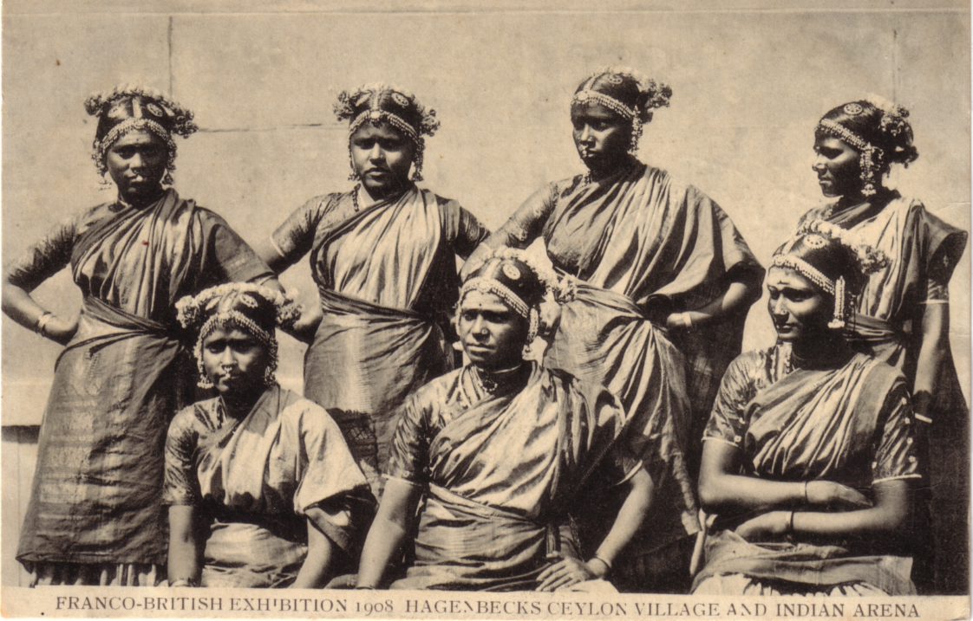

International Exhibitions and National Identity
By
Burton Benedict

Since the end of the Second World War, nearly 100 former colonies and dependencies have achieved political independence. Most of these new nations are relics of the colonial era. Many are amalgams of diverse peoples with various languages, customs and religions. The consolidation of national power has been a major difficulty for these countries and all have sought appropriate symbols to project an image of unity for their own people and to present to the world at large. Like many older nations, they have invented traditions (Hobsbawm 1983) and reconstituted history. They have delved into the events of their pasts to find appropriate symbols and to construct narratives which will justify their national identities. Prehistoric ruins can be cited as evidence of early nationhood. The origin myth of a particular group can become part of the history of a nation made up of many groups. A local skirmish can be interpreted as a milestone in the struggle for independence. History, of course, never speaks for itself. In these cases it is made to speak for national identity.
There were many ways in which these new national identities could be expressed, from speeches in the United Nations to the construction of new capital cities. One arena in which they could be displayed was the international exhibition or world’s fair (1). Almost without exception the major international exhibitions were sponsored by nations with colonial dependencies. Each displayed its colonies, or its internally colonized peoples, to its home population, to its rivals and to the world at large. They were tokens in the festivals of competition which world’s fairs became (Benedict 1983).
The exhibits and the exhibitions of which they were a part were ephemeral, yet the same sorts of displays recurred in exhibition after exhibition. The exhibits themselves became a kind of tradition. Some became semi-permanent in natural history and ethnographic museums. Perhaps even more lasting were the effects these manufactured traditions had in the colonies themselves. The exhibits fed back into the colonies (which sometimes had local exhibitions) to help create the images they had of themselves. At recent international exhibitions this could be seen in the displays mounted by former colonies which had become politically independent. These exhibits were rarely exact copies of colonial displays, but they retained many of their elements The leaders of the new nations wanted to symbolize cohesion in communities which often lacked it and to establish the authority of their governments. Such exhibits were exercises in the imagery of nationalism.
Britain and France were the principal colonial powers and major sponsors of international exhibitions, but the United States also held international exhibitions in which it displayed its own colonies, both internal, such as Native Americans and Eskimos, and external, such as the displays at the 1904 fair in St. Louis which occurred shortly after the Spanish-American War brought the Philippines, Puerto Rico and Guam under American rule. Belgium and the Netherlands also had exhibitions in which they displayed their colonies. Even countries which were themselves political dependencies such as Canada, Australia, South Africa, India, New Zealand, and Indo-China held exhibitions in which they displayed colonized peoples such as the South Pacific Islanders shown at the New Zealand Exhibition of 1906.
Colonies and international exhibitions

At the time of the exhibitions in the late nineteenth and early twentieth centuries, colonies occupied different places in the national consciousnesses of Britain, France and the United States, Britain had virtually all of her colonies and had developed elaborate and well- entrenched structures for administering them. France, having lost nearly all of her possessions in the new world, was in the process of acquiring piecemeal an entirely new empire in Africa and Indo-China. The French colonial empire did not reach its fullest extent until 1919. (2) How the colonies were to be administered and, indeed, whether it was a good idea to have colonies at all, were live political issues in France in a way that they were not in Britain.
The colonies of the United States were mostly internal, the Native American reservations within her borders. Generally the prevailing policy was that their inhabitants should be assimilated into the general population. Colonies have been less important to the United States than to either France or Britain.
The exhibits of colonies and dependent peoples at international exhibitions reflected attitudes and policies of the colonizing powers. At all world’s fairs the British, French and Americans showed a sense of their own superiority over the cultures of their colonized dependents. For the British this was expressed in social distance which may have derived from British class structure and a strong sense of history. British law itself is based on precedent, and history was often cited to justify British colonial presence. The British sometimes saw themselves as heirs to the Romans in relation to their colonies. (3) They emphasized the unity of empire in their exhibitions (MacKenzie 1984), but this was not equivalent to turning the inhabitants of colonies into Britons.
By contrast French law is based not on precedent but on general principles. History does not have to be cited to justify colonial rule; French civilization will do. Perhaps the French did not stress history because, as Hobsbawm suggests (1983 p.272), nineteenth and twentieth century French history was divisive not unifying. The colonial question itself was divisive.

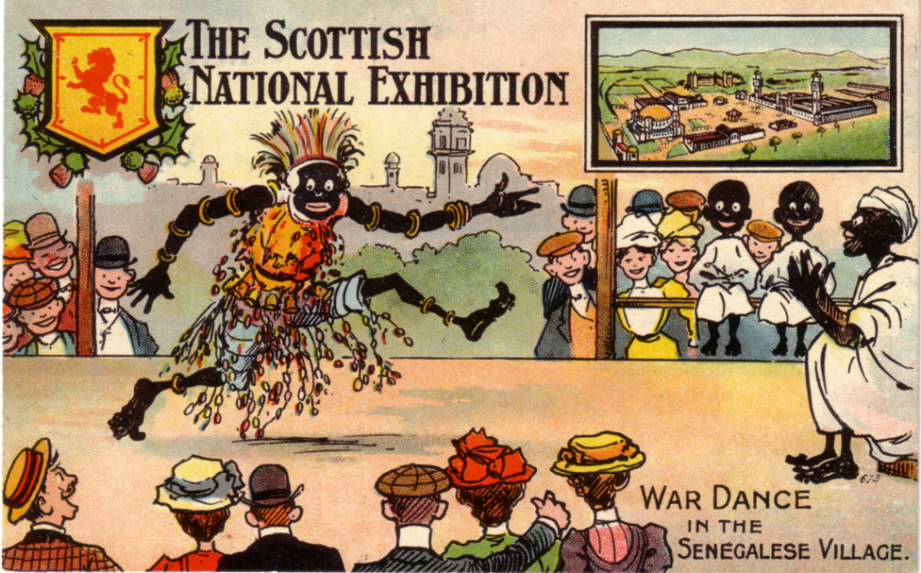

By contrast French law is based not on precedent but on general principles. History does not have to be cited to justify colonial rule; French civilization will do. Perhaps the French did not stress history because, as Hobsbawm suggests (1983 p.272), nineteenth and twentieth century French history was divisive not unifying. The colonial question itself was divisive.
American emphasis on educating and assimilating Native Americans and other dependent peoples was tempered by ideas of racial and social evolution which placed darker skinned people low on an evolutionary scale. Such ideas were also present in British and French exhibitions, but these countries, on the whole, were dealing with colonies located far from their shores while Americans were dealing with enclaves within their own national boundaries. Moreover many of the colonial peoples shown by the British and French came from societies which were still more or less intact. Most Native American societies, on the other hand, had been so decimated that they presented welfare problems which had to be dealt with domestically. At the time of the exhibitions in the early twentieth century, assimilation into the general American population, itself made up of immigrants from many parts of the world, seemed the best way of treating these pockets of Native American culture.
Apart from showing piles of colonial produce, exhibition organizers constructed pavilions in ‘indigenous' styles. The Paris exposition of 1889 had such pavilions for Cochin-China, Cambodia, Annam-Tonkin and Algeria. In addition there were 'villages’ for Senegal, Gabon-Congo, New Caledonia and Tonkin. Natives had been imported to help build these villages and then in habit them, putting on displays of their arts and crafts. Such ‘exotic’ exhibits were popular. They also provided an arena in which each colonial power could flaunt its possessions to its rivals.
For the Louisiana Purchase Exposition held in St.Louis in 1904 the government mounted a 47-acre Philippine exhibit which included six villages 'typical of Philippine life (see illustration) from the lowest grade to the better class’ (Francis 1913, 1, p.565). There were some 75,000 catalogued exhibits, and 1,100 people from the archipelago took part.
The reproductions of palaces, buildings and villages were almost always designed by European or American architects, not by the inhabitants of the colonies, even if native materials and craftsmen were used. All sorts of liberties were taken with indigenous styles to fit the demands of the exhibitions. An example is the pavilion built in Paris to house Senegal and the French Sudan in the 1900 Exposition. Its inspiration came from plans of buildings in Djenne and Timbuktu. The original asymmetrical placing of the domes was made symmetrical and the whole building turned into a kind of neo-classical palace despite the use of traditional hand-moulded brick. This style was exported back to Djenne when a new mosque was built there in 1907 (Prussin 1986:18). Adaptations of this building appeared in colonial fairs at Marseilles in 1906 and 1922, finally manifesting themselves as a restaurant at the Paris Exposition Coloniale in 1931.

The Exhibits of Britain, France and the United States

Differences in ihe approaches of the three colonizing nations can be appreciated by comparing exhibits and programmes of public performances at the British Empire Exhibition of 1924, the Paris Exposition Coloniale of 1931 and the Louisiana Purchase Exposition at St. Louis in 1904. At Wembley the British mounted an enormous historical pageant witb a cast of 15,000 people, 300 horses, 500 donkeys, 730 camels, 72 monkeys, 1,000 doves, 7 elephants, 3 bears and a macaw (Walthew 1981). It was called 'The Pageant of Empire: an Historical Epic’ and was largely written by Rudyard Kipling with poetry by Alfred Noyes set to music by Sir Edward Elgar. It took three days to see the complete performance. (4) The image which held it together was ‘the Bridge of Empire’, a bridge, to quote ‘The Time.s started by the heroes of the past and completed by the Dominions and Colonies with their achievements and sacrifices for the common cause’ (British Empire Section April 23, 1924 p.xii). In the vast Wembley Stadium, a literal bridge spanning a harbour basin between two towers was constructed every three days with each historical episode considered as a block of stone that was swung up on a scaffolding and placed into position. The episodes showed the colonization of each part of the empire beginning in the distant past. The episode on South Africa, for example, began with Phoenicians rounding the Cape in 606 B.C. There was also a procession of pioneers led by St. George of England. A few impatient people’, wrote the editor of the The Weekly Bulletin of Empire Study, a publication for schools, ‘are already enquiring what the Assyrians and the Carthaginians, the Byzantines and the Popes have to do with the modem British Empire. The answer is that nobody can understand the British Empire who does not understand its history.’ (No. 5 Feb 22, 1924, p.41). Thus the British Empire was given an air of historical inevitability. The Pageant concluded with crashing music, ringing bells and the cast streaming back and forth across the bridge while choirs sang Kipling’s Recessional in which God too appears to have picked the British.
In contrast the whole of the Exposition Coloniale of 1931 was a theatrical performance. (5) As the exposition guide enthused: ‘L’Exposilion Coloniale est une Fete. L’Orient, le Desert, I’Afrique Noire, les Troptques, ie charme des lies. Visions, enchantements; les Delacroix et les Gauguins. C’est la Fete du Tourisme et de I’Ex- otisme, loujours a la mode.’ (Keim 1931 p.7). The art deco style and striking colours of the buildings, the elaborate fountains, the fantastic illuminations and light shows at night combined to present a kind of colonial utopia. There were ballets, evenings of music and dance from Senegal, Madagascar, Tahiti and Cambodia. There were colonial symphony orchestras and athletic contests. The emphasis was not on the history of conquest but on indigenous cultural performances fostered under French rule and the civilizing mission of France.
The emphasis in the Philippine exhibit at St. Louis was on education seen in a social Darwinian context. This evolution was shown in the six villages on exhibition: While all of the seventy or more groups of people in the archipelago could not be represented we had the least civilized in the Negritos and the Igorots, the semi-civilized in the Bogobos and the Moros and the civilized and cultured in the Visayans as well as in the constabulary and scout organizations (Francis 1913. I, p.565).
The performances at St. Louis in 1904 featured what were supposed to be indigenous customs of the people on display - mock wedding ceremonies and tribal dances. They were shown as ethnographic curiosities, soon to be superseded by American education. A model school held daily sessions for the children on exhibit. During the course of the fair 13,000 teachers saw them (Francis 1913: I. p.567). Exhibits of Native Americans at this fair included an ‘Indian School’ at which white teachers inculcated civilized American ways in their pupils.
One may question how effective all this propaganda for empire was on the metropolitan populations of Britain, France and the United States. The 1924 British and the 1931 French fairs occurred at a time of economic depression in the West. Both governments wished to encourage investment in and emigration to their colonies and saw the exhibitions as means to further these goals. There may also have been some effort to reassert weakening colonial dominion. Independence movements were brewing in many parts of both empires. The imperial powers were displaying their colonies as the era of empires was drawing to a close. But if the various colonies did not feel at one with the mother country, the displays mounted in their names were at least creating views of themselves which could be used later to justify their claims to be separate nations. Nigeria or Senegal, for example, could claim that they were nations, in part because they had been colonies and had been displayed as though they were single entities. Indonesia’s claim to West Irian was based on Dutch colonial occupation, not on a common culture.

The amusement zone

Nearly every international exhibition had an amusement zone which in many ways stood in opposition to the rest of the exhibition. Here the aim was to divert not instruct, to provide pleasures of the moment rather than to plan for the future. Impressive serious buildings in harmonious hues were replaced by bizarre structures in garish clashing colours. In the main fair exhibitors were governments or major corporations run by established authorities. In the amusement zones the exhibitors were private enterprises run by ‘marginal’ show-people. Among the rides and sideshows there were often ethnic displays - Eskimos, ‘cannibals' from Dahomey, Native Americans, Polynesian dancers. Most were drawn from colonial dependencies. A Dahomean village complete with inhabitants seemed to feature in almost every British, French and American world’s fair throughout the late nineteenth and early twentieth centuries. There were enough fairs so that entrepreneurs could take the same concession to exhibition after exhibition.
Through these displays particular stereotyped impressions of certain ethnic groups gained wide currency in the west. It appears that the performers soon became professionals, and audiences came to expect certain types of performances from particular nationalities or ethnic groups. After the political independence of former colonies such performances became symbols of nationality. The Osaka fair of 1970 featured 73 national days which nearly always included performances: classical dances from India, a wedding ceremony from Malaysia, folk dance troops from Uganda, Tanzania, Nigeria, Zambia, Pakistan, Vietnam, Laos, Cambodia, and Indonesia (Japan World Exposition 1970 vol 2).
The amusement element was not confined to the amusement zone. Exhibitors in the main fair used all sorts of entertainments to attract the public. Colonial exhibits could provide entertainment as well as or along with instruction. From exotic products to exotic peoples was not a large step and one taken with more and more elaboration particularly in the French fairs.
There are important differences between exhibiting objects and exhibiting people. (6) Objects don’t talk back. In many exhibits people were treated as objects and not given the opportunity to talk back. They may not have been put in glass cases, but they were often placed at some distance from their audiences, roped off. They often spoke languages unintelligible to their audiences and this helped maintain social distance. Where the exhibited people gave performances, theatrical conventions operated to keep performers and spectators apart. People could also be arranged to explicate theories as they were in the evolutionary sequence of 'villages' at St. Louis where Pygmies (see illustration) were placed in sequence with Patagonians. Typology took precedence over geography.

Stereotypes and tradition-inventing

In all these displays and performances, whether British, French or American, in the main fair or in an amusement concession, a kind of lumping took place which reinforced ethnic and national stereotypes (see Rydell 1984). Even where such performances were not distorted to cater to the tastes of European and American fairgoers, they were often based on the practices of a particular ethnic group or segment of a colony’s population. Thus all Native Americans might be thought to wear feather bonnets or all the inhabitants of the Gold Coast to be Asante or all inhabitants of French West Africa to be like the Dahomeans shown at so many exhibitions. Such impressions are reinforced if the people on display are housed in structures associated with only one group - the wigwam, the igloo, the grass hut, the Indochinese temple, the west African mud stockade. The South Sea Islands Village shown by the Oceanic- Trading Company on the Midway at Chicago in 1893 consisted of four Samoan houses inhabited by 25 natives from Samoa, Fiji, Rotuma and Wallis Islands (World’s Columbian Exposition Official Catalogue Part XVII 1893).
Two sorts of tradition-inventing went on at colonial exhibitions. One was promulgated by the colonial powers and attempted to depict the peoples and cultures of empire as though they were parts of single whole; the metaphor of family was often used with the colonial power described as ‘mother’. This tradition claimed that these countries and their peoples were being led forward to greater social, economic and cultural progress by the mother country. This image of unity was stressed by Britain, France and the United States though not in the same way. Britain tended to emphasize economic aspects, while France, though she did not neglect the economic, placed emphasis on cultural aspects.
The United States promoted the Americanization of its dependent peoples.

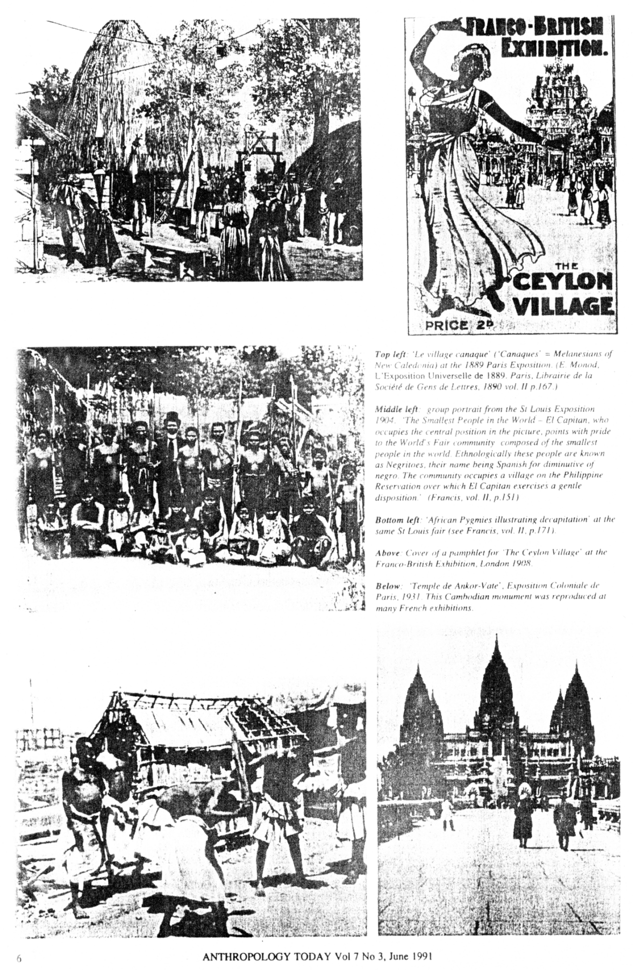
At the same time that empire unity was being stressed, and very consciously stressed, a second exercise in tradition-inventing was going on which may have been less conscious and which operated to a large extent in opposition to the first. This was the invention of separate traditions for each colony or dependent group which promoted their own national and ethnic identities.
Two major international exhibitions have been held since the political independence of most former colonies: Expo 67 in Montreal and Expo 70 in Osaka. (7) In both, new nations participated extensively, even small ones such as Mauritius and Togo. Such nations could not afford to construct their own pavilions and were housed in modular structures designed, constructed and financed by Canada and Japan. At Expo 86, a smaller fair in Vancouver, the organizers increased their roster of nations and hence their claim to be international by constructing and largely furnishing a South Pacific pavilion which housed Fiji, Western Samoa, the Cook Islands, Tonga, Vanuatu, Papua New Guinea and the Solomon Islands. Another six nations were crammed into a modular structure for the Organization of Eastern Caribbean States. Thus the form of the pavilions of these small new nations was not under their control, a situation not very different from that which obtained in the colonial era. In these recent fairs some of the wealthier new nations commissioned their own pavilions, but they were often designed by or in collaboration with European architects. Within the pavilions the displays show continuity with exhibitions of the past. There are the raw materials, the native crafts, the development projects. Exhibitions generate a kind of uniformity of display. Films of development projects in one country generate films of development projects in other countries and all shot in more or less the same way. Every country shows its crafts. In buildings monumentality engenders further monumentality. The more nations compete the more alike they become and vice versa.

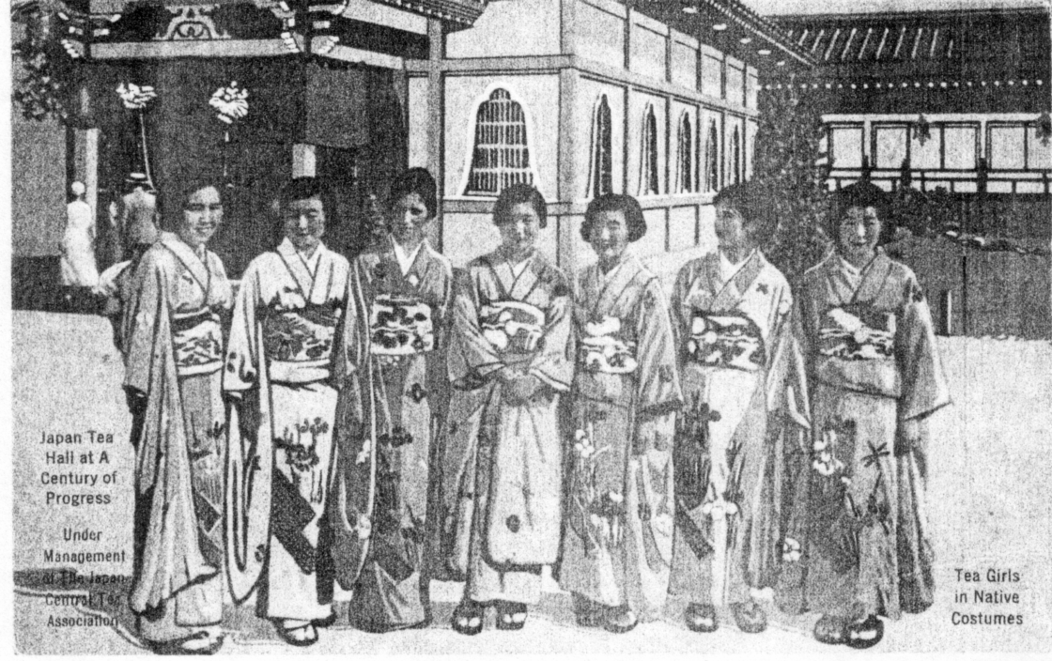

The major innovations in design and symbol-making in post-World War II exhibitions have come not from nations, new or old, but from multi-national corporations. Their logos have become better known than many national symbols. Corporations have become the principal sponsors of recent world’s fairs where their highly popular pavilions have consistently outshone those of all but the largest nations. Corporations have employed amusement zone techniques such as rides, mechanical monsters and theatrical entertainments. The ride is one of the most effective techniques because the spectator is a captive, fixed in a moving seat and propelled over a course while messages are fed to one both visually and aurally. The epitome of such an exhibition is Epcot, a kind of permanent world’s fair in Florida. Here major buildings with names such as ‘Spaceship Earth’ and ‘The Land’ are corporate pavilions run by AT&T and Exxon respectively. An area of ‘national’ pavilions reveals that the buildings in ‘national’ styles are not run by the .nations concerned but by corporations.
Former colonies may have achieved political independence, but few have achieved economic independence. Their displays at international exhibitions may symbolize their nationhood, but the exhibitions as a whole show that the imperial nations of the past have been replaced by the multinational corporations of the present. International exhibitions now seem to reflect a new form of dependency.

Notes

The author is Director of the Lowie Museum of Anthropology, University of California at Berkeley. His book, The Anthropology of World's Fairs: San Francisco's Panama Pacific International Exposition of 1915, was the subject of an illustrated article by Roberto Da Malta in …..’.s predecessor, October 1983

A version of this paper was presented at a conference entitled Making Exhibitions of Ourselves’ held at the British Museum in February 1986. For trenchant criticism of earlier drafts the author thanks Marion Benedict. Brian Durrans and George Starr.

1 For lists of international exhibitions see Allwood, 1977; Beutler, 1973; L.e Livre des Eypositions Universelles 1851-1989. I983 and l.uckhurst, 1951. For pre-World War I American expositions see Rydell 1984.

2 For a succinct discussion of the French Colonial Empire see Betts 1978. For an analysis of the popularization of this new empire see Schneider 1982.

3 The French appear only to have used this analogy in respect of Algeria (colonized in 1830).

4 This event was foreshadowed by The Festival of Empire held at the Crystal Palace in Sydenham, London in 1911 in conjunction with the coronation of George V It also had a cast of 15,000 and consisted of a cycle of four parts of eight scenes each showing the history of Britain from pre-Roman times and culminating in ‘The Gathering of the Overseas Dominions around the Mother Country' (Lomas 1911).

5 Useful discussions of this exposition can be found in Le Livre des Expositions Universelles 1851-1989 1983 and in Ageron 1984. See also l’illustration for 23 Mai. 1931.

6 For a classification of the different types of display of people see Benedict, 1983.

7 Very few new nations had displays at the Brussels Exposition of 1958. On the other hand, the large Belgian Congo and Ruanda-Urundi exhibits were reminiscent of pre-war exhibitions. Late colonial and post-colonial displays at international exhibitions have been briefly but cogently discussed by Hodier.

Ageron, C.-R. 1984. ‘l'Exposition coloniale de 1931:
Mythe republicaine ou mythe irnperiale?’ in P. Nora (ed) Les lieux de memoire: I La Republique Paris.
Allwood, Johni. 1977. The Great Exhibitions. London.
Benedict, Burton. 1983. The Anthropology of World's Fairs: San Francisco's Panama Pacific International Exposition of 1915 Berkeley and London.
Beutler, C. 1973. Weltausstellungen im 19 Jahrhundert. Munich.
Betts, M. 1978. Tricouleur: The French Overseas Empire. London and New York.
British Empire Section. 1924. The Times London, April 23.
Francis, David R. 1913. The Universal Exposition of 1904. St. Louis.
Hobsbawm, Eric and Terence Ranger (eds ). 1983. The Invention of Tradition. Cambridge.
Hodier, C. 1983. L'epopee de la decolonisation & travers les expositions universelles du XXe siècle in Le livre des expositions universelles, 1851-1989. Paris. L' Illustration 1931. Paris, 23 mai.
Japan World Exposition. 1972. Osaka 1970 Official Report Osaka.
Keim, Albert. 1931 : Manuel de 1'Exposition Coloniale Internationale de Paris 1931. Paris.
Lomas, S. C. (ed.). 1911. Festival of Empire Souvenir of the Pageant London.
Luckhurst, Kenneth W. 1951. The Story of Exhibitions. London and New York.
MacKenzie, John M. Propaganda and Empire. The Manipulation of British Public Opinion 1880- 1960. Manchesler
Prussin, Pnissin. 1986. Hatumere: Islamic Design in West Africa. Berkeley, Los Angeles, London.
Rydell, Robert W. 1984. All the World's a Fair: Visions of Empire at American International Expositions 1876-1916. Chicago.
Schneider. William H. 1982. An Empire for the Masses: The French Popular Image of Africa, 1870- 1900. Westport,
Walthew, K. 198!. ‘The British Empire Exhibition of 1924’ in History Today, vol V, London, August.
The Weekly Bulletin of Empire Study 1924. London.
World s Columbian Exposition: Official Catalogue of the Exhibits on the Midway Plaisance. 1893. Chicago.

Will Ducks Fly in 1940?
Edinburgh and Japan
by
Stanley K. Hunter

I spent two days at this year's Edinburgh Festival and kept my eyes open for any exhibition materia1. After my exploits in California I thought I would try something a little less ambitious.
One of the Main displays at this year's Festival was "Behind Golden Screens - Treasures from the Tokyo Fuji Art Museum", This was held at the Royal Museum of Scotland, in Chambers Street (until October 20).
To supplement the wonderful material on show, the Museum added a few items from its own collection, included was a lacquer picnic case from a small Japanese collection purchased by the National Museum of Scotland at the 1876 Centennial Exposition in Philadelphia, The picnic set is a superb D-I-Y sake drinking kit. Confusingly, it was labelled as purchased in Philadelphia in 1976 and titled as such in the newsletter "Museum reporter" although correctly dated in the text!
“The Japan Festival” is the theme of a good number of exhibitions in Great Britain this year, including both Edinburgh and Glasgow, The Fine Art, Society, in George Street, Edinburgh, featured "Opening the window; British Artists in Meiji Japan 1880-1900", Glasgow painters were influenced by Japan and the Society was showing an early masterpiece by Sir John Lavery, This is the first time his 1883 “Bridge at Grez’ has been shown in Scotland, I managed to pick up a copy of the catalogue of the 1984-85 Lavery exhibition organised by the Society and the Ulster Museum.' It has twenty illustrations of Lavery paintings of the 1888 Glasgow International Exhibition, including sketches of portraits for his monumental “State Visit of the Queen to the Exhibition,"
"The State Visit" had been dreadfully damaged in the March 1941 blitz and not restored until the centenary of the exhibition where it formed the centrepiece of the anniversary celebrations. It is now on long-term loan to the Glasgow Royal Concert Hall where is magnificently displayed. Sadly, one of the 1888 Exhibition paintings was stolen from a Glasgow gallery earlier this year. It was valued at £45,000.
I managed to visit two book fairs in Edinburgh on my Festival visit - one in Chambers Street and the other in George Street, I saw a couple of the 1888 and 1901 Glasgow Exhibition heavyweight art books (coffee tables would have to be prettv strong to cope with them and I already had copies). I also saw the Lord Provost's copy of a 1911 Scottish Exhibition catalogue, but let it go, as I did with a wonderful book on Gustave Eiffel with not a few Paris exposition illustrations, 1 did claim a bound Volume I of the "Scottish Art Review",
This is really a choice item and is valuable for its contemporary accounts of the 1888 International Exhibition, Some of the reports were by artists actually involved with the exhibition including some of the celebrated “Glasgow Boys”. As well as illustrating some of the works of art on show, four of Lavery’s exhibition paintings are reproduced.
Then my eye lit on a flimsy small folio brochure entitled "The International Exposition of Japan - Tokyo - Yokohama 1940¹. Although the booklet was printed, the cover appears to have been hand-lettered by brush and a fine watercolour of Mount Fuji affixed to the front,
The brochure was a formal announcement of the exposition to be staged from March 15 to August 31, 1940, to mark the 2,600th anniversary of the accession of the Emperor Jinmu. The exposition was to cover 500 acres of reclaimed land in Tokyo and also a site at Yokohama, In 1937,
attendance was confidently estimated to be 45,300,000 although this was rounded down later to 40 million.
Then I noticed that the brochure was only part of an envelope on the exposition, There was a 13-page booklet on the Classification of Exhibits, an 8-page "Extract from the Regulations" a large sheet itemising Japan's official participation in the major exhibitions from 1873 (Vienna and London) to Paris (1937), Apart from London (1833 Forestry, 1884 Hygiene and 1910 Japan-British), the only ventures in "England" appear to have been Edinburgh (1884 Forestry) and Glasgow in 1901!
Next, inside the envelope I found a coloured brochure (April 1938), on the exposition plans. Along with all the usual statistics, there was a chatty dialogue by two characters, entitled "will Ducks Fly in 1940?". Intended to be a friendly insight on the great show, I found it rather like rubbing one's teeth along a rough granite block!
The first practical steps had been taken in July 1935 by establishing a nursery for trees and shrubs to be transplanted to the exhibition sites. The actual sites were selected in January 1937 and the project was officially recognised by the Government the following month.
In July a special session of the Diet authorised the advance sale of admission tickets with lottery coupons. The first lot, amounting to ¥10 million, went on sale in March 1938 - this was to have repercussions!
Finally, I unfolded a large colour plan of the sites (scale 1:5000) which supplemented the colour plan in the booklet, The exposition site was to be reclaimed waterfront on Tokyo Bay, split by the mouth of the Sunida River, In Yokohama the subsidiary site was at Yamashita-Cho on the waterfront of Yokohama Harbour This venue appears to have been reserved for a maritime hall, aquatic products, an aquarium and a music pavilion, In all, 400 acres were to be devoted to buildings and amusements and 500 acres for aquatic sports.
It is interesting to note that while the daily average of attendance was originally reckoned to be (maximum 666,000), the car parking could accommodate a mere 6,000 vehicles,
His Imperial Highness Prince Chichibu was proclaimed Patron, with Prince Fuminaro Konoe, the Prime Minister, as Vice-Patron.
All the printed material made for attractive reading, A brief look, however, at the indexes of the "London Times" and the “Glasgow Herald” tell a different story, The political situation in the Far East was far from the objects of the exposition "to contribute to the development of world industries, to the fusion of the Oriental and Occidental civilization, and to the promotion of world peace."
Japan was rampaging through China and its links with Germany and Italy made the rest of the Occident wary of the future, Vichy France gave Japan a free hand in Indo-China, Australian dockers organised a major boycott of Japan. The US ambassador in Tokyo warned of a possible attack on Pearl Harbour. Japan appeared at the Golden Gate exposition in 1939-10 in the last attempt to encourage peace in the Pacific rim.
Even before this, the Japanese had taken a hard look at the situation as the ferment grew and by July of 1938, the International Exposition of Japan was officially postponed. The celebrations of the 2,600 th anniversary took place and a set of four stamps was issued,
Prince Konoe resigned as premier and the US Navy in the Pacific was almost destroyed on '”The day of Infamy”, in December 1941, The organisers of the exhibition which had proclaimed peace must have had bitter regrets.
A stamp was issued to nark the 1949 Foreign Trade Fair at Yokohama but the first major exhibition to be held in Japan was the 1970 Osaka World Exposition - a “Category 1” event. It merited three sets of stamps. In tribute to those who had supported the 1910 Exposition, the organisers of Osaka accepted the tickets issued for the Tokyo-Yokohama exhibition! Attendance was 64,218,770 and there was a profit of almost ¥20,000 million (£22.6 million).
I walked down the Royal Mile to pay a visit to Huntly House in the Canongate, This 16th century merchant’s house is now the city museum and has a small selection of relics of the International Exhibition of 1886 and 1890 and the Scottish National Exhibition of 1908,
After the 1886 centenary exhibition staged at Huntly House, I donated 14 of the better items of my collection of 1886 souvenirs to the city collection. I was pleased to see some of these items on show at an exhibition held in the City Art Centre last year, Issue No, 9 of our newsletter included a copy of the pamphlet (also No,9) commemorating the centenary exhibition, The pamphlet is still available at 25p (plus postage) from the City of Edinburgh Museums.
I visited the “Book Festival" in Charlotte Square and managed to have a brief chat with Colin Baxter, his postcards are in every bookshop and newsagent in Scotland, Surprisingly, he does not appear to have a misty cloud around his head - but he still loves the work of Charles Rennie Mackintosh, as featured in the 1990 European City of Culture 22p stamp,
The Fair gives an opportunity to have a rare close-up of the statue of the Prince Consort (1876) The western side of the plinth shows the Opening of the Great Exhibition of 1851. Normally this statue is fenced off to the general public.
A number of Festival Fringe venues were being staged on The Meadows, a traditional old park of the City. On the way I had a look at the statue, now erected in a little square near The Meadows, which had won an award at the 1886 International Exhibition (restored after storm-damage a few years back),
The Meadows was bustling, The West Meadows was the site of the 1886 exhibition, A sundial and pillars still commemorate the exhibition as does one of its main thoroughfares - Jawbone Walk, The original whale jawbones which featured at the Zetland and Fair Isle Knitters stand remain in situe (and can be seen on postcards).
Two weeks before, I had visited a fair staged at Ingliston (The permanent site of the Royal Highland Show on the outskirts of Edinburgh) and bumped into a dealer-friend who was carrying two fine woven silk souvenirs of the 1886 Exhibition, He assured me that he had hoped to meet we there, which was pretty precognitient as I have never attended an antique fair there before!
The recent announcement of the decision to build a Museum of Scotland next to the Royal Museum of Scotland in Chambers Street had just hit the headlines when the Prince of Wales resigned in protest at the lack of public participation,
The Royal Museum of Scotland, in addition to its Japanese exhibition (to be supplemented on September 12. with 'Discovering Japan") - had displays “New Museum for Scotland Site findings” and "A New Museum for Scotland" (both until October 27), showing the winner in a list of 371 entrants.
Public unease at the decision was voiced in a Salon de Musses refusts 100 yards away in Victoria Terrace (displaying a million pounds of discarded entrants) and the other short-listed at the University Dept. of Architecture in Chambers Street, Few competitions can have received such architectural support.
The Royal Institute of Architects in Scotland (RIAS) staged its own festival exhibition - 'Winners & Losers - Scotland and the architectural competition" - surely an oblique reference to the decision taken over the Museum.
The section entitled "In Safe Hands" recalls the 1901 Glasgow International Exhibition and the choice of James Miller as architect, The National Monuments Record of Scotland provided a large photograph of the Industrial Hall and a smaller one of the Russian Village, Both are reproduced in the catalogue.
The display 'State Secrets" features Thomas S. Tait's impressive “Saint Andrew's House” - Scotland's Whitehall, below the Calton Hill, which was to be opened by the King and Queen in October 1939 (but aborted by World War). No mention, however, was made of Tait's even more renarkable work at the 1938 Enpire Exhibition,
Above, on Calton Hill, sits the 17th century cannon presented bv the Government to the City of Edinburgh and seen on a number of postcards, Originally Portugese, it had been captured in the Bumese War of 1886 when the country was added to the Indian Empire, It featured at the International Exhibition of that year.
I had a snack in the Waverley Market, This had long been used for exhibitions, It was opened in 1869, In 1882 it housed the International Fisheries Exhibition, I have a fine silver medal awarded at this exhibition for smoked haddock! It was this exhibition that inspired Edinburgh to host the 1884 International Forestry Exhibition and the 1886 International Exhibition, The Waverley Market was the site of a large range of exhibitions and shows - including the 1927 Empire Exhibition, It has been totally remodelled as a shopping mall.
Further west along Princes Street lie both the Royal Scottish Academy and the National Gallery of Scotland. The National Gallery's contribution to the Festival was "Virtue & Vision; Sculpture & Scotland 1540-1990”, held in the Royal Scottish Academy. On display was a copy of an album of photographs by T. &. R. Annan & Sons of the 1901 International. In the superb catalogue was a full page illustration of the stand showing soap sculptures by Robin & Houston at the 1888 International.
I didn't manage to add much more to collection apart from a nice silver brooch for the 1901 Exhibition. The dealer also showed me an 1851 Great Exhibition personal silver cutlery set of which he was very proud, I didn't dare ask the price!
By now, I was pretty wabbit and I took my leave of the Festival City. The train passed Donaldson's School for the Deaf, featured in "Winners & Losers" under the title of “All the Time in the World – 1842”, This competition was won by William Henry Playfair, whose Royal Scottish Academy, the City Observatory and monunents on Calton Hill are illustrated on the 1989 Playfair bi-centenary Scottish aerogramne.
The grounds of Donaldson's Hospital was the site of the 1884 International Forestry Exhibition, visited by the Prince and Princess of Wales and Mr & Mrs Gladstone, Japan's exhibits dominated the eastern end of the exhibition.
To the south of the railway track is Saughton Park and Gorgie. Some panoramic cards of the 1908 Scottish National Exhibition show a steam train in the distance, this was the North British Railway Co.'s line to Glasgow (the present BR line),
Beyond Gorgie was the Meggetland site of the 1890 International Exhibition of Electrical Engineering, General Inventions and Industries, Edinburgh. Among the many attractions was Tannaker's Japanese Village, H. M. Stanley opened the Phonograph Section of the exhibition.
I recently acquired a fine postmark of the “EDIN^{R} INTERN^{L} EXHIBITION / E / MY 27" and will be interested to hear of any other dates or dies owned by members.
Two days in Edinburgh did not perhaps add too much to my collection, but they certainly added to my interest in the hobby.

