Editorial No 21

In years to come I hope that members will not remember that Newsletters 20 and 21 were issued together. I do need articles as soon as possible for future copies and I don't think I can ever get enough. My own collection of ephemera has been well used for previous issues and does need a rest. Also when I am not actively involved in Expo, research I can't rustle up a few pages so easily.

All the material in this issue has been provided by Bill Tonkin and does show that the goodies are still around even though I was a little doubtful in my last editorial.

Do not forget the Annual Meeting at the Crystal Palace . This is our Fifth Annual Exhibition Study Group Meeting and if you have not been to one so far do try to come along.

June 1991 Andrew Brooks.

Pageant of Empire
British Empire Exhibition 1924

The other day one of our members Fred Peskett phoned up to tell me he had picked up an old scrap book containing letters and cuttings of the Pageant of Empire formed by somebody who had taken part in it, was I interested and did I want it? Yes I was and yes I would like it, a few weeks later we met at the Guildford Postcard Fair and he handed it over. By one of those coincidences that do happen, at the time that Fred phoned me I had been contacted by a dealer who also had for disposal a collection of letters and cuttings of the Pageant again formed by somebody who had been in it.
I thought that two people were offering me the same item, but no, a couple of days after getting Fred's the other lot arrived. There was some duplication which was to be expected.
The first collection had been compiled by a Mr T J Christy who played two parts, one a Barbary Pirate in the Blake episode in part 2, and the other as an Indian also in part 2. The other participant was a Miss M. M. Grey, who played the part of a maiden in the vineyard scene in the Australian episode, in part 3.
It is from the souvenirs kept by these two people that I have tried to tell the story of the Pageant of Empire, and show the enormous amount of thought that went into organising the 12,000 men woman and children who offered their services on a voluntary basis. There is still a lot to find out, for instance I don't know how all these people were first contacted, was it perhaps through advertising in the newspapers, the participants came from all walks of life and from all social orders.
After volunteering their services each person received a letter from Mr W M Hill, secretary of the Empire Pageant Council thanking them for their offer and informing them that their name and address had been recorded, and that they would be receiving further details. This letter was on black headed notepaper, with the message duplicated in purple, the letter is dated the 5th of July. This is strange as the second letter sent out later states that rehearsals will take place on the 3rd 4th and 5th of July. I think the first letter must have been sent out before the 5th, bearing in mind that the Pageant opened on the 21st July.
The second letter was from the Chief Administration Officer Lieut General Sir William T Furse K.C.B. D.S.O. enclosing an Enrolment Certificate bearing the signature (printed) of H.R.H. Prince Arthur of Connaught who was the President of the Administrative and Finance Committee of the Empire Pageant Council. This certificate with the embossed royal coat of arms in blue is a very impressive piece and it is no wonder that many were kept, as they were meant to be. The letter (which is undated) states that the participant will shortly receive notice of the first rehearsal, and details of the scene in which they are to impersonate a character, the date of the first rehearsal would be on the 3rd 4th or 5th of July
Neither collection had a copy of the third letter and I would imagine that this, giving the time and place of the rehearsal had to be taken with the participant as a means of identification, and may have been at that time exchanged for the official pass, which was given to all taking part in the Pageant. In the case of Mr Christie this was No P E 6533, and entitled him to go into the exhibition grounds, and a seat if available in enclosure 6 or 25 during the performance of the Pageant.
The organisers had less than three weeks from the date of the first rehearsal to the opening date, to get 12,000 people (the programme states 15,000) kitted out and prepared.
On top of this Elephants, Llamas and Bulls had to be brought from India, Camels from Egypt, and Sears from Australia, to mention but a few of the animals to appear at the Pageant.
After it was all over the participants received a final letter sent out on the 11th of November (25th September crossed out) on embossed notepaper from 41 Belgrave Square and was a formal letter of thanks from H.R.H. Prince Arthur to all concerned for making it all such a wonderful success.
The Pageant was divided into three parts, the first part was performed on Mondays and Thursdays part two was on Tuesdays and Fridays and the third part was on Wednesdays and Saturdays. There were three matinees Saturday July 26th for the first part, Saturday August 16th for the second part, and Saturday August 23rd for the third part. Each part was composed of a number of scenes. The music played during the Pageant was all by British composers and each part was started by the piece specially composed for the Pageant by Sir Edward Elgar O.M., The Empire March 1924. The orchestra of 110 musicians had been selected from the London Symphony, Royal Albert Hall and the Covent Garden Theatre (Opera) Orchestras.
The scenes for each part were as follows
Part 1 Henry VII and John Sebastian Cabot
The Pioneers
The Pageant of Newfoundland The Pageant of Learning The Pageant of Canada
Part 2 The Days of Queen Elizabeth
The English Fleet in the Mediterranean, Blake and the Barbary Pirates The Pageant of South Africa The Early Days of India
Part 3 George III and the departure of Captain Cook A Pageant of New Zealand A Pageant of Australia
A Pageant of Heroes
The Empire's Thanksgiving
A programme was available for each part priced at 1/- published by Fleetway Press, who also produced two books The Pageant of Empire - A Historical Survey by Sir Charles Oman priced at 2/6, and A Souvenir Volume of The Pageant of Empire Edited by Martin Hardie with coloured plates Priced at 21/- Fleetway also produced some post cards of the event I only know of three of part 3 (episode 3 on the cards)
Warriors past and present New Zealand war with the Maori's New Zealand Peace and Prosperity If anybody knows of any other titles I should like to hear of them or better still get my hands on them, please. There is an interesting advert on the inside cover of one of the programmes, Hospital closes 60 beds because of cash shortage, so there is nothing new.
This brings to mind that the fact that the whole Pageant of Empire 1924 was very like the Festival of Empire held at the Crystal Palace in 1911 so perhaps they were saying there's nothing new then.

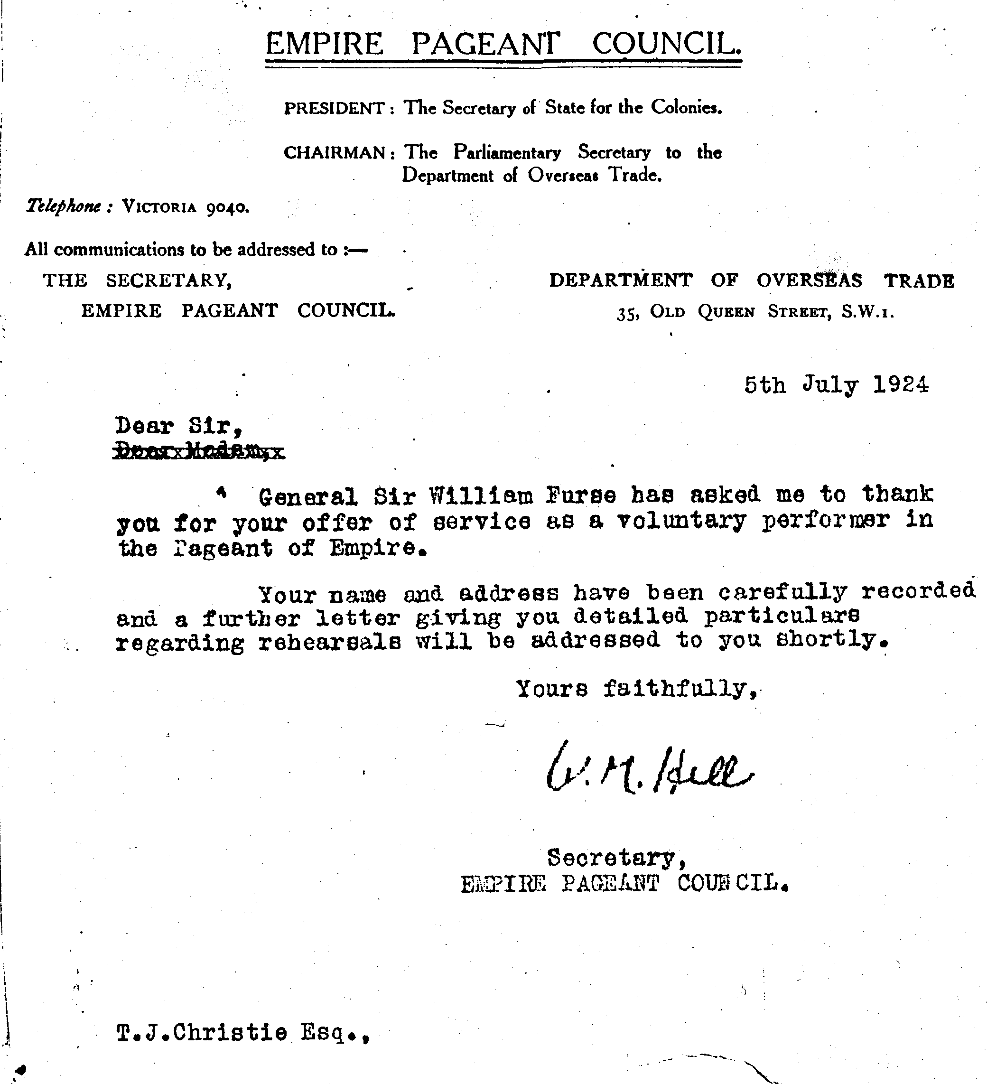

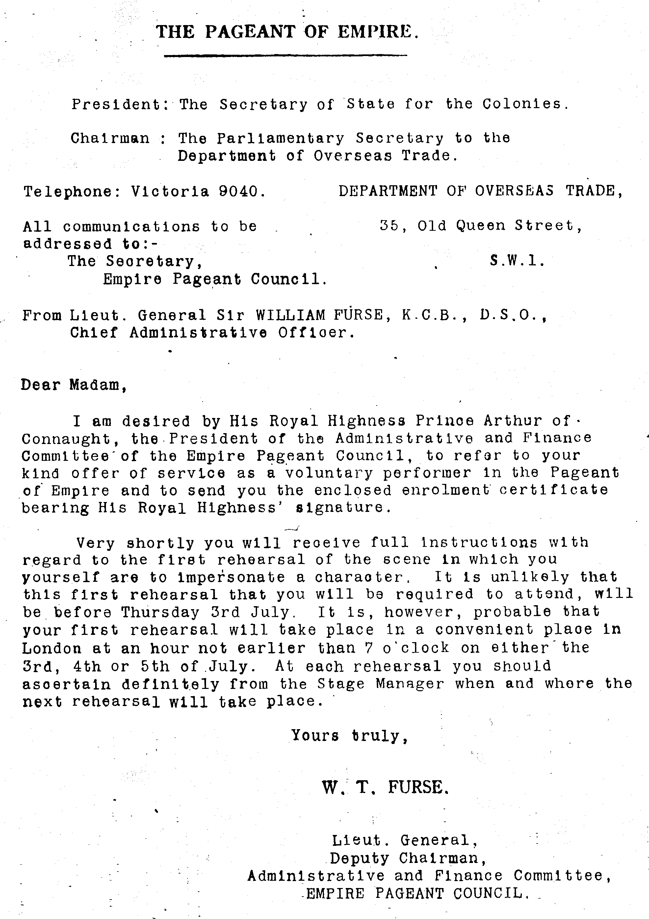

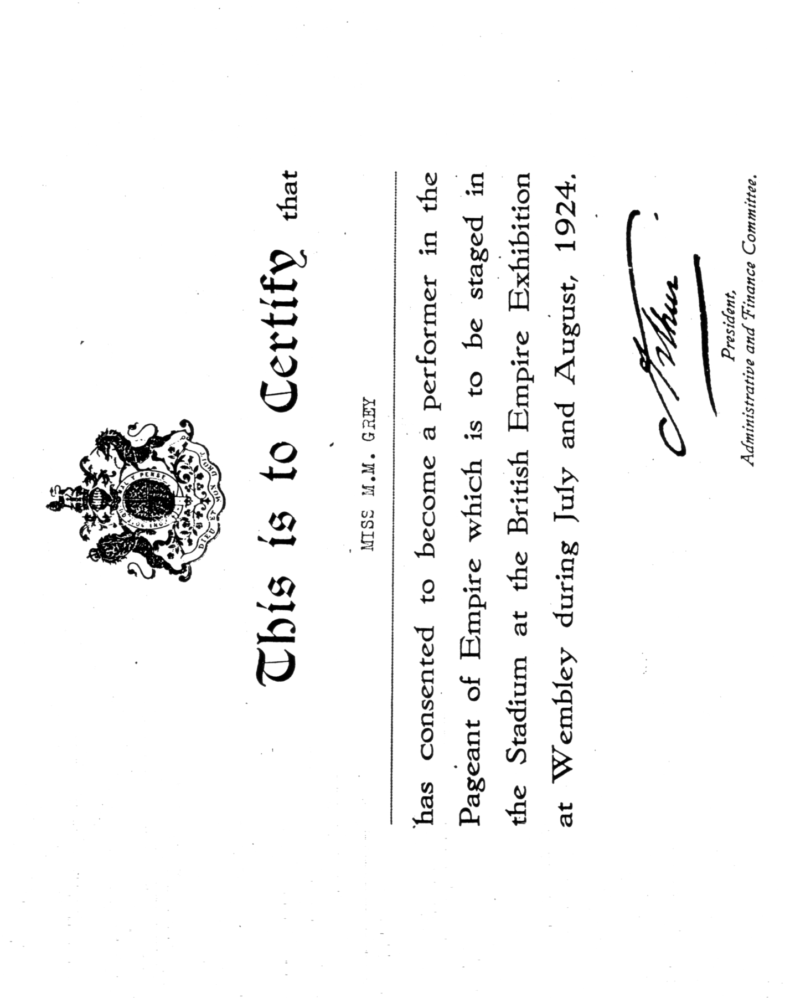

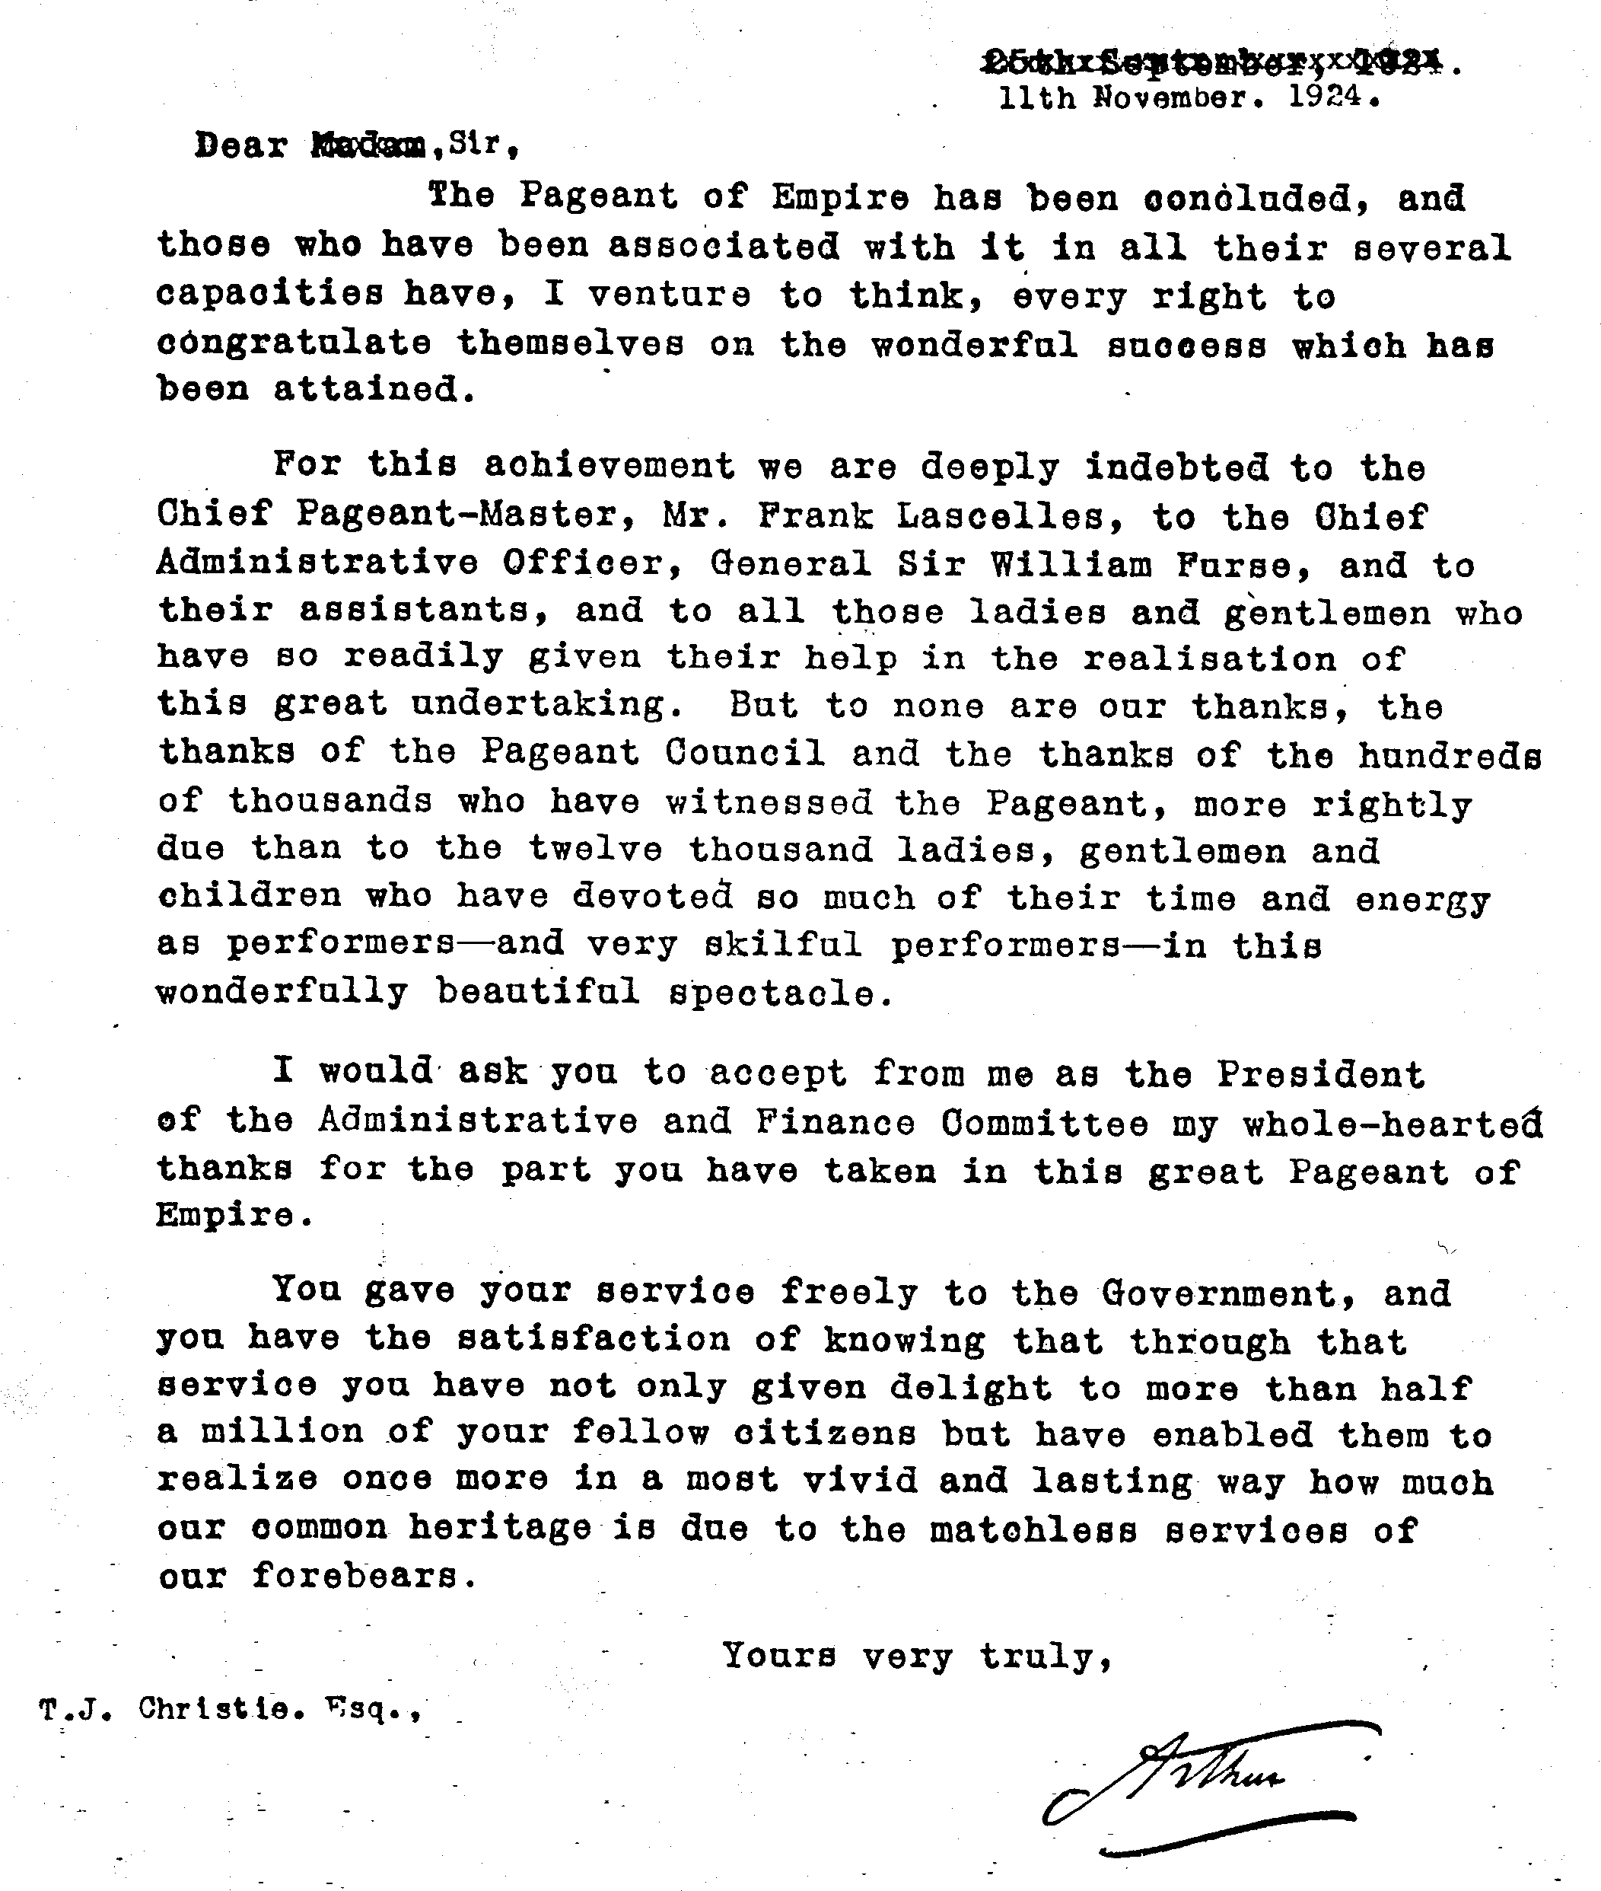

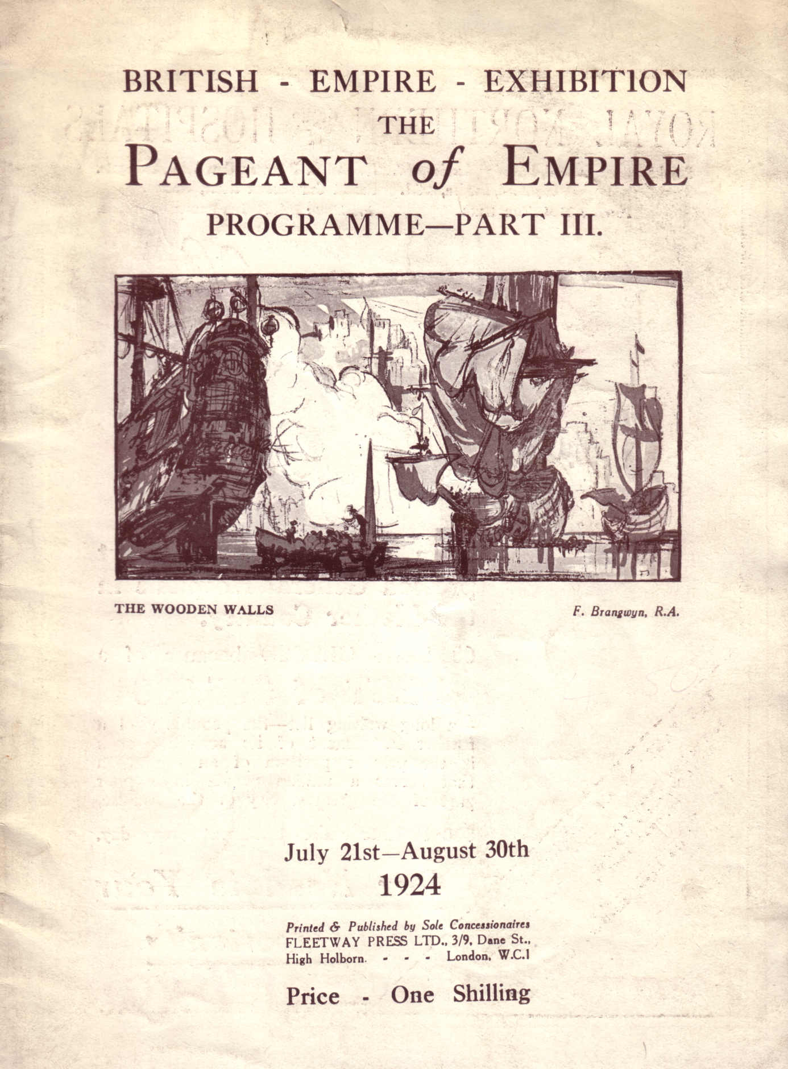

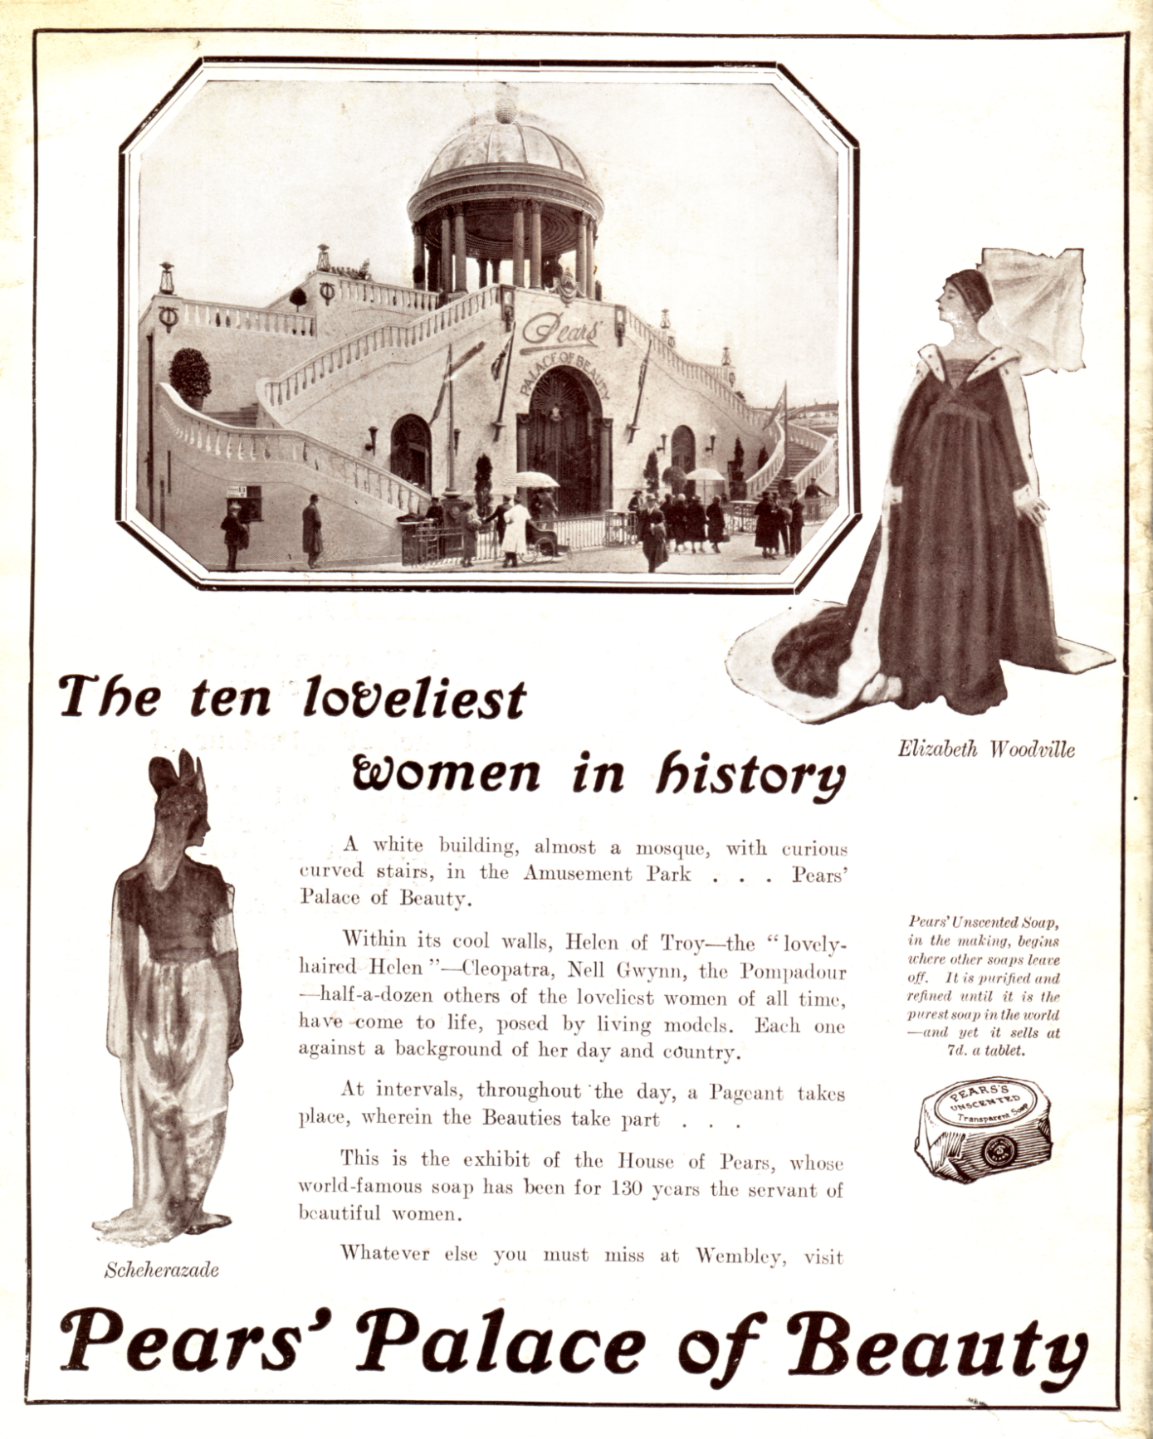

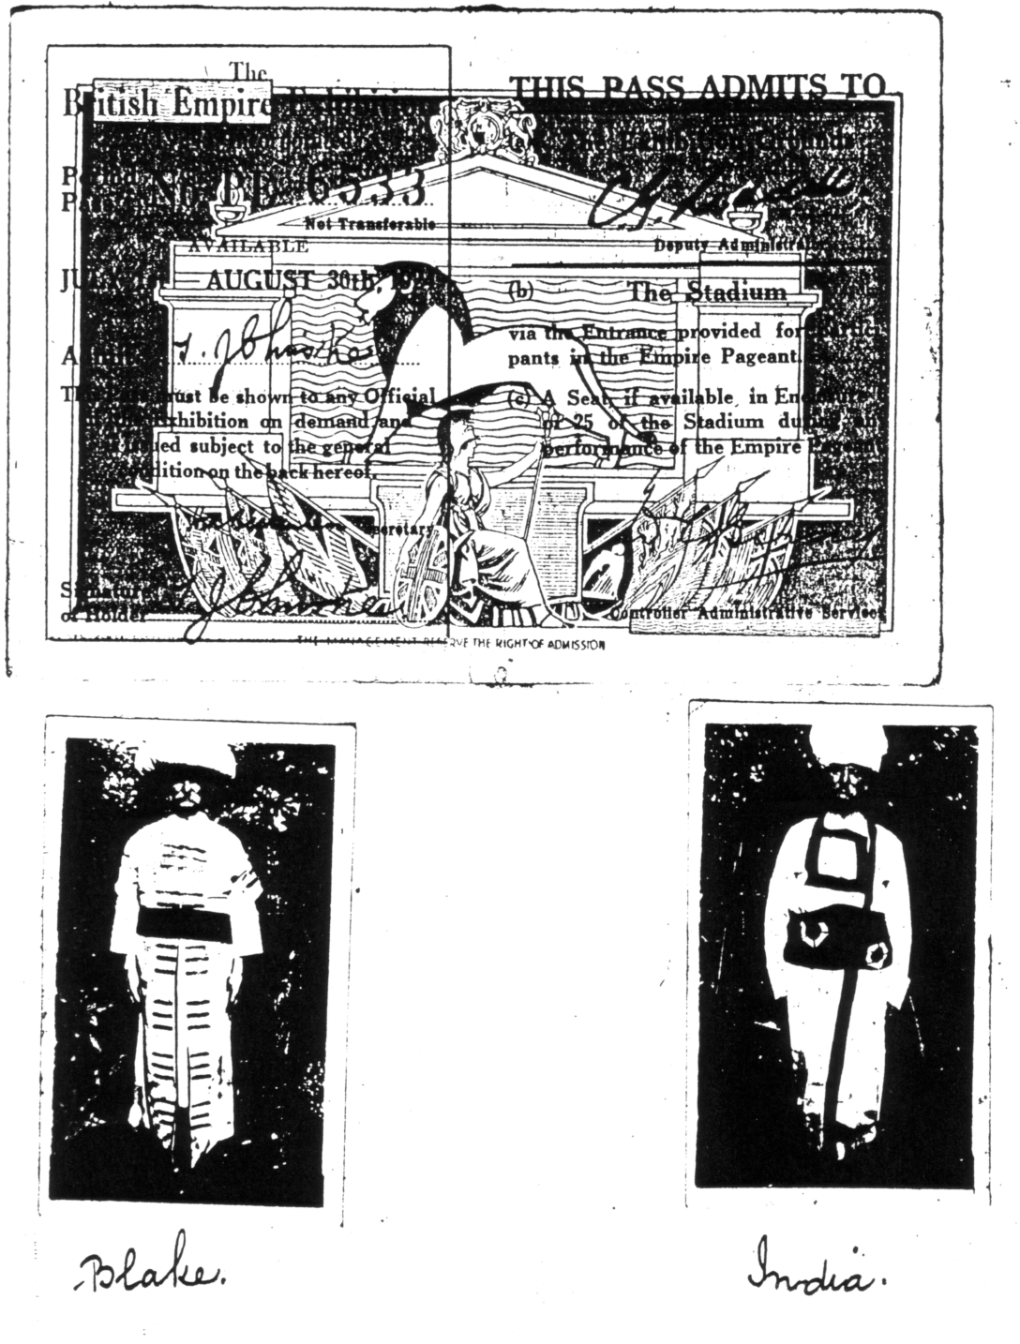

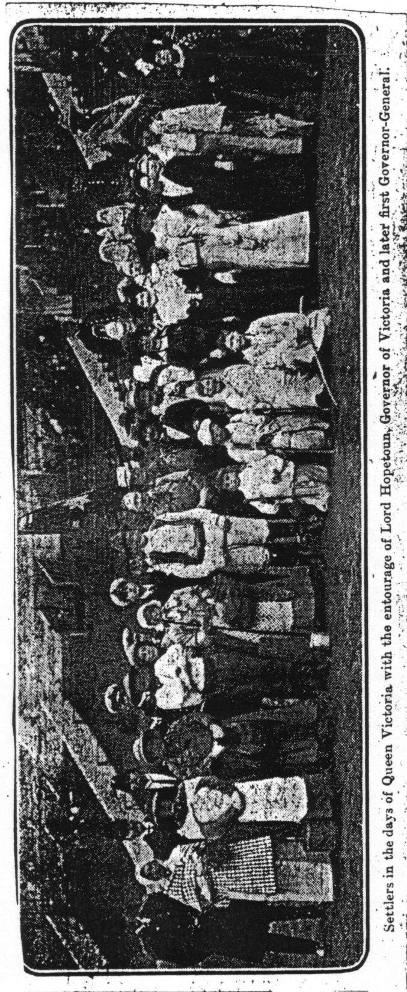

Settlers in the days of Queen Victoria with the entourage of Lord Hopetoun,
Governor of Victoria and later first Governor General

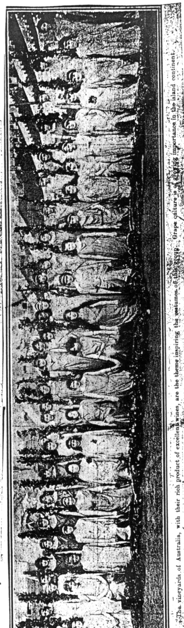

The Vineyards of Australia, with their rich product of excellent wines, are the theme inspiring the costumes of this group. Grape culture is of growing importance in the island continent

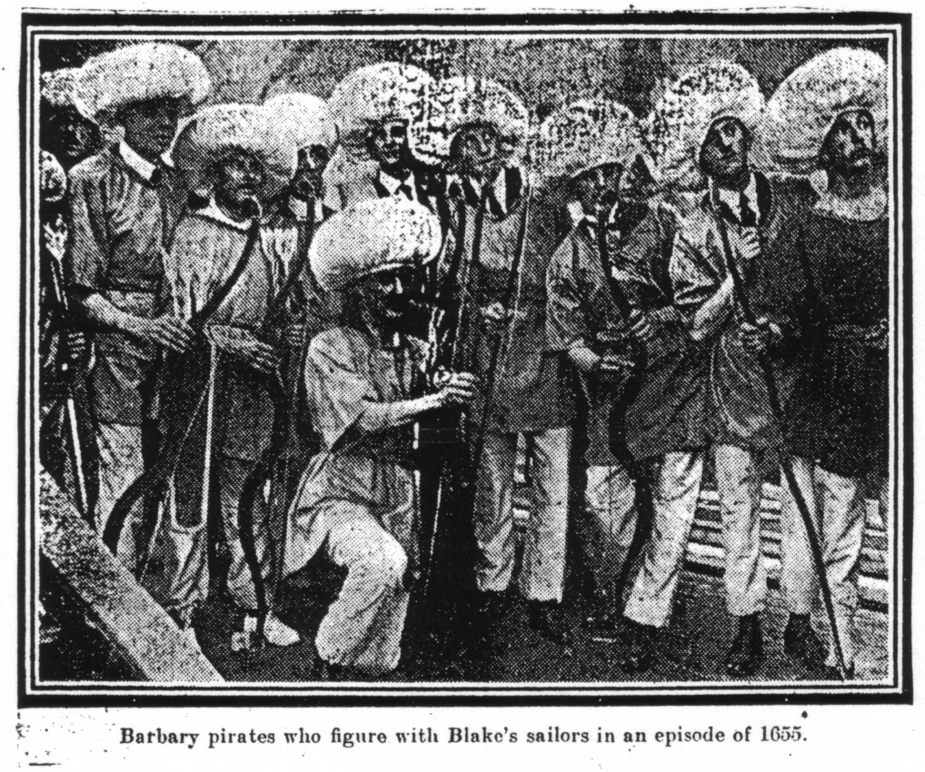

Barbary pirates who figure with Blake’s sailors in an episode of 1655

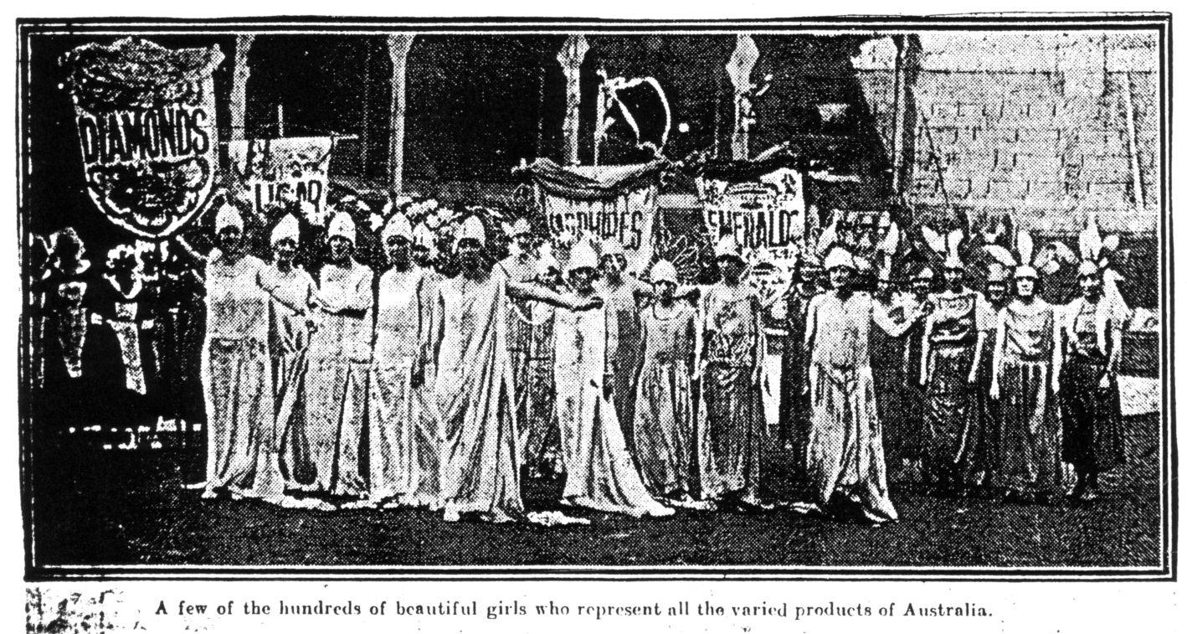

A few of the hundreds of beautiful girls who represent all the varied products of Australia

