Editorial No. 20

After a long winter when members seem to hibernate I have received two contributions for the newsletter, each one is enough to fill an entire issue. Well done Stanley Hunter and Bill Tonkin !
I am afraid that my Exhibition interests certainly went into hibernation over the winter and I'm trying to make up my mind whether it is that this has been brought on by an inability to find or purchase material or that I'm going through a phase when my World War 1 collection is holding sway.
When Bill Tonkin and Mike Perkins made a special visit just before Easter to check over the British Empire cards belonging to Fred Fletcher and myself that really has been my only contact with Expo, members since the annual meeting in September. My visits to the various P Pc Fairs in the North-East and a trip to the York Bipex yielded very little new material and other sources seem to have dried up. The exact opposite has happened with my other interest and I can't find enough time or money to keep going. This seems to be following a pattern over the last twenty odd years and I can remember a period a few years ago when the WW1 interest took a back seat. Perhaps this happens to other members as well , I can't be the only one to have two very different collecting themes?
Enough of my problems. The sun has been shining all day and therefore it has been a gardening day. I can't speak for the rest of the country but we are still enjoying a mild winter that is still with us in June! In a few days time it will be Midsummers day and we have not yet had Spring. Even an avid collector does notice the weather, not that my wife believes that! On a recent holiday in Norfolk I managed to entice her into an antique shop ( that takes some doing) and then persuade her to write a cheque out of the current account for some postcards. Talk about a champagne moment, I think she must have seen the sun shining outside. She has been trying to get the money back ever since. Perhaps other members would like to pass on a few helpful tricks in a future issue.
Now that I have achieved a suitable length for an editorial I can pass on the small amount of news that I have. Bill Tonkin has made all the arrangements for the Annual meeting (last weekend in September-28/29) Please contact Bill (081 777 8861) for details.
Stop Press news from Fred Peskett that the Festival of Britain opens on September 9th. and those members attending the Crystal Palace might be able to fit in a quick trip up the road to fit it in.

June 1991 Andrew B.

California Here I Come!
Part 1 - Interlude in London
Stanley K. Hunter

Few who attended our 1987 AGM in York would have failed to enjoy Burton Benedict's illustrated talk on the Pan-Pacific International Exposition, held in San Francisco in 1915-16 and other exhibitions of that era.
Having resolved to have a holiday in California, I was determined to visit the site of this exhibition if at all possible. A very valuable account is given in Professor Benedict's book The Anthropology of World's Fairs - San Francisco's Panama Pacific International Exposition of 1915. This was published in conjunction with the retrospective exhibition staged at the Lowie Museum of Anthropology in 1982-83.
I also got out my Brooks &Fletcher (Part II) and John Allwood's ‘The Great Exhibitions’. I perused a number of current travel guides and all made fleeting references to the three main San Francisco exhibitions and this made it all the more interesting. I was only going to spend two nights in the city, so I had to plan ahead.
The particular tour left from London. This gave me an opportunity to visit The Twilight of the Tsars exhibition at the Hayward Gallery. I was keen to see the section on Fedor Shekhtel’. This architect was responsible for the Russian Street at the 1901 Glasgow International Exhibition, This was a very popular feature and is seen on a number of exhibition postcards.
As well as Shekhtel’s plans for his pavilions and photographs from the rare Russian booklet of the exhibit, there was a beautiful scale model of one of the pavilions. The model will be going to Moscow but it is hoped that it will be shown in Glasgow. So far only copies of the blueprints of the pavilions have been shown in Glasgow (at Glasgow's Glasgow Exhibition).
Shekhtel was so pleased with his Glasgow pavilions that he used them for his own bookplate (an example being shown). A good deal is being made of whether Shekhtel‘ met Charles Rennie Mackintosh while in Glasgow for there are links with CRM's Glasgow Style and the Russian Hew Style used at the Glasgow exhibition. CRM (whose proposed Concert Hall for the 1901 Exhibition is shown on a University postcard) exhibited at the Moscow Hew Style exhibition in 1902.
I already had a look at the "Mackintosh in Context" exhibition being held at The Building Centre in Store Street. This had been seen in Glasgow last year and shows CRM's participation in a number of European exhibitions, including Turin and Moscow.
I also visited the Royal Institute of British Architects, Portland Place, to see Festival of Britain - 40 fears On. I did not manage to attend the film Brief City and its discussion (Sir Hugh Casson), but enjoyed the display of photographs of the various pavilions Batched with the architects' drawings. In lieu of a catalogue, Here was a Xerox of an article, Bays of Hope reprinted from Building Design (April 26, 1991) which is essential reading for any Festival of Britain addicts.
To mark the 40th anniversary of the Royal Festival Hall, a free party was held there on May 3, reviving memories of 1951 with souvenir tee-shirts (certainly not in vogue then!), etc. Of particular interest was the Festival Portfolio of eight postcards, which must be in every Festival collection.
A display of Festival photographs was advertised, to tell the story of the Royal Festival Hall. I only saw a series of display boards with a few pictures and (as I missed the free party) am not sure if this was the advertised attraction. If so, it was extremely modest. Never mind, I was all set for my flight to Los Angeles!

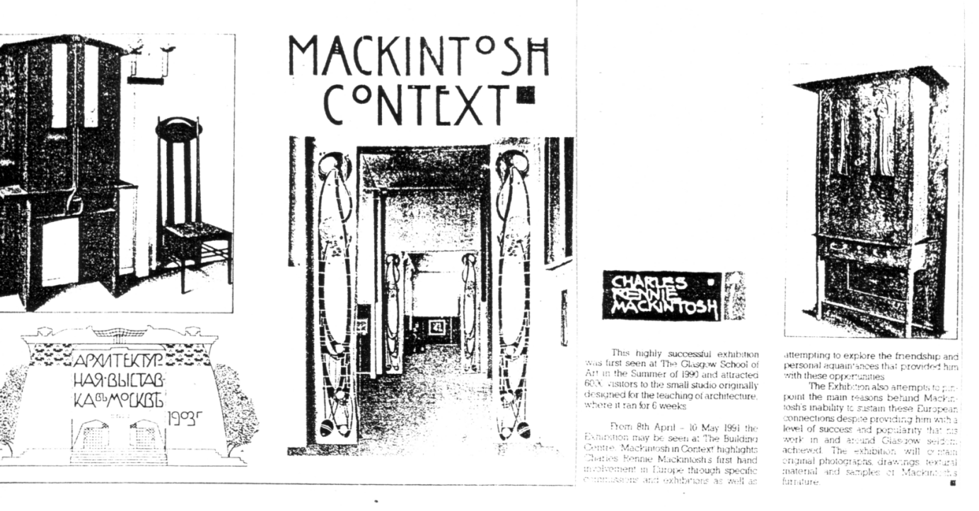

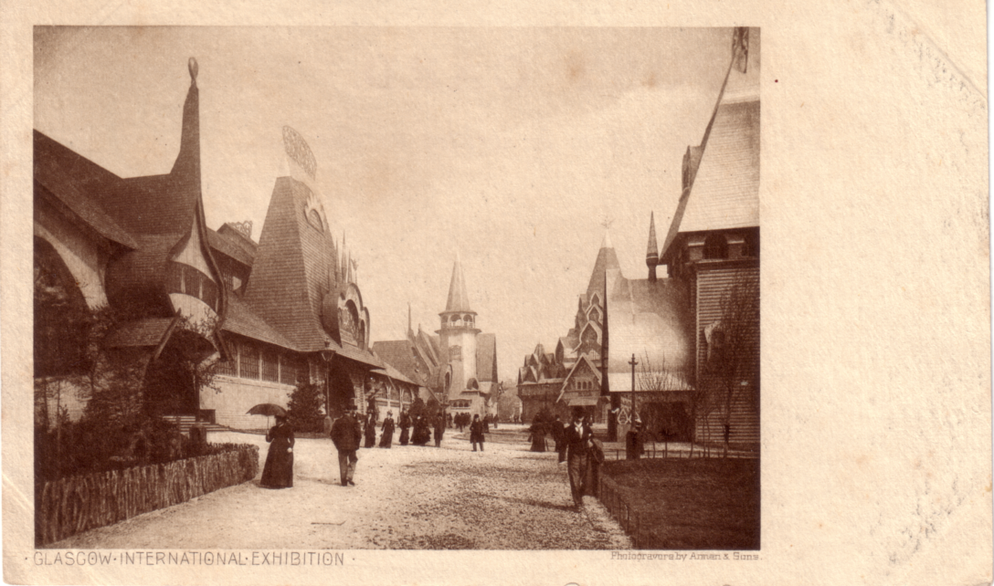

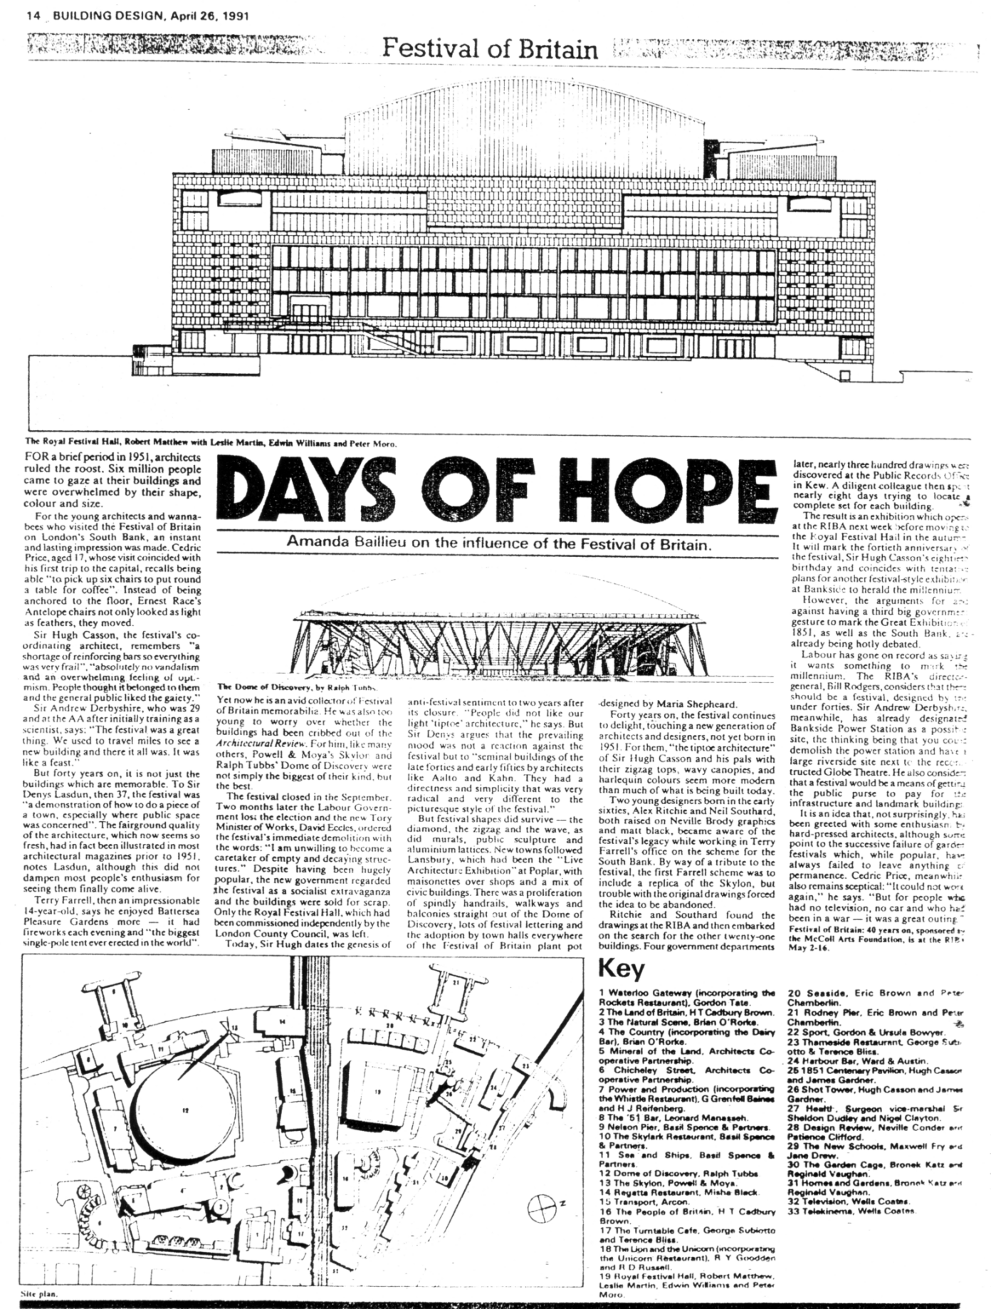

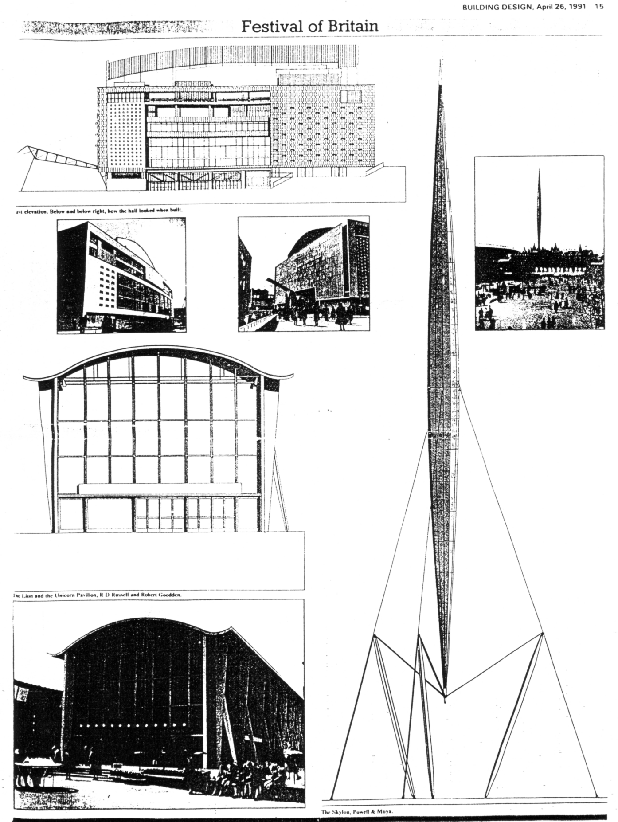

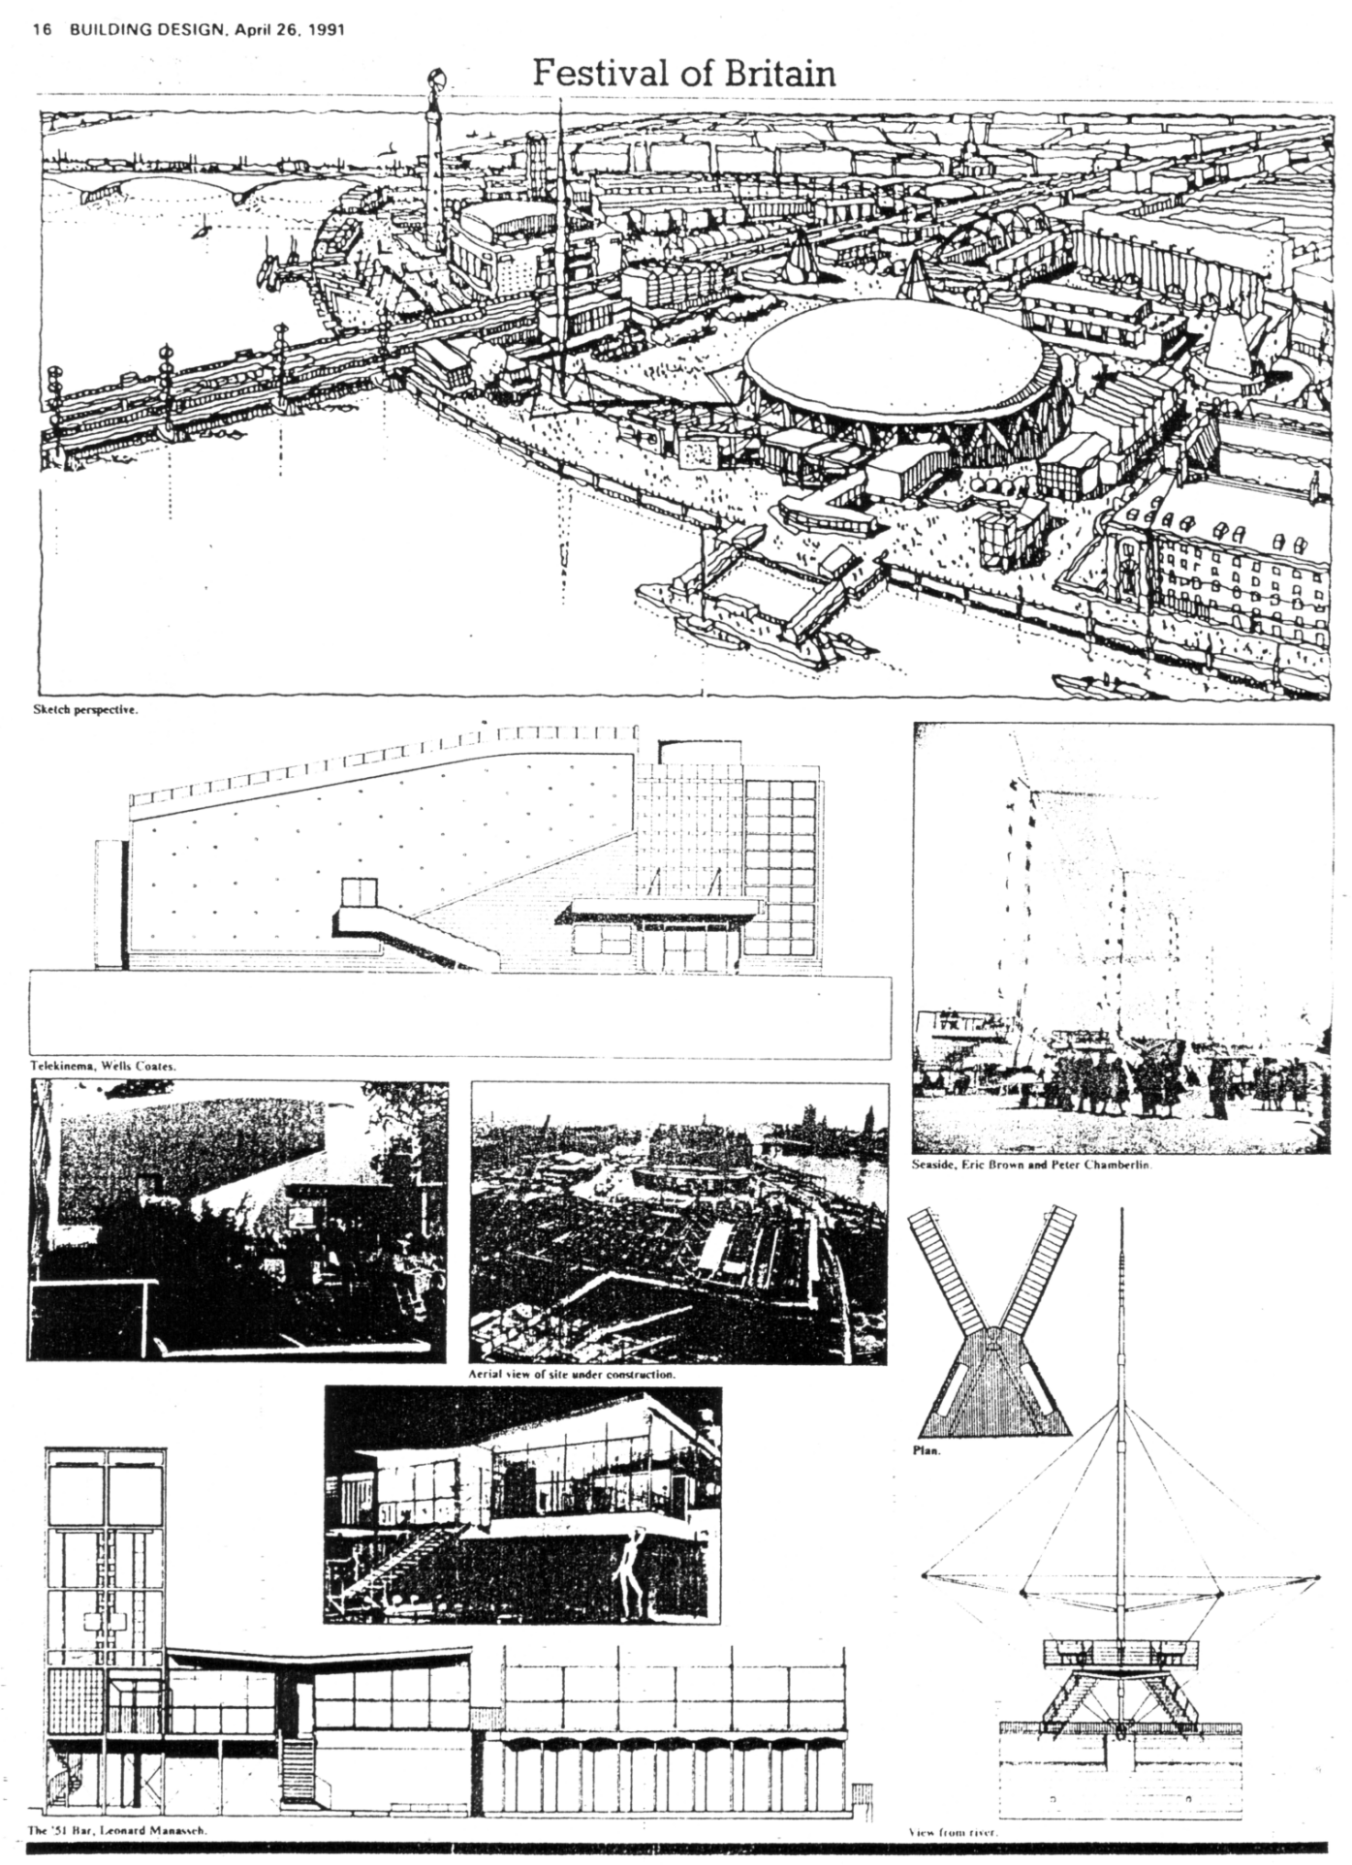

California Here I Come!
Part 2 - California
Stanley K. Hunter

Our first tour stop after Los Angeles was San Diego, to the south. We were given a tour of this lovely city, now the second largest in the state, after LA. At my request, the tour bus visited Balboa Park, which now covers 1,400 acres. It housed the Panama-California Exposition which opened in 1915.
This could have been a serious rival to San Francisco's own show but diplomatic moves ensured that in return for San Diego's support for San Francisco's campaign for national recognition, in 1916 it was given a number of attractions when the ‘Frisco’ exhibition closed. Attendance was 3•80 mn.
Balboa Park now incorporates eight museums and galleries. The California Tower, 200 feet high, is a focal point of the park on El Prado and was built for the exposition. It is now the San Diego Museum of Man and is widely seen on modern postcards.
Balboa Park also hosted the California-Pacific Exposition of 1935-36 and this is featured in the Museun of San Diego History, in Balboa Park on El Prado. A number of the 1915-16 pavilions were used again. Attendance was reckoned to be 7-20 mn.
We toured Mexico, Arizona, Nevada and Utah before returning to California. Our breath taking helicopter flight over the Grand Canyon was marred by the news that a light aircraft of tourists had crashed a few days later and all seven on board had been killed.
After stopping at Visalia, just south of Fresno, I realised that this had been the home of the most celebrated of exposition statues - The End of the Trail. This plaster by James Earle Fraser shows an
exausted Red Indian. It was taken up as the symbol of fate of the native American and widely copied and shown on many postcards, etc. Silvania had the original which was in a distressed state. In a deal with a museum, the town replaced the plaster with a bronze copy.
We entered San Francisco by crossing the SF-Oakland Bay Bridge. This is a curious construction of two separate bridges separated by an island in the middle. The original island was Yerba Buena but an artificial island was added to house the 1939-40 Golden Gate Exposition,
The first important exhibition held in the city was the California Midwinter International Exposition which opened in January 1894. It was held in Golden Gate Park and ran for over six months and had 1-32 mm visitors. An important advocate was Michael H de Young, who had been involved in the 1893 Chicago Exposition. The M. H. de Young Memorial Museum had been erected for the exposition and de Young was entrusted to set up a permanent museum. Originally this only had exhibits shown in 1894. It has been greatly extended and only two sphinxes from the old building survive, when it was rebuilt in 1921.
Nearby is the Japanese Tea Garden which was also constructed for the 1894 exposition, when it formed part of the Japanese Village. After Pearl Harbour, it became the Oriental Tea Garden but it was renamed again in 1952. It is often featured on modern postcards.
To the north of the city lies the site of the 1915 International Exposition (16-87mn visitors). Only the Palace of Fine Arts survives and this only due to popular demand. It consisted of a rotunda facing a lagoon. The actual galleries formed a huge semi-circle around the rotunda. Eventually it fell into disuse and decay. It was pulled down but in 1964-67 it was rebuilt after a popular campaign. I got a handsome poster marking the floodlighting of the building on its 75th anniversary. It is still held in great public affection.
In 1969, the galleries were converted to The Exploratoriam, - the Museum of Science, Art & Human Perception. It is inspired by the modern approach of the Science Museum in South Kensington (financed by the Great Exhibition of 1851!) and incorporates a theatre, The Palace is well represented on modern postcards. It has a two-frame display of relics from the 1915 exposition, There is a little booklet, Palace of Fine Arts - a brief history. I also obtained a more substantial work San Francisco's Wildflower - The Palace of Fine Arts, which traces in pictures the history of the building, I had hoped to visit the Military Museum nearby in the Presidio, the military encampment occupied by the US Sixth Army, Unfortunately the museum - which I understand has a 1915 Exposition collection - was closed due to damage suffered in the 1989 earthquake. The effects are still being felt in the city, While we were there, two workmen were killed in the demolition of the fatal freeway which caused so many casualties,
The tour organised a night trip of the city, including Treasure Island, just off the SF-Oakland Bay Bridge, An excelent view of San Francisco can be seen from Treasure Island, which got its name froa the fact that Robert Louis Stevenson had written his novel while living in the region.
The 1915-16 exposition had marked the revival of San Francisco from the April 1906 earthquake (and fire) and the opening of the Panama Canal. The 1939-40 exposition marked the end of the Depression and the opening of the two spectacular bridges - The Golden Gate and the SF-Oakland Bay Bridge.
We only spent a few minutes on Treasure Island - so I resolved to return the following day. The 400-acre island - constructed for the 1939-40 exposition - was intended to be converted into the international airport for San Francisco. The use by the three China Clippers was one of the highlights of 1939. The exposition administration building was to be the airport terminal and the Palace of Fine Arts and the Hall of Air Transportation were to be aircraft hangars,
The island proved quite unsuitable for civilian air travel and there was satisfaction on the decision to hand it over to the US Navy as a base and go to the Bay Shore for the new international airport.
To-day, there is public access to Treasure Island only as far as the US Navy gates. There is a small public souvenir kiosk, with proceeds going to the Treasure Island Museum. All that survives of the exposition is the admin building and the two huge hangars.
After signing-in at the gate, I went to the admin building which houses the US Navy-Marines-Coastguard museum as well as naval offices. The museum incorporates a splendid section on the 1939-40 expositions (and the building of the Bridges and Treasure Island itself).
The collection has a wonderful selection of souvenirs, including the jewelled key used by the Governor when he opened the exposition. There is a good selection of contemporary postcards on display and a large scale model of the landmark Tower of the Sun, A video runs, showing a variety of contemporary film.
During my visit, a party of church members from San Francisco appeared and I was invited to join them in an exposition film presentation in the lecture room below. An excellent guide gave details of the exposition and we found that a good proportion of the visitors had been at the exposition. I also learned the room had been the secret war-room for the campaign in the Pacific. The exposition, which was intended to cement unity with all countries of the Pacific was clouded by the war between China and Japan and the outbreak of the war in Europe. Germany was absent but Japan had a fine pavilion while China had only managed a private exhibit. As Hitler and Stalin invaded, countries like Norway and the Baltic states closed their pavilions. France fell and its pavilion had to be maintained privately.
The first year (with a winter opening) made a heavy loss. A second, shorter, season, was adapted to concentrate on light entertainment helped to reduce the deficit and clock up a grand total of over 17 mn visitors.
The museum has an association which is presently fundraising to preserve a number of statues which have survived and are on display in front of the building. The souvenir shop retails a good number of souvenirs of the exposition, I purchased a copy of Tbe San Francisco Fair, Treasure Island 1939-40 which is a splendid book of 50 reminiscences, with many colour plates. I also obtained one (of two) anniversary tee- shirts, a medallion, slides, a poster, and s set of repro postcards.
Soon, we were on our way back south to LA and the end of the tour.

