Editorial No. 2.

It is with deep regret that I have to announce the death of Henry Morgan, the well-known and knowledgeable collector of Exhibition ephemera. Fred and I had the pleasure of meeting Henry at the BIPEX 1979 and we were able to thank him for the tremendous help he gave to us in the task of compiling the P.P.C checklists for the Wembley Exhibitions. We had exchanged letters for a period of three years and I intend to publish selected material in the forthcoming issues because he had sound ideas on various avenues of research one could follow and I would not like to think that all his efforts were in vain.
Three members have contributed to this edition, with articles on the Wolverhampton 1902, White City and the Alexandra Palace sites.
I have just received a very comprehensive account of the Australian Exhibitions and this will be in No.3 (Feb. - March) other contributions will be most welcome!
Fred Fletcher would like information on the designers /constructors of the large amusements (Water Chute, Scenic Railway etc.) found at the Edwardian exhibitions and in particular he wonders if anyone can shed any light on J. Calvin Brown (see illustrated card).
Information on Earls Court, Olympia and Crystal Palace is requested by John Allwood - don't expect a reply until the New Year because John is going to be fully occupied with his business commitments for the next few weeks.
I would like advice and assistance in two areas concerning exhibition postcards. Firstly, how should the major catalogues list the cards? I have my own ideas but I would prefer to hear some other ideas before attempting a short article on this topic. Secondly, we are attempting to bring up to date a listing of British exhibitions for which cards are known. We can add at least twenty exhibitions to the original listings in Parts 1 & 2 but there must be many more local exhibitions we have missed.

New member

Percy Oliver
66, Kitchener Street,
Trigg 6020
Western Australia

Change of address

Mrs Sylvia Onions Mr Fred Stephens
89, Hemerdon Heights 19, Leeds Road,
Plympton, St. Johns,
Plymouth. Wakefield,
PL7 3EZ West Yorkshire.
Plymouth 334484 WF1 3JW

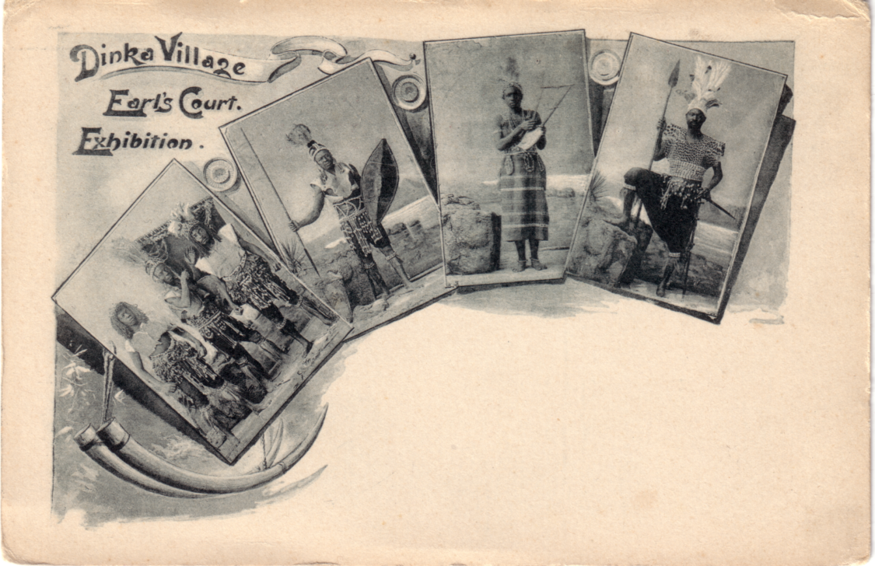

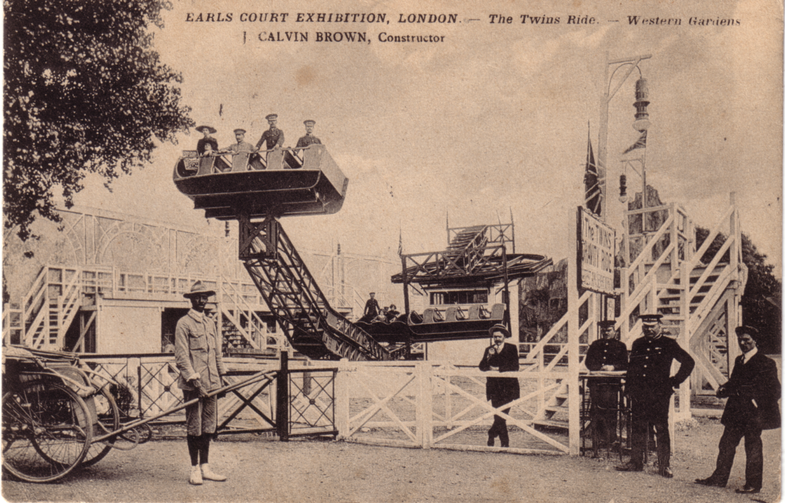

Pictures on front page
S Berger. Publisher R. Mosinger, Zagreb. Coloured card.
Festival of Empire (Rotary ?) Real Photograph
Ideal Home Exhibition 1910 B/W card

Pictures on page 16
Dinka Village Earls Court 1900 B/W card
Calvin Brown Earls Court Year ? B/W card (See note by F. Fletcher)
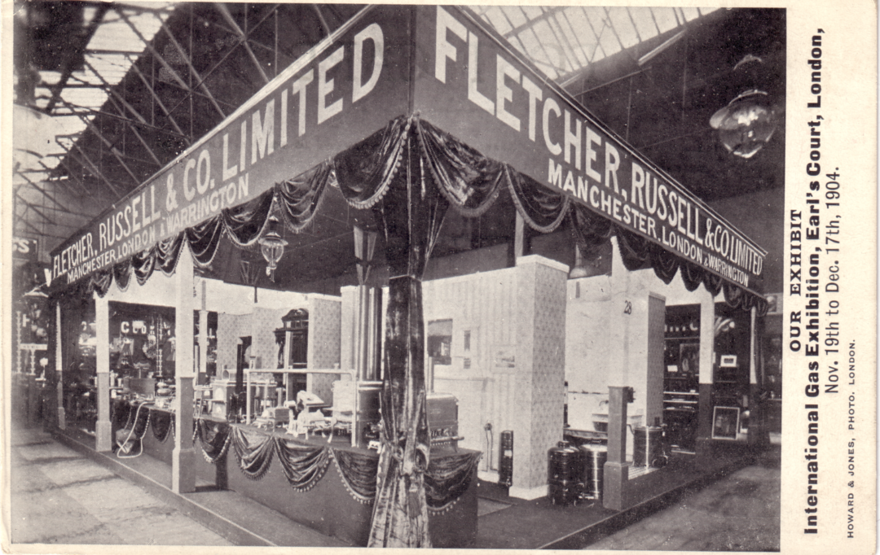

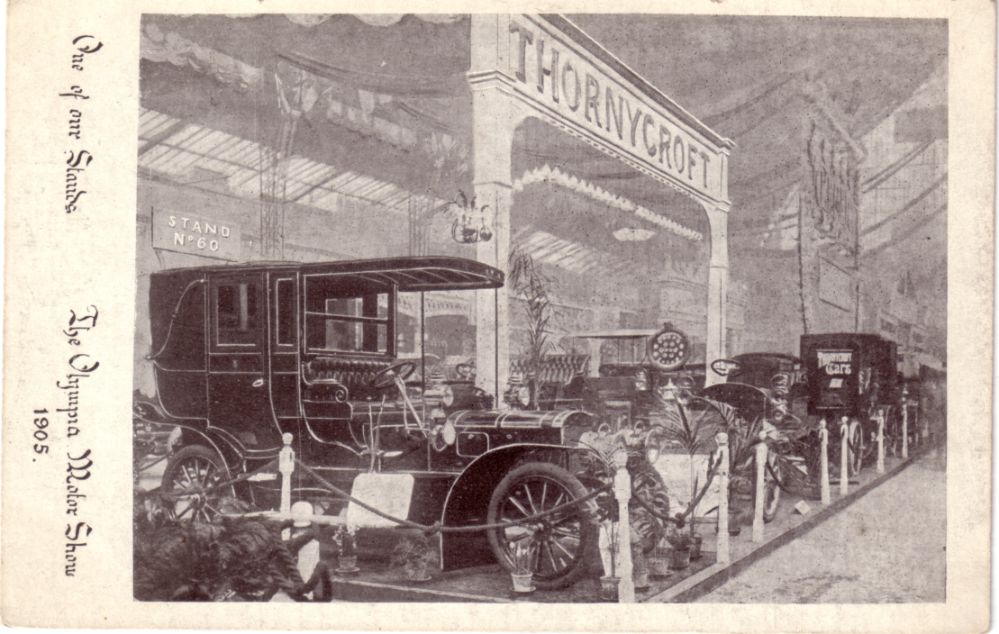

The Wolverhampton Industrial & Art Exhibition 1902
By
Sylvia Onions

The Exhibition was held on the site of the Old Wolverhampton. Race Course which was situated approximately 1 mile from the town centre and this was renamed Test Park. The park is 1¼ miles in circumference and the Exhibition buildings extended into adjoining fields and countryside for about halfway around the park.
The Exhibition was opened on the 1st May, 1902 by the Duke and Duchess of Connaught and Strathcona and was he first major attraction which had been housed in the Black Country for some time.
The entrance had magnificent gates made by Fayliss, Jones and Fayliss (Now G.E.). After entering the gates, the first building was the Industrial Hall which housed stands from such Midland firms such as John Thompson Boilers, George Price Safe Makers, Electrical Construction Company, James Gibbons Art Metal Works, the Beau Ideal Cycles, Joseph Evans hand and power pumps, Edwin Darks tubes and even a Chinese laundry.
The park contained two lakes and one of them had an electric launch and a Swan boat which were used by the visitors to the Exhibition at a small cost. The other lake there was a waterchute which was ascended, by means of a type of ski-lift and was completed by a boat ride which slid down the chute into the lake. There were also punt type boats on both lakes which were on. hire to the visitors, There was one unusual casualty on the waterchute. It would appear that Colonel Thorneycroft, grandfather of Lord Peter Thorneycroft was a passenger in a boat which descended the chute at an angle and hit the water rather roughly. The Colonel, who was in his eighties was injured and died a few months later.
The park also contained a complicated spiral railway, Three band stands one of which is still standing, a kiosk bandstand and a very interesting Shell Bandstand. One band which played at the Exhibition was the very famous Blue Hungarian Band. There were also bands from Germany and several local works bands.
The means of transport from, the town centre to the exhibition was by tram and a special tramway called “The Lorrine System" was opened in conjunction with the opening date. The whole of the exhibition grounds and part of the town centre of Wolverhampton were illuminated by electrical lighting.
The entrance to the Exhibition was by special daily programme which cost a penny and visitors could obtain meals at one of the two restaurants in the grounds.
Alas the Exhibition was a financial flop because of the appalling weather in 1902. It would appear that the summer was ruined by torrential rain and for years afterwards a very wet summer was always remarked to be "Exhibition weather” by the local people.
The Express and Star, a well-known Wolverhampton based newspaper was one of the backers of the Exhibition and they had a soft pencil drawing of the grounds by George Phoenix, a local artist on display in Wolverhampton Art Gallery. There were several prints sold at the time to visitors but not many seemed to have survived.
One of the small kiosks was later used in Wolverhampton until recent years and a Black Country Folk Singer, Jon. Raven fought hard to try and get it restored. However the local authority had it removed and it is now in a transport museum. It had been used as a bus shelter and I wonder how many passengers knew where it originated from.
It would appear that the firm of W. H. Whitlock were the sole printers of post cards of the Exhibition. It is not known how many different cards were issued because the same views were in sepia and black and white both in vertical and horizontal format. I have 16 unused cards and they are as follows:

Machinery Hall and Chute Swan boats
Canada section Spiral toboggan
Industrial Hall View of Exhibition
Shell bandstand Canada buildings (Horizontal)
View from the West House of many troubles (Maze)
View from the Water Chute Water Chute
Machinery Hall Water Chute (Different view)
General View Concert Hall

I considered that I had a complete set until I saw a book printed by W. H. Whitlock which contained about 24 pictures of the Exhibition. None of my postcards are numbered in way so if
anyone can help.?
For those interested in prices of the era, an Italian Bedstead with brass mounts sold for £1.16s 6d, a childs cot for 11s 8d, and a London model hat for 15s l1d.
I also collect ephemera from Exhibitions and I recently acquired in Tavistock, of all places a Glass Jug made by the firm of John Baird, Glasgow at the Exhibition. The jug is engraved “Sarah Knowles” and shows a general view of the grounds with a leaf pattern on each side. It is a most beautiful piece of glassware in perfect condition and is a good example of the capability of the workmanship of almost 80 years ago.

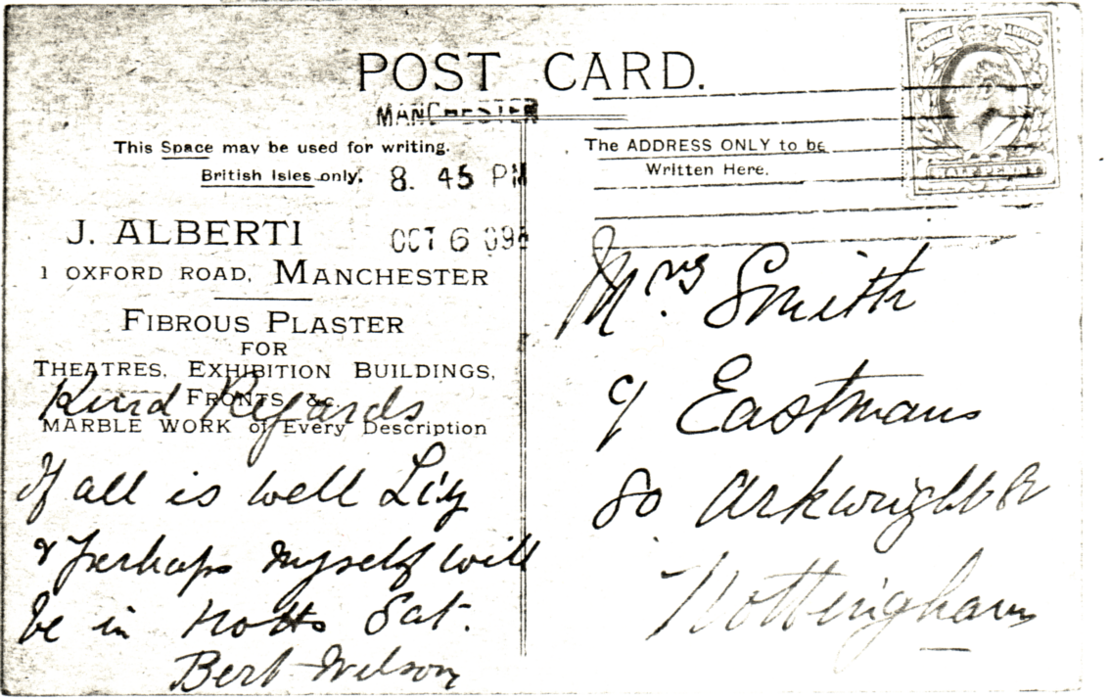

White City
By
Don. R. Knight

The subject of exhibitions seems to be endless. Part of the fun is looking for additions to ones collection at ephemera meetings, stamp and antique fairs etc.
I first became interested in the subject of the White City Exhibitions more than 7 years ago whilst collecting postal history. Having seen the many postmarks and picture postcards from the exhibitions I decided to continue with the subject and find out more about the history of the buildings and grounds. The ephemera from the White City will continue until the White City Stadium ceases to hold greyhound race meetings.
The official guide for the Franca-British Exhibition cost 1/-. There were several editions of which I have No.’s 4, 5 and 6, I also have the daily programme priced 3d for 25 August, 15 September and 10 October. The official souvenir consisted of 16 pages which included 4 pages of description about the exhibition. The black and white souvenir from the exhibition was 8" by 10" in size and appeared in two versions one as the souvenir and the other presented with the compliments of three companies P.B. Burgoyne & Co., Ardath Tobaoco Co. and Moet Chandon with full information about the companies printed on the back.
A programme for the fifth day of the Olympic Games 17 July was printed with 40 pages, cost 6d and contained the general rules. The full records for the Games were published in a 236 page book by the Sporting Life.
There also exists a 16 page programme dated 23 July 1906 for Mrs Jesse Boot's party to the exhibition, a guide by Ward-Lock A Co. to London and the Franco-British Exhibition, a printed paper serviette for the visit of the French President on the 25-29 May to London, sheet music written by Ezra Read entitled “Around the Exhibition” and two special edition newspapers by the Daily Mail for July-October and August-October. I have not yet found any ephemera from the 1909 Exhibition.
The guide for the Japan-British Exhibition 1910 was printed in several editions of which I have No.s l and 3. I also have a daily programme for the 27 August, a card issued for advertising purposes by Formosa Tea Co. which when opened resembles a bamboo screen and sheet music by Oscar Verne “Japan in London”. I have no items for 1911 but I do have a daily programme for the 19 October 1912.
I have nothing for the years 1913 1914 but it was in this year, 1914 that the last major exhibition was staged here.
The Stadium was purchased by the Greyhound Racing Association in 1926 and one year later the first greyhound Derby was run. I have a race card for 24 May 1934 and I wonder how many are still around today as on the back page is printed “For a complete record of racing and trials at this track detach this page and retain it for reference”, Derby programmes for 1937-39 1977-79 and a Golden Anniversary 1927-77 programme.
Speedway came to the Stadium on the 19 May 1928 and I have a 4 page race sheet from this meeting as well as a single sheet for the 29 August 1928 meeting. The first White City Rebels race meeting was held on the 24 March 19/6 and the last on the 13 September 1978. Two championship meetings were held on 1 July 1979 and 5 August 1979.
The Amateur Athletic Association first field its A.A.A. championships in the Stadium. in 1908 and in 1932 on the 1-2 July on a new track held the first of 33 champion ships. I have the 1932 programme of 64 pages, and the programmes for 1951-55, I also have the programmes for
The British Games 1938, 1946 and 1951-57,
Festival of British Games 1951
U.S.A. v British Empire 15 August 1936,
Great International Athletics meeting 2 August 1937,
Polytechnic Harriers 29 May 1937
Athletic meeting U.S.A. the. R.A.F. A.A.A. 6 August 1945
Metropolitan Walking Club 14-15 June l946,
Floodlit athletics 21 September 1955 12 September 1956
British Empire & Commonwealth v U.S.A. 14 September I960
Oxford. & Cambridge v Harvard & Yale 23 June 1951,
Great Britain v France 4 & 6 August 1951
Caledonian Games 13 May 1950 30 May 1953, and
London Fire Brigade A.A. 31 August 1968
Boxing programmes include
Gus Lesnevich v Freddie Hills 26 July 1948,
Bruce Woodcock y Freddie Mills 2 June 1949«
Football programmes include,
Queens Park Rangers 2 & l6 March for season 1962-63.
The items mentioned are in my collection and 1 am always on the look- out for more.

Any information available regarding this exhibition card please write to Alison Finch 7, Lansdowne Cres, Bath.
History of Alexandra Palace
by
John Allwood (c) 1980

The success of the Crystal Palace at Sydenham in South London had led many people to consider the possibility of a similar 'People's Palace in North London.
Duringthe first half of the nineteenth century London’s population had doubled and the audience for such an enterprise was certainly there. In June 1856 Cecil Rhodes great uncle, Thomas Rhodes, died leaving Tottenham Wood Farm, a 450 acre dairy farm, to his grandchildren.
They decided that the property could be put to better use and, on 12 November 1858, “The Times'' carried a prospectus for the development of part of the Farm into a 150 acre Park including a 'Palace of the People' with the remaining 300 acres available for sale as residential building land.

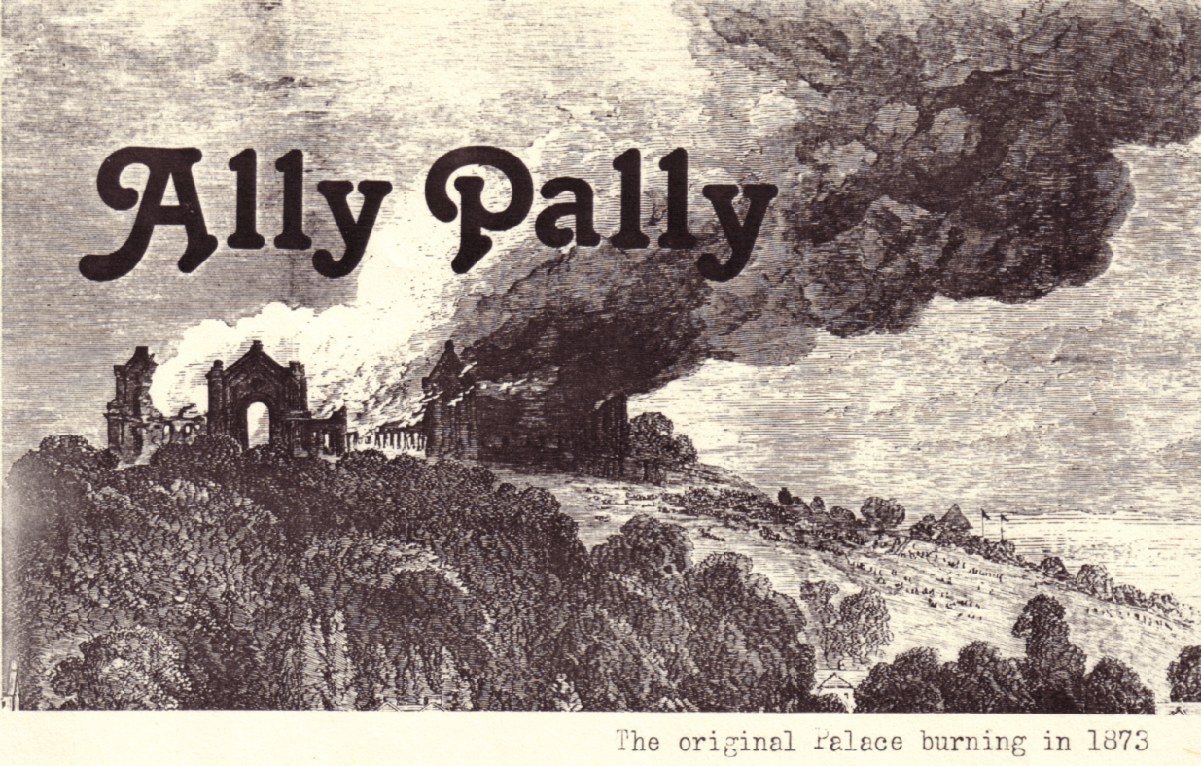

A 'Palace of the People' was designed by Owen Jones whose colour scheme for the original Hyde Park Crystal' Palace had been such a success and who had been deeply involved in the production of the historical sections of the Crystal Palace at Sydenham, not surprisingly, it took the form of another glass palace. It had a huge central glass dome covering a winter garden, a concert hall, an enormous 10,000 seat theatre and plenty of space in colonnades and the main naves for exhibitions, refreshment rooms and sales areas.
Railway passengers were to arrive in a. station directly beneath the Palace specially built by the Great Northern Railway who were not slow in seeing the passenger potential of an amusement centre alongside 300 acres of new housing development.
In March 1860 The Great Northern Palace Company Limited was announced with a share capital of £400,000. But the public were not interested end the plan failed to materialise. As a result of this failure the Muswell Hill Land Company was formed to manage the Farm until its future was decided.
Two years later, in August 1862 a second prospectus was issued by a different group. The North London Park and Land Company Limited put forward their proposals that 200 acres of the Farm should be used for a public park with the remaining 250 acres being sold for ‘first class building’ and the Tottenham Wood House remaining for development as a 'first class hotel'. The share capital was set at £250,000 and this time the plan met with some success.
A year later, on 23 July 1863, the park finally opened with a Grand Horticultural Fete. In the meantime the name of the park had been changed. It was to be called Alexandra Park in honour of the new Princess of Wales, Princess Alexandra of Denmark, who had married the heir to the throne a month previously. The company also changed its name to the Alexandra Park Company Limited.
The Times correspondent who attended a private view a few days before the official opening was impressed: to say that “Muswe11 Hill Park is well timbered gives but a faint idea of its rare sylvan beauty even in England, where only the true meaning of parks is understood. “There are walks, some mere shrubberies, some wider, grander and more ambitious, and one, the oak walk, which is as gently darkened as an old cloister and is in its way a kind of old cathedral of trees. Beyond this fine oak walk, beneath the thick shade of which there runs a kind of silence in the vegetation, and only soft cool mosses grow, the path leads up across the meadows to a steep hill, which in the future is to be Muswell Hill proper, for on this is to be built whatever building is intended for the Alexandra Park.” He goes on to mention the plans for the revival of the 'people's palace' idea - 'On this hill it is, we believe, intended to erect a large proportion - the nave, domes, side courts, transepts - in fact, all glass and iron structure of the exhibition Building'.
The 1862 International exhibition building had remained empty on its Cromwell Road site since the close of the exhibition. Finally, in July 1863 the government decided against purchasing the building and allowing it to remain at South Kensington and demolition was already under way when the Alexandra Park Company started negotiations for the purchase of all parts of the structure except the art galleries. At the end of I860 agreement was reached with the 1862 Exhibition Commissioners and the building contractors who owned the structure and preparatory work was started on Muswell Hill to receive the new building, Mr Alfred Meeson of Meeson & Johnson designed the new Palace using the materials that it was possible to save from the 1862. exhibition building. The new Palace had a S00 ft. nave, a central transept of 430 feet and two smaller 320 ft. transepts, all 65 feet wide. » central dome 220 feet high was planned to surmount the Palace.
At the same time a cricket field, archery ground, tennis courts, a large gymnasium and a race course were also planned for Alexandra Park. The ideas that Thomas Rhodes grandchildren had had seven years before were finally becoming fact.
The destruction of the 1662 exhibition building was carried out by Messrs Kelk & Lucas, the firm that had originally built it and still owned the structure. They were also responsible for building the new Palace on Muswell Hill.
During the building work the Alexandra Park Company held a series of special events including flower shows, a Horse Artillery -Field Day and the 21st Annual Meeting of the United Kingdom National Archery Association. All highly successful events. Disaster, however, was not far off.
In March 1865 the Alexandra Park Company went into liquidation and many of the firms involved in the Palace project went with them. In August 1865 the situation was resolved by the formation of two new companies - the Muswell Hill Estate Company to look after the housing estate and the Alexandra Palace Company to take over the running of the park and park buildings, including the thus named Alexandra Palace.
The racecourse, to this day London’s only horse racing course, opened in 1863 but was not a success. A second opening in 1872 was much more successful and racing took place before crowds of up to 30,000 on a much improved course although the tight turns still caused complaints from the jockeys.
Finally, on May 24th 1873, on Queen Victoria's 54th birthday, the Alexandra Palace opened after nine years of struggle with financial and building problems. It had cost £504,724.
Sixteen opening days later it was gone. Burnt to the ground in a fire which appears to have started through the carelessness of men working on the zinc roofing of the great dome. In only a few hours nine years work was lost.
The Directors of the Alexandra Palace Company met on the afternoon of the fire and resolved to continue with a full programme of outdoor events and to rebuild the Palace as quickly as possible. The next day they met with Mr John Johnson of Meeson & Johnson, their architects, and instructed him to immediately prepare new building designs and to start reconstruction as soon as possible, hopefully in time for the new Palace to open in twelve months time.
Their rush to replace the Palace was not surprising. They had only had sixteen days in the last nine years when any sort of revenue had been coming in to cover the. cost of the building. They had to find money quickly. The lost Palace had only been insured for £124,000.
It was not enough to cover the cost of a new building. Once again the company had to turn to the public. They issued a prospectus calling for £150,000 but, as before, the public failed to take up the shares. The original parties to the agreement that had been drawn up therefore had to find the necessary money from their own resources.
As might have been expected the architects did not take any chances the second time around and ‘a lake and four huge water towers were prudent features of the new design'.
The new Palace cost £232,000 and a further £100,000 was needed before it could open to the public once more. The Alexandra Palace Company was under ever increasing financial strain and it never stood a real chance of recovering even a small part of the large sums of money spent on the erection of the two Palaces.
Inevitably the Company failed. It could not even afford to pay the interest on the mortgages taken out to pay for the first building!
The Palace was put up for auction in 1877 along with the surrounding land but failed to make its reserve. In 1678 three separate parcels of land around the Palace were auctioned.
In May 1877 Messrs Bertram and Roberts leased the Palace and Park from the London Financial Association who had bought out the first mortgagees and now owned the Palace. They had been the catering firm at both the Alexandra Palaces and had, unlike the owners, made a good enough living from it to want to see the venture continue. They were even able to get permission to run races on the racecourse once more by paying off the stakes from previous races that the Alexandra Palace Company had been unable to pay.
Like the other great London entertainment centre at Sydenham the fare offered at Alexandra Palace and Park consisted of everything from exhibitions to elephants, from magicians to military dinners, from pantomimes to pyrotechnics. Even so over the years the Palace was shut for almost as long as it was open! In the first twenty-five years of its life it was open for iust over ten years and in that time eight different managements failed to make it a success, five of them ended in bankruptcy. In 1396 even the London Financial Association finally gave up the struggle and wound itself up. In 1891 they had tried to sell off the Palace and Park to the surrounding local authorities but without success.
In 1900 the Palace and Park finally went into public ownership under the ‘Alexandra Park and Palace (Public Purposes) Act, 1900’ which was ‘an act to constitute a body of Trustees for the purpose of acquiring the Alexandra Palace and other lands in the county of Middlesex and to empower them to hold and manage the same as a place of public resort and recreation and for other public purposes and to make all provisions necessary or proper in that behalf’, it was a fine sounding document and the surrounding local district councils all joined in providing £150,000 to purchase the property. The problems, however, were not to be solved by yet another change of ownership, it would take much more than that 'to change the fortunes of what was called in the press this 'melancholy monument to miscalculation’. The only real change was that now it was the rate payers who suffered the losses'.
They struggled through the early 1900s and even managed by 1917 to get to the point of paying off the outstanding loans made when the Palace was built but the First World War brought all their efforts to a grinding halt. By March 1915 over 38,000 Belgians had filed through the Palace which had been made into one of three emergency refugee centres in the London area. Immediately after this the Palace and park became home for the German prisoners of war. Not until 1920 was the Park open to the public again and the Palace which had, by then, been taken over by the government as offices was not to open again until February 1922.
Through the inter-war years the Trustees struggled on. In 1935 hopes were revived with the news that the BBC had chosen Ally Pally as the site of the world’s first public television service. Unfortunately the work needed to make the building habitable soon got rid of the profit made from the rent. Even greater hopes of final success were heralded by the news a year later that the Crystal Palace had burnt down. Although a few events transferred to the Palace the fire only resulted in the BBC being able to build their second London television transmitting mast at the Crystal Palace site. Ironically, television was to be the entertainment media that finally finished many of the types of events that places like Alexandra Palace could offer. Why climb up Muswe11 Hill in the rain to a mediocre seat at a concert on the Great Organ when you could enjoy a prime seat and perfect sound reproduction in the comfort of your own hone?
In 1963 the London Government Act abolished the District Councils that the Trustees represented and in 1966 the Alexandra Park and Palace Order made the Greater London Council directly responsible for the property.
Having spent nearly £500 000 a year just keeping the fabric in one piece, the Greater .London Council' sold the building, in January 1930, to the London Borough of Haringey for £1 and gave them a grant of £8 million towards renovating it.
The major part of Haringey's redevelopment work was about to begin when, on Thursday 10 July 1930, the main body of the Palace was once again burnt to the ground. Ironically, the 200 firemen that attended the blaze managed to save the BBC studios, now used for Open University programmes, mostly because of a special fire wall that was built to protect the rest of the Palace from the fire hazard of the BBC Studios! The Great Hall and much of the remainder of the Palace was gutted.
Luckily Haringey had increased the insurance cover when they took over the building and there should be about £31 million insurance money available. The major parts of the Great Willis Organ, where the fire started, had been removed by its builder's great grandson, Henry Willis IV, who was in the process of repairing it and even this could be rebuilt. Perhaps we could finally see a major new London Exhibition Complex to rival Birmingham's National exhibition Centre.
It remains to be seen if anyone is willing to take on the Ally Pally Curse which is supposed to have been cast on the site by an old woman - supposedly a witch who was evicted from Muswell Hill when the first Palace was built. Certainly the Palace has had more than its fair share of bad luck over the last 117 years.

Does anyone know anything about the travelling exhibition shown on this card ? The organisers were All-British Touring Industrial Exhibition Ltd, 446 Sirand, London 102. Informalion please to:
John Allwood Hortondene Ightham Sevenoaks Kent TK15 9HE
Items wanted by John Allwood, Hortondene, Ightham, Sevenoaks, Kent TN15 9HH (0732 882654)
Books
‘Notes and Sketches of the Paris Exhibition’ by George Augustus Sala. Tinsley Bros. London 1860. 396pages.
‘Exhibition and Display’ by James Gardner and Caroline Heller. Batsford. London (? l960).
‘Vie Prestigieuse des Expositions Historicues’ by P Dupays. Paris 1939.
‘Industrial Exhibitions and Modern Progress’ by P Geddes. Edinburgh 1837.
‘Les Expositions Universelles Internationales’ by H G Berger. Paris 1902
‘World’s Fairs from London 1851 to Chicago 1393’ by C B Norton. World’s Columbian Exposition. Chicago 1893.
‘Eighty-Eight Not Out - A Record of Happy Memories’ by Harold Hartley. Fred Muller. London 1939. 319 pages.
‘Pour National Exhibitions in London’ by Charles Lowe.
‘The Pagin Origins of Fairs’ by T. F. G. Dexter. New Knowledge Press, Perranporth 1930.
‘San Francisco’s Wildflower - The Palace of Fine Arts’ by E E Burden.
Phoenix Publishing. San-Francisco 1976.
‘Journal d’un Negre a 1’Exposition’ by G Bergeret, Paris 1901.
‘Samantha at the world’s Fair’ by Joseph Allen’s Wife. Chicago 1893.
‘Hiram Birdseed at the Lewis & Clark exposition’ by ?. Portland 1909.
Information
British Empire Exhibition - Wembley 1924-25
Information about the exhibition and, in particular, any trace of the official records of the company records of the private company that ran it - The British empire Exhibition (1924) Ltd - which was finally wound up on 15 March 1928. All the obvious place have been searched without success! If anyone has a spare copy of A. M. Low’s book ‘Wonderful Wembley’ I should be interested in buying it.
Earls Court and Olympia
Imre Kiralfy (died 1919) produced and presented many spectacular shows at both Olympia aid Earls Court before he went on to the White City and the Franco-British Exhibition and the subsequent exhibitions there. He seems to have started his career in America but his early life seems to be un-recorded. Any help with his origins and the reasons that he ended up involved in these massive spectacular events would be of great interest.
I am always interested in obtaining copies of diaries, etc. with good personal details of visits to major exhibitions as well as material on exhibitions of general interest.

British Exhibitions Commemorated by Post Cards

London
Earls Court
1893 Gardening & Forestry
1897 Victorian Era
1900 Women’s
1901 Military
1902 Paris in London
1903 International
1904 Italian
1904 International Gas
1905 International Fire
1905 Naval, Shipping & Fisheries
1906 Imperial Austrian
1907 Balkan States
1908 Hungarian
1909 Golden West & American
1911 International Ancient Art
1912 Shakespeare’s England
1913 Imperial Services
1914 Anglo Spanish
Olympia
1905 4th International Motor
1908 Worlds Mining
1908 Commercial Motor Vehicles
1910 Business & Advertising
1910 Daily Mail Ideal Home
1912 Children’s Welfare
1912 Daily Mail Ideal Home
1913 British Music
1913 Daily Mail Ideal Home
1913 Building Trades
1913 3rd International Road Congress
1920 Building Trades
1920 Daily Mail Ideal Home
1921 Daily Mail Efficiency
1922 Daily Mail Ideal Home
1923 Daily Mail Ideal Home
1924 Daily Mail Ideal Home
1925 Nations Food
1932 Young People ?
1932 Telephone
1933 Aberdeen
1935 Telephone
1936 Daily Mail Ideal Home
1936 SPG ?
1937 Daily Mail Ideal Home
Crystal Palace
1905 Colonial
1908 Mexican
1911 Festival of Empire
1913 Anglo-German
1920 Imperial War & Victory
1921 Fruit
1922 Fruit
White City
1908 Franco-British
1909 Imperial International
1910 Japan-British
1911 Coronation
1912 Latin-British
1914 Anglo-American
1921 British Industries Fair
London general
1890 Uniform Penny Post Jubilee
1891 Royal Naval
1902 Tramways & Light Railways
1906 3rd Printing & Allied Trades
1906 Bakers & Confectioners
1907 South African Products
1915 British Industries Fair
1916 Daily Mail Active Service
1917-8 War Bond Campaign
1924 British Empire
1925 British Empire
1927 Belgian & Flemish Art
1928 London Stamp
1947 British Philatelic
1951 L C C Open Air Art
1951 Festival of Britain
1951 Sherlock Holmes
1969 The Chinese
1982 The Great Japan
1982 British Philatelic
1982 National Postal Museum
Provincial
1890 Old America
1902 Wolverhampton
1903 Nottingham
1904 Bradford
1904 Newcastle
1904 Congress
1905 Cheap Cottages
1905 Newcastle
1905 Ye Olde Plymouth
1905 Salisbury
1906 C W S
1907 Loughborough Electrical
1908 North of England Cottages
1908 Hull
1908 Redruth
1908 Manchester
1909 Devon & Exeter Art
1909 Liverpool Autumn
1909 White City Manchester
1911 Coronation Manchester
1911 Bristol & West of England
1913 Liverpool International
1913 Doll ?
1914 Bristol International
1916 Loos Trenches
1929 North East Coast
1930 Welsh Empire
1936 1st Voyage of the Queen Mary
1936 3rd International Stamp
1966 Friendly Cities Postcard
1982 Birmingham National
1983 Royalty & Railways
1980 Great Railway
Scottish
1901 Glasgow International
1903 Highland & Jacobite
1903 Scottish Home Industries
1903-4 2nd East End Industrial
1904-5 Scottish Nat- Antarctic
1906 Falkirk & District
1907 Toy
1908 Scottish National
1911 Scottish National
1914 Russian
1928 Furniture Trades
1938 Empire
Irish
1902 Cork International
1906 Munster Connaught
1907 Irish Manufacturers
1907 Irish International
1909 Belfast Irish Week
1911 Ul Brasail Health & Industrial
1914 Civic
Missionary
1906 C of E Crystal Palace
1906 Bristol
1907 Great Missionary Swansea
1907 C E T S Crystal Palace
1907 Medical Newcastle on Tyne
1907 Manchester
1907 C of E Manchester
1907 Palestine in London
1907 Taunton
1908 Orient in London
1909 South American Dublin
1909 Africa & the East London
1909 Baptist
1909 Church Missionary
1910 Africa & the East Birmingham
1910 Orient Hull
1910 Africa & the East Belfast
1912 Africa & the East Nottingham
1923 Birmingham St. Joseph’s
1928 Congo Jubilee

