Editorial No 19

A few weeks have passed since the Exhibition Study Group held their Fourth Annual Conference, this time at an actual exhibition site, the world famous Crystal Palace. At the request of the members present I intend to give an account of the weekend in a separate article. This will be delivered in two parts, firstly an account of the A. G. M. , which is now always held at this meeting and secondly an account of the displays and social events.
As we move into 1991 may 1 send out a special request for articles, items or even reminiscences about the 1951, Festival of Britain. I managed to obtain a few promises for articles at the Crystal Palace but many of you who could not make the weekend must have made a personal visit to London in 1951 !
The Daily Mail Checklist will be published as a booklet for sale during 1991 and I would like you to send any additions to the published list so that they can be incorporated into the computer for the new print-out. Essentially the booklet will be Newsletter No. 16 with extra illustrations. We hope to sell about 50 copies by placing an advert in the Picture Postcard Monthly magazine.
Apart from the details of the A. G. M. and the rest of the weekend , in this copy you will find reprints of an article from " The Amateur Photographer and Photographic News ". This was provided by A. Smith who has many similar items in a run of this magazine. Bill Tonkin provides additions and updates to the D. M. I. H. E.
Information on Postcard and Ephemera Insurance has been included on the recommendation of Mike Perkins and members interested should write to Barry Horne for a proposal form. I have included a letter received from Burton Benedict and would draw members attention to the section I have asterisked in his letter. Please write to Burton with your information !
May I wish you all the best for 1991, especially Fred Peskett who hopes to achieve great things with the F.0.B. We wish him well.
Subscriptions are now due - please send your £5 to Damon Murrin, 6 Anchor Quay, Norwich NR33PR
Andrew Brooks Nov. 1990.

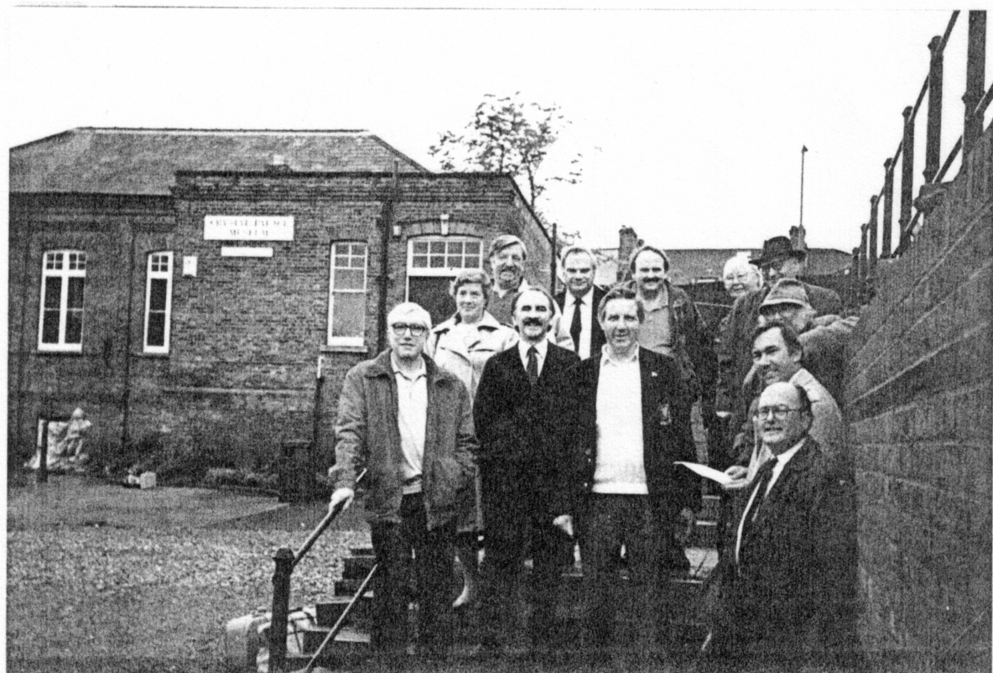

Exhibition Study Group - 4th. Annual Conference- Crystal Palace-

Members present: Don Knight, Andrew Brooks, Stanley Hunter, George Ithell, Bill Tonkin, Alan Sabey, Karl Illingworth, Mike Perkins, Arthur Smith, Damon Murrin, Celia Bailey, Fred Peskett, George Simner and invited guests included Mrs Tonkin, Mrs Anderson, Mrs Notage and Kenneth Tonkin.

Annual General Meeting . 2pm. Sept. 30th. The White Swan.

This meeting was held under the Chairmanship of Don Knight. The first item on the agenda was the election of officers for 1991 and as it had suggested at the 1989 A. G. M. that officers should perhaps keep office for a period of two years the present officers were quickly re-elected for a second term.
Chairman : Don Knight.
Vice-Chairman : Stanley Hunter.
Secretary / Editor : Andrew Brooks.
Publishing Editor : Karl Illingworth.
Promotions / Publicity Officer : Bill Tonkin.
Membership Secretary : Damon Murrin.
After the election of the officers there was considerable debate on quite a few topics and many suggestions were made which we hope will be implemented as soon as possible for the benefit of all our members.
There was general disappointment that we had been unable to attract members of the Crystal Palace Foundation to the meeting ( this had been one of the reasons for choosing the venue at the previous A. G. M. ) and Bill Tonkin who had spent much time and many telephone calls in organising the event said that he had contacted an official of the C.P.F. on more than one occasion. He had received an assurance that an invitation would go out to their members but obviously something had gone wrong ! Bill agree next year he would send out written notice of the meeting to the secretary of the C. P. F.
This led to a discussion on the venue for the 1991 meeting and it was fairly quickly decided that we should come back to the Crystal Palace. We had achieved our largest attendance for an A. G. M. and thought that if we could tap the C.P.F. members as well as circulate local philatelic societies, we could add to the numbers without getting too large. The date for the 1991 meeting was agreed and will be the weekend of the 28th & 29th September, keeping to our original idea of the last weekend in September. Bill Tonkin agreed to take charge of the arrangements.
The quarterly newsletter came under some scrutiny and everyone agreed the quality of this publication probably decided on whether some members renewed their membership or not. The editor repeated his appeal for material and said that he had been pleased with the promises he had been given already during the weekend. Karl Illingworth was thanked for his massive contribution to the newsletter and it is worth reminding members that Illingworth Developments Ltd. prints, packages and posts newsletter to all members. As a result the Group have a healthy bank balance.
Andrew Brooks (Ed/Sec) agreed to close an account in the name of the Ex. St. Group and send a cheque for the sum of approximately £250 to the Membership Sec. who will then control all the funds. (This has been done) Ed.)

Our only expenditure in 1990 was for £15 , payable to the White Swan as a deposit on the room. All the other expenses for the weekend were paid for by the members attending. A small donation was to be made to the C. P. F. who were to provide a guide for a tour of the grounds.
Probably the most contentious debate centred around the way in which we could attract more members. It was pointed out that the C.P.F. have over 1000 members and ECHO, our nearest equivalent in the USA have a similar figure. We obviously are not attempting to emulate either of these but it was decided to mount a small campaign to publicize our society. Celia Bailey suggested a 'flyer' that could be printed and made available at Fairs or to be inserted in any auction lists and magazines whenever we could persuade the owner to help us. The editor promised to modify membership application form to include a short history of the group and this could then be printed as a flyer.
There was also a need for headed notepaper that could be used by all members. The editor also promised to look into this during the year The A. G. M. closed after thirty minutes.

Displays and Social Events

Bill Tonkin had arranged a number of talks over the period of the two days with space to fix in any impromptu displays, as the need arose. The weekend finished on a high note - a guided tour of the Crystal Palace grounds.
Saturday. 11.45am. Don Knight, our Chairman, quite rightly opened the weekend with a colourful presentation of the postcards and ephemera of Earls Court, mainly of the period 1900 - 1914. The highlight of this display was the array of stunning Daily Programmes. Many of them were influenced by the Art Nouveau movement. As always , Don saved a major piece for the end, an excellent Diploma presented at the Womans Ex. in 1900.
The second display was ably executed by Fred Peskett (Founder member of the Festival of Britain Society). Fred, very modestly, proceeded to lay out a magnificent display on the Crystal Palace. Exhibitions, Aeronautica and Ballooning interest were all thoroughly covered and this immaculate show mixing contemporary material with some modern cards gave an extremely comprehensive view of the very spot where we had decided to hold our meeting.
After the AGM two members shared the next hour and delighted those with two completely different displays.
George Ithell provided original research into the characters illustrated on those well known cards of the Bal1ymaclinton Village. It is incredible think that he has managed to trace names and anecdotes for almost all of the colleens, men and donkeys at the exhibition ! For me it added a new dimension to this already interesting Irish Village.
A breath taking display of plates, mugs, vases, trinkets, paperweights commemorative medals and models - all of the Crystal Palace- were laid out by Karl Illingworth. This was a display that every Crystal Palace member should have seen. It was extraordinary and without pretending to be expert on the commemoratives of the C. P. I would pick out a stupendous paper weight which surpassed those I saw later in the museum’
The first day was brought to a close by Stanley Hunter who gave a very comprehensive display of the 1908 Scottish National Exhibition, Edinburgh.

I have not used the word comprehensive lightly. Although the possessor of a reasonable collection of this 1908 exhibition, many of the cards on view , were certainly new to me! Stanley filled all the available boards and then, alter we had viewed the sheets, turned them round to reveal another selection on the reverse.

Sunday

The morning session commenced with yet another display of extremely high quality, this time from Bill Tonkin. Starting at 1851, we wandered with Bill through many exhibitions, the highlight of which for me, was the cover for the Junior Philatelic Society prepared for the Coronation of K. G. V. in 1911. Bill has a soft spot for those really excellent Tuck cards produced for the 1910 Japan-British Ex. and he managed to slip in quite a few of the sheets illustrating this long series. I was especially delighted to see his sheets displaying countless minor exhibitions , something that Fred Fletcher and myself have researched over the years.
Fred Peskett came back with his second display of the weekend and this time showed us something quite different. The title was ‘British Postal Stationary Cut-outs used on Mail.' This traced the history of the legal, illegal and abuses of Postal Stationary which had been cut out and used on mail. The interesting thing was that the Crystal Palace stamp dealers were some of the main culprits in this shady business !
The penultimate display was again provided by our Chairman, Don Knight. This time it was a run through of all the British Philatelic Ex. The display included covers, miniature sheets etc., and concluded with a section on the Festival of Britain. Don is an excellent speaker and at every Study Group meeting he has kept us entertained and enlightened.
The displays had to come to an end as we ran out of time but Arthur Smith just managed to fit in an extra. Arthur had made the perilous journey across London, twice !!, in order to attend the meeting. This really impresses someone from the provinces not used to all the hustle and bustle. However it was nice to meet Arthur after corresponding with him for quite a few years. He brought with him on Sunday a number of items to supplement what he had seen on the previous day. He showed us a small collection of postcards and programmes on the performance of 'The Miracle’ at Olympia. Arthur then displayed a series of views of the miniature railway at Earls Court. His grandfather had built the track for the railway and then moved with it around the country when it was hired out to other exhibitions.
In the afternoon we assembled at the Crystal Palace Museum and after a pleasant half hour purchasing the many souvenirs on offer we met our guide for the tour of the grounds. Unfortunately your editor had to leave half - way through this most interesting circuit (at Paxton's Bust) to head for the train home. The highlight of course was the assemblage of prehistoric monsters at the lower end of the park and I was personally very interested in the imitation rock exposure that Paxton created to educate the Victorian visitors.
This was a very enjoyable weekend and I cannot finish without mentioning the camaraderie of the meeting. The displays were excellent but betveeen the displays we talked non-stop, about exhibitions and all sorts of other things. Bill and Nancy Tonkin organised a superb weekend and generously offered their hospitality to many of the members. On behalf of us all a most heartfelt "Thank you".

Additions to Daily Mail Ideal Home Exhibition Checklist
by Bill Tonkin.

1910 Trade Card Virol Children of all Nations
Bee Bee (Jamaica) V B/W Matt
1912 Trade Card Virol Children of all Nations
Marguerite (Breton)
Moore & Moore Pianos Glossy B/W
1922 A Luff & Sons
Add "There are two types of backs"
1925 Official cards
No. 13 A Rock Garden Dell
1927 No. 16 The Compass Garden.
1928 No. 10 Add type A
1929 No. 11 A Temple Garden.
No. 14 A Tiled Flower Garden.
1932 No. 5 Add type A
1933 No. 8 Naboths Vineyard by Baker type B
1934 No. 1 Add type A
No. 2 Hertfordshire Garden by Carters Tested Seeds, type B
No. 4 The Hailinbury Manor Garden by Ronald S. Skelton, type B
No. 20 Syon House ( Duke of Northumberland) by L. R. Russel, type B
1936 No. 3 A Woodland Garden by Carters Tested Seeds. Add type A B
No. 6 The Cypress Garden by Hillier & Sons type C
No. 7 The Delius Garden Add type A
No. 9 Add type C
No. 13 Add type A
No. 15 The Carnation Garden by Carters Tested Seeds type B
No. 16 Add type C
No. 19 Add type C
1937 No. 3 William and Mrs Gladstone Garden by R. Wallace, type B
No. 13 Henry VI11 and Ann Boleyn Garden by All wood Bros, type B
1939 I suggest that the titles in the first checklist are ignored and follow Bill's new notation
(A) Water Wheel in Background . Tree with tulips at base FR daffodils FL
(B) Water Wheel C daffodils FL & R
(C) Raised bed of carnations with iron scroll work gates in background.
(D) Round pool with fountain BR opening in wall at back with brick pillars each side.
(E) Rock pool in F Summer House with thatched roof in C background
(F) Rock pool in (F) opening in walls at back with bk. pillar each side.
(G) Pool in C large stone toadstool in F Oast house type roofed summer house to RHS
(H) Curved crazy paving path in C Rhododendrons and azaleas each side .
(I) as above but flowering shrubs instead of rho/azal.
(J) Brick wall with iron scrollwork top metal sign reads Ronald Skelton, The Nurseries, Pirbright, Surrey.
(K) Five stone steps CF with conifirs each side.
(L) Square crazy paving C F Sign in C reads Frank Cant & Co Ltd. Brunswick Rose Gardens, Colchester.
(M) Two stone steps C F with low stone wall each side. Path leads to wooden summer house in background.

Front Cover of Newsletter
Top Picture L to R. Arthur Smith, Mike Perkins, Guide, Fred Peskett, George Simner, half hidden ) Karl Illingworth, Damon Murrin, Andrew Brooks and Bill Tonkin.
Lower Picture L to R. Andrew Brooks, Bill Tonkin, Mike Perkins and Don Knight.

Picture under editorial
Back row George Simner, Fred Peskett, Karl Illingworth, Nancy Tonkin, Arthur Smith
Middle row Flo Simner, Bill Tonkin
Front row Mike Perkins, Andrew Brooks Don Knight, Damon Murrin, Stanley Hunter

