Editorial No 17

To compensate for the length of the previous newsletter the copy will be a very moderate affair. I must say that in spite of many promises I am still waiting for all those articles , long or short to fill the pages of the next newsletter.
The D. M. I. H. E. checklist has been favourably received and I would like to ask members to consider a similar venture for the Earl’s Court Exhibitions between the years 1897-1914. Arthur Smith has drawn up a preliminary list on the same lines as the early D.M. I.H. E , but it is far to big to publish in one go. If any members are E. C. collectors could you let me know and I will include you in this little research project. It is my intention, with the approval of those concerned, to issue the list of known postcards for this centre over the next few issues.
It may be a suitable time to remind our new members that we already have at least four major projects underway at the moment and the individuals involved would like all the help you can give them. Mike Perkins and Bill Tonkin are concentrating on the British Empire Ex. 1924-25. Bill Tonkin is steadily trying to make sense of the White City Ex. Stanley Hunter has been working on the Scottish Ex. for over ten years and is still recording new finds. Graham Hall, when work permits, is still beavering away at all aspects of the 1904 Bradford Ex. Please help them if you can !
The 1916 War Ex. was picked up recently in an auction lot purchased for the War interest. The booklet has quite a few pages and if anyone is interested I will send them a Xerox. I have taken the liberty to include a letter received from George Ithell that I am sure will be of interest. George has produced an excellent book on the Irish Villages at Exhibitions and I am sure is also still researching on Irish Ex.
I do hope that as many members as possible attend the yearly meeting at the end of September, Bill Tonkin has already put in a great deal of work to make this a success and I know it will be an excellent weekend.

Andrew Brooks April 1990

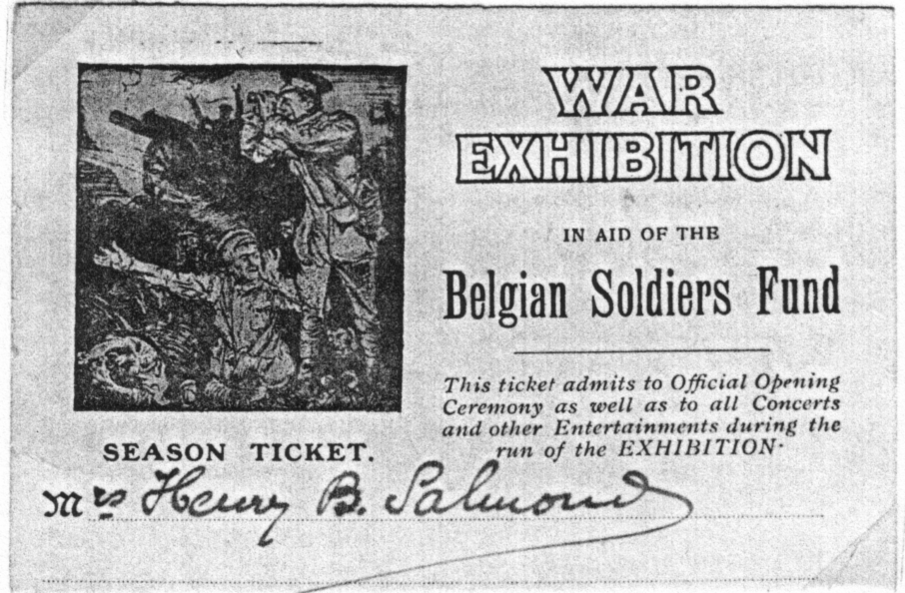

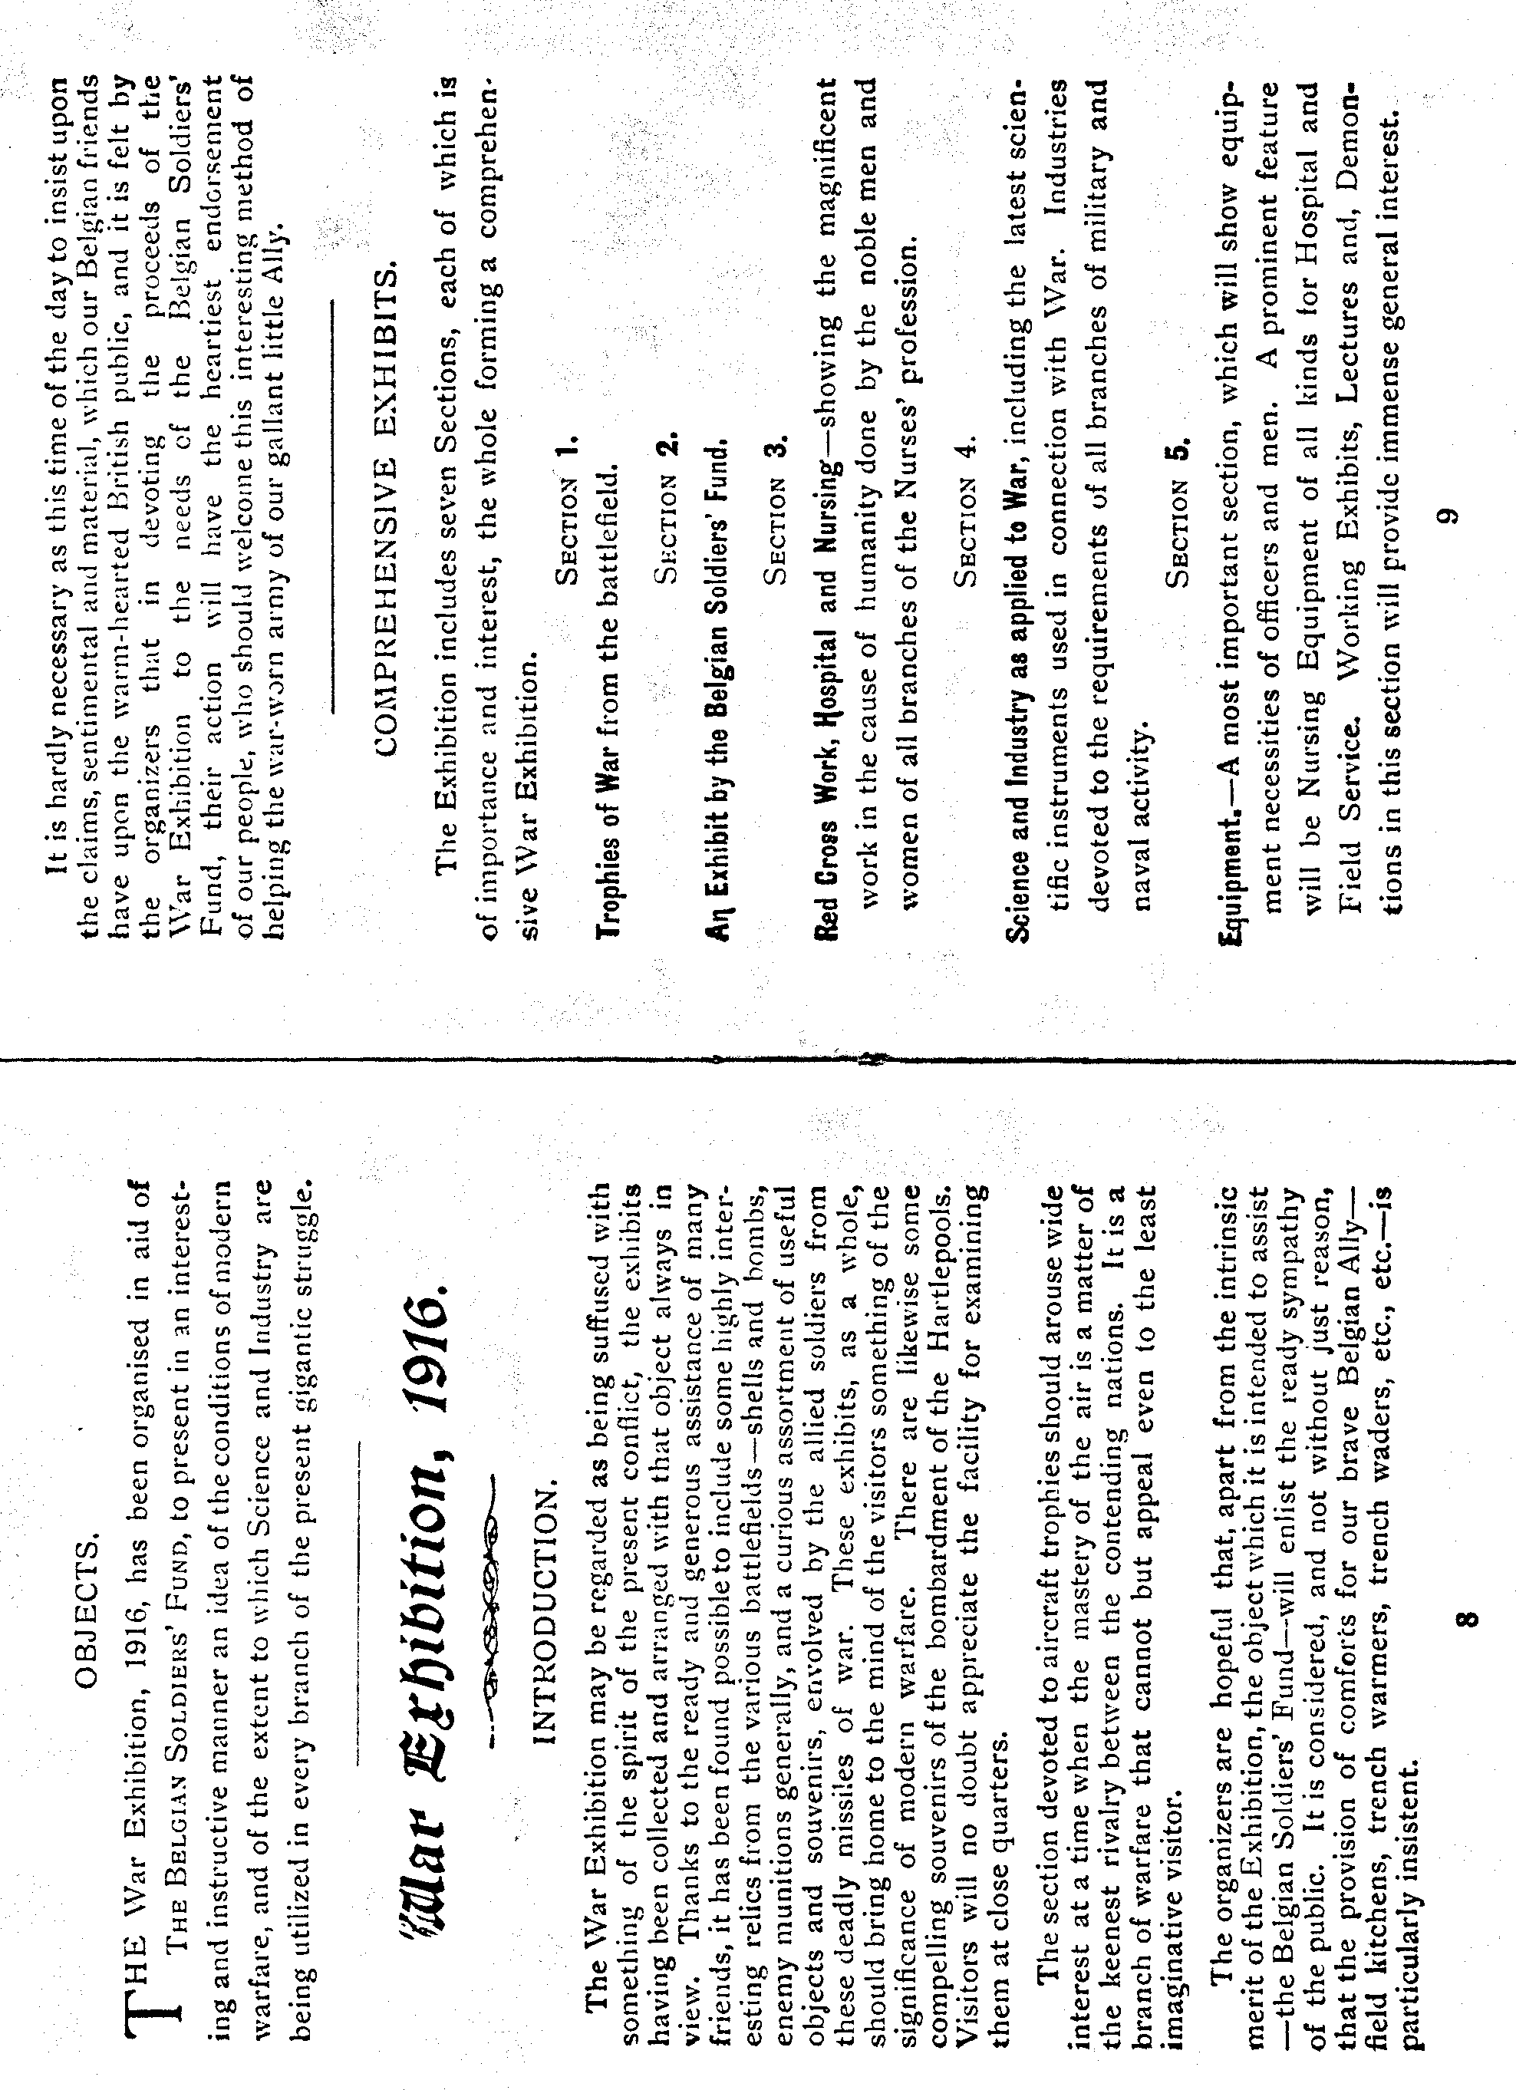

43a, Normanhurst
Feltham Hill,
Ashford,
Middx
TW15 2NG

March 5 1990.
Dear Andrew,
On receipt of the current mailing of the Daily Mail Ideal Homes Exhibition details prompted my memory of an item sent to me some time ago. This was a photo-copy (enclosed) of a parcel post receipt of 1888!! I then pursued some facts of this little recorded event, but didn't do a 'full- blooded' effort owing to other commitments at the time (5 or 6 years ago).
I came across my notes recently and it is possible that the Olympia Exhn. researchers may have some interest in my information. I'll have to apologise if its ‘old hat', but I don't think it will be.
Originally Olympia was first used from 1886 and a futile attempt was made to arouse some interest for the centenary amongst some of my acquaintances in that area. The earlier use of this area would probably be under canvas and a more open-air spectacular be witnessed. The modern Olympia buildings have been extended since 1931 and have been in constant use for all such exhibitions.
This Irish Exhibition which opened on June 4 1888 closed on October 27 1888 and 'The Times' of February 3 1888 reported that...'The first list of patrons of the Irish Exhibition to be held in Olympia in May (opening, evidentially delayed) has just been issued and contains over 200 names of noblemen, prelates, M.Ps and of distinguished men in literature, science, art and commerce which are representative of the various political creeds of the United Kingdom.
According to a statement just issued by the executive with the following objectives... (a) To place before the English public a clear view of the predominate industries of Ireland; (b) To awaken public interest in the efforts being made to revive her trade; (c) To exhibit to the many thousands of English persons who have never crossed the Irish Channel, somewhat of her deeply interesting and historical antiquarian treasures; (d) To illustrate the worth and significance of Irish art and, finally, to help moderate prejudices which are frequently tending to fetter the judgement, at the very foot of misunderstandings between people and people. It is further stated that the movement is entirely outside the area of politics, freed from all sectarian or class interest and initiated and undertaken with a worthy purpose'
A long list of the Executive Council and Trustees included many Irish peers and the Countess of Aberdeen was amongst those volunteering to manage a stall on a rota basis. A report of July 17th 'Times' 'Princess Mary, Duchess of Teck will be present and sell from the Marchioness of Salisbury's stall!.
A July 26th report says; 'that a sham fight, but very realistic takes place in the parade ground and with seven cannons in action, a drawback to the enjoyment was the inevitable noise and smoke, depicting a scene from the Indian Mutiny of a siege of a village.

Another excerpt from the October 20th issue says; 'For whatever the height to which discord runs amongst Irishmen, nobody denies that, at bottom, they are a warmhearted and kindly race and especially to children.
A generous and graceful act by the Committee of the Irish Exhibition in defraying the cost of a free trip for the School of the Benevolent Society of St. Patrick. This treat was enjoyed by the majority of the residents of this school, who qualify for this charity on being the children of poor hard-working Irish parents living in London. A total of 450 are being cared for at this time¹
'The Times' advertised on its front page of July 26th an Irish firm of Fitzgerald, Shirt Makers of 44 Patrick Street, Cork] The paper carried much news from this event and included many references to the interesting finds of Greek remains after extensive research at the site of Olympia'; amongst these dates were the 11th, 17th, and 22nd of October.
Due to bomb damage during the War of 1939-45 the geography is altered and the Gratton Road Post Office was a casualty. At one time the road was a cul-de-sac, but access from Blythe Road is now possible. I couldn't find a resident who was familiar with the area before the War, but the site of the Post Office and general shop is still intact, but was a reasonable distance from the Olympia site.
An article was published in the issue of September 1929 of Gibbons' Stamp Monthly by J. H. Daniels on 'Postmarks used at Exhibitions in Great Britain, 1951-1925'. No reference at all is made of this Irish Exhibition and another he missed out, was an Irish sponsored Exhibition of three days in Croydon from March 19 1888, to which the Government gave £1000 as a grant. The latter Show is understandable in not having any Post Office memento, but John Daniels missing out the Olympia show is surprising.
Trusting that this information will be of some value
Sincerely
George E. R. Ithell
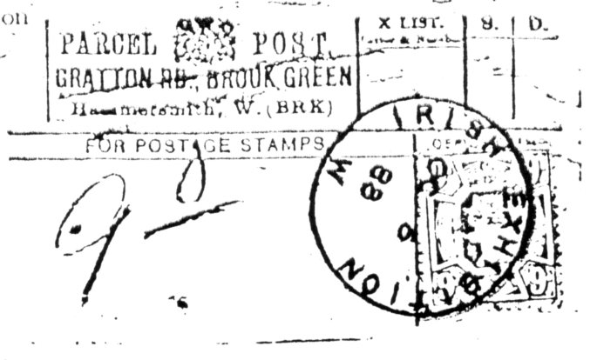

Exhibition Study Group Convention
Saturday 29th & Sunday 30th September 1990
By
Bill Tonkin

Plans for our 1990 weekend are well in hand. We are holding it this year at the White Swan, Crystal Palace_{t} London, S E 19, only a stone's throw from the site of the 1854 exhibition buildings.

The Crystal Palace grounds have been in use since 1854 when they were opened to the public. Although the Palace itself was burnt down in 1936 there are still a lot of the original artefacts to be seen. The monsters designed by Professor Owen in 185& are life sized statues of dinosaurs and other prehistoric animal;: placed around the lake in a very realistic setting.

There is also the subway under the parade which led to the High Level Station on the old London, Chatham and Dover Railway line built in 1865.

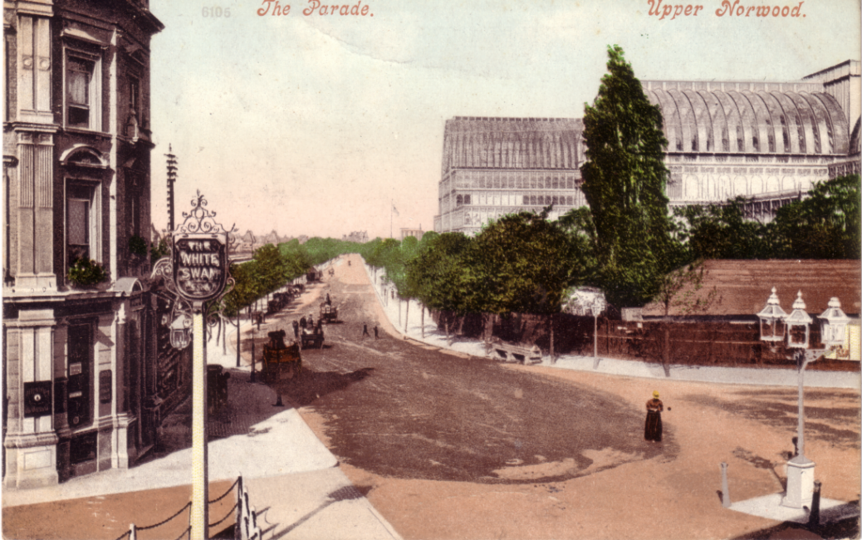

I am hoping to arrange with the Crystal Palace Foundation to have a guided tour of the grounds and also visit the Crystal Palace Museum which is housed in the 1872 School of Engineering and is the only original building within the Palace site to have survived the 1936 fire.

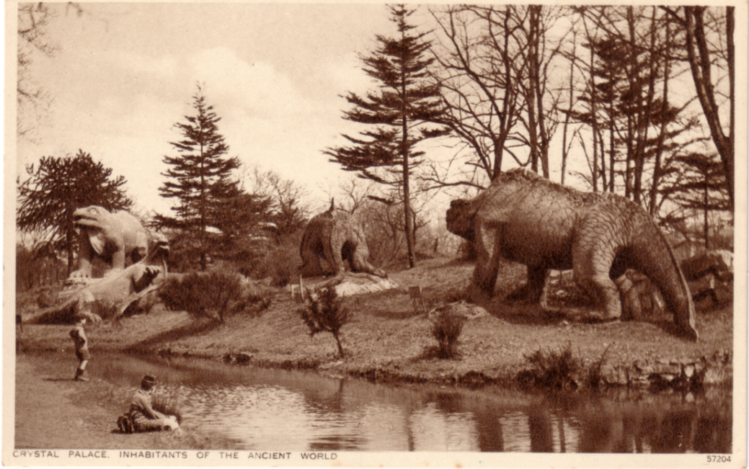

Fred Peskett and Karl Illingsworth, both members of the Exhibition Study Group, have agreed to give displays of Crystal Palace material and although other exhibitions will be covered it will be a good opportunity for members to show some of their Crystal Palace treasures. Bromley Library has also expressed interest in mounting a display for us at our meeting. I understand they have catalogues and posters etc. going back to 1851.

For those members wishing to stay overnight there is accommodation available at the Crystal Palace Sports Centre. The cost will be £19 for bed and breakfast. There are units of 1, 2, and 3 single beds to a room and I understand they already have 50 bookings for the Saturday night. If you are coming and want accommodation for the Saturday, or any other night it is essential that I know as soon as possible so that I can arrange bookings for you. Please fill in the enclosed form and return to me at 23, Bramley Way, West Wickham, Kent, B R 4 9NT (tel:- 01 777 8861). We may also use the Sports Centre for our dinner on the Saturday night and again I shall need to know how many to book for.
Remember your presence is all that is needed to make this a wonderful weekend. If your wives are coming there are large shopping centres in Croydon, or Bromley which are both only a short bus ride from the Palace. Or London's Oxford Street can also be reached in about half an hour.

