Editorial No. 16

I have devoted the whole of this issue to the checklist of the Daily Mail ideal Home Exhibition Picture Postcards. Many thanks to Fred Fletcher, Bill Early, Damon Murrin, Arthur Smith, Karl Illingworth and Bill Tonkin for their efforts in helping to bring it to fruition. Any mistakes , omissions etc., will be my responsibility.

The format of the original list needed modification and we have now arrived at a suitable compromise. I do not claim that any checklist will ever be ideal but this one will be kept on disc for all the additions that I hope you will send in when you get around to looking through those albums !

Bill Tonkin, the organiser of this year's Exhibition Study Group meeting sends advance warning of the proposed weekend in September. Please mark the dates 29th. and 30th. in your diary. A suitable room has been booked in "The White Swan" across the road from the Crystal Palace for our use during the day and so far Bill has made tentative arrangements with the Crystal Palace Foundation to visit the museum and have a tour round the grounds. Other details will be given in the next newsletter but please make a determined effort to attend this year !

Finally I would like to say that some members will be receiving a short note enclosed with this copy regarding their subs. Please send a return to the Membership Sec. so that we can make sure you receive your next newsletter.

Andrew Brooks Feb. 1990.

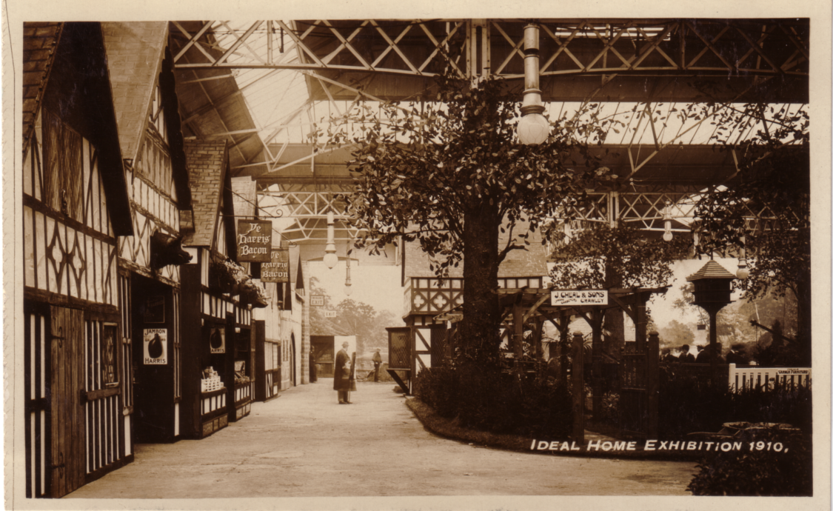

Daily Mail Ideal Homes Exhibition
check list for picture post cards

1908
Trade Cards
Major & Co. Ltd. Hull Coloured
The Solignum Cottage V
The Association of Diamond Merchants, Jewellers, Silversmiths Ltd. B/W
Showing Stand
Abbott Bros. Glossy R/phot
Showing Stand with Bee-Keeping Equipment
Other Cards
One other card recorded postmarked 1908. It reads 'This is the Garden at the ideal Home'.
View with "Boulton and Paul" house in middle distance. R/phot

1909
No Ideal Home Exhibition was held this year.

1910
Trade Cards
Holloway Brothers (London) Ltd R/phot
The Ideal House
Virol Ltd.
Virol Children of All Nations
Lillah (Zanzibar)
Thumbee (Boy) and Ummah (Girl) (Cingalese)
Chloe (Demerara)
Ranee (Jamaica)
Jippy (South Carolina)
Tu Kwong (Chinese)
Koo and Hi Di (Japanese)
Meera (Moorish)
Lim Saye (Chinese)
Other cards:
The Fine Art Publishing Co., Watford. GlossyR/phot
No titles but Ideal Home Exhibition 1910 on front.
View of Red Lion Meux's Stout Men in Tudor Dress.
General View - Sign showing Ye Harris Bacon.
General View - View to the front with men and Dovecot.
General View - View to the left.
General View - Row of Tudor Houses.
Garden Life Press, Hatton House, Great Queen Street, London W C
B/W Sketches by G B. There are three types:
A Printed on White card with 'Garden Life Press, Hatton House, Great Queen St., London W C' printed on the front down the right hand side.
B Printed on pink card, but without 'Garden Life Press,' etc. However, some also have 'Garden Life Press,' etc.
C Pale green card.
The Russian Cottage Souvenir of the Ideal Home Exhibition, April 1910. A
Scene in the Tudor Village Ideal Home Exhibition, London 1910. A
The Ideal Home A
No title - Shows front view of Harris Bacon Shop A
The Village Inn. Souvenir of the
Ideal Home Exhibition, April 1910. A & B
The Fire Station. A & C
The Waterfall A
Ye Print Shop at the Ideal Home Exhibition, 1910. A
(One card has been seen in this series that suggests, by the message on the back, that they were printed for the visitor whilst they waited!)

1911
No cards recorded.

1912
Trade Cards
"Bunty" The "Childrens' Model Kitchen" Sepia (V)
H. J. Searle & Son Ltd. Coloured
Berkeley Easy Chairs.
Virol Ltd.
Virol Children of All Nations Coloured:
The Indian House and Courtyard - The Babies' Playground B/W
The Indian House and Courtyard - The Babies' Playground
A Charming Eastern Baby V
Tu Quaong & Ah Kim V
Russian and Polish Children
Marguerite (Boulogrie)
Hi-Mi (Japanese) (Two types – one has the girl standing up plucking blossom and the other
Has the same girl sitting on the floor writing V
Sambo (West Indian) V
A group of Continental Children.
A Group of Ayahs
A Group of Many Nationalities
Lucie (East Indian) and Sambo (West Indian)
Treloar & Sons Glossy R/photo
With 'Treloar & Sons Compliments Ideal Home Exhibition1912 on front

1913
As part of the Ideal Home Exhibition, a Russian Village was built in the Annexe
Trade Cards
H. C. Cleaver Ltd.
The Church, Russian Village,
Olympia 1913 by H. C. Cleaver Ltd. Sepia Matt
The Russian Village at Olympia 1913 by H. C. Cleaver Ltd.
The Chapel, Russian Village at Olympia 1913 by H.C. Cleaver Ltd. V
The Farmhouse etc. V
The Watermill etc. V
Seven pictorial postcards were sold in a packet for 6d sepia matt with border, no publisher or photographer mentioned. Cards numbered 1 - 7:
1 Souvenir of Russian Village at Olympia 1913
2 The Village School, Russian Village, Olympia 1913.
3 The South Russian Farm etc.
4 The Crucifix in the Forest etc. V
5 The Village Church etc.
6 A Group of Russian Peasants etc.
7 North Russian Log House etc.
No. 6 has the back upright and inverted

Full colour drawn card "La Maison Electr ique".

1914 - 1921 No cards recorded.

1922
Trade Cards
A. Luff a Sons. Sepia Matt
The titles are on the back of the cards.
Photo of Blue Garden Constructed at Ideal Homes Exhibition.
Photo of Exhibit at Ideal Homes Exhibition.
Photo of Model of Blue Garden (Originally constructed for Her Majesty the Queen of the Belgians).
W. H. Gaze & Sons. B/W R/photo
Model Garden of H. R. H. Princess Alice at Ideal Homes Exhibition, Olympia 1922
Pulham & Sons. Glossy R P
H. R. H. Princess Mary's Garden, Olympia constructed and planted by Pulham & Sons., 71, Newman St.

1923
Trade Cards
E. Dixon B/W Drawing by T. C. or F. C. - (Difficult to decipher the initials.)
A Corner in the Camp.
Pulham & Son Glossy R P
H. R. H. Princess Mary's Garden, Olympia 1923 Constructed and planted by Pulham and Son, 71, Newman St., London W1.
Other cards
H. M. Queen Alexandra's Garden
H. M. Queen of Spain's Garden
Princess Patricia's Garden H. R. H.
Princess Alice's Garden Princess Mary's Garden

1924
Trade cards
J. Panicelli & Sons, 5, Rowan Rd. London Glossy R/photo
Stand or Display ?
The two cards have the above inscription but no title. They show two different views as below
(Round stone set piece)
(Square stone set piece)
Bungalow Town Ideal Homes Exhibition 1924 Glossy R/photo
Official Cards Numbered
There seems to be several types of this series; A has 'Daily Mail Ideal Homes Exhibition 1924 on the
Back and B which does not have it. Type B can be further divided into at least three different types printed in black or brown’
A Rock Garden B
" Monks Rest
No. 1 The Dell B
No. 2 Carnation Garden B
No. 3 Japanese Tea House Garden A & B
No. 4 Japanese Garden A & B
No. 5 A Rock and Terrace Garden B
No. 6 A Rill Garden B
No. 7 A Pentangular Garden A & B
(Type A has R. Neal & Sons added to the front).
No. 8 A Fountain Garden A & B
(Type B has 'Daily Mail' removed but still leaving traces, as well as George G. Whitelegg added on the front. It also has a rubber stamp 'G. G. Whitelegg, Chislehurst' on the back).
No. 9 Rill and Pergola Garden No. 11 Diana's Garden

No. 13 A Pergola Garden
No. 14 Spring and Rose Garden

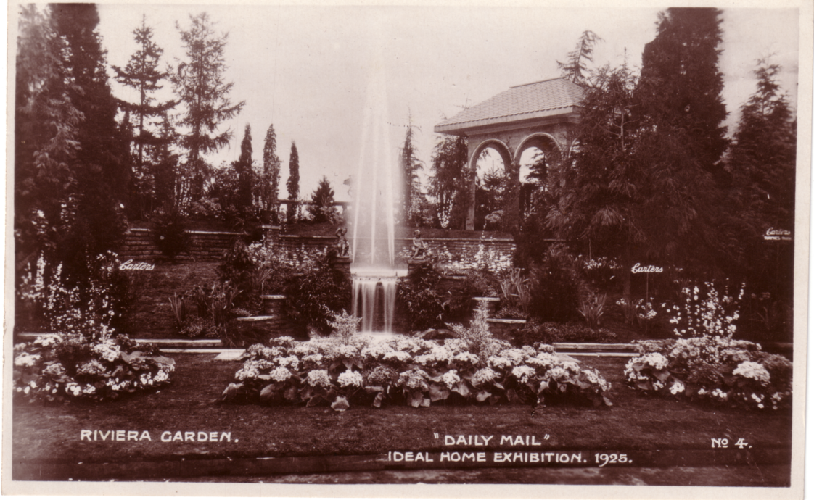

1925
Trade Cards
Lovell & Sons Sepia Matt
The Lovell House
Official Cards. Numbered Glossy R/photo

2 Stone Pagoda
3 Formal Rill Garden
4 Riviera Garden
5 Japanese Tea Garden
6 A Rill Garden

8 Stone and Lily Pond Garden
9 Elizabethan Carnation
10 A Rock Garden

12 A Rock Garden
14 A Sunk Rose Garden

17 A Picture Rock Garden

19 A Crazy Garden
20 The Hamlet of Heart's Desire

22 An Enclosure Garden

1926
Official Cards, not numbered
Alfieri Picture Service - Set of 8 Price 1/- Sepia Glossy R/photo
The American Kitchen
The Spanish Kitchen
The Swedish Kitchen
The English Kitchen
The Chinese Kitchen
The Dutch Kitchen
The French Kitchen
The Danish Kitchen

Official Cards, numbered
Photo by Capt. E. W. J. Payne on back.
No. 1 Stone Flagged Carnation Garden
No. 2 A Westmorland Garden
No. 3 Anemone Garden

No. 5 A Westmorland Garden

No. 7 A Peaceful Retreat
No. 8 A Cheddar Stone Picture Garden

No. 10 A Westmorland Rock Garden
No. 11 The End of a Villa Garden

No. 14 Rock and Bark Garden
No. 15 A Miniature Moorland Garden
No. 16 An Old English Rock and Flower Garden
No. 17 A Walled and Sunken Pool Garden

No. 19 Lily Pond and Stone Pagola

No. 22 Sunken Pool Garden

1927
Official Cards, Numbered
Photo by Capt. E. W. J. Payne on back Glossy R/photo
3 Formal and Circular Fountain Garden
No. 4 A Westmorland Rock Garden
No. 5 An Italian Temple Garden
No. 6 A Cotswold Hill Garden
No. 7 Fountain Court Garden
No. 8 A Cotswold Rill Garden
No. 9 A Village Pump Garden
No. 10 Circular Formal Fountain Garden
No. 11 Well Head and Paved Garden
No. 12 Circular Formal Fountain Garden

No. 15 A Sundial Garden

No. 17 A Carnation Garden by Allwood

1928
Trade Cards
Orpington Nurseries Co. Ltd. Glossy R/photo
Rock Garden Designed and Constructed by the Orpington Nurseries Co. Ltd., Orpington, Kent. Ideal Home Exhibition 1928' on back of card.
Official Cards, Numbered Glossy R/photo
There are two types in this series; A, which has 'Photo by Capt. E. W. J. Payne' on the back, and B, which has a plain back.
No. 1 The Cascade. A
No. 2 Terrace and Fountain Court Garden. A
No. 3 The Gnome Garden. A
No. 4 The Gnome’s Grotto A
No. 5 Terrace and Fountain Court Garden A
No. 6 The Garden End. A
No. 7 Carnation Garden. A
No. 8 A Carnation Garden. B
No. 9 A Hillside Garden.
No. 10 A Hillside Garden. B
No. 11 A Hillside Garden.
No. 12 Rock and Brooklet Garden A
No. 13 Rock and Pool Garden. A

No. 15 Domed Pergola and Pool Garden.
No. 16 A Pergola Garden

No. 18 An Aviary Garden A

No. 20 An Italian Garden A
No. 21 Dutch Perpetual Garden. A & B
No. 22 Violet Court Garden.
No. 23 Entrance to an Italian Garden. B

1929
Official Cards, Numbered Glossy R/photo
Copyright Capt. E. W. J. Payne M.C. Daily Mail Ideal Home Exhibition 1929 on back.
No. 1 Pergola & Carnation Garden.
No. 2 End of a Villa Garden.
No. 3 A Monastery Garden.
No. 4 The Old Mill Garden.
No. 5 A Japanese Garden.
No. 6 A Witch Ball Garden.
No. 7 Carnation Garden.
No. 8 Sunken Pool Garden

No. 12 A Japanese Garden..
No. 13 Cheddar Rock and Pool Garden.

No. 16 An Old Mill Garden.
No. 17 The Garden of Peter Pan.

No. 20 A Japanese Garden.
No. 21 An Old Dutch Topiary Garden.

1930 Advert Cards.
Benedict. Glossy R/photo
‘You make the Picture, Benedict Peas make the Meal’. Booth for taking photographs of members of the public after visiting the Benedict stand.

“Ten Test” Fibre Board Co., Ltd. (1929) Glossy R/photo
Ayling Old English Cottage. Ten Test (British) Lined Inside and Out. Ideal Home Exhibition 1930.
Frewen Cavity Brick House. Ten Test (British) Lined Throughout. Ideal Home Exhibition 1930.

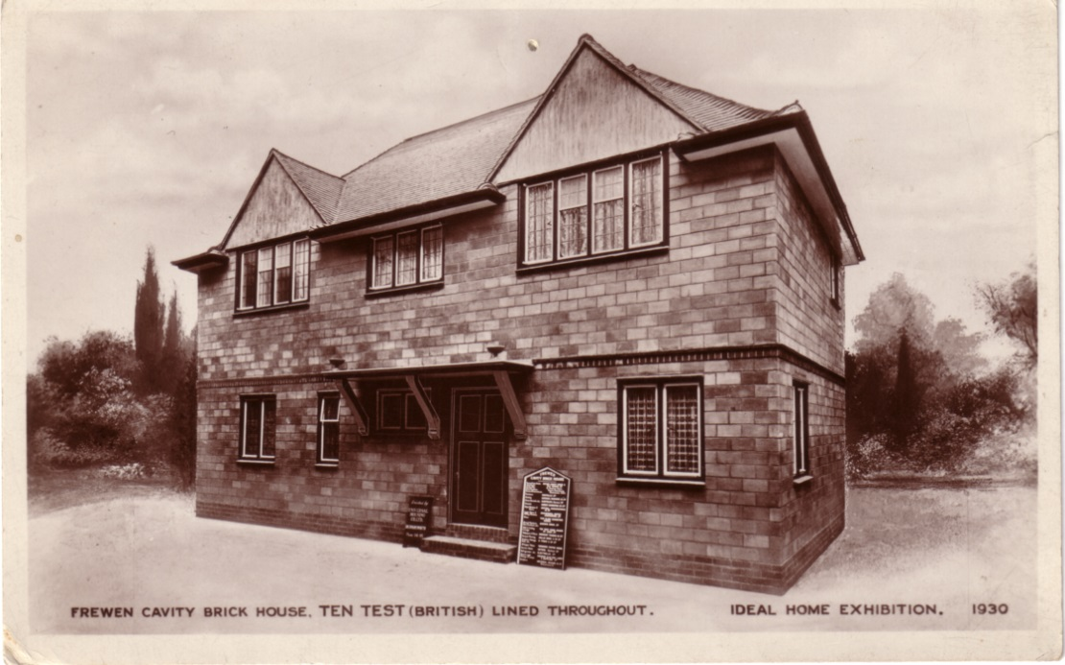

1930 Official Cards. Numbered Glossy R/photo
‘Copyright Photo by Capt. E. W. J. Payne. M.C., on the back. There are three types.
A B/W
B Coloured
C Which has a plain back
No. 1 Rocked Brook Garden. A
No. 2 Terrace and Summer House Garden. A & C
(No. 3) The Cascade Garden. A, B & C

No. 5 Arched Terraced and Pool Court A & B
No. 6 Carnation Garden A & B
No. 7 The Thatched Cottage Garden A & B
No. 8 Brook Cottage Garden A & B
No. 9 Paved Carnation Court. B & C
No. 10 Well Head and Terrace Garden A & B
No. 11 Sun Temple Garden

No. 13 Stone and Pool Terrace Garden by G. G. Whitelegg A

No. 15 An Old Well Violet Garden B
No. 16 The Garden of Legend A

No. 18 Thatched Cottage and Cascade Garden A & B
No. 19 Rock and Pool Garden. A

1931 Official Cards.
‘Copyright Photo by Capt. E. W. J. Payne. M.C., on back but not on all cards. There are three types.
A B/W
B Coloured
C Which has a plain back
No. 1 A Shropshire Garden B
No. 2 A Cotswold Garden B
No. 3 Paved Fountain Court
No. 4 A Kent Oast House Garden. B
No. 5 Entrance to an Oxford Garden V. A & C
No. 6 Shropshire Garden. B
No. 7 A Devonshire Garden

No. 9 A Devonshire Garden. A
No. 10 A Carnation Garden. (by Allwood). A

No. 12 A Westmorland Rock Garden (by Herbert Brook) A

No. 14 A Hampshire Garden (by Cheal) C

No. 17 A Carnation Walk (by Allwood)

No. 19 A Golden Retreat (by Skelton) C

1932 Official Cards. Numbered
‘Copyright Photo by Capt. E. W. J. Payne. M.C., on back but not on all cards. There are three types.
A B/W
B Coloured
C Which has a plain back
No. 1. Mapp & Lucia Garden by Carters Tested Seeds Ltd B
No. 2. Mapp & Lucia Garden by Carters Tested Seeds Ltd. A & B

No. 4. “The Flower of Life” Garden by R. Wallace & Co Ltd. B
No. 5. Rock and Pool Garden by Granville Ellis. B
No. 6. Mapp & Lucia Garden by Carters Tested Seeds Ltd. B
No. 7. “In Chancery Garden” by S. Skelton. B
No. 8. Roof Garden by Herbert Brook. A

No. 11. Rock & Pool Garden by Herbert Brook. A & B
No. 12. “Rest Harrow” Garden by Percy B. J. Murrell. A
No. 13. The Garden of Delight by Gavin Jones. B & C
No. 14. “Autmn in Arran” Garden by Allwood Bros. B & C
No. 15. “Autumn in Arran” Garden by Allwood Bros.
No. 16. Young Anarchy Garden. by G. G. Whitelegg.
No. 17. “Ovingdean Grange” Garden by R. Crewdson-Day B
No. 18. “The Ragged Messenger” Garden. B

No. 22. A Topiary Garden by John Klinkert.

1933 Trade Cards.
Nayboths Vineyards by Bakers

1933 Official Cards.
‘Copyright Photo by Capt. E. W. J. Payne. M.C., on back but not on all cards. There are three types.
A B/W
B Coloured
C Which has a plain back
No. 1 The Barrier Garden by Carter’s Tested Seeds Ltd. C

No. 3. The Barrier Garden by Carter’s Tested Seeds Ltd. V. B & C

No. 5. A Summer House Garden by R. Wallace & Co. Ltd. B
No. 6. “The Seekers” by Ronald S. Skelton.
No. 7. A Japanese Garden by Hillier & Sons. A

No. 9. Lilac Time Garden by L. R. Russell Ltd. A

No. 12. The Waterwomen Garden by Granville Ellis. C

No. 14 The Gate of Desire Garden by G. G. Whitelegg.
No. 15. “Peter Pan” Garden by Burton Holt. A & B
No. 16 The “Earth Garden” by John Klinkert. C
No. 17 A Carnation Garden by Allwood Bros. C
No. 18 “The Barrier” Garden by Carter’s Tested Seeds Ltd. B
No. 19 John Bull’s other Garden by Gavin Jones.
No. 20. “Lorna Doone” Garden by William Wood & Sons. B

No. 22 “The Honeymoon Garden.” by J. Burley & Sons Ltd A & B
No. 23 “Lorna Doone” Garden. B

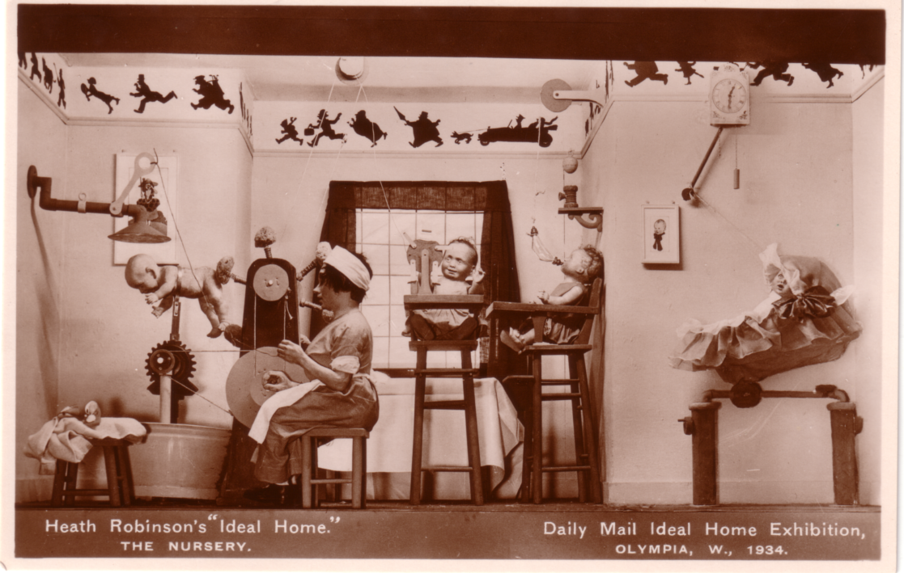

1934 Official cards, Heath Robinson’s “Ideal Home” Not numbered Glossy R/photo
The Bedroom.
The Dining Room
The Gadget’s
The Garden.
The Kitchen.
The Nursery.

1934 Official Cards. Numbered Glossy R/photo
There are three types.
A B/W
B Coloured
C Which has a plain back
No. 1 Hertfordshire Garden by Carter’s Tested Seeds. B

No. 5 Foxwarren Park Garden by J. Cheal & Sons, Ltd. B
No. 6 Westmorland Rock Garden by Granville Ellis. A & B

No. 10 Buckhurst Park Sunk Garden by George Whitelegg. B
No. 11 Buckhurst Park Sunk Garden by George Whitelegg. A & B

No. 13 A Glimpse of Chelwood Vachery. A

No. 15 Mounton House Water Garden by Hillier & Sons.

No. 17 Crowhurst Place Water Garden by J. Burley & Sons
No. 18 Peter Pan Garden by Burton Holt, Ltd. B

1935 Official Cards.
There are three types.
A B/W
B Coloured
C Which has a plain back

No. 2 A Spanish Garden, by R. Skelton. A & B
No. 3. A Japanese Garden, by L. R. Russell. B
No. 4 An Italian Garden, by Carters Tested Seeds. B
No. 5. An Italian Garden, by Carters Tested Seeds. B
No. 6 Italian Garden, by Carters Tested Seeds. B
No. 7 Chinese Garden, by Burle and Son. B
No. 8 A Dutch Garden, by W. Wood. B
No. 9 A Swiss Garden, by Granville Ellis. B
No. 10 Rosemary’s Garden, by Burton Holt. A
No. 11 A Carnation Garden, by Allwood Bros. B
No. 12 Scotch Garden, by Bakers. B
No. 14 A Rose Garden, by F. Cant. B
No. 15 Old English Garden, by J. Cheal. B
No. 16. A Dutch Garden, by W. Wood. B
No. 17 A Topiary Garden, by G. G. Whitelegg. B
No. 18 A German Garden, by G. Whitelegg. B

1936 Official Cards.
There are three types.
A B/W
B Coloured
C Which has a plain back
No. 1. A Woodland Garden by Carters Tested Seeds. B

No. 4. New England Idylls Garden, by R. Hancock. B
No. 5. Loch Lomond Garden, by R. Wallace. B

No. 7 The “Delius” Garden, by W. Wood & Sons. B
No. 8. “The Spring Song” Garden, by L. R. Russell. B
No. 9. “In a Monastery Garden”, by R. S. Skelton. B
No. 10. “Rhapsody in Blue” Garden, by J. Burley & Sons. B
No. 11. “Garden of Happiness”, by Burton Holt. B
No. 12. “Evening in the Mountains” by Gavin Jones. B
No. 13. “Peer Gynt” Garden, by J. Cheal & Sons. b
No. 14. A Tiny Garden, by B. Sunley & Co. A & B

No. 16. Schubert’s Garden, by Granville Ellis.
No. 17. Country Garden, by G. Whitelegg. A
No. 18. The Rose Garden, by Frank Cant & Co. Ltd. B
No. 19. “Rhapsody in Blue” Garden, by J. Burley & Sons. B

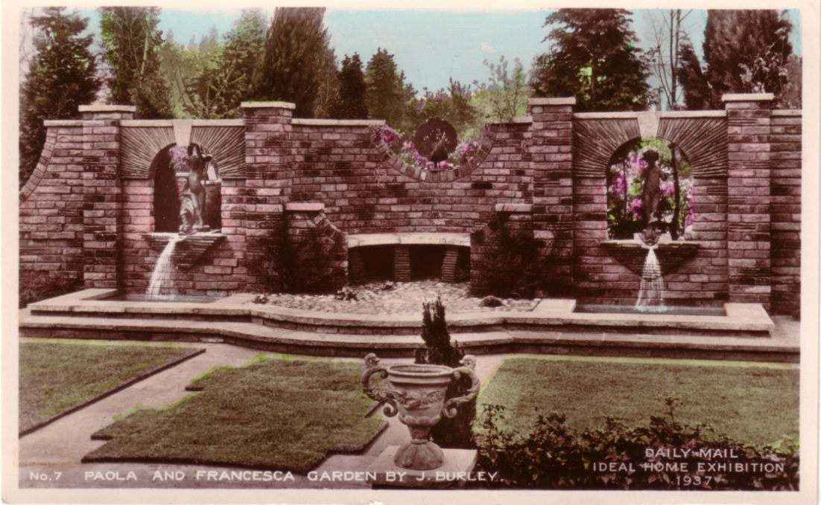

1937 Official Cards.
There are three types.
A B/W
B Coloured
C Which has a plain back
No. 1. Robert Burns and Mary Garden, by I. Walker. B

No. 4. Paul and Virginia Garden by L. R. Russell. B
No. 5a. Ergia and Numa Garden by Carters. A & B
No. 6. John Ridd and Lorna Doone Garden by Gavin Jones.
No. 7. Paola and Francesca Garden by J. Burley.
No. 8. Nelson and Lady Emma Garden by Skelton A & B
No. 9. David Copperfield and Dora Garden by G. Whitelegg.
No. 10. Josiah and Sarah Wedgewood Garden by J. Cheal. A & B
No. 11. Maud and her Lover Garden by Gant. B

No. 15. Queen Elizabeth Garden by R. Hancock. A

1938 Trade Cards.
Richard Costain. Ltd. Coloured
The House of the Seven Dwarfs as built at Olympia, 1938 by Richard Costain Ltd. From the Walt Disney and Mickey Mouse Ltd drawings in the film ‘Snow White and the Seven Dwarfs’.
N.n. “Who can that be?”
N.n. Snow White busy in the Dwarfs Kitchen
N.n. No title. - Exterior of the Cottage.
N.n. No title. - Interior of the Cottage.

1938 Official Cards.
There are three types.
A B/W
B Coloured
C Which has a plain back

No. 1. “Beverley Nichols” Garden by Carters Tested Seeds B
No. 1a. Beverley Nichols Garden by Carters Tested Seeds A & B
No. 2. Susan Erliz Garden by Frank Caut & Co. Ltd. B
No. 3. Mr. A. E. Mason’s Garden by Bros. B
No. 4. “Sir H. Walpole” Garden by J. Cheal & Sons Ltd. B

No. 6. “Rebecca West” Garden by Hillier & Sons. A
No. 7. “Dr Cronin” Garden by Wallace & Sons. B
No. 8. A Rock Garden by Granville Ellis. B
No. 9. Agatha Christie Garden by J. Burley & Sons. A, B & C
No. 10. “Gilbert Frankau” Garden by George Whitelegg. B
No. 11. “Clemence Dane” Garden by Gavin Jones. A, B & C
No. 11a. Beverley Nichols Garden by Carters Tested Seeds B
No. 12. Topiary Garden by John Klinkert. B
No. 13. Rafael Sabatini Garden by Ralph Hancock. B
No. 13a. Rafael Sabatini Garden by R. Hancock Ltd. B

No. 15. Lady Eleanor Smith’s Garden by Ronald Skelton, Ltd. B
No. 16. 17th Century Garden by Granville Ellis. A

1939
1939 Copyright Fox Photos Ltd. B/W Matt R/photo
The Garden. Ideal Home 1939. (Title to front of all three)
View – Garden with wall and arch in mid distance
View – Garden with well in mid distance
View – Garden with water - wheel in mid distance

1939 Copyright Fox Photos Ltd. Colour Matt
A natural Dafaycolour Photograph April 1939
The Gardens.
Views – Similar to above but a little further back
Views – Same area as above but a different view point
Views – Similar to above but further back

1940 – 1947 No cards recorded

1948
Daily Mail front
The Printing Presses
Carmelite House
The Linotype Machine
The Special Trains

1954 Official Cards. Numbered Glossy R/photo
No. 88. Rock Garden by Fitzpatric & Son.
No. 89. Garden Landscape by Winkfield Manor Nurseries.
No. 102. Garden Lndscape by Whitelegg.
No. 103. Garden Landscape by Granville Ellis.
No. 105. Garden Landscape by R. Wallace & Co.
No 108 A General View of the Grand Hall.
No 378 The Grand Hall.
No 379 The Grotto of Arcadia.

1955 Official Cards. No number or date Glossy R/photo
A Formal Garden by Whitelegg.
A Rock Garden and Summerhouse (Fitzpatrick)
A Section of the Village.
Georgian Terrace (Winkfield Manor Nurseries)
The Grand Hall.
The Rock Pool (Granville Ellis Gardens)

1956 Official Cards. Numbered Glossy R/photo
94/56. A Simple Garden by Garden Landscapes.
122/56. The Grand Hall, Olympia.
127/56. Informal Rock Garden by Granville Ellis.
129/56. Whitelegg, Garden.
130/56. The Dell of Orchids by Sanders.
132/56. Allwood Bros., Carnation Garden.

1957 Official Cards. Numbered Glossy R/photo
118. Entrance to Elizabethan Garden.
119. Rock and Water Garden by Granville Ellis.
123. Wild Moorland Scene by Whitelegg Knockholt
127. Iron Work in the Garden by Hancock Industries
143. The Market Place, Grand Hall, Olympia.
234. Formal Gardens by Wells (Merthsham) Ltd.

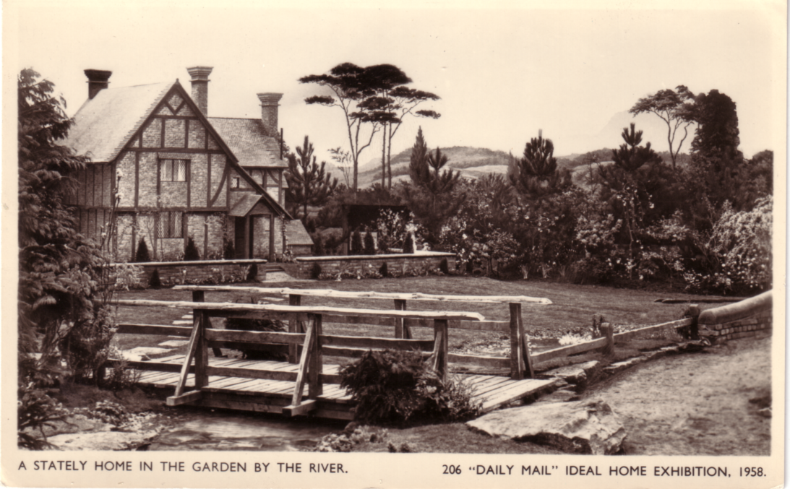

1958 Official Cards. Numbered Glossy R/photo
196. A Delightful Garden by Wallace and Barr.
206. A Stately Home in the Garden by the River.
207. A Wild Moorland Scene and Waterfall by G. Whitelegg.
211. The Palace of Fontainbleau Floodlit at Night.
244. An Old World Garden by Granville Ellis.
251. The Round House and Roof House in the Village.

1959 Trade Card.
Coloured, a large sized card measuring 102 x 52mm, on the back ‘Issued by The Senior Trade Commission in the United Kingdom.
“A Town Like Alice”.

