Editorial Number 15

Another race against time to deliver the goods before the end of the year. With a bit of luck and help from Karl, I might manage four newsletters before January 1st.

The promised re-organisation of the Study Group took place at the annual weekend meeting and I have listed below the names and titles of the officers proposed and accepted at this meeting.

Chairman Don Knight.
Vice-Chairman Stanley Hunter.
Secretary/Editor Andrew Brooks.
Publishing Editor Karl Illingworth.
Promotions /Publicity Officer Bill Tonkin.
Membership Secretary. Damon Murrin

Bill Tonkin has written an account of the annual meeting so I will try not to repeat any of his thoughts. During the course of 1990 we shall try to design and produce headed notepaper for use throughout the Study Group, something that would be suitable for official or personal use. Ideas for a logo would be welcome. I have completed an' application for membership' form but as I would like this to tie in with the new logo, I will continue to admit new members by the present method ie., by letter or telephone.

I must apologise for breaking the promise to bring the Ideal Home Ex. Listing up to date. It will appear but I have had two firm promises from members to supply their own lists and I hope to receive them shortly. Three members have helped out already and increased the listing from 67 to 270 cards. In ray original article I suggested between 250-500 cards and we have now passed the lower estimate- please help!

Membership is now due for 1990 and is £5.00 please send to

D.Murrin,
8, Anchor Quay,
Norwich,
NR3 3PR

All the best for Christmas and the New Year.

Exhibition Study Group 3rd Annual meeting – Manchester September 1989
by
Bill Tonkin

A small but keen group met for the annual get together - since our first meeting in 1987, which was a one day try out, we have made it a full weekend this year. We changed our venue from York to Manchester where Karl Illingworth kindly made his home available for the meetings and also put several of the members up for the Saturday night. The formal part of the meeting was soon over - we formed a committee to help to run the group that had been run by Andrew Brooks and Fred Fletcher for the last few years.
Our first display was given by Don Knight and he showed us many fine early exhibition items , starting with a 1851 H. M. Commissioners cover, unfortunately not postally used. This was followed by three postmarks of the 1862 International Ex. two covers and one piece and a cover from the 1871 London International Ex. These items were backed up by many other fine items from his collection.
The second display was presented by Bill Tonkin who showed Congress covers and labels with many complete panes of the labels in varying colours.
Jean Osborne gave a display of early exhibition labels which included many not seen by the members present.
Stanley Hunter showed a video of the 1938 Empire Exhibition which had previously not been seen south of the border and then followed it up with one or two items from his collection.
After a quick lunch we went upstairs where the whole of the top storey is devoted to Karl's collection. This must be the finest collection of exhibition material in the country and everything was on display and could be examined by the members. It could only be described as a very large Aladdin’s cave. Everything from medals to complete uniforms !! 1851 medals, 1862 medals to commemorate the opening of the Crystal Palace at Sydenham in 1854. An 1886 Colonial and Indian Ex. Medal and a beautiful Yorkshire Fine Art and Industrial Ex. held in 1866. And Oh! So many others!
I counted no less than 60 half pint engraved glasses, many for early Scottish Exhibitions. We then went into another room where Karl keeps his Crested China. I have often heard the expression "Breath taking" but this was the first time in my life that it has happened to me. I was conscious that I actually stopped breathing for a moment as I saw the magnificent display. I later estimated that there were about 30 items to the square foot and over 60 feet of shelving. Not only was it sorted out into different exhibitions, it was also sorted out by the different crests produced by various manufacturers. Above the shelves were row upon row of commemorative plates in china, glass etc.
On Saturday evening we went out for what has now become our traditional evening meal. We then talked about exhibitions until the early hours.
Sunday started off with another display by Don Knight. He showed a very extensive range of White City items , including the scarce Shepherds Bush Ex.B. O. on a block of 1/- , 5/-,10/- and the £1.
Andrew Brooks showed the members some Earls Court postcards and also a selection of Giant cards for the White City Ex.-I didn't know there were so many.
After this display we were left to do as we pleased and Mike Perkins and myself waded through masses of postcards looking for the Wembley material.
The meeting ended with a half hour video of the Queen's Dolls House.
A sincere vote of thanks to Karl for being a wonderful host and an appeal to all members to attend the 1990 meeting in London.

Japan British Exhibition Cards with Japanese Handstamps
by
Bill Tonkin

Some months ago I was fortunate to pick up 2 postcards issued by the Japanese Department of Communications (i.e. Japanese Post Office) to commemorate the opening of the Japan British Exhibition in 1910. These I displayed at the York meeting of the Study Group in September 1988 and gave some details of the cards and handstamps. By coincidence another member had brought along a third card to the meeting hoping to find out something about it. Karl was good enough to lend me his card to photocopy and since then I have picked up some more cards and have additional information which I thought might be of interest to the Study Group.

The Japanese Department of Communications had originally decided to hand out 2 postcards to guests at the Opening Ceremony at the White City but later decided to increase the number to 3 cards and. make the set in a special envelope available in Japan. A handstamp was also designed which was in use for 10 days only at some 1st and 2nd rate post office in Tokio. It was also available at 2 post offices outside Tokio, NAITO SHINJNKU and SHIBENJA. The handstamp is a bit misleading as the date reads 43-5-14. MEIJI is the Japanese equivalent of 1910, or the year of the reign of Emperor Mutsuhito, while 5-14 was the opening day of the Japan British Exhibition 14 th May.

The reason for putting the cards on sale in Japan was to help offset the cost of producing the cards. I have made enquiries at our Post Office archives and can find no trace of the Japanese Post Office requesting permission to use the handstamp on mail posted at the exhibition, nor is it recorded in the Post Office Postmark Pattern Book. So it is very unlikely to find the handstamp on a British postage stamp. All samples seen so far either show the handstamp on the picture side of the postcard or on the back cancelling Japanese stamps.

Getting back to the postcards the Japanese set out to make a real prestige job of the 3 cards and they certainly succeeded. Card No. 1 was . a multi coloured woodblock printing. This was the first time that this method had been used to produce postcards and it caused many problems, finally being given out to 4 different printers - The Toppan Printing Co. Ltd., Tokyo Daikokuya - Tokyo Hongo Benrido and Tetzunosuke Tamura. There are differences on the cards but fortunately each firm printed their name on the back of the card so the different printings can be easily identified.

Card No. 2 shows Prince Fushimi with the Duke of Connault and a view of the Court of Honour. It was produced by the Tokyo Printing Co. Ltd and the picture of the Court of Honour was taken from a Franco British card issued by Valentine & Sons Ltd No. 485. The card was printed by the Plaster Board Process which produced a deeply embossed card.

Card No. 3 also produced by the Tokyo Printing Co. Ltd was of
individually hand made Torinoko paper inlaid with fan shaped cut out pictures of Mount Fuji and a lion by Hokusai.

Since finding out this information some more cards have come to light. These are both Japanese cards and have the special handstamp cancelling Japanese stamps on the back. There is no address which indicates that they were handed in for the handstamp which was either done while the customer waited or sent it with a stamped and addressed envelope. Both cards have parts of the design embossed.

Card No. 4 does not unfortunately photocopy well as the back-ground is a fairly deep brown, the Art Deco leaves of green and the golden stems are lost and all that comes through is the white petals of the chrysanthemum. Also lost is the words 'Souvenir of the Anglo- Japanese Exhibition' at the top and 'Exhibition Ground’ under the picture which is again of the Court of Honour from a Franco-British card by Valentine and Sons Ltd No. 214. This was issued as a night effect over here and the Japanese have altered it to a day scene with a clear sky but still showing all the lights reflected in the water and on the buildings which again unfortunately does not come out.

Card No. 5 is multi coloured again showing Prince Fushimi and the Duke of Connault with flags of both countries. I do not know how many cards there are in this series.

In addition to these cards there seems to be a whole range of Japanese cards with no reference and not related to the Japan British Exhibition but were just taken into Japanese post offices to get the special handstamp.

My thanks to Karl Illingworth for the loan of Card No. 5 and Y Hiraoka of Tokio who was kind enough to supply me with information, on the cards and postmark.

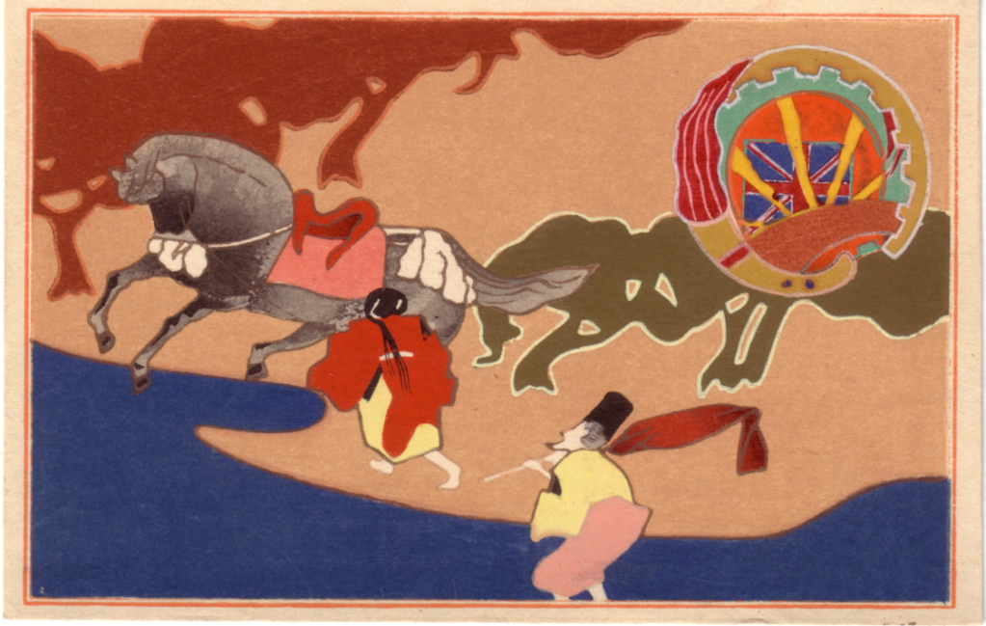
No. 1
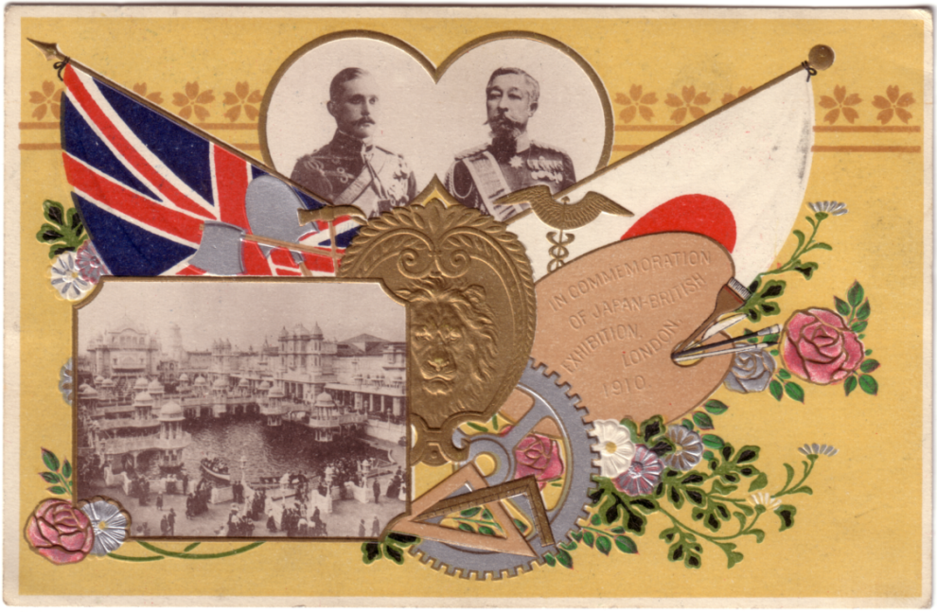
No. 2
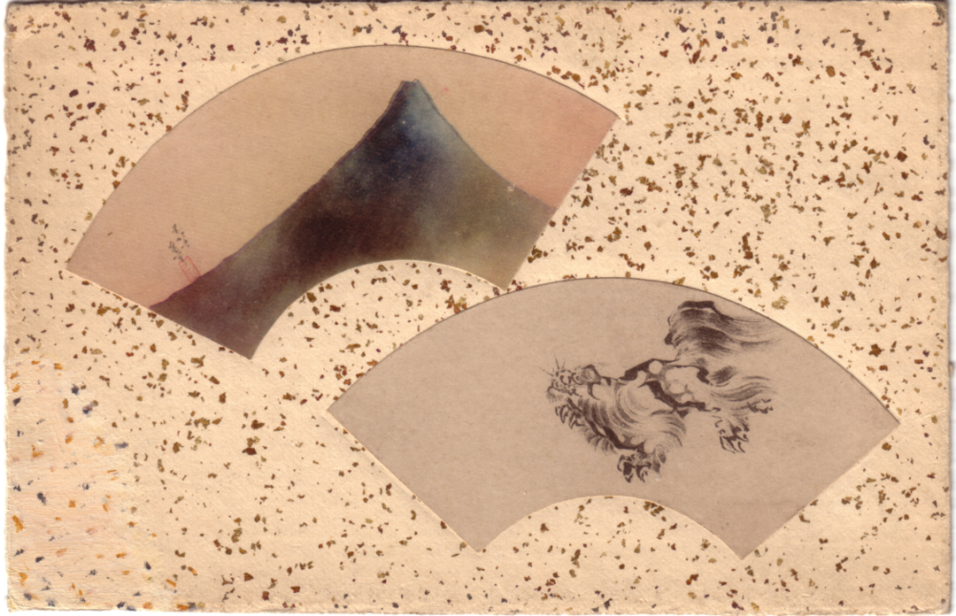
No. 3
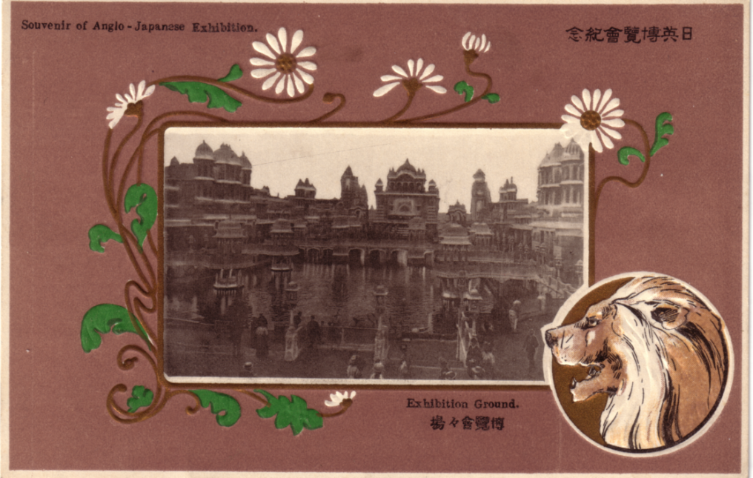
No. 4
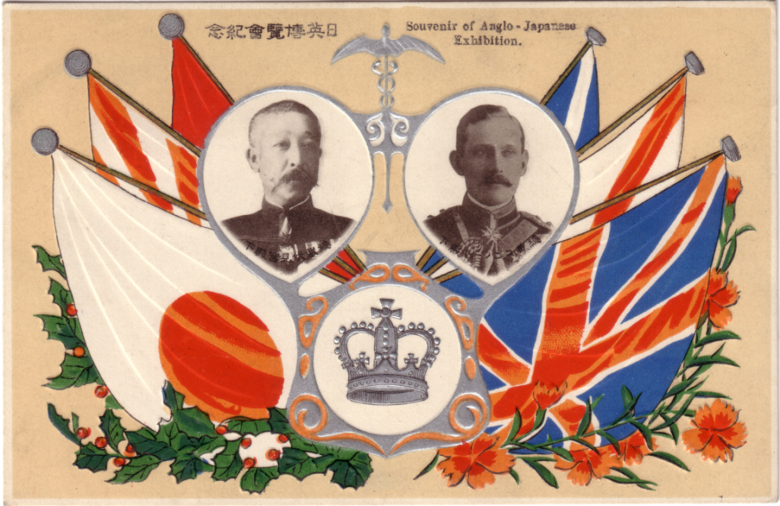
No. 5
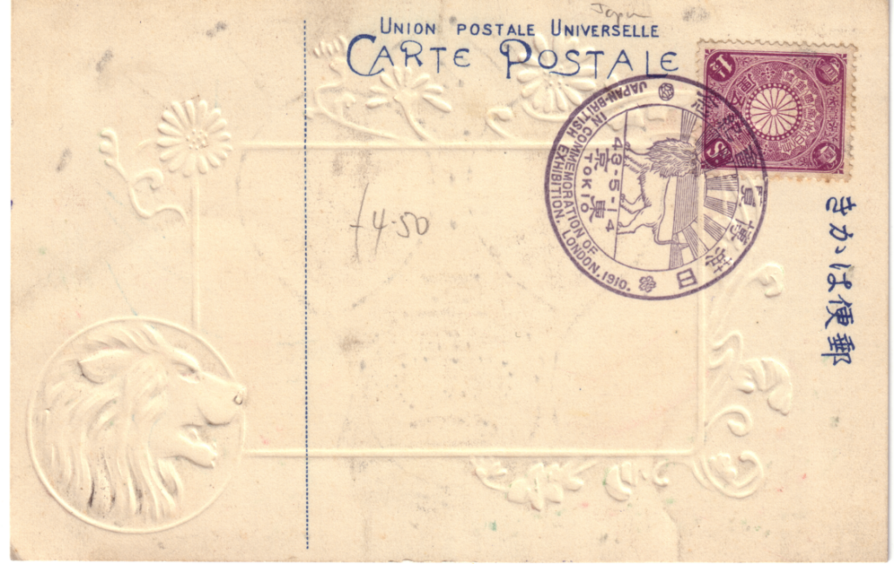
No. 6
Book Review
by
Jeffrey Green

Paul Greenhalgh "Ephemeral Vistas: The Expositions Universelles, Great Exhibitions and World’s Fairs, published by Manchester University Press 1988 ISBN 0 7190 2299? available in the U.S.A. from St Martinis Press, New York.

Surely no member of the Exhibition Study Group can ignore this 245 page book, which contains eight chapters on origins, financing, imperialism, nationalism, construction, women, fine arts, and "human showcases" in European and U.S.A. exhibitions. But it has too many weaknesses to be recommended without reservation. Although printed on glossy paper it has only twenty illustrations and they are not very good, either.
Whatever your interest, Greenhalgh’s book will take you into other areas and make you reconsider your own perspectives on exhibitions. He might be strong on art and design but he and his editor are weak on geography (Paris is a ‘north European city’ on page 222 - what ever happened to Stockholm?) and, alas, on imperial history although the book is in the Studies In Imperialism series.
He uses both ‘Dayomeyan’ and ‘Dahomeyans’ on page 94, ‘Dahomayan' on page 84, and, quoting, ‘Dahomean’ on page 85. The Gape Verde Islands are the ‘Cape Green Islands’ on page 70 while ‘Macoa’ in China should be Macau. These are not typographical errors for Portuguese Guinea is Portuguese Guiana in this list. Page 222 has ‘Morroccan’. To refer to the Belgian Congo in 1894, 1897 and 1905 (page 71) is an error that devalues the author’s views on exploitation and imperialism for the Congo was then the personal estate of Leopold, King of the Belgians, and did not become a Belgian national responsibility until the late 1900s after years of campaigning by the Congo Reform Association which involved Roger Casement, E. D, Morel, Mark Twain and Conan Doyle. To be ignorant of that movement is to be ignorant of White attitudes to Africa at the time imperialism was triumphant in exhibitions.
However the book shows just how much research remains to be done and should encourage many of us to dig away. The Public Record Office and Brent Local History Library have information on the Empire Exhibitions of 1924 and 1925, apparently untouched by Greenhalgh (who seems not to have known that the Wembley show was also in 1925). What of Canadian exhibitions - that in Toronto in 1922 involved the band of the West India Regiment, which also appeared in Wembley in 1924. What of Australia?
The typographical and editorial weaknesses are shameful for a university press and the absence of research in the newspapers of Afro-America and British West Africa, where westernised black people voiced opinions on the exploitation of their kin, is a cultural imperialism that suggests that Paul Greenhalgh has fallen into the same trap that the exhibitions did, exploiting non-European people in ignorance.
The book has a very amusing type - note 32 on page 140 refers to the -Crystal Palace and suggests its destruction by fire in 1936 was a result ‘of arsen’.
Borrow it and read it.

