EDITORIAL 13

This Newsletter Is breaking new ground in that I have not produced more than two in any previous year and quite often, only one! The last one to complete the year will be issued in October,
The article on the Piccaninny Band that played at the Anglo-American Exhibition at White City in 1914 was provided by a new member to the Group, Jeffrey Green. He requests help with his research into the following areas, - not always concerning exhibitions. Jeffrey is currently looking for photographs of black (Negro-African) people for illustrative material for a book about black people in Britain 1901-191. He is especially looking for a postcard c. 1908 of Coventry's Lady Godiva procession, 'Amgoza the celebrated African Chief' If any member can help, please note the address at the end of the editorial.
The P. P. C. checklists on the 1933 Century of Progress Exposition (U.S.A.) have been published with the kind permission of Roy Allen (Vintage Postcards International). A chance conversation at the York BIPEX brought a promise of the lists (I do hold further lists for this Expo and will forward if anyone wishes to contact me). Vintage Postcards hold extensive stocks of U.S.A. Expos. Chicago '33 and N.Y.W.F. '39-40 , being particularly well represented. Write to - 14, Wheatlands, Hounslow, Midd. TW5 0SA.
Our cover and the reproduction on p.3 were provided by Derek Bartlett. This item of Ex. ephemera is part of a 66 p. Souvenir. Brochure.
Finally I have printed part of the 1902 Daily Programme, for Paris in London and intend to publish the rest in Newsletter No. 14. Please send any of those Daily M.I.H.Ex. cards in time for this edition as I intend to bring the listing up to date.

Exhibition Study Group Meeting. Manchester Sept 30 – Oct 1

If you have not already done so please let Karl or myself know if you intend to be present. We intend to hold the sessions at Karl's house (24, Atwood Rd, Didsbury, Manchester. MC6TD 061-4343049) Please contact Karl if you require accommodation (he has kindly offered a few beds in his spacious house!) Didsbury is easily reached by Motorway, train or bus services and Atwood Rd. is close to the centre. Bring material to display etc. We expect to start at 10 am. and follow the course of previous meetings.
Andrew Brooks August 1989.

Change;
M.Graham-Bonnalie New add Flat A 27, St.Stephens Av Shepherds Bush London W12

New Members;
J. Green 18,Batemans Court, Crawley, Sussex. RH106PS Tel. 0293 26101.
I. Oldham, 12, Woodchurch Road, Liverpool. L13 3EB.
K. Davies, P. O. Box 456. Hove, East Sussex. BN3 1DY.
Laga Foreign Books, P. O. Box 80276, Baton Rouge, LA, 70898-0276. USA.

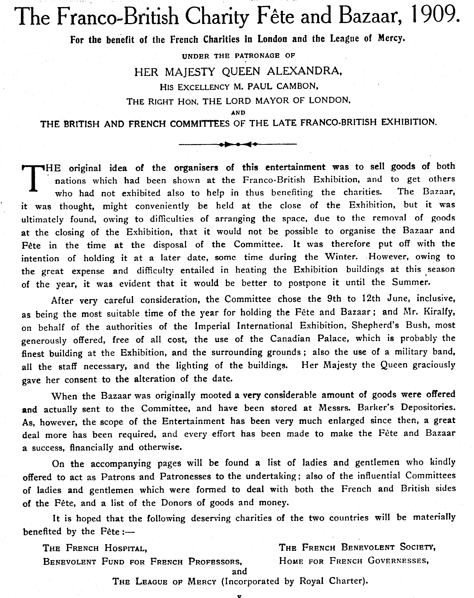

A South Carolina Band in London, 1914
By
Jeffrey P. Green

When Daniel Joseph Jenkins started charity work for orphans in Charleston, South Carolina, in 1890, he initiated a scheme that was to have several influences on thousands of his fellow black Americans. A basic education and vocational training at the Jenkins Orphanage school and farm turned nearly five thousand waifs into useful citizens. Shoe-repairing, bread-making, printing (including the weekly Charleston Messenger), and music-making gave pupils useful skills and, through public performances, publicized the orphanage and its work. Choral groups, an orchestra, and brass bands were part of the opportunities at the Jenkins Orphanage.
The bands travelled around the United States each summer (but seldom if ever west of the Mississippi), ventured into Canada, and crossed the Atlantic to perform in England. In the 1920s and 1930s Jenkins alumni worked in the company of some of the most respected black-led orchestras in the field of popular music, including those of Duke Ellington, Jelly Roll Morton, Fletcher Henderson, Jimmie Lunceford, Count Basie, Lionel Hampton, Luis Russell, and Charlie Johnson. In trumpeter
Cladys "Jabbo" Smith, the orphanage produced an original and vivacious performer who was the closest challenger to the pre-eminent Louis Armstrong.
Daniel Jenkins (ca. 1862-1937) was a giant of a man in both physique and achievement and he had considerable connections. The earliest copy of the Charleston Messenger to have been located, that of May 7, 1898, states that he was the sole import representative of the British musical instrument-maker Abraham Collins of London (who in turn was successor to the reputable Distins), which strongly suggests that the instruments available at the orphanage were not in poor condition.
In the summer of 1895 Jenkins took a band to London where they fell foul of England's child-protection laws. Nineteen years later, in 1914, he returned to England with another band from the orphanage. Jenkins had also been in Europe in 1906, traveling around British and French orphanages to investigate management techniques. He returned to Charleston to a reception that the Indianapolis Freeman (December 29, 1906, 5) noted included "musical numbers, which were rendered by the best local talent. (1) He and his second wife Eloise had left their daughter Olive in the hands of an English midwife shortly after her birth in Wigan, Lancashire, in November 1906.
She remained in England until 1920. One of his sons by his first marriage, Edmund Thornton Jenkins (1894- 1926), was called from his studies at Morehouse College in Atlanta to join the brass band in a party of twenty-eight that set off from Charleston in May 1914 to work at the Anglo-American Exposition in London.
Billed as the American Piccaninny Band and employed for ten weeks, their work at the White City exhibition complex four miles west of the center of London was so successful that in July the contract was extended into October 1914, when the Exposition was scheduled to close. Six postcards of the band were on sale to the public, one showed just John Garlington, the ten-year-old conductor; another showed a tall sousaphone player looking down on the diminutive Garlington (see the accompanying photographs from reproductions of three of the postcards).
Few visitors to the exhibition could have missed the sixteen (nineteen? Postcards) instrumentalists, whose schedule involved performing at different bandstands throughout the grounds.
A program of Friday, July 24 shows that the other two bands were regimental (20th Hussars, Lincolnshire Regiment) and that the Jenkins band started work at 11:45 A.M., playing seven selections in one hour and then resting until 2:45 P.M. when they played for two hours with a break
of fifteen minutes. They appeared in public again from 6:00 P.M. until 7:30 P.M. with a fifteen-minute break and then from 8:30 P.M. until 9:45 P.M., with a final thirty minutes beginning at 10:15 P.M. The regimental bands played until 11:30 P.M., but neither started before 1:00 P .M. The South Carolina waifs were on the bandstands just fifteen minutes less than the soldiers.
The outbreak of World War 1 at the beginning of August led to restrictions by the date of the second program to survive the years, Tuesday, September 1, 1914. This program shows that the Jenkins band started its public performances at 11:00 A.M. and was on the bandstands for the same, no-doubt contracted six hours and fifteen minutes. Three other bands (the Grenadier Guards and two non-military groups) played until the close at 10:00 P.M., with the soldiers playing for five hours and the others for about four hours each. The Charleston band's renditions are not fully known as the program is missing one page, but there appears to be no radical difference from the selections played in peacetime five weeks before
The band left Liverpool for New York on the “St Louis” on September 5, 1914. In view of the group's punishing schedule, it was wise for Jenkins to have brought spare performers, as shown by the passenger list, which names twenty-one known instrumentalists as follows:
Clarence Dreher, age 21
Edward Patrick, 20
Edmund Jenkins, 20
Edward Brown, 18
Lucius Aiken, 18
Alonzo Mills, 18
Jacob Patrick, 18
Emerson Harper, 17
Stephen Wright, 17
Eunice Briggam, 16
Clinton Brown, 16
Jacob Frazier, 16
William Gibbes, 16
Augustus Aiken, 15
William Benford, 14
George Thayer, 11
Marion Rennicks, 11
Charles Brown, II
Horace Holmes, 11
John C Garlington, 10
William Thomas, 10
The average age of the band members was fifteen, the oldest being Clarence Dreher, aged twenty-one and, one might suppose, the sousaphone player. Garlington, the conductor had six colleagues under the age of twelve. The group also included supervisor Paul Daniels (age 30) and a teacher, Sallie L. Bacon (age 26) ("Passenger list" 1914). (2)
The problem of identifying the instrumentalists in the postcards and on this passenger list are compounded by the facts that there are more names than faces and that tuition at the orphanage enabled skills to be acquired on more than one instrument. For example, like Jabbo Smith, William "Cat" Anderson, a famed trumpeter, was also a trombonist; and William "Bill" Benford played the bass in the twenties but has been identified by his younger brother, Thomas Benford, as a side drummer in 1914 London. (3) Dreher may be the sousaphone player. Edward Patrick played the cornet and his brother Jacob the trombone with Will Marion Cook's Southern Syncopated Orchestra in England in 1920 (Rye 1986, 219). Edmund Jenkins (clarinet) returned to England to study and teach at the Royal Academy of Music.
Lucius Aiken was the brother of Gus and Gene "Buddy" Aiken (usually spelled Aitkcn in jazz books). Gus Aiken was a trumpet player with Louis Armstrong, Sidney Bechet, Luis Russell, and Charlie Johnson. Alonzo Mills later taught at the orphanage and trained Jabbo Smith. He returned to London with an orphanage band in the stage play Porgy, in 1929. Emerson Harper (clarinet) made recordings in the twenties and then worked in radio in New York; he befriended Langston Hughes to the extent that Hughes's autobiography, ‘The Big Sea’ (1940), is dedicated to Harper and his wife. Hughes spent the last years of his life living with the Harpers in New York (Rampersand 1988), nos. 6, 37 and 417.
Stephen Wright (drums) and Edward Brown (trombone) have not been traced, nor has the career of Clinton Brown (baritone horn). But through John Chilton (1980) we know that Eunice Briggam or Briggams (cornet) joined the orchestra of Alphonso Trent. William Gibbes (horn or cornet) worked at Smalls' Paradise in Harlem in the 1929s when Jake Frazier (trombone) recorded with Bessie Smith and on other New York record dates.
The younger musicians who have had their careers traced include only Thayer (horn or drums), who worked in circus bands, and Holmes (cornet), who after studying at Morehouse College was to work with Elmer Snowden and Cliff Jackson. Perhaps the others, like so many Jenkins alumni, worked in weekend gigs in the jazz era, adding to an income earned outside the field of music
The social side of the band’s activities in the summer of 1914 was extensive, although the engagement at the White City was very full. Jenkins and his wife went to see their daughter in Wigan. Edmund Jenkins, with one of the Patricks, attended a service at Westminster Abbey at the end of August and there saw Kemper Harreld and his wife. Harreld, who taught music in Atlanta, had been in Berlin with Hazel Harrison and after some difficulties passed through neutral Holland to arrive in London (Green 1986) (4) Daniel Jenkins, excited by the visit of some London councillors (5) wrote to Governor Coleman of South Carolina asking for similar understanding and approval of his work in Charleston, it seems likely that one of the councillors was Mayor John Archer of Battersea, (6) who was a "race man," having been born in Liverpool of a Barbados father. He had earlier written to the Afro-American journalist John ("Bruce Grit") Bruce in New York, informing him that he intended to be involved in the Exposition,
The councillors, various members of Europe's aristocracy, and the organizers of other exhibitions paid attention to the band, but the contact that was both unexpected and somewhat exotic was with an African, One doubts that the youthful musicians took much notice, however.
Solomon Plaatje had come with others from South Africa to protest against the Natives Land Act of 1913, which reserved eighty-seven per cent of South Africa for whites. Such laws were passed in South Africa, for the imperial government in London had direct control only over South Africa's external affairs after the Union in 1910. The South Africans of the African National Congress (ANC) protested to London and tried to get imperial influence to overturn the 1913 legislation, Plaatje visited the exhibition in July, met with the band, and used postcards of the band for correspondence into October 1914. (7) Two decades before, Plaatje had participated in music-making in Kimberly, the diamond mining crater, where Will Thompson of the Fisk Jubilee Singers had made a lasting impression (Willan 1984, 43-45, 175).
Plaatje remained in England and saw his ‘Native life in South Africa’ into print in 1916. In August 1919 he returned to England from Africa and mixed with a musical and ambitious group around Edmund Jenkins, which included Will Marion Cook, several West Africans, and a delegation from Guyana (then British Guiana). Before he returned to South Africa, Plaatje was to be involved wish Du Bois and Gamy in New York and with Florence Mills in London in 1923.
Daniel Jenkins and his adult colleagues benefited from such contacts in London in 1914, and there can be no doubt that their reception encouraged them to continue with the work which, in just one field of music, has been described as a jazz nursery. Concert hall recital music was part of the Jenkins Orphanage program, and unlocated copies of the Charleston Messenger would seem to be the best source for documenting this activity.
It does seem that, even if other Afro-American institutions did not have the success in Britain that was attained by the band of the Jenkins Orphanage, investigations into other southern cities may show that other performers had tuition similar to that of the Charleston orphanage That blacks who participated in music-making, from circus rings, radio, sound recordings, theatres, and dance halls to academies, owed their basic training to outwardly prison-like waifs' homes and orphanages reflects the social system of that era but should be regarded as a major success of Afro-America and, in the case of the Jenkins Orphanage of Charleston, South Carolina, a major contribution to black music.
The need for further research is strongly suggested by a recent Smithsonian publication about American brass bands (Hazen 1987) which has no more than ten pages of two hundred detailing black brass bands. Even New Orleans research twenty years ago located about twenty photographs of brass bands (Rose and Souchon 1967). What other documentation awaits the researcher in the field of black brass band music?

References
Chilton, John. I960. A jazz nursery: The story of the Jenkins Orphanage Bands. London: Bloomsbury Bookshop. (This well-illustrated monograph is still available from Storyville, 66 Fairview Drive, Chigwell Essex IG7 6HS. England.)
Green. Jeffrey P. 1982, Edmund Thornton Jenkins: The life and times of an American black composer. 1894-192$. Westport, Conn. Greenwood Press.
---1984. Beef pie with a suet crust: A black childhood in Wigan (1906-1920). New Community (London) 11, no. 3 (Spring): 175-178. (This is largely an interview with Clive Harleston who died in New York in August 1987.)
---1986. Kemper Harreld. Storyville no. 124 April - May 138-139.
Hazen, Margaret Kindle, and Robert M. Hazen. 1987. The music men An illustrated history of Brass bands in America 1800-1920- Washington, D.C. The Smithsonian Institution.
Passenger list of the St. Louis. 1914. Public Record Office, Kew, England, File BT 27/842.
Rampersad, Arnold. 1988. ‘The life of Langston Hughes’. Vol. 2:1941-1967, I dream a world. New York: Oxford University Press.
Rose, Al, and Edmond Souchon. 1967. New Orleans jazz A family album. Baton Rouge: Louisiana State University Press.
Rye, Howard. 1986. The Southern Syncopated Orchestra. In Under the imperial carpet: Essays in black history 1780-1950. edited by Rainer Lotz and Ian Pegg, 217-232. Crawley, Sussex: Rabbit Press.
Willan, Brian, 1984. Sol Plaatje, South African nationalist 1876-1932. Los Angeles: University of California Press.

(1) My thanks to Doug Seroff for this reference.
(2) 1 am grateful to Mr. Lucius Coggins of Charleston, South Carolina, who identified Garlington, Frazier. and Mills in one of the postcards and said that the adult male with the band was neither Jenkins nor Daniels. Mr. Coggins, interviewed in 1979. recalled entering the Jenkins Orphanage in November 1914 and that none of the band who had been to London made any fuss about it.
(3) Benford's dance band was taken over by Jellv Roll Morton in New York for some classic small band jazz records in 1928, later he followed a career in religious work.
(4) Mv thanks to Josephine Harreld Love for her assistance. The September 1, 1914. program produced here belong to the Harreld’s.
(5) Councillors are elected members of London's city government.
(6) Battersea is a district of London with its own borough administration, headed bv a mayor.
(7) Anna Cunningham Curator of Manuscripts, University of Witwatersrand Johannesberg located photographs of the Jenkins Orphanage band in the Plaatje / Molema papers. My thanks to Brian Willanfor bringing this fact to my attention.

