EDITORIAL SPRING 2016

Be of good cheer and shout hooray
Old Bill was 90 the other day
And further down you’ll see on the page
That the Journal too’s reached a good old age.

Yes, last year the Journal celebrated 35 years of non-stop publishing. Well, nearly non-stop if we overlook the time when Andrew apologised to the members for not sending out a news-letter as it was called then, for two years, and that was after a one year break. I suppose you could say the Journal has had its ups and downs in the past, but since Fred has joined the editorial staff we have turned out what I think are some jolly good publications. I am very conscious that for many of our members the Journal is all they get for their money. If it’s not of interest they will walk.
Fred has also produced the Festival of Britain Society’s ‘Festival Times’ since 1996, but tells me he has now found some body to take over doing the Festival Times, although I am sure he will still contribute the odd article to them.
The good news is that I have years of Crystal Palace related articles and drawings from Fred to publish in our Journal, but this does not mean I don’t want other subscribers to send me in material. Kenneth my son has sent in a long article on Australian ‘Wembley’ postmarks, but there does seem to be a shortage of collectors with a knowledge of an exhibition related subject coupled with a willingness to do an article and spread their knowledge around.
From time to time I have had the odd member comment on the demise of our circulating packet and suggest a for sale column might be of interest. A few issues back in our summer edition I did a two and a half page sales list of about a hundred White City exhibition post cards. I have four boxes of British exhibition duplicates which must come to well over a thousand post cards, and I thought it was about time I got rid of some of them.
Now some of the cards I listed were common cards but some were very good advert and trade cards. A few years back (2008) I organised the sale of George Simner’s Festival of Britain collection which went very well and Flo was left at the end with only about twenty unsold cards out of a list of about 400 I circulated. I suppose I expected a similar response to my swaps, but to my surprise I didn’t sell a single card, not one!!
I think it is sad that in seven years we have moved from a near complete sell out, to not a single sale from a collection of exhibition cards. It almost seems that today the main object of the exercise for a collector, is to sit at his or her computer out-bidding other collectors, they’re not really interested in building up their collection. The good old days of going to post card fairs and perhaps meeting other collectors with a similar interest is now almost a thing of the past. In the heyday of my collecting, for nine years I average 64 trips to post card fairs each year. Covering the country from York down to the South Coast and from Yeovil across to Chelmsford. Every weekend I was off in the car to a fair. One day I shall add up out how many thousands of fairs I have visited since I started collecting. Sadly going to fairs is now beyond me, and believe me I do miss them.
A few weeks ago I received an auction catalogue and browsing through it I noticed an illustration of a Tasmanian Government Official Franco-British card, that I had listed in my list of duplicates. The lot was listed as a single ‘rare’ card titled ‘Packing Apples for England’ with an valuation of $150 Australian dollars (£73). It nearly reached the valuation selling for $135.85 (£67). Now these Tasmanian cards are fairly scarce cards, I have 19 out of the set of 24 and I see that some of them have cost me as much as £35 and £40 each. I offered two in my list, one ‘Packing Apples for England’ at £10 and a creased copy of another title at £2. As I wrote above neither of them sold.
I have to ask myself have all our members who collect the White City got all the Official Tasmanian Franco-British cards? I very much doubt that. If they haven’t got the cards were my prices too high? Perhaps, but then a copy of one went for £67 only last December, and as I mentioned above I have paid as much as £35 and £40 for some of my copies of this fairly scarce set. All right, so I might have paid a bit over the top for some of mine, but the fact remains after many years of collecting I am still looking for five cards to complete my set.

The Editors
Exhibition Study Group A.G.M.
Held at the Crystal Palace 10 October 2015
Report by Don Knight.

President Ramon Goodey opened the meeting by welcoming those present to a very pleasant weekend. He thanked Derek Connell for his work done for the study group at Europhilex 2015 and those who supported him at the National Philatelic meeting, a write-up will be published in Stamp Lover. He had a lot of response from their members and hopes it can be repeated. He had come to the end of his three years as president which he has enjoyed very much. He then asked Don Knight to take the meeting. A vote of thanks was proposed for Ramon with a round of applause.
Hon Secretary Don Knight reported there were three apologies for absence George Burr, Peter Denley and Dave Baker. The minutes of our last A. G. M. were taken as read as they had been distributed to all members. Minutes of the last A.G.M were proposed by K Tonkin and seconded by D Connell and passed by all. A member of the Wembley History Society had contacted Don regarding the Somalia Hut which stood next to the New Zealand Pavilion in 1925, asking if I knew what had happened to it as it was shipped back to New Zealand. With it made up of timber and straw, Don suggested it would have been stored on deck and could have been washed overboard. Ken Rumsey told him about Colin Searle wanting him to put up on our web site about him forming a Congress Study Group, this needed to go to the A.G.M. The Europhilex meeting got us 2 new members.
Treasurer Ken Tonkin reported on the finances which are sound, we have £12.539.15 in our account. There is no need to increase our annual fee.
We had no report on our Web Site. A question was raised that the group needs to have it looked at by a professional, this was agreed by all. Melvin Harrison made a phone call and arranged an appointment for someone to come along on Sunday morning.
Derek Connell gave a report on Europhilex 2015 and our meeting on the Saturday afternoon, This was well attended and attracted outsiders, of which 2 have joined the Study Group. Displays were given by Derek, Peter Denley. Kenneth Tonkin and Don Knight, Bill Tonkin attended. Europhilex was attended by15.000 people.
Election of officers at this point Ramon Goodey stood down as President. Derek Connell spoke before the election, and put it to the meeting that he would rather be elected as chairman and he proposed that Bill Tonkin be elected as Hon Life President. It was pointed out that this means a change in the constitution. Derek’s proposal was seconded by Fred Peskett and accepted by all present. Hon Life President Bill Tonkin proposed by D Connell seconded T Gazzard accepted by all, Chairman D Connell proposed by R Goodey seconded D Knight accepted by all. Hon Treasurer K Tonkin proposed D Connell seconded R Trevelyan accepted by all.
Committee G Burr, B Tonkin, R Goodey, proposed D Connell seconded K Tonkin accepted by all. Publicity Officer R Goodey proposed D Connell seconded D Knight accepted by all.
Web Master no decision. Journal B Tonkin and F Peskett and Archivist B Tonkin proposed D Knight seconded R Goodey accepted by all. Journal printing and distribution K Tonkin proposed F Peskett seconded R Goodey accepted by all. Accounts checker D Brooks proposed D Connell seconded by T Gazzard accepted by all.
Convention 2016 it was agreed by all to be Crystal Palace on the 8 and 9 October 2016. Any Other Business, Bill Humbley had donated a number of sets of cards produced for Europhilex and badges to the Study Group, D Connell handed them out to those present, having just the right number of set of cards. J Greatrex said he hoped that a special anniversary of an Olympic Games held at Crystal Palace in 1866 would be held in 2016 and he hoped the Exhibition Study Group would be involved. Fred Peskett said he will be displaying his Meccano in an exhibition The Golden Years, at Bognor Regis 2016.
The constitution to be amended and bought to the 2016 A.G.M.
Meeting Closed at 11.15 am
Francis Kiddle R.D.P. HON FRPSL.

It is with great sadness that we had the news of the death of Society member Francis Kiddle. Francis was very well known both in the U.K and around the World, his involvement in the Philatelic scene was huge. He was widely respected and received the highest possible personal recognition from his philatelic peers.
A member of many Clubs and Societies, including the Royal Philatelic Society, serving as Honorary Librarian (1979 - 1994), Vice President (1992 - 1994) and President (1994 - 1996). He was elected a Fellow in 1979 and Honorary Fellow in 2009. He was invited to sign The Roll of Distinguished Philatelists at the 77th Philatelic Congress of Great Britain held at Chichester in 1995.
Francis has made his mark over many years in organised philately both in the UK and internationally. Involved with the British Philatelic Federation from 1981 he was its Vice-President at the time of its demise. He became a Trustee for the British Philatelic Trust in 1985.
He served on many Committees and Councils, receiving awards both in the U.K and overseas, including the Royal Mail Lifetime Achievement Award and the Smithsonian Museum Lifetime Award in 2001.
Francis was also well known Judge, judging at many exhibitions in the U.K and overseas. He enjoyed the hobby, entering competitions, winning awards, giving talks and presentations, speaking at seminars on many philatelic subjects.
He was a keen collector with varied interests, including GB Overprints, Channel Islands, GB Uniform Penny Postage, Australian revenues, Morocco Agencies and Cinderella items, this last interest he shared with his brother Charles.
In his working life, in the Space Industry, he became Assistant Director of Space Technology at the Defence Evaluation Research Agency in the U.K, retiring in 1979.
We wish to express our condolences to Maire, his widow, sons John and Alan and all other members of the Family at this sad time.

The almost forgotten the International Exhibition of 1862.
The Decorative Arts Society, 1850 to the present.
Journal 38 – 2014
A book review by Matthew Denney

The Decorative Arts Society has been in existence since 1975 and may well be familiar to members of our Society. They offer the usual range of visits, international tours, there are three newsletters a year and an excellent annual journal. The journals are always interesting and well worth considering as they sometimes include articles on exhibition related subjects. The 2014 edition of the journal is explored here as it considered the International exhibition of 1862. With support from the William Shipley Group for RSA History and other bodies, the Society has produced an impressive and well-illustrated colour journal that runs to over 200 pages.
The 1862 exhibition was, of course, a huge undertaking, on a site larger than that used for the 1851 exhibition, with 26,336 exhibitors it attracted over six million visitors. It is best remembered for the disappointing building that was designed by an Army Engineer rather than a ‘proper’ architect; so disappointing was it that it was very soon demolished. In exhibition history it is the first to have included Fine Art as a separate category and is well remembered for showing some influential Japanese items and an impressive Medieval Court with furniture by some of the Victorian periods most important designers.
With eleven articles on varied subjects this is clearly a journal of collected essays on a theme rather than a history of the exhibition. Despite this the calibre of the authors writing on their own specialisms is excellent; such as Sir Mark Jones writing on medals for the Great Exhibitions, Charlotte Gere and Judy Rudoe on jewellery at the exhibition and Max Donnelley on furniture. Consequently this volume is a valuable addition to the limited literature available on the 1862 exhibition.
The articles cover disparate aspects of the exhibition; the first two consider the events that led up to the exhibition and the building itself. The building in South Kensington that has been described as ‘Hardware-Ecclesiastical-Railway- Factory-Gothic’ was controversial from the start and caused much debate. As is pointed out the shadow of the Great Exhibition hung heavy over the 1862 exhibition, and the hugely popular Crystal Palace was always likely to present too great a challenge to the organisers of 1862. Dishon’s article covers the creation of the building, its operation throughout the period of the exhibition and its all-too-quick demolition. Some of the seventeen million plus bricks and other salvaged materials being used for the equally ill-fated Alexander Palace. For those who enjoy collecting artefacts from international exhibitions, Mark Jones’s article on the award medals from 1851 and 1862 is as good a description of the various medals as one could hope to find.
The exhibition is said to have brought together ‘examples of nearly everything which civilization has created’. Of the papers in this journal only four concern themselves with these exhibits. Max Donnelly gives an excellent and thorough account of the furniture in the Medieval court, which included items that have most certainly not been forgotten by history. Charlotte Gere and Judy Rudoe consider jewellery at the exhibition, and give attention to the competition between France and England to find pre-eminence in the fine and decorative arts, a theme which seems to run throughout the period. John Agnew gives an interesting account of the machinery hail, an aspect of exhibition history that is often overlooked in favour of the more ‘picturesque’ decorative and fine arts.
Julius Bryant takes on the all too challenging job of trying to summarise the many works of art in the exhibition. The 1862 exhibition, despite Bryant’s protestations was the first to include a large selection of fine art in the form of paintings and the development of the exhibition hall as public art space is one worthy of further consideration. Anthony Burton tackles education at the exhibition as a category for display and his article leaves us rather of the mind that this was one of the less successful aspects of the exhibition.
The final three articles are more varied in approach. John Davis writes on the German States and the 1862 exhibition and uses this as an opportunity to explore the history of Germany and argue for a greater part in exhibition history for this nation, or group of more or less disparate states. Some discussion of the relationship between national and international exhibitions and the distinctions between types of exhibition might help to clarify this argument. Anthony Burton takes the teasing title ‘Did Britain Win in 1862?’ to consider the impact of design education, in particular the South Kensington Schools, on the objects displayed in 1862 when compared with 1851. The ‘Great’ exhibitions of the Victorian era were clearly concerned with international competition and the overriding Victorian concern for ‘good’ and ‘appropriate’ design that was better than other less successful design is apparent in the discourse around design and education. This is a subject that could fill many volumes and this article raises many interesting questions.
Members of our study group might question the notion that the 1862 is ‘almost forgotten’, however there are no currently available books published on the exhibition (unless I am mistaken) and surely there should be. This volume, which is available from the Society, gathers together a number of excellent articles and it should find a place on the shelves of all those interested in the history of exhibitions and nineteenth century design/art history. Perhaps this volume will help generate interest in the 1862 exhibition and lead to further publishing on this overlooked if not completely forgotten event.

Tale of an Aboriginal Lad
By
Bill Tonkin

At our last convention I displayed some items of what I suppose is my favourite exhibition, the Japan-British in 1910 and while the members were looking at the display Terry Gazzard came up to me and mentioned he had two of the Valentine ‘cut to shape with luggage label’ cards and from his description one of them was a new one to me. He agreed to send me scans of his two cards, and when I saw them, one was a new card I had never seen before. The scan was in colour and it was of an absolutely beautiful card. Why is it other peoples cards that you haven’t got yourself are always so desirable? The paper folds in Terry’s scans have unfortunately been magnified on my reproductions here.
The luggage label tied to the card showed it and his other card had both been bought and posted at the exhibition. The small envelope seen on the back contains a strip of twelve views.

I wrote to Terry thanking him for his scans as follows.
Many thanks for the scans. I envied you your cards, both posted at the exhibition too. As soon as I saw the lad, I said to myself “I know you” and it didn’t take me a few moments to find him. He is an Ainu child brought over from Japan to appear at the Japan-British Exhibition. An article in ‘The Times’ on the 16 April 1910 reported his arrival.
“The liner Kaga Maru which arrived at the Albert Docks yesterday, brought a small party of Aino and a larger company of the natives of Formosa who are to be the inhabitants of native villages at the Japan-British Exhibition.”
The Ainu party consisted of five men four woman and one child while the Formosan party had 21 men and four woman. Even in 1910 the Ainu tribe were considered an endangered species having been driven out of mainland Japan onto one of the Northern islands and the newspaper report stated their numbers had not increased since 1882. It was claimed in 1910 the Japanese Government was doing all in its power to preserve and protect them. (The Ainu are Japanese aboriginals driven out of the mainland as Japan became civilised as happened to the Australian and North American aboriginal people.)
I am sending you a scan of a post card of the lad published by Valentine in their real photograph Ainu series which are all very scarce although Valentine’s coloured cards of the Ainu are fairly common. The card of the lad (scan enclosed) and another card of a maiden (Not your girl card) are very rare and I have only seen the copies I have in about forty years of searching.
I can fill you in some more about the lad. A Japanese Professor of Archaeology Yuriko Fukasawa visited me some years ago to look at my Japan-British Exhibition post cards. It was a brief visit as I think she was a bit overwhelmed by the task. However some months later or it may have been a couple of years later she phoned me from Japan asking if she could spend more time with my collection, and could I arrange for her to stay at a local hotel for a few days.
I replied West Wickham was not hotel country but I had a spare bedroom which she was welcome to use, and she stayed three nights in my home going through my cards and recording them on her lap top.
It turned out she had lived in an Ainu village for two years while working for her dissertation which got her her doctorate, and she remembered meeting descendants of the child on the card who told her they remembered their father talking about his visit to England when he was a child.
While he was ‘on show’ an English doctor and his wife wanted to adopt the child, and promised to have him educated to become a doctor. This the parents would not agree with, and he went back to Japan with them.
Yuriko was amazed to see my Ainu maiden post card and recognised her by the tattoos on her mouth and arms and said she never expected to see a picture of her.
The photograph for this post card published by Valentine must have been taken at the same time by the Valentine photographer as the picture used for your cut out, in fact only his hands and his eyes have moved slightly. In 1910 there were two ways used to spell the name of this tribe, Ainu and in ‘The Times’ Aino.

Imperial Airways Ltd.
Part 2 by
Bill Tonkin.

Aeroplane Picture No. 5.
An Imperial Airways Passenger Aeroplane.

Details of Aeroplane picture No. 5
Publisher | Ref | P of Printed over | For address only | A of Art under | Stop to postcard | CARTE POSTALE measures | Title measures
Tuck | 5-A | Trade mark | Up & low case | l & T of ael Tuck | Without stop | 22 mm. | 75 mm.
Tuck | 5-B | T of OTO | Capitals | u of Tuck | Without stop | 33 mm. | 77 mm.
Tuck | 5-C | Pr over TOG | Capitals | k of Tuck | Without stop | 33 mm. | 76 mm.
Tuck | 5-D | Pr over TOG | Up & low case | k of Tuck | Without stop | 33 mm. | 76 mm.
Tuck | 5-E | O of TOG | Up & low case | k of Tuck | With stop | Not known. | 76 mm.
Additional notes
Picture No. 5-A. With white border, title measures 75mm. ‘Postcard.’ only is in non capital
letters.

Aeroplane Picture No. 5. Aeroplane Picture No. 6.

Aeroplane Picture No. 6.
An Imperial Airways Passenger Aeroplane.

Details of Aeroplane picture No. 6
Publisher | Ref | P of Printed over | For address only | A of Art under | Stop to postcard | CARTE POSTALE measures | Title measures
Tuck | 6-A | Trade mark | Up & low case | l & T of ael Tuck | Without stop | 22 mm. | 75 mm.
Tuck | 6-B | T of OTO | Capitals | k of Tuck | Without stop | 33 mm. | 75 mm.
Tuck | 6-C | T of OTO | Capitals | k of Tuck | With stop | 33 mm. | 76 mm.
Tuck | 6-D | T of OTO | Capitals | k of Tuck | With stop | 33 mm. | 75 mm.
Tuck | 6-E | O of TOG | Capitals | k of Tuck | With stop | 33 mm. | 77 mm.
Tuck | 6-F | OT of HOTO | Up & low case | k of Tuck | Without stop | 31 mm. | 75 mm.
Tuck | 6-G | T of OTO | Capitals | k of Tuck | With stop | 33 mm. | 75 mm.
Additional notes
Picture No. 6-A. ‘Printed in England’ on the left, With white border, title measures 75mm.
‘Postcard.’ only is in non-capital letters.
Picture No. 6-E. Title with stop measures 77mm. With a stamp and exhibition post mark for ?
September 1925.

Aeroplane Picture No. 7. Aeroplane Picture No. 8.

Aeroplane Picture No. 7.
An Imperial Airways Passenger Aeroplane.

Details of Aeroplane picture No. 7
Publisher | Ref | P of Printed over | For address only | A of Art under | Stop to postcard | CARTE POSTALE measures | Title measures
Tuck | 7-A | T of OTO | Up & low case | k of Tuck | With stop | 33 mm. | 54 mm.

Aeroplane Picture No. 8.
Imperial Airways Passenger Aeroplane. (Note title is without ‘An’)

Details of Aeroplane picture No. 8
Publisher | Ref | P of Printed over | For address only | A of Art under | Stop to postcard | CARTE POSTALE measures | Title measures
Tuck | 8-A | “ after  APH” | Up & low case | u of Tuck | With stop | 26 mm. | 58 mm.
Tuck | 8-B | PH of PHO | Up & low case | ck of Tuck | With stop | 27 mm. | 58 mm.
Additional notes
Picture No. 8-A. ‘POSTCARD No. 1A/C/56’. on back in bottom left corner.

Aeroplane Picture No. 9. Aeroplane Picture No. 10.

Aeroplane Picture No. 9.
An Imperial Airways Passenger Aeroplane.

Details of Aeroplane picture No. 9
Publisher | Ref | P of Printed over | For address only | A of Art under | Stop to postcard | CARTE POSTALE measures | Title measures
Tuck | 9-A | H of PHO | Capitals | k of Tuck | Without stop | 33 mm. | 76 mm.
Tuck | 9-B | HO of PHOT | Capitals | k of Tuck | Without stop | 33 mm. | 76 mm.
Tuck | 9-C | OT of HOTO | Up & low case | k of Tuck | With stop | 33 mm. | 76 mm.
Tuck | 9-D | TO of OTOG | Capitals | uc of Tuck | With stop | 33 mm. | 76 mm.
Unknown Type 1 | 9-E |  |  |  |  |  | 77 mm. inc stop

Aeroplane Picture No. 10.
An Imperial Airways Passenger Aeroplane.

Details of Aeroplane picture No. 10
Publisher | Ref | P of Printed over | For address only | A of Art under | Stop to postcard | CARTE POSTALE measures | Title measures
Tuck | 10-A | Trade mark | Up & low case | l & T  ael Tuc | Without stop | 22 mm. | 75 mm.
Additional notes
Picture No. 10-A. Title measures 75mm. With white border. ‘Postcard.’ which is in non
capital letters.

Aeroplane Picture No. 11. Aeroplane Picture No. 12.

Aeroplane Picture No. 11.
An Imperial Airways Passenger Aeroplane

Details of Aeroplane picture No. 11
Publisher | Ref | P of Printed over | For address only | A of Art under | Stop to postcard | CARTE POSTALE measures | Title measures
Tuck | 11-A | T of OTO | Up & low case | k of Tuck | With stop | 31 mm. | 51 mm.
Tuck | 11-B | O of TOG | Capitals | k of Tuck | With stop | 33 mm. | 52 mm.
Unknown Type 1 | 11-C-a
Unknown Type 1 | 11-C-b
Additional notes
Picture No. 11-C-a. No title. By an unknown printer Type 1, R/Photo with white border, black
back. ‘Imperial Airways Ltd’ measures 57 mm. Wembley stamp and exhibition post mark for 10 June 1925.
Picture No. 11-C-b No title. By an unknown printer Type 1, R/Photo with white border, black
back. ‘Imperial Airways Ltd’ measures 57 mm. Wembley stamp and exhibition post mark for 13 August.

Aeroplane Picture No. 12.
An Imperial Airways Passenger Aeroplane.

Details of Aeroplane picture No. 12
Publisher | Ref | P of Printed over | For address only | A of Art under | Stop to postcard | CARTE POSTALE measures | Title measures
Tuck | 12-A | Trade mark | Up & low case | l & T of ael Tuc | Without stop | 22 mm. | 76 mm.
Tuck | 12-B | OT of HOTO | Up & low case | k of Tuck | With stop | 33 mm. | 76 mm.
Tuck | 12-C | O of TOG | Capitals | k of Tuck | With stop | 33 mm. | ? mm.
Additional notes
Picture No. 12-A. Title measures 76mm. With white border, ‘Postcard.’ only is in non-capital
letters.
Picture No. 12-C. Measurement of title not known.

Aeroplane Picture No. 13. Aeroplane Picture No. 14.

Aeroplane Picture No. 15

Aeroplane Picture No. 13.
Imperial Airways Passenger Aeroplane, City Class.

Details of Aeroplane picture No. 13
Publisher | Ref | P of Printed over | For address only | A of Art under | Stop to postcard | CARTE POSTALE measures | Title measures
Tuck | 13-A-a | OT of HOTO | Up & low case | c of Tuck | With stop | 28 mm. | 75 mm.
Tuck | 13-A-b | OT of HOTO | Up & low case | u of Tuck | With stop | 28 mm. | 75 mm.

Aeroplane Picture No. 14.
Imperial Airways Passenger Aeroplane, City Class.

Details of Aeroplane picture No. 14
Publisher | Ref | P of Printed over | For address only | A of Art under | Stop to postcard | CARTE POSTALE measures | Title measures
Tuck | 14-A | OT of HOTO | Up & low case | c of Tuck | Without stop | 33 mm. | 58 mm.
Additional notes
Picture No. 14-A. Title measures 58mm.. ‘Post Card No. 1A/C 54’ on back of card.

Aeroplane Picture No. 15.
Imperial Airways Passenger Aeroplane, City Class.

Details of Aeroplane picture No. 15
Publisher | Ref | P of Printed over | For address only | A of Art under | Stop to postcard | CARTE POSTALE measures | Title measures
Tuck | 15-A | OT of HOTO | Up & low case | u of Tuck | With stop | 22 mm. | 74 mm.

Exhibition Study Group Journals

One of our members George Burr is downsizing his possessions and has handed me a long run of our journals from No. 31 (1993) to No. 91 (2008). These have all been kept in individual punched plastic pockets and are in immaculate condition. These are available to the first member prepared to collect them from West Wickham, or pay the postage. 020 8777 8861.

Souvenirs of the Crystal Palace.
Drawings and written by Fred Peskett

Souvenirs made from mixed materials.

A Trinket Box made from cardboard which is covered with red velvet cloth. A three dimensional moulded view of the Crystal Palace in “Ivorine” is fitted to the lid. Imitation “gold” bands cast in white metal are applied around the Ivorine and to the sides of the box. The interior is covered with gold cloth. The date of manufacture is around 1880/1890. It measures four inches long by three inches wide by one and a half inches high.
Shown actual size.

Full size

The Trinket Box illustrated below is made from cardboard which is covered with red cloth. The sides of the bottom of the box are plain, but the lid is ribbed. A photographic view of the Crystal Palace taken from the Low Level Railway Station is fixed under a glass top, the sides of the glass are mirrored. The photographic image of the Crystal Palace is slightly larger than a normal postcard size, but the serial number 228 and the title style are typical of being from a negative that was used for postcard production. The dimensions of the Trinket Box are:- six and three quarters of an inch long by five inches wide by one and one quarter of an inch high.

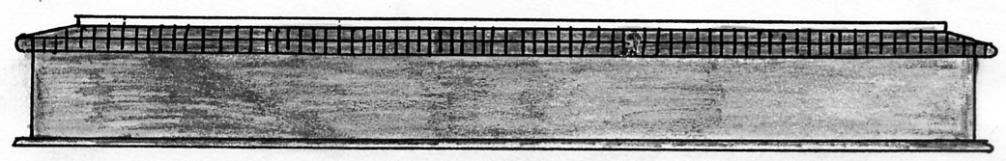

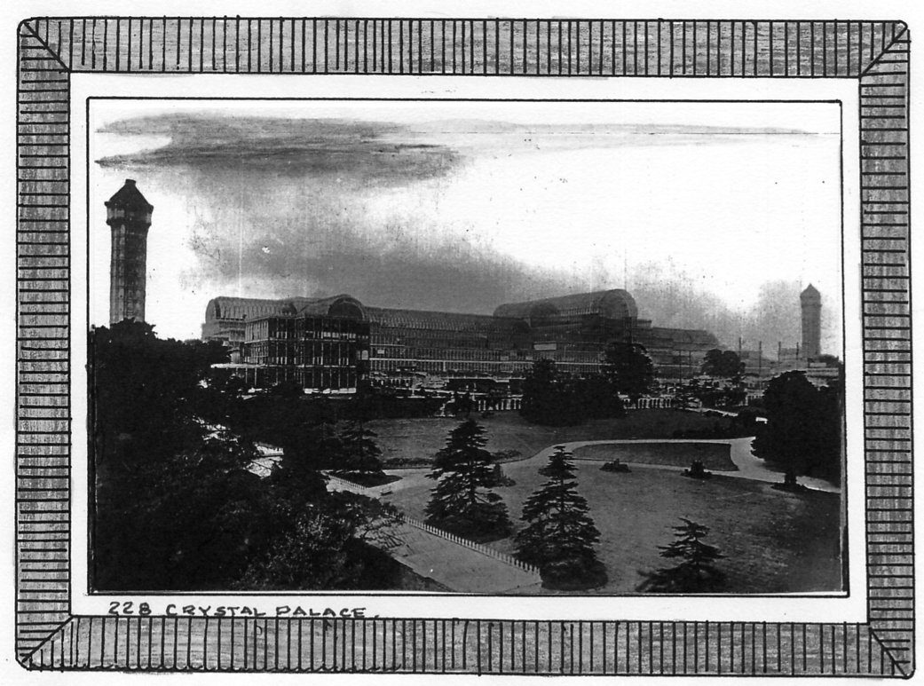

Souvenirs made from wood.

A Mauchlineware (Germanic Type) Souvenir Money-Box in the shape of a Barrel. The black and white transfer of the Crystal Palace shows both the Central and North Transepts, (the North Transept was destroyed by fire in 1866 and not re-built), although this souvenir was probably made around some time after 1890.
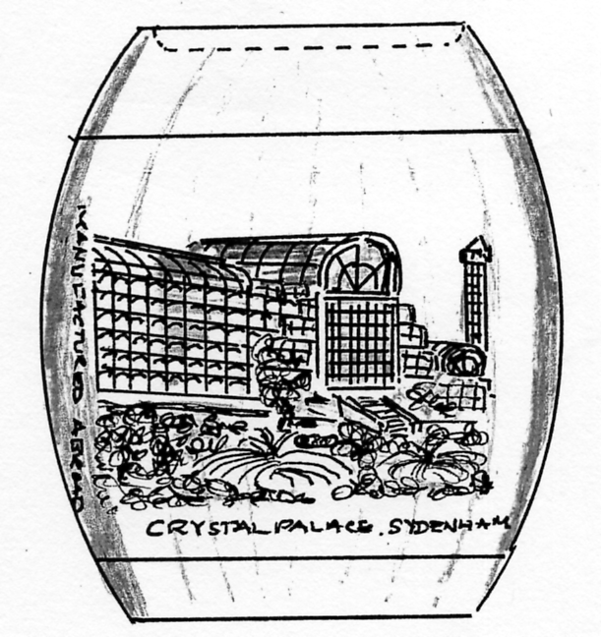
There are a number of variations to the basic design. Illustrated is the Type 1 where the diameter of the central point of the barrel is two and three eighths inches, the diameter at the top and bottom ends is one and five eighths inches, the height is two and three quarters inches. A recess is formed in the top face, this is one and seven sixteenths inches in diameter, it is one eighth of an inch deep. A slot to accept the saved coins, one and one quarter inches long by one eighth of an inch wide is at the bottom of the recess. The top of the barrel pulls oft to be able to recover the saved coins. “Manufactured Abroad” is down the left side of the transfer view.
The Type 2 Barrel Money Box is identical to the Type 1 except the “Manufactured Abroad” is down the right side of the transfer view.
A Type 3 Barrel Money Box is also identical to the Type 1 but the “Manufactured Abroad” has been omitted.
A further Type 4 Barrel Money Box has a diameter of two inches at the central point, the top and bottom diameters are one and three quarters of an inch, the height is three inches and the diameter of the recess is one and five eighths inches. “Manufactured Abroad” is down the right side of the transfer.

Below on the left is shown full size a Mauchlineware Cylindrical Box made from Boxwood with a wrap around black and white transfer of the Crystal Palace applied to the centre. The view shows the Central and North Tower, the view is pre 1866.

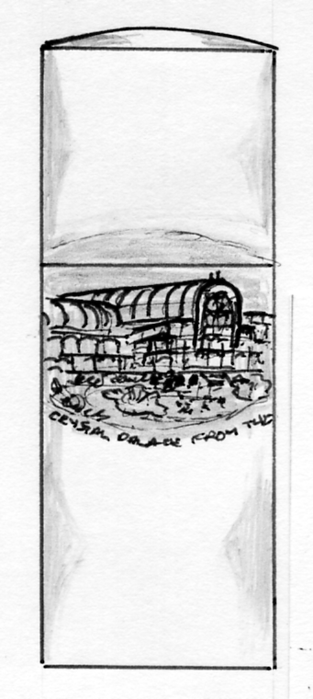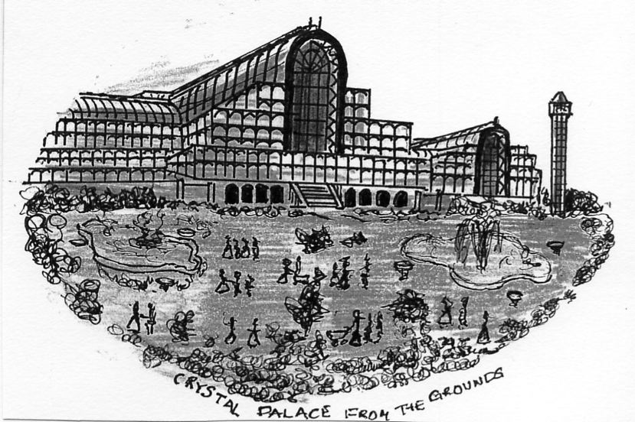

Enlarged view of the transfer

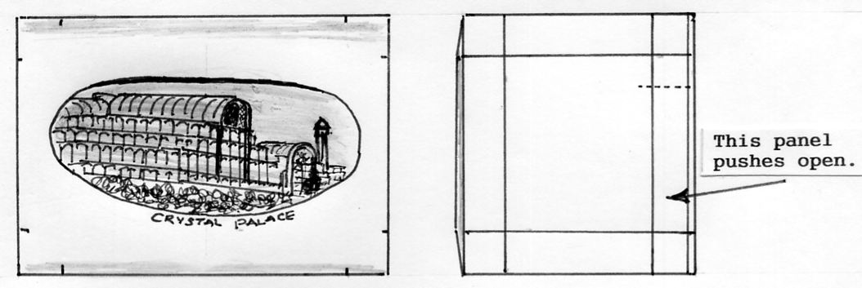

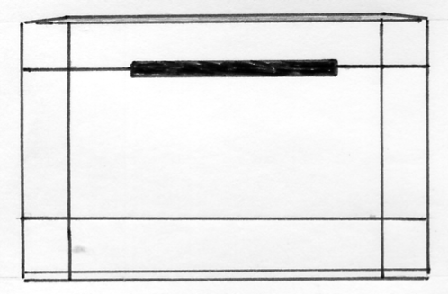
Mauchline Ware “Secret” Money Box.
The Money Box is made from boxwood. A black and white Crystal Palace transfer on the top shows the Central and North Transepts (pre 1866) There is a secret lower panel on one side that is hinged and pushes open to remove any saved coins. The dimensions are three inches long by two and a quarter inches wide by one and three quarters of an inch high to the apex of the slightly domed top. The style of the transfer and wood used are typical of it being made in Scotland.

1924 British Empire Exhibition Advertising Labels
by
Raymond Goodey

Some recent additions acquired by Raymond Goodey not previously illustrated or recorded.

Boots the Chemists Cox’s Shipping Agency Ltd. Charlesworth & Co.,
Ltd.

Hull Civic Weeks H. & B. Hoffman & Sons Ltd.

