Editorial No. 12.

In this edition the Membership list, with member's interests, has been brought up to date. Old lists should be avoided, especially if a member wishes to circulate information to everyone, as some members on the previous lists have died. Others have been eliminated because they have dropped out for their own reasons or, after many free copies, not paid their subs!
Although we are still a small group and lucky enough to be able to rely on the services of one of our members to help out with the printing and postage, I do think it important that from this year we insist on reasonably prompt payment of the annual dues. (Those members with a X at the bottom of the page - this is a reminder)
We must also try and anticipate the future needs and growth of the Group, so that increased membership does not lead to frustration and misunderstandings. A small start has been made in this direction - we now have a bank account opened in the name of the Exhibition Study Group. I would also like to see some discussion at the annual meeting on the election of officers who can perhaps map out the aims and objectives for the next ten years. Please send your comments on how you think a group, such as ours, should be organised, remembering that the main contact is through the newsletter, an annual meeting and individuals making contact.
As your editor I am sending out another urgent request for articles, postcard checklists, queries, etc. If you can write the item in longhand, it can always be typed out in my speedy two finger method, so don't let that put you off. I will even correct spelling mistakes and probably make a few of my own! However , now that Illingworth Developments print and post, your postcards or ephemera may be out of your hands for a few weeks. I can quite understand the concern to have originals back as soon as possible but trying to copy another xerox usually ends up with a black/white smear. We will take great care of anything sent.

Manchester Exhibition Study Group Meeting Sept 30 – Oct 1

This weekend was selected to try and avoid the bad weather, long nights and the British Rail winter timetable. It may well clash with the Wick Book Fair and the Tibet Postal History weekend but you shouldn't collect so much !
Do try to come and if possible let me know as soon as you can so that we have some idea of numbers. The venue will be in Didsbury, close to the centre of Manchester. Although the details have not been worked out, we shall follow the successful format from last year ie., invited talks, displays and informal chats. A start will be made by 10 - 10.30 am on Saturday and finish at 4pm on Sunday. If members wish to follow last year’s social evening dinner, this will be arranged. If you wish to make arrangements for accommodation could you contact Karl Illingworth who I am sure will be able to suggest somewhere suitable.
The Festival of Britain Society is up and running and I have received the first edition of their newsletter. This is a MUST for anyone interested in the F.O.B. (see Fred Peskett in members lists) Mike Perkins has taken the first steps with his idea of a 'circulating’ newsletter sent to those members who are interested in the listing of the British Empire Ex.(Wembley) 1924 - 5 Picture Postcards. Again , please contact Mike if you wish to be added to his list.
Melvin Harrison has promised me information on the Crystal Palace Foundation in time for the next newsletter, again write direct if you don't want to wait. As a result of the Ideal Home Ex. ppc list in No. 11 I received a long list from Arthur Smith plus a number of extra additions from Bill Early. I will publish a revised within the next year so if you think you can add any more, please hurry!
Enough for now. Hope to see some new faces in September,

© Andrew Brooks April 1989.

Grantham Industrial Exhibition - 1907

This was one of the many small exhibitions held in provincial Britain throughout the period well documented by the real photographic picture postcard. Many cards were produced for similar industrial, art, religious and other types of exhibitions and if you can forward information to me details of any in your collection , 1 would be most grateful.

This event was held at the Exchange Hall in Grantham and the Opening Ceremony was performed by the Marchioness of Exeter on Friday, 21st. January. It remained open for one week and closed on the 28 th. George Jackson was the General Manager and George Clark of Clark's Training College was the Judge of the exhibits. It took four hours to award the prizes because the standard of merit was very high in 1907!
The attendance was well above average for this show and certainly was an improvement on 1906 when the attendance was well down owing to the clash with the General Election.

Fred Fletcher.

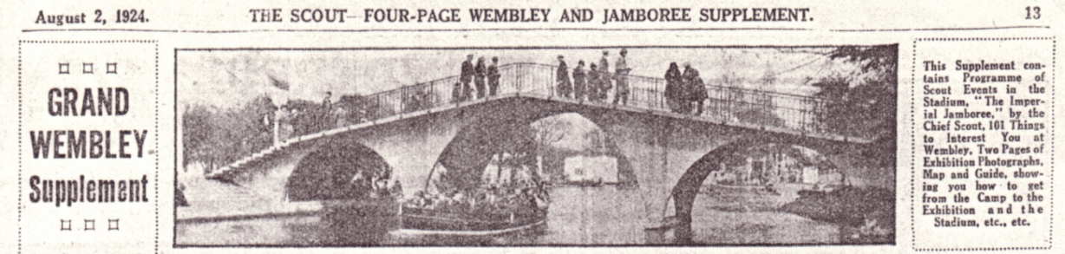

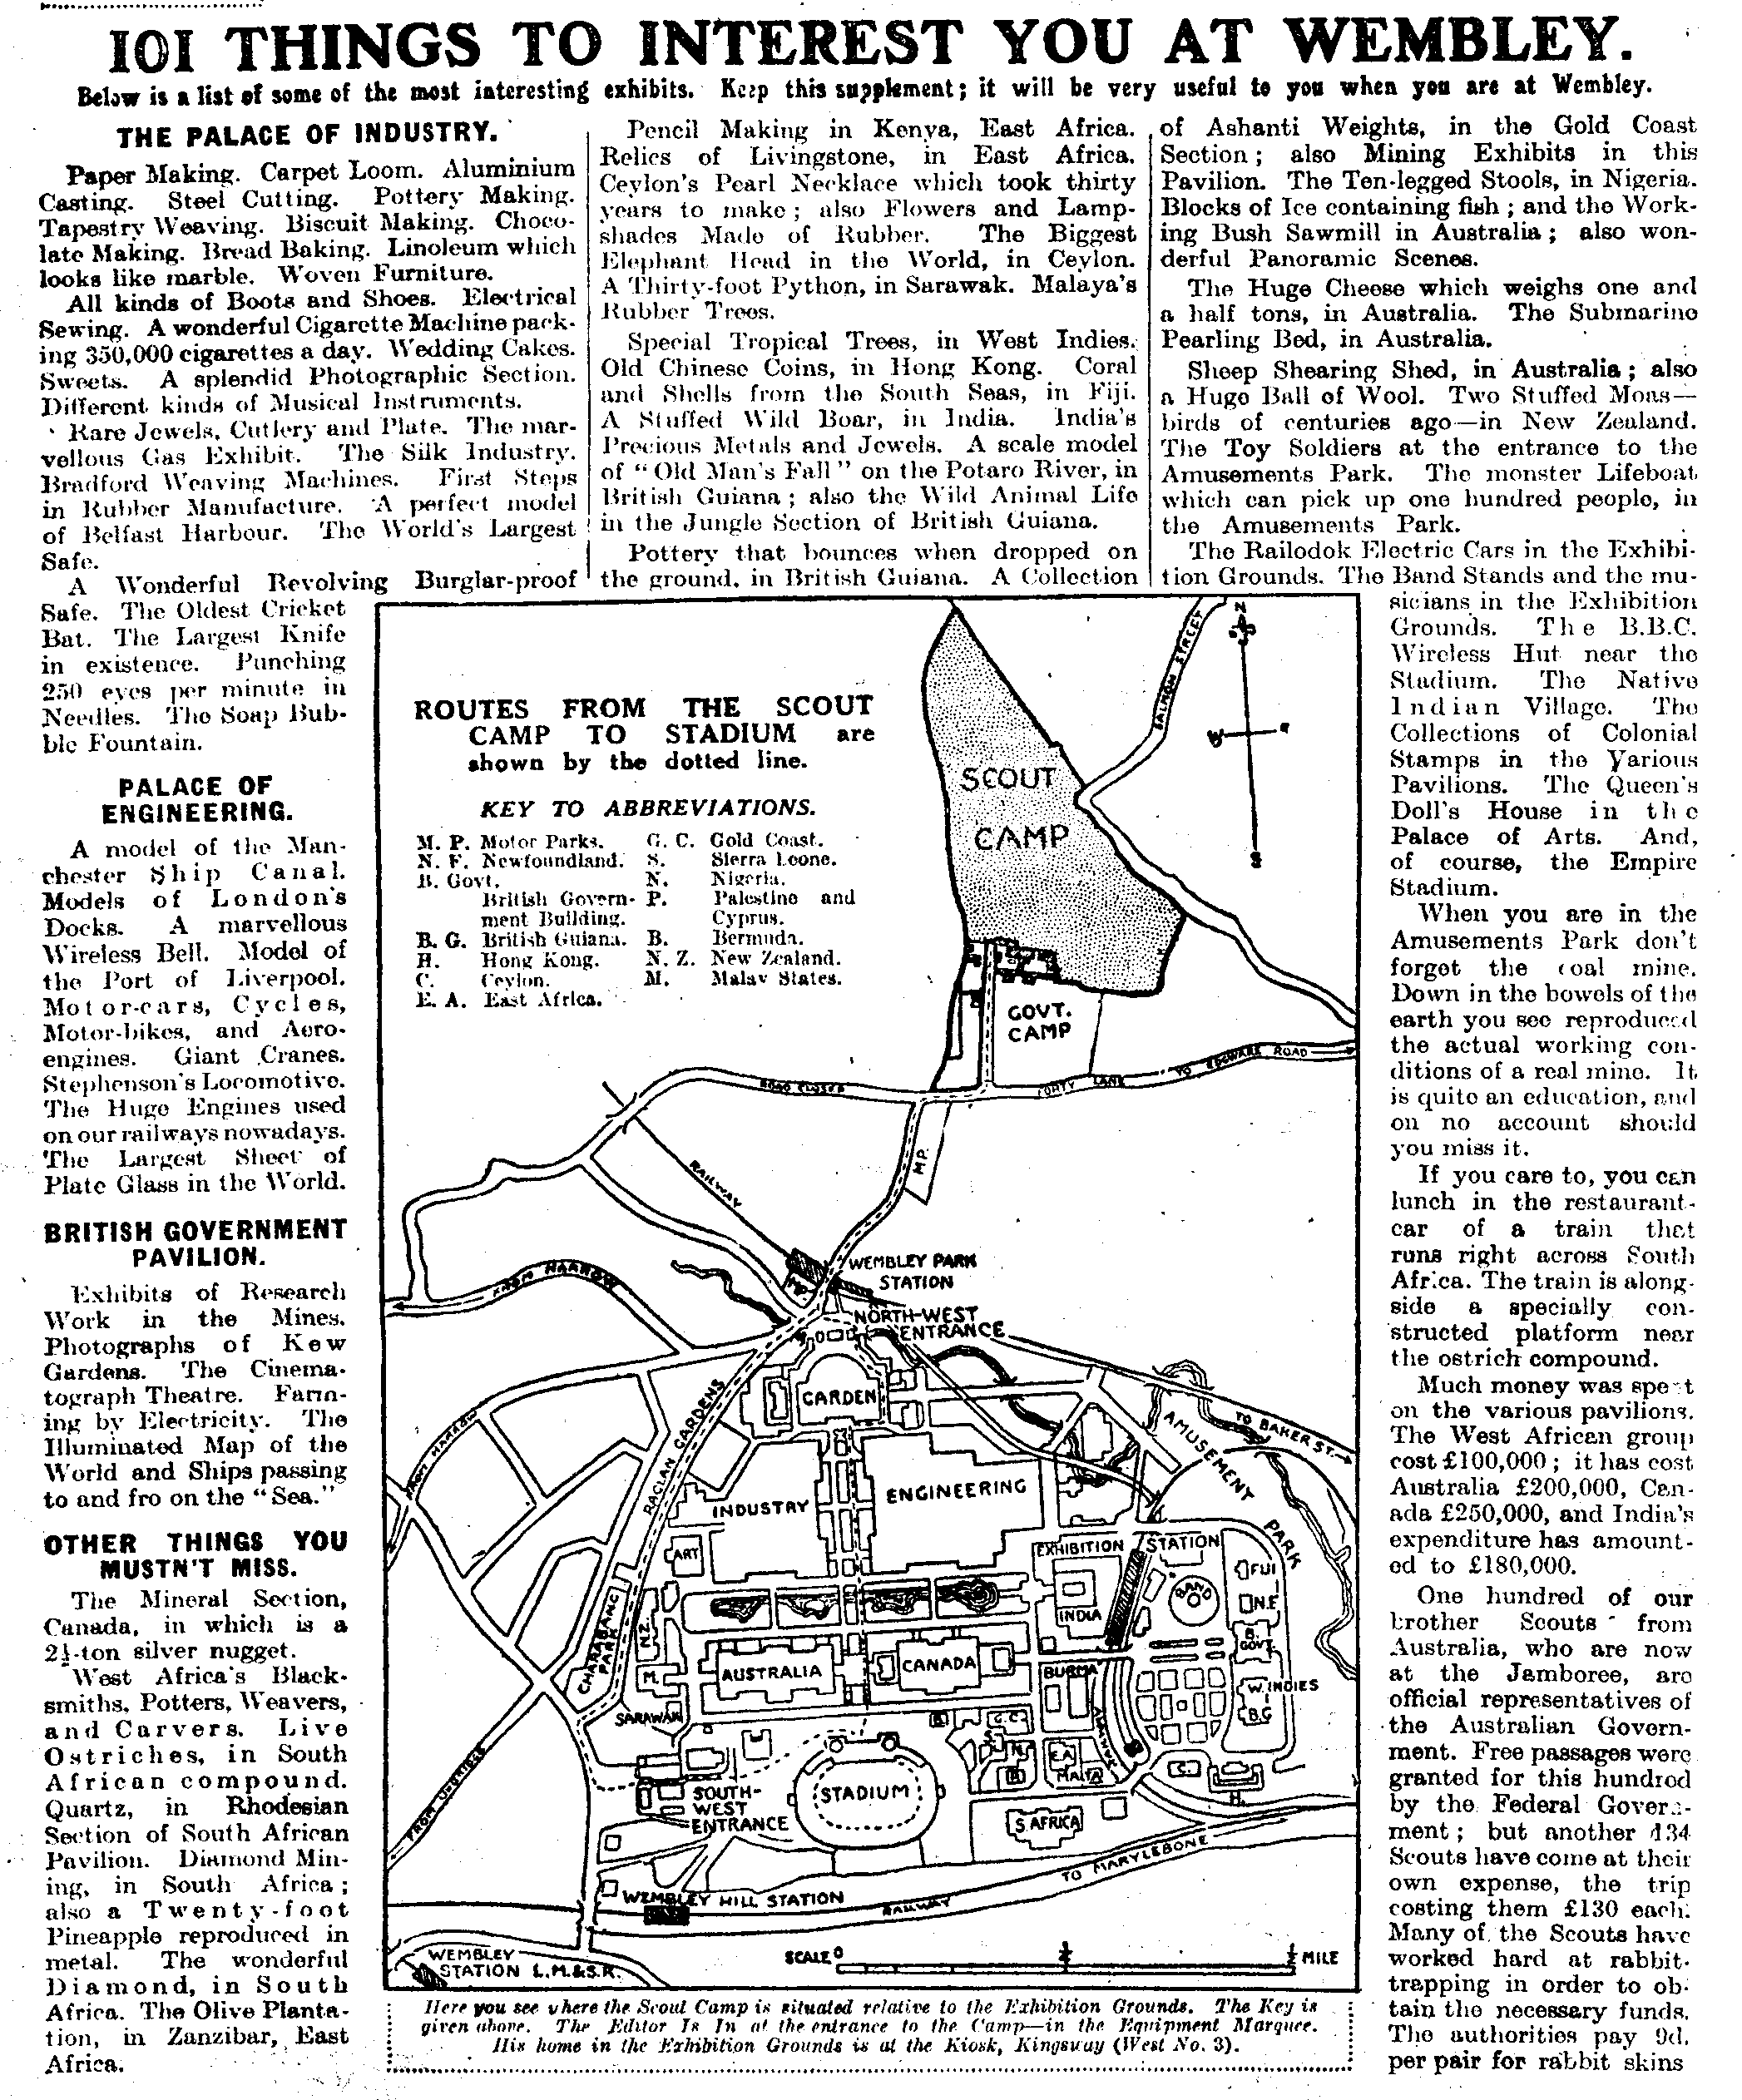
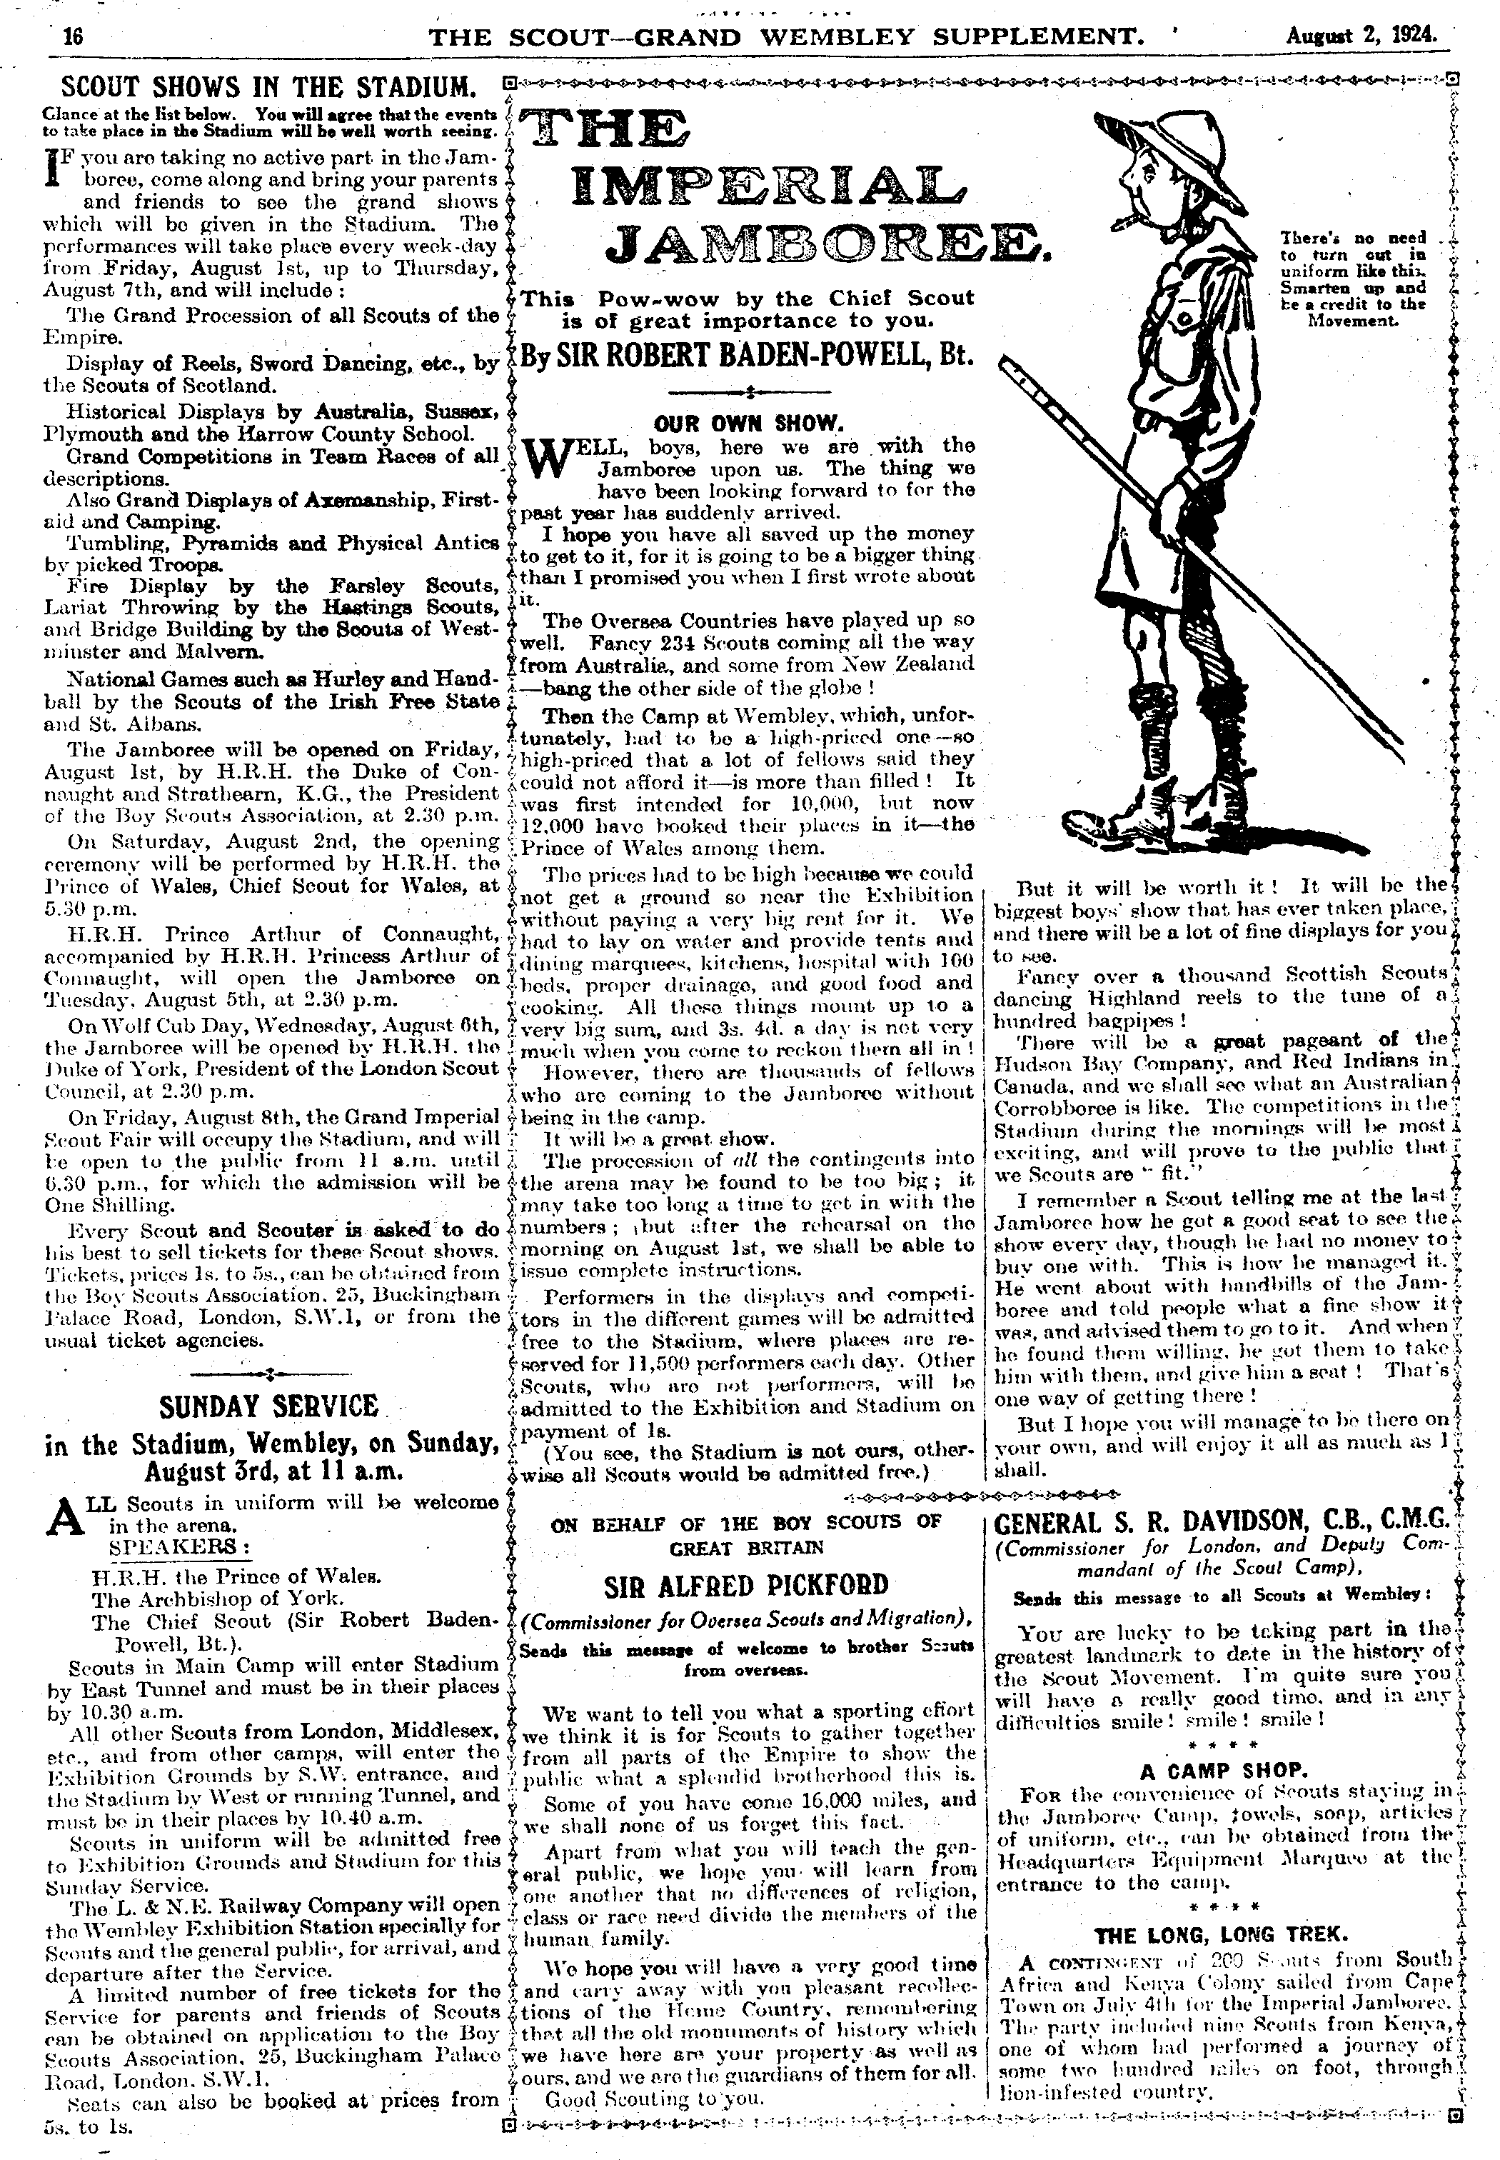

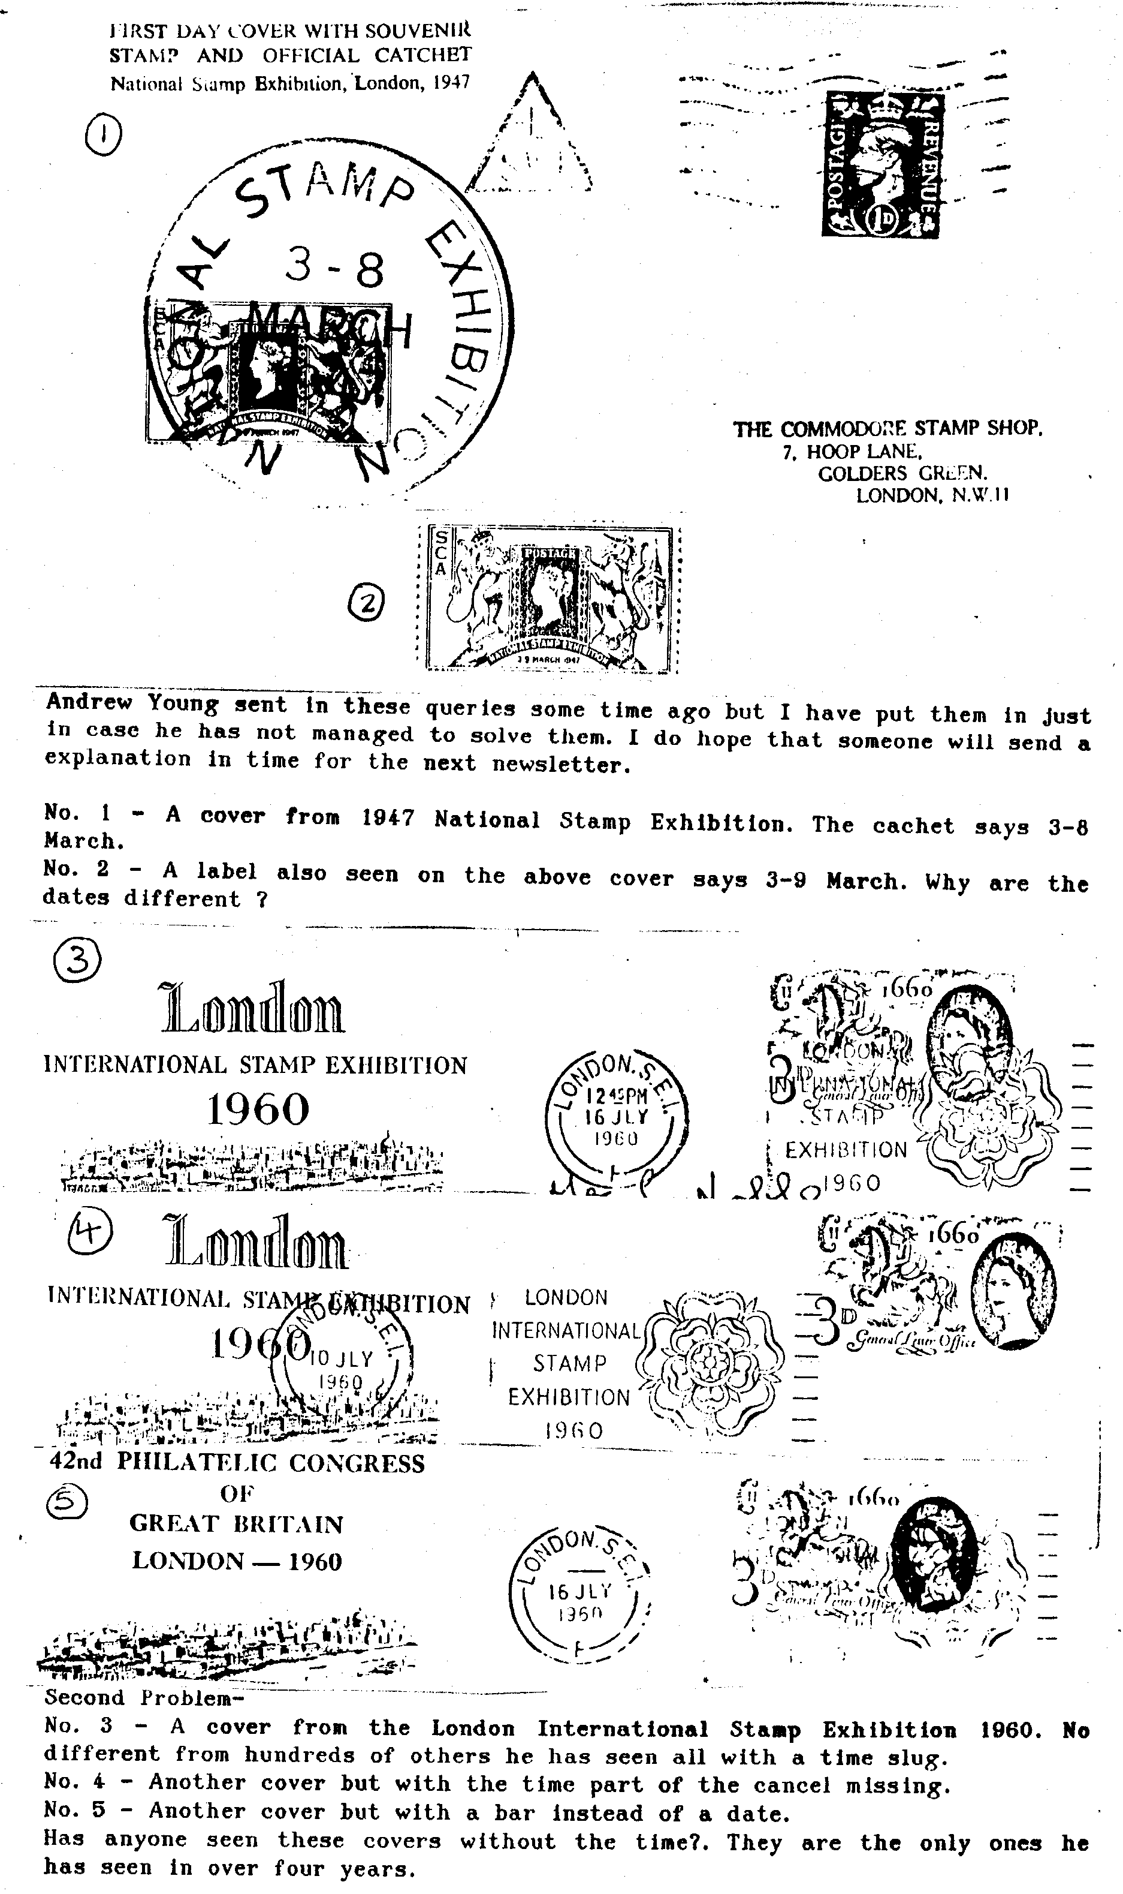
different from hundreds of others he has seen all with a time slug.
No. 4 Another cover but with the time part of the cancel missing.
No. 5 Another cover but with a bar instead of a date.
Has anyone seen these covers without the time?. They are the only ones he has seen in over four years.

NEW YORK WORLD'S FAIR 1939-40.

This Fair was held at Flushing Meadow N.Y. which is across the East River from Manhatten. Its symbol and official logo was the Trylon at 700ft. high and the Perisphere which was 200 ft. in diameter.
On April 1st. 1939 the postal authorities issued a 3 cent Blue-violet stamp, perf. 10½ x 11 (S.G. 850 ) to commemorate this event.

A great many postcards were issued by a number of licence holders leading to many different types of card.
To get into the Perisphere there was a spiral ramp from the garden below. This ramp is shown on various cards.
I have limited myself to the cards listed which I have found of special interest.

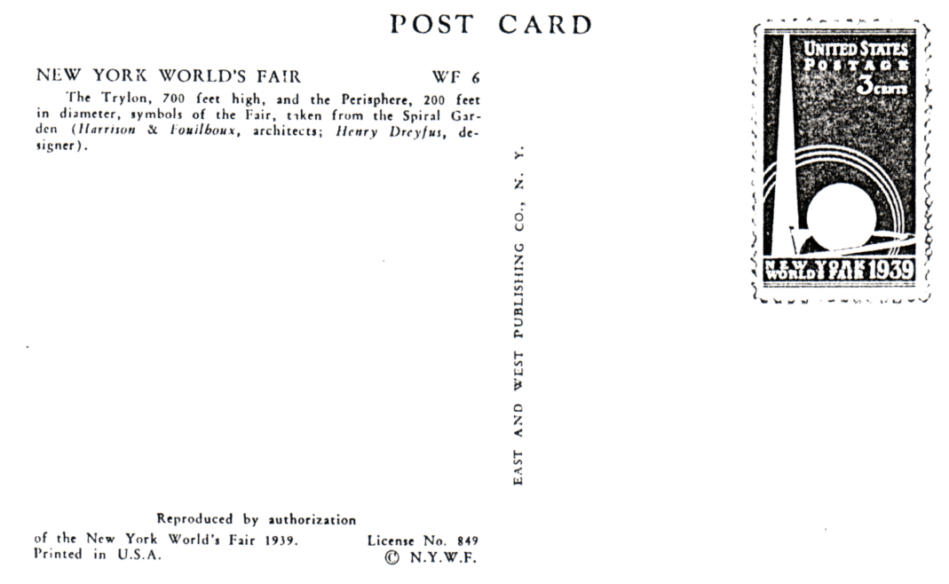

Glossy Photographic B/W (unless otherwise stated)

Licence No. 849 East & West Pub. Co.
W.F. 1 Birds Eye-view.
W.F. 6 The Trylon and Perisphere. (V)
W.F. 15 The Entrance to the British Pavilion.
W.F. 17 View from the ramp of the Trylon and Perisphere.

Licence No.69 Haberman's Real Photographs G.P.O. Box 139,N.Y.
F 25. Statue of Washington by J.Earl Frazer. (V)

Licence No. 2443 Manhatten Post Card Pub. Co. Inc. N.Y.C. (with official logo on back-white on black)
No. 6 Airplane View of Section of N.Y.W.F. 1939.

Licence No. 932 A. Mainzer, 230 Fifth Av. New York. (boxed official logo in black)
No. 252 British Pavilion (also same card in sepia)
No. 255 Aerial View of the Theme Center.(V)
No. 259 Avenue of Pioneers.(V)
No. 2G0 Lagoon of Nations.

Underwood and Underwood S/W
5F 133 Mural of Food Building N.Y.W.F. (U/D) back)

Anon. S/W
"Dancers" Dagenham Girl Pipers. From Merrie England New York World's Fair.

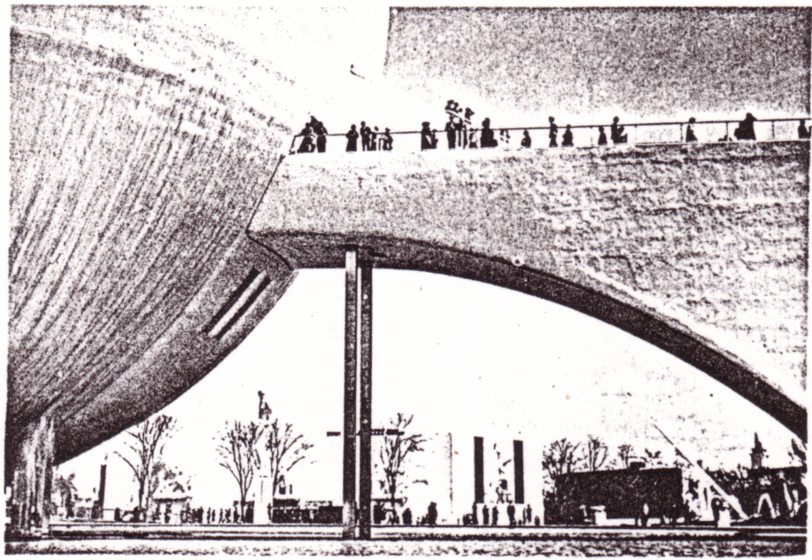

Multi-Coloured Cards.

Curt Teich and Co. Chicago. (boxed blue logo and printing on back) Licence No.67.
No. 7A-H173 (No logo) (116) NYWF of 1939 as seen from Empire State Building. N. Y. City.
No. 8A-H949 Site of World’s Fair from the Air.
No. 9A-H593 Greetings from New York World Fair, (each letter of World Fair shows a different view )

Expo Souvenir Corp. made by Grinneii Litho. Co. Licence No. 1020. (blue logo and unboxed.)
No. A35 Trylon and Perisphere - Theme Center.
No. A40 Night Air View of the N. Y. W. F. 1939.

Finally under Licence K1051 there was published a sheet of 54 (6 x 9) Poster Stamps (stickers) as a souvenir of the N. Y. W. F, Each show a different view of an American Building at this Fair with the architects names printed in the bottom margin.
Arthur P. Smith.

