EDITORIAL AUTUMN 2015

The shortage of post cards is really too sad
If we can’t keep collecting, we might just go mad.

Well it’s time for another Journal and I will start off with a couple of moans. Not that it will do any good but it helps to let off steam every now and then. I have noticed over the years things in the collecting world have altered, and as far as I am concerned in some ways not for the better.
The amount of new good material coming on the market seems to have almost dried up. Kenneth tells me there is very little in the auction catalogues, and although he still comes up to Stampex from Shrewsbury each year, sometimes it’s a wasted trip and he returns home empty handed as he has not bought anything. I know of other collectors and Ken Rumsey is one, who used to go to post card fairs regularly have now almost stopped because of the shortage of new good material.
More and more dealers are dropping out of going to fairs in favour of selling their cards through E-bay, where they can sometimes get prices that must exceed their wildest dreams. This in turn hits the fair organisers, and I heard only yesterday that Barrie Rollison who started the two day fair at Huntingdon back in I think 2009 has decided the August one will be his last. This is a great pity as his fairs were jolly good fairs. But I suppose the falling numbers of dealers plus falling attendances, coupled I have no doubt by increased hire charges for the venue has made his decision inevitable.
To me, for many years going to fairs has been a way of life. At one period for over nine years I visited on average 63 fairs each year covering from York down to the South coast and from Colchester across to Yeovil and I thoroughly enjoyed myself. I was fortunate that I was able to build up what is probably the largest collection of exhibition cards ever formed.
Even the returns from my advertising for post cards in the Picture Postcard Monthly is tapering off, my best year ever was in 1993 when I had 3,383 exhibition cards sent to me on approval. This year so far (the middle of August) I have had just under 300 sent to me. Surprisingly the percentage I buy still remains about the same. I thought as my collection grew the amount I bought would drop which would seem logical, but this does not seem to have happened and last year I bought 25% of everything sent to me.
To get onto another subject, many years ago when I was into collecting stamps I would have liked to get involved into research on stamps but this was difficult, firstly an enormous amount of research had been done on stamps and there was little left to find out and secondly I would have needed very deep pockets. Imagine what it would cost to research and plate the penny black today. When I got involved in post cards I found I was in virgin territory as virtually no one knew anything about post cards. I set out to do for post card collectors what Stanley Gibbon’s did for stamp collectors as far as publishing information about cards was concerned. In this respect I think my efforts speak for them selves.
The Gibbon’s catalogues are not only a mine of information, but they are also a price list for stamps, and if Gibbon’s have that stamp in stock, that is the price they will sell it for. This has meant that Gibbon’s have stabilised the stamp market prices for generations. The present state of affairs with post card prices that rocket beyond reason could never get off the ground with stamps because the prospective bidder would never need to go above Gibbon’s catalogue price for an item that is readily available. Other dealers can only undercut Gibbon’s prices, charging more is not a viable option. It is certain that no post card dealer will ever be in the position to offer as a complete range of post cards as Gibbons can on stamps. Only the rare stamps that Gibbon’s do not have in stock are sold in a market place that has no limit.
My final moan is that just over a year ago I asked for help on listing the B.E.E. Malay Pavilion post cards. Now these are not a scarce card, I have about eleven hundred of them, and I expect every Wembley collector has some in their collection, but only one member has come forward with an offer to let me see his cards.
When I compare this response with that over twenty years ago in 1992 when I appealed for information about the 1924-5 B. E. E. cards for a book Mike Perkins and I were doing I had enormous support from no less than forty seven B.E.E. collectors. I remember two American collectors photo-copied their complete collections and posted them to me on A4 sheets. Were collectors keener then or just more helpful??? Moan over. The Editors
Our 29 Annual Convention 10 to 11 October 2015
An open letter to members.

Dear members,
The Exhibition Study Group has been having a weekend convention for the past 28 years. These have been held at many different venues around the country, from Portsmouth to Glasgow, with a few members who came to first one at York in 1987 still attending, although I think only Don and myself have attended every one.
This year on the weekend of the 10 & 11 October we will be meeting at the site of the Crystal Palace in Penge, South London, This is a very good venue, easy to get to by car or train, the hotel was recently refurbished and the cost is very reasonable. There is a large free car park adjacent to the Tower where we hold our meetings and stay.
Over the years many members have given a display of items from their collections, we have six display boards which take twelve sheets each. You do not have to fill all of them, but it gives you a chance to show what you collect. Other members may have items to sell and you could expand your collection.
We start on the Saturday morning with a short A.G.M. at 10. o’clock with displays starting at around 11 o’clock, we have a short break at 1-00 o’clock, restart at 2 and go on until 4.30. The times are elastic and not cast in stone. In the evening we sit down for dinner and wine. On Sunday morning we start at 10 o'clock and finish at around 1-00 o’clock. If you can-not make the full weekend we would like to see you on either day. Tea or coffee and sandwiches will be available free to everyone as a few years ago it was decided the Study Group would meet the cost of this.
It was reported in our last Journal that we enrolled two new members at Europhilex 2015 where we had a table, and one of them Dave Baker has told me he will be attending the Convention, and very kindly has offered to get me and the display frames up to the palace on the Friday and home again at the end.
I can now give you the costs for the weekend which are about the same as last year. Bed & breakfast £29.90 per night single room including a cooked breakfast, our annual Dinner on the Saturday night will be £9-60 with wine extra, I don’t have a price for those arriving Friday and wanting a fish & chip supper on the Friday evening, but I think you will agree these are all very reasonable prices.
Over the years we seem to be getting more and more members turning up on the Friday afternoon and evening, and in 2009 for the first time Joan Miles laid on a fish & chip supper, which she has agreed to do again for us this year.
It has become our custom to commemorate the 100th anniversary of any exhibition that took place a hundred years ago, but we are now getting into the Great War period when exhibitions were very thin on the ground owing to the men being called up. But there will be displays of other exhibitions. If you are intending to bring some sheets to display please let Don Knight know on 020 8440 3574.
If you would like to stay you can contact The Lodge, Crystal Palace National Sports Centre. Ledrington Road, London. SE19 2BB. phone 020 8778 0131, or 8768 8148 which will get you straight through to Joan Miles without getting tangled up in a lot of recorded messages. Please mention The Study Group as we provisionally book a block of single and double rooms. Friends of members and non-member visitors are welcome, as long as they let Don or me know.
Good collecting

Tudor Houses at the 1908 Franco-BritishExhibition and the 1924 Ideal Home Exhibition.

The following is an extract from Vanishing England (1910) kindly sent in by Dilwyn Chambers.
The ancient house exhibited at the Franco-British Exhibition at Shepherd’s Bush was a typical example of an Elizabethan dwelling. It was brought from Ipswich, where it was doomed to make room for the extension of Co-operative Stores, but so firmly was it built that, in spite of its age of three hundred and fifty years, it defied for some time the attacks of the house-breakers.
It was built in 1563, as the date carved on the solid lintel shows, but some parts of the structure may have been earlier. All the oak joists and rafters had been securely mortised into each other and fixed with stout wooden pins. So securely were these pins fixed, that after many vain attempts to knock them out, they had all to be bored out with augers. The mortises and tenons were found to be as sound and clean as on the day when they were fitted by the sixteenth- century carpenters. The foundations and the chimneys were built of brick. The house contained a large entrance- hall, a kitchen, a splendidly carved staircase, a living-room, and two good bedrooms, on the upper floor. The whole house was a fine specimen of East Anglian half-timber work. The timbers that formed the framework were all straight, the diamond and curved patterns, familiar in western counties, signs of later construction, being altogether absent. One of the striking features of this, as of many other timber-framed houses, is the carved corner or angle post. It curves outwards as a support to the projecting first floor to the extent of nearly two feet, and the whole piece was hewn out of one

A picture of the old Tudor House taken at the Franco-British Exhibition for
‘The Country Home’ published in 1908

massive oak log, the root, as was usual, having been placed upwards, and beautifully carved with Gothic floriations. The full overhang of the gables is four feet six inches. In later examples this distance between the gables and the wall was considerably reduced, until at last the barge-boards were flush with the wall. The joists of the first floor project from under a finely carved string-course, and the end of each joist has a carved finial. All the inside walls were panelled with oak.

The following is an extract from the Official Guide to the Franco-British Exhibition.
A very characteristic piece of Tudor architecture is this gabled manor house, with its high-pitched roof, projecting eaves, half-timbered walls, arched doorway, and diamond- paned windows. It is curious to reflect that this house was standing until a few months ago at Ipswich, still more so that it stood there when bluff King Henry VIII. was busily engaged in turning the monks out of many a fat abbey. In front of the house is the typical old English garden, the privet hedge, smooth, close-cropped lawn, clipped yews, and symmetrical box trees, which have been in vogue since the days of Elizabeth. Beyond it there is a splendid range of undulating woodland, with here and there a gentleman’s place nestling among the trees. It is to the scene painter that all this splendour is due, and yet the effect could not be more striking were the landscape as real as the house in the foreground. No more appropriate setting could be imagined for the horticultural shows that are to be held in this part of the gardens during the summer. Just behind the Tudor House is a model cottage, which affords an effective example of the difference of ancient and modern ideals.

The following is an extract from ‘The Country Home’ (1910) Thanks to Ken Rumsey.
A Tudor house, unless it be but a representation, seems somewhat out of keeping with a modern exhibition, and one might be pardoned for wondering whether there was still such a thing at Shepherd’s Bush.
The explanation is very simple. Until quite recently an old Elizabethan building stood in Ipswich at the corner where Cox Lane meets Carr Street. During last year it was pulled down to make way for the enlargement of adjoining premises. Messrs. Gill and Reigate, whose names are well known in connection with antique furniture, bought the materials, numbered them as they were taken down, and conceived the idea of putting them together again, much in the same way that has been so much talked about in the case of Crosby Hall.
The first site selected was one in the Franco-British Exhibition, though, no doubt, the trouble spent on restoring the house will not be allowed to be wasted, and it will again go through the process of being pulled to pieces and rebuilt. The door of the old house is a fine piece of workmanship, and bears the date 1563, though probably the building itself was older. This latter was converted into shops, but now, with the help of materials obtained in the same locality, the house has been fitted up
once more as a dwelling-house. Where brickwork was required, original Suffolk “reds” have been put in. The panelling of the dining room was taken from an old house in Fore Street, Ipswich, and is quite in keeping with the rest of the house.

The door of the Tudor House and a Jack worked by a fan in the chimney

All sorts of little details have to be borne in mind when restoring Tudor houses. The peculiarities of the district have to be studied; for instance, in the Eastern Counties the oaks are of straighter grain than those elsewhere, and as the outside timbers are made to follow the grain, they are upright in the Ipswich house, and not curved as are those in the Tudor buildings of Chester and Bristol.
A point of interest is the excellent state of preservation in which the wood of the Tudor house was found to be, and the timbers were so skilfully mortised and tenoned that mechanical contrivances had to be employed to pull them apart, and this after they had been together for more than three hundred and fifty years.
It was intended to exhibit contemporary and later furniture in the rooms of the old house, as well as modern reproductions of old styles. Above is an illustration of an old jack to be seen in the kitchen of the Tudor house.
While looking for pictures of the Old Tudor House at the Franco-British Exhibition I looked at post cards in my collection, and I was struck by something I had not noticed before. The house used

by J. I. Williams & Sons while claiming to be erected at the exhibition is a different building from the Gill &Reigate old house which was the one and only genuine Elizabethan house there. As far as I know there was ever only one Tudor house there so it rather looks as if the William’s firm were cashing in on some free publicity.
We had to wait until 1924 at the Ideal Home Exhibition before another old house was taken to bits and re-assembled at Olympia this time. Way back in July 2011 I had an enquiry from a David Schenck who was researching the works of an architect Mr. Blunden Shadbolt who may at one time lived in the old Tudor house that was on display at that exhibition, could I help him. Yes I could, I had previously bought at a fair a photograph album full of photographs of the house that had been bought at the exhibition and re-constructed at an un-named site. One of the 41 6 x 4 photographs showed a stone slab let in a wall which gave a brief history of the house. Two years later in 1926 Mr Shadbolt designed a more modern house which was on display at the 1926 Ideal Home Exhibition.

The slab which has been let into a wall reads, ‘The Old Friars House Horley. Once a Rest House for poor travellers. Built about 1400. Dismantled and erected at The Ideal Home Exhibition 1924. Known as Monk’s Rest. Transplanted on this site 1926.’ The other picture is of Monk’s Rest at its new home.

A more modern cottage designed probably by Shadbolt at the 1926 Ideal Home Exhibition.

Monk’s Rest re-erected at the 1924 Ideal Home Exhibition.

Souvenirs made from Plaster.
By
Fred Peskett.

Souvenirs made from plaster would seem to be a most impracticable medium to manufacture a lasting keepsake, yet many such souvenirs were made between 1860 and 1913 which can be found in remarkable condition. Most of the Plaster Souvenirs were made in the form of a circular hanging plaque with a fancy design around the rim, most of these plaques were made in Austria for the British market. For the Crystal Palace Plaster Souvenirs, the majority feature the Central and South Transept with the South Tower.
Three types have so far been identified. Type 1 is 5" across what can only be described as an irregular circle, square or diamond, the design around the rim is a series of multi-coloured daisies and forget-me-nots, the central area is green with a white 3D image of the Crystal Palace (see figure 1.) “Crystal Palace” is incised in a banner under the building, the back is hollow and has “AUSTRIA” and “29” impressed into the plaster. A wire hanging hook is provided.
The Types 2 and 3 are similar in design. Type 2 is 7" diameter with a fancy design 1" wide around the rim (see figure 2.) Type 2 is 7" in diameter with a fancy design around the rim 1" wide,
the 3D image of the Crystal Palace is very detailed with “CRYSTAL PALACE LONDON” incised within a banner under the view. It is known that there are many variations to the colours used for this plaque, the Crystal Palace is depicted from bright blue through deep purple to black, the sky colours
range from light blue to deep pink and the rim from light yellow to gold, the back is always black with “MADE IN AUSTRIA 3491” embossed at the top. Two holes in the rim permit the use of a hanging wire.
The Type 3 is similar in design to the Type 2 but is much larger at 10" diameter, the rim design is 1½" wide. Some of the details of the Crystal Palace are different from the Type 2, there are two large urns on the wall in the foreground, there are more steps to the building and a large square block is situated on the right side of the building. "CRYSTAL PALACE LONDON" is embossed on the banner. Like the Type 2 many variations to the colours used have been seen. The back is painted black with two holes for a hanging wire, “MADE IN AUSTRIA 3678” is embossed at the bottom on the back.
A plaster plaque featuring the Central and North Transepts with the North Tower is recorded as being seen, but no such example has been found or illustrated to date.

The plaster souvenir plaques were probably made and sold as inexpensive keepsakes, they can be found representing London landmarks, including:- The Houses of Parliament, London Bridge, The Monument, The Tower of London, St Paul's Cathedral, Tower Bridge, Trafalgar Square and of course, the Crystal Palace. Others showing Canterbury Cathedral. The Cheddar Gorge, the Clifton Suspension Bridge at Bristol and the Scott Memorial in Edinburgh are also known

The Comical Creatures from Wurtemburg
By
Fred Peskett

Newspaper reports about some of the popular exhibits on show at the Great Exhibition of 1851 were unanimous in their praise for the display of stuffed animals contributed by Herrmann Ploucquet of Stuttgart, known as the “Wurtemburg Collection”. One newspaper reported that “Her Majesty the Queen lingered long looking at them, laughing all of the time, she talked about them afterwards with a smile when recalling her memories”.

Herrmann Ploucquet was the “preserver of objects” of the Natural History at the Royal Museum of Stuttgart. A book for children based on six of the animals selected by Ploucquet was published in 1851 by David Bouge of Fleet Street, London. The photographer Claudet made daguerrotypes of the six selected animals, from which drawings by William Mesom, were converted into wood engravings by M. Vizetelly for the twenty chromothithographs produced for the book. The book is titled “The Comical Creatures from Wurtemburg”. Stories were contrived about the animals, but they were typical Victorian moralistic tales, which despite the title were not very “comical”. The covers of the book are card covered with blue cloth which is incised with the title and blocked in with gold, iy is 6 wide by 8V high, it has 92 printed pages and cost 3/6d in 1851.
It is known that the stuffed animals from Wurtemberg were featured in the 1854 Crystal Palace in the North Nave Gallery, they were probably destroyed by the tragic fire Of 1866 since they are not listed in the Guides to the Crystal Palace after that year.
Views taken from the Crystal Palace Low Level Station
By
Fred Peskett & Bill Tonkin.

Part 2.

The man on cards The man on cards
without the band stand with the band stand

Proof that the band stand was added to the original photograph

Type 5a. Showing the man, a drawn in band stand and lengths of timber by the wall.

Type 5a. with the man on the left side of the enlarged illustration, and also the drawn in band stand. In the bottom left hand corner the area has also been painted over by an artist replacing the trees. The Artist obviously knew what the bandstand looked like and he probably worked from a photograph of the scene to get the position and dimensions right.

In the first picture there is a large white patch in the grass just below the flower bed. In the
second view can be seen the possibly round tubes mounted on top of the fire works masts.
Type 5b. Post cards from negative 3a. with heavy retouching to fir trees.
This is an odd one, and only a few known and some unknown post card manufacturers used it. It is a development from negative 3a. and there has been a lot of touching up by an artist particularly on the fir trees each side of the drawn in band stand and additions to the three flower beds along the path. The man on the path has also been taken out.

Bell Piccard & Co., Ltd.

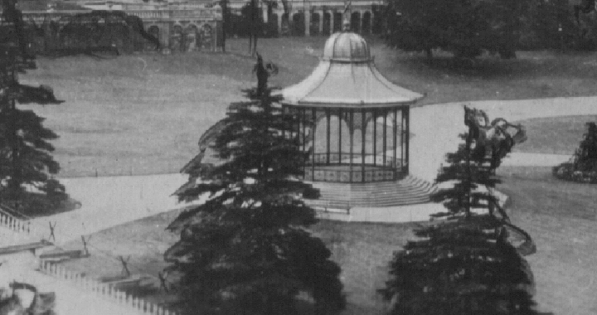

Negative 5b. shows extensive touching up by an artist on the trees and flower beds. The presence of the temporary barrier shows that No. 3a. was the original photograph and 5b. was an alteration to No. 3a. On 5b. there are many extra flaws and the man has been taken out

Showing the swirly black marks added to the fir trees

Black marks added to flower beds. Stengel & Co. Dresden & Berlin.
Type 6a.
This is another odd one with only one publisher known to have used it. there is no man and a drawing of the band stand has been added. It is almost the same as type 5b. without the retouching on the trees, and without the temporary barrier shown in 3a. but there is now part of the toboggan run
shown along side the wall. There is a small black mark on the triangle of grass.

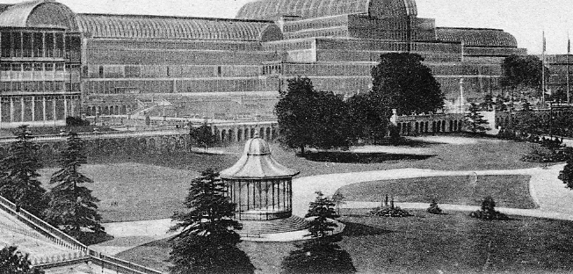
No. 6a. with no man and band stand added. The toboggan run is also shown.

Type 6b.
This again is a new photograph, the main difference is the retouching of the glass ridges over the covered passage way from the station to the Palace. The wide path from the band stand now seems filled with seats without a gangway in the centre, and the triangular patch of grass now has an attraction built up on it. You can just see the edge of the toboggan slope. There are two seats on the lower path.

Ridge and furrow roof retouched. Charles Skilton Ltd.

Man in centre of unmade path and no gangway between rows of seats

There is no gap in the middle of the rows of seats, and three round rings, perhaps targets for the archery range? There also seems to be an extra unmade path leading from the back of the grass triangle with a man walking half way down the path.

Type 6c.
The wide path from the band stand filled with seats with a gangway running along the center, and the triangular patch of grass now has an attraction built up on it. You can just see the edge of the toboggan slope. The band stand has been altered by having rows of white dots added to the posts and along the cross rails of the structure to simulate electric light bulbs. On the short path there are some marks which under a glass seem to be people. The four masts are clearly visible rising above the building in the background, on type 6c these people and the four masts are missing, also missing is the man on the unmade path although the path is still there.

Unknown publisher No. 33.

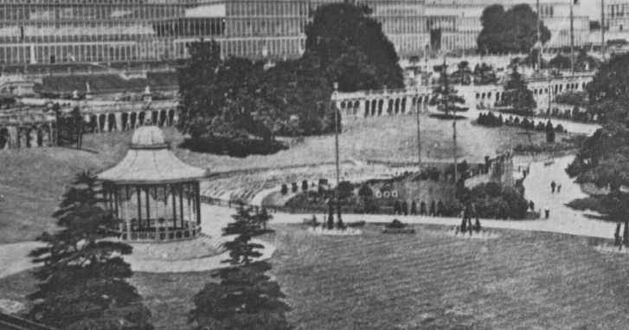

The area filled with seats is now fenced off with a gate at the end nearest the drawn in band stands, there also appears to be a gangway in the centre of the rows of seats. This gangway is on both 6c, 6d. and 6e. but on 6b. there is no gangway between the rows of seats. There is a solitary bench type seat at the far left on the path.

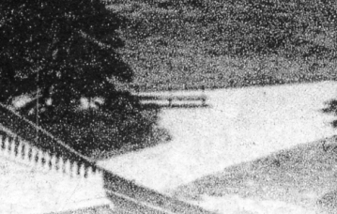

The widened path from the band stand is now filled with seats and there seems to be a gang way in the centre of the rows of seats. The triangular patch of grass has an attraction built up on it. You can just see the edge of the toboggan slope. The band stand has been altered by having rows of white dots added to the posts and along the cross rails of the structure to simulate electric light bulbs. On the short path there are some marks which under a glass seem to be people. On type 29 these people are missing. The area filled with seats is now fenced off with a gate at the end nearest the drawn in band stand. The masts show up as taller than the building in the background.

Type 6d.
Type 6d. without people on the pathway on the right. This is a good example of the added electric light bulbs. This is very similar to No. 6b. although there are several important differences such as no people on the short curved path and no four masts rising above the background building. There is still a man walking on the unmade path behind the green triangle but he is in a different position, and there is a gangway between the rows of seats which shows this is a different photograph.

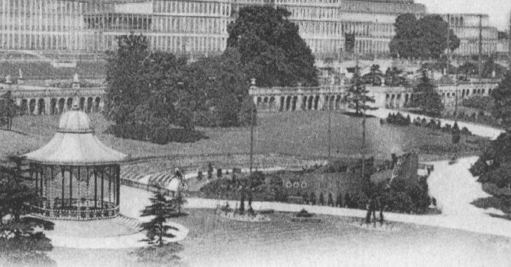
Gangway in centre of rows of seats and man at top of unmade path

Type 6e.
This is another post card with the two concrete blocks in the foreground, previously recorded as Type 1d. but now taken much later when the toboggan run was in position along side the wall and showing a band stand. The enlarged illustration shows there is no man on the unmade path.

Giant post card measures 7.875 x 5.875 inches showing concrete blocks.

Type 6f.
I suppose it could be said that F. W. Woolworth, the firm who published this post card were victims of a complete and utter cock-up when they put this job out to a plate maker or printer. The negative to make the printing plate type 6d. was used back to front. Nobody checked the plate after it was made and that’s how the post cards were printed and sold.

F. W. Woolworth back to front Photochrom 1911

Type 7a.
A new photograph was taken ( or was the view manufactured ? ) for the 1911 Festival of Empire where replicas of the parliament buildings of the colonies were built. Valentine also published a series of post cards showing a model of the Empire buildings (Not taken from the station) with the Palace in the back ground. On some cards it is the pre 1866 Palace with three transepts and on other cards they show a Palace with the missing transept.

1882 International Fisheries Exhibition
12 April – 29 April at Waverley Market, Edinburgh
From the Stanley K. Hunter Archives

Plan of the 1882 International Fisheries Exhibition, 12-29 April at Waverley Market, Edinburgh

Waverley Market, opened in 1869. At first an open market, it was roofed over with an ornamental garden in 1877. Being such a large hall, it was occasionally used for public meetings, circuses, and carnivals. After the removal of the vegetable market in the 1930’s, the building was used for a variety of public events and finally demolished in 1973.

