EDITORIAL SPRING 2015

Apologies, apologies, all the way
That’s what I’ve got to say today.

An apology to Andrew Brooks
When Kenneth was doing the accounts for our A.G.M. he phoned me to say he could not get in touch with John Greatrex our auditor and in one of those mental blackouts older folk are sometimes afflicted with I suggested he contact George Burr to do it which he did. I completely forgot that Andrew Brooks had agreed to be our auditor at our last A.G.M. So sorry Andrew, we’ll use you next year.
An apology for the late delivery (In February) of the Christmas Journal
I think everything that could go wrong with the Winter Journal, did. I held it back initially because I wanted to include the report of our convention which Derek Connell kindly wrote for us this year. By the time I had got the report and a photograph to use and finished the Journal, Kenneth had gone off on a Skiing holiday.
When he got back he found he had drawn the short straw in his absence and was going to have the pleasure of his dad staying with him for Christmas. I on my part thought I could save the Group a bit of postage and take the Journal up with me to Shrewsbury. I am not sure whether I took some germs up with me at Christmas and gave them to Kenneth, or whether he brought them back from Switzerland and gave ‘em to me. It must be said we are both generous to a fault so it could have been either way. Certainly about a week after Christmas we were both in bed taking penicillin for chest infections. Kenneth being younger got over it quicker and feeling the need for some warmth went off to Egypt for a couple of weeks to recuperate, while being a bit older, it takes me longer to get over things, and as I write this on the 8th of February I’m still coughing and spitting. As soon as he got back from his second holiday, he made his first job getting the Journal out.
When he looked at the sheets of address labels he found two sheets had been misprinted and couldn’t be used. I always assume every thing I do is perfect and had not checked them before I took them up at Christmas, so there was further delay while I reprinted the labels and sent them up. Well, you know what they say, “Better late than never”.
In my last editorial I wrote about some forged covers that are on the market now, and elsewhere in the journal I have illustrated the advert showing the covers. Going back a few years to the Christmas of 2010 which I also spent with Kenneth at Shrewsbury, while I was up there we visited a dealer Peter Robards who was just starting to sell off some of the Karl Illingworth collection, and amongst the items he had for sale were some Wembley first day of postage material. One of these was a forged Stadium first day post mark on a Wembley stamped stationery penny post card. Peter had twigged it was a forgery although it was not marked as such, and priced it accordingly. The card was additionally overprinted cancelled on the front and back, and as it was cheap I bought it.
Peter had some other B. E. E. stationery post cards and covers for sale, a one penny stationery card with a 1½d stamp added with a machine cancel for April 23 1924, and a 1½d stationery envelope with a penny stamp added and with two Palace of Industry hand stamps for May 9 1925, both first day of issue. Kenneth took one look at them and said to Peter “You know these are both forgeries?” Peter’s face dropped and so did the price of the two items, which again I bought.
I see from my records I bought 71 items off Peter that Christmas, some of the gems of Karl’s collection, the like of which we will never see again. In the February I bought a lot of Karl’s crested china from Peter at the Shepton Mallet fair.
At the time I tried to find out what had happened to Karl. Kath his wife was selling off his collection, here and there in bits and pieces to dealers and through auction firms and although I wrote to her and even had a letter delivered by hand to Kath, she never replied. I can only assume Karl had died, but why keep it a secret?
Later the bulk of Karl’s collection was disposed of in an Adam Partridge auction in 2012 when the incredible extent of his enormous collection came to light. There will never be another like it.
The Editors.
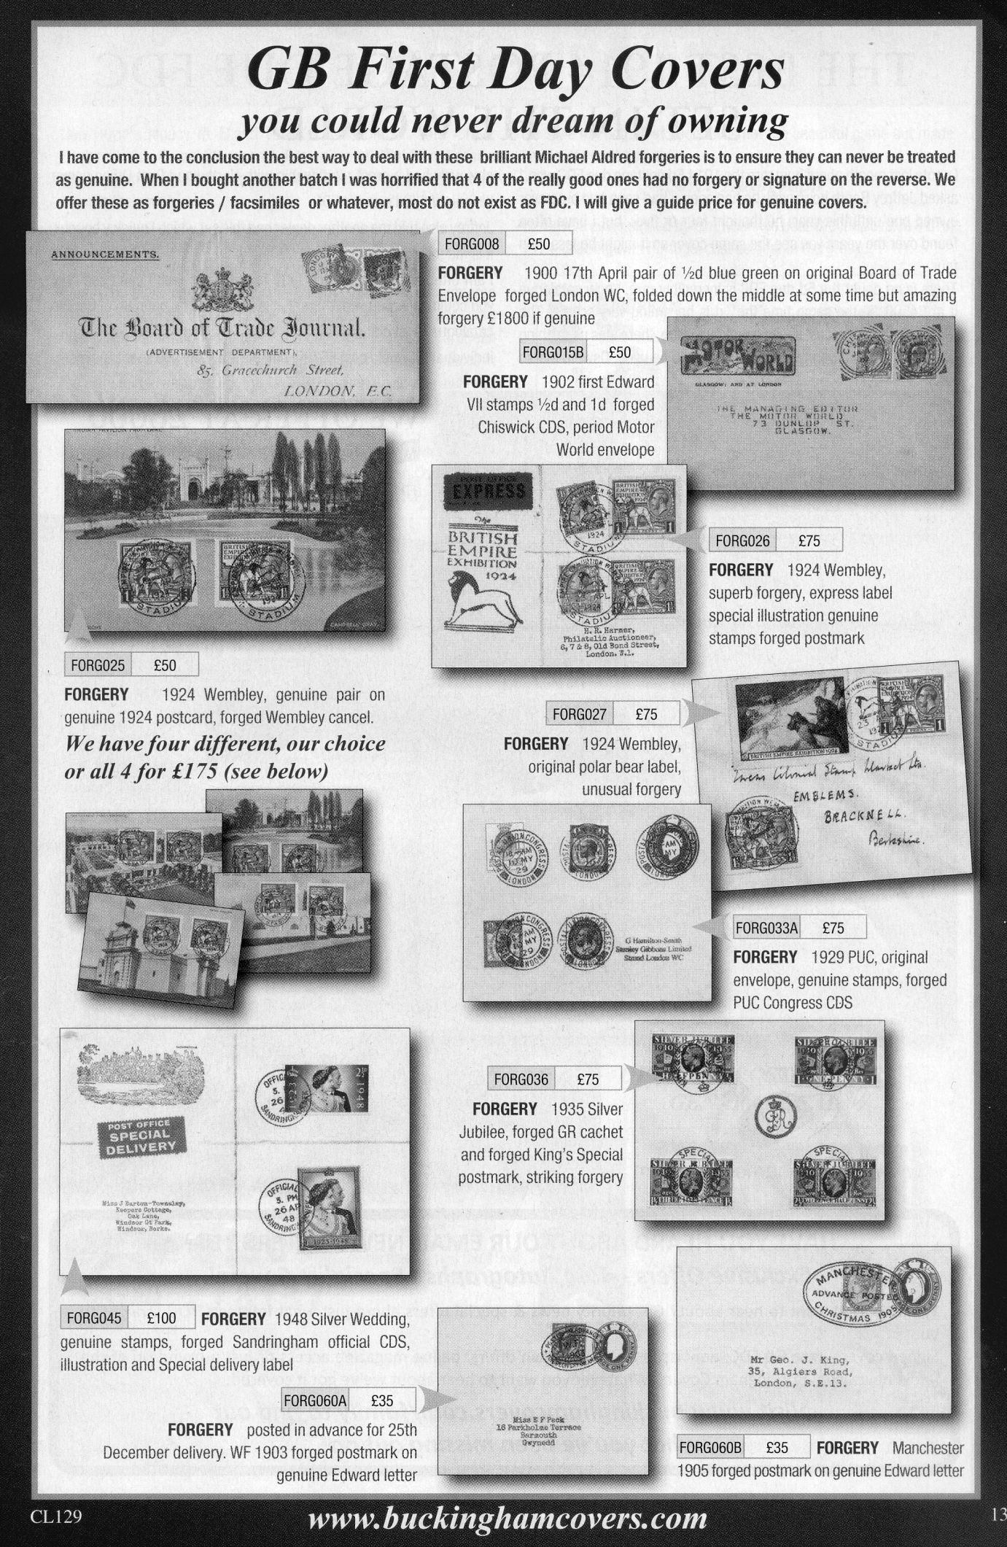
Proposed joint meeting of the National Philatelic Society and the Exhibition Study Group.
by
Ray Goodey (President)

Members will remember our proposed joint meeting with the N.P.S last year had to be postponed. I have now contacted the National programme organiser to arrange a new date. The meeting will take place on Saturday 12th September 2015. This is somewhat later than I had hoped, but at least it gives us plenty of time to plan and prepare. The meeting will be held at the ‘Welsh Centre’, 157-163 Gray’s Inn Road, London WC1X 8UE.
Doors at the Centre are usually open around 10.30am. this for the usual National (members only) auction. The general meeting for our displays will be in the afternoon starting at 2.45pm. The displays will be in two sessions, each of 9 frames, 12 sheets per frame (108 total), with members giving a short talk about their display. The subject; anything to do with exhibitions.
I would like as many members as possible coming along to the meeting, giving a display or not. Those of you who can give a display, please let me know the number of sheets and subject of your display so I can plan the afternoon programme. I do not require the details until the beginning of August. This is a long way ahead I know, I will be reminding members with further details in the Summer edition of the ‘Journal’. My thanks, Ray Goodey (President).

Additional notes on the Carillon in Hyde Park
by Ken Harman in the Spring Journal No. 104 in 2012

In 1924 the New Zealand Government decided to replace the Dominion Museum (1865) and, in 1928, it chose a site occupied by the Mount Cook gaol on Mount Cook. The Government had been considering the building of a National War Memorial since the end of World War I and it had even voted A£100,000 for the purpose in 1919. It decided to incorporate such a structure with the Museum.
Two years earlier the Wellington War Memorial Carillon Society was formed and in May that year they raised A£10,000 to buy a 49 bell carillon. The bells were offered to the Wellington Citizen's War Memorial Committee but they declined in favour of a silent memorial - the Cenotaph, on Lambton Quay. The bells were then offered to the Government to be included in the National War Memorial.
The carillon bells were made at Gillet and Johnston in Croydon, England. with the tender being let in July 1927. While planning began on the memorial the bells were lent to the Newcastle-on-Tyne Exhibition. They were then temporarily hung in Hyde Park before being shipped to New Zealand.

Souvenirs of the Crystal Palace.
Drawings and text by Fred Peskett

Souvenirs made from mixed materials.

A Crystal Palace Sewing Box. Type 1.

This is a rectangular box for holding sewing tools and accessories. The box measures eight and one eighth inches long by three and five eighths inches wide by one and a half inches high. It is made from wood and covered with a cream coloured “plastic” material, the lid is joined to a base with brass hinges and has a brass fastener fitted to front. The corners of the lid and base are reinforced with brass corners, and there is a brass carrying handle riveted to the lid. “A present from the Crystal Palace. “ is engraved on the lid and infilled with silver. The interior of the box has a pale blue silk lining.
Fitted to the inside of the lid is a diamond shaped bevel-edged mirror. The sewing tools consist of a button hook, a needle case and a bodkin etc. This souvenir dates from the late 1880’s and was made in Germany.

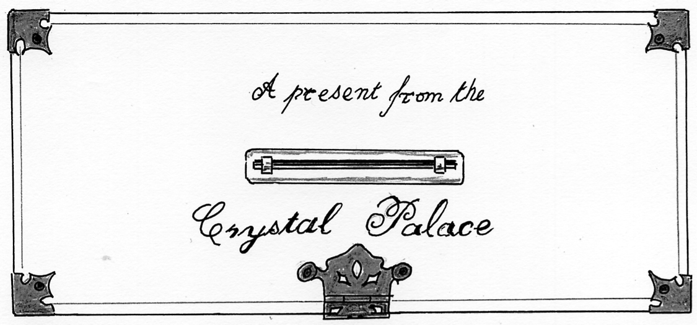

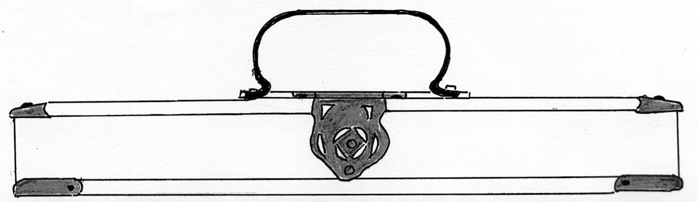

A Crystal Palace Sewing Box. Type 2.
This is similar in construction to the Type 1 except that it is smaller, being six and one eighth inches long by three and three eighths inches wide by one and a half inches high. The re-inforcing corner brackets are made from nickel plated tin-plate, as is the catch for the hinged lid. The supporting plate for the handle has a fancy pattern and is made from nickelled tin. The engraved wording is different and is set within a curve “A Present from Crystal Palace.” is above the handle, “Made, in Germany” is above the catch. A diamond shaped mirror is fitted into the interior of the lid, and both the lid and box are covered in red silk inside. The tools are:- A needle case, a bodkin, a button hook, a cotton threader, a bradawl and a thimble, (not silver) all of the handles of the tools are fashioned from ivory.

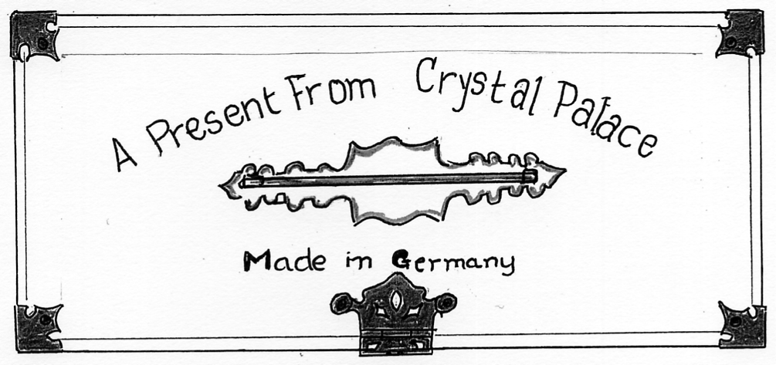
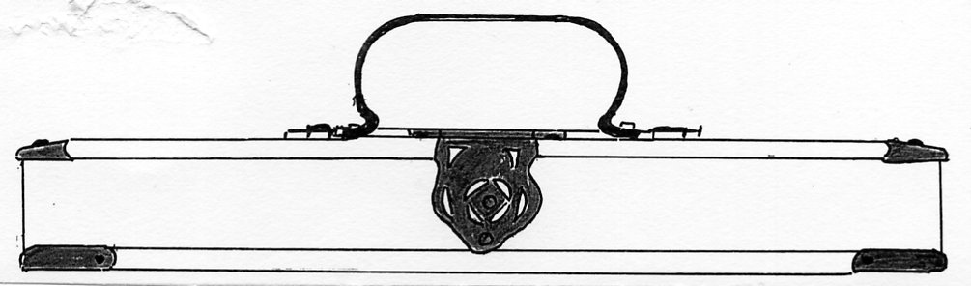

A Crystal Palace Shaving Kit. Type 3.

The box is identical in construction and dimensions to the Type 2 box but the wording over the handle has “the.” between “from” and “Crystal”. and “Made, in Germany” is omitted. The interior of the box is covered with purple silk and it contains four “Cut-throat” razors, “Solignen, Germany” is stamped on each blade, and the sides of the razors are in ivory with a plain shield crest on one side.
There is also a Type 4, which has not been seen, but is the same box style as Type 3, it is fitted with light green silk and contains a set of Manicure Tools.

Toy Music Box

The Toy Music Box shown in the illustration below has the top and bottom plates made from 3" diameter by V1 thick steel discs, the side is formed from tin-plate which is covered with a thin wooden veneer, this is secured to the discs by being soldered to the top disc and by three equi-distant set-screws at the bottom. A pin type cylinder music box is fitted inside and operated by a brass handle protruding from the top disc, the handle has a Ivory knob. When the handle is rotated, the tune "Home Sweet Home is played.
A black and white transfer of the South Transept and South Tower of the Crystal Palace with the fountains operating is featured on the top of the music box, the title is "THE CRISTAL PALACE" the spelling suggests the maker is Germanic. Under the bottom plate there is a colour transfer of a young girl seated at a piano, the style of her clothing, and the design of the piano puts the date of manufacture at around the late 1890's.

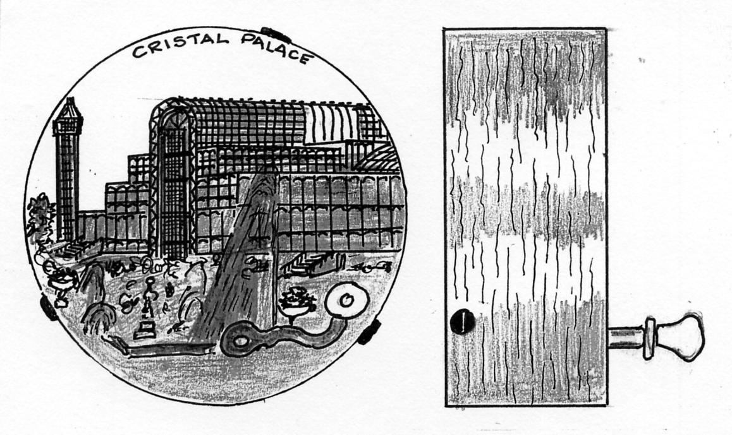
Similar music boxes can be seen at the Museum of Childhood, Bethnal Green, and the Toy and Doll Museum at Brading on the Isle of Wight, the top transfers of these are coloured scenes from Nursery Rhymes, like Humpty Dumpty and Little Jack Horner.
Souvenirs made from Ivory.

There are specific laws regarding the buying and selling of an item made from Ivory, in as much the item must have been made prior to 1947, therefore any souvenirs made in this material associated with the the Great Exhibition of 1851, or the Crystal Palace at Penge Place are certainly in conformance with this law. The law also refers to items made from mixed materials where one of them is Ivory.
The souvenir shown below is a brooch made from Ivory and can be dated because it is in the original presentation box which is made from thin wood covered with brown embossed paper with added gold highlights, the box is lined with royal blue cloth. A card inside reads:- “To dear Aunt Nell from your loving nephew James, Christmas 1893”. The brooch is typical of a piece of jewellry made in Ivory for the British market by Indian craftsmen, these were imported into Britain in their thousands, the place name was left blank, being added in marking ink by the retailers. There is a horizontal pin fixing on the back made from brass.
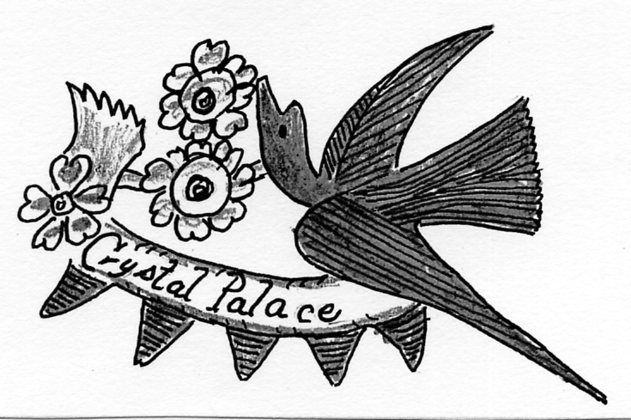
The illustration is double full size

Despite being 120 years old, the brooch is in a remarkable condition, it is doubtful if Aunt Nell ever wore it.

It Pays to Advertise
by
Bill Tonkin

I have been advertising to buy post cards every month for 25 years now, since the beginning of 1990 in the Picture Postcard Monthly which must be a bit of a record, and for me it has really paid off. I have listed the amounts sent to me, and the amounts purchased. I am not a dealer and all the cards I buy are for my own collection. I buy on average about a quarter of all cards sent to me, I thought that as my collection increases this % would go down but it does not seem to have done so to any great extent.

Years Number sent Average sent Number Average bought %
on approval in each year bought in each year bought
Five years 1990-1994 9,997 2,000 2,533 506 25%
Five years 1995-1999 7,332 1,466 1,907 381 26%
Five years 2000-2004 4,081 814 1,363 273 33%
Five years 2005-2009 3,745 749 993 199 26%
Five years 2010-2014 2,605 521 701 140 20%
Totals 27,760 7,497

The five yearly totals show a steady decline over the 25 years in the number of cards sent to me on approval since 1990. I shall never see the 1992 figure of 3,383 cards sent in on approval and 746 bought again. When I look through my records for 1990 I see Kevin Ramsdale, Karlyn Goulborn, Julian Dunn, Derek Popplestone and Neil Garland have all been sending me approvals for 25 years, with the exception of Karlyn who has retired. Another early dealer still sending me approvals is Mike Pearl who started in 1993. To all of these dealers and the many others later who have materially helped me build up my collection I owe a sincere thank you.
In addition to my advert, at one point over a nine year period in my heyday I averaged going to 63 post card fairs every year, more than one fair each week. Since 1990 I’ve gone to nearly 900 post card fairs in all. Although I was collecting in 1953, I kept no records of my trips or spending before 1990
While one of my main interests is British exhibition cards in general, I am always looking for varieties on cards. This is from my stamp collecting days and the sort of thing I am looking for, to give two examples is clouds in the sky and titles. Probably the most common of all exhibition cards are the Valentine’s coloured 1908 Franco-British Exhibition cards. The picture printing plate was made and printed in two stages, the first shows the building or view, and the second stage was the blue sky with clouds as a background. (It never rained on post cards) Every time Valentine’s needed another print run they used the same plate with the building but created a new cloud background. One card showing the Court of Arts is known with 10 different cloud backgrounds.
Again on the Valentine’s 1908 Franco-British Exhibition cards after the picture side was printed the title was printed as another operation and they saw no need to keep a record of what actual wording was used or whereabouts it was positioned on the card, top or bottom, or even whether it was printed in one, two or three lines. The result was that one card numbered 178, featuring Ballymaclinton the Irish village was printed in no less than 23 different ways ranging from just the two worded ‘Irish Village’ to the eighteen worded ‘Main Entrance, Ballymaclinton, the M’Kinley Cottage on the right, M’Clinton’s Town erected by the makers of M’Clinton’s Soap’
For my sins I collect the lot, and many other types of variety and to do this I have to have the card in front of me to check it with all the other cards of the same view in my collection. Getting post cards on approval for me was the only practical way to build up my collection.
I do not buy through E-bay as I feel to attempt to build up a collection by out-bidding the rest of the world on E-bay is a form of madness I can’t afford. 2014 saw me at only three post card fairs, at 89 I find it increasingly difficult walking now and am virtually house bound, only going out to do a bit of shopping twice a week, so I rely on my advert. This means my collection is only very slowly increasing now, but looking back I’ve had a jolly good innings and have built up what is regarded as the largest collection in its field there is, so I have no complaints.
The time I used to spend at fairs I now spend appreciating and researching my collection, and here I have (I hope) years of pleasure in front of me. I still manage to get enough new cards to keep up my interest in the hobby of post card collecting. And yes, I do miss post card fairs, to me, standing on the raised entrance at Shepton Mallet and looking over the seething mass of dealers and collectors, and itching to get down there amongst them and hoping it was going to be a good day for finding cards, was a wonderful experience.

Views taken from the Crystal Palace Low Level Station
By
Fred Peskett & Bill Tonkin.

Part 1.

When the Study Group published our book on the post cards of the Crystal Palace in 2006 we thought we had covered the subject pretty well, but our research since then has been non-stop and at the moment runs to nearly 100 pages of new material.
One line of research that has been ongoing is the study of the most common of all the Crystal Palace post cards, the view taken from the Crystal Palace Low Level Station. Initially we thought the original photographs were taken from the railway bridge, but our thinking now is that they were taken from one of the upper windows on the top floor of the lower level railway station. This would have given the hight to see over the boundary wall and get a splendid view of the Palace on top of the hill. From the earliest days going back to the days of Negretti & Zamba this vantage point was used and through the years professional photographers, and it was probably J Russell used this position to take photographs which were then sold around to over 200 different post card publishers.
Although there must be thousands of post cards of this view published by hundreds of different publishers, a close examination shows they are all derived from about a dozen original negatives.
Probably for the first time in regard to post cards we have used a process long known to stamp collectors as ‘fly speck philately’. This is where a small mark on the original negative can be used to relate any real photo or printed post card by any publisher to the original negative.
Some sort of chronological sequence can be arrived at, because since all the pictures were taken from exactly the same spot (and here I am talking of a variation of feet not yards) because they were all taken from the same window it, follows that as the cameras were pointed in the same direction to get both towers in the view, all the pictures would be identical and changed very little over the years.
In fact to start with only two things did change, the growth of the flowers in the flower beds and the fir trees. The fir trees are important because they acted like the mercury in a thermometer as the top of the tree slowly crept up, when measured against the asphalt path in the background, as they showed a steady growth with the passing of the years.
Another clue for dating is the shape of the concrete path which splits into two to enclose a triangular patch of grass. Over the years the shape of the path was altered, eventually to include a band stand.
It might appear that using postal cancellations might be an aid to dating, but in fact this is not so. Many of the undivided back cards postally used as far back as 1902 are in fact views of the last stage of development when the band stand had been built, while many of the earlier stages of development have much later dates than this when postally used.
Photographs taken before the fire of 1866 destroyed the north transept, which was never rebuilt, were still being used for post cards up until 1911.
The photographs taken from this spot have been given numbers by the authors originally starting with number 1 to number 9, until an even earlier view used as a post card turned up, so now the earliest state is listed as number 0 with some intermediate variations added.
Post cards from negative No. 0.
This is the earliest known post card published from negative 0. The four masts used for the fireworks displays are barely visible.

Enlarged section of a post card from negative No. 0 showing the rather sparse plants growing in the flower beds. The top of the fir tree gets lost in the second flower bed, and is nowhere near reaching the path. The four masts used for the fireworks display are almost invisible, and there are no park bench type seats on the path. The paths themselves are clear of marks and blemishes which help to identify later views. Post cards with this view were published by only one publisher known by the initials R & J. D.
Post cards from negative No. 1.
This photograph must have been taken some time after negative 0 as the flower beds seem full of low growing plants. In this view the fir tree does not seem to have grown much taller and still does not reach the path. There is a small dot on the path about 17 mm in from the right edge, and a row of black dots under the centre flower bed. These flaws are present on all the post cards published from this negative.

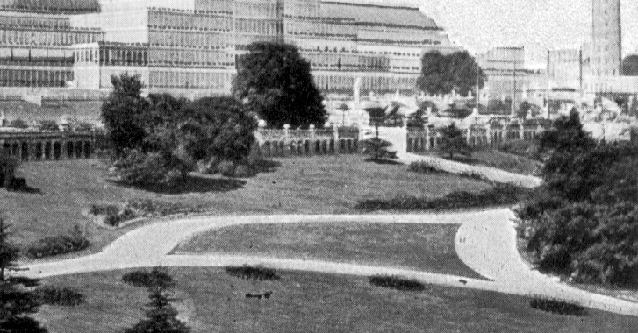
Enlarged section of negative No. 1 showing the black spot near the end of the lower path and the row of dots under the middle flower bed. There is also a very feint mark in the centre of the short curved path. The top of the fir tree still gets lost in the second flower bed, and has not reached the path. There are plenty of flowers growing and the park seat on the right end of the path is very feint. Post cards from negative 1 were published by 16 different publishers.

Post cards from negative No. 2.
The view from negative No. 2 is very similar to No. 1. the top of the fir tree now just breaks into the path and the plants in the flower beds have grown, and are now much taller, the tops of the plants like the fir tree just breaks into the path and are clearly visible against the white path background. There is a park bench type seat on the path at the far right by the fifth flower bed, which is more noticeable than on type 1. The black spot on the lower path is gone but there is a large black spot about half way up on the short curved path to the right. This seems to be a development of the feint mark noted on type 1, this is on all cards. The four poles on which were mounted the fireworks displays are clearly visible on the right of the building, these have been drawn in, some more heavily than others. 27 publishers used this view for post cards.

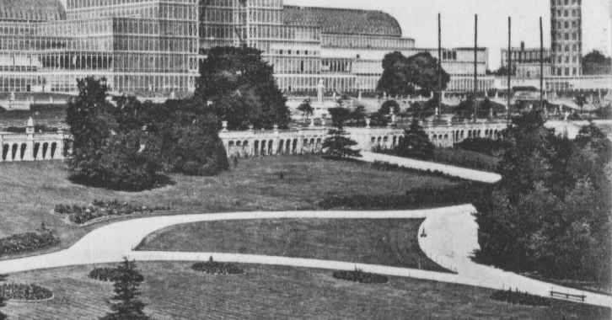
View from negative No. 2, very similar to negative No. 1 but constant flaws in a different position and the four poles on which the fireworks displays were mounted have been drawn in and are now clearly visible.
Post cards from negative No. 2a
On some of the cards printed from negative No. 2. more of the bottom part of the negative was used, these are listed as No. 2a and the view now shows what appears to be two large concrete structures or blocks? in the bottom foreground, it is not known what they are. On the type 2. views where a space was left for a title or short message, and the bottom part of the negative was not used, they do not appear.
Type 2. Type 2a.
Showing extra detail when more of the bottom of the negative was used

Post cards from negative No. 2b.
Negative No. 2 was heavily retouched and this can be seen in the horizontal lines and the surround to the building. The four poles on which were mounted the fireworks displays are clearly visible on the right of the building.
Crystal Palace from negative No. 2 Crystal Palace from negative No. 2b
showing the heavy retouching to the
building

Post cards from negative No. 3.
This view shows what appears to be a mound of earth between the firs and the path. The top of the fir tree just reaches where the two paths join as in type 2, 2a and 2b. The photograph was possibly taken early in the morning as there are no people in sight. The flower beds along the path all have long sticks or canes ready for the plants. On these cards more of the right part of the negative is used and the South Tower is not shown. The four masts are not so prominent and seem to be shorter, and because more of the right side of th negative is shown we can now see a second park seat.

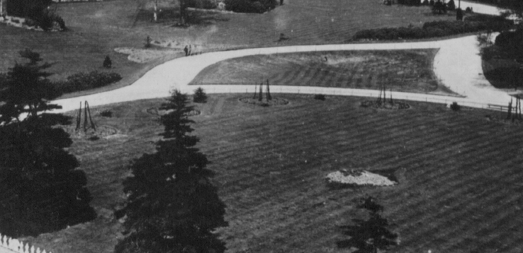
Negative No. 3 showing mound of earth and long sticks in the flower beds.

Post cards from negative No. 4.
The next stage in the development of this view was tall and vigorous plants growing in the five flower beds. The top of the fir tree has grown and now reaches into the top path at the join of the
two paths. This was the most common negative used for post cards and no less than 75 different publishers used it.
On some cards the paths are lined with a low barrier seen as a series of upright posts joined along the top. It seems the rails only appear on R/Photo or some litho printing cards where the quality of reproduction shows up the rails. On the coloured printings, being of a poorer quality the rails do not show up.
Negative No. 4 The fir tree has grown and so have the contents of the flower beds. The four poles for fireworks are not so prominent as in negative No. 2, but each pole seems to have a long cylindrical object near the top which was probably part of the fireworks display, see enlargement.

Post cards from negative No. 4a.
Several publishers used a slightly different view to type 4 listed as type 4a the main difference is that there are cross struts drawn in on the four masts. These cross struts also appear on type 7b.

Post cards from negative No. 5. (Without man on wall)
At this point the shape of the path was drastically altered and the top path was made much wider, this was eventually to accommodate rows of seats for people to sit and enjoy entertainment’s and listen to the music from the covered band stand, at this time not yet built.
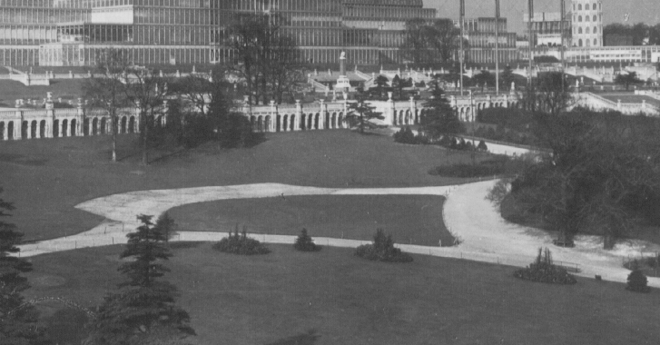
From negative No. 5. The top path has been widened to take rows of seats, eventually an entertainment was mounted on the triangular patch of grass. The flower beds all show vigorous plant growth
Postcards from negative No. 5 were published by 14 different publishers.

Post cards from negative No. 5a. (With added visitors and without man on wall)

Type 5a with a lot of visitors drawn in.

Postcards from negative No. 5a were only published by Valentine & Sons Co., Ltd. Who were very prone to adding visitors to scenes.

Post cards from negative No. 5b. (With man on wall)
There was an interesting variation on negative No. 5 it would appear two photographs were taken, on one, used by M. & Co., Ltd., a man can be clearly seen standing on the top of the boundary wall. Under magnification he can be seen with his hands in his pockets and wearing a cap. All the other publishers were supplied with the photograph without the man.
No. 5 Without man on wall No. 5b With man on wall

Post cards from negative No. 6.
The next development was to extend the path into a circular area that would house the base of the proposed band stand. This negative was only used for a very few cards, it was then altered to include a bandstand drawn in by an artist, see No. 6a. There is a small figure of a man standing on the path, he also appears on both No. 6a. and 6b proving both types come from the same original No. 6. negative. Note the temporary barrier and the sawn timber stacked alongside the wall ready to build the toboggan run.

Barrier and lengths of timber.

The man on cards The man on cards
without the band stand with the band stand

To be continued.

Late Foot Note.

I’ve just heard from Charles Kiddle that he has decided to give up standing at fairs and his attendance at the London 2015 Europhilex fair at the Business Design Centre, Islington, from 13-16 May will be his last appearance. So visit him up on the balcony at stand 60 where he will be dealing in advertising labels as usual. He feels now he’s 75 it is time to give up. My life Charles, you young lads have got no stamina these days.

