EDITORIAL WINTER 2014

Our convention is over until next year,
Put back to October from what I can hear.

Yes our twenty eighth convention has been and gone, we had a good crowd, two more than attended for the last two years and we also got two new members who joined during the meeting, so all in all it was a satisfactory weekend. Elsewhere there is a report of the convention and the balance sheet for the last year which shows an excess of expenditure over income of nearly £250.00. Our treasurer Kenneth Tonkin pointed out we had nearly £800.00 of one off expenses during the past year which included our sponsorship for London 2015, the hire of a meeting room there, plus a donation towards the Lion Head Memorial Plinth to commemorate the 1924-5 British Empire Exhibitions which has our name on the metal plaque.
I don’t know where this year has gone, as I sit here at my new computer, it’s half way through November. I have had the thing about three months now, and am still finding it very difficult to use. I have been on Windows 98 for most of my computer life and you know what they say about old dogs and new tricks. On a happier note young Fred is back wearing shoes after nearly a year in slippers, the maggot treatment has done him a power of good eating all the bad bits and leaving his feet about 99.9 % perfect.
It must have been at our last convention that Derek Connell gave me a magazine ‘Cover Lover’. One full page advert was devoted to modern forgeries for sale produced by a Michael Aldred. Now it is no offence to produce a forgery providing it is made clear that the item is a forgery and not genuine. It is only when the intent is to deceive a collector and sell a forged item as a genuine article that it becomes a criminal offence. If I read the article correctly Aldred has been marking the covers as forgeries, but apparently now some are being offered to at least one dealer without it being made clear they are forged items. The advert states “When I bought another batch I was horrified that four of the really good ones had no forgery or signature on the reverse”. I am sure the dealer who is a very reputable dealer made sure the four items were suitably inscribed before offering them for sale.
Aldred is producing forged rare post marks on to genuine period covers or post cards and on one cover even includes a genuine Wembley advertising label. Illustrated in the advert are twelve examples of forged Stadium 23 Apr 1924 first day post marks. Most forgers in the past have slipped up because they use genuine Wembley stamps but with the wrong perforation. If Aldred is using stamps with the right perforation then these are very dangerous forgeries and are likely to fool anyone, even experienced collectors.
He is not restricting his efforts to Wembley covers but is also forging first day postmarks on old covers using genuine Victorian and Edward VII definitive stamps of the period, he is also offering 1935 Silver Jubilee and 1948 Silver Wedding covers with special forged post marks.
I know two members of the Study Group who have paid four figure sums for their stadium covers of which I believe only four are known to exist. I don’t expect they are overjoyed to know that forged stadium post marked first day post cards are available at £50 and covers at £75, in quantity!
Another thing that is not made clear is how durable is the marking presumably on the back of the items. Is it in pencil or ink which can be easily removed ?
Many years ago I gave a talk to my stamp club on the use of ultra-violet lamps for identifying the various phosphors and detecting forgeries. After my talk which included giving demonstrations to members in a small darkened side room, one of them Guy Linfield asked me to check some Victoria (Australia) high value stamps on a large piece with a blue registration mark that he was doubtful about. The piece with town post marks which looked perfectly genuine in daylight, when viewed under U-V light showed a large discoloured blob and traces of ink signatures across the stamps under the blob. They were fiscally used postage stamps with the signatures cleaned off and replaced with forged town hand stamps. The value of his piece fell from hundreds of pounds to a few shillings. So it might be a good idea to check any scarce post marks on covers you have bought recently, or are considering buying with an U-V lamp. It might save you being caught by a modern forger.

The Editors
McClinton’s Soap into the 30’s
Sent in by
Dilwyn Chambers

People’s Friend 13-2-1937 People’s Friend 12 -2-1938

Dilwyn Chambers periodically sends me in scans of cuttings from magazines or books and he surprises me by the depth and variety of reading matter he gets through, and what he finds. These adverts shows McClinton’s were still going strong well into the late 30’s. Barilla was an alkali made from burning a plant growing in Mediterean countries.

1914 Anglo-American Exposition

There seems to be a bit of a mystery about the closing date of the Anglo-American ‘Exposition. ‘Special Event Postmarks of the United Kingdom’ by G Pearson gives the dates as from 16 May to 11 August with another unexplained date 18 September. ‘The Exhibitions’ by Don Knight also gives the closing date as 11 August, while the ‘Catalogue of British Exhibitions’ by Stitt Dibden does not mention a date. The interesting thing is all three authors publish the same illustration of an example of an Anglo-American postmark showing the date 8 PM 11 August. Now how can this be? Did they all copy their example postmark from the post office record book, and was there a note in the record book to the effect that this was the last day of use of the postmark. This is pure speculation as I don’t know the answer.
What started this head scratching was a scan from Ken Rumsey recently received of a 3d Anglo-American Exposition Daily Programme dated 29 August. Don states the exhibition was closed in a hurry owing to the imminent start of The Great War. Of course the existence of this late date programme does not mean the exhibition was open on that day, it could mean that when the exhibition closed they were left with a lot of programmes already printed and never used. There must be local newspapers reporting the closing of the exhibition, and until one turns up we shall not know the closing date for sure.

The Exhibition Study Group’s 28th Annual Convention.
By
Derek Cornnell

The annual E.S.G. get together was held in the autumn at The Crystal Palace in South London. A crowd of us arrived on the Friday afternoon, checking into The Lodge adjacent to the National Sports Centre. This hotel is usually occupied by young athletes, so goodness knows what they made of us! We really must get some fresh blood!
Having arranged our frames in the Paxton Suite, our conference room for the weekend, we retired to the lounge to show off a few of the treasures discovered since last we met. Some of us went for a stroll in the autumn sunshine around the lakes and waterfalls at the bottom of the Park to view the dinosaurs created to impress the Victorian visitors. We paused for a cup of tea and a bun in the Palace Cafeteria admiring its marvellous mural of the Crystal Edifice, whilst being entertained by the scatty squirrels and the now native parakeets.
A glorious fish and chip supper accompanied by enthusiastic conversation about exhibitions and their souvenirs concluded an excellent first day.
We got down to the more serious business of the A.G.M. the next morning with the usual officers' reports. Issues covered included the success of our meeting at Spring Stampex and the unveiling of a lion's head corbel at Wembley, which E.S.G. sponsored. There was then more detailed discussion about our forthcoming meeting at the 2015 Europhilex International Stamp Exhibition in Islington next May. We will give a display and talk on the 1940 Uniform Penny Post Centenary celebrations in Room F' of the Business Design Centre from 3pm - 5pm on Saturday 16th. Everyone welcome!

During the lunch break the Committee had their photograph taken with the three
“Stadium” covers, together, as far as anyone knows, for the first time.

After that it was displays all the way. Being the 90th anniversary of the 1924 British Empire Exhibition at Wembley, Don Knight kicked off with programmes and tickets of some of the events held in the Stadium, such as “The Pageant of Empire”, “London Defended” and “Searchlight Tattoo”.
Peter Denly followed up with his comprehensive collection of machine slogans advertising The Exhibition from every country in the Empire. These included continuous Krags, single circle Universals and double circle Hey Dolphins.
Kenneth Tonkin showed early cancellations pointing out early trials where they had trouble drawing the Wembley Lion! There were misplaced postmarks, first days, last days and late usages, Kenneth also showed two of the only three known examples of the very rare “Stadium” handstamp on cover.
Derek Connell finished the morning with a run of the various postmarks, postal stationery and telegrams in use in 1924 across the top row of all six frames, with their 1925 equivalents underneath in row two for comparison. This display included the third known “Stadium” handstamp.

The afternoon brought a variety of subjects, starting with Ron Trevelyan's allegorical postcards, “wavy flag” postmarks and poster stamps showing the various Palaces and Pavilions of the 1915 Pan Pacific Exposition of San Francisco.
To commemorate the start of the First World War, George Burr showed a series of postcards illustrating the art work of Bruce Bairnsfather, famous for his “Old Bill” cartoons. (“If you know of a better ‘ole, go to it!”)
Fred Peskett then paid tribute to our location with a display of aviation, Samuel Franklin Cody, fireworks, Hiram Maxim's fairground flying machine, circuses and dog shows, all at the Crystal Palace.
Don then displayed a beautiful 1862 map of South Kensington showing that year's Exhibition, the Museum and The Royal Horticultural Society's Gardens.
Bill Tonkin concluded our Saturday Showtime with an in-depth study of postcards of the Crystal Palace and grounds taken from the railway station. It's extraordinary how one view can have so many variations with visitors coming and going, fir trees growing, paths moving and a disappearing and reappearing bandstand!
That evening the Exhibition Study Group held its annual celebratory dinner, utilising a souvenir tablecloth from the British Empire Exhibition! Accompanying the excellent food and wine were good company, good conversation, and questionable jokes!
Sunday morning saw President Ramon Goodey return to the subject of Wembley with his vast collection of poster stamps. Here were Lloyds Bank Exhibition branch, Waterlows labels showing the Postmans Gate and pages of Wembley Lions with company names and stand numbers, some still attached to invoices.
Barry Coker displayed his postcards of the 1914 Anglo-American Exhibition at the White City, including Star Spangled Banners and Union Jacks, the “Gee Whizz” ride and a model of the Panama Canal. He followed these with Charles Flowers' art cards of the Wembley Pavilions produced for private firms.
Bill then astounded us with another display of variations, this time of the Malaya Pavilion, but showing the many different printings and layouts of the post-card backs. We also saw different series of cards from the Malayan Government, from agriculture to religious buildings.
Derek reminded us that 2014 is also the 80th anniversary of the 1934 “APEX” Airpost Exhibition and gave a display of its postcards, postmarks, pigeongrams and poster stamps.
Melvyn Harrison, of the Crystal Palace Foundation, then displayed memorabilia connected with the Armed Forces and the Imperial War Museum at the Crystal Palace as well as the Palace's own Police Force. Melvyn runs a stall at our gatherings, selling books and D.V.D.s and other merchandise of the Foundation.
And finally, Don brought us more up to date at Wembley with the stamps, postmarks and programmes of the 1966 World Cup, as well as a few footballers' autographs he had acquired more recently.
So that was it for another year. An eclectic mix of philately, postal history, poster stamps, postcards and ephemera. Hope to see you next year, during the weekend 9th, 10th, and 11th October 2015.

Another 1851 ‘Cadger’ pipe
drawn and written by
Fred Peskett

Above is shown yet another different Clay Cadger Pipe to commemorate the Great Exhibition of 1851. This one is listed as Type 5. There are many differences to the four previous types, the off-set of the transepts on each side of the bowl is half an inch. The flags on the top of the side transepts is more like a pennant. There is an “empty” cartouche each side of the stem and even these differ on each side. The view from the stem/mouthpiece end is also very different from any other type so far found.
There is also evidence of the pipe having been used for smoking! Tobacco stains in the bowl and tooth marks on the mouthpiece.

Giant Campbell-Gray post cards.

Since Fred and myself wrote our book on Crystal Palace post cards there has been a steady trickle of previously unknown cards come on to the scene. While this was to be expected we were surprised to find that Campbell Gray produced two different sizes of giant cards with printed backs the same as on the standard post card sized cards he published. One was a multi view card of which only a top half has survived. I suspect the complete card would have had 16 reduced size views. The scenes are all of places on the All Red Route railway line.
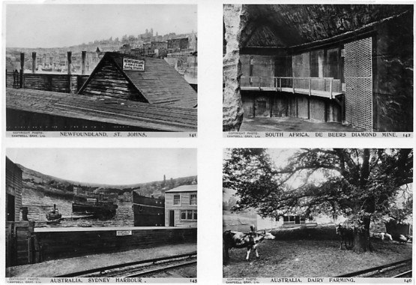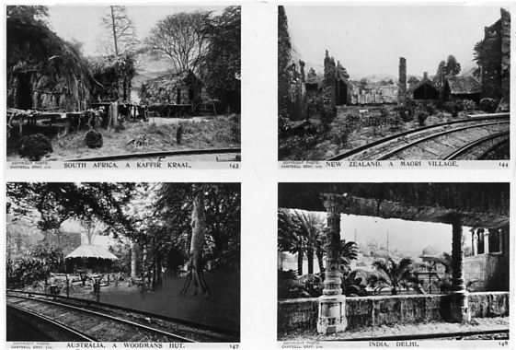
Two quarters of the top half of a giant card.

Campbell Grey Type 3 Giant Multi View Post Card.
R/Photo giant card measuring 305 x 253 mm., brown back with ‘Photograph at The Festival of Empire, 1911’ measuring 230 mm., no divider or stamp box. Only the top half of this Multi View Giant card is known (and that is cut in half) with the bottom half missing. The top part consists of eight small views in rows of four numbered 141-148. Possible the other missing half may have contained another eight views numbered 149-156. All the views have an imprint on the bottom left on the front before the title reading ‘Copyright Photo. Campbell-Gray Ltd’.

Back of two quarters of the top half of a giant card.

The picture of the printing on the back is 60% of full size, it actually measures 230 mm.

141. Newfoundland, St. Johns.
142. South Africa, De Beers Diamond Mine.
143. South Africa, A Kaffir Kraal.
144. New Zealand, A Maori Village.
145. Australia, Sydney Harbour.
146. Australia Dairy Farming.
147. Australia, A Woodmans Hut.
148. India, Delhi.
Campbell Grey Type 3a Giant Post Card.
R/Photo giant card measuring 305 x 253 mm., brown back with ‘Photograph at The Festival of Empire, 1911’ measuring 230 mm., no divider or stamp box. As these giant cards are not to the same proportion as Campbell-Grey’s normal sized post cards most of the giants show more of the original negative at the top or sides of the picture. Usually this extra is just sky. but in No. 78 the ‘New Zealand Building’ we can now see there is a large New Zealand Flag waving on top of the flag pole, which is not included on the normal sized post cards. Some of the cards are known with the variety with and without the hyphen between Campbell-Gray, the same as can be found in the standard sized cards.

No. 61. Australian Building, Festival of Empire, Crystal Palace.
More of the original negative appears at the top of the giant as sky.
No. 62. Newfoundland Building, Festival of Empire, Crystal Palace. Vert left.
More of the original negative appears on each side of the giant card.
No. 63. Indian Building, Festival of Empire, Crystal Palace.
More of the original negative appears at the top of the giant as sky.
No. 75. Grounds from the Empire Steps, Festival of Empire, Crystal Palace.
More of the original negative appears at the top of the giant as sky.
No. 76. Canadian Building, Festival of Empire, Crystal Palace.
More of the original negative appears at the top of the giant as sky.
No. 77. South African Building, Festival of Empire, Crystal Palace.
More of the original negative appears at the top of the giant as sky.
No. 78. New Zealand Building, Festival of Empire, Crystal Palace.
More of the original negative appears at the top of the giant including a flag.

Campbell Grey Type 4 Giant Post Card.
R/Photo giant card measuring 207 x 153 mm., brown back with ‘Photograph at The Festival of Empire, 1911’ measuring 178 mm., no divider or stamp box. As these giant cards are not to the same proportion as Campbell-Grey’s normal sized post cards most of the giants show more of the original negative at the top or sides of the picture.
No. 15. The Crystal Palace and Grounds, Festival of Empire.
More of the original negative appears at the side and top of the giant.
No. 61. Australian Building, Festival of Empire, Crystal Palace.
More of the original negative appears at the top of the giant as sky.
No. 62. Newfoundland Building, Festival of Empire, Crystal Palace. Vert right.
More of the original negative appears on each side of the giant card.
No. 74. Birds Eye View, Festival of Empire, Crystal Palace.
More of the original negative appears at the top of the giant as sky.
No. 75. Grounds from the Empire Steps, Festival of Empire, Crystal Palace.
More of the original negative appears at the top of the giant as sky.
No. 76. Canadian Building, Festival of Empire, Crystal Palace.
More of the original negative appears at the bottom of the giant.
No. 77. South African Building, Festival of Empire, Crystal Palace.
More of the original negative appears at the top of the giant as sky.
With and without hyphen to Campbell-Gray.
No. 78. New Zealand Building, Festival of Empire, Crystal Palace.
More of the original negative appears at the top of the giant including a flag. With and without hyphen to Campbell-Gray.
No. 79. Crystal Palace and Terraces, Festival of Empire.
More of the original negative appears at the top of the giant as sky.

The Crystal Palace Auction Catalogue
Published by
Knight, Frank & Rutley 1911

Since our convention I have had the opportunity to examine two different editions of the Crystal Palace Auction Catalogue, my own copy and one on loan for several weeks from a new member who joined at our last convention Chris Stewart. To have two to examine does not happen very often as these catalogues are fairly scarce and when one comes up for auction usually fetches a fairly high price. I have heard one went for £2,000 on E-bay, but this would be an exception, around the £500 mark would be more realistic figure.
The picture on the front cover, one of the views from the Low Level Railway Station is in colour on the First Edition and in sepia in the Final Edition. The edition type is printed at the top of page 1. There are other differences, the printing of the title and imprints on the cover of the first edition is in brown on a stone coloured cover, while on the final edition the printing is in black on a grey cover. This prompted me to go through each edition page by page to see if there were any other differences in the two editions.
Since very few collectors have seen a copy I will describe the book in some detail. It’s fairly large 11 x 17 inches with 64 numbered pages. (Only one sheet in every three is numbered so there are approximately 192 pages) The pages with text have cut edges while the pages with illustrations have uncut rough edges. The covers overlap the book by about a quarter of an inch on the sides except on the spine, which means in just over a hundred years the covers are usually a bit tatty with some short splits and creasing on the edges. The final edition has an extra four pages at the back listing Stocks and Shares and Conditions of Sale.
The format of the catalogue is a page of text printed on both sides and numbered. Between each numbered page are two sheets bearing illustrations on the two facing inner sides which are interleaved with a loose sheet of tissue paper. measuring 10 x 15. The sheets bearing illustrations are not numbered and start after six pages of text.
Pages 1 to 34 give a history of the Crystal Palace from its opening in Hyde Park in 1851 up to its years at its final location at Penge. While there are no major differences in the first nine pages there are three occasions where there is an alteration of text between the two editions. Pages 10 to 34 are without any alterations noted, but when we come to the section after page 35 it becomes obvious that each page has been reset with alterations, usually a few words added or a few words taken out.
On page 39 for instance the first edition has the words ‘and refridgerating plant’ in line 16, in the final edition these words do not appear, while on the same page in the final edition we have ‘are galleries on the south’ and in the first edition it reads ‘is also a gallery on the’ without the word south.
On page 47 the paragraph starting with ‘The driving machinery’ is reduced to five lines in the final edition but it is in six lines in the first edition, also still on page 47 the last paragraph is in three lines of text, but in the final edition this is increased to 12 lines.
It is not only the text that has been altered, the picture facing page 51 has been printed with the top of the picture on the right of the page, while in the final edition the top of the picture is on the left of the page.
Pages 49 to 64 are taken up with a list of properties in Crystal Palace Park Road and Thicket Road giving details including their freehold ground rent values.
The illustrations are all in sepia and range from the various stages of construction of the Crystal Palace at Penge, continues with highlights throughout the years of some of the important events that took place there, and finishes with the Festival of Empire in 1911 from photographs by Campbell-Grey.

Little Gems of the Postal History of the Great Exhibition of 1851. Number 5.
The Halifax Steamer to Bermuda Letter.
By
Fred Peskett.

The folded cover shown below has more to do with taking part in the Great Exhibition than actually being from the exhibition. Atkin & Manvilles of Walbrook Building, London, were a firm of Solicitors who acted as agents to obtain insurance for many of the foreign and colonial countries that were exhibiting at the Great Exhibition, although the text of the letter is concerned with other business, the Great Exhibition is mentioned.

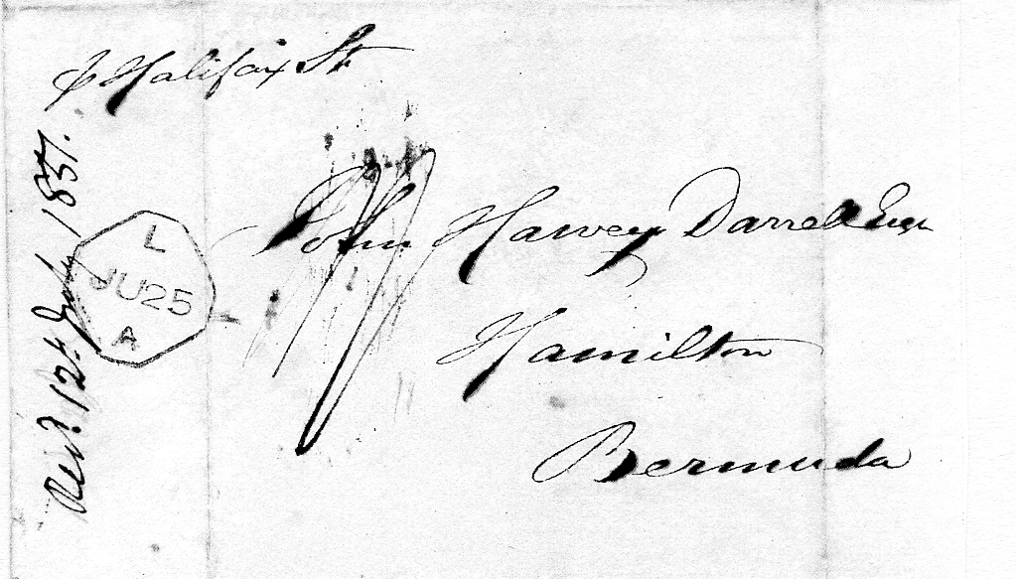

This pre-stamp 1851 folded letter is from London to Hamilton, Bermuda via the Halifax Steamer. There is a Liverpool transit mark on the left side of the front and two manuscript endorsements show that it took eighteen days to reach Bermuda (there is no arrival mark) it cost 1/- to send.
The letter reads :-
Walbrook Buildings, London, 24th, June, 1851.
Dear Sir,
In order not to delay a prompt acknowledgement by the- first packet, Mr Atkin has desired me to write and thank you for your letter of, the. 22nd. While covering a commitment by the. Lords of Her Majesty’s Treasury for thirty pounds on account of Parkwoods debt, due. to him which in conformity with you letter is £30.3.0, and Mr. Atkin will himself, take, an early opportunity of writing to you.
We are all engaged with the. great Exhibition, so that all other business is in a state of, inanimation.
I am
Dear Sir,
Yours respectfully’
(signed) J. I. Manvilles
John Harvey Darnell Esq.
The above letter was found in the American Postal History box of the Salisbury Stamp Dealer. Dauwalder’s in Fishergate Street. Dauwalder’s are a noted shop for their stock of world wide Postal History. Vintage Hornby Trains, Dinky Toys, and all sorts of “Big Boys Toys”! It was April 1990 according to my diary. As usual, I was putting together a new collection to display at the local Philatelic Societies and to use for a Postal History Competition entry. This time it was to be “The Propaganda Envelopes from the American Civil War”, these colourful envelopes told the story of the conflict from both sides, sometimes humorous, but generally tragic.
These covers were of course 100% “philatelic” by their nature. Dauwalder’s always carried a large stock of American Postal History, so was always on the look out for the U.S.A. Exhibition envelopes for the 1933, 1939/1940 and 1964 exhibitions.
I suppose the envelope I found may have been put in the North American box by virtue of the Halifax Steamer connection, I will never know .
The American Civil War collection grew to around a hundred display sheets, it was seen and appreciated by the members of the Portsmouth, Southampton, Fareham, Hayling Island, Romsey and Basingstoke Philatelic Societies, but it was declared to be a “load of rubbish” by a visiting Judge for the Portsmouth Postal History Competition, so it was duly sold off to make way for another collection.

Little Gems of the Postal History of the Exhibition of 1851 . (Number 6.
The Maxwell & Company Letter. 1850.
By
Fred Peskett .

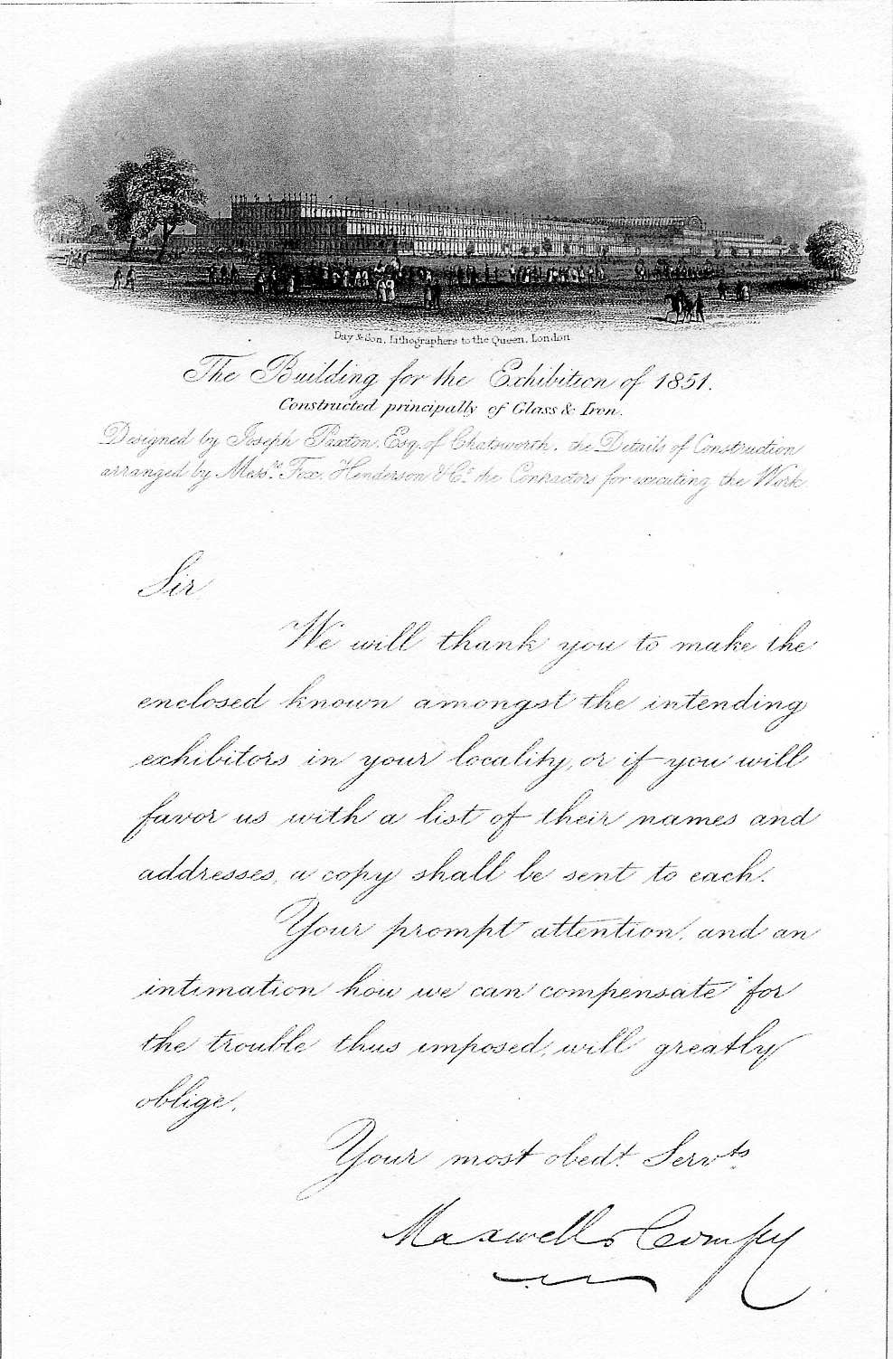

Illustrated above is a black & white engraved note paper of the Great Exhibition Building by Day & Son, London. This has been overprinted by Maxwell & Company to solicit subscribers to advertise in the Official Catalogue for the Great Exhibition, on behalf of the Royal Commission of 1851.
Day & Son also published this headed notepaper in the half foolscap size, it was also printed in dark blue on a pale blue paper in both sizes. The representation of the Crystal Palace by Day’s engraver is excellent, since it gives a good idea of the correct perspective of the exhibition building, which many other engravers of headed notepaper failed to do.
The story of how this little gem came to find its way into my collection is by one of chance, just by being at the right place at the right time.
At a London Book Fair at the Russell Hotel, Russell Square in 1985, 1 was offered the One Shilling Great Exhibition Catalogue for £25, this item of engraved notepaper was included in the price. It was the first time I had visited the Russell Hotel Book Fair, I remember coming away very impressed with what I had seen, and very poor from what 1 had purchased! There was a lot of scarce Festival of Britain ephemera dotted around the stands as well!
Both the notepaper and catalogue had, most likely, been the property of the same person or organisation, there is one clue that could prove this to be true. Folded and placed between the pages of the catalogue is a newspaper cutting from 1851 which refers to several “Exhibitors at the Great Exhibition from Bath”. nearly all of these were companies, engaged in furniture making.
I don’t wish to sound greedy, but I would have liked to have also found the envelope the notepaper was sent in. (if of course, there ever was one?)

The Exhibits of F. & C. Osier at the Great Exhibition of 1851
By
Fred Peskett

The Crystal Fountain designed, manufactured and displayed by the glass company F. & C. Osier is one of the most celebrated and featured of the items on display at the Great Exhibition of 1851 but this company had several other notable displays at the exhibition, all manufactured in glass which rarely ever get a mention.
A pair of Crystal Glass Candelabra each carrying fifteen lights, each candelabra was eight feet high. The Crystal Candelabra had previously been purchased by Queen Victoria and were shown with her permission. It is thought that the Queen purchased them for Osbourne House on the Isle-of-Wight, if they still exist and their whereabouts are currently unknown.
A Crystal Glass Candelabrum in frosted glass supported by three glass Griffons, a large table Candelabrum with a prismatic shaft and a set of large Lustres with Crystal Prisms were also on display.
Unusual exhibits were busts of people in glass. Displayed were the Busts of Queen Victoria, Prince Albert, Shakespeare, Milton, Scott and John Peel, all made in frosted glass.

An E-bay Bargain

Mike Perkins has just told me someone is trying to sell a second hand copy of Don Knight’s book ‘The Lion Roars’ for seventy five pounds. It might be a good idea if Don ran an advert on E-bay offering his book at a more realistic price as I believe he still has some not sold up in his loft.

A Ladies Diary
By
Fred Peskett.
At a recent Antiques Fair in Chichester, I found a small leather bound diary with additional sections for personal accounts and memoranda, it also contain engravings of churches, and famous buildings with a few short stories and some poems. It is titled “Pawsey’s Ladies Fashionable Repository for 1853”, and measures 4¾ high by 3¼ wide with 188 printed pages and some Crystal Palace interest.
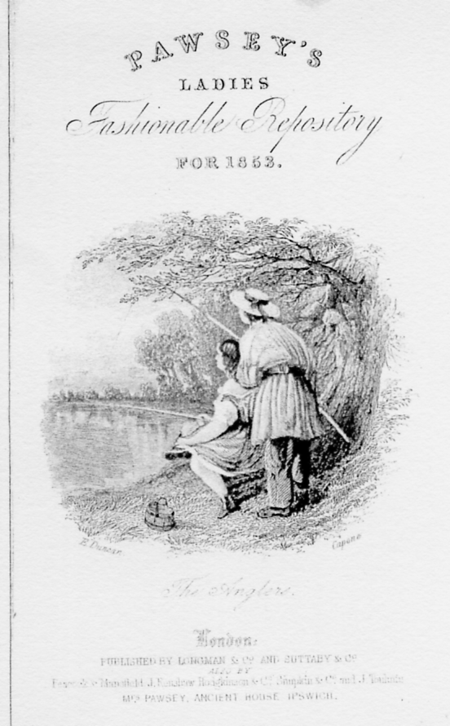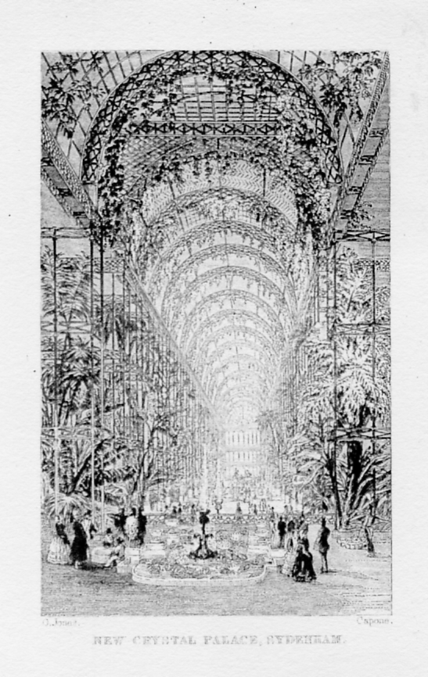

New Crystal Palace Sydenham.

Not yet the palm trees flourish there,
Not yet the creepers hang their hair,
From arch and trellis, breathing round,
Enchantment o’er the fairy ground,
Not yet the sparkling fountains fling,
Their cool jets ‘mid the blossoming,
But we have seen what art can do,
We know she can again renew,
The beauties of that famous pile,
The pride and wonder of our isle,
That as by magic sleight was wrought,
Obedient to the master thought,
Here we shall find a summer clime,
In midst of dreary winter time,
Here lovely flowers of tropic birth,
Will blossom in adopted earth,
Here orange groves will scent the air,
And wondrous plants of virtues rare,
Will please the eye and teach the mind,
Here, best of all, the poor may find,
A Sabbath’s undegrading rest,
And ‘mid God’s varied works may learn to know
Him best.
Mrs Bird.

The book has a frontispiece of a monochrome engraving of the interior of “The New Crystal Palace at Sydenham” showing what the artist thought that the new “Winter Garden” would look like. The view is a little over the top in respect of the amount of foliage he envisaged to be in the new Palace. There is a piece of poetry to accompany the interior illustration, given in full. The engraving was by Capone, based on a drawing by O. Jones.
No further information has been found about the engraver Capone. However, Owen Jones was the Director of Art for the Crystal Palace Company, he was also responsible for the interior decoration of the 1851 Great Exhibition Building.
The popular belief was that the new Crystal Palace would be a-Winter Garden, the poem above reflects that belief.

Charity Shop and Bin Diver
by
Fred Peskett

Shop Book Finds! Fred Peskett. I suppose I am fairly well known as a Charity Shop and bin diver! Sometimes I find a small souvenir glass for the Festival of Britain, and once I even found a rather nice moustache cup and saucer with a multi-coloured transfer of the fountains and grounds of the Crystal Palace, this was priced at under a fiver.
Recently a little gem was found on a Charity Shop bookshelf marked “Very old books, £1.00 each”. I selected one with a title “The Prize Tretise” by Henry Weeks. A.R.A. It is an essay on the “Fine Arts Section of the Great Exhibition of 1851” which Mr Weeks submitted to the Society of Arts in a competition for their Prize Medal of 1851. The publisher of the book is Vizetelly & Co., 135 Fleet Street, published 1851. There is a manuscript inscription in ink on the front paper “J. Butler, Esq. with the Author’s kind regards” The covers are red cloth covered card with the title recessed and filled in with gold. It has 150 printed pages and measures seven and five eighths high by five inches wide.
Mr Weeks was very critical in his book about the Fine Arts in the Great Exhibition, he makes it very clear that he was not in favour of the “Gothic” approach to Art, in particular in respect to the furnishings, a style very popular in the mid 1800’s and abundant in the designs on show at the exhibition. However, he was most appreciative of the work of the silver and goldsmiths even though some elements of the Gothic style was present. Much of Mr Weeks Tretise covers the art of the sculptor, and from the manufacture of souvenirs of their work with the use of what he terms “The Beautiful Parian Marble”. He makes no distinction between the British and Foreign exhibits at the exhibition, although he does give great praise to the Belgian and American sculptors, especially Hiram Powers, and his statue of the Greek Slave.
This little book is well worth picking up if you find another copy, it is doubtful if it will be a Charity Shop, but it may be worthwhile paying a couple of pounds in an Antiquarian Bookshop. Mr Weeks does not reveal if he won the Prize Medal from the Society of Arts, but as he remarks in his Preface “Quod Valeat” (To stand or fall as may be).
While on the topic of “Old Books” I did have another Charity Shop find a couple of years ago. I was very lucky to be on hand to rescue a book from being thrown into a rubbish bin! It was a copy of “Mrs Brown at the Crystal Palace” by Arthur Sketchley. It was in a very poor condition, with the back cover detached, (which is why it was being re-cycled) Published in 1860 by George Routledge & Sons, and printed by Charles Dickens and Evans, Crystal Palace Press, it has card covers, 155 printed pages six and five eighths high by four and one eighth wide The front cover has a drawing of Mrs Brown sitting at a round table in the Crystal Palace Refreshment Rooms, holding an upright knife in one hand and a bottle of gin in the other. On the table is a pork pie, a cottage roll and a glass and jug of ale.
It is about the famous Mrs Brown and her adventures, this time visiting Mrs Milsom who lives over at Penge, so she would also visit what she describes as “the Cristshul Pallis”, the whole book is written as how Mrs Brown would speak, “Certingly naybours is a blessin’ tho’ sometimes bloomin noosances”.
Mrs Brown books are hard reading, but delightful items to display

