EDITORIAL AUTUMN 2014

Our Convention will soon be here once more,
Where members display their treasures galore

Yes our twenty eighth convention will soon be here and at our last one we decided to revert to the first full week end in October the 4th and 5th for this year’s convention. It will be held at the Crystal Palace as before, all together we have met at the Palace eleven times although for the three from 1990-92 we met at the White Swan, a pub on the roundabout at the top of Anerley Hill. The cost for bed and breakfast this year is £30.90 per night. Tea and coffee during the day and sandwiches at midday are supplied free to members and visitors by the Group. I don’t have a price for the evening meal, but it will be around the £10 mark.
We generally have an attendance of 16 to 18 members, and after the short A.G.M. we see displays which are always of interest, containing some rare items. This goes on through the Saturday and in the evening we have our annual dinner, held in the same room as our meetings. On the Sunday morning from 10 o’clock until 1 o’clock there are more displays before everyone say’s goodbye.
If you can only attend during the daytime you may not wish to stay for the dinner, and not wish to bring a display, although we all like to see each others treasures.
The Crystal Palace Centre has bed and breakfast facilities at a very reasonable cost. To book contact Joan Miles at The Lodge, Crystal Palace, National Sports Centre, Ledrington Road, London, SE19 2BB or phone 020 8778 0131. To get through direct to Joan Miles use 8768 8148. The 8778 0131 number gets you lost in recorded messages.
If you are coming please let our secretary Don R. Knight know at 020 8440 3574. e.mail donald@btinternet.com and let him know if you can bring a display, this can be just a few sheets up to as many as you like. Our six frames can hold about 72 to 90 sheets.
I can still remember that first convention at York in 1987, it was a wonderful do. You must remember that until then collectors were isolated people, who in the main never met anyone else with the same interest. To spend a whole day hearing people talk exhibitions and see selections on display from some of the great collections of the time, from Don Knight, Grahame Hall, Stanley Hunter and Karl Illingworth was an experience I have never forgotten. Certainly at that time I was just starting seriously collecting exhibition material and never dreamt in my wildest dreams that one day my collection would be classed as one of the greats.
It was so successful that everybody wanted a two day event next year, as it has been ever since. Nancy and I met Mike Perkins at that first convention, a friendship that has stood the test of time. We have held conventions at York (four times) Manchester (once), Crystal Palace (ten times) and Wembley (five times), Portsmouth (three times) Glasgow (once) Bradford (once) and Hatfield (twice).
Crystal Palace is easily got to, and although it is not a five star hotel Joan Miles and the staff at the Lodge bend over backwards to give us a good time. So what about some more bodies, there are still members living in the London area who we havn’t seen for years, or even ever, so come on, give yourself a treat.
It will not have escaped members notice that 2014 is the 90 th anniversary of the 1924 British Empire Exhibition and I would not be surprised if we saw some odds and ends from that exhibition. Perhaps it’s just as well as Valentine’s only published seven post cards for the Anglo-American Exposition at the White City in 1914, having lost the contract to Gale & Polden and J. Weiner. There were other exhibitions held in 1914 Ideal Home and the Royal Naval and Military Tournament to name but a couple. We must not forget Bradford which celebrates its 110th anniversary and if Grahame Hall was still a member I am sure we should see some Bradford. So taking it all round we have plenty to look forward to at our next convention.
Young Fred has sent me a number of articles he has done while he has been house bound recently and lots of drawings. Fred is a very fine artist and I intend to include many more of his drawings in the months to come. His knowledge and collection of souvenirs of the Crystal Palace at Hyde Park and Penge is probably unrivalled.
The Editors
FLEETING CITIES
Imperial Expositions in Fin-de-Siecle Europe
by
Alexander C. T. Geppert

Palgrave Macmillan, 2010, paperback 2013.
A Book Review by Matthew Denney

The recent paperback edition of Fleeting Cities by Alexander Geppert makes a welcome addition to the current literature on exhibition history. Although there has been some publishing in recent years this is still a surprisingly under published area of history and a field that still has a tremendous variety and scope to offer the historian working in many varied fields. The readers of this journal will not need convincing of this.
Geppert’s book is based closely on his PhD dissertation ‘London vs. Paris: Imperial Exhibitions, Transitory Spaces, and Metropolitan Networks, 1880-1930’ which was submitted at the European University Institute in Florence. Consequently it is an unapologetically academic work, of the 400 pages 150 are given to supporting material, and the structure of introduction / methodology / historiography / justification / case studies / conclusion is a familiar one. PhD dissertations do not always make the most engaging of books, and if a sentence such as:

Thus, the book combines empirical research with an underlying interest in large theoretical issues in order to explore the possibilities of a relational historiography that is simultaneously open to multiple perspectives and considers mutual influences, perceptual interdependencies and transitional interrelations in a new form of network analysis.

leaves you cold, then the introduction and conclusion at the very least may not be for you.
The research that underpins this volume is most impressive, Geppert brings a European perspective to his work and has worked in archives and libraries in many countries. His apparent ease in a number of different languages has enabled him to take a far reaching overview of the subject, and his analysis and insights benefit from this. The bibliography is as exhaustive an exhibitions based bibliography for the period in question as could be hoped for, and this, together with the list of exhibitions and biographies in the appendicies make this a valuable research tool for all students of exhibition history.
The case studies lie at the heart of this book, in these five chapters Geppert considers specific exhibitions: Berlin 1896, Paris 1900, London 1908, Wembley 1924 and Vincennes 1931. This approach allows a researcher to successfully focus a study in what is otherwise an unfeasibly large area of history, it may however leave a reader wishing for a wider field of reference, and specific aspects and relationships with other exhibitions that have not been included might leave the reader with unanswered questions. Fortunately Geppert works hard to limit the shortcomings of this approach and shows a convincing knowledge of many other exhibitions that are not considered in detail, consequently the reader is seldom unconvinced by the arguments presented.
Of the case studies, the first for the Berlin 1896 exhibition was the least familiar to me, and the national nature of this event and the relatively small scale on which it was presented leads one to question its inclusion. The well referenced consideration of why Germany did not play a more confident role in the history of 19th century exhibitions is both interesting and surprising, and the national rather than international exhibition is presented as a reflection of Berlin and even the nation’s lack of confidence on the global stage.
With the Paris Exhibition of 1900 we are on far more familiar ground, and the city is well portrayed as having an abundant confidence and a sense of place as the ‘City of Expositions’. Geppert introduces the notion of ‘Clou’ within an event and suggests Paris comes as close as any city to taking full ownership of the notion of the home of exhibitions. 1908 and the Great White City offer a different approach with the exhibition as a commercial venture with wider overtones of a civilizing event which might have had some impact on deteriorating European relationships. Kiralfy went as far as to suggest the possibility of an Anglo-German exhibition in 1916, history took a different path. Wembley exemplifies the displays of’ ‘Empire’ and the surprising, and very welcome discussion of the 1931 ‘Exposition Coloniale’ that suggest this is a medium in decline.
The case studies are interestingly written and are the most accessible part of this book, their length means there are many aspects that are omitted from discussion. Few specific exhibits are mentioned, architectural discussion is brief and stylistic developments are not considered. This is a volume far more concerned with current theoretical readings of exhibitions and contemporary responses, in particular ‘exhibition fatigue’, and interestingly ‘exhibition swindle’.
With nearly enough interesting and informative illustrations, including eight in colour, this is a welcome addition to the literature. With well reasoned and informative argument around certain aspects of a number of familiar and some rather less familiar events, this work has much to recommend it. The impressive bibliography and the extensive footnotes have much to offer the student of exhibitions, and if the language is a little confused and the argument slightly convoluted at times it rewards the persistent reader with interesting and though provoking insights and information.
The work is all the more impressive in not being written in Geppert’s own native German and for this alone he should take much credit.

Proposed Joint Meeting of the National Philatelic Society
and the Exhibition Study Group.
By
Ray Goodey

I am extremely sorry to report that the above meeting, planned for the 11th October has had to be postponed. It appears the National programme organiser has inadvertently double booked the meeting on the 11th October, and with his programme for the later part of 2014 printed and arrangements made it was easier for our visit to be changed.
I will be in touch with the National shortly to arrange a new date, which hopefully will be early in the new year 2015.

Little Gems of the Postal History of the Great Exhibition of 1851. Number 4.
John Valentine’s “Industry of All Nations” envelope
By
Fred Peskett .

The Industry of All Nations Envelope was sponsored by Elihu Burritt, an American blacksmith from Connecticut. The example shown was printed by Ackermann of London, and published by John Valentine of Dundee. The engraving featured symbolic representations of Art, Industry and Commerce. The Crystal Palace is to the left of the space reserved for the postage stamp. There are at least six variants known in respect of the printing on the back flaps of these envelopes, also the colour of the paper used was variable. The printing ink was generally black, but one printed with blue ink has been recorded. The printing variants on the back are:-
left. right. paper colour.
(a) Johnson & Hunter. Ackerman & Co. Azure blue.
(b) Parry & Company. Ackerman & Co. Azure blue.
(c) Johnson & Hunter. Ackerman & Co. Azure blue.
(Scott) (R. Theobald)
(d) Johnson & Hunter. William Tweedie. Azure blue.
(e) Johnson & Hunter. Ackerman & Co. Blue ink on white (R. Theobald) (E. Fry) paper
(f) Paten & Richie. William Bremmer. Azure blue.

There must have been thousands of these envelopes printed since,
30 envelopes were sent post free for 12 penny postage stamps.
50 envelopes were sent post free for 16 penny postage stamps.
100 envelopes were sent post free for 24 penny postage stamps.
250 envelopes were sent post free for 48 penny postage stamps.
Unused examples are generally found, but used copies are very rare and can command very high prices.
There is another “Industry of All Nations” envelope, only this one was produced some seventeen years later in 1868. M. Moons, a Belgian stamp dealer from Brussels, published a book and catalogue of Illustrated Postal Stationery. Permission was granted by Valentine to include the Industry of All Nations envelope, the reproductions were loosely mounted within the catalogue. The engraving for Moons book was by Belgian artist F. Deraedemaerker, his engraving was much sharper than the Valentine original, it was also printed on thinner and a deeper blue paper. “Deraedemaerker Fecit” is printed at the bottom left on the front of the envelope. The only back imprints are for Johnson & Hunter Edin. and London, on the left side at the back and “ENGRAVED & PUBLISHED BY J. VALENTINE, DUNDEE” (25 Adhesive, of 30 plain sent post free for 12 Penny Post Stamps)
Ackerman & Co. London, (on the right side, back)

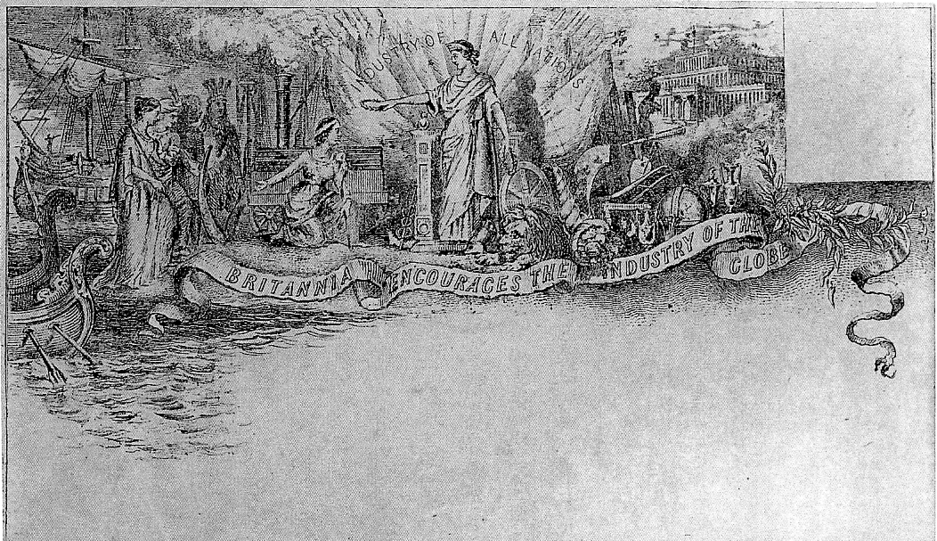
Published by John Valentine of Dundee.

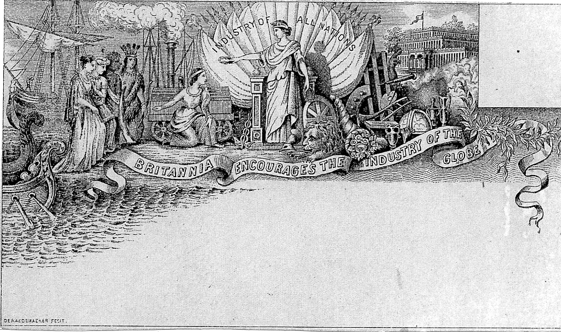
The engraving for Moons book was by Belgian artist F. Deraedemaerke, Note the small imprint Deraedemaerker Fecit” in bottom left corner
The only variant of the re-print is therefore either a plain or an adhesive back flap. Because it was contained in a book, the re-print is far scarcer than the original, you could expect to pay at least three times the price of the original for the copy.
The story of how both of these Industry of All Nations envelopes came to find their way into my collection is a fairly normal story, well, as normal as one can generally get !
Some 15 years ago there was a Stamp Shop in the East Street Mall in Chichester ran by a dealer, John Smith. John’s shop was far from being a “run of the mill” stamp shop, to the uninitiated it may have seemed to be a little bit chaotic, (well not a little bit maybe a lot!) Boxes of envelopes, stamps on sheets, stamps off sheets, albums and ephemera was stacked everywhere, some were actually marked with their contents, but this was rarely a good indication of what was actually in the box, but John’s stock quickly changed, what was in the box marked British Postal History, could change overnight, but it would still be British Postal History on the box?
John was always on hand to steer you to what you wanted. Apart from my usual requirements for Crystal Palace, Festival of Britain and the 1851 Exhibition, I was putting together a collection of the Pioneer American Air Mails, C.A.M. flights for the domestic air routes and F.A.M. flights for the International routes. Thanks to John I quickly put together a most interesting collection including mail carried by aviators such as Charles Lindberg, and the “Crash Mail” for which there was plenty around from the early air-mail flights. I was browsing through a box which I thought may yield a cover or two for this collection when I found the Valentine Industry of All Nations envelope, when I presented it for payment, John said “I’m sure there is another one of these around, when I find it I will put in the Save for Customers box”.
Sure enough, the next time I went to see him I was handed the envelope he said he had, “How much was the last one?” asked John, “£8” I said being honest, “Same again” said John. He should have looked closer, it was the Deraedemaerker re-print! by the time I discovered that it was the re-print, John had sold the shop and retired.

Souvenirs of the Great Exhibition 1851.
Drawings and written by Fred Peskett

Souvenirs made from wood and made from mixed materials.

A large Trinket Box.
This box is made from polished deal and has a multicolored transfer on the lid of red, pink and yellow roses surrounded by leaves. “A Present from” is on the top left corner, and “Crystal Palace” is at the top right corner “Made Abroad” is at the bottom centre, (this suggests that the item was made in one of the Germanic countries) A varnish has been applied over the transfer. The lock is fitted with a diamond shaped brass escutcheon plate. The dimensions of the box are, six and one half inches long by four and one half inches wide by two and three quarters inches high.

A Trinket Box made from wood which is covered with a simulated black, white and brown embossed snake skin paper. A thin brass escutcheon covers a wire lock. The lid has a cloth hinge, there is a beveled edge mirror fitted into the lid. The bottom is lined with blue silk and is fastened to the base by red buttons. It measures four inches long by two and one half inches wide by two inches high to the top of the domed lid. The date is around 1895 to 1910.

There is another Trinket Box which is identical to the shape and dimensions of the previous box, so it is probably produced by the same maker. This one has the words “A Present from the Inventors Exhibition”. There was such an exhibition held at the Crystal Palace during 1887. The style of the wording on both boxes is identical. The brass escutcheon plate covering the wire lock is of a different design (see sketch) and the interior of the box is covered with a pale pink silk fastened with light blue buttons.

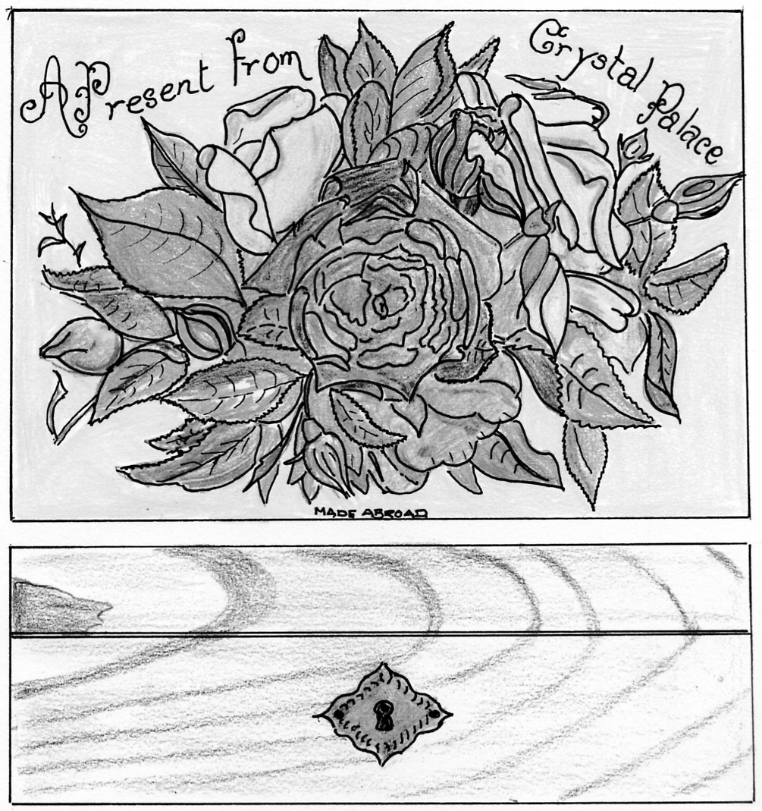

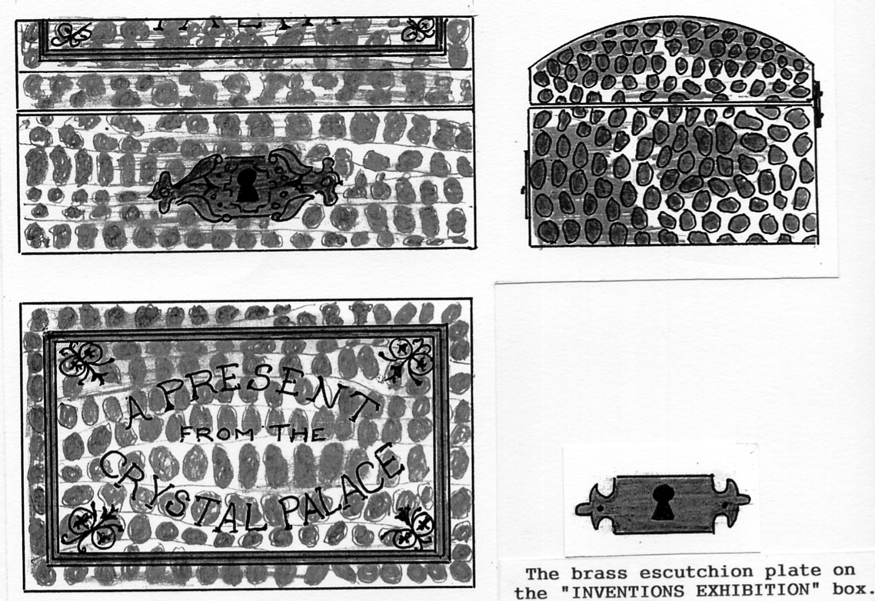
(75% full size)
Monument to the British Empire Exhibition 1924-25
By
Don R. Knight

May 2013 saw the demolition of the last building standing which was the Palace of Industry built for the British Empire Exhibition 1924-25. Three Lion Head Corbels were saved, these were the bases of flag poles which were seen on the Palaces of Engineering, Industry and the Stadium. Phillip Grant of the Wembley History Society and I felt that one of them should be mounted on a plinth some-where near the Exhibition site. Phillip made contact with Alex Hearn of the Brent Parks Department who felt the same.
A meeting was called of members of the council and Phillip and I attended. The Study Groups committee had agreed to fund something towards the costs of building an appropriate commemorative monument as did the Wembley History Society. Alex Hearn said funds were available which could pay for the building of a base on which the Lion Corbel could be mounted. Phillip and I agreed to do a drawing for this. A site was talked about and it was decided the green if front of North Way House, Empire Way would be the ideal place. The approved drawing went to a number of Brent Council contactors for a quote to do the job, Conway came up with a price which was accepted.
It had been hoped that it would be ready at the time of the 90th Anniversary Exhibition opening on the 24 April, but this did not happen. Work started soon after the F.A. Cup Final 17 May and was finally completed by the 20 June 2014. The Exhibition Study Group paid just under £200 which was half the cost of plaque fixed to the base on which the Lion Head Corbel is mounted. The plaque records the history of the British Empire Exhibition 1924-1925.
On Monday 28 July 2014 at a small ceremony on the green opposite York House, Wembley Hill Road, the Lion Head Corbel was unveiled. This now stands as a monument to the British Empire Exhibition. Our President, Ramon Goodey, Vice President, Derek Connell and Secretary Don Knight were present at the unveiling.

Owen Jones and the Crystal Palace Water Temples
by
Fred Peskett

Owen Jones was a remarkable architect and designer, he was responsible for the interior decoration of both the Hyde Park and Penge Park Crystal Palaces, he was also very much involved with the design work in the grounds of the Crystal Palace in particular the two Water Temples situated at the top of the twelve stepped cascades. These two identical octagonal Water Temples were some sixty feet high, each had a statue of the Messenger God Mercury on top, with nude female forms inside, although some engravings show these forms, they cannot be seen in contemporary photographs, which gives rise to it being suspect that they were not actually installed due to Victorian modesty? The metal-work of the Temples was painted purple and red.-
Water was pumped up through the hollow cast iron supports of the Temples, then cascading from a bulbous ring supporting the statue of Mercury, eight cast bronze cupid heads decorated the apex of the domes of the Temples with water gushing from their mouths, this gave the effect of a water curtain around the Temples, which may be the reason the nude statues could not be seen in photographs? Eight lions decorated the base of the octagonal structures, each had water gushing from their mouths into a large four leafed clover shaped pond before tumbling down the twelve stepped cascades ending in two waterfalls falling into the lower basins before being pumped back to the top of the Water Temples by four forty horse-power pumping engines.
The Water Temples and Cascades were first used during the afternoon of June 18th 1856 in front of Queen Victoria and 20,000 visitors. The Water Temples were still active in 1875, but by 1895 it would seem that they had been dismantled, a photographic view of the water features dated June 1895 does not feature the Water Temples, and the clover leaf pond had been filled in.

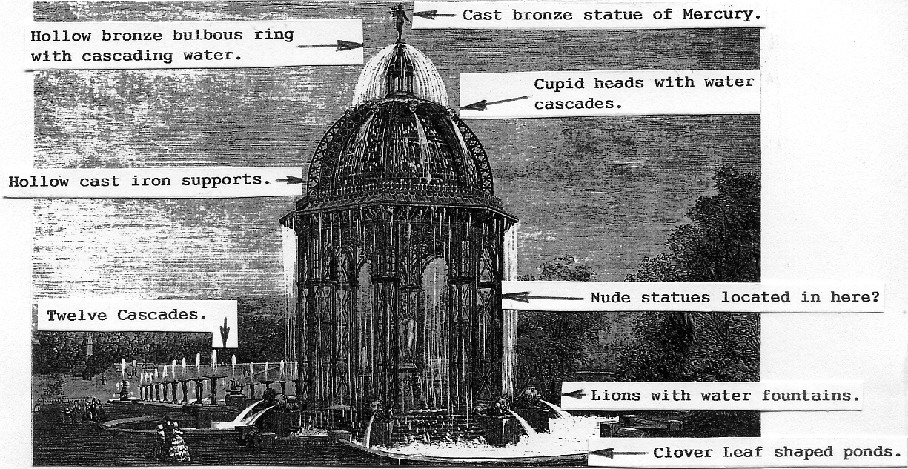
Based on a wood engraving from The Builder 21 June 1856

My Favourite Souvenir of the Crystal Palace
By
Fred Peskett.

A few weeks ago I was giving a talk on the Postal History of the Crystal Palace to a local Philatelic Society, as usual I took along a couple of items of ephemera and souvenirs which I think adds a little more interest to multiple sheets of stamps, envelopes and postcards. I asked the audience that if anyone had a question about the history of the Palace, then I would do my best to answer it or find the answer and inform them in due course.
One person did ask a question which for a few seconds floored me, “What is your favourite item from the Crystal Palace?” “That is one that you treasure the most”. My answer was that all of my souvenirs were a treasure, and as such they were all favourites. But when I returned home and was packing the items away I started to think seriously about my favourite item.

An illustration from Peter’s Paradise

After much consideration I came to the conclusion that it was a Child’s book “Peter’s Paradise, a Child’s dream of the Crystal Palace”, by George H. Robinson, illustrated by James Denholm and published in London by Simpkin, Marshall, Hamilton, Kent & Co Ltd.
The date of publication is not marked, but the style looks to be around the mid to late 1800’s, the illustrations are a mix of sepiatone plates and colour chromolithographs. Peter is aged about 7 years and wears a typical Victorian Sailor Boy’s Outfit.
The story is based on a dream that Peter has of a visit to the Crystal Palace, the story is written in verse which starts
“I know a little child named Peter,
I am sure you cannot find one sweeter.
He says “That the Palace, so lovely, so nice,
Makes him dream in his sleep, that he’s in Paradise,
And here are but some of the wonderful sights.
Which crowd round the bed of young Peter o’ night’.

One of the sepia views of the Crystal Palace shows the building with the North Transept, this was destroyed by fire in 1866 and never re-built. However, it is not uncommon for books and postcards to feature the North Transept even during the 1930’s, perhaps there was a desire to see the Palace symmetrical again?
Having arrived in the grounds of the Crystal Palace, Peter enters the Palace and visits the Pompeian and Egyptian Courts before going into the Monkey House, he then watches a fireworks display, and chats to the boy who looks after the donkey who pulls the grass-cutting machine, he skates on the ice of one of the frozen ponds, and watches the balloon “Victoria” lift-off from in front of the Crystal Palace. Peter then returns to the interior of the Palace to see the Greek Court, then back to the grounds for a spot of fishing and rowing in and on the Great Lake, A walk down to see the Prehistoric Animals is followed by seeing the collection of stuffed animals in the “Wurtenberg Gallery”. Finally Peter climbs on board the balloon “Victoria” and is flown home to wake up after a busy night dreaming of the Crystal Palace.
The balloon “Victoria”, I have seen a reference to a balloon of this name being flown at the Crystal Palace, it may have been in a copy of the Illustrated London News? Again the North Transept is featured on the Crystal Palace building. The balloon is rising from the Archery Ground in the Crystal Palace grounds, another feature of the 1860’s.
I have one criticism, I wish the illustrator had made Peter’s facial expression a little more happy! instead of looking such a miserable little git!

Spectators at the Crystal Palace Fire.
By
Fred Peskett.

My latest visit to the Midhurst Grange Flea Market has yielded a bag full of newspaper cuttings from December 1st, 2nd and 5th 1936, all about the fire which destroyed the Crystal Palace. One interesting area found in the cuttings is about the crowds watching the blaze, here are a few “snippets”.
What no ice creams?
One enterprising young man went round the crowd selling peanuts and bars of chocolate, some people thought it was like being at the pictures.
Over the wall and up the hill, or Over the hill and up the wall!
Many of the spectators found they could get a grandstand view of the blaze by climbing the seven foot high wall around the goods yard adjoining the High Level Railway Station, they could then stand on the mounds of coal or climb on to the loaded goods trucks in the siding, fearing a calamity the station staff opened the gates of the goods yard and allowed crowds in without the seven foot climb.
The case of the strange light.
Sightseers at the Tram Terminus near the South Tower were amazed to see a series of extremely bright lights passing up and down inside the South Tower, it was revealed later that they were powerful arc lamps carried by firemen damping down sparks on the spiral staircase of the tower.
Let there be light.
The newly installed street lights along the Crystal Palace Parade proved to be very effective, they were automatic, coming on at dusk and going off at dawn. They remained working throughout the duration of the fire, finally going off at day-break. All of the lights continued to work despite the intense heat, falling debris and thousands of gallons of water being sprayed over them.
Any old iron?
When morning came extra trolley-buses had to be deployed along the routes to the Crystal Palace to cater for the thousands of spectators and souvenir hunters, extra police were also on duty. One passenger was refused entry to a bus because he tried to get a six foot high chunk of iron on board!
Be prepared!
Another enterprising salesman wandered through the crowd trying to sell Fire Insurance Policies, it is doubtful if he managed to find any takers unless he came across Sir Henry Buckland!
A suggestion that came true.
An article in the Croydon Advertiser suggested that the now vacant site of the Crystal Palace could be used to build a National Physical Training Centre with sports fields, athletic tracks, swimming pools and a college for Physical Training. It said “the youth of today wants grass, not glass”.
A Closer look at two Franco-British Exhibition Post Cards.

I recently had some correspondence and scans from Ken Rumsey pointing out some interesting things on two Franco-British Exhibition cards that I had not noticed when I wrote my magnum opus on the White City. The cards were published by A. N. Paris. (Believed to be Alphonse Noyer.) This is an up-dated version on my A. N. Paris. book entry.

R/Photo hand tinted with white border, black back with ‘CARTE POSTALE’. These cards are published in France and they all have the same title. They are hand tinted, and the dresses can be found in different colours. They feature the national symbolic figures Britannia and Marianne holding hands. As is usual with hand tinted colours these can vary. Two different pictures were published, in the first (Type 1.) the two ladies are both facing the camera, in the second (Type 2.) they are facing each other.
At a first glance it would appear that the pictures of the two women facing the camera come from a single negative, but a closer examination shows that although the models have remained stationary Marianne has moved her head slightly and also her eyes. On this post card the manuscript title has been written in a different way at least four times. The title writer had difficulty in spelling British Exhibition and in all cases it is spelt Bristish Exibition. They were also not too sure about where to put hyphens and full stops.
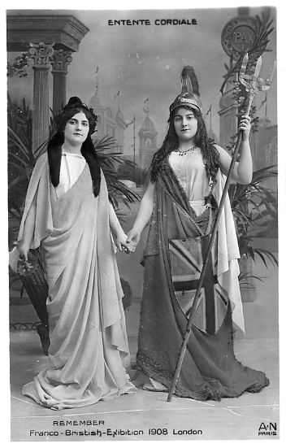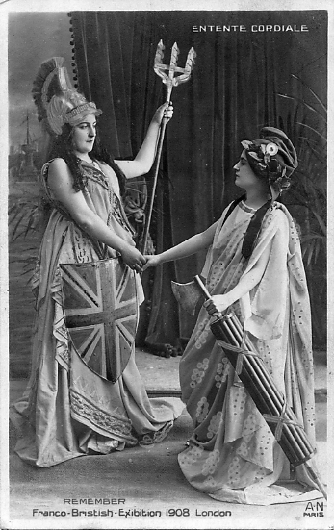
Type 1 Type 2

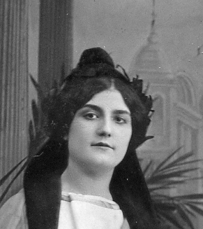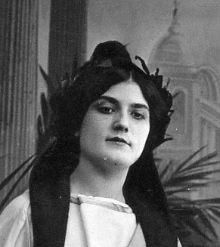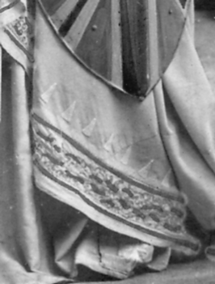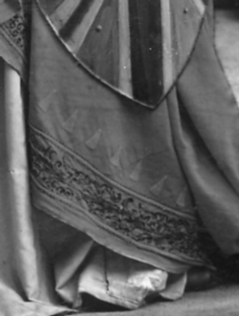
Eyes looking to left Eyes looking down Pattern to yellow dress Red dress

It now appears that both type 1 and 2 of A.N. cards were published with matt and glossy surfaces, the front of the glossy cards were whiter than the matt cards which were of a greyer white. In type 1 the glossy cards show Britannia in a white dress, while in the matt cards her white dress is covered in dark spots in groups of three. In type 2 the glossy cards show Marienne’s blue dress without spots while in the matt cards the blue dress is covered in spots in groups of eight.
Another thing I noticed was that the spots on the dresses of both matt cards seem to be different, certainly when I got them blown up on the computer screen they were not all the same. On the first series of cards where the women are facing the camera 1 is different from 2 and 3 which are the same, although 3 is slightly feinter, and 4 is the glossy type without dots.
In the type 2 where the women are standing sideways, 1 and 2 are the same, 3 and 4 are the same although 4 is moved over slightly, and 5 is the glossy type without dots.
It seems to me that the dots were added to the negative at a later time as the patterns of dots do not follow the folds in the cloth
Type 1. Women facing camera

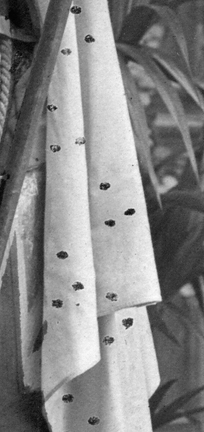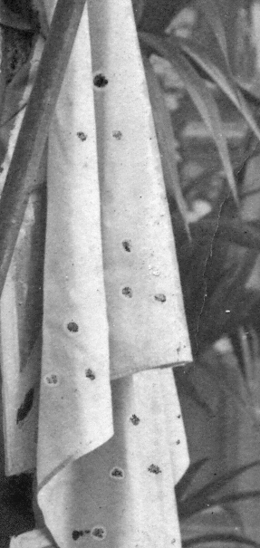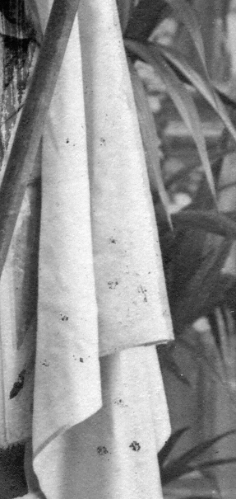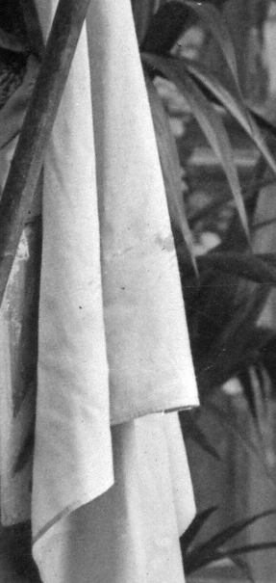
1 2 3 4

Type 2. Women sideways to camera

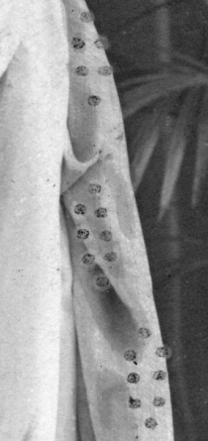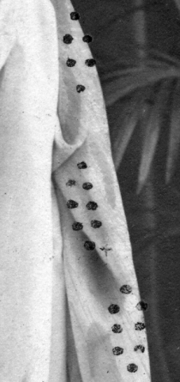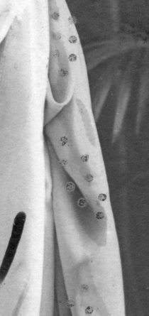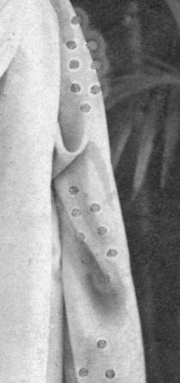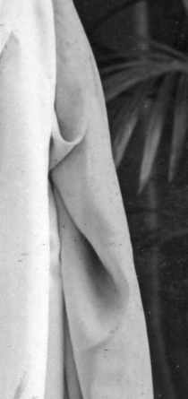
1 2 3 4 5

A.N. Type 1A. Featuring national symbolic figures Britannia and Marianne holding hands standing facing the camera. Glossy surface. Two negatives were used, in one Marianne has moved her head slightly and also her eyes and is either looking left or downwards..
N.n. A Entente Cordiale. Remember Franco Bristish-Exibition 1908. London. (Eyes down, with stop after 1908. and London. and one hyphen measures 51 mm.) Vert. left.
N.n. B Entente Cordiale. Remember Franco-Bristish-Exibition 1908 London (Eyes left, without stops after 1908 and London and two hyphens measures 52 mm.) Vert. left.
N.n. C Entente Cordiale. Remember Franco-Bristish-Exibition 1908 London (Eyes left without stops after 1908 and London and two hyphens measures 54 mm.) Vert. left.

A.N. Type 1B. Featuring national symbolic figures Britannia and Marianne holding hands standing facing the camera. Matt surface. Britannia’s white dress and train is now decorated with black or grey dots in groups of three.
N.n. A Entente Cordiale. Remember Franco-Bristish-Exibition 1908 London (Eyes left, without stops after 1908 and London and two hyphens measures 52 mm. In addition to the black dots (1) the red part of the dress now has a white irregular pattern) Vert. left.
N.n. B Entente Cordiale. Remember Franco-Bristish-Exibition 1908 London (Eyes left, without stops after 1908 and London and two hyphens measures 55 mm. black dots (2. No white irregular pattern to red part of dress.) Vert. left.
N.n. C Entente Cordiale. Remember Franco-Bristish-Exibition 1908 London (Eyes left, without stops after 1908 and London and two hyphens measures 55 mm. In addition to the black dots (3) the red part of the dress now has a white irregular pattern, not the same as type A) Vert. left.

A.N. Type 2A. Featuring national symbolic figures Britannia and Marianne holding hands standing sideways to the camera. Glossy surface. The title was re-done several times.
N.n. A Entente Cordiale. Remember Franco-Bristish Exibition 1908 London (Without stops after 1908 and London and one hyphen measures 52 mm.) Vert. right.
N.n. B Entente Cordiale. Remember Franco-Bristish-Exibition 1908 London (Without stops after 1908 and London and two hyphens measures 54 mm.) Vert. right.

A.N. Type 2B. Featuring national symbolic figures Britannia and Marianne holding hands standing sideways to the camera. Matt surface. Britannia is in a yellow and red, dress, while
Marianne’s blue dress has black spots in groups of eight.)
N.n. A Entente Cordiale. Remember Franco-Bristish-Exibition 1908 London (Without stops after 1908 and London and two hyphens measures 53 mm. black dots (4) Vert. right.

A.N. Type 2C. Featuring national symbolic figures Britannia and Marianne holding hands standing sideways to the camera. Matt surface. Britannia is in a red dress with black markings while Marianne’s blue dress has black spots or black and white spots in groups of eight.)
N.n. A Entente Cordiale. Remember Franco-Bristish Exibition 1908 London (Without stops after 1908 and London and one hyphen measures 52 mm. black spots (2)) Vert. right.
N.n. B Entente Cordiale. Remember Franco-Bristish Exibition 1908 London (Without stops after 1908 and London and one hyphen measures 52 mm. black and white spots (1) Vert. right.
N.n. C Entente Cordiale. Remember Franco-Bristish-Exibition 1908 London (Without stops after 1908 and London and two hyphens measures 54 mm. black spots (3)) Vert. right.

1914 Anglo-American Exposition

There seems to be a bit of a mystery about the closing date of the Anglo-American ‘Exposition. ‘Special Event Postmarks of the United Kingdom’ by G Pearson gives the dates as from 16 May to 11 August with another unexplained date 18 September. ‘The Exhibitions’ by Don Knight also gives the closing date as 11 August, while the ‘Catalogue of British Exhibitions’ by Stitt Dibden does not mention a date. The interesting thing is all three authors publish the same illustration of an example of an Anglo-American Exhibition postmark showing the date 8 PM 11 August. Now how can this be? Did they all copy their example postmark from the post office record book, and was there a note in the record book to the effect that this was the last day of use of the postmark. This is pure speculation as I don’t know the answer.
What started this head scratching was a scan from Ken Rumsey recently received of a 3d Anglo-American Exposition Daily Programme dated 29 August. Don states the exhibition was closed in a hurry owing to the imminent start of The Great War. Of course the existence of this late date programme does not mean the exhibition was open on that day, it could mean that when the exhibition closed they were left with a lot of programmes already printed and never used. There must be local newspapers reporting the closing of the exhibition, and until one turns up we shall not know the closing date for sure.

Refurbishing the Crystal Palace (old Low level) Station

Transport for London has now completed the first phase of the work to refurbish Crystal Palace station. The original Victorian ticket hall, a Grade II listed building originally built in the 1870s has now been re-opened to serve as the new ticket office at Crystal Palace station.
As part of the TfL station enhancement programme, the building was restored by Mansell Construction Services Ltd in line with a scheme approved by English Heritage and the London Borough of Bromley.
Did you know?

1. The old ticket booth within the original Victorian ticket hall was carefully dismantled then
shipped to the East Anglia Railway Museum for use in one of their future exhibits.
2. 150 square metres of brickwork cleaning and repairs to damaged pointing was carried out to restore the station.
3. The floor of the new ticket hall is a complex Victorian bridge structure and is 10 metres above the railway line.
4. The current station building dates back to 1877 and replaced a more modest structure built on the same site in the 1850s.
5. The Communications Equipment Room at the station used to be a men’s toilet.
6. One of the upper windows facing the Crystal Palace was from where a photographer took a photograph of the Crystal Palace over the brick wall of the roofed walkway from the station to the palace that was reproduced on many millions of post cards.

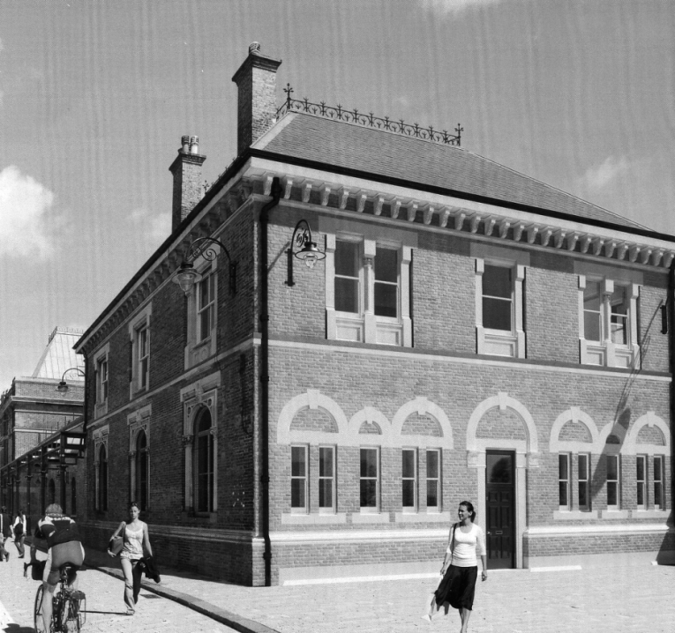

An artist’s impression of what the refurbished station might look like when finished.

Probably taken from one of the upper windows of the Station in 1903 this and others taken later from the same spot was syndicated to nearly 200 different post card publishers.

