EDITORIAL SUMMER 2014

I’ve passed middle age now, and I’ve slowed up a bit,
But my hobbies are keeping me mentally fit.

Roughly every three months I sit in front of my computer with a blank screen and try and think up two lines of drivel to start the Journal. It seemed like a good idea when I started, and someone once said it adds a bit of class to the Journal.
By the time you get this issue, Spring Stampex will be over and Derek Connell has done a report on it. I can add to his report as Kenneth tells me two visitors who attended and saw the show we put on have joined. I say ‘we’ but as you all know when it comes to work it usually falls to a very small handful of members who make up the ‘we’.
Raymond Goodey is doing a good job in bringing the study group to the notice of potential new members and including the joint meeting with the Cinderella Stamp Club raised our new influx by a total of three. We are fortunate in having a good working committee. Don Knight is a first class speaker with a collection to match who more than pulls his weight in the group and Derek Connell is an up and coming lad and I foresee a good future for him in the Study Group. I won’t say what his future is, in case I frighten him off.
There seems to be an increasing number of clubs and societies falling by the wayside and for two reasons. Either nobody wants give a few hours to run them, or they are being killed off by ever increasing rents. When both these conditions apply then it’s best to call it a day. Until last November I was secretary of a small post card club that had been going for nearly 30 years. When I left them they were without a Secretary, Assistant Secretary or Treasurer. The church we hired a room from had raised the rent from a 10% increase every three years to a 10% increase every other year. A suggestion was put to the meeting that as we could no longer consider ourselves viable we close the club and donate our funds of about £500 to a charity. The voting was four to carry on, three to close and one didn’t know.
In this Journal I am publishing an article on the Eddystone Lighthouse. This all started out when I read in the Philatelic Exporter about the post cards published for the 1891 Royal Naval Exhibition by Colin Such. The Philatelic Exporter is the stamp trade magazine and its circulation is restricted to those involved in the stamp trade. So how did I become a subscriber to a Stamp Trade magazine ?
Well the story goes back nearly fifty years When our son Kenneth was doing a bit of wheeling and dealing at school in stamps. I used to take him with me when I visited a stamp dealer ‘Buster’ Keaton who specialised in booklet and coil stamps. Any of these where the perforations were trimmed too badly for Buster to sell, he put in a tin on his desk to be used up for postage. Kenneth used to rummage through Buster’s tin buying any that were not too badly trimmed with inverted or sideways watermarks to sell at school or at the stamp club. One year for his birthday we gave him some printed notepaper with the heading Kenneth Tonkin Stamp Dealer, and using this, I sent off a year’s subscription to the Exporter. That was in about 1966, It’s a good magazine and I’m still getting it.
In his article Colin mentioned the five printings of the Royal Naval Exhibition post cards, this was news to me and I wrote to him asking if he could give me details of the five printings. It turned out that Colin Such was in fact Warwick & Warwick the Auction firm and he had gleaned out about the five printings in a lot that had passed through his firms hands. He was able to put me in touch with the buyer of the lot and the previous owner, who turned out to be a member of the Study Group David Hiscock. The lot had been bought by a stamp dealer Trevor Price dealing as Hanley Stamps who still had the collection and agreed to send me scans of each page. These illustrated the five printings and later David Hiscock sent me coloured scans of his collection taken before he parted with it, which contained more information. David had recorded the details of no less than 83 of these cards, and when I spoke to him about the enormous outlay he must have incurred, as these cards usually go for £50 or more a time, he admitted that whenever one came up for auction he asked the firm to send him scans of the front and back.
The Editors
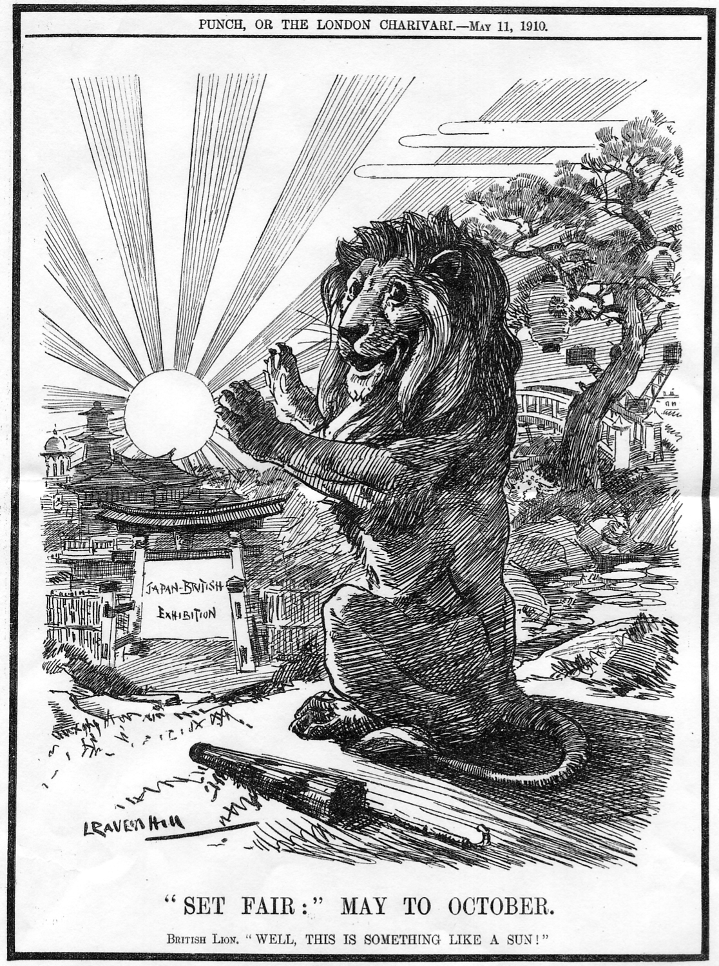

Two members, Ken Rumsey and Stuart B. Smith have both sent me copies of the above illustration that appeared in Punch in 1910. Ken’s was probably sent in over a year ago while Stuart’s was more recently. I had decided to include the illustration in this edition of the Journal when on Monday 12 May I received a letter from Mrs. Jacqueline Smith informing me that Stuart died on the 13 April. I had never met Stuart but we had corresponded for some years, exchanging scans of Japanese shipping and exhibition post cards which we both collected.
The last time Stuart wrote to me, was to send scans of post cards of the Nippon Yusen Kaisha Line S. S. “Kaga Maru” the ship that brought the Ainu and Formosan people from Japan to appear in the Japan-British Exhibition at the White City in 1910. Stuart made many visits to Japan, and I always found him very helpful. I shall miss him and have sent a letter of condolence to Jacqueline.

The Exhibition Study Group at Spring Stampex.
by
Vice-President Derek Connell

Spring Stampex at The Business Design Centre in Islington was a joy as usual, with its free entry, free programme and free souvenir postcard. Various new and old issues of stamps were available at the Post Office, with suitable daily postmarks and all the frames of stamps (invited and competitive) and all the dealers (including ephemera and postal history) anyone could want.
The organisers of London 2015 Europhilex had a stand distributing information about next year’s International and their latest publicity postcards, illustrating items from all the London International Stamp Exhibitions since 1890. (We have sponsored the 1940 card which will be available at Autumn Stampex.)
Incidentally, our own E.S.G. member, Ron Trevelyan, entered an intriguing exhibit entitled “French International Exposition Paris 1937”, telling the story through stamps, postmarks, Cinderella’s and postcards. Congratulations, Ron, on winning an A.B.P.S. silver medal!
Likewise, one of our stalwart Scottish members, Jean Osborne displayed a marvellously absorbing exhibit of the labels and ephemera of the 1901 Glasgow International. Jean chose not to be judged, entering by invitation in celebration of the 30th anniversary of the B.T.A.
But there was something new this year and that was The Exhibition Study Group! As you will have read in the last Journal, we hired a room on the Saturday morning and invited members, friends and visitors to join us. To celebrate the ninetieth anniversary of the British Empire Exhibition at Wembley, Don Knight brought his extensive collection along, and displayed it in a game of two halves.
As you would expect, Don’s display was superb, with the full range of all those souvenirs that were available at Wembley ninety years ago. There were the pre-publicity slogans, leaflets and entry tickets, followed by the first day covers, stamps and various postmarks of the different Post Offices. Postal stationery, telegrams and postcards completed the line-up. Because we had the room for two hours, I for one was very pleased to be able to study the material in more detail than usual, and actually have time to read all the write-ups!
In case any new members or friends reading this are unaware, Don co-wrote with the late Alan Sabey a very comprehensive book called “The Lion Roars at Wembley” which contains everything you’ve ever wanted to know about the B.E.E., but were afraid to ask! Contact Don if you want to buy one - special rate for members - see inside front cover.
Now it’s no good pretending this first get-together at Stampex was an unqualified success. We did rattle about a bit in the room and we could have done with a few more attendees. The start time was only half an hour after the doors had opened and the Business Design Centre itself was not exactly heaving! It became busier later in the day so perhaps next time we should try for an afternoon slot. I strolled up and down the gallery and stuck my nose in a couple of other meetings, and some of them didn’t seem to be doing any better than us!
The idea, of course, is to get some new faces to join our ranks to inject some fresh blood into our group. Publicity is the name of the game and since the passing of Alan, we have no publicity officer. Any volunteers to take the post, help with the organisation, or come up with some good publicity ideas, would be very welcome. Contact any of the committee.
Next year, having sponsored the 1940 publicity card for London 2015 (also at Islington) we have taken an all-day table and a meeting room from 3pm to 5pm on Saturday 16th May. We will put up a display of the events of 1940 which, of course, was the centenary year of Postal Reform and the Penny Black. War broke out, the planned Earls Court Exhibition was cancelled, a smaller event was held at Lancaster House and that year’s Congress was held at Bournemouth.
I’m thinking we might dress the room up a bit, so if anyone has any wartime memorabilia they’d like to exhibit, posters, tin helmets, ration books etc. please contact me.
By the way, if anyone is interested, I’ve just started a new series of articles in Gibbons Stamp Monthly on the Stamp Exhibitions of London. Part one, 1890 Guildhall in the April edition, on sale in March.

A Mauchlineware Pencil Box type 4.
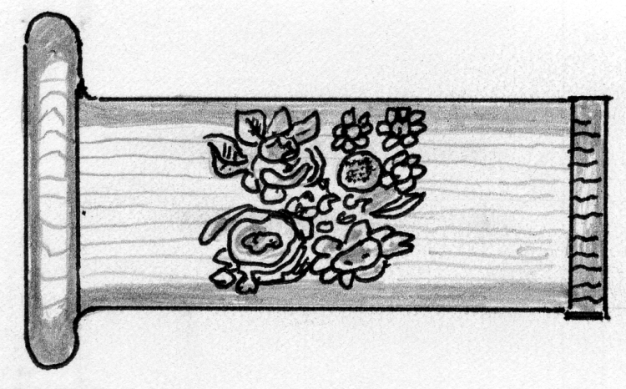
by
Fred Peskett
The transfer design on the main body of the Pencil Box is identical to the Types 1 to 3, however the pull-off lid has a different transfer of roses, violets, pansies, and what looks like an orange! The shoulder for pulling off the lid is a larger diameter than the Types 1 to 3 and has a different colour wooden disc glued to each end of the closed ends of the Pencil Box. The type of wood used for the main body and the pull-off lid is also different from the Types 1 to 3 and is of a far coarser grain, which is also reflected in both of the end caps.
Shown actual size.

A Mauchlineware Tobacco Jar.

Made in boxwood this souvenir is shown full size. The design around the black and white transfer of the Great Exhibition Building is a series of alternating red and black concentric circles. The lid is a tight fit to the body to keep the contents fresh, when the lid is removed there is still the smell of tobacco. Three and one half inches diameter by three inches high.
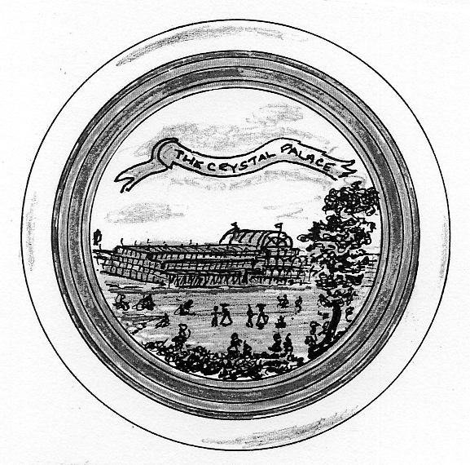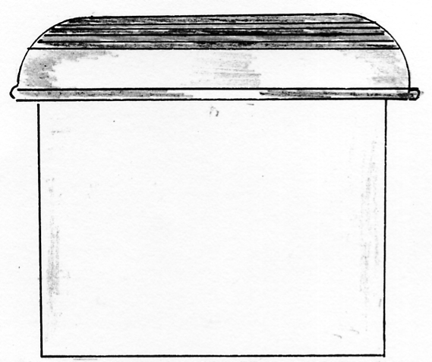
(75% full size)

A Mauchlineware Trinket Box.

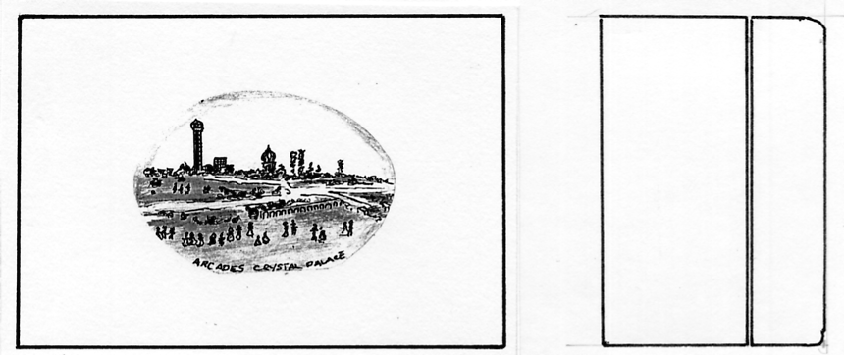
(75% full size)
Made from polished boxwood this is a simple but very rare transfer of the Arcades at the Crystal Palace. The view shows the North Tower with part of one of the original Water Towers on the right. One of the Water Temples is at the center. The Archery Ground is at the center right.
This box is a “genuine” made in Mauchline, Scotland souvenir, the craftsmanship is superb, from the perfect fitting of the lid to the miniature dovetail joints used in the construction of the box. Three and one quarter inches long by two and one quarter inches wide by one and one half inches high.

Yet another 1924 Map has turned up, this time reported by our Secretary Don Knight who claims he bought it about 20 years ago and has just found it again. It is advertising Eno’s Salts.

Contents of different panels on Map number 48.

I. Advert for ‘The World’s Greatest Proprietary Known and sold throughout the British Empire. When you visit the British Empire Exhibition call at THE ENO KIOSK
K, L, M & N Picture of the Imperial Stadium and text on the British Empire Exhibition. The
headings of the paragraphs are, Variety and Colour, Monster Military Tattoos, A Fellowship of Empire and The Great Home-coming.
S. How the Exhibition began, text on purposes and Co-operative report
T & U. All the World will be at Wembley, Fifteen miles of Exhibition, three lines of text and picture of a Bird’s Eye View of the Grounds.
V. Art of the Empire, The two Georgians and Short Time Exhibits

The Story of Ballymaclinton.

Part 3 of a three part article by George Ithell from the Exhibition Study Group archives.

The Death of King Edward on the 6th May 1910 caused the Official Opening of the Japan-British Exhibition to be postponed. The original date fixed was May 12th and it was suggested that a much later date would be respectful. However King George V was mindful of the hardship and unemployment which would occur if there was any delay, so when consideration on these points was taken the Opening was only postponed until May 14th and without the Ceremony. The Exhibition was closed for the day of His Late Majesty’s funeral, May 20th. Very little mention is found regarding Ballymaclinton’s third year, but the names of the Lord Mayor of Dublin and that of Cork, together with the Chairman of the Chamber of Commerce from the Orange Free State a Mr W. A. Doherty, also the Managers of Irish Railways are to be found in the list of the General Committee.
“It is nature’s own soap” was the slogan which appeared on most wrappings, invoices, advice notes, letter heads and any advertisement of McClinton’s soap. Consequently this narrative would not be complete if the mention of Professor John Kirk was omitted. He was born at East Plean, Stirlingshire on July 4th 1813, and began his working life as an indentured apprentice to a blacksmith, a Mr John Miller in Bannockburn. Most of his evenings were spent studying the Bible which convinced him that his vocation was with the Church. He was then educated for the Ministry of the Congregational Churches, and took on his first Ministry at Hamilton between the years 1839 to 1845. He was inducted on October 23rd 1845 at Bristol Place Evangelical Union Church, Edinburgh and remained there until his retirement on February 8th 1876. During this term he became Professor of Practical Theology at the Evangelical Union Hall of Theology in Glasgow, a position he held from 1859 until his death, October 27th 1886. He was a prolific writer and was responsible for beginning and editing numerous journals. One of these journals which he began in 1846 was ‘The Christian News’ and after his retirement from the ministry, a weekly article was included which was to become a very popular feature, and for the next eleven years no less. These articles were the basis of the book which was published in 1899 and another improved edition in 1904. It had been the intention of the Professor to produce a similar book but it was Edward Bruce Kirk the son who was to have the privilege.
Contemporaries had nothing to say but good of the man, and all his life he was seeking to help in some way to ease the burden of the more unfortunate. An instance of his unselfishness was illustrated when he had arrived early and taken his seat on a coach. A late arrival was denied acceptance as a passenger owing to the coach being full. Professor Kirk practised his Christianity and promptly gave his place to the now fortunate woman. He then proceeded to walk the thirteen miles home. So here is a man that the large number of people with whom he came into contact, believed everything he told them. What was more remarkable was that his deductions were right. He had an abhorrence of all alcohol and proved it’s disservice when it was found to lower the resistance of the body. ‘Papers on Health’ was the title of the successful weekly item and one of the readers, a maid was employed at the home of the sick Earl of Carrick. The Countess was so impressed with the character and success of the Professor that she ultimately invited him to stay with the family where he gave valuable assistance to ease-his Lordship’s condition. In these ‘Papers’ Professor Kirk made constant references to the quality of McClinton’s Soap and advocated it’s use for anything from a broken limb to whooping coughs.
‘Soothing effects are the reward when the rich lather from McClinton’s Soap, is massaged on the skin’ he says. Another reference is ‘Delirium in fever, croup and asthma to the obvious eczema, McClinton’s Soap is a recommended aid for cure and relief.’ Clothes are also mentioned that ‘They are also to benefit from the soda-free product.’ He had given considerable time as a student to the study of anatomy and in his ministerial visits to the sick had developed a few remedies of his own. It was not surprising to hear of the medical men invoking him ‘mind your own business’. Indirectly his work in the promotion of missionaries was responsible for the ‘Kirk philosophy’ spreading to the Continents of Asia and Africa, the backwoods of America and on the Pampas of the South. ‘It is nature’s own soap’ and McClinton’s deny that any inducement from them occurred and state that ‘Dr Kirk was as honest a man as they’.

90th Anniversary of the British Empire Exhibition 1924 – 1925
By
Don R. Knight

Staging a British Empire Exhibition was first talked about in 1913, when there were three exhibitions sites to choose from. These being the Crystal Palace, Earls Court and the White City Shepherds Bush. These ideas came to a sudden stop due to the outbreak of the First World War in 1914. In 1919 after the war talks started up again and with a committee formed they selected a parked area at Wembley, famous for its partly constructed tower known as Watkins Folly.
The site was to cover 216 acres and was to be served by the Metropolitan line trains and a main line from Paddington a journey of just 10 minutes. Members of the British Empire were invited to come to the Wembley Exhibition first planned to open in 1923. On the 10 January 1922 at an official ceremony the first sod of soil was cut by the Duke of York (later to be King George VI). This was on the site on which the Famous Wembley Stadium and its Twin Towers was to stand.
The British Empire Exhibition Company 1922 had agreed with the Football Association that the stadium would be ready for the Football Association Cup Final in 1923. The Empire Exhibition had been delayed until 1924, so when the first cup final in the stadium between Bolton and West Ham was played on the 28 April building work was going on all around the stadium. The cup final admission was pay on entry, so led to some 126,047 spectators getting into the stadium by paying or using ladders to gain entry.
The British Empire Exhibition was declared open in the stadium by King George V on 23 April 1924, St Georges Day. His message was to be heard all around the British Empire by radio.
Two special commemorative postage stamps were issued by the Post Office and were only on sale at the post office counters in the exhibition. This lead to the many philatelic dealers having a field day producing First Day covers, Harmers sent these to all its customers with a note saying they might be of some value one day. This has proved to be correct as collectors have to pay anything from £100 to £500 for one, the two stamps cost one penny and one and half penny, (into days money two pence). Four pre stamped postcards were also issued.
The exhibition was open Monday to Saturday from the 23 April until 1 November 1924, over 16 million visitors paying one shilling and six pence (7p) adults and nine pence (4p) children. 1924 was a very wet summer but still attracted visitor from all over the world. Schools bought children on day trips as did many companies bringing employees by train and coaches.
The largest pavilion was the Palace of Engineering, which was six times as large as London’s Trafalgar Square. Next was the Palace of Industry, alongside of this was the Palace of Fine Arts in which visitors could see the Queens Dolls House. Today it can be seen in Windsor Castle. Members of the British Empire had their own pavilions, Australia, Canada, New Zealand, India, South Africa, East Africa, Ceylon, Bermuda, Newfoundland, Hong Kong. The Government Pavilion showed a map of the world high lighting the areas of the British Empire, along with other aspects of the empire.
Not only could the visitors enjoy the displays in the exhibition halls, they could travel on the never-stop railway, with its stations around the eastern side of the exhibition. The train was propelled along the railway lines by what was described as a continuous cork screw which would become closer as the train entered the station. With the train slowed down passengers could get on and off. The Amusement area drew lots of visitors with the Scenic Railway, Jack and Jill’s Hill the Helter Shelter and many other attractions. There was also a children’s play area where visitors could leave their children while they went round the exhibition.
Visitors would have bought a guide book, picture postcards, pieces of souvenir china and leaflets given away at the exhibition stands, not to forget the postage stamps. The Exhibition closed on Saturday 1 November 1924 and with some changes reopened on the 9 May 1925.

British Empire Exhibition, Wembley
Colonial Advertising Slogans and Hand stamps
An Appeal for information

It is now thirty years since the publication of Alan Sabey and Don Knight’s book ‘The Lion Roars at Wembley’. During this time much new material has been found and many of the periods of usage need revision. I propose to collate details of any examples ESG members may have and prepare a new listing which will appear in future editions of the Journal. It would be enormously helpful if any member who has a collection of these postmarks could let me have copies. I will be pleased to reimburse any photocopying costs incurred.
Please send to Ken Tonkin, High House, 22, Porthill Road, Shrewsbury, Shropshire, SY3 8SA

Malay Pavilion Post Cards
By
Bill Tonkin

I expect most of our members who collect exhibition post cards will be familiar with the long set of Malay Pavilion post cards. The lowest number recorded in the book Mike Perkins and yours truly wrote back in 1994 is number 112 and the highest number recorded is 10120. Fortunately the publishers of the post cards did not use a consecutive system of numbering, and we are not looking at a set of about ten thousand cards. I have been doing a lot of research into this series of cards, and the 90th anniversary of the opening of the exhibition seems to me a good time to involve the members of the Exhibition Study Group in an in depth study of these cards.
Even now we cannot say for sure how many cards there are in the complete basic set, it could be around 730, this does not include the typographical errors. We do know there are at least 142 titles we are missing in our records. Another line of research we have carried out is to list all the constant typographical errors that occur in the printing of the backs of the cards. I agree this is a labour of love, and I imagine there are not many collectors who are interested in varieties on post cards, but that’s my thing and it keeps me off the streets as my mother used to say.
What I am asking members to help me with is for them to go through their Malay Pavilion cards and see if they have any of the numbers listed below, which are cards we have no details of. Most of the 19 series are of 50 cards but we believe eight of the series are much shorter. In each case I have listed up to the last known number in each shorter series.
As far as I know a collector Denis Bundy was the first to notice that the last two digits of the number never went above 50 but he never got any further than that. The credit for eventually solving the problem must go to Mike Perkins way back in the early 1990’s when we were working on our book “Postcards of the British Empire Exhibition, Wembley. 1924-1925”. He was sitting in front of his computer with the Malay list on the screen when the penny suddenly dropped. Houghton Butcher did not use a consecutive range of numbers but the numbers represented a code to divide the post cards into sections and series, each series covering a subject. Once the nut was cracked it all fell into place as follows.
There are ten sections, and these have been given titles which indicate their contents. The first digit of the number, gives the section the card belongs to. To give an example all cards beginning with the digit 3 belong to the ‘Mining, Gold and Tin’ section. The second digit indicates the series in that section. Most sections only have one series, but some like section 9, General Views has four series, i.e. 91, 92, 93, & 94. The last one or two digits refer to the card number in that series which run from No. 1 to 50. No series had more than fifty cards in it, but probably some did not have this many. So card No. 9317 means it belongs to Section 9 Series 3 card No. 17. Cards that start with a number 1 followed by 0 are from section 10.

Range of Number Section Series Subject of
numbers of cards number number series
in series in set
112-1150 50 Section 1 Series 1 Agriculture.
121-1250 50 Series 2 Agriculture. F. M. S.
131-1323 25 Series 3 Agriculture. Rice and Rubber.
231-2350 50 Section 2 Series 3 Damar, Gutta Percha, and Flora.
241-2430 30 Series 4 Flora.
311-3150 50 Section 3 Series 1 Mining, Gold and Tin.
411-4150 50 Section 4 Series 1 Native Tribes, Sakai and Semang.
421-429 10 Series 2 Native Tribes, Sakai and Semang.
511-5150 50 Section 5 Series 1 Railways.
521-5216 20 Series 2 Railways.
614-619 10 Section 6 Series 1 Native Artefacts.
711-7149 50 Section 7 Series 1 General Views.
721-7232 35 Series 2 General Views.
811-8146 50 Section 8 Series 1 Fauna and Flora.
911-9150 50 Section 9 Series 1 General Views.
921-9250 50 Series 2 General Views.
931-9350 50 Series 3 General Views.
941-9428 30 Series 4 General Views.
1011-10120 20 Section 10 Series 1 Religious Buildings.

The first column gives the lowest and highest number recorded in that series, while the second column gives the total number of cards in that series. Where this is not 50 it has been rounded up to the nearest 5. This gives a projected total of 730 post cards and if we allow for another 20 to cover the additional cards where we do not know the number or title and the several cards where the same number and title is given to different views we come to a grand total of 750. Out of this number we know the title and details of about 590 post cards.
We have reached the end of what our joint collections of about 960 Malay Pavilion cards can tell us and have listed just over 580 titles. We now need an input from any members who have any of these cards. They are not scarce by any means and I am sure there are lots of them in various collections. Basically there are two things we are hoping you can help us with, firstly to find out what the missing titles are, and secondly I should like if possible to see the cards or scans of the backs to list the varieties on the backs.

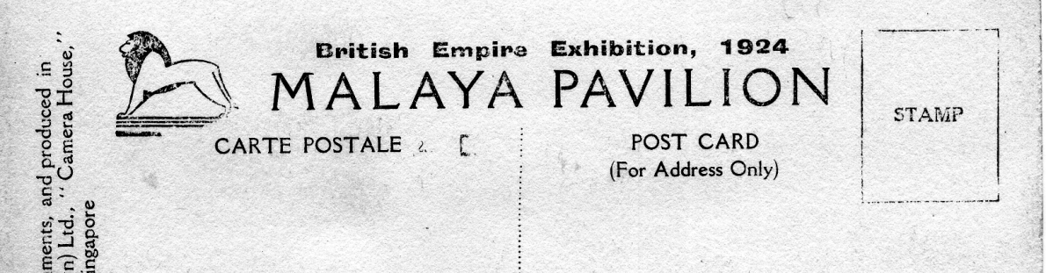
The Houghton Butcher (Eastern) Ltd Post Cards.

Numbers of cards we do not know the titles of, do you have any of these? If you do please contact me, Bill Tonkin

Section 1, series 1. 111, 113, 114, 1119, 1122, 1124, 1135, 1137, 1145.
Section 1, series 2. 125, 128, 1215, 1216, 1217, 1219, 1220, 1223, 1227, 1233, 1235.
Section 1, series 3. 135, 137, 138, 1315, (And any after 1323 to 1350, these may not have been published)
Section 2, series 3. 236, 237, 238, 239, 2310, 2311, 2318, 2321, 2328, 2335, 2342.
Section 2, series 4. 244, 2411, 2429, (And any after 2431 to 2450, these may not have been published)
Section 3, series 1. 311, 313, 314, 317, 3112, 3132, 3134, 3143.
Section 4, series 1. 4121.
Section 4, series 2. 422, (And any after 430 to 4250, these may not have been published)
Section 5, series 1. 515, 5118, 5121, 5122, 5123, 5125, 5127, 5128, 5129, 5132, 5133, 5135, 5136, 5138, 5139, 5140, 5141 5143, 5144, 5145, 5146, 5147, 5148.
Section 5, series 2. 522, 524, 527, 528, 529, 5210, 5211, 5212, 5213, 5214, (And any after 5217 to 5250, these may not have been published)
Section 6, series 1. 611, 612, 613, 615, 617, 618 (And any after, 6110 to 6150, these may not have been published)
Section 7, series 1. 7129, 7130, 7131, 7132, 7133, 7134, 7135, 7137, 7142, 7147, 7150.
Section 7, series 2. 723, 7224, , (And any after 7232 to 7250, these may not have been published)
Section 8, series 1. 815, 818, 819, 811, 812, 815, 816, 818, 8120, 8121, 8132, 8142, 8147, 8148, 8149, 8150.
Section 9, series 1. 9117, 9118, 9126, 9130, 9134, 9138, 9141, 9144, 9146, 9147.
Section 9, series 2. 927, 9210, 9220, 9231, 9232, 9233.
Section 9, series 3. 9321, 9326, 9327, 9329, 9332, 9333, 9344.
Section 9, series 4. 9416, (And any after 9428 to 9450, these may not have been published)
Section 10, series 1. 10115, (And any after 10120 to 10150, these may not have been published)

The Eddystone Lighthouse
by
David Hiscock

A Very Victorian Entertainment
Lighthouses were the engineering wonder of the age. In 1882 James Douglass replaced Smeaton’s famous Eddystone with a new engineering masterpiece. What better then, but to visit a full-size replica at the big exhibition, go up it in comfort, see the new lighting equipment, view the surrounding landscape and send a picture postcard home complete with decorative post mark from a height of 150 feet.
The International Exhibition of Navigation, Travelling, Commerce and Manufacture
May 11th to November 6th 1886
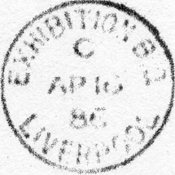
The International Exhibition of Navigation, Travelling, Commerce and Manufacture was referred to as the “Shipperies” Exhibition and was held in Liverpool in 1886, J. J. Webster designed and had constructed a full size replica of the new Eddystone Lighthouse. It contained two lifts to convey visitors who paid a shilling, to the top. There they were able to inspect a fourth order dioptric lens lit by the new electric arc light, advertised as “the most powerful light in the world” and view the Exhibition and the surrounding country from a height of 150 ft. The lighthouse remained in the Exhibition Grounds for the Jubilee Exhibition the following year.
3,080,508 people visited the “Shipperies” Exhibition but how many paid 1/- to ascend to the lighthouse gallery is not known. Plans of the Exhibition Grounds do not show a Post Office on site and as far as it is known no used example of the postmark exists.
Royal Jubilee Exhibition 1887
The “Shipperies” Exhibition was not a financial success and it was decided to recoup losses by celebrating the Queen’s Jubilee with another exhibition on the same site. The lighthouse remained as part of this Jubilee Exhibition. No postmark was proofed for this exhibition and the site plan shows no Post Office. But possibly because of the Exhibition, two of the first ten machine cancellors used by the Post Office, manufactured by Bickerdike, were on trial in the main Liverpool Office during the year. The other machines were in London. Examples of these first cancels are rare.
Royal Naval Exhibition
May 2 to October 24 1891
In 1891, the Lighthouse was re-erected in Chelsea Hospital Grounds in London for the Royal Naval Exhibition. Here it entered philatelic history by being illustrated on postal stationery postcards sold at the top of the lighthouse, and if posted there they received a special postmark. In 1893 it was again re-erected at the Gardening and Forestry Exhibition at Earl’s Court where similar postal arrangements operated. It then disappears from history but a few postcards showing the lighthouse were printed for a proposed exhibition in Manchester. This article describes the postal arrangements associated with the exhibitions the lighthouse formed part of. In particular, the different varieties of cards showing the lighthouse.
The earliest known example is a plain postcard, showing the special postmark used on items posted in the temporary post box placed at the top of the Exhibition lighthouse. The large style of decorative postmark was first used by the Post Office the previous year for the different events and exhibitions for the Centenary of Penny Postage. The card is neither the Exhibition card nor was it posted, and the date (May 8th) is the earliest seen so possibly it is a trial cancel.
For the Royal Naval Exhibition held in the grounds of the Chelsea Hospital, ½d postcards were printed on the plain side with a picture of the Eddystone Lighthouse model in blue. Both Post Office and Stamped To Order cards were used and several different printings can be identified. The cards used (using nomenclature from ‘British Postal Stationery’ by A.K.Huggins) are as follows: CP21a, CP21b and CS3. These are shown below with enlarged details showing the differences.
Post Office Regulations permitted only the address on the stamped side of the card and if printing was required on the correspondence side, the Stamped to Order cards which used stamp Die 3 and a slightly different heading, were used. At this time privately printed picture postcards were allowed in some countries but the Post Office did not permit them until 1892. Commemorative postmarks came into use at the various exhibitions and events to commemorate the Centenary of the Penny Post in 1890 and special Post Office pictorial postcards were sold to receive them. Their popularity probably enabled the pictorial postcard to be printed for the Royal Naval Exhibition.
These cards were sold for a 1d at the top of the lighthouse, and if posted in the box provided received the special postmark. There were four separate components to the picture side of the postcard,. The ‘ROYAL NAVAL EXHIBITION’ heading, the double underlining, the sub-heading ‘TOP OF EDDYSTONE LIGHTHOUSE’ and the large vignette of the lighthouse itself. All four components at some time were moved or altered allowing different printings to be identified. At least five have been identified to date and are described chronologically in detail on the following pages. They have been temporarily described as types 1 to 5.
First Printing
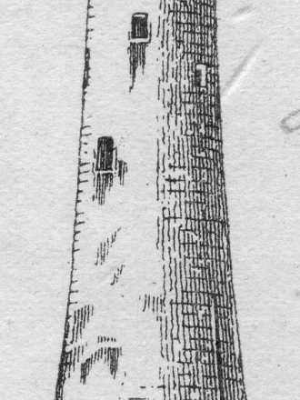
The Exhibition opened on May 2nd but whether the special postcards were available then is unknown. The special postmark was used on the 8th May on a plain postcard (CP21a). This suggests that the illustrated cards were not available on that date. This is somewhat confirmed as the Post Office notice to postmasters advising them of this special card is dated 2nd June. The card posted on 29th May to Newark is one of two used in May so far seen, the other being posted on the 28th May. Similar cards postmarked 6th, 17th and 18th June have been seen. The unique detail on these cards is that the double underline begins under the centre of the space between the ‘L’ and ‘N’ of ‘ROYAL NAVAL EXHIBITION’ and is 39mm in length.

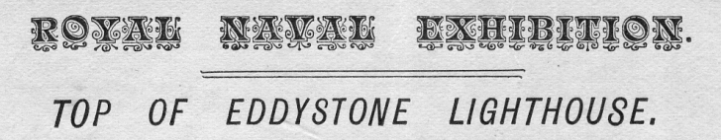
1st printing (Mrs Eliza Gold)

2nd Printing
A card posted on 4th June shows a change to the positioning of the double underline in relation to the other segments of the printing. Subsequently, eight further cards showing this feature have been seen dated 10th, 12th, 13th (2), 18th, 19th, 23rd and 29th June. On these cards the double underline begins approximately 2mm further to the left than the first printing. See detail below enlarged for clarity. One card posted on 6th June shows the format of cards posted in May as do two cards cancelled ‘per favour¹ on the 17th and 18th June. I have no explanation other than some old stock was discovered. There is no flaw to the tower.

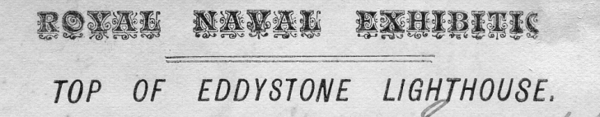
2nd printing (A H Short)

3rd printing
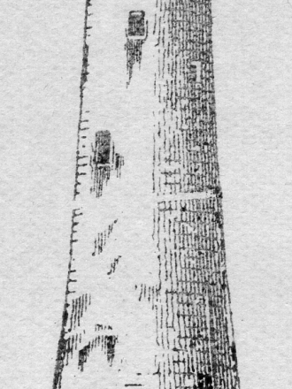
A card posted on 4th July shows a break in the lighthouse tower. This does not quite sever the right hand edge. Nine further cards cancelled up to 24th August show a similar break. During the period seven other items posted at the top have been seen: One letter with Id fiscal (SG F12) struck ‘on the nose’ and two postcards (Huggins CPI) posted 27th July, a letter with a penny lilac (SG 174) posted 17th August, and three postcards (CP 12a), one ‘per favour’ on August 20th. Cards seen posted on 15th, 27th and 31st July are CP21b, all others are CP21a.

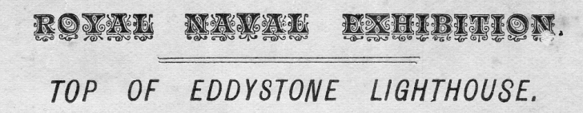
3rd printing (Talbotson)
4th printing
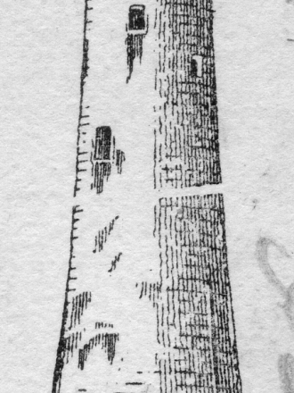
Five cards have been seen used between 5th and the 12th of September. Cards posted on the 5th and 8th September are CP21b but cards posted on the 7th, 8th, 10th and 12th are now stamped to order’ type CS3.
All these cards show a change in the break in the tower which now extends through the right hand edge

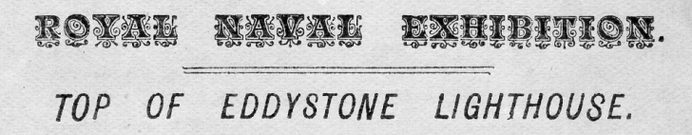
4th printing

5th Printing

Only six cards seen in this period, one posted on 21st September and five posted on 7th October, these last all addressed to members of the Pickering family. All cards are ‘Stamped to Order’ type CS3. Lighthouse vignette similar to previous printing but ‘ROYAL NAVAL EXHIBITION’ underlining and ‘TOP OF EDDYSTONE LIGHTHOUSE’ is reset and is shorter measuring 63mm instead of 70mm. The break on the tower extends through both sides of the tower the same as in the fourth printing. The ‘O’ in ‘EXHIBITION’ is now upright, underlining reduced in length from 39mm to 30mm.
On October 12th a plain postcard was posted at the top of the Lighthouse but no other posted items have been noted until the last day of the exhibition on 24th October when four items have been seen. Two plain postcards (CP21a) and (CP21b) a letter with a penny lilac and one postal stationery envelope (EP31a). On the 19th October at least eight postcards were postmarked. Six were postcards (CP21a), one of these had been postmarked at the 1890 Penny Postage Jubilee Exhibition on 2nd July1890 and two were (CP25). Who went to all that trouble?

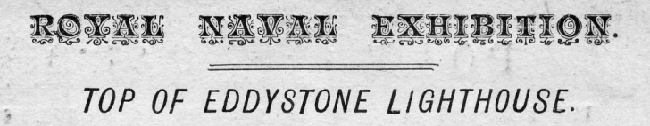
5th printing (Ralph Moore)

No | Day | Date | Exhcard | Print  ing | Huggins | Addressee | Notes
1 | Fri | 8 May | No |  | CP21b | Per favour
2 | Thur | 28 May | Yes | 1 | CP21a | Miss Eliza Gold
3 | Fri | 29 May | Yes | 1 | CP21a | Miss Jack ?
4 | Fri | 29 May | Yes | 1 | CP21b | Miss Smith
5 | Thur | 4 Jun | Yes | 2 | CP21b | A H Short
6 | Sat | 6 Jun | Yes | 1 | CP21b | L Headley
7 | Sat | 6 Jun | No |  | EP31 | Mayvene Headley
8 | Wed | 10 Jun | Yes | 2 | CP21a | Colonel Baldry
9 | Thur | 11 Jun | Prob |  | CP21b | Miss Wolf ?
10 | Fri | 12 Jun | Yes | 2 | CP21a | F W ?
11 | Sat | 13 Jun | Yes | 2 | CP21a | Hutton | Skewed printing
12 | Sat | 13 Jun | Yes | 2 | CP21a | Edwin Clark | Skewed printing
13 | Sat | 13 Jun | No |  | CP21b | Mrs Laura A Tomkins | Posted at the top
14 | Tue | 16 Jun | n/a |  | EP29 | Mrs N R Noell /
15 | Wed | 17 Jun | Yes |  | CP21a | Per favour
16 | Wed | 17 Jun | Yes |  | CP21a | Per favour
17 | Wed | 17 Jun | Yes |  | CP21a | Per favour
18 | Thur | 18 Jun | Yes | 2 | CP21a | Mr Stevenson
19 | Wed | 18 Jun | Yes | 1 | CP21a | Per favour
20 | Fri | 19 Jun | Pos |  | CP21b | Erased
21 | Fri | 19 Jun | Yes | 2 | CP21a | Mr Lincoln
22 | Mon | 22 Jun | Yes | 2 | CP21a | Master A Mackeson
23 | Tues | 23 Jun | Yes | 2 | CP21a | Mrs E Atkins
24 | Wed | 24 Jun | Prob |  | CP21a | Miss P Lovibond
25 | Mon | 29 Jun | Yes | 2 | CP21b | Mrs Ward | Not posted at Exhibition
26 | Tues | 30 Jun | Yes | 2 | CP21b | W E Marsh
27 | Sat | 4 Jul | Yes | 3 | CP21b | Mr M J Jarvis
28 | Wed | 15 Jul | No |  | CP21b | Matthew Jarvis | Posted at the top
29 | Thur | 16 Jul | Yes | 3 | CP21b | Mrs Abrahams
30 | Fri | 17 Jul | Yes | 3 | CP21b | Erased
31 | |Sat | 18 Jul | Yes | 3 | CP21b | Per favour
32 | Mon | 27 Jul | Yes | 3 | CP21b | J R Robinson
33 | Mon | 27 Jul | n/a |  | Rev | Mr Morley
34 | Mon | 27 Jul | n/a |  | CP1 | Mr Morley
35 | Mon | 27 Jul | n/a |  | CP1 | Mr Morley
36 | Mon | 27 Jul | Yes | 3 | CP21b | Mr Morley
37 | Fri | 31 Jul | Yes | 3 | CP21b | Cecil Shepherd
38 | Thur | 6 Aug | Prob |  | CP21 | Mrs B. Samuel
39 | Fri | 7 Aug | Yes | 3 | CP21 | Miss Brent
40 | Sat | 8 Aug | Yes | 3 | CP21 | H Tickwell
41 | Mon | 10 Aug | Yes | 3 | CP21 | Mr Norris
42 | Tue | 11 Aug | Yes | 3 | CP21 | Miss C Gibbs
43 | Sat | 15 Aug | Yes | 3 | CP21 | E W Hecksall | Oval Cancel ?
44 | Mon | 17 Aug | n/a |  | SG174 | L Headley
45 | Tue | 18 Aug | Yes | 2 | CP21a | Hans Muller
46 | Wed | 19 Aug | Yes | 2 | CP21a | Mrs Short
47 | Thur | 20 Aug | Yes | 2 | CP21b | Per favour
48 | Thur | 20 Aug | No |  | CP21b | Per favour | Chelsea duplex cancel
49 | Mon | 24 Aug | Yes | 3 | CP21b | Silitoe
50 | Mon | 24 Aug | Yes | 3 | CP21a | M Talbotson
51 | Sat | 29 Aug | Yes | 3 | CP21b | Mrs Hildre
52 | Sat | 5 Sep | Yes | 4 | CP21b | Tr(engro)use
53 | Mon | 7 Sep | Yes | 4 | CS3 | ?
54 | Tue | 8 Sep | Yes | 4 | CS3 | Per favour
55 | Wed | 9 Sep | Yes | 4 | CS3 | Mrs Lowery
56 | Wed | 9 Sep | Yes | 4 | CS3 | W E Wolfe
57 | Thur | 10 Sep | Yes | 4 | CS3 | Master Ernest Walker
58 | Sat | 12 Sep | Yes | 4 | CS3 | Mrs Cooper
59 | Fri | 18 Sep | pos |  | CP21a | J G Campbell
60 | Mon | 21 Sep | Yes | 5 | CS3 | Ralph Moore Esq
61 | Wed | 7 Oct | Yes | 5 | CS3 | G A Pickering
62 | Wed | 7 Oct | Yes | 5 | CS3 | G A Pickering
63 | Wed | 7 Oct | Yes | 5 | CS3 | Mr Pickering
64 | Wed | 7 Oct | Yes | 5 | CS3 | Mr Pickering | Skewed printing
65 | Wed | 7 Oct | Yes | 5 | CS3 | Mrs Pickering
66 | Mon | 12 Oct | No |  | CP21a | T J Bray
67 | Mon | 19 Oct | N/a |  | CP | Per favour | With German Exh p/m
68 | Mon | 19 Oct | N/a |  | CP | Per favour | With German Exh p/m
69 | Mon | 19 Oct | N/a |  | CP | Per favour | With German Exh p/m
70 | Mon | 19 Oct | N/a |  | CP | Per favour | With German Exh p/m
71 | Mon | 19 Oct | N/a |  | CP | Per favour | With German Exh p/m
72 | Mon | 19 Oct | N/a |  | CP | Per favour | With German Exh p/m
73 | Mon | 19 Oct | N/a |  | CP | Per favour | With German Exh p/m
74 | Mon | 19 Oct | N/a |  | CP | Per favour | With German Exh p/m
75 | Mon | 19 Oct | N/a |  | CP | Per favour | With German Exh p/m
76 | Mon | 19 Oct | N/a |  | CP | Per favour | With Ge.& RN Exh p/m
77 | Mon | 19 Oct | N/a |  | CP | Per favour | With Ge & PP Exh p/m
78 | Sat | 24 Oct | Prob |  | CP21a | Mrs Warren
79 | Sat | 24 Oct | N/a |  | SG174 | Mr C J Baker
80 | Sat | 24 Oct | No |  | CP15a | A D Gunn
81 | Sat | 24 Oct | No |  | EP29a | A D Gunn
82 | Sat | 24 Oct | No |  | CP15a | Mrs Emma Cooper
83 |  |  | Yes | 2 | CP21a | Miss Brown &Land | Not cancelled
84 |  |  | Yes | 2 | CP21a | F W Moorhouse | Not cancelled
85 |  |  | Yes | 1 | CP21a | Unused | Skewed printing
86 |  |  | Yes | 3 | CP21a | Unused

Three dies were used for the stamps, in die one there is a single line at the top, in die two this is bifurcated and in die three the line is trifurcated, as described by Huggins in “British Postal Stationery”. He also describes the small coloured triangles in the top corners of dies I and III and the larger coloured triangle in die II. Another difference, die I has three and a half small rings on each side at the top, dies II and III have three and a half rings plus a spot which may be just the top of a fifth ring. These are easier to identify than the lines which are sometimes obliterated by the post mark. The drawings of the three types is by David J. Hiscock

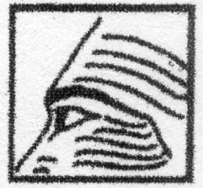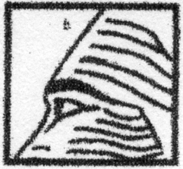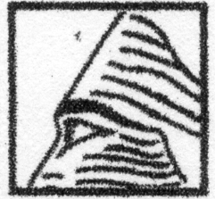
CS3 CP21a CP21b
The stamp is die I The stamp is die II The stamp is die III

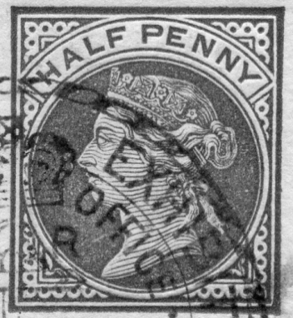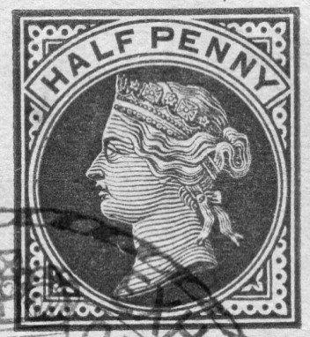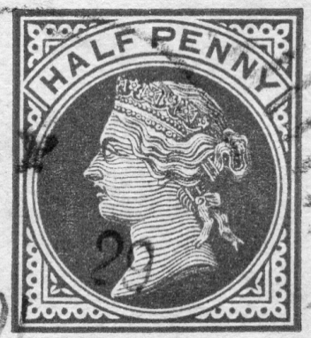
Moore Lincoln Mrs Ward
CS3 CP21a CP21b
Small coloured Large coloured Small coloured
triangle triangle triangle

