EDITORIAL SPRING 2014

They ask how I am, now I’ve reached eighty eight
I tell ‘em I’m fine, I’m feeling just great.

Well here we are in 2014, I wonder what this year will bring. I mentioned in our last Journal that I intended publishing a series of monographs on subjects that do not warrant the publishing of a book, but which may be of interest to just a few collectors. The first was on the 1924 Wembley maps of which we now know of 47 different types. I thought this was a good plan for the future, but it seems I was not the first to think of the idea.
I was going through a pile of odds and ends when I came across a small publication by Andrew Brooks done in 1991 titled ‘Occasional Paper No. 1’. It was a twenty page checklist of ‘Daily Mail Ideal Homes Exhibition Post Cards’. I don’t think Andrew ever got round to a No. 2 in the series.
I was involved in Andrew’s project and ever since I have up-dated Andrew’s original list with more entries as I found the cards. In the winter Newsletter of 1993 there was an article by Arthur Smith on Ideal Homes slogan post marks that I shall include, so another monograph just wants a bit of tidying up and it’s done. The monograph on the B. E. E. Malay Pavilion post cards is also under way and when it is finished members will see it announced in the Journal.
Else-where in this Journal you will find a letter from Ramon Goodey our President announcing the Study Group is to have a room at the Spring Stampex to house a display by Don Knight celebrating the 90th Anniversary of the British Empire Exhibition. I hope as many members who can get to London will support this initiative by Ramon who is trying to build up our membership through advertising the Study Group where ever possible.
I hear regularly from Fred our joint Editor who remains remarkably cheerful under the most trying circumstances. You’d better not read any further if you’re a bit squeamish or just about to have a meal. His latest trial is to have gentles (maggots) wrapped around his feet to eat the bad parts. The gentles don’t come on the National Health but cost him an extra £400 as they are not gentles from the ordinary blue bottle fly, but come from a special green bottle fly. Apparently the days are gone when a hospital could go into a fishing tackle shop and buy a pint of gentles for about a £1. However Fred is not complaining as the gentles seem to be doing the job, and Fred is well on the mend.
Readers will notice we have a new layout for the front page, thanks to a suggestion by our President Ramon Goodey, and might be interested in knowing how the old front page evolved.
I became joint editor with another member Damon Murrin after Andrew Brooks who had done the first 23 Newsletters wanted a rest. We produced our first Newsletter as it was called then No. 24 in the Spring of 1992. Damon had gone to a printer to choose a font for the heading and this has been used ever since. I don’t know the name of the font, but what decided us was it was a font that was in use in 1851.
I believe it was Andrew Brooks who came up with the idea that we should have headed note paper and coined the phrase “Devoted to the conservation and study of all matters relating to exhibitions”. I still have best part of a ream of our original headed note paper. Needless to say I soon scanned the heading onto my computer and have used it for my exhibition correspondence ever since.
I used to send Damon the material for the newsletter and Damon produced the front page heading and surround. Instead of a solid frame Damon drew two lines with a biro about an eighth of an inch apart. It was then sent off to Karl Illingworth who printed and posted it at his own expense.
This lasted until the end of 1993 when Damon dropped out, and I became the sole editor until Fred joined in 2006. The double lines were also dropped and I used a solid frame on the front page. Now we have an emblem on our front page designed by Ramon Goodey, so it is a joint production by four people, Andrew, Damon, Ramon and myself.
The Editors
A letter from our President Ramon Goodey

The Exhibition Study Group at the Spring ‘Stampex’.
The Group has hired a room at ‘STAMPEX’ on Saturday 22nd February from 10.30am to 12.30. The room will be open for everyone attending the exhibition. Our Secretary Don Knight has agreed to mount a display entitled “The 90th Anniversary of the British Empire Exhibition, 1924-5” which will be on show for the two hours.
Books published by the Group, plus others which are obtained through the Group will be available for purchase. Membership forms will also be available for any visitors who may wish to join the Group.
Stewards Required.
Stewards will be required to keep an eye on the display and to answer any questions from visitors about the Group with the hope of recruiting new members, which of course is the whole object of the meeting. If any members who will be attending the show can spare a half hour or more to act as stewards I would be grateful if you could let me know, (01245440434), either just before the exhibition or at the exhibition itself.
Thank you for your help, I look forward to seeing you there.

The Story of Ballymaclinton.

Part 2 of a three part article by George Ithell from the Exhibition Study Group archives
with illustrations added.

On Thursday January 3rd 1907, a ceremony was performed when the Comte de Manneville cut the first sod. The £600,000 outlay then made rapid progress with the greatest use of plaster and cement, the overall appearance of these new edifices encouraged the ultimate title of the big estate. The main contractors were the forerunners of the now famous firm of George Wimpey Limited. This firm was then a partnership and became a limited company in 1919. Their records of this contract have unfortunately disappeared in the space of time.
An informal Opening Ceremony took place on May 14th 1908 at 2.30 p.m. with volumes of rain spoiling the occasion. The Prince of Wales, later King George the Fifth and his wife, Princess Mary, accompanied by an entourage of 200 V.I.P’s began their tour at the gate where now stands the new Television Theatre, converted from the old Shepherds Bush Theatre. A fact that marred this day, discounting the atrocious weather, was also the un-readiness of the majority of the area. Visitors were apparently tolerant of the hazards of scaffold poles and planks and other equipment necessary in the building trade, which had to be negotiated at many points Reports of the difficulties were no advertisement and although an M.P. wrote to the Times’ of his concern, experience and discomfort, the public patronised the Exhibition and 6,600,000 were the final figures for the first year. This then was The Franco-British Exhibition.
As the anticipated number of people expected on the first day was about 30,000, the promoters were overwhelmed by the count of over 123,000 visitors at 6.00 o’clock. Two main topics for the critics were the insufficient toilet facilities and exits. In the earlier days of the exhibition there was only one exit a mile and a quarter from the entrance. One could leave by the exit in Wood Lane but only onto the new Station which was built especially after an appeal by the Organising Committee. This is now the Wood Lane Underground Station and was under the Great Western and Metropolitan Railways administration.
The State Opening took place on the 26th of May when the King, Edward Vll and his Queen, Alexandra, were accompanied by the French President M. Fallieres. They were blessed with very much better weather conditions and thus able to make a more satisfactory tour of the Palaces of Art, Industry and other amenities of great interest, both to the layman and specialist. Not least of the Royal party’s enjoyment was their visit to the Irish Village. On entering Ballymaclinton through a massive stone gateway with a portcullis and looking rather formidable, although decorated with the English and Irish flags, an old man caused some concern. He carried a decorated shillelagh and breaking the police cordon made a successful effort to present the French President with his gift as a token of Ireland’s continuing affinity to France.
An Irish firm, Messrs McLaughlan & Harvey Limited who claimed to be the only Irish building firm with a London address, were complimented on the state of Ballymaclinton Town’s completion in comparison to the other parts of the Exhibition. They were responsible for the erection and supply of replicas of Irish buildings and monuments, such as the ruins of an old Church with its Norman edifice, a Cross of Cong, a Round Tower similar to the one at Killkullen. This Tower was built so that visitors could climb the hundred or so stairs, thereby getting a bird’s-eye view of the entire 140 acres of the main Exhibition. Amongst the buildings erected were small factories where the Irish staff were able to demonstrate the skills in various arts and industries. Prowess in the culinary art, baking and cooking with primitive utensils over an open peat fire was a very fascinating spectacle. The staff who enjoyed this privileged change of scene were experts in their field, and those chosen to act as guides made a favourable impression with their knowledge of Irish history and customs.
The restaurant provided food from the stock of the vegetable garden where the soil had been imported specially to cover a large area of the ten acres which was the area of the Irish Village. A farm yard added to the authenticity, and the rental for the site was £5,000, an enormous sum then. Cottages were also built for the housing of these members of the staff but one particular dwelling was a very unique building. This was a replica of President McKinley’s grandfather’s house which was at Dervock, Co. Antrim, from which the original window frames, doors, stairs and flooring had been built into this exhibit.
There was also a productive soap factory, pottery, lace, carpets, cobblers and a blacksmith’s forge where lucky horse-shoes sold for six-pence. In the Irish Art Gallery ballads were sold at five for one penny with the guarantee that they were - ‘Printed in Ireland, on Irish paper with Irish ink. At the Shrine of Saint Patrick stories were related, one very popular one about ‘The Twin Sons of Ler who were-turned into Swans until the Great Bell of Saint Patrick should ring on Christianity. Copies of famous jewellery, such as the Tara Brooch etc. were shown and described many of which went as presents to Irish relatives and friends overseas. Most of these exhibits were viewed but Queen Alexandra was fascinated with the lace, she being herself no novice, and made a number of visits at later dates.
On one occasion, in an attempt to have a private and impromptu visit, the Queen incognito, was denied this by a party of schoolgirls who, when they recognised Her Majesty, formed a Guard of Honour, much to the mixed feelings of the Queen. Prominent samples of lace came from the Convents at Belturbet, Ardee, Dalkey and Youghall to name a few, and many visitors were invited to create their own design.
The list of visitors included Royalty from abroad and other notabilities from all over the world, and the Record Book read more like ‘whos who’ There was a report regarding the visit from the two Royal grandsons of the King, Edward and Albert - both later to become Kings, where they spent most of their time on the scenic railway. From one of the many Post Card stands the young Princes purchased some and decided to write to someone. Considering what to say, one was over heard to say, ‘Let’s say we have been twelve hundred miles on the Canadian Railway through the Rockies. This Canadian Exhibit was one of the amusements in the main part of the Exhibition and was reputed to have carried 2,300,000 passengers during 1908. .
Many firms produced Picture Post-cards which at this time were very popular and Valentine’s of London, Dundee and New York printed many in colour and monochrome. Many of these cards have been collected and fortunately saved to picture this historic event in its entirety. Many of the colleens are shown working, dancing or just looking beautiful in their typical Irish dress, and from the pictures published the girls would find plenty of admirers also that the advertisements exhorting one to note the colleens complexion etc. would be taken a little more seriously!
Another of the cards shows the Ballymaclinton Fire Brigade under the expert tuition of Joe Mason who was at one time with the firm Merryweathers Ltd: another of the firms still operative today. He had the honour of being presented to Their Majesties with others chosen for special services. Ballymaclinton continued its life under a new Exhibition title in 1909, but the Imperial International Exhibition was not the success of the Franco-British the previous year and consequently the receipts for the Irish charities suffered. This was more disappointing due to the fact that as the Olympic Games had created an attraction to overseas visitors, a great deal of experience and planning for the staff was lost. Ballymaclinton attracted over 2,000,000 visitors during 1908 with the 40,000 figure of September 17th topped only by the huge crowd which obviously had been attracted by Royalty on the initial day.
A farewell supper party was held, followed by a dance on the Monday November 2nd for all the staff. There were some absentees the following day when their return to Ireland was scheduled. In 1910 Ballyinaclinton was to suffer still more. The Japanese dominated the Exhibition of that year and owing to the expense of the area rented by McClinton’s it was decided to economise. A ‘dodge-em’ car track occupied what had been part of the village and consequently most of the industries disappeared and only display facilities remained. Ballymaclinton Post Office was a casualty and in subsequent Exhibitions at the White City, records refer only to ‘an Irish Village’. There is mention of a Little Ballymaclinton at the Scottish Exhibition of 1908 and again in 1911.

OLYMPIA Corporate History 1884-1999
by
© John Glanfield
January 2012

1930. February. Olympia Ltd revalues assets and Increases capital.
On completion of Empire Hall the buildings and equipment at Olympia were independently valued at £2.254m. A public issue of shares followed to offset development costs, increasing the company’s issued capital to £1.275m.

1933. February. Philip Hill announces vast expansion plan for Olympia.
By 1931 the insatiable BIF had again outgrown Olympia. A section was driven back to the White City. Philip Hill announced at the February 1933 Fair that he would build a colossal hall less than 150 yds diagonally south east of Olympia on the comer of Kensington High Street and Warwick Road, where Charles House stands today. Joseph Emberton prepared outline plans for a handsome structure with 45,000 sq. metres of exhibition space on the 3.5-acre site, almost doubling Olympia’s capacity. Its roof would clear-span 245 ft, the longest unsupported span in Europe at that time. The hall would be connected to Olympia by subway Addison Road station was to be moved a short distance south to adjoin the Hammersmith Road bridge. There would be direct pedestrian links from its platforms into the new hall and the existing centre (The station was renamed Kensington Olympia in December 1946).
Hill put in a planning application to the LCC. after which the project quietly died. Over the next eighteen months it became clear that the BIF had different ideas for its future location.

1933. November. BIF relations with Olympia sour.
Almost certainly for fire-separation and evacuation reasons, LCC building approval for the Empire Hall had been conditional on the topmost (third) level being fully enclosed rather than overlooking the atrium as did levels 1 and 2. In November 1933 as the 5th BIF at Olympia approached, the Fair’s management and the Dept of Overseas Trade complained to Olympia that level 3 was unacceptably isolated and had become un-lettable. It was still under construction in year 1 (1930) so had been unavailable. For the following two years the BIF’s furniture trades reluctantly occupied level 2 and the enclosed level 3 before leaving the Fair in despair and returning alone to White City in 1933. They were replaced that year by sections of the radio and music trades which combined to stage a ‘Hall of Radio & Music’ in Empire Hall, afterwards refusing to return to level 3. Olympia would not waive its rental, reminding DOT that BIF had approved the building’s design before construction began.
National Archives. Kew, Dept of Overseas Trade file. piece TI61/6I8
The dispute soured relations and clouded Philip Hill’s proposal earlier that year to build another 45.000 sq m of hall-space. It was shelved.

1936-37. Olympia fears Earls Court’s ‘pull’.
By spring 1936 as Earls Court neared completion, Olympia Ltd felt the undertow sucking some of its valued shows away to the new centre. Hill responded by opening a visitors’ cocktail lounge on Grand Hall’s ground floor and an exhibitors’ club at balcony level accessible from the Grand and National Halls.
More radically and dangerously, Olympia Ltd had facilitated the registration of Exhibitions Ltd on 6 February as an independent entity with offices in St James’s Street It was to compete directly with event organisers by creating and staging exhibitions at Olympia that would backfill shows lost to Earls Court. By April 1937 it had made a £13.000 loss, largely attributable to compensation paid to its MD, a Mr Lascot. on early termination of his contract. That same month Exhibitions Ltd was offered to Olympia Ltd. its shareholders having lost patience and refused further funds to seek the purchase of Montgomery’s hugely successful Building Exhibition at Olympia. This appears to have been a pre-emptive attempt to block any move by Greville Montgomery to take his show to Earls Court. In fact, it stayed put at Olympia until its switch to the NEC in 1977. Exhibitions Ltd staggered briefly on. Before its demise it was planning a Film Fair in 1938 (no record of it’s taking place yet traced)

1936. May. The BIF pulls out of Olympia
The May 1936 BIF would be its last at Olympia. The organisers had booked into the larger Earls Court Exhibition Centre, then nearing completion, only to learn around Christmas 1936 that the building would not be ready for it to open the following May. Olympia was no longer available. The huge BIF was driven back to White City with only weeks to reorganise.
The Board of Trade ceased to support the Fair in 1954 when its popularity fell away as specialised ‘vertical’ trade fairs gained strength, primarily on the continent. The Fair closed for good In 1954.
Nations! Archives. Kew. Treasurery file, piece T/161/618

1936-37. Philip Hill opens London’s first multi-storey car park - at Olympia.
Joseph Emberton was commissioned to build it. Planning consent was sought in May 1936
and granted the following January. The delay reflects the novelty and complexity of the application.

1940-46. Olympia is requisitioned for war service.
Olympia came under government control on 10 January 1940 as civilian internment camp No. 14. During the Dunkirk evacuation it was Gen. Charles de Gaulle’s assembly point for what became the Free French Army. The Royal Army Service Corps then took the halls over as a transport depot until October 1944 when they became military clothing stores, and finally a demobilisation centre 10,000 tons of stores were held there at any one time. Some 250,000 men were kitted out since the October 1944 start, and 300 drew their civvies on the final day, 23 March 1946. Olympia was derequisitioned that June.
HMG paid annual rental of £32,500 for at least part of the period, but this failed to cover interest payable on debenture stock and overheads. £27.4s Od p.a. was paid for ‘hire of chattels’.

1943-44. Harold Hartley’s death aged 91.
29 September 1943 At his beloved Brook House, North Stoke. Oxford.
1944 Olympia Chairman Philip Hill’s death aged 71.
15 August 1944 At Windlesham.
1947. September. Reginald G Heaton resigns.
For reasons of age after 35 years as Olympia’s much loved Managing Director, He died the following year.
1951. 31 January. Sir Charles Cochrane’s tragic death.
Seizure, scalded in his bath. Aged 78.
1957. E.T. ‘Monty’ Swann joins Olympia board.
A well-remembered and respected director.

1964. Olympia acquires entire share capital of A. R. Taylor & Co.
East Anglian timber importers and joinery mfrs. Olympia’s continuing diversification contributed over one third of profits other than from halls rentals (40% in 1968). Some operations within Olympia Ltd were conducted by wholly-owned subsidiaries, including Olympia Exhibitions Ltd trading as hall proprietors, Barren Bros Ltd as exhibition stand and electrical contractors; Sutcliffe Catering Group Ltd which operated through nine subsidiaries as industrial caterers; and Maclise Road Garages (Olympia) Ltd.

1964. October. Chairman Oliver-King at AGM.
Olympia Ltd will miss no opportunity to exploit its various assets to the full. A new exhibition centre elsewhere may emerge several years hence, and the long term possibility of redeveloping Olympia may arise. Conversations were accordingly proceeding with Second Covent Garden Property Co. Ltd, of which Oliver-King was a director.

1967-68. Olympia is served a compulsory purchase order.
Olympia is served a compulsory purchase order on the Blythe Rd corner. The order was successfully opposed by the company which demolished the last remaining buildings and levelled the site late in 1968 for ‘development to enhance the viability and value of the business.’ It served as an invaluable lorry marshalling area and car park for Empire Hall/Olympia 2 traffic.

1968.
E.T. ‘Monty’ Swann steps down as MD
But remains on the board he had joined in February 1957. He reverted to MD in 1973. below.

1969-71. Olympia contemplates merger with Earls Court.
By 1969 the National Exhibition Centre project was beginning to focus on Birmingham rather than London’s old Northolt airport, or off the Ml near Leicester. Olympia’s board feared the approaching battle on two fronts - The Court’ and NEC. For years it had been diversifying its investments as a hedge against future trouble from any quarter, and was currently exploring options with the Greater London Council to redevelop Olympia.
The possibility of a defensive merger of Earls Court with Olympia was also contemplated, but exchanges between the two in May 1969 came to nothing. It seems that Olympia initiated their further meeting on 16 April 1971. At that critical point Olympia’s Oliver-King resigned his chairmanship on 2 April Nevertheless he still attended the meeting as a board member. His reasoning is unknown, but for the past seven years he had been spearheading Olympia’s strategic planning in quite another direction - its redevelopment. He was replaced by Joint Vice-Chairman Lord Sandon (MD of Coutts Bank and a director of National Westminster Bank). Olympia’s other Joint Vice was Earl de la Warr. The Hon H.W. Astor became Deputy Chairman.
Olympia was represented at the meeting by Astor and Oliver-King Earls Court by its chairman Major General Ritchie and Messrs Bowie and Peter Cutmore MD. Earls Court concluded that they would gain nothing of substance and broke off the dialogue
With the NEC looming, it seems probable that Earls Court took the view that it was not going to enlarge its lettings pool by another 50,000 sq. m. in a reverse take-over of Olympia at a time when the NEC was poised to poach a sizeable catch of London’s biggest exhibitions. (As a public company, Olympia would find it much harder to marshall shareholder support to acquire The Court, and with similar concerns)

1971. September. There now being no chance of a merger with Earls Court.
Lord Sandon laid Olympia’s future on the line at its AGM that September, 1971. He pointed to ‘the intended redevelopment of the Olympia site which might well prove of significance’ He also had to report that pre-tax profit fell by £54,000 over the previous year’s £498,726.
Two months later the NEC secured outline planning approval for the Birmingham site. Phase 1 would deliver 89,000 sq. m of exhibition space when it opened on 2 February 1976.

1972. January - March. Property group buys Earls Court & a stake in Olympia.
The first intimation of an Earls Court take-over by property tycoon Jeffrey Sterling’s Sterling Guarantee Trust (SGT) had come in City reports at the end of January 1972. His objectives became clearer a week later when he bought Sir Robin McAlpine’s 18% stake in Olympia for £1,6m. SGT’s £4.4m bid for Earls Court was accepted on 23 March.
Sterling had acted very quickly on word of the NEC’s planning approval. He clearly anticipated that its destructive effect on London’s exhibitions at the two halls would end in time in their near insolvency. Acquisition now would enable SGT not only to manage their decline appropriately, but also pre-empt moves in the same direction by rival developers.
News that the NEC was about to build at Birmingham, followed by reports that a property developer had bought Earls Court and was poised to swallow Olympia, came as a triple whammy to the exhibitions industry. Much of its London-based end was left in turmoil.
SGT speedily announced plans for redevelopment of the 17.7 acre Earls Court site in alliance with Town and City Properties (T&C). They were already in talks with London Transport Executive about varying the Earls Court lease which still had seventy years to run, and were inviting LTE to include an adjoining 15 acres in a single massive £50m development.
Having bought Earls Court, it emerged that SGT planned to sell off the venue’s property assets to a new development company jointly owned with T&C, reportedly for £7.5m cash. The deal promised a healthy profit and SGT would still have a 40 per cent stake in the subsequent development. The news left many London exhibition organisers anxiously preparing Plan B. Without a highly improbable declaration from Sterling that he was committed to retaining substantially both London halls as exhibition centres, a rush of the capital’s shows to Birmingham would become a certainty Not all could possibly succeed.
SGT was formed in 1969 and quickly became noticed following its acquisition of Salisburys the handbag retailer, Gamages dept store in the City, Buck & Hickman tools distributors, and Wharf Holdings. Jeffrey Sterling’s strategy was to take over companies with under-utilised property potential and quickly release a large slice of cash in the land by forming a joint development company, or by land sale.

1972. September. Lord Sandon signals Olympia’s redevelopment after NEC opens.
The chairman stated that ‘closure of Olympia synchronised with the provision of facilities elsewhere is both desirable and an economic necessity. The board continues to pursue plans for Olympia’s redevelopment.’
He announced a pre-tax profit of £559,965 for the year to 31 March 1972 against the previous year’s £444,170.
In the general upheaval J. Lyons announced that its Cadby Hall HQ and food factory were vacating the Blythe Rd premises opposite Olympia. The premium 10 acre site fronting Hammersmith Road would be redeveloped. It was 40 years too late to be of value to Olympia.

1973. March. SGT secures Olympia. Earls Court and Olympia unite in shotgun marriage.
SGT bought out Associated Newspapers’ 37% stake in Olympia for £4.2m. Assoc. Newspapers had held this to protect its Ideal Home Exhibition, but having secured SGT’s guarantee of a show site ‘until at least 1988,’ it agreed to sell. SGT successfully bid £11.35m for Olympia.
Jeffrey Sterling revealed that the Olympia site would be redeveloped for other purposes after the Earls Court building had been converted to mixed use with a much smaller but modern exhibition hall. He expected large events such as the Motor Show and the Royal Tournament to move to Birmingham, whilst others could occupy Olympia pending completion of the new Earls Court and their transfer there Olympia would then close for good.

1973. April-May. SGT moves in at Olympia Ltd.
Strong new board appointments followed.
30 April. Bruce MacPhail SGT’s steely MD, and his co-director Peter J. Ford joined the board.
13 May. Olympia’s Chairman Lord Sandon was replaced by Major-General W.H.D. ‘Dick’ Ritchie, charismatic Chairman of Earls Court Ltd.
Ralph S. Carver appointed Deputy Chairman. (Earls Court board member since January 1973)
Olympia Board member E.T. ‘Monty’ Swan reverted to MD. see ‘1968’ above.
Peter Cutmore joined Olympia’s board. (Deputy Chairman Earls Court Ltd.).
4 July. Olympia’s J.M. Ockleshaw resigned from the board.

1973. June-July. SGT and Town & City Properties create Earls Court and Olympia Ltd. (EC&O).
Major-General Ritchie was appointed Chairman of the new company on 4 June. It was owned 60% by T&C, 40% by SGT. Terms for the acquisition of the Olympia site reflected a value of £15m.
Under-performing managers at both venues, and the internal rigidities that accumulate over time in a sellers’ market were removed as a first step in merging and managing the businesses. Significant operational changes followed.

1973. November. OIL crisis - game-changer.
SGT’s carefully crafted strategy was compromised when the oil crisis broke. Middle Eastern oil and gas producing countries had taken control of their resources before increasing prices to the point where a world-wide recession threatened. It had built over the summer and merged in Britain with trade union objections to a government-imposed prices and incomes policy. The mix exploded in November with a miners’ overtime ban just as winter set in, government cuts in fuel oil and petrol deliveries, and a 50 mph limit on all roads. Petrol rationing coupons were issued but never used. The economy slumped and commercial property values dived.
Sterling’s redevelopment plans became expensively stalled.

1973-74. SGT marks time.
Jeffrey Sterling kept the two halls open through the ‘Black Winter’ of 1973/4. Its 3-day weeks of power rationing and miners’ strikes felled Edward Heath’s government in March 1974. Sterling could have ridden out the crashed property market by closing the heavily loss-making Earls Court, but it was a premium national asset and such action was unthinkable. A property upturn was possibly several years distant. Sterling could only mark lime by retaining both halls as show centres.

1974. April. Sterling Guarantee Trust merges with Town & City.
Sterling Guarantee Trust merged with the ailing Town & City Properties in a reverse take-over. T&C changed its name to Sterling Guarantee Trust PLC in 1983 to mark Jeffrey Sterling’s success in nursing (he company back to health. In February 1985 Sterling merged his SGT with P 8 O. (Sterling was simply a non-exec director of P & O when it faced a hostile bid from Trafalgar House in 1983. The battle ended with P S O triumphant and Sterling as chairman).
1974. August. Olympia’s redevelopment to follow a refurbished Earls Court.
6 August 1974. Following strong representations from the Dept of Trade & Industry, Greater
London Council and the exhibition industry. Town and City Properties announced plans for a major facelift of Earls Court. On its completion Olympia was likely to close and the site converted for non-exhibition purposes. Probable phasing would see Earls Court close in 1976 to begin refurbishment, when its exhibitions ‘could be transferred to Olympia’ pending completion.
The unspoken but inevitable consequence would be a crisis for many remaining events at Earls Court as they became stranded in the interim through lack of space and/or acceptable dates at Olympia. A move to the NEC would then be the only option for most. The chances of survival for some events forced to transfer to Birmingham would be questionable.

1974. August. Major-General W.H.D. Ritchie retires (resigns?) as EC&O chairman.
He departed 9 August 1974, only 14 months after his appointment. Replaced by Christopher Stewart-Smith. board member. SGT

1975 - on. All change at EC&O.
First, SGT had to overcome a severe loss of confidence in the exhibition industry. Event organisers were wary of promises from a property developer turned semi-saviour, and Jeffrey Sterling only put up £1 5m to start a much needed Earls Court & Olympia ‘Facelift’ programme. It was not enough to demonstrate long-term commitment once the property market recovered. For that reason alone, at least one big show, the British International Toy & Hobby Fair, held back from booking into Earls Court and went instead to the NEC. Others were leaving London for Birmingham. The turning point came in July 1979 when, concerned at the rising loss of London shows to the NEC, Greater London Council Leader Horace Cutler announced a £5m loan to kick-start ‘Bow-Wave’, a rolling halls modernisation programme funded by EC&O It was to be repaid when later profits reached an agreed level.
The GLC’s powerful commitment was hugely significant. It came as a timely expression of confidence that EC&O had an assured future. The GLC’s starter money and EC&O chairman Christopher Stewart-Smith’s bold initiatives (below) triggered a rolling modernisation programme for Earls Court and Olympia. As value was added, hitherto frozen rental tariffs were unlocked to fund some £8Om of major improvements. To this must be added the £100m later invested to build Earls Court 2.
Stewart-Smith got rid of Olympia’s hedge investments in a timber company and property, gave Leslie Overs, MD of Olympia’s Electrical Services contracting division, his head (Overs joined the board of EC&O September 1974), likewise the imperturbable Peter Harrison, MD of Olympia’s slandfitting company Barren Brothers Ltd, and formed profitable subsidiary service companies in catering and security Philbeach Events Ltd was another such, creating and staging successful exhibitions and special events in-house and elsewhere. It was led by David (‘give it a punt’) Fasken who eventually became EC&O group managing director and deputy chairman.

1976 Before the gain came the pain.
The NEC opened in 1976, soon capturing five of EC&O’s blue chip exhibitions plus Earls Court’s commercial director Terry Golding to become NEC’s chief executive. The ‘lost’ events included Earls Court’s Motor Show and the impressive Furniture Show, Fasken replaced both with strong variants, his hugely popular London Motorfair having first to overcome powerful objections from the ever-protective SMMT.

1978. Empire Hall closes for exhibitions.
The NEC’s adverse impact on London lettings brought closure to the 4-level Empire Hall in May 1978. The hall was the most marginal of EC&O’s assets at that time. It was leased to Allied Retailers, reopening 27 December 1980 as ‘UKAY OLYMPIA,’ a home furnishing super-store.

1983. Empire Hall gets new name, new market, and a makeover.
Trade Fairs organiser John Glanfield joined EC&O in October 1983 to formulate and implement a marketing strategy for the Empire Hall. Its retailing lease had been recovered that year by EC&O. Renamed Olympia 2 (O2), the hall was converted to permanently carpet-tiled space with improved amenities, lighting, and a packaged shell scheme. It was targeted at a new sector for the company - exhibitions which had outgrown hotels and small halls and needed a bridging venue to expand into, perhaps later moving on to a major hall. O2 opened early in 1984 with 19 lettings in hand. It quickly became a popular premium-rate staging post for such shows. O2 was marketed and managed as an independent unit within the group. A 500-seat conference centre was built on the historically notorious top floor in 1985 with a dedicated entrance on Hammersmith Road. The lower ground floor was converted to exhibition space soon afterwards.

1985. Earls Court & Olympia becomes part of P&O.
In a dramatic move in 1985, Jeffrey Sterling merged Sterling Guarantee with P&O in a reverse take-over, later becoming Chairman of the shipping, construction, property and services conglomerate. EC&O became a subsidiary of P&O.

EC&O chairman Christopher Stewart-Smith stood down, moving on to P&O. T.C. Tim’ Harris at EC&O had risen through chief accountant and managing director to now become chairman. The incisive and hard-driving Harris finished what Stewart-Smith had begun.
Thanks to the 1973 oil crisis and Sterling’s resolute reaction. Earls Court and Olympia’s premises and profitability had been transformed. Chairmen Stewart-Smith and Harris set in train a golden age for the two centres. So intensively were they occupied that together they achieved more whole-hall occupancy days each year than any comparable exhibition centre in W. Europe.

1999. 23 March. Earls Court & Olympia change hands.
Pressured by the City for which conglomerate entities such as P&O were losing appeal, the company announced a major asset disposal programme. It was intended to raise more than £2 billion. P&O would focus on its maritime businesses.
Earls Court and Olympia were up for sale. There were numerous bidders. Fittingly, both centres went to the Morris brothers. With their father Sam Morris they had transformed Islington’s Agricultural Hall - the ‘Aggie’ - into the successful Business Design Centre. With their new acquisition they now controlled some 90% of London’s purpose-built exhibition space. The £183m purchase was financed with equity from Candover and a loan from Credit Suisse First Boston. Earls Court & Olympia Group Ltd would manage the assets, led by Chief Executive Andrew Morris.
After more than a century of rivalry, London’s three historic centres became united under one house flag

Souvenirs of the Crystal Palace.
Drawings and written by Fred Peskett

Souvenirs made from brass.

The pin tray shown is made from pressed brass sheet, it measures four and one eighth inches long by two and three quarter inches. wide and is half an inch high. The Great Exhibition Building is featured embossed with the words, The Worlds Exposition of Arts & Manufactures London 1851. The embossed border design is about forty years ahead of it’s time, since the sinuous plant forms depicted are associated with the Art Nouveau style from the 1890’s to the early 1900’s.
This particular souvenir seems to have survived in fairly high numbers, therefore it is possible that it may have been produced in the Machinery Section of the Great Exhibition, and given away as a free sample, although there is no direct evidence to support this theory.
There is a Type 2. of this souvenir, identical to the pattern shown below but pressed from copper sheet.
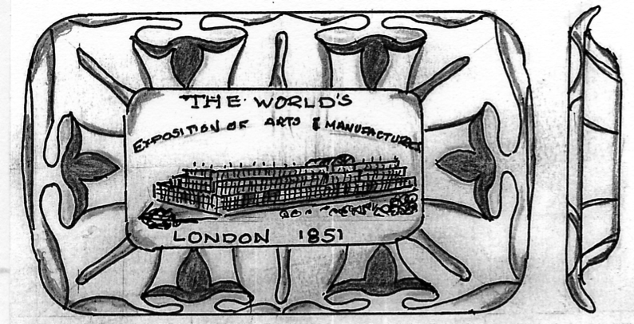

(Illustrated full size)

Souvenirs made from wood.

Mauchlineware.
Mauchlineware was a popular type of souvenir produced in the small town of Mauchline, about eight miles north east of Ayr, Scotland. The souvenirs were made from boxwood, each one had a black and white transfer applied featuring a local landmark or beauty spot to remind the visitor of a happy memory. Some items which are said to be Mauchlineware are in fact made in Germany, but they are included under the generic term for this type of souvenir. The period Mauchlineware was being made was from around the 1820’s to the 1890’s.

Mauchlineware Pencil or Pen Box. (Type 1).
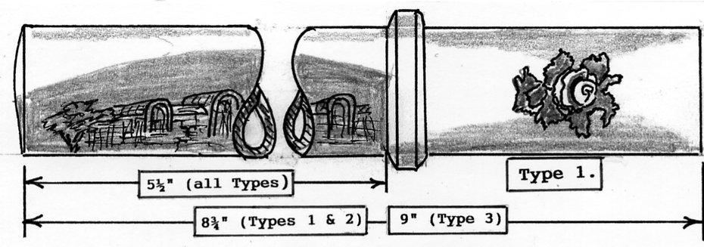
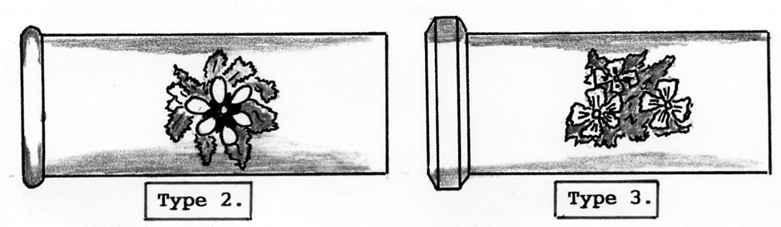

This souvenir is one of the types made in Germany, it is cylindrical and is one and one eighth inches in diameter by eight and three-quarters inches long. The body pulls apart to reveal a hollow tube in which to store the writing tools. The transfer design is the Crystal Palace as seen from the Low Level Railway, however, it is a very early view, the Water Towers are not shown but the North Transept is featured, this was destroyed by fire in 1866 and was never re-built. Views located on a cylindrical surface are difficult to depict, therefore the drawing has been ‘opened out’ as it would have been before the transfer was applied. “Made in Germany” is below “Crystal Palace, Sydenham”. A transfer of a small “rose with a foliage” design is on the pull-off end.
The Type 2 version has radial instead of angular sides to the end collar of the pull-off section, and the transfer design on the end section is a daisy with foliage, not a rose.
The Type 3 version has the same angular sides to the end collar of the pull-off section as the Type 1, and the transfer design on the pull-off section is pansies with foliage. “Made in Germany” is omitted on the Type 3 from under the transfer of the Crystal Palace, and the overall length is nine inches, not eight and three quarters.

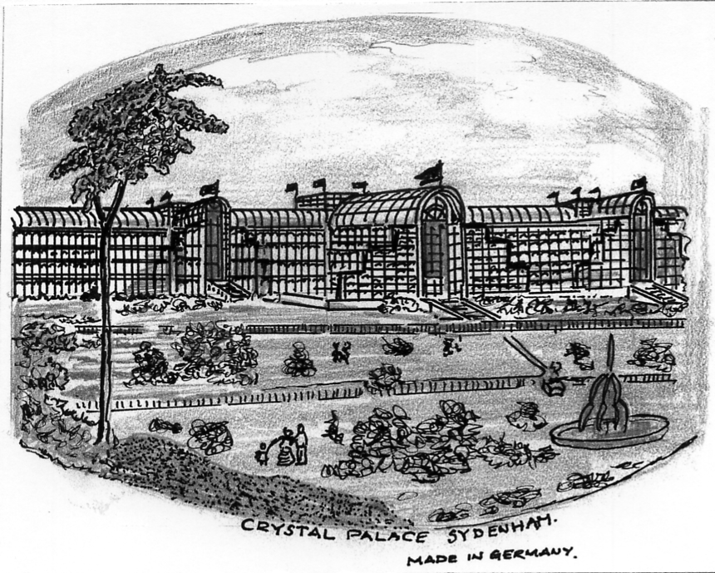

The developed transfer design around the body of the Pencil/Pen Box. (75% full size).

Japanese cancellations to commemorate the
Japan-British Exhibition 1910
by
Bill Tonkin

I first wrote an article for our Newsletter as it was called then in 1989 on these post marks and post cards produced in Japan to commemorate the opening of the Japan-British Exhibition at Shepherds Bush in 1910. Since then some more information has come to light and an up-date is long overdue. Some years ago when I was doing some work on these post marks Alan Sabey who was then an Honorary Librarian at the Royal Philatelic Society did me some photo-copies of articles from some of the books in their library. From these and from other material I can illustrate the three post marks and the information leaflet that was with the cards in the envelope. Also I can give you a full translation of the information leaflet.
A date error occurs on the leaflet which were printed before the sudden death of Edward VII caused the opening day to be put back from the 1st to the 14th of May. An attempt was made to alter the wrong date and on some of the sheets the date was corrected by an orange-red overprint to the 14th, while in others it remained unaltered but time ran out and not all of the leaflets were altered. So the leaflets are known in two types, altered and un-altered, how many were altered is not known.
While I am on dates the date on the postal hand stamps reads 43-5-14 which is a bit misleading, but the 43 stands for Meiji the number of years of the Emperor’s reign.
Although I have been fortunate enough to get the envelope and all four printings of the wood block card I have never been able to find a leaflet altered or unaltered. While the Tokio hand stamp is reasonably common, I would be very surprised if any collector in this country has the Shibuya and Naitö-Shinjuku post marks although they must exist in collections in Japan. I have been looking for them for most of my collecting life without any luck. The dots on the Tokio scan are the gold and silver specks used in the printings.

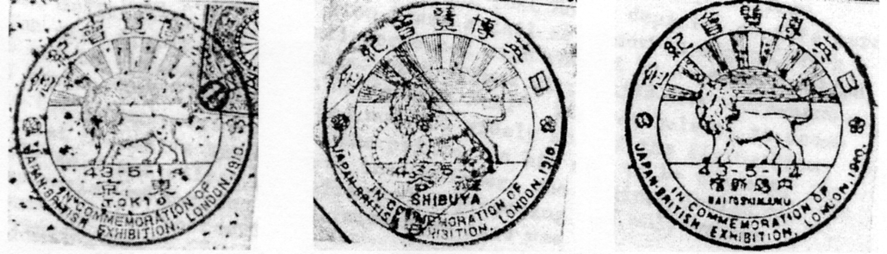
Tokio Shibuya Naitö-Shinjuku

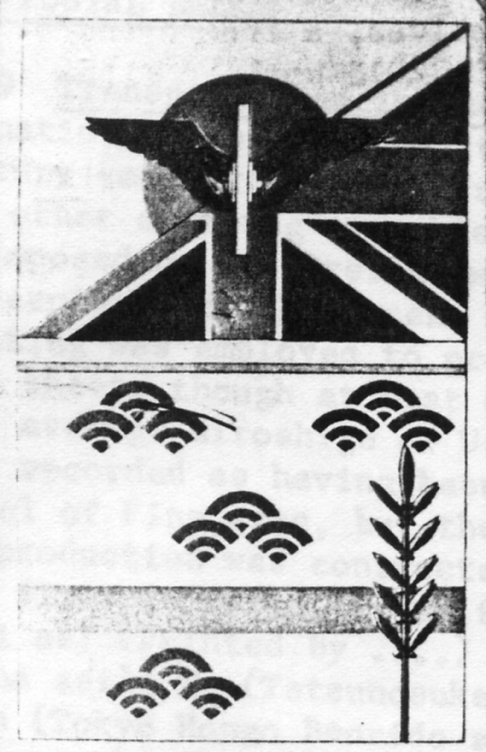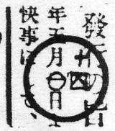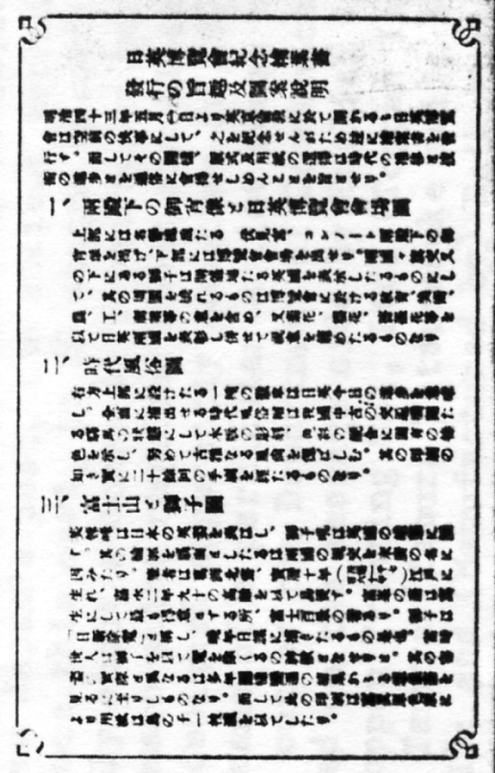

The packet Alteration The leaflet enclosed with
the set of three cards

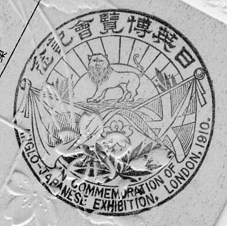
This is the special cachet used in Japan to commemorate the exhibition, obtainable on request probably for a small charge. It was not used to cancel mail and bears no town identification or date.

Translation of the leaflet

Purpose of the Release of the Commemoration Postcards for the Japan-British Exhibition, and Explanation of the Designs of these Post Cards.

These picture postcards are issued to commemorate a most gratifying event, the Japan-British Exhibition to be held in London from Meiji 43, May 1st). Moreover, the design, mode of printing, and paper quality of these postal cards will make people aware of the changes of the times and the progress of technology.
1. Portrait of the Princes and View of the Japan-British Exhibition. In the upper portion of the card appear the portraits of the Honourable Presidents, Prince Fushimi and Prince Connaught, in the lower a picture at the exhibition site. The lion crest beneath both national flags stands for the country entertaining the exhibition, Great Britain, while the surrounding implements symbolise the display of education, fine arts, agriculture, industry and commerce at the exhibition. Chrysanthemum, cherry blossoms and roses represent both Japan and Great Britain, and express their congratulations to the auspicious occasion.
2. Genre Picture of Olden Times. The badge in the right upper corner denotes the current advancement of both nations. The genre picture displays the means of transportation, the ‘Ekiba’ (stage-horse), during Japan's Middle Ages. The woodblock carving and combination of colours in this picture retain the classical elegance. This picture required hand printing through twenty steps.
3. Mount Fuji and the British Lion. Mount Fuji and the British Lion constitute the gallant symbols of Japan and Great Britain. The fan-shaped outlines signify the hope that the friendship between the two nations will increasingly strengthen in the future, reminiscent of a fan expanding upon being opened. The pictures are creations of Hokusai Katsushika who was born in Edo in Horeki 10 (1760) and died in Kayei 2 (1849) at the age of 90. This representation of Mt. Fuji is but one of his many hundred special views of Fuji-san. In his later years he used to draw a lion every day as a ‘Nishin joma’ (a daily amulet), because at those times the people thought that the lion was a god and a talismanic animal. The reason why the lion in the picture of this postcard departs greatly from reality is that the image of the lion was transmitted traditionally over the ages until it assumed the appearance of the one shown in this postcard picture. The printings were prepared by colour photography, while the paper of the postcard was produced by a technique known as ‘Tori no Ko Ichimai Suki’

Additional information on the three cards was published in the 1972 May-June issue of ‘The Postal Bell’ by Dr. Felix D. Bertalanffi

According to contemporary records, it was first planned to produce merely a small quantity of these technically complex cards just for presentation to members of the Japanese and British Exhibition Committees during the opening ceremony of the Japan-British Exhibition at Shepherd’s Bush.
Had this initial intention been executed, the cards would have presumably disappeared into obscurity. But likely, as their manufacture proceeded well it was decided to have them produced in a similar quantity as other recent commemorative postcards, 300,000 sets. They were sold on the opening day of the exhibition, May 14, 1910, at First and Second Class post offices in Tokyo, as well as at the Shibuya and Naitö-Shinjuku Post Offices. Deviating from the original intention entirely, apparently none of the cards were presented at Shepherd’s Bush on opening day, although presentation sets, differing by having been supplied with a bilingual Japanese and English explanatory leaflet, were given away at later occasions.
Although one would expect all three cards to occur still in like quantity, it seems that No. 3 has become quite rare and is much scarcer than the other two. The reason is unexplained. Whether it is that the fan-shaped photographs glued to the cards came off in the damp and humid climate prevalent in some areas of Japan, and hence more of these cards were discarded, is pure conjecture.
The card itself was intentionally produced with rough and uneven edges (which should not be trimmed!). It is speckled with flakes of pure gold by a process called in the explanatory leaflet “Tori no Ko Ichimai Suki”, Bird-of-child-one piece manufacture (of paper), evidently a method not too widely known! nevertheless, it seems likely that Hokusai’s instruction to the printer on his sketch of the flying lion “apply gold and silver powder” gave the designer, who appears to be unknown, inspiration of putting it into effect when preparing the original design of this commemorative postcard.

