EDITORIAL WINTER 2013

Our convention is over until next year,
Put back to October from what I can hear.

We tend to blame banks for all our troubles but there is a good side to them as well, as you will see when you read in our treasurer’s report at our A.G.M. where our bank made a generous donation to our funds. Many years ago I was packet secretary of my local stamp club the Bromley & Beckenham Philatelic Society, and exactly the same thing happened to me. One month on my balance sheet a mysterious credit of £200 appeared. I certainly had not paid it in, Their account was with Lloyds bank at the time and Lloyd’s just would not admit they had made a mistake. That went down in our balance sheet as a donation from Lloyd’s Bank. So history is repeating itself.
We have decided to revert to the first full week end in October for our next convention, partly because two members of the Crystal Palace Foundation found the end of September clashed with a local do they like to attend, and they can’t be in two places at once.
The attendance this year was the same as last year which is very encouraging when you remember that six of our regulars could not make it. Alan Sabey had died, Peter Denley, Ron Trevelyan, Fred Peskett, Martin Frelford and John Greatrex were absent, the total was made up by members returning to the fold after an absence of several years and a new member. I was particularly pleased to see Andrew Brooks after a far too long an absence, also Mike Perkins.
Our President Ramon Goodey has turned out to be a ball of fire, and has dedicated himself to bringing the Study Group to the fore at several functions next year, in the hope we can increase our membership. His first venture was the joint meeting with the Cinderella Stamp Club back in July. Apart from an enjoyable day we met a lapsed member who has re-joined, attended and displayed at our convention this year.
I have decided to do a series of monographs on subjects that may have a limited appeal to collectors and that would not support the publication of a book, but I feel strongly that this knowledge should be made available to those interested.
I have written, sometimes assisted by other collectors, and had published, eight books, ranging from 60 pages to my magnum opus of over 650 pages, but unfortunately now that I have covered all the popular exhibitions, the financial outlay and the storing of the unsold books makes this unpractical.
On the other hand I can produce in house books one at a time on demand, and I think this is the way forward. Now that we live in a computer age it is within my ability to produce an in house book at virtually no cost. In fact the greatest cost is the postage at £1.10 per copy. They may not have the gloss of a professional product, but they will serve their purpose of bringing knowledge into the public domain. Monograph No. 1 is available at £4.00, any profit will go to the E.S.G.
After my monograph No. 1 on the 1924 B.E.E. Maps, No 2 will probably be on another B.E.E. subject, the Malay Pavilion post cards published by the Malayan Government and printed by Houghton Butcher of Singapore. I am not aware of any research done on these cards since 1993 when Mike Perkins and myself did a lot of work on them.
Even now we don’t know how many cards there are in the series. The cards are all numbered and the lowest number recorded is 112 and runs up to 10120. A collector Dennis Bundy was the first to realise the last two digits never went above 50. The numbers do not run consecutively as was once thought, but is a code that Mike was the first one to crack back in 1993. We are now pretty sure there are 20 series with a possible total of 780 views, and out of these we have recorded just over 580 of the titles.
An aspect of the Malays cards are the typographical errors on the printing of the backs. After our 2013 convention Mike came to stay with me until Thursday and we spent three days up-dating my list of constant varieties from his collection.

The Editors
Annual General Meeting 2013
Held at Crystal Palace 28 September
Report by Don R. Knight.

President Ramon Goodey opened the meeting by welcoming those present to a pleasant weekend He asked everyone to stand for a minute in memory of Alan Sabey. He then asked Don Knight the secretary to take the meeting.
Apologies received from Fred Peskett, Peter Denley and Ron Trevelyan.
The minutes of the last meeting as published in the Winter Journal and copies at hand were proposed by Barry Coker seconded by B Tonkin and accepted. No matters arising.
Hon Secretary said very little had happened until the committee's spring meeting when Ramon Goodey who had been talking to an officer of the Cinderella Stamp Club about a joint meeting and this had been arranged at The Royal Philatelic headquarters at Devonshire Place, London on Saturday 6 July. This was attended by 6 members and all had a enjoyable day.
Ramon to try for a room at the Spring Stampex 2014, this has now been booked, Don Knight to do a Wembley Display which will commemorate the 90th anniversary of the 1924 British Empire Exhibition. The Study Group is sponsoring a card, one of 15 to promote EuroPhilex 2015,13 - 16 May. in London.
Ken Tonkin our treasurer produced the balance sheet which shows we have a healthy balance of over £12,000. A sum of £404.55 was shown on the sheet as a donation. Ken explained this was due to a bank error which our bank, refusing to accept they could make a mistake, left in our account as a donation. Proposed by Derek Connell Seconded by Barry Coker, and accepted.
Journal and Archives, Bill Tonkin gave great credit to Fred Peskett for supplying him with the many articles for the journal which makes his job much easier. Appeal to members to send articles in. Enquires on the archives the past year amounted to six. In the Summer edition in answer to a. request, to find the origin of Hartswood Tennis Club Pavilion he had been able to come up with a building that had been part of the 1908,1909 and 1910 White City Exhibitions. He received letter of thanks and a book published which records the history of the tennis club.
Ken Rumsey gave a report on our web site, said he has had a number of enquires which he passes on to the relevant members. He would like to find out how many visits the site has had, Mike Perkins to see about having a counter. Ken and Mike were thanked by the meeting.
Election of Officers, President Ramon Goodey, Vice President Derek Connell, Hon Secretary Don Knight, Hon Treasurer Kenneth Tonkin, Committee of four, George Burr, Fred Peskett Ken Rumsey, Bill Tonkin, Journal Team Bill Tonkin and Fred Peskett. Web Masters Ken Rumsey and Mike Perkins, Archivist Bill Tonkin, Accounts Examiner Andrew Brooks, were elected en bloc, Proposed Don Knight Seconded Derek Connell agreed by all
The office of Public Relation Officer will be decided at a meeting to be held by Ramon Goodey Derek Connell and Don Knight at a later date.
Meeting for 2014 will be at Crystal Palace on Saturday and Sunday 4th and 5th October.
A.O.B. President Ramon Goodey said that a room has been booked at the Spring Stampex on Saturday 22 February between 10.30 and 12 30. Don Knight to display 1924 British Empire Exhibition for 90th Anniversary. Derek Connell to do a leaflet with history of the Group, this information could be sent to various stamp magazines. We will be wanting members to act as stewards. We have been invited to display at the National Philatelic Society 11 October 2014 in the afternoon, venue and other information to follow.
2015 EuroPhilex 175 years of the postage stamp, the Study group is sponsoring one of the 15 special cards, the cost of this is £250, Proposed by Derek Connell Seconded by Kenneth Tonkin all agreed. We will have a room from 3pm on the 16 May.
A proposed joint convention with the Cinderella Stamp Club did not get any support at this time.
The A.G.M. was attended by 14 members, and closed at 11.30 am

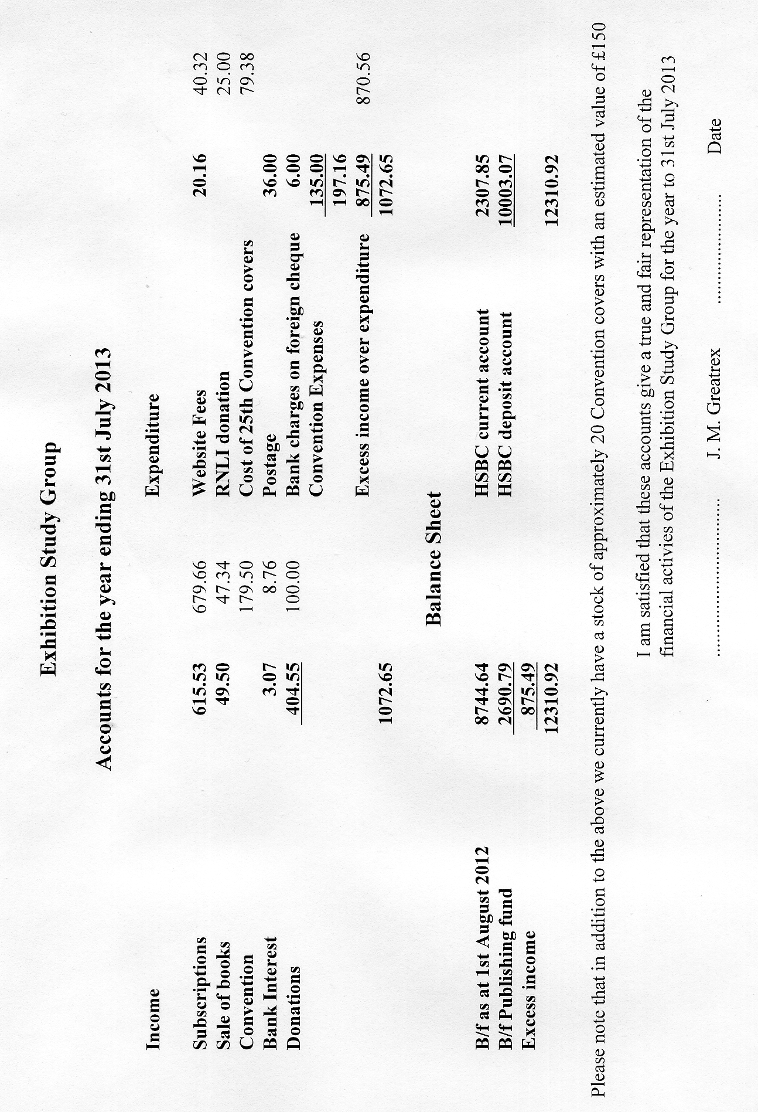
Displays at the 2013 Convention
Recorded by Don R. Knight.

The displays started with Don Knight putting up Scottish Exhibitions, 1888 with an invitation to a event which was attended by Queen Victoria, Followed by the 1901 Glasgow Exhibition, 1908 Glasgow Exhibition and the 1911 Edinburgh Exhibition, These had special handstamps used during the course of the exhibition, the many types of picture postcards and lettercards. Andrew Brooks put up some early British stamp exhibition items, this included an early copy of Stamp Collecting. Charles Kiddle showed Bournemouth and views of the area, then went on to show material of the 100th anniversary of the Penny Black 1940 at Bournemouth and London. Bill Tonkin went on to talk and show what he calls Paint Box display. The cards shown had been retouched on the original negative (glass plate) and showed how the changes could he seen on the cards.
George Burr had three china models of the Queens Dolls House from the 1924 British Empire Exhibition and talked about the modern card of this from Windsor Castle where it is on display to today. Views of the Ideal Home in postcards, and a photo showing Whit Monday at the Wembley Exhibition. Our President Ramon Goodey showed his recent purchases starting with a Proof Handstamp of one of British Empire Exhibition cancellations, a First Day cover from the Palace of Engineering. Official envelope and sheet, a quarter sheet of the Lloyds Bank labels in blue. He told how the difference of the 1925D and no D came about, the dates always shows that this was a Saturday and when they had a busy day at the exhibition they used a second cancel which was minus the D. He finish with showing a photo of a vending machine from which the exhibition stamps came out in coils along with an example of a coil join.
Derek Connell started by showing the Penny Black from 1840 and other items from that time, then went on to the Guildhall Exhibition of 1890 from this he showed the many items collected from the 1940 Centenary of the Postage Stamp and included a catalogue from it. The 1990 London Stamp World held at Alexandra Palace North London, with the special souvenir sheet showing the Penny Black, the covers and handstamps. His display which covered the 150 years of the Postage Stamp he lead into EuroPhilex, the Exhibition Study Group is sponsoring one of the cards, while at the Autumn Stampex he got two of the first cards and had a Stampex handstamp applied to them. Don Knight rounded the afternoon off with some of his 1938 Glasgow Exhibition postcards, some of which raised talking points. Derek Council said that Billy Butlin had purchased one of the buildings which was rebuilt at his Skegness Holiday Camp.
Sunday sharp at 10 o'clock the final displays started with Charles Kiddle putting up over 40 sheets of Cinderella labels from Great Britain ranging from the White City Exhibition, Olympic Games, Earls Court Motor Shows and the British Empire Exhibition 1924-1925. Don Knight put up a display of the 1940 Bournemouth and London Exhibition, this was the third display of these exhibitions which had covered them almost to the limit. In 2015 the Exhibition Study group will be expected to cover the Centenary of the Postage Stamp 1940. Bill Tonkin talked about Valentine & Sons postcards published for the early exhibitions. His research showed how the same visitors as single people and as groups could be seen on many cards British and Foreign. Don Knight went on to show the lettercards and postcards of the Empire Exhibition Glasgow 1938. Then to finish the displays for the Convention Bill Tonkin displayed and talked about the Ideal Homes Exhibition at Olympia 1908 to 1913.
A vote of thanks by President Ramon Goodey to all of those had had put up the many interesting displays over the weekend.

Disposal of Alan Sabey’s collections.

Alan Sabey collections are to be auctioned in the new year by Grosvenor. Members will be aware Alan built up outstanding collections of the 1908 and 1948 Olympics as well as many other areas that he had an interest in.
Little Gems of the Postal History of the Great Exhibition of 1 851. Number 3.
The Wilson, Walker & Co. Envelope of 1853.
By
Fred Peskett.

Although the envelope shown below was posted on May 9th 1853 there is no doubt that it is associated with the Great Exhibition of 1851. On the front of the envelope is an embossed green shield with the conjoined heads of Queen Victoria and Prince Albert in white on a red circular background. “PRIZE MEDAL” is above the heads and “1851” is below the heads. In a red scroll under the shield is CLASS XVI, this was the group under “MANUFACTURES” for Leather (including saddlery and harnesses) Skins, Fur and Hair. A fancy embossed flap seal on the back of the envelope has a blue crest for Wilson, Walker and Co. Leeds. Spanish Leather Works.

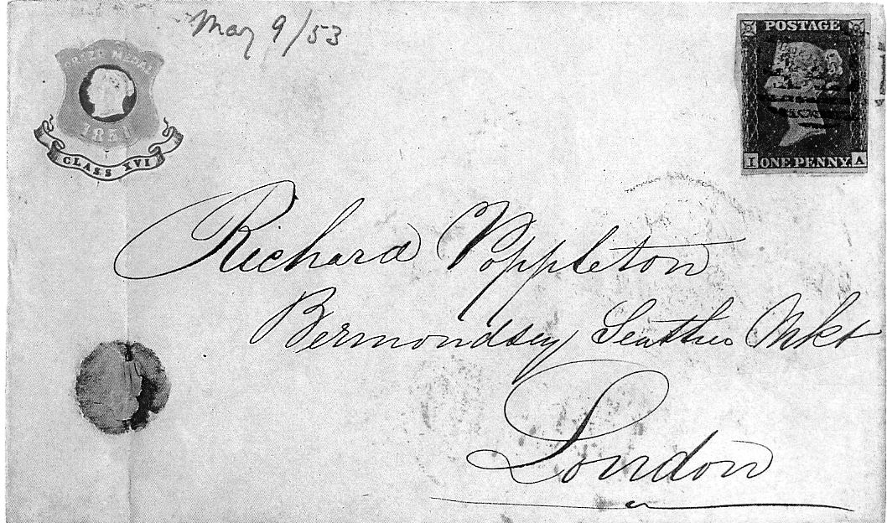

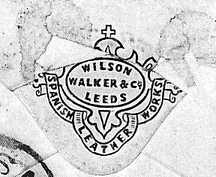
Wilson, Walker and Co. won a Prize Medal for their display of finely carved leather goods, including saddles, upholstery and leather bags. The company was obviously so proud to have been awarded a medal so they had this envelope produced to advertise the fact. So far it is the only example known to have survived, yet the company must have had many hundreds if not thousands printed to send to their clients and probably, competitors as well!.
The envelope is addressed to Richard Poppleton at the Bermondsey Leather Market, London who was a leading supplier of tanned leather in this country at the time of the Great Exhibition
I am afraid that there is no “good fortune” about the way this one came into my collection, other than the fact that it came my way via a very contorted route.
It was about fifteen years ago that I had an important phone call from George Simner who had been to Stampex during the day, he had spotted a couple of Great Exhibition Engraved Letter Heads on one of the dealer’s stands, he enquired the price, and thought that 1 may be interested, George gave me the dealers telephone number, always game for a new piece of G. B. Postal History, I gave the number a ring, only to find the dealer lived and worked from the Isle of Wight, just twenty minutes away.
I arranged to hop over the Solent on the Hovercraft to Ryde to meet the dealer and have a look at the Letter Heads, for which the dealer had not just two, but a dozen different ones! The day was foggy, the Hovercraft was cancelled, so I had to make a dash over to the Isle of Wight Passenger Ferry by taxi, this was also cancelled but the car ferry to Fishbourne was still running, the car Ferry is a long way from the Passenger Ferry, but I managed to make it with a few seconds to spare and was still able to get to see the dealer at the appointed time!
Needless to say, I purchased all of the Letter Heads, then the dealer produced this Wilson, Walker and Co. envelope, I had visions of a re-mortgage on the house but the price I was quoted was very reasonable at £10. I would have loved to have seen the contents of the envelope. Were Wilson, Walker & Co. congratulating Richard Poppleton on the supply of top grade leather, or was it “Look what we’ve got”?

British Empire Exhibition Paquebot Slogans
By
Ken Tonkin

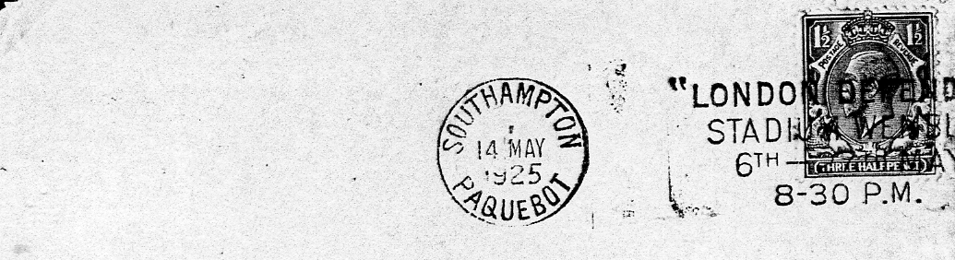
The Alan Sabey 14 May 1925 Southampton Paquebot post mark

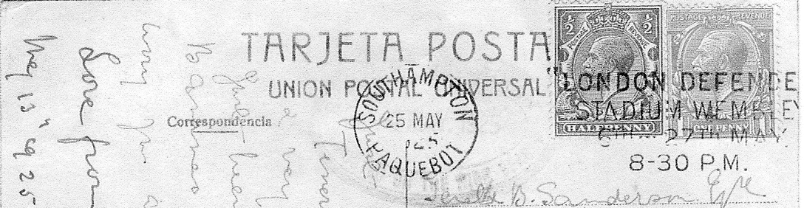
25 May 1925

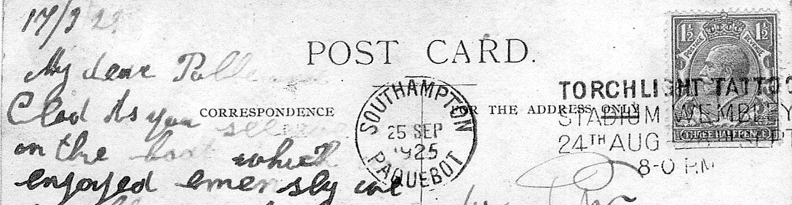
25 September 1925

The Alan Sabey collection contained a ‘London Defended’ advertising slogan used in conjunction with a Southampton Paquebot datestamp dated 14th May 1925. I recently acquired the same Paquebot slogan dated 25th May illustrated below. Until now this was the only UK Paquebot slogan advertising an event at the Wembley exhibition known. The recent discovery of a Southampton Paquebot ‘Torchlight Tattoo’ slogan, shown below, suggests that the use of Paquebot slogans may be more widespread than previously thought. The ‘London Defended’ and ‘Torchlight Tattoo’ slogans were the only ones used in Southampton but it is possible that slogans used in other cities may also exist with Paquebot datestamps. If any member has any other Paquebot slogans please send details to Ken Tonkin.

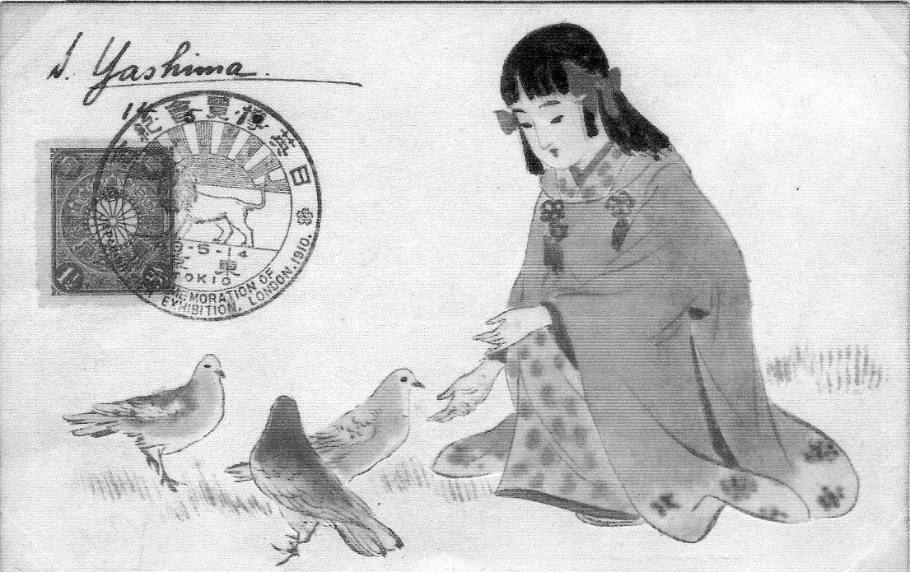

A thing of beauty is a joy forever, a scan of a beautiful hand painted Japanese card with the Tokio hand stamp only in use for one day in Japan to celebrate the opening day of the Japan-British Exhibition. The date is a bit misleading 43-5-14, the 43 stands for the 43 year of the reign of the Emperor, 5-14 is the date of the opening day, the 14 May. Although this card originated in Japan, the firm that published it came over and had a stand at the Exhibition and sold similar hand painted cards, done by a Japanese lady artist in one minute. Scan sent in by Mike Ellis.

The Ancient Order of Frothblowers
By
Bill Tonkin

In our Autumn Journal I told the story how purely by chance I turned over a scrap of paper on the breakfast table and found a scan of an Ancient Order of Froth Blower cinderella. Now I am presently engaged in sorting out (and hopefully throwing out) papers that have not been looked at for about 18 years, and again purely by chance my eye caught the word Froth Blower. It was in a letter sent to my wife Nancy by Joyce Walker a West Wickham historian, now sadly no longer with us, and it was a potted history of the Frothblowers as follows. But before I leave the story of the cinderella scan, I must record that Charles Kiddle very kindly sent me the label as a gift, thank you Charles.
In 1924 Sir Alfred Fripp, a London surgeon who had removed King Edward VII’s appendix, set up a fund-raising organisation to raise money for what he called his “Wee Waifs” charity. This charity was named the Ancient Order of Froth Blowers. The jokey title with the pseudo-high sounding name became immediately popular, especially in public houses. Life membership was five shillings and this entitled the member to “blow froth off his beer, other members beer, and occasionally off non-members beer, provided they are not looking.” The motto was “Lubrication in moderation”. Fund-raising ventures included the sale of ties, cuff-links, handkerchiefs, Christmas cards and crackers. By 1927 membership of the Froth Blowers was over 232,000 and the charity collected £15,000 in one year alone.
Some of the Frothblowers money was used to buy Stramshall Lodge, standing in about 10 acres of land in Woodland Way, West Wickham, for use as a children’s heart hospital and convalescent home. The hospital known as Heartsease had surplus land and two acres were donated by Sir Alfred to the East Central London District of the Girl Guides Association, of which his wife, Lady Margaret Fripp was District Commissioner. It seems that it was not only because of the Fripp connection that this particular District was chosen but also because many of the Guides living there came from very poor homes and had never had a holiday. Grants were made from the Frothblowers to enable each Guide unit to have one outing per year.
A building was erected in the style of a log cabin, heated by a wood-burning stove. As soon as the site came into use in 1926 the Southern Railway issued special rate tickets at 1/7d (one shilling and sevenpence) from London Bridge to West Wickham. The Station Master at West Wickham allowed the Guides to leave their trek cart under the stairs at the station so that they could transport their kit to Heartsease.
Each year on the third Saturday in May a Divisional Rally was held at Heartsease for Guides and Rangers who travelled on special trains from London Bridge. Camping virtually stopped when war came in 1939 and the hut was .used at various times as a store for waste paper, a kitchen for a British Restaurant, and by the Home Guard. The Froth Blowers continued to pay the rates and insurance, otherwise the site was self-supporting In 1983 the insurance valuation was increased, a timely move since less than six months later arsonists caused serious damage to the nut and main services. After repairs and other improvements made since, the site is fully operational, allowing for a hiccup when trees falling in the 1987 storm caused more damage. The Froth Blowers to this day (1991) are still concerned with the finances of Heartsease.
Joyce Walker
Source : “The Story of Heartsease” Joan Baker- Private publication.

Souvenirs of the Great Exhibition of 1851.
Drawings and written by Fred Peskett

The “Giant” Clay Pipes.

Novelty “Giant” Clay Tobacco Pipes were popular in the mid 1800’s particularly those with the bowl in the form of the heads of current politicians and military leaders also famous London landmarks, so it was inevitable that the Crystal Palace built to house the Great Exhibition of 1851 should be manufactured as one of these giant pipes as a souvenir.
An initial look at these pipes seems to show that they are all identical and produced from the same mould, however, a closer examination reveals that there are a number of variations to the basic design, which suggests that there were several manufacturers of these souvenirs.
One pipe examined has a name in a panel on one side of the stem “W. T. Elare”, with “London” on the other side, this may have been the maker although it could have been the retailer? Since doing this article and drawing another clay pipe has been found of this type which has the impression far more distinct. and a correction is necessary. The name is actually W. T. Blake. The previous one has a poorly impressed B & K! A feature not previously noted for this Type is that the impression of the Transept is off-set to the centre of the bowl by 10°. On all other types the Transept is in the centre of the bowl.
There is a Great Exhibition Giant Clay Pipe on display at the Westbury Museum, Fareham, Hampshire, together with both halves of a steel mould, which was used for producing the pipe. Fareham and nearby Portchester were two towns noted for a number of clay pipe making factories, one in particular who made giant pipes was Leigh of Portchester. There is a seam of white clay from the “London Clay” geological deposits in the area near to Fareham which is ideal for clay pipe manufacture.
The pipe factory of Leigh was demolished around 1972 and the debris dumped in a land-fill site at Cams Bay, Fareham. By 1976 coastal erosion had uncovered the debris and had exposed fragments of clay pipes and items associated with their manufacture. I visited this site at low-tide and collected hundreds of the bowls of the conventional sized pipes and a few fragments of the giant pipes including those from the Great Exhibition type, so a name can be given to a least one other maker.
Four Types are listed plus one variant of the Type 1. None of the pipes found show any signs of being used for smoking!
The conventional size of clay pipe is known for the Building at Kensington for the 1862 Exhibition, but so far none of the small versions have been found for the Great Exhibition of 1851.
If you have one of these “Giant” Clay Pipes in your collection which shows any differences to those described and shown above please let me know so that it can be added to data already collected. Thank you.
Fred Peskett.

For the purpose of identification the pipe with a known maker’s mark has been used as the basic design.
Type 1.Side view:-
(a) Has a “W.T. Blake” maker’s mark in a panel on one side of the stem and “London” on the other side.
(b) There is a small flag over the Transept on each side of the bowl.
(c) Around the windows in the Transepts each side of the bowl are small stars in each box.
(d) The design under the bowl is two fancy scrolls.
(e) The overall length of the pipe is 7½”.
Front and back views:-
(f) Front view the central ridge is fully up to the rim and is plain. View from the stem end:- The Transept rests on protruding plinth, and there is a square block over the centre of the Transept.

Type la. The design is identical to Type 1, but the length is 7”.

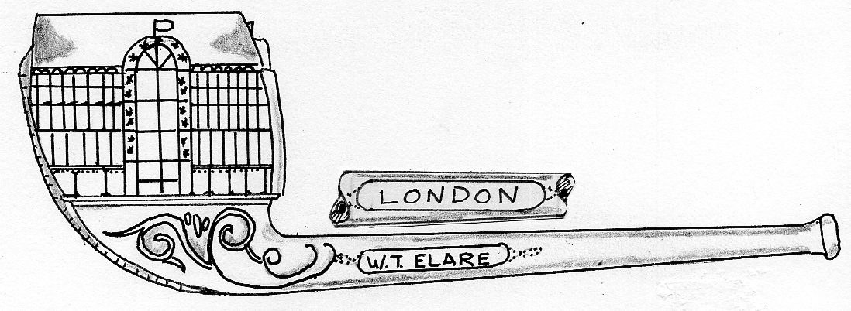
Type 1 Pipe

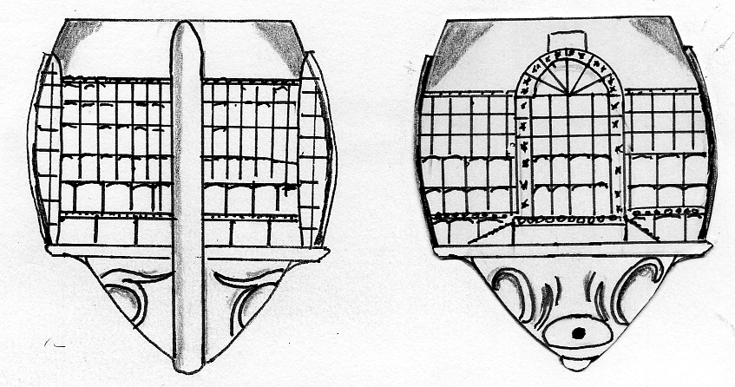
Type 1 view from the front Type 1 view from the stem

Type 2. Side view:-
(a) There is no maker’s mark on the sides of the stem,
(b) The flag over the Transept is longer and tilts down to the right.
(c) The boxes around the windows of the Transept are plain, but the lower windows have a radius to the tops
(d) The design under the bowl has one fancy scroll and two serrated leaves.
(e) The overall length of the pipe is 7%”
Front and back views:-
(f) Front view:- The central ridge ends just above the roof and is serrated. View from the stem end:- The Transept does not rest on a plinth and the roof is angled rather than curved.

Type 3. Side view:-
(a) There is no makers mark, although fragments found at Portchester are the same as this pipe which suggest that it could be made by Leigh.
(b) There is a large flag over the Transept on each side of the bowl.
(c) Around the windows in the Transepts each side of the bowl are small diamonds in each box.
(d) The design under the bowl is a single scroll, two serrated leaves with a series of dots.
(e) The overall length of the pipe is 7%”.
Front and back views:-
(f) Front view:- The central ridge is narrow, does not reach the rim of the bowl and is serrated. View from the stem end:- The boxes of the Transept have small diamonds, the roof is formed by two arcs and not a full radius, there is no representation of a flag over the roof.

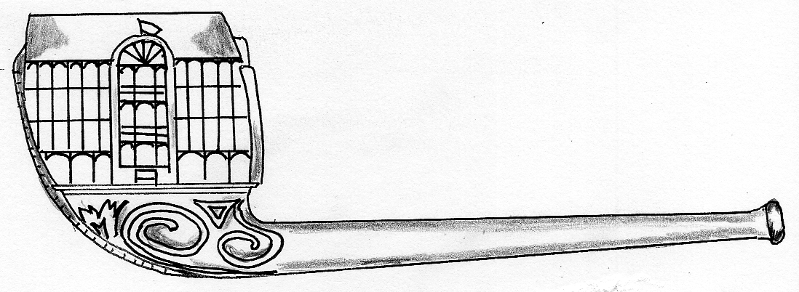
Type 2 Pipe

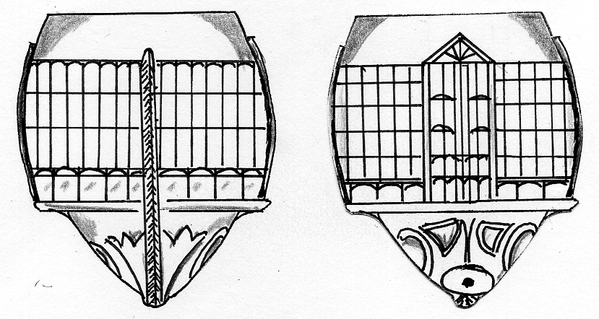
Type 2 view from the front Type 2 view from the stem

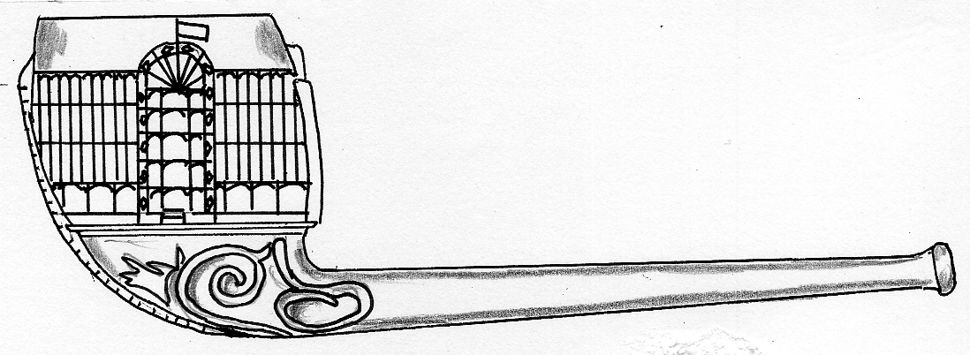
Type 3 Pipe

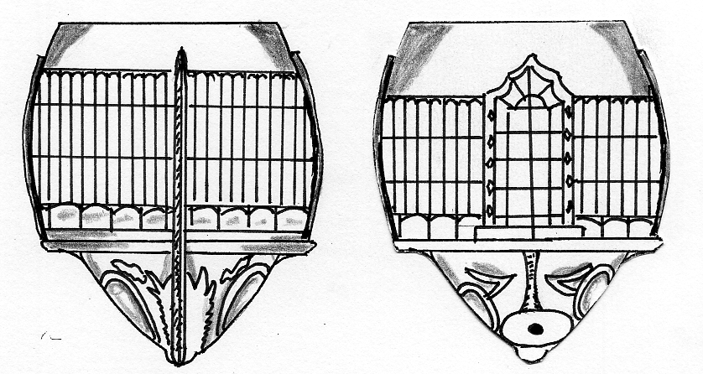
Type 3 view from the front Type 3 view from the stem

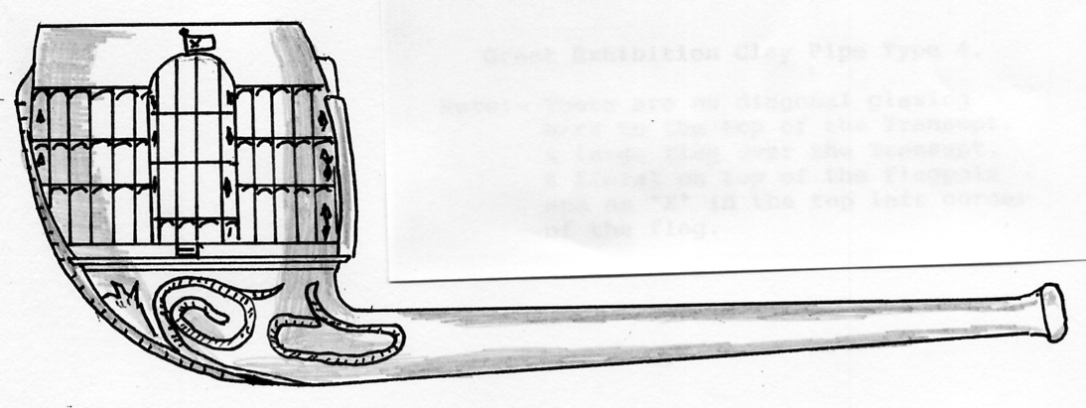
Type 4 Pipe

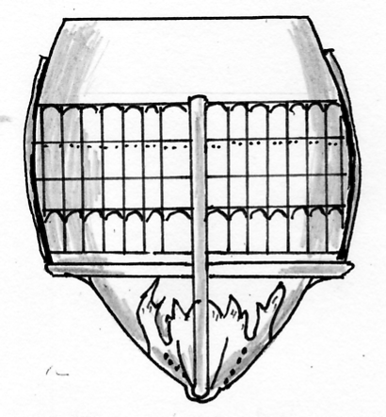

Type 4 Pipe from the front
Another type has Just been found, this is recorded as Type 4. The shape and features are generally the same as the Type 2, but the flag over the Transept is much larger than the other types and has an “X” in the top left of the flag adjacent to the flagpole, the flagpole has a round finial on the top. The view of the Transept does not have the diagonal glazing bars at the top.

Type 4 Pipe from the front.

OLYMPIA Corporate History 1884-1999
by
© John Glanfield. January 2012

Known directors as at 4 March 1905
Frederick Harold Payne, (late MD of second Olympia Ltd and director of Allsopp & Sons Ltd].
As Managing director & acting secretary 277 ordinary shares.
Percy C Quilter. stockbroker 250 ordinary shares.
Emile Daoust. gentleman 200 ordinary shares.
Principal shareholders as at 22.3.1905
Charles Morrison 34,373 shares.
Sir Cuthbert Quilter MP 21.000 shares.
Edward Frederick Quilter 21.000 shares.
John S Banner MP 11,000 shares.
National Archives. Kew company papers piece BT31/10934/83008.

1912. 11 July. New Olympia Company ceases trading
Edward C Moore was appointed liquidator Olympia had collapsed with heavy losses arising from Payne’s decision to back impresario Charles Cochran’s stunning production ‘The Miracle’ (24 December 1911-2 March ‘12) Olympia put up all the money in return for half the profits, the other half to be divided equally between Payne and Cochran. Olympia had secured a mortgage of £11,000 to underwrite its commitment. The company lost nearly £20,000. Attendance’s averaged 5,000 at each of the twice-daily performances for the first 2-3 weeks, with box office receipts falling just below running expenses. Lord Northcliffe’s eventual support through his Daily Mail brought full houses, but too late for recovery Ironically, the production had to close on 2 March to make way for the Ideal Home Show.

1912. 7 August. ‘Pa’ Payne returned to Allsopp’s at this low point.
But he left Olympia with an assured long-term future, its lettings calendar transformed He joined the board of Earls Court Ltd as chairman in February 1913. The fledgling Trade Fairs and Exhibitions industry was quick to grasp the opportunities presented by Frederick Payne’s vision. Olympia’s transformation presented the nation’s first true exhibition centre, offering its tenant shows annual continuity and growth. His courage had set the industry on a radically new course that holds good today. He deserves to be fittingly commemorated

1912. Olympia (1912) Ltd is formed, and buys Olympia.
Chairman: Sir Gilbert Greenall.
Managing Director Reginald Heaton who had founded Olympia’s International Horse Show in 1907. He sold his farm and stud for £12,000 in order to take up Sir
Gilbert’s invitation to join him.
Directors: Sir Richard Cooper.
Wm. Bainbridge,
Robert Flemming.
Co. Secretary: Wallace Jones, late MD of the second Olympia Ltd. in 1895, etc.

Capital £100,000 in £10 shares and £50,000 in £100 debentures at 4.5%.

1914 & World War 1. Olympia initially requisitioned as a temporary civil prison camp.
For German nationals and other potentially hostile aliens. From 1915 it became an Army clothing store.
De-requisitioned spring 1919.

1914. June. Olympia acquires W Kensington Gardens.
Sir Gilbert Greenall purchased Nos. 4-32 W Kensington Gardens, a row of substantial houses and gardens fronting Hammersmith Road. Behind them lay Olympia. It was clearly a vital site if Olympia was to expand. The National Hall and the east end of Olympia 2 now occupy it. Sir Gilbert secured the freeholds for £23.000 from the Latymer Foundation of Edmonton, an educational trust, in June 1914. It was an inspired acquisition. War came only weeks later, delaying its redevelopment.
For purchase of W Kensington Gardens by Olympia see London Metropolitan Archives, piece No. MCC/CL/L/EO/092
Planning consent to demolish at least part of this property and build a further hall was granted in 1917 subject to certain conditions. Olympia failed to signify acceptance.

1922-23. THE ‘New Hall’ (National Hall)
Renamed The National Hall in 1930 on completion of the Empire Hall- now O2. The Motor Show’s pressing need for more space forced the expansion of Olympia’s capacity The four most easterly houses in West Kensington Gardens fronting Hammersmith Road together with the remaining Vineyard Nursery buildings round the corner in Addison Road were demolished to make way for the Hall. James Carmichael of Wandsworth was contracted 23 April 1922 to build it for £494,000. Construction began immediately, though L.C.C. consent had not been given. Olympia was summonsed for proceeding without approval.
The young Architect Joseph Emberton chose an unadorned external style, believing that a building’s function or purpose should determine its architectural form. The structure is a smaller and lower version of the adjoining Grand Hall. It boosted Olympia’s exhibition space by more than 9,000 sq. m to 28.000 sq. m in all. The site was cleared and the hall completed in just 12 months from award of contract. ‘New Hall’ was first occupied in May 1923 for a tobacco exhibition.

1929. February. Olympia (1912) Ltd is sold for £1m.
Philip Ernest Hill, a financier and Chairman and MD of Philip Hill & Partners Ltd. a major
issuing house, purchased Olympia on 27 February 1929 and took possession 25 March. He registered Olympia Ltd, inviting applications for £400,000 7% preference shares of £1.0 each, and 400,000 ordinary shares of 5 shillings each to acquire the property from Olympia (1912) Ltd.
The urbane and highly regarded Reginald Heaton was retained as Managing Director and joined the board. 14 Freehold properties acquired with Olympia included:
Maclise Mansions (a block of flats in Maclise Rd fronting Addison Rd Station; 2 shops on ground floor)
No 1 Maclise Rd (corner shop let to an exhibition furnisher).
Nos. 21,23,27 &29 (4 shop units in Madise Rd)
No 31 Maclise Rd and Olympia Mansions in Beaconsfield Terrace Rd.
The 60,000 sq. ft ‘Otto House’ site in North End Rd West, approx. 450 yds from Olympia With a 516 ft frontage to N End Rd it had been intended to make this a car park for Olympia.
Addison Court Gardens and other properties on the Hammersmith Rd/Blythe Rd corner, see below,
1929, March. The British Industries Fair, para 1.
All would be administered by the Kensington Property Company Ltd, a wholly owned subsidiary of Olympia Ltd.
1929. March. The British Industries Fair announces transfer to Olympia
The country’s biggest trade event was the annual British Industries Fair with sections in Birmingham and London’s White City. The still-growing London section totalled 1,500 display stands with a combined frontage of six miles, the Fair was created in 1915 to counter wartime trading difficulties abroad, and was sponsored by the Department of Overseas Trade (DOT).
To Hills’ bemused delight the BIF organisers approached him early in March 1929 just days after his purchase of Olympia and the London Fair’s closure on the 1st. They wished to explore the possibility of transferring it to Olympia the following February for the next 10-years. The Fair had been staged since 1921 at the White City, built by Imre Kiralfy for his giant Franco-British Exhibition of 1908. Its halls were run-down and lacking adequate services. The recent BIF was a disaster, freezingly fogged-in for the period leaving the poorly heated buildings bitterly cold An exhibitors’ rebellion was raging, fuelled by complaints from home and overseas buyers. The Exhibitors’ Advisory Committee met on 15 March to urgently consider three options.
1. Acquire the whole available While City site and construct thereon single-storied buildings for the exclusive use of the Fair exhibitors, stands being left in situ from year to year.’
2. The construction and leasing to exhibitors of suitable buildings by the Underground Railway Company [sic! at Earls Court’, i.e. the derelict Earls Court showground built by John Whitley in 1886/7 and later developed by Imre Kiralfy.’
3 Occupation of Olympia with material additions, ‘(researcher’s emphasis).

The Advisory Committee voted 11:1 for Olympia. Philip Hill had quoted ‘some £25,000 p.a. for 10 years’. The BIF would have to pay White City over £20,000 to secure release from its Letting Agreement that would not terminate until after the 1930 Fair. Accordingly, Hill agreed to waive part of Olympia’s first year’s rental equal to the sum payable to the Shepherds Bush company, to be repaid to Olympia over the remaining nine years. The BIF calculated that all the Fair’s outgoings would be met if exhibitors were charged 2s/9d per sq. ft. (10.75 per sq. ft. £l.16 per sq. m.) Critically however, the London Fair’s net sold area of 318,000 sq. ft (29,500 sq. m.) could not be matched by Olympia’s estimated 285,000 sq. ft. net (26,500 sq. m.). The deal was clinched with Hill’s promise to construct the Empire Hall (now Olympia 2) in time for the next Fair opening 17 February 1930. He also gave promise of future additional space if required. The BIF and DOT were well satisfied.
The Times, 20 March 1929. National Archives. Kew Treasury file piece T161/618.
Hill had caught a beauty. Within days of buying Olympia this coveted 10-year letting just fell into his lap Had Sir Gilbert Green all any expectation of securing the BIF his price for Olympia would have carried a hefty premium. Hill announced to the Press on 19 March that the BIF was coming. National Hall’s architect Joseph Emberton was immediately appointed That same month he rushed out a structural design for approval and quantity survey, sought LCC planning consent and appointed contractors. The groundworks started on 1 April.

1929-30. EMPIRE HALL (Olympia 2).
The Hall’s construction cost £580,000. It replaced the last four West Kensington Gardens properties fronting Hammersmith Road, leaving only a bank at No 34 and the Bell and Anchor pub (38-40) on the corner of Blythe Road and Hammersmith Road. Immediately behind them stood two blocks of flats - Addison Court Gardens. These four properties occupied the site of today’s Olympia 2 car park. The bank and pub were demolished around 1967/8. Addison Court probably went in 1957.
The cramped site forced Emberton to build upwards, adding 20,000 sq. m to Olympia’s gross letting capacity which now totalled nearly 50.000 sq. m. His front elevation, hinting Art Deco, is clad in concrete slabs cast from crushed Portland stone aggregate and fixed to the structure with tie rods The interior remains configured like a department store to stimulate visitor flow to upper levels. The tight schedule forced construction to run simultaneously with excavation for a basement restaurant and adjoining kitchens. 35,000 loads of spoil were removed in 20 weeks.
The exceptionally tight construction deadline was not fully met Only two of Empire Hall’s three exhibition floors were completed and fitted-out in lime for the Fair in February 1930, but it remains a stunning achievement. Escalators were not installed until 12 February 1937, three days before that BIF opened.
The Grand, National and Empire Halls were so named following completion of the latter. A covered footbridge was also built across Addison Road at this time to link the station directly with Grand Hall.

