EDITORIAL AUTUMN 2013

Doing too much, can lead to bad pain,
Your back gives up, it can’t take the strain.

The doggerel at the top refers to pain in my shoulders, spine, hips, knees and now right hand from arthritis. With so many members much worse off than me, I don’t want to be left out. I managed to get up to the Royal to give my display, but it meant having a cab both ways. But it was worth it.
In the last quarter’s Journal I wrote in the Editorial the following, “I’ve said it before and I’ll say it again, if Fred fell in the pit he’d come out smelling of violets”. One Journal later I am saying it again, “if Fred fell in the pit he’d come out smelling of violets”. One day last week trying out his new veins and knee joints he hobbled round to a local charity shop and found a Festival Crown in its original carton as sold at the Festival. It was only £1.99 so he bought it. Now Fred is one of the few people who knows and remembered that the Mint made a cock-up and by mistake released for sale at the Festival Gardens 100 crowns without the inscription round the edge. Need I say more ? Fred tells me they fetch about £950 in auction when one comes up. I hope his luck holds out in other directions as Fred has to go in for further treatment involving moving veins around from arms to legs. I, and I am sure everybody wishes him well in the weeks ahead.
The totally unexpected death of Allan Sabey has had quite an impact on collectors country wide. The Journal has received more comments, than for any other members death in the past. Fred tells me the Portsmouth Philatelic Society observed a minutes silence at their last meeting, and elsewhere I am publishing a letter from Anne Stevens about Alan.
Some time ago I agreed to compile a book on Alan’s British Empire Exhibition Colonial Postal Cancellations and it was agreed at an A.G.M. that the Study Group would publish it. To this end Alan lent me his complete collection of post marks mostly on covers for a couple of months to scan for illustrations in the book. This I have done and Alan has gone through the draft copy making some amendments, and although it is too late to apologise to Alan for the delay on my part in getting it finished, this, when published will be a fitting memorial to him and his unique collection.
He had the satisfaction or is it the frustration of knowing there was only one Australian town cancellation he was short of for completion, an incredible achievement. Since his death yet another previously unknown cancellation has turned up on E-bay, an Australian Free postmark. On the other hand at least one of his postal cancellations is the only known example ever recorded.
On Saturday 6th July half a dozen of us made our way to the ‘Royal’ (see report else where) together with about the same number from the Cinderella Stamp Club to give a joint display, organized by our Raymond Goodey. There, although I did not realize it until the next morning, was set in train a reminder of a fact I have known of for years and almost forgotten. Had I announced it during our visit to the ‘Royal’ it would have created a bomb shell of a Guinness Book of Record proportion. To put it in a nut shell I have written proof amongst my odds and ends that I have been collecting Cinderella’s for 86 years, since 1927 in fact. To me personally this is too important to be ignored and I have done a short article on ‘Cinderella’s of Ye Ancient Order of Froth Blowers’.
Mike Gorringe has come up with another Wembley Map, this makes number 47, will we reach 50 I wonder ?
Mike Perkins phoned me the other day to tell me he had looked up Amazon on the internet and out of curiosity had looked to see if there was any mention of the book we did on the British Empire Exhibition post cards. To his surprise there were nine for sale, at £17.95, £36.99, £48.97, £49.99, £69.95, £69.99, £85.53, £85.58 and £179.95, all plus U. K. Postage. Exactly four years ago I remaindered 224 books at £1.60 each. I’m speechless and my fingers have all gone numb and I can’t type any more, I suppose my only consolation is mine were sold and Amazon’s are not likely to sell.

The Editors.
Exhibition Study Group Convention
28 and 29 September 2013

Time is coming fast for another Annual Convention, to be held on the weekend of the 28 and 29 September at Crystal Palace. Over the years we have an attendance of 16 to 18 members, and after the short A.G.M. we see displays which can be of great interest, containing some rare items. This goes on through the Saturday and in the evening we have a dinner. On the Sunday morning from 10 o’clock until 1 o’clock there are more displays before everyone say’s goodbye.
If you can only attend during the daytime you may not wish to stay for the dinner, and not wish to bring a display, although we all like to see each others treasures.
The Crystal Palace Centre has bed and breakfast facilities at a reasonable cost. To book contact Joan Miles at The Lodge, Crystal Palace, National Sports Centre, Ledrington Road, London, SE19 2BB or phone 020 8778 0131. Please let me know if you are coming and if you have a display, this can be as 10 sheets up to 80 sheets, you may be looking for information or items to add to it and someone could help.

Don R. Knight Hon. Sec. 020 8440 3574. e.mail donald@btinternet.com

Hartswood Tennis Club
Near Shepherds Bush
Can you help.
By
Don R. Knight

I recently had a letter and pictures regarding the Pavilion at Hartwood Tennis Club asking if I knew of the origin of the building. In 1978 when I published a small book The Exhibitions. Great White City, I put in a small paragraph about the Hartwood Tennis Club saying it is showing it age.
The lady who had worked for the B.B.C as a picture researcher has tried to trace the origin of the Tennis Pavilion. In 1911 after the Coronation Exhibition was held on the site, some of the buildings and scenery were sold by Mr J. C. Platt at an auction held on the 6th 7th 8th December 1911. Items included in a small newspaper advert shows Scenic Effects, Surplus Materials and Stock, including Magnificent Panoramic Scenery. Buildings of 1910 Japan Exhibition, the Irish and Native Villages, Electric Boats, Bandstands and Tramcars. The Spiral Railway. Westinghouse Gas Generating Plant and Gas lamps, Bedsteads and Bedding, Native Wares, Brasses, Carvings and Japanese Armoury and Weapons and more.
One of the buildings was purchased by a member or members of Hartwood Tennis Club, the building was taken down piece by piece and transported to the site at Hartwood Road, Stanford Brook and rebuilt. Over the years many hours of enjoyment had been spent on the tennis courts and in the pavilion, but as reported in the Brentford and Chiswick Times on the 28 December 1985 the building was destroyed by fire.
Gutted but not burnt down. The White City Exhibition building had a steel framework filled-in with fireproof, concrete or plaster, slabs. Dilapidated and nearly 80 years old, Hartswood’s pavilion withstood the flames.
One picture was taken in 1976 and the second in 1986 after the fire. From these the design and size of the building can be seen. Please can you help and give any idea of it location at the White City Exhibition site between 1908 and 1910.

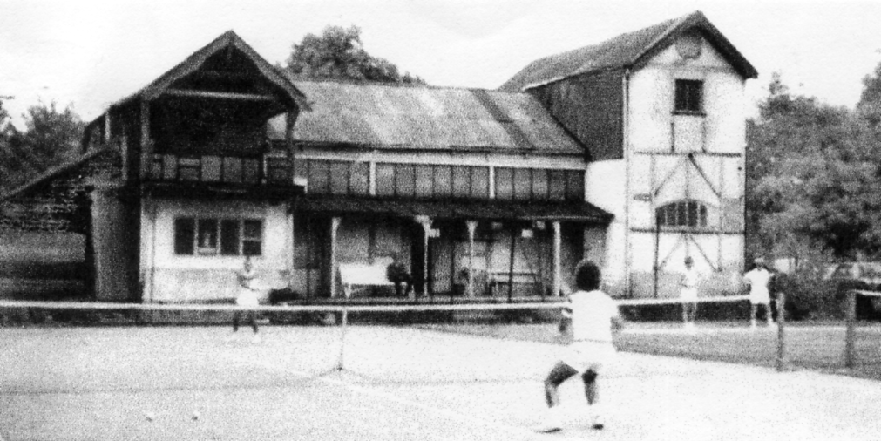
1976 in its heyday

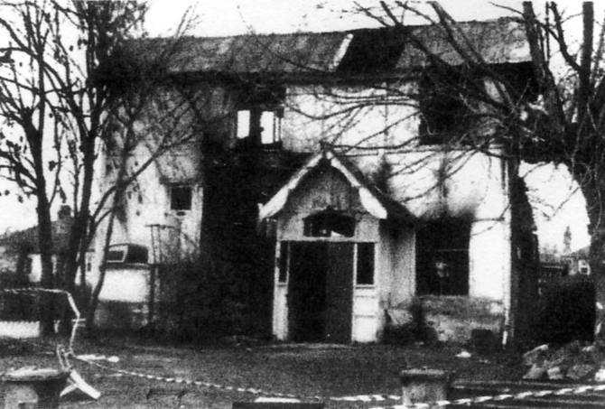
1986 after the fire

Letter from Anne Stevens
Dear Bill,
Ted and I were saddened to read in the Journal that Alan had passed away. On our last trip to the Convention at Crystal Palace we were talking to Alan and I don’t know how it came up in conversation, but I mentioned that I had spoken with someone who’d been working out his finances. I suggested that perhaps he should factor in some extra cash, perhaps to go on holiday. I was absolutely floored when, looking into the far distance, he replied, “I suppose I could go to Grimsby” ! GRIMSBY? I exclaimed as Europe / India / the States had flitted through my mind, “Yes he said, I like going up there”.
I was further surprised, when finishing relating this anecdote to Alan, he told me he too liked Grimsby, had a cousin who lived there and was, in actual fact, soon to go on holiday there himself.
Sure enough, three weeks later, a postcard arrived showing a picture of the Royal Dock, Grimsby c1970, with a message from Alan tempting us to “Savour all the delights of Grimsby”.
A sad loss to the Study Group.
Best Wishes
Anne
The Palace of Industry
British Empire Exhibition 1924 - 25
Demolished 2013
By
Don R. Knight.

The Palace of Industry built in 1922 and 1923 as part of the British Empire Exhibition 1924 -25 and was the last building to be demolished this year.
In 1924 and 1925 the Palace was the second largest building built for the exhibition, the largest was the Palace of Engineering which was six times as large as Trafalgar Square, London. Displayed in the Palace of Industry in 1924-1924 were many machines showing the manufacture of stockings , tapestry, needles, paper, bread, biscuits, chocolate, cigarette making and packing. Aluminium casting, medal stamping, carpet loom, paper making, to name a few thing seen by the visitors and companies looking for machinery for their companies.
The British Empire Exhibition went into liquidation when it closed in 1925, building were sold and demolished and the materials sold. Three of the building remained, the Palace’s of Engineering and Industry and the Stadium. The Stadium was purchased by Arthur Elvin in 1926 and he sold shares to his many friends, his not costing him any thing. In 2000 the stadium was sold to the Football Association for two hundred million pounds plus two million for the memorabilia.
The Stadium was demolished and the Twin Tower were the final part to be demolished in February 2003, the new National Stadium cost over eight hundred million pounds and saw its first Cup Final in 2007.
The Palace of Engineering was demolished in 1980 and today the area has a large retail park. Over the years the Palace of Industry has been divided into units and has had many uses, offices, auction room, warehouse, storage and a distribution centre. In 2010 half of it was demolished and was used as a coach and car park on Wembley match days.
In 2013 eighty nine years after its construction the demolition company moved in to clear the last part of the British Empire Exhibition and by the end of May all that could be seen was a large heap of crushed concrete. Quintain Estates the developers had taken steps to save eight Lion corbels (bases of flag poles) that would and have been seen by the millions of visitors over eighty nine years when walking along Wembley Way ( Olympic Way ).
In preparation for the final demolition a man on a cherry picker (lift) cut around each one with a hydraulic cutter, so making it easy to lift off as the demolition team got to them. This was done and three or four are in fair condition to be saved and hopefully be displayed in Wembley at a site or sites to be decided.
Pictures taken by Don Knight

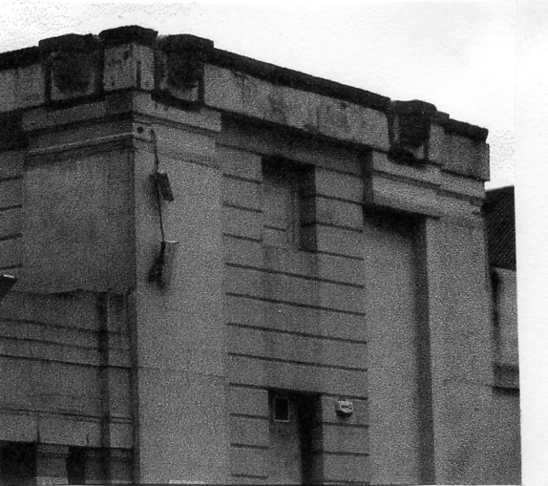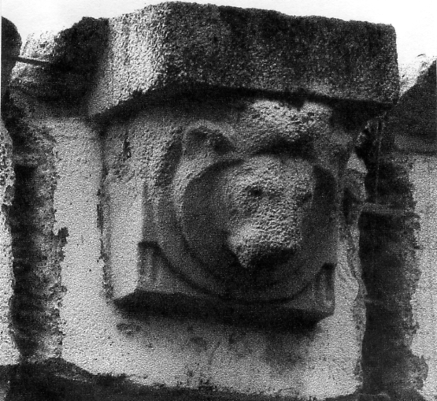

A Message from the President, Ramon Goodey.

The joint meeting with the Cinderella Club on 6th July was, I think from the feedback received, enjoyed by all who attended. A full report appears elsewhere in the Journal. My thanks to those members who gave displays. Unfortunately ‘Midpex’ was held on the same day, but the date for the meeting had been agreed between Cinderella CIub/RPSL, thus we could not change it.
Our next ‘event’ is of course the Annual Convention on 28-29th September at Crystal Palace. Don will be organising it as usual with the AGM on Saturday morning followed by members displays and the annual dinner in the evening. Sunday morning, more displays. Tea / Coffee, biscuits etc. will be available during the two days, all free of course, but payment will be required for the Dinner on Saturday evening.
I am planning two events for next year. First, an open meeting at ‘STAMPEX’. We can hire a room for two hours, stands are available for displays, full details will be announced in the Journal as soon as arrangements have been made. The Public will be allowed to see displays, and hopefully ask about the Group. We shall need members to act as stewards to answer visitors questions and act as security. Hopefully we can attract new members, not only by them visiting but also publicity in the ‘Stampex’ catalogue given out free to the public.
The other event. The National Philatelic Society have asked if members could give displays at one of their meetings next year. This will be held in the afternoon at the Welsh Centre, 157-163 Grey’s Inn Road, WC1X SUE, again date and times will be given in the Journal. It will give the Group more publicity as the meeting will be announced in the Philatelic Press.
My best wishes for the Summer, enjoy your collecting.
Ray Goodey. President

Joint meeting between Exhibition Study Group and The Cinderella Stamp Club
by
Derek Connell (Vice President.)

Well! What an intriguing day we had when we visited the Royal Philatelic Society in Devonshire Place within the old London Borough of St. Marylebone, back in July. Our president, Ramon Goodey had approached the Cinderella Club chairman, Chris Harman with a view to arranging the shared get together and with the co-operation of The Royal, and with the efforts of the two officers, the day was a rip roaring success.
Arriving at the imposing Georgian front door on the corner of Devonshire Street, we were shown into the library and served tea, coffee and chocolate biscuits! Quite a few familiar faces belonged to members of both organisations, so the ice was soon broken and the banter flowed.
Moving to the upstairs exhibition room, E.S.G. opened, putting Ray into bat with an excellent, colourful 30 sheets of British Empire Exhibition publicity labels, some of which are exceedingly rare. Ron Trevelyan continued with 24 fascinating sheets of British Industries Fairs and 24 captivating sheets of The Crystal Palace. Derek Connell squeezed in 15 sheets of Exhibitions of “The Aggie” (The Royal Agricultural Hall) for which he had won a silver medal at Stampex.
Bill Tonkin concluded our first half with his famous “cut and paste”. It was a joy to see this display again and of course many of the Cinderella members had never seen it. Bill has put in many hours of research into postcards of various exhibitions both at home and abroad, showing how the manufacturers used the same cut outs of individuals and groups of people time and again to add visitors to otherwise empty streets in photos taken before the exhibitions were open.
After a suitable break for viewing, Derek started our second half with three frames of Festival of Britain stamps and postmarks, souvenir and charity labels. Ron then returned with two extraordinary frames of French Trade Fairs, which date back to Roman times.
The E.S.G. then had the distinction of being represented by Cinderella expert Charles Kiddle. He gave an outstanding and informative 36 sheets on the 1904 World Fair at St. Louis (“Meet me in St. Louis, Louis) pointing out that, like Paris in 1900, The Olympics were held here, amid little interest. How times have changed!
Our half of the show was wound up by our secretary, the one and only Don Knight, who, before his display, gave a brief tribute to Alan Sabey who, of course, was a Fellow of The Royal. Don also did some P.R. for our group giving a description of our activities and leaving some Journals for any of The Cinderella Club to take. He then amazed us with 36 sheets of a combination of first rate early Congresses and a selection of the colour combinations of the “(deal Stamp” issued at the Jubilee International of 1912.
After a suitable period viewing the second leg, it was time for lunch. Some of us visited one of the nearby hostelries for a pie and a pint (or similar) whilst others took the opportunity to relax at The Royal and study some of the permanent frames on the walls or the small museum in the basement.
The second half of the meeting was hosted by members of The Cinderella Stamp Club and they did us proud. We were treated to a magnificent miscellany of Terrific Triangles, Exciting Exhibitions and Authentic Australians! Pride of place, however, went to Francis Kiddle’s superb display of Congress material, some of it very rare. Being a collector of all things London, I was particularly impressed by the 1923 Congress and International Exhibition Collection, including the programme with an illustration of Big Ben on the cover! Francis has announced that he is donating his entire collection of Congresses to The Royal.
Finally we were approached by organisers of London 2015 and asked if we would like to promote E.S.G. by sponsoring one of fifteen advance publicity postcards which will depict fifteen of the most famous stamp exhibitions. Four of your committee were present so we made a decision to go ahead, choosing the 1940 centenary of the Penny Black Exhibition, which was overshadowed by the Second World War. Perhaps if any members have 1940 material they may care to show it at our convention at Crystal Palace in September (details elsewhere).
Meanwhile, to sum up our day at The Royal, a wonderful time was had by all and a great vote of thanks is due to Ray for organising it. If you couldn’t come, better luck next time. If it was too far to come, perhaps you could organise such an event in your neck of the woods, perhaps with a local philatelic society or exhibition event. We’d certainly support you.
Hoping to see you at the Convention.
Cheers!

Cinderella’s of Ye Ancient Order of Froth Blowers.
by
Bill Tonkin.

At the Joint meeting with the Cinderella Stamp Club at the Royal on Saturday 6 July I was talking to Charles Kiddle when he happened to mention he had recently moved. You might let me have your new address I said and he tore off a piece of paper and wrote it down. This I folded and put in my pocket.
I was at breakfast next morning when I noticed a folded piece of scrap paper in front of me. Ah! I said to myself, that’s Charles new address and in an idle moment turned it over to see what was on the back.
On the back Charles had scanned in an image of a Cinderella label with the magic letters A O F B in the design and the full title below ‘Ye Ancient Order of Froth Blowers’. Now I have been a fully paid up life member of that charitable organisation for 86 years, being enrolled on the 1st of February 1927 at the Naval Oiling Station, Southsea at their meeting held at the Goat Hotel, now gone, (but Fred tells me the Naval Oiling Station is still there).
I think I may well be the last surviving life member of the A O F B as I am sure it has gone out of existence by now.
I have not only kept my 30 page hard back membership book but as you will see on page 3 of my book there is a round seal with a multiple radiused edges in blue on silver with the Froth Blowers silver cuff links featured in the centre. I still have my silver cuff links which were presented to all life members, these I still wear on occasions.

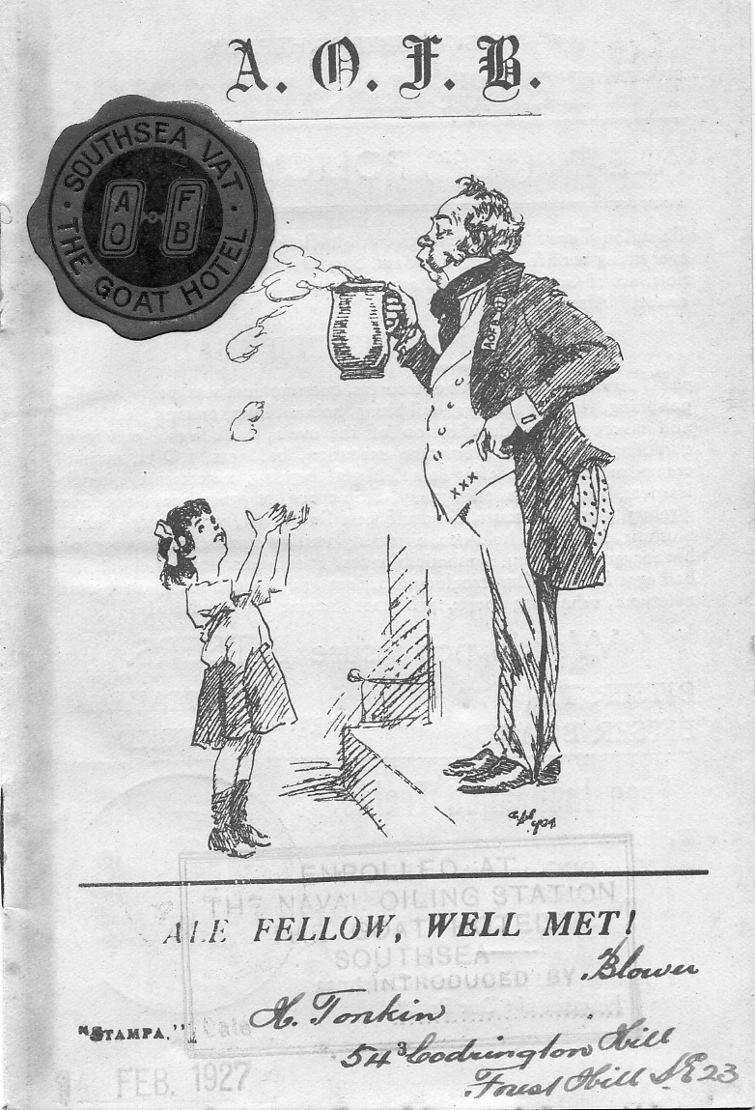
And then the penny dropped, this was the written proof that I had been a Cinderella collector for 86 years. I think at that point the world changed its orbit round the sun as all the vases started rattling on the mantle piece.
How did all this come about ? Well my uncle Dan of blessed memory, was a member and a ‘Blower’. They had an hierarchy within the A O F B that if you enrolled 25 new life members you then became a ‘Blaster’, a 100 a ‘Tornado’, 500 a ‘Monsoon’ and 1,000 a ‘Grand Typhoon’ and so on. Uncle Dan wished to become a ‘Blaster’ and was obviously scraping the bucket when he remembered he had a young (very young) nephew Billie and promptly enrolled me as a life member.
My membership book contains my name, address and number 179209, my uncle’s name and address, he lived literally just across the road from us, at 54, Codrington Hill and we were at 55. There is also a rubber stamp impression with the location of the Vat (branch) where I was enrolled, plus the date 1 Feb. 1927. Now the interesting thing is that this is indisputable written proof that I started collecting Cinderella’s as far back as February 1927, 86 years ago, and that’s going to be a hard one for anyone else to beat.
Getting back to the A O F B about a quarter of a mile from my home is the headquarters of a West Wickham Girl Guides group. This is built on land gifted to the Girl Guides in perpetuity by the A O F B. They also gave land for a heart hospital called I believe ‘Heartsease’ later to become the Cheyne Hospital, which was also in West Wickham, The A O F B was also into organising day trips to the sea side for children and as Charles’s scan shows was involved in endowing 50 children’s cots to various hospitals.
Amazing what memories Charles stirred up in writing his address on an odd scrap of paper. Needless to say I have asked him if I can buy his A O F B Cinderella if it is available.

A New Wembley Map
reported by
Mike Gorringe

Mike Gorringe has sent me in scans of a new map he has just acquired, this brings the number of different adverts on the 1924 British Empire Exhibition maps up to 47. Way back in 1998 in Journal No. 51 I wrote a short article on these maps by Kennedy North and printed by Dobson Molle & Co., Ltd. as, as far as I know nobody has really studied them. The map is so common selling then for only a few pounds, that I should imagine there is not a collector of Wembley ephemera that does not have one or more in his collection. I appealed for members to check their maps and let me know if they had anything new to report. I was told originally there were about 20 different maps. This proved to be wrong and the total soon stood at 36 (2004). At the latest count (July 2013) there are now 47.
I have done a 16 page A4 booklet describing all 47 maps, and if anyone is interested I will send them a copy for £4.00 (in second class postage stamps will do) any profits to go to the group.

Contents of different panels on Map number 47.

I. Advert for British industries Fair 1924.
K, L, M & N Picture of the Imperial Stadium and text on the British Empire Exhibition. The headings of the paragraphs are, Variety and Colour, The Tomb of Tut, Monster Military Tattoos, and An Empire Parliament.
S, T, U & V 4 pane advert for Norvic Shoe Co. at Stand N. 512 in the Palace of Industry, Shoe and Leather Trades Section

Little Gems of the Postal History of the Great Exhibition of 1851
The Society of Arts Garter Envelope, 1850.
Number 2. by
Fred Peskett.

There is a long and interesting story behind this one! About twenty years ago I was putting together a collection of late Victorian and the Three Kings Postal Stationery that had the pre-printed postage stamps cut out and pasted to plain envelopes in lieu of genuine postage stamps for postage. These Cut-outs were initially against the Postal Regulations, which makes them very desirable and collectable, the rules were later relaxed to enable Cut-outs to be used for postage, never-the-less, the collection made an interesting display for showing to the local stamp clubs.

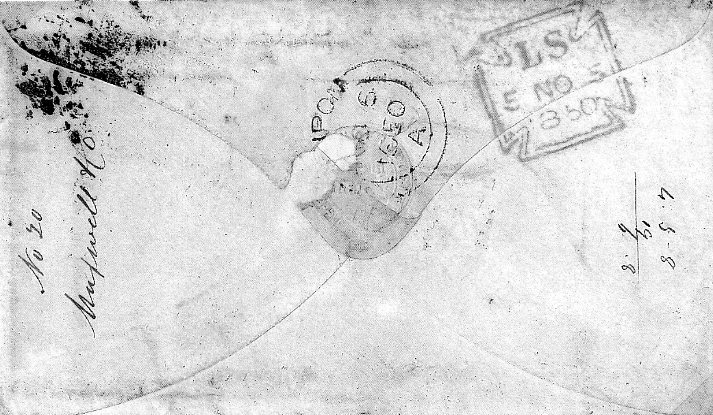

I was sent an auction catalogue for a sale of philatelic items from a venue in Southampton, one lot appealed to me, being listed as:- “Unusual Collection of cut-out Postal Stationery and other unusual and interesting items. Q.V. to K.G. VI”. I made a postal bid which was probably the only one, since the lot went for £2.00. I sorted out the items I wanted and put the remainder into my “look at later” box. Some seventeen years later I got around to having a look in the box. The Cut-out display had long since been shown at several clubs and sold off. So I thought I would get rid of the rest of the rubbish, one of the first items to come to the surface was the envelope shown. I was about to screw it up and throw it in the waste-paper bin, but something said “look at it a bit further”. The flap of the envelope had an embossed “Garter Seal”, a piece was missing, but with a glass I could see it had some writing which seemed to read:- “EXHIBITION OF INDUSTRY” around the belt, and “OF ALL NATIONS” inside the garter. This needed looking into further. The envelope has an imperforate penny red postage stamp with “stars” in the top boxes and “D” & “H” in the bottom boxes. It was addressed to:- A. Henry Vivian. Esq., Pateley Bridge, A London horizontal oval with 19 in a diamond postmark cancelled the postage stamp, on the reverse is a red LS 5 NO 5 cross and a blue RIPPON circular cancel for 6th Nov. 1850. (a pencilled inscription “244/127 £75 the lot” is also on the front which may imply that this envelope was once part of another auction lot of penny reds on cover?)

The research into this envelope went as follows:-Being dated November 6th 1850, probably made it identifiable to the Great Exhibition the following year. I was able to have a look at the records of the Royal Society of Arts, although the example
I had found was not recorded, in January 1851 an embossed flap envelope for the Society of Arts was introduced, it had the same garter seal and wording, but it was against a blue background. Further research with the Victoria & Albert Museum revealed that A. Henry Vivian was a Juror for Class Group VI Manufacturing Machines and Tools at the Great Exhibition.
So far it is understood that no further examples of this particular embossed flap envelope has been found and recorded, although several examples of the blue background Garter Seal are known. It is possible that the envelope I have could be a pre-production envelope used either in error or deliberately before the Society of Arts envelope was formally introduced?
I think the envelope I have may well be defined as being an item of Great Exhibition Postal History? I am rather pleased I did not screw it up and toss it into the waste-paper bin!
The small picture is a re-constructed illustration of the Society of Arts Garter Seal on the envelope described above.

OLYMPIA Corporate History 1884-1999
by
© John Glanfield. January 2012

1894 Jan on. Resignations from the board of Olympia Ltd
Joseph Lyons January 1894.
Harold Hartley January 1894. He joined Kiralfy shortly afterwards to redevelop the Earls Court and form the immensely successful London Exhibitions Ltd to stage its lavish shows. National Archives. Kew company papers piece C26/523
John Hart May 1804. Ironically, he later became a member of the creditor’s Committee of Inspection during the company’s winding-up
Of the four one-time Syndicate trustees, only Montague Gluckstein remained on Olympia’s board, as chairman to the end.

1894. 17 Dec. Olympia Ltd shareholders meeting.
The company’s first production had been the spectacular and very profitable ‘Constantinople, or Revels of the East. ‘It ended its eleven months run on 30 October 1S94 A balance sheet prepared as at that date showed a net profit of £33,847 and cash at the bank £30,256.
This balance sheet was first presented to shareholders on 17 December when a second dividend |(10s) was declared to bring the total paid to date to 15s per share, a yield equivalent to 15% pa However the balance sheet recorded cash at the bank as £11,500 rather than £30.256 as stated in the October original. No explanation was given for the discrepancy. When Montague Gluckstein was questioned at a public examination of the directors the following year he asserted that all the expenditure between 20 October and 26 December 1894 when The Orient exhibition opened, was on capital account. He denied emphatically both that the dividend was paid out of the newly raised funds, and that a loan of £15,000 had been obtained by the directors expressly for the purpose of paying the dividend.

The directors also reported that they had secured 5.25 acres of freehold land directly opposite Olympia on the other side of Blythe Rd.
(This looks intriguingly like the optional parcel of ‘upwards of 5 additional acres in dose proximity’ that Edward Hunt had offered the NAH company ten years earlier). Its southern boundary adjoined Joseph Lyons’ newly built Cadby Hall HQ and food factory fronting Hammersmith Road. The land would shortly be transformed into Olympia’s magnificent ‘Blythe Road Annexe Gardens’ with promenades and exhibition buildings. To fund the acquisition and its development the board proposed to increase capital by £77,500, offering 77.500 shares of £1.00 at a premium of 5s per share The company would also construct a lavish Winter Garden on the 2.5 acres between the W. end of Grand Hall and Blythe Road. It originally held stabling for 120 horses. It would now become a large single storey glass-roofed extension off the hall’s ground floor, and was later renamed the Grand Hall Annexe. The industrial-looking structure was replaced in turn by the impressive recent extension of Grand Hall at ground and gallery levels.
The company report and accounts were adopted and approx. £46,000 was subsequently subscribed in response to the share offer. Of this, £22,500 went to (he vendors of the Blythe Road site, and £15.000 was spent on its development.
The Times 6 Nov. 1895 report of public examination of directors.

1895 February. Olympia Ltd increases its debt burden
Fresh capital from the share offer notwithstanding, the company secured mortgages on the newly acquired Blythe Rd site totalling £37,500, of which sum J Lyons & Co. provided £20,000.
National Aichives. Kew. company papers, piece J14/I85.

1895. 11 May. Application to wind-up Olympia Ltd
The petitioners were Robert Legg of City Iron Works (owed £578.16.2) and John Levy, printer & stationer (£91.9.11]. Only five months earlier, the board had published a bullish report and encouraging accounts, declaring a generous dividend and inviting shareholders to subscribe a new stock issue.

1895 1 July. Application granted
George Stapleton Barnes was appointed Receiver. Nominal capital at 1 July 1895: £191,868 of £1.00 shares issued and fully paid up Secured debts. £76,500 mortgages on debentures as security. Other mortgages £48,000 (incl. the £37,500 held on the Blythe Rd site). Unsecured debts total c. £23.350. (The Receiver was released 6 September 1901 and the company was dissolved 24 December 1907).
National Archives. Kew. company papers, piece J13/1248

1895 5-19 November. Public examination of the directors of Olympia Ltd
In the course of the examination of the directors by Mr Registrar Hood at Carey Street, they attributed the crash to a severe 12-week frost earlier that year followed by a continuing ‘flu epidemic. Over 34,000 had attended on 26 December 1894, the opening day of the company’s lavish production ‘ The Orient at Olympia.’ but numbers later declined steeply and forced its premature closure the following July. Costumes alone had cost £20,000.
Attention was then drawn to the shareholders’ meeting of 17 December 1894 (above) at which a second dividend had been declared. The Official Receiver noted that the balance sheet dated 20 October, but first published at the 17 December meeting, showed £30,256 cash at the bank whereas the true figure by 17 December was £11,500.
It also emerged four weeks after that December meeting that unsecured debts were approx. £60,000, no mention of this having been made to shareholders when they were invited to subscribe to the new issue. The Receiver later told a shareholders meeting that he considered the directors of the company had been less than frank with them when capital was increased on that occasion, in view of the change in the finances of the company between the October date of the balance sheet and its December publication
The Receiver assured shareholders that his examination would be rigorous.
In reply to counsel for the shareholders Montague Gluckstein emphatically asserted that the issue of fresh share capital was not used to pay the dividend announced at the December meeting, and that the dividend had been honestly and fully earned. He said all the expenditure in building and preparing for The Orient from 20 October (the date of issue of the balance sheet) until the show’s opening on 26 December 1894. was met from capital. He strongly denied that the 10s dividend was paid out of capital, or that a loan of £15,000 had been obtained by the directors expressly for paying the dividend Gluckstein denied a later suggestion from counsel that the Prospectus had been drawn En such a way as to conceal the facts. He also denied that the debenture bonds were acquired so as to reduce the price to be paid for the property. .
There was some confusion over the sum paid for the Blythe Rd Annexe Gardens site. Gluckstein told the examiners that as reported at the shareholders meeting, the land had cost £22.500 plus £15,000 for its development. Seven days later he amended this, stating that from figures which he had compiled, the respective costs were £40,000 and £13,000 The Times, 6 and 13 Nov. 1895, reports of the examination

1895 1 October. A second Olympia Ltd is registered
The Scheme of Arrangement between Olympia Ltd and its creditors involved the formation of a new company in the same name which would take over all the assets and liabilities of the old. The new Olympia Ltd was capitalised at £225,000 in £1 shares, the old business and its debts to be secured in return for shares in the new The original shareholders were credited with 12s 6d per old share, paying a further 7s 6d by instalments to secure each fully paid 20s share in the new company.
Receiver George Barnes was to effect the sale on behalf of the creditors on specific ‘new equity for old debt’ terms. He stipulated however that the scheme would not be confirmed until 100,000 shares in the new company had been applied for. Barnes later raised the threshold to 125,000 shares, causing the directors to decide themselves to pay the necessary deposits on the difference between the new target and shares already subscribed. They were soon able to waive their rights on this top-up stock as others sought to buy in Olympia reopened on Boxing Day 1895. By 15 January 150,000 shares had been subscribed.
Chairman: Edward Lee, solicitor
Directors J. C. Hill & Walter Hill (advertising contractors representing the creditors).
John Hugh Broughton-Leigh of Willenhall nr Coventry, (gentleman).
Wm George Devon-Astle, (dealer in Colonial stocks).
Gen Manager Wallace Jones
National Archives, Kew, company papers, piece B T31/6450/45462
The Times 16 January 1896

1895 October-January. Sir Augustus Harris.
King of London theatre and a large shareholder in second Olympia Ltd. was appointed General Manager in October - a master stroke. He planned to reopen the Hall on Boxing Day for a ‘Grand National Military and Sporting Exhibition’ to run for an extended season presenting military combats, representations of great military events. military life at home and abroad, and sporting exhibits including polo, cricket, football, bicycling, hunting, shooting, and field sports, plus a race meeting. The show was a great success. Sir Augustus joined the board on 15 January 1896.
The Times 28 November 1895 & 16 January 1896.

1896 May. The ‘Annexe Gardens’ in Blythe Road formally open
An immense throng including many MPs and clergy attended the opening of the pleasure gardens on 16 May 1896. An imposingly tall palm house and a large exhibition Pavilion stood in over live acres of grounds. They were linked to Grand Hall by a broad subway beneath Blythe Road, brilliantly lit and resplendent with murals and mirrors. The Pavilion’s 40 ft high roof was supported by pillars disguised as palm trees, with real palms in profusion. The facade and side of the building totalled nearly 500 ft according to the local Press. The Times declared ‘the new hall is almost a rival of the original building (Grand Hall).’
This stunning asset cost over £18.000 (£9m in 2010), yet it was forcibly sold months later.

1896. June. Sir Augustus Harris dies.
Sir Augustus died on 22 June of a wasting disease and overwork. Frederick Harold ‘Pa’ Payne, a most able director of brewers and principal creditors Allsopp & Sons Ltd, took over as Managing Director of the second Olympia Ltd. Edward Lee had earlier given up the chairmanship, claiming after the company went into receivership that he had stepped down because he considered the board was ‘unnecessarily hampering Sir Augustus Harris.’ Walter Hill had replaced him. The Times’, reports 28 November 1895 16 January. & 18 May 1896.

1896 24 June. Walter Hill takes second Olympia Ltd into receivership
Days after the death of Sir Augustus, Hill told shareholders that pressure from creditors had led to appointment of an Official Receiver of the company. It held £57,243 of share capital, with liabilities (additional to a £27,500 mortgage on the Annexe Gardens) comprising first debentures for £80,500 and other loans and debts totalling c £14,500. There were also unsecured creditors for some £6,500. The total amount of ordinary share capital and debts was £72,000. The company had taken over liabilities from the old Olympia Ltd which, it later pleaded, were unasertainable at the time and proved onerous. The costs of the scheme sanctioned by the Chancery Court had been very heavy, as also the financing of the Blythe Rd annexe project Nearly one quarter of the entire share capital was wiped out before the doors opened. Thereafter, weekly takings fell short of expenditure by £500-700.
It was resolved that a committee be appointed to confer with the directors and formulate a scheme to keep the company afloat. The committee included ex-chairman Edward Lee, and Montagu Gluckstein. late chairman of the original Olympia Ltd whose undoubted business acumen was highly valued. (His summons by the Official Receiver of the first Olympia Ltd and his conviction for breach of trust arose two years later, in 1897-8). The Times; report. 25.6.1896

1896 8 July. Creditors secure winding-up of the second Olympia Ltd. (Dissolved July 1903)
On a petition by Robert Adams, engineer (£132.10.0 owed). First debenture holders Allsopp & Sons Ltd took provisional possession of the property and on an order by Justice Vaughan they paid out the second debenture holders and took definite possession.
National Archives. Kew pieces BT31/6450/45462, J13/1466, J14/185.

c 1896. The Annexe Gardens are sold.
Wallace Jones, late General Manager of the company, had taken on the operation of the Gardens and Pavilion under an arrangement with the Receiver in which Jones would pay all outgoings in lieu of rent However, the pressing need to meet liabilities forced the sale of this new and hugely costly development. It was demolished for the present Post Office and adjoining monolithic PO Savings Bank building, erected ca.1899.

1897 November. J Lyons forecloses on mortgage.
J Lyons & Co. had started an action against the second Olympia Ltd in March. In November Lyons foreclosed on Olympia’s mortgage of £21,764.5s.8d.
National Archives, Kew. legal papers, piece J14/185.

1897. Official Receiver summons HI. Gluckstein and others for alleged breach of trust.
George Stapleton Barnes, Official Receiver and Liquidator of the first Olympia Ltd issued a summons on 15 August under section 10 of the Companies (Winding Up] Act, 1890 alleging misfeasance or breach of trust by Gluckstein, Lyons, Hart and Hartley in relation to the company.

1898 17 February. The summons is heard by Mr Justice Wright.
The Official Receiver requested an Order that ‘Montague Gluckstein, who with Joseph Lyons, John Hart and Harold Thomas Hartley look part in the formation and promotion of [Olympia Ltd] and was also a director thereof was guilty of misfeasance or breach of trust in relation to the said company in that he and [Lyons, Hart and Hartley! being such promoters and directors as aforesaid secretly and without the knowledge of the said company obtained and retained for their own use out of the purchase money paid by [Olympia Ltd for the Olympia properly] the sum of *£6341 which was divided among them as follows - M Gluckstein £1441, J. Lyons £1441, J. Hart £2306, H.T. Hartley £1153’.
The Receiver asked that Gluckstein be ordered to repay the whole amount with interest at 5% pa. plus costs. However the summons was dismissed, with costs awarded to Montague.
National Archives, Kew, piece J13/l248.
The Times. 27 May 1898, report of appeal following dismissal of the summons.
*£6,341 equates to £2.5m in today’s terms (2010, average earnings).
See http/www.measuringworth.com/calculators/ppoweruk/

1898. 12-13 May. Appeal against dismissal of summons against Montague Gluckstein.
The Official Receiver’s Appeal was heard in the Supreme Court before the Master of the Rolls and the Lord Justices Rigby and Collins. Though only Gluckstein was before the Court, Lyons, Hart and Hartley as the other promoters of the first Olympia Ltd were joined with him in the judgement.
The Master recited the allegation that Gluckstein and others, being promoters and directors of the company, made a secret profit of £20,000 at the expense of the company. The defence is that the profit in question arose from a transaction with which the company had no concern and was, moreover, fully disclosed to the company. The case is important, not only to Mr Gluckstein and those associated with him, but to all persons engaged in Forming companies and who take shares in newly-formed companies. The most ingenious mechanism has been devised in order to bleed this company to the extent of £20,000 without the knowledge of the shareholders, and the question is whether that mechanism will answer its purpose.’
The Times, 27 May 1898, report of appeal following dismissal of the above summons.
Note £20,000 equates to £7.5m in today’s terms [2010) using average earnings.
The Master then summarised the dire financial situation faced by the National Agricultural Hall Co. when it entered receivership He said that the company’s ability to pay off Olympia’s debenture holders depended on what could be raised by selling it. Obviously the more the property sold for, the better for those who held the securities. He went on - ‘If the securities could be bought up cheap, and the premises could then be sold for much more than the sum due on them, a substantial profit would be made. Further, if the same persons could buy the debentures cheap and also buy [Olympia] if they could resell the property at an advanced price, they would make a double profit by paying themselves as holders of the securities the [full] amount due on them; and secondly, by paying themselves as vendors the advanced price at which they resold the property. Moreover, if it could be arranged that they should not pay for the property until they got paid the advanced price at which they resold it, they would not be under the necessity of making cash advances themselves to any considerable extent. These observations will render what was done quite clear.’
There was no attempt to conceal the syndicate’s sate of Olympia and its profit of £40,000, and there was no cause for any complaint in this, save that it enabled the syndicate to make a secret profit out of its earlier debenture transactions.
The burden of the Master’s conclusion was that Gluckstein, Lyons, Hartley and John Hart had secretly taken profits from the company for their self-enrichment in breach of their duty to inform the company of what they were doing. The legality of these transactions was undisputed save for the alleged failure to declare the profits on the discounted bonds.
In earlier public examination during the winding-up Gluckstein had denied that the bonds were acquired in order to reduce the sale price of Olympia.
Times report. 6 November 1895
The Master gave his opinion that the order dismissing the Receiver’s summons must be reversed and an order be made for repayment by Gluckstein of the sum mentioned in the summons after deducting what if anything may have been recovered from the other defendants, with interest at 3% and of the costs arising there and earlier. Justices Rigby and Collins concurred. The Receiver’s Appeal was upheld. for this & related corporate events.
See National Archives, Kew. pieces BT31/5532/38446 & J14/185.
Also ‘Times’ reports of 25 July.2 August. 6. 13, 14. 20, 28 November 1895, 16 January, 25 June 1896, 27 May 1898.

1903-4. Historic turning point for Olympia and the wider exhibition industry.
Olympia’s farsighted MD, Frederick Harold ‘Pa’ Payne transformed the Hall and soon its fortunes over the winter of 1903/4 In place of the ruinously inflexible semi-permanent seating and the immovable arena for cattle shows and circuses, he created a clear-floor display space adaptable for exhibitions, arena events and as a seated auditorium.
The tiered seating for 4,000, the plush boxes and the arena itself were ripped out, a new concrete floor was laid and lightweight demountable seating was purchased. At £8,000 (£3m today) it was a costly operation for a company in receivership but having literally cleared the decks, Payne’s refit accelerated the emergence of the modem exhibition industry. He wooed and won the 3rd annual SMMT Motor Show, bringing it to Olympia in February 1905 It proved so successful that a repeat followed in November. The Royal Naval & Military Tournament finally switched from Islington in 1906, and the following year the ‘Aggie’ lost Montgomery’s International Building Trades Exhibition (later Interbuild) to Olympia. The Daily Mail Ideal Home Exhibition was launched there in 1908. Other trade and public events followed. Not all were winners, but a busily profitable calendar became established as Olympia led its industry into a new century of enduring growth.

1904 December. The ‘New Olympia Company’ acquires Olympia
Payne’s new approach promised better days for Olympia. It was with that expectation that the New Olympia Company Ltd was Incorporated on 28 December 1904 Its nominal capital comprised £89,100 in ordinary shares of £1.00, and £900 in £1.00 preferential management shares.
Vendors Allsopp & Sons received in payment an allotment of £89.093 in ordinary fully paid £1.00 shares - 99.99% of the issue - plus an option exercisable by them at any time on or before 25 March 1905 to require The New Olympia Company Ltd to issue to their nominee on payment of £1.00 per share all 900 of the preferential management shares, or any lesser number as required Additionally, The New Olympia Company would accept and settle the vendor’s Olympia-related debts and liabilities.

To be continued

