Editorial Number 11

Certain decisions were taken by an ‘ad hoc' committee during the York meeting '88 that will bring about some major changes in the aims and objectives of the Exhibition Study Group.
We are to produce four newsletters per year and because of this the membership , this year, will be £5.
The kind offer by Karl Illingworth to publish and post the newsletter has also eased the problem for the editor! I will only need to send Karl the photo ready copy and one part of the time consuming exercise will be taken care of by Illingworth Developments.
Another problem, one which I have aired before, has been resolved. The members decided overwhelmingly to include Philatelic Exhibitions and Pageants within the scope of the group. I hope that this will be immediately reflected in the content of the newsletter.
I found 1988 to be rather a thin year for collecting Exhibition material. If I had not picked up a few choice cards at BIPEX and a lot of space fillers from a certain person from Bingley, it would have been my worst year since I started on the theme. Is it just me or are we all having difficulty? I suppose the best thing about the year was the celebration of the 50th. Anniversary of the Scottish Empire Exhibition. As I write this editorial I have yet another book in front of me, picked up only yesterday, on this event. The title is ‘The Empire Exhibition of 1838 , The Last Durbar ' by Bob Crampsey. It gives a prominent acknowledgement to Stanley Hunter (who is he Ed?) and on the strength of that I paid out my £12.95. ( Pub Mainstream Publishing ) I must draw to the attention of the members the outstanding book of the year as far as I am concerned , this is Glasgow's Great Exhibitions (details at the end of the newsletter.) What have we to look forward to this year, certainly something on the Paris 1889 and the 50th. Anniversary of the New York's World Fair. How about an article from somebody on either event. Deadline for copy for the next newsletter is March 30th.
Another plus for the year was that at least two new Initiatives appear to have got off the ground, one relating to the Festival of Britain and the other the British Empire Exhibition 1924/25. I hope to be able to give a report on each development in the next newsletter as well as listing the details of those groups already in existence eg. Crystal Palace and Wembley groups. If anyone can give me up to date information on these or any other groups, I would be most obliged.
The Study Group meeting for 1989 will be held in Manchester. In late September or early October. Details In newsletter No. 12.
The subs, for 1989 are now due for nearly all members so to avoid disappointment in March please send your £5 now!

Andrew D. Brooks Jan. '89.
Fairhaven,
Sunderland Road,
East Boldon,
Tyne & Wear,
NE360NA

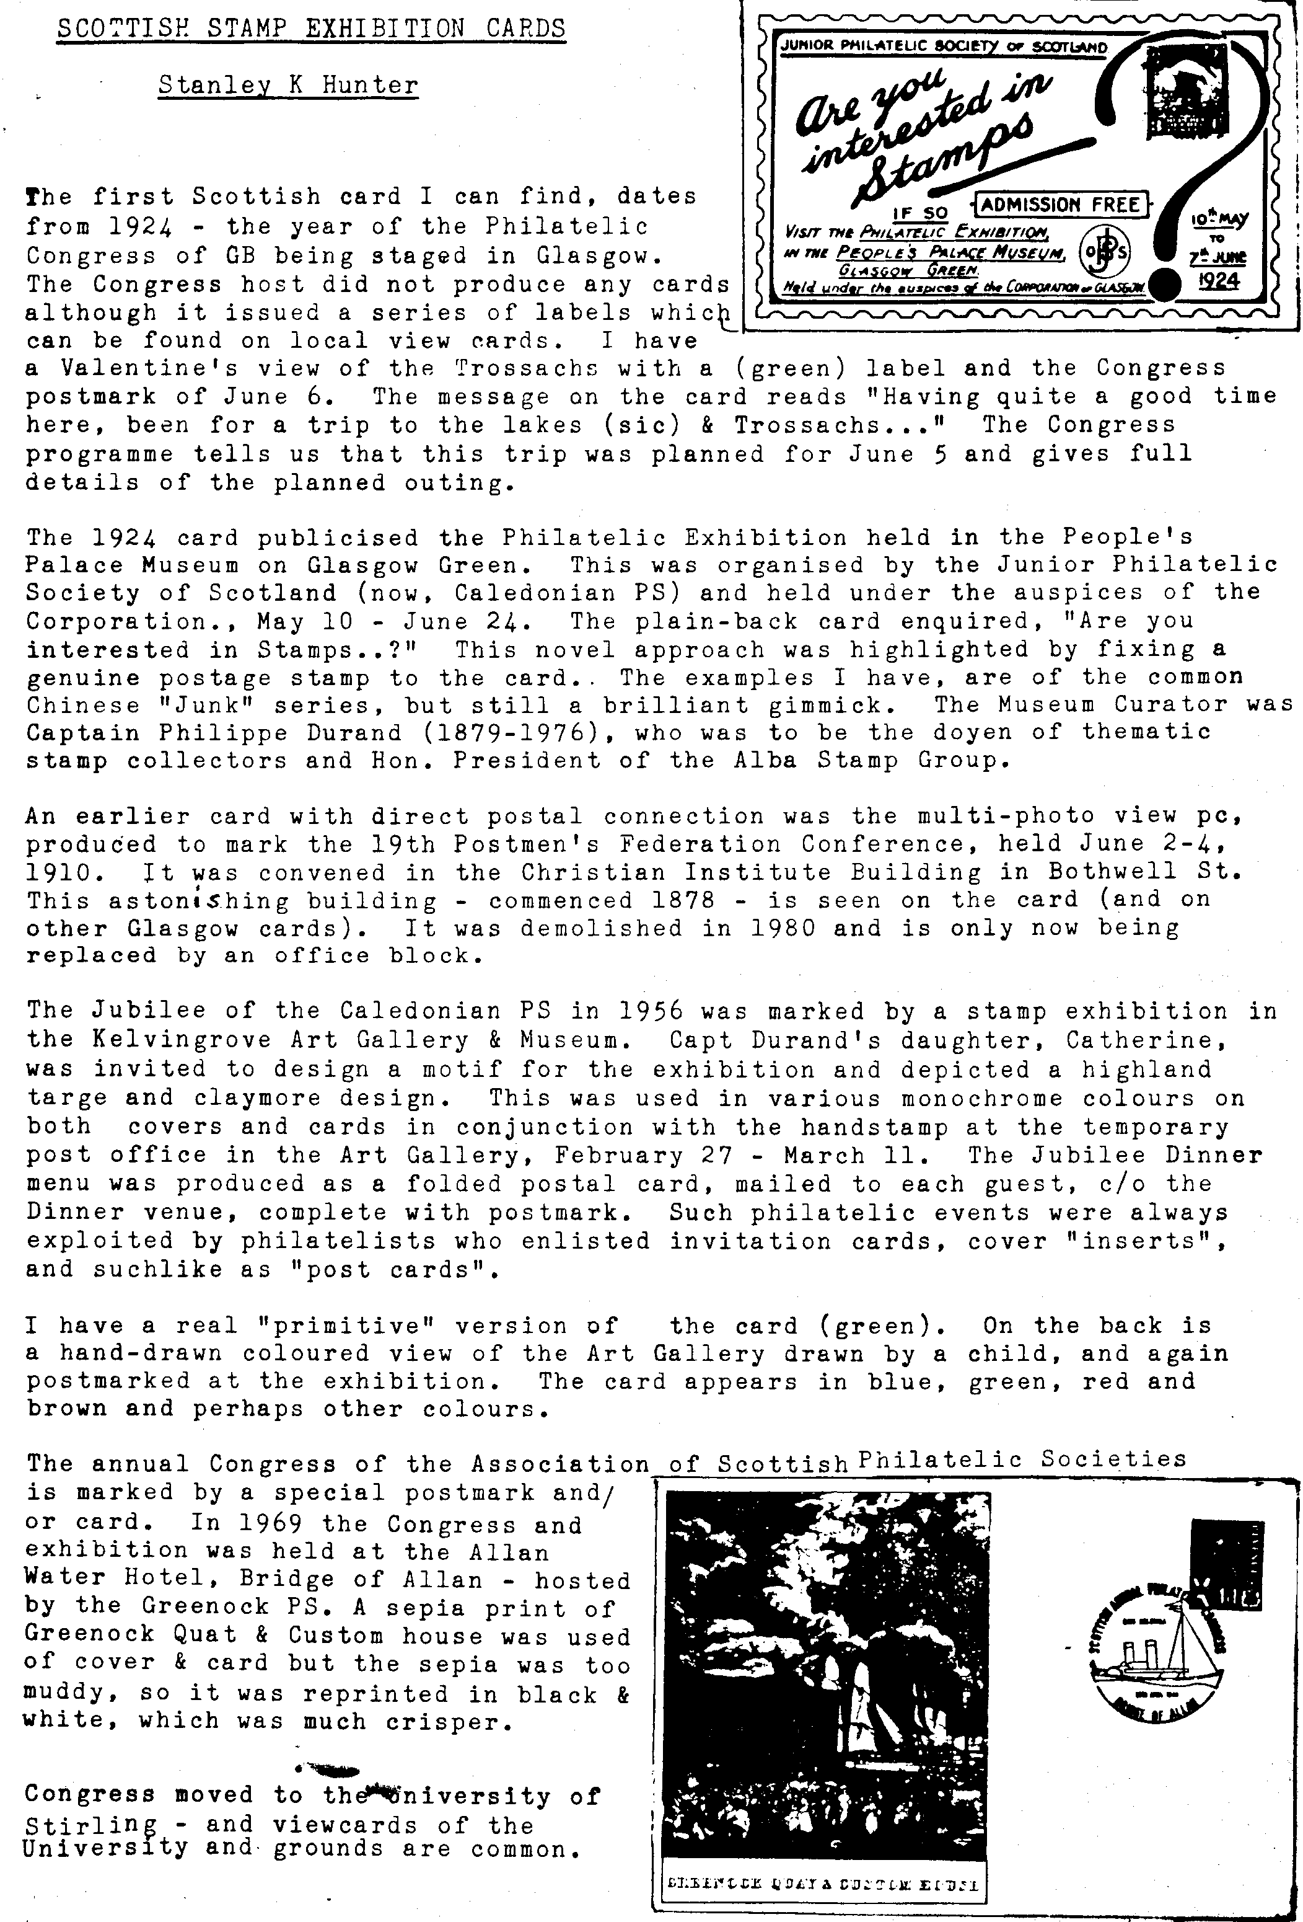
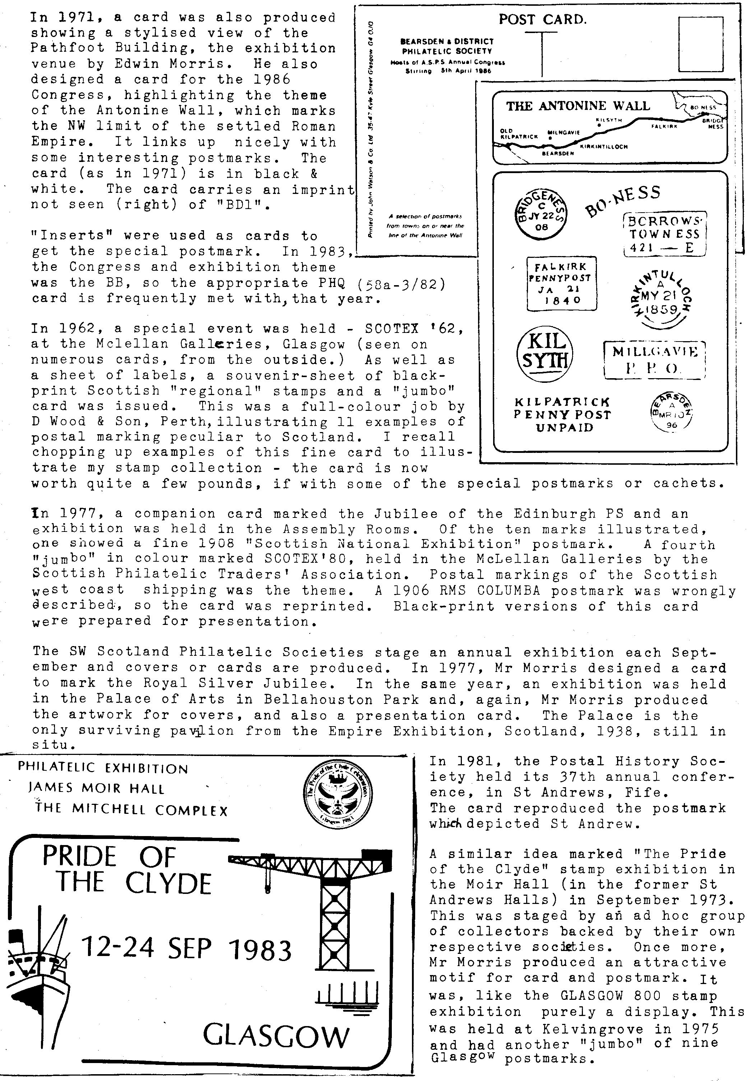
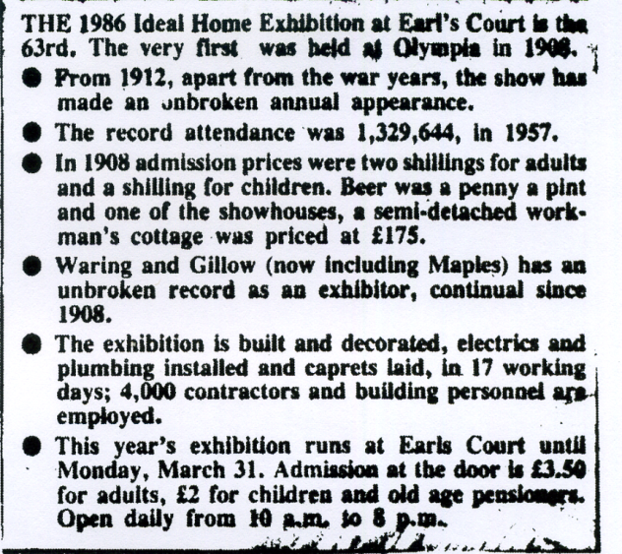

This fact sheet cut out of a local newspaper a couple of years ago prompted me to write a few notes on the postcards of this exhibition. Fred Fletcher and I have been listing these cards for a few years as we picked up the cards at fairs and wherever else we could lay our hands on them. I must admit in the early days they were in the same class as the Missionary Ex. and for a time we did tend to turn our noses up at them!
Most of the cards produced in the inter-war years are virtually all the same. They tend to be real photographic, sepia or sepia colour tinted. A few are black/white. Most were photographed and the copyright of a certain Captain E. W .J. Payne M.C.
If I had to guess at the numbers produced each year , it would have to be between one to two dozen. This would give us an estimate of between 250-500 cards for the period 1919-1939. We have listed 67 without any real effort. Pre-1914 we have only recorded cards for the years 1910 and 1913 and we would certainly like to hear from anyone with other dates After the Second World War , we have only listed cards for three years 1954, 57 and 58, but we believe that this can be extended.
I do not pretend that all the titles are absolutely correct, some of the cards are not in our collections and will have been scribbled down from another source and this is how errors creep in. Also it is taken as read that Ideal Home Exhibition or Daily Mail Ideal Home Exhibition is incorporated in all the titles.
We regard this as a starter and would like to publish all your additions before the end of the year.

Andrew D. Brooks Fred Fletcher Jan. 1969.

1910 Ideal Home Exhibition. B/W Glossy (Interior general view of the Tudor Village) Two different views recorded.
1910 Souvenir of the Ideal Home Ex. , April 1910. B/W sketch of Red Lion Inn. Pub. Garden Life Press, Hatton House,Great Queen St. L.W.C.
1913 As part of the I. H. Ex. a Russian village was built in the annex.
Seven pictorial postcards were sold in a packet for 6d. Sepia matt, with border. No pub. or photo.
No. 1 Souvenir of Russian Village, Olympia 1913.
No. 2 The Village School
No. 3 The South Russian Farm
No. 4 The Crucifix in the Forest
No. 5 The Village Church
No. 6 A Group of Russian Peasants
No. 7 North Russian Log House
1919
1920
1921
1922 Nil returns for each of these years.

1923 H. M. Alexandra's Garden.
H. R. H. Princess Alice's Garden.
H. R. H. Princess Mary's Garden, Olympia. Constructed and planted by Pulhaa and Sons, 71 Newham St. Wl. ( The last card is different in that the title is very roughly typed over the picture)

1924 A Pergola Garden. (13) This is the number on the front of the card)
Japanese Tea Garden (3)
A Rock Garden ( no number)
The Dell (1)

1925 Elizabethan Carnation Garden (9)
The Lovell House. Y.J.Lovell and Son, 6 Bathurst St. W.2. B/W Matt ( not usual type)
Riviera Garden (4)

1926 The End of a Villa Garden. (11)
Set by Alfieri Picture Service, 12 Red Lion Court, E.C.4.
The American Kitchen The Spanish The Swedish The English ..
The Chinese The Dutch The Danish The French

1927 A Westmoreland Rock Garden (4)
A Village Pump Garden (9)
Fountain Court Garden. (7)

1928 Entrance to an Italian Garden (23)
The Cascade (1)
A Carnation Garden.(8)
The Gnome Garden (3)
Dutch Perpetual Garden. (21)

1929 A Witch Ball Garden (6)
Carnation Garden (7)
A Japanese Garden (5)
An Old Mill Garden. (16)

1930 Well Head and Terrace Garden by G. G. Whitelegge. (10 ) Colour/Tint.
The Cascade Garden C/T.(3) Colour/Tint.
Rock and Pool Garden (19)
The Thatched Cottage Garden (7)
Terrace and Summer House Garden. (2 ) Colour/Tint..
Frewen Cavity Brick House, Ten Tested (British) Lined Throughout.

1931 A Kent Oast House Garden. (4) Colour/Tint..

1932 The Ragged Messenger Garden (16) Colour/Tint.
Mapp and Lucia Garden by Carters Tested Seeds (2) Colour/Tint.

Mapp and Lucia Garden by Carters Tested Seeds (6) C/T.
The Garden of Delight by Gavin Jones (13) C/T.
A Topiary Garden by John Klinkert (22)
'Autumn in Arran' Garden by Allwood Bros. (15)
Young Anarchy Garden by G.G.Whitelegge (16)
Root Garden by Herbert Brook (8) C/T.
1933 The Honeymoon Garden by J.Burley and Sons Ltd. (22)
The Earth Garden by J. Klinkert. (16)
'Lorna Doone' Garden (23)
‘Lorna Doone' Garden by William Wood and Sons. (20)
John Bull's other Garden by Gavin Jones. (19)
The Barrier Garden by Carters Tested Seeds Ltd. (3)
The Gates of Desire Garden by G. G. Whitelegge (14)
Naboth's Vineyard by Bakers.
The Barrier Garden by Carters Tested Seeds.(18) C/T.
1934 Heath Robinson's Ideal Home;
The Garden
The Dining Room
The Bedroom
The Nursery
The Kitchen
The Gadgets.
Crowhurst Place Water Garden by J.Burley and Sons. (17)
1935
1936 A Tiny Garden by B.Sunley and Co. (14)
The 'Delius' Garden W. Wood and Son. (7)
New England Idylls Garden by R. Hancock. (4)
A Woodland Garden by Carters Tested Seeds. (1)
'In a Monastery Garden' R.S.Skelton. (9)
1937 Robert Burns and Mary Burns Garden by I Walker. (1)
Paul and Virginia Gardens by L.R.Russell.(4)
John Rldd and Lorna Doone Garden by Gavin Jones. (6)
David Copper field and Dora Garden (9)
Maud and her Lover Garden by Caut.(ll)
Nelson and Lady Emma Garden by Skelton. (8 )
Eger la and Numa Garden by Carters. (5a)
Paola and Francesca Garden by J.Burley. (7)
1938 Beverly Nichols Garden by Carters Tested Seeds.(lla) C/T.
1954 Garden Landscape by R.Wallace and Co. (105)
A General View of the Grand Hall (108)
Garden Landscape by Whitelegge (102)
by Granville Ellis (103)
Rock Garden by Fitzpatrick. (88)
1957 The Market Place, Grand Hall, Olynpia. (143)
Iron Woork in the Garden by Hancock Indus. (127)
1958 A Delightful Garden by Wallace and Barn (196) B/W.
An Old World Garden by Granville Ellis (244)
The Palace of Fontainbleau Floodlit at Night (211)
A Wild Moorland Scene and Waterfall by G.Whitelegge. (207)
A Stately Home in the Garden by the River (206)
Undated but almost certainly in the Fifties.
A Rock Garden and ®»amerhoae (Fitzpatrick) The Rock Pool
Granville Ellis Gardens)

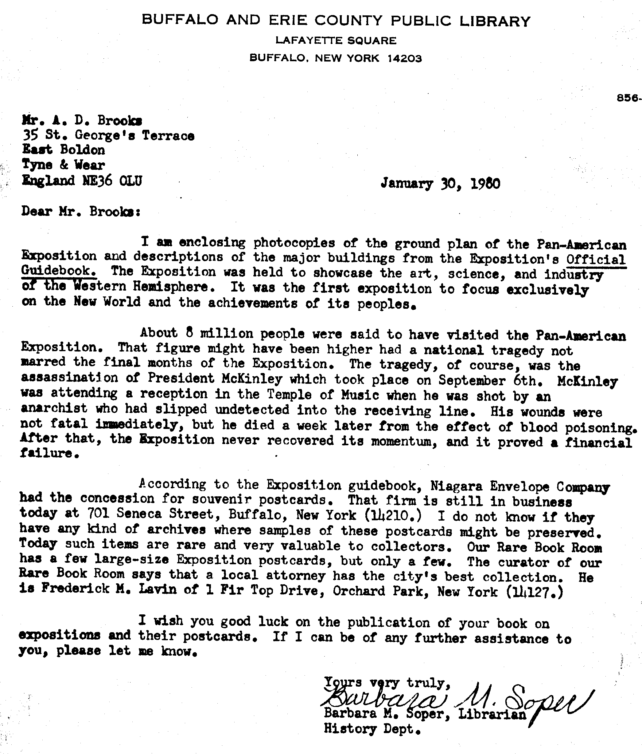

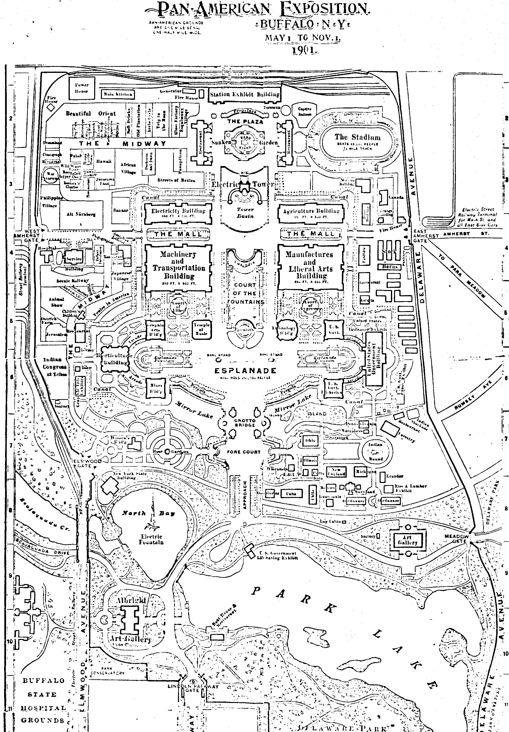
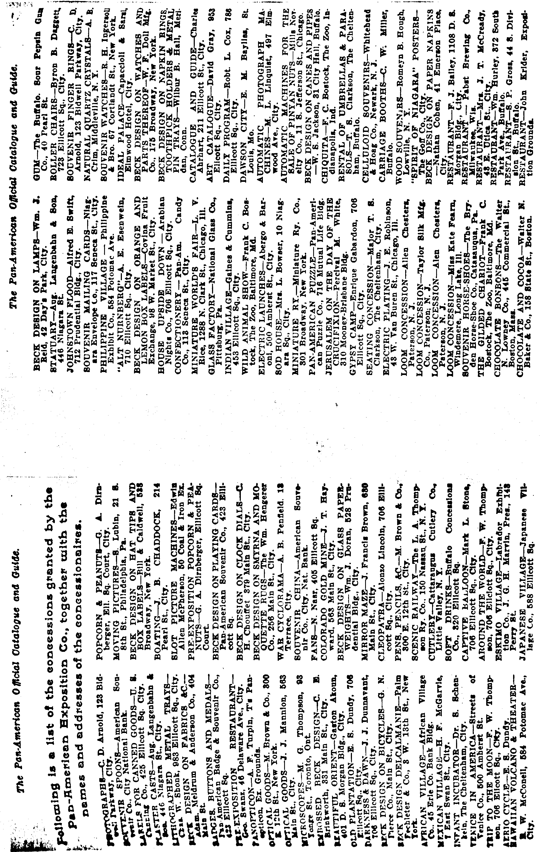

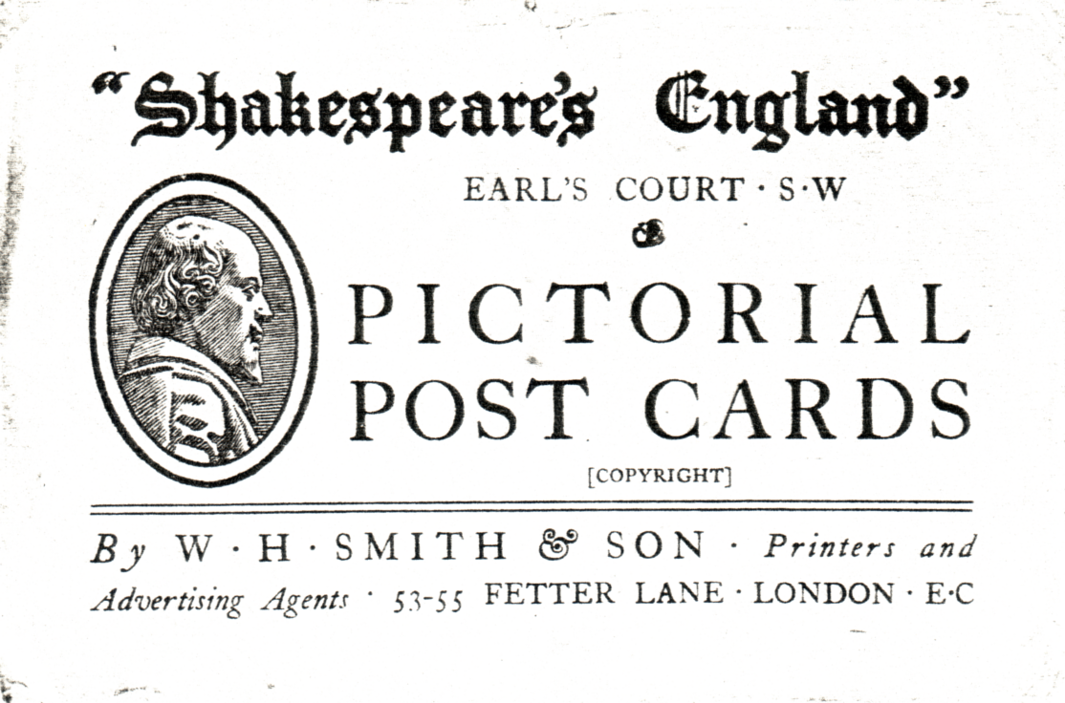

Shakespeare's England

In the summer of 1912, Mrs. Cornwallis - West (the former Mrs Randolph Churchill) organised an exhibition at Earls Court in London, called ‘Shakespeare s England’ and Colonel Foss and the Company were able to lend her some items from the Armada ship.
The Pall Mall Gazette on July 30th., 1912, ran an account of the visit of King George V and Queen Mary to the exhibition. Their Majesties arrived in a closed motor car at the Warwick Road ntrance on the ’hard’, with its severe paving of cobble stones which the Queen found to be terribly realistic, Mrs. Cornwallis - West, pointed out with her white sun-shade, the features of the harbour and Drakes fine galleon.
The King inspected the cannon-balls from the Armada ship of Tobermory and remarked that ‘people were not likely to walk off with ammunition as heavy as this was in their pockets.'

F. A. Fletcher 1988.

As far as the postcards for this exhibition are concerned we have listed the following series;

Rotary 6951 A-X ie; 24 cards. These are the normal high quality cards associated with this publisher.

W.H.Smith. A set of 12 Real Photographic cards

W.H.Smith. A set (s) or series of cards with no number/letter where we have recorded 19 cards.

A. D. Brooks .F .A. Fletcher & A. P. Smith.

