EDITORIAL SUMMER 2013

Poor Old Bill is losing his mind,
It comes on so fast, as you will find.

Loosing his mind, who me? Yes it has to be said that senile decay is beginning to rear its ugly head. This all started about two months ago when I finished the Spring Journal about half way through February. For some reason I placed the pages together with the address labels and a letter to Kenneth in an old A4 envelope I had laying about, I can only assume I did this to save getting up and going into the other room to get a new A4 envelope to address and post.
Five weeks later I was tidying up my desk and I came upon an old A4 envelope under a pile of odds and ends. I wonder what this is I thought and looked inside. I have often heard the expression ‘Open a can of worms’ now I know what it means. So the Journal was sent to Kenneth five weeks later than intended.
To add to the tale of woe the Journal arrived at Shrewsbury the day before Kenneth left for a holiday in Majorca. So I must apologise to you all for the lateness of the Spring Journal and hope it never happens again.
Since then I’m afraid it has been all bad news. Fred Peskett has had to go into Hospital to have both knees replaced. Initially it was thought he would be in hospital for 14 weeks which is unusual for this type of operation, but generally the procedure is to do one knee, let the patient recover and then do the second knee. In Fred’s case they decided to do both at the same time. Before the could operate they discovered the blood circulation in one leg was not sufficient to allow the operation to proceed. The answer was to take a vein from the best leg and transfer it to the bad leg. This did not go too well and they had to have two go’s at the job to get it done. All this time they were talking about the possibility of Fred loosing a leg, leading to his comment that he might have to change his name to ‘Peg leg Peskett’. Anyhow the transfer of veins and knee jobs has taken place and Fred is now home and facing weeks of therapy and learning to walk again.
It is typical of Fred that while he was in hospital he was wheeled down one day to the canteen for a cup of tea and there just happened to be a few books for sale to help fund the hospital. He managed to purchase a 1951 Festival of Britain Catalogue for Manchester for 75p. I’ve said it before and I’ll say it again ‘if Fred fell in the pit he’d come out smelling of violets’.
But to be serious, I am sure we all wish Fred all the best in the coming weeks if not months. That I am afraid is only the start of the bad news, I have just heard a few days ago that Alan Sabey has passed on. I have heard he was found dead, sitting in his armchair, and he is believed to have had a heart attack. Elsewhere in the Journal is an obituary written by Don Knight who must rank as one of Alan’s oldest friends. Alan was a staunch supporter of the Study Group and contributed many articles for the Journal, the last only a few weeks before he died. I have included it in this Journal under Wembley Snippets.
In 1996 Alan arranged for the purchase of George Ithell’s archives for the Exhibition Study Group and the article on Ballymaclinton comes from those archives. When George died in 1996 it was realised that while his collection of stamps and post cards would be disposed of by auction, all of his notes on his research over the years into the Irish Villages at various exhibitions being of no monetary value would probably be lost, and a decision was taken to see if the Exhibition Study Group could obtain these papers. Alan met with George’s wife and arranged the purchase on our behalf of his “no value” material, the results of many years work by George. It would have been a tragedy if this had been lost.
I understand Peter Denley has had one of his vertebra removed from his spine and is at present undergoing therapy, and Raymon Goodey has just come out of Hospital, again with back trouble. I have just heard that another long time member Jean Osborne lost her husband after a long illness, early in April. Jean is another member who although living in Scotland has never the less been a keen supporter of the Study Group.
The Editors.
Alan Sabey 5 May 1942-2 April 2013

I have known Alan Sabey for over forty years, due to our mutual interest in the British Empire Exhibition 1924-1925 held at Wembley. Alan was collecting the special postage stamps issued for the exhibition, the postal stationary, and the postmarks produced for the exhibition. This included the postmarks on covers from members of the British Empire and the slogan cancellation advertising the exhibitions first used in 1922 and each year up to and including 1925. Also going into the 1948 Olympics staged at Wembley. I was collecting all aspects of Wembley at the same time.
In 1980 I spoke to him about doing a book recording the history and philatelic side of the British Empire Exhibition. He set out the record of the stamps, postal stationary, the advertising slogans, the postmarks of members of the British Empire. I put together the history of the exhibition and recorded some of the many postcards and commemorative china. Alan came up with the title of the book “The Lion Roars at Wembley” which was published in 1984, for the 60th anniversary of the Exhibition.
So well had he researched the philatelic side of the British Empire Exhibition that to this day no one has been able to add to this.
The Exhibition Study Group was founded in 1980 and Alan became a member, becoming the treasure for 20 years, publicity secretary and president for 3 years. At the Annual Convention, Alan always gave a display.
He became a member of the Cinderella Society, being that many types of advertising labels were produced for the British Empire Exhibition and very quickly had published the records of these in a book.
He was a member of the Great Britain Philatelic Society for many year displaying and entering the competitions with his Wembley collection.
He was a member of the Royal Philatelic Society (London) for many years and became a Fellow of the Royal after displaying his Wembley collection of 600 sheets in 52 frames.
Alan always set his targets high and entered his Wembley collection into National and International Competitions, winning awards at both levels. In June 2001 he was awarded a large Gold in the International F.I.P Belgica Exhibition in Brussels. His last entry in International Competition was his 1908-1948 Olympics, at Olympex 2008 in Beijing. He was 1 of 4 Olympic collectors to display at the I.O.C. Olympex 2012 at the British Library, London. Over the years Alan became well known by the stamp dealers who would go out of their way to keep any special British Empire Exhibition items, to which he had first offer on.
Alan Sabey will be remembered by his friends, members of the Philatelic Societies and stamp dealers as “Mr Wembley”
He will be Sadly Missed.
Don R. Knight

Tribute to Alan Sabey
by
Mike Gorringe

During the 1980’s I joined the Ashford Philatelic Society in Middlesex (APS) and was soon joined into the committee as Publicity Officer when the last person stepped down.
My interest in the British Empire Exhibition started a lot earlier following a gift of a BEE Lloyds Bank Cinderella label given to me by my Grandfather and the search started. Local Stamp and Ephemera Fairs were frequented and it wasn’t long before I amassed my ‘Wembley’ collection.
At the APS evenings many visitors displayed their own collections and Alan Sabey was one of them and yes, he showed Wembley. His displays were truly professional and I said to myself “I can do that”.
Indeed my own expertise allowed me to show my own prepared displays to our members and was asked to display to other groups in the Middlesex Federation area. APS members encouraged me to enter the Middlesex Philatelic Federation Annual Competitions and indeed I was up against some tough opposition. Imagine my amazement, and satisfaction, to have won the First Prize in the Postal History Section during 1989.
During that year, I was asked to make sure I was at the next meeting as Certificates were to be presented and to my surprise Alan Sabey was the one person to present me with my Certificate and also a personal gift which he had prepared himself-a copy cassette recording of the King’s Opening Speech on the first day, 23rd April 1924,
To be honest I was quite speechless but very proud also for our Society. From that day on Alan was to be a very helpful advisory on all things BEE and we had many an e-mail conversation, some about Ebay offers!

A Wembley Snippet from Alan on 15 February 2013

The last vestige of the British Empire Exhibition is about to disappear. When this goes there will be nothing apart from a couple of Lion’s heads from the Lucillus Restaurant. These are preserved in a wall outside a new structure on the site. They were around when I conducted that walk some years ago (1993) but I cannot remember if they were in their original place or set in the new wall.
Philip Grant would like members to know that Quintain Estates (developers for Wembley City) have advised him that they may begin demolition of the remaining section of the Palace of Industry building in Olympic Way before their planning application to use the site as a temporary car park goes to Brent’s Planning Committee next month (13 March).
If you want to photograph or see this last standing remnant of the British Empire Exhibition, you had best do so soon! Although they intend to knock it down, they have offered to donate the Lion’s Head corbels from the building to Brent Council, so that we can still see those when we celebrate the B.E.E’s. 90th anniversary next year.
Alan

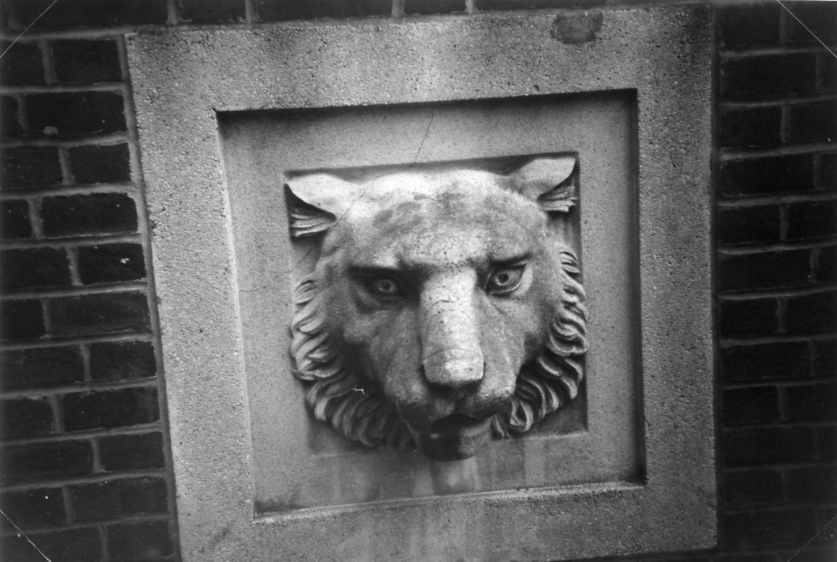

Yes they were set in a wall as this photograph by Wyn Anderson shows,
taken during the walk Alan organised on 26 September 1993.
The Story of Ballymaclinton.

Part 1 of a two part article by George Ithell from the Exhibition Study Group archives
with illustrations added of contemporary souvenirs from the Irish Village.

The type of shop required in any community such as in Donaghmore, Co. Tyrone, was of great importance for it’s merchandise, and what would be more needed than the grocers. The year the story begins is 1820.
In a period of very difficult time of Irish history, the affluence, such as it was which Ireland enjoyed before the Union with Great Britain in 1801, was sadly reduced by the departure of the nobility and gentry. Consequently, the trade and economy suffered, but needs bred resourcefulness and ideas were experimented with.
One of these resourceful people was a David Brown who was the proprietor of the local shop. In a little back room of his premises he was able to produce a cheap soap suitable mainly for household chores, but no doubt was also used on the hardy skins of some of the customers. With the soap being a huge success David Brown progressed with another of his experiments for candles. These were of course in great demand before the advent of electricity. The demand for both of these commodities continued and a new business was launched and prospered. David Brown’s son James joined him and ultimately followed and developed the industry considerably, James Brown was then succeeded by his twin sons,. David and Robert.

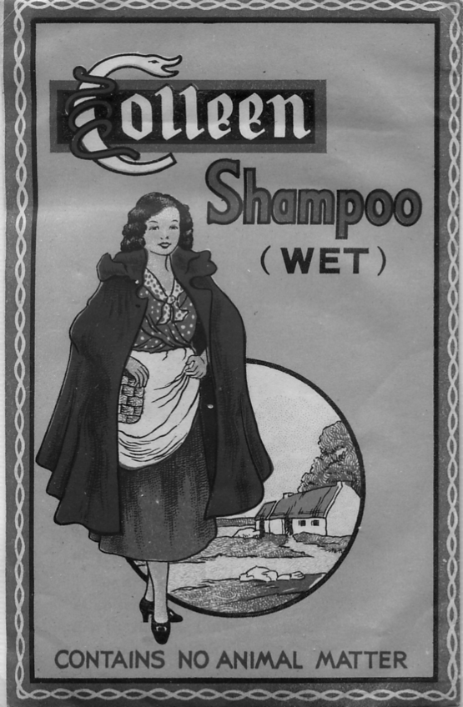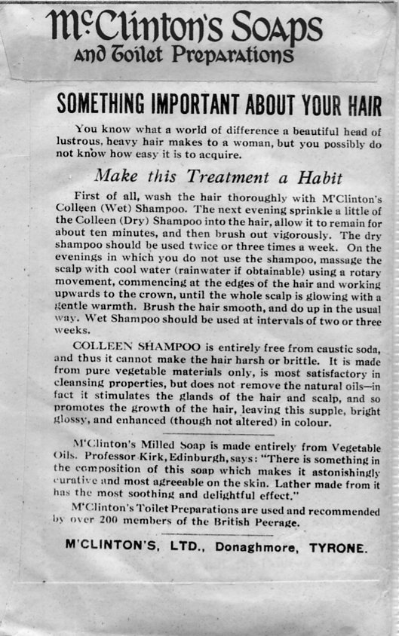

An unopened packet of Colleen Shampoo. Although it is not dated it could well have been sold
at the time of the Franco-British Exhibition, or soon after. On the back it mentions Professor Kirk.
The pictures are 75% full size.

In 1895 the firm of David Brown & Son was now large enough to take over another soap manufacturer in Belfast. This was McClinton’s whose scented and unscented soap was their speciality. McClinton’s name was retained for the brands of toilet soap but the household soap was still sold under the original name. Another of the firms activities was a large farm which with the soap works gave employment to upwards of one hundred people in the area.
David and Robert Brown were very much respected by the entire community with their attitude to life. The altruistic outlook the brothers had, overcame a problem which at that time was immense. The housing situation was dreadful by present day standards, but a colony of cottages with four rooms complete with half an acre of garden to each one was built. The charge for rent was minimal, just Two Shillings per week and that with the rates paid!

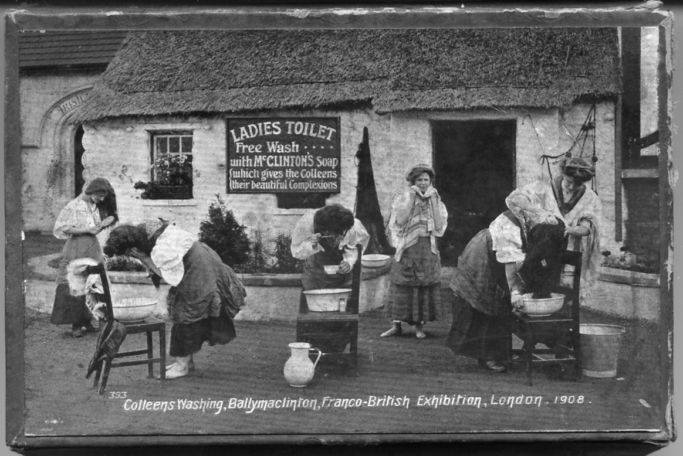

Valentine’s supplied the printed paper to go on the lid of this box which would have held three
bars of soap. The origin of the picture is one of their post cards.

Tuberculosis and other killing diseases were a scourge in Ireland about this time, and with others, including Lady Aberdeen, the wife of the Lord Lieutenant, David and Robert formed a Society to gather funds to combat these ills and were successful in raising large sums of money. Ballymaclinton Village at the Franco-British Exhibition in 1908, was in the form of an advertisement and also to gain funds for the charities for which Ireland so badly needed. A donation, or token charge to enter and view the village was paid into the fund of the National Woman’s Health Association of Ireland. many other firms displayed their products and made valuable contributions to interest the 2,000,000 visitors the first year. Charitable organisations were in attendance with reports and results of their work. Demonstrations by the Church of Kildare Training College for the Blind in the methods of reading Braille, was a revelation.
It was the general opinion that since 1900 there had been a very considerable improvement in the Industrial Development in Ireland and that the. Irish contribution to this Great Exhibition, added still further potential, The designers in their efforts for the fullest authenticity included the essential General Shop. This shop was given full Postal facilities not only for stamps, but for Postal-orders and a Continental Telegraph Service. This was then designated The Ballymaclinton Post Office. This was the first time in the history of British Postal services that the name of .a person was the subject of the title. No reference to that point has been made anywhere yet.
In the Post Office Records Department a notice in the Circular No:1835 states that - ‘A temporary Branch Office under the designation of Ballymaclinton. Shepherd’s Bush Exhibition W. Code J.M.C. for the transaction of Telegraph and Postal Order business and for the sale of stamps, opened on July 14th 1908, and in a later circular the closure as October 31st the same year.
The following year, an item in the Circular No. 1881 of May 18th states that-’Reference to the Branch Office known as Shepherd’s Bush Exhibition. B.O. the Town Sub-office under the designation of Ballymaclinton, Shepherd’s Bush Exhibition W. will be opened in a few days time in the Irish Village, Imperial International Exhibition for the sale of stamps and Post Office business On a later page in the same Circular another reference ‘a similar Office known as the Scottish Village both opened from 10 am until 11 p.m. on the 1st June 1909’ The reported closure was on October 26th 1909. A special hand-stamp for each of these years is common, but a single-ring skeleton type for use on ‘parcel and packets was in use from May until September 1909 only.’ A Parcel Post label to be used in conjunction with the latter was another innovation. Ballymaclinton Exhibition - Shepherd’s Bush W. in two straight lines with the J.M.C. code in the title area.

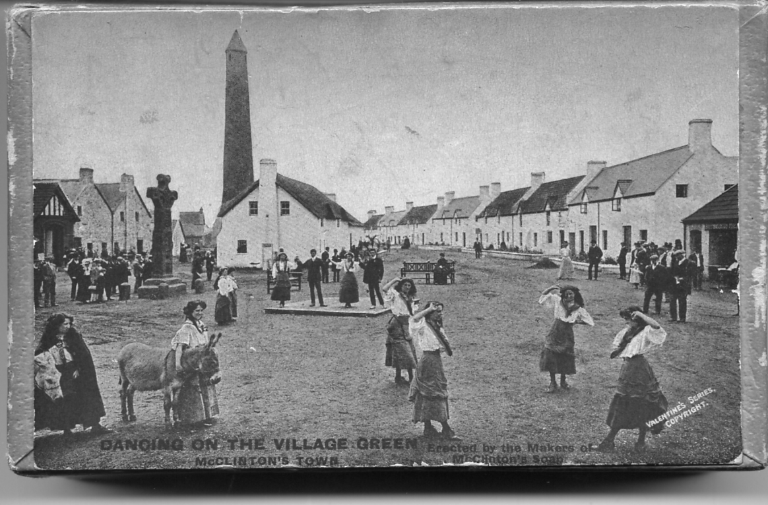

Another soap box which like the previous one is about 1 inch deep. Although it can hardly be
seen the printing on the box top is in a style not used by Valentine on their post cards, so this must have been specially printed by Valentine’s for Maclinton’s.

These last two items are recorded by the late W. G. Stitt Dibden. At the same time the hand-stamp was issued so also the mail-bag seal, a crown motif with the Ballymaclinton Shepherd’s Bush Exhibition placed axially in smaller letters than the dated hand-stamps. The Post Office facilities were axed in 1910.
1908 was the year that Britain was to stage the Olympic Games. As the idea of a joint venture for a French and British exhibition had been suggested by a Trade Convention, The Great White City was planned and the site chosen. The White City Stadium at Shepherds Bush, although modified in the last few years, is the only remaining building which was part of the huge project culminating in a very successful and much appreciated event. The spirit and tolerance in which a great deal of thought and organisation on the part of the two countries is seen when the French wanted 1907 to be the chosen year and agreed that the Olympic year would perhaps be more satisfactory.

Souvenirs of the Crystal Palace.
Drawings and written by Fred Peskett

This is the start of a major new series of articles compiled for the Exhibition Study Group Journal which describes and illustrates the souvenirs which were manufactured for both the Great Exhibition of 1851 and the Crystal Palace at Penge Park.
The Souvenirs can be found in a multitude of different materials, ceramics, plastics, fabrics, wood, paper and card, plaster, glass, tin-plate, steel, copper, brass, ivory, silver and gold, as well as a mixture of several of these materials. Those souvenirs associated with the Great Exhibition were only available for a few months, whereas those for the Penge Crystal Palace were on sale for some eighty-two years, many exhibitions were staged within the Crystal Palace and Grounds, each having their own souvenirs available as a memory of a visit, so there is plenty of scope for many interesting and varied items to be included in the series.
The majority of items to be illustrated will be by drawings, the reason for this is two-fold, (a) finer details can be shown within the drawings and (b) it is far cheaper than by photographs! The majority of the items will be shown “actual size” although there will be instances where the size will be reduced, such as plates, in order that the drawing will fit an A4 sheet, (any change to the actual size of the item will be noted)
The initial articles are compiled from items in my own collection, but is it hoped that members of the Exhibition Study Group who have collection of Great Exhibition and Crystal Palace items can assist by sending me a detailed description, and a photograph or a drawing of any item they would like to see featured.
There is an interesting aspect in relation to the souvenirs associated with the Penge Crystal Palace, this concerns the word “the”. A survey revealed that certain souvenirs (no matter in which medium they are made) can either be “A Present from Crystal Palace”, or “A Present from the Crystal Palace”, this suggests that those souvenirs with the word “the” are specific to the building and grounds, whereas those without a “the” are associated with the area which became known as “Crystal Palace”. Transfer views of the building are known in both wordings!
It is strange that when Mr. Punch coined the name in 1850 as a rather derogatory term for what he called “Prince Albert’s Crystal Palace”, The joke somewhat re-bounded on Mr. Punch, since the name was so apt for Joseph Paxton’s masterpiece, that the name lives on even though the building was destroyed many years ago.
The first part of the Series features a couple of the more unusual souvenirs from the Crystal Palace in papier-mâché and mixed materials. The next part will be on the souvenir Giant Clay Tobacco Pipes from the Great Exhibition.

Items made from papier-mâché.

Papier-mâché is a material popular from around 1810 to the 1890’s. it was made using rags and paper which had been mixed with size (a substance similar to glue) then pressed into a mould and left to harden. Many items shown at the Great Exhibitions of 1851 and 1862 were made from this material including fairly large pieces of furniture, such as tables, chairs and cabinets, smaller items like blotters were also produced as souvenirs, many of these had a view of the Great Exhibition Crystal Palace on the front with portions of exotic butterfly wings added to represent iridescent windows. Other substances used for impressing into the mould included nacre (mother-of-pearl) from shell-fish and gold leaf to represent foliage and plant leaves.
The designs using mother-of-pearl have generally survived in a reasonable condition, whereas those with added gold leaf are found in a rather poor state of preservation. Two souvenir small dishes from the Penge Park Crystal Palace are shown below, they date from around 1875. They measure 3¼” diameter by ¾” high. The background is the normal papier-mâché black finish with the plant leaves in gold leaf, the scrolls are white bordered with blue and the wording is black.
A visit to the Crystal Palace was made complete by the purchase of a souvenir to remind you of a happy day, or as a gift for Mum, Dad, Grandma or a favorite Aunt.

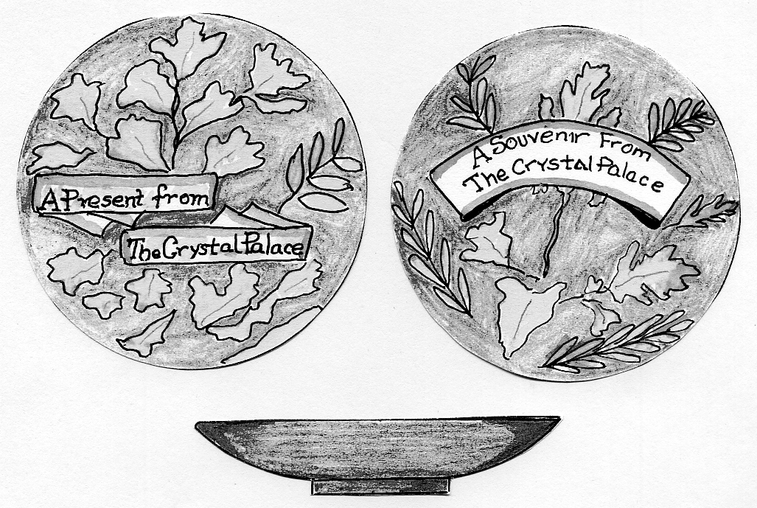
75% of full size

Items made from Mixed Materials.

One of the small inexpensive souvenirs available from the shops and stalls in the Crystal Palace was a handy “Sewing Kit”. Several versions of these are known, including the one described and illustrated below. It is made from mixed materials. The carrying case is made from cardboard with a covering of white “Ivorine” on the front and back, Ivorine was a commercially available artificial material made to simulate ivory, the framework on which the front and back are hinged and the ends of the case are made from tin-plate which has been embossed with a cross-hatch on the top and base and a stone-work design on the ends, a carrying handle and a retaining loop for the sides is made from steel rod. Inside there are two hollow metal tubes soldered to the base to hold wooden cotton reels, for black and white cottons, there are two packets of assorted sewing needles and a bodkin, a clip between the cotton reels holds a silver thimble, which is hallmarked as “London 1878”, this may be the date the Sewing Kit was manufactured, although it is possible it was replaced at some time if the original was lost? (It would seem unlikely that a silver thimble would be in a cheap souvenir) The Ivorine front is impressed with a design and worded “A Present from the Crystal Palace” this is infilled in gold.
Despite being over a hundred years old the Sewing Kit shows no signs of ever being used! which suggests that it was kept as a memento of the Crystal Palace.
Another Sewing Kit similar in construction to the one described above but of an earlier manufacturing date is illustrated below. This one is made from cardboard with a covering of Ivorine on the hinged front and back. The base and tapered ends are covered in blue velveteen cloth. The fastening is by blue cord which is knotted to each end. The contents include a wooden reel of white cotton, two packets of assorted needles, (the insides of the front and back also contain provision for additional needles), a loose silver thimble is hallmarked for Birmingham 1858.
The wording on the front panel is impressed and infilled with silver, the back has a sepia photographic image of the Crystal Palace Nave with Osier’s Crystal Fountain in the foreground.
Unlike the other Sewing Kit this one exhibits signs of being well used, since many of the needles from the front panel are missing and only half of the white cotton is on the reel.

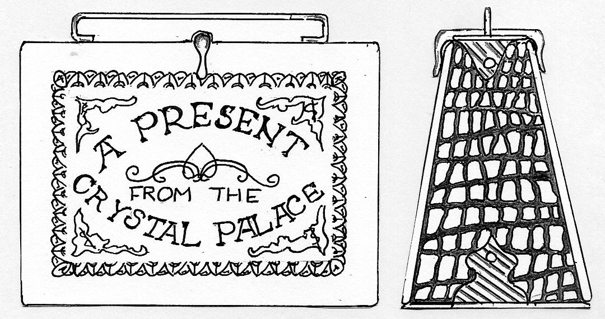
75% of full size

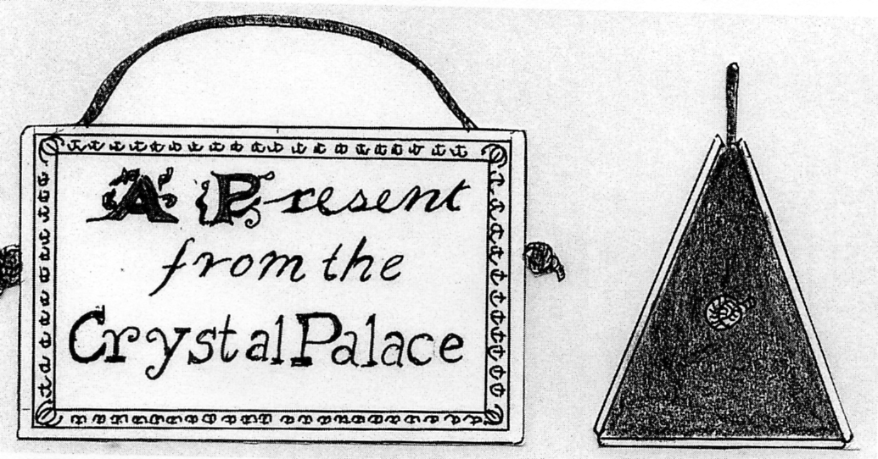
75% of full size

OLYMPIA Corporate History 1884-1999
by
© John Glanfield. January 2012

The above reports recording a September 1884 deadline were obviously published the previous year. The Prospectus is dated August 1885. That the option was indeed offered seems entirely plausible Its terminal dating would tie in with the purchase of the site in April 1884. See also below - ‘1894. 17 December, para 3.
‘an offer has been made to rent the hall for some weeks at £500 per week, and another offer from one of the first refreshment caterers in London to pay a minimum rent of £1,500 pa for the refreshment rooms. Morning Post’
Bertram & Co. first held the refreshment licences at £1.500 p.a. Joseph Lyons secured them in 1891.

1886. The National Agricultural Hall first opens its doors
A full first-night house of 9,000 were captivated by the vast hall, the novelty and brilliance of its electric arc lighting and the stupendous acts of the Paris Hippodrome Circus. Roman Games with furious chariot racing raised a pall of dust above the huge arena. The audience rose to its feet in a frenzy of cheering. (Arena 280 ft/85m x 142 ft/43m. 7 circuits = 1 mile)
Severe daily crowd management and communication problems arose on the platforms at Addison Rd station opposite the Hall. A meeting of senior officers of the London & NW Railway and other operators met to agree urgent measures. Public address systems did not exist. The muddy and poorly metalled Addison Road also presented difficulties. But it was a great show and a highly profitable opener.

1887. Insolvency looms for National Agricultural Hall Co.
Company finances were in a serious state even as the Hippodrome Circus was generating huge attendance’s exceeding 369.000 in the first eight weeks alone.
Accommodation & charges
1 row of 28 luxurious private boxes fronting the promenade beside the arena £2.2s.
Behind them a tier of 30 much smaller private boxes furnished as above: £1 1s.
Stalls 5s = 25p.
Grand circle 2s6d = 12.5p.
Amphitheatre 1s = 5p.
Public response to the shares issue was disappointing Take-up was not helped by serious competition from John Robinson Whitley’s huge and newly opened Earls Court showground. His inaugural American Exhibition opened 9 May 1887. The open-air arena featured the European debut of Buffalo Bill’s sensational Wild West Show. The event ran 151 days, daily attendance’s averaging 15.000. Rivalry between the two venues persisted for 86 years until their amalgamation in 1973. Earls Court’s personnel labelled Olympia ‘the Village Hall’.
The NAH board had confidently expected to welcome the popular annual Grand Military Tournament, then at Islington’s Agricultural Hall. Indeed, its dynamic Secretary Maj-Gen E.S. Burnaby had been a key and active promoter of the transfer from the outset, welcoming the new hall’s larger arena for his battle re-creations. But Burnaby died shortly before the NAH opened, and contrary views prevailed. The board was shocked at the news - the Tournament would have attracted other major shows. It moved to Olympia, as the NAH had become, in 1906.
The company’s attempts to generate cash included 3 carriage department supervised by coachmaker Mr J W Turner. It offered showroom and sale facilities for ‘high class carriages, especially patents and those of newest design.’ A display gallery was shrewdly sited between the two tiers of private boxes Surplus phaetons, landaus and broughams of the gentry were charged at 3/-(15p| per week for display, and five per cent of sales.

1888 10 January. Creditors petition for winding-up of NAH company.
The board sought fresh capital in an attempt to fend-off a Winding-up Order.

1889. National Agricultural Hall Company to compulsorily cease trading
The petition was granted on 12 January. The company was burdened with debt. Encumbrances included £100,000 of debentures and a £10.000 mortgage. The Hall’s estimated sale value fell well short of liabilities. NAH Co. was finally dissolved 14 March 1894 when receiver Thomas A. Welton was discharged. Most unfortunately, he was ordered to destroy all books after 6 months.
National Archive. Kew corporate papers. pieces BT3I/3335/19814 & RAIL404/171

1891 July. Imre Kiralfy Ltd. (IKL)
A Syndicate was incorporated 16 July 1891 to stage a stunningly ambitious production at Olympia. ‘Venice in London’ (1891 -93], the brainchild of caterer and entrepreneur Joseph Lyons and Harold Hartley his business associate, proved a hugely profitable spectacular complete with gondolas in lead-lined canals leading from Grand Hall into Olympia’s gardens. It was designed and directed by impresario Imre Kiralfy who had no financial interest in IKL but gave his name to it, doubtless to add weight and attract backers. Instead he wanted a percentage of the gross takings, but settled for 40% of net profit He estimated the production cost at £17,000.
Chairman *John Hart Director, J.&H. Hart advertising & publishing. Hart was the
2nd largest investor in IKL
Committee of Management
*Montague (Monty) Gluckstein. Director of J Lyons & Co. Ltd.
Isidore Gluckstein Another key member of J Lyons Co. Ltd
*Joseph Lyons MD of J Lyons & Co. Ltd.
*Harold Hartley MD & chairman The Pure Water Co. Ltd, supplier to J Lyons
Herman Hart, Secretary Co-director with John Hart (above) of J.&H. Hart
*Trustees of IKL
Initial subscribers only (1 share each): Charles Close, believed to be Hart’s chief clerk. James Adams, believed to be Hart’s advertising manager.
The Gluckstein’s were brothers whose astute financial deals had greatly impressed Hartley. They traded in tobacco as Messrs Salmon and Gluckstein The company was building a chain of retail outlets and went public in 1895. By the turn of the century it owned 140 tobacconist shops. They were bought by Imperial Tobacco in 1902. Montague Gluckstein’s acumen and backing enabled Joseph Lyons to create his food empire, iconic corner houses and tea shops.
IKL raised £18.000 from members and friends. Capital never exceeded £25,000 although ‘Venice’ cost over £60.000 to produce. Their bank saw them through with an overdraft on very inadequate securities. The show’s full outlay was recovered in the first three months of its 13-month run. IKL’s tenancy agreement with the receiver secured the Hall for a year. It was rent-free for approx. 6 months of build-up until the show opened, then £300 per week. J Lyons was appointed sole catering, liquor and tobacco sales concessionaire in return for 15% of gross receipts.

1892. Hartley resigns
Harold Hartley resigned from IKL in summer 1892 to concentrate on his Pure Water Company’s affairs (but see ‘Freehold Syndicate’ below). Hartley had bought the bankrupt aerated water producer on a whim at auction in 1884. It caused him to meet Joseph Lyons four years later when he and Monty and Isidore Gluckstein were building the Lyons food empire. Hartley later moved into combing the world each year for outstanding acts for Imre Kiralfi’s hugely successful super-shows at Earls Court. Harold Hartley’s fascinating autobiography ‘Eighty Eight Not Out’ (F Muller, 1939) relates his EC&O days at length.
National Archives. Kew. Pure Water Co. papers piece C26/523

1893 & 1895. Kiralfy is replaced by his brother
Kiralfy’s fee for a follow-on show at the Hall was considered inequitable by IKL Instead, his talented brother Bolossy was engaged to retain the hugely costly canal system and produce ‘Constantinople, or The Revels of the East (December 1893-November ‘94). It matched the profitability of Imre’s Venice’

Imre Kiralfy Ltd voluntarily winds-up by resolution 10 July 1895, appointing Montague Gluckstein as liquidator.
National Archives. Kew. company papers piece BT31/5110/34428

1893. The Freehold Syndicate
An unregistered syndicate was formed in January 1893 to acquire The National Agricultural Hall, create a company to buy it at a profit, ‘weight’ the new company’s board with the syndicate’s nominees, and ensure that a condition attaching to the purchase would require the companies of two syndicate members to be appointed as sole licensees for provision of refreshments and advertising.
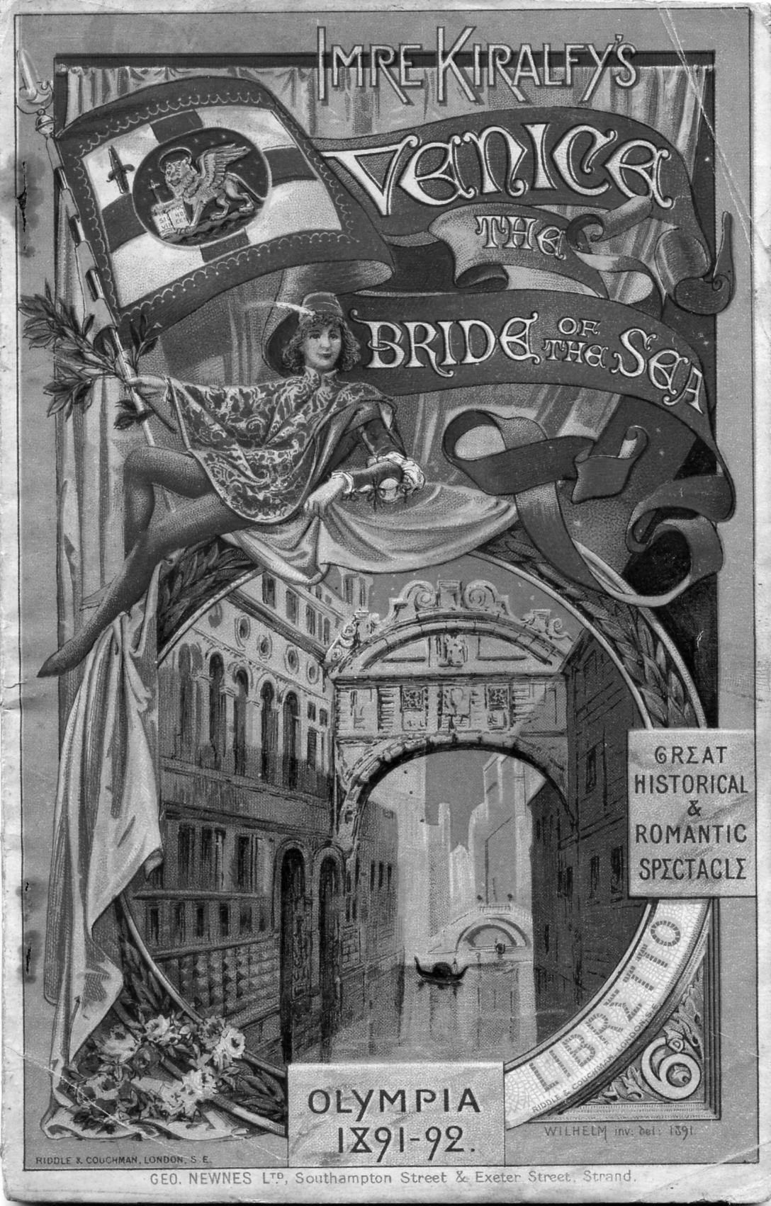

An agreement was entered into between syndicate secretary John Hart and 32 others It set out the syndicate’s proposal that each member would subscribe funds for purchase of the National Agricultural Hall before selling it on to a company to be registered by the syndicate or to some other purchaser. It proposed the appointment of members Lyons. Hart, Hartley and M. Gluckstein as the syndicate’s Trustees with full powers to manage the purchase and re-sale of Olympia. and to become directors of any company formed to purchase the NAH, if so elected. They would also have full powers to purchase ‘as an interim investment’ any first mortgage bonds of the National Agricultural Hall Company Additionally, resale of the NAH property would be conditional on the appointment of J. Lyons & Co. to supply refreshments, and appointment of J. & H. Hart as advertising agents for the purchasing company
The Times, 27 May 1898: report of appeal. 13 November 1895, examination of directors Olympia Ltd
Signatories to the syndicate agreement committed £35,950 in all, of which only £7.192 was paid.
The Times 6 November 1895 report of proceedings.

1893 Jan-Feb. Syndicate buys heavily discounted National Agric. Hall bonds.
Shortly after its creation the syndicate’s four Trustees were able to buy debenture bonds from holders at a discount because of the perceived inability of the National Agricultural Hall Co. to redeem in full. Hartley later said \’took no share in this purchase’. The Syndicate paid £27,220 for first debentures nominally worth £32.000, which later realised £42,358 They also paid £500 for second mortgage bonds nominally worth £10,000, which afterwards realised £5,096. The profit on these transactions was £20,734, of which the four trustees received £6,341 between them, apportioned Hart £2,306. Gluckstein £1.441 Lyons £1,441. Hartley £1,153.
High Court Order 17 2 1898. National Archives. Kew. piece J13/1248
The Times, 6 November 1895, report of examination of directors, 27 May 1898, report of appeal.

In 1895 Montague Gluckstein stated at a public examination of the directors of Olympia Ltd that the reason for the purchase of the NAH was that a competitor had offered £90,000 for it and was prepared to go to £160,000. When challenged by counsel for the shareholders, he contended that purchase of the bonds of the National Agricultural Hall Co. ‘was properly described as an interim investment,’ the syndicate’s solicitors having advised them that ‘this description was... a proper form of disclosure to the public of the nature of the transactions’ The Registrar in bankruptcy responded ‘I think I should call it a speculation’.
The Times. 13 Nov. 1895, report of public examination of the directors of Olympia Ltd.

1893. 8 Feb. Freehold Syndicate pays £140,000 for National Agricultural Hall
Unusually, the competitive bidding for the NAH was conducted in the chambers of Mr Justice North in the Chancery Division of the High Court of Justice, It was he who had ordered the sale. The syndicate seemed almost recklessly determined to buy at all cost, securing the property for £140.000 in response to the underbidder’s £132,000, whereas all earlier bids had risen by no more than £1,000 at each stage.
The Times 13 November 1895. examination of directors of Olympia Ltd. & 27 May 1898, report of appeal.

1893. 20 March. Freehold Syndicate sells National Agricultural Hall for £180.000
The syndicate had registered Olympia Ltd on 20 March and appointed syndicate founder member Charles Close as Trustee of the new company. The syndicate then entered into an agreement with Close (acting for Olympia Ltd) that the company would purchase the Hall for £180,000. The syndicate would thereby gain a profit of £40,000 gross, £34,923 net to add to its £20,734 profit on the debentures.
High Court Order 17 2 1898. National Archives. Kew, piece J13/1248.
The Times 6 Nov 1895. report of proceedings. 27 May 1898. report of appeal.

1893. March. Olympia Ltd and the birth of ‘Olympia’
Under its new ownership the Hall was renamed Olympia.
The board of Olympia Ltd.
Chairman Montague Gluckstein
Directors; Joseph Lyons, Harold Hartley
John Hart, Capt. Watson
George Hicks, Edwin Levy
Secretary Herman Hart (John Hart’s brother). H. Hart was later replaced by Mr H. M. Fisher.
Applications were invited for £155,000 in £5 shares in Olympia Ltd, and £70,000 in 5% debentures.
Target total £225.000, of which £180,000 was to be applied to purchase of Olympia, the
balance as working capital. In the event only £94,890 was subscribed for shares, including
£10,000 from the directors
The company’s Prospectus quite openly slated that the Freehold Syndicate had earlier bought Olympia for £140,000. It went onto record that the promoters of the new company (Gluckstein, Lyons, Hartley and John Hart) were members of the syndicate and that they would act for the syndicate as vendors of the NAH property to Olympia Ltd. This was followed by a caveat which would prove controversial.
‘Any other profits made by the syndicate from interim investments are excluded from the sale to the company.’ Gluckstein later confirmed that ‘interim investments’ meant the discounted debenture bonds acquired by the syndicate.
The Prospectus also locked-in a condition of sale that obliged Olympia Ltd to award certain contracts to named suppliers, viz.
The catering & liquor contract at Olympia to go to J Lyons 8 Co. Joseph Lyons and Montague Gluckstein were directors of J Lyons and directors of Olympia Ltd Olympia would receive 15% of gross receipts from catering/liquor sales (Lyons held this license under differing Olympia hall owners for the next 60 years].
The advertising sales contract for Olympia to Messrs J & H Hart, John Hart being a director of J&H Hart and now a director of Olympia Ltd. His company would receive commission of 25% of gross receipts for all advertising secured by Olympia e.g. poster hoardings, show catalogues etc.
The Times 27 May 1898. report of appeal.

to be continued

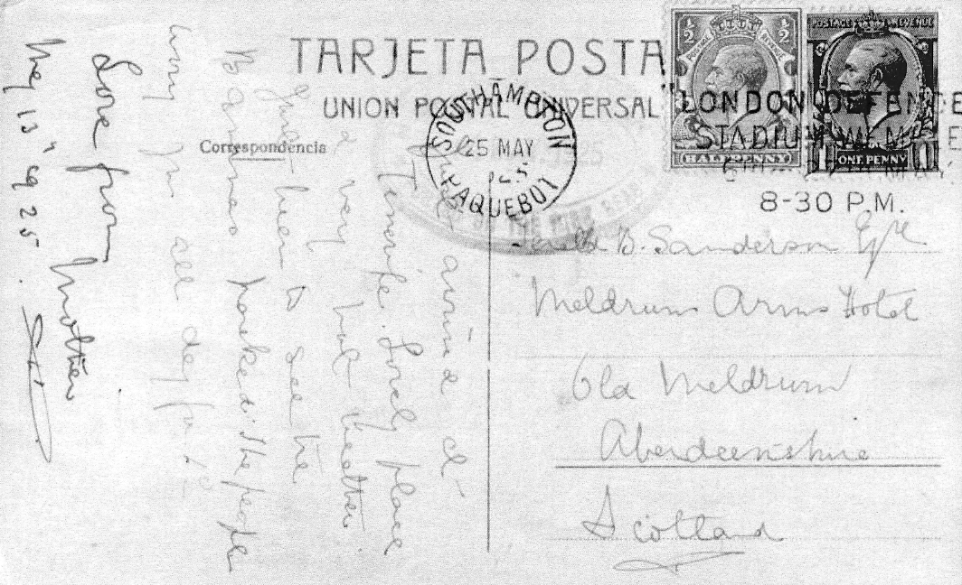

A fairly scarce Wembley paquebot post mark

A Wembley single circle Universal machine ‘London Defended’ slogan cancellation was used at Southampton with a Paquebot town die in 1925. This was used on foreign mail coming into the country. Original illustration supplied by Kenneth Tonkin.

