EDITORIAL SPRING 2013

Alan’s sent me a scan of a card that is new
But wait till next Christmas when I’ll show it to you.

Alan Sabey noticed my comment in the last Journal about my running out of exhibition Christmas cards which I use to illustrate the front page of the Winter journal each year. He has kindly sent me a scan of a 1924 British Empire Exhibition Christmas card to use next Christmas which I have not seen before, thanks Alan.
I have also published in this Journal a letter from Peter G Griffin regarding the article on Gerald Spenser Pryse labels which we published in the last Journal. This proves that at least two members read the Journal. Peter sent in a long article which I split over three Journals way back in 1994, don’t leave it so long again Peter, as at 86 I might not be here in another 19 years.
Readers will notice I have started what will be in three or four parts a Corporate History of Olympia sent in by John Glanfield author of a History of ‘Earls Court and Olympia’ published in 2003. John worked at Olympia for 15 years. He joined the company in 1979 and became halls director of Olympia and then Earls Court, so his knowledge of what he writes about is probably un-rivalled. I found it fascinating reading,
As many of you know I have advertised for exhibition cards every month in the Picture Postcard Monthly since 1990 and kept a record of my purchases. To date I have had a total of 26,468 exhibition and missionary post cards sent to me on approval, out of these I have purchased 7,163 cards, so advertising has in my case has well and truly paid off.
Last year I had 465 cards sent to me on approval, out of which I bought 123 (26 %). I don’t expect I shall ever see the 1992 figure of 3,383 cards sent in on approval again. One interpretation of these figures is that more people are selling through E-bay.
On the other front, 2012 saw me at very few post card fairs, only three in fact, a poor number when compared with the 9 years 1993-2001 when I averaged 64 fairs each year, covering the country from York down to the South Coast and from Yeovil to Colchester, and must have clocked up thousands of miles in the car.
I realised some years ago that many dealers had started selling their better cards through E-bay and I had to accept that I was unlikely to get as many good cards at fairs as I used to. Three of our largest dealers have stated they will not do any more fairs in favour of E-bay. I cannot blame dealers for selling their cards through E-bay, as after all, they are in business to make money. I don’t think there can now be any doubt that E-bay is affecting attendance’s at fairs of not only dealers but collectors as well. I still plan on doing Shepton Mallet in February, but it may well be my swan song. I do miss going to fairs as I have made many friends over the years, but from what my friends who do go to fairs tell me, I think there is very little chance of picking up good cards now. The scarcity of good cards is even affecting E-bay now I’m told.
I find it increasingly difficult walking now and am virtually house bound, only going out to do a bit of shopping two days a week. I had a full length body scan several years ago and was told I have arthritis in my shoulders, spine , hips, and knees and now my right hand is affected.
Looking back I’ve had a very good innings and built up what must be regarded as the largest collection in its field there is, so I have no complaints. The time I used to spend at fairs I now spend appreciating and researching my collection, and here I have years of work in front of me. I still manage to get enough new cards to keep up my interest in post card collecting and exhibitions.
The Editors
Travelling Exhibition notice
sent in by
Dilwyn Chambers

I wonder if this ever got off the ground, and what towns it visited. The notice comes from ‘The Old Contemptibles’ magazine January 1948

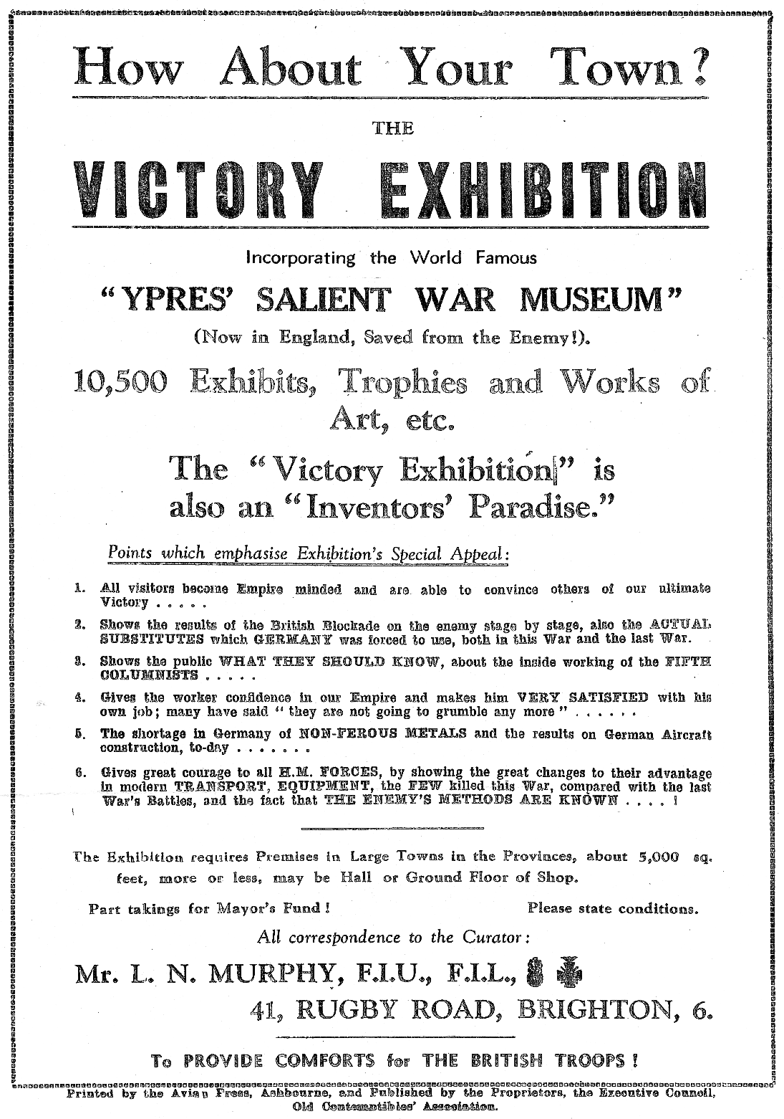

The Merchant Venturer and Me
By
Fred Peskett.

One of the titled trains introduced by British Rail for the Festival of Britain was the “Merchant Venturer” on the Western Region, running from Paddington to Weston-Super-Mare via Bristol and return. It was still running in 1957 and I made good use to travel on this service during part of my National Service with the Royal Air Force, however, my recollections was more of a Merchant Misadventurer for at least two trips. I was stationed at R.A.F. Rudloe Manor, a small unit on the outskirts of Bath, near the Wiltshire village of Calne, famous for Bowyers Pork Sausages. I was able to go home to London for most of the weekends, a 13/6d Forces return fare would take me from Chippenham to Paddington then the Underground to Charing Cross and the local Southern Region service to Welling in Kent.
The Merchant Venturer stopped at Chippenham then ran as an express to London, One Friday evening the bus from Calne to Chippenham was running late, and I just managed to get to the station, buy a ticket and get on the platform only to hear the whistle being blown for the departure, I raced along the platform and just managed to get into the last coach before it started off. I really should have noticed that I was the only passenger in the coach, and when I went to use the toilet I found the end door locked, that alone should have rang a few alarm bells, but I settled back in the seat and watched the scenery go by as the train gathered speed, it should now be non-stop to London, at least it was until the train started to slow down a mile or so outside of Swindon, and then came to halt at Swindon railway station, most unusual I thought, after a few minutes I looked out of the window, sure enough, the coach was in the station but the rest of the train was missing, I later found out that the last coach was a “slip-coach” and was dropped off before entering a station so that it would coast to a halt, the coach was later picked up by another locomotive ready for the next journey. I had over two hours to wait before another London bound train stopped at this station. I made a resolution never to ride in the last coach of a train again, but thank goodness there was one occasion due to a similar late running service that I did get into a last coach and it probably saved my life.
My next encounter with the Merchant Venturer was on the Paddington to Chippenham journey. After a long weekend at home and perhaps a few pints the night before. I was back on the train with sufficient time to get to Chippenham, catch a bus to Rudloe Manor change into uniform and be on duty by 3pm. I remember it was a rather hot day, the carriage was full and I was very, very sleepy and long before reaching Reading I must have dozed off. When I woke up I noticed there were different people in the coach, and the man opposite looked at me and said, “Were nearly there” As the train pulled into a station I found out to my horror that it was Weston-Super-Mare, the end of the line, some forty odd miles further than my destination, hence by the time I reached my camp I was some four hours absent without leave, put on a charge and got five days “Jankers”, moral, don’t fall asleep on trains!
I mentioned earlier that getting into a rear coach probably saved my life. It was also in 1957 and I was doing a course at R.A.F Cherhill, near Marlborough, Wiltshire, There were no railway stations near to the camp, which in fact was just a couple of wooden huts nestled below one of the “White Horses” of Wiltshire, but there was a rather rickety Coach Operator called “Ace of Cards” who ran a weekend service to Victoria Coach Station for around 1Q/- return for Servicemen. There was one unique feature about the service, when the coach started the journey the driver would keep the speed at around 30 mph. but if you started rattling coins in a hat as a tip the speed would increase relative to the noise of the coins jangling in the hat I It was a foul evening on one trip, very foggy, and the coach was quite late getting into Victoria Coach Station,
I managed to get the Underground from Victoria to Charing Cross, where I found the train I wanted was still waiting to leave for Welling. I boarded the last coach in case the train departed before I reached the front coaches, the coach I was in was packed with standing room only so there was no chance of getting further along the train via the corridor, I always tried to get into one of the first two compartments since they were nearest to a footbridge for the exit when the train stopped at Welling Station.
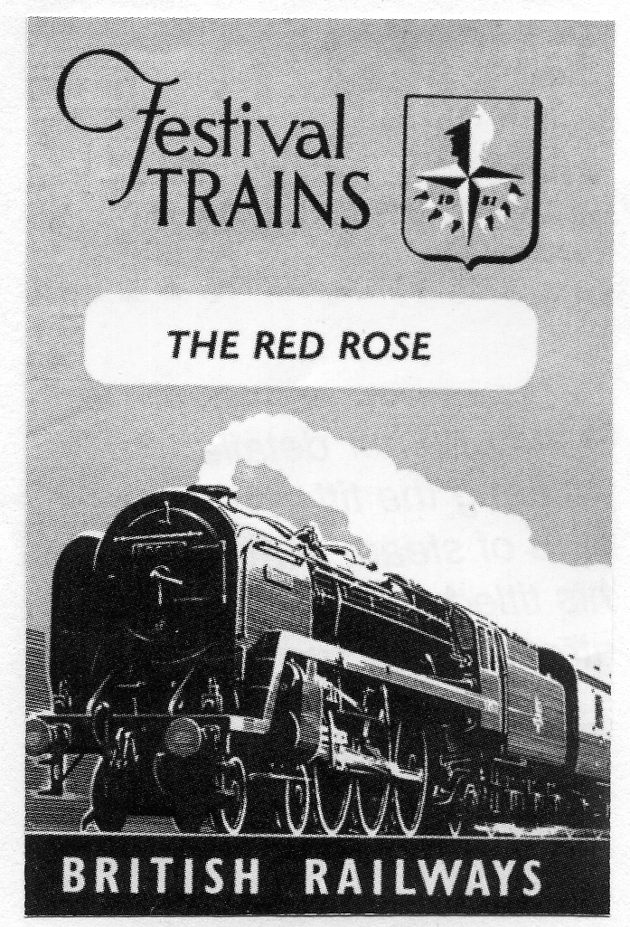
The train was late in leaving Charing Cross due to the thick fog, when it reached St Johns Station, after leaving New Cross it suddenly lurched with a tremendous bang, and came to a sudden halt the passengers in the coach were thrown all over the place, including me. What had happened is now history, It was the Lewisham Train Disaster, over thirty people in the front two coaches of the train I was on together with over a hundred people in two other trains were killed. Had the coach arrived at Victoria on time and I had arrived at Charing Cross early I would have been in one of those coaches for sure! The train I was on had collided with the rear of another train, the front two coaches had jack-knifed upwards under a rail bridge which had a train crossing at the time. Part of the train crossing the bridge fell on to the coaches below causing such a tragic loss of life.
The bridge was shored up in the weeks following the crash with a massive selection of R.S.J.’s, these are in fact still there supporting the bridge, whenever I travel on the Dartford Loop Line I feel shudders when the train goes under this bridge.
British Rail published a series of leaflets to promote the Festival Trains, the one shown is for the Red Rose, that linked Liverpool to London, others in the series were The Norfolkman, The Royal Wessex and the Kentish Belle, the one for the Merchant Venturer seems to be very rare.

British Empire Exhibition Narrow Gauge Railway
Contents of an email sent to Alan Sabey
by
Stephen Mourton

I note on the Exhibition Study Group website that you have listed the remaining items from this Exhibition. I think you can add one more. It is a carriage which ran on the narrow gauge railway line operated by Roadrails Ltd. The carriage's history has come to light this year after being given to a railway group of which I am a Director. Our group first learnt of the carriage's survival in 2008 but it was only earlier this year that we were given permission to move it to our site.
The carriage was constructed by the Gloucester Railway Carriage & Wagon Co. Ltd. Some of the company's records have survived in Gloucestershire Archives, from where we were able to find a works photograph of the type of which 18 were constructed for Roadrails Ltd.
As far as I know this is the only survivor. At some time after the Exhibition closed it was returned to Gloucestershire and used on a farm as extra accommodation before being moved to another site in Gloucestershire from where we recovered it
We are keen to find more pictures of the Roadrails railway in action at the Exhibition, as, so far, we have only located two. By contrast the more well-known Never Stop Railway has quite a lot of pictures, including the British Pathe footage. Perhaps you or your group may know of more Roadrails material from the Exhibition.
Hope this information is of interest. There are pictures of the carriage as it is now on our website www.toddington-narrow-gauge.co.uk.
My e-mail address is stephen.mourton@bt connect.com

Exhibition Study Group Joint Meeting on Thursday 6th July 2013
Your invitation to attend
From our President
Ramon Goodey

At our last AGM we discussed what measures we could take to increase both our membership and generally publicize the Study Group. With that aim in mind, I have been in touch with a number of other clubs/societies to try and arrange meetings/displays by members. The results of my contacts will be discussed at our next Committee meeting in February, full details will be reported in the next Journal issue.
Meantime, I have arranged a joint meeting between ESG members and the Cinderella Stamp Club to be held on 6th July 2013 at the Royal Philatelic Society, 41, Devonshire Place, London, WIG 6JY (see map. Busses passing Devonshire Place, 18, 27, 30, 205, 453)

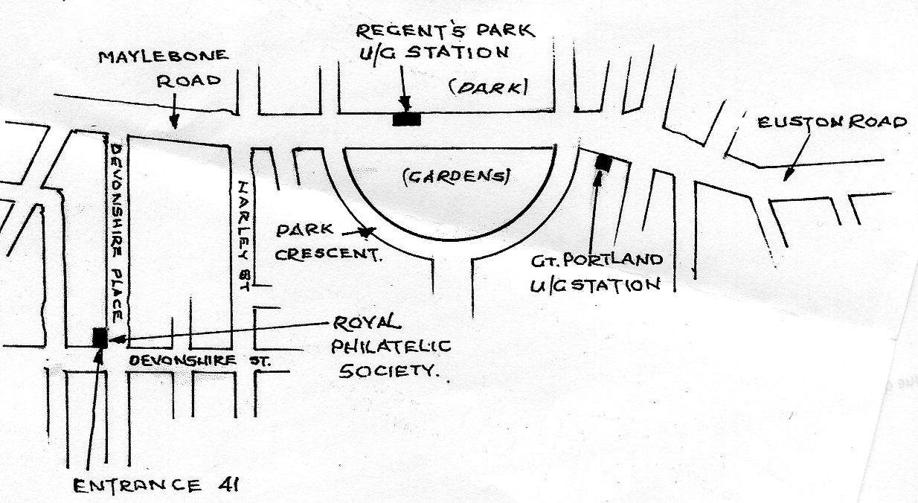

All members are invited, if you can bring along a display, Please give me a ring, 01245 440 434 so that we can plan our programme. '41' will be open from 9.30 am when Coffee / Tea will be available. Meeting starts at 11am, Lunch break 1 to 2.15pm (Pubs etc. nearby) Meetings usually finish around 4.30pm. We hope to have displays to fill 11 frames, 12 sheets per frame in two sessions, that's 264 sheets total. We will probably give our displays in the morning. Displays can be either Exhibition or Cinderella subjects. I hope that as many members who can attend will do so, to represent the Group.
There will be Dealers at the meeting.

A History of Bassett-Lowke
by
Ken Rumsey

Bassett-Lowke was a toy company in Northampton, England, founded by Wenman Joseph Bassett-Lowke in 1898 or 1899, that specialised in model railways, and construction sets. Bassett-Lowke started as a mail-order business, although it designed and manufactured some items.
Bassett-Lowke entered into contracts with manufacturers such as Twining Models and Wintringham’s, also of Northampton. While the company is perhaps best known for model trains, it had a long history of the manufacture of model ships. Before and during World War One, the company was dealing with a firm referred to in Bassett-Lowke catalogues as “B M C”. There is confusion as to what the initials stood for: internet sellers have identified it as “Birmingham Metal Company” or “Brighton Model Company”.
The collaboration between Bassett-Lowke and B M C produced a model fleet of every class in the British navy from 1885 through 1916 including tugs, troop ships and the royal yacht. The models were formed using hollow cast lead with the wire masts cast into the hulls. The models were painted and issued in numbered sets, paper flags with each set to be cut out and applied. The scale was described in the catalogue as “one inch equals eighteen hundred inches”. While the models were rudimentary by later standards, every class of vessel was easily recognisable by the funnels and guns and masts. The series may have been discontinued during World War One since the last vessels were of ships commissioned about 1916. Possibly the series was abandoned due to rationing of metal.
Later copies appear for sale on the internet. These can be distinguished from the originals, which were hollow cast Two copies are common, the first cast in solid lead with no wire masts and large numbers inscribed on the bottom. The second are in pot metal and represent three ship classes from the original sets; the King Edward VII, Lord Nelson and Swiftsure. During World War II, wood and wire ship models in the 1; 1200 scale were issued under Bassett-Lowke sponsorship for military contracts. Unlike the earlier rudimentary B M C lead models, these models are detailed and command a high price.

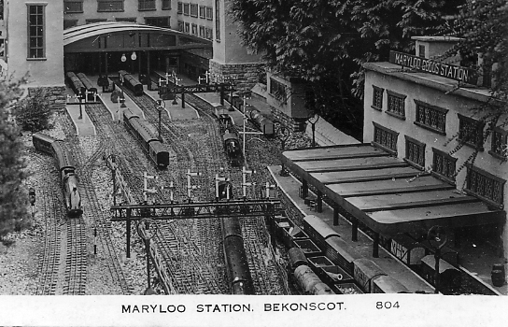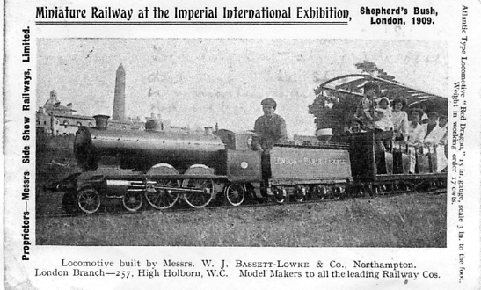
Beckonscot Model Village London to Paris journey

Bassett-Lowke produced trains from 15-inch (381 mm) gauge live steam models to Gauge 2, Gauge 1 and 0 gauge. The first 15-inch steam locomotive, test run on the Eaton Hall Railway, in 1905 was Little Giant. Unlike other engines on the line it was a replica of main-line locos, built for a public miniature railway at Blackpool. It was a quarter scale 4-4-2 Atlantic tender engine, though not an exact copy of any particular prototype. This engine still exists in private ownership.
In 1909 along with Henry Greenly W J Bassett-Lowke started and edited Model Railways and Locomotives Magazine.
In 1914, Bassett-Lowke produced the second Pacific 4-6-2 of any size built in Britain (the first was GWR 111 The Great Bear). This was John Anthony, built for a miniature railway at Staughton Manor. It was never delivered, but after storage at Eaton Hall during World War I was sold to the Ravenglass and Eskdale Railway and renamed Colossus. It was scrapped in 1927. Ravenglass and Eskdale had purchased another Bassett Lowke Atlantic, the Sans Pareil.
In the 1920s, Bassett-Lowke introduced 00 gauge products. The company provided custom-built railways; one such layout survives in modified format at Bekonscot Model Village in England.
In 1939, Bassett-Lowke was producing a working model of Churchills trench digging tank known as Cultivator No. 6.
Bassert-Lowke’s decline starting in the late 1950s and can be blamed on at least two factors: sometimes people would browse the firm’s free catalogue and buy similar or nearly identical items elsewhere at lower price; and interest in technical toys declined in the late 1950s and even more in the 1960s. Bassett-Lowke’s fall was mirrored by its U.S. counterparts, the A. C. Gilbert Company and Lionel Corporation. In 1964 the company ceased retail sales and sold its shops, including one at High Holborn in London, to Beatties. Bassett-Lowke went out of business in 1965.
In 1966 the company was acquired by Messrs Riley and Derry, and in the late 1980s by Nigel Turner, a Northampton businessman, and the company was based next to his business of Turner’s Musical Merry-Go-Round, near Wootton, Northampton. In 1993 the name was revived with short run white-metal models. These included a Burrell-type traction engine, Clayton Undertype steam wagon, Burrell-type steam roller, and a London B-type bus. The name was acquired in 1996 by Corgi, which linked it with live steam 0-gauge locomotives.
Key competitors to Bassett-Lowke were Hornby and Exley. Homby acquired Corgi in 2008 so consequently now manufacture Bassett-Lowke models.
Narrow Gauge Railways Ltd
In 1912 W. J. Bassett-Lowke, Robert Proctor-Mitchell and John Wills set up Narrow Gauge Railways Ltd. / (NGR) to promote and run 15-inch (380 mm) railways. An earlier company, Miniature Railways of Great Britain Ltd, went into voluntary liquidation in 1912. NGR’s first railway opened in 1912 at Luna Park in the Pare des Eaux-Vives, Geneva, Switzerland. In Britain, the Ravenglass and Eskdale Railway was taken over, converted to 15-inch (380 mm) gauge and reopened in 1915. The Fairbourne Railway followed in 1916.
Locomotives
Bassett-Lowke locomotives were often re-named when moved and it is uncertain whether a locomotive is new or an old one with a new name. The list (probably incomplete) is not definitive. Most of Bassett-Lowke’s locomotives were designed by Henry Greenly who was a contributor to Model Engineer magazine.
Class 10 Atlantic
Little Giant for Blackpool
Mighty Atom for Sutton Coldfield
Entente Cordiale for the 1909 Exposition Internationale de l’Est de France at Nancy
Red Dragon for the Imperial International Exhibition of 1909 at White City, London
Green Dragon same as Red Dragon
King Edward for the 1910 International and Universal Exhibition at Brussels, Belgium
King Albert same as King Edward
King Leopold same as King Edward
George the Fifth for Southport
Class 20 Atlantic
Prince of Wales for Southport
Class 30 Atlantic
Synolda for Sand Hutton Light Railway, then to Belle Vue, Manchester, later Southend-on-Sea, currently Ravenglass and Eskdale Railway.
Sans Pareil for Luna Park, Geneva, Switzerland, then to Ravenglass and Eskdale Railway.
Count Louis for Count Louis Zborowski, then to Fairbourne Railway. Now at Evesham Vale Light Railway.
Class 60 Pacific
John Anthony for J.E.P. Howey, then (re-named Colossus) to Ravenglass and Eskdale Railway.
The Class 10 and Class 20 had narrow fireboxes. The Class 30 and Class 60 had wide fireboxes.

The following extract is from the official guide book of the Imperial International Exhibition of 1909, listing one of the attractions ‘A TRIP TO PARIS’ through Ballymaclinton, the Irish Village, Fare 6d.
All the experiences of a journey from London to Paris can be sampled in this novelty, with the additional delight of accomplishing the troublesome passage between the two countries by means of a representation of the much-discussed Channel Tunnel in Miniature trains, drawn by locomotives modelled on those of the great British lines.
The travellers leave the capital and proceed through charming Kentish scenery to Dover. Here instead of stopping at the pier head by the side of a turbine steamer, the train descends into a tunnel connecting the two countries, and during this subterranean voyage a number of unknown glimpses of scenes of the under water world are seen through vent holes in the side of the tunnel. Live fishes are detected swimming about, then a wreck is encounted, and other marine scenes witnessed.
Reaching the French coast the train makes a quick run through the beautiful fields of Normandy to Paris, a fine view of the city being shown before the return journey to the Metropolis is begun. Five carriages make up a train, each accommodating fifteen persons, and are drawn by the diminutive engine at a speed of from five in the tunnel to eighteen miles an hour in the open stretches.

Souvenirs of the Crystal Palace
Please can you help Fred ?

Hopefully the “Ceramic Souvenirs of the Crystal Palace” will be the title of a new book I am planning to produce. I have over 300 ceramic items relating to the Crystal Palace in my own collection which is probably only the tip of the iceberg of all the souvenirs created during the 82 years the famous building stood in Penge Park.
I would welcome any information on items held in other members of the Exhibition Study group’s collections, to include a description of the item, type of transfer design (if any), maker or pottery, or country of origin, and the dimensions either in metric or imperial, ideally a photograph would be most welcome. All information and photographs used will be credited to the owner.
The types of ceramics I envisage that will be included are as follows:-
Crested China, such as W.H. Goss, Willow Art, Arcadian, Foley, Shelly, etc. “A PRESENT FROM THE CRYSTAL PALACE” souvenirs which includes plates, cups and saucers, egg cups, mugs (shaving and moustache) etc, most of the “PRESENT FROM” souvenirs were made in Germany, Austria, Bavaria, Saxony and other Germanic States from around 1860 to the early 1900’s.
Another area of ceramics is the items given as prizes from the Crystal Palace Art Union, these are generally manufactured by Minton, Copeland and Spode, frequently made in Parianware, or
bone china.
As a slightly? more ambitious task I am considering the inclusion of the ceramics produced as souvenirs for the Great Exhibition of 1851, and similar items which feature the 1851 Exhibition Crystal Palace on souvenirs made for the Festival of Britain in 1951, and subsequent souvenirs such as those issued by Wedgwood and Spode in more later years. There is also a possibility that both areas of the Crystal Palace could be extended to include other souvenirs such as glass paperweights, Mauchlineware, etc, etc.
As far as I am aware, no attempt has ever been made to list and illustrate the souvenirs of Paxton’s Palaces, it is true that over the years several books about antiques and collectors magazines have featured articles, but the illustrations of the souvenirs amount to just a couple per article. I am not planning to include items of ephemera at this stage, this warrants a whole or several books in their own right. I appreciate that a book on the souvenirs of the Crystal Palaces’ would never be considered to be complete, but any such undertaking will be far better than no book at all! For obvious reasons I am not planning to include any degree of scarcity or the estimated values of any item included.
I would appreciate any help, no matter how small it may seem, such information can possibly be essential when compiling the book.
Please contact Fred Peskett. 124 Havant Road, North End, Portsmouth, Hants. PO2 OBP.
Telephone 02392 665630. Thank you.

British Empire Exhibition Sterio Cards
by
Alan Sabey

These are 12 stereo cards recently listed on E-bay. It could be a complete set. They do not have titles printed on the card, so these are my own descriptions.
Malaya Pavilion
Maori House
The Lake
Old London Bridge (angled view inside the bridge)
Old London Bridge (straight view inside the bridge)
India Pavilion
Railodok car near Old London Bridge
Courtyard of India Pavilion
Gateway to Burma Pavilion
Burma Pavilion
Amusement Park “The Whip”
View from Old London Bridge towards the Stadium
The one card I already have is from a different series.
The title is Tulips and lupins grace the lovely gardens at the entrance to the Wembley Exhibition, London. On the left side is ‘Realistic Travels London Cape Town Bombay Melbourne Toronto’ On the right side is ‘By Royal Command of their Imperial Majesties King George V and Queen Mary’.

Postal History of the Great Exhibition of 1851 and the Crystal Palace.
By
Fred Peskett.

I have been invited to give a talk in 2013 to a London area Postal History Society, the theme is The Great Exhibition of 1851 and the Crystal Palace. I made a start in sorting through my collection to pick out a few items for display, it was while I was doing this that I realised that many of the items I was selecting had a story to tell, it also occurred to me that very little, if any, of my collection had ever been featured in the Exhibition Study Group Journal, and since I am Co-editor with Bill, then it was about time I put this right! So here is the first of several articles:-
The Thomas De La Rue 1851 Envelope
The firm of Thomas de la Rue exhibited a wide range of stationery at the Great Exhibition, as well as Warren de la Rue’s patent machine for folding and gumming envelopes. The machine was steam powered and operated by two young boys, it was capable of processing 3,600 envelopes per hour. The machine was awarded a Prize Medal in Class XVII for manufacturing Machines and Tools. According to Maurice H Bristow in his book “The Postal History of the Crystal Palace”, published in 1983, only two used examples of the de la Rue envelope were known used and two unused, both the used examples were posted from Brussels to Lincoln’s Inn, London on the 26th January and 19th July 1852 respectively. Since Maurice Bristow’s book was published a further example has turned up, also posted from Brussels to Lincoln’s Inn, but my one was posted on the 10th November 1851, making it the only one used in the Exhibition year
In June 1986 the late George Simner and I had been to a stamp fair in a hotel in the Strand, London, George wanted to buy some display sheets from Vera Trinder’s shop, after George made his purchase I suggested we ought to take a look in Covent Garden Market, Monday being Antiques day!
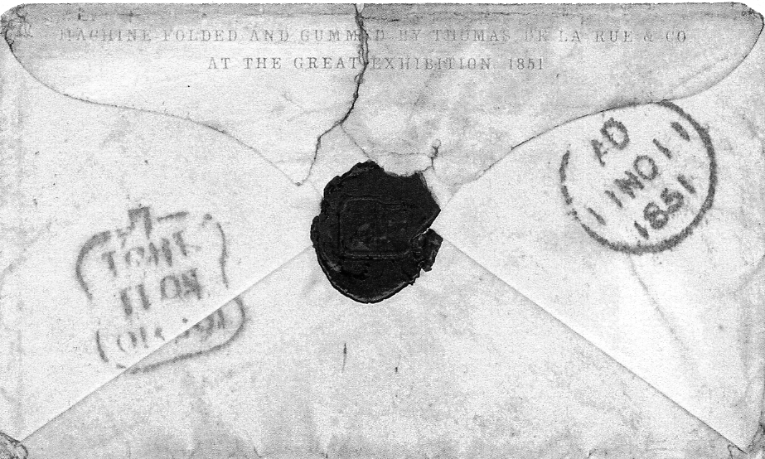

This envelope resides in my collection, how it came to be there is told
in the following story:-

As we walked towards the Market we came to a stamp shop that had a “Closing Down” sign in the window. We went in, George found some Postal History for the 1937 Paris Exhibition and the 1938 Glasgow Empire Exhibitions, he was well delighted. I asked for any Crystal Palace Postal History, expecting the usual negative response, but the owner of the shop came up with de la Rue Envelope, he said it would be £25, since it had already been reduced considerably, I just had to have it, he also offered me a nice envelope with 1862 International Exhibition Duplex cancel for a further £25, but on the grounds of poverty I had turn this offer down! (how foolish) I did not ask how much the original asking price for the de la Rue envelope was, but in hindsight I think it may have been one of my better purchases.
While on holiday in Guernsey I have done a lot of research on the Thomas de la Rue Company at their Head Office in St Peter Port, one of the interesting facts that I have found is that, yes, the Machine for folding and gumming envelopes shown at the Great Exhibition could process 3,600 per hour! but like most firms in the 1850’s de la Rue had to look after the pennies, so the two boys operating the machine were instructed to put the same envelopes through, time after time! It really does stand to reason that this is what was happening, otherwise there would have been several million envelopes around in 1851, with de la Rue becoming bankrupt. There would probably be a fair few still around today, not just the five which are known!
One item that will be featured in a later article is the Thomas de la Rue Frontispiece for a Great Exhibition book, which has a piece of pressed ivy mounted on to it, most likely the only surviving piece of organic material from the Hyde Park Crystal Palace.

A rare sheet of Wembley Labels
by
Peter G. Griffin

The next sheet of labels was sent in by Peter G. Griffin as a follow up for the article published in the last issue of our Journal, he writes,
In response to the article on the Gerald Spenser Pryse labels I enclose a photocopy of the complete sheet (less three small pieces of the selvage,) it took me years to find the twelve different labels for the set, and then I came by the enclosed sheet. Everything is se-tenant and where it should be, but the illustrations in Journal 107, like my own original reconstruction is incorrect.
This may help anyone doing a reconstruction to finally get their labels in the correct order. Peter goes on to say ‘it may be the only full sheet in existence’. This is not quite correct, as follows,
Thanks Peter for making available a scan of a complete sheet which is certainly extremely rare, I only know of one other complete sheet and that is owned by Alan Sabey. When Alan and I publisher the book on Wembley labels way back in 2003 (Exhibition Study Group publication No. 6) and having Alan’s sheet to work from we did get the layout correct. When Alan got his complete sheet he let me have his set of singles, Even as singles I don’t expect there are many complete sets about.

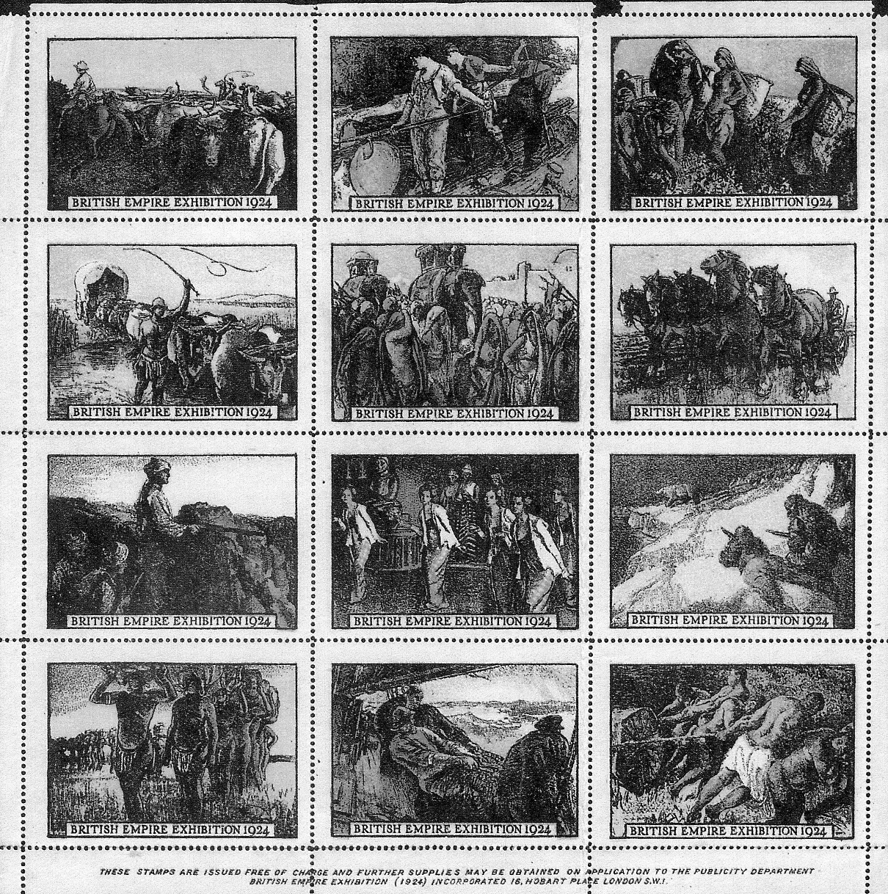

Three new Wembley labels

The Ewbank and Frost labels both on complete invoices were sent in by Alan Sabey.
At our convention Raymond Goodey showed me a new advertising label he had recently acquired. As soon as I saw it, it rang a bell, Ray was good enough to lend it to me so I could scan it for the Journal. The design was originally published as a post card by Fleetway Press and is from a drawing by Ernest Coffin. Fleetway actually published two post cards of the drawing, the first was numbered 4 and was produced by screened photogravure.

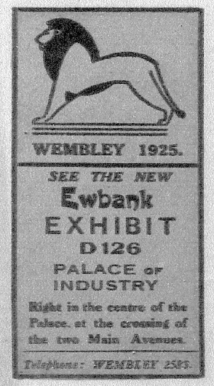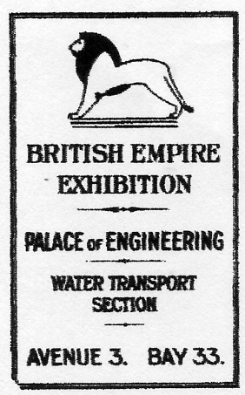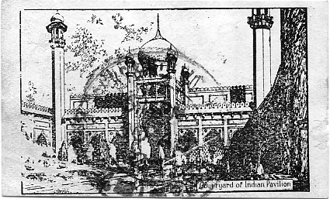

Ewbank Frost Bros (In red) Fleetway Press Ltd.
(Entwisle & Kenyon Ltd., Accrington)
It was one of twelve views by Coffin numbered 1-12, the process gave a very poor image and Fleetway later re-published the set as line printings which gave a much better image, these were numbered 57-68. Both were sold in packets of 12 cards for 6d.
Since Fleetway Press had the originals it is almost certain that they published the advertising labels and this is the first intimation that the drawings were ever published in this format, and if the Valentine labels are anything to go by they were probably published in sheets of twelve made up of four rows of three. It has taken nearly 90 years for one example to surface, I wonder if we shall ever see any more or even a complete sheet?

John Glanfield has been working for some time on a corporate history of Olympia and Earls Court. He has just completed the Olympia section and has very kindly sent me a copy and given permission to publish it in our journal. As it is over twenty pages I shall spread it over three journals, and parts two and three will follow in the next two journals. It is a fascinating story of the financial manoeuvrings of high powered and very wealthy businessmen over nearly 130 years.

OLYMPIA Corporate History 1884-1999
by
© John Glanfield
January 2012

Working notes
Nomenclature
1. The National Agricultural Hall 1884, 16 May
Renamed Olympia 1893, March, by Olympia Ltd. as purchaser
2. The Grand Hall was formally named 1930 on completion of The Empire Hall
3 The New Hall 1923 on completion
Renamed The National Hall 1930 on completion of The Empire Hall
4 The Empire Hall 1930 on completion
Renamed Olympia 2 1983 on conversion as specialist venue for smaller events

Primary sources
Earls Court & Olympia, archives
The National Archives, Kew. Company records (BT31 series. J series), railway operators’ records (RAIL series). Treasury and other records, as indicated.
London Metropolitan Archives. LCC and GLC files on Olympia, 1895-1983. Correspondence Between Olympia and the LCC re building consents etc. Correspondence with London & NW Rly.
The British Library. Company records, memoirs.
The Guildhall Library
The Royal Borough of Kensington library
Hammersmith & Fulham Archives & Local History Centre

Other sources
The British Library. Periodicals,
Bird, Peter, The First Food Empire. A History of J. Lyons & Co. Phillimore. Chichester, W Sussex, 2000
Binns, Lt-Col PL. The Story of the Royal Tournament, Gale 8 Polden, Aldershot, 1952
Cochran, Charles, Cock-a-Doodle-Do, J. M. Dent, London, 1941
Cochran, Charles, Showman Looks On, J. M. Dent, London, 1946
Cochran, Charles, The Secrets of a Snowman. Wm. Heinemann. London. 1925
Exhibition Study Group, http://www. studvqroup.org.uk/
Hartley, Harold, Eighty Eight Not Out, F Muller, London, 1939
Heppner, Sam, ‘Cookie,’ L Frewin, London. 1969 isbn 09 0954 10 6
Ryan, Deborah, The Ideal Home Through the 20th Century, Hazar Publishing, London, 1997. ISBN 1
874371 81 4
Stem, Ernest. My Life My Stage, V Gollancz, 1951
The Times’.

1884 March. Site is acquired for National Agricultural Hall (NAH)
On 10 March Edward Yates of 2 York St. Southward sold the 6.25 acre site for £41,000 to Edward Lindsell Hunt, gentleman, of 140 Albany Street, Middx.

1884 April.
On 10 April the site was sold on by Hunt for £52,000 to James Thorne, Trustee of The National Agricultural Hall Company Ltd pending its registration. The terms of sale required the company to transmit direct to Yates the payment due to him from Hunt in the form of £31,000 cash and £10.000 in paid-up £10 shares in the company. Hunt to receive the balance of £11,000 in cash.
National Archives. Kew. Co. Prospectus, piece RAIL 404/171.
Also contract between parties on terms of sale. 21 1 1885. piece BT31/3335/19814.
The NAH site lay sandwiched between the celebrated Royal Vineyard Nursery on its north side (established c.1745 by plantsman James Lee), and 4-32 West Kensington Gardens to the south, a row of eight substantial houses fronting Hammersmith Road. The run of their back garden fences was the Hall’s boundary. The nursery and surrounding area north of Hammersmith Road had earlier been a vineyard since at least the 1600s, producing a good Burgundy

1884 16 May. Creation of The National Agricultural Hall Company Ltd (NAH Co.)
Company Registration 7644 Aims.
‘To provide healthy amusement and reinvigorate by brilliant demonstrations the national love of athletic exercises and contests of skill: to raise the tone of popular taste by entertainment’s and displays which shall be of the purest and highest character: to educate the masses, aye, and even the ‘classes’ by exhibitions of art, science and industry.’
President, NAH Co. The Earl of Zetland
Chairman The Rt. Hon The Earl of Lathom (the Lord Chamberlain)
Deputy Chairman Sir John Humphreys
Directors Maj-Gen Duncan Baillie. W. W. B. Beach, W. Armine Bevan,
Wentworth L Cole of the Albert Hall, J.C. Lawrence, Thomas Pain of
Tattersalls, H. J. Waterlow, Alderman.
Gen. Manager Mr J.S. Wood. Reputedly a discreet and sober man and event organiser, having produced an Old English Fair in South Kensington that took London by storm. More recently. Woods had staged a Shakespearean event.
Some 200 vice-presidents were appointed, including four Earls. Major landowners and those in the sporting world predominated. The Earl of Zetland was no doubt instrumental in securing many of the eighty peers and sixty knights among them.
Nominal capital £200,000 in shares of £10.00, half taken up privately. The balance was offered to the public whose response proved disappointing. As an inducement, buyers of twenty-five or more shares were offered life membership with free admission to the Hall and gardens when open to the public.
National Archives, Kew, piece Rail404/171 include company prospectus and application for shares, with press quotes on the prospectus, reproductions of two of Henry Coe’s drawings and sketches of the building, and correspondence of the railway companies operating through Addison Rd. station, relevant to the new hall.
piece BT31/3335/l9814 incl copy of the1885contract to purchase land for the Hall, Memorandum of Association of The National Agriultural Hall Company Ltd. Returns of capital & shares, winding-up papers.

1885 July. The foundation stone is laid
The ceremony on 21 July was followed by a fine luncheon for company directors and invited shareholders in a pavilion on or near the site. Hosted by its President The Earl of Zetland, who laid the engraved stone after a cavity beneath had been filled with the usual documents and coins’. He expressed the hope that it might prove the foundation of a building that would be of infinite service to the agricultural interests and industries of the nation. The stone is visible inside the Grand Hall’s main entrance, a small room on the right.

The National Agricultural Hall Company prospectus
The directors announced acquisition of the Kensington site for £52,000 estimating the build cost at £130,000. (Lucas 8 Son the general contractor would receive £131,573). The Press anticipated a final overall cost of £225,000 including contingencies to yield a dividend of 5% Annual net profit of around £12,000 was thought to be achievable. The prospectus cited the smaller and more remote Agricultural Hall in Islington where return on capital was said to be 12% despite its ‘manifest disadvantages.’ The ‘Aggie’s’ £10 shares had recently touched £23.
Architect Henry Coe, who with Mr Peck had built the Agricultural Hall, completed much of the design of the NAH before being taken ill and resigning. Sadly, he died late in 1885. James Edmeston took over. Coe’s ambitious floor plan and sinking engraving of the ‘Grand Hall’ accompanied the Prospectus. This was said to be the largest framed structure in the kingdom at 440 ft/134 m long and 249 ft/76 m wide beneath the tall arched roof with its dramatic 170 ft/52 m clear span. The roof stands 115 ft/35 m high at the apex, the glazing set in 1,200 tons of cast iron This and the building’s iron frame are of exceptional tensile strength, cast by Andrew Handyside & Company at the Britannia Foundry, Derby The 10,200 sq. m ‘footprint’ was nearly 50% greater than Coe’s Agricultural Hall, with a further 4,300 sq. m overall at gallery level. Four shop units flanked either side of the main entrance. They were listed among other revenue generating sources including the refreshments concession, auction sales, tennis courts, and the establishment of commercial registers of farms, estates, breeding cattle and stallions.
Four accompanying pages of favourable Press comment included,
‘The Company have also secured the optional right to purchase at any time before 29 September 1884 upwards of five and a half additional acres in close proximity ‘ Aberdeen Journal. Morning Advertiser and other titles.
To be continued

