EDITORIAL WINTER 2012

It will soon be Christmas, of that there’s no doubt,
My choice of those post cards is fast running out.

Our convention is over for another year, and it has to be said that the members attending was the lowest for some years. I don’t know what to put this down to, several regulars were not able to attend, Alan Sabey was unable to attend, Peter Denley was in bed with back trouble and his cheery face was missed. Ken Peters from Biggin Hill wrote to me and said his car had broke down and was in a garage, it would have cost him £100 return for a cab. He adds that as he writes his car is again dead as a dodo. Ken has a contingency plan for next year and it seems is considering hiring a bicycle for trouble free transport. Mike Perkins is saving up for a months holiday in New Zealand. Kenneth Tonkin was down to come and he had prepared two displays to show, but unfortunately a business meeting he was attending in China got delayed and put back, and he had to go out there and miss our convention. He did give me a few sheets of 1862 covers to display on his behalf, but kept his display of Wembley post marks back, as he didn’t think I knew enough to give a talk about them.
On the Friday evening for the fish & chip supper from an attendance of 11 in 2010 we were down to 5. At that number Joan Miles said she could not ask the kitchen staff to come in for just five meals, but good girl that she is, Joan went out and bought fish and chips from a local shop for us.
The attendance on the Saturday was also down from 23 in 2010 to 13 and on the Sunday from 21 in 2010 down to 8.
There was some discussion at the A.G.M. about the fallen attendance and several measures were adopted. It was proposed that refreshments , tea coffee and sandwiches would be paid for by the Study Group rather than be charged to members attending. Members will still pay for their Supper and Annual Dinner. Also at our A.G.M. in 2009 after our convention at the Ramada Hatfield Hotel in 2008 where they charged us £200 to use their conference room for our meetings, we passed a resolution to the effect that those attending the convention should pay £9 in future to help offset the cost of holding the convention.
Next year in 2009 when we were back at the Crystal Palace with no cost for the Paxton Suite where we meet, there was some muttering about this charge, which at the time we were unable to alter because it was an A.G.M. decision. At our A.G.M. this year we passed a resolution cancelling the £9 charge. The Study Group is not short of money, and while it is nice to have a large amount in the bank, that is not one of the object of the Study Group as laid down in our constitution.
I don’t know what part, if any the general state of the economy plays in our falling attendance but I would like to say loud and clear that the Crystal Palace Lodge while not a luxury hotel gives first class accommodation, the rooms are spotless, and the meals are at a very reasonable cost. Lets face it where in London can you get a single room bed and breakfast for under £30.
When you add to this the very high standard of the displays, and the pleasant company, it all goes to make a jolly good weekend.
Don is going to call a committee meeting in the not too distant future to discuss what we can do to halt the decline in attendance.
On a happier note, I have had three letters from members congratulating me on the Karl Illingworth article, it’s nice to know my efforts are appreciated and some members have taken the trouble to write and tell me. Those of our members who have a dual membership in the Festival of Britain Society will know that Fred Peskett has asked for a volunteer to take on the job of doing the Festival Times, their newsletter. Fred tells me he intends to carry on doing articles for our Journal.
Since Fred became Joint Editor of the Journal some years ago, he has provided a constant imput, and the Journal would not be the Journal it is without his help. We are both conscious that for many of our members who do not attend our convention the Journal is all they get for their money. If it’s not worth their annual subscription they will leave, it’s as simple as that.

The Editors.
Exhibition Study Group A. G. M. 2012
Held at Crystal Palace Saturday 29 September.

Apologies received from President Alan Sabey and Peter Denley and Kenneth Tonkin.
Don Knight in the absence of the President took the chair. Welcomed 13 members to the 26th Convention and thanked them all for attending, wishing them all an enjoyable weekend.
Don then asked the members to stand in memory of Bob Tough who died earlier this year.
Bill Tonkin had published in the back of the Journal information for booking into the Crystal Palace Centre and to let our secretary know if they were attending and if they would be putting up a display. This did not bring any new members to the convention, members do not have to give up the whole weekend but support is needed if it is to continue for many years to come.
The minutes of the 2011 A.G.M. were Proposed by Fred Peskett Seconded by Melvin Harrison and accepted. There were no matters arising.
Secretary Don Knight reported that the special covers produced for the 25th Convention did not bring many sales to members, but he had cleared the costs by selling some to a London dealer. It was proposed that he tries to sell the remainder the same way. He thanked Ramon Goodey, Derek Connell and Kenneth Tonkin for all their work in getting the cover produced.
We are listed in Reflections of a Bygone Age and I have returned the form for 2013. Mr Rene Dee author of Sweet Peas, Suffragettes and Showmen about the Royal Horticultural Hall, London had been invited to come this weekend, but was unable to.
Treasurer Kenneth Tonkin had given his apologies, but had sent copies of the accounts to Bill Tonkin and John Greatrex. Bill said our finances are in good order with over £11,000 in the bank. The balance sheet is published in this Journal.
Election of Officers
President. Alan Sabey has now served his term of 3 years and the new President to be elected, Ramon Goodey was Propose by Derek Connell Seconded by Fred Peskett and supported by the meeting.
Vice President. Derek Connell was proposed by Ramon Goodey Seconded by George Burr supported by the meeting.
Secretary. Don Knight,
Treasurer. Kenneth Tonkin
Committee. George Burr, Fred Peskett, Ken Rumsey and Bill Tonkin.
Public Relations Officer. Alan Sabey.
Joint Journal Team. Bill Tonkin and Fred Peskett.
Journal Sponsor: is printed and distributed by Kenneth Tonkin.
Web Masters. Mike Perkins and Ken Rumsey.
Archivist. Bill Tonkin.
Accounts Examiner. John Greatrex.
These were proposed en bloc by George Burr seconded by Ron Trevelyan and supported by the meeting.
Venue for 2013. It was Proposed by Ramon Goodey seconded by Bill Tonkin that we hold the 2013 Convention at Crystal Palace on the 28 and 29 September, Supported by the meeting. These dates do not clash with Stampex.
Any other business.
1 It was proposed that we look into holding a meeting at Stampex at some time, We could get leaflets done to hand out at Stampex. Ramon Goodey to look into cost of room.
2 Fred Peskett had made a Meccano model on the request of Boris Johnson which went on show near to Stratford, This now stands in a local school.
3 The work on a Wembley book is giving Bill Tonkin problems due to quality of the photo-copies, this is on going.
4 Two Exhibitions to commemorate the 2012 Olympic Games have taken place in London, one at the Royal Opera House the other at the British Library, this one had a special Handstamp use by the Royal Mail. Both were very good, Alan Sabey showed his 1948 Olympic item at the British Library. Don Knight had an Exhibition at Fulham Palace on the 1908 Olympics.
5 Bill Tonkin Proposed that due to our funds being so strong the costs of the refreshments be paid by the Study Group, this was seconded by George Burr and carried by the meeting.
The A.G.M. Closed at 11.05. Don R. Knight

Exhibition Study Groups Displays at Convention 2012

Saturday 29 th
To start the conventions displays
Don Knight showed early items of Alexandra Palace, with postcards and programs. This lead up to London Stamp World 1990 this was the first major event to be held a the Palace after the fire in the early 1980's. The Royal Mail issued two special sheets to help fund the exhibition, first was Edward Lear, second was Building. He laid out the official program, the many first day covers produced. These covered the 150th Anniversary of the Penny Black, with covers for the special events being held daily.
Kenneth Tonkin display was given in his absence was of the rare postmarks of the 1862 exhibition held in Exhibition Road, on display were covers with the numbered handstamps.
Bill Tonkin displayed a study of the 1912 Ideal Stamp with the many colours they were printed in, including full sheets in blue and red. The special postcards in the many colours and card they had been printed on. Then Bill followed with his study of Snap Shots of the British Empire Exhibition 1924 -25. With a number of exploded boxes, then the pictures being picked out with the many variations. Bill would like to hear about any Snap Shot boxes you may have, please.
Ramon Goodey showed a study of proofs for the design of the British Empire Exhibition stamps by Noel Rooke, Eric Gill and six designs by Harold Nelson. These were not the originals but still rare. He told about the designs being redrawn for the postal stationary.
Fred Peskett talked about his finds at local collectors fairs and antique markets. He then showed an 1851 Crystal Palace jigsaw puzzle, a small brass box the size of a crown piece when opened had six pictures of the Palace. Items from the 50th anniversary 1901 Military Exhibition and John Handrup silhouette cards.
Melvin Harrison showed a very large plan of the Crystal Palace site drawn up in 1911, showing the many classes of house to be built around the perimeter, these are standing today. A superb book from 1851 with pictures of the interior of the Palace. In 1911 the site was bought for the nation and in 1914 became a charitable trust.
Fred Peskett went on to give a display of Colonel Cody material with a letter signed by him, a cover and balloon flights form the Crystal Palace.
Derek Connell who's interest is London Postal History and Events, started with the White City and the 1908 Olympic Games. Followed with the Wembley 1948 Olympic Games, First Day covers the Air Letter error with the misplaced stamp and the over printed Olympic stamps. Then we saw the start of the 2012 build up to the 2012 Olympic Games, with the games coming to London the many handouts the Souvenir sheet, to be followed by stamps, and early badges and coins.
Don Knight To close the afternoon Don showed the London Olympics 2012 with the many postmarks sponsored for the first day of issue on the special sheet produced by the Royal Mail. Then followed with the Gold sheet stamps for the 28 Gold Medal Winners, two covers for the closing day. Then came the same for the Paralympic Games with only some of the 34 Gold Medal Winners.

Sunday 30 th
Sunday’s displays started with
Ron Trevelyan showing the New York Worlds Fairs 1939-1940, The exhibition was visited by King George VI in 1939. He showed the postmarks, postcards, these showed the great amount work the had been put into the Fair, not knowing that the second world war was about to start. During a visit to an historic house he had seen a model of the 1862 Exhibition Building by which was a jigsaw box of
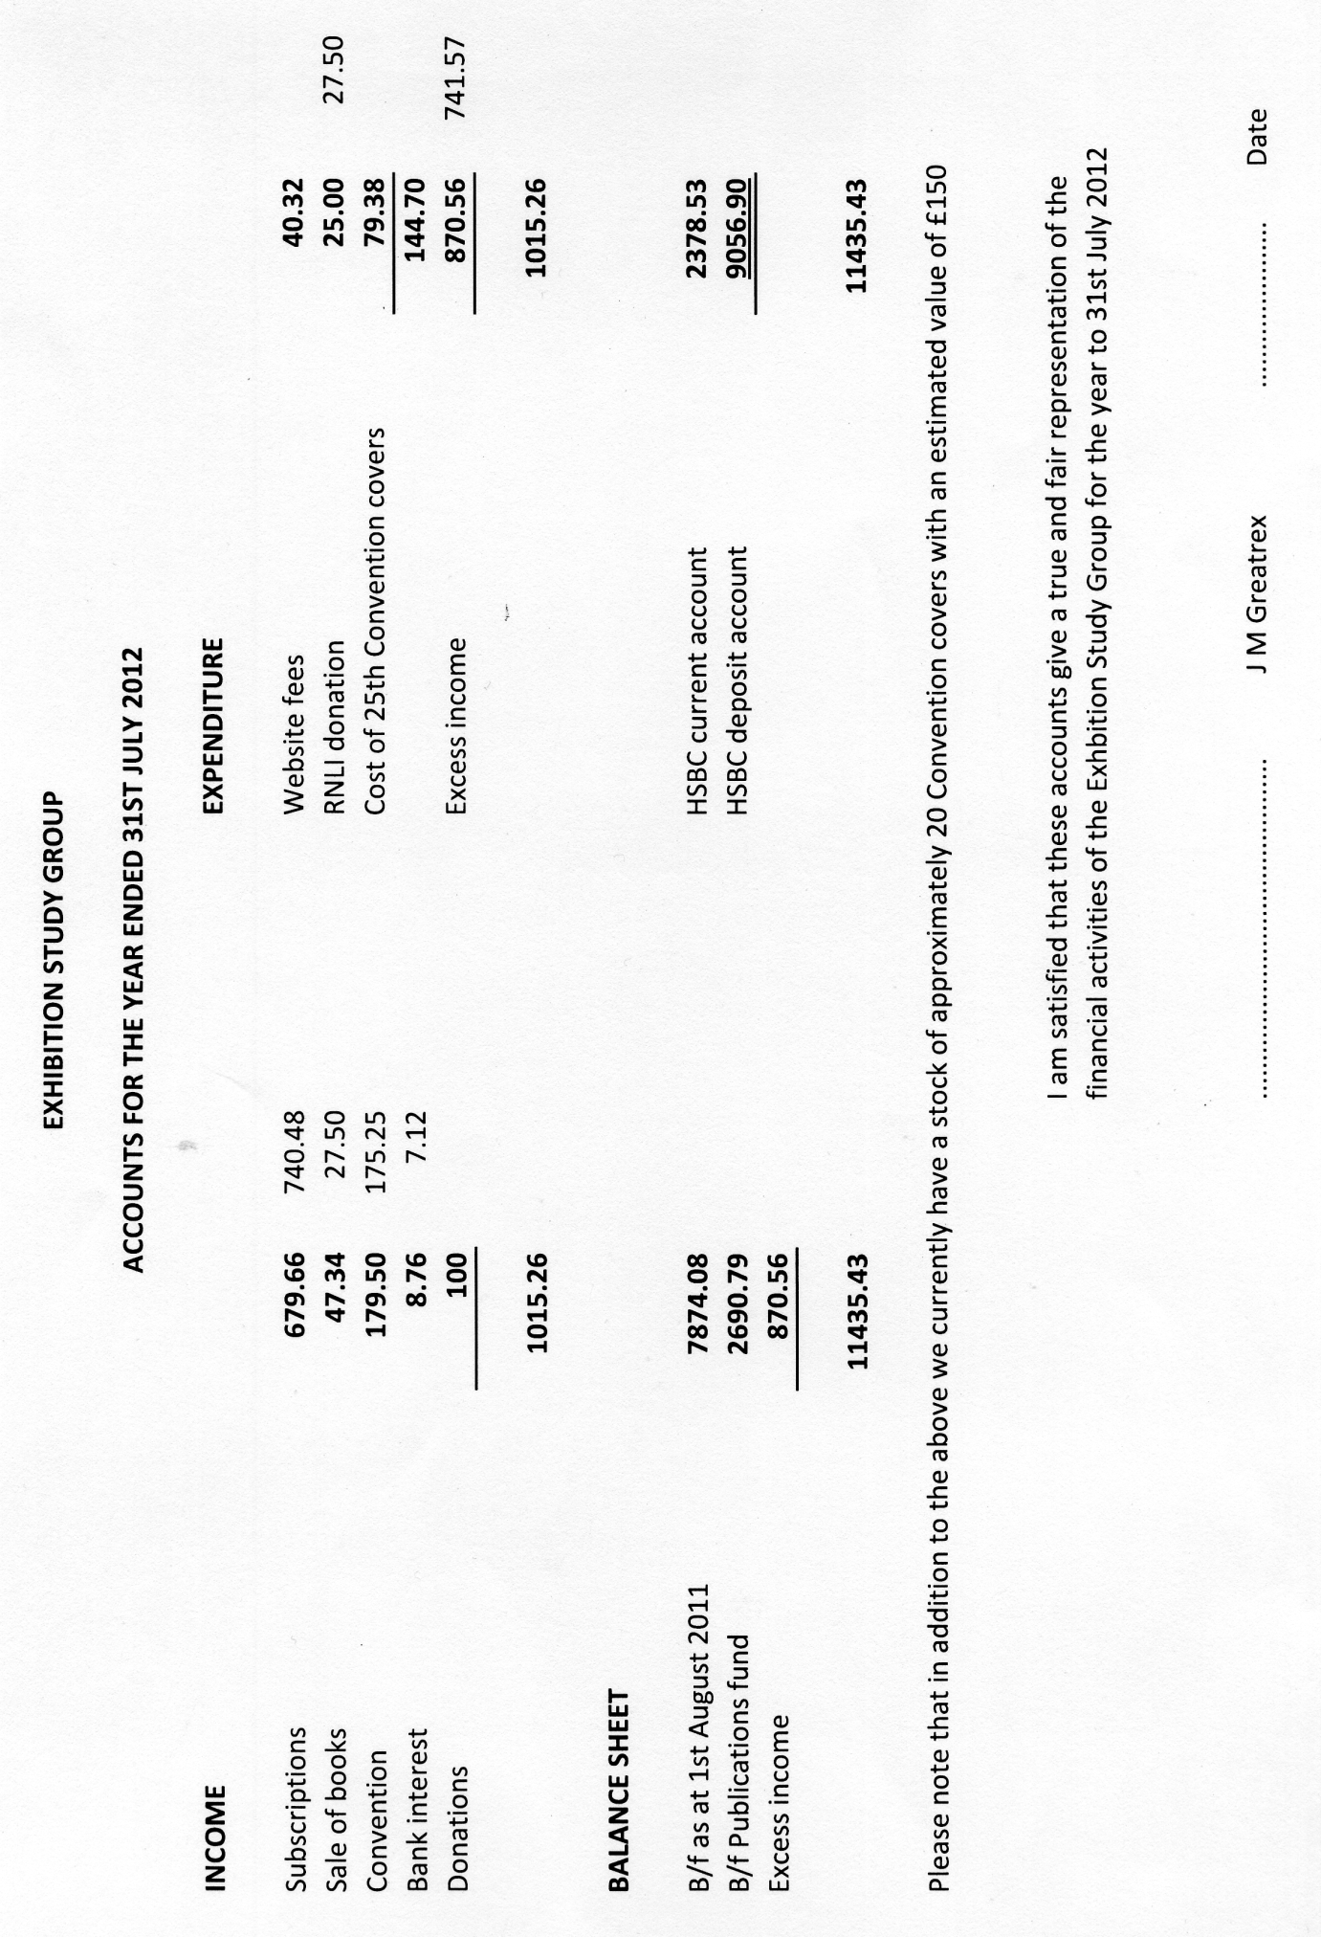
the 1851 Crystal Palace as shown by Fred Peskett on Saturday. He finished with colour prints of the interior of the Crystal Palace by George Baxter.
Terry Gazzard showed and talked about single postcards he had collected over the years.
John Greatrex talked about a project he is working on for 2015 to commemorate the Crystal Palace, with computerised pictures.
Derek Connell put up the last display to close the convention with the tour of the Olympic flame around Great Britain. He showed views of the towns and cities the Olympic Torch went through and what length he had been to get the relevant postmarks. The many badges, coins, postcards and there was much more.
Don Knight went over the displays in brief on what we had seen over the two days and everyone joined in with the applause of thanks. The President Ramon Goodey said how he had enjoyed the weekend and that everyone had as well and is looking forward to the 2013 Convention to be held on the 28th and 29th September at Crystal Palace.

2 May 1938: The Empire Exhibition Service
by
Jack B. R. Murray

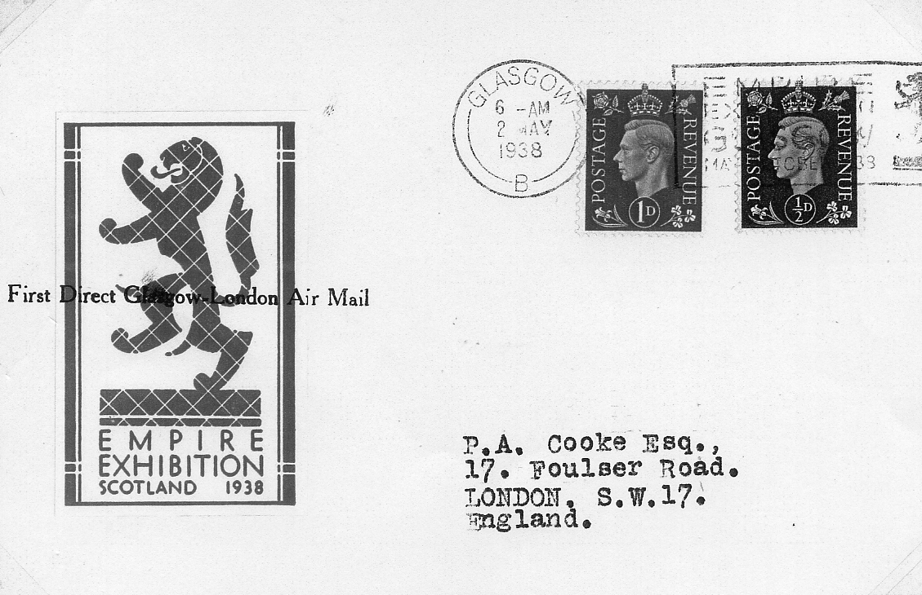

To facilitate Glasgow - London communication during the 1938 Empire Exhibition in Glasgow, RAS operated an accelerated service until 3rd September. Mail and passengers were flown direct to Liverpool where connection was made with the main Belfast - London flight. All services were utilised by the Post Office for the carriage of mail. DH 86 planes used on the first day were:
Croydon - Liverpool G - ACVY Mercury
Liverpool - Glasgow G - AEWR Venus
Glasgow - Liverpool G - AEWR Venus
Liverpool - Croydon G - AEFH Neptune
Only twenty first flight covers are known from the first southbound flight, the stamps are cancelled by the 6 a.m. Glasgow machine cancellation with the EMPIRE EXHIBITION GLASGOW slogan. Covers are decorated with red and white exhibition stickers which have been overprinted ‘First Direct Glasgow - London Air Mail’. No mail has survived from the first northbound flight.

Alexis Soyer, A Postscript
by
Fred Peskett

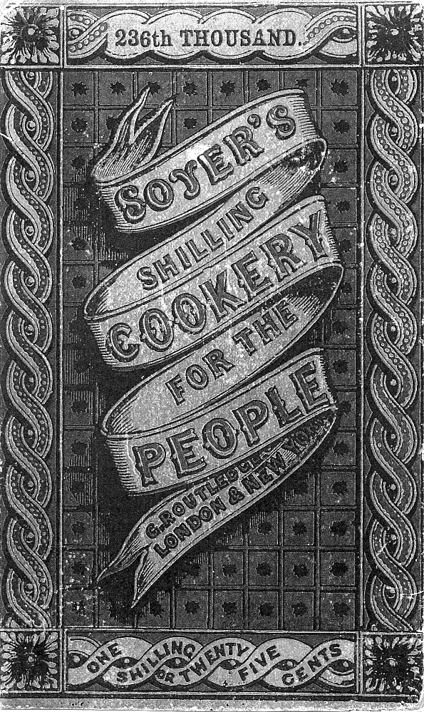
A few issues ago I wrote an article about the exploits of Alexis Soyer who established an alternative eating house at Kensington Gore to cater for visitors to the Great Exhibition of 1851. Soyer’s main gripe was that only cold food was available at the dinning areas in the Crystal Palace, and that the food they did serve was far too expensive.
One of Mr Soyer’s other enterprises was mentioned in the article, but at the time very little was known about it. This was Soyer’s Mobile Kitchen for the Army. I can now complete the information and provide an illustration of Mr Soyer’s Invention, thanks to a little book found for 50p in a Charity Shop, “Soyer’s Shilling Cookery for the People”, published in 1852 for 1/- or 25 cents. In the book Alexis Soyer describes his Mobile Kitchen for the Army, so here it is in his own words:-
During the period of the famine in Ireland, I took with me a portable kitchen, and erected it opposite the Royal Barracks in Dublin, and with which I cooked and delivered rations for 26,600 persons daily.
Having last year taken a peep at the camp at Chobham, as well as the camp at Satory in France, and seeing, by the ordinary manner in which the provisions for the different messes were cooked, even in France, that a large amount of nutriment of the food was lost, it occurred to me that, if a moveable kitchen could be made to travel
with the army, it would be
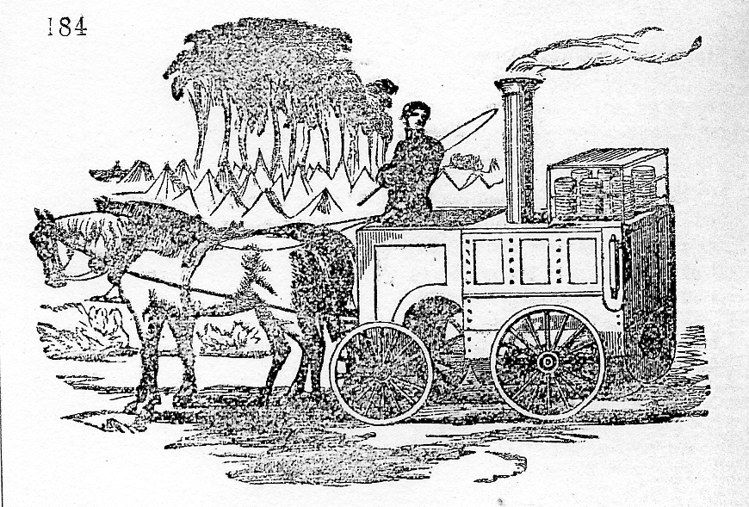
exceedingly useful, whilst on the march, or when encamped. (see illustration)
The following is an explanation of the kitchen below: The carriage is made of sheet-iron, weighing with water, fuel &c., a little more than one ton. The lower part consists of a circular steam boiler, and the upper part, of an oven. Over the oven are placed the various pans containing the rations required to be cooked by steam, and on each side is a hanging shelf, which will hold steam saucepans in front and, round the driver’s seat is a reservoir for water, and a place to hold the condiments, &c.
The plan of working it would be to draw it near to a stream or reservoir for water-if brackish or muddy it does not matter, (Any tainted water is made good by first converting it into steam.) there fill the boiler and reservoir and remove it to any convenient spot. The fuel may consist of wood, coal, turf, &c. Within one hour after the fire is lighted the steam would be up, and the oven hot, and with six feet long and three feet wide, rations for 1,000 men could be cooked by baking and steaming in about two hours, and the apparatus moved on again, or it would cook whilst on the march, if on an even road.
Its advantages are, saving of time, labour, men and food, and the certainty that the men could get their food properly cooked.
The cost of each apparatus would not exceed £100

Sherlock Peskett Holmes solves another Mystery
by
Fred Peskett and Bill Tonkin

A short time ago I picked up this post card of a Fireman at the Crystal Palace in July 1913 and as we keep each other informed about new Crystal Palace post cards I sent Fred a copy of it. Shortly afterwards I received the following.

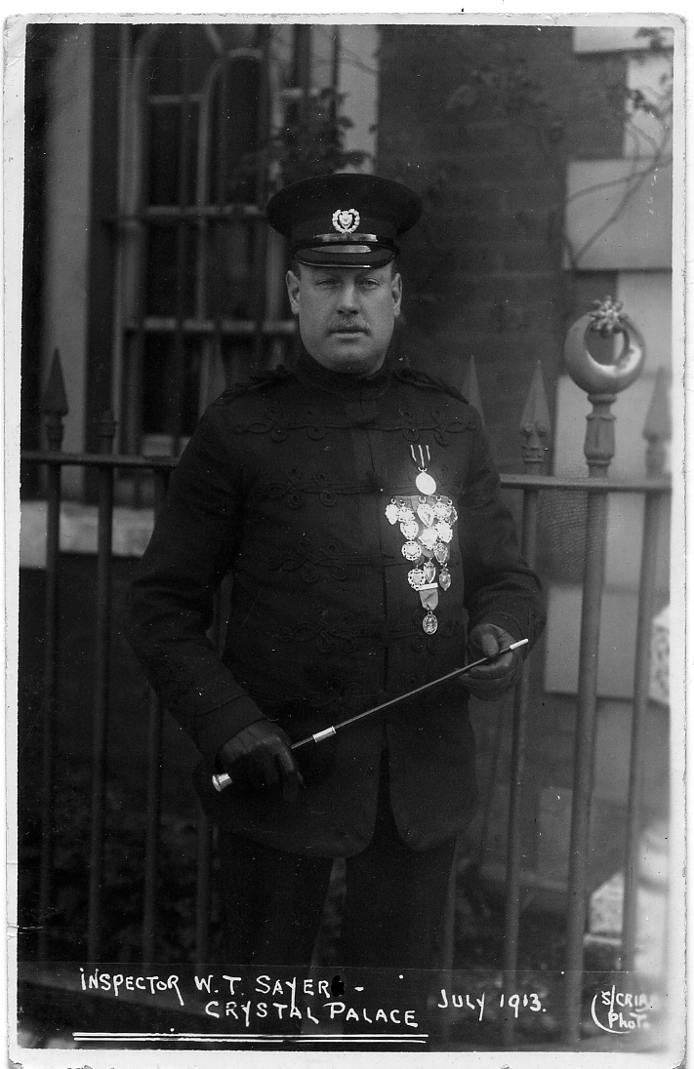
Now I have some further information on S. Crib. At the Antique Fair I went to last Sunday, I met Andrew Bowker, who is an expert on Portsmouth postcards, S. Crib = Steven Crib, who had a studio in Laburnum Grove, North End, Portsmouth, just a few minutes walk from where 1 live! Steven Crib was in business with postcards from 1900 to about mid 1920 when he died. The postcard of Inspector W. T. Sayer shows him standing outside the entrance gates to the offices of Copnor Fire Station, again a short walk from where I live. This can be detected by the sign on the gatepost, the Star over a Crescent, (The Portsmouth City Crest). This Victorian Fire Station was destroyed by enemy action in 1941, and re-built during the 1950’s in the “Festival” style. It closed as a working Fire Station about four years ago, and will shortly be demolished and replaced by a purpose built Nursing Home. S. Crib was famous for his postcards of the 1901 and 1911 Fleet Reviews at Spithead for the Coronations of Edward VII and George V. It is surprising just how much information can be found from a few simple facts, I think we should call ourselves “The Postcard Detectives?”
Convention 2013
By
Hon Sec Don R Knight.

I hope you enjoy reading about the Exhibition Study Groups Convention and the many types of displays that were shown. This gives you our members the opportunity to show what and how they collect and to give the knowledge gained to other members. The display can be just a few sheets or anything up to 80 sheets. Members can come for just the Saturday or the Sunday morning, the Crystal Palace hotel is good so is the food. Please put the 28th 29th September 2013 in you diary and come, meet and enjoy other members collections.

British Empire Exhibition Railway Tickets and Stubs
by
Mike Gorringe

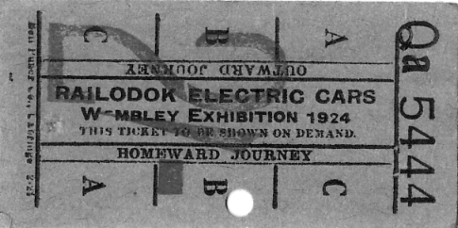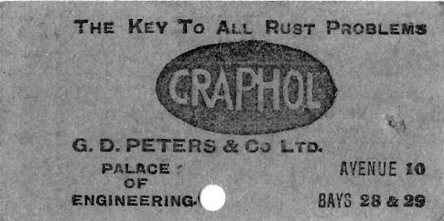
1
No. 1 Railodok Electric Car ticket Outward and Homeward Journey, ticket No. Qa 5444. fare 2/- overprinted in red, Advert for Graphol on reverse ‘The Key To All Rust Problems, G. D. Peters & Co. Ltd., Palace of Engineering, Avenue 10 Bays 28 & 29’.

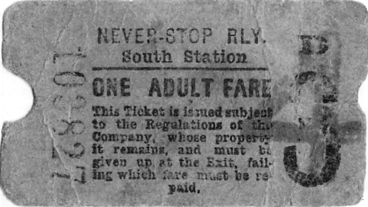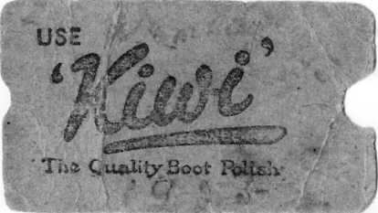
2
No. 2 Beige BEE Neverstop Railway ticket (South Station) One Adult Fare, ticket No. 103827. 3d overprinted 4 in purple, Advert for Kiwi Polish on reverse ‘Use Kiwi The Quality Boot Polish’. 1925 in pencil.

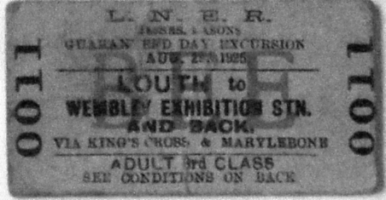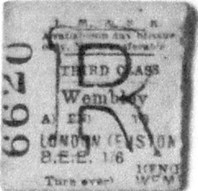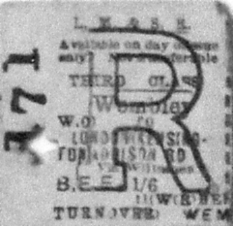
3 4 5
No 3 Beige Guaranteed Day Excursion return ticket No. 0011 (full) from Louth to the Wembley Exhibition Station 1925, over stamped BEE in red.
No 4 Green L.M. & S.R. return half ticket No. 6620, third class, Wembley to London (Euston), includes entrance fee to exhibition 1/6d. Dated June 14th 1924.
No 5 Green LM. &S.R. return half ticket No. 171 with cross punch hole, third class, Wembley to Kensington / Addison Road, includes entrance fee to exhibition 1/6d., Dated 2 Oct 1925

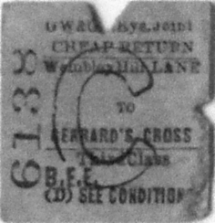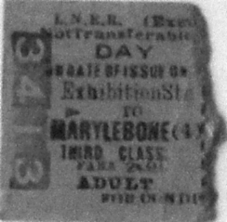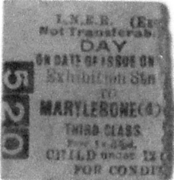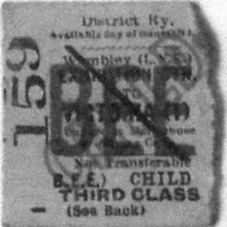
6 7 8 9
No 6 Beige G.W. & G.C. Rys Joint punched cheap return third class, ticket stub No. 6138, Wembley Hill L&NER station to Gerrard’s Cross, overprinted B.E.E. and large C (child?) Dated 10/12 (?) Sept.
No 7 Pink L.N.E.R. Day adult ticket No. 3413, third class, Exhibition Station to Marylebone (4) Fare 2s 9d. Dated (?) Oct 1924
No 8 Pink L.N.E.R. Day half child under 12, ticket stub No. 520, third class, Exhibition Station to Marylebone (4) Fare 1/4d. Dated 5 July 1924
No 9 Beige District Railway child ticket stub half, (Wembley L.N.E.) Exhibition Station to Victoria Third Class No. 159 overprinted Child / BEE and diagonal bar. Dated 10 Oct 1925

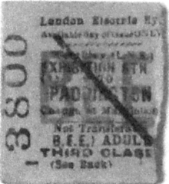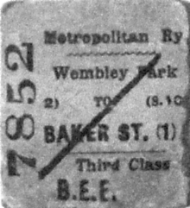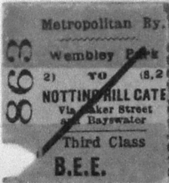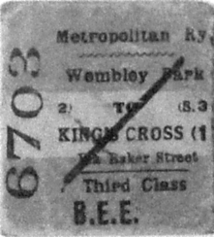
10 11 12 13
No 10 Beige London Electric Railway ticket stub half - Wembley LNE Exhibition Stn to Paddington, Adult Third class No. 3800, overprinted BEE and diagonal bar. Dated 8 Sept 1925
No 11 Pink / White / Grey (faded colours) Metropolitan Railway ticket stub, return half Wembley Park to Baker Street 1 Third class No 7852 overprinted B.E.E. Multi-coloured but faded
No 12 Pink / White / Grey Metropolitan Railway ticket stub, Wembley Park to Netting Hill Gate, third class No. 863, overprinted B.E.E. Date unclear, multi-coloured
No 13 Pink / White / Grey Metropolitan Railway ticket stub, Wembley Park to Kings Cross (1), Third Class No 6703, overprinted B.E.E. Part date ‘24 Multi-coloured

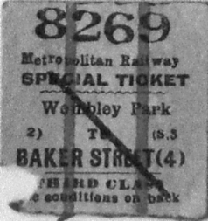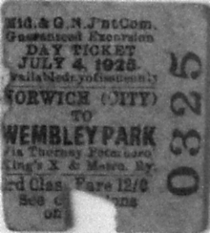
14 15
No 14 Yellow / Red / White Metropolitan Railway punched ticket stub, Special Ticket, Wembley Park to Baker Street (4), Third class No. 8269. Dated 08 Oct 1924 (No indication of BEE)
No 15 Beige Mid & G.N. J’nt Com punched Day ticket No. 0325, third class, Norwich (City) to Park, via other stations, excursion rate of 12 / 0, Dated 4th July 1925

Earlier this year I had a phone call from Kiki Werth, a lady who was interested in the Gerald Spenser Pryse posters. I imagine she was a dealer in these, as Kiki said she had had 19 of the 24 posters pass through her hands. This led to some correspondence between us which may be of interest to our members. This is a letter I sent to Kiki in reply to one from her.
Many thanks for your letter and enclosures, so often people are only too ready to pick your brains and that’s the end of the story. You are obviously like myself, somebody who files things away in case it comes in handy one day. I enjoyed our conversation on Imre Kiralfy and his doings at Earls Court and Shepherds Bush.
So here’s a little more to go in your Gerald Spencer Pryse file. In addition to the posters a set of 12 perforated gummed labels were published. The labels (or Cinderella’s as they are sometimes called) are not numbered, neither do they have individual titles, only “British Empire Exhibition 1924”. The titles and ‘E’ numbers given are taken from the proofs of the posters in the Victoria & Albert Museum. The sheet has an inscription printed on the bottom selvage reading “These stamps are issued free of charge and further supplies may be obtained on application to the Publicity Department. British Empire Exhibition (1924) Incorporated. 16, Hobart Place London S. W. 1.” in two lines. The labels measure 44 x 39 mm. Line perforation 14¾.
Although they were originally given free, they are now a very collectable item, as is almost everything to do with the two British Empire Exhibitions at Wembley in 1924 & 1925. This set of 12 would probably sell now for around £250-300. Not quite in the poster class yet, but they do nicely fit on an album page.

1 Burma, Temple dancers. E.25-1925.
2 Arctic Territories, The Polar Bear. E.27-1925.
3 India Frontier States, Balneli riflemen. E.26-1925.
4 British East Africa and Tanganyika Concession, Native bearers. E.23-1925.
5 Australia, Cattle station. E.37-1925
6 Canada, Log rolling. E.24-1925
7 Ceylon, Tamil coolies at work on a tea plantation. E.31-1925
8 South Africa, The Trekking waggon. E.32-1925.
9 India, The procession of elephants. E.35-1925.
10 Australia, Team ploughing. E.30-1925.
11 British Fisheries, Hauling in. E.34-1925.
12 Nigeria, Timber hauliers. E.22-1925.

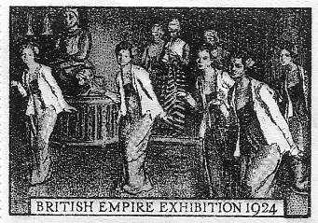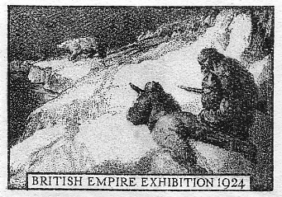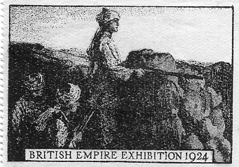

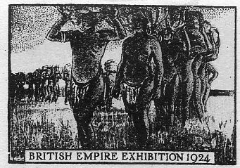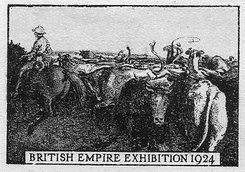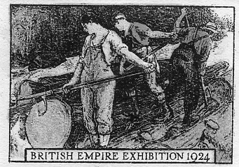

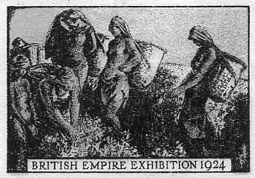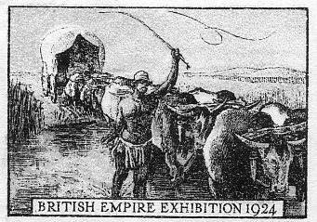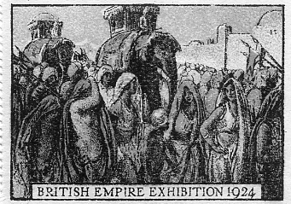

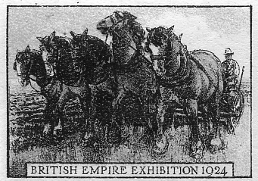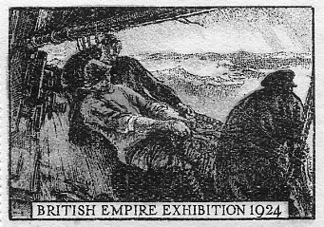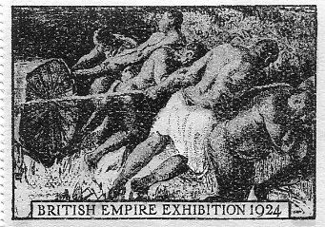

Only one complete unbroken pane of 12 is known, but there may well be other complete panes about. Sets of single labels are slightly more common. A single label is known overprinted by the Abbey Sports Co., Ltd. in 1924, with “See the “Abbey” Range at Stand F 221.” which they would have used on correspondence and invoices to advise customers that they were on stand F 221 at the Wembley Exhibition in 1924.
Two post cards published by R. Johnson & Sons of Newcastle show each end of the interior of the hall of Ford School in Northumberland, and displayed on the walls of the hall are full sized posters of these labels. Judging by the school furniture the posters must have been at least 2ft by 3ft and four different posters can be identified.

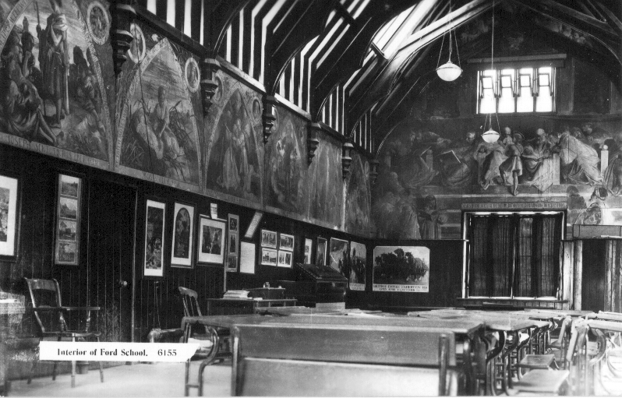
On this post card three posters can be identified, Australia Team Ploughing,
South Africa the Trekking Wagon and Arctic Territories the Polar Bear

The only difference in the posters to the perforated gummed labels is the addition of ‘Open April to October’ under ‘British Empire Exhibition 1924’ and in smaller printing ‘Scenes of Empire’. The post cards are real photographic post cards which means that under a strong glass the printing along the bottom of the posters on the walls, can be clearly read. Something you cannot do with computer scans.
Dear Bill,
Here is the article from Apollo Magazine October 1925 about Wembley Exhibition Posters by Spencer Pryse. Of the 24 listed I have never seen 2, 3, 8, 14 & 24. I have had the others at one time or another, and have photos of some of them.
Best Kiki.

The British Empire Lithographs
By
Martin Hardie

At the beginning of the Great War, when official committees were encouraging the output of posters that were undignified in appeal and obnoxious in design and lettering, Mr. Spencer Pryse won the honour of being the first to realise the needs of the time in productions of real artistic merit. He was in Antwerp at the outbreak of war, and was an eye-witness of the tragedy which overtook Belgium. On actual scenes of the evacuation he founded his pathetic lithograph of Belgian refugees struggling to escape from the advancing terror; and for the Belgian Red Cross Fund in London, made his noble poster of “Belgian Refugees in England.” Before he was wounded, and while still on active service, he produced a series of nine lithographs, entitled, “The Autumn Campaign, 1914,” and a powerful recruiting poster, “The Only Road for an Englishman.” Earlier than all this, in 1913, he had made a memorable series of dignified posters for the Labour Party, and with the encouragement of Mr. Frank Pick, that wise and far-sighted advocate of the poster, had done brilliant work for “the poor man’s picture gallery” in the stations and booking-halls of the Underground Railways Company.

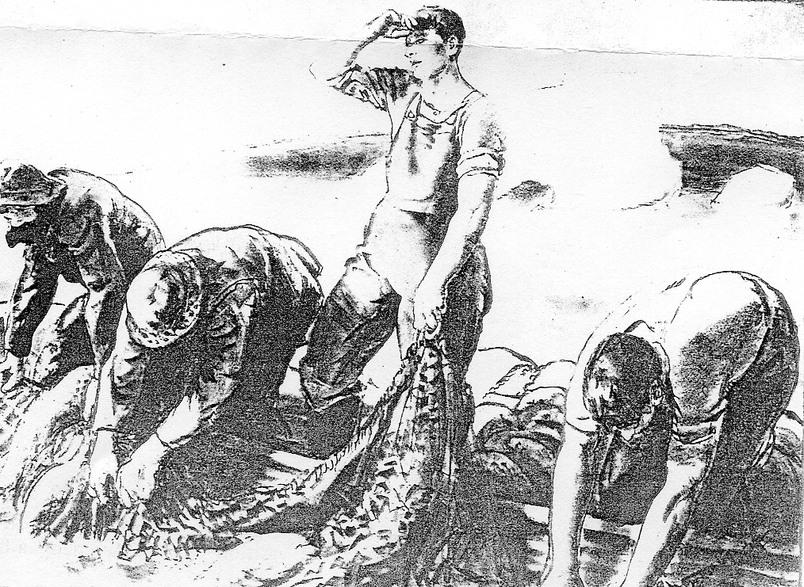
Newfoundland Trap fishing for cod
One of Spencer Pryse’s lithograps not published as an advertising label

All of those who knew Spencer Pryse’s work up to this point heard with enthusiasm that he had been commissioned last year to prepare a series of twenty-four posters for the British Empire Exhibition at Wembley. The posters were made; and owing to what misunderstanding, or change of policy, they were never used for their original purpose, need not now be considered. The fact remains that they were not used, and that as the outcome of late litigation in the King’s Bench Division the Exhibition paid damages and costs, handing over to the artist as his own property, so far as the proof edition was concerned, all such lithographs as had not been already destroyed.
All of this is past history, but it is only fair and right to add that Counsel for the Exhibition Authorities admitted that the failure to use the posters had nothing whatever to do either with their merit or their mode; of execution, and indeed paid a high tribute to the artistic value of the posters in question, stating that “if this case had proceeded, nothing would have fallen from me in any way detrimental or otherwise than complimentary to these particular pictures. We are glad to pay our tribute to the merits of his work.” With so fair and generous withdrawal, those who admired Spencer Pryse’s work and were jealous for his reputation as an artist, could not but be content.
Five of the lithographic stones were unfortunately destroyed, after a few proofs only were primed. Nineteen scones remain as the property of the artist, and from each of these about 250 proofs have been printed. Specimens of these were shown in a recent exhibition of Mr. Spencer Pryse’s work held at the Alpine Club under the management of the Twenty-one Gallery: and sets have been acquired by the British Museum, the Victoria and Albert Museum, the University of Wales, the Clarkc University, U.S.A., the Chicago Public Library, the National Gallery of Canada, Ottawa, and other public institutions. A large proportion of the edition is being reserved at a price which does not exceed the original cost of priming in the hope that one or more public benefactors, interested in Empire propaganda, may acquire them for presentation to schools and other public institutions.
Lord Lasccllcs has generously given a lead by purchasing a number of sets for this laudable purpose. As we shall hope to show, the posters should have permanent value for the forwarding of Empire ideals not only in schools, but in regimental and village institutes, ex-service men’s clubs, and elsewhere, quite apart from the decorative merit which they possess.
First of all, it may be said that the series of nineteen lithographs practically covers the field of the Empire, though it is an unhappy fact that the five lost, including a New Zealand picture of a Maori canoe and one devoted to the Pacific Islands, were among the most interacting from an aesthetic point of view. The Indian Empire and the Dominions of Canada, Australia, and Africa, enjoy two subjects apiece. The remaining prints, considering their small number, cannot give more than selected images and incidents, bin they are wonderfully comprehensive in their survey, and form significant symbols of the spirit and space and environment in the separate parts and parcels of the Empire.
The list is as follows :—
1. Nigeria. Timber hauliers.
2. New Zealand. The Maori canoe.
3. British East Africa and Tanganyika Concession. Native bearers.
4. Canada. Log rolling.
5. Coaling Stations of the Empire. A lighter in tow.
6. Burma. Temple dancers.
7. Indian Frontier States. Balneli rifleman.
8. Pacific Islands. Dancers on the beach.
9. Arctic Territories. The Polar bear.
10. Gold Coast. A chief in state.
11. India. The paddy fields.
12. Ireland. Girls gathering seaweed to make into kelp.
13. Australia. Team ploughing.
14. Ceylon. Tamil coolies at work on a tea plantation.
15. South Africa. The trekking wagon.
16. Sudan. The camel caravan.
17. British Fisheries. Hauling in.
18. India. The procession of elephants.
19. Newfoundland. Trap fishing for cod.
20. Australia. Cattlc station.
21. West Indies. Fruit gatherers.
22. New Zealand. Pastoral scene.
23. Hong Kong. Street scene.
24. Malay Confederacy. Woman carrying durian.

In the selection of subjects and in their preparation the representative authorities of the Colonies and Dominions were consulted throughout, and gave valuable advice and assistance. Natives were sent to the artist’s studio; costumes were freely placed at his disposal; and more than one colonial governor visited him to check the exactness of his work while it was still in progress. The lithographs, therefore, are not merely important as marking a very high stage in Spencer Pryse’s achievement as an artist, but form a valuable and authoritative representation of the power and resources of the Empire.
Spencer Pryse has the sense of style, and the constant sympathy not only with his subject, but with his material technique, that make for excellence. He works always with the bold design and the vigour of draughtsmanship that arc nowhere more necessary than in lithographs designed as posters or for wall-decoration. With all the right qualities of drawing to give them force, these nineteen lithographs arrest attention and enforce their message that tells of the daily life and activities of our kith and kin in far-off lands, of outdoor work in field and fold, of men “who drive the road and bridge the ford,” of the blaze of sun and colour and native pageantry, of rich resources developed and enlarged. With dignity of design and colour, with large gravity and simplicity of treatment, and, above all, with popular and pictorial appeal, the lithographs are documents of life and work in remote parts of the Empire, and illustrate impressively the present greatness and vast possibilities of our Dominions and Colonies.
It is, of course, impossible here to enter into detailed descriptions of all the different subjects. The illustrations that accompany this text serve, even on a reduced scale (for one must remember that the prints arc three feet high and over four feet wide), to show the harmonious flow of line and colour in the originals, and to indicate their radiant proclamation of the Empire’s grandeur.
About the Ceylon picture, it may be pointed out that the harvesting in the tea plantations is done by Tamil coolies, who travel from Madras, just as in my own young days Irish harvesters came to cut the corn in Berwickshire, and as folk from the East End still make an autumn holiday of picking hops in Kent.
Of the Gold Coast subject it may he remarked that all self-respecting chieftains have their umbrellas made in Manchester. The trap fishing of Newfoundland, with small nets on floats, is peculiar to Newfoundland, and is the staple industry all round its coasts, the fish being largely exported to Spain and Italy. But this is not the place to continue with a long list of facts and history, and of the habits, industries, and activities of the warp and web of Empire that these lithographs so ably and carefully represent.
And just as posters in every belligerent country during the Great War became munitions in the fight, summoning men to arms, spreading propaganda, appealing for money and aid of every kind; so in times of peace lithographs like these might well serve to extend knowledge of the Empire, and to encourage Empire settlement and the use of Empire products. If the recent report of th Imperial Economic Committee become effective, the Government may well think of the poster-work of Spencer Pryse when considering the Committee’s plea for “direct and simple appeal” to the British public, and their recommendation for intensive advertisement of Empire products. There could be no more direct and simple appeal, and no better encouragement to think and buy imperially than that given by a series of poster such as these.

