EDITORIAL AUTUMN 2012

As I write, its nearly the end of June,
Our next Convention will be here soon.

I just don’t know where the time goes these days, the weeks and months tick by so fast. I, and I hope many of you, will be thinking of our Annual Convention and Dinner. The Exhibition Study Group has been having a weekend convention for the past 25 years and this will be our 26th. It was decided at our last Annual General Meeting to go back to holding it on the last full weekend of September Saturday the 29th and Sunday 30th and to meet again at the Crystal Palace. This is a very good venue, easy to get to by car or train, the Lodge has recently been refurbished and the cost is very reasonable. Over the years we seem to be getting more and more members turning up on the Friday afternoon and evening, and in 2009 for the first time Joan Miles laid on a fish & chip supper for us.
If you intend to stay over night you can contact Joan Miles at The Lodge, Crystal Palace National Sports Centre. Ledrington Road, London. SE19 2BB. phone 020 8778 0131, mention The Study Group as we have provisionally booked a block of single and double rooms. Friends of members and non-member visitors are welcome, as long as they let Don Knight know. Last year we had eighteen members attend, slightly down on 2010 when we had 23, which is about 30% of our active British membership. In addition we have 9 foreign members and about a dozen archives, libraries or organisations who are either members or receive complimentary copies of our Journal.
It was suggested at our last committee meeting that we devote the last sheet of the Journal to a questionnaire that can be detached and sent to Don Knight to help him work out a programme for our weekend. So if you are attending please do this.
The regulars know the drill by now, but for those who may be thinking of a first attendance we start on the Saturday morning with a short A.G.M. at 10. o’clock with displays starting at around 11 o’clock, we have a short break at 1 o’clock, restart at 2 and go on until about 4.30. There are short breaks during the morning and afternoon for tea or coffee. In the evening we sit down for a roast dinner and wine. On Sunday morning we start at 10 o'clock and finish at around 1 o’clock. If you can not make the full weekend we would like to see you on either day.
I have just been on the phone (25 of June) to Joan Miles and can now give you the costs for the weekend accommodation which are the same as last year. Bed & breakfast £29.90 per night single room or £46.20 for a double twin bed room, our annual Roast Dinner on the Saturday night will be £9-00 wine extra, and for those arriving early and wanting a fish & chip supper on the Friday evening this is also £9-00. Tea or coffee £1.00 per break and sandwiches mid day if required £2.50. I think you will agree these are all very reasonable prices. I accept it is not a five star hotel, but the rooms are spotlessly clean, Joan and the staff could not be more helpful, and we have the free use of a conference room to hold our meetings in. When we met at the Ramada Jarvis in Hatfield a few years back I think they charged us £200.00 a day for the use of a conference room, after Don Knight knocked them down a bit from I believe £250.00 a day.
This year there are several centenaries we can celebrate, I suppose the most important is the 100th anniversary of the 1912 Latin-British Exhibition held at the White City, although it must be said the amount of material available to display cannot rival many of the other exhibitions we have celebrated in the past. Another one just getting established in 1912, was the Ideal Home Exhibition which started in 1908 and then missed 1909 before starting again in 1910 and is still going strong having passed it own centenary, then there is the Royal Tournament which started even earlier and can claim its birth in 1880 when the first ‘Military Tournament and Assault-at-arms’ was held at the Agricultural Hall, Islington. This sadly closed its doors for the last time a few years ago.
And now for some sad news about our co-editor young Fred who has just had an operation on his leg which did not go well. The doctors are not giving up and he is booked in again so they can have another go. I know we all wish him every success and a speedy recovery.
The Editors.
The visit of M. Fallières, President of the Republic of France to the Franco-British Exhibition.
Pictures and translation by Alan Sabey.

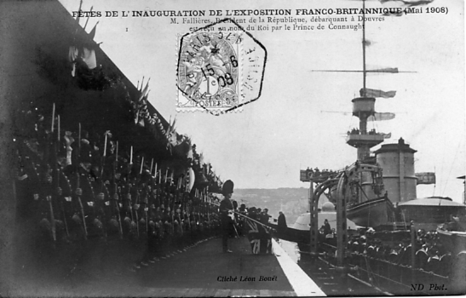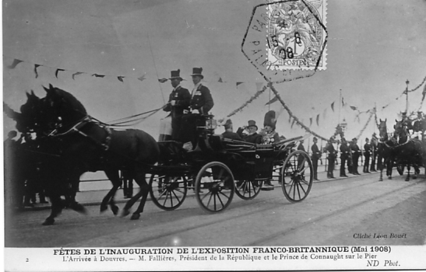
No. 1 No. 2

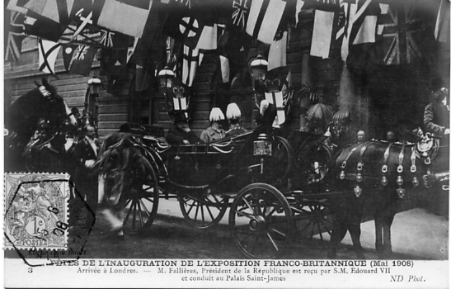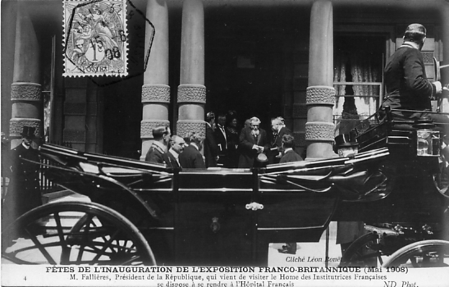
No. 3 No. 4

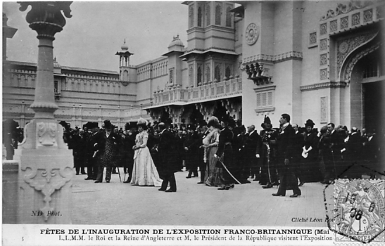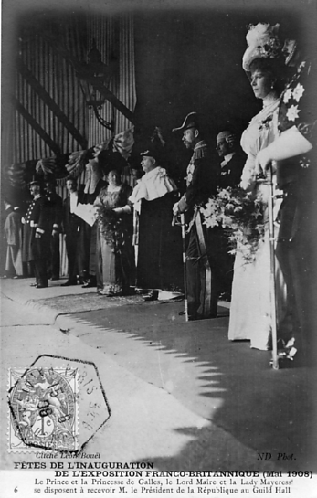
No. 5 No. 6 Vert left

1 M. Fallières, President of the Republic, disembarking at Dover and was met by the Prince of Connaught on behalf of the King.

2 The arrival at Dover, M. Fallières, the President of the Republic and the Prince of Connaught on the pier.

3 The arrival at London - M. Fallières, President of the Republic is met by H, M. Edward VII and taken to St. James’ Palace.
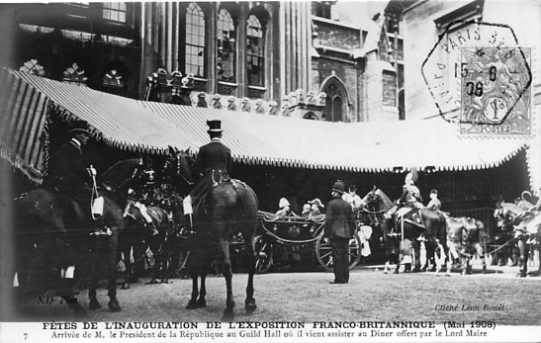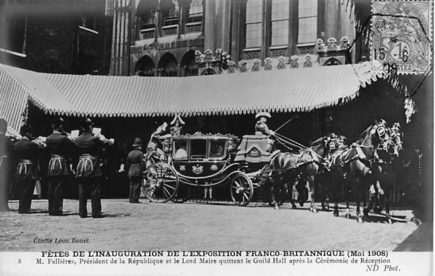
No. 7 No. 8

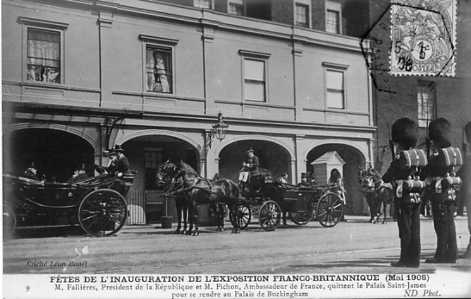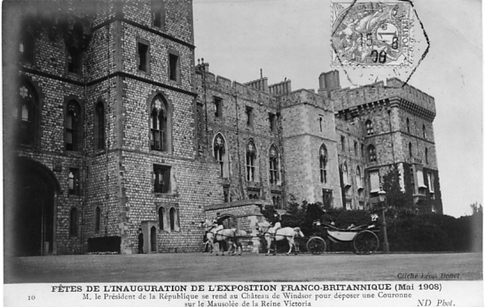
No. 9 No. 10

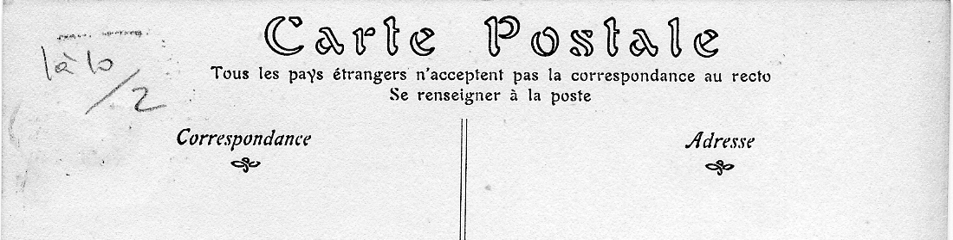
The back of the French postcards.

4 M. Fallières, President of the Republic, who had visited the home of the French Academy, then went to the French Hospital.

5 Their Majesties the King and Queen of England and M. the President of the Republic visiting the Exhibition.

6 The Prince and Princess of Wales, the Lord Mayor and Lady Mayoress waiting to receive M. the President of the Republic at the Guild Hall. (Vert. left)

7 The arrival of the President of the Republic to attend the dinner put on by the Lord Mayor.

8 M. Fallières, President of the Republic and the Lord Mayor leaving the Guild Hall after the reception.

9 M. Fallières, President of the Republic and M. Pichon, the French Ambassador leaving St. James’ Palace to go to Buckingham Palace.

10 M. Fallières, President of the Republic went to Windsor Castle to leave a wreath in the Mausoleum of Queen Victoria.

Alan Sabey has been invited to show his 1948 Olympic Games stamps as part of a display in the British Library commemorating the three occasions that London has hosted the Olympic games, 1908, 1948 and 2012.
His collection has been scanned by British Library staff to be available to visitors on touch-screen equipment. Some actual items will be on display in a specially constructed set.
Alan has been interviewed by a reporter from the Harrow and Wembley Observer as Wembley was the principal venue in 1948 and had his picture in the paper along with the article.
The display will be on at the British Library, Euston Rd (Nearest station Kings Cross / St. Pancras) from 24th July to 9th September 2012.

Model Railways in Ideal Homes
An extract from the Model Railway News.
sent in by Fred Peskett.

The Daily Mail Ideal Home Exhibition held at Olympia London, April 7th to May 2nd 1931, was a wonderfully fine display, equal to if not surpassing the magnificent exhibition of last year. A valuable characteristic of these shows is that they afford opportunity in acquiring ideas serviceable in planning a home and it’s equipment and from different points of view. A few hours spent in viewing the exhibits, the lighting effects and many items of interest give both enjoyment and education.
Sound Proof Rooms
A full size building appropriately termed the “Hush Hush” house was planned with the idea of isolating from exterior noise, such as might obtain from motor traffic along a main road, and confining interior noise to the room in which it is produced. The idea of interior sound isolation may be worthy of consideration in connection with model railways, especially when running a midnight service. In the “Hush Hush” house the interior walls, floors and ceilings were rendered sound proof by a special wall board “Treetex” which is a sound and heat insulator and is capable of decorative treatment. Address, Treetex, 421-4 Australia House, London, W.C. Tough Kraft paper, eel glass from Nova Scotia and other materials were used and advantage taken of sound blanketing experience gained by the May Construction Co., Ltd.. in the construction of studios for the B.B.C.
Utilising a Waste Space
An object lesson giving thought to possibilities in making use of a disregarded space for installation of a model railway system was the series of tableaux entitled “Behind the First Floor Back.” The scenes illustrated a flat roof space above the rooms outbuilt at the rear of a house.
One showed the usual desolate flat space occupied only by a cat. The others showed utilisation of the space as a roof garden, a gymnasium and sun bath, outdoor sleeping quarters and an outdoor playroom, this latter scene contained a model railway, so our readers hobby was recognised amongst the tremendous “Ideal Home” exhibition.
Small Scale Bricks
A firm of brick makers, Messrs, W. T. Lamb & Sons, 43 Shoe Lane. London, E.G. 4 are making actual bricks to small scale. They have found considerable sale for these amongst technical institutions for educational purposes and are considering the possibility of making smaller sizes. Readers requiring actual building materials of small scale should enquire of the firm. The size at present made, 31/4 X 15/8 X 1 thickness, might prove useful and adaptable in construction of bridges, culverts and other details of a. large model railway. The samples which we inspected are very clean, well made and flat. Smooth blue bricks to small scale are also made by this firm.
Models
An inspection of models, though not of actual railway character, is beneficial in giving ideas both of construction and standard in model railway work. The varied show of models of buildings gardens and estates by Partridges Models Ltd., 21 Buckingham Street, London, W.C., also realistic models of horses by Mr. Reginald C. Fly, F.R.I.B.A., 12 Clifford’s Inn, Fleet Street, London, E.G., a large model of Nelson’s ship “ Victory “ with exquisite carving on figure head and stern exhibited by South Sea Beach and Publicity Committee and Mirror Grange a large dolls house type of model were very instructive as well as interesting and pleasing.
The latter model exhibited by the Daily Mirror Newspapers Ltd., is the supposed home of “Pip, Squeak and Wilfred” portrayed in the Daily Mirror and the Sunday Pictorial, It was worth viewing by model railway engineers as an example of building construction and the wealth of model furniture and accessories contained within the rooms. These are an education in realistic detail. Examples of furniture in miniature shown on several stands would also have been of interest to model railway visitors.
Electricity
Automatic and semi-automatic house lighting plants in operation and a variety of electrical accessories were also of interest.
The Model Engineer’s Workshop
In our opinion an ideal home should contain a workshop where mechanical work can be done in comfort and under hygienic conditions, it should be sound proof.

Note. There is not much about exhibitions in this short article about the 1931 Ideal Home Exhibition, but there is however one item I did not know, I have often come across post cards of Mirror Grange and I have never connected them with the 1931 Ideal Homes Exhibition. You live and learn.
The editor.
Snapshots for your Snapshot Album Part 2
by
Bill Tonkin.

J. Beagles & Co., Ltd.
British Empire Exhibition New (1925) Series. 12 Official Views for your Snapshot Album.

In 1925 Beagles issued a set of twelve snapshots in a white box with blue printing on the lid which was loose and not hinged like some of the Wildt & Kray boxes. The snapshots had titles printed on the front but were not numbered. On the back at the bottom was printed ‘Photo Campbell-Gray’ and ‘Published by J. Beagles & Co. Ltd.’. The snapshots measure 3½ x 2¾ inches.
Three 1925 sets have been examined and the box is labelled ‘New (1925) Series’ which implies there was an earlier 1924 series. It must be fairly scarce as one has not been reported so far. This seems likely as in 1924 the Burma Pavilion went under that name. In 1925 it became the Schweppes Pavilion and Beagles used the original 1924 name on the snap shot, which implies there was a 1924 series published and when it was republished in 1925 they did not alter the name.

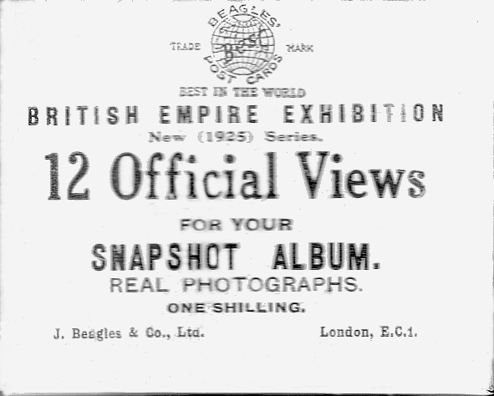

Beagles New (1925) Series.
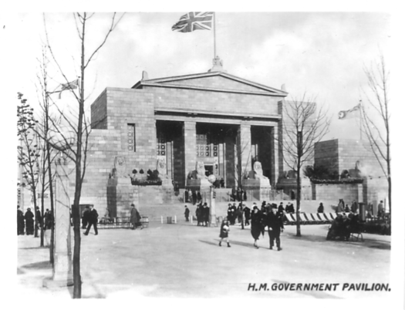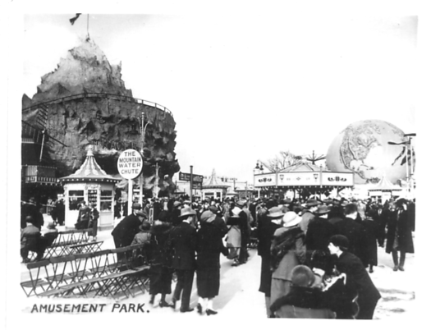
H.M. Government Pavilion
Amusement Park
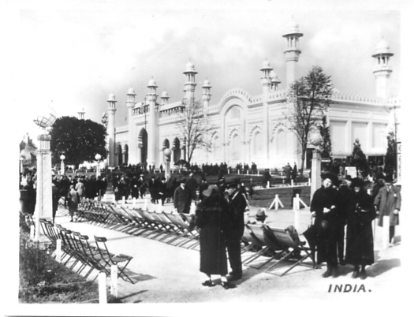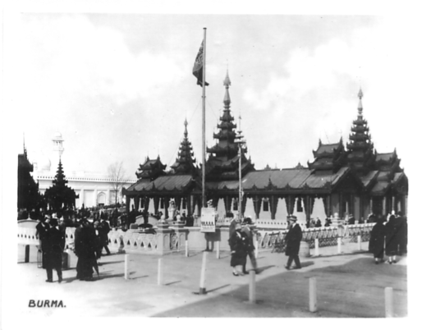
India
Burma
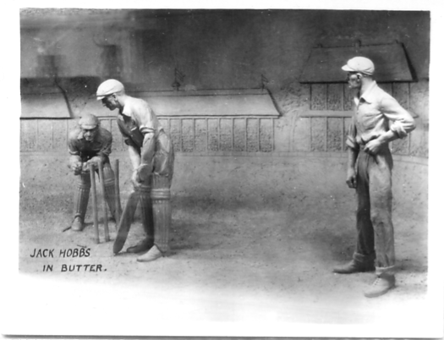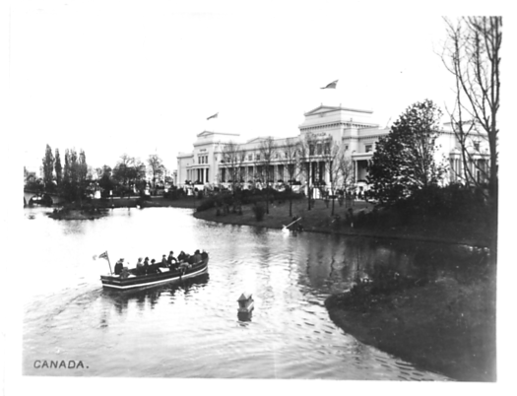
Jack Hobbs in Butter
Canada
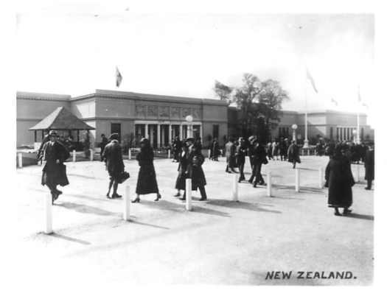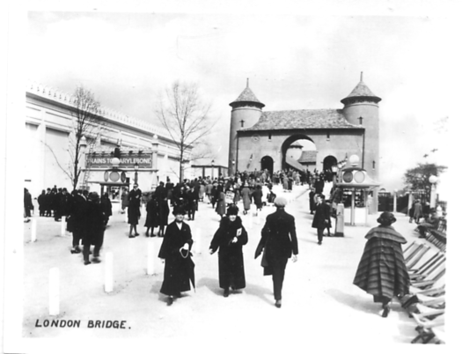
New Zealand
London Bridge
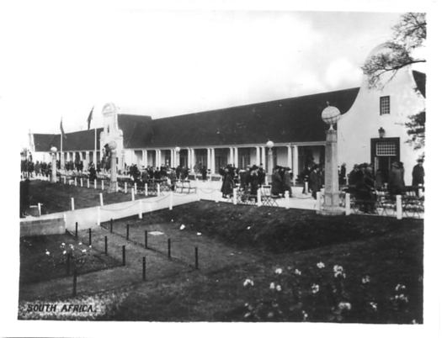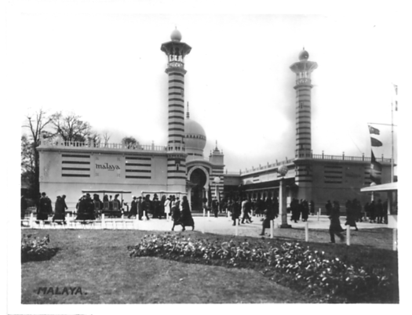
South Africa
Malaya
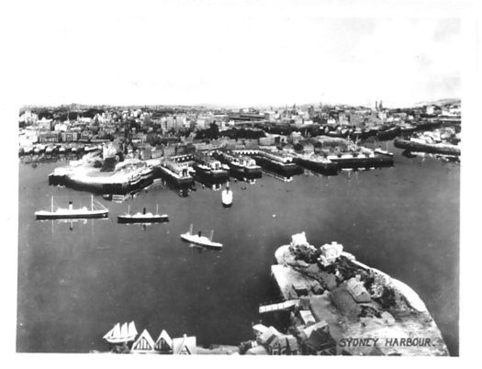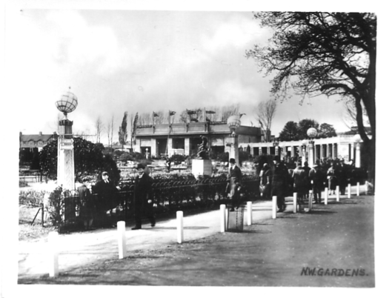
Sydney Harbour
N.W. Gardens
Campbell-Gray
12 Photogravure Snapshots of The British Empire Exhibition Wembley. 1925

This was the only set of snapshots out of all the publishers that were not real photographs, but were photogravure printings. The snapshots were numbered but without titles, these were printed on the back of the envelope. As only one packet is known we cannot say if there are any varieties.
They have been listed as 1925 as the views include Treasure Island and the Cyprus Pavilion.

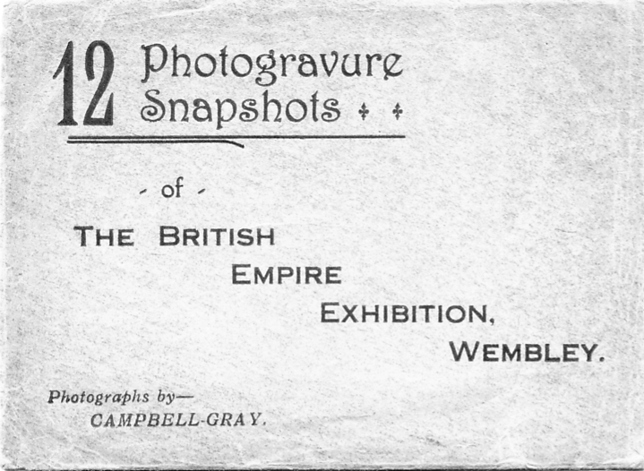
Dark brown printing on a light brown envelope.

List of Contents
No. 1 Palace of Industry and the Lake
No. 2 Malaya Pavilion
No. 3 The Gardens showing Nigeria
No. 4 Treasure Island, Amusement Park
No. 5 The Lake and Indian Pavilion
No. 6 Indian Pavilion by Night
No. 7 Kingsway and Palace of Industry
No. 8 Cyprus Pavilion
No. 9 Canadian Pavilion from the Lake
No. 10 Model of Sydney Harbour, Australia Pavilion
No. 11 Australia and the Rock Garden
No. 12 H. M. Government Pavilion

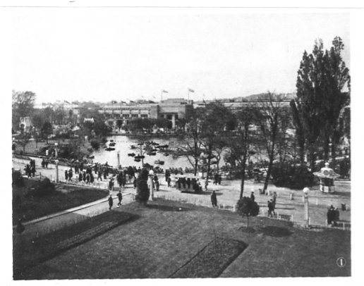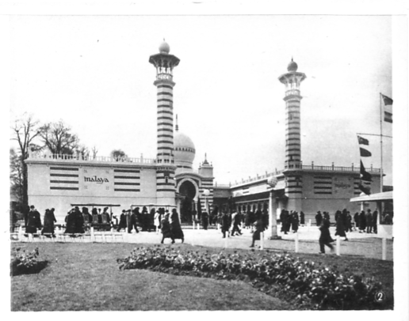
1 Palace of Industry and the lake
2 Malaya Pavilion
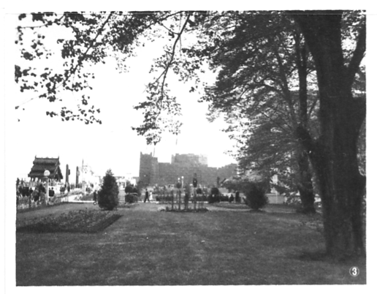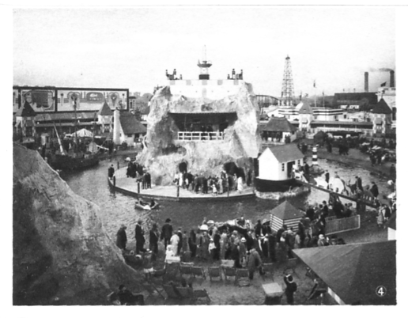
3 The Gardens showing Nigeria
4 Treasure Island, Amusement Park
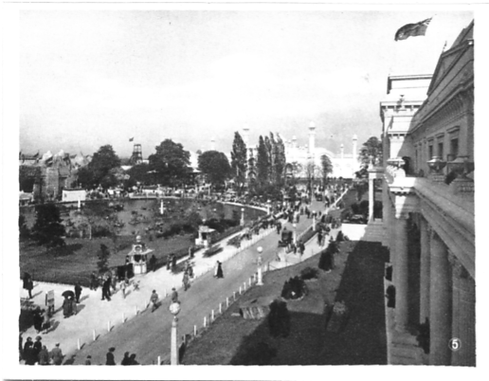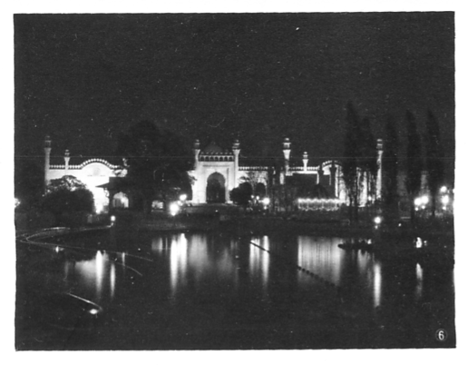
5 The Lake and Indian Pavilion
6 Indian Pavilion by Night

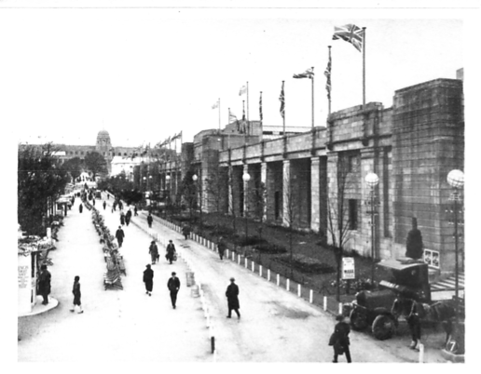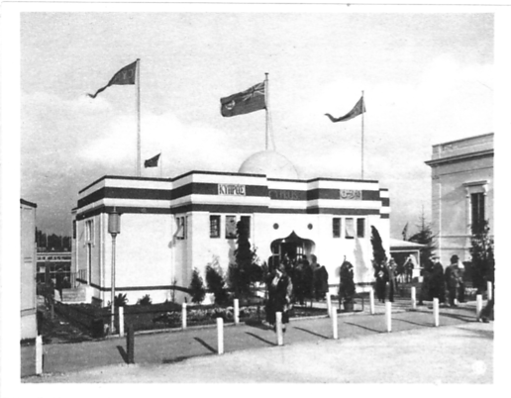
7 Kingsway and Palace of Industry
8 Cyprus Pavilion
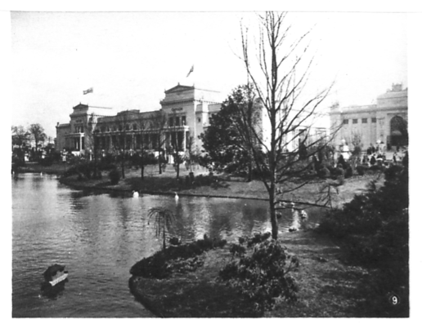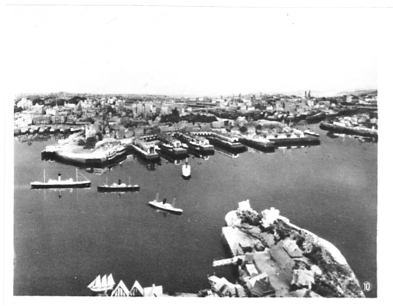
9 Canadian Pavilion from the Lake
10 Model of Sydney Harbour, Australian Pavilion
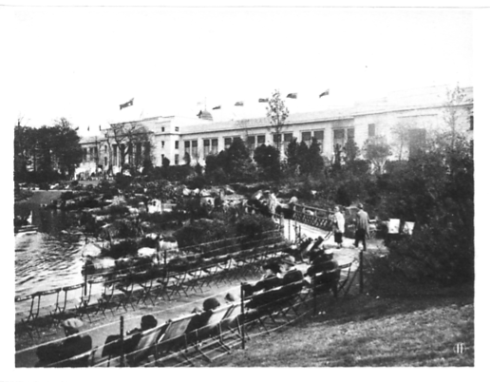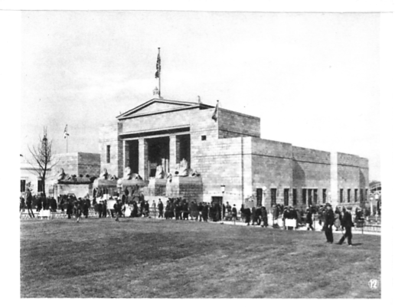
11 Australia and the Rock Garden
12 H. M. Government Pavilion

Fleetway Press Ltd.

Fleetway Press had the sole concession to sell postcards within the exhibition and presumably this covered the small cartons of snapshots as well. There were two cartons of snapshots for 1924 each containing 12 small photographs measuring 3½ x 2¾ inches titled Series No. 1 containing views numbered 1 to 12, and Series No. 2 containing views numbered 13 to 24. The titles of each view was printed on the flaps of the cartons, these sold at one shilling per carton.
For 1925 it would appear they only published one carton titled Series No. 1 containing views numbered 1 to 12. The existence of a 1925 Series No. 2 carton has never been recorded, it is possible someone somewhere has an example and if so I would like to know just to set the record straight.
12 Snap Shots of the British Empire Exhibition, Wembley.
1924 Series No. 1

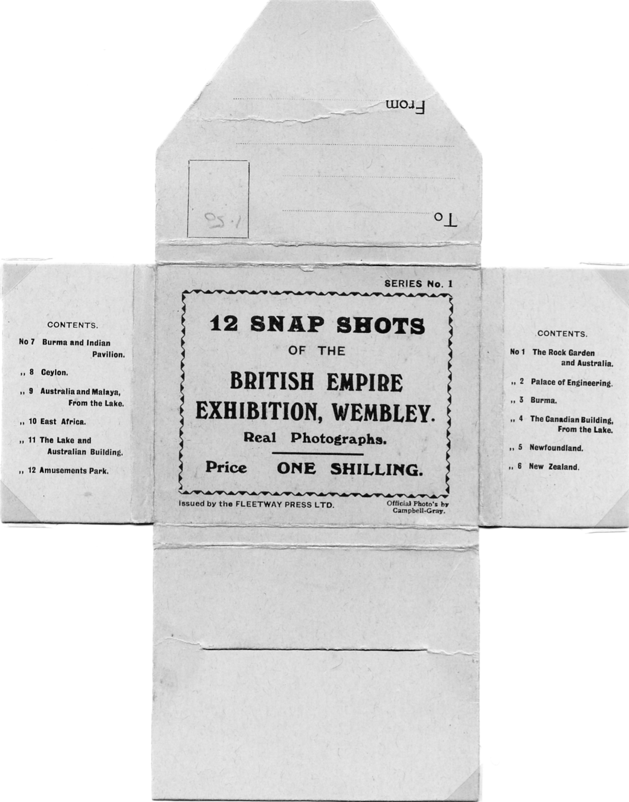

No. 1 The Rock Garden and Australia
No. 2 Palace of Engineering
No. 3 Burma
No. 4 The Canadian Building from the Lake
No. 5 Newfoundland
No. 6 New Zealand
No. 7 Burma and Indian Pavilion
No. 8 Ceylon
No. 9 Australia and Malaya from the Lake
No. 10 East Africa
No. 11 The Lake and Australia Building
No. 12 Amusement Park
Fleetway Press Ltd
12 Snap Shots of the British Empire Exhibition, Wembley.
1924 Series No. 1

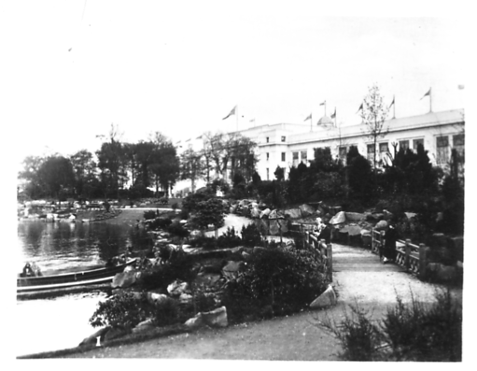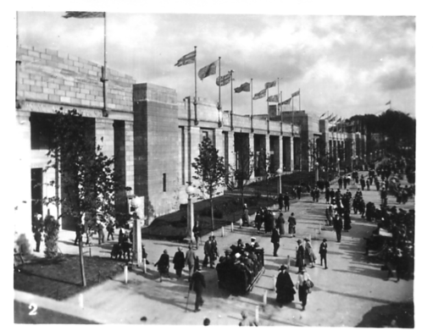
1. The Rock Garden and Australia
2. Palace of Engineering

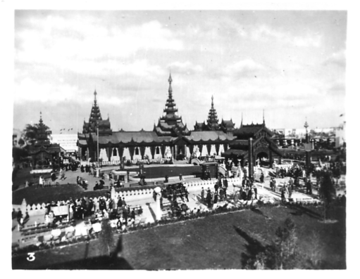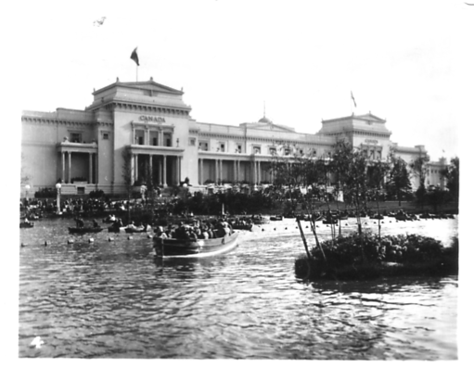
3. Burma
4. The Canadian Building from the Lake

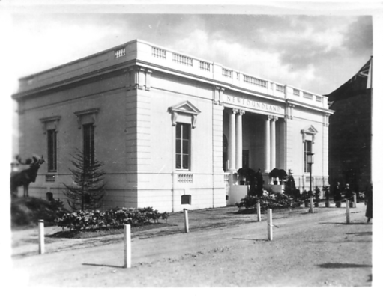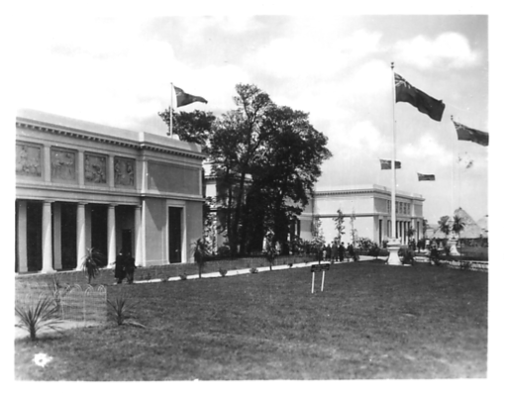
5. Newfoundland
6. New Zealand

What Fleetway did do for 1925, was to give up using cartons and package their snapshots in paper wallets and these were sold at the same price as the 1924 cartons using the same format, Series No. 1 and No. 2 with views numbered from 1 to 24.
I say ‘their snapshots’ and this is a bit misleading as it becomes apparent on inspection that all of Fleetway’s 1924 snapshots and cartons are absolutely identical with those published by Wildt & Kray (W & K) in 1924. The only difference is in the small imprint on the cartons, one reading ‘Issued by the Fleetway Press Ltd’ and the other ‘W & K London’. The ornamental border around the text is the same, the printing layout is the same, and they even used the same coloured cardboard for the cartons.

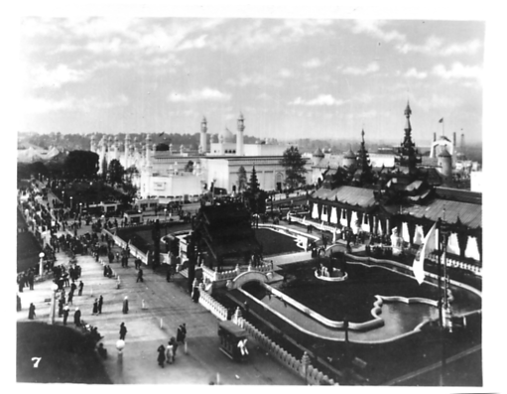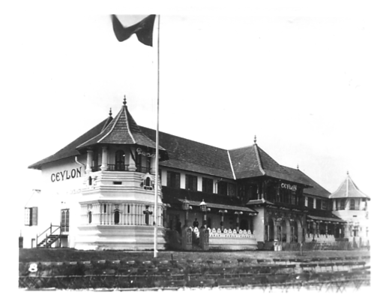
7. Burma and Indian Pavilion
8. Ceylon

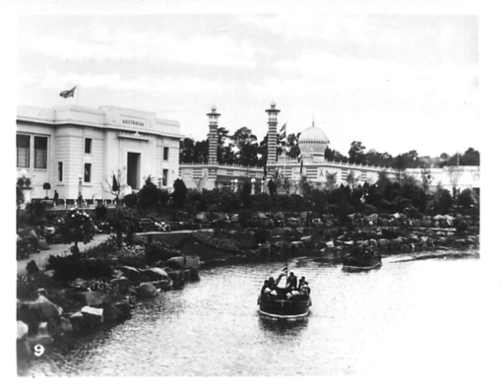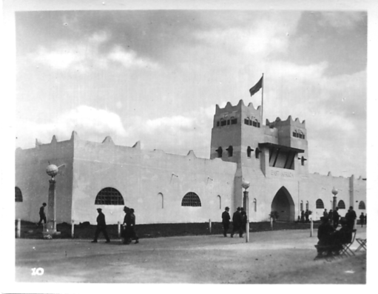
9. Australia and Malaya from the Lake
10. East Africa

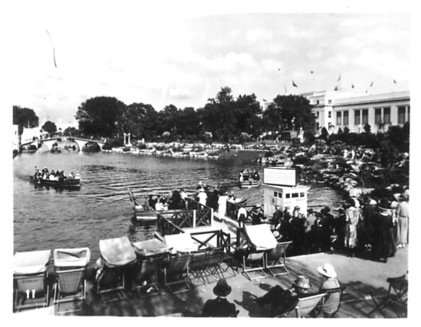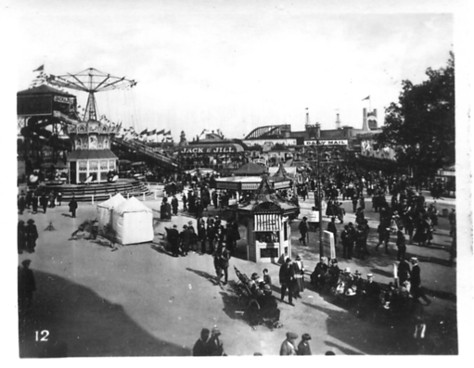
11. The Lake and Australia Building
12. Amusement Park

Now which came first the chicken or the egg? Did Fleetway produce snapshots for W& K or did W & K produce them for Fleetway. This is where fly spec philately comes into the picture. When we examine the small numbers on the snapshots it becomes obvious that during the publishing life of each series the numbers were redrawn on some of the negatives used for the printings. Under a glass the numbers not only vary in size, but are written differently and are in a slightly different position. There are two varieties of all numbers from 1 to 24 in the W & K snapshots while in the Fleetway’s only six of the numbers are redrawn out of the 24 numbers published.
In 1925 the difference in quantities of rewritten numbers is even more noticeable, Fleetway published no rewritten numbers, while W & K’s views numbered 1 to 12 were all rewritten in two styles. As only one 1925 W & K Series 4 set is known it cannot be said if there were any rewritten numbers 13 to 24.
The implication of this is that I believe Fleetway used a much smaller quantity of snapshots than W & K and from this that W & K was the actual manufacturer

Redrawn numbers 5, 7, 8, 10, 14 and 19 in 1924 Series No. 1.

Fleetway Press’s Snapshots Series No. 1 and No. 2. are identical with Wildt & Kray’s Series No. 1 and No. 2. But whereas Wildt & Kray used all 24 redrawn numbers Fleetway used only six.

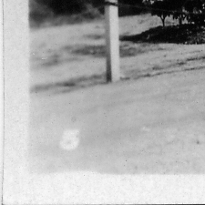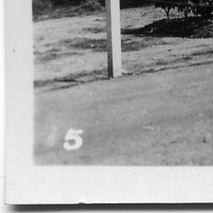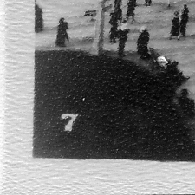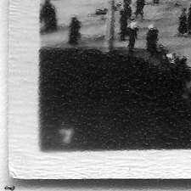
No. 5 No. 5 Redrawn No. 7 No. 7 Redrawn

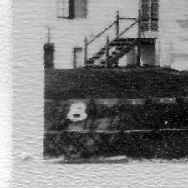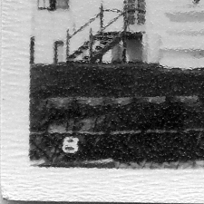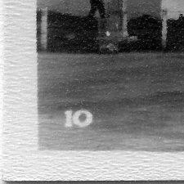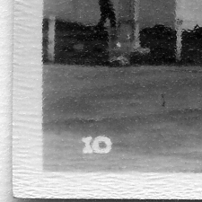
No. 8 No. 8 Redrawn No. 10 No. 10 Redrawn

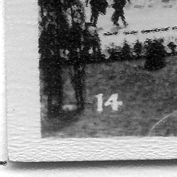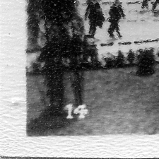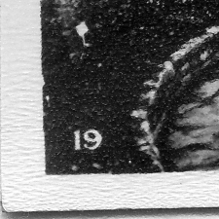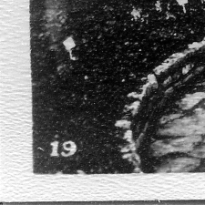
No. 14 No. 14 Redrawn No. 19 No. 19 Redrawn

No. 12 is much thinner in the second picture, but this is not a redrawn number. The Snapshot has been over developed, resulting in a thinner 12. For the redrawn 12 which is much smaller see under Wildt & Kray 1924 Series No. 1.

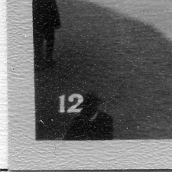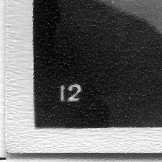
No. 12 No. 12 Thin type

Source of varieties of 1924 Series No. 1 snapshots numbered 1 to 12.

I had seven complete and one part set of three of the 1924 Series No. 1 cartons of snapshots to examine and these are listed as types A to H. The numbers 1 to 12 refer to the printed numbers of the views. As you can see the bulk of the numbers are in the original large size (Ln). In nearly each case where a smaller rewritten number (Sn) is used on a second negative there are different clouds (Dc) in the sky. Only one carton (A) were all of the snapshot numbers in the large original size, all the others show a mixture of large and smaller numbers.

A B C D E F G H

1 Ln Ln Ln Ln Ln Ln Mis Ln
2 Ln Ln Ln Ln Ln Ln Ln Ln
3 Ln Ln Ln Ln Ln Ln Ln Ln
4 Ln Ln Ln Ln Ln Ln Mis Ln
5 Ln SnDc SnDc SnDc Ln SnDc Mis SnDc
6 Ln Ln Ln Ln Ln Ln Ln Ln
7 Ln SnDc SnDc SnDc SnDc SnDc Mis Sn
8 Ln SnDc SnDc SnDc SnDc SnDc Mis Sn
9 Ln Ln Ln Ln Ln Ln Mis Ln
10 Ln Sn Sn Sn Sn Sn Mis Sn
11 Ln Ln Ln Ln Ln Ln Mis Ln
12 Ln Ln Ln Ln Ln Ln Mis Ln

No. 5 is printed on a very light background and is not easily seen. It is much lower down and the clouds are different.
No. 7 is much smaller and lower down, the clouds in Sn are feinter than in Ln
No. 8 is much smaller and lower down
No. 10 is slightly smaller and lower down with large serifs to 1
No. 14 is lower down with the 4 leaning backward
No. 19 is much smaller and lower down
No. 12 has not been seen in the smaller size in these packets, a much thinner 12 is known but I do not consider this a redrawn number but think it is caused by the Snapshot being over developed. For an example of the smaller size redrawn 12 see under Wildt & Kray Series No. 1

Abbreviations used
Dc Different clouds from original large numbered types
Ln Large original numbers
Mis Missing Snapshot in an incomplete set
Sn Small redrawn number which are usually much lower down (10 is not much smaller but has large serifs.)

Source
A Mounted in display. £1.50 written in stamp box
B Tanner (5, 7, 8, & 10 in display)
C £2.50 on carton
D Loose set
E M Perkins brown sheets
F M Perkins Album
G M Perkins odds
H A Sabey

26th Exhibition Study Group Convention
Saturday 29th and Sunday 30th September 2012
The Annual General meeting will take place on Saturday and will start at 10.00
Displays will start at 11.00 on both mornings
If you are coming to the 2012 Convention would you please fill in this form
and return it as soon as possible to
Don Knight. 2, Crescent Rd, New Barnet, Herts. EN4 9RF.
020 8440 3574

If you intend to stay over night please contact Joan Miles at The Lodge, Crystal Palace National Sports Centre. Ledrington Road, London. SE19 2BB. phone 020 8778 0131

Annual Dinner

Will you be requiring a meal on Friday evening
Yes.......... No..........
Will you be attending our annual dinner on Saturday evening
Yes.......... No..........
If yes how many will be in your party ..........

Display

Will you be bringing a display or giving a talk to the meeting
Yes.......... No..........
What is the subject or title of your display or talk
................................................................................................................................................................................................................................................................................................
Will either day suit you for your display
Yes.......... No..........
If the answer is no do you prefer to give your display
Saturday morning Yes..........
Saturday afternoon Yes..........
Sunday morning Yes..........
If possible give more than one option.

Please give your address and phone number
in block letters

Name......................................................................................

Address..................................................................................

...................................................................................

...................................................................................

Postal code..............................Phone number......................................

E.Mail....................................................................................

