EDITORIAL SUMMER 2012

I used to be able to walk quite fast,
But walking’s now a thing of the past.

I am still a member of a race walking club, as well as a member of two cycling clubs, and riding my bike is another thing I shall never do again. Walking is now becoming increasingly difficult, and I’m now down to going outside the house twice a week to do my shopping. The good news is I can sit in the car and drive all day, so I’m not completely house bound. So why am I still a member of one walking and two cycling clubs. Well I got many years of pleasure out of the clubs, and I still keep up my subscriptions to help them financially, if not physically. I managed to get to the Shepton Mallet post card fair on the 24 and 25 February where some of the dealers were already selling material they had got from the Adam Partridge auction sale of the Karl Illingworth collection on the 11 February. (See letter below)
A long term project I have started is to re-record the first 100 Journals in a better form than I had done previously. Many of the pages of the early numbers were scanned which takes up so much computer space, (It fills five C-D’s) and I am now saving them using O.C.R. and am hoping to get all 100 Journals onto one C-D.
Else where in the Journal you will see we have just lost another member who has supported us for many years, Bob Tough, who with his wife Gwen have been keen members of the Study Group from its earliest days. Instead of flowers it was his wish for money to be donated to the R.N.L.I. and we have done this. A far more useful way of showing respect than buying flowers.
About a month ago a friend brought his camera and gave me a lift up to the Lower Level Station at Crystal Palace to have a look at the spot from where so many of the post cards of the 1854-1936 building were taken. I had saved this job for winter time, when the leaves were off the trees, hoping to get a good view of the wall from the railway bridge. The wall I am talking about is the wall of the covered walk way that used to exist from the station up to the Palace. Unfortunately although the wall is still there, the area is so overgrown it was difficult to see through the under growth. Looking at the wall from the park side you get a good clear view. Most of it is still there although the roofing has long since gone. One part has been demolished to make way for a roadway from Ledrington Road into the grounds, but the stretch of wall that appears on all the post cards is still there.
I had originally thought that the photographs of the Crystal Palace were taken from standing on the railway bridge outside the Low Level Crystal Palace station, but I am now thinking the view was taken from higher up. In fact from the upper windows of the Low Level station, unfortunately the station was closed for building work and we were unable to get in. So that’s a trip for another day.
On the 11th of April the Exhibition Study Group held a committee meeting at the Crystal Palace to discuss one or two matters, and one of the things that came up was the enormous increase of postage rates. There was concern about this although it has to be said the bulk of our postage costs are very generously paid for by Kenneth. We felt this must not be taken for granted and it was suggested the Group make a donation to Kenneth to off-set part of the postage costs. When I spoke to Kenneth about this he made the suggestion that as our Journal only just tips the scales onto the next postage level at present, it might be an idea to make the journal one sheet less, 8 sheets instead of 9 sheets or 14 pages instead of 16 pages not including the cover sheet. He took a mocked up 14 page Journal and envelope to the post office, and Bingo it went just within the second class large letter weight. So in future the postage costs for the Journal will actually be less instead of going up, dropping from 92p at the old rate down to 69p for the new rate. Good thinking Kenneth, he’s not only saving money, he’s also saving Fred and myself a little bit of work. Probably if I hadn’t mentioned it, I don’t suppose members would have noticed the missing sheet.
The Editors
Letters to the Editor

I am publishing a letter sent to our secretary Don Knight from Ken Peters, one of our members.

Dear Don
Did you hear of the enormous Exhibition memorabilia auction held on Saturday by Adam Partridge?
The auctioneers described it as one person’s collection! This must surely mean that the collector would be known to the members of the Committee. I only learnt about the auction late on Friday afternoon, from a friend. Too late to put in any bids.
I rang the auction house today to see if there were any unsold lots. Normally there would have been but this was a special where everything had to go. The estimates were all clearly lower than the real value of the items, so it will be interesting to see the hammer prices.
I am so disappointed that there wasn't a ring-round to alert members to the auction.
Ken Peters

Don passed this letter over to me and I have published it with Ken’s permission. I think a lot of our members were sorry to have missed this sale as unfortunately no news of the sale was leaked out to collectors of exhibition memorabilia. I spoke to somebody at Adam Partridge the auction firm and was told they only advertised the sale in an Antiques magazine. I pointed out to them that many mentions of the Study Group has appeared in the Philatelic Bulletin, Stanley Gibbons Monthly, Picture Postcard Monthly, our own web site and we have published our own quarterly Journal since 1980, all to no avail, I was told they had never heard of us. They were good enough to send me a copy of the auction catalogue and a list of the hammer prices.
The ‘All must go’ auction of exhibition memorabilia for sale without any reserves, was the Karl Illingworth collection. Else where in the Journal I have published an article on Karl and some comments on the sale, and other sales of his collection.

Nelson’s Views of the Crystal Palace (The Interior)
by
Fred Peskett

Nelson published several little souvenir books about the Crystal Palace. The views of the “Interior” are quite interesting. It is known that at least two versions were published, each version contains twelve chromolithograph views on cards held loose in a green coloured folder. The cards are all uniform in size measuring 6.5” wide x 4.125” high. One set has rounded corners, the other has square corners, eight of the cards are common to both sets but four cards in each set are different.
The set with the rounded corners features four of the views of areas in the Crystal Palace which were destroyed by the fire of 1866, the square cornered version has these views replaced with other views including one showing an external view of the Crystal Palace. It is probable that the rounded corner version was the first printing. Circa 1856 to 1866, and the square cornered version published to reflect the changes in the Palace after the fire, possibly between 1866 to 1870. 1870 is given as a date because the external view shows the “Water Temples” which were removed in 1870, but it also shows the North Transept, destroyed in 1866 and not re-built. It does seem rather strange that this view was included in a series marked as the “Interior”, perhaps no other view of the interior was available at the time of publication.
The views contained in each set are as follows:-
Rounded corners (1st) Square Corners (2nd)
Court of Lions. Court of Lions.
Facade of the N.E. Arts Court. Facade of the N.E. Arts Court.
Vestibule of N.E. Arts Court. Vestibule of N.E. Arts Court.
Nave and Crystal Fountain. Nave and Crystal Fountain.
Facade of Mediaeval Court. Facade of Mediaeval Court.
Pompeian House. Pompeian House.
Byzantine Court. Byzantine Court.
Great Orchestra. Great Orchestra.
Tropical Department. Renaissance Court.
Egyptian Court. Mediaeval Court.
Great Egyptian Figures. Bronze Fountain.
Mammoth Tree. View of the Crystal Palace.
There is one other feature that is slightly different, that is the intensity of the colour. The general colouring is sepia and black background with added blue and lilac, the rounded corner versions are much deeper in colour than the square corner versions.

Robert (Bob) Tough M.B.E.

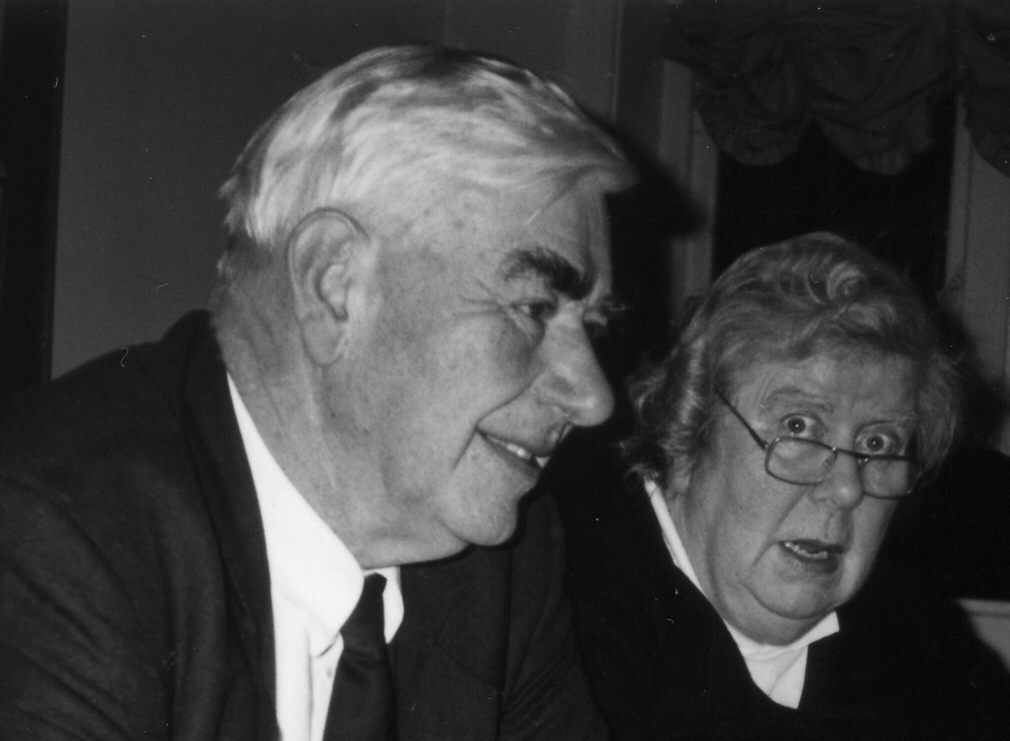
Bob and Gwen Tough at our Seventh Annual Convention at Wembley in 1993

Three days ago I received a phone call from John Tough with the sad news that his father had passed away on the previous Thursday. Both Bob and his wife Gwen who members will remember passed away on Christmas Day 2008 have been two of our keenest supporters for many years, going back to about 1990, only missing I think two conventions when we met at Glasgow and Bradford as these were too far for Gwen to drive. I remember they attended Expo 92 and at our convention that year we all got a half pint china mug, a souvenir from the British Pavilion at the exhibition. Bob managed to attend his last convention, albeit in a wheel chair in 2008, brought over for the day by John. Bob’s funeral was on Thursday 10th May. The Exhibition Study Group was represented there by our President Alan Sabey and Secretary Don Knight, the Study Group has sent a donation to the R.N.L.I. in respect with Bob’s wishes
Bob was a committee man, at one stage he was sitting on 19 of them. He held qualifications in Naval Architecture and was a leading member of the Ship & Boat Builders National Federation which became the British Marine Federation. He was heavily involved in the Leisure Boat Committee and the Commercial Boat Builders Association. He represented the industry on technical, membership and training committees and was on the Boat Show board. When Dad finally retired, he was appointed Honorary Life Member of the British Marine Federation. In 2007 he was awarded the Peter Millward Memorial Award by the British Marine Federation. He was the Treasurer of the Thames Boating Trades Association for 36 years. Dad was also a fellow, committee member and had been treasurer of the Yacht Brokers, Designers and Surveyors Association.

The Commercial Side of the Crystal Palace.
by
Fred Peskett

Right from the time the Crystal Palace was opened in 1854 there were a number of retailers who had either outlets, shops or advertising space within the Crystal Palace building. Here are just a couple of the more interesting merchants who were advertising in the “Penny Guide to the Crystal Palace” during 1863.
1. Messrs Gabriel, Surgeon, Dentist. This Company had an exhibition of specimens of artificial
teeth and soft gums at the entrance to the Industrial Court.
2. J.C. and J. Field had a kiosk selling “Fine Paraffin Candles” for which they were awarded a
Prize Medal at the International Exhibition of 1862. These candles were said to burn without the odour of burnt wax.
3. Jonas Brook and Brothers, manufacturers of Sewing Cottons and Silks had a small kiosk
advertising their products for which they were awarded Prize Medals at the Great Exhibition of 1851, The Paris Exposition of 1855 and the International Exhibition, Kensington in 1862.
4. F. Cash exhibited and sold Meerschaum Pipes, Cigar Cases and Snuff Boxes from the Royal
Stall in the Industrial Court.
5. Messrs Lewin Mosely, Dentist and Surgeon had a huge display of false teeth with many
items for sale in the Stationery Court. Teeth were at priced at 5/- each and a full set of new choppers for just £3. It was noted that “real teeth” could be substituted for a “premium” payment, (probably taken from a corpse?)
6. George Jennings had a shop in the Industrial Court selling all sorts of extracts, pickles and
preserved meats and fruits.
7. Bryant and May sold their patent “Special Safety Matches” on the stall operated by F, Holt.
Holt also produced some remarkable trade tokens from his stall in the Crystal Palace.
8. Phillips & Company, Tea Merchants had a stand in the South East Gallery selling “Duty Off
Tea” at 6d a pound and strong black tea at 2/-, 2/4d and 2/6d to 3/- per pound.

Thomas Karl Illingworth Collector Extraordinaire
by
Bill Tonkin.

The first time I met Karl was at our convention in 1987 organised by Andrew Brooks at the Black Swan in York. It was here that for the first time members had a chance to meet one another. This was the start of a lot of long lasting friendships, it was there Nancy and I met Stanley Hunter, Don Knight and Mike Perkins for the first time. Karl like myself and many others there were not founder members, this select group was restricted to nine collectors and friends that Andrew knew. Andrew had put in a notice in Picture Postcard Monthly announcing the formation of the Exhibition Study Group and in response to this our membership shot up to 46.
The first Newsletters as they were called then in 1980 were produced by Andrew, but Karl soon took over the printing and distribution at his own expense for most of the first 23 issues, up to 1998. I had become Editor in 1993, and the system then was for me to prepare the master copy and post it to Karl who did the rest. If Karl was not about I spoke to Rob. Stewart who as far as I could make out was his 2IC at Illingworth Developments Ltd one of Karl’s businesses. Karl had known Rob since their school days, and Rob had early started working for Karl and moved up as Karl prospered.
Karl had started out in life carrying bricks up a ladder in a hod for his father who was a brick layer by trade. His first business venture was to buy a derelict two up and two down cottage, renovate and sell it at a profit. This showed him the way forward, and he was soon deeply into property development and by the time I got to know him, he was a seriously wealthy man. He was one of the first to move into owning residential nursing homes for the elderly and when in 1989 he invited the Study Group to hold our third convention in his home he had no problem supplying beds for those attending as by then he told me he had 200 beds in homes he could borrow.
His home was crammed full of his collection and I remember when I went into a large double room shelved from floor to ceiling full of crested china I actually stopped breathing for a moment. I have heard the expression ‘breath taking’ but it is the only time I have ever experienced it. Later counting how many pieces were in one foot of shelving I estimated there was about 3,000 pieces of crested china in the room. The bulk of it was Wembley and other exhibitions. His other collecting interest was the Manchester Ship Canal and there was a lot of crested china for that too.
Mike Perkins was there and we were able to spend a lot of time going through Karl’s post cards and making notes of cards to include in the Wembley book we were working on. Karl had five Pathe Freres Cinema post cards and I still have the notes and photo-copies I made in 1989 and when I checked on the four cards I bought at the Shepton Mallet Fair on the 24 February 2012, I knew they came from Karl’s collection.
As he built up his collection of exhibition memorabilia, he made no secret of the fact that it was his ambition to found a museum for exhibition souvenirs. He once considered buying the South African Pavilion built for the 1938 Scottish Empire Exhibition from Nobel Industries, who originally bought it after the exhibition closed to use as a sports pavilion. Unfortunately the metal work in the window frames had so rusted, it was just not practical.

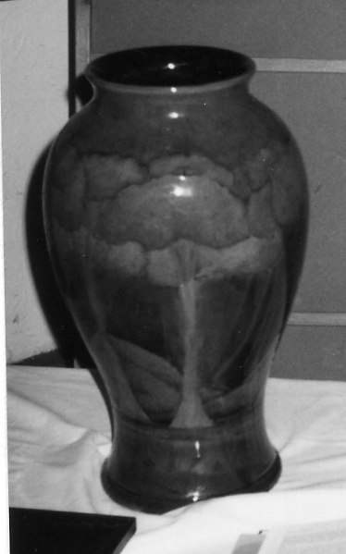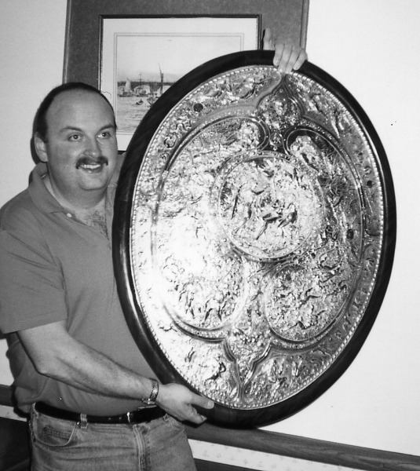

The Moorcroft Vase at our Karl with the Elkington Shield at our 1993
1991 Convention Convention

Another interest of his was the Manchester Town Football Club where he had his own box. He was part of a small group who used a helicopter to travel to the away games. He told me that our convention was the only thing that took precedence over football, and he looked forward all year to our convention, which he never missed, the last one he attended was in 1997.
By now Karl was looking for major items and at our 1991 convention he showed two such items, the Moorcroft vase which he paid £6,000 for, and the Wembley Fire Brigade brass helmet. In reply to a question by Andrew Brooks he admitted he had probably spent best part of a quarter of a million on his collection by then.
In 1993 at our convention he showed us the Elkington shield that had been awarded a gold medal at a Paris exhibition possibly the 1900.
Without doubt the largest item Karl ever managed to obtain was a huge vase or urn, This was coming up for sale in an auction and Karl was interested in it, which was one of a pair that was exhibited and gained an award at an international exhibition. The other one to the pair was on display in a pottery museum. Karl visited the museum and realised the one coming up for auction was in better condition than the museum copy, which was missing the ornamental lid and had one or two chips. See photograph on the front of this Journal taken in the museum where the vase was on display.
I cannot remember where the photograph came from, I can only assume that Karl took it when he visited the museum and must have passed it on to me. I cannot even recall where the museum was, it was possibly something like the Coalport China Works Museum, but I didn’t make notes of the facts at the time.
Karl attended the auction and managed to acquire the vase. It was made in parts and was held together by a large iron screw up the centre. When this was undone the top came apart from the base and he was able to pack the pieces in the back of his car and drive it home.
At a committee meeting held in April 1994 at Karl’s house in Manchester, I reported that Mike and I had not been able to find a publisher for our book ‘Postcards of the British Empire Exhibition Wembley 1924-1925’, and during the discussion Karl very generously said that one of his companies would sponsor the printing costs. An offer which was gratefully accepted.

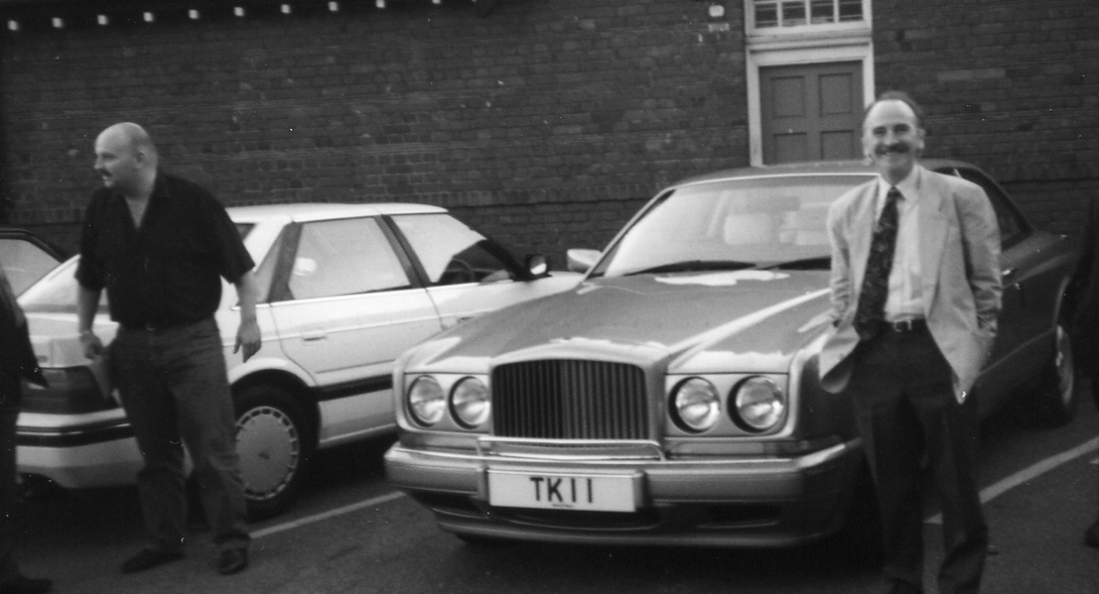

Karl, his Bentley with personalised number plates TKI 1 and Andrew Brooks at our 1995 Convention

When the invoice came I phoned Karl who said he would send a cheque to me. When it came I saw Karl had paid the £3.500 printing costs with a personal cheque. I phoned him and reminded him he was going to pay through on of his businesses, but he replied he had decided to make it a personal cheque. I suggested that at the end of each year I would repay money raised by the sales of the book to him, but this he did not want. I said we could not accept the money as a gift and made the suggestion that the Study Group form a publishing fund to help future authors, and the money generated from the sales of our book go into this fund. He thought this was a good idea and that is how the publishing fund came into being, through Karl’s open handed generosity. Since the creation of the publishing fund, the Study Group has paid for no less than seven books nearly all made available to members at the bare printing costs.
On 3 June 1995 we held a committee meeting at a motor way cafe at Newport Pagnall and about all I can remember of that was Karl telling us of the problem he was having getting just the right shade of red for his new Bentley, a problem none of the committee had experienced.
At this time Karl was a great benefactor of the Study Group not only funding the Publishing Fund but also paying for the production and distribution of our Newsletter for nearly eighteen years.
Then an incredible rumour got around that he was in prison. I phoned Rob Stewart and told him I had heard this rumour and was it true? He gave me a strange reply saying he would ring me back in a couple of minutes and put the phone down. Sure enough he rang back and said he had just spoken to Karl, and yes it was true. This was to me unbelievable and I asked what Karl had been up to. The answer and I can still remember the actual words were “He was helping out some people who were not so well off as he was and it all went terrible wrong” He had been sentenced to three years. I heard afterwards that his father in law and brother in law had both gone inside as well. I only spoke to him once while he was inside, and the only thing I can remember of the conversation is in answer to my query he said his collection was safe, as I heard the banks were calling in his loans. That was in about 1998
After he was released Karl dropped out of sight, it appeared he had moved from White Hall,
Whitehough, Chinley, the large house he had purchased before his troubles, and his where-abouts were not known.
The collecting world of exhibition material soon became aware that a new buyer had appeared on E-bay ‘1924lineone’. At first there were only a few known facts known about the newcomer, his requirements were wide, he apparently collected all British and Foreign exhibitions, and he had the money and will to outbid any opposition. It was not long before a name was put to this buyer, Rob Stewart. A new name not known previously as a collector, but putting two and two together it appeared more than possible that Karl’s old school friend was still working for him. A Letter to Karl through Rob Stewart went unanswered.
Two members of the Study Group Alan Sabey and Ken Rumsey at different times contacted Rob asking him not to out-bid them for items they wanted and in both cases their wish was granted, and they got the items they wanted, with Rob abstaining from bidding. By this time Rob had made an incredible 35,000 purchases on E-bay. This number was given to me by Brian Hill the husband of one of our members who checked on 1924lineone a few years back, but I am going from memory as I don’t still have his letter to confirm this number of sales.
And then things started to go wrong, another member Jean Osbourne had sold material to 1924lineone and had trouble getting her money, although it did come through in the end. Soon after Jean told me 1924lineone had been banned from using E-bay.
A new actor now comes on the scene on E-bay, Karl’s daughter Alexandra who was selling Wembley advertising labels on E-bay. She told Alan she was selling some of Karl’s duplicate labels.
The story now takes a terminal twist with Cathy, Karl’s wife starting to dispose of his collection through a number of dealers. In 2010 one dealer Peter Robards bought over a 1,000 Wembley post cards, items of postal history and pieces of crested china from Cathy. There is no doubt this came from Karl’s collection as I know the history of one post card I bought from Peter. Karl had bought it originally on E-bay through Rob for £38, Cathy sold it to Peter with a lot of other material and I bought it from Peter for £3. I know it was the same card as I have the original E-bay print out showing the front and back of the card. Once again my attempt to contact Karl through a letter delivered to Cathy his wife by Peter, went unanswered. In a previous Journal (No. 100 Spring 2011) I have told how Kenneth and myself spent three days over Christmas 2010 going over Karl’s collection that Peter had bought from Cathy. Later Peter bought more crested china from Cathy and I got a sizeable chunk of it at the 2011 Shepton Mallet fair.
Peter by now had acquired so much of Karl’s exhibition collection from Cathy that he used a Stamp Auction firm BSA Auctions to dispose it at a special two day sale on Thursday 18 and Friday 19 August 2011. On the first day they intended putting up 1123 lots covering all the main exhibitions world wide from 1851. including a large amount of Wembley crested china. The second day was devoted to finishing any left overs from the previous day, and then going on to exhibition medals, medallions and tokens, starting with lot 1500 and going up to lot 1773.
Unfortunately BSA Auctions although they may be very competent in dealing with stamps, fell down when it came describing other items in the first days sale. In stamp auctions the catalogue only has to give a SG number followed by M or U and this tells the vendor all he wants to know about that item. While one line will do for stamps, the same will not do for china ware and Peter told me he was a bit disappointed with the results, and he was left with a lot of unsold lots. These he intended disposing of through E-Bay. Fortunately it was a different story with the medals and they saved the day for him.
We are now getting to the end of the story with the latest disposal of many tens of thousands of exhibition items through the Adam Partridge Auction Sale on 11 February 2012. An ‘all must go’ sale with no reserves. Bids for lots down to £5 were accepted.
Sadly no news of the sale leaked out to collectors of exhibition memorabilia, and when I raised this with a member of the Adam Partridge staff, I was told they had never heard of the Exhibition Study Group. Apparently they just advertised the sale in an Antiques magazine, so our members all missed out. They did very kindly send me a catalogue and list of hammer prices. It has to be said there will never be another sale like it.
Descriptions of the lots were kept to a bare minimum, for example Lot 750 “Various, a quantity of post cards including London 1909, Brussels 1935 etc.” went for £10 while over 70 lots mainly described as “Various approximately 100 stereoview cards for various exhibitions” went for anything between £70 and £140. That is except three lots which went for a lot more because they were wrongly described as Crystal Palace 1862 going for £220, £270 and £440. I hope the buyers were not too unhappy when they got home and examined their purchases and realised the 1862 was not held at the Crystal Palace. Ah well, caveat emptor, which my Concise Oxford Dictionary tells me means ‘Let the buyer beware (he alone is responsible if he is disappointed)’ which I think sums it up very well. It is mind boggling to think of Karl accumulating over 7,000 exhibition stereo cards, and even more surprising that they all sold. There must be a lot of very keen stereo collectors somewhere out there.

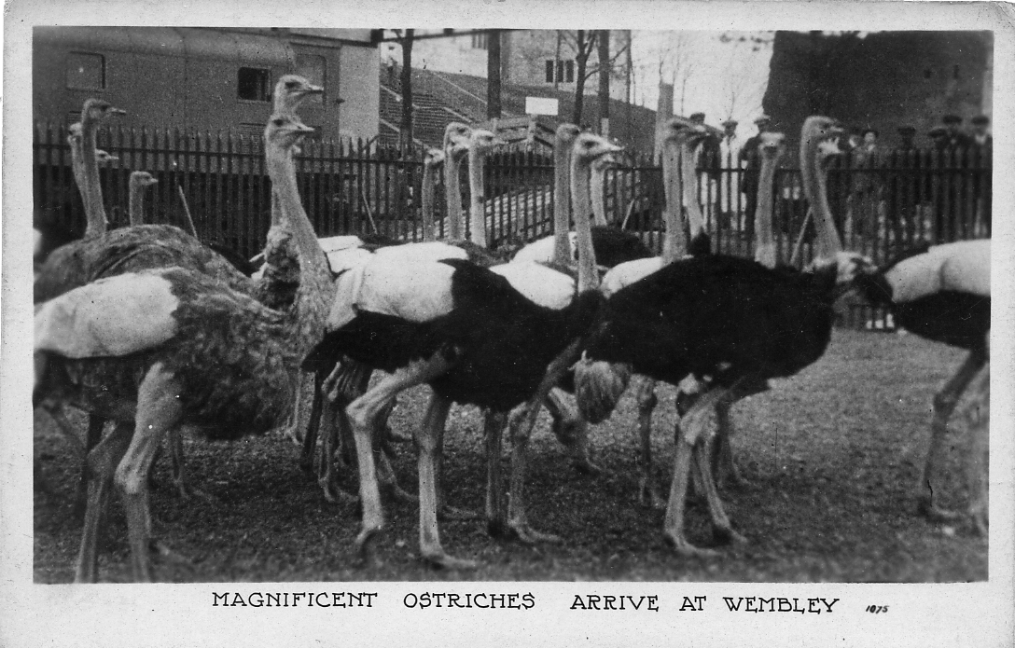
A Pathe Freres Cinema post card from Karl’s collection.

It is difficult to come to any conclusions about the sale, because there are no details given, or very little. Regarding Wembley post cards Lot 765 an album of approx. 200 post cards some relating to Wembley including four Felix the Cat went for £140 plus a buyers premium of 18 % , but not knowing how many of the 200 were Wembley doesn’t help us much. Another “album of 140 Wembley cards including 6 pullouts” fetched £75 plus 18 %. The last item is the only lot where a price can be related to a given quantity of Wembley cards, including the buyers premium the cards went for 63p each. Certainly at Shepton Mallet in 2012 where these two lots surfaced in one dealers stock, there were some very good and very scarce cards indeed amongst them.

I think Shepton must be a lucky fair for me as I have done very well there in the last two years, mainly it must be said getting material from the disposal of Karl’s collection.
And what of Karl, there are plenty of rumours, but no hard facts. At the time his daughter Alexandra was selling his Wembley advertising labels the family was still living together. It must have broken his heart to see his collection go for, in many cases, peanuts, and very small ones at that.

A Strange feature at the 1911 Festival of Empire solved.
by
Fred Peskett

On some photographs and postcards of the Crystal Palace that show the Central Transept from the Terraces, there is a rather strange looking square column that can be seen between the two staircases that lead to the Royal Box. It is known that these staircases were built during 1910 for the Festival of Empire Exhibition. The column does not feature on any of the views known to have been taken prior to 1910, but it does appear on postcard views published by Bemrose and other printers for the Festival of Empire, so it must have been erected for this event.
Postcards and photographs taken between 1914 to 1919 when the Crystal Palace was occupied by the Admiralty do not have this structure visible, so it must have been removed or demolished between 1912 to 1914. On most of the views where this column can be seen there seems to be a rectangular black plate at the top, but it is general unreadable, however, there is one postcard in the OXO Festival of Empire Series that can be deciphered with the aid of a strong magnifying lens, it reads:- “WAYGOOD LIFTS” there is further proof in the Bemrose Festival of Empire Guide with a small advert for WAYGOOD LIFTS saying “See our display on the Terraces”. The column may have been a working model lift, it was far too small to be of any functioning use.

Universities Mission to Central Africa (UMCA)
by
Ron Trevelyan

This may seem somewhat outside the normal run of subjects for the Exhibition Study Group Journal, but I have been persuaded by Bill Tonkin to put pen to paper. Bill has had a long-standing interest in missionary postcards, which in some cases have been linked with exhibitions, whereas in my case I have been attracted by the Rhodesia / Nyasaland subject matter shown on a number of the UMCA cards.
It did not take me long to realise that Bill had done an enormous amount of research on the UMCA cards. These were published for sale in the UK for a period of about 40 years -from 1903 until the outbreak of the Second World War, The postcards were intended to raise the profile of the missionary work being carried out in Africa by UMCA and hopefully raise funds through donations and the sale of the cards. The cards showed scenes of everyday African life and the influence of the missionaries there.
Bill's research has come up against considerable difficulty over establishing when and how the postcards were published, but his records have been improved by information received from an archivist at the United Society for the Propagation of the Gospel (USPG) via another collector. The USPG resulted from a merger of the UMCA with the Society for the Propagation of the Gospel (SPG) in 1965. It appears that the cards were published in a number of series (12) in packets containing coloured, toned and black and white cards, as well as some striking silhouette ones. The accuracy of these findings has been undermined by the number of reissues and reprints which exist. Nevertheless the cards can be sorted into a rough chronological order by noting the address of UMCA on the back of the cards. From 1897 this was Dartmouth Street, Westminster and in 1929 it became Central Africa House, Wood Street, Westminster (later Great Peter Street). There are no clues as to who the artists or publishers were and little guidance can be obtained from postmarks on the postally used cards. These are in a minority and in any case cards can be left in a drawer for years before being used. Despite all these problems the fact remains that most of the cards are very attractive and collectable and portray a period of social history. I am leaving it for Bill to provide a few examples.
Whilst I enjoy having a collection of UMCA cards with the benefit of information gleaned from Bill, I admit that my interest stems from the historical background of the mission. The Rhodesian Study Circle takes a close interest in all missionary activity in the early days, because missionaries formed a large part of European settlement and much research has been carried out on how the mail reached these isolated outposts.
The idea of a mission to Central Africa was started by David Livingstone who was in the UK following his journeys in Africa between 1841 and 1856. In 1857 he gave a lecture to the Senate House at Cambridge University where he exhorted the audience of undergraduates to carry on his work in Africa to make an open path for commerce and Christianity. Some of his audience formed the UMCA. Similar enthusiasm was raised at Oxford University which led to the formation of the Oxford and Cambridge Mission to Central Africa, The Universities of Dublin and Durham also became interested so that the name was changed to the UMCA.
David Livingstone left the UK for Africa in 1858 to begin his Zambesi Expedition, whilst the UMCA became established here. Its ambition was to pursue evangelistical, medical and educational work in East and Central Africa and to make a major contribution in the fight against slavery and leprosy. In 1861 at the invitation of David Livingstone the UMCA sent an ill-fated mission to the Shire Highlands. It encountered problems through the lawlessness of the region and first attempts at forming a mission there proved disastrous. There were many deaths from fever. There was public criticism of David Livingstone when they heard of the dangers to which the mission had been exposed. In 1863 the UMCA withdrew to Zanzibar to establish a network of missions in East Africa. Despite this bad start the UMCA returned to Central Africa in 1880 and the Diocese of Nyasaland was created. It proved to be the forerunner of much missionary activity by other organisations. Its separate existence in London until 1965 shows how initial problems were overcome. The 140th Anniversary of the UMCA was celebrated in 1997 with Eucharist at Great St. Mary's University Church in Cambridge.
I hope this will help to show what an interesting background lies behind the publication of a few postcards.

The Crystal Palace Asphalt Roller Skating Rink,
The Grange at Midhurst,
and Mr &. Mrs G. H. Whitelocke.
By
Frcd Peskett.

The West Sussex town of Midhurst is probably better known to most people as the location of Cowdray Park, the home of British Polo, but for me it is the “Grange” a building once a very stately home, it is now the venue of many of the towns activities including, a bi-monthly Antiques Fair, a monthly market of collectibles, antiques, bric-a-brac and postcards. A quarterly Antiquarian Book Pair which also includes ephemera and yet more postcards, and to cap it all a fortnightly indoor car-boot which covers just about everything. Each event at the Grange is supported by at least a hundred plus stalls spread over four large halls.
Visits to these events have over several years provided me with a wealth of exhibition related and other goodies, including the now famous 1895 Crystal Palace Cup Final Programme found tucked in a Palace guide which I purchased for just £5, the Great Exhibition two handled “Loving Cup” which is eight inches in diameter by 12 inches high with a black transfer of the exhibition building around the outside, a mauve transfer view of the interior of Palace including Osier's Fountain on the inside and a brown transfer of the Prize Medal of the Exhibition on the inside base. Made by Copeland in 1851, it cost £100 but according to an antiques expert it is valued at well over six times that amount. At one of the Car Boot sales five weeks ago I found a 1938 Meccano Number 7 Outfit, still strung in the original sales box and in pristine condition. It cost the huge price of £35.00 So it came as no surprise when I went to the Monthly Market on the 17th February this year to notice on one of the tables a cardboard box 9” wide x 12” long x 2½” deep with “CRYSTAL PALACE ETC” pencilled on the lid. A look inside gave me one of those three-penny bit, half-crown moments, since much of the contents related to the Crystal Palace Asphalt Roller Skating Rink and to Mr and Mrs George Henry Whitelocke, who were Champion Roller Skating Dancers in the early 1900’s.

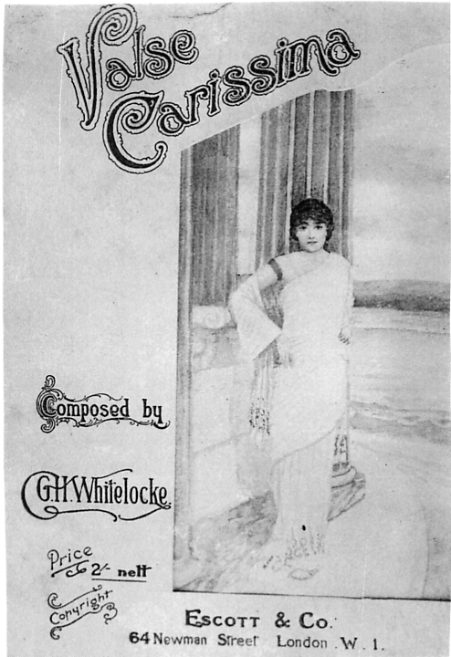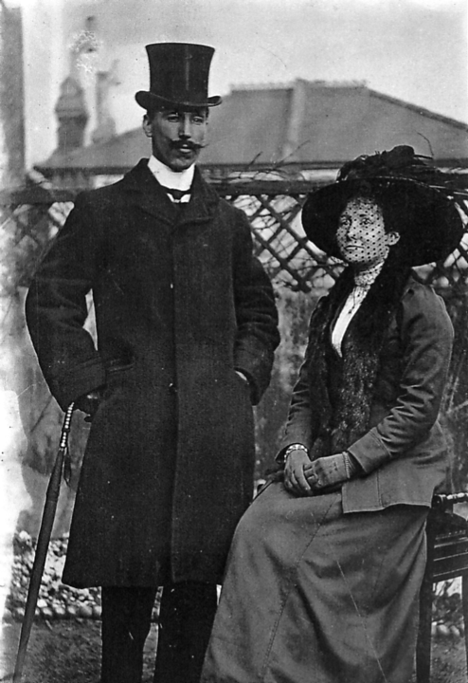

Left:- A photograph of the cover of a piece of sheet music composed by George Henry Whitelocke, a covering letter from Escott & Co the publisher dates this music to 1904.
Right:- A photographic postcard of Mrs and Mrs G. H. Whitelocke, which is post marked East Dulwich, 12th May 1911.

There was masses of Crystal Palace ephemera including five advertising posters each 2’ 6” wide x 3’ 6” high when unfolded, these cover the period from 1906 to 1911, one of them relates to a Roller Skating event for the Festival of Empire Exhibition in 1911. Apart from many family photographs, there is a collection of letters from various music publishing companies, George Henry Whitelocke was also a composer of dance music to be used for roller skating, some of these letters are quite enthusiastic about his compositions, others are downright rude, saying that he hasn’t a hope in hell of getting them published, these letters run from 1880 to 1899, there is one piece however, which seems to have made the grade, called “The Jockey’s Patrol”, there is a letter telling him that it had been added to the repertoire of Wellington’s Light Cavalry Military Band. They played at the Italian Exhibition 1888, the Spanish Exhibition 1889, the French Exhibition 1890, the Naval Exhibition 1891, the Horticultural Exhibition 1892 and the Gardening and Forestry Exhibition 1893.
The Light Cavalry Military Band was made up from ex Guardsmen musicians, who looked splendid in their blue, scarlet and gold uniforms. There are a total of 98 items in the collection for which I paid £50. this works out at 51p per item, quite a bargain?

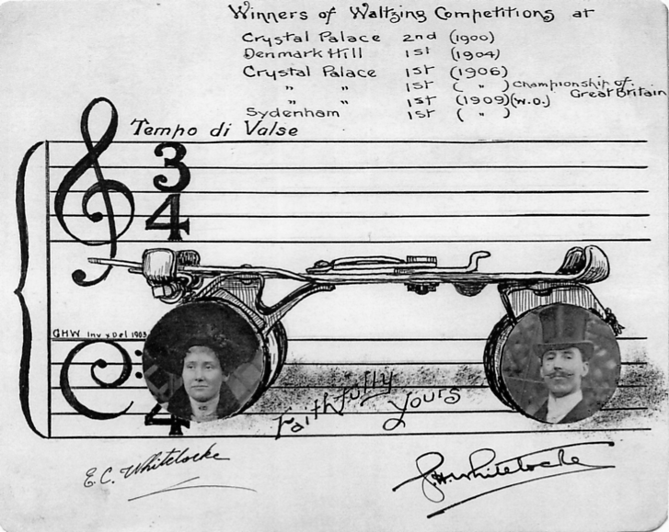

Top:- A copy of the original artwork for Mr & Mrs Whitelocke’s business card, shown about half size. This dates to 1910/1911.

Snapshots or Real Photographs for your Snapshot Album. Part 1.
by
Bill Tonkin

Yes, you know what I mean, those little boxes or folded cartons of usually 12 small Snapshots that most of the postcard publishers manufactured and sold in addition to their post cards. I expect you are all like myself, you see them at a fair, buy them if the price is right, take them home, look at them once, and put them away in a box or drawer and never look at them again.
When Mike Perkins and myself did the update of our Wembley Book in 2004 we included for the first time Snapshots and did some limited research into the contents of the packets and it became obvious to me that here was a subject that would repay going into later, in some depth. At the time we listed the various types of packets but did not go much further into the subject than that. Now that I have virtually stopped going to post card fairs I have the time to enjoy my collection and really getting to know my various sidelines. Over the years I have accumulated a lot of the packets published by various firms. I recently had the opportunity to greatly increase my collection, and this started me looking at the packets in much greater detail than I have done before.
When you come to examine the contents which all look the same at a quick glance, what a wealth of variety there is. To a person like myself who has always been attracted by varieties from the normal, this has proved a fascinating field. They have everything so dear to my heart. The same view, sold and packed by the same firm, in the same carton, can be found with different clouds in the sky, there are redrawn and repositioned numbers on the snapshots, some times large numbers were redrawn in a much smaller size, and not just reduced in size but written in a different hand. To my surprise Valentine on one series of cartons went to the trouble of carefully scratching out the numbers on the negatives, so they cannot be read, although under a glass traces of the numbers can still be seen. Why did they start by putting numbers on the snapshots and then go to considerable trouble deleting the numbers we shall never know.
Some of the post card manufacturers, Beagles, Campbell-Gray, Fleetway, Raphael Tuck & Sons, Valentine & Sons, probably Walshams and Wildt & Kray, also published sets of small snapshots, usually real photographs, which vary slightly in size, being approximately 85 x 70 mm. The snapshots were sold in several types of packets. Some firms used small boxes either with loose lids or hinged lids. another form of package was a folded cardboard carton that had provision for an address and stamp box, but it must be said they seem to have been kept more as a souvenir and so far very few has been seen postally used. Other sets were sold in folded paper wallets or envelopes.
Most of the series were of twelve snapshots and some firms published two series for 1924 and two again for 1925. If they were numbered, on the bottom left or right corner Series 1 would run from 1-12 and Series 2 from 13-24. One exception is the Fleetway 1925 Wallets where Series No. 1 and No. 2 both run from 1-12.
In this listing notice is taken of the variations of the setting of the printing of the packets. There are also variations in the size and shape of some of the numbers on the snapshots that have numbers, showing that some series had the numbers redrawn.
Where a carton has the contents printed in numerical order on the flaps this is reading them with the flaps laid out flat so that 1 - 6 is on the right and 7 - 12 is on the left. If they are read with the flaps folded this gives a different sequence of titles.
When real photographs were manufactured, at some stage a number and sometimes a title was hand written on to the negative. From this original negative copies would be made so that multiple printings from the much enlarged negative could take place.
In some cases a transparent adhesive strip was used (like selotape) and the title or number would be written on this, which was then stuck onto the negative, Often the edge of the strip shows up and can be easily seen.
It is not known whether some publishers replaced the numbers they printed on snapshots, or whether they had two sets running at the same time. It is certain that snapshots are known of the same view by the same publisher with very different looking drawn numbers on them. The why and the wherefor are not known, all we are left with is the fact that different numbers exist. Very often where there are two different shaped numbers the clouds in the sky are different too.
Some publishers Fleetway for instance only needed to replace about half a dozen snapshots with redrawn numbers out of the 24 snapshots in series 1 and 2 for 1924. Other publishers like Wildt & Kray in their 1924 series 1 and 2, published the whole 24 snapshots with the original large numbers and also published the same series with redrawn numbers in a much smaller size.
It is fair to ask which out of the two types of numbers are the original, and which are the redrawn numbers. I think the larger size numbers are the first and original numbers since Valentine only used about six of the smaller numbers out of a possible 24.
In the close examination of Fleetway’s and Wildt & Kray’s 1924 series 1 and 2 snapshots, it becomes obvious that they were all produced by one firm. The snapshots, the titles, the numbers written on the snapshots, even the varieties like the sloping ‘4’ in the redrawn smaller ‘14’ are the same for both publishers. This is also apparent when the folded cartons are examined. The decorative frame surrounding the printing is the same on Fleetway’s folded cartons, as it is on the Wildt & Kray boxes. The only difference is Fleetway has ‘Issued by the Fleetway Press Ltd’ in the imprint at the bottom left, and Wildt & Kray has ‘W & K London’. They even used the same shade of buff cardboard for the cartons. Wildt & Kray’s sets were sold in maroon coloured boxes either with a hinged lid or a loose lid, and these are the most common of all the snapshots. On the other hand Wildt & Kray’s folded cartons are very scarce and I have only ever seen one for their 1924 Series 1.
I favour Wildt & Kray as the actual manufacturer of the snapshots and cartons, rather than Fleetway, on the grounds that all the 24 numbers from 1 to 24 are known in the original large size and also in the redrawn smaller size, while Fleetway only published about 6 redrawn numbers out of the 24.
I should mention here that Alan Sabey and Mike Perkins both generously let me borrow their collections of snapshots to examine, and without having this amount of material, this study could not have been done. All together 95 packets of snapshots have been examined. The commonest series was Wildt & Kray No. 1 with 12 sets from the three sources, and No. 2 with nine sets. There must have been greatly reduced quantities published in 1925 as four of No. 3 and only one of No. 4 has been seen.
Beagles 1925.
No differences in titles have been seen.
Campbell-Gray.
Only one packet has been seen, the contents were photogravure printings and not real photographs
Fleetway Press 1924 Series No. 1.
Numbers 5, 7, 8, & 10 were redrawn and are in a slightly different position.
Fleetway Press 1924 Series No. 2.
Numbers 14 and 19 were redrawn and are in a slightly different position.
Fleetway Press 1925 Series No. 1.
No numbers were redrawn.
Fleetway Press 1925 Series No. 2.
Numbers 3, 7, 8 & 11 were redrawn and are in a slightly different position.
Raphael Tuck & Sons.
British Guiana No. 1 & No. 2.
Canadian Pavilion No. 1, No. 2 and No. 3.
Only one of each carton has been seen, so it cannot be said if any numbers were redrawn.
Unknown publisher
Probably Walsham, only one packet has been seen, so it cannot be said if any numbers were redrawn.
Valentine & Sons. Carton titled British Empire Exhibition Wembley. Without a number (1)
Valentine & Sons. Carton titled British Empire Exhibition Wembley. No. 1
Valentine & Sons. Carton titled British Empire Exhibition Wembley. No. 2
Some numbers were redrawn.
Valentine & Sons. Carton titled Valentine’s Snapshots. Without extra printing outside frame
Valentine & Sons. Carton titled Valentine’s Snapshots. With ‘Titles on the reverse side of the photos’ and ‘Wembley’.
Valentine & Sons. Carton titled Valentine’s Snapshots. With ‘Titles on the reverse side of the photos’ and ‘Wembley No. 2.’
Some numbers were redrawn.
Valentine & Sons. Carton titled Wembley
Some numbers were redrawn.
Valentine & Sons. Carton titled Wembley Exhibition. Double line frame No. 1
Valentine & Sons. Carton titled Wembley Exhibition. Double line frame No. 2
Valentine & Sons. Carton titled Wembley Exhibition. Ornamental round emblem No. 2.
Some numbers were redrawn.
Wildt & Kray 1924. Series No. 1
Numbers 1-12 were all redrawn, in the 12 sets examined four had either all large or all redrawn numbers the others had mixtures of numbers.
Wildt & Kray 1924. Series No. 2.
Numbers 13-24 were all redrawn, in the nine sets examined only two had mixtures of numbers. The rest had either all large or all redrawn numbers.
Wildt & Kray 1925. Series No. 3.
Numbers 1-12 were all redrawn, the four sets examined had either all large or all redrawn numbers, there were no mixed sets.
Wildt & Kray 1925. Series No. 4.
Numbers 13-24 are very scarce and only one box has been seen. It is therefor not known if the numbers were redrawn or not.
All illustrations of packets and cartons are 75% of full size and the small enlagements of numbers are 150% of full size.

