EDITORIAL WINTER 2011

My mind’s a blank, I can’t think of a rhyme,
I’ll have to give up, there’s no more time.

Once more our Convention has come and gone, All the members enjoyed themselves, well nearly all. Fred Peskett nearly came to blows with a large group of foreign students who decided to have a sing song outside his bed room window. He stood it until 2.00 in the morning when he got out of bed, dressed and went outside to explain that some people wanted to get to sleep. Despite the language barrier he managed to get his message across.
The Convention started with our A. G. M. and the only important change in our line up of officer was the installation of Ken Tonkin as Treasurer in place of Alan Sabey who has done the job for 17 years. Elsewhere Alan Sabey has done a short report on the displays at our convention.
Alan mentioned to me he was over at Crystal Palace recently with his cousin and wanted to show him the pedestrian way under Crystal Palace Parade amongst other things. At the start of his Presidency he remembered several members looked at it and found it to be full of junk and lots of plants and even bushes growing out of the brickwork. Alan wrote to English Heritage and was glad to see when he visited the tunnel, that the undergrowth has been removed and it looks a lot better down there. Its still in a bad state but perhaps they are working on it to make it look more respectable and safer. While he was there he called in a the Lodge and saw Joan. who told him she has put sixteen rooms aside for the Group.
At least two auction houses are offering a lot of material from the Karl Illingworth collection which is now being disposed of by Cath his wife. Despite having written to Cath and Karl several times, no reply has been received, and while there are several rumours nobody knows what has happened. What at least is sure, is that Karl’s collection is being disposed of for peanuts.
I mentioned several journals ago of a Bermuda card that Karl paid £35 which I bought for £3 off a dealer who in turn had bought it amongst a large collection of post cards and crested china from Cath. That established that the collector 1924lineone who had bought so much on E-Bay over the years was in fact Karl. I had long suspected that an old school friend of Karl’s, Rob Stewart was managing the transactions on Karl’s behalf. Rob had worked for Karl for many years and when Karl was building up his business empire, Rob was his 2IC.
I understand from Peter Robarts who put a lot of Karl’s material bought from Cath in a B.S.A. auction, that although the medals went well, the sale of the crested china was a disappointment, and he will now offer it on E-Bay. When I saw Karl’s crested china collection at his home in 1989 I estimated he had about 3,000 pieces. It will be much larger now and the problem with it, is the sheer space needed to display, or even keep it in. Houses these days just don’t come large enough. Even Karl was beginning to find this out, and at one time he was seriously considering buying the South Africa Pavilion built for the 1938 Scottish Empire Exhibition to house his collection. After the exhibition closed the pavilion was sold to Nobel Industries who re-erected it and used it as a sports pavilion. When Karl saw it the metal Crittal window frames had so rusted away, that it would have proved too costly to consider moving it to a new site.
I remember at our 1991 convention Andrew Brooks remarked to Karl that he must have spent a fortune on his collection, Karl’s answer was “about a quarter of a million”, I remember this as the three of us were admiring his large Moorcroft vase he had just paid £6,000 for. That was before his buying spree on E-Bay started, where I believe he was listed with over 30,000 buys. There is no doubt in my mind that Karl acquired both the Dennis Bundy and the Stanley Hunter collections, as parts of both of these collections have come on the market via Cath within the last few months. The largest Exhibition memorabilia collection ever built up is now being sold off, and I wonder if the existing collectors have either the money, the space, or perhaps even the inclination to absorb it. One item coming up is the 1924 Wembley Fireman’s helmet that Karl displayed at our fifth Annual convention in 1991 at the Crystal Palace.
The Editors
James Miller
Architect of the International Exhibition of 1901
By Fred Peskett

The International Exhibition held in Glasgow in 1901 was remarkable for the styles of architecture of the various buildings and pavilions. Foreign countries were well represented despite there having been a huge International Exhibition during 1900 in Paris. Holland, Russia, Belgium, Sweden, Canada, India, Spain, Norway, Denmark, France, Japan, Austria, Morocco, Persia, Mexico and Italy all had pavilions designed by their leading architects. The United States reproduced the same pavilion in Glasgow that they erected in Paris for the 1900 exhibition. Germany declined to be represented from the architectural, the artistic and the commercial aspects on the basis that the exhibition was far to close to the 1900 exhibition.
The principle architect employed by the Scottish Exhibition Committee was Mr James Miller, I.A. He was thirty-nine years old in 1900 from Perthshire, he had served his apprenticeship with the well known and respected architect Andrew Heiton from Perth. In 1888 he started work with the Caledonian Railway where he remained until 1892, when he formed his own business and was the architect responsible for Belmont Church, Hillhead. Prince's Pier Station, Greenock. Gonrock Station. The Railway Station at the Botanic Gardens, Glasgow, and the Kelvinbridge Station on the Glasgow Central Railway.

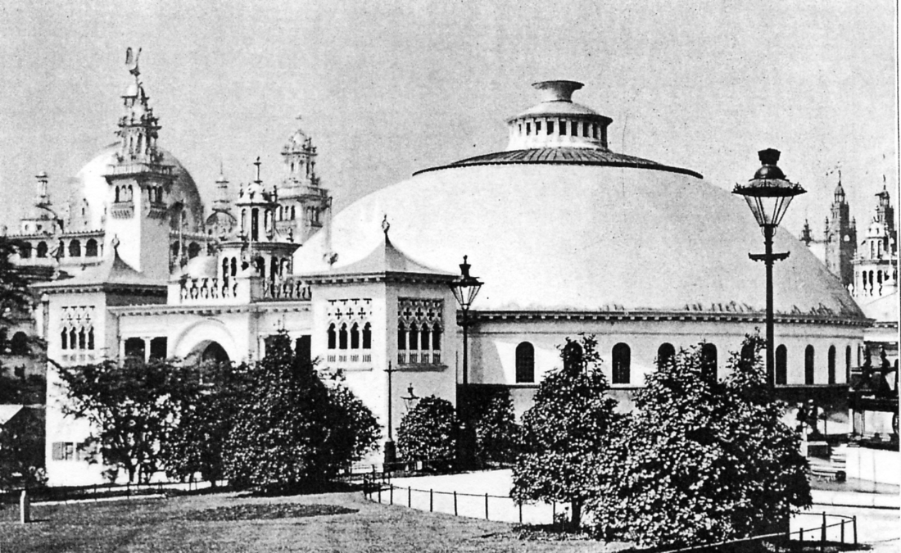

The Concert Hall by James Miller, the Industrial Building can be seen on the left.

He also designed the Glasgow Subway Station at St. Enoch Square. Kelvinbridge Mansions, and the Clydebank Municipal Buildings and Town Hall. With such a pedigree James Miller was the ideal person to become the principle architect for the 1901 exhibition. Mr Miller made use of many architectural styles for the various pavilions he designed, the Oriental style being the dominant, with a sprinkling of the Spanish Moorish and the Byzantine styles being prevalent. Some of his buildings were influenced by the Venetian and Spanish Renaissance styles as well as a touch of the classic Indian.
One of the dominant buildings for the exhibition was the Industrial Building, the black and white photographs reproduced for this article give a good idea of the size of this building. According to the specification it was a very colourful pavilion.
The architectural style of James Miller's Industrial Building was in the Spanish Renaissance.
It was 700 feet long and 380 feet wide covering an area of 23,000 square feet. The building had a central dome surrounded by four huge towers rising to a height of 160 feet.

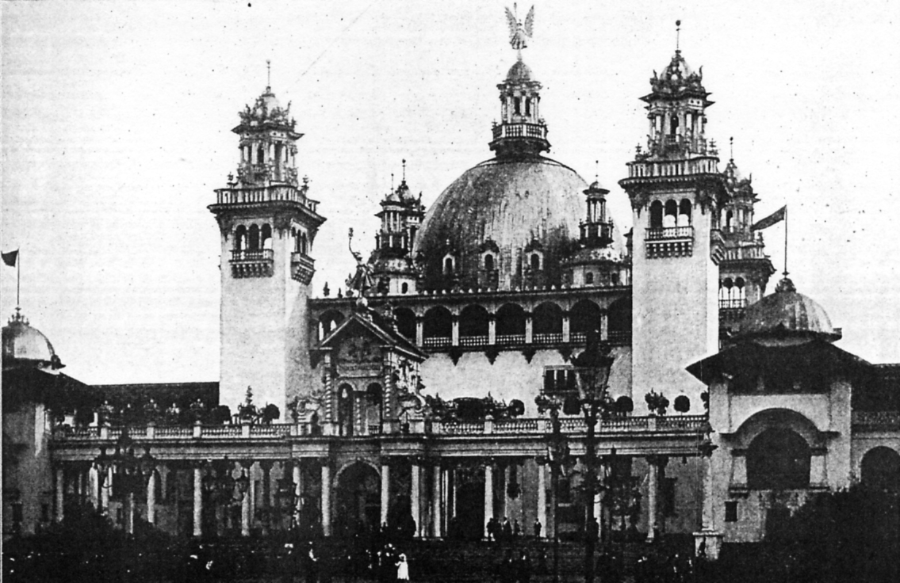

Front entrance of the Industrial Building by James Miller

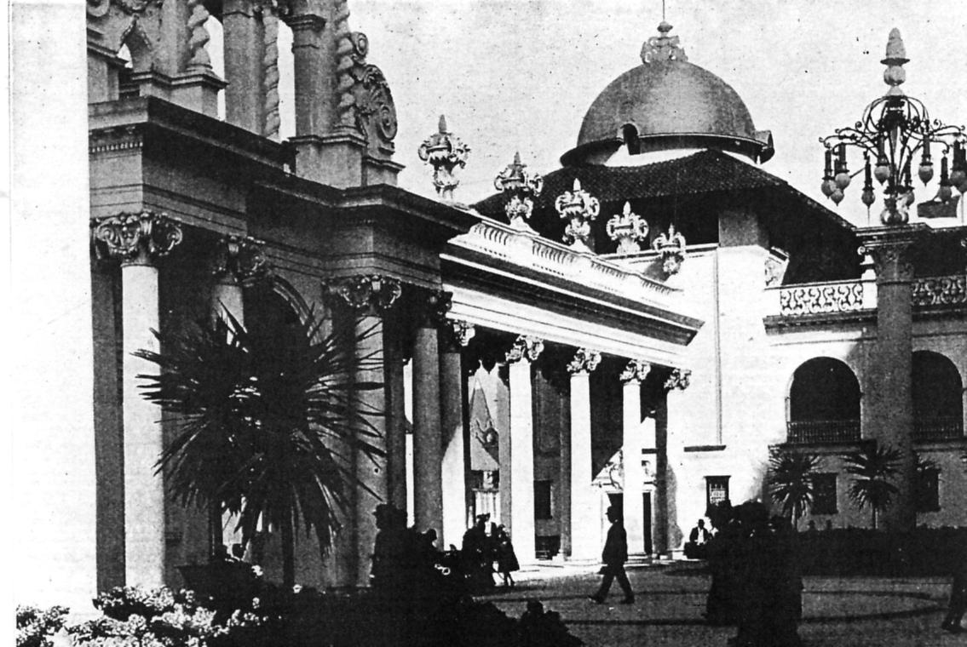

View from the Courtyard of the Industrial Building

he central dome was 135 feet high from the ground level to the apex, this was topped with an ornate flèche some 32 feet high, mounted on the flèche was a large winged female figure of “Light” by Albert H. Hodge, of London, it was 12 feet high with the outstretched wings at 12 feet, the right arm extended upwards with the hand holding an electrically lighted torch, in the left hand she held a branch of palm leaves.
The dome and the cupolas of the four towers were covered in gold, the walls were in pure white and the roofs of the towers were finished in pale green. The eight corner towers had the roofs covered in red Spanish tiles with the roof running between the towers being painted in bright orange. All the timber work, such as the eaves were painted green. The whole of the building including all of the decorative work was formed of fibrous plaster composed of stucco, canvas and wood. A half million yards of canvas was used, the cost of the building came in on budget at £25,000.
Another of James Miller's buildings was the Grand Concert Hall, described by him as being likened to a gigantic steel umbrella. It was in the Venetian Gothic style, circular in shape with a wide gallery supported by cantilevers. The roof formed a huge dome, coloured blue. The acoustics of the Concert Hall were found to be very poor, a constant troublesome echo produced problems which were never resolved.
While the name of James Miller is predominant as the architect for the Scottish Pavilions of the exhibition there was another young up and coming Scottish architect by the name of Charles R. Mackintosh who was busy designing a couple of houses on the exhibition site including, Gilmoor Cottage Homes, Dawyck House Gates and Dundas House.
The finance for the 1901 Glasgow International Exhibition was partly funded from the previous 1888 International Exhibition at Kelvingrove, this exhibition generated very healthy profits, some of which enabled the Kelvingrove Museum and Art Gallery to be founded. The Foundation Stone of the Museum was laid in 1897, with the opening of the museum scheduled to take place in 1901 and coincide with the 1901 International Exhibition.

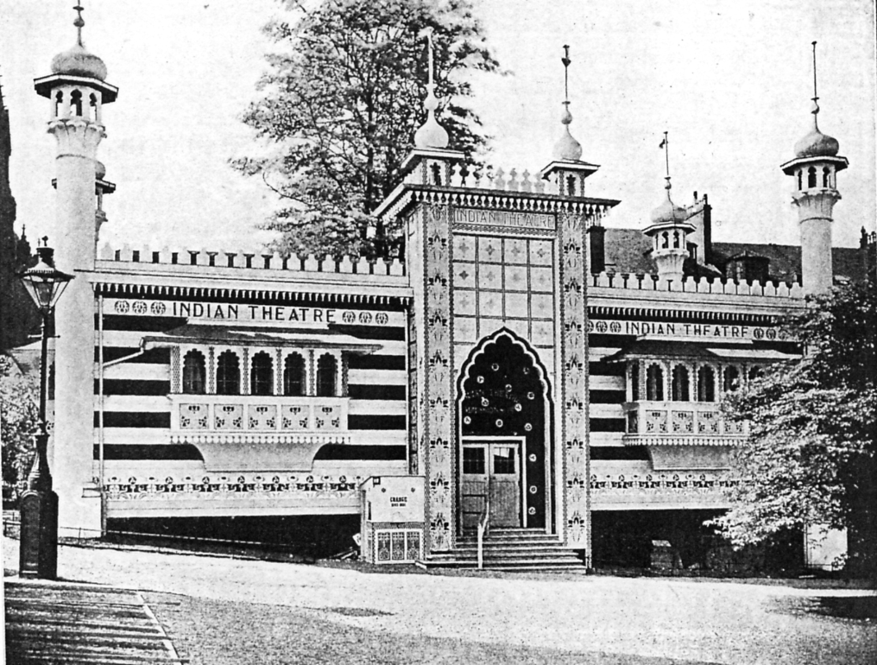

The Indian Theatre also designed by James Miller

The Glasgow International Exhibition of 1901 attracted some 11,497,000 visitors, making it one of the most successful exhibitions ever to be staged in Great Britain.

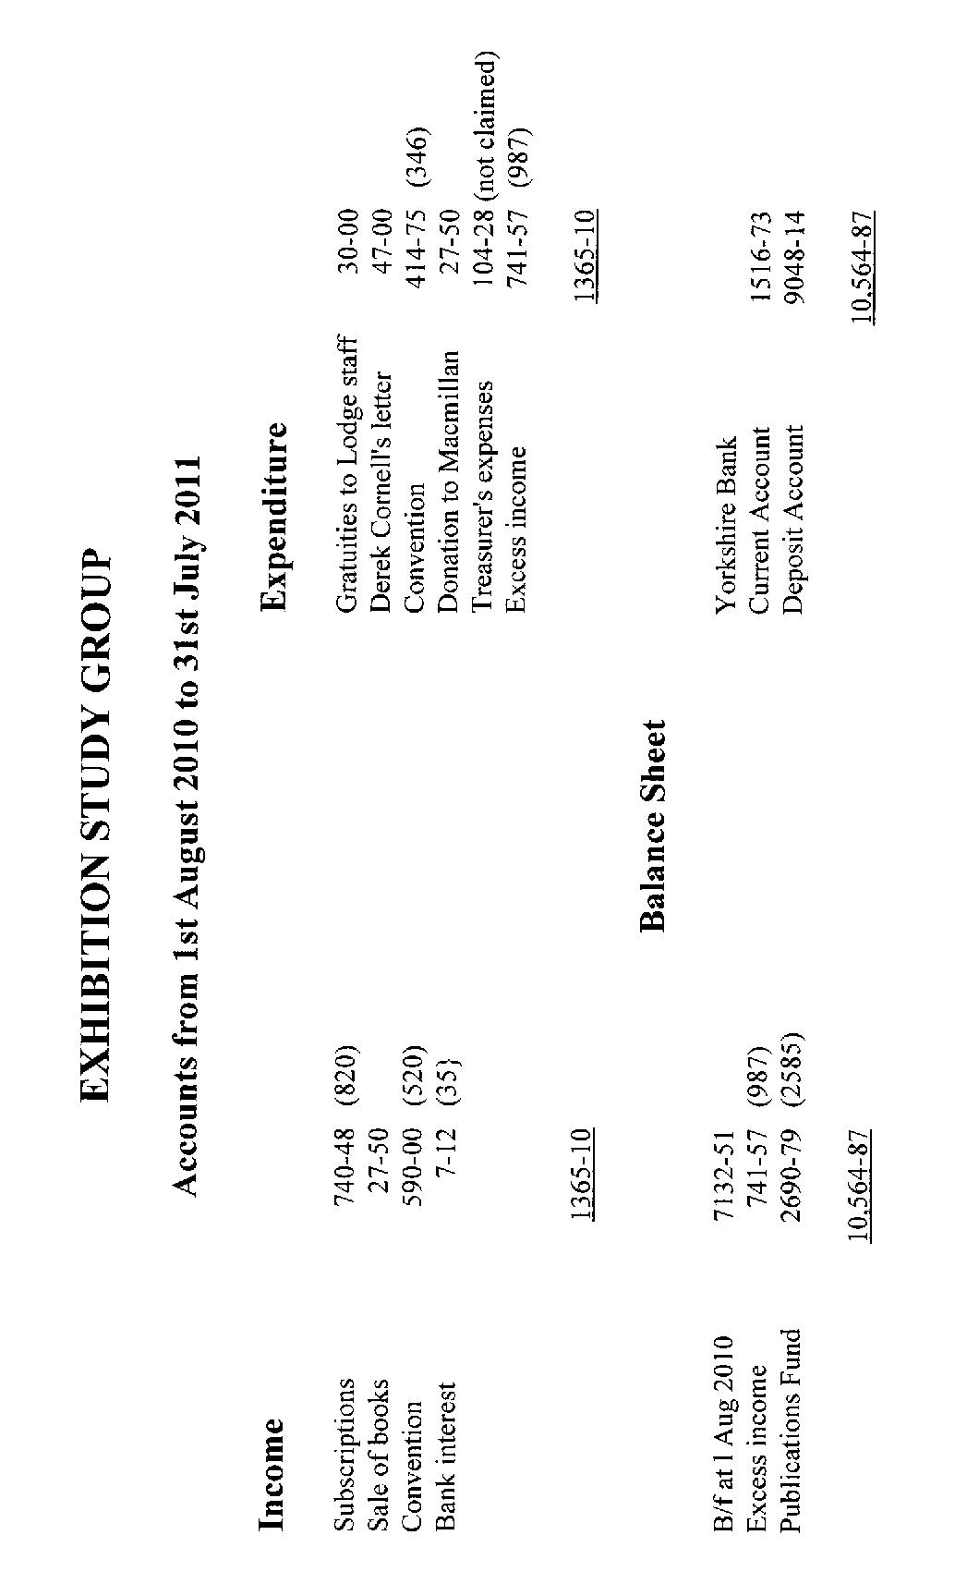
The Convention displays 2011
By Alan Sabey

After the AGM was over, we got down to the serious business of looking at displays by members. As would be expected these concentrated on the centenaries of the Coronation Exhibition at the White City and of the Festival of Empire at Crystal Palace.
King George V became monarch on 6th May 1910 and his coronation took place on 22nd June 1911. Air flight was still in it infancy so the Hendon to Windsor Flights in September 1911 were somewhat of a novelty and they carried mail and a number of these items were shown by various members.
In addition, we saw ephemera from the Crystal Palace from 1853 to 1937. These included letters, tickets and programmes of events including a horse show. Later in the displays, Fred Peskett told us about the fire started that completely destroyed the Palace and this was illustrated by picture postcards of the fire and the aftermath including the later demolition of the water towers.
Ron Trevelyan showed postcards and labels of the 1911 Pageants plus postcards of the Coronation Exhibition at the White City, and exhibitions in Glasgow and Brussels where one of the buildings also caught fire.
Bill Tonkin showed cards of the Pageant of London and we learned that the ladies who took part were given a clothing allowance towards the cost of getting their costumes made.
Wembley was not forgotten when Ken Tonkin showed handstamps of the British Empire Exhibition and some of the items once belonged to the President. Ray Goodey showed publicity labels for the British Empire Exhibition as well as a range of Torchlight Tattoo postal slogans and the 1920 Scout Jamboree labels overprinted for use at Wembley.
Derek Connell showed ephemera and philatelic items from the 1951 Festival of Britain and included the parcel labels from a special machine. These resembled miniature bus tickets. The By My Way and the Greater London Fund for the Blind labels were shown.
Alan Sabey for his President's Display, showed the stamps of several Malayan regions and North Borneo, overprinted for the Malaya-Borneo Exhibition in March 1922 timed for the Official Visit of the Prince of Wales (later King Edward VIII). There were some varieties on the overprints like malformed letters and wrong letters used such as BORNEQ for Borneo. This was the first time that the Group had seen such a different sort of display.
John Greatrex entered into the Olympic spirit a little early and brought along identical Olympic Torches from 1948 (London) and 1956 (Melbourne) and photos were taken showing how the Olympic flame was passed from one runner to the next in the Torch Relay. The two “Olympians” were Alan Sabey and Don Knight. On the Sunday John talked about the mascots Wenlock and Mandeville with publicity for the 2012 Games.
Don Brookfield showed some hand drawn covers with Festival of Britain stamps and posted at Chudleigh in Devon
Melvyn Harrison talked about the Crystal Palace Club in the Italian Rooms in the Palace but this closed permanently on 9 February 1915 some months after the outbreak of World War I.
All those who came to the Convention were presented with the special red souvenir cover with the recently issued Windsor flight sheetlet cancelled with a special Exhibition Study Group handstamp based on the Festival of Empire flag cancellations from 1911.
As usual, everyone left on the Sunday afternoon feeling they had enjoyed a great variety of displays and look forward to the next Convention on 29th and 30th September 2012, again at Crystal Palace.

“WILD AUSTRALIA” At The Festival of Empire, Crystal Palace, 1911
By Fred Peskett

One of the highlights of the Festival of Empire was the performance of “Wild Australia”. This was a novel twist on the traditional “Wild West Shows” performed by William Frederick Cody (Buffalo Bill) in the late 1890's and Samuel Franklin Cody with his “Klondyke Nugget” show at Alexandra Palace.
The act was billed as having all the thrills and spills of a Rodeo with the fun and excitement of the Bushlife of Australia, together with a large helping of slapstick comedy to prompt roars of laughter.
Three performances were given each day during the exhibition. One on the Pageant Ground at 3-30pm and two on an open area near the Empire Avenue called “The Wild Australia Building”, these were at 6pm and at 8pm each evening. No two performances each day were identical, the acts being selected from the following:- The Australian “Buckjumpers”. Sixty bare-back riders test their skills on riding wild horses, bucking bullocks, and bucking mules. The programme stated that these were the greatest outlaws that could be found in the whole of Australia! There was an act in which the daring and skill was man-handling venomous snakes and hungry crocodiles, rifle shooting by a lady champion with great accuracy and marksmanship. The Stockman's Whip, showing the skill of using a stock-whip over sixty feet long, lassoing and rope spinning, and a demonstration of using the boomerang and throwing spears. The finale of the hour long entertainment were two set pieces, “How to Catch a Horse Thief” and the “Capture of Ned Kelly and his Gang”. These two set pieces had a cast of over eighty performers.
To see the Wild Australia” show was an additional cost to the entry for the exhibition, at 3/-, 2/-, I/-, and 6d, or you could hire a box to hold six persons at 21/-.
The programme mentioned that Official Souvenir Postcards of the Wild Australia could be purchased from the Bemrose Postcard Kiosks around the grounds of the Crystal Palace. A facility was also available for writing, and posting the cards in boxes to have the Special Festival Postmark added, doubtless other postcard publishers cards found their way into these boxes, but it does answer the question as to why so many of the Bemrose postcards have the special flag cancel on the stamps.
The daily programmes for the Festival of Empire Exhibition contained many advertisements canvassing for emigrants to go and live and work in the Colonial Countries, the theme of emigration was also contained within each of the pavilions of the countries. British Columbia claimed that it was “the most British of the Canadian Provinces, a land of fruit, flowers, minerals and immense timber and fishing resources, together with being a paradise for sportsmen”. It claimed to offer high wages, low taxes and free education.
New Zealand wanted emigrants for farming, mining, timber jacking and fishing, cheap fares were available for farmers, farm hands and single women for domestic servants.
The British Empire Agency Ltd. offered posts in Australia, British Columbia, British East Africa, Canada, New Zealand, Rhodesia, and South Africa for all trades.
One country that did not canvas for immigrants was India, The literature available indicated that unless you were already in the Colonial or Civil Service, or were the owner or prospective owner of a tea plantation there was not really a place for you to come and live the exclusive life enjoyed by those already there.
Originally the Pageant of London was scheduled to have the final performance on the 21st July 1911, but owing to the great success it exceeded the hopes of the Festival of Empire Council and with the co-operation of the 15,000 performers it was extended until September 16th. Mr Frank Lascelles continued as the Master of the Pageant, as did the band of fifty musicians and chorus of five-hundred to provide the background music for the Pageant.
The whole of the interior and much of the Upper Terraces of the Crystal Palace were devoted to the All-British Exhibition. It was a showcase for all that was best in British design and manufacture. Most of the exhibitors had a facility whereby the goods on show could be ordered. Charles Baker, Tailor, was one such outlet who had on display their lightweight rainproof Hurlingham overcoats, these could either be obtained from stock at “ready to wear” prices of 29/6d, 39/6d, or 49/6d, or “made to measure” at 34/6d to 59/6d. For the ladies, John Noble from Manchester offered Mail Order dresses, by sending Mail Order Catalogues, patterns, and self measurement forms for orders direct from the Brook Street Mills.
But perhaps the most encompassing item for sale was the “Thermos Flask” as the invention of merit. It was claimed the flask was used in Canada for the coldest of places, to give a life saving hot drink for the weary settler and intrepid hunter. In the blazing sun of India the Thermos Flask is

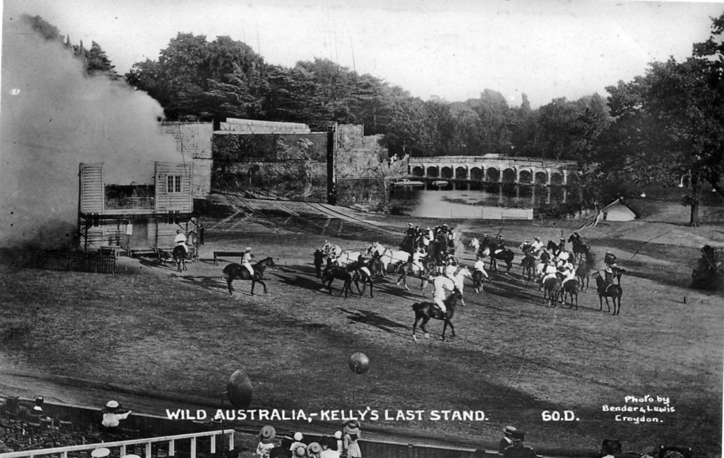

One of a set of four post cards published by Bemrose & Sons featuring Ned Kelly and his gang.

priceless in furnishing the cold drink for the traveller and businessman. In Africa the heat of the daytime can be quenched with the cold drink and in the frosty nights a hot cordial from the flask is a godsend. The advert invited visitors to come and see the interesting experiments with Thermos Flasks during the Festival of Empire.

Money Matters and the Great Exhibition of 1851
By Fred Peskett

Some of the more obscure ways in which money was made at the Great Exhibition of 1851 were described in 'The Illustrated London Almanac For 1852”. £400 was paid by the visitors to use the washing facilities, and £2,427 in spending a penny at the Public Conveniences, (so it would seem that not many people washed their hands after using the loo!) A total of £831..3s..3d was taken for the care and looking after of walking sticks and umbrellas, while visitors shilling catalogue was £3,200, and the profit from eating buns, cake, ices and drinking ginger beer came to £5,500.
The money taken for admission was £275,000 in silver and £81,000 in gold. During the run of the exhibition £90 worth of bad silver was taken, but only one piece of bad gold, this being a faked half sovereign. Most of the bad silver was in the form of half-crowns, and this was done on the half-crown and five shillings days!
The lowest dally take of money was £920.2 shillings, this was on the first “One Shilling Day” on Monday 26th Hay, but it was on the last “One Shilling Day” Wednesday 8th October that the highest receipt of £5.283. 8 shillings was taken at the doors.
Contrary to notices at the entrance doors, change was given, sometimes a French visitor would offer a “Napoleon” which was mistaken for a Sovereign, they were then given nineteen shillings change and the liberty of admission for less than threepence.
There were many organs on show at the Great Exhibition, the closing to the public was marked on the 11th October at 5pm by all of the organs and massed choirs striking up the National Anthem.
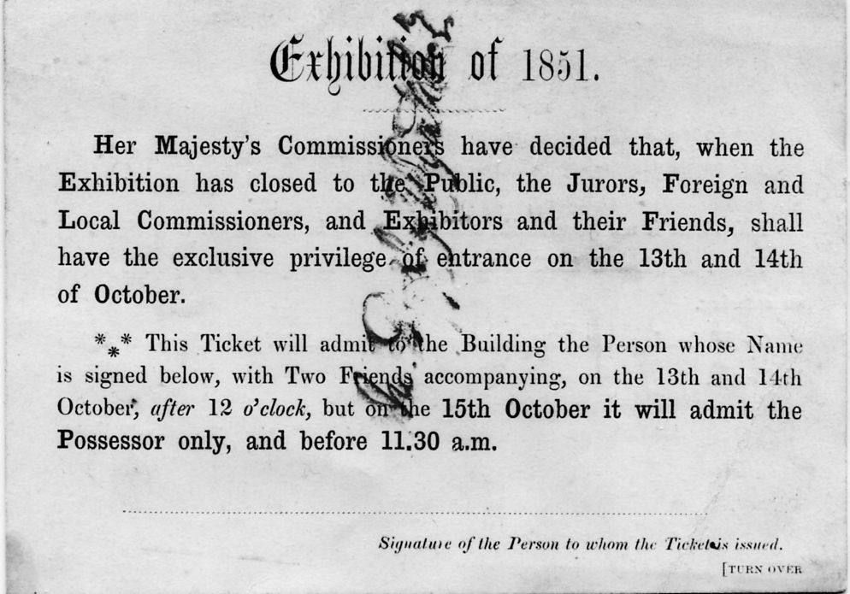

An unused special admission ticket with Digby Wyatt’s signature

On the Monday and Tuesday the 13th and 14th October the Crystal Palace was open to Exhibitors and their friends, this was without charge, but by admission ticket only. On Wednesday 15th October Prince Albert brought the Great Exhibition to a final close with a short ceremony and the receipt of the Reports by the Jurors. This ceremony took place on a temporary dais in the middle of the Transept. (The Crystal Fountain having previously been removed.)

A very belated reply to a letter from Tony Davies of last December, recording his find of a new Sierra Leone card. As Tony is aware, both series 1 and 2 of these Tuck R/Photo cards are very scarce, in fact I was beginning to think series 1 did not exist. The back of your scan shows that the Daily Mirror cards we listed in our book, were in fact series 1. The collector who supplied the titles for all the Daily Mirror cards way back in 1993, forgot to mention they were marked series 1. At that time neither Mike Perkins or myself had seen a series 1 card. In over forty years I have only found four of series 2 type B. This is the final list of Series 1 titles.

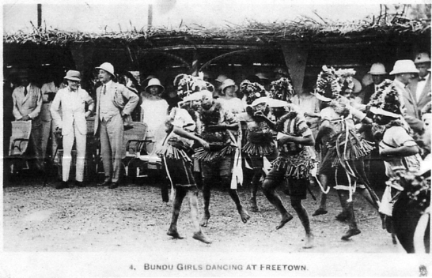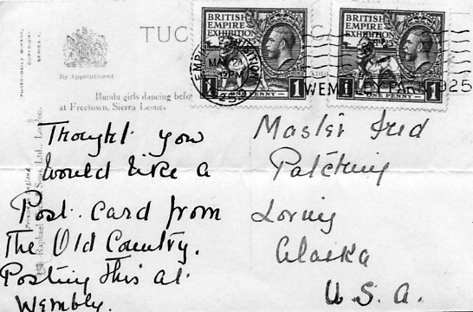

Type 2. Printed by Raphael Tuck & Sons Ltd., R/Photo, brown back with the Royal Coat of Arms.

Series 1.
Type A. Without Copyright Sierra Leone Government. but with Photo Daily Mirror Copyright. It is reported that this series was issued in B/W and Sepia
1. Paramount Chiefs from the Northern Province.
2. Paramount Chiefs gathered at Freetown. (Wembley stamp and exhibition post mark June 1 1925)
3. Bengen - A Famous Girl Dancer.
4. Bundu Girls Dancing at Freetown. (Wembley stamp and exhibition post mark May 2 1925)
5. Schoolboys - Sons of Chiefs.
6. “Au revoir” to Sierra Leone. Vert

A few new items from Alan Sabey

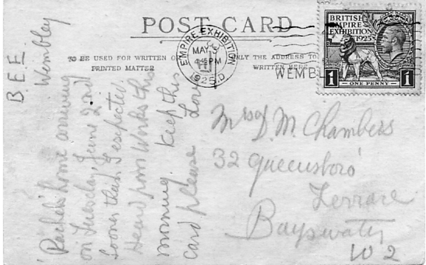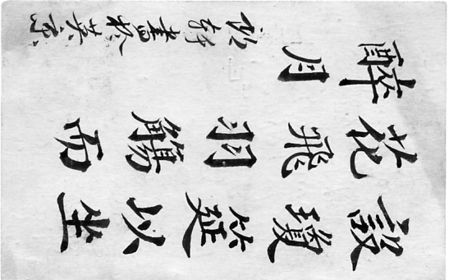

Post Card from the Hong Kong Pavilion

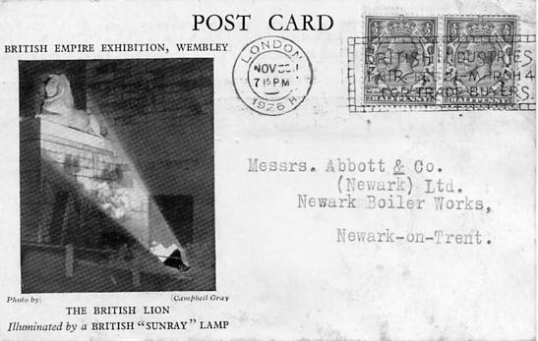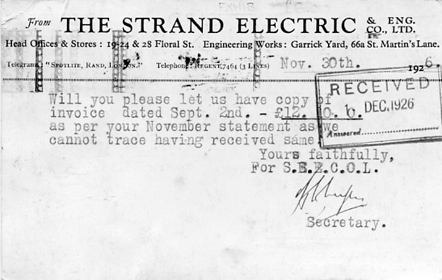

Late usage of an advertising postcard from The Strand Electric & Eng. Co., Ltd.

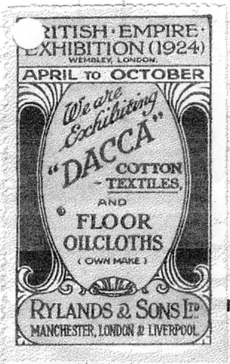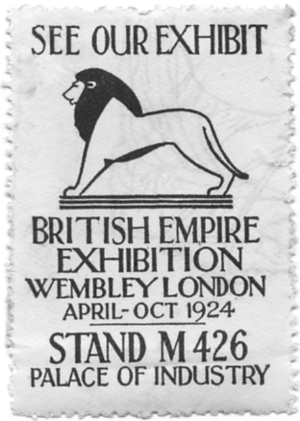
Palace of Industry Label for Doulton & Co., Ltd.
Stand K 385 Lambeth S. E.

Static Steam Engines on show at the Great Exhibition of 1851.
by
Fred Peskett

After seeing the locomotives displayed in Section 5 Machines for Direct Use, including Carriages, Railway and Marine Mechanisms featured in our last edition, we now have a chance to see the Static Steam Engines that were featured in this section.
Section 5 was situated in a special annex to the main building of the Great Exhibition, it was probably anticipated that the gathering of many working steam engines would create not only a tremendous noise, but no doubt the mechanical smells would not be conducive to the enjoyment of the visitors looking at the other exhibits in the main building. Never-the-less, the aroma of burning coals, acrid smoke, steam and hot oil must have given the visitor quite a thrill, just as it did when .you walked past a lounging steam locomotive in the good old days!
Just like the engravings of the locomotives, the artists tended to be a little generous with their interpretation, and in some instances the proportions of the item is somewhat exaggerated.

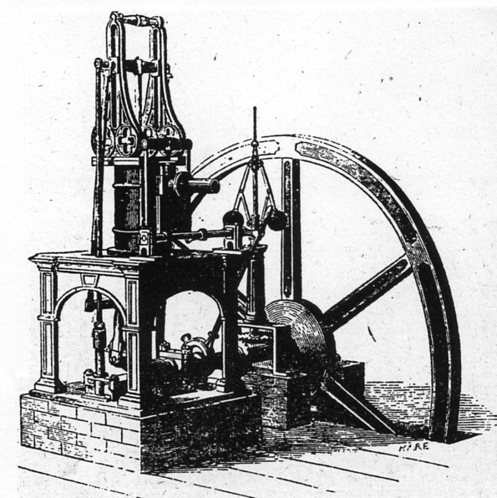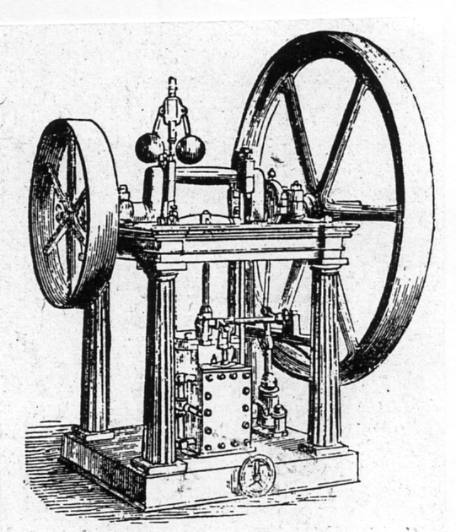
Figure 1. Tuxford’s Non-condensing Figure 2. Tuxfords Slide-Valve Portable
Expansive Table Engine Steam Engine

The engineering company, Tuxford of Lincoln exhibited their Non-Condensing Expansive Table Engine, which simply meant that the steam cylinder stood on a cast iron frame table. It was designed to operate other machinery through a belt drive system, this engine was available with various outputs ranging from two horse power to eight horse power and prices from £150 to £300. (see Figure 1)
Another steam engine by Tuxford was one of a “slide valve” type, this was a portable unit and its main use was to operate a water pump, (see Figure 2)
It can be seen from the engravings that in both of Tuxford's Steam Engines that were on show at the Great Exhibition, the design of the framework was based on classical forms, “Gothic” in Figure 1, and “Roman” in Figure 2.
An unusual steam engine was Joyce's Patent Pendulous Steam Engine, operated by an inverted cylinder, this steam engine was in operation throughout the run of the exhibition, and was shown driving textile manufacturing machinery, there was also another one working in the Main Building driving “Master's Ice Making Machine” in the refreshment room. (see Figures 3a and 3b)
At least two of these engines were in operation at the Great Exhibition. This engine was first designed in 1834 and improved by 1851. It is believed that several of these engines were used at the Crystal Palace at Penge Place, for operating the Ice Making Machines for the Refreshment Rooms,

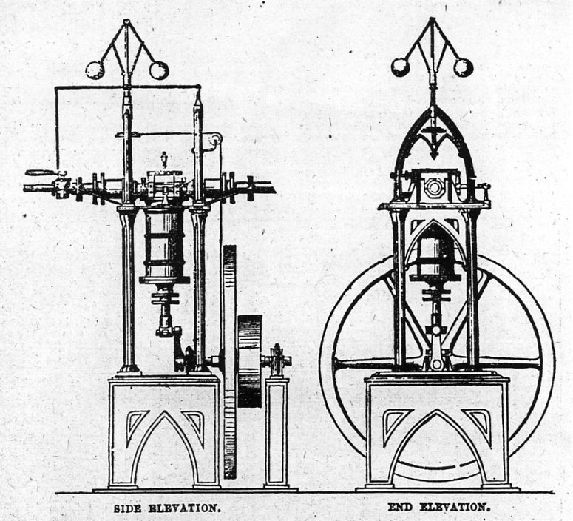
Figures 3a and 3b. Side and end elevations of Joyce's Patent Pendulous Steam Engine,

Thousands of this type of engine must have been produced and several examples are known to have survived and can be seen at the Science Museum, London, The Industrial Museum, Bradford, The Museum of Hampshire Life at Milestones Museum, Basingstoke and at the Ironbridge Gorge Museum. A couple are also known to be in private collections.

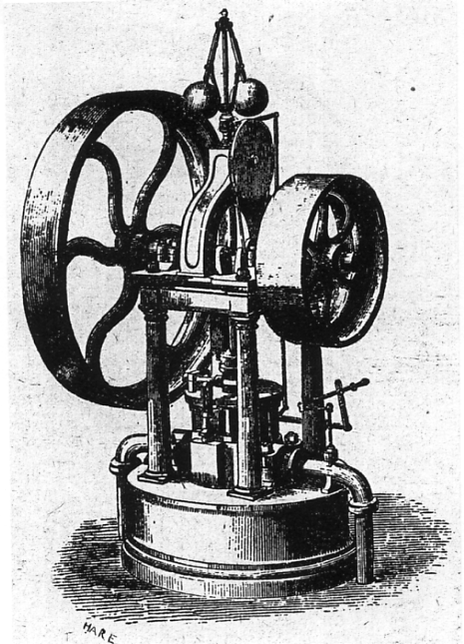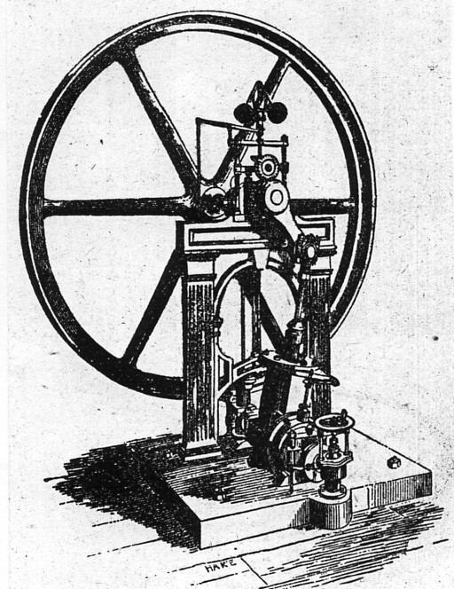
Figure 4. Crosskill’s Oscillating Figure 5. Clayton & Shuttleworth’s
Steam Engine Eight H. p. Steam Engine

An oscillating steam engine was displayed by Crosskills of Beverley, Yorkshire, whereby the steam chest was mounted on the side of the cylinder, (see Figure 4)
Messrs Clayton and Shuttleworth had on show a eight horse power oscillating engine with an unusual curved slide for the eccentric rod. This engine was suitable to power small marine craft, (see Figure 5)

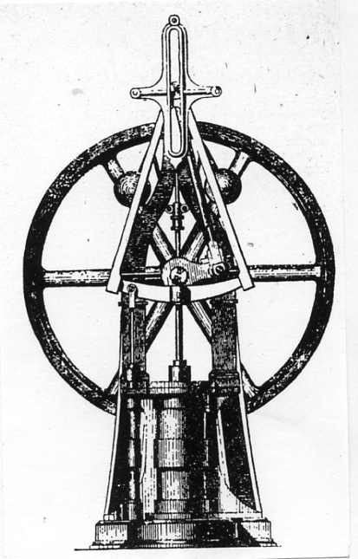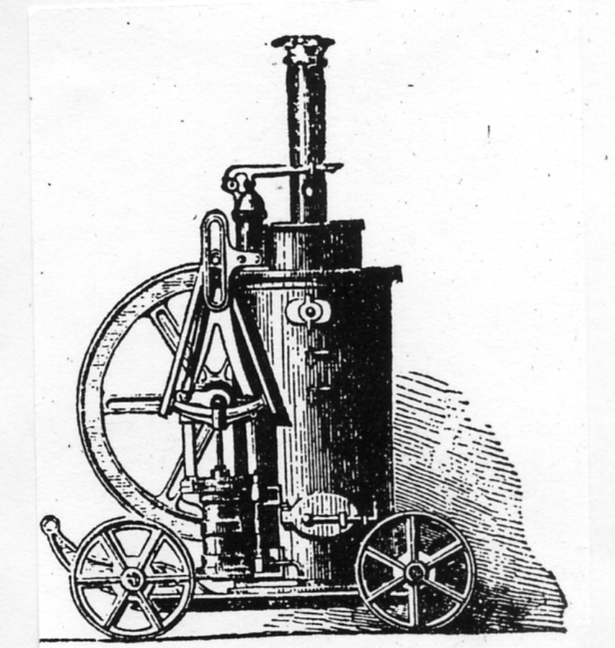
Figure 6a Figure 6b

Lynch & Inglis of Manchester demonstrated a couple of steam engines, a stationary type for use with agricultural machinery (see Figure 6a) also the same engine mounted on a wheeled platform coupled to a vertical boiler to form a portable steam engine for use around the farm or factory, (see Figure 6b)

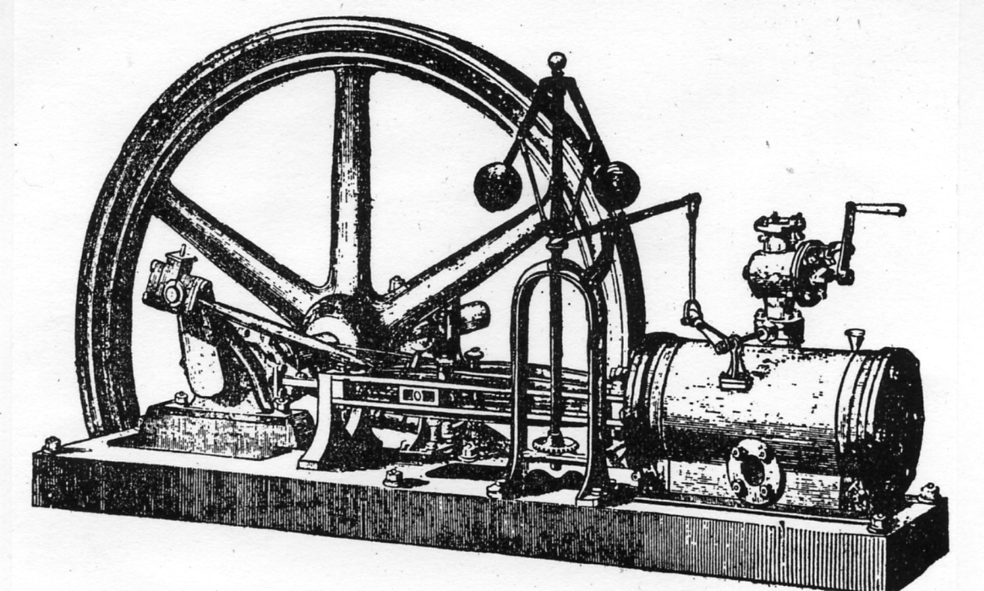
Fig 7. F. W. Turner’s Horizontal Steam Engine

E. F. Turner of Ipswich, exhibited a conventional type of horizontal steam engine with the steam cylinder being lagged with wood. (see Figure 7)

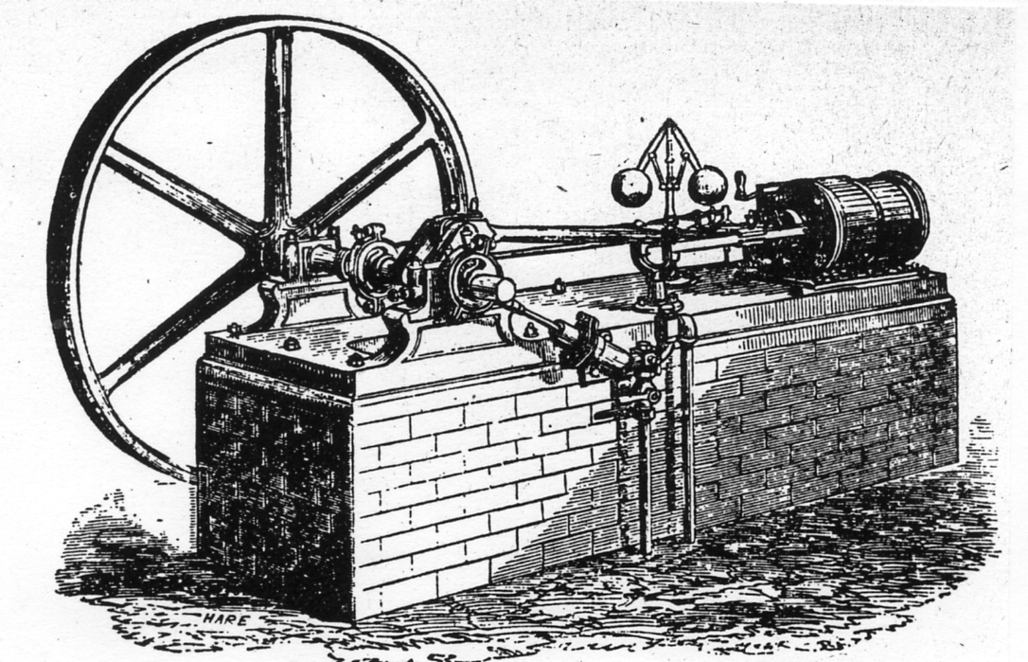
Figure 8

Another horizontal steam engine of conventional design was by Ransomes and May, this was designed for use as a marine power plant, (see Figure 8)

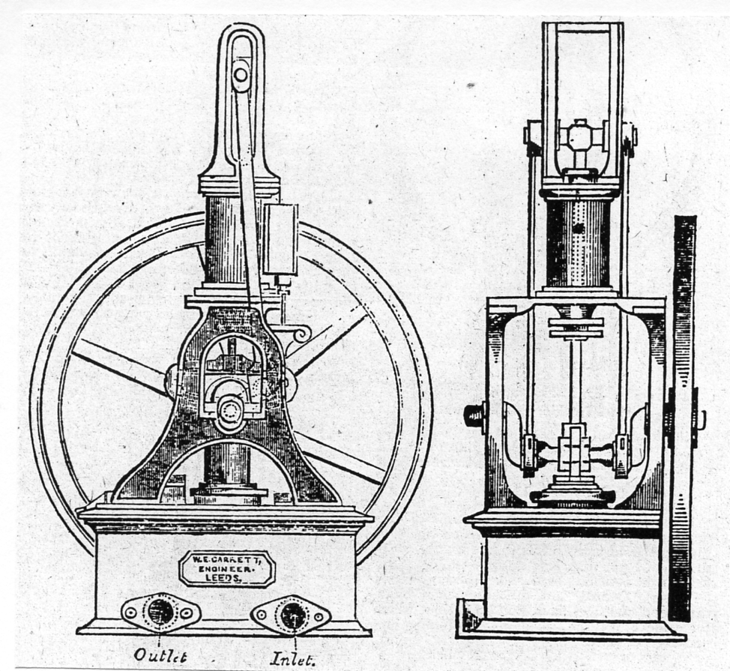
Figure 9
A steam pump by Carrett, was not only on show in Section 5 but was also chosen to operate in the Boiler House of the Great Exhibition during 1851. This pump was removed and installed in one of the Boiler Rooms in the re-designed Crystal Palace at Penge, and was in use from 1854 until the destruction of the Palace by fire in 1936! (see Figure 9)

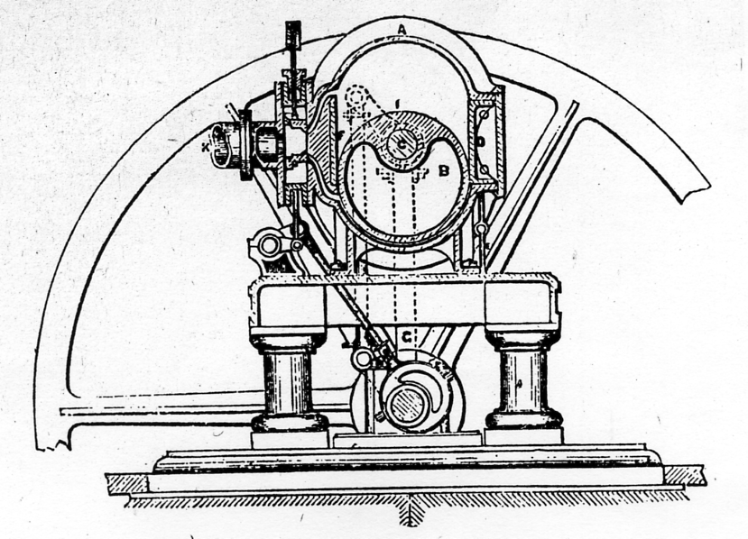
Figure 10a

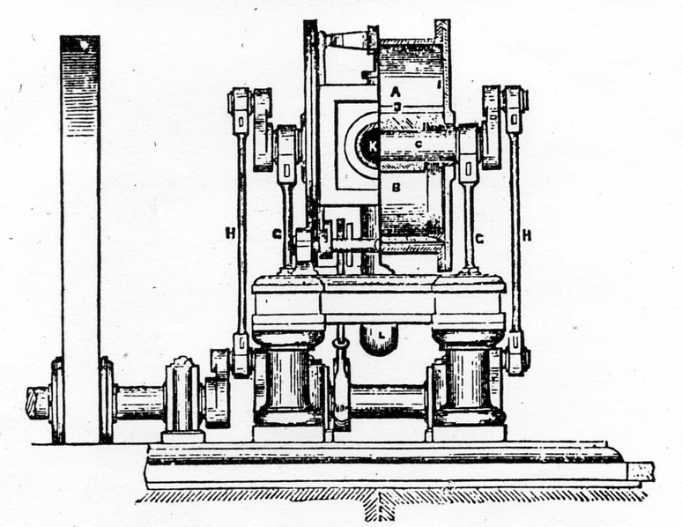
Figure 10b

Last but by no means least on show was Simpson & Shipton's Patent Short-Stroke Reciprocating Engine, which could be seen operating a whole section of Cotton-Spinning Machinery during the duration of the exhibition, (see Figures 10a & 10b)
And so on leaving Section 5 of the Great Exhibition our ears would have to get accustomed to the relative calm of the Main Exhibition Hall, and our nostrils to the aroma of the humanity of the day tempered a little by the scent coming from the “Lavender Water Fountain” in the Nave.

WELCOME TO ALL NATIONS.

All hail to the Nations that people the earth!
To the sons and daughters to whom they give birth!
We greet them with pride to this isle of our own,
They will all be right welcome from zenith to zone.
We welcome thee, Germany, loving and true,
The muses have ever been nurtured by you;
And commerce and industry flow in the tide,
Of your beautiful rivers, green, golden and wide.
But we welcome thee more for that thou didst give birth
To the noblest of Princes that e’er grac’d the earth;
Whose heart is so large that it takes in its span
The weal of all nations, child, woman and man.
All hail to the nations, o’er land or o’er sea!
We welcome them all to the home of the free!
We welcome thee France, with thy heart full of glee,
For ‘tis wise, when we can, to let sorrow go free;
And Russia we hail, who in commerce’ wide train
Has spread her broad arms over mountain and main.
We welcome thee Sweden, for happiness reigns
On the hearths of your homes, in the blood of your veins;
Norwegian and Finraan, Lap-lander and Dane,
Ye all will be welcome that swell the great train.
And thou mirth loving Italy, land of sweet song,
For Music and Poetry dwell in thy throng.
Where the sky’s e-ver blue and the stars ever bright.
And love holds his revels by day and by night.
Bonnie Scotland, fair Ireland, we scarcely need name.
For as sister and brother ye share in our fame;
But America, broadest of lands on the earth,
we greet all your talent, acknowledge your worth.
We welcome ye too, men and maids of the East,
where spices and pearls scent and shine at your feast;
Here the maids of all lands with each other may vie,
they are born of one earth, they will bloom ‘neath one sky;
For the stars will shine on as they do in their land,
and the moon will look down in her beauty so bland.
And the sun will blaze forth in his brilliance and might.
And will herald ye all to the Palace of Light!
There Industry, Science, and Art will combine,
to show rich treasures from nature’s vast mine;
And to him who deserves we’ll of praise give the meed,
What-ever his country, his colour, his creed.
Here the hand of a brother we’ll freely extend.
And in all whom we meet only welcome a friend.
Peace, peace, be our motto! may ev’ry one feel,
He was born to contribute to somebody’s weal:
And that England may aid in the beautiful plan.
Of every one’s helping his own fellow man.
That our Queen and our Country act nobly their parts,
Be the pride and the boast of all true British hearts!

