EDITORIAL AUTUMN 2011

Here’s Number 102, how time does go,
My set in ring binders, make a lovely show

Alan Sabey our treasurer has notified Don Knight and myself that he will not be standing for re-election as treasurer at our Annual General Meeting in October. Friends of Alan will know that for the last couple of years he has not enjoyed the best of health, far from it, and as our longest serving officer, he has been our treasurer for 17 years, no one can deny he has earned a rest.
Alan took over from Nancy who briefly came on the committee to sort out our finances after our previous treasurer went for three years without presenting an annual balance sheet. A state of affairs which we had to bring to an end.
Apart from serving as an officer of the Group, Alan has over the years probably been the most prolific contributor to the Journal with articles and short snippets of information mainly on the British Empire Exhibition, see the article on the Wembley table lamp later in this Journal. Also sending me images and descriptions of new Wembley post cards as they come his way.
It can be said that Alan is the type of member who is the essential backbone needed in any club or voluntary organisation. Without this sort of dedication by usually a few members, clubs will fold up, as we have seen in other organisations.
We unfortunately now live in an age where in general nearly everybody wants to be entertained with no obligation, and rolling your sleeves up and doing something is no longer an option to be considered. This is a sad state of affairs as speaking for myself I have thoroughly enjoyed the sense of achievement in the work I have done for the Study Group and other organisations I have worked for since retirement. I gave it 15 years and when I was 80 I gave up a lot of the positions I held on various committees, as I felt it was time to make way for younger people. But jobs are creeping back and I am now secretary of a Bowling Club Association and a Post Card club. As my mother would have said “It keeps ‘im off the streets”.
Members will be happy to know that we have a volunteer to take Alan’s place as treasurer. Well I think he volunteered. I was staying at a pub, actually it was more of a stately home called Claverton House near Battle with Kenneth and my daughter Susan for a weekend and I mentioned we had to find a replacement for Alan, and it may possibly be I had to twist Kenneth’s arm a little bit, I just can’t remember. It was during the evening and my memory gets a little bit hazy as night draws in. Would you believe it, the place had no Harvey’s Bristol Cream, but Susan, good girl that she is went out to the local super market and brought back a bottle
Any how I phoned Don and informed him, so that will save him knocking on a few doors.
As this Journal gradually unfolded on my computer it became obvious that this edition will come to be known as the ‘Railway’ edition from the number of railway articles published. We just hope our readers are interested in steam trains. And before I leave the subject did you know there is a name for keen railway enthusiasts, apparently according to the article they are ‘railwayacs’
In the last Journal I wrote that back copies of articles that had appeared in our Journal would be available at a cost of £1.00 per article. This was well received and so far the group has benefited to the extent of £62.00. If any other members would like to order articles please make the cheques out to W. E. Tonkin and not the Exhibition Study Group, as I can pay it in through my bank account but I do not have access to the Exhibition Study Group account. Some of the articles may only be half a page while others might run to three or four pages
I have again been asked to provide the display at the Picture Post Card Show at the Royal Horticultural Hall on September 2nd to the 4th where I shall show about 200 sheets of the Festival of Empire and possibly some of the Glasgow 1911 National Exhibition and Coronation Exhibition.

The Editors
Our 25th Exhibition Study Group Convention 2011
a letter from
Don Knight.

Dear members,
The Exhibition Study Group has been having a weekend convention for the past 24 years. These have been held at many different venues around the country, from Portsmouth to Glasgow, with many of those who came to first one at York still attending.
This year on the weekend of the 8 & 9 October we will be meeting at the site of the Crystal Palace in Penge, South London, This is a very good venue, easy to get to by car or train, the hotel has just been refurbished and the cost is very reasonable.
Over the years members have given a display of items from their collections, we have six display boards which take twelve sheets each. You do not have to fill all of them, but it gives you a chance to show what you collect. Other members may have items to sell and you could expand your collection.
We start on the Saturday morning with a short A.G.M. at 10. o’clock with displays starting at around 11 o’clock, we have a short break at 1 o’clock, restart at 2 and go on until 4.30. In the evening we sit down for dinner and wine. On Sunday morning we start at 10 o'clock and finish at around 1 o’clock. If you can not make the full weekend we would like to see you on either day.
I can now give you the costs for the weekend which are down on last year. Bed & breakfast £29.90 per night single room (£6 cheaper than last year) or £46.20 for a double room, our annual Dinner on the Saturday night will be £9-00, and for those arriving early and wanting a fish & chip supper on the Friday evening also £9-00. I think you will agree these are all very reasonable prices.
Over the years we seem to be getting more and more members turning up on the Friday afternoon and evening, and in 2009 for the first time Joan Miles laid on a fish & chip supper, which she has agreed to do again for us this year.
This year amongst others we intend to commemorate the 100th anniversary of the 1911 Festival of Empire and Pageant of London held at the Crystal Palace. 1911 was a good year for exhibitions as there was also the 1911 Glasgow Scottish National Exhibition, the Coronation Exhibition at Shepherds Bush, the 1911 Royal Army & Naval Tournament and an Ideal Home Exhibition featuring Tudor times with a Tudor village. 2011 is also the 160th Anniversary of the Great Exhibition and the 60th anniversary of the Festival of Britain. So the Study Group has never had so much to celebrate and there should be no shortage of displays. I have no doubt other exhibitions will be featured as well during the weekend. let me or Bill know.
If you would like to stay you can contact The Lodge, Crystal Palace National Sports Centre. Ledrington Road, London. SE19 2BB. phone 020 8778 0131, please mention The Study Group as we have provisionally booked a block of single and double rooms. Friends of members and non-member visitors are welcome, as long as they let Bill or me know.
Good collecting
Don R. Knight Hon Sec.

The Cover to Commemorate the Twenty-fifth Exhibition Study Group Convention

At our last Annual General Meeting it was agreed the group should do something to commemorate the holding of our 25th Annual Convention, one suggestion was to issue a commemorative cover with a special hand stamp. We later held a committee meeting and decided to go ahead with the A.G.M proposal of a commemorative envelope with the post office miniature sheet to be issued in October and with a special hand stamp to be applied by the Post Office. Raymond Goodey who has had some experience of designing first day covers, offered to, and has, designed the envelope and Derek Connell was co-opted onto the committee to help organise the venture with the Post Office. It has been suggested that all members attending our 25th Convention will receive one of our commemorative covers free of cost and the covers will further be available to members at £6.50 which includes postage. Since the illustrated cover features the Crystal Palace and this year is the 160 anniversary of the opening in Hyde Park of the Great Exhibition it is hoped the cover will have an appeal outside the ranks of the Exhibition Study Group. The covers can be ordered from Don Knight 2, Crescent Rd, New Barnet, Herts. EN4 9RF. 020 8440 3574

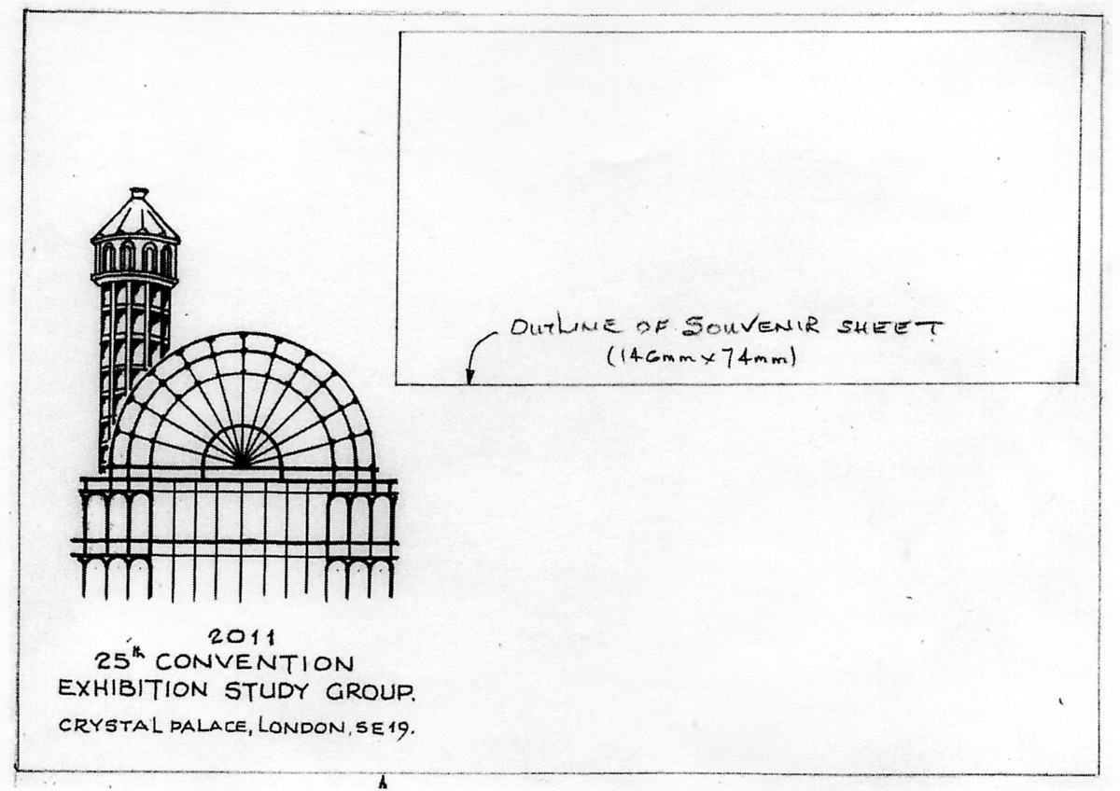

There is another centenary to be observed in 2011 and that is the first United Kingdom internal airmail flight in Britain the Hendon to Windsor Flight. It may not be generally known that originally Crystal Palace was to be used for the Coronation flight, and in May it was planned to send mail by aeroplane from the Festival of Empire to places within Britain to be agreed. Unfortunately in June legislation was brought in restricting flying over populated areas. This Bill caused the arrangements using Crystal Palace to be abandoned. Later the bill was got round by using a route from Hendon to Windsor. This information which I was not aware of, has been supplied by Derek Connell. The souvenir sheet commemorates the first United Kingdom Airmail flight to Windsor.
Kenneth Tonkin is seeing to the printing of the Commemorative covers, and it has been suggested that the covers to be given out at our convention dinner be printed in a different colour and we print 25 for the dinner and 100 for sale. The cost of the souvenir sheet is the limiting factor.
The duplex post mark is a round double ring similar to the Coronation Exhibition handstamp with the addition of a flag like the 1911 flag cancel of the Festival of Empire.

Locomotives on show at the Great Exhibition of 1851.
by
Fred Peskett

Perhaps the most famous of all the locomotives that were on show at the Great Exhibition of 1851 was the “Buddicom” displayed by the French Railways, this locomotive was again on show in Great Britain during the 1951 Festival of Britain at the South Bank Exhibition in a prominent place in the Transport Pavilion, It was once again seen at the Victoria & Albert Museum during 1976/7 for the 25th Anniversary of the Festival of Britain, “A Tonic to the Nation”
If you browse through one of the 1851 catalogues you will see that there were several other full size locomotives on display in Class 5 “Machines for Direct Use.” “Carriages, Railways and Marine Mechanisms”

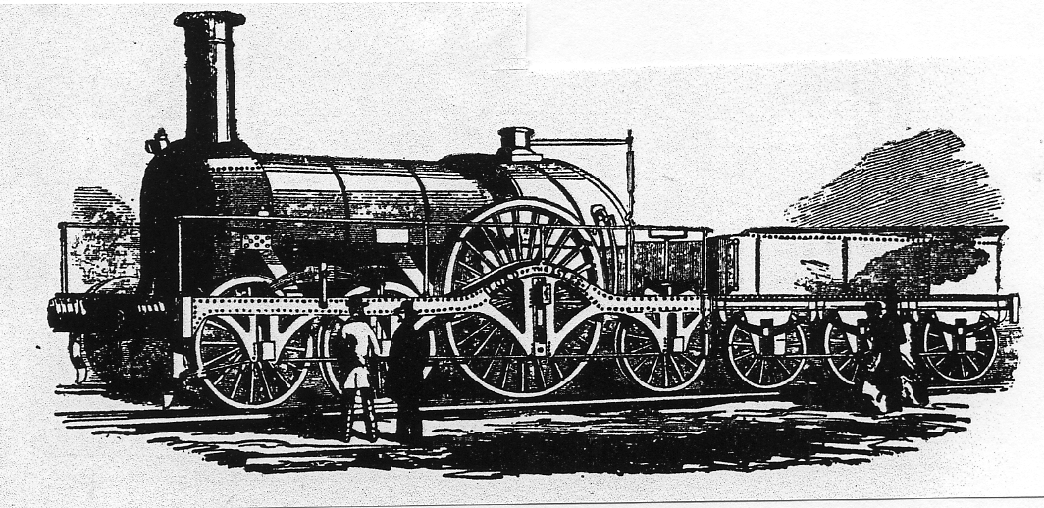

Figure 1. The Great Western Lord of the Isles.

The Great Western Railway exhibited “The Lord of the Isles” designed by Gooch in 1847. The driving wheels of this locomotive were some 8 feet in diameter and ran on the Great Western Broad Gauge track favoured by Isambard Kingdom Brunel. This locomotive had the effective pulling power of 743 horses, and could haul a passenger train of some 120 tons at a speed of 60 miles per hour This locomotive was also exhibited at the Edinburgh Exhibition in 1890, The Chicago Exhibition in 1893 and at Earls Court in 1897. The size of the Locomotive is somewhat exaggerated in this contemporary engraving.

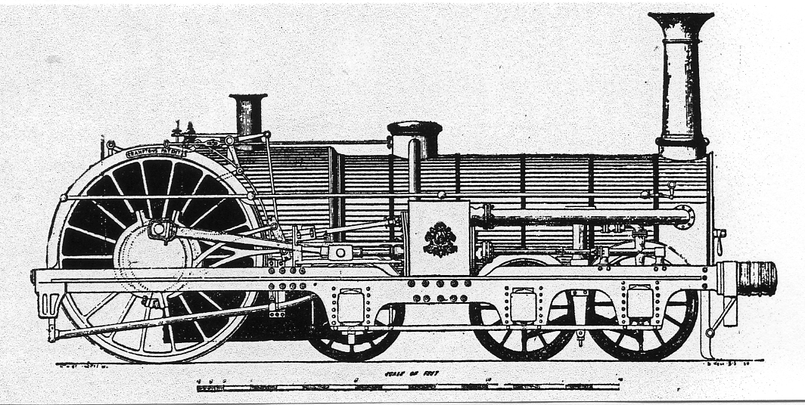

Figure 2. The London, North Western Railway locomotive, “Liverpool”.

Exhibited close to the Lord of the Isles was the London and North Western locomotive “Liverpool” designed by Crampton, it also had a huge 8 feet diameter driving wheels at the rear, but operated on the “standard” gauge track of 4 feet 8 inches It was more powerful than the Lord of the Isles at 1,140 horse power.

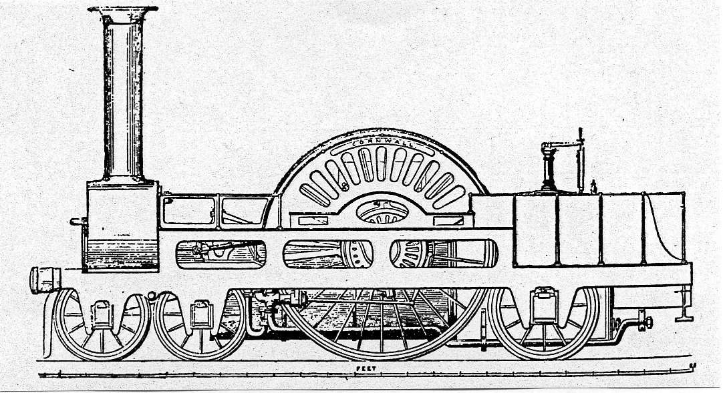

Figure 3. The London North Western Railway’s Locomotive “Cornwall”.

Another locomotive shown by the London & North Western Railway was “Cornwall” designed by Richard Trevithick and built at Crewe in 1847, the driving wheels were a massive 8 feet six inches in diameter.

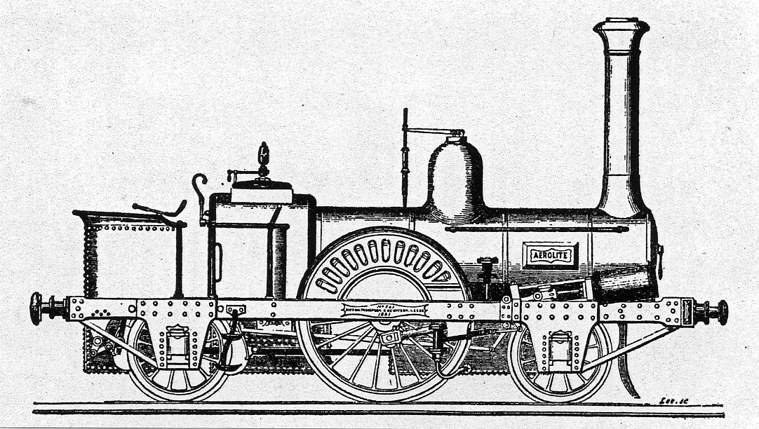

Figure 4. Kitson’s “Aerolite” locomotive as shown at the Great Exhibition

The engineering firm of Kitson, Thomson and Hewitson exhibited their locomotive the “Aerolite” The driving wheels were six feet in diameter with the others at 3 feet 8 inches in diameter. This small “tank” engine could carry a half a ton of coke and 500 gallons of water to give a run of 50 miles. It was used to haul light express services for short distances. This loco was rebuilt several times after the exhibition before it finally went into service.

A most unusual “Tank” locomotive was displayed by E.B. Wilson & Company which had two boilers and two fire-boxes side by side, it was not made clear if there was any advantage in having this configuration.

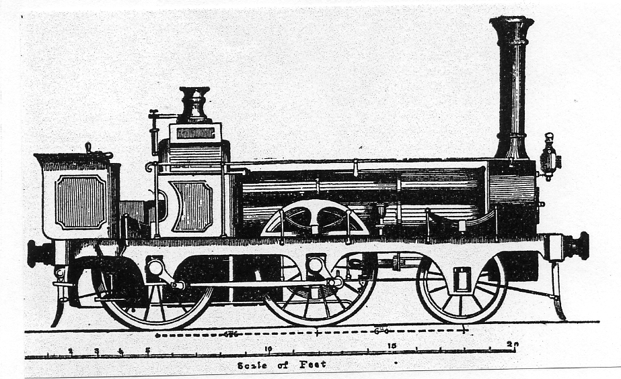

Figure 5. Wilson’s two “Side by Side” boilers and firebox configuration locomotive.

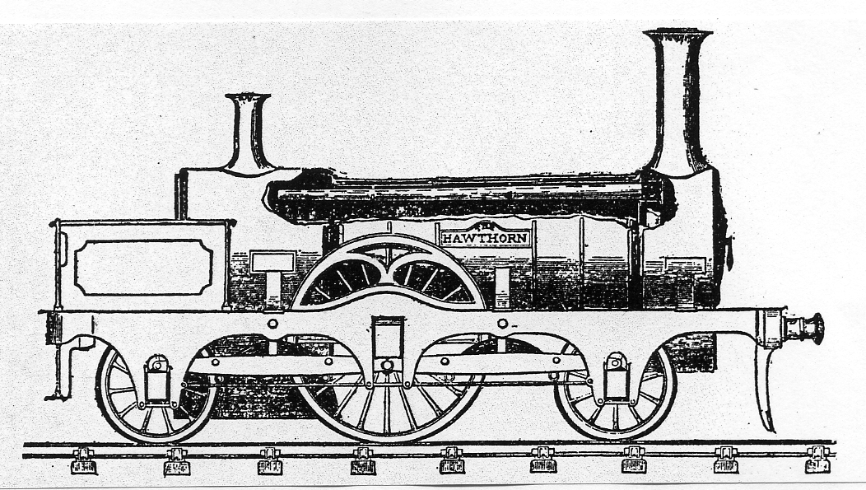

Figure 6. R & W Hawthorn’s locomotive “The Hawthorn”.

Nearby was the “Hawthorn” built by R & W Hawthorn. It was unique in having the cylinders internal inside the chassis.

A strange looking locomotive on display was “Ariel’s Girdle”, a 2-2-0 tank loco with small front bogie wheels and large rear driving wheels. It was constructed for the Eastern Counties Railways by Kitson’s of Leeds and was exhibited with a carriage made by Brown & Marshall of Birmingham.

The French also exhibited another locomotive at the Great Exhibition “The Lahore” a six coupled wheel tank engine by Cail & Company of Paris. The engraving in the catalogue may be somewhat ambiguous as to the size of the locomotive relative to the visitors!

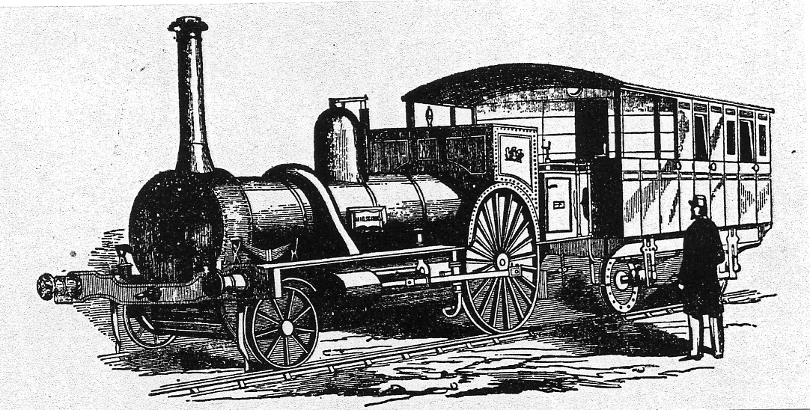

Figure 7. “Ariel’s Girdle” designed and built by Kiton of Leeds.

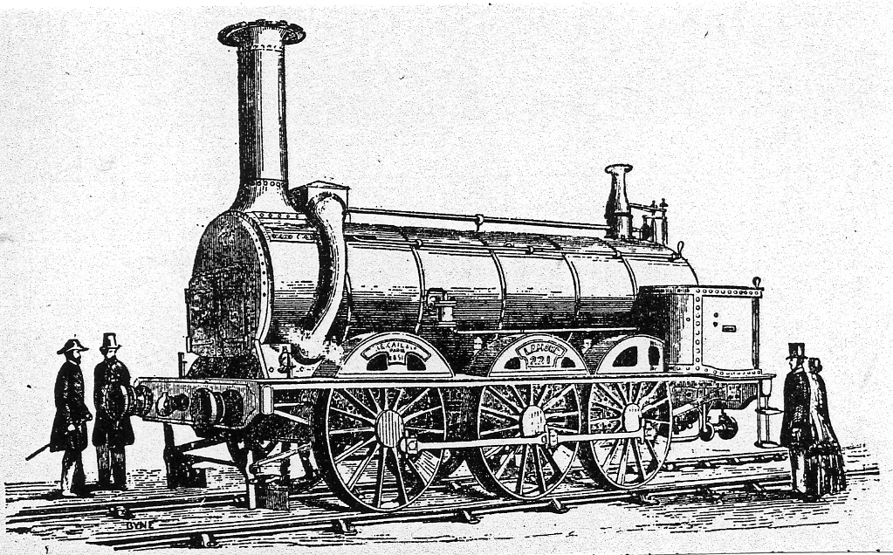

Figure 8. The “Lahore” The six coupled French locomotive.

Model of the Malay Pavilion Wembley 1924
by
Alan Sabey

Back in May 2010 a picture of a model was published in the Lincolnshire Family History Society Journal and Alan Sabey who gets the Journal identified it as a replica of the Malay Pavilion at the 1924 British Empire Exhibition. This led to some correspondence between Barry the owner of the model and Alan, this is an extract from their E-mails.

Dear Alan,
Joyce Walmsley, the Editor of Lincolnshire Family History Society Journal forwarded a copy of your e-mail to me, providing the identity of the building my Grandfathers model was based on. It has answered a question that for many years eluded me. I have even contacted the Malaysian National Museum trying to get an answer to no avail. As you can see I have attached three pictures of my Grandfathers model that I hope show you the model in greater detail than was possible in the Journal in case they are of interest to you.
Members of my family have always wondered what the building was the model depicted. Also as my Grandfather never left the U.K. after returning from the first world war it did not seem possible that he could have ever seen the building itself, but as my Grandfather was a Londoner then a trip to Wembley was only a ride on the Underground or bus. I know he visited places like Abbey's as well as the Music Halls as he wrote a number of Poems about them. Whilst many Londoners were relatively poor it never seemed to stop them going out visiting places of interest as well as entertainment. Mind you entrance to the music hall could be had for 6p. Not bad for a nights entertainment.
The mystery is no more thanks to you. I wrote the article for the journal to show off the talents of my Grandfather of whom I am I think justifiably proud. I never expected to find the true identity of the building the family called the Taj Mahal for want of anything better. Incidentally whilst the model I have is in a wooden case around 8 ½ inches long a cousin has another version that is around twice the size.
Barry

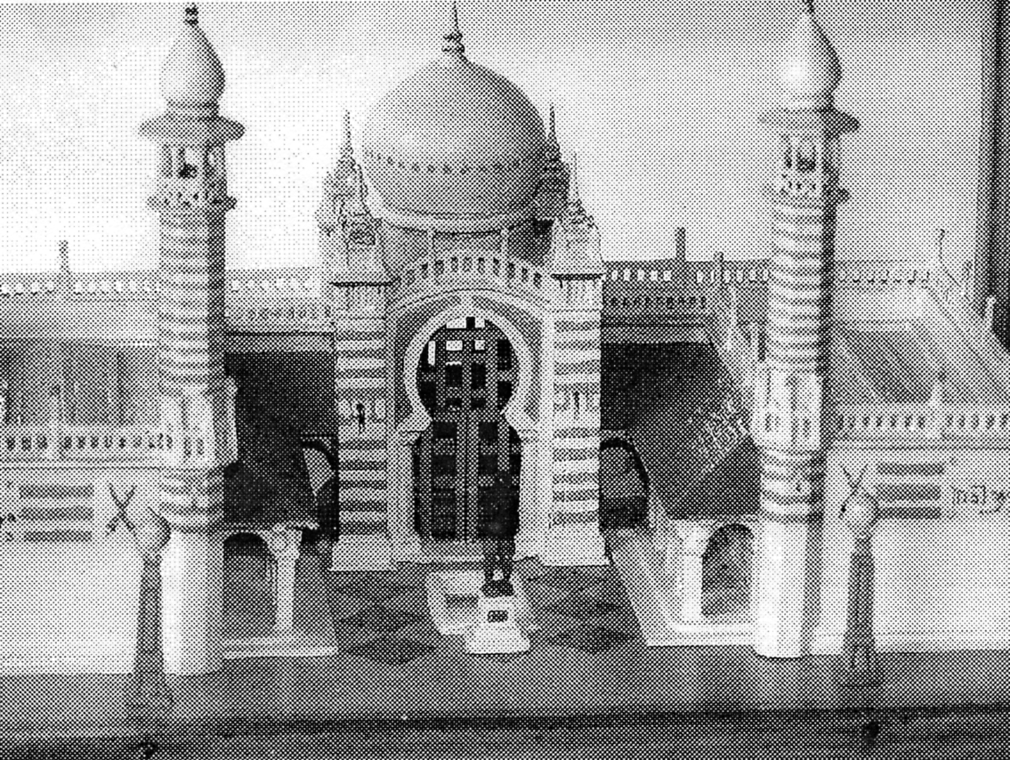

Model of the Malay Pavilion Wembley 1924

Railway Toys at Earl’s Court
From an article by Alfred Wynne that appeared in the 1901 Volume of
‘The Railway Magazine’
submitted by Terry Walden

“In those days there were giants.” The phrase is a familiar one in the mouths of persons who sigh for “the good old days.” But the twentieth century has gone one better, if the phrase be allowed, than those same good old times; and though we cannot boast of giants, we may proudly point to a dragon. Visitors to the Military Exhibition at Earl's Court in 1901 will be familiar with the aspect of this new and strange addition to their fauna of London. As it wriggles, grim and glaring, along its sinuous path round, the Queen's Court, a row of passengers perched upon either of its scaly flanks, the curious onlooker is irresistibly reminded of the—
young lady of Niger,
Who went out for a ride on a tiger;
But returned from that ride
Seated snugly inside,
“While a smile decked the face of the tiger.
But in this case the smile is on the face of the passenger, whose safe arrival at the end of his trip, still on the outside of his uncouth beast of burden, perhaps accounts for the fierce look of discontent and malice which, sits so grimly on the latters visage.
Our dragon, be it noted, is of Chinese nationality, and fully justifies the vivid imagination with which native artists have for ages past portrayed the members of his tribe. If we are to believe the veracious narrative of the captive's eloquent custodian at Earl's Court, the poor creature has fallen from very high estate; having in salad days been a familiar pet of the Dowager Empress of China, at the foot of whose bed he used nightly to sleep the sleep of the faithful; from which it is easy to realise the difficulties which confronted the Allies in the late operations at Pekin. Furthermore, it throws some interesting light upon the domestic habits of the Imperial Chinese family. Our dragon being 90 ft. long, it is obvious that Her Imperial Majesty does not stint herself in the extent of her private apartments.

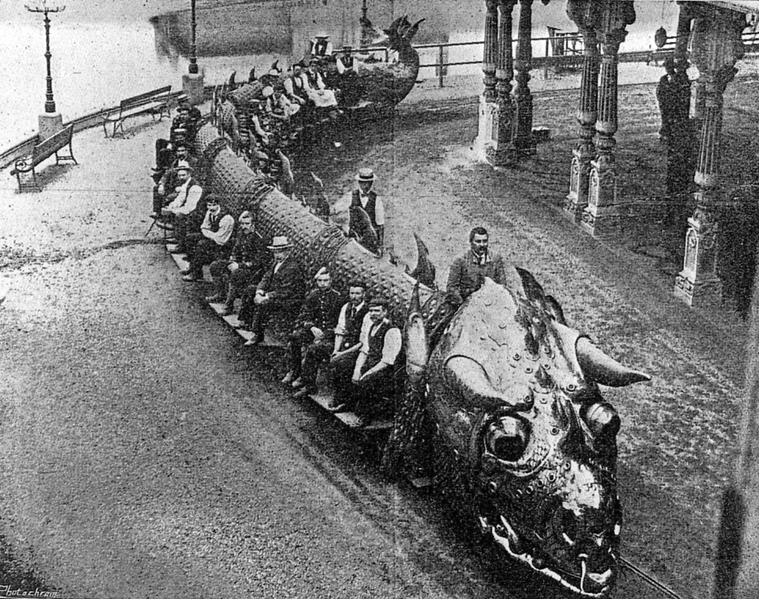

The Chinese Dragon, which was so popular, as a beast of Burden, at the Military Exhibition
at Earl’s Court in 1901. photo by A. E. Johnson.

Naturalists will be interested to hear that this same “keeper” of the Royal dragon, in reply to a query as to whether his charge was oviparous or viviparous, stated that “ he wasn't quite sure which but, anyway, he was waterproof!
Paradoxically, this Chinese Dragon was “ born” in the Jardin d’AccIimatation of Paris. To be precise, it owes its origin to Mr. Walter Stenning. In one-respect it is certainly unlike any others. of its family—it is a patent dragon! Mr. Stenning has wisely protected his invention, both at home and abroad. A vivisection of the fantastic beast reveal the fact that its interior consists of an electrically-propelled train carried on bogies, of which, the segments, or joints, of the dragon's long body form the carriages. Within these same segments, which externally carry the passengers' seats, are placed the accumulators that furnish the current for the dynamo providing the locomotive power.
The dragon, of course, travels over a tram line, but the wheels and every other part of its mechanism are most ingeniously concealed beneath the glittering carapace. This latter is in itself a work of art, consisting of painted canvas covered from snout to tail with countless scales of beaten copper, nickel, and brass. It was made by M. Tachaux, the celebrated Parisian armurier, and has been pronounced by experts one of the finest pieces of its kind in existence. The mechanism is controlled and the whole contrivance animated by an engineer concealed from view within the hideous head, which thus is furnished with brains, for all its ugliness. In completing the circuit of the Queen's Court at the Exhibition, the track is perforce a sinuous one; and the snake-like ease with which the dragon threads his way in and out and round about, his nostrils snorting and his eyeballs gleaming, is realistic to the point of uncanniness.
And so successful has this novel toy proved, that the “Chinese Dragons” are to be turned into a limited liability company. Let us hope the tramway companies will not be drawn by an alluring prospectus into an alteration of their existing systems. Motor-cars are bad enough; but a Chinese Dragon in the streets of London would be the last straw to break the poor bus-horse’s back.

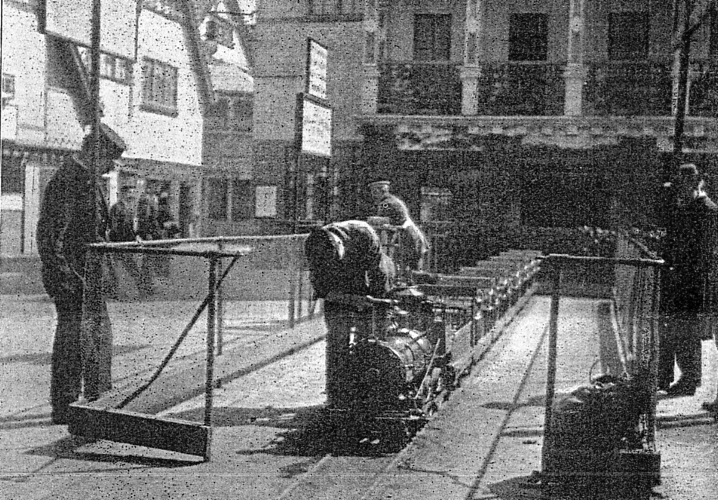

The Toy Train and Railway at Earl’s Court 1901. photo by A. E. Johnson.

Another novelty at Earl's Court in 1901 was the miniature railway. Visitors to the exhibition will have seen it for themselves, and to those who have not our pictures will convey the best idea of its outward semblance. It is not surprising to learn that these toys—though they are really more than that—come from America, where they have attained great popularity. The manufacturers are Messrs. Cagney Bros., of New York, who turn out two classes of “ miniature railway.” That at Earl's Court is a specimen of the smaller, Class C, 12 in. gauge. It should be noted that, despite our use of the word “toy,” the locomotives are the genuine thing; and it is a known fact that a -12 in. gauge locomotive is just as hard to build as a standard, the only difficulty being the cost of the material. A detailed description will, perhaps, interest those of our readers possessed, of intimate “ railway knowledge.”
Coal is the fuel used on the miniature railways, and the drawing capacity of the locomotive is 5,0001bs. in Class C (to which the Earl's Court engine belongs), and 10,0001bs. in Class D, an example of which, may be seen at the Glasgow Exhibition. The track may be either straight or circular, and may extend from 1,000ft. to 100 miles. The average speed is about 10 miles an hour, from which it will be seen that on country estates a miniature railway may be used for many purposes besides that of amusement.
LOCOMOTIVE.

This is of the standard eight-wheeled American type, with a leading truck and four-coupled drivers. Its length is 5 ft. 4 in., width 18 in., and height 28 in. from the rails to the top of the smoke-stack. The driving-wheels are 10in. and the truck wheels 5 in. in diameter. The 2 in. diameter cylinders have a stroke of 4 in., and the weight of the engine is 6001bs. The boiler is steel, and tested to 4001bs. to the square inch. Its diameter is 10 in., and is wagon-top shape, equipped with Korting injector; and it holds 10 gallons of water. The fittings of the locomotive are all complete, and include sand-box, bell, whistle, and head-light.
TENDER.

This is of two-truck type, 3 ft 5 in. long, 18 in. wide, and made of iron. The wheels are 5 in. in diameter, and its capacity is 15 gallons of water. The tender is utilised by the engineer as a seat from which to operate the throttle, reverse the lever, etc. The total length of locomotive and tender is 8 ft. 9 in.

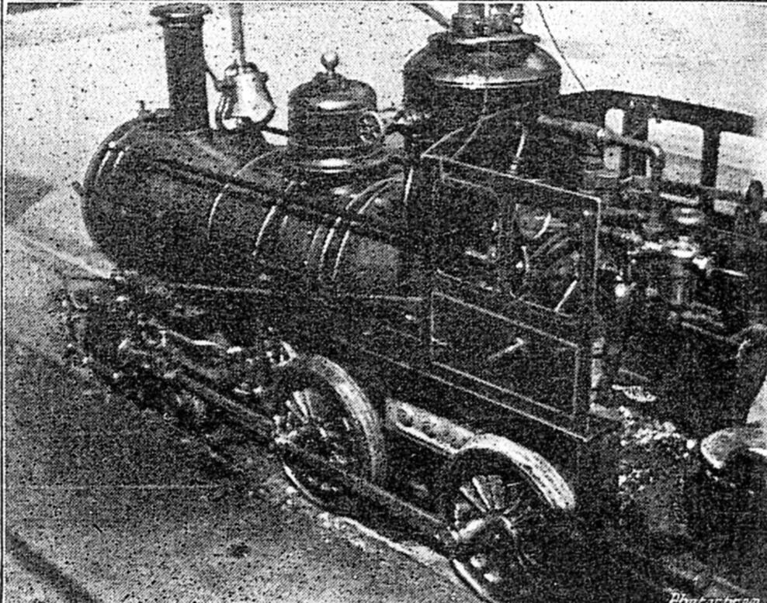

The Locomotive of the Earl’s Court Toy Railway. photo by A. E. Johnson.

CARS.

The nature of these is best seen from our illustrations. Each is capable of seating two passengers, and is fitted with the necessary springs to ensure comfort. The complete train includes ten cars, capable of carrying a score of passengers. The gauge of the track is 12 5/8 in., and the permanent way used is the regular 81bs. to the yard L rail. The net weight of the complete outfit is l1,5001bs.
At Callao, in Peru, a Class D 15 in.-gauge train was established some time ago for regular passenger traffic between a local park, and the city. The line was capitalised for £5,800, and pays a dividend of 25 per cent. And at the Elk's Fair, Louisville, two years ago, a similar attraction took over £300 in nine days, the working expenses for that period being £6 15s.
At Earl's Court the track is, of necessity, a limited one; but it amply demonstrates the astonishing- capabilities of the little locomotive, trundling its train of absurdly gigantic passengers. Its popularity is undeniable, and “railwayacs” in particular, will find it a source of much pleasure and instruction.

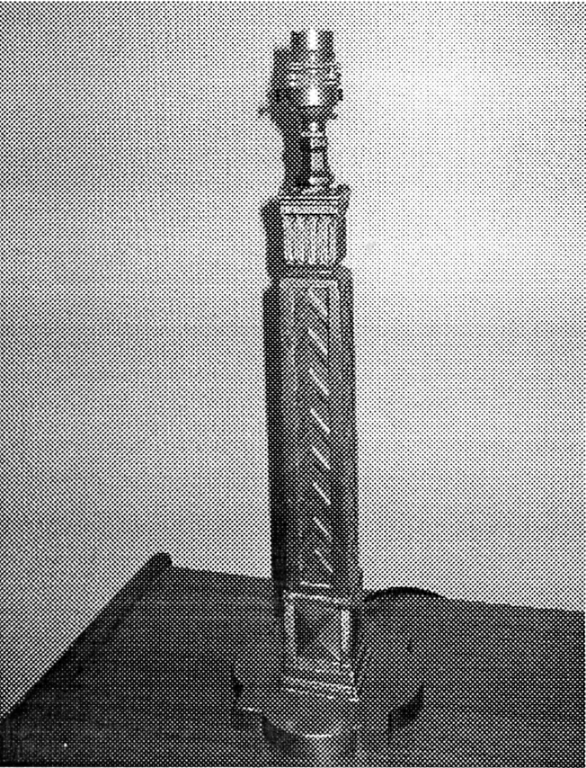
Wembley Table Lamp
by
Alan Sabey

The lamps around the Exhibition site at Wembley were made by G.E.C., a local firm in East Lane.
They also made souvenir lamps 17 " tall and they had a replica of the Globes containing the light bulb that were on the originals. Examples of the original lamps from the site can be seen outside a building at Cannon Hill, Southgate, London N14. Some years I wrote an article for the Group's Journal about where items could still be found.
Mine came up on E-bay but without the original lamp holder which no doubt had got broken. I collected it from the sellers who told me they had only seen three of these souvenir lamps in twenty years and only one of those three still had the original Globe.

Wembley Table Lamp

New Wembley Maps
by
Mike Gorringe

Mike has sent me details of two maps he has just acquired, or to be correct he has sent me the maps on loan. I found these are already listed, also something I have never seen before, it is page 7 of “The News” for Friday September 21 1973. In it they announce the next issue will commemorate the Golden Jubilee of the Newspaper which will contain a supplement article about the 1924 British Empire Exhibition. As a foretaste they have printed on page 7 the back of one of the 1924 maps. The sheet of newspaper which measures 16½ x 24½ has a slightly reduced copy of the map No. 36, containing on panels K, L, M & N a picture of the Imperial Stadium and text on the British Empire Exhibition. The headings of the paragraphs are, Variety and Colour, The Tomb of Tut, Monster Military Tattoos, and An Empire Parliament. Panels T & U is split in half horizontally with the bottom half containing text titled The “Metro” Route to the Exhibition as in the original map, while the top half has an announcement inserted about their Golden Jubilee issue in place of the Metro route map.

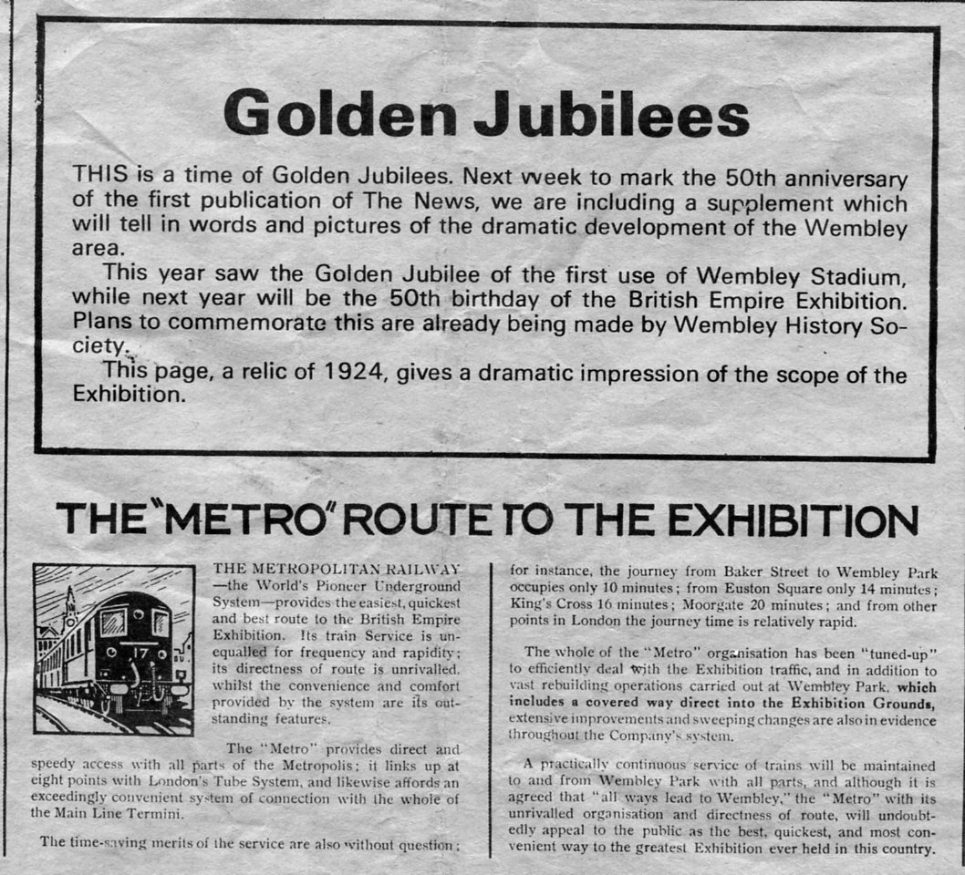

Panels T and U of the Map No. 36 reprinted in ‘The News’.

Ken Harman is a keen historical researcher of the Croydon area, and while delving into the life of Edward Morton came across the grave of a man who played a major part in the organising and running of the British Empire Exhibition, and thought members might like to know some details of the life of Baron Stevenson G.C.M.G.

Baron Stevenson and the 1924/1925 Wembley Exhibitions.
By
Ken Harman

On a recent visit to Ewhurst in Surrey I was looking in the churchyard for the grave of Edward Morton who had previously lived at Sanderstead Court, South Croydon but moved to the Ewhurst area in the mid-1920s. He had been co-owner with a brother of a large food-processing firm on the Isle of Dogs, London. Having succeeded in my task, I noticed a prominent grave for a Baron Stevenson (James Stevenson). Although I did not know then who he was, I have found that he had been a major figure in the planning and control of the 1924 and 1925 British Empire Exhibitions.
James Stevenson was born in 1873 in Kilmarnock, the son of a warehouse manager at the John Walker whisky distilling firm, better known for Johnnie Walker whisky. He started work with another firm in Glasgow but later joined Walker's as a commercial traveller. It was expanding at that time and he soon rose to be a manager and then a director. He had remarkable powers of concentration, immense enthusiasm together with the ability to inspire others.
However, World War 1 upset plans everywhere and Stevenson was recruited by Lloyd George to assist the government with organising war production. He held many appointments in the Ministry of Munitions where his skills were much appreciated and he certainly made a valuable contribution to the provision of war supplies. After the war ended, Walker's expected him to return but this did not happen immediately as he continued with further public service. He was created a baronet in 1917 which was also the year his wife died.
In 1924 he was appointed Chairman of the Board of the Standing Committee of the British Empire Exhibition, Wembley. Unfortunately the work on this enormous undertaking was severely delayed by bad weather and also by a strike so that construction became an even more difficult task. It was largely due to Stevenson's efforts that it was possible to carry out the opening on time. Just before this took place on 23rd April 1924, King George V conferred honours on him by creating him Baron Stevenson of Holmbury. Stevenson's forceful personality ensured that the exhibition would run for a second year and after it closed in 1925 it was primarily due to him that the large stadium was preserved - to become "the home of English football".
His connection with the Ewhurst area dates from the early 1920s when he moved to Holmbury House which was a large Victorian property on a hillside above Holmbury St. Mary on an estate of some 30 acres.
On the commercial side, in 1925 there was an amalgamation of whisky distilling firms and Stevenson managed to secure generous financial provision for himself and the Walker family. Although he joined the newly-created enlarged firm (The Distillers Company) illness soon intruded and he died at Holmbury House on 10th June 1926. A memorial service was held on 14th June 1926 at St. Margaret's, Westminster attended by many people of repute.
His second wife moved from Holmbury House afterwards, living until 1935. It remains today as the Mullard Space Science Laboratory, part of University College London. An inscription on Baron Stevenson's tomb in the southern extension of the churchyard at Ewhurst reads:

IN EVER LOVING REMEMBRANCE
JAMES STEVENSON G.C.M.G.
1st BARON STEVENSON OF HOLMBURY
1st BARONET
BORN APRIL 2nd 1873. DIED JUNE 10th 1926.
AND HIS WIFE STELLA. LADY STEVENSON.
BORN APRIL 9th 1875. DIED JULY 7th 1935.
LOVE IS THE FULFILLING OF THE LAW

A memorial west window can be seen inside the church. A fine tribute to Baron Stevenson was issued by Winston Churchill: (He had) exhausted in the service of the State the vital forces which by an easier and less disinterested career might have been carried to a long old age. He leaves behind an example of public spirit, of rectitude, and of flexible originative capacity, which those who aspire to be leaders of British industry may well emulate.
Would that this could be said of some public people these days!

Some new items

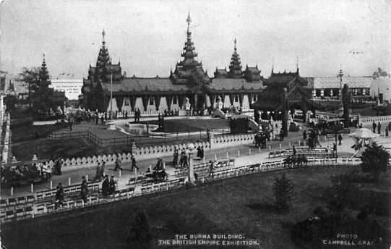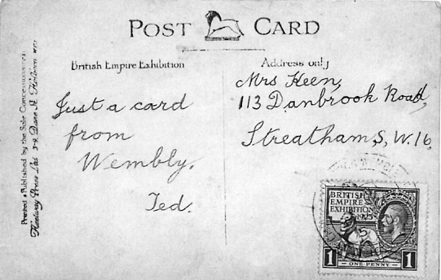

Fleetway Type 24. Sepia R/Photo with coloured tints, reported by Roger Weeks in Journal 99.
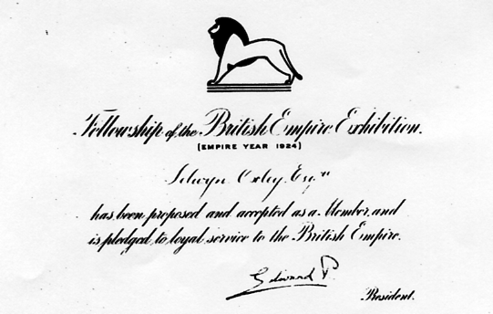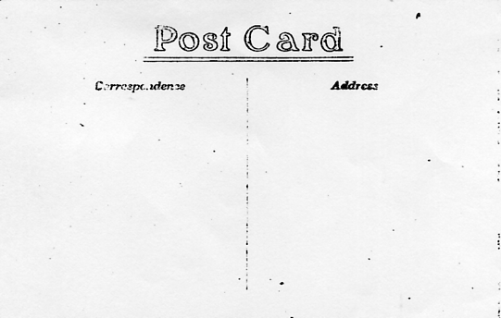

It would appear that membership of the Fellowship of the British Empire Exhibition was acknowledged by post on a post card.

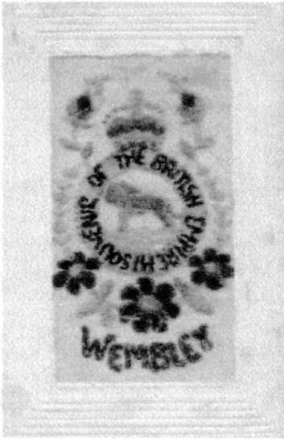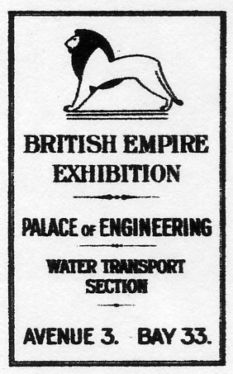

A silk British Empire Exhibition card recently sold on E-bay for £77.11. Also a new Wembley label in Red used on a sheet of the headed note paper by Frost Brothers Ltd., Rope Manufacturers & Yarn Spinners of 342, Commercial Rd, London. E1. Three items reported by Alan Sabey.

We don’t normally publish articles about the Festival of Britain, as they have their own ‘Festival Times’ but this article has a foot in both camps, so here it is,

Fireworks at the Crystal Palace?
by
Fred Peskett

No, not really, these photographs are from a series found at the Midhurst Antiques Fair and show the fireworks being displayed against the backdrop of the Crystal Palace Screen at the Festival Pleasure Gardens Battersea Park in Festival Year, 1951.
There were two areas in the Gardens that were Crystal Palace Look-alikes, the screen in the photographs and the Vauxhall Beer Garden.
Note the great expense given to such detail as the litter bin in the vertical photograph, in reality, a battered old oil drum.
The fireworks were displayed each night except Sundays and were provided by Joseph Wells of Dartford, Kent, James Pain & Sons Ltd of Mitcham, Surrey, Wilders Fireworks of Birmingham or Standard Fireworks Ltd from Huddersfield. Only Pain is still in the pyrotechnic business, under the name Pains, Wessex.

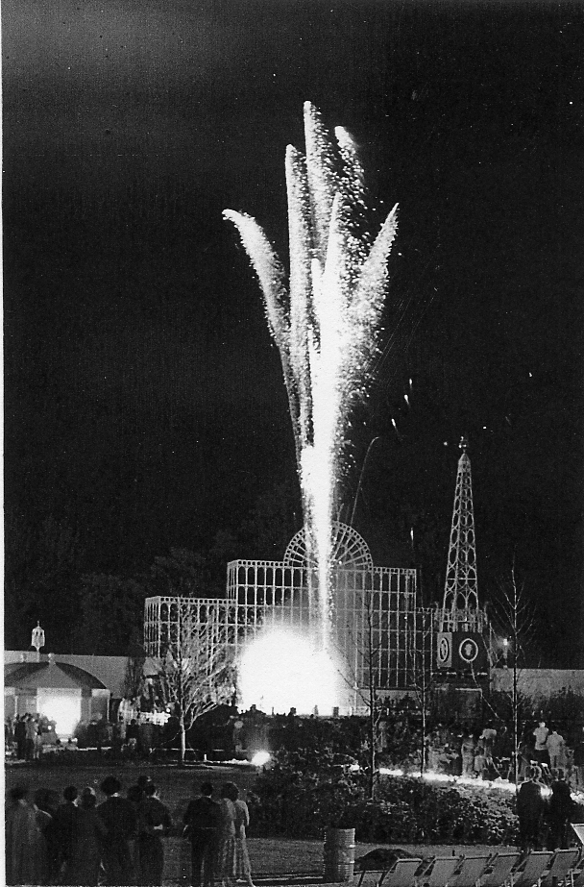

A photograph of fireworks at the Festival of Britain

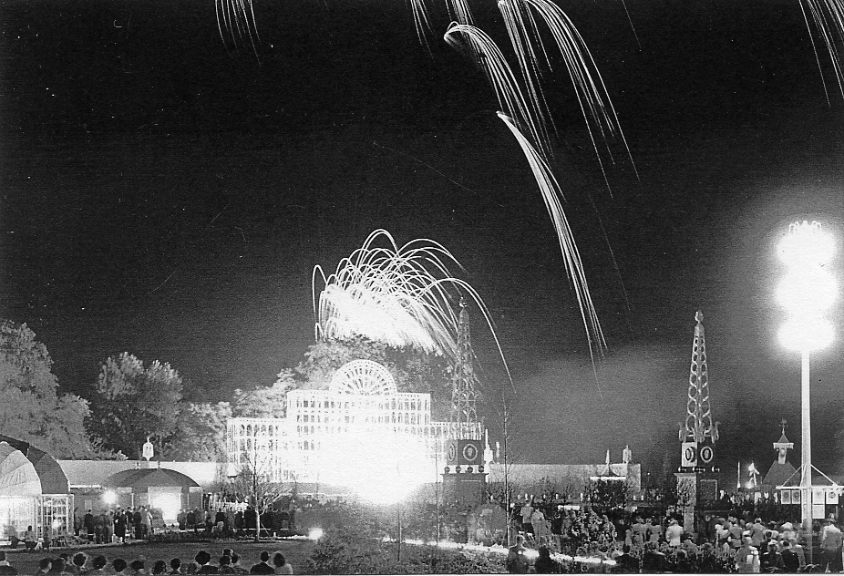

A photograph of fireworks at the Festival of Britain

