EDITORIAL SPRING 2011

Oh! Jump for Joy, Hip Hip Hooray,
Here’s our 100th Journal, for you today.

Yes this is our 100th Journal. The first 23 Newsletters as they were called then, were produced by Andrew Brooks, joined by a sponsor Karl Illingworth doing the printing and distribution. I took on the job of Editor at No. 24 in the spring of 1992 with Karl still doing and paying for the distribution until he dropped out and my son Kenneth took over from No. 52 in 1999. In 2005 Fred Peskett joined the team as Joint Editor.
The Study Group has been very fortunate to have members willing to sponsor our Journal since No. 1 in 1980. We should never forget that our present very healthy financial state, is due to our sponsors generosity.
I believe I have mentioned in the past the visits (11 in total) by a young American student Kirsten Ziomek to delve into my Japan-British Exhibition post cards and ephemera. Unfortunately her six month permit ran out just before our convention and she had to return to America. Her researches since returning home has taken her to Hokkaido one of the Northern islands of Japan where the Ainu were driven to from mainland Japan way back in the 1800’s. While there she was able to get the name of the young 10 year old Ainu lad that came over with his family to appear at the Japan-British Exhibition in 1910. This lad is featured on one of my Valentine post cards
Even more remarkable she was able to meet and talk to his daughter, a lady who now must be in her 80’s. So that is two Ainu and Formosan natives photographed at the 1910 exhibition whose descendants have been traced and interviewed.
I am busy twisting Kirsten’s arm for an article on her last journey to Japan to meet the Ainu. Kirsten had already spent two years in Japan teaching English while studying for her Masters, and is now going for her Doctorate.
Kirsten told me they have strict rules in Japan about interviews with the Ainu people which are strictly censored. I said as soon as you get clearance perhaps you could do a short (or even long) article on the Ainu for me to publish in the Exhibition Study Group Journal. But not if it would jeopardise the thesis for your doctorate.
The following is an extract from the last E-mail I had from Kirsten.
Thank you for your note. Sorry for the delay. The name of the ten year old boy is Jensuke Kaizawa. I was very excited to met the elderly daughter. I will have to check my notes again to see if she mentioned her age or not.
The strict rules regarding Ainu interviews is implemented by the Ainu themselves, who see it as a way to protect them for being exploited or cheated. There is a famous case of an Ainu woman who sued a book publisher for printing her photo as young girl, without her permission. One day she opened the book and found a photo of herself. So now these extra tight restrictions are meant to stop outsiders (like me) from exploiting the Ainu.
However, one could argue that the Ainu who are implementing the rules (and numerous paperwork) are the ones who are getting to control the representation of Ainu. Some of the people I met during my trip who are controlling what can get published or not, are also are the ones involved with an archive in London that has a connection to Ainu related material and are issuing the same type of control over that archive as well.
I do hope to contribute to your newsletter, if I get clearance, and most likely after I graduate (hopefully this coming June). The Ainu first want me to translate the interview notes into Japanese and English and they will check with her whether or not each bit of information can be published or not.
Hope its not too cold in London. I am hoping I will have a long stretch of productivity but I still have some more post doc jobs to apply for. It will be nose to the grindstone for a long while!
Take care, Sincerely Kirsten.
The Editors
Mr Molony’s Account of the Crystal Palace.
Typed out by Fred Peskett.

Some time ago I wrote up a poem I found in a 1950’s book about a visit to the Great Exhibition by a Country Gentleman. It was fairly obvious that the poem was only a few of the verses that was probably published, I recently found the complete poem in a copy of PUNCH magazine, so here it is.

With ganial foire
Transfuse me loyre
Ye sacred nymphs of Pindus,
The whoile I sing
That wondthrous thing.
The Palace made O’ windows!

Say, Paxton, truth.
Thou woundthrous youth.
What sthroke of art celestial.
What power was lint
You to invint
This combineetion cristial,

O would before
That Thomas Moore,
Likewise the late Lord Boyron,
Thim aigles sthrong
Of godlike song
Cast oi, on that cast oiron!

And saw thim walls.
And glittering halls,
Thim rising slendther columns.
Which I poor Pote,
Could not denote.
No, not in twinty vollums.

My Muse’s words.
Is like the birds
That roasts beneath the panes there,
Her wings she spoils
‘Gainst them bright tiles,
And cracks her silly brains there.

This Palace tall.
This Cristial Hall,
Which Imperors might covet,
Stands in High Park
Like Noah’s Ark,
A rainbow bint above it.

The towers and fanes.
In other scaynes.
The fame of this will undo,
St Paul’s big doom,
St Payther’s Room,
And Dublin’s proud Rottundo.

Here come likewise
Her bould allies
Both Asian and European;
Prom East and West
They send ‘their best
To fill her Coornucopean.

I seen (thank Grace!)
This woundthrous place
(His Noble Honour Misther
H. Cole it was
That gave the pass.
And let me see what is there).

With conscious proide
I stud insoide
And looked the World’s Great Fair in
Until me sight
Was dazzled quite,
And couldn’t see for starin.

There’s holy saints
And window paints.
By Maydiayval Pugin;
Alhamborough Jones
Did paint the tones
Of yellow and gambouge in.

There’s fountains there
And crosses fair;
There’s water-gods with urns;
There’s organs three.
To play d’ye see,
“God save the Queen,” by turrns.

There’s Statues bright
Of marble white
Of Silver, and of copper;
And some in zinc.
And some I think.
That isn’t over proper.

There’s staym Ingynes,
That stands in lines.
Enormous and amazing,
That squeal and snort,
Like Whales in sport.
Or elephants a-grazing.

Tis here that roams.
As well becomes
Her dignitee and stations.
Victoria Great,
And houlds in state
The Congress of the Nations.

Her subjects pours
From distant shores.
Her Injians and Canajians;
And also we.
Her kingdoms three,
Attind with our allagience.

There’s Cabs on Stands
And Shandthry danns;
There’s waggons from New York here;
There’s Lapland Sleighs
Have crossed the seas.
And Jaunting Cyars from Cork here.

Amazed I pass
From glass to glass,
Deloighted I survey ‘em;
Fresh wondthers grows;
Before me nose.
In this sublime Musayum!

Look, here’s a fan
From far Japan,
A sabre from Damasco;
There’s shawls ye get
From far Thibet,
And cotton prints from Glasgow.

There’s German flutes,
Maroocky boots.
And Naples Macaronies:
Bohaymia
Has sent Bohay;
Polonia her polonies.

There’s carts and gigs.
And pins for pigs;
There’s dibblers and there’s harrows
And ploughs like toys
For little boys.
And elegant wheel-barrows.

For them genteels
Who ride on wheels,
There’s plenty to indulge ‘em;
There’s Drosky’s snug
From Paytersburg,
And Vayhycles from Bulgium.

There’s granite flints
That’s quite imminse.
There’s sacks of coals and fuels.
There’s swords and guns.
And soap in tuns.
And Ginger-bread and Jewels.

There’s taypots there
And cannons rare;
There’s coffins filled with roses;
There’s canvaas tints.
Teeth insthrumints,
And shuits of clothes by Moses.

There’s lashins more
Of things in store.
But thim I don’t remimber;
Nor could disclose
Did I compose
From May time to Novimber

Ah, Judy thru!
With eyes so blue,
That you were here to view it!
And could I screw
But tu pound tu,
‘Tis I would thrait you to it!

So let us raise
VICTORIA’S praise
And Albert’s proud condition.
That takes his ayse
As he surveys
This Cristial Exhibition.

It is Mr Punch who is writing the poem, by the reference to Judy in the penultimate verse. All twenty-seven verses of the poem are reproduced. The spelling is as written in 1851. It sounds like Mr

Punch had a bit of a lisp? Many of the meanings have now been lost over the 160 years since it was written, but there is still some sense and some humour left to give the inhabitants of the twenty-first century something to smile about!

The Same but Different!
by
Fred Peskett
Over the years Bill Tonkin has entertained us with his detailed look at the picture postcard publishers and their methods of hoodwinking the public by doctoring views, adding people or changing titles in order to have cards ready for the opening of various exhibitions. It is in this tradition that I have looked in some detail into the Guides for the Crystal Palace by the well known publisher “Photochrom”, This company was also well known for it’s prolific publication of picture postcards, many of the views listed were also published as postcards.

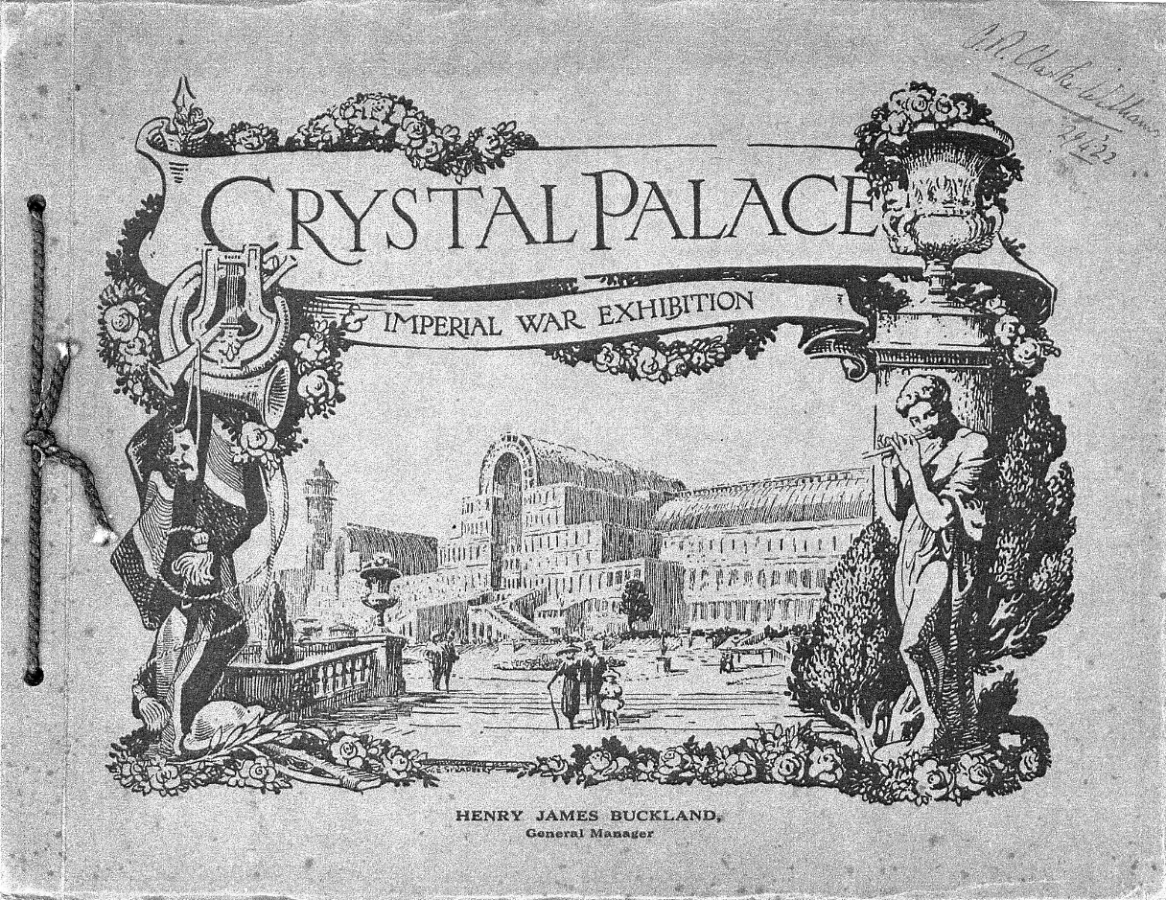

As far as it is known, Photochrom first published the Crystal Palace Guide in 1920 for the Imperial War Exhibition. This guide has card covers, with the contents being bound with blue cord. The colour of the card is brown with dark brown printing. It is unpaginated and contains twelve photographic views of the Crystal Palace and the War Exhibition. The cover illustration is an artist drawn picture featuring, on the right side:- A youth in a draped cloth playing a flute or a penny-whistle, he is leaning against a background of shrubs and a large urn. The centre is a view of the Crystal Palace showing the Central and South Transepts and the South Tower. On the left side are:- from the top, musical instruments, a lyre, a trumpet and a French horn. Below these is a Theatre Mask hanging on a draped Union Jack, below the flag is a soldier’s helmet and rifle. “CRYSTAL PALACE” is in a large banner over the central view with “& IMPERIAL WAR EXHIBITION” in a smaller banner underneath. The photographic views are mounted on dark grey card, (the note in

brackets is a fuller explanation of the subject matter). The size of the guide is 9.625ins wide x 7.5ins high.
Where a postcard is known of the view, it is marked by an *. The other views were not issued as postcards although postcards were issued by Photochrom of similar views of the same topic.

CRYSTAL PALACE, VIEW FROM THE TERRACE.*
CRYSTAL PALACE, VIEW FROM S.W.*
CRYSTAL PALACE, THE NORTH NAVE. .(View showing guns and flags).
CRYSTAL PALACE, VIEW FROM THE CLOCK. (View showing aircraft in foreground with parachutes and flags hanging .from the roof).
CRYSTAL PALACE FROM S.E.*
CRYSTAL PALACE, THE BIG GUN.
AERIAL VIEW OF CRYSTAL PALACE.*
CRYSTAL PALACE, GENERAL VIEW.*
CRYSTAL PALACE, THE FAMOUS GLASS FOUNTAIN. (Parachutes and flags also on show).
CRYSTAL PALACE, MAIN TRANSEPT (With guns and flags on show)
CRYSTAL PALACE, AIRCRAFT SECTION.
CRYSTAL PALACE, TYPES OF AIRCRAFT.

Now it would seem that Photochrom had the contract with the Crystal Palace Trustees for publishing the guide for at least the next ten years and possibly longer.
The 1924 Guide to the Crystal Palace.

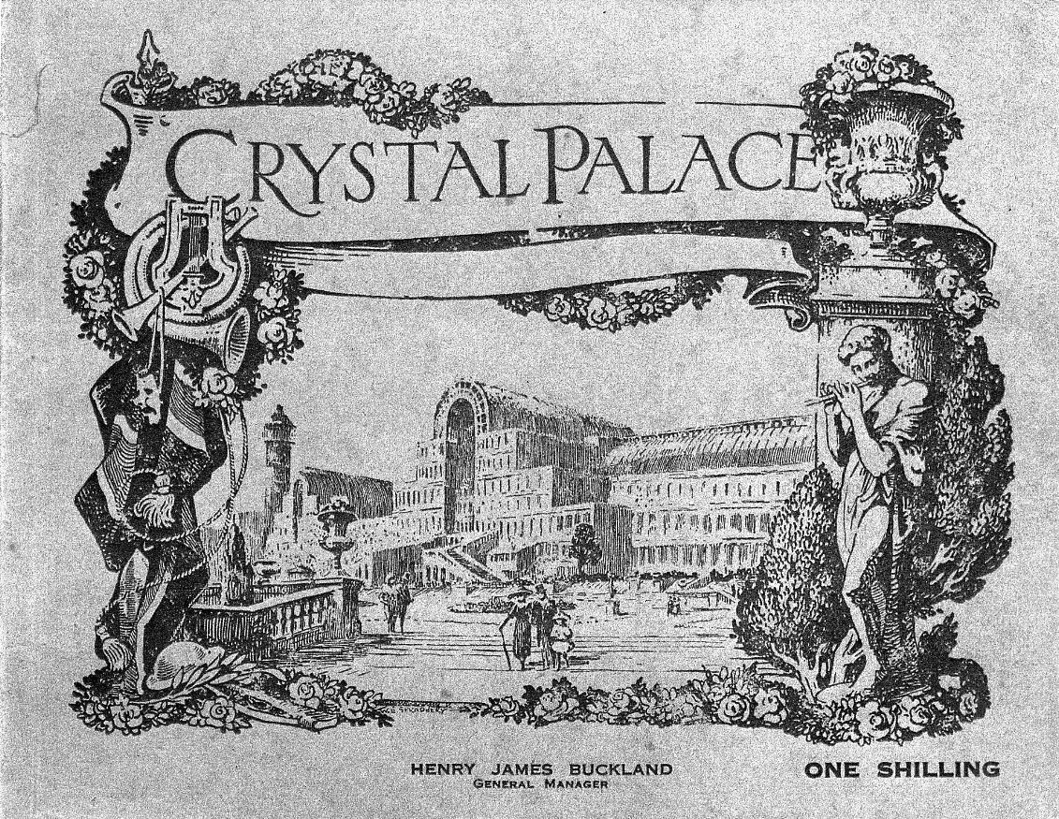

The cover design was similar to that of the 1920 Imperial War Exhibition except that it had 24 printed pages of text and 16 pages of black & white photographs, the cover is glued to the contents. The cover illustration is identical to that of the one published in 1920 except that the smaller banner is

empty, and “ONE SHILLING” is added at the bottom right. The size of the 1924 to 1930 guides is:- 9ins. wide x 7ins. high.
The photographic views are printed on glossy paper and are in the following order, where postcards are known, this is indicated by an *.

Facing Page 4. CRYSTAL PALACE FROM S.W.*
Facing Page 5. CRYSTAL FOUNTAIN & BIG CLOCK 40FT DIAMETER, CENTRE
TRANSEPT SOUTH NAVE.*
Facing Page 8. CRYSTAL PALACE, VIEW FROM TERRACE.*
Back of the above view, THE NORTH NAVE.*
Facing the above view, AERIAL VIEW OF CRYSTAL PALACE.*
Facing Page 9. ENGLISH MEDIAEVAL COURT*/ALHAMBRA COURT
Facing Page 12. CRYSTAL PALACE, GENERAL VIEW.*
Back of the above view, COLUMNS OF THE TEMPLE OF KARNAK, EGYPTIAN COURT.* Facing the above view, CRYSTAL PALACE FROM S.E.*
Facing Page 13. GIANT FIGURES OF RAMESES, THE EGYPTIAN COURT.*
Facing Page 16. CRYSTAL PALACE, BOATING LAKE.*
Back of above view, COURT OF LIONS IN THE TRIBUNAL OF JUSTICE. THE
ALHAMBRA COURT.*
Facing the above view, CRYSTAL PALACE FROM THE PARADE.*
Facing Page 17, INTERIOR OF THE RENAISSANCE COURT IN THE NORTH
NAVE.
Facing Page 20, THE MEGALOSAURUS IN THE ANIMAL PARK.
Facing Page 21, (a composite of four views) “PREHISTORIC ANIMALS. IN THE ANIMAL PARK. POPULAR AMUSEMENTS IN THE GROUNDS.
THE CAPTIVE FLYING MACHINE.

The 1925 Guide to the Crystal Palace.
The 1925 Guide was identical in cover and contents as the 1924 version except the colour of the cover is sepia/grey and with sepia-tone photographs.
The 1930 Guide to the Crystal Palace.
The June 1930 Crystal Palace Guide is where things begin to get interesting! The cover illustration and method of binding is the same as the 1924/5 versions. The colour .of the cover is now blue. Still ONE SHILLING. “1930” is in a scroll on the back cover. There are now 44 printed pages, the text has generally been revised and sections added to list the Sculptures on show at the Crystal Palace. All the views are in sepia-tone on glossy paper, some new photographs have been added, with some glaring mistakes in the previous guide captions is now corrected!
Facing Page 4. CRYSTAL PALACE FROM S.E.* (This is the same view as the previous guides but the title was CRYSTAL PALACE FROM S.W.)
Back of the above view, CRYSTAL FOUNTAIN & BIG CLOCK 40FT DIAMETER, CENTRE
TRANSEPT, SOUTH NAVE.* (This was facing page 5 in previous guides)
Facing the above view, CRYSTAL PALACE, VIEW FROM TERRACE.*
Back of the above view, THE NORTH NAVE.*
Facing Page 12. AERIAL VIEW OF CRYSTAL PALACE.*
Back of above view, ENGLISH MEDIAEVAL COURT*/ALHAMBRA COURT.*
Facing above view. CRYSTAL PALACE, GENERAL VIEW.*
Facing Page 13, COLUMNS OF THE TEMPLE OF KARNAK, EGYPTIAN COURT.* Facing Page 20, A SCENE AT ONE OF THE MUSICAL FESTIVALS.
Centre spread over 2 pages, THESE TWO PANORAMAS PRESENT A CONTINUOUS PICTURE
SHOWING ONE OF THE TWO SPORTS GROUNDS TOGETHER
CAPABLE OF ACCOMMODATING 150,000 SPECTATORS.

On the back of the spread is a composite of four views:- THE COURT OF SCULPTURE.
THE GREEK COURT. THE NATURAL HISTORY COURT.
A CORNER OF THE MOORISH COURT.
Facing Page 28, CRYSTAL PALACE FROM THE N.E.* (This is the same view as the previous guides but the title was CRYSTAL PALACE FROM S.E.)
Back of the above view, GIANT FIGURES OF RAMESES.*
Facing the above view, CRYSTAL PALACE BOATING LAKE.*
Facing Page 29. COURT OF LIONS NEAR THE TRIBUNAL OF JUSTICE ALHAMBRA COURT.*
Facing Page 30. CRYSTAL PALACE FROM PARADE.*
Back of the above view, INTERIOR OF THE RENAISSANCE COURT, IN THE NORTH
NAVE.
Facing the above view, THE MEGALOSAURUS IN THE ANIMAL PARK.
Facing Page 31. (a composite of four views) PREHISTORIC ANIMALS. IN THE ANIMAL PARK,
POPULAR AMUSEMENTS IN THE GROUNDS, THE CAPTIVE FLYING MACHINE.
It would seem that Photochrom had the same problem with their postcards as they had with the pictures in the guides. From 1920 Serial Number 47644 is CRYSTAL PALACE FROM THE S.E, but after 1930 it is Serial Number 47644 CRYSTAL PALACE. The same goes for Serial Number 51410, from 1920 it is captioned CRYSTAL PALACE FROM THE S.W. after 1930 it becomes Serial Number 51410 CRYSTAL PALACE. It .is suspected that that once the error was detected the publisher was not sure of the direction the view was taken, so played it safe by leaving the direction out!

Survey of Falkland Island Court Post Cards.
by
Bill Tonkin

I mentioned in our Winter 2010 Journal that the Falklands Islands Philatelic Society are publishing the article which appeared in our Spring 2009 Journal on the Falkland Islands in their newsletter the Upland Goose, and I have suggested to Bill Featherstone their editor that they may like to join in a joint exercise with the Study Group to try and find out just how many of the British Empire Exhibition Falkland Islands Court post cards have survived.
These cards must be about the scarcest set of B.E.E. cards there are, and as far as I know, no collector has managed to get the complete set of eight cards. What I have suggested is both groups circulate through their newsletters the forming of a list of all the known cards. So if you are lucky enough to have any in your collection, please make a note of the titles and let me have it. Please also add if the card is,
1 mint i.e. unused,
2 postally used in G.B,
3 postally used at the B.E.E.,
4 postally used in the Falkland Islands.
After the 1924 exhibition closed the remaining cards that were not sold were taken back to the Falkland’s and finished up in the Museum in Port Stanley where they were put on sale at 1d each. It would seem likely that they were all sold by the time the Museum burned down in 1944. Very few Falkland Islands Court cards postally used in the Falkland’s exist today, and it will be interesting to see how many turn up in the proposed Survey.
Around 1990 when Mike Perkins and I were gathering information for our book on B.E.E. post cards we knew of only one collector who owned a single card ‘Diorama as seen from the Western Gangway showing Melchion Harbour in the South Shetlands’. The American collector Henry R. Heburn who visited the Falklands three times looking for post cards had also only acquired one card and by an unfortunate coincidence it was another copy of the Diorama card. This led us into the

mistaken belief that the Falkland’s Court only published the one design. The break through came when I was able to get two cards at the York Post Card Fair in 1992 or 1993. This was the first intimation that the eight pictures in the ‘Guide to the Exhibits at the Falkland Islands Court’ at Wembley were actually illustrations of a published set of eight post cards.
In the last 20 years I have managed to get six of the eight cards, plus two duplicates. All the views are of scenes taken inside the Falkland Court. About two years ago Ken Rumsey managed to locate five of the mint cards three of which finished up in my collection. Apparently a member of the public walked into the Collectors Shop in Port Stanley with a small number of the cards for sale. The owner of the shop bought several and Ken and myself bought the remaining five. Phil Middleton the owner of the shop is trying to complete a set, the last I heard was he was one card short. Ken’s two cards were eventually sold on E-bay.

A Christmas Story
or
The Case of the Missing Post Card

This dear reader is a true story of the strange and mysterious happenings that befell a post card collector (me) over Christmas. Now if Charles Dickens had written this I am sure he might have called it something like ‘A Christmas Story’ and worked a few hungry orphans into it, while Edgar Wallace would have concentrated on the mystery side and thought up a more snappy title like ‘The Case of the Missing Post Card’.
The story starts with the discussion within the family on who’s going to have the ‘Old Man’ for Christmas, this year Kenneth drew the short straw, and putting a brave face on his fate invited me to stay with him at Shrewsbury for a few days over the festive season.
Now a couple of weeks before Christmas I had had a phone call from a dealer to tell me he had just purchased an enormous collection of exhibition material, post cards, postal history, crested china, mainly but not all Wembley material. Amongst the post cards was no less than 600 cards with a 1d red Wembley stamp. I realised he was talking about a several day visit which I couldn’t fit in before Christmas, but I could get up just after the holiday. Could he arrange accommodation locally for me, yes he could, and we left it at that.
A couple of days later Kenneth phoned me to tell me of a recent purchase on E-bay, from a seller who had just purchased an enormous collection of exhibition material, post cards, postal history, crested china, mainly but not all Wembley material. Amongst the post cards was no less than 600 cards with a 1d red Wembley stamp. Was his name Peter I said knowing what the answer would be. Yes said Kenneth, have you got his address was my next question. Again yes it’s a small village about 20 miles from me he said. Well get on to him and see if we can visit him on Christmas Eve, when I shall be up with you I said, and this was arranged.
So fairly early on the 24th we turned up at the dealers home, and spent all day sorting through a mass of material. The only cloud on our horizon was that Mike Perkins had already been through some of it before us. We wanted quite a lot and took boxes of stuff back to Kenneth’s to go through on Christmas day. Boxing day saw us both back at Peter’s going through the rest of the material, and buying more. I even brought a lot home to check through, as well as 20 pieces of Wembley crested china to add to my collection. Our joint bill ran into four figures, so you can say it was a Christmas to remember.
Now we come to the mystery. When Mike and I were doing the Wembley book in 1994, One of the collectors we visited was Lyn Lane and she had two Bermuda post cards by an artist called C. F. Tucker, both with a message written on the back saying Bermuda Pavilion Wembley 1924/5. We felt this was sufficient proof that they were Wembley post cards. Never-the-less I would liked to have found a Tucker post card with a Wembley stamp and exhibition post mark to settle the matter beyond doubt. This was to be a sixteen year wait.
In the meantime I had met a lady dealer at a fair who collected Tucker post cards and to her I mentioned my desire to find a Tucker post card posted at the exhibition. Jean Cullen of Sevilla

Postcards beat me to it and a few years ago in 2008 was good enough to send me scans of a Tucker card posted at the exhibition with the exhibition stamp and post mark.

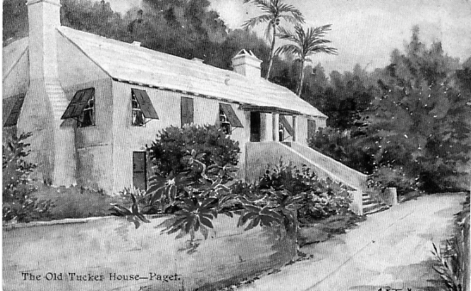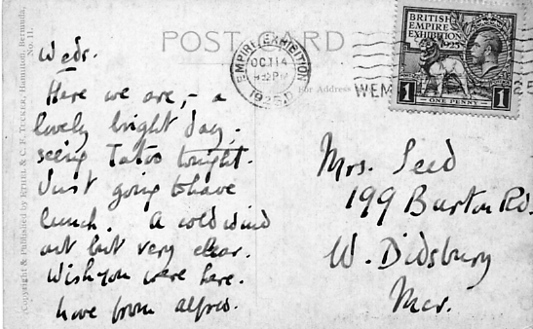

The Old Tucker House, Paget. Painted by the artist C. F. Tucker.

When I got home from my Christmas break the first thing I did was to go through all the cards I had bought, looking for one in particular, a Bermuda Tucker post card with a Wembley stamp and exhibition post mark. The sixteen year wait was finally over. The picture was strangely enough the same view of the Old Tucker House as Jean Cullen’s and when I went to my files I found not only the picture but the back was identical to Jean’s scan. I had her card in my hands. Five minutes later I was talking to her on the phone. Yes she remembered sending me a scan but then she lad lost the card and had not been able to find it since. I’m not surprised I said, “I bought it last week”. Had she been burgled was my next question? no never she replied. If she had been burgled then I should have been bound to return it to her. The only suggestion she could make was that in some way she had put the card by mistake into her sales stock, perhaps the sleeve stuck to another sleeve, not noticed and then sold at a fair.
Jean told me it was her intention when she found her mislaid Tucker post card to make arrangements leaving it to me in her will. I think this goes to show the close friendship that can exist between a dealer and a collector who meet together over the years at various fairs up and down the country. Something that is hardly likely to arise from an E-bay transaction between two people who will never meet.
Research on post cards is an ongoing and never ending process with some of us. Here are some observations by Fred Peskett.

Some observations on Crystal Palace Postcards.
by
Fred Peskett

S.S. Series.
The S.S. Series has a card serial numbered 197, this card is also listed in our book as Unknown Publishers Numbers 49 and 76. but look at the Bemrose Festival of Empire card No 52 which is a photograph credited to Bender & Lewis, they are all identical even down to the title! So do the S.S. Series and the Unknown date to 1911? As far as I know, Bemrose did not publish any Crystal Palace postcards before or after 1911, the Festival of Empire being the only ones.
I have the S.S. cards and the Unknown 76 with posting dates ranging from 1915 to 1918 sent from the Royal Naval Division at the Palace, and one of the S.S. posted in 1921. Also the SB-Series 23 card was from the same negative but with different title. I see that S.S. also produced cards of the South African and Canadian buildings, both of which were occupied by the Royal Naval Air Service when the Crystal Palace was the Royal Naval Division, these may also be of Bemrose origin?
1 think that these were re-issued to enable the members of the forces to send home a picture of their billet? Perhaps Bemrose sold selected negatives to other publishers post 1911, since I feel sure they did not reissue themselves.

Talbot postcards of the Crystal Palace.
I think it safe to say that Talbot produced their “Alexandra” Series from Type 1 to Type 5 before the fire of 1936, and Types 6 to 10 in the “Harold” Series after the fire. I think that also Talbot produced the “Excel” Series before 1936 since the Type 1 Excel's are identical negatives for the 12 postcards as the Type 1 Talbot Alexandra Series, with the exception of the position of the captions and the 01 instead of 10. I think that the Excel Series were another range of Talbot's perhaps being marketed in packets of 6 or 12, and maybe at a different price range. Talbot being a local firm to Norwood may also have produced the Excel cards for a local Stationer? Whatever the reasons Talbot was the photographer stated on the Alexandra and Harold cards.

Photochrom.
Have a look at the following postcards.
Crystal Palace from the Italian Terrace, (all types)
Crystal Palace, serial no 47666 (all types)
Crystal Palace from the S.E. 47664 (all types including colour)
All these cards were produced from the same negative, some with a wide angle view, and some close up. All these cards are known to have been sent from the Palace during the 1914-18 war.
Photochrom view of the Crystal Palace from the Low Level Railway station.
I have come to the conclusion that all postcards showing the view from the Low Level Railway Station were taken before mid 1909, except one which is the Photochrom “General View of the Crystal Palace and Canadian Buildings”. 1 have found a reference in a newspaper from June 1909 stating that work in constructing the pavilions for the 1910 Festival of Empire Exhibition had commenced. Since the Canadian Pavilion was one of the largest, I assume the foundations would have to have been in place prior to or shortly after this date. If one looks at the Photochrom view it will be seen that the original fir trees shown in negatives 1-9 were retained, but the ivy covering the walls of the Colonnade leading up to the Crystal Palace had been removed, also there is a considerable amount of debris against the wall.
There is no evidence of the Toboggan Run, but the hut at the top of the Run is still there. If you look at the wall just below the pile of debris there is a large section of the wall that has been removed, the hole is filled with wooden planks. Perhaps this was a new entrance to the Colonnade for visitors to the Festival of Empire coming in from the Low Level Railway Station? and the debris was from making the hole?
So 1 am of the opinion that this Photochrom postcard should be included in the views of the Crystal Palace from the Low Level Railway Station as Negative Number 10, since if you remove all the Festival of Empire buildings from this card you have a view from the Low Level!

New 1924 British Empire Exhibition Map No. 45
Reported by
Mike Gorringe

Here we have another new 1924 British Empire Exhibition map, again reported by Mike Gorringe, who you will remember also reported the last new map No. 44. He first mentioned this to me by E-mail and later at my request was good enough to loan me the map to examine and scan, see the front cover. Mike was one of the first collectors to get hooked on Wembley maps and he wrote to me way back in 1998 to say he had thirteen different maps. Since then his collection has grown, and he keeps me posted on new acquisitions as you can see.
In his last E-mail to me he remarks,
“You mentioned about E-bay in the last Journal and I can reiterate that costs go sky high for no reason, apart from the ‘must have’ brigade.

I paid just over £4.00 for the Adams map, but one prior to that by another seller sold for £38.00! It was only a standard map with basic information - no advert like the one I bought! I know because I always ask the seller about the various advert panels!.
There is a lot of varied stuff on there currently and Alan Sabey will confirm that the Australian Government Visitors book with Royal signatures went for over £830.00! Reserve was £500.00. It was bought at auction two years ago in Dorset!
One really has to curb spending otherwise it gets out of hand, so be very watchful of prices.
Silly question and very long way off - will the group be doing anything for the 2024 100th BEE anniversary? Exhibition at Wembley ?”.
Mike Gorringe

Well Mike,
I think I can answer that last point here and now, yes the Group will almost certainly be celebrating the 100th anniversary of the BEE in 2024. Perhaps I should start getting my display mounted now as I’m unlikely to present it in person as I shall be 99 by 2024.
A | B | C | D | E | F | G | H
I | J | K | L | M | N | O | P
Q | R | S | T | U | V | W | X

Layout and letters allocated to each panel on the back of the map.
I is the back and J is on the front of the folded map

Contents of panels on Adams Map number 45.

A. Picture and text on Canada.
B & C. Five pictures and text on West Africa, East Africa, Bermuda, West Indies and British Guiana.
D & E. Picture and text on British Government Pavilion.
F & G. Five pictures and text on Burma, Malaya, Palestine & Cyprus, Ceylon and Hong Kong.
H. Picture and text on Australia.
I. Advert for Robert Adams. Door Springs of Quality & Value. Ref. No. L 274 59op
J. Front of map when folded.
K, L, M & N Picture of the Imperial Stadium and text on the British Empire Exhibition. The headings of the paragraphs are, Variety and Colour, Monster Military Tattoos, A Fellowship of Empire and The Great Home-coming.
O. Picture and text on Newfoundland.
P. Picture and text on New Zealand.
Q. Picture and text on South Africa.

R. Picture and text on Palace of Engineering.
S. How the Exhibition began - Primary Purposes - A Co-operative Effort.
T, & U. All the World will be at Wembley, Fifteen miles of Exhibition. Bird’s eye view of the Grounds. (as Fleetway postcard No. 31).
V. Art of the Empire - The Two Georgians - Short Time Exhibits.
W. Picture and text on the Palace of Industry.
X. Picture and text on India.

Letter from Tony Davies
Dear Bill,
Here is a scan of a postcard I recently purchased for 99p. It is a black & white photo of the Children's Y.M.C.A. Hut, Wembley Park. I do not know whether it is an official Wembley Exhibition card, but the reverse is identical to the Walshams cards without name or address, and the wording on the front is similar in script to Wembley Exhibition cards. I wonder whether you can give any clues?
Kind Regards. Tony Davies
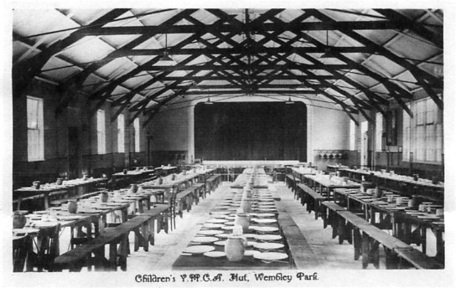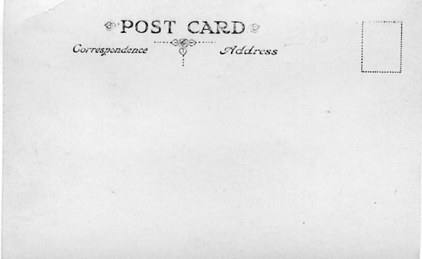
Children’s Y. M. C. A. Hut, Wembley Park

Dear Tony,
Many thanks for your letter and scan of the Y.M.C.A. post card. Yes I would say this is almost certainly a British Empire Exhibition Post card as the Y.M.C.A. were present in both 1924 and 1925.
The Official Catalogue for 1924 gives the address of their pavilion as No. 10 in Section E. Eastern Girdle (E.S. North), but only mentions ‘Literature dealing with the activities of the Association’ as being available, with no mention of a children’s hut. They were flanked on one side at No. 9 by a sweet manufacturer Maynards Ltd who were manufacturing sweets daily in their Kiosk. On the other side at No. 11 was the Oil Well Engineering Co., Ltd.
The 1925 Official Catalogue has even less to say about them except they were now located in the Outer Girdle No. 8. They were still next to the same sweet manufacturer as in 1924, Maynards Ltd at No. 7 and on the other side at No. 9 was Products and Equipment Ltd dealing in Fancy Goods, Novelties and Leather Goods.
The thing I can’t explain is the Y.M.C.A. picture shows they were set up to cater for large quantities of children (forms rather than chairs for adults). There were crèches for young children run by the Red Cross, but these were for small children not old enough to feed themselves. The shape of the hut seems to be the same shape of hut present in the Children’s Crèche, and as this was manned by volunteer nurses, it is possible the Y.M.C.A. also helped out with staff.
J. Lyons had all the other feeding establishments tied up. I wonder if this was connected to the Park Royal accommodation centre?

Snippets from Punch 1851
by
Fred Peskett

Punch Magazine during 1851 published many satirical pieces about the Great Exhibition, some were a bit near the mark as to being very derogatory but others poked some gentle fun, here is a couple of the more acceptable quotes!

"Not allowed to be Drunk on the Premises."
No Spirits (with the exception, perhaps of a glass of Cherry Brandy) - No Wine (excepting, probably, a taste of Antimonial) -No Beer (saving always, the harmless Ginger), are to be served in the Great Exhibition, after a long day's journey through its many streets of counters, we can imagine a thirsty countryman rushing up to the refreshment stall, and being told that they cannot possibly let him have anything to drink stronger than a glass of water. How disappointed, how enraged he will be! and we can imagine his looking round the Crystal Palace and giving vent to the following phillipie; "Dong it! I must say the building is beautiful enough, but 1 tell you I should have admired your Glass a precious sight more, if I could have a drop of Summit in it!"

A File to smooth Asperities.
The Sheffield Times describes an extraordinary file, which is to be sent from Sheffield to the Great Exhibition. This remarkable file is adorned with designs as numerous as those on the original shield of ARCHILLES, all cut and beaten out with hammer and chisel. How much more sensible and friendly to show distinguished foreigners files of this sort, than to exhibit to them files of soldiers!

A Whisper to Prince Albert.
Mr Punch, with extreme deference, begs to whisper one little question to His Royal Highness Prince Albert.
How beautiful is the Palace Crystal! Would not a public dinner, given in Hyde Park to the builders of the aforesaid Palace-the workers in iron and glass-be a dainty sight to set before his Majesty the Sovereign People?

A Trifle from Sandwich.
Among the most interesting objects in the Great Exhibition, will be found a wonderful specimen of the most elaborate carving-consisting of nothing less than a ham, carved into 5000 slices of the most delicate texture by a waiter at Vauxhall. He has employed his leisure hours for the last twenty years in completing this extraordinary triumph of the art of carving, and so beautiful is the workmanship, that the material is rendered quite transparent; the minutes fibre is plainly traceable; and how there is substance enough left to hold together, is the source of universal astonishment among all who have seen this marvellous piece of waitercraft!
The piece above was in response to a question asked in the Times on how mean the caterers were in carving ham so thin that was used in the sandwiches sold in the refreshment rooms at the Great Exhibition. Punch managed to turn the answer into an art form!

Marking the Centenary of the 1910 Japan-British Exhibition
8 December 2010 -11 February 2011
At The Embassy of Japan
101-104 Piccadilly, London W1J 7JT
Open weekdays 09:30 -17:30, closed weekends
by
Don R. Knight
Author and Exhibition Collector

Marking the centenary of the 1910 Japan-British Exhibition held at White City in London. The Embassy of Japan will display artefacts kindly provided by the London Borough of Hammersmith and Fulham, the Japan Society, Victoria and Albert Museum and Mr Donald Knight. Mr Knight shares with us his knowledge of the exhibition 100 years ago: In 1907 Imre

Kiralfy was a Director at Earl’s Court where the Balkan States Exhibition was held. The Colony of Art Missionaries had invited Japan to take part and they put on displays that exhibited every aspect of
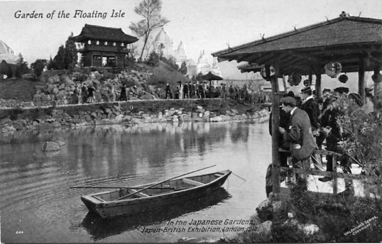
their wonderful crafts. Visitors could see carpenters, frame makers, screen and basket makers, bronze workers, lantern painters and embroiderers from Kyoto. Twice daily there was even a display of Japanese cormorants fishing in a lake. The exhibition lasted for five months.
The following year, Imre Kiralfy was the Director General of the Franco-British Exhibition at Shepherds Bush. London. The exhibition covered 100 acres and had 100 buildings, both large and small. The buildings, which were painted white to protect them from the weather. gave rise to the term White City, which is how the area is known today.
Having seen the success of the Japanese displays at the Balkan States Exhibition of 1907 and building on his experience with me Franco-British Exhibition. Imre Kiralfy and his committee invited the Japanese Government to come to London in 1910 to show the world its manufacturing and crafts.
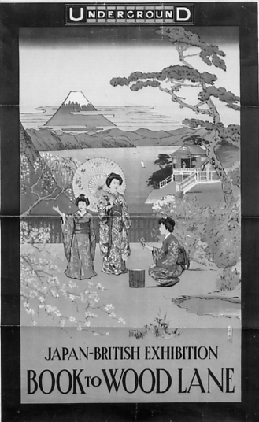
On Saturday. 14 May 1910. the Japan-British Exhibition opened without any great ceremony due to the death of King Edward VII a little over a week earlier. Most of the buildings remained unchanged from the Franco-British Exhibition of 1908. the Canadian Pavilion became the Wrestling Hall, Japanese gardens and floating islands were built along with Japanese-style buildings. The Formosa Hamlet with the Formosa Oolong Tea Room was constructed as well as the Uji village and an Ainu home village. Fairground rides also attracted visitors to the exhibition. The Flip Flap, which was also used at the Franco-British Exhibition, continued to attract visitors. They came to travel in its carriages which sat on the ends of two 150 toot long arms and rose upwards, allowing their passengers aerial views of the exhibition, depositing them at the opposite side from where they began. When The Japan -British Exhibition closed on 31 October, over 8 million people had visited it.
© London Transport Executive
Today, we can see what had been the gateway to Fair Japan at the exhibition which now stands at Kew Gardens. London and behind the BBC television centre in Wood Lane are the Japanese Gardens.
The End

It may be of interest to members to know that several years back I lent some of my post cards to be used on a television programme titled ‘The Lost Gardens’. The post card of the Japanese Tea House and rowing boat that Don has used to illustrate this article was one of my cards they used. When the programme was shown it became apparent that technicians had worked on the still water to make it appear as a running stream with moving ripples clearly seen on the water. I wonder how many viewers realised it was not an actual picture, but a doctored post card they were watching?
Unfortunately as I typed this out I realised the exhibition at the Japanese Embassy was drawing to a close, and members would not be able to see Don’s material on display.
Bill Tonkin.

Steam Engines on show at the Great Exhibition.
by Fred Peskett

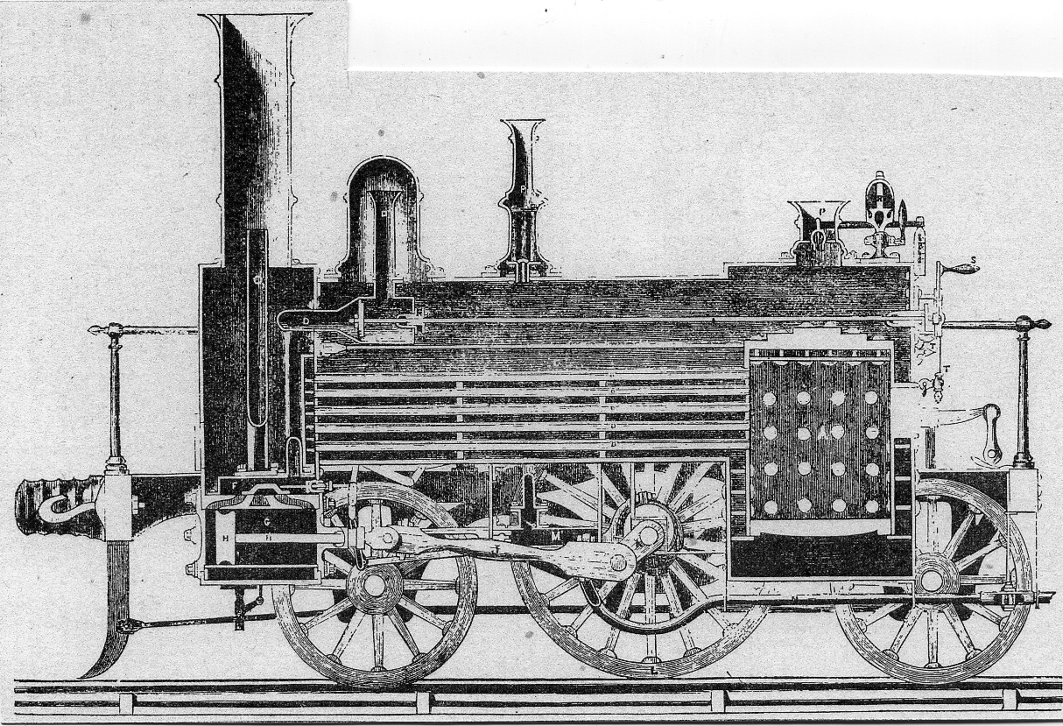

The steam engines featured at the Great Exhibition which are described in this article are, with the exception of Figure 1, the portable Steam Engine types. Figure 1 is a sectional model of a Sharp & Roberts locomotive made by Watkin & Hill.

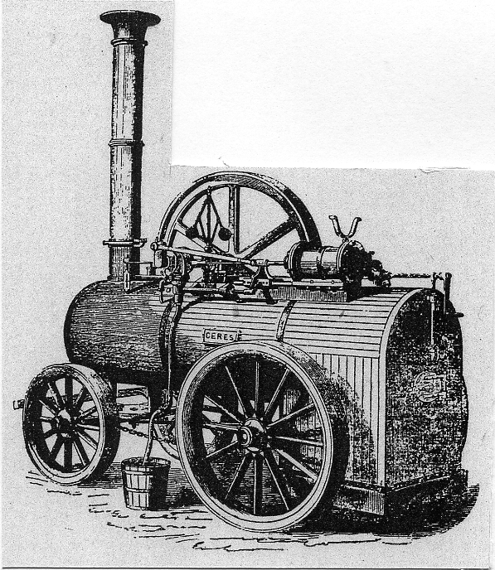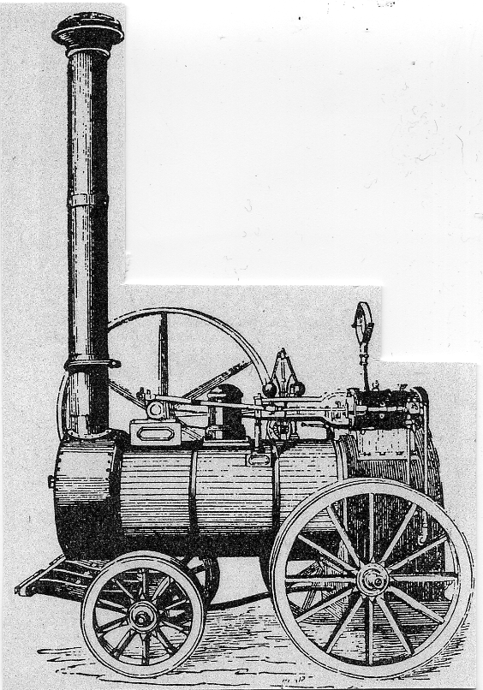
Figure 2. “CERES” A portable steam engine by Barrett, Exall & Andrews. All of the portable engines were without any form of traction, and steered by yanking round the front wheels or sometimes the rear wheels. Because they were not mobile by steam, there was no requirement for a platform at the back. Figure 3. Top right:- A Burre11 six-horse power portable steam engine, note:- this one has a steam dome on the boiler.

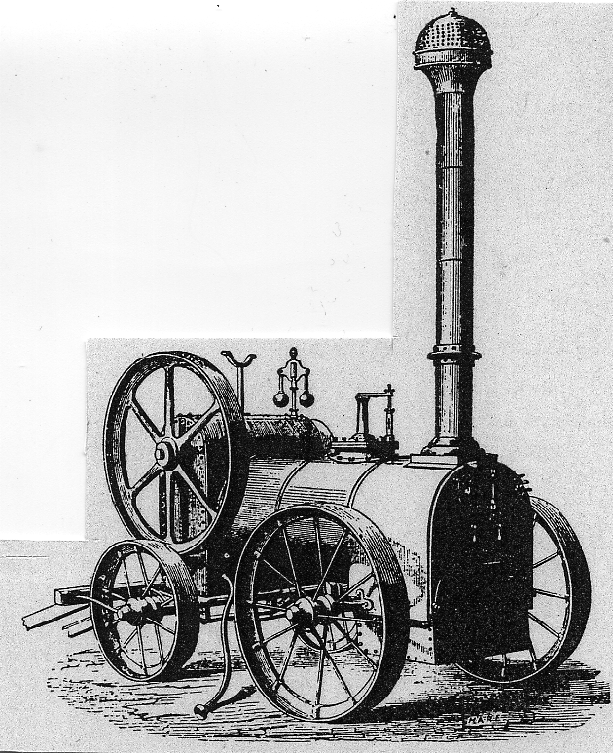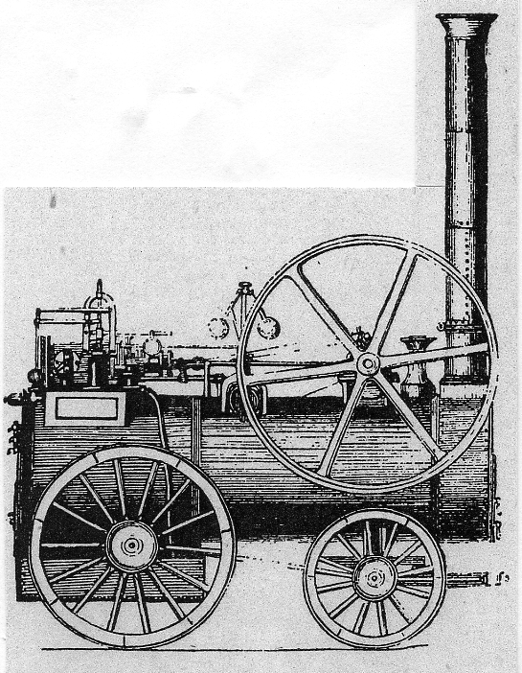

Figure 4. Top left:- Tuxford & Son’s Agricultural portable steam engine with enclosed cylinder, this was made in four and six horse power versions. Figure 5. Top right:- Turner’s four horse power steam engine with automatic water feed system.

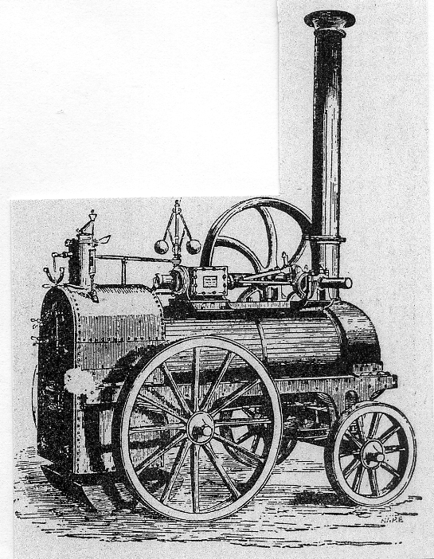
Figure 6. Ransome & May’s sprung girder frame steam engine.

