Editorial No 10 September 1988

This Issue Is devoted to a project close to my heart and thankfully close to someone- elses. Ten years have passed since Fred and I published ‘Part 1 Exhibitions' and at the time we predicted that Valentines, the famous postcard publisher, must have issued over a thousand different cards for the White City events. I remember being gently chided about this at Bipex and at other fairs when I rubbed shoulders with fellow collectors and dealers. Research into this topic ceased after the book appeared and apart from adding to the list in a desultory fashion, we have not improved, refined etc., our work for over ten years.
Bill Tonkin has ‘taken up the cudgel' and I hope that those of us who collect the White City will make every effort to help him.
This newsletter replaces the one on Philatelic Exhibitions. At the last minute. Bill persuaded me to insert this copy so that any members attending the York meeting would be able to study the problem in advance.

Andrew Brooks.

Exhibition Study Group - York Meeting 1988

This meeting will be held at the same venue as last year- The Black Swan Inn, Peasholme Green, York. YO1 2PR. Tel. 0904 25236.
Date Saturday ,24th.Sunday ,25th. September.
All members , friends and relatives are welcome. Cost will depend on the number of people attending but will be approximately £2 per day (including coffee and biscuits).The hotel has a few rooms for B/B and Graham Hall also recommends the Annjoa House .Nillfield Road, Scarcroft Road, York. Y02 1NQ. Tel. 0904- 653731.
Last year was enjoyed by all but the tight schedule did not leave any time to chat and discuss problems etc. The plan this year is to give members more time to 'do their own thing'.
Possible Programme Saturday
10.00 Coffee at Black Swan
10.30. Talk by Don Rnight -London Exhibitions.
11.30 Dinner and possible visit to York Book Fair, Postcard shops or Study groups.
4.00 Talk and display by Andrew Brooks . Collecting Expo. Ephemera.
Sunday -Start with coffee
10.30 Bill Tonkin . Japan-British Expo. 1910.
11.30 Invitation to Inch Books for a viewing and a glass of wine.
2.00 Stanley Hunter
3.00 Mike Perkins-British Empire 1924/5. Postcards.
This is only an outline of the weekend and I expect many other things will be going on to do with Exhibitions!

© Andrew D. Brooks 1988

Valentine and Sons. Postcards printed and published for the White Citv
Exhibitions -1908-1914 List 1.

I suppose most of us have at some time thought it would be nice to make a list of the White City Valentine cards, after all they are numbered, so it should not be too difficult. Writing down 1-1000 in an exercise book is soon done and then comes the easy bit, filling in the titles. It is at this point that one or two anomalies crop up and before long it becomes clear that the numbers are a bit of a snare and delusion and it is not so simple after all.
I have felt for some time that a numerical list with titles added can only be regarded as a supplementary list to a main list , which I think will have to be in alphabetical order. There will be other supplementary lists of the various types of borders, conveyances, patriotic, etc. The first problem is to sort out the ‘Artists Impressions'. These are cards which it has been suggested were produced before the exhibition opened ( see page 55, Fletcher & Brooks - British Exhibitions 1900 - 14.) and are not numbered.
During a conversation with Andrew Brooks when the idea of a listing for the White City cards was discussed, it was felt that the only way to tackle the Artists Impressions was to Xerox the whole lot and circulate the results among the members of the Exhibition Study Group. I agreed to act as a clearing house for information and have produced the first instalment, which is an illustrated list of the different basic designs. This will be followed by list No. 2 which will cover the different cards of each basic design ie., photographic, B/W, coloured, white border etc., and also, which I feel is of equal importance, the back of the card. When list No. 2 has been produced, I hope members will help out by sending me details of additions to the list either by a xerox copy (front and back) or the loan of the cards for me to xerox. Hopefully we should end up with a fairly clear picture of what is known to have been issued.
In this first list it has been necessary to give the cards a reference code and I have listed each card alphabetically followed by a number ie., B- l, B-2 etc. I have kept to the main words of the title and ignored prefixes like In the Court of Honour and In Court of Honour and these are to be found under C-I6 and C-17.
As new cards are recorded they will follow on in their alphabetical group. Once the Artists Impression cards have been done, I intend to start on the rest of the Valentine White City cards and complete them in stages. For instance the majority of the B/W and Sepia cards do not have numbers, but when they have been issued in colour or photographic type cards a number has been added. So a first step must be to put a number to all the unnumbered cards that should have numbers. I shall then be in a position to start filling in the titles in the exercise book.

Bill Tonkin September ‘88.

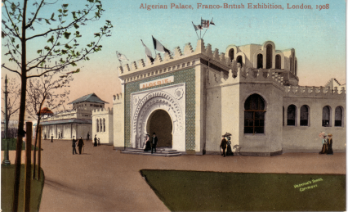
A-1 Also see under ‘French Colonies’

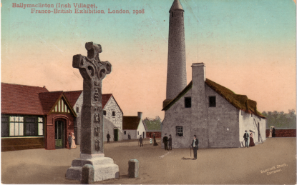
B-1

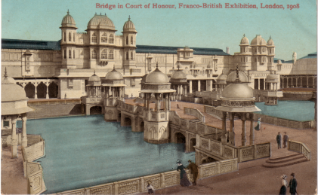
B-2
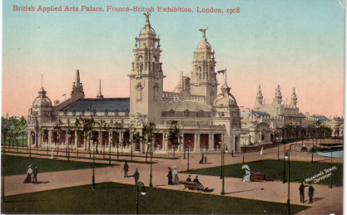
B-3

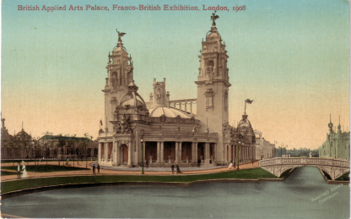
B-4

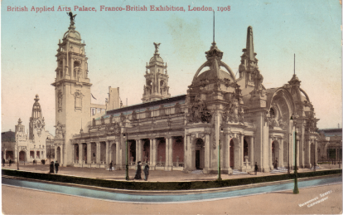
B-5
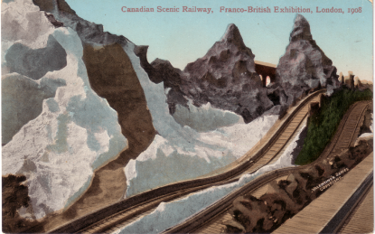
C-1

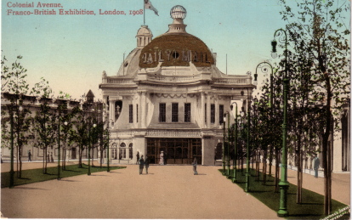
C-2

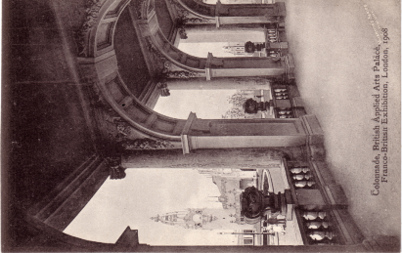
C-3 No clouds type 1
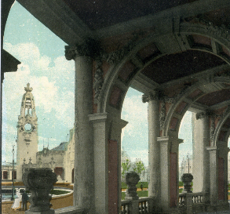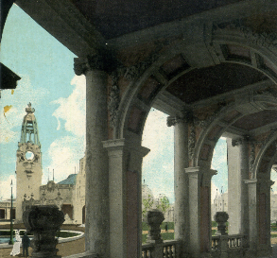
C-3 Cloud type 2 C-3 Cloud type 3

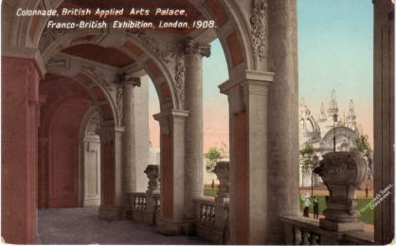
C-4

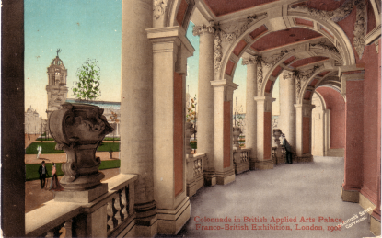
C-5

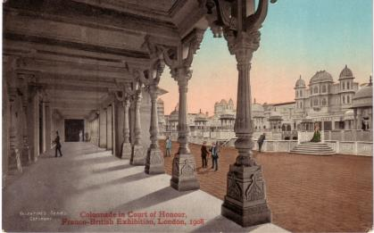
C-6

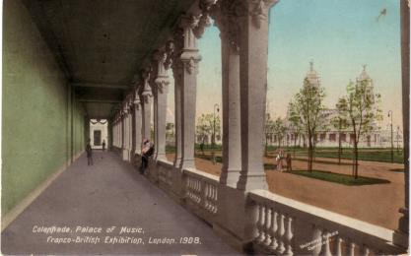
C-7

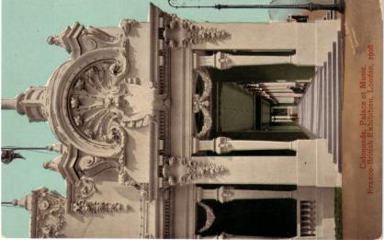
C-8

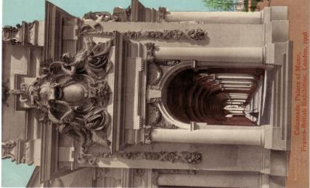
C-9

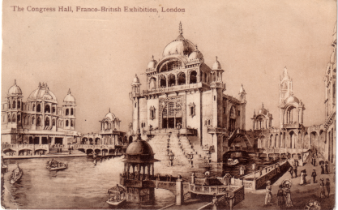
C-10

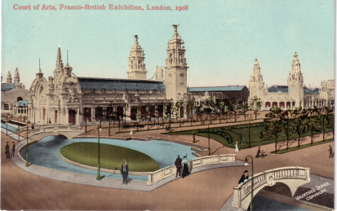
C-11

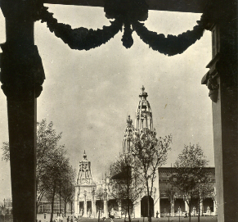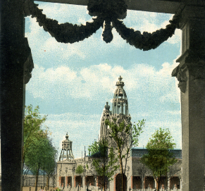
C-12 No clouds type 1 C-12 Clouds type 2

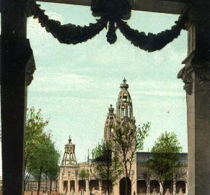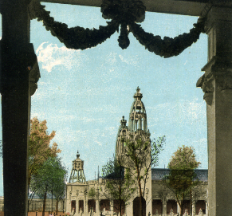
C-12 Clouds type 3 C-12 Clouds type 4

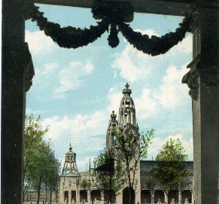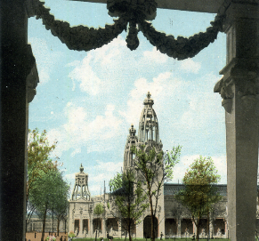
C-12 Clouds type 5 C-12 Clouds type 6

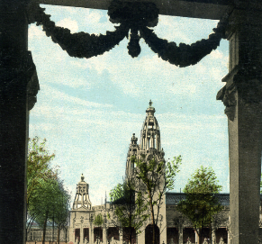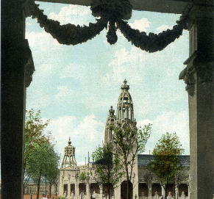
C-12 Clouds type 7 C-12 Clouds type 8

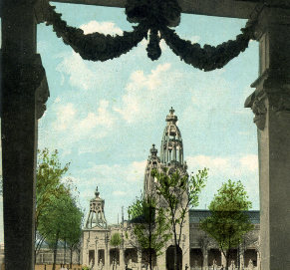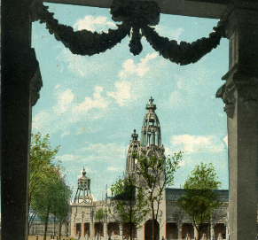
C-12 Clouds type 9 C-12 Clouds type 10

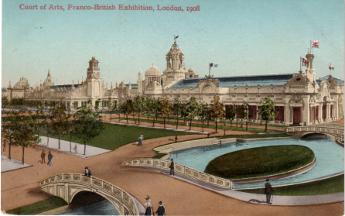
C-13
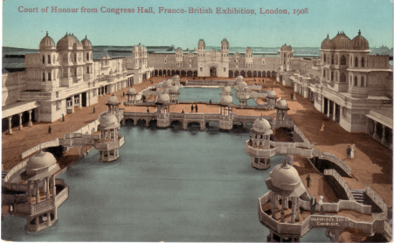
C-14

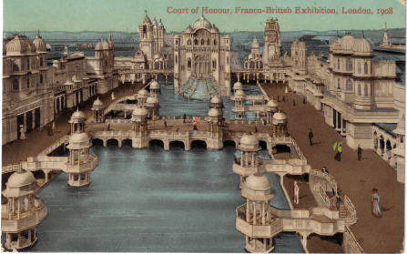
C-15

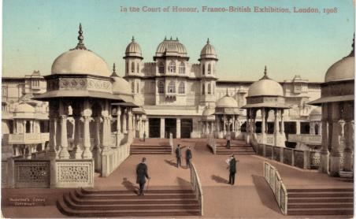
C-16
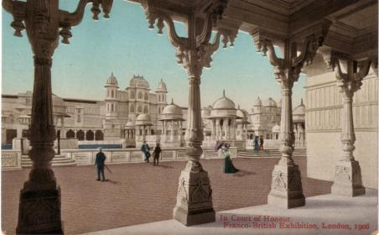
C-17

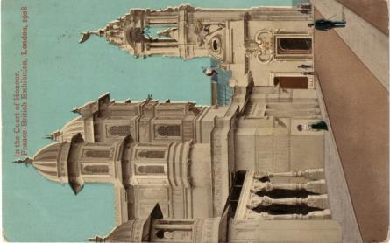
C-18 No clouds type 1

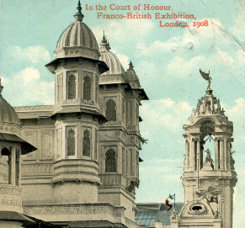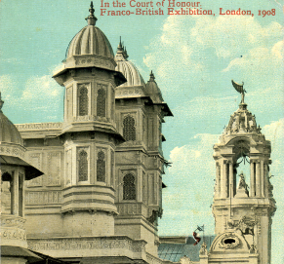
C-18 Clouds type 2 C-18 Clouds type 3
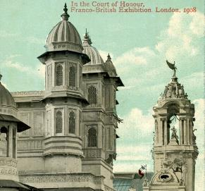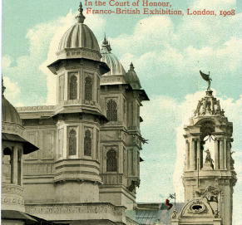
C-18 Clouds type 4 C-18 Clouds type 5

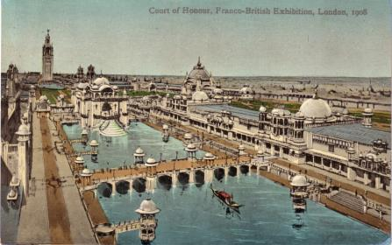
C-19

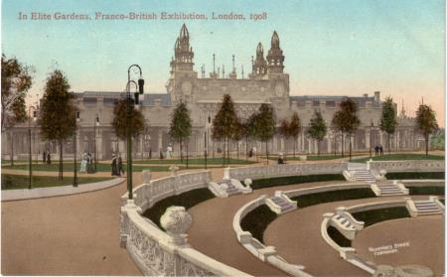
E-1
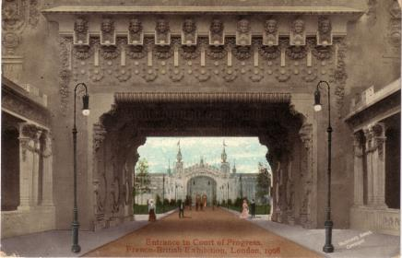
E-2

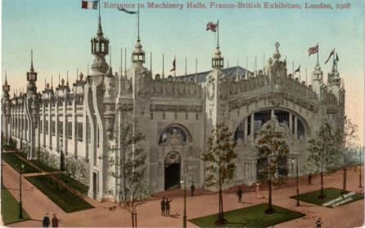
E-5

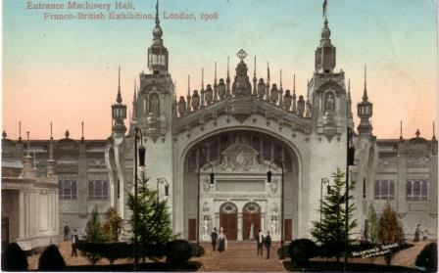
E-3
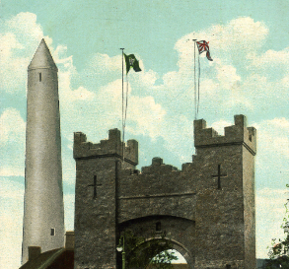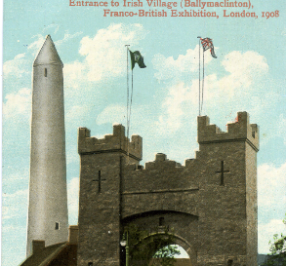
E-4 Clouds type 1 E-4 Clouds type 2

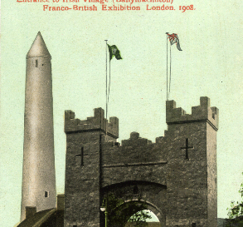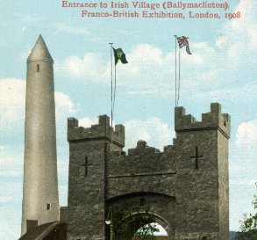
E-4 No Clouds type 3 E-4 Clouds type 4

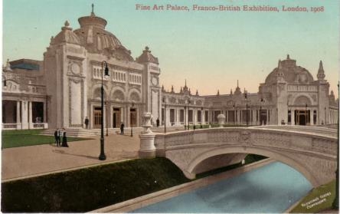
F-1

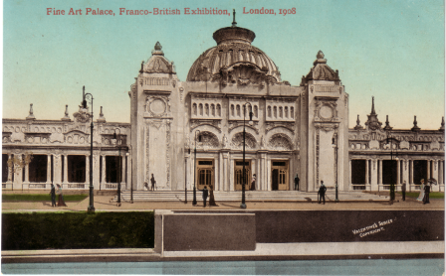
F-2

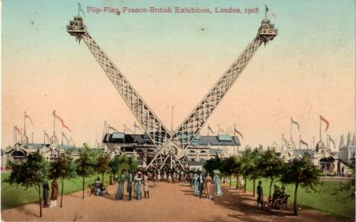
F-3

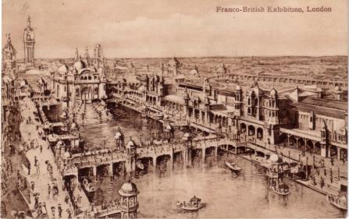
F-4
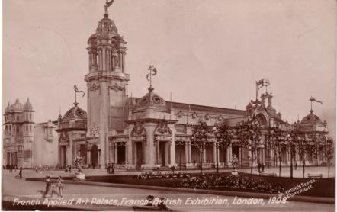
F-5

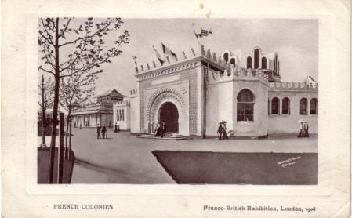
F-6

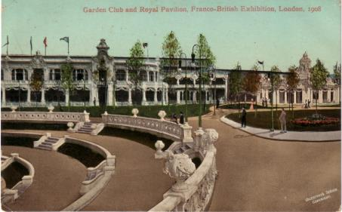
G-1
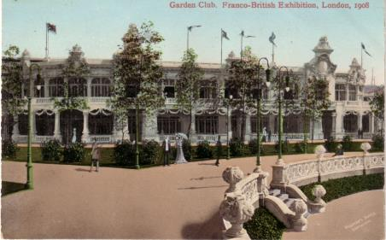
G-2

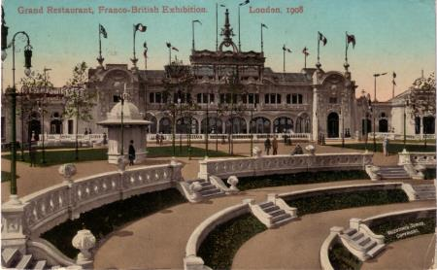
G-3

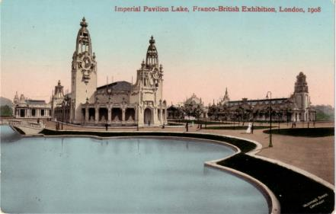
I-1
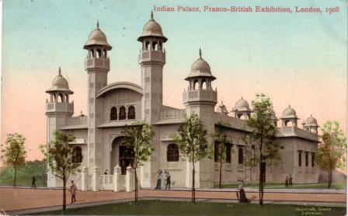
I-2

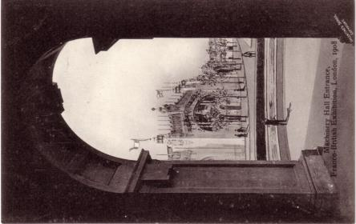
M-1 No Clouds type 1

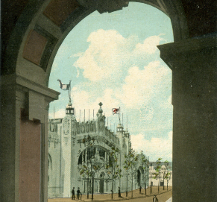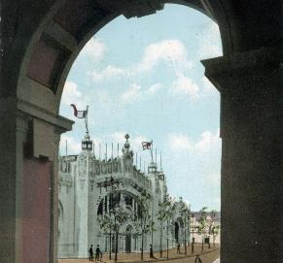
M-1 Clouds type 2 M-1 Clouds type 3
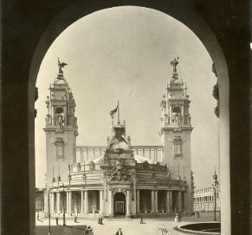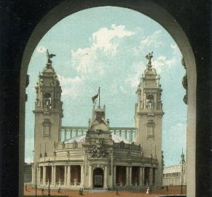
N-1 No Clouds type 1 N-1 Clouds type 2

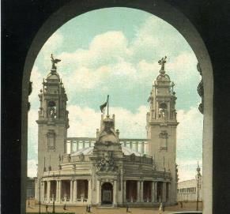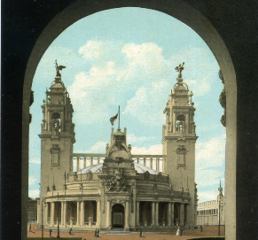
N-1 Clouds type 3 N-1 Clouds type 4

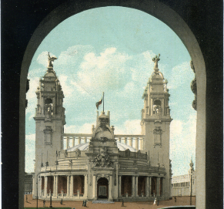 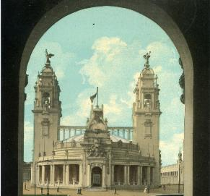 N-1 Clouds type 5 N-1 Clouds type 6

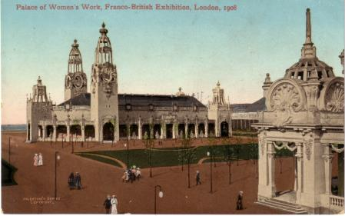
P-1

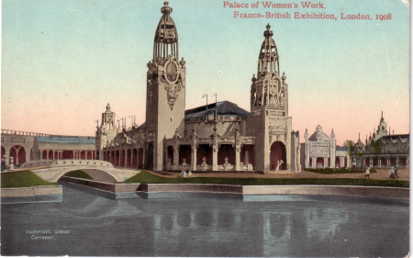
P-2

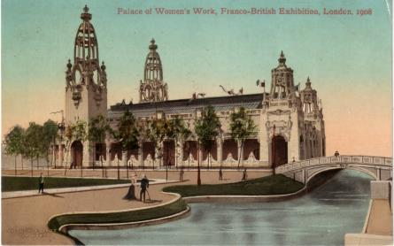
P-3
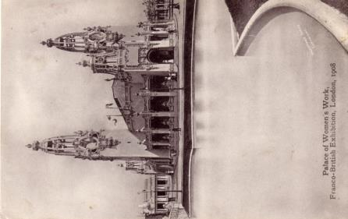
P-4

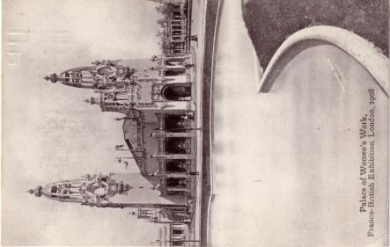
P-5

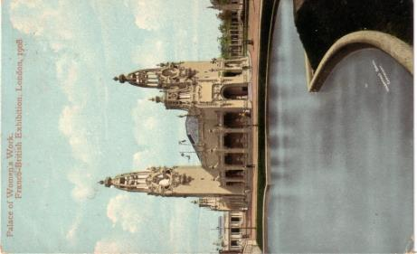
P-6
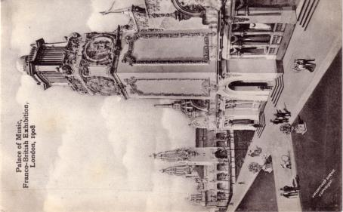
P-7

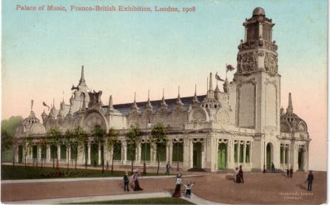
P-8

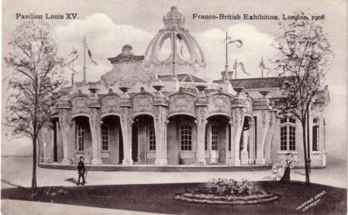
P-9
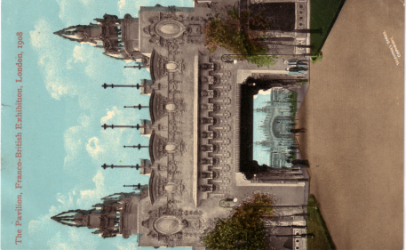
P-10

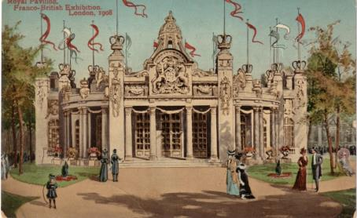
R-1

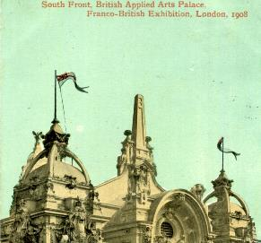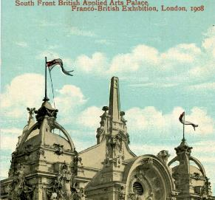
S-1 No cloud type 1 S-1 Cloud type 2
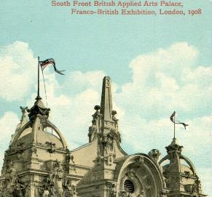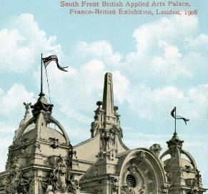
S-1 Cloud type 3 S-1 Cloud type 4

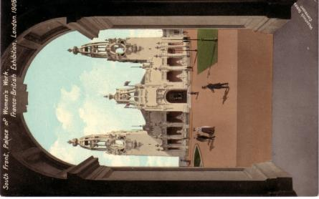
S-2 Cloud type 1

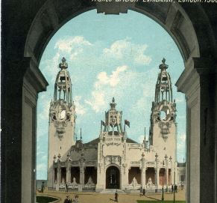 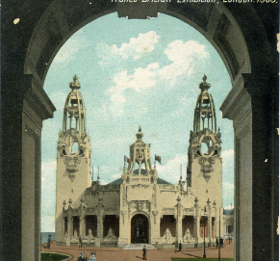 S-2 Cloud type 2 S-2 Cloud type 3

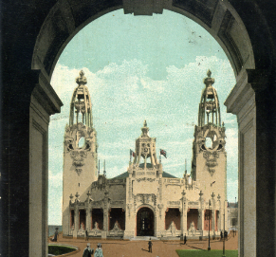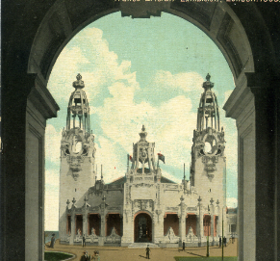
S-2 Cloud type 4 S-2 Cloud type 5

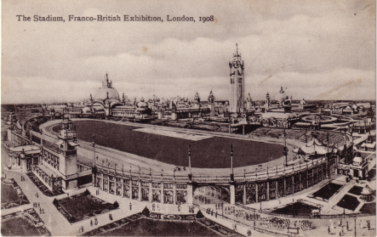
S-3

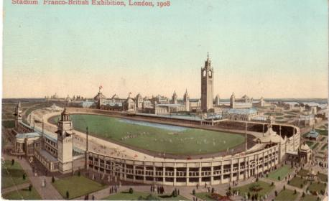
S-4
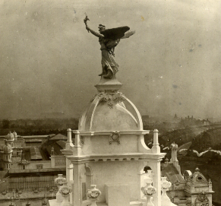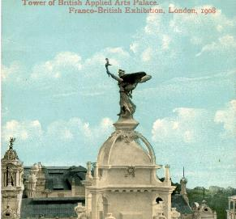
T-1 No clouds type 1 T-1 Cloud type 2

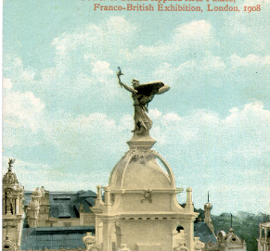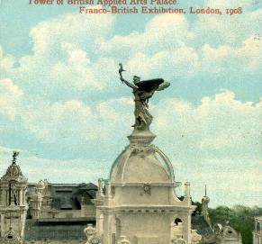
T-1 Cloud type 3 T-1 Cloud type 4

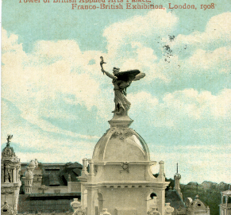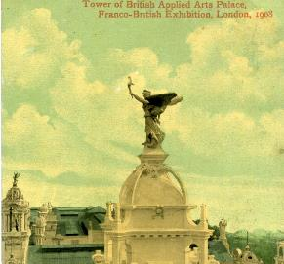
T-1 Cloud type 5 T-1 Cloud type 6

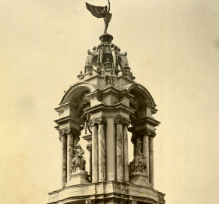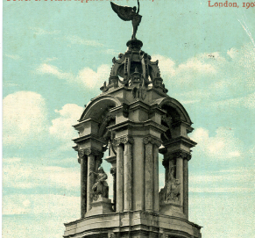
T-2 No clouds type 1 T-2 Cloud type 2

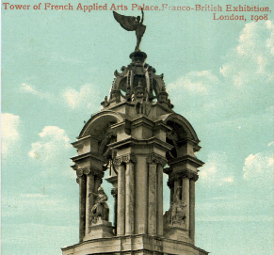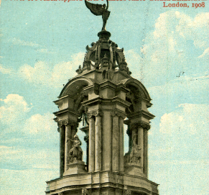
T-2 Cloud type 3 T-2 Cloud type 4

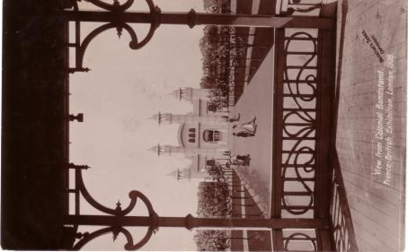
V-1 No clouds

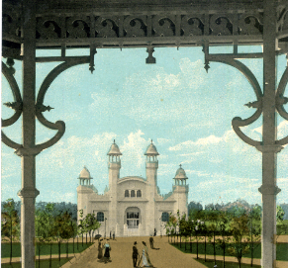 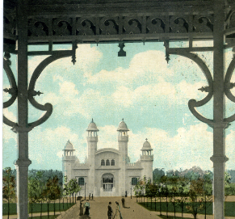 V-1 Cloud type 2 V-1 Cloud type 3

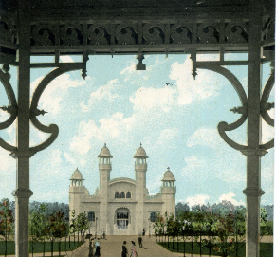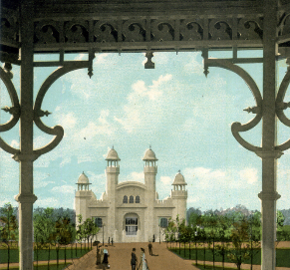
V-1 Cloud type 4 V-1 Cloud type 5

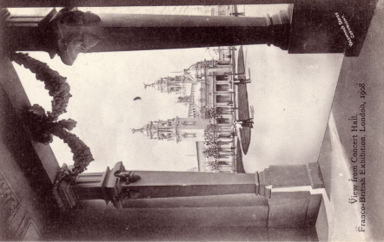
V-2 No clouds type 1

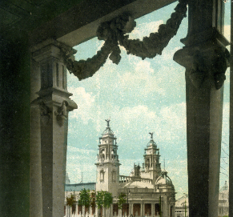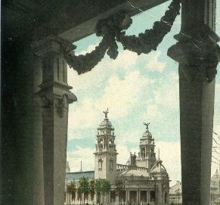
V-2 Cloud type 2 V-2 Cloud type 3

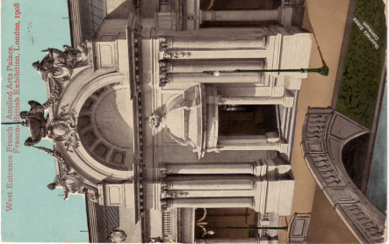
W-1

