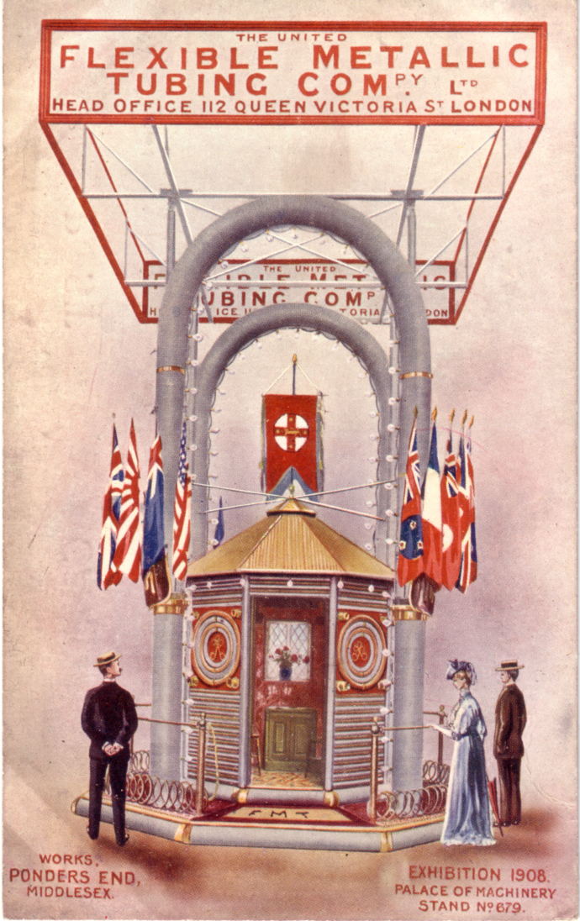
Illustration C

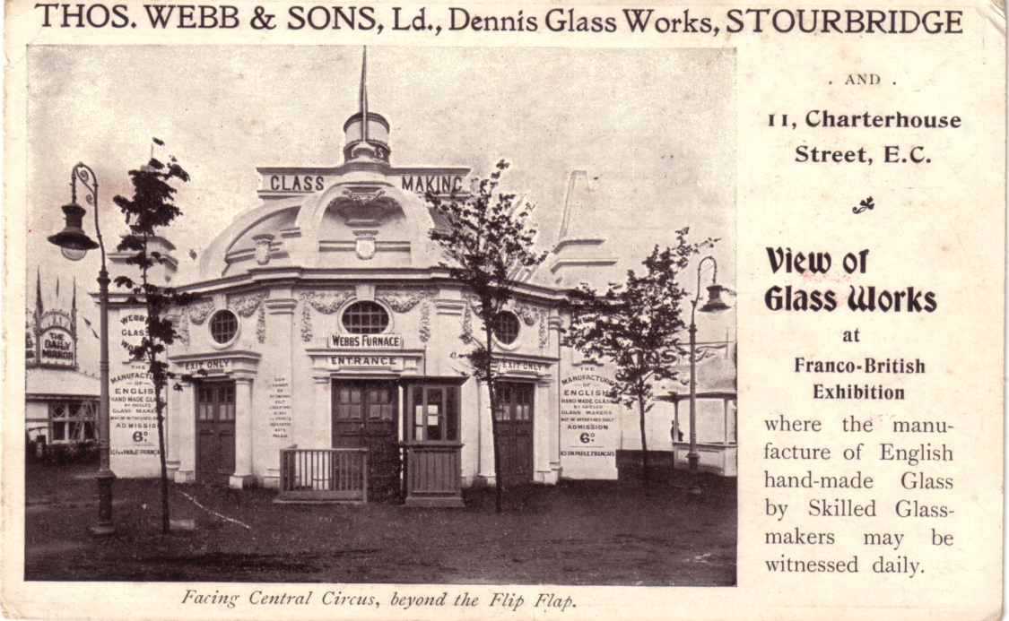
Illustration D

Editorial No. 1

This newsletter is being circulated to ten members and already I have news of other interested collectors who would like to join the group. I hope that the numbers do not multiply at the rate they did in a similar group in the U.S.A! ECHO now has over eight hundred members after being in existence for only a few years. I have given details of this group in the newsletter for anyone who would like to join.
Contributions to the first newsletter are mainly concerned with picture postcards and although this is understandable, the scope of Exhibitions will bring other articles more concerned with their history and other collectable items, such as tickets, programmes and souvenirs, for later publications.
The names and addresses and collecting habits of the original ten members have been listed. New members only will be listed in successive issues but a full membership list will be available on request by any member.
I think that it is important in the early issues that we should try to formulate a policy for the group, and that subsequent issues will reflect this. What balance do we require between pure research (check lists etc.) and articles of general exhibition history? Do we encourage sales and wants lists for a small cover charge? How much illustrated material do we require? My own ideas, admittedly rather vague at the moment, lean towards asking members to co-ordinate the research for particular exhibitions. The information they require could be published through the newsletter and then members can send information direct to the co-ordinator. At a later date this information would be made available, possibly through the newsletter. Could all members comment in these ideas and suggest where they might be able to accept responsibility for either one exhibition or group of exhibitions.
As an experiment for the next issue (October), I would like members to send copy (type written if possible) for wants or sales. There will be no charge for this issue even for a full page! Articles for publications are also required.
Membership fee for 1981 - I suggest 75p will cover the cost of postage and xerox fees.

Illustrations

A National Series 677. Col.

B No. PU or PR. Black and green.

C No. PU or PR. Col.

D Trade card. Map of exhibition on reverse.

Members

Andrew D. Brooks Fairhaven, Sunderland Road, East Boldon, Tyne and
Wear
Boldon 364219 World Exhibitions 1881 – 1980 Post cards and printed ephemera. Special interests. White City and Earls Court
Frederick A. Fletcher 35, St. Georges, East Boldon, Tyne and Wear.
Boldon 364240 World Exhibitions 1881 – 1980 Post cards and printed ephemera.

Don Knight 2 Crescent Road, New Barnet, Herts.
081 440 3574 Special intrests. White City, All aspects.

Con Rutter 94, Brockfield Park Drive, Huntingdon Road, York.
0904 22440 World Exhibitions Ex Silks and Advert cards.

Stanley K. Hunter 34, Gray street, Kelvingrove, Glasgow. G3 7TY
041 3992 775 Scottish Exhibitions, All aspects.

Henry Morgan Courtney House, 28, Westcliffe, Dawlish.EX7 9DN.
British Exhibitions, Special interests White City and Wembley. (Deceased)

Sylvia Onions 139, Underlane, Plymton, Plymouth. PL7 Q32
World Exhibitions, Special interests Wolverhampton
White City, Festival of Empire, Wembley and Bradford.

John Allwood Mortendene Ighthan, Sevenoaks, Kent. TW1 3QT
0732 882654 All Trade, National and International Exhibitions with
Particular emphasis on British Ex. And International Exhibitions / World Fairs, General Exhibition Information.
(Deceased)

Don White Noble Lowndes Buildings, 32, Hanover Street, Dunedin
New Zealand
New Zealand Exhibitions, all aspects.

Graham Hall 43, Moorside, Micklethwaite Lane, Micklethwaite, Nr. Bingley 4518 Bingley, West Yprkshire.
Bradford Exhibition.

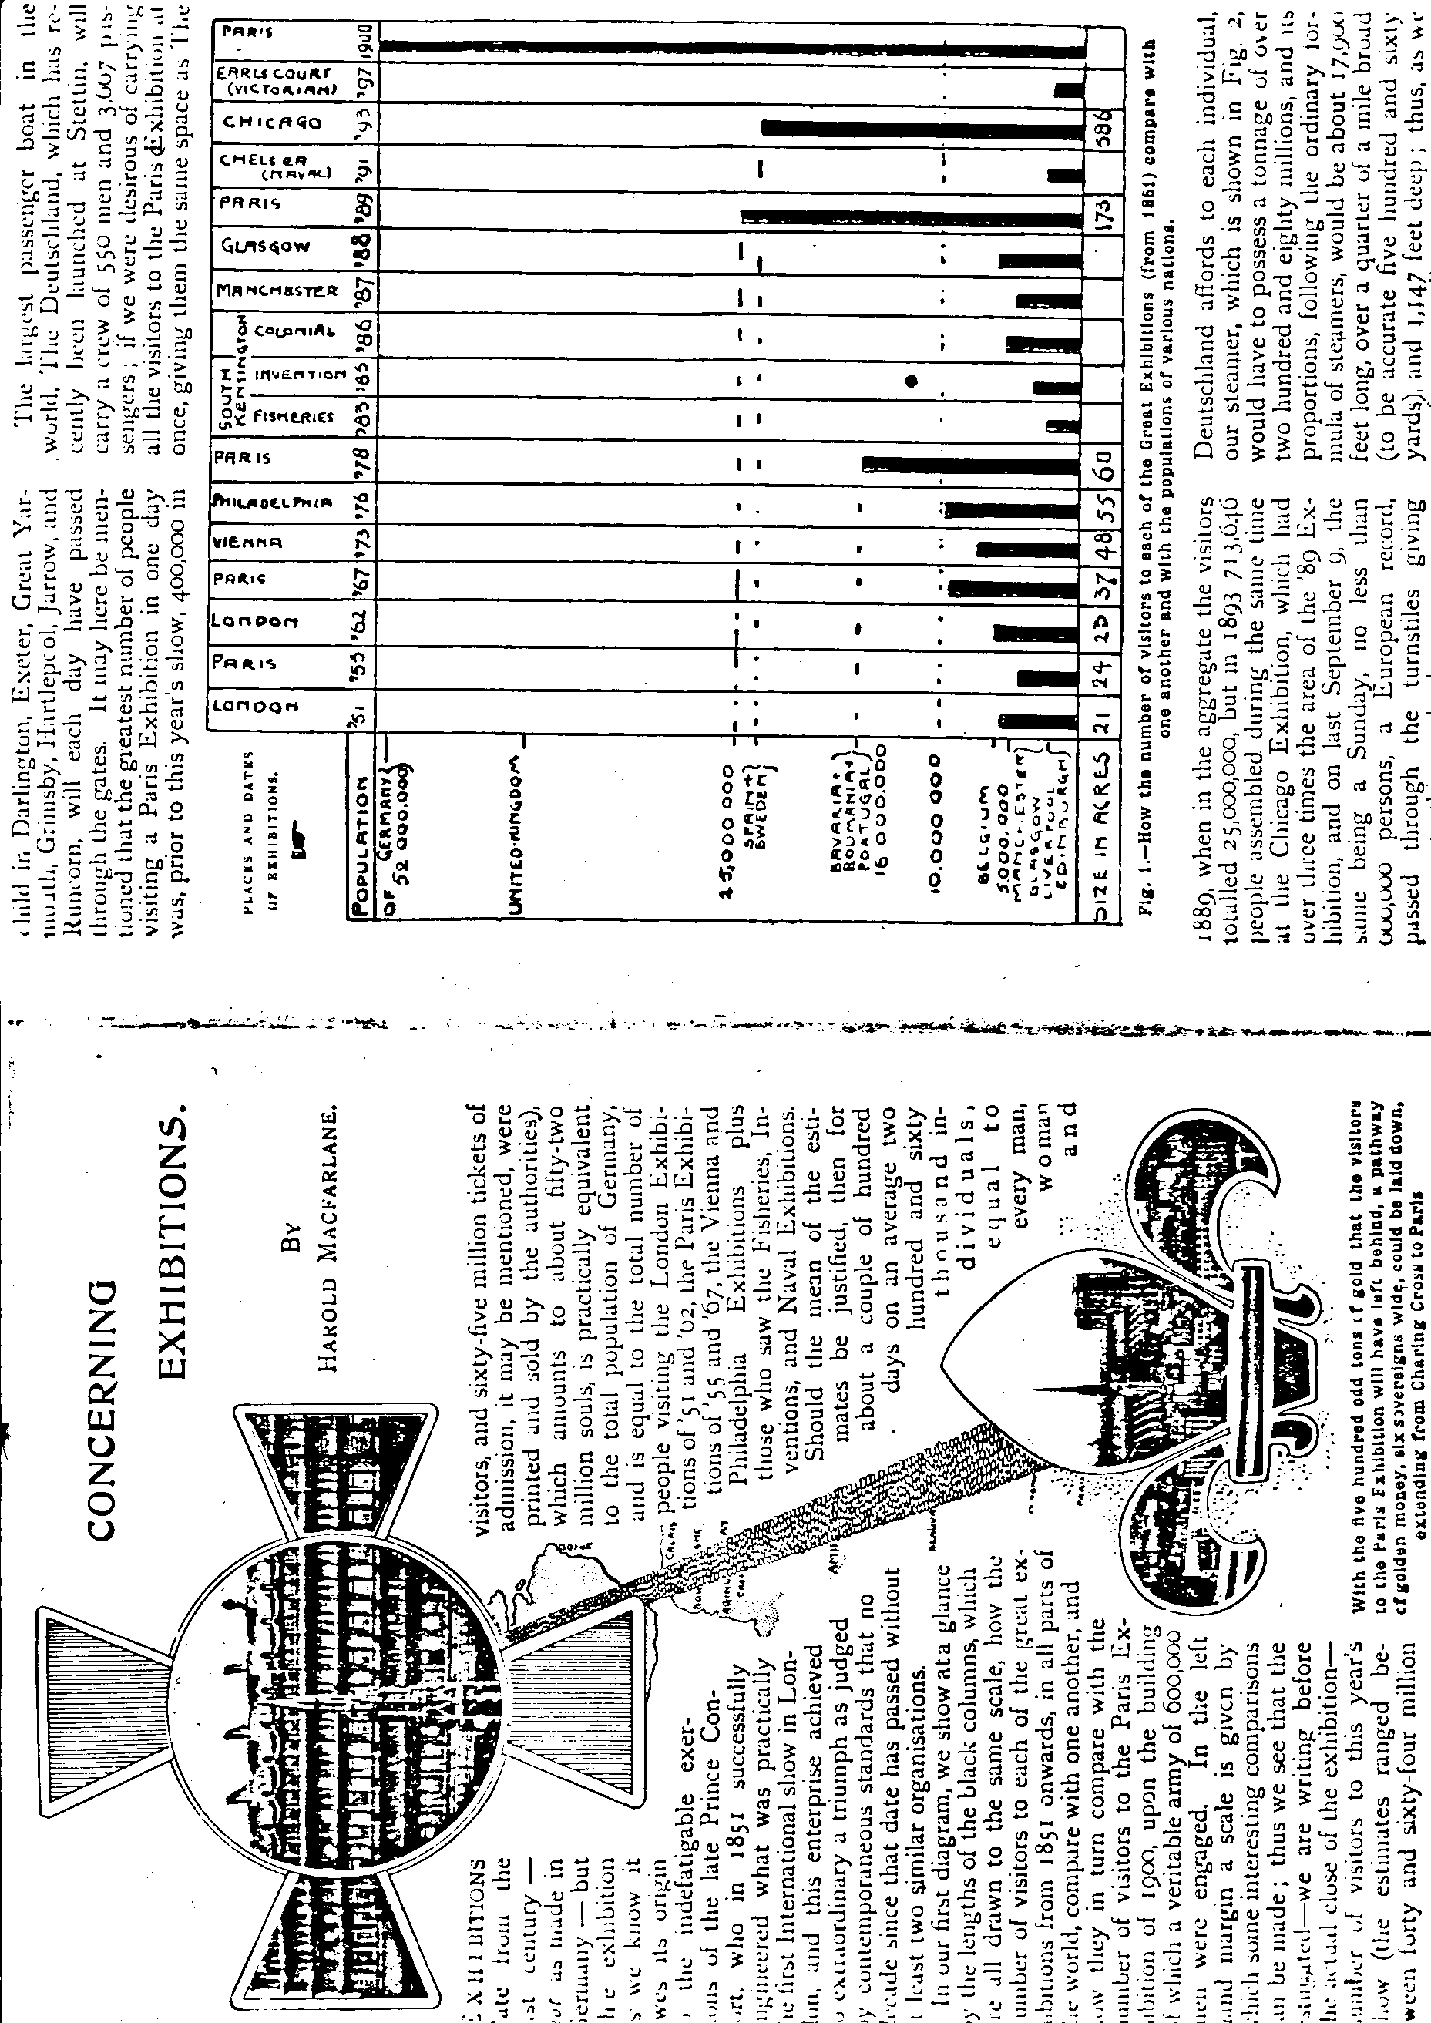

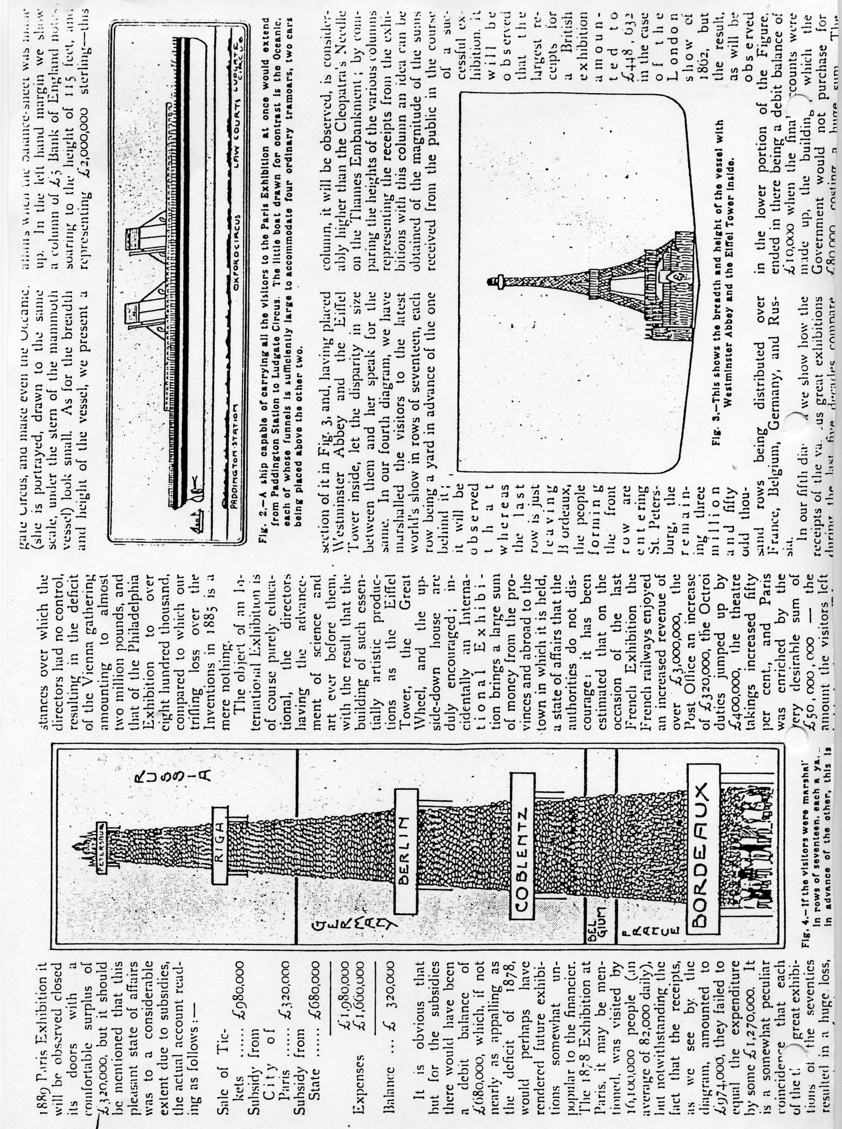

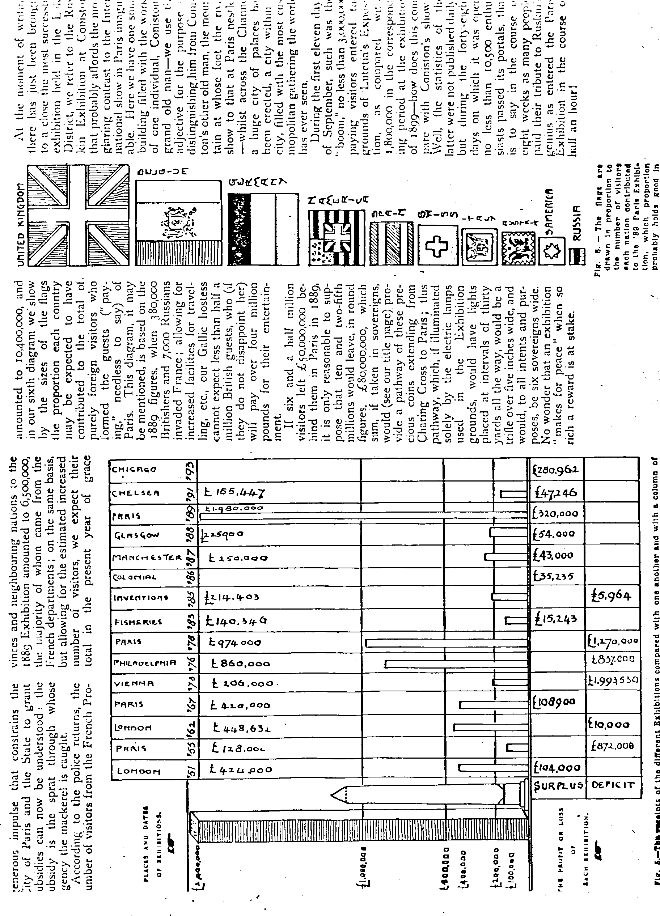

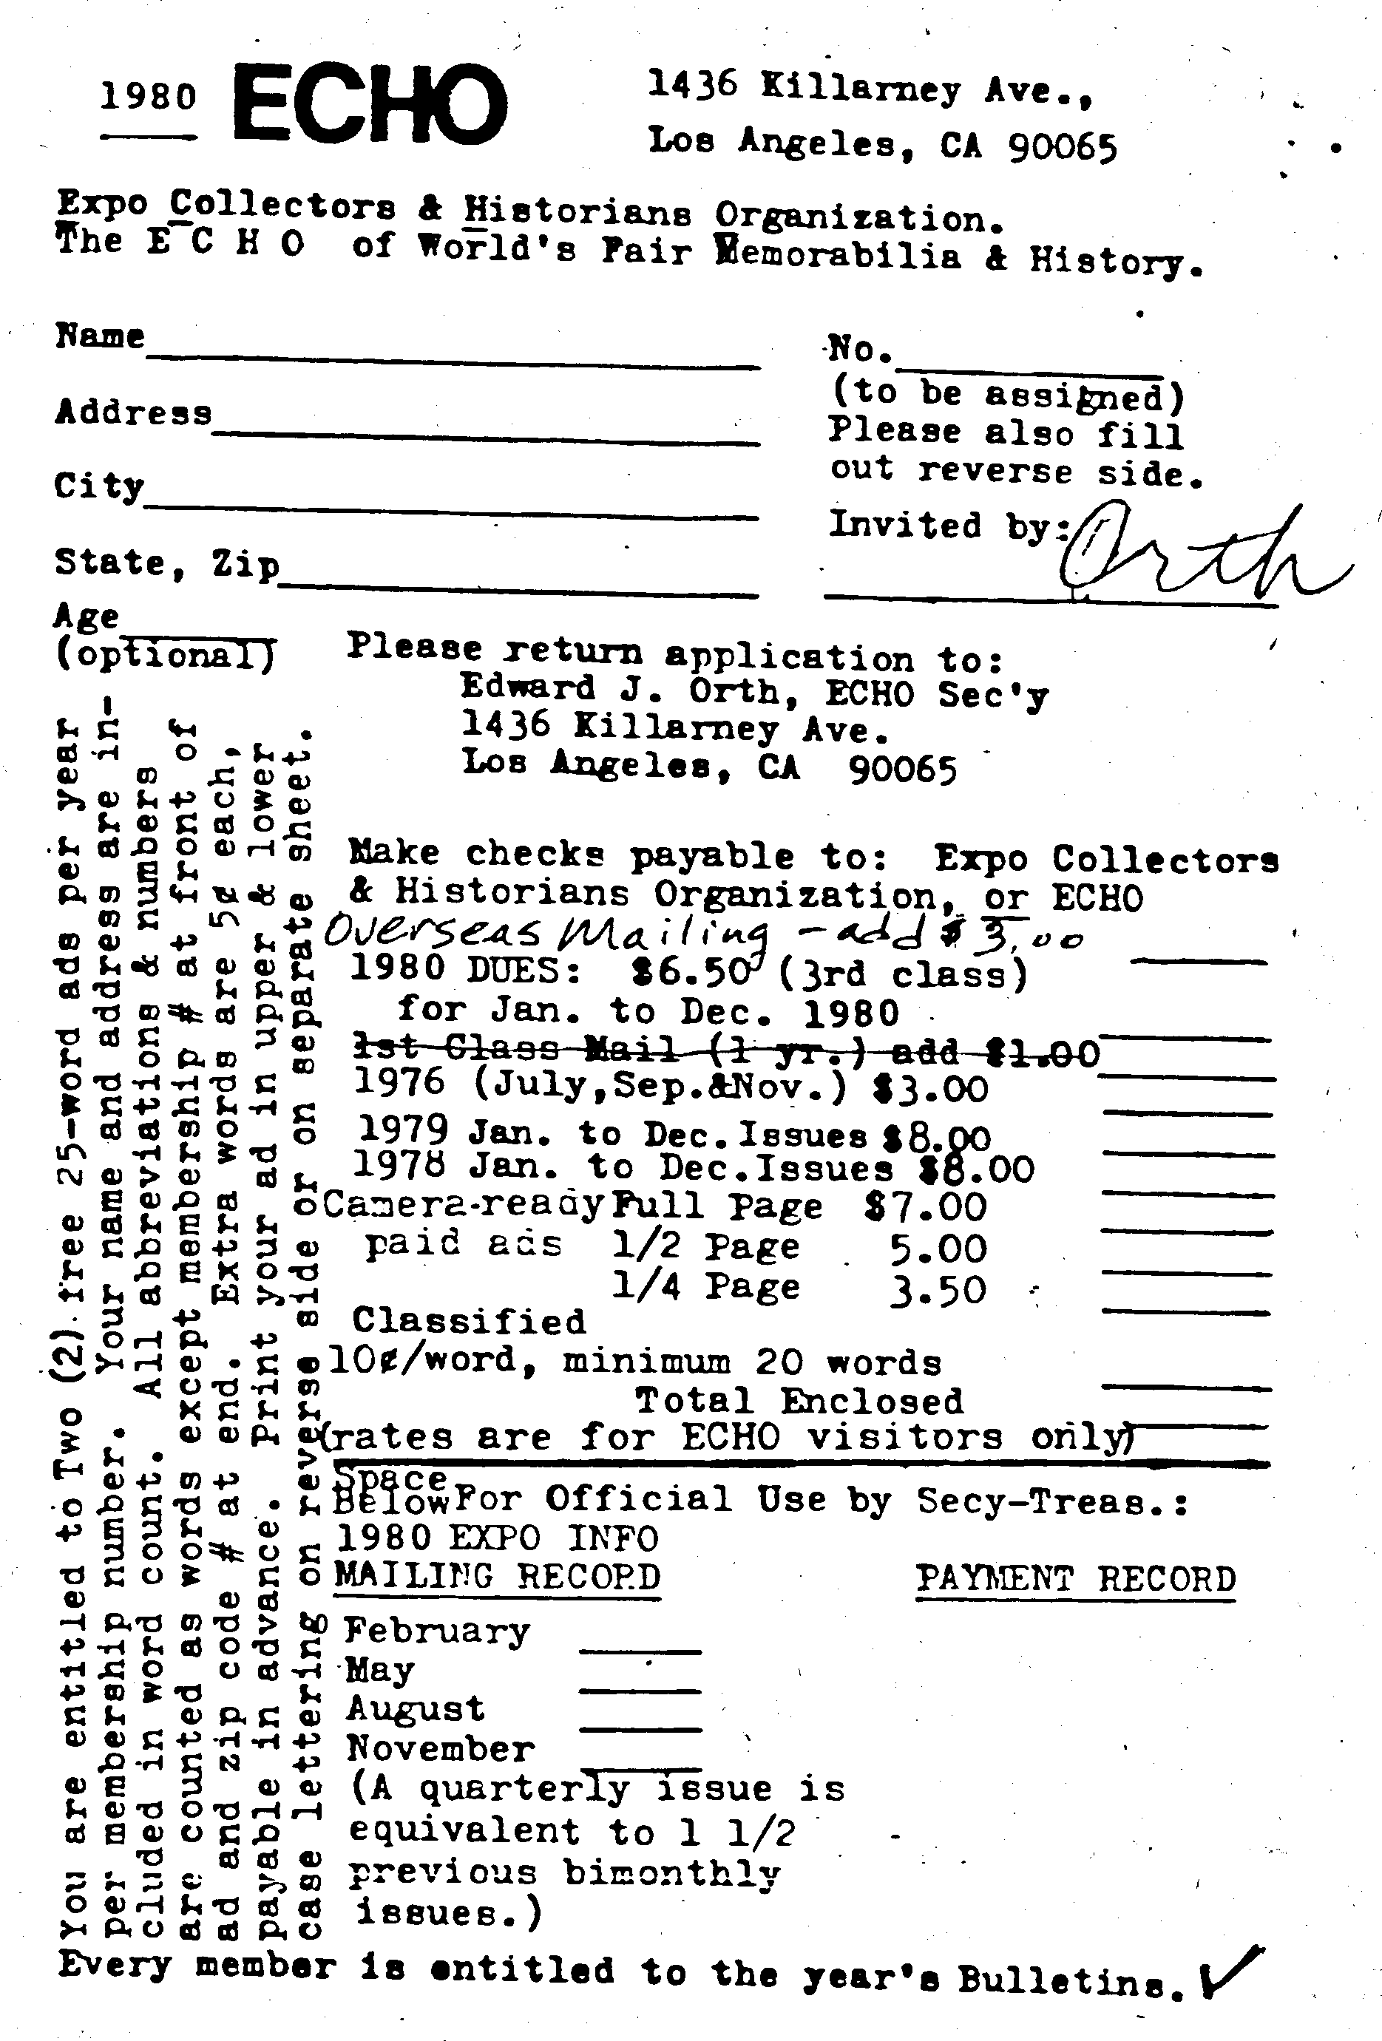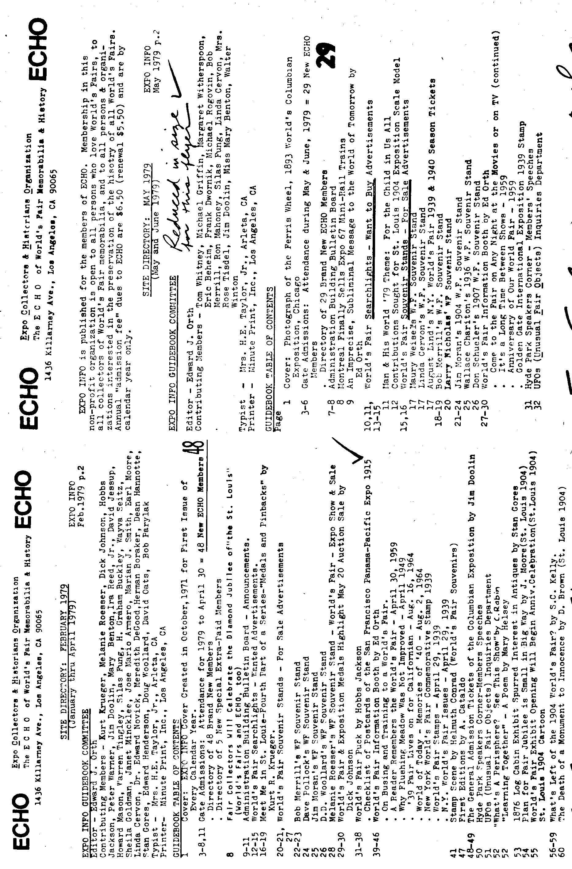

Letter to the Editor
Dear Sir,

I am afraid I have to take issue with Messrs, Fletcher and Brooks on a point of usage. In the course of their listings, they refer to some cards as “screen printed”, when in fact they are surface-printed from halftone blocks. This is a misuse of words which is becoming prevalent in stamp-collecting circles, but we should not allow it to be established in the postcard world.
Printing processes seem to cause a great deal of confusion in collecting circles, though a little knowledge and a good lens can usually answer any questions. There are many named processes, but they are all variants of a few basic techniques; the distinctions between these basic techniques depend upon the way in which the pigment is transferred from the printing surface to the paper.
The 'Big Three' processes are gravure, typography and lithography.
In gravure processes, including engraving, etching, photogravure etc., the ink is transferred from recesses in the printing plate, and so stands up in relief above the surface of the paper. In typographic processes, surface-printing, halftone etc., the ink is transferred from the raised parts of the design on the printing plate, so that the printed parts are slightly impressed into the surface of' the paper (typically each line is bordered by a narrow margin of ink squeezed out around the raised design on the plate, but the line itself is impressed). In lithographic processes, including offset, heliozincography etc., the ink is transferred from a flat (or curved) surface, and the paper remains flat.
Screens- are a method of treating a picture image so that a picture with a gradation of tones can be reproduced with an ink of a single colour (and similarly for coloured pictures, using four or more superimposed colours). The image is split up into a grid of dots which vary in size, and in gravure “processes in depth also; these printed dots blend at normal viewing distances to create the impression of variations in tone, though the dots are always visible on closer examination. The point I wish to press home is that screens are used in the preparation of pictures for reproduction by gravure, surface and lithographic processes, so that the use of the term “screen printing” in this sense does not provide a satisfactory description of the method in use.
There are other printing processes which do not depend upon the transfer of ink from an inked surface to the paper. In photography, xerography, electrostatic spray and similar processes, the distribution of the pigment is controlled by optical or electrical means, and there is no printing surface. Finally, there are stencilling processes, in which the ink passes through what could loosely be termed the printing surface. The term “Screen printing”, properly used, refers to a stencilling process. It was originally “silk screen printing”, but the adjective tends to be dropped, as nobody is going to refer to it as “man-made fibre screen printing”. As in an ordinary stencil type duplicator, the pigment (more of a paint than an ink) passes through holes in a stencil supported on a fabric screen; the ink on the finished product stands up in relief on the surface of the paper, and usually shows traces of the weave of the fabric screen.
While this may be considered a pedantic distinction in relation to postage stamp printing, it is not mere pedantry to insist on the proper usage in relation to postcards. There are postcards printed by the silk-screen process; what are we to call them, if we misappropriate their correct name to use it as an imprecise description of something which already has its own name?
Yra ffly.
H. G. Morgan

Sorting out the Wembley Official Postcards

The official publishers for the British Empire Exhibition were the Fleetway Press, a firm which came into existence during the first World War and lasted until about 1930. Not only did they publish guides, programmes etc., but they had the sole concession for the sale of postcards at kiosks throughout the Exhibition grounds.
Postcard collecting as a hobby was at a fairly low ebb.in 1924/5, most cards having been kept as souvenirs of the Exhibition, rather than as contributions to serious collections. so nobody at the time seems to have taken the trouble to record what cards were actually issued. At first sight this appears easy. All the cards carry the Fleetway inscription, including ‘Sole Concessionaires’ on the back, together with the name of the Exhibition. True, some of them have a ’Wembley Lion’ and some of them an ‘FPLtd.’ monogram, but the ones with the monogram have the date 1924, while those with the lion are undated. From the dates of use, and from some of the subjects pictured, it becomes clear that the ‘lion-backs’ were issued in 1925, so we can separate the two years and deal with them separately.
The first batch of cards issued in 1924, in order to be available for sale on opening day, had to be prepared beforehand, and so they could not show the exhibition with the public in attendance. These are the cards contained in packets labelled as Series A-D. Ernest Coffin had prepared a series of line drawings which appear as illustrations in the 1924 Guide. These twelve drawings were issued as two sets of six photogravure cards as Series A and B; they were sold at l/- per packet. Each card is numbered on the back, from 1 to 12, and we have the beginning of a logical system. But Series C contains cards numbered from 25 to 36. It looks as if the system is breaking down already.
For a long time, cards numbered 13 to 24 were listed as missing but it later became clear that this series was devoted to the Novelty Cards in Colours' advertised (at four pence each) on the flaps of the other packets. The faces of the cards have designs similar to ordinary ‘pull-out’ cards issued with views of seaside resorts; the only hint of their Wembley origin is that The British Empire Exhibition is printed where the name of the resort would ordinarily appear. The concertina insert carries miniature reproductions of the twelve Coffin drawings. The address side is a modified version, printed in black or blue, of the standard Fleetway back. Only a few of these have been recorded.
Series C and D carry the numbering from 25 to 42, still with cards prepared before the exhibition opened. series C consists of twelve sepia halftone cards, some of them clearly artist’s impressions, others apparently based on photographs, with some degree of artwork to disguise the fact that buildings were incomplete and presumably surrounded by builders rubbish. Series D consists of six coloured artist's impressions, signed 'POTTS' (except for No, 39, the only one in vertical format, which seems to be unsigned.
Now comes another break in the series; No. 43 is a glossy photograph (which were sold singly at three pence each). No.44 has not been recorded, but is presumably another glossy photograph, for with No’s. 45-50 we come to a series of six glossy photographs of the State opening ceremony, followed by No’s, 51-56, a series of aerial photographs.
Series A and B, at six cards for a shilling, were apparently considered to be a bad buy’, for Series E, numbered from 57 to 68 are reprints in sepia from line blocks of the same Coffin drawings but now with all twelve in a single shilling packet. They are well printed, and it is doubtful if the general public noticed any difference (except in price) between them and the earlier post cards. Fortunately for the collector, both series are numbered so no difficulty arises in distinguishing them.
There is scope for investigation into the date of issue Series E. It would be interesting to hear from postmark enthusiasts of the earliest date of use of cards from this series; do any of them exist with the 23 April ‘First Day’ cancellation? The same applies to the aerial photographs No’s 51-56.
Cards numbered 69 to74 form a series glossy photographs, distinguished from later ones by the absence of the Campbell Gray copyright inscription in the bottom margin.
Up to this point, the numbering system has been quite clear there was one series of serial numbers, regardless of the type of card. Series letters were allotted, in the same order, to sold in packets, skipping over the novelty and photographic which were sold singly. But now the system breaks down irrevocably. Numbers from 75 up were allocated only to glossy photographs the packet cards were unnumbered. The only way to approach listing is by way of the cards found in apparently untouched This, as will be seen later, presents problems; for the moment the problem is best attacked from the other end.
The packet flaps list the other series on sale, with details of the contents of each packet. Early packets list only series A, B, C, D. plus the novelty and Queen's Dolls House series, packets, from F onwards, list C, D, E, F, G, H, I, J, plus novelty, Dolls House and Photo cards. Packets for Series K, M, N and O also exist, but no packet or reference has been found for any Series L.
the cards in series M, N and 0, eight photogravure cards have the series letter on the back, in place of the number, lettered cards for each series have been recorded, with no extra series. Series K consists of twelve halftone cards (all repeated in other of the gravure series M - 0); again, these are known to exist with no discrepancies. Series J consists of 'Six Fine Art Views', and six (or possibly seven).coloured halftone cards signed by Ernest Coffin.
We are left, then, with a possible Series L, plus series F, G. H and I (which according to the contents lists should comprise between them 36 photogravure views). But there are known, and as yet not accounted for, more than 36 unnumbered and unlettered photogravure cards, plus six (or possibly five) coloured halftones which signed 'POTTS' or apparently unsigned. (The doubt as to numbers can be resolved if anyone can report a copy of 'New Zealand Pavilion’ and clear up whether it is signed by Coffin, Potts or unsigned.
From the reported contents of packets H and I, it seems quite clear that they did not always contain the same nine cards. It remains to be seen whether all the ‘unidentified photogravure’ cards can be allocated to packets, and whether all the existing cards have been listed.
Apart from these regular series, other cards were published by Fleetway for the 1924 exhibition. A series of numbered glossy photographs (five known) was issued for the Pageant of Empire and another (eight known.) for the Palace of Arts. Letter cards were also published. Other 1924 Fleetway cards, probably issued in their capacity as postcard publishers, rather than as official concessionaire were produced for ‘Pears Palace of Beauty’, and a card with a back quite distinct from the official series shows Maori carvings in the New Zealand Pavilion.
Finally, published by Fleetway, but produced by Raphael Tuck, were the six series of eight coloured cards of the Queen's Dolls House. Tucks presumably produced these cards by virtue of their Royal warrant, but publication was formally by Fleetway by virtue of their sole concession for the exhibition. Tucks continued to issue the same cards without the Fleetvay inscription, while the Dolls house was touring the country in the later 1920s; strictly speaking these later issues are not Wembley Exhibition cards.
If 1924 poses problems in listing- the official cards, 1925 is nothing short of a nightmare. There were at least eight series issued in packets, of which only two are known. The glossy photographs were a mixture of straight reissues of 1924 cards, with identical faces including No’s in front of the number, and new issues for 1925, re-using some of the numbers already used for different views in 1924. The 1925 new issues were normally distinguished by the omission of ‘No.’ but from No. 102 onwards the prefix reappeared.
No attempt will be made here to list the 1925 issues, but any information, particularly on the contents of 1925 packets, will be gratefully received. Apart from the lion on the cards, the 1925 packets can be distinguished from 1924 by the fact that the packet is in vertical format, with narrow flap, and the series are numbered instead of lettered. Needless to say, the halftone and photogravure cards are without numbers or letters. It is at present impossible to say how many different cards exist, though there should be at least 68, and less than half this number have been listed at present.

Festival of Empire. Rotary Post Cards Series 6799

6799-1 Birds Eye View from Tower of Canadian Parliament House.
6799-2 Birds Eye View, South Aspect.
6799-3 Birds Eye View. North Aspect.
6799-4 New Bandstand and Centre Walk.
6799-5 Centre Walk with Australian and New Zealand Pavilions.
6799-6 Canadian Parliament House.
6799-7 Australian Parliament House.
6799-7 South Africa.
6799-8 New Zealand Pavilion.
6799-9 South Africa Parliament House.
6799-10 Newfoundland Parliament House.
6799-11 Archipelago North Tower Gardens.
6799-12 The Joy Wheel.
6799-13 The Canadian Parliament House.
6799-14 The Sugar Plantation.
6799-15 Native Hut.
6799-16 The Pageant Ground and Amphitheatre.
6799-17 General View of Grounds.
6799-18 The Bandstand.
6799-19
6799-20 All Red Route Railway.
6799-21
6799-22 Mountain Railway.
6799-23 Promenade.
6799-24 The Bandstand.
6799-25 Canadian Parliament House.
6799-26 The Promenade.
6799-27 Birds Eye View of the Amphitheatre.
6799-28
6799-29 Coaster and River Caves.
6799-30
6799-31 Bostocks Zoological Congress.
6799-32
6799-33
6799-34 Charles I. on his State Barge.
6799-35
6799-36
6799-37 The Pageant of London. Scene 4. Part 4. The Treaty of Waitangi.
6799-38
6799-39
6799-40
6799-41 The Pageant of London. Scene 7. Part 3. Bartholomews Fair.
6799-42
6799-43
6799-44
6799-45 The Pageant of London. Scene 6. Part 3. Rejoicing after the Battle of Trafalgar.
6799-46
6799-47
6799-48
6799-49
6799-50

Franco-British Exhibition F. Alexander Real Phot

-- Franco-British Exhibition, Australian Pavilion.
-- Franco-British Exhibition, Court of Honour by Night, shewing Fireworks.
-- Franco-British Exhibition, Elite Gardens shewing Garden Club.
-- Franco-British Exhibition, Machinery Hall.
-- Franco-British Exhibition, Palace of British Applied Arts.
-- Franco-British Exhibition, Palace of French Applied Arts.
-- Franco-British Exhibition, Palace of Music.
-- Franco-British Exhibition, Shepherds Bush Entrance.
-- Franco-British Exhibition, The Court of Honour.
-- Franco-British Exhibition, The Irish Village.
-- Franco-British Exhibition, The Stadium shewing Swimming Tank.
-- Franco-British Exhibition, Wood Lane Entrance.
13 Special Day in Court of Honour, Franco-British Exhibition.
14 Swan Boats in the Court of Honour, Franco-British Exhibition.
15 The Scenic Railway the most popular diversion at the Franco-British Exhibition.
16 The Indian Pavilion, Franco-British Exhibition.
17 The Pride of the Irish Village, Franco-British Exhibition.
18 The Palace of Women’s Work, Franco-British Exhibition.
19 The Spiral Railway, Franco-British Exhibition.
20 Cascade Gardens, Franco-British Exhibition.
21 General View showing Flip Flap, Franco-British Exhibition.
22 The Canadian Pavilion, Franco-British Exhibition.
23 The Royal Pavilion, Franco-British Exhibition.
24 The Flip Flap. the great thing at the Franco-British Exhibition.
25 The Senegalese at Home, Franco-British Exhibition.
26 Rickshaws do a big business in the Cascade Gardens, Franco-British Exhibition.
27 The Court of Honour from the Lake Steps, Franco-British Exhibition.
28 A Swan Boat in the Elite Gardens, Franco-British Exhibition.
29 Old London-A Dabbler in Stocks.
30 Eastern Sports, Franco-British Exhibition.
31 The Court of Honour showing French Dress Section, Franco-British Exhibition.
32 Some Very Clever Elephants, Franco-British Exhibition.
33 A Typical scene in Ballymaclinton. (The Irish Village.), Franco-British Exhibition.
34 Ceylon Village, Franco-British Exhibition.

